Managing people
Student’s name:Daniela Nedelcu
Student’s id:1922478
Course Name:Managing People

Executive summary
New upgrades and modern technologies in the functioning measures of HR management processes have altered the scope and aim of people management. This report evaluates concepts of managing people and employee retention by elaborating on several real-life examples of organisations which assist marketers to understand the current employee retention approaches practised by big or small enterprises. The current report evaluates the core issues and challenges faced by the global organisation concerning people management and performance management along with evaluating significant approaches for extending knowledge of people management.

Table of Contents
Introduction: 4
Coherently analyse the relationship between structure, culture, people, and organisational performance 4
Evaluate issues, challenges and approaches to recruitment, selection, performance management and employee engagement 5
Impact of those issues and challenges on the organisations globally: 7
Best practice approaches can companies used to ensure productive recruitment and selection, performance management and employee engagement 9
Evaluate the behavioural approach to management, by understanding the factors that affect differences in individual behaviour 11
Conclusion: 12
References: 13

Introduction:
As stated by Tahir et al., (2019, p.424), People management retention strategies develop differences between bad, mediocre, good and great employee retention. Controlling people in the organisations generally results in a positive organisational environment, benefits and employee training process. As commented by Gavin et al., (2020), all of these activities of people management help to integrate brand image and enhance workforce morale in the organisation accurately. Developing productive people management concepts within the organisation assists to enhance a competitive edge in the job market along with helping to attract more people to the organisation. The current report is focusing on the issues and challenges faced by organisations while inputting effective people management aspects in the organisation along with evaluating the interrelationship between organisational culture, structure, people and performance.

Coherently analyse the relationship between structure, culture, people, and organisational performance
As argued by Yakubovich et al., (2019, p.40), eventually, the study of organisational cultures is highly linked with organisational structures and performance. In simple words, organisational structures are the reason behind developing productive or inactive organisational cultures and organisation performance is the result of implementing productive structure and culture. However, it is essential to determine an effective organisational structure and culture to achieve the projected goals and objectives to enhance organisational performance (Spiceworks, 2022).
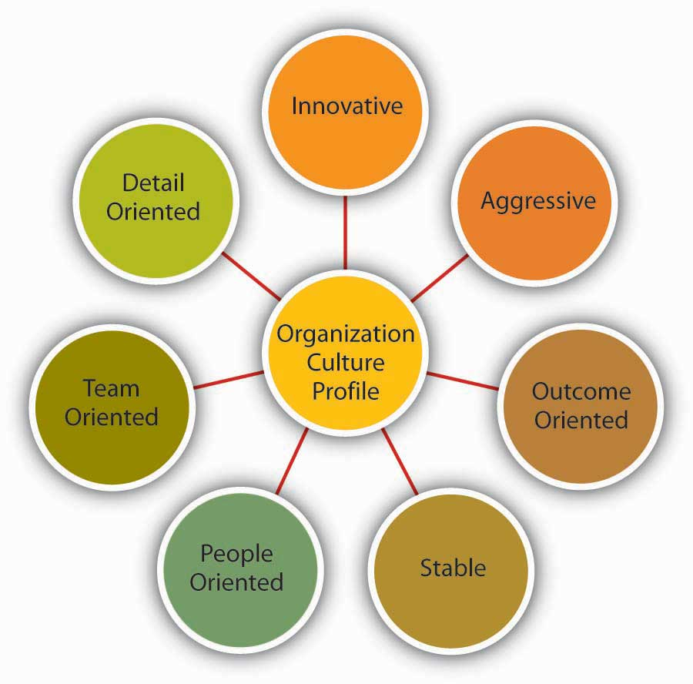
Figure 1: Interrelationship between Organisational cultures and performance
(Source: Umn.edu, 2022)
As stated by Gellatly et al., (2020, p.158), organisational structures such as Matrix, functional, divisional, and rigid support different types of organisational cultures such as Rigid structures like Netflix support hierarchical culture within the organisation. In Netflix, they involve experienced and talented people to enhance their innovative abilities and its organisational structure is highly hierarchical which supports the flow of information in descending order in the company. On the other hand, Tesco performs a functional structure which supports market culture by which the organisation constantly motivates its workforce. Moreover, Tesco is a high-customer and market-oriented organisation where every employee has the power to participate in the decision-making process. Hence, it can be evident that different organisational structures change the concept of organisational cultures and influence organisational performance as well.
To achieve productive organisational performance and accurate employee retention businesses need to focus on people management strategies that not only enhance employee morale but it assists to improve the personal growth of the employees. However, the flow of communication and decision-making attributes also indicate productive evaluation of the organisational structures and link them with the organisational performance. Moreover, it has been observed that organisational cultures and environments are directly linked with employee retention because effective working culture attracts talent. For example, Google is known for its open-minded organisational culture where the managers and leaders constantly support their employees through the interactive and flat flow of communication. A constantly motivating environment and encouraging atmosphere assist the employee to become more effective, productive and committed to the organisation (Linkedin.com, 2022).

Evaluate issues, challenges and approaches to recruitment, selection, performance management and employee engagement
Elements | Issues | Challenges | Approach
Recruitment and selection | Lack of resources and ideology develop major issues in the recruitment and selection process. Moreover, a proper recruitment process also develops hindrances for organisations. For example, Amazon’s recruitment process is based on 6 critical measures which are slow and elongated that lead to the mental breakdown of the employees. The recruitment and selection process of Amazon includes three individual screening and two interview processes where employees lose their temperament and impact the recruitment process (Segal, 2022). | - It is hard for the organisation to choose productive ways to approach the recruitment and selection process.  - Slow and multiple stages of recruitment and selection process that impact employee engagement and enhancement of people management of the organisation.  - Lack of technical knowledge increases barriers in the recruitment and selection process of the organisations. | Organisations can use an assessment that helps to measure employees' skills, cultural formats and interests. Using SMART metrics that can assist to develop structured interview events that serve several ways to analyse candidates more relevantly. Research has evaluated structured interviews which help employers to set a clear set of questions to ask every candidate to assess their reliability, and effectiveness to enhance the chances of hiring more talented people in the organisations.
Performance management | In the pandemic situation, the number of effective workers in the labour market is not available to develop issues for organisations. However, a lack of accurate talents increases insufficiency in the workforce and leads to a negative impact on performance management. Moreover, in the current scenario, organisations are facing a variety of issues and challenges regarding high turnover rates, employee layoffs and other retention measures that directly change the working attributes of the businesses. For example, Hyatt hotels have faced an immense high turnover rate during the pandemic situation which impacts its business services and performance negatively (Managementheaven.com, 2019). | - Lack of efficient talents in the pandemic situation.  - In the pandemic situation, the organisations face high turnover rates and employee retention measures  - Lack of knowledge regarding diversity and inclusion increases cultural differences in organisations. | Organisations can adopt the retention approach by investing more time to extend their job descriptions which must reflect the core vision of the organisation. For example, Apple always elaborates on its morale with the job descriptions that enhance its brand image along with increasing employee retention as well.
Employee engagement | In the current situation, businesses are facing different issues and challenges regarding employee engagement because the market dynamics are highly competitive and as result, the business does not have sufficient resources for strengthening its performance measures. Moreover, in some organisations communication gaps between the employer and employees are increasing issues within the organisation because it increases miscommunication, misconception and misunderstanding between the leaders and employees. Additionally, the | - High competition in the labour markets and organisations.  - Not having a productive system to track employee satisfaction and recruitment success plans.  - The high communication gap between employers and employees | Experts use the measures of proactive instead reactive that increase an active pipeline for potential talents. Businesses need to search for an effective way to extend their employee networks. However, it would enhance the quality of business approaches and increase employees' interest towards the business as well.

Impact of those issues and challenges on the organisations globally:
Throughout the discussion in the above table, it can be evident that the organisation has faced several challenges with the recruitment and selection process along with impacted employee retention as well. From the beginning of the pandemic situation, the government has restricted physical presence in the workplace which led to the complete shutdown of the business. Several businesses convert their business activities from offline to online processes but maximum small, large and medium-sized organisations face significant issues including high turnover rates, lack of resources, communication gaps, lack of qualified candidates and many more which gradually decrease recruitment and selection rates globally.
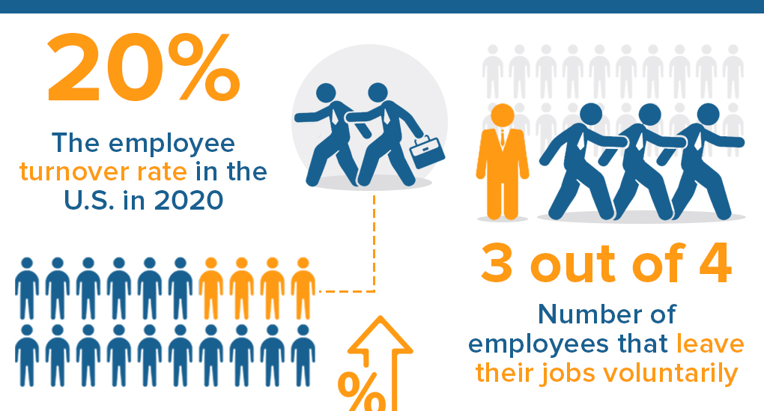
Figure 2: Employees Turnover rates (All industries)
(Source: Andre, 2021)
For example, the tourism and travel business in the UK including Premier Inn, Novotel and other hotels or tourism agencies face immense turnover rates in the very first period of the Pandemic. Moreover, it has been observed that Greater London has faced the largest fall in room involvement 2019-2020. In 2020 only 20% of usual rooms were acquired by the customers who indicate a fall in revenue in the tourism industry. Hence, it can be evident that maximum organisations lay off their employees due to a lack of resources and a shortage in revenue structures (Andre, 2021).
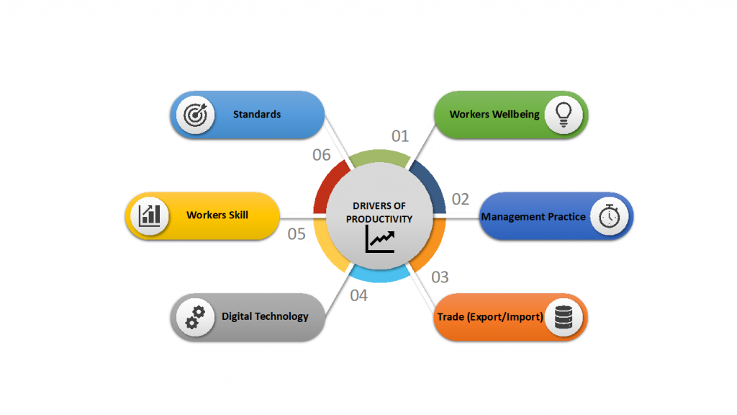
Figure 3: Drivers of productivity
(Source: Adem, 2021)
Not only the tourism and travel industry but the retail, hospitality and healthcare sector has faced a high turnover rate due to a lack of financial stability. Customer engagement and employee turnover are two reciprocal measures because when customer engagement is high the business demands more employees but when customer engagement is low the business tends to lay off its employees which leads to a higher turnover rate (Roberts, 2021). More specifically, the current turnover rate in the UK is nearly 15% every year which is still high for the business. For example, in an investment in the New York Times, it has been seen that Amazon's employee turnover rate is almost 150% which is completely double from industry measures. The elongated recruitment process, immense pressure on the employees and lack of employee retention strategies are the main causes behind the huge turnover rate in the organisation (Segal, 2022). On the other hand, it has been observed that Tesco's annual turnover rate is only 35%, which is lower than industry standards. The democratic working culture and interactive working environment increase employee satisfaction which leads to higher employee morale and commitment towards the organisation. Moreover, it has been observed in Sainsbury that the organisation has faced a 3.87% decline in its recruitment ratio from 2019; in 2020 the organisation recruited almost 111,900 employees whereas the organisation recruited almost 181,900 employees in 2017. This ratio indicates that organisations are facing different issues with their recruitment, selection, performance and employee retention measures (Roberts, 2021).

Best practice approaches can companies used to ensure productive recruitment and selection, performance management and employee engagement
As discussed by Chanana, (2021, p.2508), the recruitment and selection process is an integral element of a business because without potential employees the organisations can't achieve their projected goals. Moreover, it can be evident throughout the discussion that not only do small or medium-sized organisations face issues with turnover and other recruitment issues but large organisations face massive implications regarding their performance and people management measures. However, any organisation needs to deploy effective and potential employee retention strategies to mitigate the issues they are facing in current times.
Developing productive communication channels between employer and employee:
Organisations need to increase internal communication bridges that might help the organisations to enhance employee retention and morale. For example, Tesco has a productive flat communication process where the information flows divisionally and every employee has the power to interact with their leaders regarding any innovation or suggestion. Productive communication between the leaders and teams helps to increase team working activities and enhances the dependency rate as well. Tesco is one of the most influential examples of productive and positive communication culture because in this organisation employees can communicate with seniors or juniors without significant mindedness which helps them to explore more, visualise more, being creative, innovative and interactive as well. Productive working culture not only helps the business to enhance employee engagement or retention but also helps the employees to become competent and accurate in their jobs. It helps to enhance productivity, morale and commitment of the workforce which results in a high-performance rate for the companies.
Developing job posts that reflect the organisation's morale:
As argued by Benjamin et al., (2019, p.100), for reducing issues in job posts and job attention, organisations can evaluate an alternative way to strengthen their job posts which would reflect the organisation's motto. For example, Apple always highlights their company vision, to bring differences through innovations. It helps the business to elaborate its vision and mission towards the candidates and helps them to identify their dream jobs more easily. Moreover, Netflix also focused on its company morale which refers to innovations that are the core reason the organisation tends to recruit talented candidates instead of fresher or inexperienced people. The organisation believes that experienced people might understand the organisation's morale and improve their performance by adopting it. Hence, it can be evident that businesses need to focus on the company morale and reflect their demands more specifically in the job posts to enhance employee engagement and improve performance management.
Using social media for targeting talents:
In the current digital era, people are living more online lives than offline. Social media is one of the most integrated and easy ways to elaborate company demands in front of the candidate. In social media, several and a huge number of candidates are present who are looking for their dream jobs. The business can use social media for job recruiting strategies to easily recruit candidates and enhance their morale as well. Maximum small and medium-sized organisations use social media as a recruiting way for encouraging their job interests and recruiting more candidates without extra expenses. Social media platforms are cost-effective and an easy way to reach diverse people globally and approach jobs without any middle barriers. For example, LinkedIn is one of the most popular and effective social media platforms where almost 98% of employees present and approach their jobs using it. Almost 92% of global organisations use social media platforms as the medium of recruitment which enhances their service quality and helps to acknowledge others about the organisation's morale, statement, vision, demands, requirements and mission without any further assistance (Linkedin.com, 2022).

Evaluate the behavioural approach to management, by understanding the factors that affect differences in individual behaviour
As stated by Kumar et al., (2020, p.1092), the behavioural approach of people management evolved significantly because the leaders and managers discovered that deploying ideologies of the classical approach of people management failed to improve efficiency and workplace harmony. The behavioural concept of people management highlighted the classical approach of human aspects. However, in classical theories, organisations use various manual terms and measures to take care of the people within the organisation but nowadays modern technologies have completely changed the scenario which enhances productivity rate as well. The behavioural approach is subdivided into two adjacent branches
- Human relations and
- Behavioural science approach.
These two segments evaluate core aspects of individual behaviours and help the leaders to understand their subordinate's behaviours traits along with different psychological measures.
Human relations:
In terms of human relations, it refers to the potential ways in which leaders or managers connect with their subordinates. Managers face major issues while tackling the business aspects and employees' morale because individual behaviour impacts the decision-making process massively. However, this approach helps the managers to feel the importance of employee recognition and social aspects for enhancing their formal behaviours. The managers can initiate developing potential interrelationships with the employees by providing them extended motivation and encouraging them in their way which helps them to understand their value and morale towards the organisation. In addition, organisations can adopt different experiments to increase their employee retention and engagement such as interviewing programmers, internal assessments, Bank wiring test rooms and others that help the managers to understand employees' requirements which drive their behaviour towards the business (Managementheaven.com, 2019).
Behavioural science approaches:
This is an extension of the human relation approach that focuses on the individual attitudes, behaviours and performance of the individual which can enhance the quality of work ace interactions. Moreover, the advocates of this approach consider the complicated structure of Human activities because this approach evaluates that focusing on psychological measures is more essential rather than focusing on physical activities. Organisational structures, cultures, and environments influence individual attitudes and behaviour in the workplace. For example, Google provides an extensive and open-minded environment for the employees where they can roam, play or watch videos. The organisation provides extensive attention to individual behaviours because its beloved individual behaviours influence team behaviours as well. Google provides an innovative and extensive working environment for the candidates who increase their creativity, innovation and critical thinking ability (Managementheaven.com, 2019).

Conclusion:
Lastly, it can be concluded throughout the discussion that managing people is highly essential for businesses to achieve their projected goals and ensure their productivity as well. The current report evaluates concepts of employee retention and employee engagement by identifying core issues and challenges faced by organisations. Moreover, this report evaluates the aspects of employee retention and addresses specific solutions for mitigating the issues and challenges. This report evaluates real-life examples that ensure higher productivity and the potential quality of the current research study.

References:
Adem, A. (2021). Finding the Measure of Management. PrOPEL Hub. Available at: https://www.propelhub.org/finding-the-measure-of-management/ [Accessed 26 Nov. 2022].
Andre, L. (2021). 112 Employee Turnover Statistics: 2021 Causes, Cost & Prevention Data. Financesonline.com. Available at: https://financesonline.com/employee-turnover-statistics/ [Accessed 26 Nov. 2022].
Bonaccio, S., Connelly, C.E., Gellatly, I.R., Jetha, A. and Martin Ginis, K.A., 2020. The participation of people with disabilities in the workplace across the employment cycle: Employer concerns and research evidence. Journal of Business and Psychology, 35(2), pp.135-158. https://link.springer.com/article/10.1007/s10869-018-9602-5
Chanana, N., 2021. Employee engagement practices during COVID‐19 lockdown. Journal of public affairs, 21(4), p.e2508. https://onlinelibrary.wiley.com/doi/abs/10.1002/pa.2508
Feinstein, M.J., Hsue, P.Y., Benjamin, L.A., Bloomfield, G.S., Currier, J.S., Freiberg, M.S., Grinspoon, S.K., Levin, J., Longenecker, C.T., Post, W.S. and American Heart Association Prevention Science Committee of the Council on Epidemiology and Prevention and Council on Cardiovascular and Stroke Nursing; Council on Clinical Cardiology; and Stroke Council, 2019. Characteristics, prevention, and management of cardiovascular disease in people living with HIV: a scientific statement from the American Heart Association. Circulation, 140(2), pp.e98-e124. https://www.ahajournals.org/doi/abs/10.1161/CIR.0000000000000695
Linkedin.com. (2022). The relationship between Organizational Culture, Structure and Performance. Available at: https://www.linkedin.com/pulse/relationship-between-organizational-culture-structure-kabelo/ [Accessed 26 Nov. 2022].
Managementheaven.com. (2019). Behavioural Approach to Management. Available at: https://managementheaven.com/behavioral-approach-to-management/ [Accessed 26 Nov. 2022].
Roberts, D. (2021). Coronavirus and the impact on the UK travel and tourism industry - Office for National Statistics. www.ons.gov.uk. Available at: https://www.ons.gov.uk/businessindustryandtrade/tourismindustry/articles/coronavirusandtheimpactontheuktravelandtourismindustry/2021-02-15 [Accessed 26 Nov. 2022].
Saeed, B.B., Afsar, B., Hafeez, S., Khan, I., Tahir, M. and Afridi, M.A., 2019. Promoting employee's pro-environmental behaviour through green human resource management practices. Corporate Social Responsibility and Environmental Management, 26(2), pp.424-438. https://onlinelibrary.wiley.com/doi/abs/10.1002/csr.1694
Segal, E. (2022). Amazon Responds To Release Of Leaked Documents Showing 150% Annual Employee Turnover. Forbes. Available at: https://www.forbes.com/sites/edwardsegal/2022/10/24/amazon-responds-to-release-of-leaked-documents-showing-150-annual-employee-turnover/?sh=33a69b661d0b [Accessed 26 Nov. 2022].
Spiceworks. (2022). What is People Management? Complete the Process with Best Practices. Available at: https://www.spiceworks.com/hr/performance-management/articles/what-is-people-management/ [Accessed 26 Nov. 2022].
Stone, R.J., Cox, A. and Gavin, M., 2020. Human resource management. John Wiley & Sons. https://books.google.com/books?hl=en&lr=&id=uCIgEAAAQBAJ&oi=fnd&pg=PR13&dq=Evaluate+issues,+challenges++and+approaches+to+recruitment,+selection,+performance+management+and+employee+engagement+&ots=PJLRWy0QF0&sig=vx2jgXL3vaRwtMSajTwraZ-z6jA
Sureka, R., Kumar, S., Mangla, S.K. and Junior, F.H., 2020. Fifteen years of the international journal of productivity and performance management (2004–2018). International Journal of Productivity and Performance Management, 70(5), pp.1092-1117. https://www.emerald.com/insight/content/doi/10.1108/IJPPM-11-2019-0530/full/html
Tambe, P., Cappelli, P. and Yakubovich, V., 2019. Artificial intelligence in human resources management: Challenges and a path forward. California Management Review, 61(4), pp.15-42. https://journals.sagepub.com/doi/abs/10.1177/0008125619867910
Umn.edu. (2022). 8.4 Measuring Organizational Culture. Available at: https://open.lib.umn.edu/principlesmanagement/chapter/8-4-measuring-organizational-culture/ [Accessed 26 Nov. 2022].

