Slide 1

Slide 2

Slide 3

- This presentation is prepared as part of coursework for the module "Learning in the Digital Era"
- This presentation includes three tasks that are assigned in Assignment 2. In task 1, there will be a discussion of Self-Evaluation, based on Gibbs’ Reflective model. The professional development plan was discussed in Task 2, and a summary of Unit 4 Topic 1 was presented in Task 3.

Main Body

Video Link:
https://youtu.be/YV22y3jyfXo?si=hh4ShSJbGecKgazX

Slide 4
Gibbs’ Reflective Model (1988) is a six-stage approach to reflecting on and making sense of experiences for enhanced learning [1].
One of the most well-known cycle models of reflection guides you through six stages to help you explore your experience: description, feelings, evaluation, analysis, conclusion, and action plan [2].
My experience:
While working a hectic shift at my workplace, I witnessed a customer become irritated due to a delay in his order. He started yelling and complaining about it. It was my responsibility to address his complaint. I apologised to him and resolved his problem as soon as possible.
2. Emotions
I felt stressed and somewhat anxious after the customer became angry and raised their voice at me, but I kept my cool.
3. Evaluation
My ability to maintain composure and de-escalate the situation was effective; however, there was room for improvement, as it should have been made clear from the beginning that there would be delays.
4. Analysis
The customer's outburst was primarily due to the wait time. Communication skills and emotional stability are key factors, and my delay caused tension.
Slide 5

One of my most important strengths is consistency in my work. I can stick to something for a long time, make progress step by step, and achieve my set goals. Another important strength I have is that I do not need others' motivation to reach my objectives; I can motivate myself effectively. I have confidence in my abilities. It gives me an opportunity to face new challenges with a positive attitude.
I can also consider myself someone with good organisational skills. Being well-organised, I can plan my schedule and manage my time properly. Good organisation prevents me from feeling too stressed. Besides, I am a communicative person, able to share my opinions with others without any problems. My communication skills are valuable because I work effectively in a team.
Weakness:
Another area for improvement is my time management; I often struggle to juggle multiple activities. Moreover, I often overthink and may procrastinate when making decisions, which can make otherwise straightforward tasks more difficult than necessary. Finally, I might sometimes find myself easily distracted by other things. Even though such weaknesses may pose difficulties, recognising them enables me to address them properly.

Slide 6

Learning skills can be enhanced through self-awareness, which requires learners to reflect on their thoughts, feelings, and behaviours. Self-awareness enables people to identify their strengths and weaknesses, as well as the behavioural patterns that shape their learning process. The other quality is open-mindedness, which requires people to be receptive to new information and viewpoints. Open-mindedness allows people to adjust and broaden their knowledge base. Lastly, confidence plays an instrumental role in enhancing self-awareness and open-mindedness. Confidence enables learners to take risks and overcome the barriers that may impede their growth and development.

Slide 7

The individual in question is a hardworking, ambitious person who is interested in improving their knowledge and skills. One important aspect here is enhancing English-speaking skills through various learning strategies, such as talking with friends or fellow students and listening to audio resources available in educational settings.
Furthermore, the individual wants to succeed in academic and professional life. To accomplish this goal, the person demonstrates strong organisational skills and follows an efficient learning strategy, including completing all university-related assignments on time and adhering to a well-thought-out study routine.
Another priority in personal development is improving language skills, such as writing and spelling. For instance, the individual takes online courses in foreign languages and learns new vocabulary to write more effectively and use the target language correctly.
In summary, the individual is highly interested in self-improvement. The process is evaluated weekly and monthly. Given that the person is diligent and persistent and uses appropriate resources and tools, they will easily achieve their learning objectives in due course.

Slide 8

Learning to Learn
The skill of “learning to learn” involves developing the ability to become more flexible, reflective, and effective at acquiring new information. The process of becoming an agile learner involves being ready for new experiences, a willingness to take risks, and treating failures as constructive feedback [7]. In addition, adopting a constructive attitude helps to maintain motivation in difficult and unusual situations [8]. Going beyond one’s comfort zone is beneficial for learning and development, whereas considering diverse viewpoints enhances analytical thinking. Moreover, feedback plays an equally significant role by highlighting personal strengths and weaknesses.

Slide 9

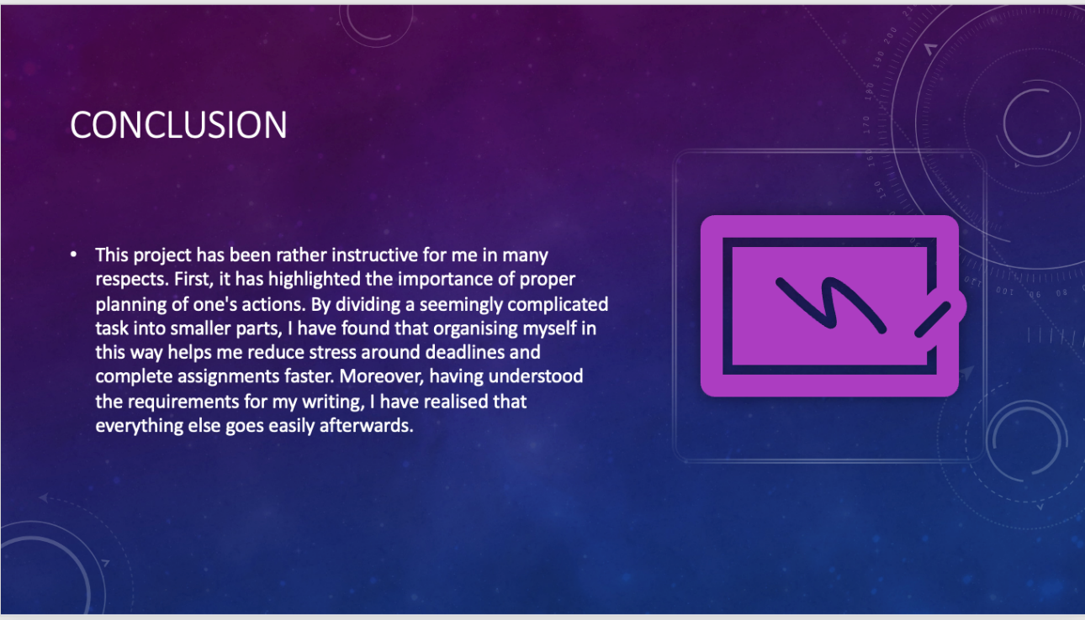
Conclusion:
This project has been rather instructive for me in many respects. First, it has highlighted the importance of proper planning of one's actions. By dividing a seemingly complicated task into smaller parts, I have found that organising myself in this way helps me reduce stress around deadlines and complete assignments faster. Moreover, having understood the requirements for my writing, I have realised that everything else goes easily afterwards.
Secondly, by analysing different aspects of the given topic, I have come to realise the importance of applying critical thinking to the material collected during research. Indeed, it is necessary not only to gather facts but also to compare and evaluate different views on the issue.
Furthermore, while receiving feedback and reviewing the completed part of my task, I have discovered how important it is to reflect on my thoughts and see what changes should be made. Such a procedure is crucial because it allows improving constantly.
All in all, I have gained confidence after dealing with difficulties.
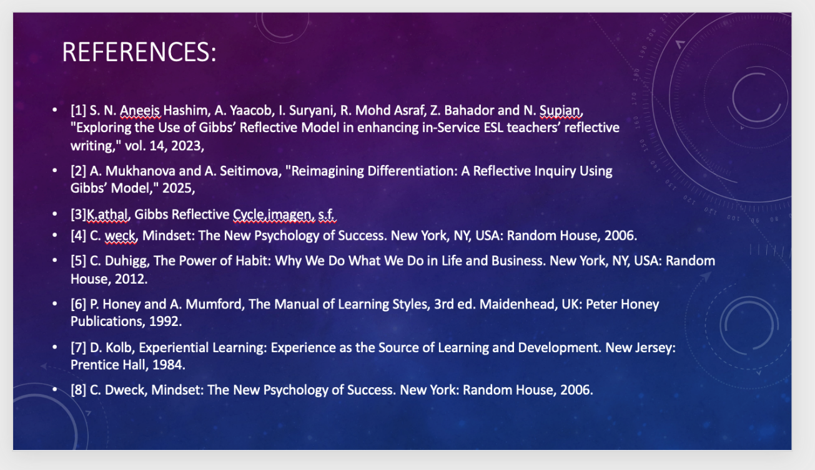
References
[1] S. N. Aneeis Hashim, A. Yaacob, I. Suryani, R. Mohd Asraf, Z. Bahador and N. Supian, "Exploring the Use of Gibbs’ Reflective Model in enhancing in-Service ESL teachers’ reflective writing," vol. 14, 2023,
[2] A. Mukhanova and A. Seitimova, "Reimagining Differentiation: A Reflective Inquiry Using Gibbs’ Model," 2025,
[3]K.athal, Gibbs Reflective Cycle,imagen, s.f.
[4] C. weck, Mindset: The New Psychology of Success. New York, NY, USA: Random House, 2006.
[5] C. Duhigg, The Power of Habit: Why We Do What We Do in Life and Business. New York, NY, USA: Random House, 2012.
[6] P. Honey and A. Mumford, The Manual of Learning Styles, 3rd ed. Maidenhead, UK: Peter Honey Publications, 1992.
[7] D. Kolb, Experiential Learning: Experience as the Source of Learning and Development. New Jersey: Prentice Hall, 1984.
[8] C. Dweck, Mindset: The New Psychology of Success. New York: Random House, 2006.

