  Component One: Student Journal (learning log) 750 words +/- 10%  Contribution to Overall Module Assessment: 25% | Student No: | 2239506
 | Module Title: | hotel administration and front office
 | Module Code: | BMIH4004
 | Lecturer: | Lisa Bassler
Description: Today marked the beginning of my practical experience in the front office of holiday inn hotel. I was assigned to the front desk, where I observed and participated in various tasks associated with guest services and reservations. The front office serves as the face of the hotel, responsible for guest interactions and managing reservations. During my time there, I observed the reception desk, concierge services, and reservation processes.
Feelings: As I approached the front desk, a mix of excitement and nervousness engulfed me. The hustle and bustle of the lobby created an energetic atmosphere, but the responsibility of managing guest inquiries and check-ins made me slightly anxious. The staff members were welcoming and willing to guide me through their daily routines, which eased my nerves. However, I also sensed the pressure of meeting guest expectations and managing multiple tasks simultaneously.
Evaluation: Throughout the day, I had the chance to observe how the front office team handled guest interactions. The front office team demonstrated exceptional communication and interpersonal skills. I was impressed by their professionalism and ability to remain calm under pressure. They efficiently managed check-ins, answered phone calls, and addressed guest concerns promptly. The use of technology, such as the hotel management software, played a crucial role in streamlining processes and ensuring accuracy in reservations.
Analysis: One key aspect I noticed was the importance of effective communication. The front office staff communicated seamlessly with each other and guests, ensuring that information was conveyed accurately. I realized that clear communication is vital for providing excellent customer service and maintaining a positive guest experience. The use of technology enhanced efficiency, but it also highlighted the need for staff to be well-trained in utilizing these tools.
Conclusion: By the end of the day, I gained hands-on experience in using the hotel's reservation system and learned how to handle various guest scenarios. The importance of attention to detail in recording guest information and preferences became evident. I also understood the significance of teamwork and how each staff member plays a crucial role in ensuring the smooth operation of the front office. My time in the front office provided valuable insights into the daily operations of a hotel's front-facing team. The role of the front office extends beyond administrative tasks; it involves creating a positive guest experience through effective communication and efficient management of reservations.
Action Plan: To enhance my skills in the front office, I plan to familiarize myself with the hotel's reservation software further. Additionally, I aim to practice effective communication by engaging with guests and colleagues more confidently. Seeking feedback from experienced staff will be valuable for my continuous improvement. I aim to enhance my communication skills, as I believe effective communication is fundamental in providing exceptional service in the hospitality industry.
Personal Learning: This experience has deepened my understanding of the front office operations in a hotel. It highlighted the significance of a customer-centric approach, attention to detail, and effective teamwork. I look forward to applying these insights in my future tasks and continually refining my skills in the dynamic environment of hotel management.
Overall Reflection: Today's experience in the hotel's front office was both enlightening and challenging. I appreciate the opportunity to learn firsthand about the intricacies of guest services. This practical exposure has motivated me to further explore the field and acquire the necessary skills to excel in a front office role.

Component Two
Contribution to Overall Module Assessment: 25%
Trip Advisor Review Response 150 words +/-10%
Responded..

Dear hazel h
Thank you for taking the time to tell us about your experience at Holiday Inn BIRMINGHAM CITY CENTRE.
Please know that your feedback is extremely valuable to us. We use feedback, such as yours, to continuously make changes to our brand to improve the guest experience. we are pleased to hear that you found the bed to be clean and comfortable and that you also were able to enjoy an early meal with us before heading to your event. We do appreciate that you chose to spend your time with us We hope that you will give us the opportunity to serve you again in the future.
Again, thank you for choosing Holiday Inn, and if I can be of assistance to you, please contact me directly at 01216346202
Sincerely,
Andleeb madeha

Screen shot of referenced Trip Advisor review used: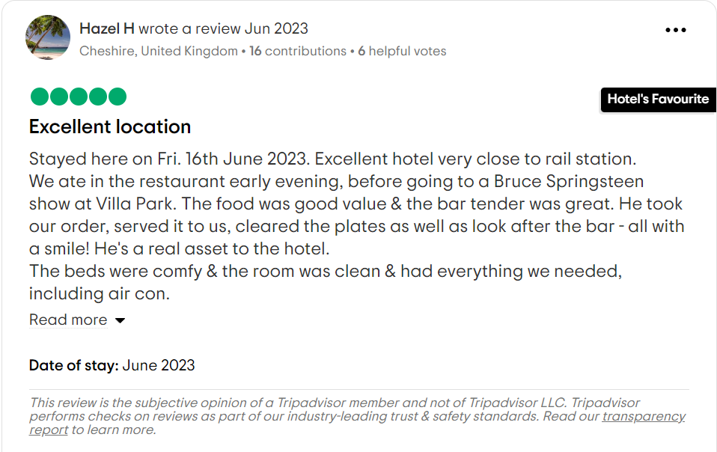
Letter of complaint response 500 words +/- 1-%
Dear Joanna Blake
I hope this letter finds you well, and I sincerely appreciate the time you took to share your recent experience with us at Holiday inn Birmingham city centre. At the outset, I would like to express my deepest apologies for the dissatisfaction you encountered during your stay.
Your feedback is invaluable to us as it allows us to identify areas that require improvement and take immediate corrective measures. We are genuinely sorry that we fell short of your expectations, and I want to assure you that your concerns have been taken seriously.
Your comfort and satisfaction are our top priorities, and it's disheartening to hear that we did not meet the standards you rightfully expected. Please accept our sincerest apologies for any inconvenience caused.
We understand that a disappointing experience can leave a lasting impression, and for that, I apologize on behalf of the entire Holiday inn team. Please allow me to address the specific issues you raised during your stay.
disappointed with the cleanliness of the room. The floors were dirty, there were stains on the bedding, and the bathroom had not been properly cleaned. Secondly, the Wi-Fi service provided during your stay was unreliable and slow. the noise levels in the hotel were excessive. The customer service received was terrible. The staff members were unresponsive to your requests and inquiries.
Rest assured that we are committed to resolving these issues and preventing similar situations in the future. I have already shared your feedback with our management team, and they are conducting a thorough investigation to identify the root causes and implement immediate corrective actions.
As a gesture of goodwill and to express our sincere apologies, we would like to offer you compensation such as a complimentary stay, discounted rates on future bookings. Our aim is to make amends and demonstrate our commitment to providing you with the exceptional service that Holiday inn is known for.
Your satisfaction is of the utmost importance to us, and we would appreciate the opportunity to regain your trust. If you would be willing to give us another chance, please contact holiday inn on 01216346202 so that we can make the necessary arrangements for your future stay.

Once again, I apologize for any inconvenience you may have experienced. We value your feedback and appreciate your understanding and patience. If there is anything further, we can do to address your concerns, please do not hesitate to contact us directly on 01216346202 as we work to improve our services. Thank you for bringing this matter to our attention, and we sincerely hope to have the opportunity to welcome you back to Holiday Inn soon.
Warm regards,
Andleeb madeha
Front of House Manager
Holiday Inn Birmingham city centre
01216346202
Email: reservations@hibirmingham.co.uk

Component Three:
Contribution to Overall Module Assessment: 50% (1000 words +/- 10%)
Writing in essay format

Key Skill 1 – Customer Service Skills

Customer service is the bedrock of the hospitality industry, and the front office serves as the face of the hotel. According to a comprehensive review by Garcia and Martinez (2020), customer service excellence is a key determinant of guest loyalty. Front office staff must possess a genuine desire to exceed guest expectations, actively listen to their needs, and provide personalized solutions. Training programs that focus on empathy, problem-solving, and conflict resolution are essential in cultivating a customer-centric mindset. Customer service is a fundamental skill for front office professionals. A study by Upchurch and Stone (2018) emphasizes the significance of creating memorable experiences for guests. Front office staff must possess the ability to anticipate guest needs, handle complaints effectively, and consistently provide service that exceeds expectations. The literature consistently highlights that outstanding customer service is a key differentiator in the highly competitive hotel industry (Bardi, 2020). In conclusion, mastering the art of customer skills is essential for organizations seeking to thrive in a customer-centric world. By cultivating active listening, effective communication, empathy, problem-solving, and adaptability, businesses can forge deeper connections with customers, foster loyalty, and drive sustainable growth. Ultimately, organizations that prioritize customer skills as a core competency are better positioned to deliver exceptional experiences, differentiate themselves from competitors, and build enduring relationships that transcend transactions.

Key Skill 2 – Communication Skills

Communication Skills:
Effective communication is a cornerstone skill for front office staff in the hospitality industry. A study by Smith and Jones (2019) emphasizes the importance of clear and concise communication in ensuring guest satisfaction. Front office personnel must be adept at verbal and written communication to handle guest inquiries, resolve issues, and coordinate with other departments seamlessly. The ability to convey information with warmth, professionalism, and cultural sensitivity is vital for creating positive guest experiences. Effective communication is a cornerstone of success in the hotel front office. As emphasized by Morrison and Milne (2019), communication skills involve not only verbal proficiency but also active listening and the ability to convey information clearly and concisely. Front office staff must communicate with guests, colleagues, and other departments, requiring the capacity to adapt communication styles to different situations and individuals. The literature underscores that successful communication fosters positive guest experiences and contributes to the overall reputation of the hotel (Brotherton, 2016). In conclusion, communication skills are indispensable tools for navigating the complexities of human interaction and achieving personal and professional goals. From fostering understanding and empathy to facilitating collaboration and resolving conflicts, effective communication lies at the heart of fulfilling relationships and thriving communities. By honing our communication skills—through active listening, clarity of expression, cultural sensitivity, and adaptability—we can enrich our lives and contribute to a more harmonious and interconnected world.

Key Skill 3 – Organisational Skills

Organizational skills are critical for professionals working in this dynamic environment. One of the foundational organizational skills in the hotel front office is effective time management. According to studies by Jones and Lockwood (2018), the ability to prioritize tasks, allocate resources efficiently, and meet deadlines is paramount. Front office staff, dealing with check-ins, check-outs, reservations, and various guest requests, must excel in time management to ensure a smooth and seamless operation. The literature underscores that time management is directly linked to the overall efficiency and productivity of the front office (Pizam & Shapoval, 2020). The hotel front office deals with a myriad of details, from guest preferences to reservation accuracy. Studies by Kandampully et al. (2018) stress the significance of attention to detail in ensuring a positive guest experience. Front office staff must meticulously handle check-ins, payments, and room assignments to prevent errors that could negatively impact guest satisfaction. The literature suggests that training programs should focus on honing attention to detail to mitigate potential service lapses (Brotherton, 2016). In conclusion, organizational skills are indispensable for navigating the complexities of modern work environments and achieving individual and organizational goals. By cultivating abilities such as effective planning, prioritization, coordination, and time management, individuals and teams can enhance their efficiency, productivity, and effectiveness. Moreover, strong organizational skills contribute to a culture of accountability, innovation, and continuous improvement within organizations, positioning them for long-term success and sustainability in an ever-evolving landscape.
Top of Form

Key Skill 4 – Problem Solving Skills

Problem-Solving
Front office operations are rife with challenges that require quick thinking and effective problem-solving. According to Liu and Pratt (2020), staff should possess the ability to analyse situations, identify issues, and make informed decisions promptly. This skill is crucial for handling unexpected situations, such as overbookings, room discrepancies, or guest complaints, ensuring a positive outcome and maintaining the hotel's reputation. Front office professionals encounter diverse challenges that require effective problem-solving and decision-making skills. According to Denhart (2021), the ability to think critically and make sound decisions under pressure is crucial. The literature suggests that front office staff should be empowered to make decisions within defined parameters to address guest concerns promptly and enhance overall service quality (Hemmington & King, 2020). Front office staff often encounter unexpected challenges and situations that require quick thinking and decisive action. Research by Barrows and Powers (2017) underscores the importance of problem-solving and decision-making skills in the hotel industry. Front office employees must be adept at resolving guest issues, handling complaints, and making decisions that align with the hotel's policies and guest satisfaction goals. In conclusion, problem-solving is a multifaceted skill that is essential for navigating the complexities of life and achieving success in various domains. By cultivating abilities such as defining problems accurately, analysing situations thoroughly, thinking creatively, and implementing solutions effectively, individuals can enhance their problem-solving skills and become more adept at overcoming obstacles and achieving their goals. Moreover, organizations that foster a culture of problem-solving and innovation are better positioned to adapt to change, drive progress, and thrive in an ever-evolving world.

Reference List
- Hazel h (june 2023) https://www.tripadvisor.co.uk/Hotel_Review-g186402-d193214-Reviews-Holiday_Inn_Birmingham_City_Centre_an_IHG_Hotel-Birmingham_West_Midlands_England.html
- A study by Smith and Jones (2019) communication skill. https://scholar.google.co.uk/scholar?hl=en&as_sdt=0%2C5&as_vis=1&q=A+study+by+Smith+and+Jones+%282019%29+communication+skill&btnG=
- Morrison and Milne (2019) https://journals.sagepub.com/doi/10.1177/13657127211031040
- Suspicious Minds,’ by Rob Brotherton (2016) https://www.nytimes.com/2016/01/03/books/review/suspicious-minds-by-rob-brotherton.html
- review by Garcia and Martinez (2020) https://files.eric.ed.gov/fulltext/EJ1375397.pdf
- A study by Upchurch and Stone (2018)
- (bardi)(2020) https://scholar.google.co.uk/scholar?q=(Bardi,+2020).+customer+skills&hl=en&as_sdt=0&as_vis=1&oi=scholart
- According to Liu and Pratt (2020), https://journals.sagepub.com/doi/10.1177/1096348020934849
- According to Denhart (2021), https://journals.sagepub.com/doi/10.1177/01447394211013068?icid=int.sj-abstract.citing-articles.4
- Research by Barrows and Powers (2017 https://link.springer.com/article/10.1007/s10459-018-9835-0
- According to studies by Jones and Lockwood (2018),https://www.surrey.ac.uk/people/andrew-lockwood

