Database concepts
2509337
Matthew Hope
09/01/2026

Introduction
In this report is a database creation of an e-bike rental service. The database is used to store and manage the information. It keeps track of customers, e-bikes, rentals, payments, staff, and maintenance activities. By organizing the data into related tables, the database helps monitor bike availability, rental history, payments, and servicing schedules, which improves accuracy and reduces errors. This report includes the database design, an Entity Relationship Diagram (ERD), descriptions of the main entities and their key attributes, the relationships between them, and screenshots of each part of the database. Furthermore, there has been queries and tests run to show the database works. Overall, the database makes managing e-bike rentals easier, more organized, and reliable.

Table of Contents
Introduction 1
Table of contents 2
Scenario analysis 3
Entity-relationship diagram 6
Data structure Development 8
Normalization Compliance 10
Sample Data Population 11
Query Development 13
Validation and Testing 15
Conclusion 16
References 17

Scenario analysis

“An entity is a data object, either real or abstract, about which we want to collect information” [1]. The electric bike rental service contains several main entities that represent the key parts of the system. These entities are connected so the data stays organised and easy to understand.
The Customer entity stores information about people who rent e-bikes. Its attributes include Customer ID, full name, email address, and phone number. A customer can make multiple rentals, creating a one-to-many relationship with the Rental entity.
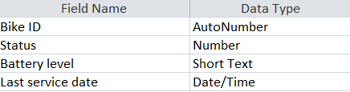

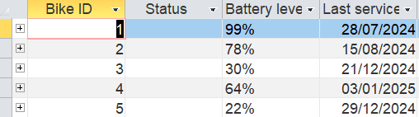

(Figure 1 and 2)
The Bike entity stores details about each e-bike, such as Bike ID, status, battery level, and last service date. A bike can be rented many times and can also have multiple maintenance records.
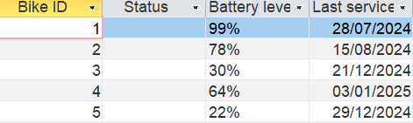

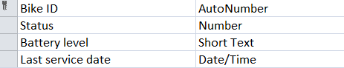

(Figure 3 and 4)
The Rental entity records each rental transaction. Its attributes include Rental ID, Customer ID, Bike ID, start date, end date, and rental cost. This entity links customers and bikes together and forms relationships with both.
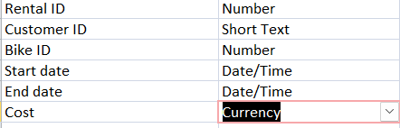

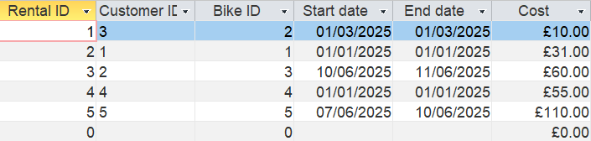

(Figure 5 and 6)
The Payment entity stores payment information for rentals, including Payment ID, Rental ID, payment amount, payment method, and payment time. One rental can be linked to more than one payment.
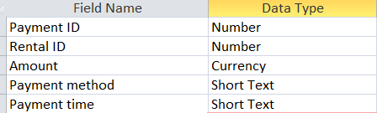

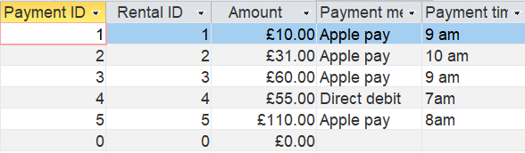

(Figure 7 and 8)

The Staff entity stores information about employees, including Staff ID, name, role, email, and phone number. The Maintenance entity records servicing work carried out on bikes, including maintenance ID, bike ID, staff ID, description, cost, and service date.
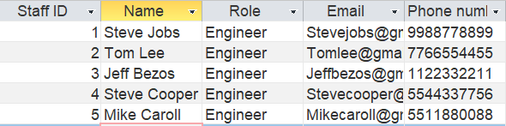

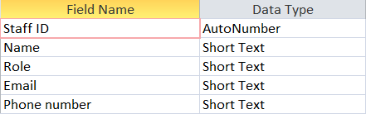

(Figure 9 and 10)
Maintenance records all servicing activities for bikes and includes Log ID, Bike ID, Staff ID, Description, Cost, and Service Date. Each maintenance record is linked to one bike and one staff member, while bikes and staff members can have multiple maintenance records.

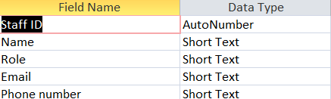

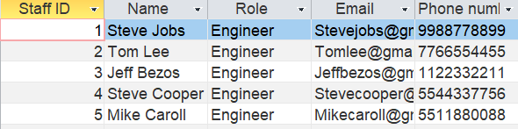

(Figure 11 ad 12)
The relationships in the e-bike rental database show how the tables are connected and how data is shared between them. These relationships help keep the data organised and accurate.

Entity-relationship diagram
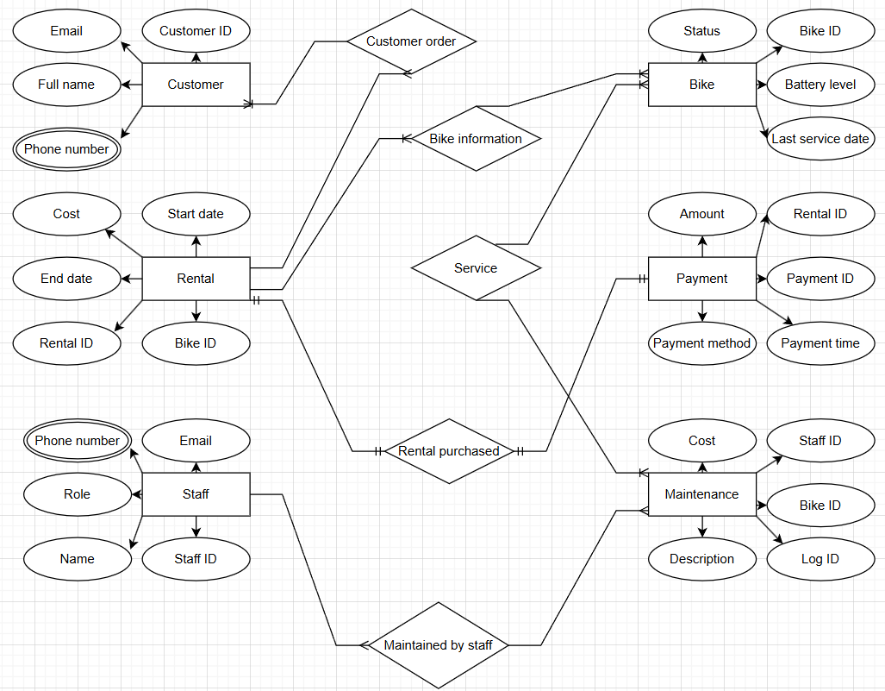

(Figure 13)

“An entity relationship diagram (ER diagram or ERD) is a visual representation of how items in a database relate to each other. ERDs are a specialized type of flowchart that conveys the relationship types between different entities within a system.” [2] This ER diagram shows the e-bike rental system and how its main parts are connected. The Customer entity stores customer details such as customer ID, name, email, and phone number. Customers place orders that lead to a Rental. The Rental entity records each hire, including rental ID, start date, end date, cost, and the bike used. The Bike entity stores information about each bike, such as bike ID, status, battery level, and last service date. Payments for rentals are stored in the Payment entity, which includes payment ID, amount, payment method, and payment time. The Staff entity stores staff details, including staff ID, name, role, email, and phone number.

The Maintenance entity records maintenance work carried out on bikes, including log ID, description, cost, and the staff member responsible. Overall, the diagram shows how customers rent bikes, make payments, and how staff maintain bikes. The diagram is a crucial part of the design process as it helps you communicate, design and understand it before you build the database.

Data structure Development
Using the ER model, the database design includes six main entities: Customer, Bike, Rental, Payment, Staff, and Maintenance. Each entity is connected by relationships with the appropriate constraints which will ensure the data’s integrity.
Constraints are the rules that are applied to the database, and they control what date can be stored in it. Constraints keep the data consistent and valid by preventing incorrect data from being entered. In this database one of the constraints is the “primary key”. This uniquely identifies each record in the table and I cannot be duplicated. Another constraint applied is “NOT NULL”. This ensures that the column must have a value and cannot be left empty.
The entities have many relationships between them. “In relational database design, a relationship is where two or more tables are linked together because they contain related data. This enables users to run queries for related data across multiple tables.” [3]
The “one to one” relationship is applied in this database. This means that each record in one table is linked to only one record in another table.
Example: One staff member has one staff profile.
The “one to many” relationship is also included. One record in the table can be linked to many records in another table, but each record links back to only one record.
Example: One customer can have many rentals, but each rental belongs to one customer.
The final relationship included in this database is the “many to many” relationship. Many records in one table can be linked to many records in another table.
Example: Customers and bikes have a many-to-many relationship, resolved using the Rental table.
The Customer and Rental entities have a one-to-many relationship. One customer can make multiple rentals over time, but each rental is linked to only one customer. A foreign key constraint is used in the Rental entity to reference the Customer, ensuring every rental belongs to a valid customer.
The Bike and Rental entities also have a one-to-many relationship. A single bike can be rented many times, but each rental involves only one bike. A foreign key in the Rental entity links to the Bike entity, and an availability constraint ensures a bike cannot be rented if it is already in use or under maintenance.
The Rental and Payment entities have a one-to-one or one-to-many relationship, depending on the business rules. Each payment must be linked to a valid rental using a foreign key, ensuring payments cannot exist without a corresponding rental.
The Staff and Maintenance entities have a one-to-many relationship. One staff member can carry out multiple maintenance tasks, but each maintenance record is assigned to one staff member. Foreign key constraints enforce this relationship.
The Bike and Maintenance entities also have a one-to-many relationship, ensuring all maintenance records relate to a specific bike.

Normalization Compliance
The data model should be normalized to Third Normal Form (3NF) to minimize redundancy and dependency issues.
“Normalisation is a technique for producing a set of relations with desirable properties, given the data requirements of an enterprise.”[4]
The ER diagram is in 3NF because every table only includes data that fully depends on its main key. There are no partial or transitive dependencies between non-key fields. This structure reduces repeated data, prevents errors when adding, updating, or deleting information, and keeps the database organized. Overall, it ensures efficiency, maintains data integrity, and makes managing the database much easier.
The normalization to 3NF involves the removal of transitive dependencies. If a dependency exists, we remove the attributes from the relation by placing the attributes in a new relation.[4]

Sample Data Population
Five sample records were added to the database to test how well the bike rental system handles real data across all tables. These entries help confirm that the Customer, Rental, Bike, Payment, Staff, and Maintenance entities are correctly linked and that the relationships between them work as expected. By inserting sample rentals, payments, and maintenance logs, we can check that foreign keys connect properly and that each table stores only the information it is responsible for. The database has been designed in Third Normal Form (3NF), meaning each table contains data that depends only on its primary key, with no unnecessary duplication. Adding sample data helps verify that this structure works in practice. These initial records make it easier to test queries, validate constraints, and ensure the system behaves correctly before larger datasets are added.

Customer entity sample data
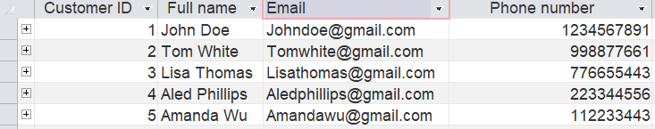
(Figure 14)
Rental entity sample data
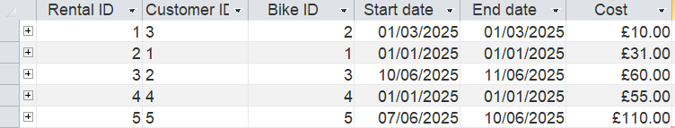
(Figure 15)
Bike entity sample data
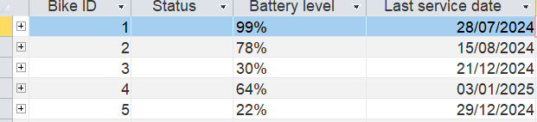
(Figure 16)

Payment entity sample data
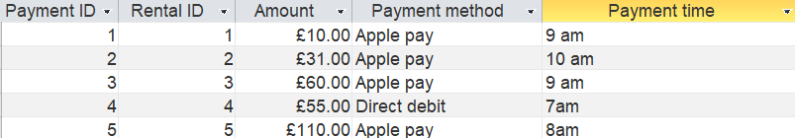
(Figure 17)
Staff entity sample data
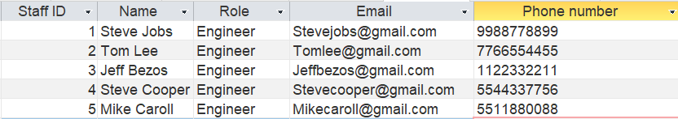
(Figure 18)
Maintenance entity sample data
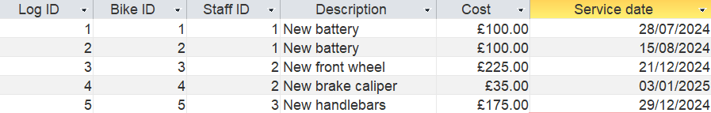
(Figure 19)
All five sample entries were added successfully, and every table linked as expected. The database worked smoothly, confirming relationships, constraints, and the overall structure functioned correctly during testing.

Query Development
Design and run a series of practical queries to demonstrate how the system can be used. Example queries might include bikes currently out on rental, bikes due for service, most frequently used bikes or rentals by a particular rider
The choice of relevant queries is left to your discretion, but some examples could be like reviewing bike availability, service needs, and user activity patterns

Query 1:
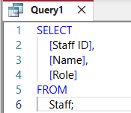
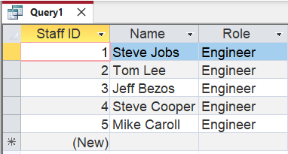

(Figure 20 and 21)
This query retrieves a list of all staff members from the Staff table. It shows each employee’s ID, name, and role. By running it, the database displays information about everyone working at the bike rental shop. It is a simple way to view staff details quickly.

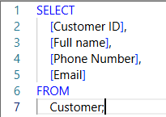
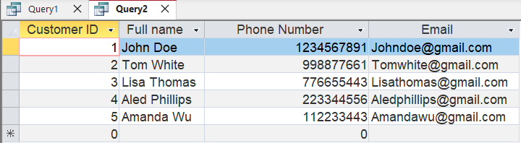
Query 2:
(Figure 22 and 23)
This query retrieves a complete list of all customers from the Customer table. It shows each customer’s ID, full name, phone number, and email address. By running this query, the database displays all registered customers, making it easy for staff to view and manage customer information quickly and efficiently.

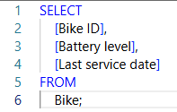
Query 3:
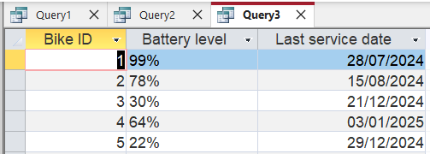
(Figure 24 and 25)
This query retrieves all bikes from the Bike table, showing each bike’s ID, battery level, and last service date. It allows staff to quickly see which bikes are available, rented, or under maintenance, helping manage the inventory efficiently.
The queries ran successfully and returned accurate results, showing staff, customers, and bikes as expected. This demonstrates that the database is working correctly, with tables properly connected, data stored consistently, and information easily retrievable for daily operations.

Validation and Testing
The database follows 1st, 2nd, and 3rd Normal Form. All tables store simple, separate pieces of data, like customer names, bike types, and rental dates. Each field depends on the whole key, and there are no extra or repeated dependencies. Testing showed it works, queries returned correct rentals, payments, and maintenance, and rules stopped wrong data. For future databases, using clear column names and avoiding reserved words will make it easier to use and reduce errors.

Conclusion
Overall, the creation of the e-bike database efficiently stores and manages information about customers, bikes, rentals, payments, staff, and maintenance. Testing confirmed that queries returned accurate results, constraints prevented invalid data, and relationships between tables functioned correctly. The database follows 1st, 2nd, and 3rd Normal Form, ensuring minimal redundancy and good data integrity. The report demonstrates that the system meets user needs and supports daily operations. For future improvements, more data validation rules will be included and more sample data entered for additional testing.

References
[1] Y. Bai, SQL Server Database Programming with Visual Basic.NET: Concepts, Designs and Implementations, 1st ed. Hoboken, NJ, USA: John Wiley & Sons, 2020. doi: 10.1002/9781119608493.
[2] I. Belcic and C. Stryker, “What is an Entity Relationship Diagram?,” *IBM Think*, IBM. [Online]. Available: https://www.ibm.com/think/topics/entity-relationship-diagram. [Accessed: 10 Jan. 2026]. :contentReference[oaicite:0]{index=0}
[3] “What is a Relationship in Database?,” Database.Guide. [Online]. Available: https://database.guide/what-is-a-relationship/. [Accessed: 10 Jan. 2026]. :contentReference[oaicite:0]{index=0}
[4] T. M. Connolly and C. E. Begg, Database Systems: A Practical Approach to Design, Implementation, and Management, 6th ed., global edition. Harlow, UK: Pearson, 2015.

