Sean Hazelby

Construction Management

(Written Part)

Deborah Hughes

Level 6

Contents
Performance Issues and Incentivisation 2
Solutions for Recovering time. 4
Gant chart 5
References 11

Performance Issues and Incentivisation
Addressing issues like performance and incentivisation is a vital and yet overlooked part within construction. Without these attributes within the workforce, there is danger that the works may go overschedule and end up lacking in quality and therefore gaining cost. These are effects that no client wants to see so it’s important to outline how they will be tackled.
There are many methods to incentivise and boost productivity within the workforce, but first it is important to understand what can cause performance issues and delays in the project overall as a result.
- Weather
One of the more reoccurring and most damaging delays is the weather and this causes issues in performance. The weather is very unpredictable and as a result can result in days where site works cannot commence, thus causing a negative impact to the project programme. With bad weather it is not only the works on site that can’t presume, but it also causes issues across the board for deliveries and travelling to work. Therefore, even dry works on site like carpentry get affected by the weather. This will affect the project by delaying the completion date unless measures to gain back lost time are out in place.
The weather not only can completely stop the works on site, but can also damage what’s already been completed, thus causing a further delay. Things like high winds could rip soffits and torrential rain could cause leaks thus causing the injector to gain moisture and having to be replaced. The weather can not only stop the project in its tracks but can even move it backwards. In a less serious sense, things like casual rainfall cause disruption also. Worker’s mindsets and moods get affected with the weather. Even the slightest bit of rainfall will show a decline in performance which is a big problem.
The Overall temperature causes havoc also. From a bricklaying standpoint, you cannot lay anything when the temp is lower than 4 degrees Celsius as the cement will not be able to dry. This was indeed the case in December 2022 where there was a lot of frost which would last all day. This means the bricklayers cannot lay thus pushing the completion date forward in time. On the other end of the spectrum, very high temperatures are very hard to work in and very exhausting for the workforce. This would cause workers to do half days potentially or leave site at an earlier time due to the heat. This again causes delays as the works is not being completed fast enough.
The weather can cause a lack of motivation for the workforce, and this is natural. This will of course cause a lack of productivity and performance. For the site-specific scenario, you cannot lay concrete in torrential rain which would offset the project. This would mean our Driven piled foundation would be delayed thus causing every other task on site to be offset by however long the rain will last. The weather has a massive part to play in construction and it’s effects could be monumental.
(Benarroche, 2022)
- Poor communication
A lack of effective communication causes havoc from top to bottom. It is imperative that every member attached to the project in some way, can communicate effectively with one another. Communication breakdowns can cause financial stress for the project for however small or insignificant they appear at face value. Lack of communication causes knock on affects for those later down the line which can cause performance issues for those in question which filters its way round like a ripple effect. Collaborating with one another is an essential skill for the workforce. Effective communication can help regain delays in some cases but will certainly cause more of them if it is not up to scratch which shows how much of a powerful tool it is. Communication is the corner stone of construction, without it – it’s effects are obvious.
(Martinelli, 2022)
- Lack of skilled labour
A lack of skilled labour will have a negative impact on the performance of the project. Workers need to have the necessary skills to complete the task at hand or this will cause delays and lack of motivation for the works. A lack of skilled labour means there is a risk that the quality of works on site may suffer – potentially needing to replace work and pay more money out to fix and rectify. This obviously is not what we want. This will cause delays and will cost more money for the client which is something we want to avoid. Skilled labour means that we have competent persons assigned to tasks that can complete on time to a high standard. This is something we need in every project. For my specific scenario of the Driven Piled Foundation, we don’t want a land surveyor and engineer who mark and set out the piles wrong only later to find that when the piles have been driven into the ground, they are in the wrong place. This would cause delays in rectifying the mistake and cost a large sum to replace. This is what need to be avoided. Having proper training and ability to communicate effectively comes under being a skilled worker and are attribute that every worker needs to have.
(Pro Crew Software, 2019)
- Budgeting & Funding issues
Funding issues can be very distressing for a company, and this filters its way down the pyramid. With a company potentially loosing money, people get uncertain of their wage and jobs. People can lose motivation very fast and can even end up leaving the company for more stable jobs. This is what the delays stated previous can cause and is of course something which needs to be avoided in this project. Issues with funding leads companies to ultimately to cut corners which inevitably ends up in issues with performance levels & motivation. As a result of this, morale of the workforce declines and it shows in the work. Having enough time pre construction and having a clear plan for the project is essential in managing a company’s cash flow.
(Pro Crew Software, 2019)

Solutions for Recovering time.
Incentivising people when time has been lost is a very important thing to do as it can limit the damage that that delay will cause. This is often never even thought of. People tend to think that when time is lost – there is no way of getting it back. Although this is true to an extent, there are ways to help the situation and potentially even regain in some cases. These solutions for lost time range from action to contractual agreements precontact.
- Overtime
When a delay has occurred one of the oldest methods of regaining time back is working longer hours to meet a deadline. This is often the case in completing schools or in this case, university buildings for the September deadline, where the deadline cannot be shifted so it must be completed by then. This is the most common form of trying to rectify delays, but it doesn’t mean it is the best method. Although it’s effective when done correctly, it causes a lot of added stress on the workforce which could disincentive a few people thus landing us in the same scenario at some point down the line. This is however a good incentive as it is clear. The task must be completed by a certain date or it would mean more stress down the line.
(Pro Crew Software, 2019)
- Boost workforces
This is also a very common method to regain time that has been lost. This is usually combined with overtime to ensure that the project is completed by the date intended. Boosting the number of people on site makes sense but this is only as effective as the organization of these extra workers. They need to be skilled workers who are being assigned to the areas that are lacking in progress. There is no point upping on personnel if they are competent as this will only lead to further problems and ore delays down the line. This adds a good incentive for people to work together and along side with one another.
(Pro Crew Software, 2019)
- Partnering
Partnering inputs delays within the contract so that when they occur, they are not as damaging. The is a great way to be prepared for delays and issues with performance. Partnering allows better communication and more flexibility. Partnering recognises that delays are natural. Ranging from weather, poor labour, supply chain issues, disputes over wages and so on. This contract allows for EOT’s (Extensions of Time) from contractors allowing them more room and making sure there is no legal routes being taken when something is delayed. This reduces stress on the contractors end thus improving the performance. Stress is one of the more unspoken things in construction that leads to a reduction in performance and incentivisation and cannot be overlooked.
(Cotton, 2021)
- Critical path analysis
One way to evaluate and assess delays, performance and incentivisation is Critical path analysis. A critical path analysis allows us to see how one task affects the other when delays occur. It shows the most important flow of events that will happen on site and will call these the ‘critical path’. When a delay occurs on the critical path it usually means there will be a large disruption to the works which means it’s important to understand which areas cannot afford to be delayed. This is presented typically in a visual format thus making it easier to understand for a wider range of people. Use of these analysis makes it clearer for everyone how their actions may affect others down the line. This is good because it makes the workforce more aware of others during not only the construction phase, but also the whole RIBA stages of the project. We want workers to be more aware of others as this helps with deadlines and team works. Being aware of others in your team is a vital attribute to teamwork and a construction project cannot function without teamwork. A Critical path analysis assists with this and gives a good incentive to not cut corners and do the works to a high standard..
(Pro Crew Software, 2019)
- Spotting delays early
Although this is not a method as such, spotting delays early can certainly limit the damage of a delay. None of the above can be at its most effective unless this is something that is done. When things are spotted later, you are given less time to think and forced into action much faster. This makes it very likely that the decision you are going to make is not going to be the correct one and may lead to more issues down the line.
(Pro Crew Software, 2019)

Gant chart
The Gant chart displays a project that will last over 2 years in total. It goes through the RIBA 2 to 7. This goes from the concept design phase all the way up to the in-use stage. A Gant chart is a visual representation of the flow of events within a construction project
The chart covers all the actions required for the project along with a specific section within stage 5 of the RIBA plan of works of my choice which was the drive piled foundation. The Gant chart goes through all the RIBA Stages starting from stage 1 and going through all the way to stage 7. The project has a start date of 21st December.
Timeline of the project
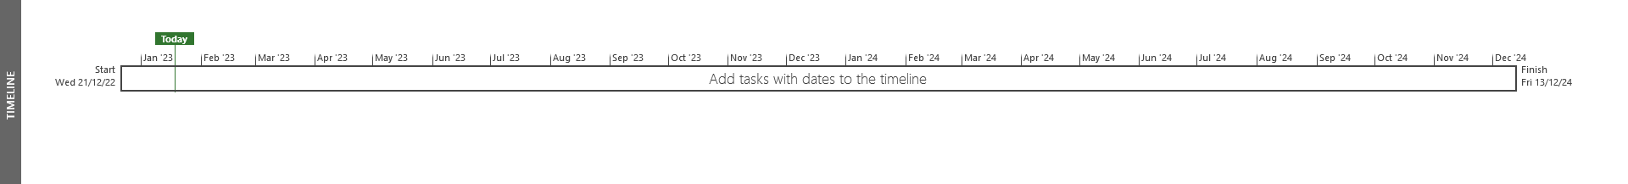
RIBA Stage | Length of time (Days)
Concept Design (2) | 40
Developed Design (3) | 109
Technical Design (4) | 126
Construction (5) | 340
Handover & Close Out (6) | 13
In Use (7) | 120

This however isn’t considering the RIBA stage 1 with planning as this can take years to come back. The construction phase is going take the longest as is seen in the table above.
This is the construction phase. I chose to do the driven piled foundation and went into detail on the step by step of this along with resources and manpower. Costs were also added and concluded that the piled foundation would take 713 days to complete without the delay of the concrete supply. With the 5 weeks delay it would take a total 748 weeks to complete
Costs screenshot
Using the resource feature in Microsoft project, I can see how much will be spent on resources throughout the project or in this case the element of my choice which was the Driven Piled Foundation. As stated above, this element of works will cost £33,000,000 in resources. The rates used are indicative costs which have been applied to all resources involved with the piling.
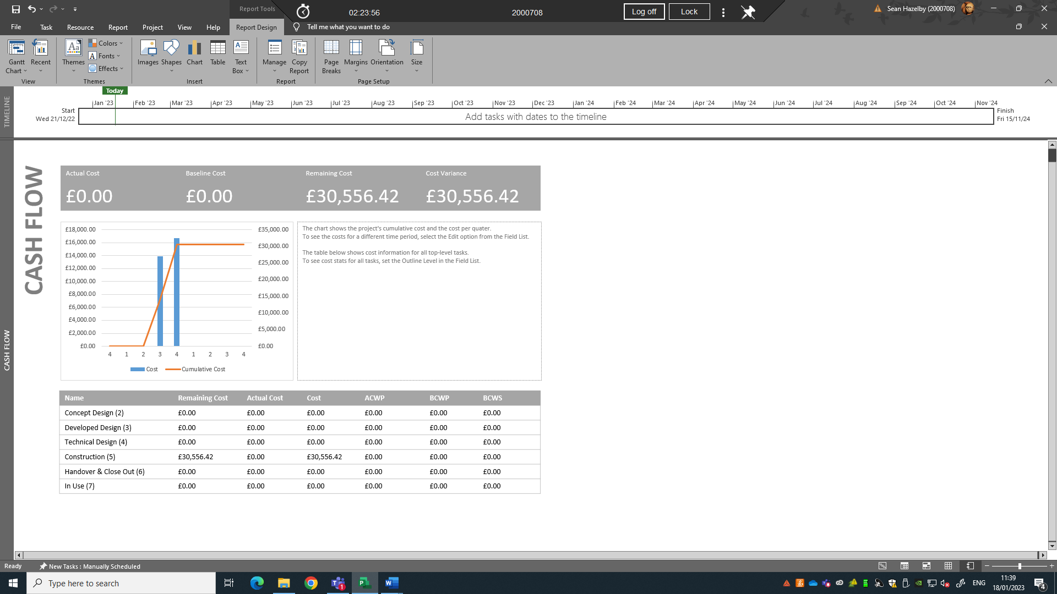
The driven piled foundation will cost £30,556,42. To allow a buffer zone, I would be safe with a price of £32,000,000 for resources of the driven piles.
Setting Baseline
Setting the project baseline is impotant to see the original flow of tasks within the project prior to deviations and delays. This is important as it will potentailly clearly show how behind (or ahead in rare cases) you are. Being able to see delays is impotant as this is vital information that can drastcally change a project. The project Baseline with no delays can be seen in the image below.
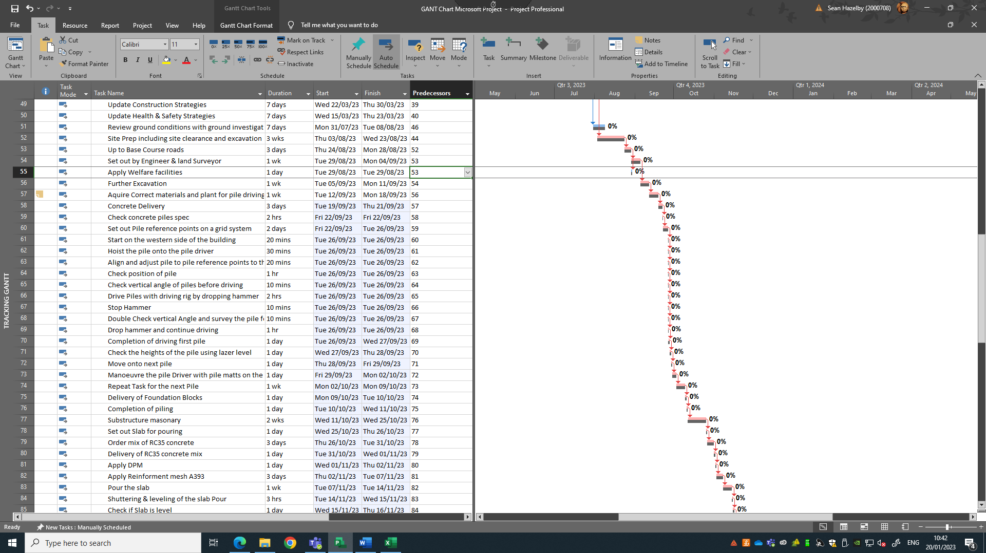
As you can see, the Project has no delays yet and therfore the project baseline does not deviate from the projects flow of events. This is a perfect secenario but an unrealistic one to say the least. Programmes never stay to the baseline perctly as there are always delays and kncok on impacts here and there which causes deviations from the original path.
Below is an image of the Project with the delay due to the concrete company going on strike. As was listed above, there are numerous delays which can occure thus affecting the programme.
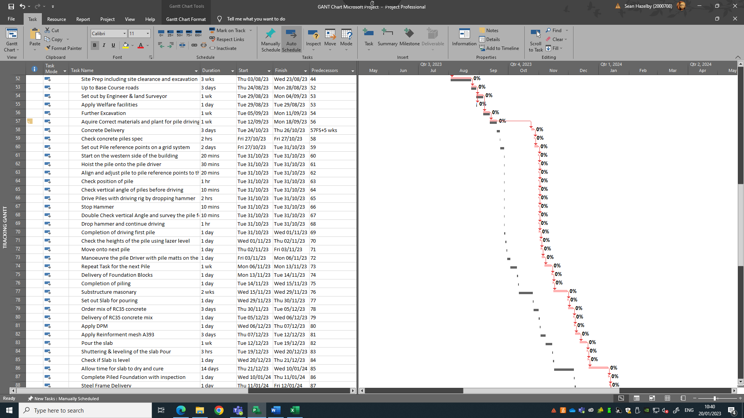

By implementing the delay of the concrete company going on strike for 5 weeks, you can clearly see how the project is affected. The project will be offset from the point of needing concrete which would be at foundation stage. By delaying the foundation for 5 weeks, we are then delaying the rest of the project as none of the construction phase can move forward without it.
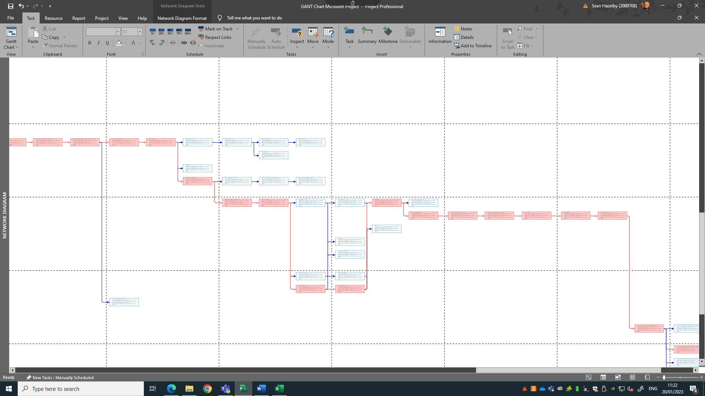
In red you can see the critical path shown. The foundation is on our critical path, and nothing can be completed before it is in place. You could argue that we could do some of the external works like getting the roads up to base course, but this would have already been done at this stage. This is a delay that will be unavoidable but it’s impact can be minimized if we use the solutions for delays as stated previously in the document.

Specific element Driven Piles
I have chosen to do the driven piled foundation as my specific element. As seen in the screenshot above you can clearly see the process of driven piles in this project.
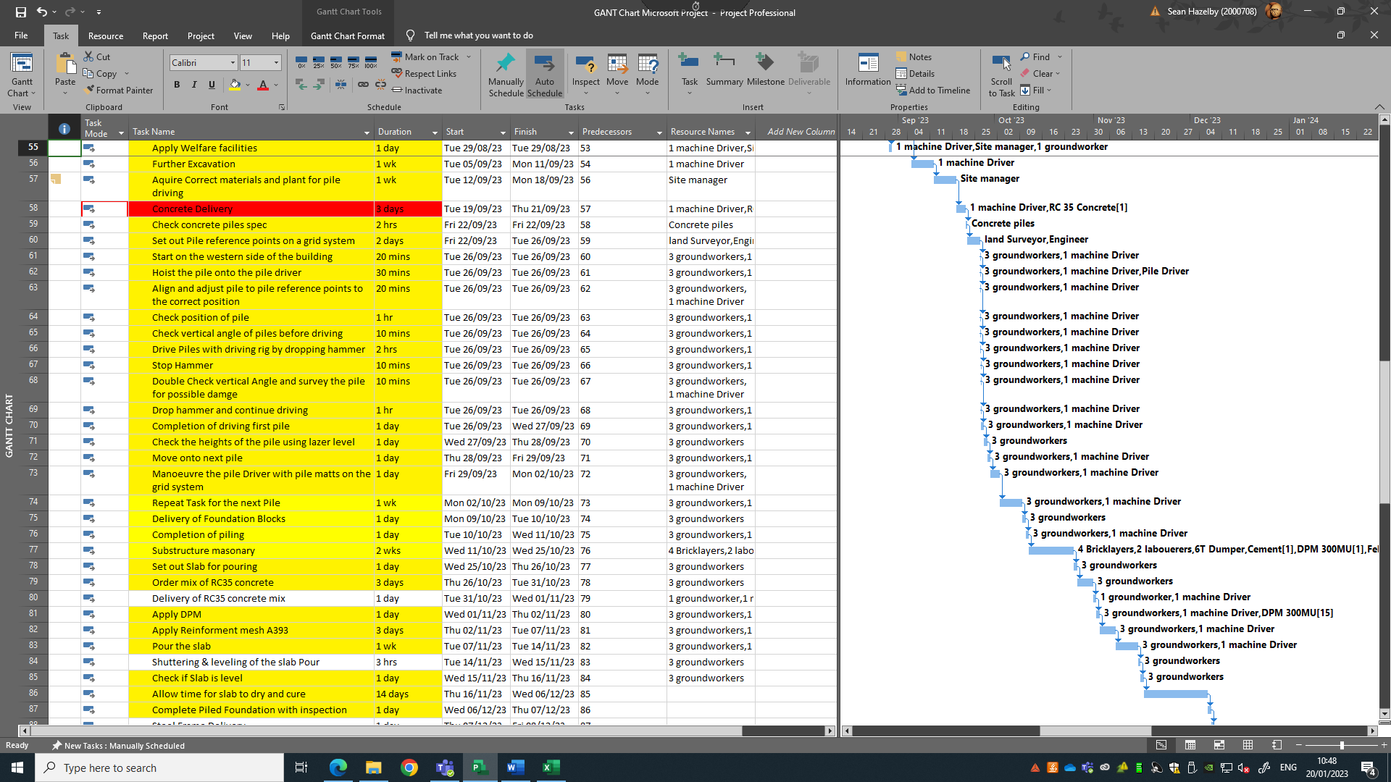
The piling process will start as early as the site prep. One the site is prepared; the engineer and land surveyor will set out the piling points as references. Once the concrete has been obtained and all the points are marked out in a grid system, then we can commence with the piling. Piles will need to be hoisted onto the pile driver and then driven into the points set out. This will be carried out by 3 groundworkers and a machine driver for the piling rig. I think this is a satisfactory number of workers for the task. We don’t want multiple groups working on the same task as this creates confusion. We want 1 gang of groundworkers who are skilled and competent who can collaborate with one another. During the driving of the piles, they will need to be carefully by stopping and checking to see if the driving is accurate. This means there will need to be clear communication between the pile driver operator and the groundworkers. The pile driver is too loud for standard talking therefore it will require walkie talkies to complete the task. Once the pile is down to the intended level it will then need to be checked again further using a laser level and seeing if they match the levels that engineer stated to them. When this is all checked and correct then you will move onto the next pile and manoeuvre the pile matt along with this in the grid system, moving from east to west. Once this process has been repeated and all the piles are set and driven into the correct levels in the correct locations, the substructure masonry will need to take place along with setting out the slab. DPM will need to be applied before RC35 Concrete will be poured and screeded. Once the concrete is cured it will then be complete.

Resources
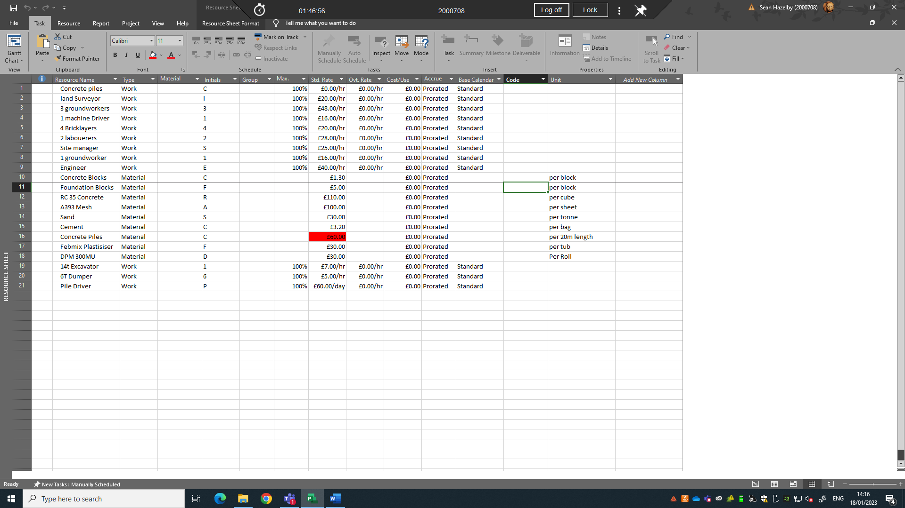
You can clearly see the resources attached to the task above. Resources include plant, labour and materials and have all been allocated a price attached to them. Prices have been assumed and are not final prices by any means. There are plenty of local providers of these resources spread about in Swansea which will be a key factor for the project. We want the project to use local materials and local suppliers for the works as this will benefit local communities by bringing more economy to the area. Sourcing materials from local suppliers might mean we have to pay higher price, but I feel this will be compensated by the shorter lead times and deliveries. Building good work relationships with local suppliers will eventually bring the cost down and as a result you will be gaining by shorter lead times and by paying a good price for the materials ordered. This would be best value for the project.
We want workers who are competent and skilled who are ready to work and competent tasks at hand. Obtaining skilled workers mean offering good training, this could be something that we might want to do within this project.

References
Citation | URL | Last Opened
(Benarroche, 2022) | https://www.levelset.com/blog/construction-delays/ | 19.1.2023
(Cotton, 2021) | https://lclawyers.com.au/time-delay-building-contracting-important-distinctions-liquidated-damages-general-law-damages-delay/ | 19.1.2023
(Martinelli, 2022) | https://www.highspeedtraining.co.uk/hub/communication-in-construction/ | 19.1.2023
(Pro Crew Software, 2019) | https://procrewschedule.com/how-construction-project-managers-can-deal-with-delays/#:~:text=Best%20Ways%20to%20Deal%20with%20Construction%20Project%20Delays,6.%20Accelerate%20work%20and%20redefine%20critical%20path.%20 | 19.1.2023

