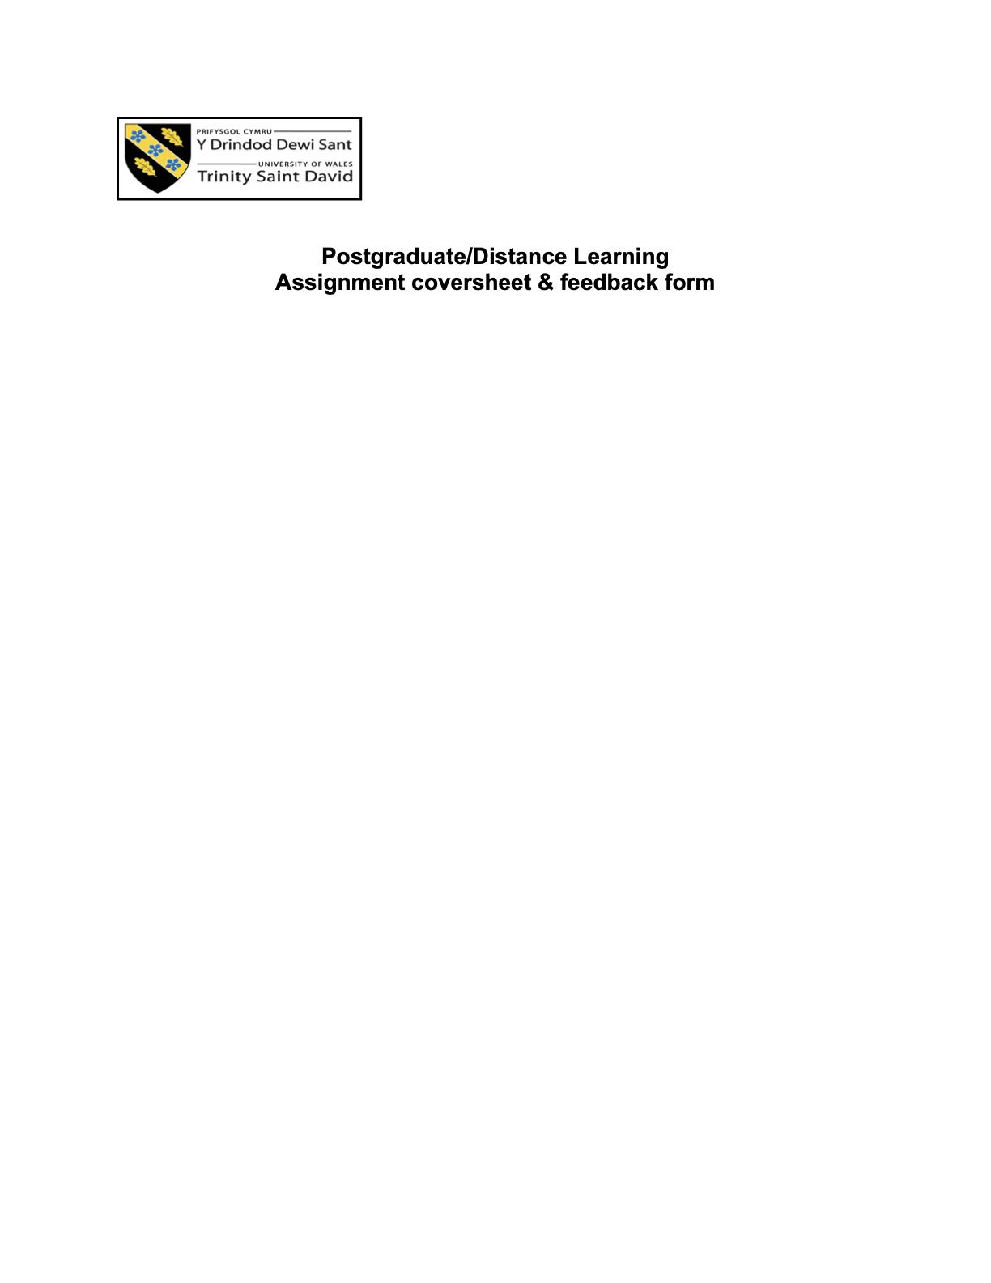
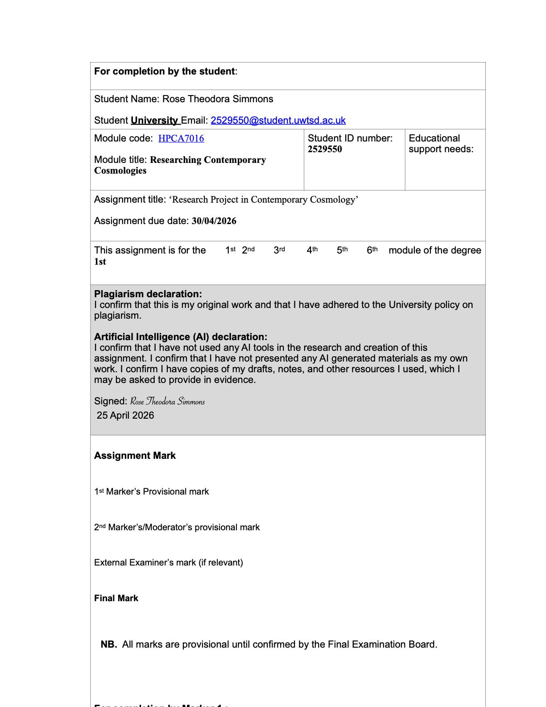

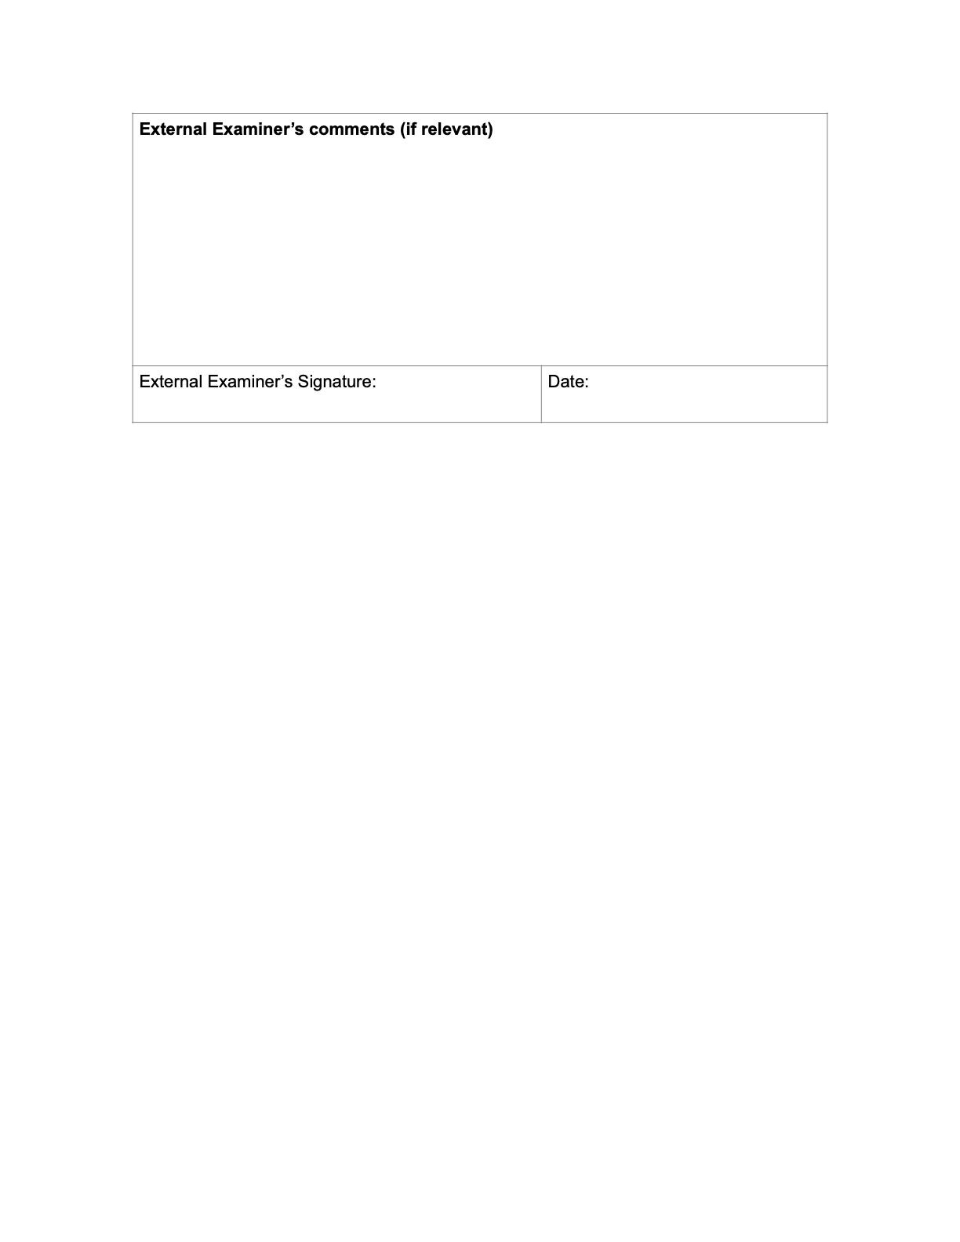

Research Project in Contemporary Cosmology

Introduction

This study examines how artists and creative practitioners realise and work with a sense of personal cosmology, and how this orientation manifests in the objects they make. While cosmology is often approached through formal systems—religious, philosophical, or scientific—this research focuses on how it operates solely within the creative practice.

Drawing on Project One (personal cosmologies) and extending into Project Two (objects and practices), the study considers how individual orientations toward the sky, and, indirectly, their approach to creative practices, are shaped by an inner cosmology and are expressed through material engagement. Rather than identifying or categorising belief, the research asks how meaning, timing, and relation take form within creative work—through decisions, processes, and the conditions under which objects are made.

The central research question guiding this study is: how do artists and creative practitioners materialise ‘personal cosmology’ through the making of creative objects? This question dances between two established approaches: the study of cosmology as belief, and the study of objects and practices as embodiments of meaning. Rather than merging these approaches, the study examines the movement between them—how action is translated into form and how artists' objects come into being.

In this context, ´personal cosmology´refers to how individuals make sense of meaning, time and timing, purpose, and their relationship to the wider world. This may be articulated through recognised systems such as religion, philosophy, or astrology, or take shape more implicitly through repetition, symbolism, and practice. The study does not evaluate the validity or consistency of these orientations, but considers how they are worked through and made perceptible within creative processes.

This research grew out of a recurring observation: artists often describe their work in ways that suggest meaning without fully putting it into words. Terms such as ‘flow’, ‘timing’, and ‘intuition’ appear frequently in artists’ descriptions of their work, yet are rarely explained in concrete terms. Rather than dismissing this language as imprecise, the study treats it as indicative of an underlying orientation—one that is recognised in practice even when it resists clear articulation.

As a practising artist, I am familiar with this language and its rhythms, while remaining external to the specific artistic practices and media of the participants involved. This dual position allows for sensitivity to how artists describe their work, while also requiring thoughtful attention to the distance between interpretation and experience. As Uwe Flick argues, the researcher's position shapes how knowledge is produced and interpreted in qualitative research.

The study listens closely to the participating artists as they discuss their practice through their own descriptions, focusing on how meaning, timing, and orientation emerge through the process of making. This research looks at cosmology through creative practice, focusing on how meaning is formed and sustained in the process of making. It explores how cosmology is worked through in practice rather than held as a fixed system of belief, taking shape through material engagement, timing, and the unfolding of the work.

Literature review
The study of cosmology within the humanities has traditionally focused on formal systems—religious doctrine, philosophical frameworks, or scientific models of the universe. Within cultural astronomy, however, there has been a sustained effort to broaden this definition, recognising that cosmology also operates at the level of lived experience. Professor Nicholas Campion’s work offers a key point of departure, particularly in its understanding of cosmology as relational, where the cosmos is experienced as “inside us as much as outside us.” These frameworks do not have to be internally consistent or formally articulated; rather, they function as ways of orienting oneself within the wider world.
Freya Mathews, a philosopher of ecological thought, suggests that cosmology is not simply a set of beliefs, but part of how individuals and groups inhabit and respond to the world, shaped by environment, history, and lived conditions, and in turn shaping perception and action. Which is shaped by environment, history, and lived conditions, and in turn shapes perception and action. Understanding cosmology as something lived makes it possible to examine it through creative practice, where meaning develops through the act of making rather than being fully defined in advance.
Within anthropology, there has been a move away from analysing formal systems of belief alone, toward understanding how meaning is lived in practice. This is reflected in phenomenological work, particularly that of Maurice Merleau-Ponty, who emphasises perception and embodiment as the way the world is encountered. From this perspective, meaning develops through engagement with the body, with movement, and with the materials and environments people inhabit that give meaning to life. This line of thinking can also be seen in anthropological work on religion and experience, including Jack Hunter's examination of how individuals relate to the unseen and the extraordinary without necessarily organising these experiences into formal systems.
Such perspectives are particularly relevant when considering artistic practice. Rather than beginning with a defined cosmological framework, many artists describe their work as emerging through process, their experimentation, and response. Tim Ingold contends that making should not be understood as the implementation of a preconceived design; rather, it unfolds through an ongoing engagement with responsive materials, in which form emerges from the process itself rather than being predetermined and imposed. This shifts emphasis away from intention as something fixed in advance, and toward process as something that unfolds over time.
Ingold’s account helps reframe creative work as a place of origin where meaning is worked out rather than applied. However, while his focus remains largely on material engagement, he gives less attention to the cosmological significance of these processes. The present study builds on this by suggesting that the artist's interactions with—timing, intuition, repetition, and making adjustments—are actually shaped by broader orientations toward time, order, and relation.
Alfred Gell’s theory of art and agency provides a further point of reference, particularly regarding how objects mediate relationships among artists, viewers, and the contexts in which they are encountered. For Gell, artworks are not passive objects, but take part in shaping how they are perceived and engaged with. While his framework has been widely applied within the anthropology of art, it also elicits questions about how objects come to embody intention, belief, or orientation. In the context of this study, this suggests that the objects produced by participants may carry traces of the processes and frameworks used in their making, even when these are not explicitly stated.
Material culture studies have shown that objects do not simply represent meaning, but hold and convey it in ways that are not always fully expressed in words. Jude Hill’s work on amulets, for example, examines how objects can hold significance that exceeds their material form, acting as objects of attachment, memory, or protection. His work illustrates the extent to which meaning can be embedded within objects without being fully articulated, a unanimous point that was reflected in the participants’ accounts of their own work.
Ronald Grimes’ writing on ritual deepens the complexity of the relationship between cosmology and practice. He suggests that different cosmological frameworks correspond to distinct forms of ritual behaviour—whether cyclical, ordered, or improvisational—and provides a useful framework to consider how practice mirrors underlying assumptions about the world. Although his focus is on ritual, Grimes suggests that the form and style of ritual reflect how the world is imagined—for example, whether it is approached as ordered, cyclical, or open-ended. A similar pattern can be observed in creative practice, where artists describe processes that move between repetition, structure, and responsiveness.
Taken together, these works suggest that cosmology is not only expressed through belief, but through practice—particularly in how people work with materials. While these themes have been explored across anthropology and material culture, little attention has been given to how this operates within contemporary artistic practice, particularly through the process of making and to how artists themselves describe their processes. Existing literature tends either to analyse artworks from an outside viewpoint or to situate them within wider cultural or historical contexts. Less is known about how practitioners understand the roles of meaning, timing, and orientation in their own work, and how these elements become visible through making.
This study, therefore, contributes to existing research by bringing together insights from cultural astronomy, anthropology, and material culture and applying them to the lived processes of contemporary artists. By focusing on how participants articulate their own experiences, it becomes possible to examine cosmology not as a fixed system, but as something that moves between language, practice, and form—sometimes named, sometimes implied, but consistently present within the act of making.

Methodology

This study utilises a qualitative approach, combining an open-ended questionnaire with semi-structured interviews. This allows participants to describe their work in their own terms, while also creating space for more detailed reflection in conversation. The intention was not to exclusively test a hypothesis, but to follow the process of artists who attribute meaning and orientation to their practice, a specific body of work, or into the objects they make. Eighteen participants completed the questionnaire, and five took part in follow-up interviews. Both provided enough depth to observe recurring patterns across responses. Participants were mostly practising artists working across a range of disciplines, including: painting, ceramics, jewellery design, and photography.

The questionnaire was designed to invite reflection rather than to steer participants toward any particular conclusion. Instead of asking respondents to fit their experience into fixed categories, it prompted them to describe their process, choices, and sense of meaning in their own words. In doing so, it follows an interpretive approach to social research—one associated with Clifford Geertz—in which understanding comes from close attention to how people describe what they do, rather than from abstracting their accounts into a single explanatory scheme.

Interviews were conducted remotely by Zoom (audio-only), recorded with consent, and transcribed verbatim. Although a set of guiding questions was prepared, the conversations remained open, allowing participants to speak at length and follow their own line of thought. In a semi-structured interview, direction emerges through the exchange rather than being fixed in advance.

The analysis was interpretive and qualitative, focusing on patterns that emerged across responses while remaining grounded in participants’ own language. Kathy Charmaz’s constructivist approach to grounded theory provides a useful reference point, emphasising that themes are developed from the data rather than imposed in advance. In this sense, the research draws loosely on grounded theory, where themes are developed from the data rather than imposed beforehand. The aim was not to produce generalisable claims, but to understand how participants describe their experience and how this relates to their practice.

Personal cosmology
Organising the design consisted of two primary parts: a qualitative, mixed-methods design–combining questionnaire data with semi-structured interviews. The aim was to explore how ‘personal cosmology’ is experienced and expressed within creative practice: Likert-scale items addressing themes such as symbolism, purpose, and temporal orientation, alongside qualitative prompts inviting participants to describe specific works, materials, and processes.
The term ‘personal cosmology’ was introduced when participants were interviewed and spoke about their creative process. It was also included in the questionnaire's introduction section, as defined and explained in the opening section.
In this study, ‘personal cosmology’ refers to a participant’s self-described worldview or orientation—how they make sense of meaning, time, order, and purpose in relation to the cosmos—which may be expressed explicitly through named systems or implicitly through patterns of language and practice.
When I shared the initial draft of the form with a small number of reviewers, some interpreted it as astrology or planetary systems, while others found it abstract or unclear. A few described the phrase as intellectually demanding and hesitated to answer. In the interviews, however, several participants returned to the term unprompted, describing it as intriguing and, for some, unexpectedly clarifying, a language for linking their creative process to the significance they attribute to particular objects.
Rather than providing more details and attempting to define the term ‘personal cosmology’ further, or simplifying it into a prescriptive definition, I kept it and included the feedback in the findings, which supported the qualitative orientation in which meaning emerges from participants’ own understanding rather than being predetermined by tightly bounded categories. A narrower explanation would have risked steering responses towards a single conceptual framework, flattening the gradient of valuable insight about the artist’s own process and orientation of meaning-making in their work. Instead, the introduction also emphasised that there were no correct or incorrect answers, inviting participants to engage with the term in their own way. The questionnaire was then distributed through an open network of social channels, including my personal mailing list of approximately 2,500 individuals and a social media network of approximately 21,000. Participants were asked to share the questionnaire within their own networks of artists, resulting in a broadly distributed, non-targeted, and anonymous sample.
The questionnaire, completed anonymously by participants, was developed as part of a qualitative study to allow them to define the concept ‘personal cosmology’ on their own terms, applying a broader methodological approach to observe their understanding when given space to interpret it. In practice, this resulted in a range of responses, from explicit references to astrology, ritual, and elemental frameworks, to more implicit descriptions grounded in intuition, experience, and material engagement.
The data analysis was carried out using a grounded, thematic approach, identifying patterns across both questionnaire and interview data. Responses were read closely and identified for recurring patterns, including references to process, timing, intuition, material interaction, and cosmological language. Rather than beginning with a fixed set of categories, themes were allowed to emerge from the data and quantitative elements were incorporated in a limited, supportive capacity rather than serving as the primary focus.

Participants and ethics
Participants were over eighteen and gave informed consent by ticking consent boxes before taking part. Questionnaire responses were collected anonymously. All participants completed an online questionnaire (see Appendix A), after which a smaller number were invited to take part in follow-up interviews. For the interviews, all participants were given non-identifying labels (Participants 1–5), and it was made clear that any material used in the study would be anonymised.
All interviews took place on Zoom in a thirty-minute audio format, with no video recording. Each participant was invited to talk through their process, a current body of work, an object, or a particularly representative one of personal cosmology, and to describe it in whatever language felt natural to them related to ´personal cosmology´. This was a deliberate choice: the aim was to stay with how meaning is experienced and expressed, rather than to shift the focus toward visual interpretation or external evaluation of the work.
Throughout the interview process, where participants mentioned specific works, locations, or personal histories, I either omitted those details or generalised them unless they spoke about them in a way that remained broad and non-identifying. This was strictly a matter of confidentiality, but also of keeping the focus on how participants described meaning and practice, rather than on biographical details.
That same attention to context applies to my own role in the research, the way I listened, the kinds of follow-up questions I asked, and what I recognised as significant were shaped by my position in relation to the participants. For that reason, it is important to clarify where I sit on the insider–outsider continuum, and how that positioning may have influenced both the data collected and the interpretation that followed.
Research position
The research was conducted from a position that was both close to and separate from the participants’ world. As a practising artist, I am familiar with the language, timing, and habits of creative work. At the same time, I am not embedded in the participants’ specific media or individual working processes, which helped me remain aware of differences in how they described making and meaning. This position makes it possible to recognise shared patterns without assuming a single framework of meaning.
This same level of attentiveness extends to my own role in the research: the way I listened, the follow-up questions I asked, and what I recognised as significant and relevant were shaped by my position in relation to the participants. For that reason, it is important to clarify where I sit on the insider–outsider continuum, and how that positioning may have influenced both the data collected and the interpretation that followed.
The approach aligns with phenomenologically informed anthropology, where lived experience is treated as a primary source of knowledge and meaning is understood to emerge through participation rather than abstraction—an orientation described by Michael Jackson as part of ‘existential anthropology.’ Rather than explaining participants’ accounts from the outside, this study approaches them as descriptions of how creative practice is experienced from within.

Findings: patterns of practice
Eighteen participants took part in the research. Each completed a questionnaire anonymously, and more than half volunteered for a follow-up interview. Five interviews were then selected at random, providing sufficient material for recurring patterns to be identified across participants. Given the open-ended nature of the questions and the depth of the responses, the focus here is on the richness of the material rather than the number of participants.
In both the questionnaire (n = 18) and the interviews (n = 5), few participants identified a clearly defined way of making. Rather than a fixed method or approach, their responses point to a more intuitive approach that informed how they engaged, pivoted with each process, utilised materials, handled timing, and made choices, even when it remained unarticulated.

Cosmology as language
When asked about their process of making, most participants acknowledged a sense of personal cosmology. 64.7% strongly identified with the idea, with a further 17.6% indicating moderate agreement that something beyond logic was part of their process. What is notable is the way in which this was described. Rather than presenting cosmology as a fixed framework, participants spoke of it as something they move through, that is part of them, or that they return to. For many, it appeared as a background condition—present but not always articulated in formal terms, describing it as coming alive through their creative practice.
When participants characterised their orientation, over half (52.9%) described it as both explicit and implicit. While others emphasised its changeability, noting that it can shift depending on the situation or phase of their work. In other words, cosmology was rarely treated as an immovable fixture; it was something that could be spoken, dialogued, and an ongoing, almost entity-like aspect of themselves, mentioned. Two participants described this directly in their interviews. One spoke of a distinction between themselves as the subject and something they enter into dialogue with, which informs decisions while painting. Another referred to a form of guidance that appears during moments of creative blockage, describing it as something that “knows what to do”. When they have a creative block, it also operates quietly within the process.
At the same time, cosmological language was not absent. In the interview sample, four out of five participants (80%) explicitly drew on frameworks associated with astrology or elemental thinking. One participant described their process as an internal dialogue with planetary forces, specifically referring to Mercury as a point of communication in their work (Participant 4, interview). Another spoke of working through a strong identification with fire and initiation (Participant 5, interview), while others described their practice in terms of water—flow and movement, or of earth, emphasising weight and grounding (Participant 3, interview).
These references were not presented as adherence to formal systems, but as ways of making sense of experience. Cosmology appeared less as a formalised system and more as a vernacular that participants draw on when it aligns with how they work. This aligns with Campion’s view of cosmology as a way in which human beings locate themselves in relation to the cosmos. The data indicate that this orientation is often personal, adaptive, and situational, rather than fixed.

Process, timing, and the emergence of form
Cosmology is most visible in how participants describe their process and their experience of making. Across responses, emphasis consistently fell on what happens during making rather than on predefined concepts or the objects themselves. Objects were rarely described as concrete outcomes, but as part of the process through which participants reflected on and understood their work.
The questionnaire data reinforced this emphasis on process, when participants were asked what most shapes their work, 82.4% pointed to composition, 76.5% to process, and 76.5% to form more frequently than to initial ideas or pre-defined themes. Material choice also played a significant role amongst 52.9% of the participants, but again in relation to how it behaves within the process of making, rather than as a symbolic decision made in advance toward a fixed outcome. Participants varied in their material choices, each working with a distinct medium such as clay, gemstones, metals, or paint, would often describe this as a kind of responsiveness. One noted that the work develops “layer by layer,” and that completion is felt through the brushstrokes rather than being something predetermined. Another participant described their experience with ceramics, by carving clay–removing material from the centre outward, using a Japanese technique they had been trained in, until the piece revealed itself. Across these accounts, making is not executed according to a fixed plan; it is discovered through engagement.
Timing plays a significant role in ´personal cosmology´. Questionnaire responses indicate a strong sensitivity to when a work begins, shifts, or concludes, with an average rating of 4.35 out of 5 for the importance of timing and 64.7% assigning it the highest value. Participants did not describe this in mechanical terms, but as something sensed within the process—knowing when to continue, pause, or stop. In this respect, making aligns with Ingold’s notion of correspondence, where form emerges through interaction rather than imposition. Participants repeatedly described moments of alignment, intuition, or “knowing,” suggesting that the process is guided by an underlying orientation that shapes how these moments are recognised.

Relation, environment, and orientation beyond the self

A third pattern concerns how participants situate their work in relation to something beyond the individual self. This was one of the most unchanging findings across the questionnaire: 64.7% strongly agreed that their work is oriented toward something larger than themselves, with a further 23.5% agreeing.²¹ This “something larger” was described in a range of ways—nature, history, memory, energy, manifestation, or simply a sense of connection. It remained a steady point of reference across responses.

Participants also identified specific conditions under which this sense of relation becomes stronger. Meditation or ritual (82.4%), solitude (76.5%), and music (76.5%) were among the most frequently cited.²² These are not external influences in a straightforward sense, but conditions that appear to support a different mode of attention—one in which the work becomes clearer or more responsive to the process.

One participant described this as a form of dialogue with their subject, in which decisions are guided by a relationship that develops over time. Another described their work as a form of collaboration, not only with other people but with circumstance—timing, opportunity, and change. In both cases, the work is understood as emerging within a field of relations rather than from a single point of control.

Freya Mathews emphasises a relational understanding of the world, in which meaning emerges through engagement rather than abstraction. This is reflected in participants’ accounts, where this relational quality is experienced directly in the act of making. Shaping how they approach their work, respond to change, and understand their role within the process.

Objects as extensions of practice
If cosmology is present in process and relation, it becomes tangible in the objects that emerge. Participants did not describe their work as separate from themselves, but as continuous with their experience.
In several cases, there was no clear boundary between describing the self and the work. One participant spoke about painting the body as a way of working through lived experience, while another described their practice as inseparable from their understanding of life outside the studio. Even where participants resisted articulating meaning directly, they suggested that it is present in the work—something that can be felt rather than explained.
When participants were asked during the interview process how they recognised that a piece had reached completion, they rarely delineated an endpoint. Instead, they described a moment of recognition: the work “feels done,” “reveals itself,” or “I just know.” It is experienced as a feeling or as a point of internal resolution. This indicates that completion is not imposed from outside, but recognised within the process.
From a material culture perspective, this supports the idea that objects carry meaning not only through representation, but through the processes that produce them. Gell’s argument that artworks function within networks of relation is useful here, particularly in understanding objects as mediating intention—extending the agency of the maker through their effects on others. The findings of this study suggest that this relational network also includes the internal frameworks through which the work is made. The object reflects ‘personal cosmology’ as it takes form through the process of making, carrying traces of decisions, lived experience, and orientations that are not always immediately visible but remain embedded in its form. The object is therefore less a finished outcome than a continuation of the process through which it came into being.

Conclusion
This study set out to examine how artists understand and work with a sense of ‘personal cosmology’, and how this sense becomes manifest in the objects they produce. Rather than approaching cosmology through formal systems alone, the research focused on practise—on how meaning, timing, and orientation are experienced in the act of making.
The findings suggest that while most participants recognise a sense of ‘personal cosmology’ in their work, it is rarely held as a fixed or internally unified system. Instead, it appears more fluid, a way of working, sensing, and responding that shapes how their creative decisions are made in practice. Participants move between explicit references, sometimes drawing on symbolic language—astrology, elemental identity, planetary dialogue—and forms of orientation that are less easily named, more often describing a felt awareness within the process.
No single model of ‘personal cosmology’ materialised. Instead, several shared patterns emerged. Responsiveness, timing, relation, and continuity between self and work. Both the questionnaire and interview data reinforce one another. While the questionnaire highlights broader patterns—high levels of identification with cosmology and a strong emphasis on process and timing—the interviews show how these are lived in practice. Taken together, they suggest that cosmology is not separate from creative work, but takes shape through it.
‘Personal cosmology’ is neither absent from contemporary practice nor limited to established traditions. Instead, it is adapted and reworked within the conditions of making. What becomes visible is not a rejection of cosmological thinking, but a change in how it operates—less as a fixed system, and more as something worked through in practice.
This is most apparent in the process of making objects – observing this across both questionnaire and interview data, participants described “as something that unfolds rather than execution.” Decisions are not always planned in advance, even when commissioned. When a prior plan is in place and a technique they’ve long relied on, the objects still emerge through interaction, adjustment, and recognition.
Timing is steadily emphasised in participants’ descriptions of their process. Knowing when to continue, pause, or stop is not described as a rule but as something felt. Ingold’s account of making as correspondence—where form develops through engagement rather than imposition—helps to frame this. The findings suggest that this engagement is also oriented: participants describe working in relation to time, environment, and, in many cases, something experienced as beyond themselves.
This sense of relation is steady across the data. A large majority of participants describe their work as oriented toward something larger—whether framed as nature, energy, memory, or a broader field of meaning. This is not always defined, and often resists clear articulation, but it is consistently present. It shapes how participants approach their work, the conditions under which they feel most connected to it, and the way they recognise completion.
In the objects produced by participants, this sense of orientation—towards time, environment, and something beyond the individual—is not expressed directly. Participants rarely describe their work as illustrating a belief or system. Instead, objects are understood as continuations of process, where something internal becomes tangible without being fully articulated. The work retains traces of how it was made—its timing, its adjustments, its moments of recognition—and remains closely tied to the conditions that produced it. This makes it difficult to separate an internal framework from the object itself, as participants describe understanding not as something already formed, but as something that develops through the act of making.
Cosmology varies across participants, indicating that it resists uniformity. It persists as a way of working with the world. It informs how time is understood, how process-oriented creative decisions are made, and how meaning is recognised in the course of making. It remains present in contemporary creative practice, even where it is not explicitly defined. Participants’ references to astrology, cycles, and elemental structures point to a wider sense of connection—whether to nature, the cosmos, or an internal way of knowing—that shapes how they work. Within cultural astronomy, this suggests that cosmology is worked through in practice rather than held solely as belief.
Further research could extend this research across different communities and forms of practice or examine more closely how specific cosmological frameworks are adapted within contemporary contexts. It may also be productive to explore how audiences encounter these works, and whether similar orientations are recognised from outside the process.
This study reinforces the idea that creative practice offers a distinct vantage point for showing how cosmology can be a lived practice without being formalised, and how it can take form without being reduced to explanation. In the act of making, orientation can be fostered, tested, and recognised. The objects that emerge through making do not articulate this directly; they hold it in their form, where it persists beyond explanation.

Bibliography
Campion, Nicholas, Astrology and Cosmology in the World’s Religions (New York: New York
University Press, 2012)
Charmaz, Kathy, Constructing Grounded Theory, 2nd edn (London: Sage, 2014)
Uwe Flick, An Introduction to Qualitative Research, 4th edn (London: Sage, 2009)
Gell, Alfred, Art and Agency: An Anthropological Theory (Oxford: Clarendon Press, 1998)
Geertz, Clifford, The Interpretation of Cultures (New York: Basic Books, 1973)
Grimes, Ronald L., The Craft of Ritual Studies (Oxford: Oxford University Press, 2014)
Hill, Jude, ‘The Story of the Amulet: Locating the Enchantment of Collections’, Journal of
Material Culture, 12.1 (2007), 65–87

Hunter, Jack, Engaging the Anomalous: Collected Essays on Anthropology, the Paranormal, and
the Extraordinary Experience (Leiden: Sidestone Press, 2015)

Ingold, Tim, Making: Anthropology, Archaeology, Art and Architecture (London: Routledge,
2013)

Jackson, Michael, and Albert Piette, ‘Anthropology and the Existential Turn’, in What Is
Existential Anthropology?, ed. by Michael Jackson and Albert Piette (New York: Berghahn Books, 2015), pp. 1–27

Mathews, Freya, For Love of Matter: A Contemporary Panpsychism (Albany: SUNY Press,
2003), p. 1.

Mathews, Freya, The Ecological Self (London: Routledge, 1991)

Merleau-Ponty, Maurice, Phenomenology of Perception, trans. by Colin Smith (London:
Routledge, 1962)

Uwe Flick, An Introduction to Qualitative Research, 4th edn (London: Sage, 2009), p. 14.
Nicholas Campion, Astrology and Cosmology in the World’s Religions (New York: New York University Press, 2012), p.10.
Freya Mathews, The Ecological Self (London: Routledge, 1991), p. viii.
Maurice Merleau-Ponty, Phenomenology of Perception, trans. by Colin Smith (London: Routledge, 1962).
Jack Hunter, Engaging the Anomalous: Collected Essays on Anthropology, the Paranormal, Mediumship and Extraordinary Experience (San Anselmo, CA: Daily Grail Publishing, 2012).
Tim Ingold, Making: Anthropology, Archaeology, Art and Architecture (London: Routledge, 2013), p. 2
Alfred Gell, Art and Agency: An Anthropological Theory (Oxford: Clarendon Press, 1998), pp. 6–7.
Jude Hill, ‘The Story of the Amulet: Locating the Enchantment of Collections’, Journal of Material Culture, 12.1 (2007), 65–87.
Ronald L. Grimes, The Craft of Ritual Studies (Oxford: Oxford University Press, 2014), pp. 203-205..
Clifford Geertz, The Interpretation of Cultures (New York: Basic Books, 1973).
Flick, An Introduction to Qualitative Research, p. 149-52.
Kathy Charmaz, Constructing Grounded Theory, 2nd edn (London: Sage, 2014).
Charmaz, Constructing Grounded Theory, p. 47.
Flick, An Introduction to Qualitative Research, p. 14.
Michael Jackson and Albert Piette, ‘Anthropology and the Existential Turn’, Introduction, pp. 1–2, 4, 11.
Questionnaire data, author’s research (2026).
Questionnaire data, author’s research (2026).
Campion, Astrology and Cosmology, p. 10.
Questionnaire data, author’s research (2026).
Ingold, Making, p. 2.
Mathews, Freya, For Love of Matter: A Contemporary Panpsychism (Albany: SUNY Press, 2003), p. 1.
Interview data, author’s research (2026).
Gell, Art and Agency, pp. 6–7.
Ingold, Making, p. 2.

