

Module Name: Learning in the Digital Era
Module Code: BMBM4008
Assignment Name: VLOG & Supporting notes
Topic: Academic and digital skill development
Student Name: Dylan Thomas
Student Number: 2513722
Lecturer: Ffion Cumberpatch
Deadline: Monday 8th of December 2025, 23:59

WORD COUNT: 568

Supporting information/plan

My understanding of academic and digital skills development-
- Better understanding of the importance of critical thinking when it comes to research and its reliability through the need of using valuable research in assignments.
- The importance of structure and applying necessary academic models such as ‘ the 4A’s’ into essays and other academic pieces. Learned the importance through needing to use this model in essays, such as Robyn’s first assignment.
- Being able to take other people’s information and opinions on board to effectively compare to my own work and research in order to give a wider view of the situation and the task in hand
- Managing time and dates more effectively in order to be able to gather necessary and reliable research and complete assignments on time and up to the standard I'd like
- Knowledge development of using digital tools such as the online library in order to gather academic journals to use for my work
- Skill development in navigating various different software applications effectively, such as the university hub in order to find course work details and assignment submission pages

New skills gained-
- The ability to correctly reference sources of information using the Harvard referencing format, and to be able to reference different academic pieces such as books and journals. Lessons in class with Ffion and Lisa Ellis, the library liaison helped learn the different referencing formats (books, journals, other academic sources of information).
- Being able to find sources of information relatable to the course and the task in hand through using applications and websites such as the online library, online research journals through google and other search engines and the AI research assistant.
- Being able to effectively analyse sources of information and what the information content is aimed at providing for the reader
- To see how reliable a piece of research is, the reliability of the author and publisher are and whether the resource is up to date with the current day using the CRAAP test. We implemented the CRAAP test into our first assignment and were made to analyse a piece of information using this.
- Providing a well researched and engaging powerpoint. We presented a powerpoint in front of the class.
- The ability to talk relatively confidently in front of a small crowd, through the powerpoint presentation.
- The ability to analyse someone else’s presentation and work, see how they could improve and attempt to input that into my own work.

AI impact on my studies-
I haven’t needed or wanted to use any AI tools for my studies as I would like to fully commit myself with no extra assistance in the first year of my academic studies in order to see my current capabilities and to see where I need to improve in my future studies.

Challenge I faced-
At first finding relevant and reliable information was a struggle as I didn’t know where to begin looking but the more I research and the more I find the easier it becomes.

Achievement I’m proud of-
Creating and completing a powerpoint presentation on Celebrity Endorsement in Marketing as talking in front of small crowds has always made me very nervous and anxious but I feel as if I gained confidence the longer it went on.

Personal Goal-
Being more confident in my own capabilities as I know what I am capable of but feel as if my lack of confidence stops me from reaching my full potential.

Appendices

Referencing-
Jun. M et al, (2023) When is Celebrity Endorsement Effective? Exploring the Role of Celebrity Endorsers in Enhancing Key Brand Associations: Journal of Business Research, vol. 164, URL:
https://www.sciencedirect.com/science/article/pii/S0148296323003090#s0025.

This is an example reference I used in assignment one of the the Learning in the Digital Era module and helped me develop my referencing skills and knowledge.

CRAAP Test-
I found two interesting journals containing reliable information on the given task. The first, titled ‘When is Celebrity Endorsement Effective’, contains numerous studies into the effect of celebrity endorsement on the consumer when a product is known and unknown to current consumers. Being created in September of 2023, it shows the validity and reliability of the post as it’s up to date with current endorsement trends. As the title suggests, it’s a journal in which the contents completely contain research and findings in this particular topic. The editors of this piece have gathered their research and findings and used many other models to support their evidence, proving the authoritative and accurate factors of the journal. The purpose of this piece was clearly to inform the reader of the effects and results of celebrity endorsement on the consumer market which again provides credibility to the source.

I had to evaluate pieces of information and apply the CRAAP test to validate them. This is an example of a CRAAP test I produced for one of the journals.

Powerpoint-
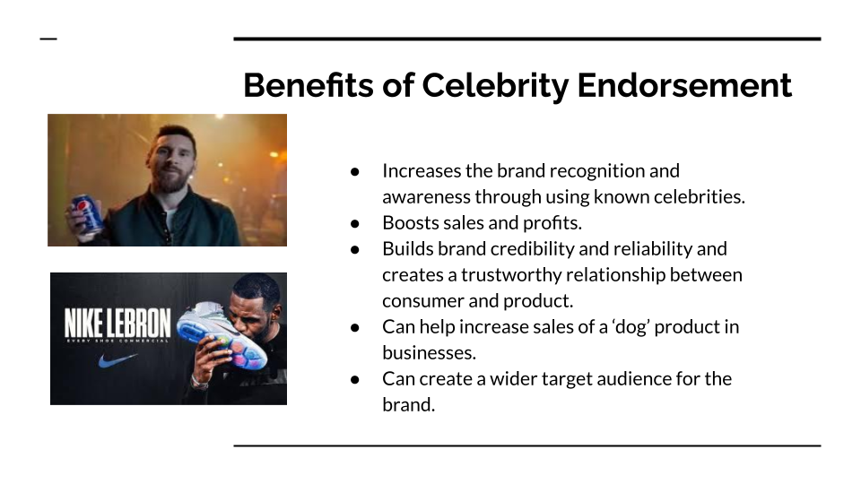
I produced and presented a powerpoint about celebrity endorsement in marketing which contained this ‘Benefits of Celebrity Endorsement’ slide.

3 minute reflective VLOG link: Recording-20251204_194127.webm

