12/11/2025
Module: ANALYSING and SOLVING PROBLEM
Code: ACCA4019
student Name: LAZENI YEO
Student ID: 2428669
Module Lecturer: REDHWAN ALAMRI
Institution: UWTSD, London

Table of Contents
Introduction 2
1. Problem breakdown and Requirement analysis 3
1.2 Applying the MoSCow prioritization Method 3
3. Proposed Solution and system Explanation 5
4. Reflection and justification 11
Conclusion of Reflection 13
References 14

Introduction

The rapid expansion of e-commerce has transformed customer expectations around delivery speed accuracy and convenience. Online grocery services in particular operate under strict time pressures because customers rely on timely delivery of perishable goods. Grocer Quick, an online grocery delivery service, is currently encountering operational inefficiencies in planning and managing daily delivery routes. These inefficiencies are resulting in extended travel times, increased fuel consumption, and delays that compromise customer satisfaction. To address these issues, this report examines the route optimization challenge faced by the company and formulates a logical, structured solution. The approach includes breaking the problem into manageable components, identifying constraints, and establishing prioritized requirements. A flowchart and pseudocode are developed to represent the proposed system, and each step is supported by academic reasoning and industry practices related to route optimization and operational planning. The purpose of this report is to provide GrocerQuick with a solution model that enhances delivery accuracy, reduces operational waste, and improves overall system performance. Furthermore, as competition intensifies within the online grocery sector, companies are increasingly required to adopt data-driven and automated decision-making tools to maintain service quality. GrocerQuick’s current manual or semi-manual route planning methods are no longer sufficient to handle growing order volumes, dynamic customer locations, and real-time traffic variations. Inefficient planning not only affects operational performance but also undermines cost efficiency, sustainability goals, and long-term scalability. By integrating optimization algorithms, predictive analytics, and systematic evaluation techniques, the organization can transition from reactive decision-making to a proactive, intelligent logistics framework. This shift is essential for meeting modern customer expectations and maintaining competitive advantage.

1. Problem breakdown and Requirement analysis
GrocerQuick`s core issue is an inefficient routing and allocation mechanism that results in longer delivery distances and inconsistent delivery times. To understand the depth of the problem-solving techniques. The challenge primarily revolves around three operational tasks:
- Assigning orders to deliver vehicles.
- Planning routes that minimize distance and fuel usage.
- Ensuring all deliveries stay within a maximum of 30-minute permissible delay.
- A Structured analysis helps reveal the key factors contributing to operational gaps.

1.2 Applying the MoSCow prioritization Method
To clearly outline what the final system must achieve, the MoSCoW model is applied. This model categorizes requirements into four levels. Must-have, Should-have, and Won`t-have.
- Must-have Requirements
These features are essential for the system to function effectively:
- A reliable method to allocate orders to available delivery vehicles
- A route optimization mechanism that minimizes travel distance
- A system that ensures no delivery exceeds the 30-minute delay threshold
- Consideration of vehicle capacity to avoid overloading
- These Characteristics form the foundation of GrocerQuick`s operational needs.

- Should-have Requirements
These are secondary but still important improvements:
- Reallocation capability if a route risks missing delivery deadlines.
- Ability to factor in traffic patterns when assigning orders.
- Monitoring delivery timing throughout the route.
- Could-have Enhancements
These additional features may be considered for future upgrades:
- Customer Automatic notifications with estimated delivery times.
- Intelligent route sequencing for smoother navigation.
- Integration with real-time traffic APIs.

- Wont-have Requirements
These features are outside the current project scope:
- Drone deliveries
- Autonomous vehicles routing
- Predictive demand analysis models

  - Key Variables
To design an effective optimization model, the variables influencing the system must be clarified:
- Order location: Each order has a specific geolocation and delivery window.
- Vehicle attributes: Capacity, fuel efficiency, and starting point.
- Travel distance: Determines fuel use and estimated time.
- Traffic conditions: Although not dynamically simulated, these influence delivery duration.
- Services time: The number of minutes required at each stop.
Delay tolerance: Maximum of 30 minutes allowed beyond scheduled delivery time.
These variables collectively shape the performance and behavior of the optimization System.

2.3 Constraints
The system must operate within several limitations:
Vehicles cannot exceed their maximum carrying capacity.
All deliveries must be within a 30-minute delay.
Fuel consumption must be reduced to improve cost efficiency.
Route planning must continue to function even when new orders are added.

2.4 Structured Breakdown
To simplify the complex task, the problem is divided into three interconnected components:
- Order Allocation: Assign each order to the closest and most suitable vehicles.
- Route planning: Generate a fuel-efficient path for each vehicle.
- Delivery Monitoring: Detect and resolve late deliveries through reassignment.
This structure lays the groundwork for developing an effective optimization algorithm.
Additionally, the problem becomes more critical as order density increases during peak hours, creating further pressure on route planners and drivers. Inefficiencies at this stage not only slow down the overall workflow but also create a ripple effect across subsequent deliveries. Without a systematic approach, small delays accumulate into larger operational setbacks. Therefore, addressing these routing challenges is essential for maintaining service reliability, reducing unnecessary travel, and supporting GrocerQuick’s long-term operational stability.

3. Proposed Solution and system Explanation

3.1 Conceptual Overview
The proposed solution is based on heuristic optimization, a technique widely used to solve Vehicles routing problems (VRP). Heuristics do not guarantee a mathematically, perfect
Answer, but they provide efficient, practical solutions suitable for real-world delivery
Unlike exact optimization methods that require significant computational resources, heuristics generate fast and near-optimal routes suitable for real-time delivery operations.
This approach helps to manage fluctuating order volumes, variable customer locations, and strict delivery windows more effectively.
The 2-opt optimization step further refines initial routes by removing inefficient loops, reducing distance, fuel usage, and unnecessary navigation complexity.
This layered process ensures that delivery routes remain both practical and operationally efficient for GrocerQuick.

Operations: The approach combines nearest-neighbor logic, capacity-based allocation, and
Route improvement methods like 2-opt.
The process: Begins with gathering all required information, such as vehicles details, orders
List, and depot location. A distance matrix is then constructed to compute distances between
Every delivery point. Using this information, orders are assigned to vehicles based on capacity
And location proximity. Initial routes are generated sequentially, then improved using the 2-opt
method which removes unnecessary route loops. Finally, delivery times are validated, and any
Order that risks exceeding the 30-minute delay is reassigned.

3.2 Flowchart of the System
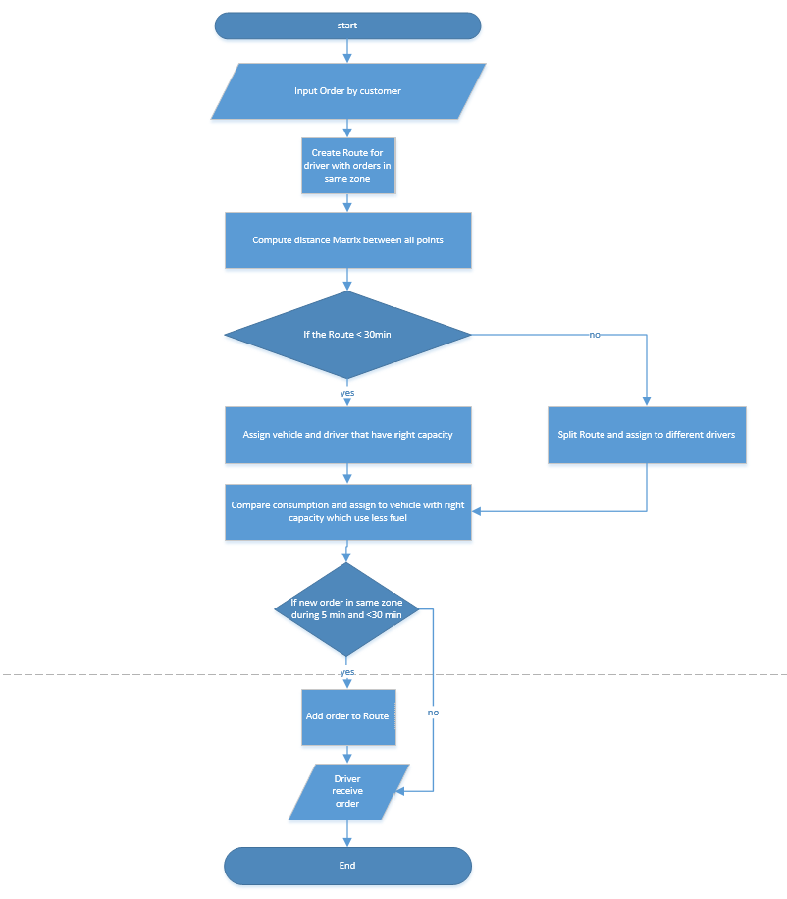

3.3 The Pseudocode
The pseudo code represents a simplified structure of how the system processes orders, assigns them to vehicles, and optimizes the route using heuristic logic. It highlights the decision flow including feasibility checks, delay validation, and iterative improvement.
Start
Step1: InputOrder
Step2: CreatRouteForZone
Step3: DistanceMatrix, ComputeDistanceMatrix
Step4: If RouteDuration <30 minutes then,
Step5: AssignDriverAndVehicle (route)
Step6: SelectLowestFuelConsumptionVehicle, (vehicle, route)
Step7: While NewOrderAvailable, procced new order
If NewOrder*zone=route, zone and
TimeSinceLastOrder<5 minutes and
UpdateRouteDuration < 30 minutes,
THEN
Step8: AdOrderToRoute
ELSE, BREAK, ENDIF, ENDWHILE
Step9: NotifyDriver, ELSE
Step10: SplitRouteAsignVehicleAndDriver
End.

3.4 Explanation of key Decision points
These decisions form the core intelligence of the system and ensure each step contributes to an efficient delivery process. Proper sequencing reduces not only travel time but also potential customer waiting time. Delay validation ensures the system remains aligned with GrocerQuick’s commitment to timely service. Orders assignment Decision, the algorithm first decides which order suits which vehicles. This step ensures:
- The closest vehicles are assigned
- Capacity is never exceeded
- Delivery timing remains possible
- Route Sequencing Decision
The next decision selects the next delivery points from the vehicles’ current location. Choosing the shortest distance reduces fuel cost and total travel time.
Delay Validation decision: If a route risks exceeding the delivery window, orders are reallocated to keep the process with limits.

3.5Assumptions
These assumptions remove unpredictable variables, making the model easier to process and evaluate. Standardizing conditions helps the heuristic perform consistently and produce reliable outcomes.
To keep the model practical:
- All vehicles start from the same depot
- Every delivery has a standard services time
- Vehicles have equal capacity and performance
- No emergency roadblocks or unexpected weather changes

3.6 Fuel efficient Considerations
By minimizing unnecessary travel segments, the system naturally lowers engine workload and burns fuel. This contributes to both operational savings and environmental sustainability targets. Fuel efficiency is achieved through:
- Fewer unnecessary turns
- Smarter order grouping
- Reduced backtracking
By designing compact routes, GrocerQuick can significantly reduce fuel expenditure and enhance environmental sustainability.
3.7 Time Efficient (30-Minute Limit)
This structure ensures that even with increased workload or unexpected delays, the delivery window remains protected. The approach strengthens the overall reliability of GrocerQuick’s delivery operations. The 30-minute delivery window is protected by:
- Real-time validation of estimated arrival time
- Alternative order selection if time is exceeded
- Route adjustment using 2-opt optimization
- This ensures customers receive their groceries within the promised timeframe.

4. Reflection and justification
Solving GrocerQuick’s optimization challenge required a structured, analytical, and systematic problem-solving approach. The process began by identifying the core constraints that significantly influence delivery efficiency, namely vehicle capacity, fuel consumption, and strict delivery timing requirements. Recognizing these constraints was essential because any route optimization model must operate within clear physical and operational limits. Breaking the larger problem into three manageable components order allocation, route planning, and continuous monitoring helped simplify the complexity and provided a clearer roadmap for developing a practical solution. Order allocation determines how effectively resources are utilized, and poor allocation often leads to longer distances and unnecessary fuel usage. Route planning ensures vehicles take the shortest and most feasible paths, while monitoring helps identify risks of delay and allows timely corrective action. This decomposition created a balanced workflow where each step contributed directly to operational improvement.

Justification of Approach
A heuristic-based solution was selected for this system due to its practicality and suitability for real-world logistics environments. Unlike exact optimization methods which may require extensive computational power and long processing times heuristics are capable of generating near-optimal solutions quickly and consistently. This makes them ideal for daily operational use where new orders, traffic conditions, and delivery windows may change frequently.
The heuristic approach supports scalability and performs well even with large datasets, which is essential for GrocerQuick as order volume is expected to grow over time. Moreover, literature in the field of operational research suggests that exact optimization models often become impractical for real-time VRP because they struggle with dynamic variables. In contrast, heuristics strike a strong balance between accuracy and speed, enabling actionable decisions without computational burden. Therefore, the chosen method is both academically justified and operationally suitable.

Strengths
Capable of scaling across multiple vehicles without compromising performance. Effectively manages and respects delivery-time constraints. Produces near-optimal results significantly faster than traditional optimization models Adapts. Well to fluctuate daily order volumes and operational variations. Reduces unnecessary travel, resulting in lower fuel usage and improved efficiency. These strengths demonstrate that the system is not only reliable but also robust enough to support long-term operational needs.
Limitations
Despite its advantages, the approach has some limitations. The model assumes relatively stable traffic conditions, which may not always reflect urban environments. Additionally, it does not account for differences in fuel efficiency or performance between individual vehicles. Because heuristic methods do not guarantee globally optimal solutions, there may occasionally be slightly better routes that the system does not identify. However, these limitations do not hinder the system’s ability to perform effectively in real-time delivery settings.

Future Enhancements
Several improvements can further enhance the system’s capabilities: Integration of live traffic data for more realistic travel-time estimations. Machine learning models for predicting demand patterns and adjusting delivery readiness. Real-time GPS tracking linked with a centralized dashboard for visual route monitoring. Dynamic optimization that updates routes whenever new orders arrive. These enhancements would elevate the system from a static heuristic solution to an intelligent, adaptive logistics platform.

Conclusion of Reflection
Overall, the problem-solving process clearly demonstrated the value of structured reasoning, systematic decomposition, and practical optimization techniques when dealing with complex logistics challenges. By breaking the issue into smaller, manageable components, it becomes easier to identify the most critical constraints and design an effective operational framework. The selected heuristic approach proved both feasible and efficient, offering rapid, near-optimal results without the computational difficulties of exact optimization methods. This makes it highly suitable for real-time delivery environments. Ultimately, the solution provides a strong foundation for improving GrocerQuick’s delivery accuracy, reducing fuel consumption, [1]and enhancing overall customer satisfaction. [2] [3]

References
[1] | M. N. H. Máximo, "A Hybrid Adaptive Iterated Local Search with Diversification Control for the Capacitated Vehicle Routing Problem," 2020.
[2] | Y. Z. X. Lin, "Learning 2-Opt Heuristics for Routing Problems via Deep Reinforcement Learning," (Springer Open Research Article), 2021.
[3] | H. W. Q. Liu, "An Optimization Model for Vehicle Routing Problem in Last-Mile Delivery," Expert Systems with Applications, 2023.
[4] | P. Toth and D. Vigo, The Vehicle Routing Problem, Philadelphia: SIAM, 2014.
[5] | S. Lin, "A heuristic algorithm for traveling-salesman problem," Operations Research, vol. 21, p. 498–516, 1973.
[6] | C. Archetti and M. Bertazzi, "Developments in VRP with time windows," European Journal of Operational Research, vol. 290, no. 799–817, p. 799–817, 2021.
[7] | S. Clegg, "The MoSCoW method for prioritisation," PMI Journal, vol. 10, pp. 49-44, 2018.
[8] | J. Block, "Same-day delivery: Challenges and solutions," Transportation Research Procedia, vol. 46, pp. 25-12, 2020.
[9] | G. W. Clark, "Scheduling vehicles from a central depot," Operations Research, vol. 12, no. 4, p. 568–581, 1964.
[10] | X. W. E. W. G. X. W. E. W. B. Golden, "The Evolution of the Vehicle Routing Problem," 2022.
[11] | Z. Chen, "Algorithm and Application in Vehicle Routing Problem: A Review," Journal of Engineering Research and Application, 2025.
[12] | D. V. P. Toth, "Heuristics for the Vehicle Routing Problem," 2022.

