Nathan Mackechnie
2116209
Manufacturing Design & Technology
Approx 5,190 words

Task 1 – DfAM Case Study 1
1. Introduction 2
2. Component Selection 2
2.1 DfAM Demonstration 2
2.2 Relevance 2
3. DfAM Principles And Concepts 3
3.1 Component Consolidation 3
3.2 Internal Structures, Lattice or Cellular 3
3.3 Mass Customisation 3
3.4 Build Volume Optimisation 3
4. Process and material Selection 4
4.1 AM Process Selection 4
4.2 Material Selection 4
5. Design and optimisation 5
5.1 Quality Functional Deployment 5
5.2 CAD 3D Modelling 6
5.3 Finite Element Analysis 7
5.4 Topology optimisation 9
6. Print preparation 10
7. Conclusion 12
Task 2 – High-Volme Production – Portable Wind Turbine Redesign. 13
1. Concept Design Appraisal 14
1.1 Identify Customer and end user needs 14
1.2 Design Specification 14
2. Manufacturing Process Proposal 15
2.1 Business needs and cost drivers 15
2.2 Selection of the Manufacuring process 16
3. Design and Development 17
3.1 Part analysis 17
3.1.1 Hub 18
3.1.2 Hub cap 19
3.1.3 Blades 20
3.1.4 Main Body and Spacers 21
3.1.5 Remaining components 21
4. Summary 22

Task 1 – DfAM Case Study

Introduction
Additive Manufacturing (AM), commonly known as 3D printing has revolutionised the manufacturing industry, streamlining processes, reducing costs and saving time (Gebhardt, 2016). Using AM, manufactures can create complex designs, tailored to a specific purpose. For designers to be able to fully capitalise on the advantages of AM, they must embrace ‘Design for Additive Manufacturing’ (DfAM) principles (Varotsis, 2022).
Within this report DfAM principles will be applied to a chosen component that can be found at Sony UK Technology Centre (Sony). The selected component will serve as a case study, allowing the demonstration of a range of DfAM principles and concepts.
This report will also explore the use of design tools such as Finite Element Analysis (FEA) validate designs through simulation, generative design for automated design, topology studies to achieve optimal structural performance, Design Failure Modes & Effects Analysis (DFMEA) for risk assessing the component and Quality Functional Deployment (QFD) to prioritise customer requirements (Rizzi, 2021)
The constraints imposed by the chosen AM process which in this case is 3D Printing, will also be addressed. Factors including shrinkage, post- processing, cost and support structure requirements will be carefully analysed to demonstrate a thorough understanding of the manufacturing limitations.

Component Selection
To effectively demonstrate the principles of DfAM, selecting an appropriate component is imperative. This section of the report will outline the process of component selection along with a rationale for choosing the component.
The chosen component for this study is a single board PCB (Plastic Circuit Board) carrier, designed to transport a singular PCB which has been broken out from a multiple panel by an operator, down a conveyor belt and into an automatic testing pod. This component can be found at the beginning of the production line, making it a relevant case study for exploring DfAM within the workplace. Figure 1 shows the carrier with a PCB located within.
Figure 1 PCB Carrier and PCB
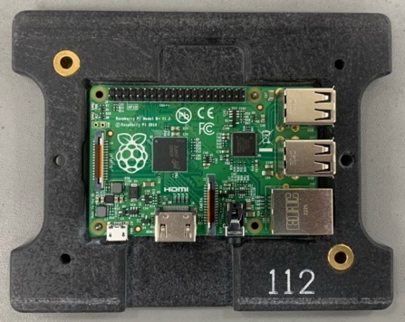

2.1 DfAM Demonstration
The carrier presents opportunities to apply various DfAM Principles and concepts. For example, internal structures, such as lattice or cellular designs can be introduced to reduce weight while maintaining strength.

2.2 Relevance
The PCB carrier is directly related to the operations at Sony and is used daily by operators who work along the production line. The current PCB carrier is manufactured out of Durastone (Duraflex, 2010), being made from this material presents challenges that AM will allow Sony to overcome. For example, due to the material selection, Sony must purchase the carrier from a supplier, this comes with high costs, long lead times and limited flexibility and control over modifications. By using AM to manufacture this component, Sony can produce the carriers in house, eliminating tooling costs, lead times and allowing for more flexibility and control over the design.

DfAM Principles And Concepts
The section of the report, DfAM principles and concepts will be discussed. These principles will then be applied to the carrier, presenting a design brief for the final design of the carrier.

3.1 Component Consolidation
Component consolidation is the concept which involves merging multiple parts into a single integrated component (Newton, 2022). By apply this concept, the overall assembly process of a product can be simplified, material usage can be reduced, production efficiency increased, and weight decreased, all of which contribute to driving down manufacturing costs and output timings.
Figure 2 PCB Carrier
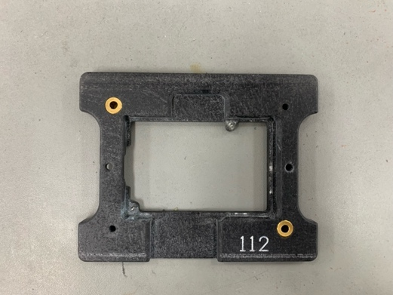
As seen in Figure 2 above, the carrier consists of 2 components, the main body constructed of Durastone, and the location holes which are made from brass inserts. The purpose of the holes is to serve as insertion points for the test jig pins, aligning the carrier with the test jig.
The incorporation of brass inserts in the carrier is crucial to enhance its durability due to the chosen material, Durastone. Durastone is known for its high cost, making frequent replacement impractical from a cost perspective. However, since the new carrier will be 3D printed using a more affordable material, there is a possibility to remove the brass inserts. This opportunity will be discussed further once a FEA has been completed on the design.

3.2 Internal Structures, Lattice or Cellular
Lattice or cellular internal structure designs have a significant role in the optimisation of components in additive manufacturing. Lattice structures are composed of interconnected struts which offers improved heat disparity and strength-to-weight ratios. On the other hand, cellular structures consist of interconnected voids, resulting in less material usage, weight reduction and enhanced structural integrity. The internal structure of the carrier will be cellular, this structure offers the required strength and uses less material, making it lighter, cost less and reducing the print time.

3.3 Mass Customisation
Mass customisation is an approach that combines the benefits of mass production and customisation (FormLabs, 2021). The carrier will not be produced in large quantities, once the production lines are equipped with the carriers, carriers will only be produced once requested by the customer, which in this case is members of production. By using this approach, we can guarantee customer satisfaction by having the capability to manufacture on demand, minimising production downtime. To ensure mass customisation is implemented strategies such as creating a modular design to increase flexibility will be implemented.

3.4 Build Volume Optimisation
By effectively utilising the available build space of a 3D printer, the build volume can be optimised allowing multiples of a component to be printed at one time. This is done by arranging and nesting multiples of a component within the build space, minimising waste, production time and maximising output (Stevenson, 2020). As the carrier is dimensionally small, it will be possible to strategically arrange the build space to be able to print multiple at one time. Careful consideration must also be done when orientating the carrier within the build space, by optimising the orientation within the build space, support structures (Raise3D, 2020) can be minimised. Minimising support structure reduced material usage and assists in achieving optimal surface quality.
Overall, the DfAM principles discussed above must be considered when re-designing the carrier for AM. By considering the above principles, the carrier can be optimised, minimising waste, driving down costs, decreasing production time, increasing flexibility and improving customer satisfaction.

Process and material Selection
In this section, the chosen AM process will be discussed and analysed, highlighting the advantages and disadvantages of the selected process. Then material selection addressed, also highlighting the advantages and disadvantages.

4.1 AM Process Selection
The selected additive manufacturing method for the fabrication of the carrier is 3D printing, specifically utilizing the fused deposition modelling (FDM) technique. FDM is widely adopted among manufacturers, including Sony, who have a strong interest in leveraging FDM for in-house component production. The chosen printer for this project is the UltimakerS5 (Ultimaker, 2020), which will be operated using the Cura program.
One of the key advantages of FDM is its cost-effectiveness for Sony. Currently, the carrier is outsourced, incurring setup and tooling costs of approximately £25 per carrier. By utilizing FDM in-house, the cost per carrier can be significantly reduced. Based on data from Ultimaker, the average energy consumption of the UltimakerS5 during printing is 0.3 kWh. Considering the average cost of electricity at 0.34p/kWh (EDF, 2023), the estimated runtime cost is approximately 0.61p per carrier, which is considerably lower than the setup costs of the current supplier.
3D printing in-house also offers Sony the advantage of fast turnaround times and increased design flexibility. Modifications to the carrier design can be quickly implemented, and prototypes can be printed and tested within the same day, enabling efficient iteration and validation processes.
However, it is important to address certain considerations associated with 3D printing, such as the need for support structures. Support structures can have a negative impact on print quality and may require post-processing. During the design stage, careful attention will be given to minimizing the need for support structures wherever possible, ensuring optimal print quality and reducing post-processing requirements.
Overall, 3D printing with FDM as the AM process for the carrier offers a fast, cost-effective and flexible solution, making it a great choice for the project.

4.2 Material Selection
The material selected for the carrier is Polylactic Acid (PLA), a thermoplastic commonly used in 3D printing. During the selection process, many factors were considered to ensure its suitability as well as functional properties needed for the desired performance.
Like all material PLA exhibits shrinkage distortion during the 3D printing process as the material cools, however, when compared to other materials, the shrinkage percentage is lower (Flynt, 2021). This ensures accuracy within the component and minimises risks of deformations in the fully printed carrier. In addition to this, PLA has low porosity, preventing the accumulation of moisture and contaminants within the material and contributing toward the structural integrity of the component (Fink, 2022).
PLA is known as an isotropic material, meaning PLA exhibits predictable and uniform mechanical behaviour regardless of the direction of forces applied (Filament2Print, 2020). This property is beneficial as it ensures the carriers performance is reliable and consistent.
As the carrier will be required to be transported along a conveyor belt, surface and tribological considerations are vital to the functionality. Although PLA typically has a high-quality surface finish, features such as fillets and chamfers can greatly decrease the quality, making post-processing steps such as sanding or polishing vital in achieving optimal surface quality (Slump, 2023).
With manufacturing business such as Sony driving sustainability, PLA is a good choice as it is biodegradable and is procured from renewable sources (BioPak, 2023). The utilisation of PLA aligns with the sustainability goals of Sony, addressing concerns such as resource depletion and environmental footprint.
Acrylonitrile Butadiene Styrene (ABS) is also a common thermoplastic that was considered as a material choice for the carrier. ABS is slightly lower in price than PLA, costing £17.43 per kg compared to PLA costing £18.23 per kg. Although ABS may have a lower price per kg, the benefits of PLA, such as biodegradability, lower melting point and higher strength outweigh the cost difference (Hubs, 2022).
Overall, through evaluating factors such as shrinkage distortion, porosity, isotropy, surface and tribological, post processing, cost and sustainability, PLA is a suitable material choice for the carrier.

5. Design and optimisation
The use of design tools and techniques are crucial in achieving an efficient and functional design, enabling the attainment of an efficient and functional design (Leary, 2019). In this section of the report, the focus will be discussing the tools and techniques applied and demonstrate how they have influenced the final design.

5.1 Quality Functional Deployment
Quality Functional Deployment (QFD) is typically applied during the early stages of component design. The purpose of QFD is to align customer requirements with the design activities, conducting a QFD early on will ensure that the decisions are made based on a thorough understanding of customer needs (Quality-One, 2016).
First it is imperative to understand the basic functional requirements of the carrier, which is to transport a PCB securely into a test pod then into a test head, the empty carrier is then transport back to the operator. In this case, the operator is the customer, from analysing the process and discussing the specific needs with the key stakeholders, information was gathered which can be used in the design process. For example, the carrier must be easy to hold with one hand, light, easy to place a PCB into, mistake proof and robust. This information and requirements are then translated into the engineering characteristics of the carrier, this involves attributes such as robustness, dimensional accuracy, suitable material, ergonomics and alignment mechanisms. Relationships between the customer requirements and engineering characteristics are then identified, creating design rules that must be followed.

5.2 CAD 3D Modelling
To create precise 3D models, computer-aided design (CAD) software serves as the primary tool in the design stage. Using CAD enables designers to explore various design possibilities, allowing the visualisation of a component's geometry and features (Basumallick, 2022). The software predominantly utilised at Sony is Solidworks, a CAD package has the capability of 3D modelling, simulation and analysis. In this section I will be demonstrating each stage of the design process of the carrier.
Using a digital calliper to measure the physical component, the foundations of the 3D model can be constructed. Figure 2 below shows the initial 3D model of the carrier, this was created by using the sketch tool, smart dimensions tool, mirror and both extrude and extruded cut features. As accuracy is vital to ensure the PCB fits securely into the carrier, shrinkage must be considered. As discussed in 4.1, PLA can shrink up to 2%, therefore, to accommodate for this, the recess of the carrier was increased by 0.2mm in both x and y directions.
Figure 3 3D Model of carrier
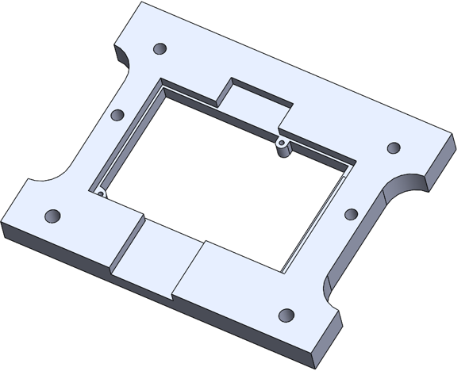
Once the basics of the carrier are created, features such as fillet and chamfer are applied. By chamfering the perimeter of the inner rectangle, the operation of placing the board is easier as the board will slide into position. Along with this, the fillet feature is used on several edges and corners, giving a smooth face.
Figure 4 Fillet and chamfer features applied.
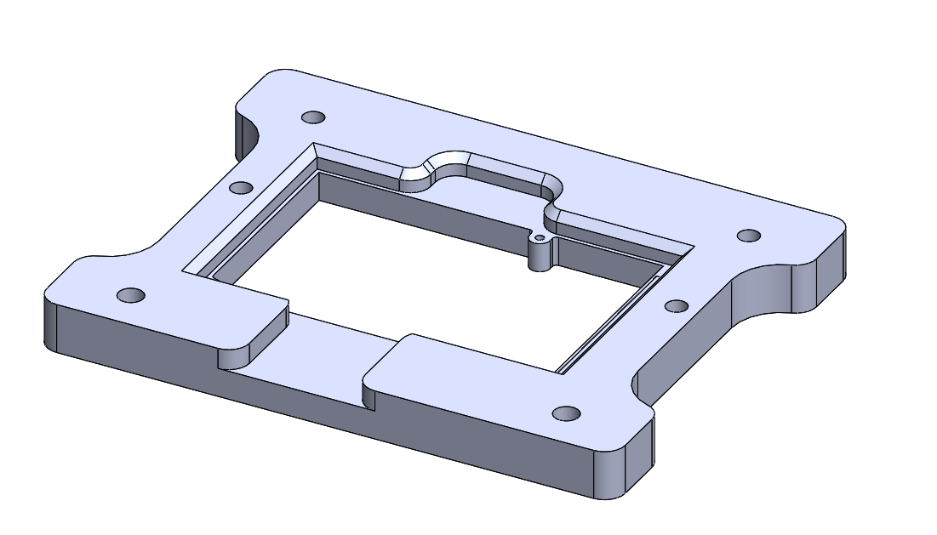
To accommodate for the corners of the PCB, circles are cut into the corners of the inner rectangle. This is visible in figure 4 below.
Figure 5 Corners
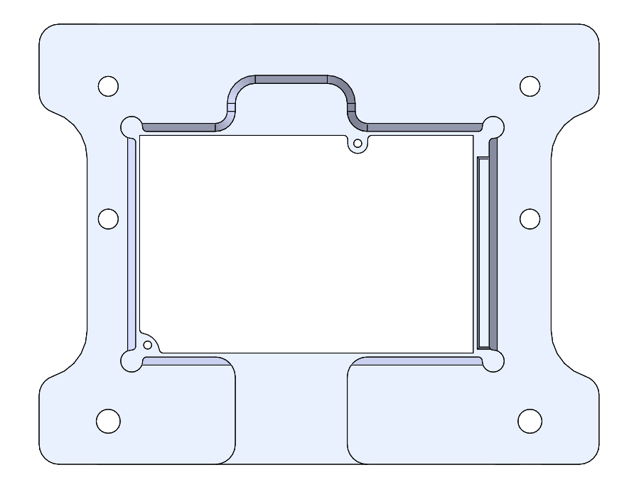
It is also evident that the carrier is Poka-yoke. Poka-Yoke is a Japanese term that refers to error-proofing as a form of quality control (Calvin, 2012). If the PCB is correctly orientated, it will sit flush into the recess of the carrier, ensuring the correct alignment. However, when place in the incorrect orientation it will not sit flush as the right-hand side of the recess has a step as seen in figure 4. This then resulting in the PCB protruding above the carrier, causing it to meet with a laser barrier as it transported down the conveyor, alerting the operator and stopping the carrier from entering the test pod.
5.3 Finite Element Analysis
Finite Element Analysis (FEA) is used by designers to assess the structural performance of components under different loads. This form of virtual testing highlights potential stress concentrations and structural weaknesses (Brush, 2021)
Through using FEA, it is possible to trial multiple materials and make a choice on which is most suitable for the component. As discussed in section 3.1, the original design of the carrier has 2 brass inserts on the insertion holes of the test jig, the first FEA will consist of analysing the carrier with the inserts and the second will be without the inserts. These results will then be used to decide on whether the inserts are needed or not.
Figure 6 FEA Analysis
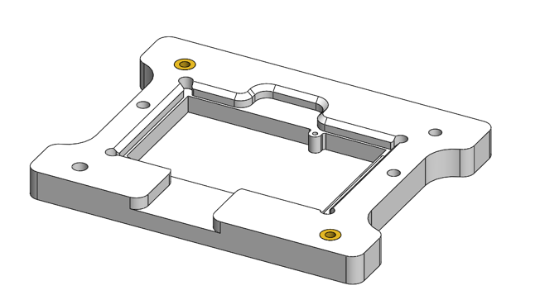
Through creating a simulation study on Solidworks, the materials of the components are assigned. For the main body of carrier, Plastic PLA is assigned to the main body and brass for the inserts as seen in figure 6 above.
Figure 7 Applying mesh controls
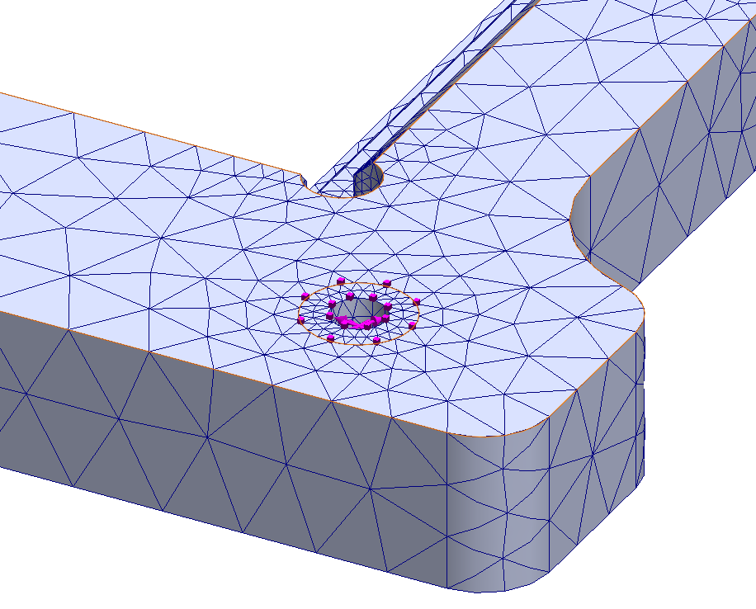
A load of 6N is then applied to the internals of both brass inserts as this is the contact location between the insertion pins and the carrier. A mesh is then created, and a mesh control is applied to both brass inserts, allowing for a much finer mesh and therefore a more accurate simulation as shown in figure 7.
The simulation is then run and presents the following results depicted in figure 8.
Figure 8 Simulation results with brass inserts
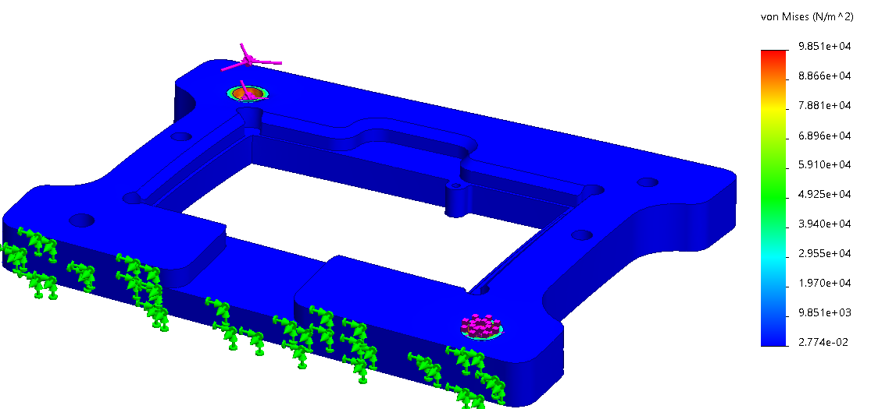
The steps above are now repeated for the carrier without the inserts and the results are as follows.
Figure 9 Simulation results without brass inserts
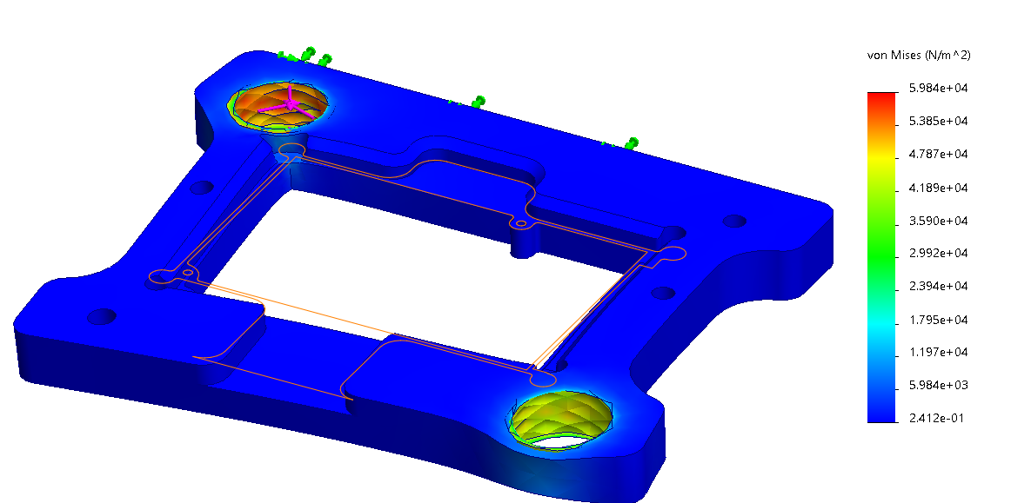
From reviewing both results depicted in Figure 8 and Figure 9, it is apparent that when devoid of the brass inserts, there is significant deformations when subjected to a 6N force. While it is unlikely for the carrier to encounter a force of that measure, these results underscore the importance of including the brass inserts to enhance the durability of the carrier, resulting in cost and time savings. Therefore, although component consolidation is a significant advantage in AM, the benefits of including the brass inserts outweigh this principle.

5.4 Topology optimisation
Topology optimisation is used by designers to optimise material distribution within a component (Sigmund, 2013). By applying this study through Solidworks, excess material is moved from the component while maintain the original structural integrity. The first step taken was to reduce the thickness of the carrier and to reduce the length of the inserts to accommodate this change, figure 9 depicts this.
Figure 10 Thickness reduced
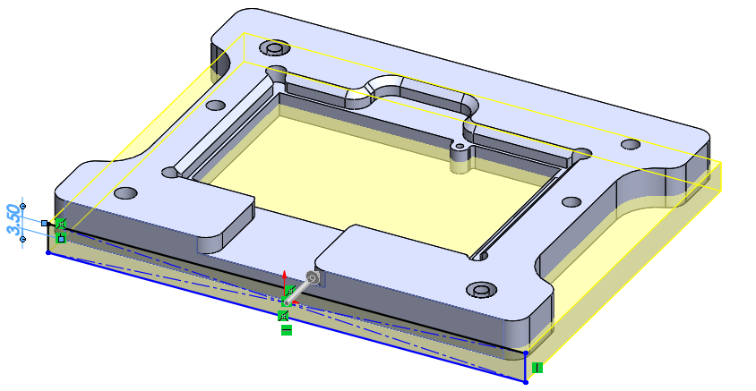
Following similar steps to conducting the FEA, the same material is applied to the carrier, load, and fixture points. The mesh used is a fine mesh, allowing for improved material optimisation. Goals and constraints are then set, the goal selected is ‘Best Stiffness to Weight ratio’ with the constraint of reducing the overall mass of the carrier by 35%. The study is then run and produces the following results presented in figure 11 below.
Figure 11 Topology study results
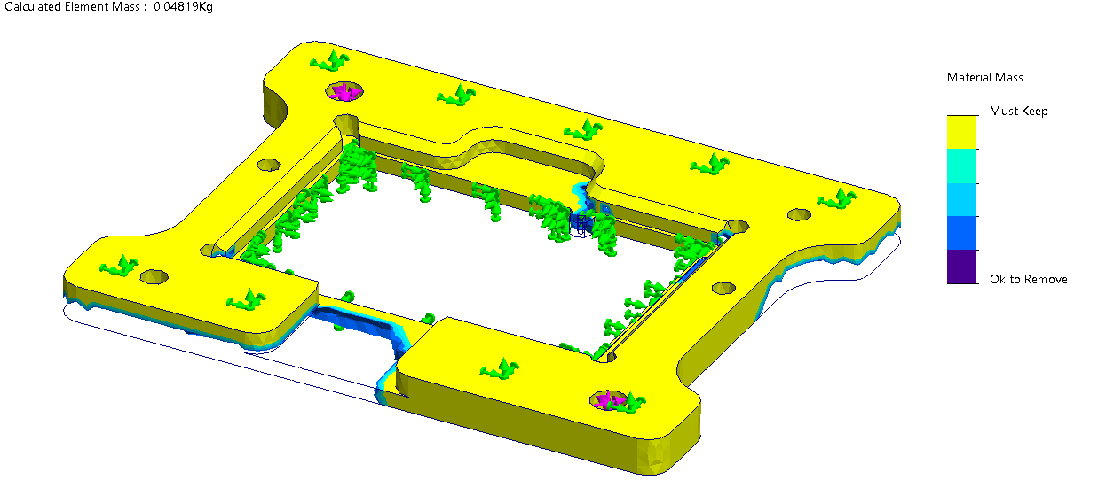
A scale can be seen on the right-hand side, showing what area is ok and must keep for material removal. With these results, the carrier is then edited to remove unnecessary material with confidence that structural integrity will not be affected.
Figure 12 Material removed from model
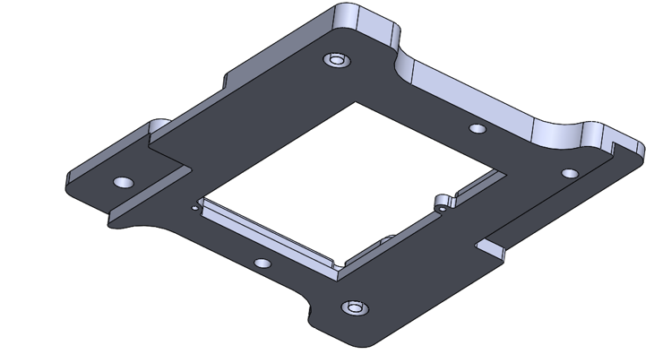
The material highlighted as ok to be removed is taken away from the carrier using the cut extrude feature. The material usage for the carrier has now been optimised.
6. Print preparation
The final optimised design of the carrier is now uploaded into the Ultimaker Cura software to prepare for print. The carrier model, which is saved as an STL file, is uploaded and placed on the bed as shown in Figure 13.
Figure 13 Final design imported to Cura software
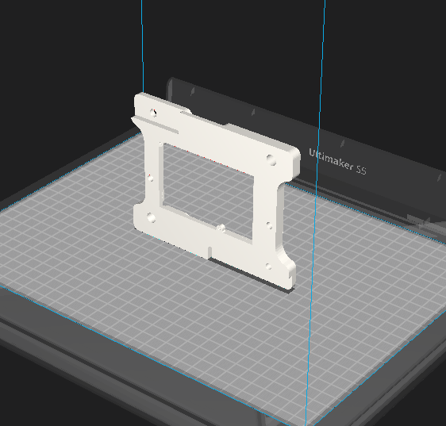
The component is then selected, and a print profile is applied. The profile applied is a custom profile, modified for accuracy within the component. The next step is orientating the component in a suitable position to ensure that the support structure is minimised where possible. The file is then sliced, and a preview window is opened, revealing the locations of support structures shown in blue in Figure 14.
Figure 14 Preview window
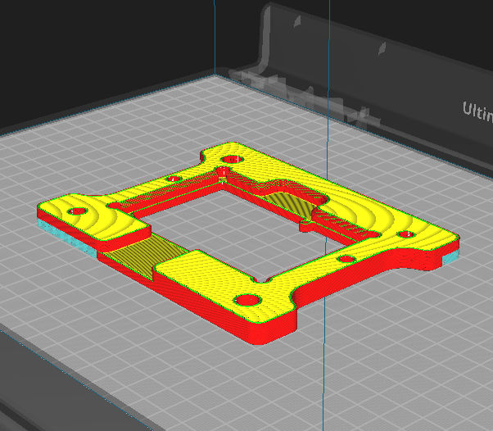
The final step before printing the component is optimising the print bed. To maximise output up to 4 carriers can be printed at one time, taking 18 hours and 7 minutes to print in total as shown in figure 15.

Figure 15 Optimised print bed
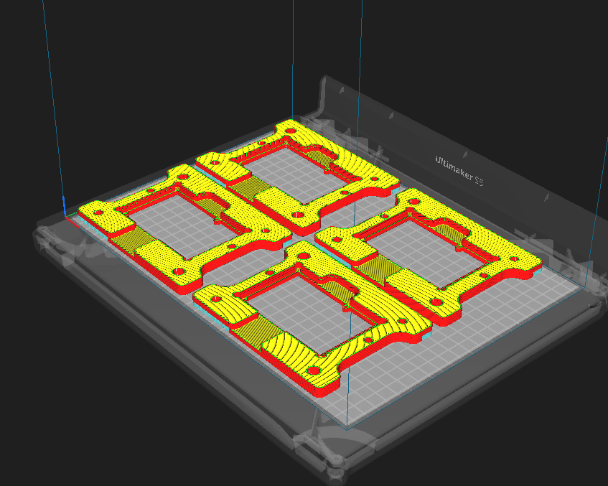

7. Conclusion
The implementation of AM for the design and production of the PCB carrier has proven to be a highly advantageous approach. By incorporating DfAM principles, such as component consolidation, lattice structures, and mass customisation, significant improvements have been achieved in terms of functionality, efficiency, and cost-effectiveness.
The selection of PLA as the material for the carrier has demonstrated favourable mechanical properties, environmental sustainability, and cost advantages. PLA's biodegradability and renewable sourcing align with Sony's commitment to sustainability. Furthermore, the utilisation of PLA has resulted in reduced manufacturing costs compared to the previous method, as well as enhanced durability and weight optimisation.
The additive manufacturing process chosen for the fabrication of the carrier, specifically FDM, has proven to be a suitable and cost-effective method. With the Ultimaker S5 printer and the Cura software, Sony has gained in-house production capabilities, eliminating the need for outsourcing and reducing lead times. The flexibility offered by FDM has allowed for rapid prototyping, design iterations, and customisation, enabling quick response to design changes and functional requirements.
The integration of quality methodologies, such as QFD, has enhanced the design process and ensured robustness, reliability, and customer satisfaction. The careful consideration of factors like shrinkage distortion, porosity, material properties, and post-processing requirements has further optimised the final design of the carrier.
Overall, the integration of AM, DfAM principles, material selection, process optimisation, and quality methodologies has revolutionised the design and production of the PCB carrier. Sony's commitment to sustainability, cost-effectiveness, and design innovation has been realised through this transformative approach. The success of this project sets a precedent for future AM applications within Sony and underscores the significance of additive manufacturing in driving efficiency, customisation, and sustainability in the manufacturing industry.

Task 2 – High-Volume Production – Portable Wind Turbine Redesign.

Concept Design Appraisal
A concept design appraisal must be conducted to begin the redesign of the portable wind turbine (PWT) for mass production. At this stage, the expected customer and end user needs are identified as well as considerations such as public perception and aesthetics (Khoo, 2009). This stage will also include the use of Quality Functional Deployment (QFD, ensuring that the decisions made within the design process are through a thorough understanding of the customers' requirements and expectations.

1.1 Identify Customer and end user needs
The customer of the PWT can vary depending on the intended use. From searching online there are many potential customers for this product, such as:
- Outdoor enthusiasts – This customer enjoys activities such as camping and hiking, a PWT could be a great source of renewable power for charging equipment and devices in remote locations.
- Motorhome owners – A great market could be the motorhome industry, the PWT could provide basic power to the motorhome once parked.
- Sustainable energy advocates – Those who are committed to reducing their carbon footprint may be interested in this portable source of renewable energy.
- Education sector – The education sector is a great customer for this product, it can be used in demonstrations for students and possibly be used for learning activities and studies.
From identifying potential customers of the PWT, it is then possible to list the end user needs:
- Portable – The PWT must be portable for ease of transportation. Considerations must be made towards the weight and size to ensure it can be easily transported and carried.
- Durable and weather resistant – The PWT will be used in an outdoor environment and therefore must withstand various weather conditions.
- Easy to operate – Customers value simplicity and should not face a complex process when setting up or storing the PWT.
- Efficient – The PWT must efficiently convert wind energy into usable electrical power.
- Safety – Safety of the user must be priorities, the incorporation of features such as covers and guards must be considered to prevent harm to the user.

1.2 Design Specification
The following table presents the design specification for the PWT.
Table 1 Design Specification
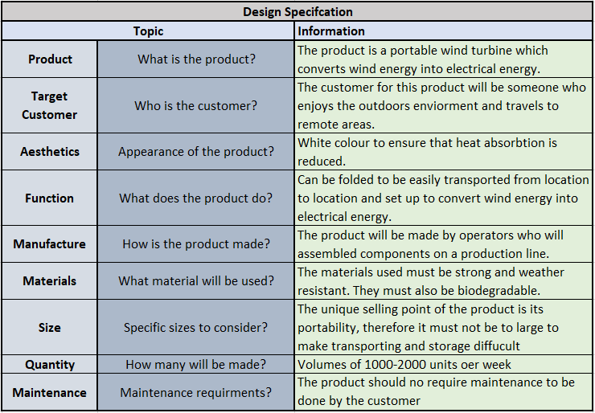

Manufacturing Process Proposal

2.1 Business needs and cost drivers
It is essential to identify the key business needs to be able to develop an effective manufacturing process for the portable wind turbine. Table 2 shows a list of the business needs of the manufacturing process and an explanation of each need.

Table 2 Business needs
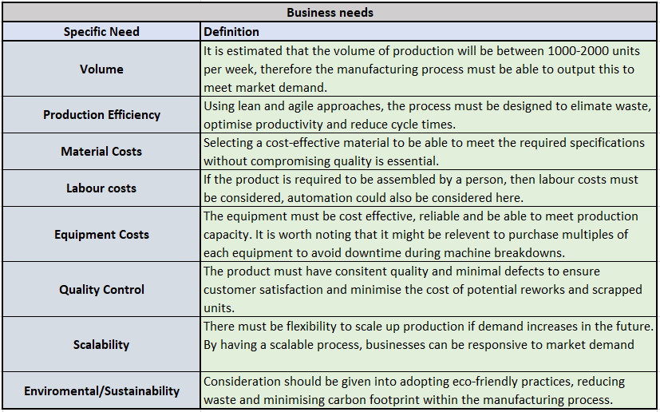

2.2 Selection of the Manufacturing process
The selected process for the mass production of the PWT is injection moulding. Injection moulding is a process that involves injecting a molten material into a mould, producing consistent components each time (TWI, 2019).
Injection moulding offers a cost effected solution for high volume production due to its efficient material usage and quick cycle times, allowing to the business to produce volumes of 1000-2000 units per week whilst also offering scalability for higher volumes.
Figure 16 shows a graph portraying the cycle times for injection moulding (Chang, 2015)
Figure 16 Injection Moulding cycle time
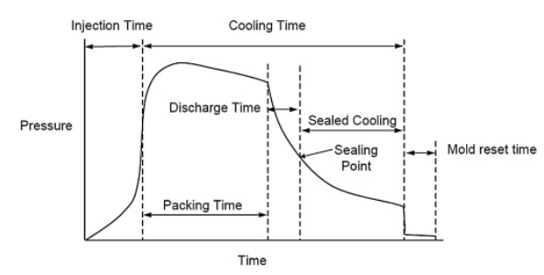
As seen in the graph above, most of the cycle time is accumulated during the cooling of the plastic. Steps can be taken to reduce cooling time and therefore maximise the output. One step is to reduce the wall thickness of the part to the minimum requirement, by doing so, less material is used resulting in a quicker cooling time (RevPart, 2019).
The upfront costs of injection moulding will require investment from the business, the costs accumulate from the cost of buying the equipment and tooling needed for the product. With casts (Tooling) costing between £400 and £4000 (RexPlastics, 2013), purchasing casts off from a supplier can be costly. To mitigate these costs, the business could look at creating casts in house rather than purchasing from a third-party supplier. This can be done by CNC machining the casts from aluminium or 3D printing the cast from Stereolithography (SLA) material which is the most cost-effective choice of the two (FormLabs, 2020).
Injection moulding can produce consistent high-quality components, minimising waste in regard to defects and maximising efficiency by produced good useable product (Hatch, 2022). Through injection moulding various components of the PWT, the business can be confident that the outputted product will be identical each time, reducing the risk of quality defects and epidemics and therefore minimising the risk of delays in production.
Sustainability is a paramount concern for manufacturing businesses, and injection moulding stands out as a sustainable method for several reasons. Material usage is efficient within the injection moulding process, minimising waste as only the required amount of material is injected into the mould for each component (Moayyedian, 2018). The material used for the components will be Low-Density Polyethene (LDPE) which is considered a sustainable material when compared with other plastics due to its recyclability.

Design and Development
This stage will focus on optimising the existing components of the PWT, preparing it for efficient and cost-effective production and a scale of 1000-2000 units per week. Principles such as Design for Manufacturing (DFM) and Design for Assembly (DFA) will be applied with the goal of ensuring the final design of the PWT is manufacturable, assembly friendly and economically viable to produce in large volumes (Sampey, 2022). Each component will be analysed and DFM and DFA principles will be applied to potentially identify any possible areas that can be re-designed.

3.1 Part analysis

3.1.1 Hub
Figure 17 Hub
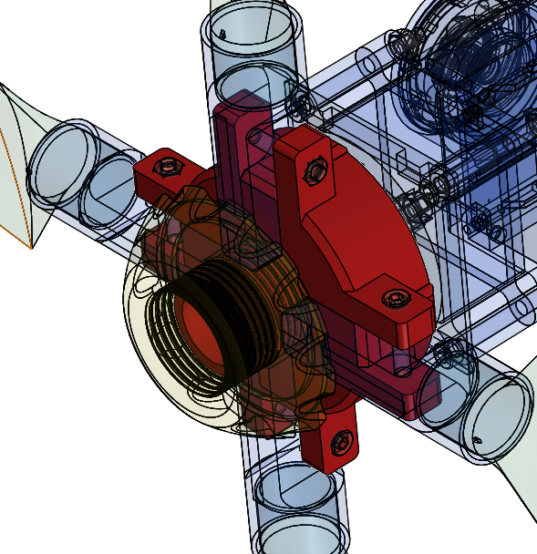
The hub is connected to the motor at the centre and the 4 blades are then connected around the perimeter of the hub. When lift is generated from the blades, the hub rotates transferring the wind energy to the motor. The threaded section seen in Figure 17 is the location where the hub cap is attached, this will increase the assembly time which will affect the production output. To overcome this, the part is redesigned without the thread and recesses for the hub cap to be attached. Another feature that will be beneficial during the assembly process is the addition of recesses for the head of the screw and the nut, the addition of these recesses will ease the assembly process as both screw and nut will be easier to locate and hold into position while tightening. The edge of each flat face is rounded by using the fillet feature. Implementing these design modifications results in the utilisation of lower pressure during manufacturing and minimising the risk of defects (Fast Radius, 2021). Figure 18 illustrates the redesigned hub.
Figure 18 Redesigned Hub
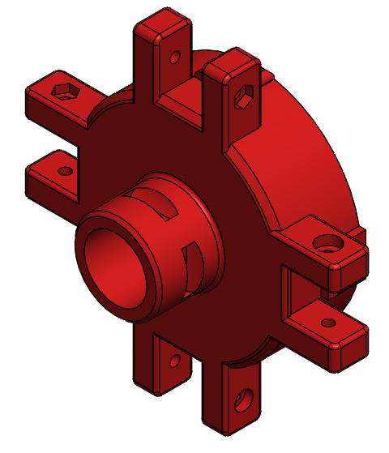

3.1.2 Hub cap
Figure 19 Hub Cap
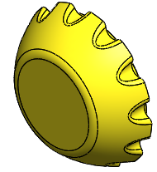
This part is attached onto the head by a thread, as the thread has now been removed from the hub the first modification of this part is the removal of the thread and the addition of 4 press fit mechanisms. Doing so will allow this part to be press fitted by hand by the operator, reducing the assembly time. Here it is vital the component is fitted correctly first time as removal will be difficult and will require a tool which may damage the part. The size of the part can also be reduced meaning less material is used during the manufacturing process, result in a cost saving. The groves on the part also add complexity to the design, to simplify this the many groves seen on the perimeter will be removed, presenting a smooth face. The below figures show these modifications. With these modifications, injection moulding will be difficult due to the undercuts formed by the press fit mechanism, therefore this part must be 3D printed (Fast Radius, 2021).
Figure 20 Hub cap addition of press fit mechanism
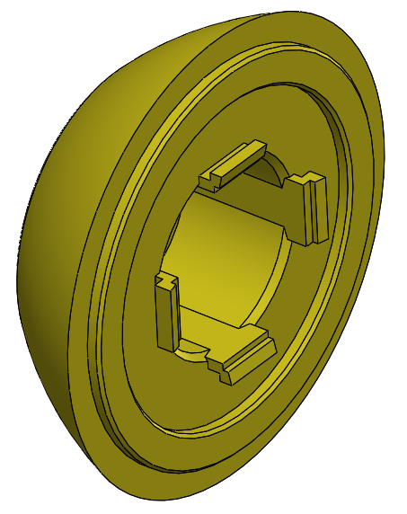

Figure 21 Hub cap simplified shape and reduce size
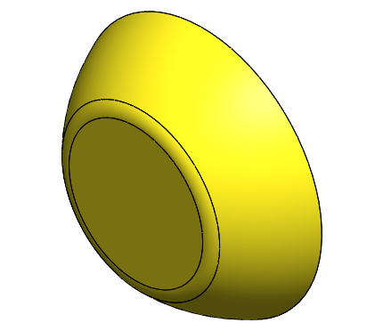

3.1.3 Blades
Figure 22 Blades
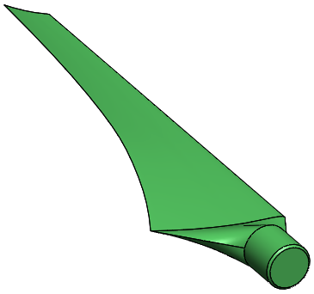
The blades of the PWT follow an aerofoil design, generating lift with their curved shape which then causes the blades to rotate, capturing the wind energy. The aerofoil shape must be maintained during the redesign process and therefore only minor modifications will be done to this component. As previously stated, sharp edges can present challenges during the injection moulding process. To overcoming these obstacles, the sharp edges of the blade are rounded by adding a filleted edge as seen in figure 23 below.

Figure 23 Blade modification
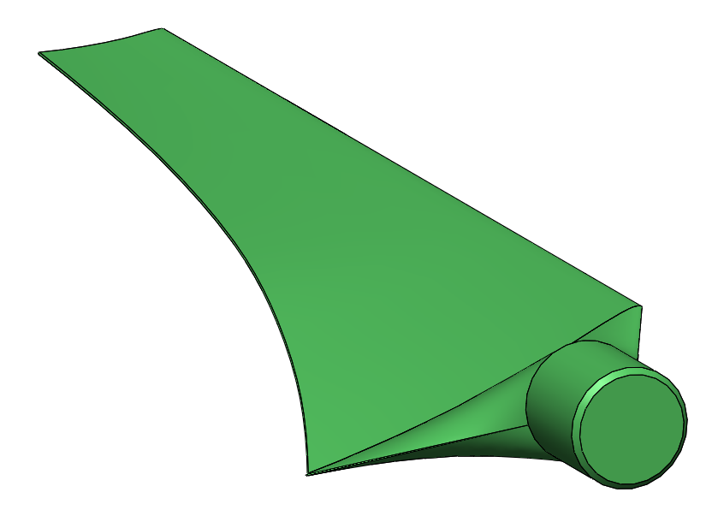

3.1.4 Main Body and Spacers
Figure 24 Main body and spacer
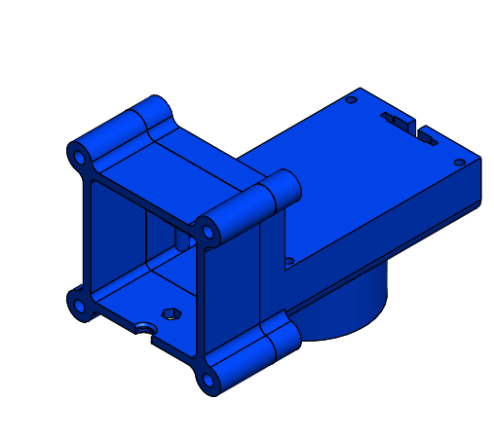
Through applying DFA principles to both components, it is identified that both could be combined to become one component. By introducing this modification 4 screws and nuts are removed resulting in a cost saving in components and a reduction in material usage.
Figure 25 Combined main body and spacer
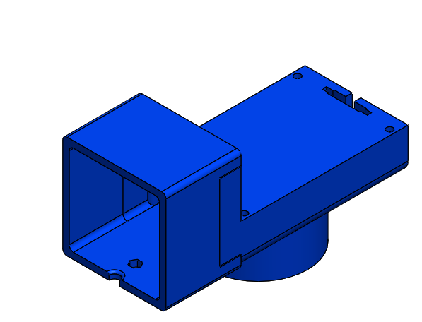

3.1.5 Remaining components
After further analysis of the remaining components, there will be no further re-designs. The remaining parts will be bought in from suppliers, eliminating the need to manufacture these in house. By outsourcing the remaining components, the manufacture can focus on the quality of their own parts whilst the supplier controls the quality of the remaining. The manufacture will also save on manning by outsourcing, which may be more cost effective than building these components in house.

Summary
In summary, 4 components of the PWT have been modified through applying DFM and DFA principles. While re-designing components it is essential to consider the design specification as well as the business needs to ensure that any modifications remain within the specification and do not negatively affect the final product. The addition of recesses in the head allow for an easier assembly process as the placement of the nut and bolt is held in place easier, this modification also improves the overall aesthetics of the product by eliminating the protruding components. The thread is replaced with a press fit mechanism, eliminating the assembly process of tightening the hub cap on by hand, reducing the assembly time and increasing production output.
The hub cap was also modified to include a press fit mechanism, the inner thread is removed, and 4 male press fit connectors were added. Although this modification may improve production efficiency, there is a risk of damaging the component if the product needs to be re-worked. To avoid this, it is recommended that the business performs extra checks before fitting the hub cap and create a tool which can remove the hub cap without damaging any components. To avoid the need for complex moulds, the grooves along the perimeter of the hub cap were removed, minimising the risk of material defects therefore reducing cost and increasing efficiency.
It was imperative that the shape of the blades remained aerofoil to generate lift from passing wind, therefore the only modification made to the blade was to round the sharp corners. By eliminating the sharp edges, injection moulding of this components becomes easier as less pressure is needed for the operation. Defects may also occur if a component has sharp corners as material may not fully fil the mould in these areas.
The final component to be modified was the main body of the PWT which also incorporated a spacer. Originally, the spacer was fitted to the main body by 4 bolts and nuts, increasing assembly time and material cost. The redesigned component is now a combination of the main body and spacer, eliminating unnecessary components, reducing assembly time and material cost while improving production output.
It is recommended that the remaining components are outsourced, this will allow the business to reach production quantities of 1000-2000 units per week. By outsourcing these components, the business can focus it resource on the 4 components discussed above.

References
Basumallick, C. (2022). What is CAD (Computer Aided Design)? Definition, Types, and Applications. [Online]. SpiceWorks. Available at: https://www.spiceworks.com/tech/devops/articles/what-is-cad/ [Accessed 22 June 2023].
BioPak. (2023). What Is PLA Plastic?. [Online]. BioPak. Available at: https://www.biopak.com/uk/resources/what-is-pla [Accessed 29 June 2023].
Brush K. (2021). Finite Element Analysis (FEA). [Online]. TechTarget. Available at: https://www.techtarget.com/searchsoftwarequality/definition/finite-element-analysis-FEA#:~:text=Fini [Accessed 23 June 2023].
Calvin, C. (2012). How to Poka-yoke CAD Drawings. [Online]. ISixSigma. Available at: https://www.isixsigma.com/software/how-to-poka-yoke-cad-drawings/ [Accessed 23 June 2023].
Chang, K. (2015). Molding Cycle. [Online]. Sciencedirect. Available at: https://www.sciencedirect.com/topics/engineering/molding-cycle [Accessed 4 July 2023].
Dassault Systems. (2022). What is a Lattice Structure in 3D Printing. [Online]. Dassault Systems. Available at: https://www.3ds.com/make/solutions/blog/what-lattice-structure-3d-printing#:~:text=for%203D%20Printi [Accessed 19 June 2023]
Duraflex. (2010). Durastone. [Online]. Duraflex Products. Available at: http://duraflexproducts.com/Durastone.html [Accessed 19 June 2023].
Fast Radius. (2021). Ensure injection molding designs are production-ready with this checklist. [Online]. FastRadius. Available at: https://www.fastradius.com/resources/injection-molding-designs-production-ready/ [Accessed 10 July 2023].
Filament2Print. (2020). The importance of isotropy in 3D printing. [Online]. filament2print. Available at: https://filament2print.com/gb/blog/91_isotropy-3d-printing.html [Accessed 28 June 2023].
EDF. (2023). What is kWh. [Online]. EDF Energy. Available at: https://www.edfenergy.com/energywise/what-is-kwh-guide#:~:text=According%20to%20the%20Energy%20Savin [Accessed 29 June 2023].
Fink, J. (2022). Porous Plastics. [Online]. Wiley. Available at: https://www.google.co.uk/books/edition/Porous_Plastics/52R6EAAAQBAJ?hl=en&gbpv=0 [Accessed 28 June 2023].
Flynt, J. (2021). How to Deal with Shrinkage When 3D Printing with PLA. [Online]. 3Dinsider. Available at: https://3dinsider.com/pla-shrinkage/ [Accessed 26 June 2023].
FormLabs. (2020). How to Estimate Injection Molding Cost?. [Online]. formlabs. Available at: https://formlabs.com/eu/blog/injection-molding-cost/ [Accessed 5 July 2023].
FormLabs. (2021). Guide to Mass Customization. [Online]. formlabs. Available at: https://formlabs.com/eu/blog/mass-customization/ [Accessed 20 June 2023].
Gebhardt, A. (2016). 3D Printing for Prototyping and Manufacturing. [Online]. Hanser Publications. Available at: https://www.google.co.uk/books/edition/Additive_Manufacturing/2itPjwEACAAJ?hl=en [Accessed 18 June 2023].
Goswami, T. (2011). Low Density Poly-Ethylene. [Online]. sciencedirect. Available at: https://www.sciencedirect.com/topics/engineering/low-density-poly-ethylene [Accessed 5 July 2023].
Hatch, M. (2022). Injection moulding – What are the advantages?. [Online]. Protolabs. Available at: https://www.protolabs.com/en-gb/resources/blog/injection-moulding-what-are-the-advantages/#:~:text=I [Accessed 5 July 2023].
Hubs. (2022). 3D printing with PLA vs. ABS: What's the difference?. [Online]. Hubs, A Protolabs Company. Available at: https://www.hubs.com/knowledge-base/pla-vs-abs-whats-difference/ [Accessed 29 June 2023].
Jenkins, M. (2023). Wind Turbine Blade Design Optimization with SimScale. [Online]. SimScale. Available at: https://www.simscale.com/blog/wind-turbine-blade-design/#:~:text=Wind%20turbine%20blades%20generate% [Accessed 10 July 2023].
Khoo, L. (2009). Design concept evaluation in product development using rough sets and grey relation analysis. [Online]. ScienceDirect. Available at: https://www.sciencedirect.com/science/article/abs/pii/S0957417408005897#:~:text=early%20as%20possibl [Accessed 2 July 2023].
Langnau, L. (2020). One way to solve porosity in additive manufacturing. [Online]. MakePartsFast. Available at: https://www.makepartsfast.com/one-way-to-solve-porosity-in-additive-manufacturing/#:~:text=Typically [Accessed 27 June 2023].
Leary, M. (2019). Design for Additive Manufacturing. [Online]. Elsevier Science. Available at: https://www.google.nl/books/edition/Design_for_Additive_Manufacturing/ZJbBDwAAQBAJ?hl=en&gbpv=0 [Accessed 20 June 2023].#
Moayyedian, M. (2018). Intelligent Optimization of Mold Design and Process Parameters in Injection Mold. [Online]. Springer International Publishing. Available at: https://www.google.nl/books/edition/Intelligent_Optimization_of_Mold_Design/uwJ2DwAAQBAJ?hl=en&gbpv=0 [Accessed 5 July 2023].
Newton, E. (2022). 3D Printing for Part Consolidation – The Ultimate Guide. [Online]. all3dp. Available at: https://all3dp.com/1/3d-printing-for-part-consolidation-the-ultimate-guide/ [Accessed 19 June 2023].
Quality-One. (2016). Quality Function Deployment (QFD). [Online]. qualityone. Available at: https://quality-one.com/qfd/ [Accessed 26 June 2023].
Raise3D. (2020). How to Use 3D Printed Support Structures. [Online]. Raise3D Academy. Available at: https://www.raise3d.com/academy/when-and-how-to-use-3d-printed-support-structures/#:~:text=What%20is [Accessed 20 June 2023].
RevPart. (2019). How To Minimize Cycle Time In Injection Molding. [Online]. RevPart. Available at: https://revpart.com/maximizing-cycle-time-in-injection-molding/ [Accessed 5 July 2023].
RexPlastics. (2013). How much does injection molding cost?. [Online]. Rexplastics. Available at: https://rexplastics.com/plastic-injection-molds/how-much-do-plastic-injection-molds-cost#:~:text=A%2 [Accessed 5 July 2023].
Rizzi, C. (2021). Design Tools and Methods in Industrial Engineering II. [Online]. Springer International Publishing. Available at: https://www.google.co.uk/books/edition/Design_Tools_and_Methods_in_Industrial_E/NElSEAAAQBAJ?hl=en&gbpv=0 [Accessed 18 June 2023].
Sampey, P. (2022). DFM & DFA: The differences, benefits and how to do them?. [Online]. Haughtondesign. Available at: https://haughtondesign.co.uk/dfm-dfa-differences-benefits/ [Accessed 5 July 2023].
Sigmund, O. (2013). Topology Optimization. [Online]. Springer Berlin Heidelberg. Available at: https://www.google.co.uk/books/edition/Topology_Optimization/ZCjsCAAAQBAJ?hl=en&gbpv=0 [Accessed 29 June 2023].
Slump, G. (2023). PLA Smoothing: How to Smooth 3D Prints. [Online]. All3DP. Available at: https://all3dp.com/2/pla-smoothing-a-beginner-s-guide/ [Accessed 28 June 2023].
Stevenson, K. (2020). Does 3D Print Build Volume Really Matter?. [Online]. Fabbaloo. Available at: https://www.fabbaloo.com/2020/10/does-3d-print-build-volume-really-matter [Accessed 20 June 2023]
TWI. (2019). What is injection moulding. [Online]. TWI Global. Available at: https://www.twi-global.com/technical-knowledge/faqs/what-is-injection-moulding [Accessed 4 July 2023].
Ultimaker. (2020). 3D printing: The total cost of ownership. [Online]. Ultimaker. Available at: https://assets.ctfassets.net/7cnpidfipnrw/1SuqJAFZL7w4scpghUY6Ye/dce94aac109955fc238040d655b274a5/ultimaker-white-paper- [Accessed 29 June 2023].
Varotsis, A. (2022). What is design for additive manufacturing. [Online]. nTop. Available at: https://www.ntop.com/resources/blog/what-is-design-for-additive-manufacturing/ [Accessed 18 June 2023].

