WORD COUNT: 6407
Submitted in partial fulfilment of the requirements for the degree of BA(Hons)Advertising and Brand Design at University of Wales Trinity Saint David.
TITLE: CAN CONTROVERSY BE JUSTIFIED IN CONTEMPORARY ADVERTISING?

Hannah Barnes
P146339
Advertising and Brand Design
Supervisor: Martin Bush

13TH DECEMBER 2017
TABLE OF CONTENTS

Sections |  | Page No.
List of Illustrations |  | 3
Summary of Topic |  | 4
Introduction |  | 5
Chapter 1: Religion |  | 6
 | Commercialising Christmas | 7
 | Toscani & Benetton | 10
 | Priest Kissing Nun | 12
 | Angel and Devil | 13
Chapter 2: Race |  | 14
 | Pepsi, Promoting Unity, Peace and Understanding | 15
 | Black Woman Breast-feeding White Child | 21
Chapter 3: Disease |  | 22
 | HIV & AIDs | 23
 | Man Dying of AIDS | 24
 | Parodies | 28
Conclusion |  | 28
Bibliography |  | 30
Illustrations |  | 35
Appendix |  | 36

LIST OF ILLUSTRATIONS:
Figure 1: Herring T. (2017) Greggs’ representation of the baby Jesus [ONLINE]. Available at: https://www.theguardian.com/business/2017/nov/15/greggs-nativity-jesus-sausage-roll-advent-calendar [Accessed 29 November 2017].
Figure 2: Adam & Eve/DDB. (2015) #MulberryMiracle. [Online Video]. 7 November 2015. Available from: http://www.thedrum.com/news/2015/11/07/ad-day-mulberry-mulberry-miracle. [Accessed: 30 November 2017].
Figure 3: Toscani O. (1990) Priest Kissing Nun [ONLINE]. Available at: http://collections.vam.ac.uk/item/O232017/united-colors-of-benetton-poster-toscani-oliviero/ [Accessed 29 November 2017].
Figure 4: Toscani O. (1991) Angel and Devil. Available in: Saunders D. (1996) Shock in Advertising. 1st ed. London: Batsford Design Books. Page 84
Figure 5: Pepsi. (2017) Pepsi advert with Kendall Jenner pulled after huge backlash. [Online Video]. 5 April 2017. Available from: http://www.independent.co.uk/arts-entertainment/tv/news/pepsi-advert-pulled-kendall-jenner-protest-video-cancelled-removed-a7668986.html. [Accessed: 3 May 2017].
Figure 6: Coca Cola. (1971) I'd Like to Buy the World a Coke. [Online Video]. 1971. Available from: https://www.theguardian.com/business/2017/apr/05/from-cokes-flower-power-to-kendall-jenners-pepsi-ad-how-ads-co-opt-protest. [Accessed: 26 November 2017].
Figure 7: Toscani O. (1989) Black Woman Breast-Feeding White Child. [ONLINE]. Available at: http://collections.vam.ac.uk/item/O222939/poster-toscani-oliviero/ [Accessed 27 November 2017].
Figure 8: Frere T. (1990) David Kirby On His Deathbed. [ONLINE]. Available at: http://time.com/3503000/behind-the-picture-the-photo-that-changed-the-face-of-aids/ [Accessed 10 October 2017].
Image 9: Da Vinci. (1498) Last Supper. [ONLINE]. Available at: https://www.khanacademy.org/humanities/ap-art-history/early-europe-and-colonial-americas/renaissance-art-europe-ap/a/leonardo-last-supper [Accessed 28 November 2017].
Figure 10: Toscani. United Colors of Benetton. (1992) Man Dying of Aids. [ONLINE]. Available at: http://collections.vam.ac.uk/item/O76080/man-dying-of-aids-poster-frare-therese/ [Accessed 28 October 2017].
Figure 11: Alan Tilby. Act-Up. (1992) There’s Only One Pullover This Should Be Used to Sell. Available in: Saunders D. (1996) Shock in Advertising. 1st ed. London: Batsford Design Books. Page 52

SUMMARY OF TOPIC:

Introduction
In order to answer this question, one must have a clear understanding of the terms used.
“Advertising is at the core of contemporary culture and at the heart of debates about postmodernism, globalisation and consumer culture…visual-based advertising [is] at the centre of an increasingly world-wide consumer culture… to create value-added brands or commodity-signs.” (Barker 2004: 3)
Although there are many potential devices and platforms available to advertisers, I will be looking predominantly at visually-based adverts because, as Chris Barker suggests, visual-based advertising is increasingly popular.
According to Kim Sheehan (2004: 8), director of communications at the University of Oregon, adverts attract criticism due to four reasons: “The role of consumers in the advertising process” when the consumers were left out of the advertising process; “The appropriateness of advertising” where adverts could be harmful to society due to the nature of the product; “The role of advertising as a force that undermines our culture” promoting negative behaviours within a culture; “The profane nature of advertising” when provocative advertising is in poor taste. I will focus on the last of these. This is the most difficult to regulate because it is subjective as people from different backgrounds will get different messages from an advert.
“Members of an audience bring their own worldviews to the advertising message and create meaning from the messages. This simple fact results in many of the intended and unintended effects of advertising.” (Sheehan 2013: 253)
Marianna Cage, an expert in consumer psychology, believes that many adverts are intentionally shocking to the viewer to make the advert more memorable and stand out in a cluttered advertising environment (Cage 2012: 483). John Hegarty, advertising executive and a founder of the agency Bartle Bogle Hegarty, agrees with this idea stating that “As humans we respond more to emotions than we do to logic” (Hegarty 2014: 37). This implies that by using fear and shock to connect with consumers, advertisers can have a bigger impact on consumers, making them more likely to be influenced and persuaded by the advert.
The Advertising Standards Authority (ASA) is the organisation responsible for regulating adverts to determine whether they are likely to cause widespread offence. They categorise adverts under these headings “race, religion, gender, sexual orientation, disease, disability or age” (ASA 2015). I will focus on religion, race and disease. By selecting only 3 categories I will examine each in more detail and depth.
Chapter 1: Religion
Introduction
Adverts often feature references to religion, through themes and imagery. The ASA suggests that this is because they “provide a quick and recognisable cultural reference point with which to engage consumers.” (2015). Although, the ASA allows advertisers to reference religion, they have general rules to help advertisers avoid causing widespread offence such as, “avoid using images or symbols central to a faith” (ASA 2015). Anything that appears to mock a religious belief is also likely to be considered offensive by the ASA (2015), and consequently may be banned; however, this is difficult to measure as it can be subjective.
Commercialising Christmas
There is an on-going debate about whether commercialism has had a negative or positive effect on Christmas. Joe Jenkins (2002: 177) suggests that it has had a negative effect saying “today, people ignore the deeper religious meaning behind the festival and think of Christmas in terms of shopping” and blames commercialism as the reason why suicide, separation and debt peak at this time of year. Whereas Martin Johnes (2016: 38), history professor at Swansea University, argues that “Commercialism was one of the reasons why the festival survived and prospered… [and] did not undermine the family and charitable elements”. Johnes suggests that family relations are made stronger as families unite at Christmas time. Johnes (2016:39) also indicates that people are more generous during the Christmas season through the gift giving process, and donating large amounts to charity.
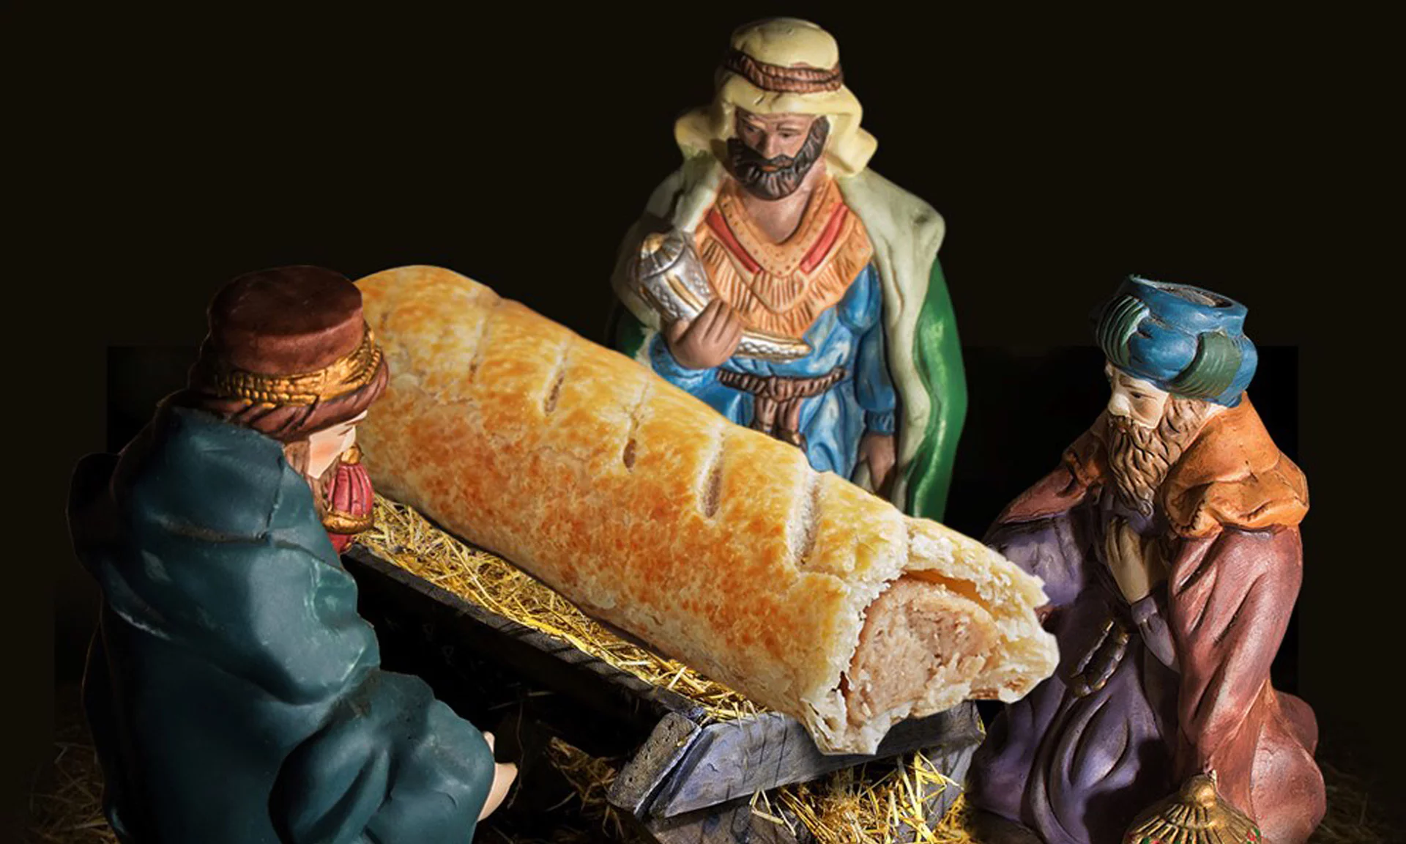
A recent example of an advert that has shed light on this debate is an image appearing in this year’s Greggs advent calendar, and similar promotional material for the company. The image shows a sausage roll placed in a manger surrounded by wise men, in place of baby Jesus, a spoof of the nativity story.
Figure 1: Herring T. (2017) Greggs’ representation of the baby Jesus
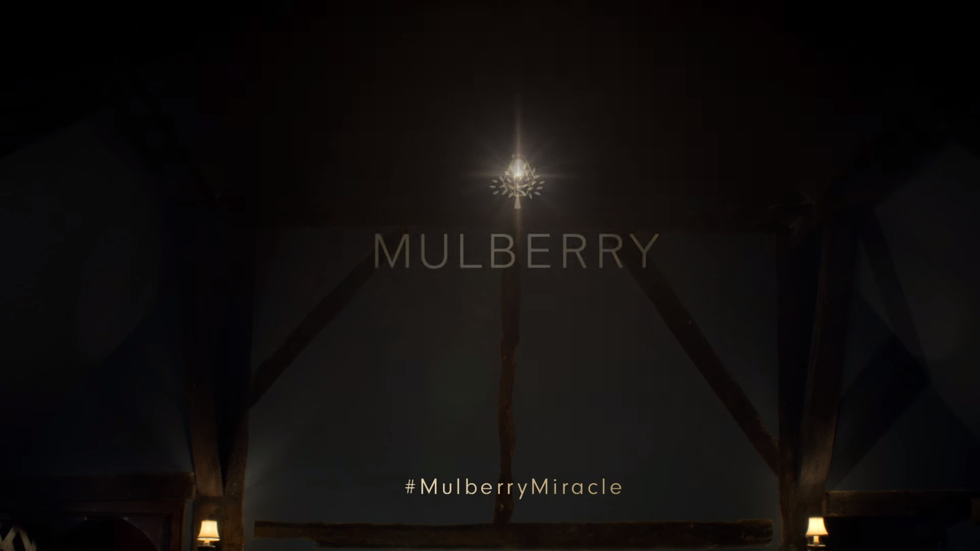
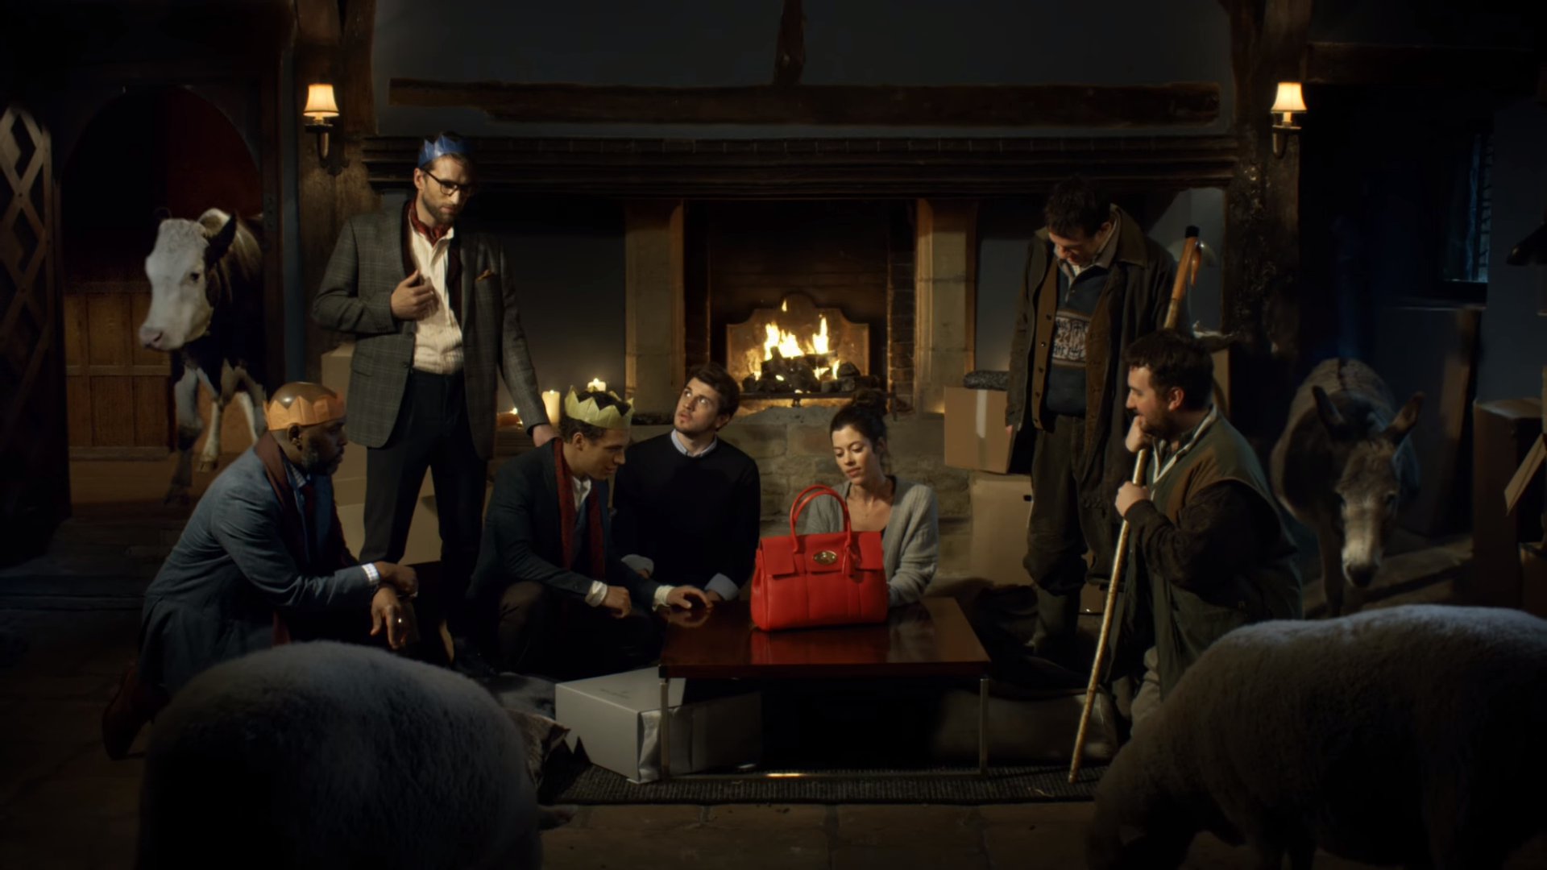
Another advert referencing the same story is the 2015 ‘Mulberry Miracle’ advert. It begins in what looks to be a stable, with a fire in the background. A couple are in the stable and the man hands the woman a Mulberry branded box. As the woman opens the box, orchestral, hymn-like, choral music starts playing, timed to coincide with her stunned reaction to the handbag. Two shepherds appear at the doorway, after hearing about the new bag and begin admiring the bag, closely followed by three men, wearing the paper crowns commonly found in crackers, resembling the three kings. Watching everyone marvelling the bag, the gift giver states “Guys, it’s just a bag.” Which is met with awkward laughter from the others. The last shot shows the group surrounding the bag in admiration, before panning upwards revealing a naked bulb hanging from the ceiling, in place of the star of Bethlehem.
Figure 2: Adam & Eve/DDB. (2015) #MulberryMiracle
Although both adverts parody the same story in a similar way to one another, they received very different levels of criticism. The Mulberry Miracle advert was reported by Mark Sweney, media business correspondent at the Guardian, 2015, as blasphemous and undermining “the central messages of their faith [Christianity].” Despite receiving 42 complaints about the advert, the ASA described it as a “playful and ridiculous comparison with the nativity story which was more likely to be seen as a humorous reference to consumerism than ridiculing the religious story.” (Sweney 2015). Many people in the creative industry spoke favourably of the advert, for example, Jennifer Faull (2015), brands editor at The Drum, described it as “an unexpected hit” and “rather impeccable” whilst crowning it “Ad of the Day”.
However, people were far less willing to defend Greggs bakery. In an interview with Rebecca Smithers, consumer affairs correspondent for the Guardian (2017), Reverend Mark Edwards described the advert as disrespectful and ”showing a total disregard and disrespect towards one of the greatest stories ever written”. Spokesperson for the UK Evangelical Alliance, Dan Webster, agreed with the sentiment, and told Smithers (2017) the image “seems to be manufacturing a scandal to sell baked goods and neglecting the real scandal of Christmas. Every year some company creates a Christmas controversy for commercial gain.” Webster is accusing the bakery of intentionally causing a scandal, suggesting it is planned in the hope that they will benefit from the controversy. However, Greggs released a comment apologising for the image, stating they had no intention of offending anyone, but never withdrew the product (Smithers 2017). It seems unlikely that Greggs would admit to intentionally creating controversy so it is difficult to know whether this is true.
Reverend Stephen Barnes from Aberfan (Appendix A) has an opposing view, stating that “many have little knowledge of the events that took place at the time of Christ’s birth” and using an adaptation of the nativity story “may prompt some to take a fresh look”. However, Barnes (Appendix A) feels the difference between the advert is that in the Mulberry advert the man giving the bag in the advert “got it right [saying] ‘It’s just a bag’”, suggesting that instead of mocking the religion they are mocking the commercialism of Christmas.
Despite adapting the same story in different ways, the Mulberry Miracle advert seems justified because it seems to be mocking commercialism rather than religion. However, the Greggs image does not seem justified as there is no accompanying text or narrative to direct interpretation. The simple use of a caption alongside the image, would have helped Greggs control the message that they were trying to portray.
Oliviero Toscani & Luciano Benetton
United Colors of Benetton was created in 1965, by the Benetton family, and slowly grew into an international company, with Luciano Benetton as Chairman from 1978 to 2012 (AdAge, 2003). Donald Brady, professor of marketing at American University in Alabama, describes Benetton as a
“a global upmarket clothing company based in Treviso, Italy…well known for the non-traditional and controversial nature of its advertising during the 1980s and 1990s” (Brady 2015: 279).
Toscani became Art Director for Benetton in 1982, before this he worked as a fashion photographer. In an interview with Frances Kennedy, a reporter for the Independent newspaper, Luciano Benetton explained why he felt the need to start advertising and why he chose Toscani:
“I didn't have any particular suggestions or restrictions to guide him, except that the campaign had to be different - very different - and it had to be international. I had figured that the traditional system of advertising with a different campaign for each country wasn't the way ahead. I also wanted to make people aware of the spirit of our company.” (Kennedy 1999)
The fact that Benetton did not want Toscani to create “traditional” adverts, and wanted to make people aware of the “spirit of the company” rather than informing people of the products that the company had on offer, was not common in the 1980s. Also creating an advert that would work globally, without adaptation, for different cultures and languages, would encourage the use of imagery and little or no type; this explains the format of the majority of Toscani’s early work for United Colors of Benetton.
Toscani, most famous for his work with the United Colors of Benetton, is one of the most controversial creative directors in the world. As Jacek Sobczak writes,Toscani uses themes such as “reportage, anti-racism stills, refuting stereotypes” to shock and disturb people. Sobczak continues by comparing the adverts to “giant newspapers…which question our taboos and fears and cause spontaneous discussion” (Sobczak 2015: 100). Comparing the adverts to newspaper would suggest that Toscani was blurring lines between advertising and photo-journalism.
Later on in Kennedy’s interview, Benetton confesses that they “deliberately sought ideas that would be provocative” in order to escape the traditional advertising route of just selling a product. Benetton admits that despite trying to avoid offending anyone, the messages from campaigns have sometimes been misunderstood. It has been suggested by Rick Poyner, a writer specialising in design, that this is because simplifying a complicated subject down to an image is not enough to form a full statement and leaves the image open to the interpretation of the audience. However, this may be intentional as Toscani said in an interview with CNN (2010) “We want criticism. Criticism helps. We are not interested in consensus.” This would suggest that he does not care if his messages are open to interpretation and considers this is a good thing.
Brady, describes the initial adverts produced by Toscani for Benetton as “mild in terms of content and “acceptable to most people”. Brady notes that the themes and messages of the campaigns become more confrontational and controversial at the start of the 1990s; he suggests the reason for this is to draw attention to significant world issues and increase the brand’s value. He feels that the controversy started “throughout the 1990s” when the “ads had no relationship to the company or its products” (Brady 2015: 279).
Toscani, Priest Kissing Nun¸1990
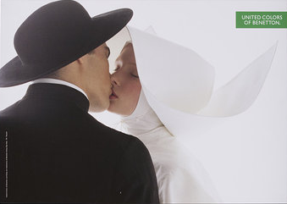
An example of an advert produced by Toscani for Benetton, with no apparent relation to the brand or its products, would be Priest Kissing Nun (1990). Lester, author and professor of communication at California State University, summarises the advert and the effects it had,
Figure 3: Toscani O. (1990) Priest Kissing Nun
“Two models, employed by Benetton, wear the clothing of a priest and nun who kiss for the camera in this studio image. The picture upset many Catholics because it seemed to mock their religious beliefs.” (Lester 2013: 72)
The controversy surrounding the advert resulted in a ban in Italy after protests from the Vatican and a Eurobest Award (Brady 2015: 280). As Benetton is based in Italy and given Toscani is of Italian heritage, it is likely that he would have been aware of the advert’s effect, suggesting Toscani would have known about the controversy that the advert would cause, and would have anticipated the reaction it would receive. This could suggest that Toscani sought acclaim regardless of the risk of offending consumers.
Luciano Benetton thought that the advert was a joke, showing the habit does not define the priest or nun (Brady 2015: 280). According to Stuart Elliott, writer for the New York Times and Pulitzer Prize winner, Toscani also found the advert to be entertaining, suggesting that young people would find the advert new, different and fresh and that more traditional institutions would be the only ones perturbed (Elliott 1991).
Toscani also admitted that different cultures react differently to his campaigns, he noted that Spain reacted more positively to the Priest Kissing Nun advert than Italy for the aforementioned reasons (Elliott 1991). Kirstin Holz found similar results in her thesis for a variety of Toscani’s campaigns noting that “Germany responded more tolerantly and openly…whereas England did just the opposite” (2007). This proves that responses to shock advertising are at least somewhat influenced by culture.
Toscani, Angel and Devil, 1991
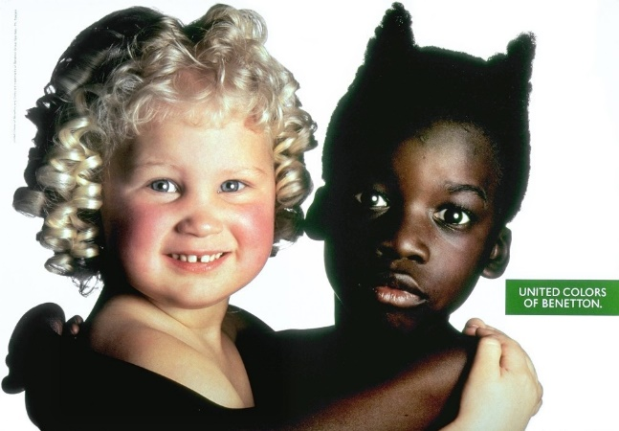
This is another example of an advert produced by Toscani for Benetton, with no clear relation to the brand or its products. The jarring juxtaposition, highlights the differences between the girls in the advert. This image was used as part of Toscani’s equality themed campaigns.
Figure 4: Toscani O. (1991) Angel and Devil
Poyner, noted how the white child looked angelic in comparison to the black girl, whose hair had been styled to resemble devil-like horns (Poyner 2006). It could be interpreted to mean Benetton are suggesting that society sees black people as ungodly or sinful. Another detail that some may miss, is the gap between the white girl’s teeth. Natalia Kubacka states in her thesis, that this is “considered as a sign of happiness, beauty and wisdom in some cultures” (2012: 41).
Once again, the controversy caused by different interpretations of the message could have been managed by accompanying the image with a caption or strapline. Although this could potentially weaken the advert, it would have helped people understand the aims of the advert and strengthened the message Toscani was trying to convey. However, if the intention behind the advert is simply to be provocative and ignite discussion without regard to controversy or ethics, then the advert was successful.
Although depicting an angel and devil, the main subject of this advert is race.
Chapter 2: Race
Introduction
“Few issues are as controversial as race and nation…powerful photographs show us as a society fraught by racial conflict and struggles to transform the social order” (Fusco 2003: 8) As this quote suggests, many of the most controversial adverts are based on the theme of race, whether they are trying to promote unity or make an artistic statement.
“‘Race’ is… based on alleged biological characteristics, including skin pigmentation … race is taken to be a form of identity. Race is understood not as a universal or absolute existent ‘thing’ but rather as a contingent and unstable cultural category with which people identify.” (Barker 2004: 170)
This definition of race, taken from The Sage Dictionary of Cultural Studies, suggests that race is not a physical thing, but is an identifier used to socially categorise people.
Similarly to Barker’s definition Coco Fusco, an artist and writer specialising in race and gender, argues that “race is fiction, a cultural construction that shapes our social interactions”. Fusco further defines race “as a concept that is adapted by its users… its meaning is constrained by poles of difference” (Fusco 2003: 16). Stating that its meaning is constrained by poles of difference, suggests separation and opposition between different groups, and that identifying with a certain race can be harmful, as people will categorise and stereotype you. This could be why she goes on to say, “behind any discussion of race lurks an accusation of racism waiting to spring forward.” (Fusco 2003: 16). If this is the case then it may be problematic for any brand to refer to race in an advert without the potential for controversy or being accused of racism.
Pepsi, Promoting Unity, Peace and Understanding
According to Bob Stoddard, the recognised authority on Pepsi memorabilia, Pepsi has been around since 1898, and was created by a pharmacist, like many drinks of that era (2007: 12). Stoddard suggests the fact the drink didn’t contain any harmful ingredients, which was unusual at the time, was a reason for Pepsi success in the early days. At times, Pepsi managed to outsell its main competitor, Coca-Cola. Stoddard (2007: 20) credits their promotions such as the Pepsi challenge for this. Stoddard also notes that the Pepsi Cola company now own a variety of drinks, such as ice tea, and sell the produce globally, in more than 186 countries (2007: 20).
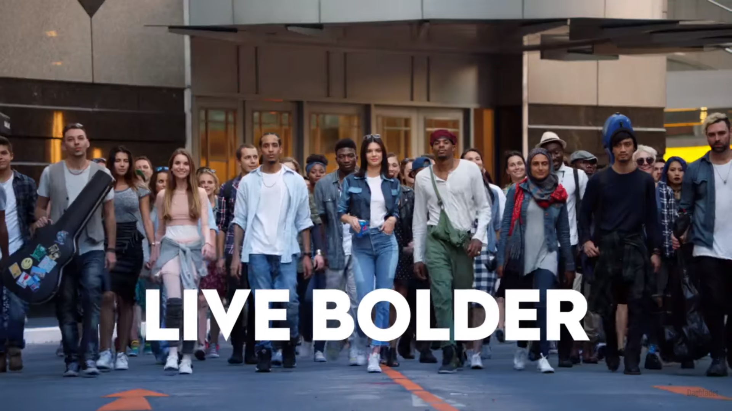

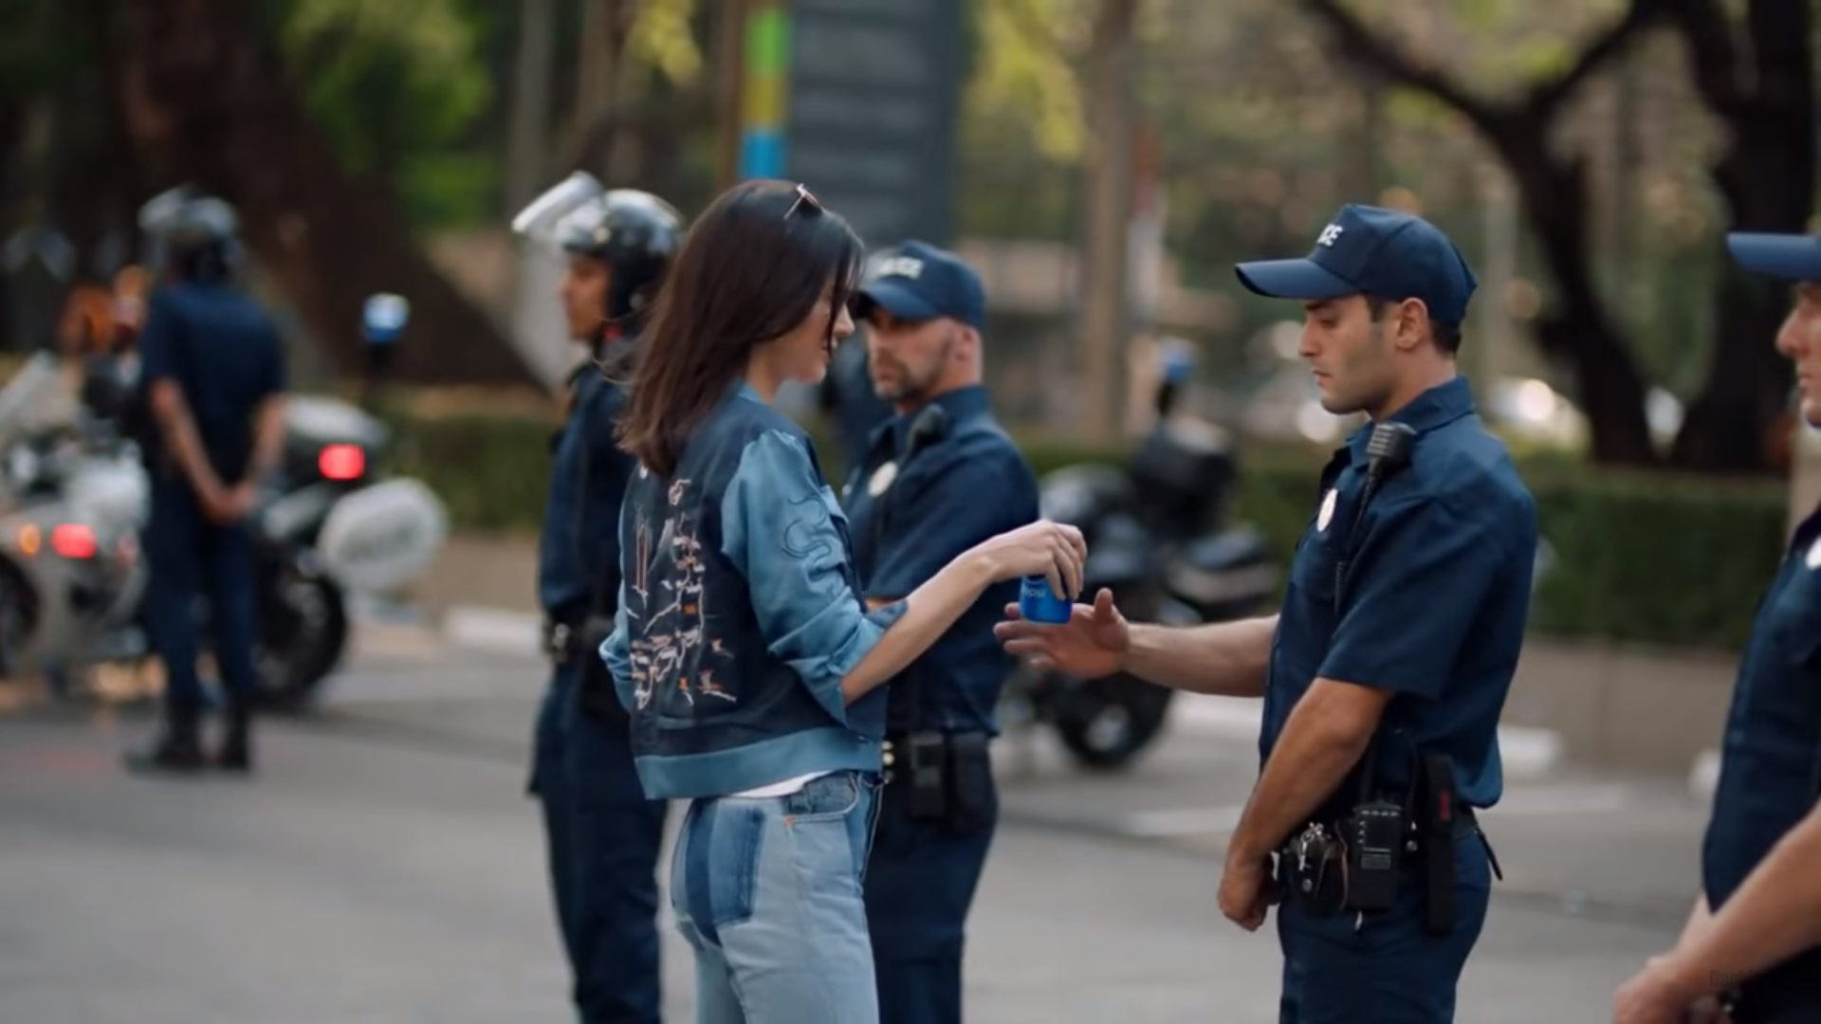
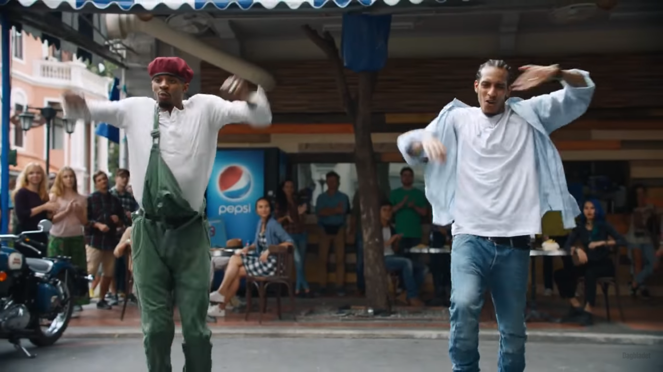
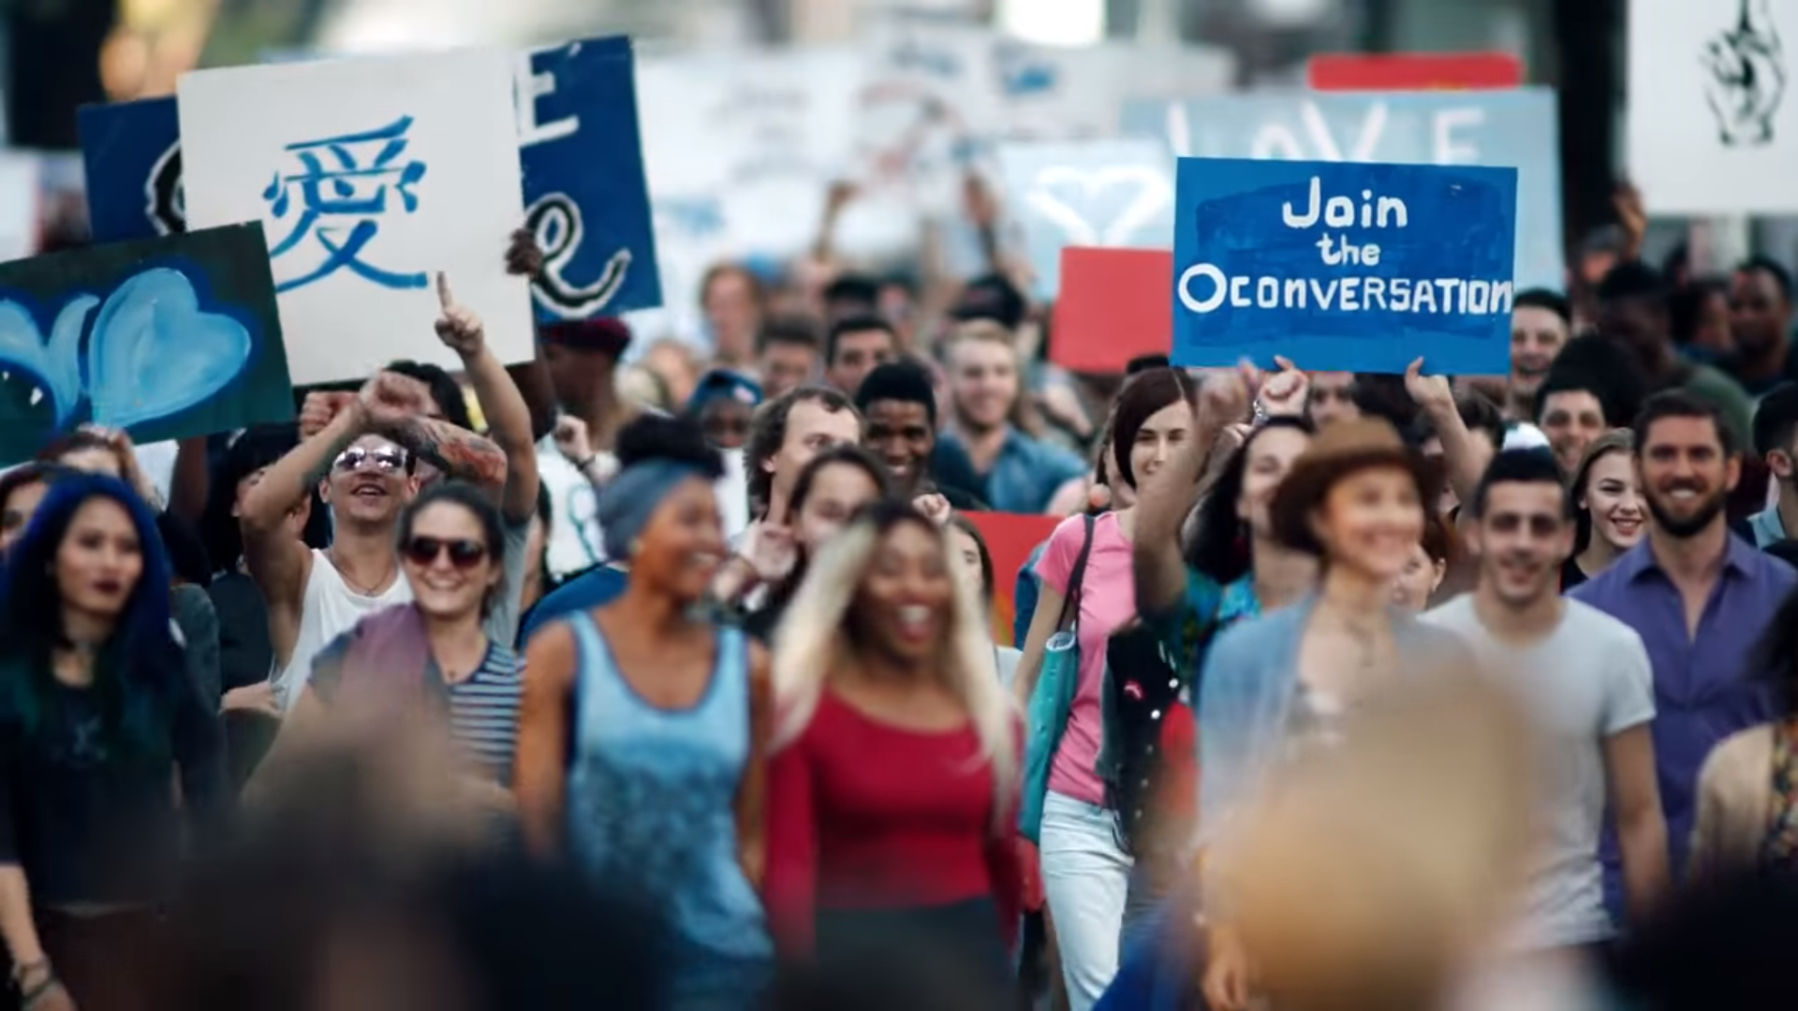
Pepsi have been responsible for one of the most controversial adverts this year. Christopher Hooton, the culture editor for the Independent, described the advert as “The nadir of brands using ethical consciousness to sell products” (2017). Despite Pepsi defending their advert to The Guardian newspaper as “trying to project a global message of unity, peace and understanding”, the advert was pulled within 24 hours of release due to heavy criticism, with Pepsi saying “Clearly, we missed the mark, and we apologise. We did not intend to make light of any serious issue.” (Batchelor 2017). According to Rance Crain, editor-in-chief of AdAge, approximately a quarter of viewers had a “less favourable view of Pepsi” compared to half who had a “more favourable view” (Crain 2017).
The advert opens with a cellist on a skyscraper roof, with Skip Marley’s ‘Lions’ playing in the background. The advert shows a diverse group of people, a frustrated photographer wearing a hijab, a cellist, black men street dancing, transsexuals, a large crowd holding signs, protesting, and super-model Kendall Jenner, at a nearby photo-shoot. Intrigued by the crowd, the model decides to leave the photoshoot, tearing off her wig and handing it to a black woman, in order to join in the protest. The model walks through the crowd, smiling, ‘high fiving’ and ‘fist-bumping’ those around her. As she gets to the front of the protest, the music quietens, she walks past the barrier to a police-officer and hands him a can of Pepsi. As the police-officer takes a drink from the can, the crowd erupts into celebration and cheer. The last scene in the advert shows the model with the protesters walking directly towards the camera, with the strapline, “live bolder, live louder, live for now” appearing on screen.
Figure 5: Pepsi (2017) Pepsi advert with Kendall Jenner
The biggest issue people had with the advert was it appearing to trivialise the Black Lives Matter (BLM) movement (Batchelor 2017). As written by Shanelle Matthews (2017), director of communications for the movement, BLM was created in 2013 after the acquittal of Trayon Martin’s murderer, George Zimmerman, and driven further when a similar thing happened in 2014 with the murder of Mike Brown by Darren Wilson. The aims of the movement are to end state-sanctioned violence against black people, create a network in which black people feel empowered to determine their own destinies within their community and fundamentally to support all black lives. Matthews notes that other black liberation movements have focused on heterosexual, cisgender black men, making the BLM movement unique because it is led by women, queer and trans people.
One of the major factors in the criticism received by this advert was the timing. The advert “was fraught with danger at a time when police clashes with Black Lives Matter demonstrators had everybody on edge” (Crain 2017). Richard Cohen, president of the Southern Poverty Law Center, told LA Times reporter Jaweed Kaleem, “When we look at the number of hate groups, we've seen an increase in the past 15 years.” He goes on to suggest that this increase began when Obama was elected president, and points out that many white supremacist attacks coincided with Obama winning the election. Cohen believes that this is because Obama represented a change that many Americans, at the time, were scared of. Cohen described Trump’s campaign to Kaleem (2017) as “a campaign marked by racism, xenophobia, crude racial stereotypes and anti-Semitic imagery.” He also stated that the day after the presidential election, hate crimes increased significantly. The rise in racism and intolerance resulted in many activists taking to the streets in protest (Kaleem 2017). Examples of this include the protest against Trump’s Muslim ban (England 2017). Another criticism of Trump’s campaign came from Julia Felsenthal (2017), Vogue’s senior culture writer, who described Trump’s campaign as “brazenly misogynistic” and suggested that this was the reason that roughly half a million people felt the need to attend the women’s march in order to empower women across the world and help them feel that they still matter.
The advert stars Kendall Jenner, a “privileged young white model” according to the social media manager of Vogue, Naomi Pike (2017), “using a drink from a large conglomerate (Pepsi) as a peace offering”. The fact that the model used in the advert is white is part of the reason many critics such as Hooton (2017), culture editor for the Independent, think that advert had missed the mark “The model…hands the can to a…police officer who, seeing she is white, calls off the tear gas and graciously accepts the cool beverage.” Many people seem to believe that if the model used were black then the offer of the Pepsi drink wouldn’t have been as well received. It is this specific part of the advert that people seem to find the most insulting. Hooton goes on to narrate the advert “Everyone can go home now, having completed their mission to quench the thirst of local police” (2017). The idea that years of state sanctioned violence and oppression can be solved by an act as simple as this was why people thought that the advert was trivialising the BLM movement. When the advert initially appeared Martin Luther King’s daughter, Bernice King tweeted a photo of the civil rights leader facing a shielded police officer during a protest with the caption “If only Daddy would have known about the power of Pepsi” (Batchelor 2017). According to Nicolson (2017), editor-in-chief of Vice UK and a writer for The Guardian, many others took to social media to criticise the advert by photoshopping cans of Pepsi into photos of police brutality and poignant moments of Black history.
According to Sheehan, “Soft drink commercials seek to provide consumers with little entertainment breaks” (Sheehan 2004: 6). This would suggest that trying to project a message of global unity, is misplaced in a Pepsi advert, and the lack of relevance could explain why consumers felt that Pepsi was insensitive and trivialising the movement rather than promoting equality and inclusivity.
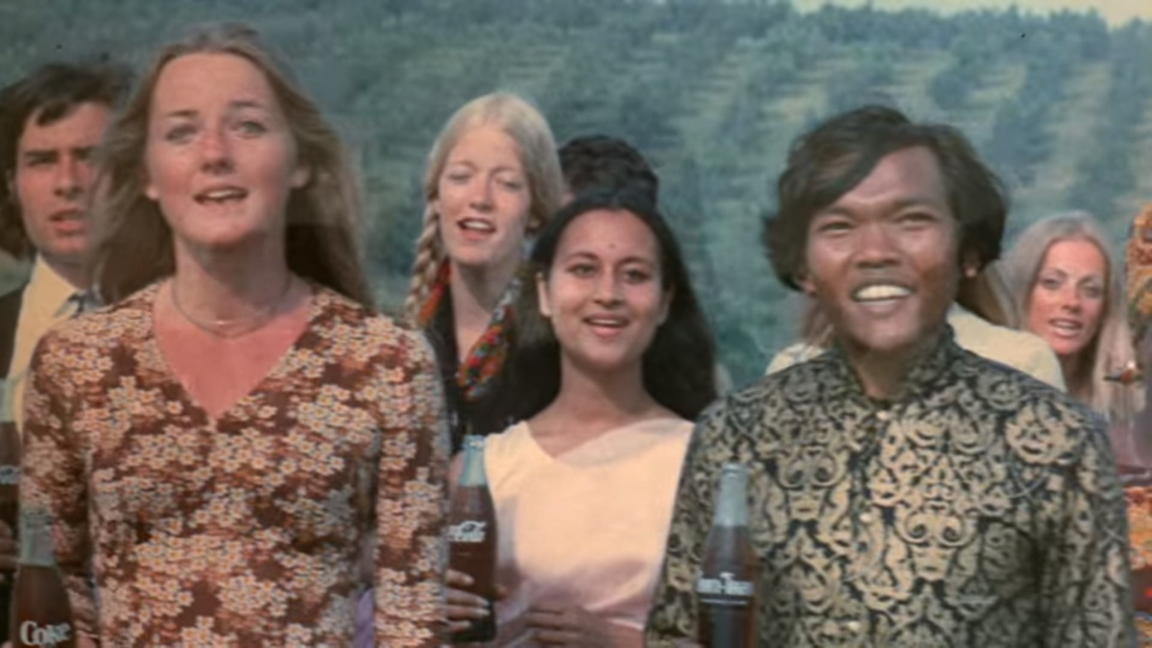
The advert has been compared by many to an advert for Coca Cola, from 1971. The Coca-Cola advert features a group of “bohemian-looking, racially diverse young people” singing about togetherness with the song “I’d like to buy the world a Coke”. This advert did not raise controversy but was instead praised by many and has been dubbed “The most famous use of activism in advertising history”. Nicholson suggests that the reason for this is likely to be because of what was going on at the time “I think it as the flower-power era, and most of America was tired of the Vietnam war” (Nicholson 2017). Crain agrees saying that the Coke commercial ran during the war with the same intention as the more recent Pepsi advert, promoting peace and unity. Crain then goes on to question why no-one found the Coca-Cola advert to be trivialising the war in Vietnam and thinks that if the advert were to be released today, people would question the relevance of people singing on a hill top about togetherness and cola (Crain 2017).
Figure 6: Coca Cola. (1971) I'd Like to Buy the World a Coke
Although people may argue that Pepsi never intended for their advert to be controversial, it is clear that Pepsi were trying to convey their message through showing visuals of protests and should have anticipated the reaction from consumers. Sheehan argues that it is important for brands to anticipate the reaction people will have to an advert, so Pepsi should have done more research and asked for feedback before releasing the advert (Sheehan 2004). Nicola Kemp, trends editor at Campaign Magazine, in an interview with The Guardian, notes that the advert was created by an in-house team at Pepsi, so it is plausible that nobody realised the deficiencies before the advert aired.
In Kemp’s interview she argues that the advert was “tone deaf” and “failed to make any political point”; she goes on to say “it stood for nothing, with these anodyne signs, and it still created a backlash”. The signs that Kemp is referring to, read “join the conversation”, “peace” and “love”. If these signs had more meaning and were referring to a specific conversation then the advert could have been justified for either raising awareness and shedding light on problems in the world. However, by failing to take a political stance on an issue, the advert is appearing to promote unity but not actually saying anything meaningful (Nicholson 2017).
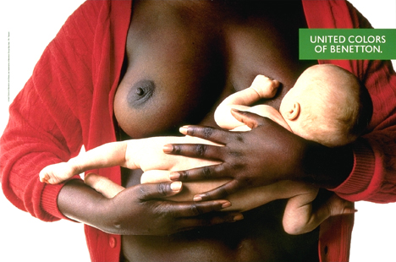
Oliviero Toscani for United Colors of Benetton, 1989, Black Women Breast-feeding White Child
In 1989, when Toscani was well established at Benetton and already well-known for his controversial adverts, this advert was released, showing a black woman appearing to breast feed a white child. According to Poyner the advert had to be pulled after causing mass outrage in America (Poyner 2006).
Figure 7: Toscani O. (1989) Black Woman Breast-Feeding White Child
Figure 7: Toscani O. (1989) Black Woman Breast-Feeding White Child
Despite Toscani’s claims that the advert was promoting peace and harmony, one of his most popular messages amongst “multi-culturalism, world peace and racial harmony” (Tinic 1997: 9), sceptics found the advert to be an insensitive reminder of slavery. As Gwyn Campbell, a widely published author specialising in economic history, states, “black women (enslaved and free) raising white children” was common-place amongst western society. He goes on to suggest that the controversy surrounding the advert was “largely because it triggered recollections of precisely the same exploitative histories within slavery” (Campbell 2014: 54). As Trena Armstrong, master in Pan-African Studies, notes, nearly 90 percent of black women in the southern states worked as maids. She describes the living conditions of these women as “dehumanizing and exploitative” (Armstrong 2012: iv). This idea is shown in the film ‘The Help’ (2012), directed by Tate Tylor, set during the civil rights movement in 1962. The Help recounts how black maids, despite being trusted to look after white children, were not even allowed to use the same toilets because it was regarded insanitary. The film also shows how powerful white people were at the time and how fearful black people were as a result, too scared to break any rules or speak out against the injustice. However, we must question whether this is an accurate source of information as the film, The Help, although loosely based on true stories, is fictional and as Armstrong points out we should question how effectively “white filmmakers, producers and authors…portray accurate life experiences of African American women” (2012: 1). Campbell, a more reliable source, agrees and suggests a similar narrative to the film, stating “black female sexuality and fertility were intimately tied to white power and control both during and after slavery.” (2014: 54) The timeline means that many of the white children nursed by these black women in the 1960s would have seen the advert, probably evoking feelings of guilt.
Whilst some people may see this as social justice, if we look at Fusco’s (2003: 16) ideology, the blame could be put on the audience for stereotyping the subjects based on their skin pigmentation rather than the brand. Another interpretation of Fusco’s philosophy would suggest that the advert is not justified as, regardless of Toscani’s intentions, drawing attention to the difference between races is not healthy for society and increases the opportunity for racist accusations to be made.
Although it could be argued that drawing attention to racial differences is not healthy, photography does essentially represent what we see, in a sense the visual reality. This advert could work as a form of education or at least limiting ignorance as it does make people think.
Chapter 3: Disease
Introduction
As Peter Twohig, professor of historical art at Saint Mary’s University, points out, models used in adverts are often chosen for their desirability. Although, seeking a relatable, realistic model, that consumers can aspire to, advertisers rarely choose someone who is unfit and poorly groomed because they want the advert to look as appealing as possible, with some advertisers claiming it is to promote better health consciousness (Twohig 2008: 53). This means that when we see someone in an advert who is unkept with a life-threatening disease, so unhealthy they are dying, it breaks the social norm, making the advert stand out and seem shocking.
The HIV/AIDs Epidemic
HIV (Human Immunodeficiency Virus) is described by the NHS (National Health Service 2017) as a virus, weakening the immune system, making your body more susceptible to everyday infections and less able to fight diseases. The term AIDS (acquired immune deficiency syndrome) refers to a number of potentially life-threatening infections and illnesses that are result of severe damage to the immune system caused by the HIV virus (NHS 2017.,
AIDs is one of the deadliest diseases. The World Health Organisation believes AIDs has been responsible for around 1.2 million deaths a year (Gallagher for BBC News 2015). The AIDs epidemic started during the 1980s and the majority of people affected were gay males. HIV and AIDs was initially portrayed in the media as a “gay disease” (MacIsaac 2017: 2). Kathryn MacIsaac, Editor at Canadian Institutes of Health Research, claims that this led to the “white, heterosexual, nondrug user” thinking that they were invincible which created a negative stigma for people with the disease (2017: 2).
This caused a wave of gay activists fighting for both medical funding and compassion, which was met with heavy criticism, as at the time, many Americans were not liberal in their attitudes towards gay sex. According to Michael Klarman (2013), a Harvard professor, in 1990 about 75 % of Americans believed homosexual sex to be immoral. However, as the decade progressed people slowly became more accepting. Bonnie Morris, a professor at Washington University, suggests that this could have been due to greater representation in the media.
Oliviero Toscani, A Man Dying of AIDs, 1992
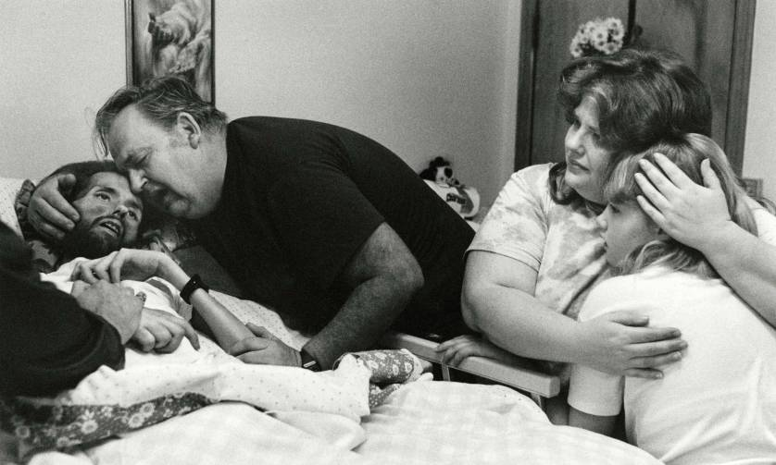
According to Ben Cogrove, a writer for TIME Magazine, the original photograph used in the advert was taken by Therese Frare, a journalism student, volunteering at an AIDs hospice, in 1990. The image shows David Kirby, a gay rights activist during the 1980s, surrounded by his distraught family, as he dies at the age of 32 and was published in LIFE Magazine in 1990. Some years later, in 1992, Toscani decided to use the photograph as part of his campaign with the ‘United Colors of Benetton’, with Kirby family’s permission (Cosgrove 2014).
Figure 8: Frere T. (1990) David Kirby On His Deathbed
Frare’s photograph was already reasonably well-known before The United Colors Of Benetton decided to use it. According to TIME, the image had been adopted as a symbol of the AIDs epidemic. This may explain some of the public outrage when the image became used to push sales of material goods. Toscani explains why he chose to use that specific image in the advert
“When I saw Theresa’s image in LIFE, I said: ‘That’s the picture’. [David] looks like Jesus Christ but he’s dying of AIDS. It’s like a painting,” (Genova 2016)
The fact that Toscani thought David Kirby looked like Jesus was probably fundamental in the decision to use the photo for the advert because there was a long running divide between the gay movement and traditional religious beliefs. As late as 1993, homosexual acts were viewed as a sin, with some right wing religious groups in America believing that AIDs was God’s punishment for being gay (Morris 2017). Using the image knowing Kirby looked like Jesus could have understandably upset many of the aforementioned religious groups by appearing blasphemous.
Instead of just using the photograph as it had appeared in the magazine, he decided to colourise the image. As Dave Saunders, author of the Best Ads series and photographic journalist, writes,
“Benetton changed away from the symbolic studio images of colourful black and white frivolity to a hornet’s nest of controversy. The spring 1992 campaign left the studio and addressed real world issues with real life photographs.” (Saunders, 1996, p51)
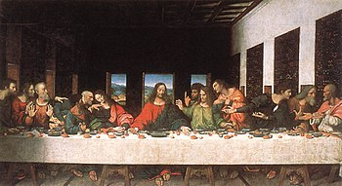
It was thought that the colourisation of the image added to the controversy surrounding the advert, as adding colour would make the image seem more realistic and up to date. The image would have needed to look realistic as it would help the viewer identify and relate to the image easier and feel more empathy for David Kirby and his family, which was important because many people were unsympathetic to the issue at the time and found AIDs unpleasant to discuss. Using oil paints to colourise the image, makes the image appear similar to classical, religious art, such as Last Supper (1498) by Leonardo Da Vinci, as does the emotion on the faces of the Kirby family. Colourising the image also helps Toscani dissociate the advert from the clichéd black and white style, often used in charity adverts that try to tap into consumers’ emotions.
Figure 9: Da Vinci. (1498) Last Supper
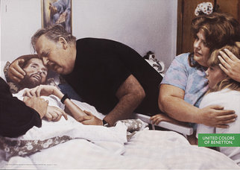
Once the advert had made it to print, it raised a lot of questions. Many people failed to see the connection between the ‘United Colors of Benetton’ and the AIDs epidemic, finding the use of the imagery to be distasteful and exploitative (V&A Museum, ND). In an interview with CNN (2010) Moray Maclennan, CEO of advertising agency M&C Saatchi, said “The perceived intrusion of a very private grief-stricken moment and to plaster it up on a poster for selling sweaters, I think it was that juxtaposition that really shocked people.” Suggesting that the intrusive element of Toscani’s advert was what made it so memorable and, arguably, successful.
Figure 10: United Colors of Benetton, (1992) Man Dying of Aids
However, Maclennan does not seem to consider the morality of the advert. As Cage (2012) suggests, if a more charitable, ethical or non-profit company had produced the advert people would be able to morally justify the use of the image, despite finding it difficult to look at. This is similar to what Saunders proposes when he suggested that United Colors of Benetton used social issues purely to appear altruistic. He goes on to say consumers saw through the façade, suggesting that the company were purely exploiting AIDs sufferers, and stripping them of their dignity, in order to sell more clothing. Saunders proposes that the anger is caused by consumers feeling misled and being dubious of Benetton’s reason to use the image, almost suggesting that Benetton are trying to guilt-trip them in some way (Saunders 1996, p34). Maclennan, Cage and Saunders all seem to agree that this is a very unusual advertising tactic for a fashion brand in the 90s. On the other hand, others may see the advert and think that the use of the image by Benetton make the brand more ethical and charitable by raising awareness for AIDs instead of showing the generic pictures of clothing that we would expect to see.
It is clear that Toscani saw the advertising space of United Colors of Benetton as a potential global communication platform and felt that it should be used to draw attention to difficult subjects that society did not want to talk about. He suggests that the criticism he receives for the adverts is misplaced and that people should be angry with themselves for avoiding difficult topics (CNN 2010). David Kirby’s mother, Kay Kirby, agreed with Toscani. In an interview with Time Magazine she said
“We never had any reservations about allowing Benetton to use Therese's photograph… What I objected to was everybody who put their two cents in about how outrageous they thought it was… We just felt it was time that people saw the truth about AIDS, and if Benetton could help in that effort, fine. That ad was the last chance for people to see…he was once here, among us." (Cosgrove 2014)
David Kirby’s father also supports Benetton’s use of the image in the campaign, stating that people seemed to think the family were being used and exploited, but he felt that they were the ones using Benetton (Genova 2016).
The advert had undeniably helped draw people’s attention to AIDs and shed light onto something that people did not want to talk openly about ; in that respect, it was a success, with a similar justification to his aforementioned work, the Black Woman Breast-Feeding White Child advert, used in 1989.
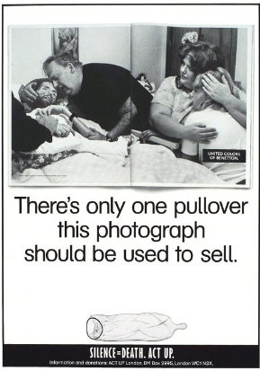
Parodies
The outrage caused by The Man Dying of AIDs advert, was so widely felt by the public, parodies were made, attempting to re-appropriate the photograph and reinstate the original message. This parody was created by the ACT UP (AIDs Coalition to Unleash Power) group. ACT UP began in America in 1987, just 5 years before the original advert was published. Similarly to Queer Nation, ACT UP was created by LGBT (Lesbian, Gay, Bi-sexual, Trans) supporters, seeking compassion and medical funding uniting to help combat AIDs and the stigma attached to it (Morris 2017). The copy in the advert implies that using the photograph to sell clothing is immoral and exploitative, which is surprising given the stance of the organisation behind the spinoff. If a group who are keen for society to address the issue of the AIDs epidemic, still found the original advert to be in poor taste, it raises the question, did Toscani go too far? However, the “silence = death” message at the bottom of the advert could be interpreted to mean that discussing the topic of AIDs save lives and therefore justifies the use of the photograph in the original advert.
Figure 11: Act-Up London (1992)
Conclusion
As Sheehan suggests controversy arises when audiences create their own meanings based on their worldviews, therefore sometimes interpreting the message differently to the brands intention (2013: 253). Adverts communicating with a single image, or a vague narrative are more susceptible to misinterpretation due to only forming half of the statement that advertisers are trying to convey (Poyner 2006). However, leaving the message open to interpretation can be intentional, like Benetton, who try to encourage discussion about the brand and the issues raised in the adverts.
Finding a single answer is problematic, the answers are specific to each advert, but there are underlying questions that can be applied to most controversial adverts that can inform ones decision. Does raising awareness of an issue or cause justify the use of the advert? How relevant is the adverts message to the brand? How many people are likely to be negatively affected by the advert? How will audience’s perception of the brand change after viewing the advert? Most of the answers to these questions are subjective, which makes it difficult to say whether an advert is justified or not. This explains why, despite the ASA regulating all adverts in the UK, there is still lots of discussion around controversial adverts.

BIBLIOGRAPHY
Books
Barker C. (2004) The SAGE Dictionary of Cultural Studies. London: SAGE Publications Ltd
Campbell G. (2014) Sex, Power and Slavery. 1st ed. Ohio: Ohio University Press.
Brady D. (2015) Essentials of International Marketing. 2nd ed. New York: Routeledge.
Ferrier A. (2014) The Advertising Effect: How to Change Behaviour. 1st ed. Oxford University Press.
Fusco C. (2003) Only skin deep: Changing Visions of the American Self. New York: International Center of Photography/Harry N. Abrams
Gallagher J, Bull C. (1996) Perfect Enemies: The Religious Right, the Gay Movement, and the Politics of the 1990s. 1st ed. New York: Crown Publications.
Garvey J. (2015) The Persuaders: The Hidden Industry That Wants to Change your Mind. Duxford: Icon Books Ltd.
Hegarty J. (2014) Hegarty on Creativity: There Are No Rules. 1st ed. Thames & Hudson.
Jenkins J. (2002) Contemporary Moral Issues. 4th ed. Portsmouth, New Hampshire: Heinemann.
Johnes M. (2016) Christmas and the British: A Modern History. 1st ed. London: Bloomsbury Academic.
Lester P. (2013) Visual Communication: Images with Messages. 6th ed. Belmont, California: Wadsworth Publishing Company.
Lois G. (2012) Damn Good Advice. 1st ed. London: Phaidon.
Twohig P. (2008) Social Studies of Health, Illness and Disease. 1st ed. Amsterdam: Rodopi
Saunders D. (1996) Shock in Advertising. 1st ed. London: Batsford Design Books.
Sheehan K. (2013) Controversies in Contemporary Advertising. 2nd ed. London: SAGE Publications.
Sobczak J. (2015) Professionalism in Journalism in the Era of New Media. 1st ed. Berlin: Logos Verlag.
Stoddard B. (2006) Warman's Pepsi Field Guide. Lola, 1st ed. Wisconsin: Krause Publications.
Tungate M. (2007) Adland: A Global History of Advertising. 1st ed. London: Kogan Page Publishers.
E-Books
Cage M. (2012) Marketing is Violence: A User Guide. Kindle Edition, London: Not So Noble Books
Films
The Help. (2012) [DVD] Tate Taylor, Burbank, California: Touchstone Productions.
Journals
Tinic, Serra A. (1997) United Colors and United Meanings: Benetton and the Commodification of Social Issues. Journal of Communication 47:3, 3-25
Theses
Armstrong T E. (2012) The Hidden Help: Black Domestic Workers In The Civil Rights Movement. Masters. Louisville, Kentucky: University of Louisville.
Holz K. (2007) Shock advertising. Are consumer responses affected by culture? A case study on Benetton campaigns under Oliviero Toscani examining German and English responses. Masters. Birmingham: University of Birmingham.
Kubacka N. (2012) ”There Are No Shocking Pictures, Only Shocking Reality”. – Oliviero Toscani. The power and role of Benetton’s shockvertising. Masters. Ylivieska, Finland: Centria University of Applied Sciences.
Online Journals
AdAge. (2003) Benetton Encyclopedia of Advertising. AdAge. [ONLINE] Available at: http://adage.com/article/adage-encyclopedia/benetton/98948/. [Accessed 25 November 2017].
Faull J. (2017) Ad of the Day: Mulberry - A Mulberry Miracle. The Drum. [ONLINE] Available at: http://www.thedrum.com/news/2015/11/07/ad-day-mulberry-mulberry-miracle. [Accessed 30 November 2017].
Poyner R. (2006) Benetton Hits Middle Age. Creative Review. [ONLINE] Available at: https://www.creativereview.co.uk/benetton-hits-middle-age/. [Accessed 24 November 2017]
Pye W. (2001) Jiang Zemin's Style of Rule: Go for Stability, Monopolize Power and Settle for Limited Effectiveness. The China Journal, 45, 27. [ONLINE] Available at: http://www.journals.uchicago.edu/doi/pdfplus/10.2307/3182366. [Accessed 23 November 2017].
MacIsaac E. (2017) AIDS Represented Within the Media. Dalhousie Journal of Interdisciplinary Management. [Online]. 13, 2 - 10. Available at: https://ojs.library.dal.ca/djim/article/download/6923/6046 [Accessed 27 November 2017].
Websites
Advertising Standards Authority. (2015) Advertising and religion: Avoiding offence. [ONLINE] Available at: https://www.asa.org.uk/news/advertising-and-religion-avoiding-offence.html. [Accessed 01 December 2017].
Batchelor T. (2017) Pepsi Advert with Kendall Jenner Pulled After Huge Backlash. [ONLINE] Available at: http://www.independent.co.uk/arts-entertainment/tv/news/pepsi-advert-pulled-kendall-jenner-protest-video-cancelled-removed-a7668986.html. [Accessed 3 May 2017].
BBC. (2005) Timeline: Fight for gay equality. [ONLINE] Available at: http://news.bbc.co.uk/1/hi/uk/4530803.stm. [Accessed 24 October 2017].
Boult A. (2015) Are you offended by this Mulberry advert?. [ONLINE] Available at: http://www.telegraph.co.uk/culture/tvandradio/12067078/Are-you-offended-by-this-Mulberry-advert.html. [Accessed 30 November 2017]
Carter C. (2013) Nelson Mandela: His impact on American activism, politics and pop culture. [ONLINE] Available at: http://edition.cnn.com/2013/12/06/us/mandela-american-impact/index.html. [Accessed 24 October 2017].
CNN. (2010) CNN Revealed: Oliviero Toscani. [Online Video]. 19 August 2010. Available from: http://edition.cnn.com/2010/WORLD/europe/08/13/oliviero.toscani/index.html. [Accessed: 12 August 2017].
Cosgrove B. (2014) The Photo That Changed The Face Of AIDs. [ONLINE] Available at: http://time.com/3503000/behind-the-picture-the-photo-that-changed-the-face-of-aids/. [Accessed 10 October 2017]
Crain R. (2017) Could Coke Still Teach the World to Sing?. [ONLINE] Available at: http://adage.com/article/rance-crain/coke-teach-world-sing/308859/. [Accessed 26 November 2017].
Curry J. (1990) A Gay Protest Against Attacks Becomes Violent. [ONLINE] Available at: http://www.nytimes.com/1990/06/18/nyregion/a-gay-protest-against-attacks-becomes- violent.html. [Accessed 24 October 2017].
Elliott S. (1991) THE MEDIA BUSINESS - ADVERTISING - Benetton Stirs More Controversy. [ONLINE] Available at: http://www.nytimes.com/1991/07/23/business/the-media-business-advertising-benetton-stirs-more-controversy.html. [Accessed 26 November 2017].
England C. (2017) Donald Trump blamed for massive spike in Islamophobic hate crime. [ONLINE] Available at: http://www.independent.co.uk/news/world/americas/donald-trump-blame-islamophobic-anti-muslim-ban-hate-crime-numbers-southern-poverty-law-center-a7582846.html. [Accessed 26 November 2017].
Felsenthal J. (2017) These Are the Women Organizing the Women’s March on Washington. [ONLINE] Available at: https://www.vogue.com/article/meet-the-women-of-the-womens-march-on-washington. [Accessed 26 November 2017].
Gallagher J. (2015) TB 'joins HIV as most deadly infection'. [ONLINE] Available at: http://www.bbc.co.uk/news/health-34658015. [Accessed 2 November 2017].
Genova A. (2016) The Story Behind the Colorization of a Controversial Benetton AIDS Ad. [ONLINE] Available at: http://time.com/4592061/colorization-benetton-aids-ad/. [Accessed 7 November 2017].
Hooton C. (2017) Pepsi ad review: A scene-by-scene dissection of possibly the worst commercial of all time. [ONLINE] Available at: http://www.independent.co.uk/arts-entertainment/tv/reviews/pepsi-ad-advert-commercial-kendall-jenner-police-protest-black-lives-matter-review-a7667486.html. [Accessed 26 November 2017].
Kaleem J. (2017) 'There's a virus in our country': The 'Trump effect' and rise of hate groups, explained. [ONLINE] Available at: http://www.latimes.com/nation/la-na-southern-poverty-law-center-05312017-htmlstory.html. [Accessed 26 November 2017].
Klarman M. (2013) How Same-Sex Marriage Came to Be. [ONLINE] Available at: https://harvardmagazine.com/2013/03/how-same-sex-marriage-came-to-be. [Accessed 24 October 2017].
Kennedy F. (1999) How we met; Luciano Benetton & Oliviero Toscani. [ONLINE] Available at: http://www.independent.co.uk/arts-entertainment/how-we-met-luciano-benetton-oliviero-toscani-1114425.html. [Accessed 26 November 2017].
Matthews S. (2017) Black Lives Matter: Herstory. [ONLINE] Available at: https://blacklivesmatter.com/about/herstory/. [Accessed 20 October 2017].
Morris BJ. (2017) History of Lesbian, Gay and Bisexual Social Movements. [ONLINE] Available at: http://www.apa.org/pi/lgbt/resources/history.aspx. [Accessed 24 October 2017].
Nicholson R. (2017). From Coke’s flower power to Kendall Jenner’s Pepsi ad – how ads co-opt protest. [ONLINE] Available at: https://www.theguardian.com/business/2017/apr/05/from-cokes-flower-power-to-kendall-jenners-pepsi-ad-how-ads-co-opt-protest. [Accessed 26 November 2017].
NHS. (2017) HIV and AIDs. [ONLINE] Available at: https://www.nhs.uk/conditions/hiv-and-aids/. [Accessed 14 November 2017].
Pike N. (2017) Kendall Jenner's Pepsi Advert Attracts Criticism. [ONLINE] Available at: http://www.vogue.co.uk/article/kendall-jenner-pepsi-advert-black-lives-matter-protest. [Accessed 26 November 2017].
Victoria & Albert Museum, London. (2017) Man Dying of AIDS. [ONLINE] Available at: http://collections.vam.ac.uk/item/O76080/man-dying-of-aids-poster-frare-therese/. [Accessed 1 October 2017].
Smithers R (2017). Rightwing group calls for Greggs boycott over sausage roll nativity. [ONLINE] Available at: https://www.theguardian.com/business/2017/nov/15/greggs-nativity-jesus-sausage-roll-advent-calendar. [Accessed 30 November 2017].
Sweney M. (2015) Mulberry's ‘Blasphemous’ Christmas Ad Escapes Ban. [ONLINE] Available at: https://www.theguardian.com/media/2015/dec/23/mulberry-baby-jesus-christmas-ad-cleared. [Accessed 30 November 2017].
Wong J. (2017) Pepsi pulls Kendall Jenner ad ridiculed for co-opting protest movements [ONLINE] Available at: https://www.theguardian.com/media/2017/apr/05/pepsi-kendall-jenner-pepsi-apology-ad-protest. [Accessed 26 November 2017].

ILLUSTRATIONS
Figure 1: Herring T. (2017) Greggs’ representation of the baby Jesus [ONLINE]. Available at: https://www.theguardian.com/business/2017/nov/15/greggs-nativity-jesus-sausage-roll-advent-calendar [Accessed 29 November 2017].
Figure 2: Adam & Eve/DDB. (2015) #MulberryMiracle. [Online Video]. 7 November 2015. Available from: http://www.thedrum.com/news/2015/11/07/ad-day-mulberry-mulberry-miracle. [Accessed: 30 November 2017].
Figure 3: Toscani O. (1990) Priest Kissing Nun [ONLINE]. Available at: http://collections.vam.ac.uk/item/O232017/united-colors-of-benetton-poster-toscani-oliviero/ [Accessed 29 November 2017].
Figure 4: Toscani O. (1991) Angel and Devil. Available in: Saunders D. (1996) Shock in Advertising. 1st ed. London: Batsford Design Books. Page 84
Figure 5: Pepsi. (2017) Pepsi advert with Kendall Jenner pulled after huge backlash. [Online Video]. 5 April 2017. Available from: http://www.independent.co.uk/arts-entertainment/tv/news/pepsi-advert-pulled-kendall-jenner-protest-video-cancelled-removed-a7668986.html. [Accessed: 3 May 2017].
Figure 6: Coca Cola. (1971) I'd Like to Buy the World a Coke. [Online Video]. 1971. Available from: https://www.theguardian.com/business/2017/apr/05/from-cokes-flower-power-to-kendall-jenners-pepsi-ad-how-ads-co-opt-protest. [Accessed: 26 November 2017].
Figure 7: Toscani O. (1989) Black Woman Breast-Feeding White Child. [ONLINE]. Available at: http://collections.vam.ac.uk/item/O222939/poster-toscani-oliviero/ [Accessed 27 November 2017].
Figure 8: Frere T. (1990) David Kirby On His Deathbed. [ONLINE]. Available at: http://time.com/3503000/behind-the-picture-the-photo-that-changed-the-face-of-aids/ [Accessed 10 October 2017].
Image 9: Da Vinci. (1498) Last Supper. [ONLINE]. Available at: https://www.khanacademy.org/humanities/ap-art-history/early-europe-and-colonial-americas/renaissance-art-europe-ap/a/leonardo-last-supper [Accessed 28 November 2017].
Figure 10: Toscani. United Colors of Benetton. (1992) Man Dying of Aids. [ONLINE]. Available at: http://collections.vam.ac.uk/item/O76080/man-dying-of-aids-poster-frare-therese/ [Accessed 28 October 2017].
Figure 11: Alan Tilby. Act-Up. (1992) There’s Only One Pullover This Should Be Used to Sell. Available in: Saunders D. (1996) Shock in Advertising. 1st ed. London: Batsford Design Books. Page 52

APPENDIX

