Individual Assignment 2

University of Wales Trinity Saint David
LONDON CAMPUS


Module: Community Engagement
Module code: LCBB4002
LECTURER: Toyin Adisa
Title of report: Assignment 2
Student name: Petar Mitev

Blogging to communicate

History of Apple Inc
Apple Inc. is an American multinational technology company which is specialized in the manufacturing of consumer electronics, software and online services. It is headquartered in Cupertino, California where the producer and testing house brought in the research laboratory. Apple Inc. was founded by “Steve Jobs”, “Steve Wozniak”, and “Ronald Wayne”. Apple has different merchandising stores which are famous as Apple stores. It has a product line of “iPhone Smartphone, iPad tablet computer and Macintosh Computer line”. The Apple computer was created by the founders on 1st April 1976, for the marketing of desktop processors and thus built the company on 3rd January 1977. Apple is now a leading company in the field of computer electronics and media sales industries (Valencia, Shahani, and Imam, 2022).
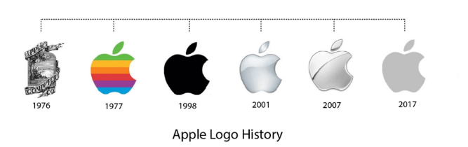
Apple launched its successful iPod music player in 2001 and become the world’s biggest public traded corporation along with improving its market capitalization. In the year 2012, Apple earned worldwide revenue of $156 billion. The company engaged with different industries and brought software and hardware to develop consumer electronics and digital distribution to build different computer techniques with the best facilities and innovations that fable silicon design (Karpyshev et al., 2021, January).
Logo
Apple incorporation is a prominent brand in the whole world. It uses the symbol which is crafted by “Ronald Wayne” who is one of the founders of the company. The logo of Apple incorporated has evolved from 1975 to 2015 and the desire to present gravity through the logo is considered a motivation for the people as science is used in the company’s logo. The logo which was invented by Ronald Wayne was not able to satisfy Steve Jobs as they want innovations in their logo; they explored and decided to show science in it. They combined all the factors in a way that can attract more and more consumers. Later, they appointed a graphic designer named Rob Janoff, who created a classic and world-famous logo in the form of the bitten apple. Steven replaces the old logo which shows Newton’s law with the new updated logo which brings significance. According to the owner of the incorporation, the creation of an apple in a simple form has a strong emphasis. This logo is giving a view of Newton under the apple tree. This was the first slogan used by the Apple incorporation which helped in gaining market in the 1970s (Ali and Mohd Rosli, 2019).
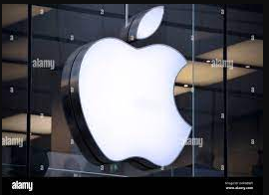
Apple Inc. - Mission and Vision
The mission and vision of Apple Company express all the success strategies that are part of the global market and offer value to its business. The mission and vision of the company encourage employees and support innovations in the competitive market. The mission and vision of the company focus on how the company can achieve growth with the coming challenges. The companies based on the technologies need to plan the strategies according to the statements of mission and the vision of the company is required to direct the efforts of the business toward the leadership’s future in the international market (Baztán Vargas, 2020).
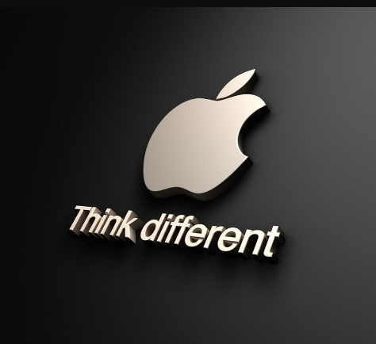
The mission of Apple is “To bring the best user experience to its consumers through its innovative hardware, software, and services”. It offers a good culture to the organisation as the designers and innovators are motivated by it. The vision of the company is that “We believe that we are on the face of the earth to make great products and that is not going to change in any manner. Why does it matter?” The mission statement of the company satisfies some conventions which are mentioned in the ideal corporate mission statements. The vision statement of the company also satisfies some of the conventional characteristics of the ideal corporate vision statement (Krajewski, 2021). 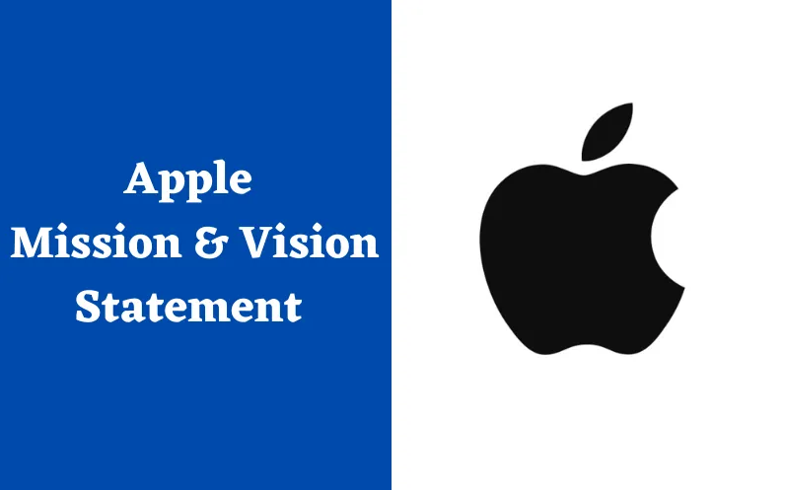

The objective of the company is to eliminate carbon footprint and emissions from the environment, as it is beneficial in producing products through different resources from the capacity of the earth. This is important to bring the best outcomes from the operations. So many facilities are brought by the organisation which helps in manufacturing the product. The carbon emission decreased by Apple at least 35% in recent years and also Apple aimed to exist in the market in the best way and gain a dominating position in the market. The objective of Apple is to produce the best product on the earth and contribute to making the environment better (Karpyshev et aL., 2021, January).
Marketing mix of Apple Inc
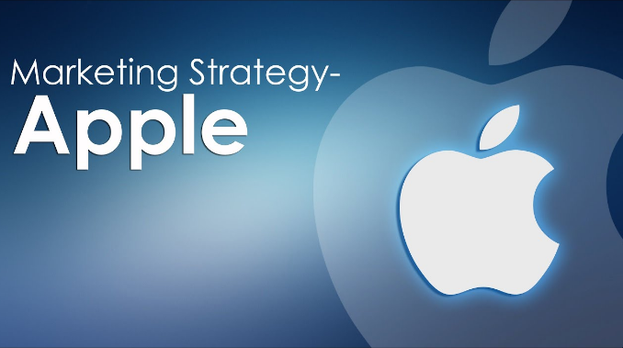
Strategies
Product refers to an object which generates demand with a high level of interest. Apple is famous for introducing innovative products which gained huge interest from consumers. The products of Apple are lined over time and fulfil the global requirements at the ultimate stage. It considers all the items which include every possible service and facility. In the advertisement mix, the product component helps in identifying that Apple is using most of its automated business (Baztán Vargas, 2020). Apple offers a variety of products including “Mac, iPad, iPhone, Apple Watch and Apple TV’. There are some services too which are offered by Apple like “Apple Music, iCloud, Apple news, books, arcade, podcasts, and fitness+ apps. The main focus here is on quality, not quantity. Different products are improved by the branching and innovations in the designs concerning other products of the same line. Apple has a diversified business in the field of computer technology at the advanced level in respect of all the procedures related to automation (Ali and Mohd Rosli, 2019).
Apple Pricing Strategy
Apple builds its value by itself as the most expensive product. The range of the products is categorized into the higher end of the products only and then the potential consumers are targeted by companies who can afford the products. It is created as the price premium policy and also a symbol of status is maintained which attracts the consumers at a huge level. Apple fixed at a certain level, no matter what are the prices other competitors are following, which means the company wants to maintain its image in the market. Great knowledge increases the quality of the products. Apple never offers their product the sale as they maintain some standards. Thus, the company is following their members which help in maintaining true justification of the products (Krajewski, 2021).
Apple Place strategy
The availability of the products can be seen everywhere worldwide. Apple has various distribution channels which help Apple to reach consumers. Apple uses both online and offline methods of taking orders from their international consumers (Baztán Vargas, 2020). Apple established its stores in different locations to directly deal with the customers. E-commerce platform brings the product directly from Apple’s official website and several different platforms like Amazon, Flipkart, etc. The different corporate sellers helped them in the true authorization. The existence of the company at an international level helps the company is targeting a large range of consumers and also helps in creating awareness of the brand on a global level that changes the behavioural aspects (Karpyshev et al., 2021, January).
Apple promotion strategy
Apple follows different promotional strategies which include the use of different mediums like TV, billboards and online ads. It includes the use of both conventional and modern methods of promotion. The website is linked with it which brings the use of social media in online operations. In their early years, a campaign was launched by Steve Job named the “Think Different” Campaign. The essential value of Apple is “We Believe” because of the passion of customers which helps in bringing change in the world and makes it a better place for survival. This makes the people be self-assured about them and not assume anything else to be proud of them. Apple’s preferment mix brings public relations as a source of attracting users. The main objective of the promotional strategy is to make the customers aware of the use of different products of Apple with an excellent experience (Ali and Mohd Rosli, 2019).

Supply chain strategy
Apple incorporation does not produce all the products on its own as they work based on an outsourcing system. For Example, Mac Computer brings the parts and combines them from several other parts where the parts are available at low prices (Valencia, Shahani, and Imam, 2022). The manufacturing takes place in the United States while the battery part is made in Mongolia, Korea and Taiwan and many different regions along with China, the most developed country. Apple brought near about 60lakhs jobs to the US population and selected various engineers to assign work for the allotted period. Apple develops the designs of the product; develops software and marketing from different areas according to specialization. The different components are combined and are made by using different minerals which brings great resources at the best allocation capacity. In terms of innovations in technology, Korea and Taiwan offers essential components to the corporation (He, 2021, March).
STP of Apple Inc
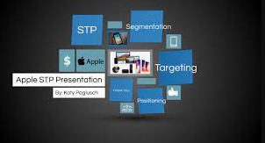
Segmentation
Apple uses the geographic fundamentals in the development of merchandising stores at the global level. The distribution of Apple products is based on the size of the family and the age group of 18-45 years. The targeted audience is the high earners who are usually at the bachelor stage and newly married couples (NIK SOH, 2019).
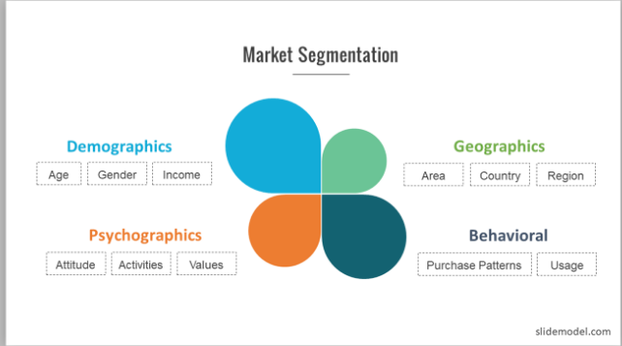
Targeting
Apple Company builds its image as the best provider of products and services in the global market with high-quality features and forward-thinking functions. Apple comes up with innovative designs for the population who are willing to pay more. Some so many consumers look for “speed and service, efficiency and advanced features along with the tools”. The company so produce products according to the requirements of the consumers (Bahador, 2019).
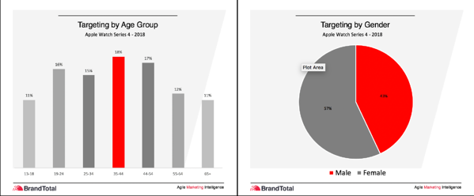
Positioning
Positioning is linked with the pattern of competition in the market in a particular industry. This approach focus on investing in the field of research and development to offer the consumers innovative features in the products. The unique ideas are used in automation which cannot be copied. An emotional connection is important to build with the customers to make the survival of the company easy in the global market (Romppanen, 2021).

References
- Ali, N.H. and Mohd Rosli, R.A.H., 2019. Digital Technology: e-Content Development using Apple Technology. Malaysian Journal of Distance Education, 21(1).
- Bahador, M.H.H., 2019. The effect of marketing mix on organizations performance. In 1st Strategic Management Conference 2019.
- Baztán Vargas, T., 2020. Strategies for Promoting Sustainability in SupplyChain Management.
- He, M., 2021, March. Analysis of iPhone’s Marketing Strategy. In 6th International Conference on Financial Innovation and Economic Development (ICFIED 2021) (pp. 669-672). Atlantis Press.
- Karpyshev, P., Ilin, V., Kalinov, I., Petrovsky, A. and Tsetserukou, D., 2021, January. Autonomous mobile robot for apple plant disease detection based on cnn and multi-spectral vision system. In 2021 IEEE/SICE international symposium on system integration (SII) (pp. 157-162). IEEE.
- Krajewski, L.J., 2021. Operations Management: Processes and Supply.
- NIK SOH, N.N., 2019. AN ANALYSIS OF AN EXPLANATION OF APPLE INC.
- Rajput, R., 2021. CONSUMER PERCEPTION TOWARDS THE APPLE COMPANY.
- Romppanen, J.M., 2021. Segmentation, Targeting & Positioning (STP).
- Valencia, J., Shahani, N.U.N. and Imam, S.S., 2022. The Concept of Creativity: Understanding Importance and Role in Business. Available at SSRN 4017291.

