Component 2

Project Appraisal
Student Name: Martin Kehayov
Student Number: 2209792
Lecturer Name: Dr. Olu Adegbite
LCBB5005

Contents
Introduction 1
Definition of project management 2
Importance of Project Appraisals 2
Overview of the Three Selected Projects 2
Methods of appraisal 4
Financial Method 4
Net Present Value 4
Return on Investment 6
Summary 8
Non-Financial Method 9
Decision Tree Analysis 9
The Multi-Weighted Scoring Model 10
Decision and Conclusion 11
Decision: 12
Conclusion 12

Introduction
This writing will analyse 3 projects, A-Solar Plant Installation. B- eCommerce platform and C- healthcare mobile application and evaluate them, based on financial and non-financial methods in order to appraise the 3 projects. To begin with, let’s find out what Project Management actually is and why is it important to appraise the projects before investing in them.

Definition of project management
Project management is the process of organising and planning a company's resources to get a specific task, event, or obligation closer to completion. It could involve a one-time project or ongoing operations involving the management of personnel, finances, technology, and intellectual property as resources. (Investopedia, 2021)

Importance of Project Appraisals
Project appraisal is the process of looking at and evaluating a project in order to accept or reject it. It involves analysing the issue or need that the project is meant to solve, formulating several approaches to solve the issue, deciding on the most suitable option, assessing the option's viability, creating a solution statement, and identifying all parties affected or involved in the project and its expected results. Project assessments are crucial because they help determine whether a project is sustainable. (Morkovich, 2011)

Overview of the Three Selected Projects
This is a project for a utility-scale solar power plant installation. The site chosen has very high solar irradiation throughout the year. The plant will be based on PV technology using solar cells, with inverters and the grid connection system to feed electricity into the local grid. The project would aim to have an installed capacity of 10 MW that could supply power to about 2,000 households. The aim would be to lower the community's reliance on fossil fuels and encourage the usage of sustainable energy. Also, several employment opportunities are generated during construction and operation, while a large number of educational opportunities are given to local schools and universities on ways of tapping renewable energies.

Project A (Solar Power Plant installation)
This project involves the installation of a large-scale solar power plant. The chosen site receives abundant sunlight throughout the year, making it ideal for solar energy generation. The plant will consist of photovoltaic (PV) panels, inverters, and a grid connection system to convert solar energy into electricity and feed it into the local power grid. The project will have an installed capacity of 10 MW, sufficient to power approximately 2,000 homes. It aims to reduce the community’s dependence on fossil fuels and promote sustainable energy practices. Additionally, the project will create jobs during the construction and operational phases and provide educational opportunities for local schools and universities to learn about renewable energy.
Vision: To generate sustainable and renewable energy to reduce carbon footprint.
Mission: To address energy shortages and promote green energy solutions.
Project B (E-commerce Platform Development)
This project is related to developing a holistic e-commerce platform that engages users in easy shopping. Users will find friendly interfaces, secure payment gateways, and efficient logistics management systems. Important functionalities include personalized recommendations, customer reviews, multiple payment options, and a mobile app for on-the-go shopping. It will cater to different ranges of products like electronics, clothing, groceries, and household items. The system will also have advanced analytics to monitor customer behaviour and optimize marketing strategies. It is believed that the convenience and assurance of security provided by an online shopping platform developed for its customers will attract a large customer pool, increase brand loyalty, and consequently enhance sales revenues.
Vision: To enhance the shopping experience through digital transformation.
Mission: To provide a robust online shopping platform catering to a wide range of products.

Project C (Healthcare mobile application)
This project involves the development of a mobile application for the provision of healthcare services. Through it, users can book an appointment with their doctors, get online consultations, and securely access their medical records. It will feature a symptom checker, medication reminder, and health tracker to aid users. The app facilitates patient-provider communication and can be used for remote monitoring and follow-up consultations. This will be done in a way that integrates with existing healthcare systems to ensure ease in data sharing and, hence, care coordination. The project looks forward to improving patient convenience and reducing the time of waiting for best outcomes in healthcare delivery. The technology-reliant app shall further health outcomes and patient satisfaction.
Vision: To improve healthcare accessibility and efficiency.
Mission: To offer a mobile application for booking appointments, consultations, and accessing medical records.

Methods of appraisal
To evaluate these projects, both a financial and non-financial method will be used.
Financial method: Net Present Value (NPV) and rate of return.
Non-financial method: Decision Tree and Multi Weighted Scoring Model

Financial Method

Net Present Value
According to Fernando (2024), Net present value (NPV) is the difference between the current worth of cash inflows and outflows over a specific time period. In capital budgeting and investment planning, net present value, or NPV, is used to evaluate the profitability of a projected investment or project.
The present value of a future stream of payments is calculated using the proper discount rate, and the result is the net present value. In general, it is advisable to pursue projects with a positive net present value (NPV) rather than those with a negative NPV.

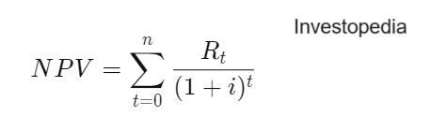
where:
Rt =net cash inflow-outflows during a single period t
i=discount rate or return that could be earned in alternative investments
t=number of time periods
​
Calculations:
Project A
- Initial Investment: £1,000,000
- Annual Cashflow: £280,000
- Discount Rate: 8%
- Project Life: 6 years
- Net Present Value (NPV): £ 294,406,31
Year 1: 280,000/(1+0.08)^1=£ 259,259,26
Year 2: 280,000/(1+0.08)^2=£ 240,054,87
Year 3: 280,000/(1+0.08)^3=£ 222,273,03
Year 4: 280,000/(1+0.08)^4=£ 205,808,36
Year 5: 280,000/(1+0.08)^5=£ 190,563,3
Year 6: 280,000/(1+0.08)^6=£ 176,447,5
NPV=259,259,26+240,054,87+222,273,03+205,808,36+190,563,3+176,447,5- Initial Investment(1,000,000)= 294,406,31

Project B
- Initial Investment: £750,000
- Annual Cashflow: £150,000
- Discount Rate: 10%
- Project Life: 7 years
- Net Present Value (NPV): £-19,737,18
For calculations for Project B and C, please see the appendix.
Project C
- Initial Investment: £800,000
- Annual Cashflow: £250,000
- Discount Rate: 7%
- Project Life: 5 years
- Net Present Value (NPV): £225,049,36

Return on Investment
Return on investment (ROI) is a performance metric that is used to evaluate an investment's profitability or efficiency or to compare the efficacy of multiple different investments. The goal of ROI is to determine the precise return on an investment compared to its cost.
ROI is calculated by dividing the investment's profit (or return) by its cost. The result is expressed as a ratio or as a percentage. (Fernando, 2024)

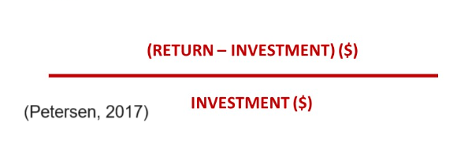

Calculations for Each Project
Project A
- Initial Investment: £1,000,000
- Annual Cashflow: £280,000
- Project Life: 6 years
Total Cash Inflows = Annual Cashflow x Project Life = £280,000x 6 = £1,680,000
Total Net Profit = Total Cash Inflows - Initial Investment = £1,680,000 - £1,000,000 = £680,000
ROI= (680,000/1,000,000)×100=68%
Project B
- Initial Investment: £750,000
- Annual Cashflow: £150,000
- Project Life: 7 years
Total Cash Inflows = Annual Cashflow x Project Life = £150,000 x 7 = £1,050,000
Total Net Profit = Total Cash Inflows - Initial Investment = £1,050,000 - £750,000 = £300,000
ROI=(300,000/750,000) x 100=40%
Project C
- Initial Investment: £800,000
- Annual Cashflow: £250,000
- Project Life: 5 years
Total Cash Inflows = Annual Cashflow x Project Life = £250,000 x 5 = £1,250,000
Total Net Profit = Total Cash Inflows - Initial Investment = £1,250,000 - £800,000 = £450,000
ROI=(450,000/800,000) x 100=56.25%
Summary of ROI
- Project A ROI: 68%
- Project B ROI: 40%
- Project C ROI: 56.25%
Based on the ROI calculations, Project A has the highest ROI at 68%, followed by Project C at 56.25%, and Project B at 40%.

Summary
Based on the financial analysis using the Net Present Value (NPV) and Return on Investment (ROI) methods, Project A emerges as the most favourable investment choice among Projects A, B, and C.
Net Present Value (NPV): Project A has the highest NPV of £294,406.31, indicating that it is expected to add the most value in present terms after accounting for the discount rate.

Return on Investment (ROI): Project A also boasts the highest ROI at 68%, indicating a high return relative to its initial investment compared to Projects B (40%) and C (56.25%).

Overall Assessment: Project A not only has the highest NPV and ROI but also aligns well with the investment criteria typically favoured for maximizing financial returns. Its strong cash flows, relative to its initial investment and discount rate, make it the most attractive investment choice among the three options presented.

Non-Financial Method

A decision tree analysis can be used to visually show the expenses, consequences and potential outcomes of a challenging decision. When analysing quantitative data and drawing a numerical conclusion, these trees are quite helpful. A decision tree is a flowchart that starts with a single fundamental idea and branches out based on the decisions you make. The model is called a "decision tree" because it generally has a branching structure similar to a tree. (Asana, 2021)

Project A: Solar Power Plant Installation
Nodes and Probabilities:
- Success: 60% chance
  - Outcomes: High community support sustainable energy production
- Delay: 30% chance
  - Outcomes: Extended timeline increased costs
- Failure: 10% chance
  - Outcomes: Regulatory issues technology failure
Project B: E-commerce Platform Development
Nodes and Probabilities:

- Success: 50% chance

- Outcomes: Increased market reach customer satisfaction

- Delay: 40% chance

- Outcomes: Technical issues delayed launch

- Failure: 10% chance
- Outcomes: Market competition platform security issues
Project C: Healthcare Mobile Application
Nodes and Probabilities:
- Success: 55% chance
  - Outcomes: Improved healthcare access patient satisfaction
- Delay: 35% chance
  - Outcomes: Integration issues user adoption challenges
- Failure: 10% chance
  - Outcomes: Regulatory challenges data security issues

The Multi-Weighted Scoring Model evaluates projects based on various criteria and assigns weights to each criterion. Scores for each criterion are multiplied by the respective weights and summed to provide an overall score for each project. (Morpus, 2024)

Criteria and Weights:
- Strategic Alignment (30%)
- Community Impact (20%)
- Technical Feasibility (20%)
- Scalability (15%)
- Risk Level (15%)
Criteria | Weight | Project A score (1-10) | Project B score  (1-10) | Project C score  (1-10)
Strategic Alignment | 30% | 9 (2.7) | 8 (2.4) | 9 (2.7)
Community Impact | 20% | 8 (1.6) | 7 (1.4) | 8 (1.6)
Technical Feasibility | 20% | 7 (1.4) | 6 (1.2) | 8 (1.6)
Scalability | 15% | 8 (1.2) | 9 (1.35) | 7 (1.05)
Risk | 15% | 7 (1.05) | 6 (0.9) | 7 (1.05)
Total Score |  | 7.95 | 7.25 | 7.95

Decision and Conclusion

Using the finance and non-finance-based analyses, we shall determine which project must be picked. The decision analysis includes NPV, ROI, decision tree analysis and MWSM.
Financial Analysis Recap NPV:
- Project A: £294,406.31
- Project B: £-19,737.18
- Project C: £225,049.36
ROI:
- Project A: 68%
- Project B: 40%
- Project C: 56.25%

Non-Financial Analysis Recap:

Summary of the Decision Trees:
- Project A: Chances of success are high, with manageable risks of delay and failure.
- Project B: Moderate chances of success but with high risks that technical problems will lead to delays.
- Project C: There's a good rate of success, although the chances of delay and failure are moderated by integration and regulatory issues.
Multi-Weighted Scoring Model Summary:
- Project A: Total Score = 7.95
- Project B: Total Score = 7.25
- Project C: Total Score = 7.95

Decision:
Having put all the projects through both financial metrics (NPV, ROI) and non-financial methods (Decision Tree and MWSM), it emerged as project A being the best. It has a high ROI value of 68% and an attractive NPV of £294,406.31. Additionally, this project brings in huge environmental and community benefits, making the investment very rounded.
Project C offers great investment opportunity as well. Having NPV of £225,049,36 and ROI of 56.25%, it will have a huge benefit for the society too. It will improve access to healthcare services for patients and reduce the healthcare costs by minimizing in-person visits. Despite that, It comes second after Project A in the investor point of view.
Lastly, Project B has a negative NPV of £-19,737.18. As a result, the project is a unprofitable investment opportunity and will not be considered any further.

Conclusion
After evaluating the projects using both financial and non-financial methods, Project A: Solar Power Plant Installation is the most favourable. This project offers significant environmental benefits by providing sustainable energy and reducing carbon emissions. It also aligns with long-term energy independence and regulatory compliance, promoting community sustainability. Additionally, Project A has a high likelihood of operational success and offers long-term cost savings. While Project B: E-commerce Platform Development and Project C: Healthcare Mobile Application respectively represent major market potential and substantial improvement in the accessibility of healthcare, all three projects present a combination of environmental impact, community benefits, and alignment with regulatory standards that make Project A the best of class. The strategic implementation plan ensures a comprehensive approach from planning through operating stages, establishing the solar power plant for successful delivery and long-term operation. This comprehensive strategy supports a vision for sustainable energy and community benefit that the project envisions.

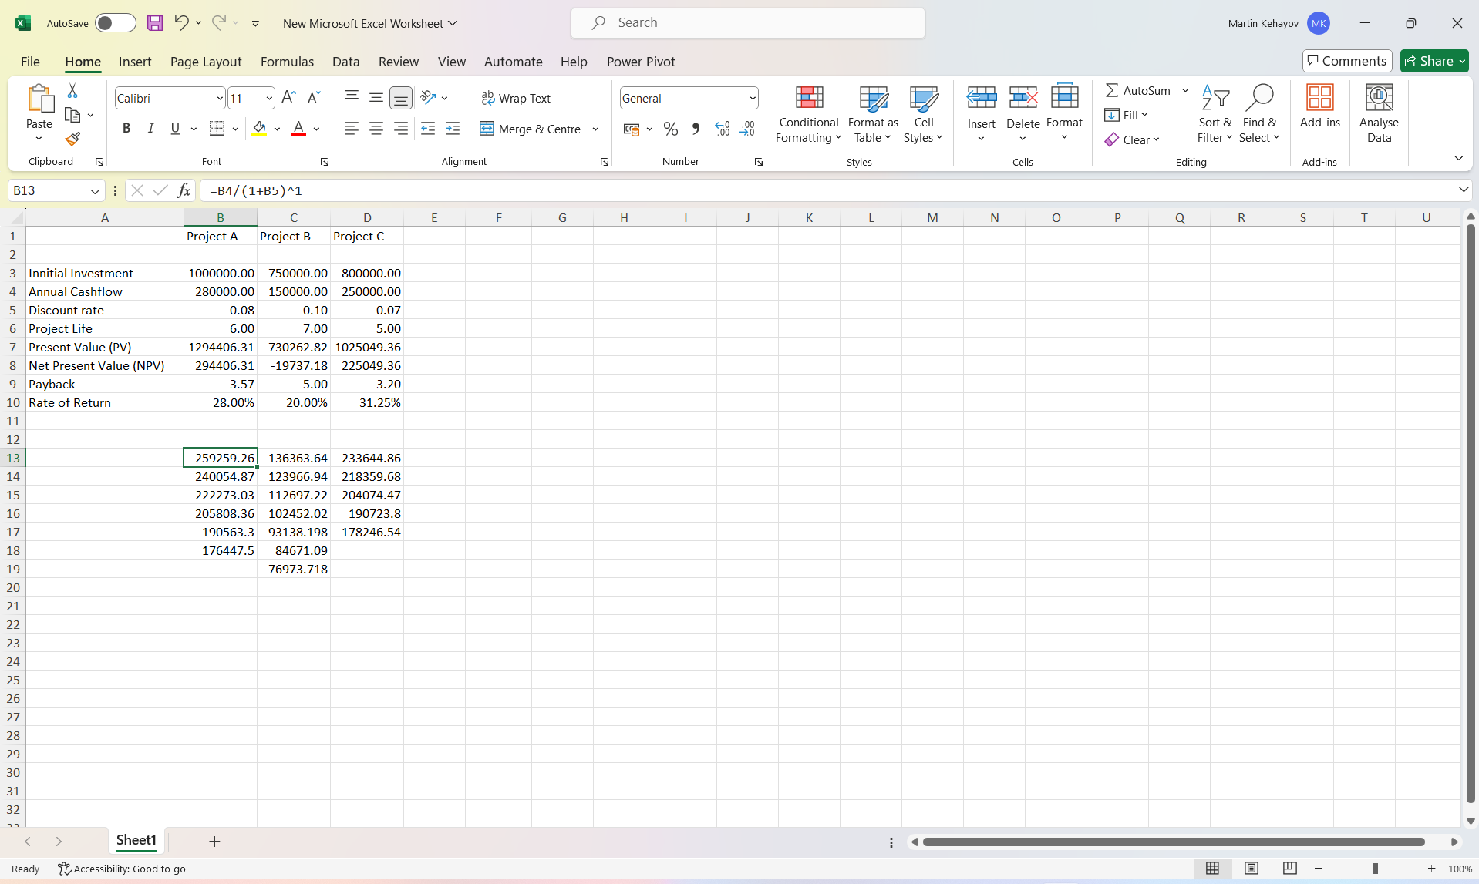
Appendix:

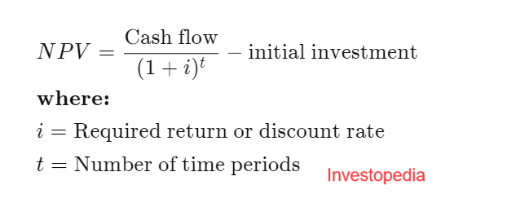

Bibliography
Asana (2021). Decision Tree Analysis: 5 Steps to Make Better Decisions • Asana. [online] Asana. Available at: https://asana.com/resources/decision-tree-analysis.

Fernando, J. (2023). Return on Investment (ROI): How to Calculate It and What It Means. [online] Investopedia. Available at: https://www.investopedia.com/terms/r/returnoninvestment.asp.

Fernando, J. (2024a). Internal Rate of Return (IRR) Rule: Definition and Example. [online] Investopedia. Available at: https://www.investopedia.com/terms/i/irr.asp.

Fernando, J. (2024b). Net Present Value (NPV): What it Means and Steps to Calculate It. [online] Investopedia. Available at: https://www.investopedia.com/terms/n/npv.asp.

Investopedia (2021). What Is Project Management? [online] Investopedia. Available at: https://www.investopedia.com/terms/p/project-management.asp.

Morkovich, E. (2011). Project Appraisal – Definition and Steps. [online] Mymanagementguide.com. Available at: https://mymanagementguide.com/project-appraisal-definition-and-steps/.

Morpus, N. (2024). A Step-by-Step Guide for Using a Weighted Scoring Model. [online] www.fool.com. Available at: https://www.fool.com/the-ascent/small-business/project-management/weighted-scoring-model/.

Petersen, R. (2017). 8 surprisingly simple steps to calculate ROI. [online] BarnRaisers, LLC. Available at: https://barnraisersllc.com/2017/03/20/surprisingly-simple-steps-calculate-roi/.

