

Enhancing Cyber Security Postures for Small and Medium Enterprises (SMEs):
A Comprehensive Threat Analysis Approach

by
DAVID NTINO

Supervisor: Dr. Nitheesh Kaliyamurthy

Project submitted as part of the requirements for the award of MSc Cyber Security and Digital Forensics

February, 2024

DECLARATION

I, DAVID SAMUEL NTINO declare that I am the sole author of this Project; that all references cited have been consulted; that I have conducted all work of which this is a record, and that the finished work lies within the prescribed word limits.

This work has not previously been accepted as part of any other degree submission.


Signed: ..

Date: .23/02/2024

FORM OF CONSENT
I DAVID SAMUEL NTINO hereby consent that my Project, submitted in candidature for the M.Sc. Applied Computing degree, if successful, may be made available for inter-library loan or photocopying (subject to the law of copyright), and that the title and abstract may be made available to outside organisations.

Signed: .

Date: 23/02/2024

Table of Contents
TABLE OF FIGURES 3
Chapter one 6
1.0 INTRODUCTION 6
1.1 Overview of Cyber Security Concepts 8
1.1.1 Threats 8
1.1.2 Threat Analysis 9
1.1.3 Vulnerability 9
1.1.4 Risk 10
1.1.5 Ransomware 10
1.1.6 Cyber-attack 10
1.1.7 Incident Management 11
1.1.8 Rationale for Cybersecurity Threat Analysis in SMEs 11
1.2 Significance of Study 12
Chapter 2 14
2.0 Literature Review 14
2.1 Review of Cyber Security Threat Landscape for 2020 - 2023 in UK SMEs. 14
2.1.1 Incident response: 14
2.1.2 Vulnerability management: 15
2.1.3 External engagement: 15
2.1.4 Internal activity: 15
2.2 Cyber Threats Affecting SMEs 16
2.3 Setting up a robust cyber security architecture in SMEs 22
2.3.1 Incident Response (IR) 22
2.3.2 Cyber Threat Intelligence (CTI) 23
2.3.3 Incident Response (IR) vs. cyber–Threat Intelligence (CTI) 24
2.3.4 Cyber Threat Awareness Training Program 24
2.4 Challenges of Mitigating Cyber Threats in SMEs 25
2.5 Cyber Security Framework 27
2.5.1 NIST Cybersecurity Framework (CSF): 27
2.5.2 ISO/IEC 27001 28
2.5.3 CIS Critical Security Controls (CIS CSC): 29
2.5.4 COBIT 30
2.5.5 FAIR 31
2.5.6 OSINT FRAMEWORK 32
2.5.7 MITRE ATT&CK 34
2.5.8 Zero Trust Security Model: 34
2.6 Ipsos (Institute Public de Sondage d'Opinion Secteur) 36
2.7 OFFENSIVE SECURITY 37
2.8 Red Team and Blue Team 38
2.8.1 Red Team 38
2.8.2 Blue Team: 39
2.8.3 Red Teaming vs Blue Team 39
2.9 Tools for conducting a red teaming attack simulation 39
CHAPTER 3 43
3.1 Introduction 43
3.2 Research Philosophy 44
3.3 Research Approach 45
3.4 Research Strategy 47
3.5 Research Choices 48
3.6 Time Horizon 48
3.7 Techniques and procedures 49
3.7.1 Data Collection: 49
3.7.2 Data Analysis 50
Chapter Four 60
4.0 Design and Implementation 60
4.1 Introduction 60
4.2 Problem Formulation 60
4.3 A scenario is developed to guide the implementation of this project scope 60
4.4 Scenario Background 61
4.5 The objective of the Attack Simulation 61
4.6 Setting Up a Simulation Environment: 62
4.7 Evon Enterprise Network Structure 63
4.7.1 Physical Topology 63
4.7.2 Logical Topology Design of Evon Enterprise 64
4.7.3 Flow diagram for Red Teaming Attack Simulation on Evon Enterprise Network systems 67
4.7.5 Steps and Procedures for Attack Simulation according to MITRE ATT&CK Framework 68
CHAPTER 5 70
5.0 TESTING AND RESULTS 70
5.1 PHISHING (Spear Phishing) ATTACK 70
5.2 ACTIVE DIRECTORY (LLMNR Poisoning) 76
5.3 INSIDER THREAT ATTACK 84
5.4 METASPLOITABLE 2 VSFTPD BACKDOOR ATTACK 87
5.5 Distributed Denial of Service (DDOS) Attack 90
CHAPTER 6 93
6.0 EVALUATION 93
6.1 SUMMARY OF ATTACK SIMULATION 93
6.2 Conclusion and Recommendation 94
6.3 Conclusion 94
6. 4 Recommendations for Future Research 94
6.5 Conclusions and Recommendations 95
CHAPTER 7 96
7.1 REFLECTIONS 96
7.2 Barriers experienced during the project 96
7.3 Positives 96
7.4 Lesson Learned 97
7.5 Guidance to future students 97
7.6 Overall 97
CHAPTER 8 98
References 98

TABLE OF FIGURES
Figure 1 bar chart showing the most disruptive threats in SMEs [14] [16] [15] [17] 18
Figure 2 NIST Framework [44] 28
Figure 3 ISO-IEC Framework [45] 29
Figure 4 CIS Framework [46] 30
Figure 5 COBIT Framework [47] 31
Figure 6 FAIR model 32
Figure 7 OSINT Framework 33
Figure 8 MITRE ATT&CK Model 34
Figure 9 Zero Trust Principle [55] 35
Figure 10 research onion by Saunders [52] 43
Figure 11 Comparison between quantitative and qualitative research [54] 46
Figure 12 Quantitative and Qualitative style [54] 47
Figure 13 Bar chart for cyber threats survey 2020 [17] 51
Figure 14 Bar chart for cyber threats survey 2021 [15] 53
Figure 15 Bar chart for cyber threats survey 2022 [14] 55
Figure 16 Bar chart for cyber threat survey 2023 [16] 57
Figure 17 Virtual Simulation Environment Setup 62
Figure 18 Evon Physical network topology structure 63
Figure 19 Logical Network Topology 64
Figure 20 Flowchart design for Proposed Red teaming 65
Figure 21 Attacks simulation for Red teaming 66
Figure 22 Flowchart implementation process for attack simulation 67
Figure 23 targets contact information 71
Figure 24 screenshot of targets social media post 71
Figure 25 Screenshot of drafted spear phishing mail 72
Figure 26 Screenshot of spear phishing mail sent to target 72
Figure 27 Screenshot of Zphisher tool 73
Figure 28 Screenshot of cloned LinkedIn ads page 73
Figure 29 Phished sign-in page 74
Figure 30 screenshot of collected target credentials Figure 31 Target LinkedIn page after successful login 75
Figure 32 Active Directory setup Figure 33 Users were added to the domain and roles assigned 76
Figure 34 Computers joined the domain Figure 35 A User successfully signed in as a domain user 76
Figure 36 Identified hosts in the domain 78
Figure 37 Disable firewall rule Figure 38 Service user added to a domain group 79
Figure 39 SPN Vulnerability 79
Figure 40 Kali configured to log credentials Figure 41 Targeted user logged in to computer 80
Figure 42 User trying to access unauthorized location 80
Figure 43 responder poisoning Figure 44 responder listening for events 81
Figure 45 Poisoned response sent 81
Figure 46 User credentials hashes 82
Figure 47 Cracking hashes with rocyou.txt 83
Figure 48 Captured packets with Wireshark 83
Figure 49 Identified targets 87
Figure 50 Metasploit vsftp exploit 88
Figure 51 Access gained 88
Figure 52 Root privilege login credentials 89
Figure 53 hping flooding 90
Figure 54 web server running 91
Figure 55 Web server down 91
Figure 56 captured packets 92

Table 1 Most disruptive cyber threats breaches in SMEs for four years [15] [14] [16] [17] 17
Table 2 Components of a red teamer's toolkit [60] 41
Table 3 Cyber threats survey for 2020 [17] 50
Table 4 cyber threats survey for 2021 [15] 52
Table 5 Cyber threats survey 2022 [14] 54
Table 6 Cyber threats survey for 2023 [16] 56

LIST ABBREVIATIONS

- BEIS: Department for Business, Energy and Industrial Strategy
- SMEs: Small and Medium-sized Enterprises
- ISO: International Organization for Standardization
- COBIT: Control Objectives for Information and Related Technologies
- MITRE ATT&CK: MITRE Adversarial Tactics, Techniques, and Common Knowledge
- UK GDPR: United Kingdom General Data Protection Regulation
- FAIR: Factor Analysis of Information Risk
- VSFTPD: Very Secure File Transfer Protocol Daemon
- LLMNR: Link-Local Multicast Name Resolution
- DDoS: Distributed Denial of Service
- DoS: Denial of Service
- NIST: National Institute of Standards and Technology
- CTI: Cyber Threat Intelligence
- CSF: Cybersecurity Framework
- CIS CSC: Center for Internet Security Critical Security Controls
- IR: Incident Response

Chapter one

1.0 INTRODUCTION
The current world is driven by technology, and every event happening in the world is somehow interconnected to exchange data, whether between two people, businesses, organizations, or even devices. As technology keeps evolving and advancing, the risks of Cybersecurity attacks are also evolving, making it imperative for every sector to adopt and implement evolving cybersecurity architecture to ensure the security of their assets.
The UK Department for (BEIS) adopts the following criteria to classify businesses in the UK: Small businesses are defined as having between 0 to 49 employees. Medium-sized businesses are classified as possessing 50 to 249 employees, this categorization is determined by the employee count and is frequently utilized to report and establish policies for businesses [1].
The impact of cyber security attacks does not just lead to the loss of information or data of an enterprise, it extends to affect the reputation of a company, affects the supply chain, and also has legal implications on the affected enterprise, which can further affect business continuity [2].
The worst cases of cyber-attacks occurred during the pandemic; were companies were compelled to transition their operations to the digital realm. without enough time to implement proper security measures to protect their assets, cyber attackers saw this as an opportunity to target Small and medium-sized enterprises (SMEs) with poorly configured security architectures. They exploited various vulnerabilities in these SMEs, by performing spear phishing and social engineering attacks, through email scams, brute force, etc. They targeted end-point devices and human error vulnerabilities [3]. These mounting cybersecurity threats were particularly targeted at SMEs, with employee strength of over 500. Even before the pandemic, SMEs often faced challenges like limited budgets and hiring skilled personnel. As the pandemic continued to take its toll on the broader economy, tighter budgets were seen also to affect cybersecurity spending strength by SMEs [4].

Based on McKinsey's research [4], SMEs have not received adequate cybersecurity support compared to larger enterprises. The cybersecurity market for SMEs, valued at over $40 billion, has been growing at more than 8 percent annually until recently. Within the SME category, there are three distinct segments based on IT requirements and personnel size:
Limited maturity: This includes small offices and some small enterprises with fewer than ten full-time employees, operating in low-digitization industries, and lacking IT resources [4].
Medium maturity: SMEs with 100 to 499 full-time employees, operating in medium-digitization industries, and possessing some IT resources.
High maturity: Involving SMEs with over 500 full-time employees, operating in high-digitization industries, and having dedicated IT resources.
Each segment has unique cybersecurity needs. For instance, the limited-maturity segment closely resembles the consumer segment, with around 90 percent of cyber spending focused on endpoint security for most companies.
Based on a report from the European Commission, SMEs are integral to the European Union's economy, constituting 99% of all businesses and providing employment for over 100 million people. Additionally, SMEs account for more than 50% of Europe's Gross Domestic Product and play a crucial role in enhancing value across various sectors of the EU economy. Not only do they facilitate digital transformation, but they also serve as a fundamental component of the EU's social structure [3].

Overview of Cyber Security Concepts

1.1.1 Threats
Organizations and individual users are struggling to stay ahead of the constantly changing and complex landscape of cyber threats [5]. SMEs are always targets for cyber threats, due to inadequate and sophisticated security infrastructures. According to the 2023 threat landscape 2023, it is stated that SMEs will face more identifiable risks at a striking scale, malware attacks are evolving in techniques, and are been used for financial gains, and geopolitical chaos will lead to more cyber threats in different sectors of SMEs [6]. Anything with the opportunity to exploit a vulnerability in a system or that impacts the availability, confidentiality, and integrity of information in a system or network is a threat. An attack agent with the ability to cause an eruption in a system which can lead to negative impacts like loss of access to service, data, and financial loss is a threat [7].
A threat actor can tend to carry out an attack but has no opportunity to do that. For example, in an organization with a robust security infrastructure and a patch management program and policies, there may be no vulnerabilities in that system, hence a threat actor with the ability to perform an actor might likely not be able to do so because there's no opportunity for him in the system [8] .
Various kinds of threats include Web-based threats, Phishing, threats to Web applications, Spam, Denial of Service attacks, Data breaches, Insider threats, Botnets, Physical threats, Ransomware, Malware, and threats from the External environment [5].

1.1.2 Threat Analysis
Based on a study [9], it is noted that the most common categories of threats discovered during threat analysis are:
- Accidental threats: these are threats caused by human error which can expose the organisation to attack. E.g misconfiguration of security devices or outdated security patches [9].
- External or Intentional threats: these are threats caused by malicious agents, to gain unauthorized access to exploit the system [9].
- Internal threats: this is one of the most dangerous threats that is often overlooked by organizations. Most organizations put more attention and resources on external threats with less attention on internal threats. An employee with malicious intent to steal sensitive data can become a threat agent for a cyber threat [9].
Therefore, threat analysis aims to assess an organization's security protocols, processes, and procedures to identify potential threats and vulnerabilities, as well as to understand possible attacks before they happen. [9].

1.1.3 Vulnerability
A vulnerability represents a potential weakness or defect within a system's database, software, or infrastructure. Such vulnerabilities may also exist within controls or processes. [7].
A Vulnerability is classified into two groups;
- Technical vulnerabilities: could be bugs found in a line of code, software, or errors in hardware configuration.
- Human vulnerabilities: these are vulnerabilities caused due to human error. A typical example is an employee falling victim to a phishing attack [7].

1.1.4 Risk

A cyber risk refers to the probability of an attack happening, and the potential impact of that attack scaled. The ability of a threat to act on a vulnerability discovered in a system is a risk to the asset owner. Certain factors could contribute to risks. Risk= threat x vulnerability [8]
No matter how secure a system is, it's likely that a risk can still be found, hence the need for frequent risk assessment and management [7].

1.1.5 Ransomware
Ransomware remains a major cyber threat in the UK, with data theft and encryption as primary tactics for cybercriminals seeking profit. Data extortion attacks, involving stolen but not encrypted data, are on the rise. From September 2022 to August 2023, 297 reports of ransomware activity were received, leading to 28 NCSC-managed incidents, 18 categorized as C3 and above. Top reporting sectors include academia, manufacturing, IT, finance, and engineering, though there is no specific evidence of academia being targeted [10].

1.1.6 Cyber-attack
As cyber-attack has become so frequent that it is now a recurring incident in SMEs. An attack occurs as a deliberate act involving malicious activities targeted at disrupting the smooth operation of an organization. The goal of a cyber-attack is usually to breach the information or system of an organization. Cyber-attack occurs due to several reasons like:
- Limited or insufficient funds to implement a more sophisticated and efficient security architecture.
- Inadequate and well-experienced security specialist.
- Cost of training employees on recent cyber-attacks.

1.1.7 Incident Management
NCSC aids Ukraine post-Russia invasion, enhancing cyber resilience. Despite ongoing cyber-attacks, the impact was mitigated due to Ukraine's robust cybersecurity and support from international partners, including the UK's cyber program. Collaboration minimizes the expected impact [10].

1.1.8 Rationale for Cybersecurity Threat Analysis in SMEs
Due to the complexity of the structure of different SMEs, the need for conducting a rigorous analysis of cybersecurity threats in SMEs becomes multifaceted. Firstly, SMEs frequently serve as suppliers or partners in larger ecosystems, making their vulnerabilities a potential channel for broader cyber threats. Secondly, the financial and reputational damage resulting from successful cyberattacks can be disproportionately impactful for smaller enterprises, necessitating proactive measures to mitigate these risks.

Aims
This project aims to determine the key threats in the UK based on available credible data, analyze their impact on Small and Medium-sized Enterprises, and implement adequate mitigation strategies.

Objectives:
- Review credible data on cyber security breaches survey in the UK, between 2020 to 2023 to identify the key threats affecting SMEs.
- Review the cybersecurity threat landscape
- Adopt a suitable methodology to meet the aim of this project
- Simulate attacks based on identified key threats
- Propose mitigation techniques
- Analyse the outcomes and provide recommendations

1.2 Significance of Study

The significance of this study is to analyze major threats and attacks affecting SMEs and implement necessary mitigation. Threats like ransomware, phishing, and insider threats are frequently occurring incidents affecting SMEs.

Structure of the project
This project is categorised into three different parts. The first part is the theoretical work that forms the basis of this project. The theoretical work involves reviewing different works of literature, journals, and research papers about cybersecurity in SMEs, and how they handle threat mitigation.
The second part discusses the problem formulation and the proposed design to be implemented in analyzing the threats; in this case the adoption of MITRE ATT&CK cyber security framework or any other available framework to perform different attacks on the proposed network. A replica of a sample SMB or SME network system infrastructure will be set up in a virtual environment, like a VirtualBox or VMWare station, and different virtual machines will be installed to represent computers and servers in that enterprise. A penetration testing will be performed to check the weaknesses and vulnerabilities in this system, and based on the vulnerabilities discovered, some attacks will be carried out.
The third part of this project will detail the findings of the attacks performed. In this case, the details of each vulnerability discovered during the pen test, details about the attacks, and whether they were successful or not? and what mitigation techniques were implemented to prevent the success of these attacks.
Chapter one gives an overview of the project, detailing the aim and objectives required for the completion of this project. It provides a guide and structure as to how the researcher will approach the project.
Chapter two is the research and literature review. It will discuss different key areas of this project topic; like different types of threats existing in SMEs, the current cyber security threat landscape, vulnerabilities in SME networks, different cyber security testing frameworks, current threat mitigation techniques, and related work.
Chapter three is the research methodology. It details the research methodology Research Philosophy, Approach, Time Horizons, Design/Strategy, Choices, Techniques, and Procedures that will aid in the completion of the project. The research onion methodology proposed by Sauders [11] will be used as a guide for completing chapter three of this project.
Chapter four is the design and implementation phase of this project. It outlines the proposed design and the implementation of this project. Beginning with the problem formulation, solution design, and then implementation. For this project, a prototype of the proposed SME network infrastructure for performing the attacks will be designed, detailing different network servers, network security devices, and configuration details, the testing bed will be set up using a virtual environment like Virtual Box, or Azure with different virtual machines.
Chapter five is where the testing and evaluation details will be documented. It details the outcome of the experiment conducted based on the proposed design and implementation in chapter four.

Chapter Six provides details about the proposed mitigation techniques and patterns that could be adopted by SMEs to ensure a more secure network.

Chapter 2

2.0 Literature Review

Introduction
The aim of this chapter is to review different works that are related to the project topic, and that have been under-studied by other researchers. Some related aspects that will aid the completion of this work will also be discussed. Different existing and emerging threats affecting SMEs and their mitigation techniques will be discussed. This chapter will also outline available cyber security frameworks available for penetration testing.

2.1 Review of Cyber Security Threat Landscape for 2020 - 2023 in UK SMEs.
For the past 4 years, according to a survey conducted by the UK National Cyber Security Centre, the following findings were analyzed according to key aspects of cyber security [12].
In 2023, the NCSC received over 2,005 reports of cyber threats on SMEs, marking a nearly 64% increase from the previous year's 1,226. The organization issued 24.48 million notifications to inform entities of cyber incidents through its automated Early Warning service. Notably, there were 327 incidents involving the exfiltration/extortion of data, indicating an 18.5% increase from the previous year.
According to a survey by [13], 38% of SMEs in the UK experienced or identified a cyber-attack in the past. Over 82% of the SMEs reported phishing attacks, and 25% identified malware, ransomware, and denial of service attacks [12].
2.1.1 Incident response: In the event of a cyber breach, being able to detect and respond swiftly to attacks is very crucial, hence incident response is necessary for minimizing operational, financial, and reputational harm. According to the report from [13], 84% of SMBs in the UK express their intention to notify their board, and 73% indicate their willingness to carry out an impact assessment. Nonetheless, a mere 18% of SMEs have a documented incident management plan, with qualitative insights indicating an informal approach often relying on internal expertise or external collaborators such as IT providers.
2.1.2 Vulnerability management: cyber-attacks are looking out for vulnerabilities in a system, this is why frequent updates and patches are essential to guide against any new vulnerabilities. Based on a survey conducted in 2022 on SMBs in the UK, 82% of SMEs have anti-malware protection up-to-date, 38% implemented a patch management policy, 34% used a security monitoring tool, 17% conducted a cyber vulnerability audit, and 13% relied on threat intelligence.
2.1.3 External engagement: 48% of SMEs relied on external and third-party information in resolving cyber security issues.43% adopted an insurance scheme, 39% used outsourced cybersecurity services, and only 6% had essential certification in cybersecurity.
2.1.4 Internal activity: the internal activities indicate the different approaches each organization took in responding to threats. From this survey, 22% of SMEs adopted and implemented a cyber security strategy, 32% conducted a risk assessment, 16% performed awareness training, and 7% assessed risks.
The research above indicates that the researcher's focus was mainly on SMEs who are online and those who are not online, were not considered eligible for the survey. Does it mean those SMEs do not encounter any form of threat? I believe they do; offline businesses can experience insider threats, impersonation, and social engineering threats.
In conclusion, the findings from the survey emphasize the for need for SMEs to prioritize cyber security approaches and invest more in incident response mechanisms, vulnerability management, external engagement, and internal activities. By addressing these key aspects of cyber security, SMEs can better protect themselves against evolving cyber threats and safeguard their operations, finances, and reputation in an increasingly digitalized landscape.

2.2 Cyber Threats Affecting SMEs
Based on the UK Cyber Security Breaches Survey Report focusing on SMEs from 2020 to 2023[14] [15, 16] [17], among organizations reporting cyber threats, phishing attacks are overwhelmingly perceived as the most disruptive, with 62% - 67% of businesses and 65% of charities identifying them as such. SMEs have experienced a high rate of cyber-attacks for the past four years as a result, and several reasons could be responsible for this. According to the 2023 cyber threats survey [16] . It indicates that more attacks were focused on businesses, where 59% were SMEs, while 69% were large enterprises. According to a report by CNBC, it is reported that 43% of the enterprises are SMEs, which has cost the companies a great loss of up to [10].
Research on the impact of cyber-attacks shows that these attacks were successful because some SMEs could not afford to implement a more robust security architecture, and insufficiently skilled cyber security experts, while small enterprises undermined the impact of these threats, some said it wouldn't happen to them, and some couldn't afford the cost of funding a security awareness training and security auditing solutions [5].
The researcher highlights the importance for SMEs to comprehend the implications of cyber threats and the possible future impacts on their organizations. [5]
Understanding the cost of cyber-attacks is very crucial for SMEs, this is why the UK government invested over £2.4 billion in funding the National Cyber Security Centre to boost IT security infrastructure in 2016, yet cyber-attacks are still on the increase. This dominance is expected, as approximately half of these entities only recall encountering phishing attacks and no other cyber security breaches. However, it's crucial to examine organizations reporting breaches other than phishing attacks and their perceptions of the most disruptive types of breaches [15].
Table 1 below indicates that even within this subset, phishing attacks remain the primary disruptor, closely followed by impersonation attacks. Interestingly, denial-of-service attacks appear to have had a greater disruptive impact on charities compared to businesses. However, as of 2023, the percentage of businesses that experienced phishing threats reduced from 67% in 2020 to 59%, while impersonating increased from 11% to 35% in 2023. This is a clear indication that threat actors are now more interested in breaching organizations through impersonation tactics [10].
Table 1 is a summary of the most disruptive cyber threats experienced by different SMEs in the UK over the past four years. Each threat indicates the percentage of SMEs that experienced disruption due to the impact of the threats listed in the table.

Proportion of SMEs identifying specific categories of breaches or attacks as the most disruptive, excluding organizations that only reported phishing attacks in the past year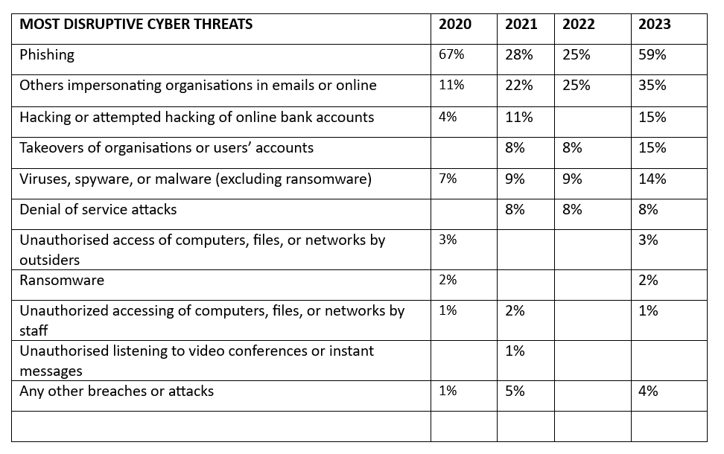
Table 1 Most disruptive cyber threats breaches in SMEs for four years [15] [14] [16] [17]
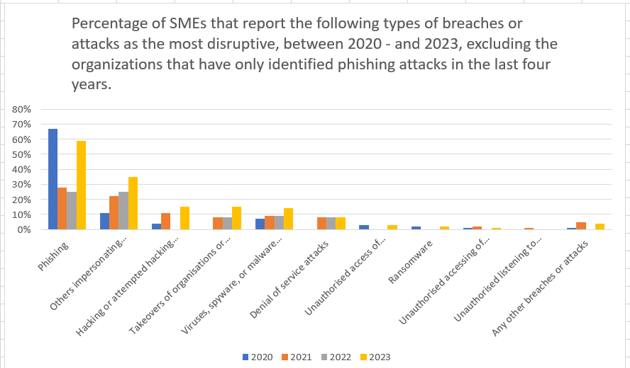

Figure 1 bar chart showing the most disruptive threats in SMEs [14] [16] [15] [17]

From the above review of cyber threats survey and analysis, the first aim of this project has been achieved, and the most disruptive threats can be considered as the key threats affecting SMEs. These key threats which are Phishing, Impersonation, Insider threats, DOS, Malware, Privilege Escalation, Social Engineering, and Ransomware have been a consistent threat affecting SMEs. Mathieus, a cyber security researcher [18] discusses key threats affecting SMEs, and those key threats include Phishing, Malware, Ransomware, Insider threats, and Human error. He explains that SMEs are often targeted by cyber-attacks for several reasons. “Firstly, SMEs typically have less robust cybersecurity infrastructure and protocols compared to larger organizations, making them easier targets for attackers. According to CNBC, 43% of hacks target small businesses, resulting in an average cost of US$200,000 per incident. However, despite the prevalence and cost of cyber-attacks, only 14% of small businesses have effective measures in place to defend against them [19]”. This project will only focus on a few of these key threats;

- Phishing threats: Phishing attacks have been particularly prevalent in the UK, with SMEs often targeted due to their limited cybersecurity resources. The UK's Cyber Security Breaches Survey consistently highlights phishing as the most common type of attack faced by businesses. The National Cyber Security Centre (NCSC) has issued numerous warnings and guidelines to help businesses recognize and defend against these types of attacks, especially those exploiting the COVID-19 pandemic as a lure. The phishing threat is now the most commonly experienced attack by businesses. According to the survey report for 2022 and 2023, 83% to 79% respectively of businesses, experienced a phishing attack [16].
It involves tricking a user to click on a link that gives the threat hunters access to the user's network. They often utilize different forms of links video links, email, website links, and sometimes social media links in the form of friend requests.
- Malware, Viruses, and Spyware threats: the 2022 and 2023 reports indicate that 12% to 11% of businesses experienced a malware attack. This particular attack occurs when threat hunters insert harmful code into a computer system or corporate network. Methods ranging from accessing compromised devices to interacting with malicious links found in spam emails or on websites are often used, and once the malicious code is inside the system network, it either corrupts the data or provides a back door for the threat hunters.
- Ransomware threats: This period saw a significant rise in ransomware attacks against SMEs, partly due to the vulnerability of their often less sophisticated cybersecurity systems. Data extortion attacks, involving stolen but not encrypted data, are on the rise. From September 2022 to August 2023, 297 reports of ransomware activity were received, leading to 28 NCSC-managed incidents, 18 categorized as C3 and above. Top reporting sectors including academia, manufacturing, IT, finance, and engineering, though no specific evidence exists of academia being targeted [10].
This particular attack is a major threat to SMEs, as they usually lack sophisticated cybersecurity structures to counter this threat, which leaves them with the option of either paying a huge amount before gaining back access to their data or losing access to it permanently. Companies like British Airways, JW Marriot, and Google, have had to pay millions of Pounds as fines for data breaches of their customers due to ransomware attacks [20]. The EU GDPR has imposed huge restrictions on how businesses and organizations collect and store user data, anything contrary to that policy, now attracts a fine. The reports show that ransomware attacks increased from 4% in 2022 to 7% in 2023 of business [16]. The high-profile attack on the NHS in 2017 served as a wake-up call, leading to increased awareness and investment in cybersecurity defenses across all sectors, including SMEs. The NCSC has been actively involved in providing advice and support to help businesses defend against ransomware. [21]
- Denial of service (DOS) threats: This happens when a malevolent entity floods a target system with excessive traffic, making it unavailable to legitimate users. Techniques such as traffic flooding, ping of death, and SYN/ACK flooding are employed to achieve this, DNS amplification, and the use of botnets. Protection measures include firewalls, intrusion detection systems, load balancers, and vigilance for unusual traffic patterns, with response plans to minimize the impact of potential attacks [22]. According to [16] [14] , 10% to 7% of businesses experienced DDOS attacks between 2022 to 2023 respectively.

- Insider Threats/Human Error: The most overlooked attack which is a major threat to businesses is the Insider threat. This threat pertains to security threats that arise from people inside an organization, like employees, contractors, or business associates, who possess internal knowledge about the organization's security protocols, data, and IT systems. In a survey study by [14] the researcher classifies insider threats from different perspectives (intention and type of threat actors) [23]. Unauthorized accessing of computers, files, or networks by staff is a typical example of an insider threat. A study on insider threats by [24] explores insider threats, as Individuals who have elevated access to an organization's resources, and their potential to disrupt proper functioning, leading to direct (financial) or indirect (reputational) consequences. This report details results from a preliminary investigation into three kinds of insider incidents—malicious, negligent, and benevolent—and how they correlate with the implementation of cybersecurity protocols.

- Remote Work Vulnerabilities
The transition to remote work amid the COVID era, exposed new vulnerabilities, with UK SMEs scrambling to secure remote access and protect against an increased risk of cyberattacks. The NCSC provided specific guidance for securing remote working environments, including recommendations for securing VPNs, using multi-factor authentication, and educating employees about the risks of using personal devices for work purposes [25].

- Cloud Security Threats
As UK SMEs increasingly adopt cloud services for flexibility and cost savings, they also face heightened cloud security threats. Misconfigurations and inadequate access controls have led to data breaches. The NCSC has published cloud security principles to guide businesses in securing their cloud environments [26].
- Legal and Regulatory Implications
UK SMEs are subject to stringent data protection laws, specifically the UK General Data Protection Regulation (UK GDPR) and the Data Protection Act of 2018. These regulations impose significant penalties for data breaches, emphasizing the need for robust cybersecurity measures to protect personal data. Compliance with these regulations has driven improvements in cybersecurity practices among SMEs [27].
- Collaboration and Threat Intelligence Sharing
There has been a growing emphasis on collaboration and sharing of threat intelligence within the UK. Initiatives like the Cyber Information Sharing Partnership (CiSP) allow UK businesses, including SMEs, to share information about cyber threats and vulnerabilities, enhancing collective defense capabilities [28].
- Impersonation threats: As of 2023, Impersonation threats were reported by 25% of SMEs in the UK [16], as one of the most disruptive threats. It involves attackers pretending to be someone else, like a trusted user, authority figure, or reputable organization, to deceive individuals or gain unauthorized access to systems or information. Examples include email spoofing, CEO fraud, tech support scams, social media impersonation, pharming, credential harvesting, and identity theft. To mitigate these threats, individuals and organizations should use security measures like multi-factor authentication, email authentication protocols, user awareness training, and thorough verification processes. Staying informed about emerging tactics and remaining vigilant online are also important.
Conclusion
For UK SMEs, the period between 2020 and 2024 has been marked by a rapid evolution in the cybersecurity threat landscape, influenced by global trends and local factors such as regulatory requirements and national cybersecurity initiatives. The response has involved not just technological solutions but also regulatory compliance, employee education, and sector-wide collaboration to mitigate risks. The support provided by national bodies like the NCSC, along with adherence to legal frameworks like the UK GDPR, has been instrumental in guiding SMEs through the challenges of this dynamic threat environment.

Setting up a robust cyber security architecture in SMEs

2.3.1 Incident Response (IR)

Cyber Security Incident Response focuses on the organization's capability to respond to and recover from security incidents effectively. According to [29], incident response encompasses the preparation, detection, containment, eradication, and recovery from cyber incidents, alongside lessons learned to improve future security posture. The effectiveness of an incident response is often measured by the speed and efficiency with which an organization can return to normal operations and minimize damages [30]. An effective incident response plan often involves a series of steps that an organization takes in response to an incident. Research by [31], focuses on evaluating the importance of administrative and technical mitigation controls in responding effectively to cybersecurity threats.
These steps typically include:
- Preparation: involving the creation of policies, procedures, and tools to prepare for a cyber incident.
- Identification: entailing the detection and assessment of the cyber incident's nature.
- Containment: focusing on halting the spread of the incident and segregating compromised systems to avert additional harm.
- Eradication: the process of eliminating the threat from the organization's environment. Recovery aims at reinstating systems and data to their regular functioning state, confirming the absence of any residual threats.
- Lessons Learned: Analyzing the incident and the response to improve future readiness and response.

2.3.2 Cyber Threat Intelligence (CTI)

Cyber Threat Intelligence involves analyzing information about adversaries and their tactics, techniques, and procedures (TTPs) to make knowledgeable choices regarding an organization's security. CTI is used to understand the threats an organization faces, anticipate malicious activities, and inform security strategies. Anzel Berndt [32] proposes that, encouraging SMEs to adopt Cyber Threat Intelligence could advantage SME managers by enhancing their understanding of cyber resilience, and guiding them in initiating its implementation through specific actions and a sequence recommended by expert experience. CTI might be a reliable source of detecting and preventing threats before their impacts are felt by an organization, but it is also a very expensive and complicated process to implement. Large enterprises might find it a bit easy to implement due to their financial strengths and vast network resources, but this is not the case for SMEs with little financial strength and limited resources. [33] Addresses the difficulties in deploying scalable threat intelligence within the current intricate threat environment and digital infrastructure. Grasping the essence of insider threats and the associated threat landscape aids in developing mitigation approaches, encompassing non-technical measures..
- Activities in CTI include:
- Collection: Gathering data from various sources about threats and vulnerabilities.
- Analysis: Analyzing the collected data to identify patterns and behaviors of cyber adversaries.
- Dissemination: Sharing actionable intelligence with relevant stakeholders within the organization.
- Integration: Applying the intelligence to enhance cybersecurity measures, such as updating security policies, configuring security tools, and training staff.

2.3.3 Incident Response (IR) vs. cyber–Threat Intelligence (CTI)

- Comparison and Integration
- Purpose: IR focuses on responding to and managing cyber incidents after they occur, while CTI aims to proactively understand and anticipate threats to prevent or mitigate future incidents.
- Actionability: IR actions are reactive, taken in response to specific incidents. CTI actions are proactive, and aimed at preventing incidents based on the intelligence gathered.
- Integration: While distinct, IR and CTI should be integrated for a comprehensive cybersecurity strategy. Intelligence from CTI can inform incident response plans, making them more effective. Conversely, insights gained from managing incidents can feed back into CTI to refine threat analysis and prediction

2.3.4 Cyber Threat Awareness Training Program
[34] Emphasizes the difficulties in identifying and detecting insider threats within organizations in both the public and private sectors, particularly those integral to a nation's critical infrastructure. [35] Examine the impact of COVID-19 on remote work practices and the cybersecurity threat landscape. It is also advisable for organizations to provide more customized cybersecurity awareness training that addresses the specific threats associated with remote working.
- Intrusion Detection Using Machine Learning Classifiers
[36] conducted an investigation, employing both quantitative and qualitative approaches to explore the obstacles faced when integrating machine learning classifiers (MLCs) within the SME ecosystem, and examining how operations are adapted to facilitate business expansion.
The study by [36] leverages global research from various fields to pinpoint gaps and opportunities in cyber security for UK SMEs. It will delve into the methodology of cyber-resilience within small and medium-sized enterprises, proposing an integrated approach that employs prescriptive malware analysis, detection, and response. This approach, utilizing open-source solutions, aims to identify and mitigate new emerging threats [37]. Through rigorous testing and validation, alongside the application of efficient algorithms and techniques for anomaly detection, safety, and security, the efficacy of this approach in improving SMEs' cyber-defense mechanisms and strengthening their overall cyber-resilience is showcased. Additional significant contributions include [38].
In summary, Incident Response and Cyber Threat Intelligence are essential, interconnected aspects of an organization's cybersecurity efforts. While IR deals with the immediate response to incidents, CTI focuses on the broader understanding of cyber threats to prevent or minimize the impact of future incidents.

2.4 Challenges of Mitigating Cyber Threats in SMEs
- Complexity in Government policies
According to [39] the researcher proposes the need for SMEs to adopt a more cyber-resilient approach to preventing cyber-attacks that is easy to implement and operate by every sector of the organization. He also discussed the challenges faced by some SMEs in implementing certain security measures against cyber-attacks. Some of these measures are influenced by governance, unassigned or unavailability of adequate resources, policies, training, awareness, and the ability to manage business continuity [40]. To add to this, it is important to note that certain policies usually involve complex procedures like planning, testing, and collaborating with external entities.
The writer presents a framework and guidelines on cyber resilience for SMEs, and how they can be implemented, with an emphasis on various dimensions that are implored in cyber-resilient implementation, including its policies [41].
- Variations in digitalization standards
Another researcher [42] highlights the challenges of setting up robust cybersecurity measures due to variations in the digitalization of manufacturing industry standards. faced by SMEs in industrial sectors. Pointing out the recent adoption of Industry 4.0 megatrend engineering research. Industry 4.0 signifies the fourth industrial revolution, characterized by the digital transformation of manufacturing and the integration of technologies like the Internet of Things (IoT), artificial intelligence (AI), and data science into industrial processes.. while the term "megatrend" is used to describe a prominent and anticipated pattern or movement expected to have a substantial impact on both business and society at large. However solid this research might be, it poses a challenge to SMEs with limited resources, due to its complexity. This writer recommends a practical and valuable tool for identifying and addressing cybersecurity threats using a structured assessment approach that will help to detect the causes of attacks, and also identify possible mitigation [42].
- Inadequate Education and Awareness for employee
On the aspect of cybersecurity education and awareness programme, [39] emphasizes the need for SMEs to develop and implement more robust awareness training on cybersecurity. He points out that a lot of SMEs are facing cyberattacks due to easy targets on the part of their employees who lack adequate cyber awareness training on recognizing phishing emails or securing their personal data and login credentials.. This study discusses the security difficulties encountered by SMEs and also recommends a high-level cybersecurity education and awareness strategy to be adopted by both small and medium, -sized organizations. This programme is developed from the study of the current literature obtained through a combined assessment of research and practices. Other challenges could be a lack of sufficient finance to set up a robust security infrastructure, Dependency on Third-party Vendors, and absence of an incident response plan and compliance requirements.

In conclusion, while SMEs face significant challenges in navigating the complexities of cybersecurity, adopting a comprehensive, informed, and adaptable approach can significantly mitigate these risks. By focusing on resilience, continuous improvement, and especially on empowering employees through education, SMEs can create a robust cybersecurity posture that protects against both current and emerging threats. This holistic strategy not only safeguards valuable assets and data but also supports the sustainable growth and competitiveness of SMEs in an increasingly digital and interconnected world.

2.5 Cyber Security Framework
Cybersecurity frameworks provide a structured approach to managing and improving an organization's cybersecurity posture. Some of the cyber security frameworks are explained below;

2.5.1 NIST Cybersecurity Framework (CSF):
NIST framework, created by the National Institute of Standards and Technology (NIST), includes five fundamental functions: Identify, Protect, Detect, Respond, and Recover. This framework offers a risk-based strategy for cybersecurity management [43].

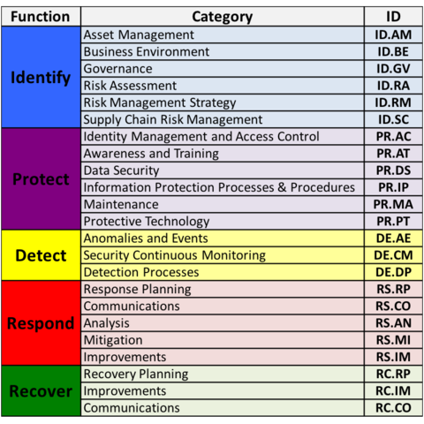

Figure 2 NIST Framework [44]

2.5.2 ISO/IEC 27001
The ISO/IEC framework, issued by the International Organization for Standardization (ISO) and the International Electrotechnical Commission (IEC), centers on an Information Security Management System (ISMS). It highlights the Plan-Do-Check-Act (PDCA) cycle to foster continuous improvement [44].

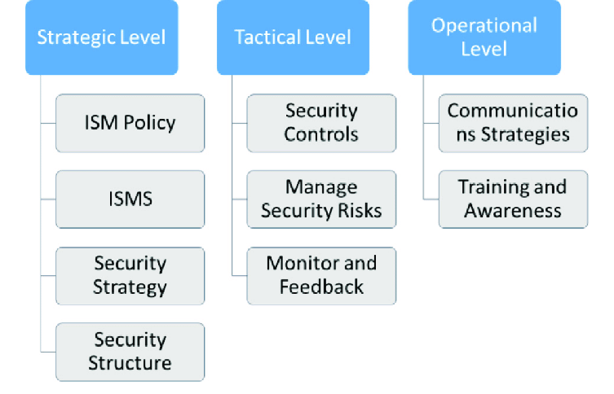
Figure 3 ISO-IEC Framework [45]

2.5.3 CIS Critical Security Controls (CIS CSC):
Developed by the Center for Internet Security (CIS), this framework comprises 20 prioritized controls for optimal cybersecurity effectiveness. It is specifically designed to mitigate common and high-impact security threats in organizations [45].
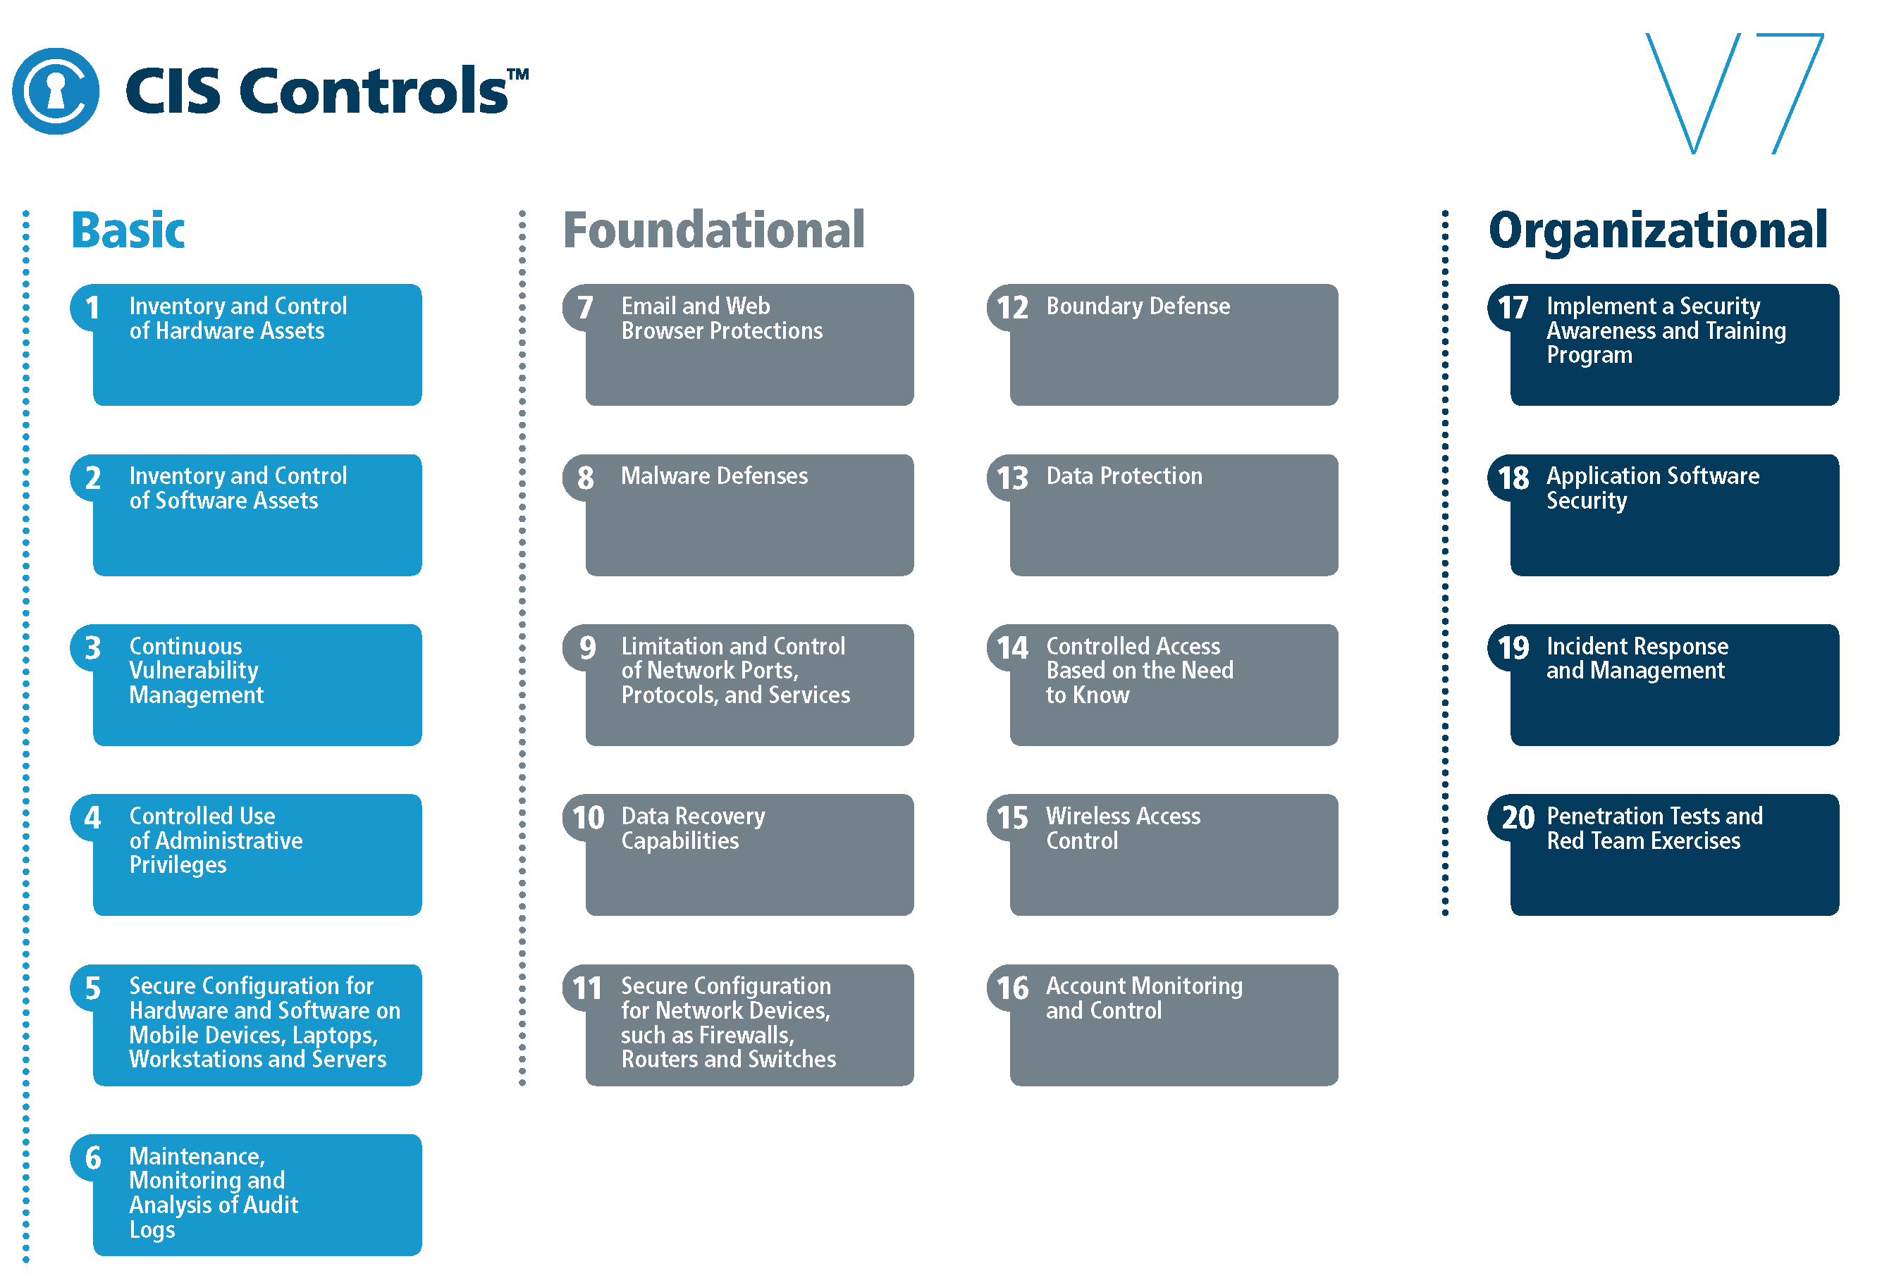

Figure 4 CIS Framework [46]

2.5.4 COBIT
COBIT, established by the Information Systems Audit and Control Association (ISACA), concentrates on aligning IT goals with business objectives. It is structured into domains and processes, offering an extensive governance framework [46].
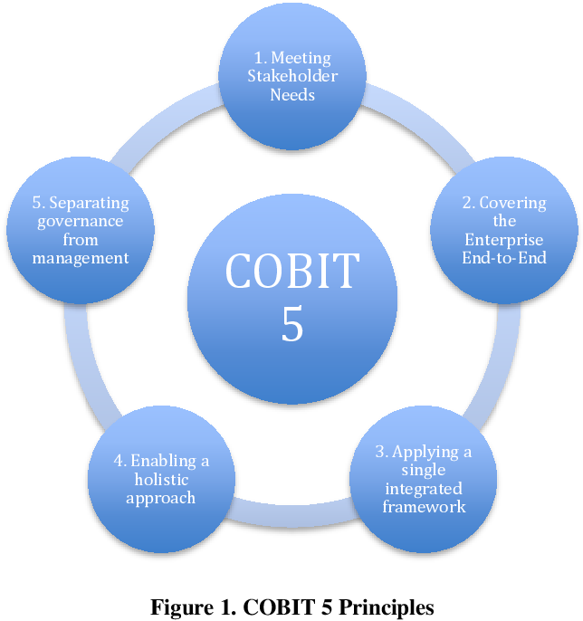

Figure 5 COBIT Framework [47]

2.5.5 FAIR
FAIR is a quantitative risk analysis framework that sets a standard for comprehending, analyzing, and quantifying information risk. Developed by the Open Group, FAIR highlights the application of probabilities and monetary values for risk assessment [47].
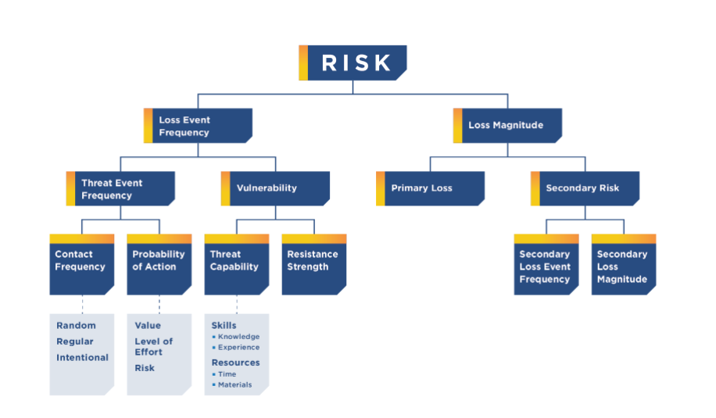
Figure 6 FAIR model

2.5.6 OSINT FRAMEWORK
Open-Source Intelligence (OSINT) is described as the gathering and examination of information that is publicly accessible from diverse sources, encompassing the internet and social media platforms such as Facebook, Twitter, and WhatsApp. This information is utilized to profile individuals and businesses for intelligence purposes. Although there is substantial discussion and investigation into the risks and vulnerabilities linked to the use of social media, this study seeks to reduce bias in comprehending these matters [48]. The OSINT Framework is a structured approach used by intelligence analysts and researchers to gather information from publicly available sources on the internet [49]. It categorizes information into various sections and provides a comprehensive list of tools, resources, and techniques for collecting and analyzing open-source intelligence. Users can access a variety of tools and methodologies organized by information categories, and the framework is continuously updated with new contributions and recommendations. Overall, it serves as a valuable resource for individuals and organizations involved in intelligence gathering,
investigations, cybersecurity, and other related fields [49].
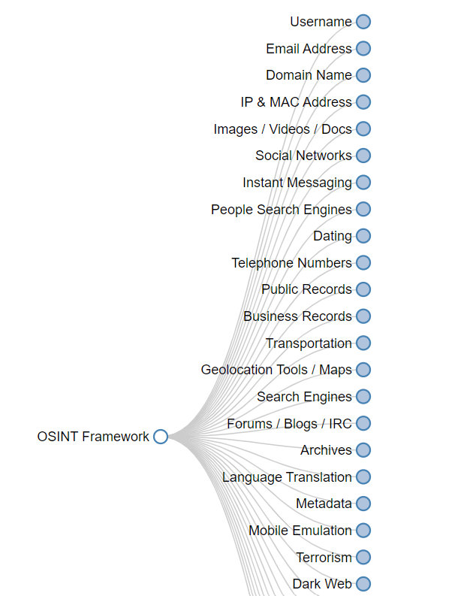
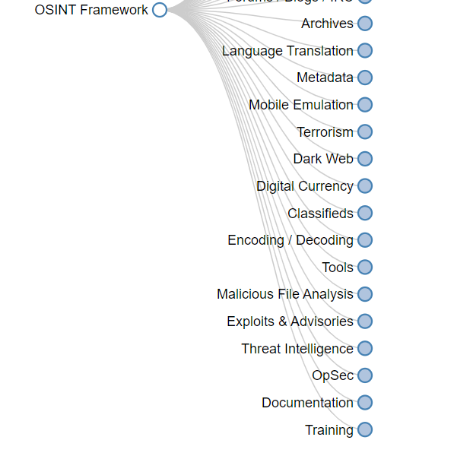

Figure 7 OSINT Framework

2.5.7 MITRE ATT&CK
It is developed by the MITRE Corporation, it offers an extensive knowledge base of adversary tactics and techniques. It is used for threat intelligence, red teaming, and improving detection and defense strategies for better security planning for organizations against cyber-attacks [50].
Fig. 8 contain a summary of the MITRE ATT&CK techniques and procedures, which will be relevant to achieving the aim of this project,
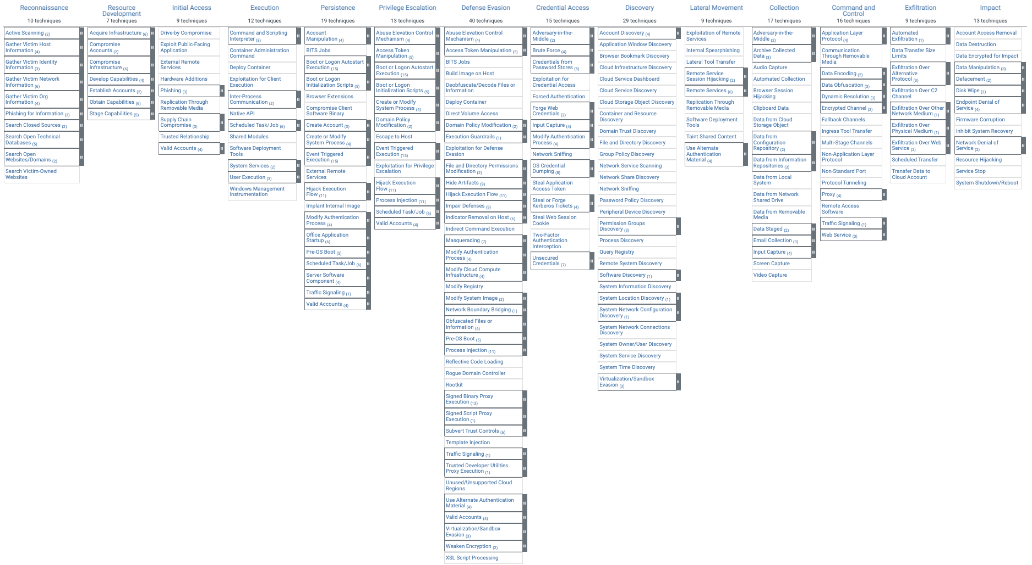
Figure 8 MITRE ATT&CK Model

2.5.8 Zero Trust Security Model:
This particular framework is not tied to a specific organization or standard, but a holistic approach to security. It assumes no implicit trust and verifies everything. Enforces strict access controls, continuous monitoring, and adaptive security measures [51].
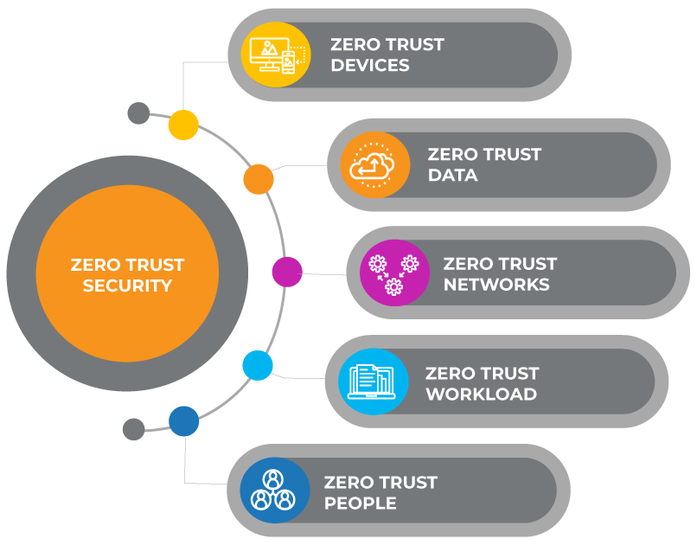

Figure 9 Zero Trust Principle [55]

In conclusion, Cybersecurity frameworks only provide organizations with a structured set of guidelines for protecting information systems, detecting cybersecurity events, responding to incidents, and recovering from attacks. These frameworks often include standards, guidelines, and practices to ensure that an SMEs information security measures are incorporated with its business objectives. They serve to ensure organizations assess their current cybersecurity posture, identify areas for improvement, and implement strategic security measures tailored to their specific needs and threats. However, without proper and well implemented security system, just having an understanding of these frameworks, won’t guarantee the safety of an organization from attacks.

2.6 Ipsos (Institute Public de Sondage d'Opinion Secteur)

Ipsos is commissioned by the UK government to carry out this survey.
Ipsos is a multinational market research and consulting firm with its headquarters in Paris, France. Founded in 1975, Ipsos is among the largest survey-based research companies globally. The firm provides a range of services, including market research, public opinion polling, and data analytics. Ipsos conducts research in various industries, offering insights and strategic advice to help organizations make informed decisions. With a presence in over 90 countries, Ipsos is recognized for its expertise in understanding consumer behavior, social trends, and market dynamics [55].
The company is committed to delivering accurate and reliable information to support clients in navigating the complexities of the business and social landscape [55].
This survey is usually conducted via telephone call, before the interview, participants are usually informed about the survey before the survey date. Participants are representatives from different organizations. During the interview, the interviewer from Ipsos calls on each representative to respond to some survey questions. Participating in this survey is voluntary, and all data are confidential, and no company personal details are always included in the report. The survey is nontechnical and participants do not require any knowledge of IT.
The survey is usually open to all sectors of businesses, including those who are not affected by cyber security issues. SMEs, Large organizations Charities, and educational institutions are all included in the survey.
The comprehensively capture all breaches experienced by organizations, encompassing both accidental and intentional breaches.
The number of UK businesses that were contacted to participate in the survey changes as each year advances. Ipsos conducted a telephone survey of 1,348 businesses in the UK using a random probability sampling method in 2020, 1,419 in 2021, 1,243 in 2022, and 2263 in 2023. This indicates that as of 203, the number of businesses participating in the survey increased from 1,243 in 2022 to 2263 in 2023.

This survey covered the following aspects:
- Understanding perceptions and stances regarding cyber security.
- Strategies employed for cyber security, encompassing both technical and governance procedures implemented by organizations for detecting and handling cyber risks.
- Characteristics and repercussions of cyber security breaches.
- Disparities based on the scale and industry of businesses.
Limitation of this survey
Businesses without any online presence like a website or social media presence were not considered eligible for this survey. This survey was first initiated in 2018 until 2023. The most recent report of this survey is 2023.

2.7 OFFENSIVE SECURITY
An offensive security "OffSec," is the term for a group of proactive security techniques that enhance network security as opposed to weakening it by employing similar techniques that threat actors employ in actual attacks. Some offsec methods include Vulnerability assessment, penetration testing, and red teaming [56]

The tactics, procedures, and techniques adopted in offensive security are like those used by actual cyber attackers. By using these techniques, cyber security experts can detect and eliminate every possible vulnerability that could be exploited by cyber attackers [56]. OffSec is divided into three methods. Vulnerability scanning, Penetration testing, and Red teaming.
Each offensive method has unique differences from each other.
According to [56], Vulnerability Scanning is an automated approach of using specialized tools to detect weaknesses or vulnerabilities in an organization's network. Vulnerability scanners can perform a full scan of a computer or network system for vulnerabilities in software, network devices, hardware driver versions, or unpatched software flaws [56]. This scanning is often performed by an insider security specialist, it is possible that not all vulnerabilities can be detected by the tools, hence, this method is not so reliable [57].
Gemma Moore, a director at Cyberis, clarifies the disparity between penetration testing and red teaming by stating that penetration testing focuses on identifying technical vulnerabilities within a specific scope of work, aiming for comprehensive coverage. In contrast, red teaming involves simulating an attack scenario, utilizing a wide array of cyber-attack techniques and tools to breach security defenses and access valuable data [57].
Penetration testing often involves the use of human security expertise to detect vulnerabilities by acting as a threat actor [57]. Penetration testing uses specialized techniques and methods similar to what an adversary would use, to get a broad analysis of every technical vulnerability based on an established scope and tries to exploit those weaknesses. This is usually performed by a penetration tester, who often has access to more advanced security tools and services, that can be used to discover more flaws than a scanner tool. They are often provided with little or no details about the network to be penetrated.
On the other hand, Red Teaming testing adopts a more sophisticated approach towards discovering vulnerabilities and exploiting those vulnerabilities to expose or hijack sensitive data from the system without being caught. Red teaming adopts every technique a real-world cyber attacker will employ to breach a network system, and attacks are often simulated from any location, without any information given to the red teamer [56]. In other words, red teaming uses every adversary technique and manipulation to breach a network to access confidential data but doesn’t steal it [58]. After the attack, the red team reports all vulnerabilities discovered, the attacks conducted, the success achieved, and the failures recorded to the organization, and also recommends necessary mitigation techniques to prevent the success of these attacks in the future.

Red Team and Blue Team

2.8.1 Red Team
Red team is a team of cyber security experts that employs every adversary skill, pattern, and technique of a real-world cyber attacker, to try to breach an organizational network, to steal or access confidential data [58]. In doing this, they have to check for vulnerabilities and inject trojan horses or malware to modify certain configurations in the network to escalate more privileges within the network. Whereas, the blue team is a team of ethical hackers to act as a repellent against the red team [58]. They employ all necessary ethical methods to try to uncover all patterns utilized by the red team while breaching the network.
2.8.2 Blue Team: The blue team uncovered the footprint and manipulations performed by the red team, to better restructure the security architecture of the network [58]. For this project, the red teaming method of offensive security is adopted to better achieve the aim of the project.

2.8.3 Red Teaming vs Blue Team
Red Teams challenge the security environment by acting as adversaries, while Blue Teams protect the organization by detecting and responding to these challenges. The interaction between Red and Blue Teams helps organizations identify weaknesses, improve incident response processes, and enhance their overall security posture.
Certain organizations utilize "Purple Teams" as well, with the goal of fostering cooperation between Red and Blue Teams. This collaboration ensures that defensive strategies are shaped by the knowledge acquired through offensive testing.

2.9 Tools for conducting a red teaming attack simulation
Certain organizations utilize "Purple Teams" as well, to foster cooperation between Red and Blue Teams. This collaboration ensures that defensive strategies are shaped by the knowledge acquired through offensive testing. Below is a table that outlines some of the most commonly used tools in red teaming, highlighting their names, capabilities, uses, and associated commands. Each tool has its specific environment and context for use, making them essential components of a red teamer's toolkit. The commands provided are basic examples; each tool offers various commands and options tailored to various attack scenarios.
Table 2 below, is a list of some of the most frequently used attack tools by red team engineers. The table includes the names of the tools, their capabilities, uses, and basic commands.
Name | Capabilities | Uses | Example Commands
Metasploit | Exploitation Framework | To exploit vulnerabilities in networks and applications | msfconsole to start; use exploit/multi/handler to set up a listener
Cobalt Strike | Post-Exploitation Tool | To simulate advanced persistent threats (APTs) for network reconnaissance and data exfiltration | beacon> powershell_import to import PowerShell scripts
Nmap | Network Discovery and Security Auditing | To detect devices and services within a network and pinpoint vulnerabilities. | nmap -sS -T4 target for stealthy port scanning
Wireshark | Network Protocol Analyzer | Capture and analyze network traffic | GUI-based; no specific command, but can use tshark for CLI
Burp Suite | Web Vulnerability Scanner | To identify security vulnerabilities in web applications | GUI-based; use proxy to intercept and modify requests
Mimikatz | Credential Harvester | To extract plaintext passwords, hash, PIN codes, and kerberos tickets from memory | mimikatz.exe to start; sekurlsa::logonpasswords to dump passwords
PowerSploit | PowerShell Toolkit | To perform network reconnaissance, bypass security measures, and exploit systems | Import-Module .\PowerSploit.psd1 to import; use specific modules like Invoke-Shellcode
Nessus | Vulnerability Scanner | To scan systems, networks, and applications for vulnerabilities | GUI-based; scans are configured and run from the web interface
Gobuster | Directory/File & DNS Enumeration Tool | To brute-force URIs in websites and DNS subdomains | gobuster dir -u https://example.com -w wordlist.txt to brute-force web directories
Gobuster | Directory/File & DNS Enumeration Tool | To brute-force URIs (directories and files) in web sites and DNS subdomains | gobuster dir -u https://example.com -w wordlist.txt to brute-force web directories
SQLmap | Automated SQL Injection Tool | To detect and exploit SQL injection flaws in database servers | sqlmap -u "http://example.com/page?id=1" --dbs to list databases
PowerShell Empire | Post-exploitation framework, PowerShell-based command and control | Lateral movement, maintaining persistence | listeners<br>usestager windows/launcher_bat<br>set Listener http<br>execute
BloodHound | Active Directory Enumeration Tool | To visualize AD environment and identify attack paths | bloodhound --CollectionMethod All
Responder | LLMNR/NBT-NS/mDNS Poisoner | To perform man-in-the-middle attacks on a network | responder -I eth0 -wrf
CrackMapExec | Post-Exploitation Tool | To automate assessment of large Active Directory networks | crackmapexec smb 192.168.1.1/24
THC Hydra | Network Login Cracker | To perform rapid dictionary attacks against more than 50 protocols, including FTP, HTTP, and SMB | hydra -l user -P passlist.txt ftp://192.168.1.1
OpenVAS | Vulnerability Assessment Tool | To scan systems for known vulnerabilities | GUI-based; scans configured and run from web interface
hashcat | Password Cracker | To perform password recovery using GPU acceleration | hashcat -m 0 -a 0 hash.txt wordlist.txt
John the Ripper | Password Cracker | To detect password weaknesses in databases or files | john --wordlist=wordlist.txt hash.txt
Table 2 Components of a red teamer's toolkit [60]

In summary, based on table 2 above, this table serves as a guide to some of the most widely used tools in red teaming. The commands provided are basic examples designed to give a quick start. Each tool comes with a comprehensive set of options and capabilities that can be tailored to specific testing scenarios and environments. However, for ethical reasons, authorization is crucial before using any of these tools to conduct any form of testing on networks or systems not owned or explicitly permitted for such activities.

Conclusion of Literature Review
This chapter has broadly covered quite a range of topics to aid in achieving the aim and objectives of this project. The cyber security landscape from 2020 to 2024 has been dynamic and challenging, particularly for Small and Medium-sized Enterprises (SMEs). SMEs have increasingly become targets of cyber threats, underscoring the critical need for robust cyber security architectures tailored to their specific vulnerabilities and resource constraints. Despite the emergence of sophisticated cyber threats, the adoption of comprehensive cyber security frameworks, alongside innovative approaches like (Intrusion Prevention and Detection Systems), and offensive security, has proven instrumental in enhancing SMEs' resilience against cyber-attacks. Furthermore, tools for attack simulation, have enabled SMEs to proactively identify and mitigate potential vulnerabilities. In achieving the aim of this project, which discovering key threats in SMEs, data collection is pivotal in ensuring adequate results are generated, hence the need to rely on Ipsos as a trusted source of survey data. The challenges of implementing robust security measures are significant, and often hindered by limited financial and technical resources. As the digital threat landscape continues to evolve, SMEs must prioritize adaptive and cost-effective strategies to safeguard their digital assets and ensure business continuity.

CHAPTER 3

3.1 Introduction
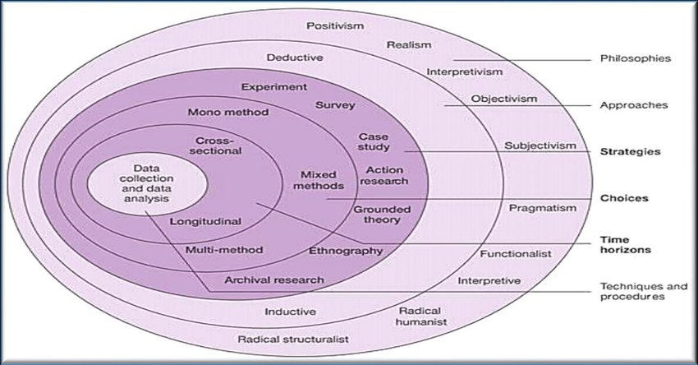
This chapter presents the research philosophy, approach, research strategy, research instrument, data-gathering procedure, and statistical technique. The research onion model will guide the discussion of this project towards achieving its aim and objectives [52].
Figure 10 research onion by Saunders [52]
The notion of the research onion, as presented by Saunders, Lewis, and Thornhill in their publication "Research Methods for Business Students" and illustrated in Figure 1, outlines a systematic approach to research design [52]. The process begins at the outer layer of the onion, where the researcher is required to define the philosophical paradigm guiding their research. Subsequently, the chosen approach aligns with the identified paradigm. For instance, in the case of a positivist paradigm, the deductive approach is adopted since positivist research involves testing theories and achieving generalizability [11].
The research onion serves as a metaphorical framework illustrating the sequential layers or phases of the research process. Saunders et al. (2007) introduced this model to aid researchers in comprehending the diverse elements associated with planning and executing a research project. Comprising six layers, the research onion delineates distinct facets of the research journey., from broad philosophical considerations to specific data collection techniques. Here is an overview of the layers of the research onion [53]:

3.2 Research Philosophy
This is the innermost layer and represents the overall approach to the research, it represents the researcher's worldview and approach to understanding the nature of reality. Common research philosophies include positivism, interpretivism, and pragmatism. For a cyber security threat analysis and mitigation study, a positivist approach will be suitable as it emphasizes the use of objective data and scientific methods. There are three main research philosophies [53]:
- Positivism: Emphasizes an objective and observable reality. Quantitative methods are often associated with positivist research.
- Interpretivism: Focuses on understanding subjective meanings and interpretations. Qualitative methods are commonly used in interpretivist research.
- Pragmatism: Integrates elements from both positivism and interpretivism paradigms, selecting the most suitable methodologies to address research inquiries
A positivist research philosophy is adopted for this project because positivism focuses on quantitative research, where the goal is to quantify variables, measure relationships, and establish statistical relationships. Positivism is also useful when working on large-scale surveys, where statistical analysis is used to infer patterns and relationships within the data collected from large numbers of participants. For this research, large-scale cyber threats survey data on SMEs in the UK between 2020 - and 2023 was collected and analyzed to determine the frequently occurring threats within 4 years, the highest-ranked threats will form the key threats, which will determine the type of attacks to be conducted.
While positivism offers robust methods for certain types of research, it's important to recognize its limitations, particularly in studying complex, subjective, and social phenomena where qualitative methods and interpretivism approaches might provide deeper insights.

3.3 Research Approach

The second layer entails selecting between deductive and inductive reasoning approaches. Deductive reasoning commences with a theory and subsequently tests it against data, whereas inductive reasoning initiates with data and formulates theories based on it. In the context of cyber security, a deductive approach may be appropriate, starting with established theories about threat analysis and mitigation. Choosing a specific research approach, is influenced by the chosen philosophy. The two main approaches are [53]:
Deductive: Starts with a theory or hypothesis and tests it through empirical observation.
Inductive: Begins with observations and patterns and works towards the development of theories.
A deductive research approach is ideal for this project because this project aims to determine the level of threats and how often it has occurred within a certain period. Since a deductive approach measures variables, establishes relationships between them, and quantifies the results, based on the survey data on cyber threats in UK SMEs, from the period 2020 to 2023, each threat will be critically analyzed based on how frequently it occurred and the impact it had on different SMEs, who were involved in the survey. Since the deductive approach relies on structured methodologies and standardized procedures, it is ideal to say that the deductive approach can be used to predict the outcome of the survey data based on the analysis done by Ipsos. While the deductive approach offers a logical and systematic method for testing theories, it may not be suitable for exploratory research or in areas where little is known about the phenomenon being studied.

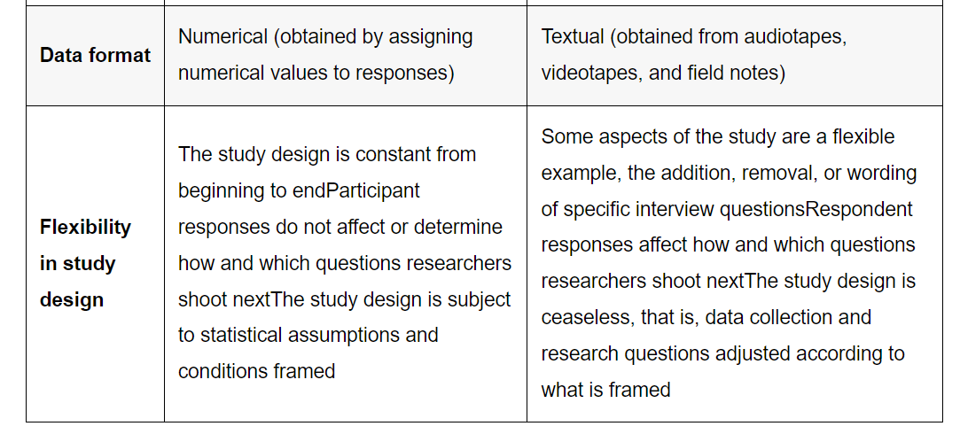
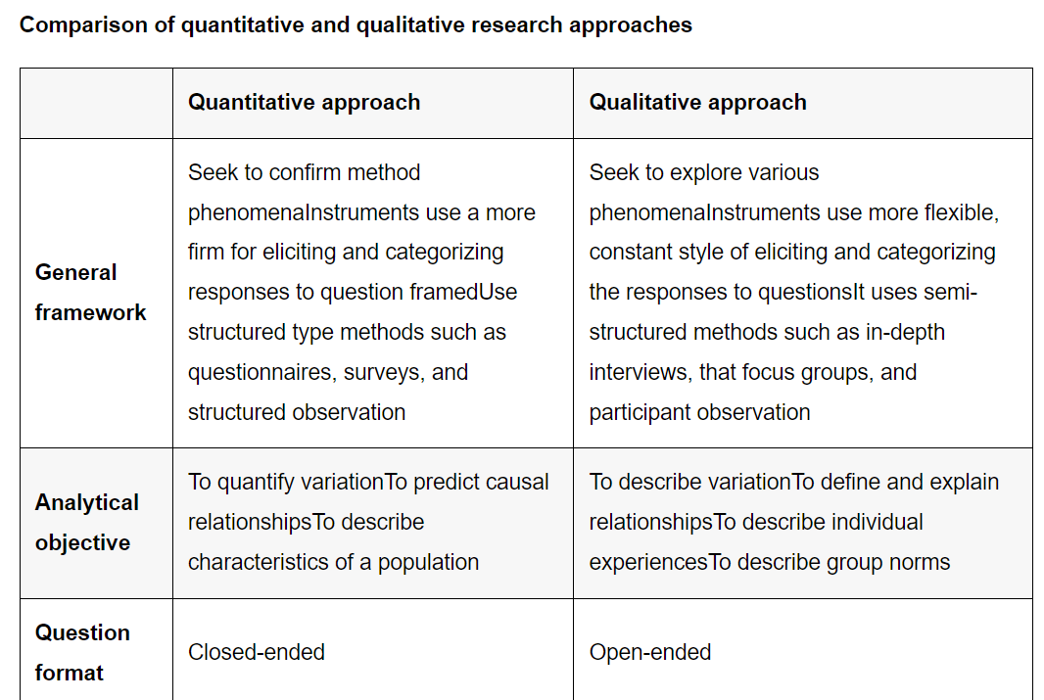
Figure 11 Comparison between quantitative and qualitative research [54]
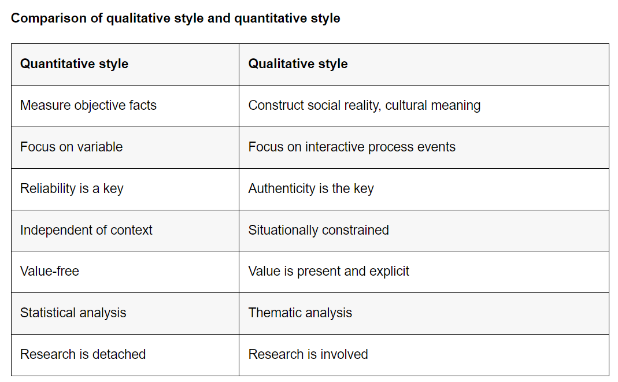
Figure 12 Quantitative and Qualitative style [54]

3.4 Research Strategy
To achieve the overall aim of this project, a comprehensive plan is required to guide the direction and approach of this project. Firstly, an experimental research design is adopted in collecting the data through in-depth research conducted to determine the cyber threats landscape in the UK for the past four years, the various cyber threats that took place in UK SMEs, between 2020 to 2024, and from deductive philosophical stance, the frequently occurring threats will determine the key threats affecting SMEs. The quantitative methodological approach was adopted for this project since the data collected was measurable, and a statistical analysis was conducted using a bar chart, each bar represented a threat, and the bar with the highest percentage formed the basis for determining the key threats affecting SMEs. By carefully considering each component of the research strategy, the quality, and the impact of the findings will aid the proper implementation of this project.

3.5 Research Choices
At the fourth layer, researchers make specific decisions regarding data collection methods, sampling techniques, and approaches to data analysis. In the context of cyber security, you might choose to collect threat data through network monitoring tools, conduct interviews or surveys with security experts, and analyze data using statistical methods. It involves decisions related to the methodology and methods chosen for data collection and analysis. Research choices include:
- Mono-method: The mono-method employs a singular research approach throughout the study. Conversely.
- Mixed methods: mixed methods necessitate integrating two or more research methodologies, typically combining qualitative and quantitative approaches.
- Multi-method: The multi-method extends this by incorporating a broader array of research techniques.
This project will utilize survey data on cyber threats in the UK over the past four years to determine the key threats affecting SMEs. Given the nature of this research, a mono-method quantitative research choice is appropriate. This involves collecting numerical data on cyber security measures and breach incidents to statistically analyze their impact rate, by Utilizing a quantitative research method to enable statistical analysis of the effectiveness of different cyber security breaches.

3.6 Time Horizon
The fifth layer is the time horizon. This layer involves decisions about the timeframe for the research. For cyber security threat analysis, the time horizon might be influenced by the types of threats you're investigating. Some threats may be ongoing and require real-time analysis, while others may involve historical data depicting the duration during which the research is carried out. This can be:
Cross-Sectional: Gathering data at one specific moment in time.
Longitudinal: Collecting data over a prolonged duration to monitor changes occurring over time.
A cross-sectional time horizon is suitable for this research choice, as it aims to assess the effectiveness of cyber security measures at a specific point in time or over the past four-year period.
Decision: Conduct the research at a single point in time or over a specific short period to capture a snapshot of the effectiveness of cyber security measures.

3.7 Techniques and procedures

3.7.1 Data Collection:
At the outermost layer, researchers determine the precise methods and techniques employed for data collection. This may encompass surveys, interviews, observations, experiments, or document analysis, among other approaches.
For this project, the data collection technique adopted is an interview. Since this project relies on secondary data generated by Ipsos, based on the report, their method of generating the cyber threats report was through a survey, where a top member staff of each SME was contacted via a phone call to participate in a brief survey, to answer some questions relating to the cyber security landscape of their organisations. This survey is conducted every year using a one-on-one conversation technique to collect detailed information to evaluate the current threat landscape.

3.7.2 Data Analysis
This project uses existing data sourced by the Department for Digital, Culture, Media and Sport, UK. Existing data from the past four years was collected and re-analyzed to determine the frequency of threats and the level of impact they had on the organizations. Using a data visualization procedure like bar charts to graphically represent the flow and trends of these attacks, the aim of identifying key threats in SMEs was achieved.
Below is a data analysis report based on the existing collected data over the past four years, between 2020 – 2023. Each table is accompanied by a bar chart to graphically represent the trends of each threat and the percentage of SMEs that were attacked by particular threats.
Percentage of Small and Medium-sized Enterprises (SMEs) that reported identifying various types of threats or attacks in 2020, among those organizations that have acknowledged any breaches or attacks.
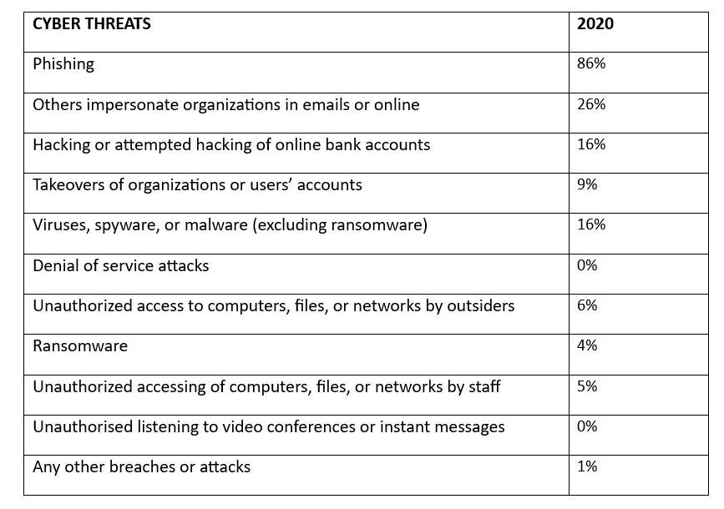
Table 3 Cyber threats survey for 2020 [17]

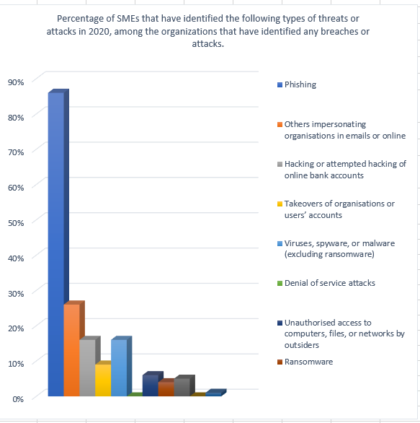

Figure 13 Bar chart for cyber threats survey 2020 [17]

Percentage of Small and Medium-sized Enterprises (SMEs) that reported identifying various types of threats or attacks in 2021, among those organizations that have acknowledged any breaches or attacks.
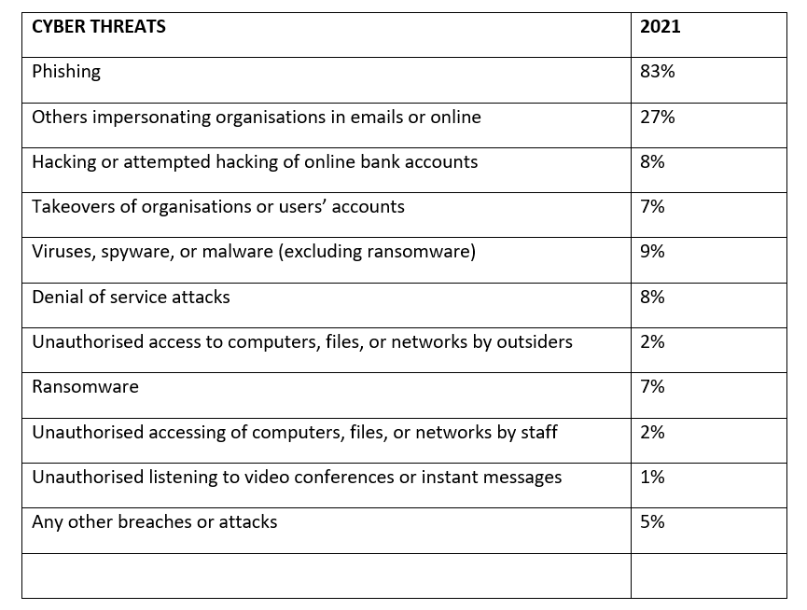
Table 4 cyber threats survey for 2021 [15]

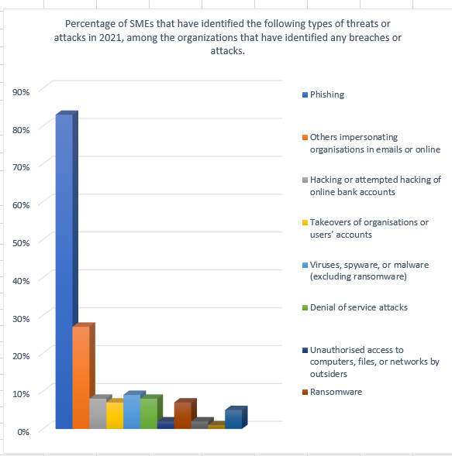

Figure 14 Bar chart for cyber threats survey 2021 [15]

Percentage of Small and Medium-sized Enterprises (SMEs) that reported identifying various types of threats or attacks in 2022, among those organizations that have acknowledged any breaches or attacks.
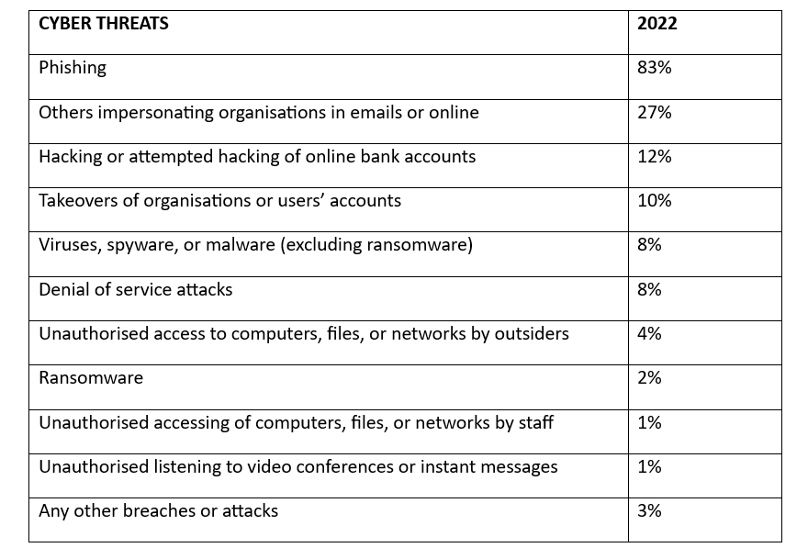
Table 5 Cyber threats survey 2022 [14]

Of the UK businesses that reported experiencing attacks in 2022 (representing 39% of surveyed businesses), phishing attempts emerged as the most common threat vector, comprising 83% of incidents. About one-fifth (21%) of these businesses recognized more advanced attack types like denial of service, malware, or ransomware attacks. Despite ransomware's lower frequency, it was still perceived as a substantial threat, as 56% of businesses had policies against paying ransoms.

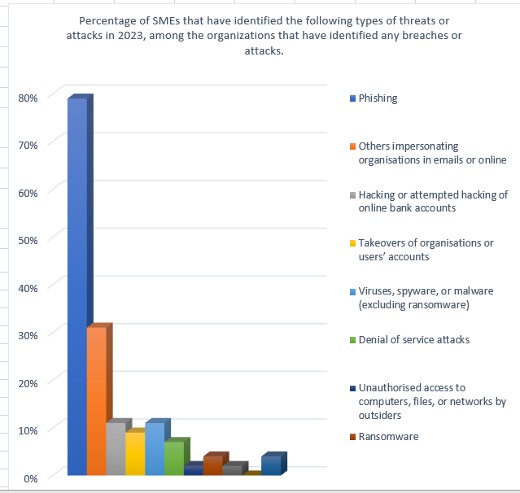

Figure 15 Bar chart for cyber threats survey 2022 [14]

Within the group of organizations reporting cyber-attacks, approximately 31% of businesses estimate being attacked at least once a week. Around one-fifth of both businesses (20%) experienced direct negative outcomes as a result of cyber-attacks, while approximately one-third of businesses (35%) encountered at least one adverse impact [14].

Percentage of Small and Medium-sized Enterprises (SMEs) that reported identifying various types of threats or attacks in 2023, among those organizations that have acknowledged any breaches or attacks.

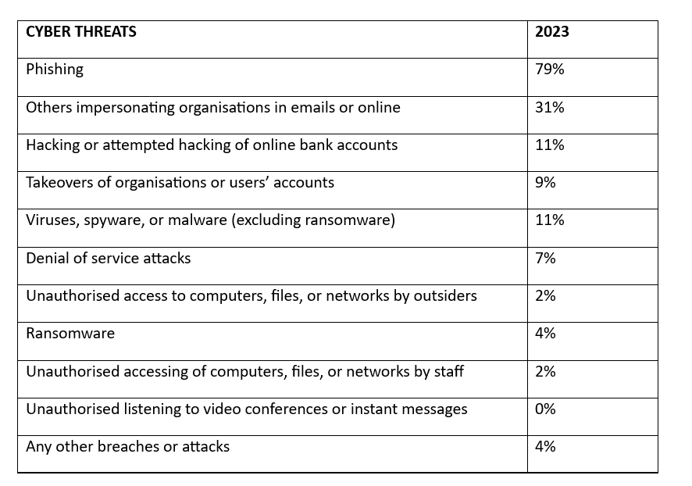
Table 6 Cyber threats survey for 2023 [16]

Figure 16 Bar chart for cyber threat survey 2023 [16]

PROJECTT PLAN (GANTT CHART)
A project plan is used throughout the project as a guide for execution and monitoring progress.
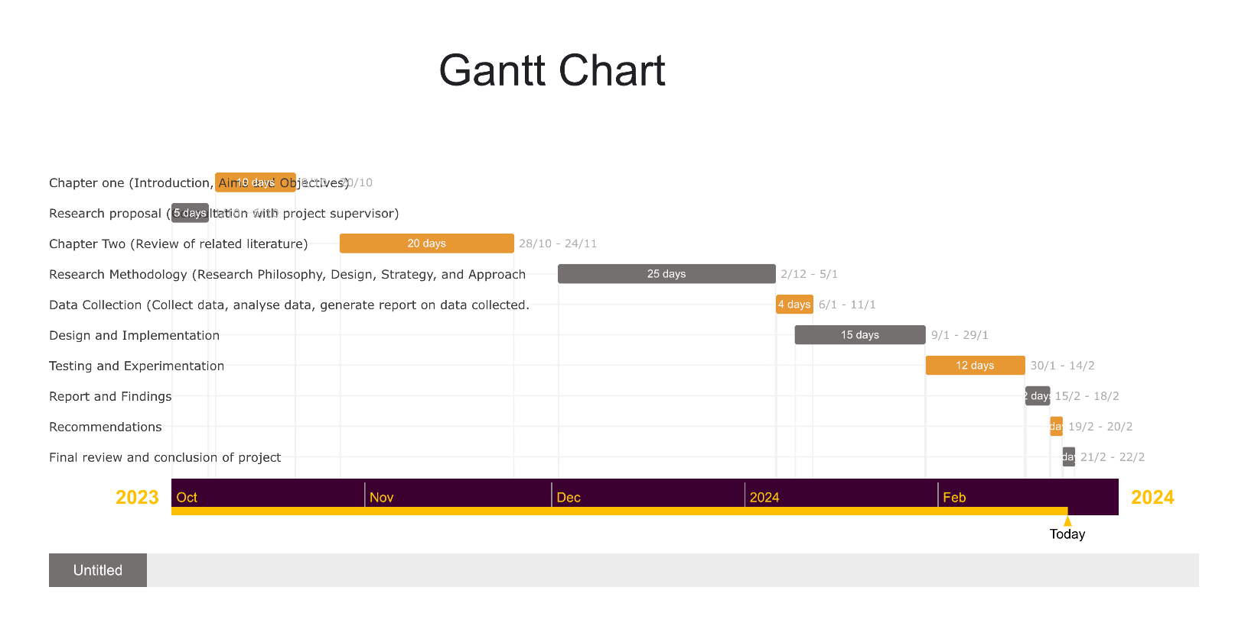

A

Contingency Plan
A contingency plan is designed to address specific unforeseen events or risks that could impact the project. It is essentially a backup plan, focusing on preparedness and rapid response to ensure the project's objectives can still be met in the face of unexpected challenges.

- The project scope of data collection is reduced to 4 years to meet the date line.
- If some of the proposed attacks fail, metasploitable2 will be used as a vulnerable machine to perform other attacks like DDOS, Dictionary attack, Metasploitable/VSFTP ,
- Some tools proposed for the implementation of this project might be effective due to patch vulnerabilities, hence some attacks might not work to complete its cycle.
- Due to the nature of Some attacks, not all tactics or steps in the MITRE ATT&CK framework will be implemented or followed.
- Some attack tools didn't work for some experiments, but other tools were deployed

SYSTEM REQUIREMENT
Hardware Specifications
Processor: Intel Core i9 or AMD Ryzen 9 (or equivalent) with at least 8 cores/16 threads to handle multiple virtual machines and intensive tasks simultaneously.
Memory (RAM): 32 GB DDR4 minimum, 64 GB recommended for running multiple virtual machines and tools without performance degradation.

Software Specifications
Operating System: A dual-boot setup with both Windows 10/11 Pro (for compatibility with Windows-specific tools and Active Directory simulations) and a Linux distribution specialized for penetration testing (e.g., Kali Linux or Parrot Security OS).
Virtualization Software: VMware Workstation Pro or Oracle VM VirtualBox for hosting multiple virtual machines (VMs) for various testing environments, including target systems and attack platforms.
Security Tools Suite:
For Windows: PowerShell Empire, Metasploit Framework, BloodHound, Mimikatz, and Burp Suite.
For Linux: Kali Linux Tools (including Nmap, Wireshark, Aircrack-ng, John the Ripper, and OWASP ZAP).

Chapter Four

4.0 Design and Implementation

4.1 Introduction
This chapter will focus on two aspects, the design phase, and the implementation phase.
The design phase will give details about the proposed design of how the testing environment.
A flowchart will guide the cover of the design phase which involves a flowchart of a sample SME network system and also the flowchart of each attack to be conducted.

4.2 Problem Formulation
Analyzing major threats that affect SMEs and implementing necessary mitigation strategies is the main aim of this project. To achieve this, a virtual network infrastructure to depict an SME network will be designed and set up using a virtual environment like VirtualBox, or VMware. Different virtual machines will be set up and configured with the Windows operating system, Windows Servers, MySQL database, Web application servers, and firewall protocol will be set up. The attacker machine will be a Kali Linux machine, victim machines will run on Windows, and metasploitable 2.
To test the current security architecture of SMEs, an offensive security approach (Red teaming) will be employed for this project.

4.3 A scenario is developed to guide the implementation of this project scope
Evon Enterprise, a small to medium-sized enterprise (SME) specializing in e-commerce solutions, has recently recognized the escalating threats in cyberspace, particularly targeting industries of its nature. As part of its strategic initiative to bolster cybersecurity resilience, the company has decided to engage a Red Team to conduct an attack simulation on its network system infrastructure. This proactive measure is aimed at identifying vulnerabilities, testing the effectiveness of existing security measures, and enhancing the company's defense mechanisms against potential cyber threats.

4.4 Scenario Background
Evon Enterprise has observed a surge in cyber threats targeting SMEs in the e-commerce sector, including phishing attacks, ransomware, and sophisticated breaches aimed at financial theft and data compromise. Given its reliance on online platforms for business operations, any compromise could result in significant financial losses, erosion of customer trust, and regulatory repercussions. Furthermore, with the integration of new technologies and expansion of remote work policies, the complexity of the company's network has increased, potentially introducing new vulnerabilities.

4.5 The objective of the Attack Simulation
The primary objective is to conduct a comprehensive and realistic simulation of cyber-attacks targeting Evon Enterprise's network system infrastructure. This includes, but is not limited to:
Identifying vulnerabilities in the network, applications, and systems that malicious actors could exploit.
Based on the identified key threats as previously discussed in Chapter 2, the following attacks will be considered by the Red team, to ascertain why and how these threats occur.
The attacks include but are not limited to Phishing attacks (Spear phishing), Domain Active Directory Attacks (LLMNR, Kerberosting), Distributed Denial of Service Attacks, Privilege Escalation, Insider attack, Ransomware attacks, and Malware, Virus attacks

4.6 Setting Up a Simulation Environment:
A virtualized environment will be set up as Evon network infrastructure.
In setting up this virtual environment, so many factors were considered, such as the scope of the attacks, legal and ethical considerations, safety and security of data and resources, and Tools and resources to be used were considered. This simulation was set up and configured on a Virtual box, with 5 virtual machines each with ISO operating systems installed on each, and all connected via a Nat Network to enable communication across all virtual machines.
Attacker_Kali Linux machine: This will act as the threat actor. It will be used to exploit other machines on the network. IP Address: 192.168.57.5
EVON Server: This machine is a Windows 2019 server with a domain controller (Evon.local) set up to manage Users, Groups, Computers, and Group Policies. IP Address: 192.168.57.8
EVWork-PC1: This machine is set up as a domain admin PC, and it is joined to a domain (EVON.local) It will be used to target the server machine. IP Address: 192.168.57.9
EVWork-PC2: This machine is set up as a user PC, and is joined to the domain (EVON.local). It will be by the Kali machine in an attempt to escalate privileges in the server machine. IP Address: 192.168.57.10
Matasploitable2: This is a vulnerable machine, with unpatched vulnerabilities. It is a testing environment for simulating how real-world attacks are performed by hackers. IP Address: 192.168.57.11
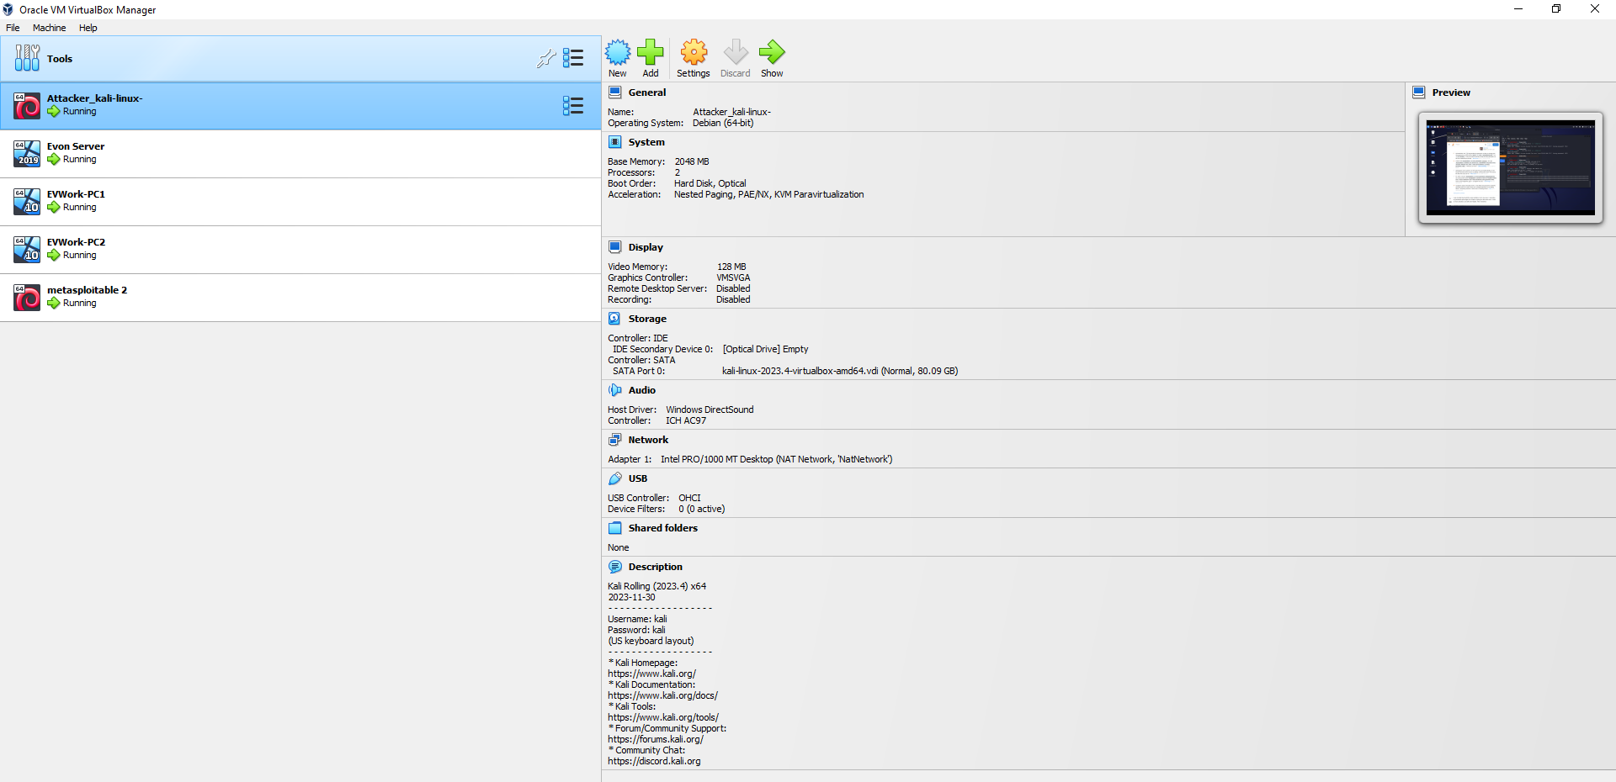
Figure 17 Virtual Simulation Environment Setup

4.7 Evon Enterprise Network Structure

This project has adopted a name for a sample SME called Evon Enterprise. Based on research a single SME in the UK comprised of 1 to 250 employees [1]. Most SMEs have no properly trained and certified network security expert. This SME network is designed as an enterprise environment with a web, Mail, and File server, each protected with firewalls and IDPs/IPS.

4.7.1 Physical Topology
Physical topology is the actual layout design of the network's hardware. It is primarily concerned with the physical layout of cables and devices, which affects the network's performance, scalability, and fault tolerance

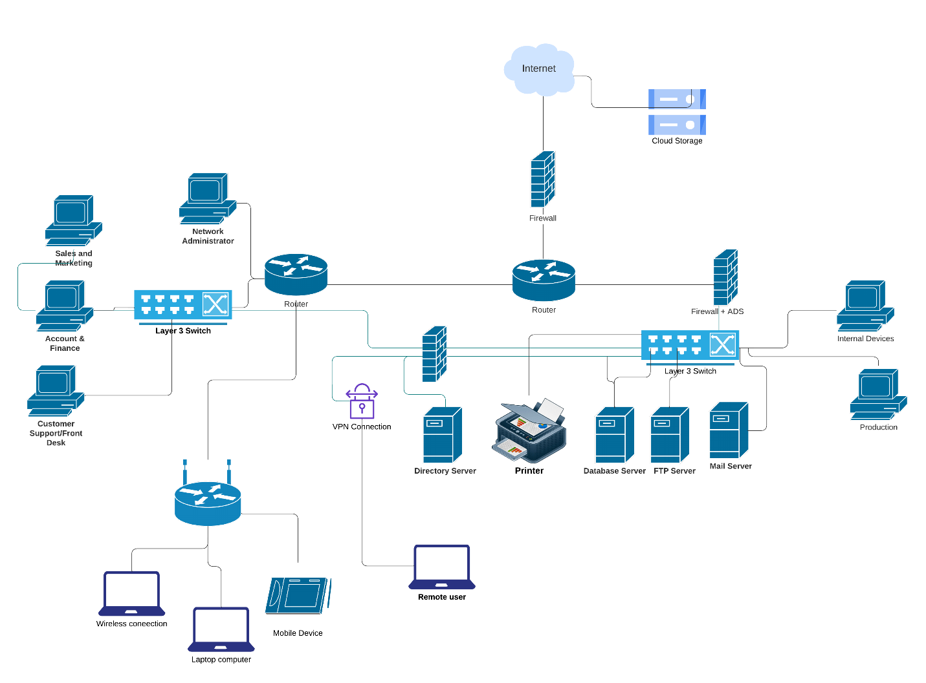

Figure 18 Evon Physical network topology structure

4.7.2 Logical Topology Design of Evon Enterprise
Logical topology focuses on how data is transferred within the network. It deals with the design of the network's data flow and protocols, impacting the network's efficiency and traffic management.

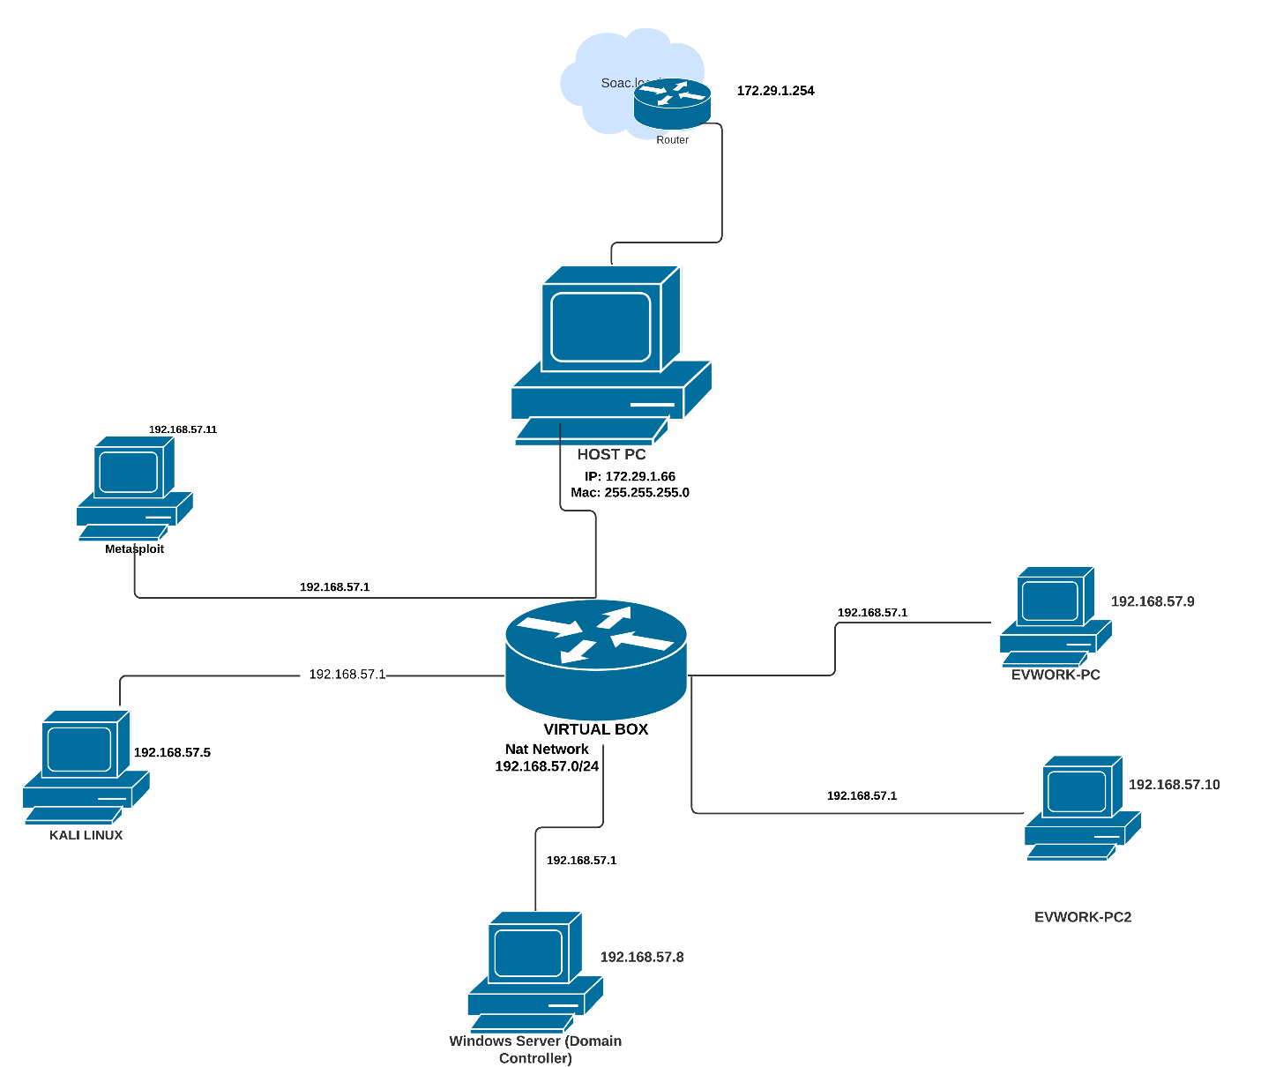

Figure 19 Logical Network Topology

Start

Set Up Virtual Environment

Choose Virtual Platform (e.g., VMware, VirtualBox)

Create Virtual Machines (e.g. Kali Linux, Windows Server 2019, Windows 10)

Set up and configure Windows Server 2019, Install domain controller, add users and computers, DHCP, Windows 10)

Set up a Virtual Machine Kali Linux and install Necessary Testing Tools on Kali Linux (e.g., Metasploit, Nmap, Wireshark, Burp Suite)

Configure Network Topology (e.g., LAN, DMZ, Wireless)

Adopt Methodology and Frameworks for Red teaming exercise.

Proceed with Simulated attacks based on proposed key threats.(Document details of simulated attacks)

Stop

Figure 20 Flowchart design for Proposed Red teaming
Start

Kali Linux machine is the attacker machine, preloaded with attacking tools, Windows server machine is set up with a Domain controller, DNS, and DHCP, populated with over 100 users and 50 computers, windows 10 machine is set up as the victim machine,

Initial Reconnaissance
(Identify IP ranges, DNS information, open Ports, etc.)

Vulnerability Scanning
(Use tools like Nessus, OpenVAS to identify vulnerabilities)

Exploitation and post-exploitation
(simulate Phishing, Impersonation, DOS, and Insider attacks)
- Attempt to gain access - Privilege escalation
- Lateral movement

Data Exfiltration
(Simulate stealing data)

Report Findings
(Document vulnerabilities, potential impact, and
recommended mitigations)

End

Figure 21 Attacks simulation for Red teaming

4.7.3 Flow diagram for Red Teaming Attack Simulation on Evon Enterprise Network systems
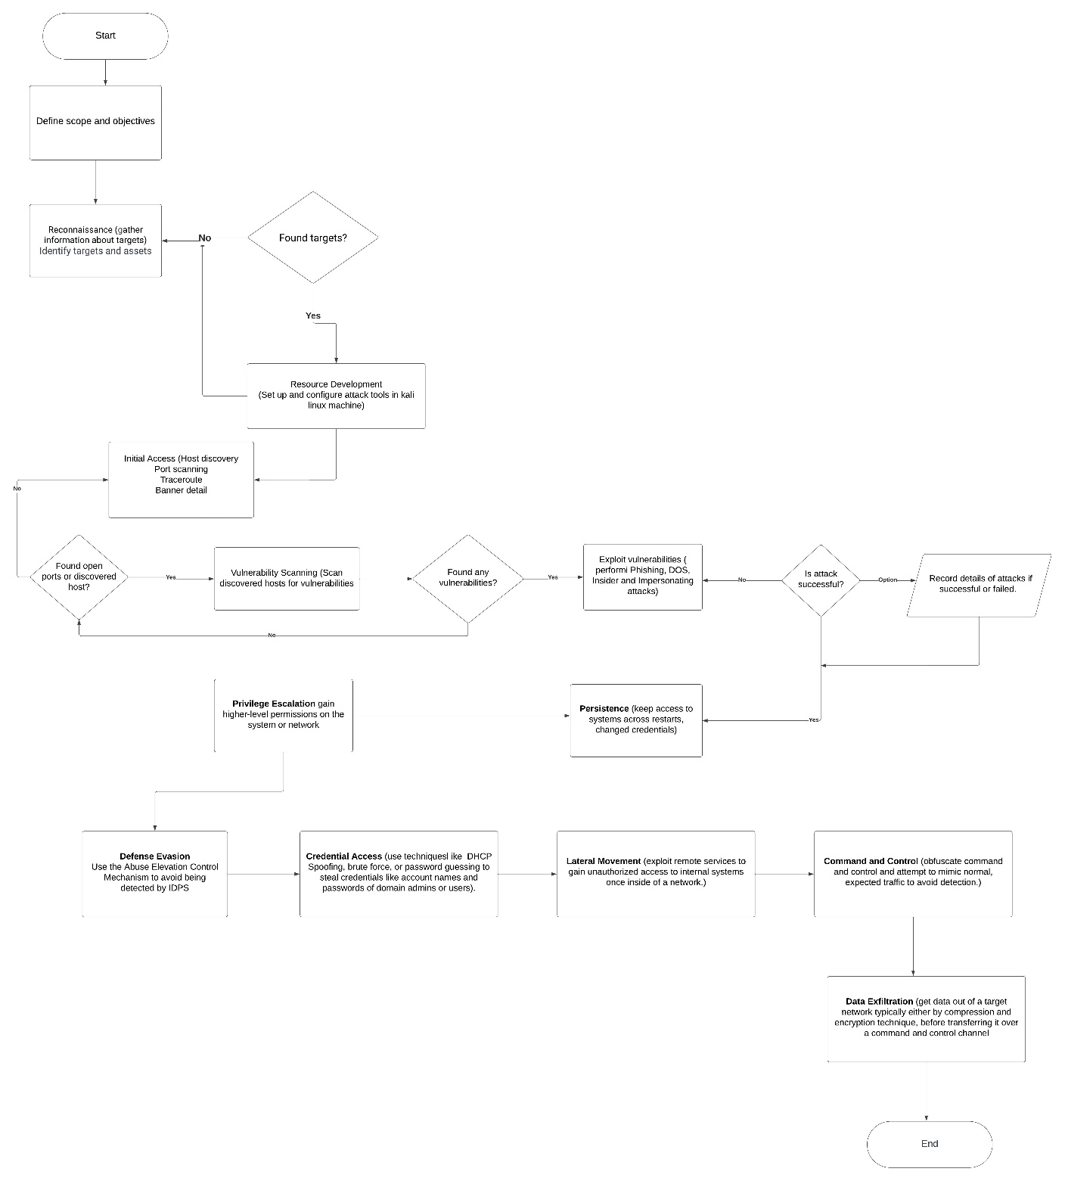
Figure 22 Flowchart implementation process for attack simulation

4.7.5 Steps and Procedures for Attack Simulation according to MITRE ATT&CK Framework
- Identifying Targets and Assets:
Identifying the specific systems, applications, and data within the attack simulation's scope. Perform attacks based on proposed key threats.
- Information Gathering (Reconnaissance):
Collect information about the target environment using passive and active reconnaissance techniques.
- Network Scanning and Enumeration:
Scan the network for live hosts and open ports. Enumerate services and gather detailed information about the target systems.
- Vulnerability Assessment:
Identify and assess vulnerabilities in the target systems. Use tools like Nessus, OpenVAS, or other vulnerability scanners
- Exploitation and Gaining Access:
Exploit identified vulnerabilities in Evon network infrastructure, to gain initial access to the target systems.
- Privilege Escalation:
Try to elevate privileges on compromised systems to simulate an attacker gaining higher levels of access.
- Lateral Movement:
Move laterally within the network, simulating an attacker's ability to pivot and access additional systems.

- Data Exfiltration:
Attempt to exfiltrate sensitive data from the target environment, simulating a real-world data breach.
- Cleanup and Reporting:
Remove any traces of the penetration test and prepare a detailed report outlining findings, vulnerabilities, and recommended remediation steps.
- Enforcing Security/Mitigations and Analysing the network security posture
Document details of the attacks, including the attacks that were successfully conducted and the ones that failed, giving reasons why they failed. Recommend mitigation techniques for the attacks that were successful.

It is important to note that due to time factors, not all of the above MITRE ATT&CK Techniques steps will be documented in all phases of the attack simulation. Some steps and techniques will be skipped in the reporting, but key phases will be documented.

CHAPTER 5

5.0 TESTING AND RESULTS

Introduction
In this chapter, details of each phase of the attack simulation will be explained and documented. Testing is based on identifying targets, vulnerability in the target, exploiting the weakness, and recommending necessary mitigation strategies. This testing will cover 4 different types of attacks; Phishing, Active Directory (LLMNR Poisoning) Privilege Escalation, Insider threat attack, Distributed Denial of Service (DDOS), and Very Secure FTP Daemon (Backdoor Attack).
NOTE: All tools, commands, and results for each attack are included in the screenshots attached to each attack types.

5.1 PHISHING (Spear Phishing) ATTACK
In Spear phishing, attackers specifically target an individual within an organization to steal their login credentials. They often gather information about the victim, such as their name, position, and contact details through social media, before launching the attack.
Goal: To assess the organization's vulnerability to spear phishing attacks from professional networking sites like LinkedIn.
- Planning and Reconnaissance (Preparation)
The target's personal information like contact details was collected via LinkedIn based on the user's profile.
The target's email address and phone number were collected via her LinkedIn account.
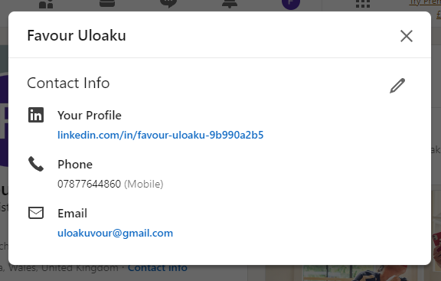

Figure 23 targets contact information

- Creating a spear Phishing message
To further prove the originality of this attack, the target had previously made a post on LinkedIn indicating an urgent need to upgrade her account to a premium account. from an attacker's perspective, that is something to capitalize on.


Figure 24 screenshot of targets social media post

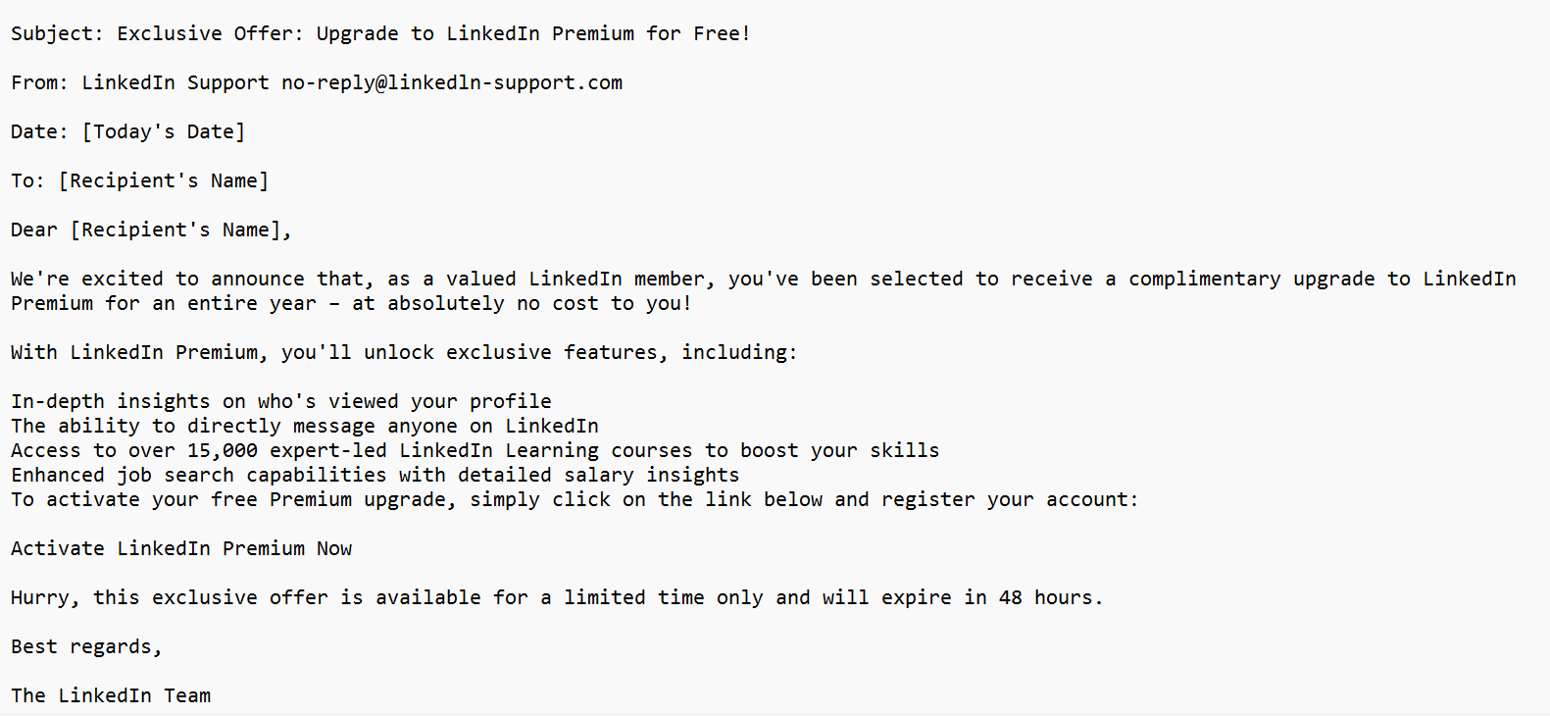
Figure 25 Screenshot of drafted spear phishing mail

- Simulation Execution
The crafted message was sent to the target via Gmail, the email claims to have been sent from the LinkedIn support team as seen in Figure 26, including a phishing link for the user the link in to claim a free one-month premium account.
Figure 26 Screenshot of spear phishing mail sent to target

- Execution
The link redirects to a controlled page simulating a credential-harvesting site. The target was directed to a clone LinkedIn page containing more details about the free one-month premium membership promo.
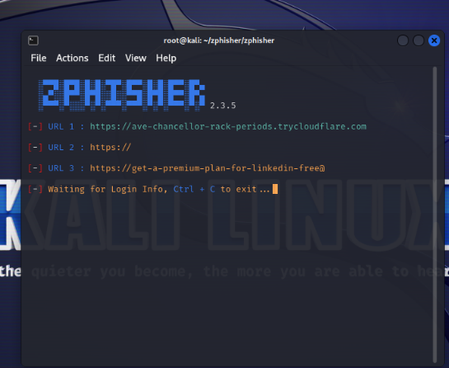
A tool known as Zphisher was used to clone a LinkedIn web page with details about the premium membership.

Figure 27 Screenshot of Zphisher tool
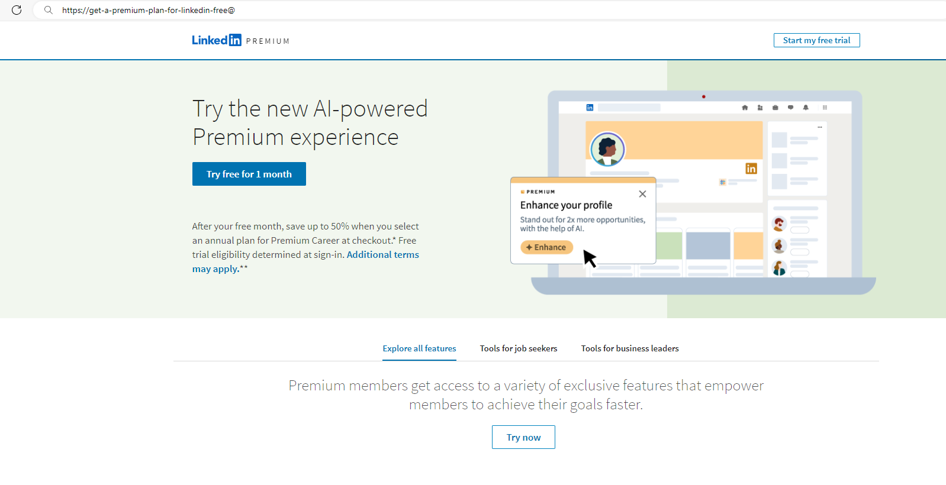
Figure 28 Screenshot of cloned LinkedIn ads page

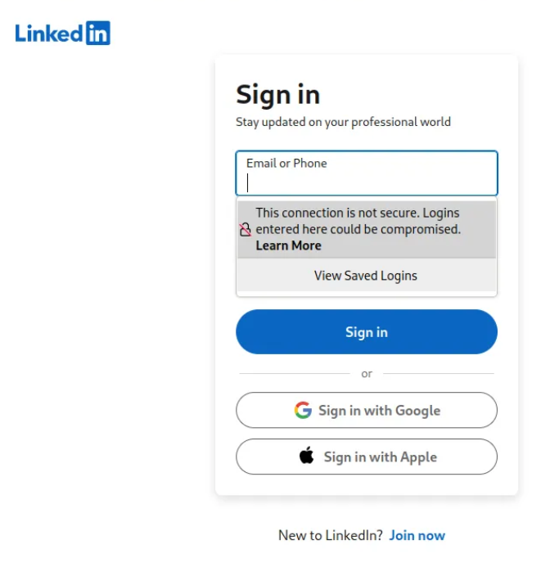
The user clicks on the “Try free for 1 month” and is directed to a sign-in page. The user was also notified that the connection was not a secured one as seen in Figure 29, and logins entered here could be compromised, this further proves it’s a phishing link.

Figure 29 Phished sign-in page

- Monitoring and Analysis
As the target signed in, her login details were harvested on Zphisher, as seen below in Figure 30, while the user was redirected to her actual LinkedIn account page as seen in Figure 31.

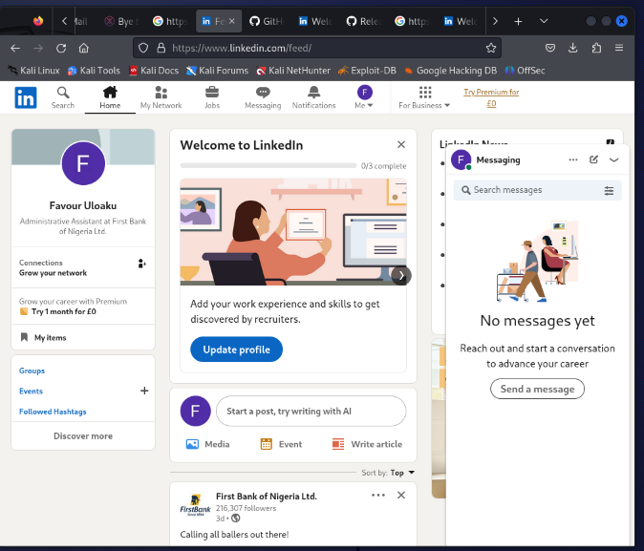
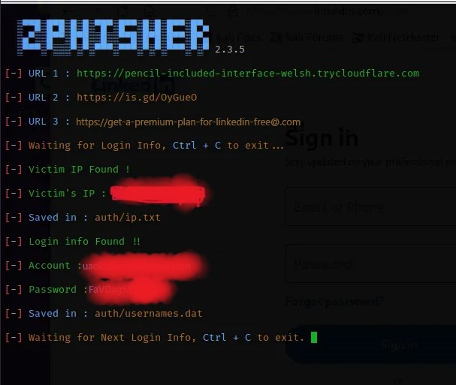

Figure 30 screenshot of collected target credentials Figure 31 Target LinkedIn page after successful login
“For privacy, the user login credentials and IP are concealed because the LinkedIn account belongs to a real user”

- Mitigation and Improvement
- Security Awareness Training (T1536): I highly recommend an enhanced training program to include the identification of spear phishing attempts, particularly those originating from professional networks like LinkedIn.
- Improve Phishing Detection (T1566.001): Implement or upgrade email and web filtering solutions to better detect and block phishing attempts.
- Strengthen Response Protocols: Improve procedures for reporting and responding to suspected phishing attempts.

5.2 ACTIVE DIRECTORY (LLMNR Poisoning)
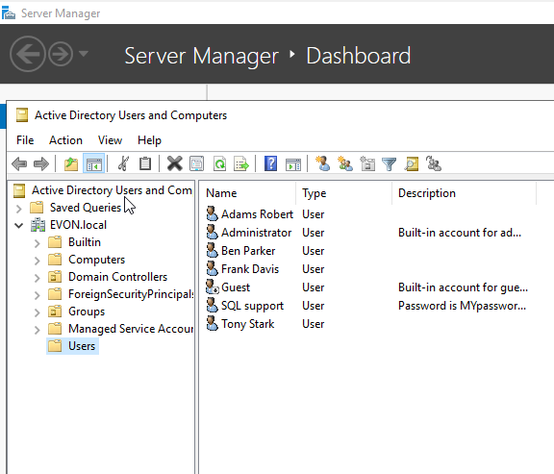
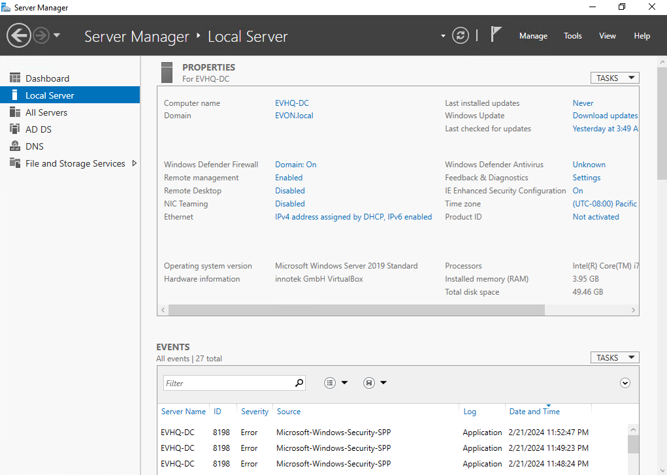
To perform this attack, an actual Active Directory was installed and configured on a Windows Server 2019. Users and computers were added, and different privileges were given according, although, some users had too many previledges, which will be exploited to elevate privileges within the domain.
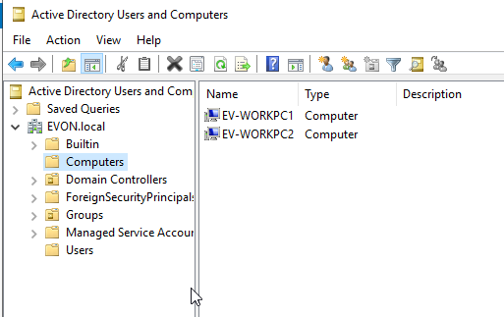


Figure 32 Active Directory setup Figure 33 Users were added to the domain and roles assigned

Figure 34 Computers joined the domain Figure 35 A User successfully signed in as a domain user

Simulating an Active Directory attack, specifically using LLMNR (Link-Local Multicast Name Resolution) Poisoning, within the context of a Red Team exercise, requires adherence to ethical guidelines and precise execution. This simulation aims to identify vulnerabilities in the network's name resolution process that could be exploited by adversaries. The MITRE ATT&CK framework categorizes this technique under "Adversary-in-the-Middle" (T1557), focusing on the sub-technique "LLMNR/NBT-NS Poisoning and SMB Relay" (T1557.001).
- Goal: Assess the vulnerability of the Evon.local network to LLMNR Poisoning attacks and the potential for credential interception or misuse.
- Scope: The simulation targets the internal network environment of Evon Enterprise, specifically focusing on exploiting LLMNR and NBT-NS (NetBIOS Name Service) protocols for credential theft. This attack is only limited to credential harvesting and does not include data exfiltration.

- Planning and Reconnaissance
Since this is a red team attack simulation, the network name and IP address were given as (EVON.local and the network IP address is 192.168.57.0/24, but the hosts on the network are unknown.
- Network Mapping: Identify network segments and devices participating in LLMNR and NBT-NS, using an Nmap scanner, the network was scanned to identify active hosts and targets.
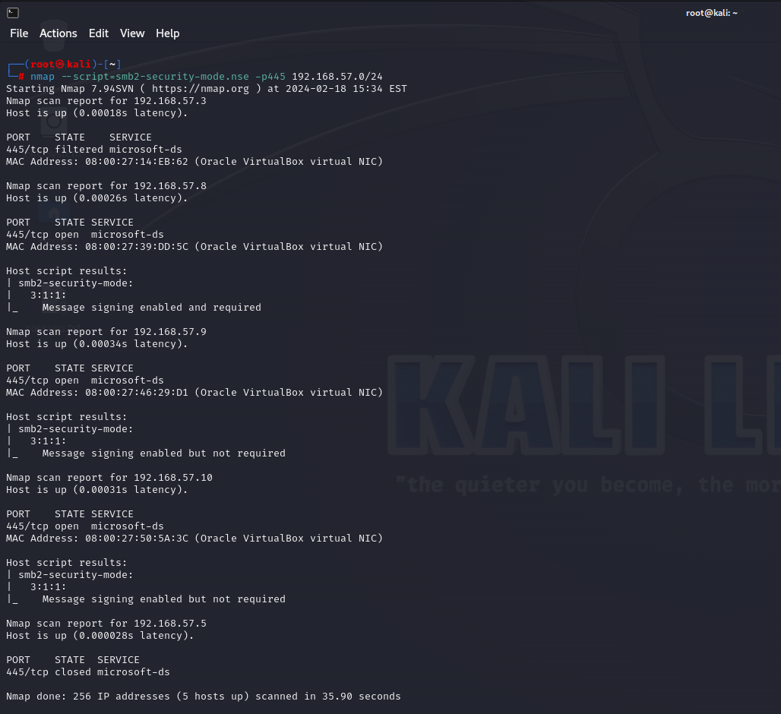
Figure 36 Identified hosts in the domain
- Identify Targets: Computers and users that frequently access shared network resources were identified, as they are more likely to generate LLMNR or NBT-NS queries as seen in Figure 36.

Some vulnerabilities were set were manually set up for this attack to be successful.
Firstly, the firewall was disabled as seen in Figure 37, the service user (SQL support) was added to the Domain Admins group as seen in Figure 38, and an SPN weakness was added (A Service Principal Name (SPN) vulnerability in Active Directory (AD) typically refers to security weaknesses or misconfigurations associated with SPNs that can be exploited to perform attacks such as Kerberoasting) as seen in figure 39.
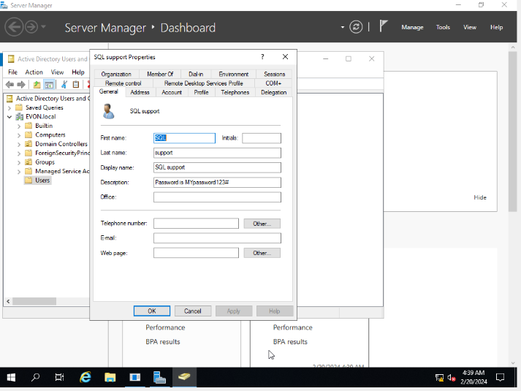
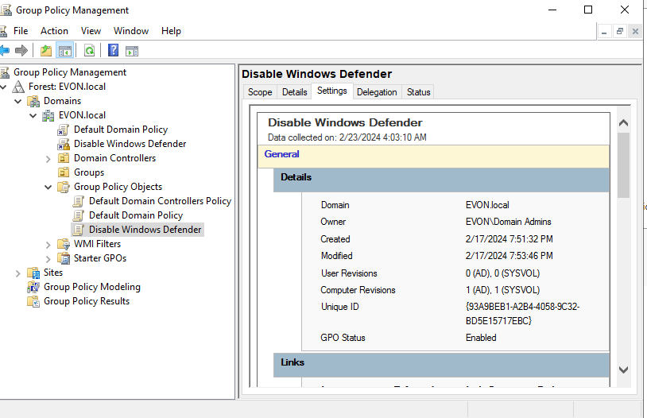

Figure 37 Disable firewall rule Figure 38 Service user added to a domain group

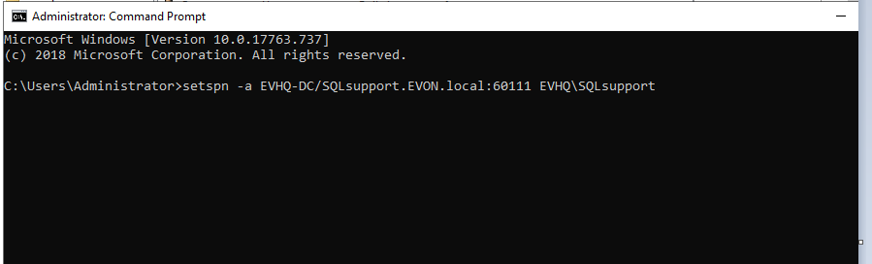

Figure 39 SPN Vulnerability

- Simulation Execution
1. Adversary-in-the-Middle
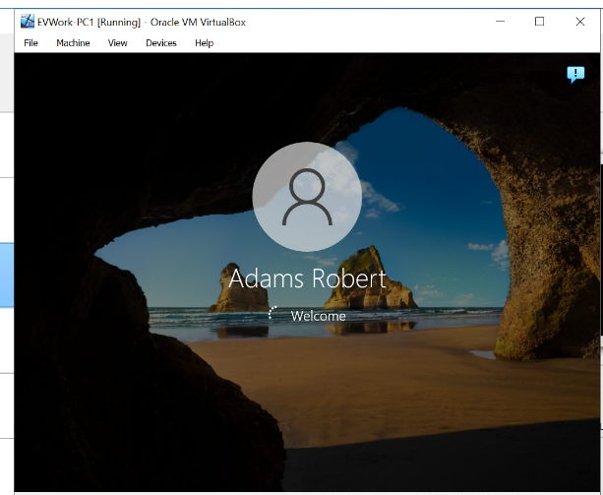
The Kali machine is configured to log any credentials as seen in Fig. 40 or hashes that are transmitted when a client attempts to authenticate to the simulated service, as seen in Figs. 41 and 42.
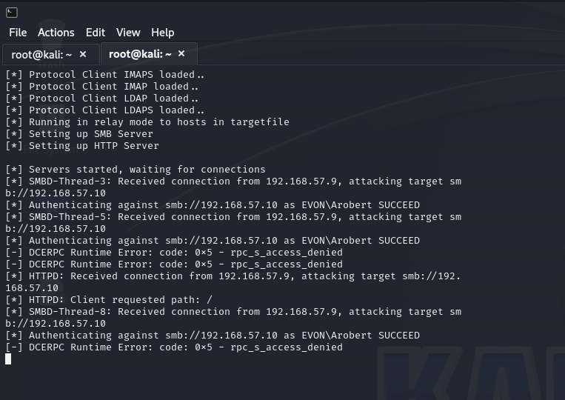

Figure 40 Kali configured to log credentials Figure 41 Targeted user logged in to computer

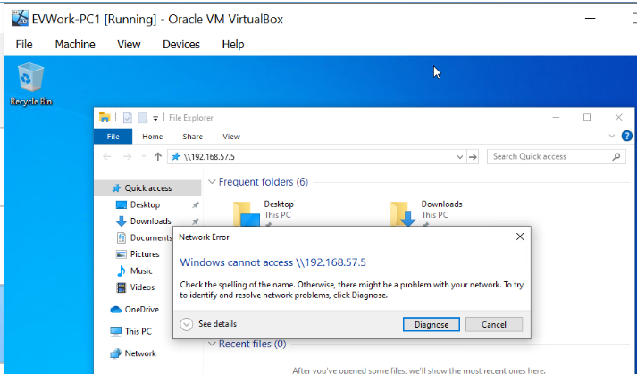

Figure 42 User trying to access unauthorized location

- Credential Access
LLMNR/NBT-NS Poisoning: Using Responder to listen for LLMNR and NBT-NS queries on the network. A user (arobert) queries a hostname that does not exist in the DNS, and the Responder "poison" the query response, falsely claiming to be the queried host, thus initiating a connection with the target device.
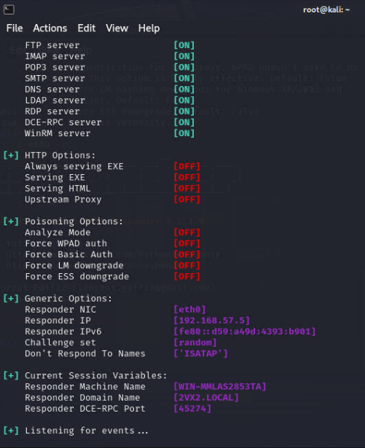
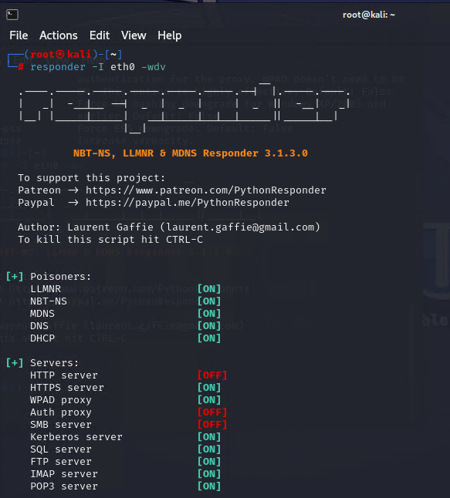

Figure 43 responder poisoning Figure 44 responder listening for events

The LLMNR Poisoned response is sent to the server, requesting logged-in user credentials as seen below in Fig. 45
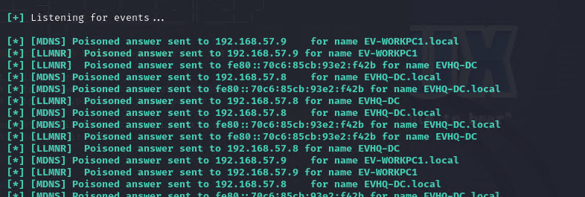
Figure 45 Poisoned response sent

- Credential Dumping: Once a connection is established, the Responder captures the NTLM hashes of the targeted user credentials sent by the querying device, as seen in Fig. 46.
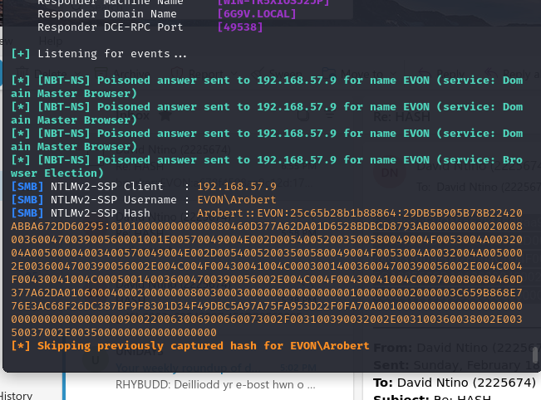

Figure 46 User credentials hashes

- Network Sniffing: The network is monitored for traffic, to capture credentials or hashes transmitted in clear text or weakly encrypted. Hashcat was used to decrypt the hashes and password lists rockyou.txt was utilized to attempt to crack the user password. Unfortunately, the hashes couldn’t crack to reveal the password, due to low system processor. RockYou.txt is a compilation of more than 14 million unencrypted passwords exposed during the RockYou breach in 2009, hence it requires a system with a more higher processor and RAM speed for it to convert the hashes to reveal the password of Arobert(targeted user) as seen in fig.

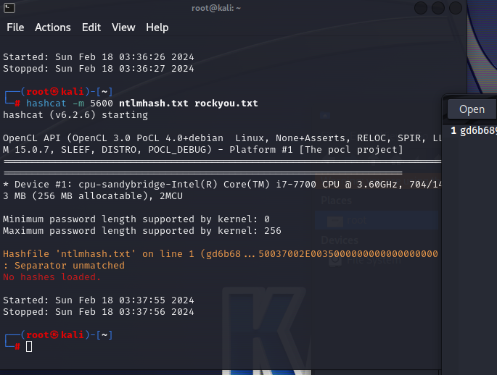

Figure 47 Cracking hashes with rocyou.txt
- Monitoring and Analysis
Command and Control: The captured traffic is analyzed for command-and-control activities, including any unauthorized access attempts to other systems using the captured credentials.
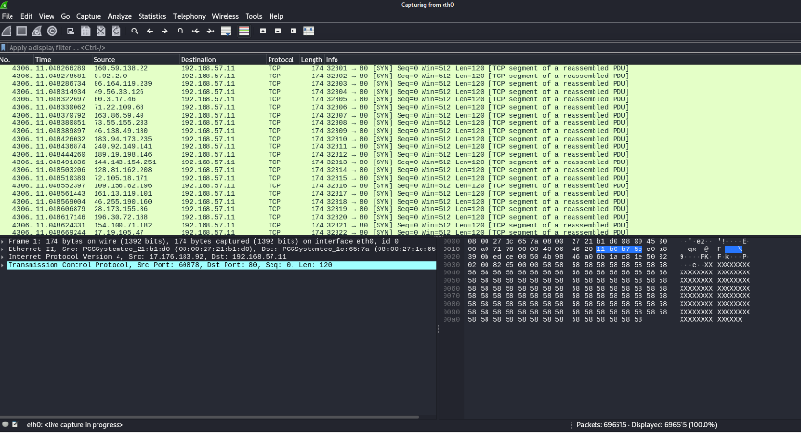
Wireshark was used to capture and analyze packets.

Figure 48 Captured packets with Wireshark

- Data Exfiltration: The NTLM hashes are collected and assessed for the potential of further network infiltration or data exfiltration as seen in fig. 48.
- Reporting and Debriefing: The BloodHound tool was used to analyze Active Directory relationships and vulnerabilities. For Lateral movement, Mimikatz tool (mimikatz.exe "privilege:debug" "sekurlsa::logonpasswords") was used to dump credentials.

- Outcome: Discovery of internal weaknesses such as inadequate network segmentation, poor password policies, and excessive user privileges.

- Mitigations: Improve network segmentation, enforce the least privilege principle, implement multi-factor authentication (MFA), and regular password audits.
Recommendations: Based on the MITRE ATT&CK framework, the following strategies are recommended for mitigating the risk of LLMNR/NBT-NS poisoning attacks.
- LLMNR and NBT-NS protocols should be disabled on network devices where possible.
- Network access controls should be implemented to limit unnecessary traffic (T1553.004).
- Encouraging the use of secure methods for authentication and name resolution.
- Require Network Access Control.

- Require strong user passwords (e.g, >14 characters in length and limit common word usage). The more complex and long the password, the harder it is for an attacker to crack the hash.

5.3 INSIDER THREAT ATTACK
As a Red Team engineer, conducting an insider threat attack involves mimicking the actions of a malicious insider to identify vulnerabilities and assess the organization's preparedness against such threats. This scenario outlines the simulated steps of how an insider is executed in a real environment or organization.
This is just a simulation of how it will be performed in the real world.

- Objective: To simulate an insider threat aimed at unauthorized access and exfiltration of sensitive company data to assess the effectiveness of the organization's internal security measures, employee awareness, and incident response capabilities.

- Pre-Simulation Preparation
Authorization: Obtain explicit written permission from senior management, detailing the scope and bounds of the simulation.

- Scope Definition: This simulation is limited to specific targets, such as accessing sensitive project documents, customer data, or financial information, without actual data leakage.

- Communication Plan: clear communication protocols must be established, with a control team aware of the simulation to monitor activities and intervene if necessary.

Insider Threat Simulation Steps
1. Information Gathering
Role Play: The identity of a disgruntled employee with legitimate access to the company network is assumed but without the necessary permissions to access sensitive data.
- Internal Reconnaissance: the disgruntled employee uses standard employee access to gather information on network layouts, sensitive data locations, and potential internal targets for exfiltration.
2. Privilege Escalation
- Exploiting Weaknesses: The threat agent Identifies and exploits weaknesses in internal controls to escalate privileges. This could involve exploiting misconfigurations, outdated software, or leveraging social engineering tactics on coworkers to gain their credentials.

- Access Gain: the elevated privileges are used to access sensitive information, ensuring actions are logged for later analysis.
3. Data Exfiltration Simulation
- Exfiltration Methods: Threat agent commences exfiltration of data through common insider methods, such as emailing to a personal account, uploading to cloud storage, or copying to external USB drives. Use dummy files to mimic sensitive data.

- Stealth Techniques: The threat agent applies various techniques that a typical insider might use to avoid detection, like slow data exfiltration or encrypting files to bypass DLP (Data Loss Prevention) systems.

4. Covering Tracks
Threat agents attempt to erase or modify logs to hide unauthorized activities, simulating an insider's effort to avoid detection.
5. Reporting and Debriefing
Immediate Reporting: Once the simulation is complete, report about the attack simulation activities is reported to the designated control team for analysis.

6. Recommendations and Mitigations:
- Conduct Thorough Background Checks: Before is hired, a comprehensive background check must be conducted to identify any potential red flags
- Implement Strict Access Controls: require MFA for accessing sensitive systems and information.
- Monitor User Activities: Implement solutions for monitoring user activities, especially for access to sensitive data.
- Secure Physical and Digital Assets: Ensure that both physical and digital assets are secure.
- Regular Security Awareness Training: should be conducted.
- Control and Monitor the Use of Removable Media
- Limit the use of removable media devices on the organization systems.
- Implement Data Loss Prevention (DLP) technologies
- Use DLP solutions to monitor, detect, and block the transfer of sensitive information outside of the corporate network.
- Regular Audits and Reviews should be performed.
- 11. Have an Incident Response Plan:
- 13. Segregation of Duties: divide critical tasks and responsibilities among d: different individuals to reduce the risk of fraud or data theft from a single point of insider compromise.

5.4 METASPLOITABLE 2 VSFTPD BACKDOOR ATTACK
Exploiting the backdoor vulnerability in VSFTPD v2.3.4 on Metasploitable 2 is a classic example of how a seemingly minor software flaw can lead to a significant security breach. This particular vulnerability allows an attacker to gain unauthorized access to the system by exploiting a malicious backdoor that was introduced in the VSFTPD v2.3.4 release.

- Information Gathering
The vulnerability in VSFTPD v2.3.4 stems from a malicious backdoor that was inserted into the version's code. When a user connects to the FTP server and submits a username containing a smiley face ")", the server listens on TCP port 6200 for a connection, allowing an attacker to connect to this port and gain a command shell with root privileges.
- Identify targets
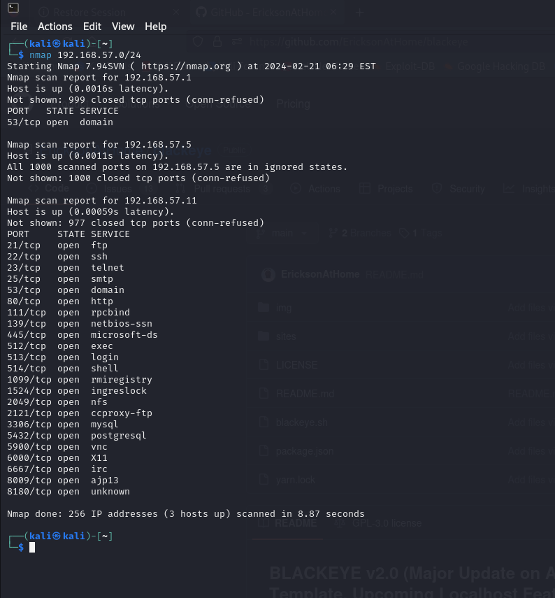
Using the Nmap tool to scan for targets on the network. The host IP is 192.168.57.5, while 192.168.57.11 is the target machine which is metasploitable2. The list of open ports is displayed, and port 21 is the chosen port to be targeted.

Figure 49 Identified targets

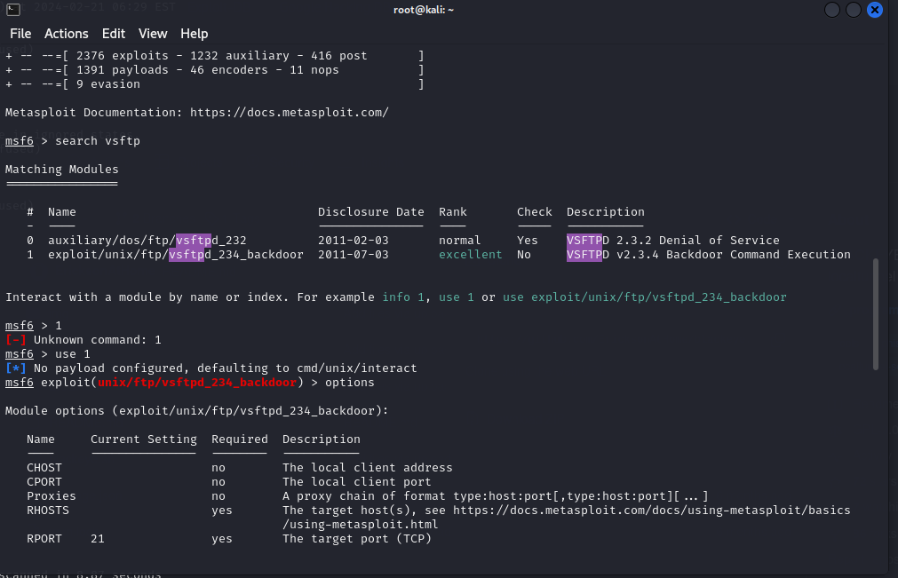
Exploiting the Backdoor:

Figure 50 Metasploit vsftp exploit

The FTP service is connected to the target using the “search vsftp” command, as seen in fig. 50.
Using the Metasploit 6 framework, to search for available VSFTP exploits, the backdoor exploit is selected and the RPORT is 21, as seen in fig. 50.
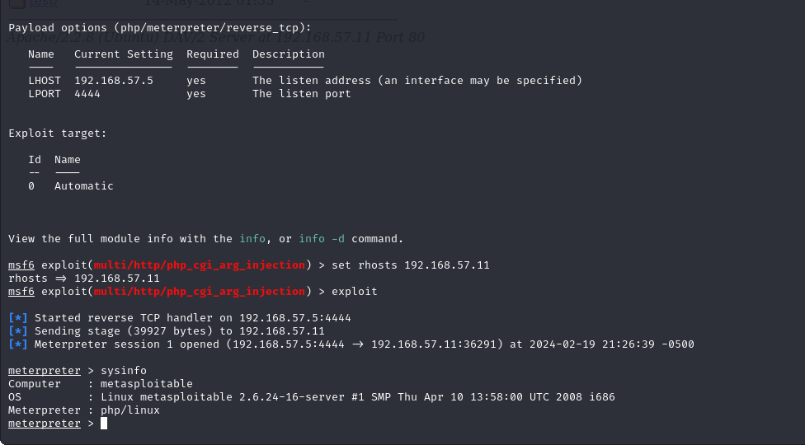
Gaining Access:

Figure 51 Access gained
The exploit is executed on the target, and the system information of the target is discovered. As seen in fig. 51.

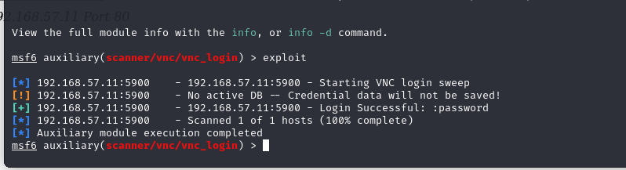

Figure 52 Root privilege login credentials
Fig. 51 shows that the author was able to gain root access into the targeted machine, and the login shows successful, with the login details displayed as a password.

- Mitigation

- Update to the Latest Version of VSFTPD
- Patch Known Vulnerabilities: Check for all unpatched vulnerabilities, and ensure they're properly patched.
- Restrict Access by configuring the firewall to limit access to the FTP server by allowing connections only from trusted IP addresses.

5.5 Distributed Denial of Service (DDOS) Attack
A Distributed Denial of Service (DDoS) attack is a malicious attempt to disrupt the normal traffic of a targeted server, service, or network by overwhelming the target or its surrounding infrastructure with a flood of Internet traffic. DDoS attacks achieve effectiveness by utilizing multiple compromised computer systems as sources of attack traffic. Exploited machines can include computers and other networked resources such as IoT devices.
- Information gathering / Reconnaissance
For this simulation, the attack is focused on the TCP Protocol, port 80: The goal of this attack is to target the layer where web server processing is done, with SYN floods, until the server resources are exhausted.

- Identify targets
The target IP address is still 192.168.57.11, with the hping3 command as indicated in the figure, the target was flooded with multiple TCP packets until it was out of resources, making the web server unavailable when requested.

- Exploitation
Using the Hping3 tool, the target IP address was spoofed with a syn flag of 120, using port 80 to flood the target, as seen in fig. 53.
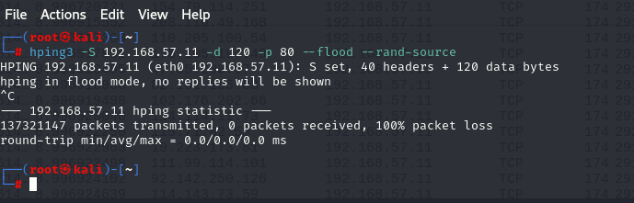

Figure 53 hping flooding

- Fig. 54 shows that the web app was available before the attack was launched.
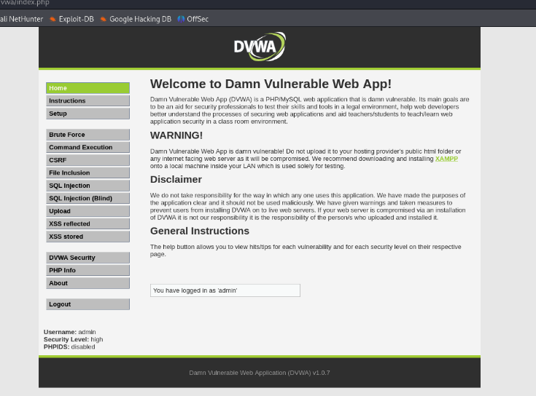

Figure 54 web server running
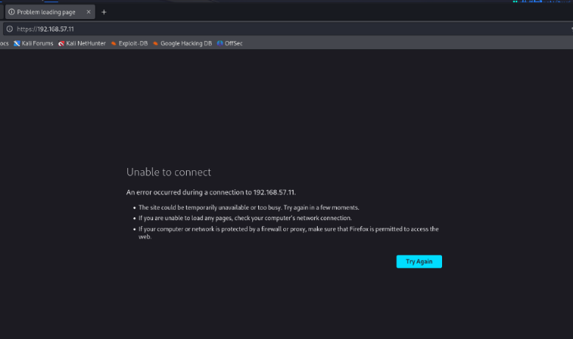

Figure 55 Web server down
- After the DDOS attack was executed, fig. 55 shows that the web app service is unavailable.

- The traffic was inspected using Wireshark on eth0 as indicated below.
A total of 137321147 was sent to the web server, which was too much for the web server.

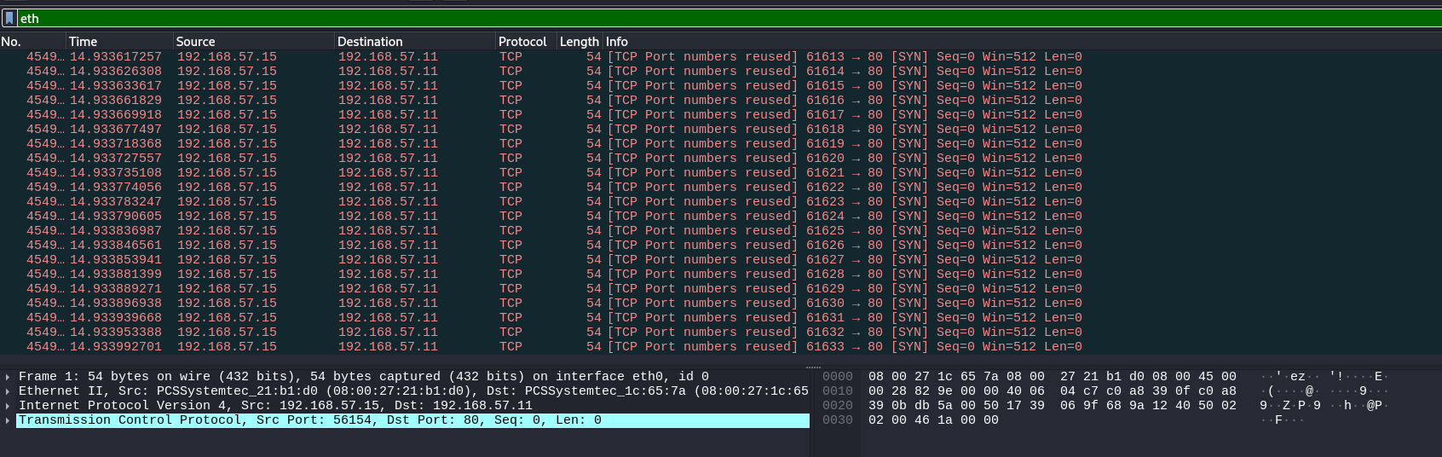

Figure 56 captured packets

- Mitigation for DDOS Attack.
To defend against DDoS attacks, organizations can employ a variety of strategies and tools:
- Increased Bandwidth: Having more bandwidth than you ordinarily need can help absorb the traffic volume spikes of a DDoS attack.
- DDoS Mitigation Services: These services specialize in detecting and mitigating DDoS attacks, often by rerouting malicious traffic away from the target.
- Intrusion Detection Systems (IDS) and Intrusion Prevention Systems (IPS): These can help identify and block attack traffic.
- Web Application Firewalls (WAF): WAFs can protect web applications by filtering and monitoring HTTP traffic between a web application and the Internet.

CHAPTER 6

6.0 EVALUATION

6.1 SUMMARY OF ATTACK SIMULATION
Attack Type | Vulnerabilities | Threats | Mitigations
DOS Attack | - Poorly configured network equipment, Unpatched software, Lack of rate limiting | - Overwhelming the system resources, Disruption of service to users. | - Implement rate limiting,  - Use anti-DDoS services and hardware, systems, and software must be updated regularly.
Phishing | - Lack of user awareness, Inadequate email filtering, and Insufficient security policies | - Theft of sensitive information, and Credential harvesting | - Regular security awareness training must be Conducted, and Implementation of advanced email filtering, and Enforcement of multi-factor authentication (MFA)
Active Directory Attack | - Misconfigured permissions,  - Stale user accounts, Lack of monitoring, and logging | - Unauthorized access to network resources, and Lateral movement within the network | - Regularly audit and correct permissions must be assigned to users based on their job roles. Implementation of account lifecycle management, Enabling detailed logging and monitoring on the server.
Privilege Escalation | - Unpatched operating systems and applications, Misconfigurations, and Use of default credentials. | - Unauthorized access and control over critical systems, Data theft, and system damage. | - Security patches must be applied promptly, the principle of least privilege must be followed, default passwords must be changed, and strong password policies must be enforced on all users in the domain.
Ransomware | - Unpatched software vulnerabilities,  Phishing and social engineering tactics, and Lack of secure backups | - Encryption of critical data with ransom demands, and Disruption of business operations | - Keep all systems and software updated, - Data must be backed-up and stored regularly, offline,  - Educate users on spotting phishing attempts.
Malware Attack | - Unsecured network endpoints, Lack of endpoint protection, and Ineffective access controls | - System infection leading to data theft, espionage, or damage, Spread of infection to other network assets | - Deployment of endpoint protection solutions, Implementation of network segmentation and access controls, Regular vulnerability assessments and penetration testing must be conducted.

6.2 Conclusion and Recommendation
Introduction
This summary report is based on two parts. The first part of this summary is based on the research work, while the second part is based on the outcome of the experiment.

Throughout this project lifecycle, the author's focus has been on analyzing the key threats in SMEs. Based on the literature reviews, SMEs have suffered several breaches since the pandemic area, and businesses now see the need to take their services online, either by storing or sharing information. Threat actors are also consistently improving their attack techniques to steal confidential data for financial gain.

In summary, the discussions reinforce the notion that effective cybersecurity is multifaceted, requiring a blend of technical solutions, strategic planning, human factor considerations, and adherence to ethical and legal standards. By embracing a holistic approach to cybersecurity, organizations can not only protect their assets and data but also foster a secure and resilient digital environment for their stakeholders.

6.3 Conclusion
Throughout this project, the author explored various aspects of cybersecurity, focusing on attack simulations, vulnerability exploitations, and mitigation strategies to enhance organizational security posture. It outlines a scenario detailing the necessity for a Red Team to perform offensive security testing on Evon Enterprise's network system infrastructure. The simulation aimed at identifying vulnerabilities, testing the effectiveness of existing security measures, and enhancing the company's defense mechanisms against potential cyber threats.

6. 4 Recommendations for Future Research
More research should be conducted on cyber threat intelligence and how SMEs with little capital can also benefit from it.
More aspects of cyber awareness training should be carried out on how every employee can be cyber security compliant.

Researchers should focus on how threats evolve, and how much impact it has on other organisations,

6.5 Conclusions and Recommendations
In conclusion, cybersecurity is a multifaceted field that requires ongoing attention to technological advancements, threat intelligence, and best practices in security management. Organizations must adopt a proactive stance, regularly updating their security measures, educating their workforce, and employing comprehensive strategies to mitigate a wide range of cyber threats. Through simulation, vulnerability exploitation exercises, and a strong emphasis on mitigation and ethical considerations, businesses can significantly enhance their resilience against cyberattacks and insider threats.
To add to this, SMEs need to consider having a reliable cyber threat intelligence (CTI) system that relates current cyber threat trends occurring all around the world, as it will help the business stakeholders to plan on how to boost their system against these threats. Another key aspect SMEs should consider is setting up an incident response plan, as this will help the business to still stay in business in the event of a cyber breach.

CHAPTER 7

7.1 REFLECTIONS
So far, the work done by the author has satisfied the aims and objectives of this project. The project has thrown more light on the challenges SMEs are experiencing, regardless of their sizes. Sometimes even organisations with the most sophisticated security architectures can still be attacked. With the data acquired from the UK cyber threat breaches survey, the author was able to identify the key threats affecting SMEs.

7.2 Barriers experienced during the project

Some of the barriers encountered during this project are outlined as follows:
1. Unable to assess credible statistics to reflect the cyber security challenges faced by SMEs of all sizes.
2. The implementation of this project was done in a virtual environment, which makes it difficult to perform some attacks like Ransomware, Malware, and Impersonification.
3. Unable to access high-performance systems with high processors and RAM Speed. This affected the outcome of some of the attacks conducted.
4. Inability to recall all commands to execute in better simulating a more sophisticated attack.

7.3 Positives
The positives of this project have better equipped the author with an in-depth knowledge of cyber threats, how cyber-attacks occur, and how organizations can prevent these threats from reoccurring in the future. More study and research will expand the knowledge of the author on key aspects to prepare plan and simulate a cyber-attack.

7.4 Lesson Learned

This project has better improved the author's knowledge of how to plan, prepare, and simulate a red teaming attack. Key concepts like the differences between a Blue team and a Red team have been clarified as a result of this project, and even the concept of penetration testing has also been clarified.

7.5 Guidance to future students

Early commencement of your project is very pivotal to the quality of work put forward. It is also important to ensure that project students have a deep knowledge of the project topic they're about to adopt before they begin to work on it.

7.6 Overall

Certainly, the discussions and scenarios explored highlight the critical nature of cybersecurity in the modern digital landscape. The conclusion drawn from these discussions emphasizes several key insights and actionable strategies for organizations striving to bolster their cybersecurity posture

CHAPTER 8

References

[1] | ehodges, " “UK Small and Medium-Sized Enterprises (SMEs) Statistics," Leyton,” United Kingdom, , 10 Jan 2023. [Online]. Available: https://leyton.com/uk/insights/articles/uk-sme-statistics/#:~:text=While%20reporting%20the%20number%20of%20SMEs%20in%20the.
[2] | I. F. D. A. &. J. C. F. d. Arroyabe, "The severity and effects of Cyber-breaches in SMEs: a machine learning approach,," Enterprise Information Systems, 17:3,, 2023.
[3] | ENISA, "Cybersecurity for SMEs - Challenges and Recommendations," 28 June 2021. [Online]. Available: https://www.enisa.europa.eu/publications/enisa-report-cybersecurity-for-smes.
[4] | V. A. a. D. D. M. B. Aiyer, "Securing cybersecurity for small businesses | McKinsey,”," 24 Mar 2021. [Online]. Available: https://www.mckinsey.com/capabilities/risk-and-resilience/our-insights/securing-small-and-medium-size-enterprises-whats-next.
[5] | J. e. a. Saleem, "A state of the art survey-Impact of cyber attacks on SME's."," Proceedings of the international conference on future networks and distributed systems, 2017.
[6] | G. Cluley, "Top 3 Cybersecurity Trends for SME Business Leaders," Graham Cluley security news, 29 01 2024. [Online]. Available: https://grahamcluley.com/feed-sponsor-cynet/ . [Accessed 1 Feb 2024].
[7] | C. Kidd, "Security 101: Vulnerabilities, Threats & Risk Explained," 20 9 2022. [Online]. Available: https://www.splunk.com/en_us/blog/learn/vulnerability-vs-threat-vs-risk.html.
[8] | D. Puzder, "Vulnerabilities, Threats, and Risks Explained | Office of Information Security | Washington University in St. Louis," 27 4 2023. [Online]. Available: https://informationsecurity.wustl.edu/vulnerabilities-threats-and-risks-explained/.
[9] | VMware, "What is Threat Analysis? | VMware," 28 sep 2022. [Online]. Available: https://www.vmware.com/topics/glossary/content/threat-analysis.html.
[10] | N. UK, "“Threats and risks,” www.ncsc.gov.uk,," Nov. 14, 2023.. [Online]. Available: https://www.ncsc.gov.uk/collection/annual-review-2023/threats-risks#:~:text=However%2C%20data%20extortion%20attacks%2C%20in.
[11] | A. Melnikovas, " "Towards an Explicit Research Methodology: Adapting Research Onion Model for Futures Studies."," Journal of futures Studies , p. 23.2 , 2018.
[12] | NCSC, "Small & medium sized organisations,” www.ncsc.gov.uk," [Online]. Available: https://www.ncsc.gov.uk/section/information-for/small-medium-sized-organisations.
[13] | U. d. f. d. media, "UK cybersecurity breaches survey," 2022. [Online]. Available: https://assets.publishing.service.gov.uk/media/62cc2ecee90e07748814bcd5/Cyber_Security_Breaches_Survey_2022_Infographic-Micro_Small_business.pdf.
[14] | E. Johns, "Cyber Security Breaches Survey 2022, GOV.UK," 30 Mar. 2022.. [Online]. Available: https://www.gov.uk/government/statistics/cyber-security-breaches-survey-2022/cyber-security-breaches-survey-2022.
[15] | E. Johns, "“DCMS: Cyber Security Breaches Survey 2021,” Network Security," 4 4 2021. [Online]. Available: https://doi.org/10.1016/s1353-4858(21)00036-2..
[16] | a. M. E. Emma John, "Cyber security breaches survey 2023, GOV.UK,," 19 Apr. 2023. [Online]. Available: https://www.gov.uk/government/statistics/cyber-security-breaches-survey-2023/cyber-security-breaches-survey-2023.
[17] | E. Johns, "“Cyber Security Breaches Survey 2020,”," GOV.UK, 26 3 2020. [Online]. Available: https://www.gov.uk/government/statistics/cyber-security-breaches-survey-2020/cyber-security-breaches-survey-2020#chapter-5-incidence-and-impact-of-breaches-or-attacks.
[18] | Mathieu, "Cybersecurity: the top 3 threats to SMEs,” Bocasay," Jun 2021. [Online]. Available: https://www.bocasay.com/cybersecurity-threats-smes/#. [Accessed 09 Feb 2024].
[19] | K. Fazzini, "The Capital One breach is unlike any other major hack, with allegations of a single engineer wreaking havoc," CNBC, 30 Jul 2019. [Online]. Available: https://www.cnbc.com/2019/07/30/capital-one-hack-allegations-describe-a-rare-insider-threat-case.html.
[20] | NSC, "Global ransomware threat expected to rise with AI, NCSC warns," 24 Jan 2024. [Online]. Available: https://www.ncsc.gov.uk/news/global-ransomware-threat-expected-to-rise-with-ai.
[21] | “. W. c. a. a. t. N. -. N. A. O. (. r. National Audit Office, "National Audit Office (NAO)," 27 Oct 2017. [Online]. Available: https://www.nao.org.uk/reports/investigation-wannacry-cyber-attack-and-the-nhs/.
[22] | Mathieu, "“Cybersecurity: the top 3 threats to SMEs,” Bocasay,," Jun. 10, 2021. . [Online]. Available: https://www.bocasay.com/cybersecurity-threats-smes/.
[23] | O. D. V. Q. -L. H. J. Z. a. Y. X. L. Liu, ""Detecting and Preventing Cyber Insider Threats: A Survey,"," in IEEE Communications Surveys & Tutorials, , Vols. vol. 20, , pp. 1397-1417, , 2018,.
[24] | A. &. L. R. c. Moneva, "Insider threats among Dutch SMEs: Nature and extent of incidents, and cyber security measures," Journal of Criminology,, Vols. 56(4),, pp. 416-440., 2023.
[25] | Kim-Kwang Raymond Choo, "The cyber threat landscape: Challenges and future research directions,," Computers & Security, pp. 719-73, 2011.
[26] | www.ncsc.gov.uk, "national cyber security centre, “The Cloud Security Principles," 17 Nov 2018. [Online]. Available: https://www.ncsc.gov.uk/collection/cloud/the-cloud-security-principles.
[27] | G. o. UK, "Data Protection Act,” Gov.uk," 2018. [Online]. Available: https://www.gov.uk/data-protection.
[28] | F. Maude, "Government launches information sharing partnership on cyber security,” GOV.UK," 27 MAR 2013. [Online]. Available: https://www.gov.uk/government/news/government-launches-information-sharing-partnership-on-cyber-security.
[29] | V. K. a. M. S. M. Thangavelu, "Impact of Comprehensive Information Security Awareness and Cognitive Characteristics on Security Incident Management – An empirical study," Computers & Security, Jul 2021.
[30] | A. G. N. B. A. M. K. K. S. Zakira Inayat, "Intrusion response systems: Foundations, design, and challenges," Journal of Network and Computer Applications, pp. 53-74, 2016.
[31] | K. K. a. M. O. O. I. Falowo, "An Assessment of Capabilities Required for Effective Cybersecurity Incident Management - A Systematic Literature Review," 2023 International Conference on Data Security and Privacy Protection (DSPP), 2023.
[32] | A. Berndt and J. Ophoff, ""Exploring The Value of A Cyber Threat Intelligence Function in An Organization"," INFORMATION SECURITY EDUCATION, 2020.
[33] | A. Ibrahim, D. Thiruvady, J.-G. Schneider and M. Abdelrazek, ""The Challenges of Leveraging Threat Intelligence to Stop Data Breaches," 2020.
[34] | N. Saxena, E. Hayes, E. Bertino, P. Ojo, K.-K. R. Choo and P. Burnap, ""Impact and Key Challenges of Insider Threats on Organizations and Critical Businesses"," ELECTRONICS, 2020.
[35] | E. Lloyd, G. Ibbotson and S. Pournouri, "An Investigation Into The Impact Covid-19 Has Had on The Cyber Threat Landscape and Remote Working for UK Organizations," INFORMATION SECURITY TECHNOLOGIES FOR CONTROLLING PANDEMICS, 2021.
[36] | N. Rawindaran, A. Jayal and E. Prakash, ""Machine Learning Cybersecurity Adoption in Small and Medium Enterprises in Developed Countries"," COMPUTERS, 2021.
[37] | L. F. Ilca and O. P. L. T. C. Balan, ""Enhancing Cyber-Resilience for Small and Medium-Sized Organizations with Prescriptive Malware Analysis, Detection and Response"," SENSORS, 2023.
[38] | C. Valli, I. Martinus, J. Stanley, M. Kirby and "CyberCheck, "A Review of A Small to Medium Enterprise Cyber Security Awareness Program," ADVANCES IN SECURITY, NETWORKS, AND INTERNET OF THINGS, 2021.
[39] | M. a. N. J. BADA, "Developing cybersecurity education and awareness programmes for small- and medium-sized enterprises (SMEs)," Information and Computer Security, pp. pp. 393-410, 2019.
[40] | weforum, "The Global Risks Report 2018 13th Edition Insight Report," 2018. [Online]. Available: https://www3.weforum.org/docs/WEF_GRR18_Report.pdf.
[41] | M. R. S. B. L. L. S. A. a. J. H. J. F. Carías, "Systematic Approach to Cyber Resilience Operationalization in SMEs," in IEEE Access, vol. 8, pp. pp. 174200-174221, 2020.
[42] | M. U. a. E. R. A. Emer, ""A Cybersecurity Assessment Model for Small and Medium-Sized Enterprises,"," IEEE Engineering Management Review, vol. 49, pp. 98-109, 2021.
[43] | M. P. Barrett., "NIST Cybersecurity Framework | Framework for Improving Critical Infrastructure Cyber security," Technical Report, vol. 1.1, 2018.
[44] | NIST, "Cybersecurity Framework Components,," Feb. 2018,. [Online]. Available: https://www.nist.gov/cyberframework/online-learning/cybersecurity-framework-components#core.
[45] | I. O. f. S. (. E. C. (IEC), "Security Techniques — Code of Practice for Information Security Controls," ISO/IEC 27002:2013 Information Technology —, 2013.
[46] | A. G. a. S. E.-Y. J. N. Al-Karaki, " GoSafe: On the practical characterization of the overall security posture of an organization information system using smart auditing and ranking," Journal of King Saud University - Computer and Information Sciences, 2020.
[47] | C. f. I. Security, "CIS Controls Version 8," 2020. [Online]. Available: https://www.cisecurity.org/controls/v8.
[48] | CIS“, "CIS Controls Version 7 - What’s Old, What’s New,” CIS,," 19 Mar. 2018. . [Online]. Available: https://www.cisecurity.org/insights/blog/cis-controls-version-7-whats-old-whats-new.
[49] | Isaca, "COBIT | Control Objectives for Information Technologies | ISACA," Isaca.org, 2019. [Online]. Available: https://www.isaca.org/resources/cobit.
[50] | F. Institute, "The Importance and Effectiveness of Quantifying Cyber Risk," fairinstitute, 2018. [Online]. Available: https://www.fairinstitute.org/fair-risk-management.
[51] | A. a. B. A. Yeboah-Ofori, "Cyber Intelligence and OSINT: Developing Mitigation Techniques Against Cybercrime Threats on Social Media," International Journal of Cyber-Security and Digital Forensics (IJCSDF), vol. 7, pp. 87-98, 2018.
[52] | Nordine, "“OSINT Framework,”Osintframework.com," 2019. [Online]. Available: https://osintframework.com/.
[53] | M. ATT&CK, "Matrix - Enterprise | MITRE ATT&CKTM," attack.mitre.org, 31 10 2023. [Online]. Available: https://attack.mitre.org/matrices/enterprise/.
[54] | cisa, "Zero Trust Maturity Model | CISA," www.cisa.gov, 1 2022. [Online]. Available: https://www.cisa.gov/zero-trust-maturity-model.
[55] | S. K, "Zero Trust Security: A Modern Approach to Securing Your Applications🔒,” Google Cloud - Community, Jul. 24, 2023. https://medium.com/google-cloud/zero-trust-security-model-a-new-approach-to-network-security-9dee89564b3e ," Jul 2024. [Online]. [Accessed 16 Feb 2024].
[56] | ipsos, "Who we are," 2023. [Online]. Available: https://www.ipsos.com/en-uk/about-us.
[57] | IBM, "“What is offensive security?," IBM, January 2024. [Online]. Available: www.ibm.com. https://www.ibm.com/topics/offensive-security .
[58] | S. Mansfield-Devine, "The best form of defence – the benefits of red teaming," Computer Fraud & Security, vol. 10, p. 8–12, Oct 2018.
[59] | T. M. S. B. C. K. A. M. a. C. P. E. Puschner, "Red Team vs. Blue Team: A Real-World Hardware Trojan Detection Case Study Across Four Modern CMOS Technology Generations," IEEE Symposium on Security and Privacy (SP), pp. 56-74, 2023.
[60] | H. Holm, ""Lore a Red Team Emulation Tool,"," in IEEE Transactions on Dependable and Secure Computing, vol. 20, pp. 1596-1608, 1, 1 March-April 2023.
[61] | S. Mardiana, "Modifying Research Onion for Information Systems Research," Solid State Technology, vol. 63(4), pp. 1202-1210, 2020.
[62] | A. Sahay, "“Peeling Saunder’s Research Onion,”," ResearchGate, Jul. 2016.
[63] | statswork, "Compare and analyze qualitative and quantitative approaches. Give a detailed introduction to the qualitative research process," 11 Nov 2020. [Online]. Available: https://statswork.com/blog/compare-and-analyze-qualitative-and-quantitative-approaches-give-a-detailed-introduction-to-the-qualitative-research-process/ . [Accessed 05 Feb 2024].
[64] | A. A. a. B. Duncan, "Cybersecurity Risk Management in Small and Medium-Sized Enterprises: A Systematic Review of Recent Evidence," 2020 International Conference on Cyber Situational Awareness, Data Analytics and Assessment (CyberSA), pp. pp. 1-5, 2020.
[65] | O. N. D. I. K. V. a. D. T. N. Vakakis, "Cybersecurity in SMEs: The Smart-Home/Office Use Case," 2019 IEEE 24th International Workshop on Computer Aided Modeling and Design of Communication Links and Networks (CAMAD), pp. pp. 1-7, 2019.
[66] | G. H. C. K. K. -H. J. J. B. a. J. F. P. Wagner, "Applicability of Security Standards for Operational Technology by SMEs and Large Enterprises," 2020 25th IEEE International Conference on Emerging Technologies and Factory Automation (ETFA), pp. pp. 1544-1551, 2020.
[67] | H. Poston, "Top threat modeling frameworks: STRIDE, OWASP Top 10, MITRE ATT&CK framework and more | Infosec," 11 Feb 2021. [Online]. Available: https://resources.infosecinstitute.com/topics/management-compliance-auditing/top-threat-modeling-frameworks-stride-owasp-top-10-mitre-attck-framework/.
[68] | L. M. a. D. S. A. Ključnikov, "Information security management in SMEs: factors of success," Entrepreneurship and Sustainability Issues," scholarly-journals, vol. 6, pp. pp. 2081-2094, 2019.
[69] | Anonymous, "Securing Small and Medium Enterprises (SMEs) Against Cyber Threats," Financial Express, 2023.
[70] | C. &. S. R. H. Rice, "The Enabling Role of Internal Organizational Communication in Insider Threat Activity – Evidence From a High-Security Organization," Management Communication Quarterly, vol. 36(3), pp. 467-495, 2022.
[71] | G. P. A. a. W. P. L. M. L. Angelo Edú, ""Cybersecurity framework for SMEs in Peru based on ISO/IEC 27001 and CSF NIST controls," 2023 18th Iberian Conference on Information Systems and Technologies (CISTI)," 18th Iberian Conference on Information Systems and Technologies (CISTI), pp. pp. 1-7, 2023.
[72] | B. I. a. H. Shima, "Network security testing tools for SMEs (small and medium enterprises)," IEEE International Conference on Applied System Invention (ICASI), pp. pp. 414-417, 2018.
[73] | T. UcedaVelez and M. M. Morana, "Existing Threat Modeling Approaches," in Risk Centric Threat Modeling: Process for Attack Simulation and Threat Analysis," Wiley, pp. pp.137-194, 2015.
[74] | A. A. B. Mohamed Ben Ahmed, "A Review on Cybersecurity: Challenges & Emerging Threats," in NISS '20: Proceedings of the 3rd International Conference on Networking, Information Systems & Security, 2020.
[75] | c. m. a. s. UK department for digital, "Cyber_Security_Breaches_Survey_2022," [Online]. Available: https://assets.publishing.service.gov.uk/media/62cc2ecee90e07748814bcd5/Cyber_Security_Breaches_Survey_2022_Infographic-Micro_Small_business.pdf.
[76] | B. a. H. S. Iyamuremye, ""Network security testing tools for SMEs (small and medium enterprises)," International Conference on Applied System Invention (ICASI). IEEE, 2018.
[77] | K. a. J. O. Renaud, "What is Preventing UK SMEs from taking Cyber Security Precautions?," 2021.
[78] | M. e. a. Patyal, ""Multi-layered defense architecture against ransomware."," International Journal of Business and Cyber Security 1.2, 2017.
[79] | Gov.co.uk, "Two thirds of large UK businesses hit by cyber breach or attack," 2016. [Online]. Available: https://www.gov.uk/government/news/two-thirds-of-large-uk-businesses-hit-by-cyber-breach-or-attack-in-past-year.. [Accessed 2024].
[80] | M. R. Shad, "Cyber Threat Landscape and Readiness Challenge of Pakistan," STRATEGIC STUDIES, 2019.
[81] | J. F. Carías, M. R. S. Borges, L. Labaka, S. Arrizabalaga and J. Hernantes, ""Systematic Approach to Cyber Resilience Operationalization in SMEs"," IEEE ACCESS, vol. 3, 2020.
[82] | S. Gourisetti, M. Mylrea, T. Ashley, R. Kwon, J. Castleberry, Q. Wright-Mockler, P. McKenzie and G. Brege, ""Demonstration of The Cybersecurity Framework Through Real-World Cyber Attack"," RESILIENCE WEEK (RWS), 2019.
[83] | N. Priyadharshini, S. Gomathy and M. Sabarimuthu, ""A Review on Microgrid Architecture, Cyber Security Threats and Standards"," PROCEEDINGS, 2020.
[84] | H. Najjari, M. Seitz, E. Trunzer and B. Vogel-Heuser, ""Cyber-physical Production Systems for SMEs-A Generic Multi Agent Based Architecture and Case Study"," 4TH IEEE INTERNATIONAL CONFERENCE ON INDUSTRIAL, 2021.
[85] | M. Compastié, A. L. Martínez, C. Fernández, M. G. Pérez, S. Tsarsitalidis, G. Xylouris, I. Mlakar, M. A. Kourtis, V. Šafran and "PALANTIR, "An NFV-Based Security-as-a-Service Approach for Automating Threat Mitigation"," SENSORS, 2023.
[86] | C. Deloglos, C. Elks and A. Tantawy, ""An Attacker Modeling Framework for The Assessment of Cyber-Physical Systems Security",," ARXIV-CS.CR, , 2020..
[87] | A. Melnikovas, ""Towards an Explicit Research Methodology: Adapting Research Onion Model for Futures Studies."," Journal of Futures Studies , p. 23.2, 2018.
[88] | M. Al-Ababneh, "Linking Ontology, Epistemology and Research Methodology," Science & Philosophy , vol. 8(1), pp. 75-91, 2020.
[89] | K. Fazzini, "“The Capital One breach is unlike any other major hack, with allegations of a single engineer wreaking havoc,”," CNBC, 30 Jul 2019. . [Online]. Available: https://www.cnbc.com/2019/07/30/capital-one-hack-allegations-describe-a-rare-insider-threat-case.html.
[90] | F. e. a. .. Barman, ""A Methodical Framework for Conducting Reconnaissance and Enumeration in the Ethical Hacking Lifecycle."," European Conference on Cyber Warfare and Security. , vol. Vol. 22. No. 1, 2023.
[91] | A. M. A. e. a. Hawamleh, ""Cyber security and ethical hacking: The importance of protecting user data."," Solid State Technology , vol. 63.5 , pp. 7894-7899., (2020).
[92] | P. M. W. a. D. R. Formosa, ""A principlist framework for cybersecurity ethics."," Computers & Security, vol. 102382., p. 109, 2021.
[93] | V. McCoy, "FAIR On-A-Page: Same Great Model, Fresh New Look," www.fairinstitute.org, 12 5 2017. [Online]. Available: https://www.fairinstitute.org/blog/fair-model-on-a-page.

