Name: Huzaira Shafqat
Student number: 2128180
Module Teacher: Steve Jones
Module Name: Food & Beverage Operations
Module Code: BMIH4002
Title: Assessment of Practical tasks (Menu Engineering)
Submission deadline: 18/11/2022

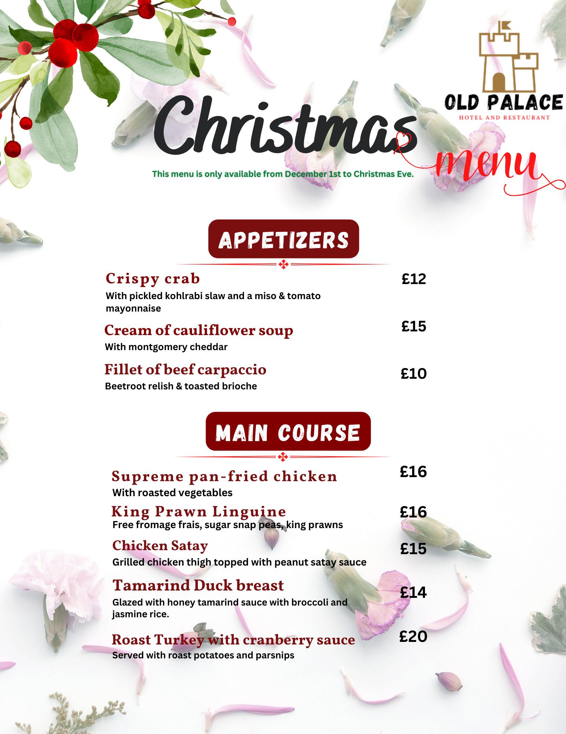

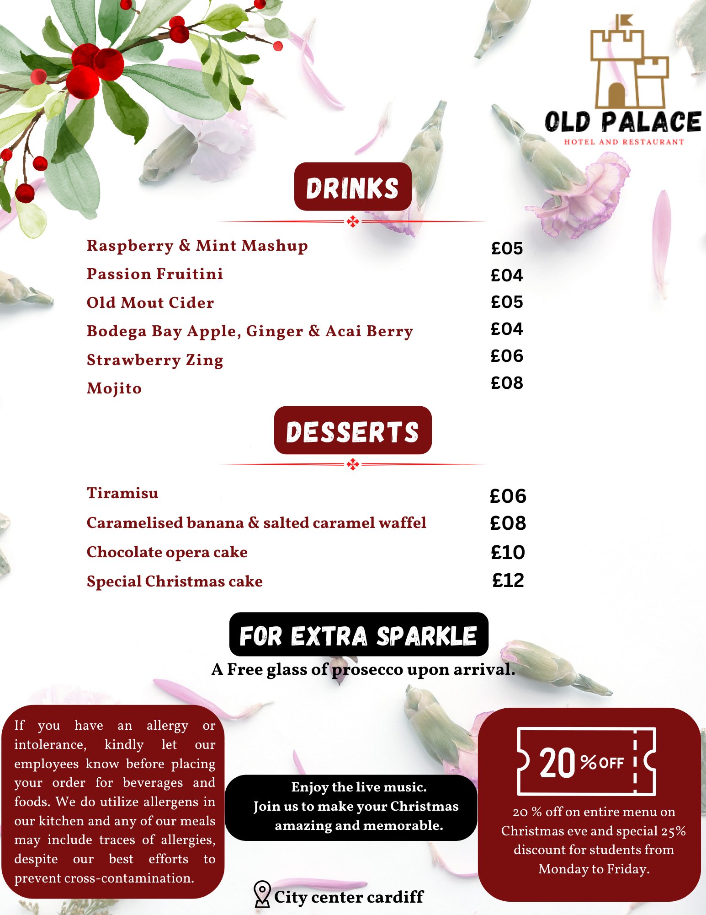

References:
Propeller. (2019). Zizzi restaurant available at
https://www.zizzi.com/menus/drinks-menu
https://www.chapel1877.com/foodanddrink/
Perth. (2013). www.canva.com available at https://www.canva.com/design/DAFRnRB56j4/IBQB90lR77ALGJwDE2sY5A/edit
Michael Wurm. (2022). Inspired by charm available at https://inspiredbycharm.com/christmas-cocktail-recipes/
https://www.busaba.com/menu/food

