

LEVEL 7 ASSESSMENT SPECIFICATION

Student name: | Chan Shuk Yan | Student ID number: | 1921901
Program: | MBA
Module: | Global Business Challenges
Module code: | BMMB7006 | Contribution to Overall Module Assessment (%): | 100%
Lecturer: | Dr. Che Cheong Poon | Internal Verifier: | Dr. Joe Leung
Assignment Title: | Analytical Report – Organisational Strategies in a COVID 19 World | Word count (or equivalent): | 5,000 words or equivalent
Submission deadline: | 22 February 2021 | The return date of provisional marks & written feedback: | Within 20 days after submission
Submission method: | All written assessments, where practical and possible, must be submitted via Turnitin unless otherwise instructed by the Lecturer. (Please DO NOT put this assessment specification into Turnitin or it will match many similarities with other students’ submissions.)  Late submission of the assessment will result in a late penalty mark. Penalties for late submission: Up to one week late, the maximum mark of 50%. Over one week late, 0%. Only the Extenuating Circumstances Panel may approve a change to submission dates.
Academic honesty / referencing: | Academic honesty is required. In the main body of your submission, you must give credit to authors on whose research and ideas your work is based. Append to your submission a reference list that indicates the books, articles, etc. that you have used, cited, or quoted to complete this assessment.

UWTSD MBA (May/Nov 2020 intakes)
BMMB7009 Global Business Challenges

Assignment Title: Analytical Report – Organisational Strategies in a COVID 19 World

“I, Ms. Chan Shuk Yan, Gloria and student number 1921901 certify this work is the result of my investigations, except where otherwise stated. All references have been duly cited”

Signed: _____

Date: 19 Feb 2021

Synopsis

Having more than Uniqlo 1500 managers trained on an annual basis, the company has been able to yield over 70 percent of revenue in the retailing industry. Amidst the pandemic, Uniqlo is one of the global enterprises that face intricate challenges in the presence of the COVID-19. Sales are significantly plummeting. This paper aims to shed light on some of the deterrents Uniqlo faces and how it attempts to avert them. It is recommended that the company utilizes efficient strategies to keep afloat during the post-pandemic face. Understanding the consumers' behavior is one of the ways of attaining this delirious outcome.

Table of Contents

 |  |  |  |  |  |  |  | Page
1 | Introduction |  |  |  |  |  |  | 1
 | 1.1 | Research motivation |  |  |  |  |  | 2
 | 1.2 | Research framework |  |  |  |  |  | 2
2 | Company Background |  |  |  |  |  |  | 3
 | 2.1 |  | History in Hong Kong |  |  |  |  | 3
 | 2.2 |  | Product portfolio |  |  |  |  | 4
 | 2.3 |  | Industry competition |  |  |  |  | 4
3 | Company’s business performance amid the economic disruption due to the COVID-19 outbreak |  |  |  |  |  |  | 6
 | 3.1 |  | Macroeconomic environment |  |  |  |  | 6
 | 3.2 |  | The cost structure |  |  |  |  | 8
 | 3.3 |  | The revenue structure |  |  |  |  | 9
4 | Analysis and discussion |  |  |  |  |  |  | 10
 | 4.1 |  |  |  | Challenges facing the company |  |  | 11
 |  |  |  |  | 4.1.1 |  | Costing challenges | 11
 |  |  |  |  | 4.1.2 |  | Pricing challenges | 12
 |  |  |  |  | 4.1.3 |  | Market sharing challenges | 13
 | 4.2 |  |  |  | Strategies to ensure business continuity under the Covid-19 epidemic situation |  |  | 14
 |  |  |  |  | 4.2.1 | The business continuity plan |  | 14
 |  |  |  |  | 4.2.2 | Implementation process |  | 15
5 | Conclusion and recommendation |  |  |  |  |  |  | 17
 | 5.1 |  |  | Conclusion |  |  |  | 17
 | 5.2 |  |  | Recommendations |  |  |  | 18
References |  |  |  |  |  |  |  | 19
Appendix |  |  |  |  |  |  |  | 21

1 Introduction

1.1 Research Motivation
COVID-19 disrupted the normalcy. It is safe to say that the virus has different implications in the business realm. The presence of the virus has caused some businesses to plummet and, at the same time, prompted new business ventures. Other businesses have experienced a significant boost in their sales due to the coronavirus outbreak. For example, the food industry and delivery systems are to expect soaring sales rates. There is a need to understand how the pandemic impacts other industries and the relationship it establishes with sales and marketing. Spending time at home may create market niches in which the fashion industry can exploit, as do other industries.
Another aspect regarding the pandemic is management. It is vital for the executives to frequently interact to keep the company going. However, interaction is impaired due to the virus. To effectively protect the working force, the management has to collude to create a working environment during and after the pandemic. The exploration of this phenomenon proves crucial as it is a distinctive factor between giant companies in the fashion industry.
Crises management is another aspect worth addressing in a comprehensive fashion. COVID 19 has been solely responsible for the downfall of various companies in multiple industries. Uniqlo's survival highly depends on the level of preparedness as well as the implementation of viable strategies before, during, and after the pandemic. The virus outbreak acts as a sharp reminder that businesses are bound to experience crises and pandemics at any time (Donthu and Gustafsson, 2020 pg284.). For this reason, the importance of preparation cannot be emphasized enough. It is critical to evaluate Uniqlo's continuity plan, given that the pandemic has disrupted the normal business process. In the face of adversity, the weight of preparation and proper execution of strategic plans cannot be overstated. Businesses are forced to change given that consumers’ behavior has altered as well. To effectively combat COVID-19, it is imperative that collective effort is made a top priority. Global effort can deter the spread of the virus and give businesses a chance to revive.
The comparison between Uniqlo and other competitors such as Nike, Zara, and H&M is of grand importance. Coronavirus threatens global connectivity, thereby hindering global business activities (Barua, 2020 pg1). Recently, the supply chains have proved to be fragile as global distribution is unavailable. Disruption of the supply chain has a rippling effect. The stock market hit its lowest amidst the pandemic, and employers were forced to urge employees to work from home. With production at its lowest, it is important to weigh what competitors are doing right in an attempt to model success. The Asian and global markets are shared with Uniqlo's competitors. It is gaining a competitive edge by adhering to the latest marketing trend aids in boosting the company's sales. This paper attempts to bring forth how COVID 19 has impacted Uniqlo, which is one of the largest consumer goods companies in Hong Kong. It seeks to establish the strategies employed to counteract the detrimental effects of the pandemic and how the company has stayed afloat amidst the crisis.

1.2 Research Framework

The main objective of the research is to collect relevant data regarding the impacts of COVID 19 on various aspects of Uniqlo's business operation. The company has been negatively impacted due to the pandemic. Statistical data that compares Uniqlo to its competitors, such as The Gap, allows one to evaluate whether the impacts are equally distributed in the fashion industry. Supply chain and globalization are other vital elements affected, as the statistical data depicts.

Uniqlo's company reports, as well as Hong Kong's government databases, render valid information related to the study. COVID 19 crises are well documented as it has brought the globe to a standstill. Stock prices and the market at large require extensive evaluation a well. Graphical representation also gives an inkling of the prevalence of detrimental results. For the most part, secondary resources are to be utilized. Comparison of the collected data allows comprehensive analysis of the collected data.

2 Company Background

2.1 History in Hong Kong
It is safe to label Uniqlo a common sighting in Japan. The company’s clothing stores are located in every corner of the city. Uniqlo is a renowned fashion retailer under the umbrella of Fast Retailing. The company is yet to reach its full potential. Currently, the company has amassed a considerable amount of success. Tadashi Yanai is a common name in the fashion industry (Teresa, 2014 pg4). At the onset, Yanai solely focused on men’s clothing. This was an inheritance from his father. Uniqlo’s domestic reach surpasses the US-based Gap enterprise in terms of per capita (Lamare, 2020 n.p.). This goes to show that Uniqlo has an extensive reach and is willing to aggressively pursue growth and scalability.
Born in 1949 in Yamaguchi, Japan, Yanai is an important and integral part of the company. For every Japanese, the period after World War Two proved difficult, and it was hard to get by. Yanai was given a menswear shop. They customized the original designs and felt that a single shop was inadequate for what he had in mind. Building an empire was Yanai’s dream. Yanai was business-oriented and valued large-scale production and distribution. Yanai learned adeptly how to build a business. He knew the importance of customer-centeredness and was eager to meet the consumers’ demands rather than what the company wanted to sell. In 1984, Yanai rebranded the organization and sought to produce women’s clothing ((Lamare, 2020 n.p.). In this case, they sought to embed differentiation and diversity within the organization. The suburbs were some of the untapped regions. He expanded to these regions for growth.
Yanai learned from The Gap since the business experienced remarkable growth. In this case, it was difficult to avert market saturation. Tadashi wanted to emulate The Gap's strategies, given that their moves prove worthwhile. Uniqlo began realizing the same result as The Gap. The business model encouraged the exclusive production and selling of the brand's clothing. The ads were almost similar to The Gap. Mirroring The Gap was a pivotal move for Uniqlo during its establishment and development.

2.2 Product Portfolio
Uniqlo adopts a wide-ranging product mix and strategy in the clothing line business. Enriched with a broad product portfolio, Uniqlo has a strong presence in the industry. The marketing mix allows the company to cater to the needs of different demographics regardless of age and gender. Here are some of Uniqlo's products; Shirts, sweaters, casual wear, Socks, Shoes, Innerwear, Polos, Fleece, and Socks, to name a few. Figure 1 shows Uniqlo’s product portfolio. These clothes are meant for both genders in different age groups. There is a collection of baby wear ranging from T-shirts and outwear to pants and innerwear. Pajamas and bodysuits also fall under this collection. Uniqlo attempts to provide a variety of unique collections that embody modern trends. The youth population finds the product portfolio appealing. The products match various occasions and can be viewed on the company's website.
. Uniqlo's selling points include jeans and jackets. Unlike other brands such as H&M that closely pay attention to trendy fashion styles, Uniqlo produces clothes that fit the consumers' preferences ((Lamare, 2020 n.p.). Trends change continually. However, Uniqlo does not seem eager to regard the market trends given that their sales soar despite this fact, and originality helps them to stand out among the competitors.

2.3 Industry Competition
As it is with any business, setbacks prove inevitable. Uniqlo had to attempt to expand during tough times. The recession during the 1990s enabled Uniqlo to penetrate the market ((Lamare, 2020 n.p.). In times of recession, people desire quality products at lower prices. Uniqlo understood this concept and delivered it. Tadashi decided to produce the goods in China as it was cheaper. The company generated huge profits. Numerous stores were step up in Japan.
Although there were various stumbling blocks, Yanai was adamant about expanding globally. Multiple stores were set up in London and New Jersey. This attempt did not come to fruition. The company incurred a huge loss, the mistake being the sizing metrics. The Asians are generally smaller in size compared to the Westerners. The clothing did not suit the American market. The company was bested by competitors such as The Gap. They conveniently offered what the market demanded at a lower price. With such a loss, Uniqlo decided to shut down all of the stores it had initially open.
Tadashi learned from this failure. To succeed, the brand had to be ubiquitous. Companies like The Gap thrived by adopting this attribute. Fashion is a delicate industry since clothes are part of one's identity. Consumers do not take what they are given rather what they want. Tadashi formulated a new plan, and this time he was determined to succeed overseas as he had in the domestic market. He sought assistance from design experts and create an innovative team that could keep up with the western trends. The products targeted different cities such as New York. Initially, Uniqlo was associated with a low-status brand, and to succeed in the Western market, and the company had to match and effectively compete with top home brands such as The Gap (Teresa, 2014 pg1). The task proved daunting, but the rewards acted as motivating factors. The company had to restructure and redo most of the things. Yanai gave the designers autonomy when it came to product design. The expansion to New York was a success, and this opened the door for the idea of furtherance of the expansion. As the demand skyrocketed, Uniqlo ensured that the inventory was readily available to alienate inconvenience from the consumer's end.
Yanai subscribes to the philosophy that missteps offer learning opportunities, and it crucially vital that an organization utilizes mistakes to better themselves. Uniqlo has a knack for emerging stronger. The retailer is determined to wholly meet the consumer's demands at good prices. Prices are kept low due to large-scale production. Uniqlo is associated with quality and low prices. These attributes were initially possessed by The Gap and other competitors in the industry during Uniqlo's first attempt to pursue global expansion. Uniqlo constantly attempts to live up to its slogan, "Made for all." The company's products target wide-ranging demographics. Age, race, gender, and other consumer segments feel that Uniqlo is the right fit for them. The same can be said about brand ambassadors and advertisements.
It can be said that Uniqlo is an oligopolistic market structure. The company has to share the Hong Kong market as well as other geographical regions that provide a market for the fashion industry giants. The Gap, Zara, and H&M are worthy competitors and dominate almost equally. The competitors, however, have to respect Uniqlo's presence and treat the company as a potential substitute.
Uniqlo’s Performance under the pandemic situation

3.1 Macroeconomic Environment
Uniqlo’s success is mostly attributed to its performance. Fast Retailing has over 1900 stores on all corners of the globe. Uniqlo made the Forbes list and was ranked 91st in 2016 ((Lamare, 2020 n.p.). The company was valued at 7 billion dollars. It is safe to say that not only is Uniqlo a renowned global brand, but it is highly valuable. Although Zara and H&M rank highly, Uniqlo has made a permanent mark in the fashion industry. Tadashi Yanai made this happen, and for that, he is a household name. Under the pandemic, Uniqlo is expected to make a significant surge in operating profit in 2021. Experts anticipate that the company will make a rebound from the pandemic and surpass its 235 billion yen and generate 245 billion yen.
It is safe to say that there has been a significant decline due to economic changes, for instance, the 2008 global crisis. The debt crisis is another aspect that takes its toll on Uniqlo's sales. A uniform consumption of fashion and luxurious products weaken during the pandemic. The attempt of Hong Kong's government to revive the economy is crucial as it helps enhance the consumers' purchasing power. The volume of Uniqlo's sales across the continents is likely to increase in the post-pandemic phase.

Uniqlo operations faced economic uncertainties during the COVID 19 pandemic that was felt by all global fashion industries (Abdulgadir and Abdulgadir, 2020). The Hong Kong GDP has been rising since 2012, reaching an ultimate high in 2019 at 366.03. Since the pandemic started, the GDP slumped to around 338 (World Banks, 2020). In the first quarter of 2021, the Hong Kong business confidence indicator fell to -17 as compared to the previous period when it was at -8. This is the lowest reading since the beginning of 2020, when the Covid-19 pandemic hit the nation. The retail sector in which Uniqlo is a major player fell deterioration was at -18 vs. -5. According to the trading economics census and statistics department of Hong Kong, the business confidence is expected to be at -1.00 by the end of this quarter. By next year (2022), the business confidence is estimated to stand at 6.00 and then to 8.00 in the future times.

Figure 3; Stock price info of Uniqlo from 2020 to 2021.
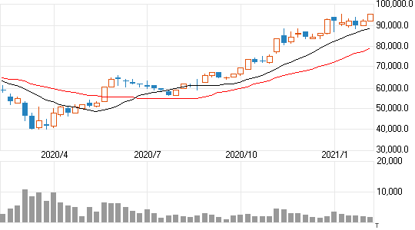

Figure 3 shows the stock price of the company increased from mid of 2020. However, during the peak of the Covid-19 during the first quarter of 2020, the stock price either remained constant or declined. The Strategic Proposals for Sustainable Supply Chains in the Fast Fashion Industry: Exploring ways to incorporate concepts and methods to confront the damaging effects of the industry. Equity markets fell into deeper depths (declined by 30-35%) since the global economic crisis widening the credit spreads and consequently leading to a collapse in bond yields. The prospects of normalcy to the world economy and financial markets depend on how soon the virus will be suppressed and finally controlled.
The crises led to the pulling back of most investors, who greatly influence expansion with the need to track the economic cycles and capital instability. Uniqlo has an economic downturn caused by the crisis, but it successfully recapitalizes its operations due to the strong capital base of the protection sector (Abdulgadir and Abdulgadir, 2020). Nevertheless, the downturn had a great impact on equity crashes, lowering interest rates, widening credit spreads, and reduced access to capital. Low equity gearings in affiliates, loans, real estates, cash & short-term, fixed income, and equities will result in investment portfolio risks. To assess a company credit risk during the pandemic, the rating agencies adopted a firm outlook on liquidity due to high capitalization intensities.

3.2 Cost Structure
Uniqlo's performance is dictated by viable strategies. These strategies are keenly evaluated to determine their feasibility. The quality and styling of the products indicate that the company pays attention to the slightest of details. The stores are aesthetically pleasing. Quality products and services accompanied by low prices are an attractive phenomenon. Consumer's experience encourages a revisit, and one is bound to redo business with Uniqlo. As the company experienced remarkable growth, profit is exposed to similar effects. The company has flourished for decades and generated billions in revenue. As of 1994, it is estimated that the company had opened over a hundred stores in Japan (Aaker, 2020 n.p.). Currently, there are over 840 stores.
Uniqlo did not rely on chance to yield success. Active consumers enable Uniqlo to flourish. Market innovation has helped Uniqlo to generate almost 70 percent of revenue in the Retailing industry (Yi, 2015 pg2). Strategies play a contributory role in this desirable outcome. To make significant headway, Tadashi had a clear vision of what he wanted to achieve. Visionary leadership is key and ensures that resources are invested towards a given cause. For instance, Tadashi realized that growth was vital for the company to succeed. He invested time and resources towards this cause, and it was later achieved despite the hiccups along the way. The company envisioned that with performance-enhanced clothes offered at the lowest price, it could assume the top position in the industry. To do this, the pursuance of global reach proved necessary. Having a great demand requires large-scale production. Large-scale production is relatively cheaper compared to small-scale production. Although not trendy, Uniqlo's products are fashionable. Table 1 indicates that retailing and the clothing industry fare well in Hong Kong. Uniqlo's success is attributed to the industry's trend. Additionally, the company employs various mechanisms to make sales. The pandemic has surely slowed down sales as it has in every other industry.

3.3 Revenue Structure
Uniqlo design its clothes so that they can be worn anywhere and at any time. The latter makes global expansion possible. As it is with any business, informed decisions increase the feasibility of strategies. The company has an agility advantage given that its operation strategies are well-thought. Making informed decisions is crucial for any business. Low cost of operation allows Uniqlo to plan effectively when it comes to design, manufacture, and product distribution. These vital processes are linked together to ensure the stability of the supply. In this case, product upgrade takes a significantly shorter time. Making orders is easier, and consumer demand dictates the ordering process. Aligning what is manufactured and what is purchased ensures that the product's life cycle is not hindered.
The soaring performance is attributed to its leadership (Barton, Carey, and Charan, 2018 pg28). Tadashi is charismatic and supports positive culture and norms. The company puts a lot of emphasis on both teamwork and leadership. It is difficult to duplicate Uniqlo's success since leadership is a strong driving force. Tadashi's firm influences the industry and values vital processes such as goal-setting. To optimize performance, Uniqlo measures progress. The company also adopts a flat structure. A flat structure is known to encourage employees as there is a chance to climb the organizational hierarchy. It is imperative that the workforce is adept and employs good communication. Embracing language diversity has helped Uniqlo to realize global success. English is mostly used given that the language is familiar in many regions. The avoidance of silo problems proves crucial since it holds back most of the Japanese-based firms.
The store experience is another important element. Micro-managing business processes such as recruitment, hiring, and training are highly rewarding. Visionary leadership enables the company to enrich people's lives. Great products maximize consumer satisfaction. The current pandemic has negatively impacted Fast Retailing. Uniqlo is no exception. For the most part, the supply chains are significantly affected. The change in consumer behavior has altered household spending. Most of the retailers have attempted to keep afloat.

4 Analysis and Discussion

4.1.1 Costing challenges
Uniqlo heavily depends on its global presence. The global pandemic has put brakes on its momentum, and this has resulted in a sales decline. The Asian market is saturated, and putting up many stores leads to cannibalism. In this case, the organization competes with itself. There have also been protests. Political instability is bad for business. A drop of 3.6 percent was recorded in Fast Retailing (Roll, 2021 n.p). Uniqlo felt a similar effect. The operating profit decreased, impacting international business. Uniqlo had to face multiple hiccups to have a global reach. The decline in international sales has a far-stretching effect.
Hong Kong has experienced several protests throughout the years. Violence and instability destabilized the economy (Iida, 2015 n.p). During this period and the aftermath of it all, sales plunged. Some consumers felt that Japanese products should be boycotted. Hong Kong is an important segment for Uniqlo. The company has to meet the needs of the domestic market before targeting other consumers. Given that the lockdown restricted companies from conducting global business, the domestic market was Uniqlo’s primary target. However, the destabilization of the market was dire and proved to be an intricate challenge. It is unclear how significant the implications of COVID 19 will be, but the devastating effects are hard to miss. To be fair, Uniqlo’s competitors have to deal with the same problem. It all boils down to organizational strategies. The importance of preparedness is key in this case. Crises are inevitable in business. Risks are to be met with timely interventions.
The lack of an ideal market makes global expansion crucial. New opportunities for fast-paced growth ensure that the company targets the right demographic. Excellent leadership has established Uniqlo as a top-ranking company.
Tadashi has attained a 700 percent return of the shareholders. In terms of market capitalization, the company has experienced a 39-billion-dollar increase (Roll, 2021 n.p). This level of success is attributed to growth and market dominance. The company has experienced tremendous growth over the years. The company is transparent about its financials and sales. The figures indicate that market sharing does not have an intensive impact on Uniqlo’s sales. The company can compete effectively with Zara, The Gap, and H&M. To stay ahead, the company has built a university in Tokyo. It is estimated that around 1500 store managers are trained on an annual basis (Roll, 2021 n.p). Constant improvement of internal processes enhances customer experience. Uniqlo can capture a broad market segment. Zara and H&M are characterized by large stores. Uniqlo emulated this style to ensure that the competitors have a limited competitive edge. As a result of this, Uniqlo realized significant profitability and customer satisfaction. Uniqlo also values employee contribution and customer feedback. Getting new points of view is pivotal. The company can make the right adjustments and develop an ideal product. Most of Uniqlo’s products are innovative. This outcome stems from a keen consideration of feedback and employees’ input.

4.1.2 Pricing Challenges
Pricing is always a challenge for most companies as they try to find the balance between quality and affordability. Consumers respond differently to a price increase, particularly by an organization that is known for developing affordable products (Schulz-Müllensiefen and Stöckmann, 2016 pg221). Taking the risk of hiking the prices does not necessarily result in increased profit margins. Sales can take a big hit and ultimately lead to a sales decline. The prospect, in this case, is unclear. However, taking risks in business results in rewards. Other companies such as Apple in the technology industry thrive by developing premium products for high prices. It should be noted that companies have different cultural backgrounds and adopt different success. Pricing strategies should consider the cost of operations and the company's primary objectives.
Tadashi has always been adamant about not hiking the prices unless it is necessary (Schulz-Müllensiefen and Stöckmann, 2016 pg221). Prices significantly impact quality. The quality of the raw materials and the efficiency of the workforce are key to developing quality products. Resource adequacy is crucial when rendering high-value products. Keeping the prices unchanged for a long time is an ambitious goal. COVID 19 has exposed businesses to new avenues of challenges. Coping and conducting business activities is costly. A higher operational cost is likely to increase the cost of products. Numerous restriction and government involve yields a similar outcome.
There is limited room for further expansion in the Asian market. Uniqlo is forced to pursue niches in the market on foreign grounds to avoid market saturation (Anwar, 2017 pg26). This goal limits price uniformity across its stores around the world. Market conditions differ in grand proportions, and this affects the pricing. The distance between raw materials and production firms dictates the severity of price disparity. The furtherance of expansion requires Uniqlo to utilize the right metrics. Before the implementation of a price hike, it is important to first establish its impacts on sales. To set this into context, Uniqlo has to assess per-customer spending. A higher rate gives an inkling that an increase in price for better quality may sit well with the consumers. Most of Uniqlo's competitors attempt to align their product prices with the company by eliminating the competitive edge that stems from the pricing strategy. Uniqlo's sales, given that their sales and quality hold up well.

4.1.3 Marketing Sharing
Uniqlo has its fair share of challenges in terms of market sharing. Hong Kong’s market is highly competitive (Chan et al., 2016 pg1). It demands the utilization of the right approaches. In such an environment, one cannot afford to make a mistake, given that competitors are inclined to thrive. For years, Uniqlo has had to share the market with top competitors such as The Gap, H&M, and Zara (Teresa, 2014 pg1). It is difficult to find unoccupied niches. The company has also put up many stores. The number of stores needs to match the demand. It is difficult to command dominance in foreign markets. It is virtually difficult to replace competitors given that they know better and about the market. Initially, Uniqlo had problems fitting in western countries. The company had to duplicate The Gap's strategies to gain a portion of the market. However, the company has gained knowledge and experience over the years, and they are faring on well.
Uniqlo aggressively pursues product diversification (Anwar, 2017 pg26). The company attempt to meet most if not all of the consumers' demands. In doing so, the company has been forced to hike the prices on numerous occasions. It is virtually difficult to preserve quality at a low cost. Pricing proves to be a challenge given that Uniqlo has a firm reputation for developing competing products at a lower price. The increase in the price of raw materials is another phenomenon that yields such an outcome. Most of the investors’ primary concern is Uniqlo’s profitability and sales. The adoption of larger pricing trends proves crucial and has a positive effect on the company’s profit margin. However, increased prices compromise the company’s reputation integrity. Apart from attempting to live by the ‘Made for all’ slogan, Uniqlo seeks to match product prices with quality. Customers are assured that pricey products embed top quality and performance compared to cheaper products. The price hikes are solely designed to meet consumers’ expectations regarding quality.

4.2 COVID 19 strategies
Effective strategies are important if a business is to operate during and after the covid-19 pandemic (de Caro, Hirschmann, and Verdonk, 2020 pg1.). Uniqlo is keen on identifying crucial regions relevant to its operations. Identifying the biggest markets ensure that sales do not take a nosedive. Business activities and operations are bound to be affected in one way or another. Uniqlo hires experts and strategists to conduct exercises to evaluate how the situation can be kept in check. Various government regulations have been put in place to ensure that the COVID 19 widespread is curbed. Proper planning dictates the success of the exercise. Important regions are broken down, and the necessary details are taken. There are various indicates that govern Uniqlo's decisions.
Uniqlo is keen on its workforce. It can be said that the workforce is an important entity in a business setting, given that production solely depends on it. Hong Kong Productivity Council (HKPC) estimates that production is likely to decline in Hong Kong due to an increase in the elderly demographic (HKPC, 2020, p35). That said, Hong Kong has been able to maintain a low rate of unemployment between 2014 and 2019. The rate of unemployment has been kept under 3.4 percent. The aging labor force is increasingly becoming a persistent problem, and this makes the available workforce a valuable commodity for the country and wide-ranging industries. Uniqlo seeks to establish workers who are located and work in vulnerable regions. Hotspot areas require quick prevention mechanisms. Reducing the number of workers in the workplace is vital. Some of the workers work from home, and this makes social distancing possible. Some commitments are rescheduled depending on the current situation. Uniqlo is also clear about its policies regarding absenteeism. As the circumstances change, Uniqlo updates its policies to befit the situation.
Constant evaluation of the supply chain is vital, given that the process is hindered by the pandemic (Kristinae et al., 2020 p675). Uniqlo clearly understands its supply chain, and it is easier to identify and expose vulnerabilities. Critical products are made a top priority, in this case, followed by suppliers' tiers. The source of raw materials has a significant bearing on the company's supply chain. Some raw materials might be sourced from isolated regions. A secondary supply is crucial unless the production is cut short. Contingency plans can be met with unexpected challenges. For instance, secondary supply can be affected by the pandemic. The alternative might fail. Deep assessment and analysis of the ongoing trend allow Uniqlo to derive crucial decisions that keep the production alive.
Uniqlo gets the sense of disruption by analyzing how fast the policymakers and the government address the coronavirus problem and other entities that impact the livelihoods. Slow resolution means that the organization has to worry about less demand and a potential recession. In the absence of coronavirus, the impacts will still be felt, particularly regarding the economy. Uniqlo measures these impacts and determines the fitting solutions. Daily changes and the frequency of the latest in specified regions indicate the reaction rate. A quick dropdown is a positive indicator that the area is implementing the right strategies.

4.2.1 Continuity Plan
As much as Uniqlo must survive as long as coronavirus lasts, comprehending the recovery process is equally vital. It is vitally important to know the shape of the market after recovery and use the current experience to draw valuable lessons. Most of the countries are solely dedicated to reinstate the health status of the populations and make individuals productive. The notion that the virus may resurge is viable. There is a need to prepare for such an eventuality. Uniqlo thinks about recovery and equips itself with a detailed plan. Most of the aspects of the virus are unclear. The importance of early preparation and filing all of the known loopholes cannot be overstated. The level of preparedness also differentiates Uniqlo from its competitors. The resumption of economic activity will determine the workability of the recovery plan. A continuity plan is exposed to changes on numerous occasions. Uniqlo is a well-run business and is equipped with a comprehensive continuity plan. The pandemic plan ensures that businesses experience fewer stumbling blocks once everything resumes back to normalcy.
Most of the companies have developed generic plans to act as deterrents to the coronavirus challenge. Like most companies, some of Uniqlo's employees work remotely. The company utilizes the presence of sophisticated technology for communication and the provision of various services. This limits the need for physical contact. Online communication enables the management to contact employees in real-time and address various issues affecting the company. The organization can also communicate with the consumers and update its policies. This ensures that the consumer base is kept informed regarding the company's activities and future plans. Data flow during the pandemic is of utter importance and should be treated as such. Uniqlo attempts to communicate right and disseminate accurate information. The workforce is kept informed. The virus has attracted confusion, making disinformation highly likely within and outside the workplace (Malecki, Keating, and Safdar, 2020 pg)1. In times of crisis, stakeholders look for reassurance. It is imperative that the stakeholders are given a sense of protection. Uniqlo shows this through adequate preparation. Tadashi’s leadership understands that truth is an important commodity in business. The organization provides accurate and consistent messages to reassure the stakeholders that their welfare is of paramount importance. A good relationship between the company and stakeholders yields multiple benefits. It makes the implementation of strategies easier.

4.2.2 Implementation process
During the implementation phase, Uniqlo identifies the potential areas of failure. A skilled workforce and individuals can assume critical roles, especially due to low production. The quality of the workforce determines the level of productivity. Services and various business processes depend on these individuals. The absence of a skilled workforce translates to a decline in production and sales altogether. Vulnerable areas demand more attention as the virus progresses. Identification of steps to reduce physical contact is another important objective. This can be achieved by working remotely and staggering the shifts. It is safe to say that a feasibility plan reinforces the strategies and enhances their effectiveness. Using a scenario analysis during implementation also enhances the feasibility of the strategies. Some of the strategies are not implementable. Theoretically, the plan might sound solid but fail to fit in real life. COVID 19 is associated with a wave of uncertainty. It is crucially vital to analyze the impacts of the coronavirus on all business fronts and how long they are likely to last. Scenario analysis tests preparedness by exploring the best and worst-case scenarios. Uniqlo can then formulate a coping mechanism based on the results of the scenario analysis. There are long-term and short-term impacts and are to be assessed as such. Asking the right questions and tackling critical sensitivities keeps some of the negative impacts at bay. However, some businesses might benefit from homestay, Uniqlo experiences negative effects. Most of the consumers in the fashion industry seek a social appeal. Clothes and other forms of attire are worn during events and when conducting daily errands.5. Conclusion and Recommendations

5.1 Conclusion
In sum, Uniqlo has been able to amass massive success. The global Asian brand has taken foreign markets by a storm due to the adoption of Japanese philosophy by Tadashi. The company pursues growth and scalability as much as it strives for essentiality and simplicity. These vital attributes have made Uniqlo a leading company in competitive-prone markets. Tadashi utilizes visionary leadership to effectively run the company. The COVID-19 pandemic has not slowed down Uniqlo’s progress as many people would have assumed. The company generates huge sales and profits. Stakeholders are happy to associate with the company. To enhance success, Uniqlo can attempt the following;

5.2 Recommendations
Strengthen the delivery systems (Kristinae et al., 2020 pg675) – this can be achieved by supporting and promoting a positive brand image and total devotion to innovation. Building a positive rapport with suppliers and consumers ensures that the product flow is not hindered at any given point. Exceeding the consumers’ expectations makes products move fast off the shelves. Hitting the demand and supply objectives is pivotal in terms of sales. As stated, large production and distribution lead to low-cost production. As the operational costs decrease, products are bound to be cheaper without compromising quality.
Understanding diverse markets – In as much as building a solid brand is crucial, sustaining a customer base that resonates with the organization's products is equally relevant. Currently, Uniqlo seems to handle diversity well, but that can be improved by comprehending diverse markets and building a brand personality that fits in foreign market environments.
Leveraging emerging opportunities – It is important to seize new opportunities if Uniqlo is going to reach its goal of global dominance. Increasing geographical and online presence proves important in this regard. Uniqlo has experienced significant growth over the last decade, but more can be done. Uniqlo is on the right path to success attainment. With a competitive advantage that it does not seem to relinquish any time soon, Uniqlo is a force to reckon with in the fashion industry.

References

Aaker, D. (2020). 6 Reasons Why Uniqlo Is Winning. Retrieved January 11, 2021, from https://www.prophet.com/2014/10/6-reasons-why-uniqlo-is-winning/
Anwar, S.T. (2017). Zara vs. Uniqlo: Leadership strategies in the competitive textile and apparel industry. Global Business and Organizational Excellence, 36(5), pp.26-35.
Barua, S. (2020). Understanding Coronanomics: The economic implications of the coronavirus (COVID-19) pandemic. SSRN Electronic Journal https://doi org/10/ggq92n.
Chan, G., Ha, S., Lee, A., Yung, L., and Ling, E.W.M. (2016). A phenomenological study of complaint behavior toward fashion chain stores: A case study in Hong Kong. Journal of Tourism & Hospitality, 5, pp.1-8.
De Caro, F., Hirschmann, T.M. and Verdonk, P. (2020). Returning to orthopaedic business as usual after COVID-19: strategies and options. Knee Surgery, Sports Traumatology, Arthroscopy, p.1.
Donthu, N. and Gustafsson, A. (2020). Effects of COVID-19 on business and research. Journal of business research, 117, p.284.
Fastretailing.com business strategy. (2020). UNIQLO business strategy. FAST RETAILING CO., LTD. https://www.fastretailing.com/eng/group/strategy/tactics.html

Fastretailing.com financial summary. (2020). Results summary. FAST RETAILING CO., LTD. https://www.fastretailing.com/eng/ir/financial/summary.html

Fastretailing.com. (2020). Consolidated sales and profit forecast. FAST RETAILING CO., LTD. https://www.fastretailing.com/eng/ir/financial/estimate.html

Hong Kong Monetary Authority https://www.hkma.gov.hk/ :Last accessed on 24th Jan, 2021
Hong Kong Productivity Council (HKPC). (2020). Re-industrialization in Hong Kong Opportunities and Limitations in Manufacturing HK Enterprises Entering into ASEAN. Retrieved January 12, 2021, from https://www.smefund.tid.gov.hk/english/tsf/deliverables/t19001002_hk_reindustrialisation_compilation.pdf
Iida, K., 2015. Political Risks and Japanese Foreign Direct Investment in East Asia: A Case Study of “China-Plus-One”. The Korean Journal of International Studies, 13(2), pp.383-410.
International Monetary Fund. (2020). The IMF's Response to COVID-19. Available at https://www.imf.org/en/About/FAQ/imf-response-to-covid-19
https://www.censtatd.gov.hk/ last accessed 24th Jan, 2021
Kristinae, V., Wardana, I., Giantari, I., and Rahyuda, A., 2020. The role of powerful business strategy on value innovation capabilities to improve marketing performance during the COVID-19 pandemic. Uncertain Supply Chain Management, 8(4), pp.675-684.
Lamare, A. (2020, June 02). A brief history of Uniqlo, the clothing company that's changing everything. Retrieved January 11, 2021, from https://www.businessofbusiness.com/articles/history-of-uniqlo/
Liu, W., Yue, X.G. and Tchounwou, P.B., 2020. Response to the COVID-19 Epidemic: The Chinese Experience and Implications for Other Countries.
Malecki, K., Keating, J.A. and Safdar, N., 2020. Crisis communication and public perception of COVID-19 risk in the era of social media. Clinical Infectious Diseases.
Roll, M. (2021). Uniqlo - The Strategy Behind The Japanese Fast Fashion Retail Brand. Retrieved January 11, 2021, from https://martinroll.com/resources/articles/strategy/uniqlo-the-strategy-behind-the-global-japanese-fast-fashion-retail-brand/
Schulz-Müllensiefen, F. and Stöckmann, A., 2016. Uniqlo: A Case Study on Creating Market Share with Affordable and Timeless Designs. In Multinational Management (pp. 221-236). Springer, Cham
UNIQLO to Start-up a Retail Shop in Bangladesh. Benchmarking, 12(2).
Spanke, M., 2020. Retail Isn't Dead: Innovative Strategies for Brick and Mortar Retail Success. Springer Nature.

Zhang, Z., Cheang, B., Li, C., and Lim, A., (2019). Multi-commodity demand fulfillment via simultaneous pickup and delivery for a fast-fashion retailer. Computers & Operations Research, 103, pp.81-96.

Zou, Y., and Chen, T.L., (2018). Industrial heterogeneity and international product cycles. Journal of Economics, 125(1), pp.1-25.

Appendix
 | Year to Aug 2020 | Year to Aug 2021
 | 1Q Actual |  | 1Q Actual  y/y | Full-year estimate | y/y
Revenue | 623.4  100% | 619.7  100% | -0.6% | 2,200.0  100% | +9.5%
Gross Profit | 312.9  50.2% | 324.8  52.4% | +3.8%  +2.2p | -  - | -  -
SG&A expenses | 224.0  35.9% | 213.2  34.4% | -4.8  -1.5p | -  - | -  -
Business Profit | 88.8  14.2% | 111.5%  18.0% | +25.6%  +3.8p | 265.0  12.0% | +55.9%  +3.5p
Operating profit | 91.6  14.7% | 113.0  18.2% | +23.3%  +3.5p | 245.0  11.1% | +64.0%  +3.7p
Cost | 10.3  1.7% | -5.9 | -  - | -  - | -  -
Profit before  taxes | 102.0  16.4% | 107.1  17.3% | +5.0%  +0.9p | 245.0  11.1% | +60.3%  +3.5p
Owners profit | 70.9  11.4% | 70.3  11.4% | -0.7%  - | 165.0  7.5% | +82.6%  +3.0p
Table 1: Consolidated Business Performance - (January 14 of Results Summary for FY2021 1Q).
Source: https://www.fastretailing.com/eng/ir/financial/summary.html
Figure 1: Uniqlo’s Product Portfolio
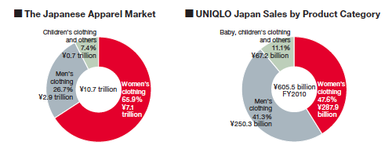
Source: https://www.fastretailing.com/eng/ir/direction/tactics.html

Figure 2: Group sales for Uniqlo at the Global retailing stores for the year 2019.

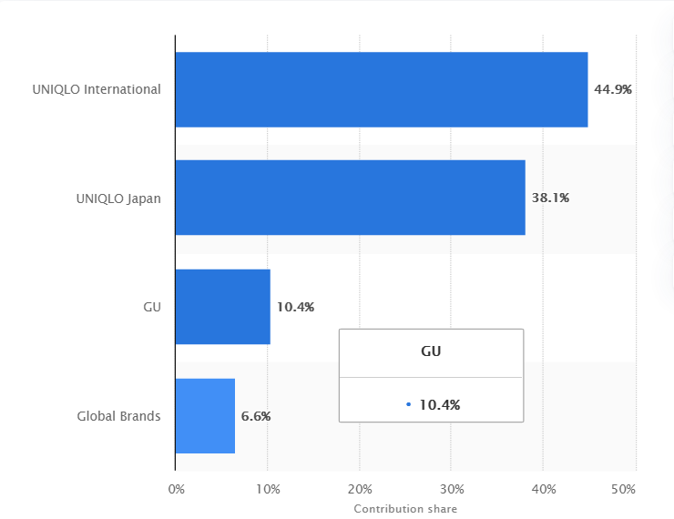
Source: https://www.fastretailing.com/eng/ir/news/1910101800.html
Figure 3: Stock price info of Uniqlo from 2020 to 2021.
Source: https://www.fastretailing.com/eng/ir/stockinfo/stockchart.html

Figure 4: Hong Kong’s GDP 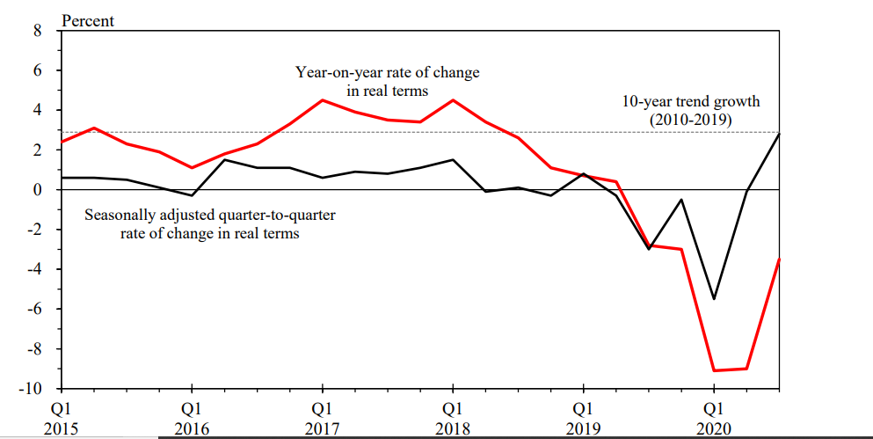

Source: Tradingeconomics.com C&S Department (2021)

Figure 5: Value index of retail sales by type of retail outlet, December 2019 to November 2020 (Average monthly index from Oct 2014 to Sep 2015 = 100) (Cont'd)
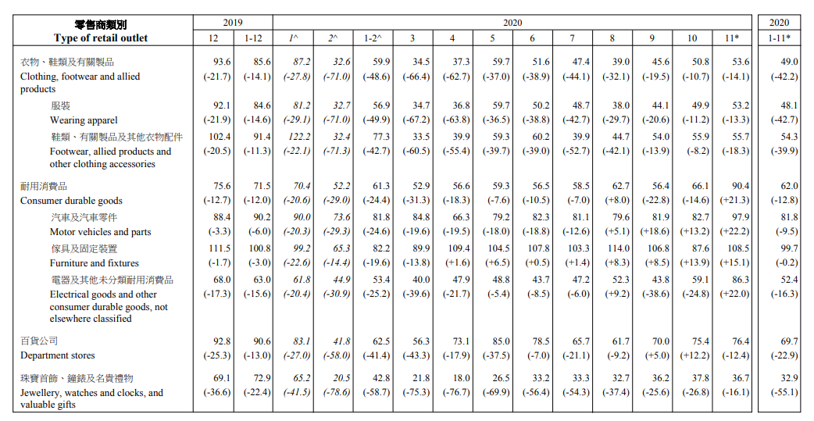
Source: https://www.statistics.gov.hk/pub/B10100062020AN20B0100.pdf

Figure 6: Marketing position of fashion brands Source: Kawashima (2012: 169), revised by
the author.
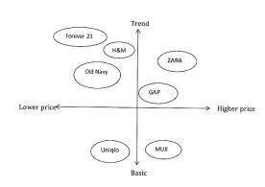
Source: Yi, Z., 2016. Are fashion retailers creative? Evidence from Uniqlo, Asia's leading fashion brand.

