The Life and Times of Caesar and Cicero (HPAH5046/HPAH6046) – Caesar set in stone? Statuary, coinage and artistic depiction of the man

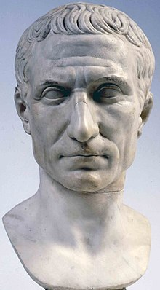
Posthumous portrait of Julius Caesar in marble, circa mid-Augustan period, Museo Pio-Clementino, Vatican Museums

In this workshop we will examine contemporary and posthumous representations of Caesar, including through surviving statuary, portrait busts on coins and literary descriptions. You should read the extracts and examine the images below. Individually or in groups, write up your responses to these images while considering the following issues:

Questions to consider
- What evidence do we have for the forms of imagery set up to honour Caesar during his lifetime?
  - Why do you think it might have irritated some contemporaries? Does it fit into the narrative of an “autocrat”?
  - Why might Caesar have allowed these statues to be erected (consider not just their form, but their topographic location) – do you think it fit into a thematic programme?
- Do you see similarities or differences with posthumous imagery?
- What points of consistency and variation can you identify between the different representations?
- To what extent is it possible to recover what the “real Caesar” looked like?
Honorific statuary and the circulation images of Caesar
“[the senate decreed on Caesar’s return from Africa in April, 46 BC]…that his statue in bronze should be mounted upon a likeness of the inhabited world, with an inscription to the effect that he was a demigod [Ἡμιθεος]…[its location was outside the Temple of Jupiter Optimus Maximus]” – Cassius Dio 43.14.6. [Trans. from Earnest Cary 1916]

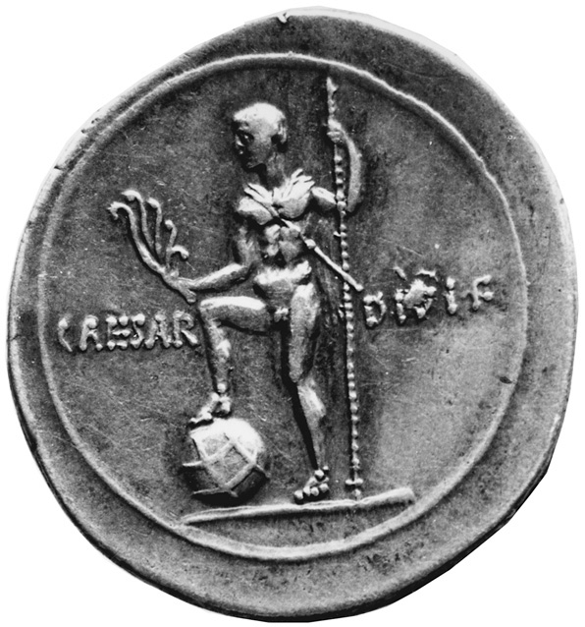
Possible parallel to Dio’s description (later second triumviral era statue)?
Denarius with Octavian as Neptune, with his foot on a globe. Mint of Rome, 31-29 B.C.

“The privileges that were granted him, in addition to all those mentioned, were as follows… they named him father of his country, stamped this title on the coinage, voted to celebrate his birthday by public sacrifice, ordered that he should have a statue in the cities and in all the temples of Rome, and they also set up two on the rostra, one representing him as the saviour of the citizens and the other as the deliverer of the city from siege, and wearing the crowns customary for such achievements…” – Cassius Dio 44.4.1, 4-5. [Trans. from Earnest Cary 1916]
[The corona civica was awarded to those who saved the life of another citizen when fighting against the enemy – it consisted of a chaplet of oak leaves woven to form a crown. The corona graminea (grass crown) was awarded to a commander or officer who saved an entire unit or army. There were also other crowns like the naval, gold, mural and camp crowns]

“Yet after all, his other actions and words so turn the scale, that it is thought that he abused his power and was justly slain. For not only did he accept excessive honours, such as an uninterrupted consulship, the dictatorship for life, and the censorship of public morals, as well as the forename Imperator, the surname of Father of his Country, a statue among those of the kings, and a raised couch in the orchestra; but he also allowed honours to be bestowed on him which were too great for mortal man: a golden throne in the House and on the judgment seat; a chariot and litter in the procession at the circus; temples, altars, and statues beside those of the gods; a special priest, an additional college of the Luperci, and the calling of one of the months by his name. In fact, there were no honours which he did not receive or confer at pleasure.” – Suetonius Divus Julius 76.1. [Trans. from J. C. Rolfe 1913-14]

“The Greek practice is, not to cover any part of the body; while, on the contrary, the Roman and the military statues have the addition of a cuirass [armour covering the torso]. Caesar, the Dictator, permitted a statue with a cuirass to be erected in honour of him in his Forum [near the Temple of Janus]…” – Pliny the Elder Natural History 34.10.18. [Trans. from Bostock and Riley 1855]
[Older examples of Roman statues with military garb exist, but it may be that this was the first instance of an Imperator permitted to have one erected inside the pomerium of Rome]

“Yield, oh steed, that stands in Caesar’s Forum, facing Latian Dione’s temple, you whom Lysippus, they say, Made for Alexander (the rider now bearing Caesar’s Wondrous head): scarce marked by time, you may Contemplate how great the distance between them. – Statius Silvae 1.185 ff. [Trans. from Kline 2012]
[Statius’ description is the only reference we have to this equestrian statue of Caesar; although there are references by Suetonius (Div. Jul. 61) and Pliny (NH 8.155) to a statue of Caesar’s favourite horse placed in the Forum Iulium in front of the temple of Venus. There is no reason to assume that the latter need be conflated with the former]

“He erected the temple to Venus, his ancestress… he laid out ground around the temple which he intended to be a forum for the Roman people, not for buying and selling, but a meeting-place for the transaction of public business, like the public squares of the Persians, where the people assemble to seek justice or to learn the laws. He placed a beautiful image of Cleopatra by the side of the goddess, which stands there to this day.” – Appian Bellum Civile 2.102. [Trans. from Horace White 1913]

“And they decreed at this time that an ivory statue of him, and later that a whole chariot, should appear in the procession at the games in the Circus, together with the statues of the gods. Another likeness they set up in the temple of Quirinus with the inscription, "To the Invincible God, [θεός ἀνίκητος]" and another on the Capitol beside the former kings of Rome. Now it occurs to me to marvel at the coincidence: there were eight such statues, — seven to the kings, and an eighth to the Brutus who overthrew the Tarquins, — and they set up the statue of Caesar beside the last of these; and it was from this cause chiefly that the other Brutus, Marcus, was roused to plot against him.” – Cassius Dio 43.45. [Trans. from Earnest Cary 1916]
[Compare this with Plutarch’s Life of Brutus: “Marcus Brutus was a descendant of that Junius Brutus whose bronze statue, with a drawn sword in its hand, was erected by the ancient Romans on the Capitol among those of the kings, in token that he was most resolute in dethroning the Tarquins.” [Trans. from Bernadotte Perrin 1918]]

“Your friend [Mark Antony] gives more rein to his insanity every day; to begin with, he has had the statue, which he set up on the rostra, inscribed with the words "To the Father, for his glorious services," so that you are condemned not only as assassins, but now as parricides also. But why do I say "you are so condemned"? "We are condemned" is the better phrase…” – Cicero Letters to Family 12.3 (Cicero to Cassius, Rome, early in October, 44 BC) [Trans. from W.G.Williams 1929]

“It was said that Amatius was only waiting an opportunity to entrap Brutus and Cassius. On this rumour, Antony, making capital out of the plot, and using his consular authority, arrested Amatius and boldly put him to death without a trial. The senators were astonished at this deed as an act of violence and contrary to law, but they readily condoned its expediency, because they thought that the situation of Brutus and Cassius would never be safe without such boldness. The followers of Amatius, and the plebeians generally, missing Amatius and feeling indignation at the deed, and especially because it had been done by Antony, whom the people had honoured, determined that they would not be scorned in that way. With shouts they took possession of the forum, exclaiming violently against Antony, and called on the magistrates to dedicate the altar in place of Amatius, and to offer the first sacrifices on it to Caesar. Having been driven out of the forum by soldiers sent by Antony, they became still more indignant, and vociferated more loudly, and some of them showed places where Caesar's statues had been torn from their pedestals. One man told them that he could show the shop where the statues were being broken up. The others followed, and having witnessed the fact, they set fire to the place. Finally, Antony sent more soldiers and some of those who resisted were killed, others were captured, and of these the slaves were crucified and the freemen thrown over the Tarpeian rock.” – Appian Bellum Civile 3.3. [Trans. from Horace White 1913]

Coinage minted in the years of Julius Caesar’s dictatorship
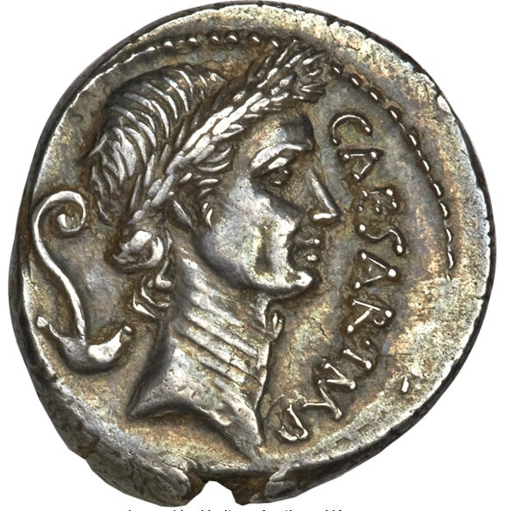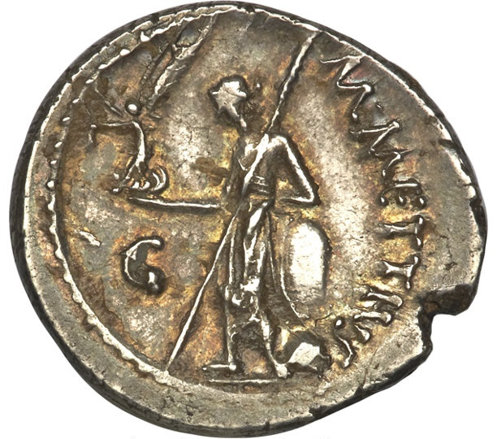
Denarius minted by M. Mettius (the moneyer), March, 44 BC, which represents Caesar with a wreath on the obverse (wreath of a triumphator?). On the reverse is Venus standing left, holding Victory in right hand and scepter in left.
[The Triumviri Monetalis was a body of three junior politicians who acted concurrently to produce coins during the Roman republic]
[Compare this obverse image with the following statement of Cassius Dio: “For himself, he wore the triumphal garb, by decree, at all the games, and was adorned with the laurel crown always and everywhere alike.” (43.43.1) [Trans. Earnest Cary 1916]

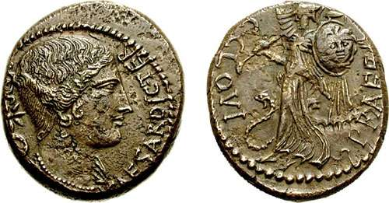
Dupondius or As. On the observe: a draped bust of Victory, wearing necklace, star behind, with the motto CAESAR DIC TER. On the reverse: PRAEF C CLOVI, Minerva standing left with trophy & shield decorated with Medusa, snake at feet. Cr476/1b, Syd 1026. [i.e. this coin features Caesar’s name and his title but not his image]

Coinage minted posthumously, representing Julius Caesar
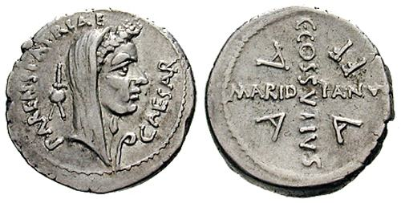
Julius Caesar denarius, minted in April 44 BC. On the obverse PARENS PATRAIE, with a veiled head of Caesar, and a wreath. On the reverse C COS SVTIVS AARDIANVS across fields, and the abbreviation AAAFF [= auro argento aere flando feriundo – (charged with casting and striking bronze, silver, and gold) i.e. issued by a Triumvir Monetalis]

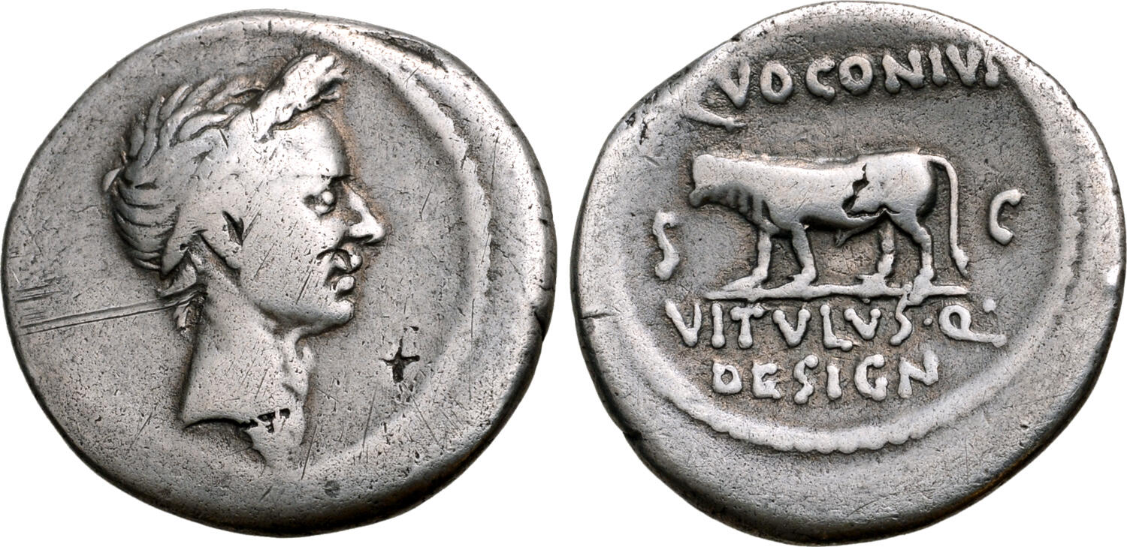
Denarius, minted in Rome, 40 BC, by the moneyer Q. Voconius Vitulus. On the obverse: a laureate head of Caesar right; on the reverse: a bull-calf walking left; Q•VOCONIVS above, VITVLVS•Q• DESIGN in two lines below, S-C across fields. Crawford 526/4; CRI 331; Sydenham 1133; BMCRR Rome 4311-2; RSC 45.

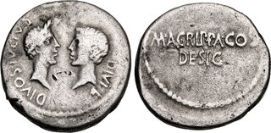
Denarius minted in 38 BC. Military mint traveling with Agrippa in Gaul or Octavian in Italy. On the obverse: wreathed head of the deified Julius Caesar right vis-à-vis bare head of Octavian; on the reverse: M • AGRIPPA COS/DESIG in two lines. Crawford 534/2; CRI 306; Sydenham 1330; RSC 129.
[Note the following statement of Appian: “Meanwhile there had arrived the time for the games which the aedile Critonius was about to exhibit, and Octavian made preparations to display his father's gilded throne and garland, which the Senate had voted should be placed in front of him at all games. When Critonius said that he could not allow Caesar to be honoured in this way at games given at his expense, Octavian brought him before Antony as consul. Antony said he would refer the matter to the Senate. Octavian was vexed and said, "Refer it; I will place the throne there as long as the decree is in force." Antony became angry and prohibited it. He prohibited it still more unreasonably in the next games given by Octavian himself, which had been instituted by his father in honour of Venus Genetrix when he dedicated a temple to her in a forum, together with that forum itself. Then at last it became evident that universal hatred of Antony was already growing out of this affair, since he seemed to be moved not so much by a feeling of rivalry toward the younger Caesar as by an ungrateful purpose to insult the memory of the elder one.” (3.28) [Trans. from Horace White 1913]

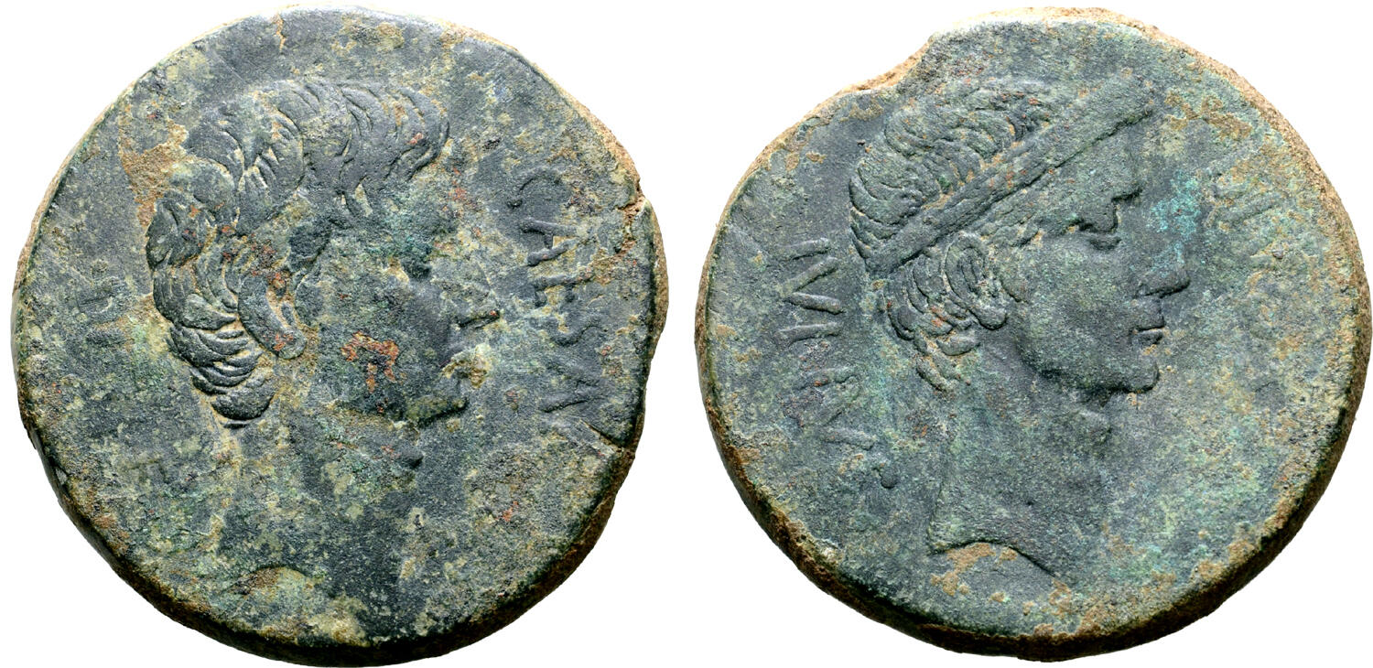
Dupondius. Southern Italian mint, circa 38 BC? On the obverse: CAESA[R DIVI F], bare head of Octavian facing the right, with slight beard; on the reverse: DIVOS IVLIVS, wreathed head of Divus Julius Caesar to right. Crawford 535/1; CRI 308; BMCRR Gaul 105; RPC I 620.

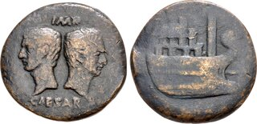
Dupondius, minted circa 36 BC. On the obverse: bare heads of Divus Julius Caesar left and Octavian right, back to back; on the reverse: Prow of galley, with multi-tier superstructure, right. RPC I 517; RIC I 158.
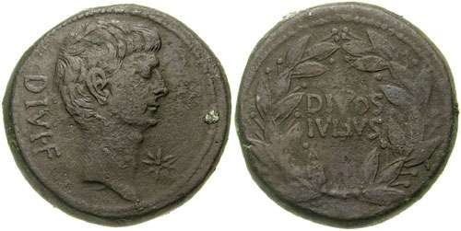
Sestertius issued by Octavian. Southern Italian mint, 38 BC. Obv. DIVI • F, bare & slightly bearded head right, star in field; Rev. DIVOS IVLIVS, two lines within wreath. RPC 621.
[See this passage of Cassius Dio: “When, however, a certain star during all those days appeared in the north toward evening, which some called a comet, claiming that it foretold the usual occurrences, while the majority, instead of believing it, ascribed it to Caesar, interpreting it to mean that he had become immortal and had been received into the number of the stars, Octavius then took courage and set up in the temple of Venus a bronze statue of him with a star above his head. And when this act also was allowed, no one trying to prevent it through fear of the populace, then at last some of the other decrees already passed in honour of Caesar were put into effect. Thus they called one of the months July after him, and in the course of certain festivals of thanksgiving for victory they sacrificed during one special day in memory of his name. For these reasons the soldiers also, particularly since some of them received largesses of money, readily took the side of Caesar.” (45.7) [Trans. from Earnest Cary 1916]]

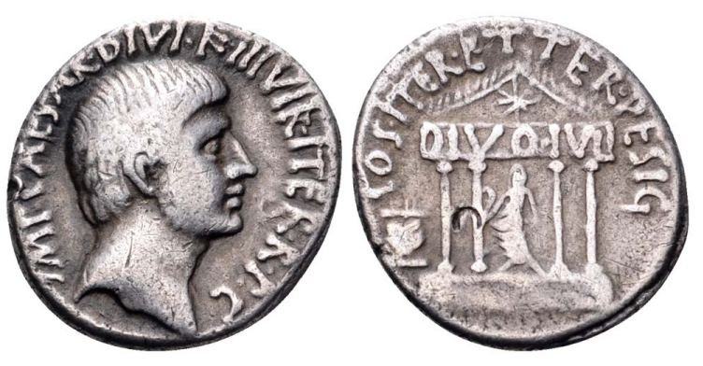
Denarius issued by Octavian in 36 BC. Mint moving with Octavian. On the obverse: IMP CAESAR DIVI F III VIR ITER RPC ("Caesar son of the divine one, triumvir a second time for managing the state"), bare head right / COS ITER ET TER DESIG ("Consul for the second time and designated for a third consulship), tetrastyle temple with Julius Caesar standing within, DIVO IVL on the architrave, star in pediment, lit altar to left. Crawford 540/2; Syd 1338; Babelon 139; RSC 90; Sear Imp. 315; Sear 1545.

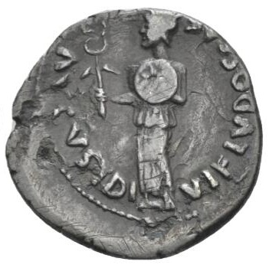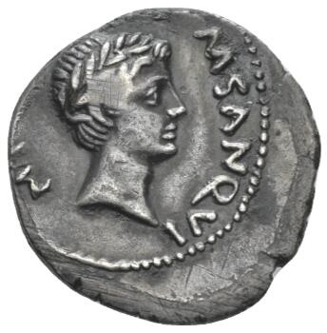
Denarius, minted under Augustus [Octavian] circa 17 BC. On the obverse: a herald in long robe and feathered helmet, holding winged caduceus and shield decorated with star. On the reverse: a youthful laureate head of the deified Julius Caesar. C 6. RIC 340.

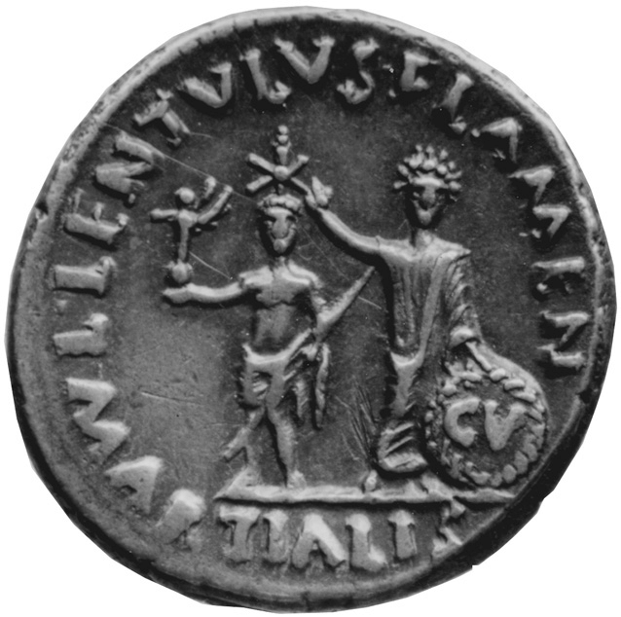
Denarius, Rome, 12 B.C. Augustus places a star on a statue of Julius Caesar, in commemoration of the appearance of the comet (sidus Iulium) in 44 BC. Augustus holds the golden shield (Clipeus Virtutis) presented to him by the Senate in 27 BC. Caesar is shown with the emblems of victory and power: a small statue of the goddess Victoria and a spear. Katalog Niggeler, 2. Teil, Nr. 1055 (Bank Leu/Münzen und Medaillen AG, Oktober 1966).

Caesar in stone – statues and busts of Caesar
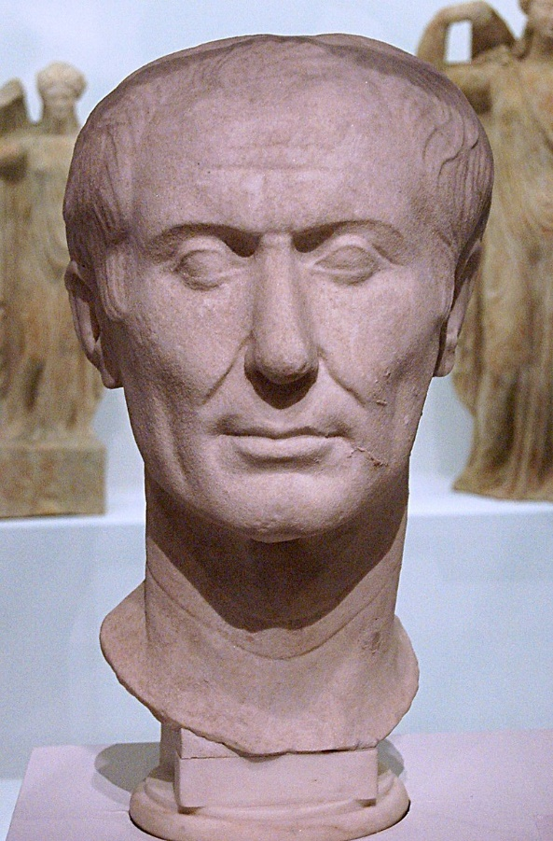
The “Tusculum type of portrait” – white marble, circa 50-40 BC. Museo d'Antichità in Turin, Italy.
[Compare this image to the coin issued by the moneyer M. Mettius (see above)]

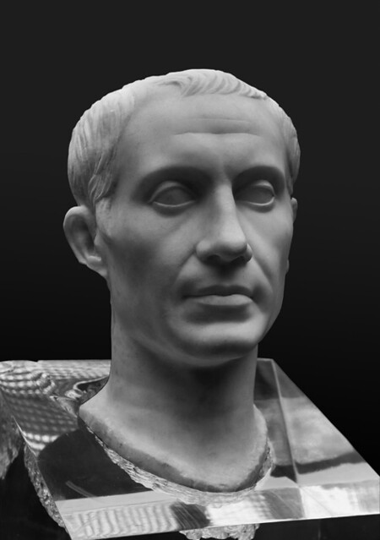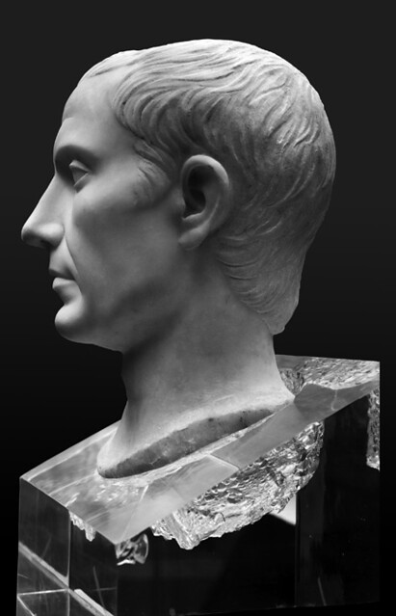
Bust of Julius Caesar found on the island of Pantelleria, Italy. First century AD (time of Claudius?).
[Compare this to the Tusculum portrait]
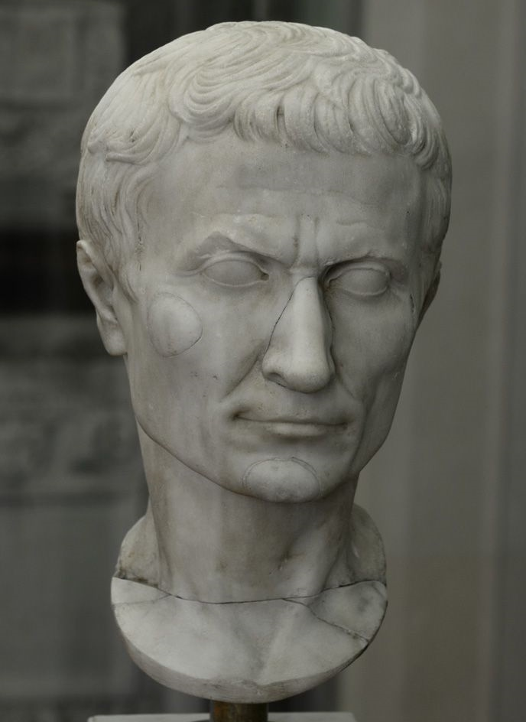
Based on an original bust of Caesar, that dated to the reign of second triumviral period. It is of the “Pisa type”. museo dell'opera del Duomo.

Posthumous portrait of Julius Caesar in marble, circa mid-Augustan period, Museo Pio-Clementino, Vatican Museums

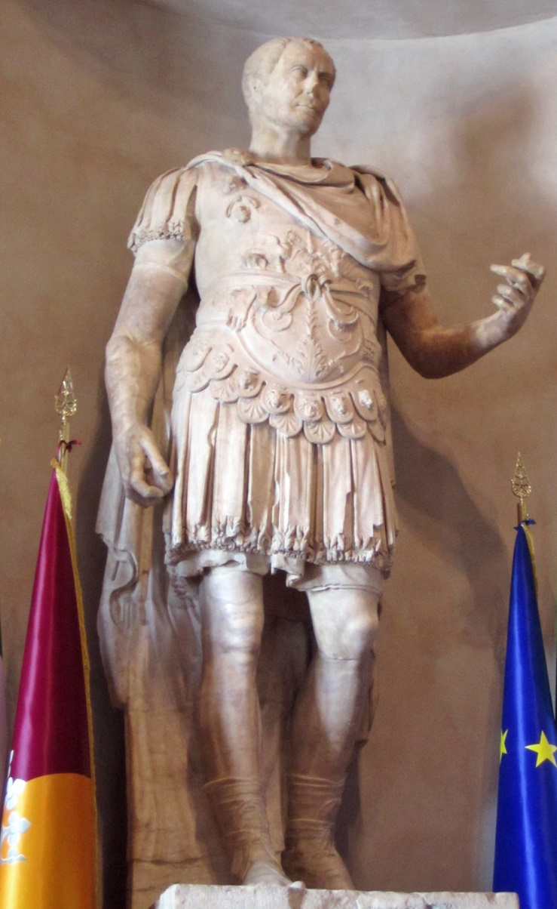
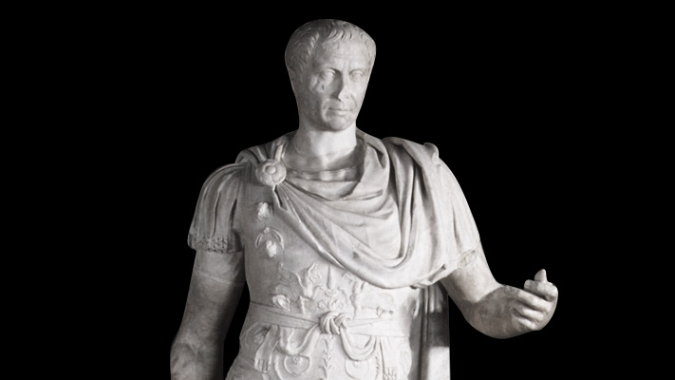
Statue of Caesar, Trajanic era. Now in Rome, Palazzo Senatorio.

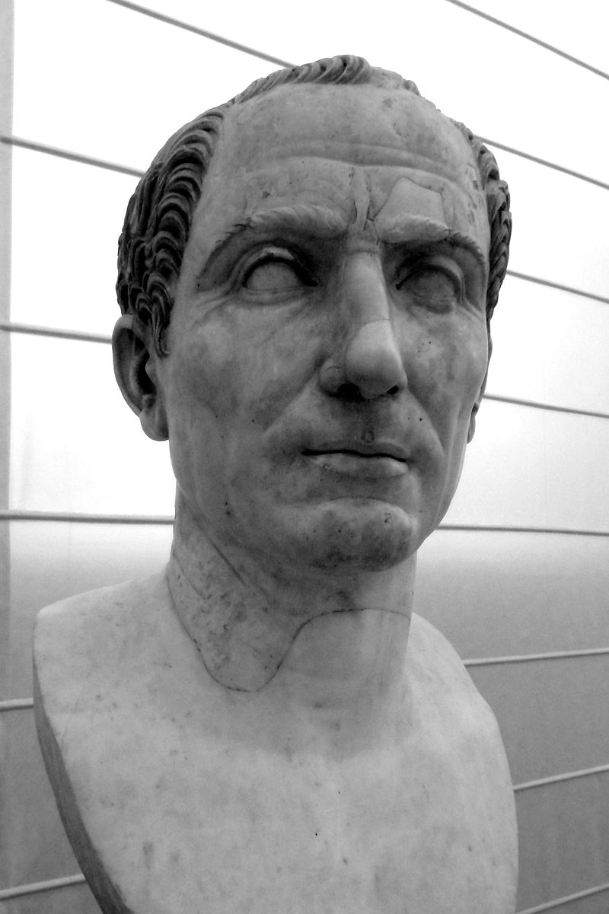
Trajanic era portrait of Julius Caesar, perhaps (partially) based on earlier mid-first century models (most likely the Tusculum type). Naples Archaeology Museum.

