BA Business Management
Data Handling and Business Intelligence
LCBB5000
Component 2 Coursework (Written Report)

Student Name: Izabela Ioana Stanescu
Student ID: 2025868
Lecturer: Zhara Mohammadnazari

Table of Contents
Part 1: 2
Discussion and analysis of the GreenMed_Healthcare_2023 dataset 2
Part B 4
Part C. 7

Part 1:

Discussion and analysis of the GreenMed_Healthcare_2023 dataset

- The Excel has been used to find the mean processing time when using Hadoop. An empty cell was clicked in the spreadsheet, and the following formula was typed.
=AVERAGE(B2:B51)
where B2:B33 is the range of cells containing the Hadoop processing time data.
Enter was pressed, and the mean processing time displayed in the cell.
In this case, the mean processing time when using Hadoop is 2.776889208 minutes.
- The Spark processing time data was sorted in ascending order. The entire column of Spark processing time data was selected. The "Data" tab in the Excel ribbon was clicked. In the "Sort & Filter" group, the "Sort" button was clicked. In the "Sort" dialog box, the "Spark Processing Time" column under "Sort by" was selected. The "Order" was set to "Ascending" (smallest to largest). The "OK" button was clicked. If the number of data points is even, the median is the average of the two middle data points. There are 50 data points for Spark processing time. To calculate the median of Spark processing time data in Excel, the MEDIAN function was used. Here is the formula:
=MEDIAN(spark_processing_time_data)
"spark_processing_time_data" was replaced with the range of cells that contains the Spark processing time data.
=MEDIAN(C2:C51)
An empty cell was clicked in the spreadsheet, and this formula was typed.
The median processing data when using Spark is 2.746910366.
- The R processing time data was sorted in descending order. The date corresponding to the first data point is the date on which R had the highest processing time. The first data point is 4.867451715 which corresponds to the date 2023-01-16.
- An empty cell was clicked in the spreadsheet, and the following formula was typed.
=STDEV.S(E2:E51) where E2:E51 is the range of cells containing the Python processing time data. Enter was pressed, and the standard deviation for processing time when using Python was displayed in the cell. In this case, the standard deviation for processing time when using Python is 1.297205735.
- Five empty cells were clicked in the spreadsheet, and the following formulas were typed respectively
=AVERAGE(B2:B51)
=AVERAGE(C2:C51)
=AVERAGE(D3:D51)
=AVERAGE(E2:E51)
=AVERAGE(F2:F51)
Enter was pressed, and the mean processing time of Hadoop, Spark, R, Python, tableau was displayed in the cell. In this case, mean processing time when using Python is the lowest; 2.573181096 minutes.
- We can see that there isn't much difference in processing times generally among the various tools or platforms based on the mean processing times. There are a few noteworthy variations, though. At 2.57 minutes for processing on average, Python is the quickest tool overall. With average processing time of 2.77, 2.75, and 2.83 minutes, respectively, Hadoop, R, and Tableau come next.
Spark is the slowest to process of all the tools, taking an average of 2.93 minutes. But it's important to remember that Spark is designed to be a general-purpose distributed computing framework, which means that, in contrast to the other technologies in our comparison, it can be used to a larger range of tasks. For instance, Spark may be used to perform computationally intensive tasks that other technologies usually handle more expensively, such as machine learning and real-time data processing. It must be kept in mind that there can be variances in processing times on the basis of specific task at hand. For example, R could perform better than Python in some statistical tasks. Python is the fastest tool available for most data science and machine learning tasks.
Python is faster than both R and Hadoop because it is a compiled language, meaning that it is transformed into machine code before being run. It therefore functions faster than interpreted languages such as R. Moreover, two of the numerous Python modules and frameworks designed specifically for data science and machine learning are NumPy and Pandas. The primary focus of these frameworks and libraries' design is performance and speed. Hadoop is slightly faster than R as it is designed to be a distributed computing environment. This suggests that several CPUs may share the processing load of large datasets. R, on the other hand, is single-threaded and can only handle data on one thread at a time. Tableau runs a little bit slower than the other programs because its primary purpose is data visualization. This suggests that it has to render the data visualizations, which takes time, before it can show them. The other tools in our comparison have faster rendering speeds because their main goal is data processing.

Part B
The differences in processing times between different tools or systems are frequently minimal. However, there are a few notable differences. In general, Python is the fastest tool while Spark is the slowest. Choosing the right tool for the job is essential, taking into consideration the specific task at hand as well as the desired result.
- We used IF function in Excel and arranged the mean time of these five programs in cell range from I18 to I22. In cell J18, we used:
=IF(I18=MAX($I$18:$I$22), "Highest", "Not Highest")
This formula was dragged down from J18 to J22 to compare the mean processing times of all programs. This formula checks if the mean processing time in I18 is equal to the maximum mean processing time among all programs. If it is, it displays "Highest"; otherwise, it shows "Not Highest". The cell references were adjusted according to actual data range to correctly compare the mean processing times and determine which program has the highest mean processing time among the given set. In J19, the highest mean processing time is given so it will show “Highest”.
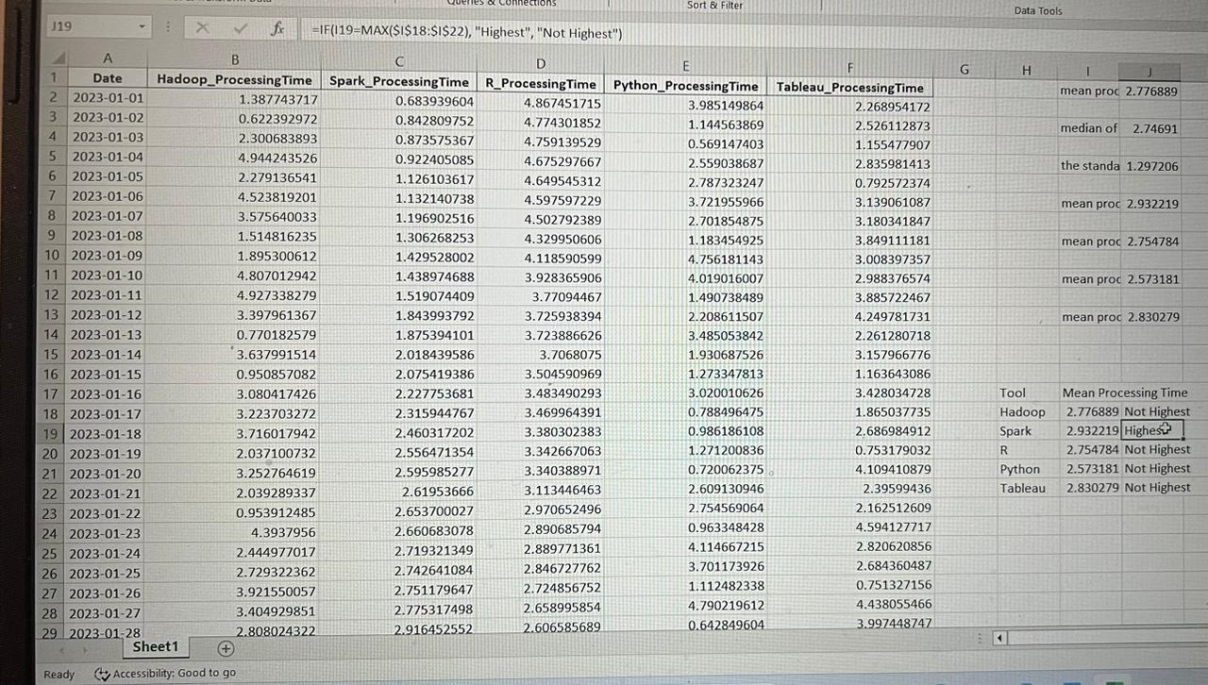

Pivot tables are a powerful tool in Excel to summarize, analyze, and present data.
I18 to I22 range was highlighted that includes the mean processing times for these programs. The "Insert" tab was used in Excel and "PivotTable" was clicked also. It must be ensured that the range selected is correct in the dialog box that appears, then the location was selected where PivotTable was to be placed. Drag the "Program" field to the Rows area. The "Mean Processing Time" field was dragged to the Values area. By default, it should summarize the values using the "Sum" function. The result can be seen in the following screenshot.
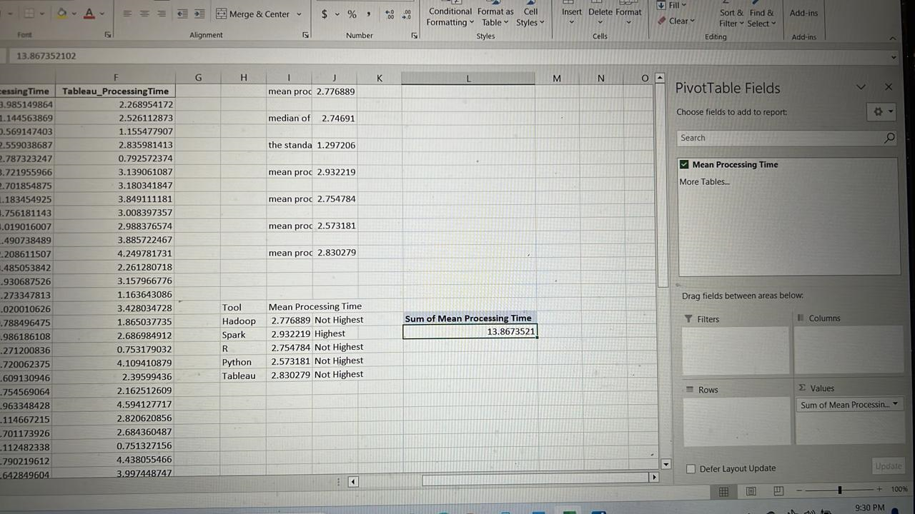

We can create various charts in Excel to visualize the mean processing times for different programs. We created the bar chart as it is suitable to compare mean processing times among programs. The range was highlighted that includes the program names and their mean processing times. The "Insert" tab was used and "Bar Chart" was clicked from the Charts section. Excel generated a basic chart using on the basis of selected data.
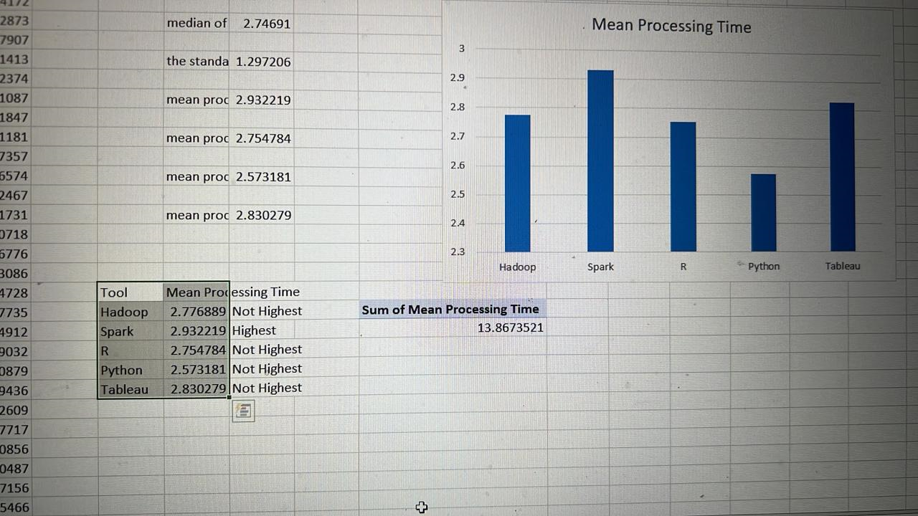

Creating a graph in Excel based on mean processing times for different programs is an excellent way to visualize the data trends. A line chart is useful depending on the nature of data. The range was highlighted that includes the program names and their corresponding mean processing times. The "Insert" tab was used, "Insert Line Chart" was clicked. Excel generated a basic line chart.
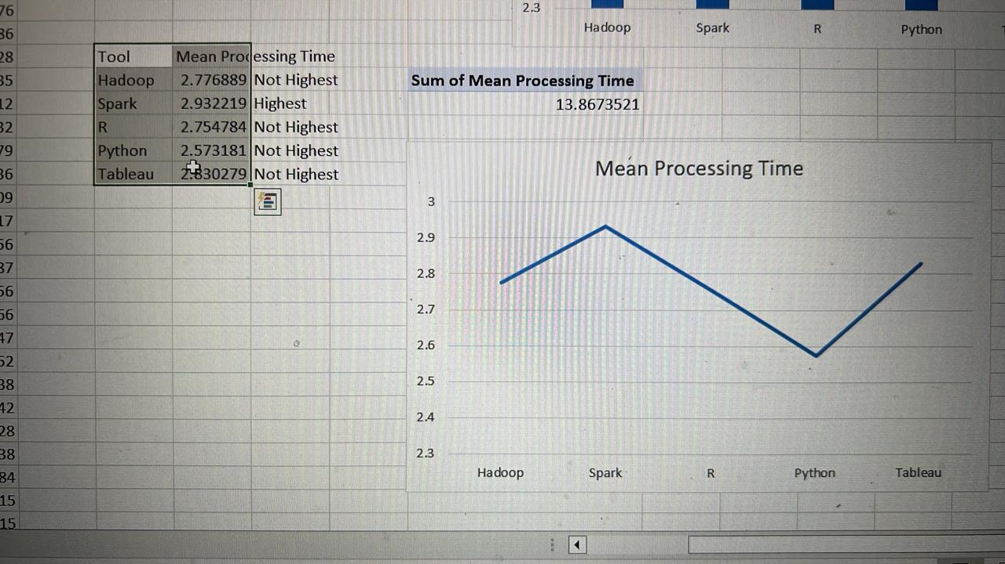

Part C.
In this report, the SPSS software is used to run the tests of correlation and create a scatter plot of two variables Hadoop and Tableau from the dataset. The purpose of this analyses is to examine and present the relationship between these two variables in terms of processing times of data these software programs take. Scatter Plot that is used in this analysis can also be used to highlight the difference in the data of the processing times of these two software programs. Following are the results of this analysis along with the output obtained from the SPSS.

Correlation analysis:

Correlations
 |  | Hadoop_ProcessingTime | Tableau_ProcessingTime
Hadoop_ProcessingTime | Pearson Correlation | 1 | .178
Hadoop_ProcessingTime | Sig. (2-tailed) |  | .217
Hadoop_ProcessingTime | N | 50 | 50
Tableau_ProcessingTime | Pearson Correlation | .178 | 1
Tableau_ProcessingTime | Sig. (2-tailed) | .217
Tableau_ProcessingTime | N | 50 | 50
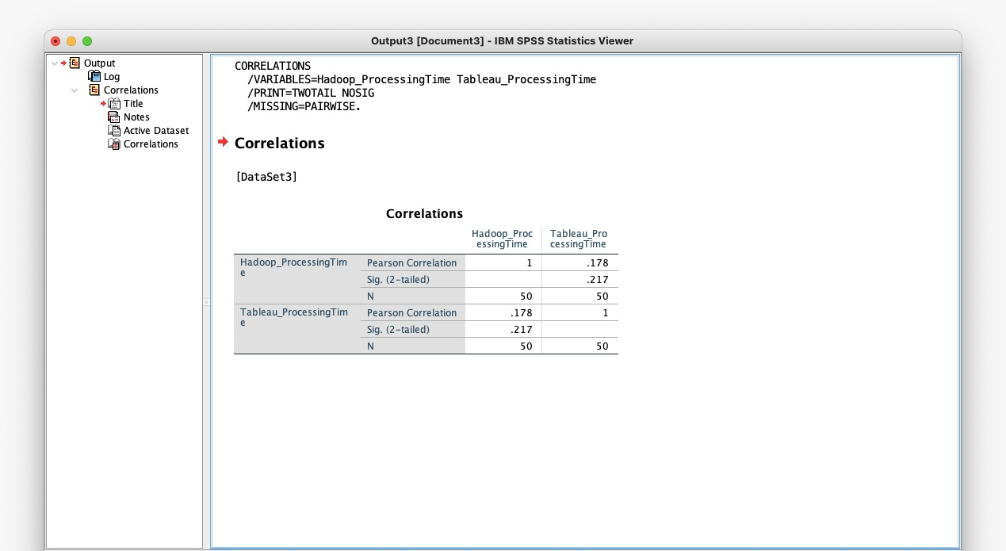
Tableau and Hadoop are two different technologies whose processing durations are correlated in this table. A linear relationship between two variables may be measured using the Pearson correlation coefficient, which ranges from -1 (perfect negative correlation) to 1 (perfect positive correlation), with 0 denoting no correlation. The correlation coefficient in this case between Tableau ProcessingTime and Hadoop ProcessingTime is 0.178, indicating a modest but positive correlation.

Determining whether the observed correlation is statistically significant depends on the significance level (Sig. or p-value) attached to the correlation coefficient. The p-value in both situations is 0.217, above the usual significance level of 0.05. This suggests that there may be a random chance explanation for the observed correlation, and it is not possible to say with confidence that there is a real correlation between Hadoop and Tableau processing times. For both variables, the sample size (N) is 50, suggesting a reasonably stable dataset. It is not possible to declare with confidence that there is a significant relationship between the two based on the data.

Scatter Plot:

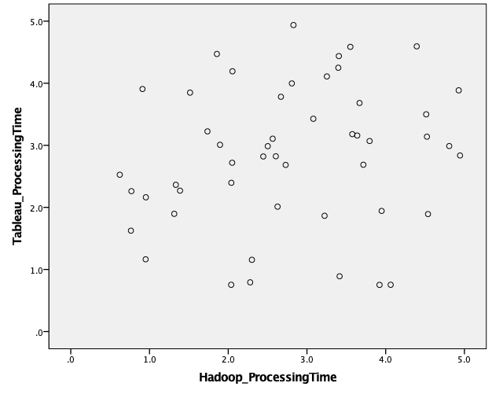

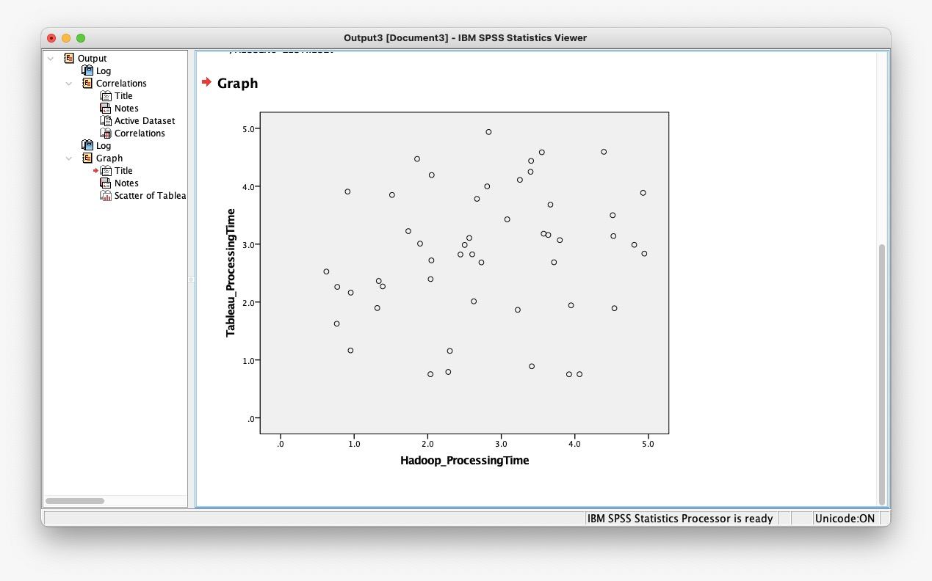
The scatter plot displays the relationship between Hadoop and Tableau's processing times. The Hadoop processing time is shown by the x-axis, while the Tableau processing time is represented by the y-axis. On the scatter plot, every dot corresponds to a particular dataset. The scatter plot demonstrates a favourable correlation between Tableau and Hadoop's processing times. This implies that Tableau's processing time grows in tandem with Hadoop's processing time. There are some dots that deviate from the trend line, thus the correlation is not perfect.
The fact that the two software tools are often used to handle big datasets might be one reason for the favourable correlation. Tableau is used to show the output, while Hadoop is utilised to split out the dataset processing among many workstations. Hadoop and Tableau will take longer to handle a dataset that grows in size and complexity. A plausible rationale for the positive correlation might be because Tableau and Hadoop are both resource-intensive software applications. They need a lot of RAM, CPU power, and storage capacity. The amount of time it takes for Tableau and Hadoop to process the dataset will increase if the server hosting both applications is overcrowded.
Furthermore shown by the scatter plot is the overall shorter processing time of Hadoop compared to Tableau. This is a result of Hadoop's ability to handle big datasets effectively. It processes the dataset far more quickly than a single computer could since it divides the processing of the dataset across many processors. Conversely, Tableau is made for data visualisation. Large dataset processing is not as efficient with it as with Hadoop. On the other hand, Tableau excels in producing interactive visuals that let users explore and comprehend data.

