Managing Projects in the Organisation
Student ID: 1604528
Nsme: Md Faisal Ahmed Rana
Module code: BMSK5004

Executive summary:
Successful project depends on the project planning, executing project and proper implementation of resources and techniques. Most of business takes project with risks. But before going to taking project, organization must evaluate the secession rate of project for understanding possibility to achieve profit from project. John Lewis has taken a project for development of new software which will track the customer’s information and organization can easily manage the inventory. So, this organization focuses on use of tools and techniques relating with project. Several tools are used in project and implementation of project plan such as Pert, COM, swot analysis, resource histogram, stakeholder matrix etc. from this concept, project documentation is important which requires evaluation of risks, stakeholders, clarifying gaols and scope of project, budgeting project to achieve the target and taking feedback from related stakeholders to improve the productivity.

Contents
Executive summary: 2
Introduction: 4
1) Provide a critical assessment of the usefulness of project management tools and techniques. 5
2) Prepare a plan for the implementation of the project and specify the relevant steps that must be followed and how the plan is going to be implemented. 10
1. Project goals, objectives and critical success factors: 10
2. Project Scope 11
3. Identifying risk and constraints affecting the project 11
4. Assumptions made about the project 13
5. Project Organisation Structure and Roles and Responsibilities 13
6. Project Control Mechanisms 16
7. Reporting Framework 17
8. Stakeholders and their Involvement 17
9. Project Planning with Milestones 19
10. Budget assumptions 20
3) Critically evaluate your ability to manage a project using feedback from others to evaluate your own ability to plan and implement a project, identifying strengths and weaknesses 20
Conclusion: 24
References 25

Introduction:
Project management is the process of initiating project plan and closing project with successful completion. Many business focuses on the project and its success by using several tools. So, organization needs to think about different types of resources which required for the project. In the project, financial resource, technological resource and human resource play a key role. Project manager applies own capabilities to achieve project goals and meet with the success of project. (Chapman and Ward, 2003) So, project manager is the key person who is responsible for playing and implementing project plan. So, skills need to improve of project manager for achieving target.
John Lewis Plc is the British high-end department store. This business includes 51 stores where 37 stores are departmental store and 12 in Home and shops. It is the visionary and popular business for its successful plan and activities in market almost 83000 employees are working in this business and working with fairly to deliver quality products. Speden Lewis undertook this business in 1929. (John Lewis, 2018) Annual sales of John Lewis are £11.5 B and sharing profit among partners. It is popular among consumers for lower price as much as possible than any competitors existing in market. It works for adapting with different culture and improves the quality of products and delver with low cost and superior quality.

1) Provide a critical assessment of the usefulness of project management tools and techniques.
Project is some interrelated activities of an organization based on planning which moves an organization towards its objectives. Each project as some unique characteristics which differentiate business function from project like time table means starting and ending time, a problem, required resources, size and scope of project and information and controlling methods. Project manager is responsible for achieving the target of project and accumulate resources, personnel to implement them in need. John Lewis works for delivering products and mainly concentrate on low cost production. It takes different types of project to ensure quality of products, to control employees, deliver low cost products as it can achieve its vision. Project management includes four phases which move a project to its success. In each stages of project management, project manager implements different types of project management tools and techniques which evaluate the project succession rate, risk management, deliver time, stakeholder’s impact and resource requirement. (Chapman and Ward, 2003) Project management tool can control the project manually and automatically. It actually depends on the organizational resources and decision. John Lewis implements several project management tools and techniques to achieve the goals such as PERT, Gantt Chart, resource histogram, stakeholder matrix etc.
PERT (Program Evaluation and Review Technique) is the planning and controlling tools for a project. It estimates the time of completion of project and provides controlling methods to reach project target. It almost relates to Critical Path Method (CPM). John Lewis uses these tools for estimating time of competition. Sometimes, organization needs to determine how much time each function will take to achieve and John Lewis determines its time using both tool. John Lewis also uses a graphical representation tool which draws a network of project to show the estimated time of each task and draw CPM diagram to show the relationship of each functions of project. (CLEDEN, 2017) John Lewis follows different steps to apply this tool in their business and estimated the time of project completion. It includes three types of time including optimistic, pessimistic and most likely time. John Lewis calculates the estimated time by using a formula:
Expected Time = (Optimistic + 4 x Most Likely + Pessimistic) / 6
Then, John Lewis focuses on critical path for determining the longest possible path to complete the project. It determines by using earliest start and finish time and latest start and finish time. Finally, organization finds a possible time to complete the project. It includes slack variable, probability to increase or decrease time and John Lewis uses estimation to determine cost, time.
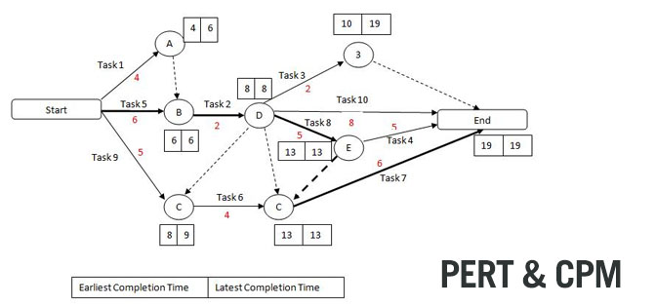
Source: (Harrin, 2013)
Gantt chart is the tool which display the time for each task. Organization uses this tool for assigning each task to employee based on time. It is the graphical representation which includes straying time, elapsed time and completion time of project task. It is mostly used for tracking the progress of project. John Lewis implement this tool in its project to understand time and how effectively it can reach its target. It shows how much time it will take for each task based on scheduled time. It clarifies about the success and failure rate about project. So, John Lewis uses this tool as its budgeting tool and estimates total cost of each functions.
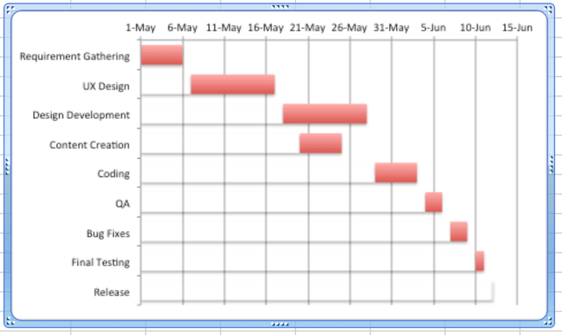
Figure: Gantt Chart
Source: (Reiss, 2013)
John Lewis applies this tool for listing activities in the project plan that will work sequential or parallel. Time will show in the top of the graph and plotting the task in graph paper to schedule time for each activity. It includes slack time and presentation time for final evaluation.
Resource histogram is another tool which is used in project for understanding and determine the resource requirement and utilization of resources. It also clarifies about resource and interested parties in each team. (Harrin, 2013) It shows how John Lewis partnership can display the resources for a particular task in scheduled time. It also helps John Lewis partnership to understand about resources availability, requirement resources for each task. Project manager of John Lewis implements this tool for managing project with success.
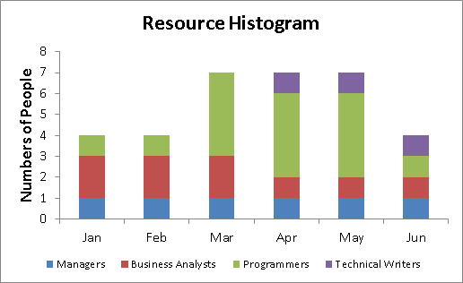
Source: (Reiss, 2013)
Stakeholder salience model is the tool which is used for understanding the power, legacy and interest towards function of project. Organization uses this tool for clarifying about the influence of each parties in project. It also helps John Lewis for understanding about the needs of stakeholders and categorised them.
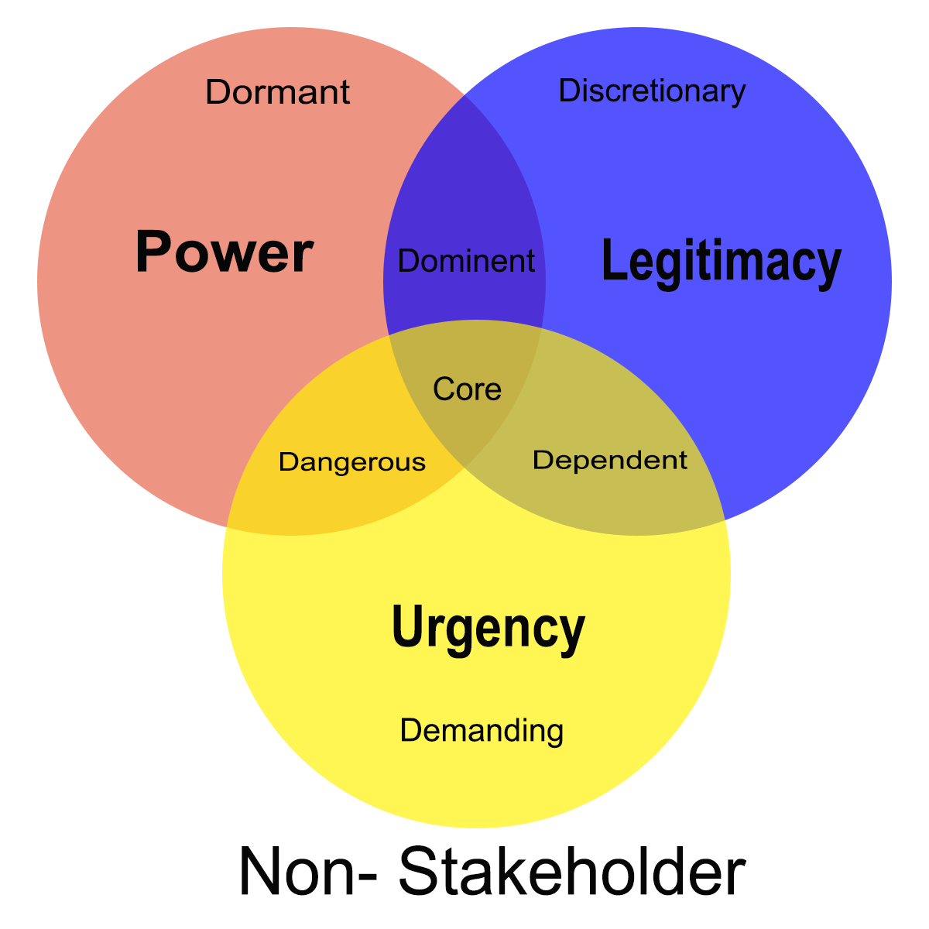
Source: (Rad and Levin, 2006)
It includes three parts such as power, legitimacy and urgency. So, each business needs to properly implement this tool to clarify about which stakeholders mostly influencing the success and failure of project. Because success and failure, mostly depends on related parties of project.
SWOT is the tool which clarifies about the organizational capabilities and deficiencies to achieve the target of project. Different organization has different strengths and weaknesses. From the case study of John Lewis partnership, it has many strengths and weaknesses to cover up the threats and achieve the opportunities to be successful in market. Strengths of this business are Robust tragedy for growth in world market, presence in both online and offline market, offering huge product line with low cist service, popular among consumers for branded products. (Melton and Iles-Smith, 2009) Weaknesses of John Lewis Plc are inconsistent profitability and lack of operation in internal market. so, all those capabilities and deficiencies crates possible opportunities and vulnerabilities for John Lewis company. Opportunities include in this company as high involvement in consumers, availability of demand and threats are changing rules and regulation and increasing competition etc.
RACI (Responsible, Accountable, Consulted, Informed) is the tool which shows how properly an organization can achieve the success by assigning task of project to responsible person. It shows the tasks for each employee working in that organization. John Lewis company uses this tool for assigning the task of project as it can easily control the project and can determine the progress of project.
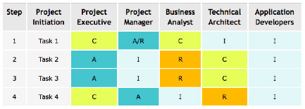
Figure: RACI matrix
Source: (Griffiths, 2010)
Each element of this tool includes the determination of success of project. Responsible includes which person is response for particular task. Then, accountable clarifies the person is accountable for failing the task. Consultation needs for achievement of this project and finally inflamed to project manager about the progress of project and how to reach the success of project.
Risk map is the tool which represents the risk of project based on impact on several factors. Organization focuses on the estimation of probability of risk which occurs in project which may be high, low or medium. (Melton and Iles-Smith, 2009) John Lewis company uses this tool for understanding about probability of risks which may occur in their business and classifies this risk based on activities in project.

2) Prepare a plan for the implementation of the project and specify the relevant steps that must be followed and how the plan is going to be implemented.
PID – Project Initiation Document
Introduction:
John Lewis is the retailing company in UK which has many stores for delivering products towards consumers. It has recently taken a project for introducing new software for tracking consumers and their behaviour and minimizing cost of products relating with reducing cost of raw materials in market for achieving customer’s satisfaction. So, it needs to uses Human resources analysis of stakeholders and measuring risks of this project to achieve success. This company later grown up by partnership business and operating business in different location in UK, wales etc.

Project goals, objectives and critical success factors:
John Lewis company wants to initiate online based business with low cost and ensure customer satisfaction in their business for achieving new era in that company. So, this business focuses on the objectives of project, deliverable of project and which benefits John Lewis will get from this project.
Project gaol for John Lewis Plc is to increase new stores in new locations and Software for our website. John Lewis focuses on how to achieve the goal and accumulates all functional manager and uses their project plan.
Objectives of project:
There are many objectives of this project which taken by John Lewis Plc and they are showing here:
- Reduce the controlling cost of raw materials and business
- It will move this company to reduce the total cost of production which achieves customer’s attention towards new products
- Move to organizational goals and objectives which provides a radical change to organizational development (Westney and Westney, 1997)
- It also coordinates in each department by applying each function in this project
- To get the profit and reach the top position in international market etc.
Benefits of this project:
Increasing suppliers and new products as well as stores will move this business to reduce the cost of products and particular sector will achieve their expectation. Such benefits of this project for John Lewis are showing here:
- It will ensure security of business and products
- It will increase productivity of business and employee will concentrate in workplace
- Each functional manager will able to apply their own decision in project planning
- It will create a competition among employees and helps to achieve the business target
- Customer service will improve and cost of taking feedback will reduce etc.

Project Scope
As this business wants to reduce the cost of production by development of new software for tracking business and ensuring safety it can focus on the scope of the project. Success of the project depends on three factors such as cost, time and quality. (Westney and Westney, 1997) So, John Lewis Plc also focuses on those factors at the time of project implementation.
- Main gaol of John Lewis project is to increase the quality of products, control the employees and provide superior value with products to customers
- Time needs to reduce. As example, John Lewis will track the customer’s order and deliver products with less lead time which will increase the customer loyalty
- Cost is main factor in each project. Organization tries to reduce the cost of delivering products and tracking customers behaviour. So, software will automatically provide feedback about consumers.

Identifying risk and constraints affecting the project
Risks includes in each projects and organization tries to minimize risk for achieving the target and provides a clear understanding to each functional areas in project to minimize several types of risks. Development of software for tracking customers and overall business is a big project for John Lewis and it includes several types of risks. It is the process of selecting the risk, managing risks with coordinating with project scope. Risk may be positive or negative which indicates the opportunities and threats to project. But John Lewis focuses on the negative risk for minimizing those risks from project to achieve target. Different types of risk include in that project and they are identifying and showing how they can impact on success of project:
- Market risk: It is the risk which includes introducing software to market and how customers and other stakeholder’s response about it. It may be positive or negative risk. Market risk has several constraints. Investors think about market risk to invest.
- Financial risk: It is the risk which includes financial investment. John Lewis needs huge amount to develop this software and maintenance and update this software in time to time. So, investment risks need to think and think how it will provide payoff. (Acharyya and Brady, 2014)
- Technology risk: Sometimes, Software can be crashed, hacked and unmated problems can occur and organization must think about this risk. It may crash the possible outcome of the project and may fail.
- Structure/process risk: Organization thinks about the success of project and of organization fails to apply proper management plan, controlling process and structure of business, project may fail. So, John Lewis needs to apply Work break down structure in their project to achieve the success of project.
Constraint also includes in each project. So, John Lewis company thinks about the constraints of project to minimize the risk. In that project, constraints are labour, cost and time. So, it should take in mind about how quickly it can reach its target. Cost constrain is the main part of that project to reduce cost is the main gaol of John Lewis company.
Risk analysis is another important part to manage risk. John Lewis can apply their won strategy and follow the steps of managing risks. Risk break down structure need to apply in their business to reduce the risks
- Quantitative risk analysis: It refers to the evaluation of risks priority based on numerical value. John Lewis company can implement this method to analyse risks based on probabilistic method. It will help to identify the achieve cost, schedule cost etc. (Griffiths, 2010)
- Qualitative risk analysis: It describes about the identified risks based on quantitative method. It clarifies how properly risk will minimize. John Lewis cam implement this analysis to identify effect of risk factors in project.

Assumptions made about the project
Development of software for tacking customer information and managing inventory though online is a big project for John Lewis company. To be successful in that project, John Lewis must need about the caters which can influence in project. Some factors may be known but some are unknown which influences to make the project unsuccessful.
Initially, project manager knows about scope of project, goals of project, deliverables of project, and particular time of project. All those factors influence in success of project. Project manager specifics those factors and clarifies in their project to achieve the success. On the other hand, Project manager thinks about the risks like marketing risk, organizational risk and project risks which is known for project manager.
Some issues are not clear towards project manager such as:
- Budget is estimated, but project manager is not aware about the total cost of that project
- Some qualitative risks which may hinders the project is not clear here
- Constraint of projects I not clear to achieve the target which may be technology
- Resources is key part for project but this organization cannot clarify how much resources required for achieving target (Malhotra, 2015)
- Stakeholders influence the project and investors sometimes may move from project and think about this.

Project Organisation Structure and Roles and Responsibilities
Project organization relates with activities mostly related to project. Many organizations in the world are relating with project. They take project by evaluating the success rate of project and manage project to achieve the success. John Lewis has taken a project for development of software and minimizing cost of services. (Malhotra, 2015) So, it needs to follow some organizational structure and they are shortly describing how implementing in project with its roles and responsibilities to project:
Work breakdown structure: Here, Project manager breaks the functional areas in sub function to distribute roles and responsibilities towards employees. It increases efficiency of productivity and helps to achieve the target.

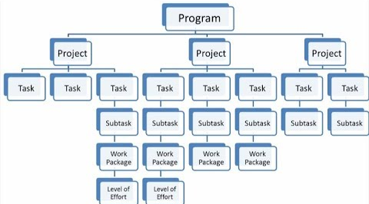
Figure: Work Break down structure
Source: (Griffiths, 2010)
Matrix organizational structure: It is the structure which includes both flat and tall organizational structure. John Lewis can apply this structure in that project to accumulate each function to the project.
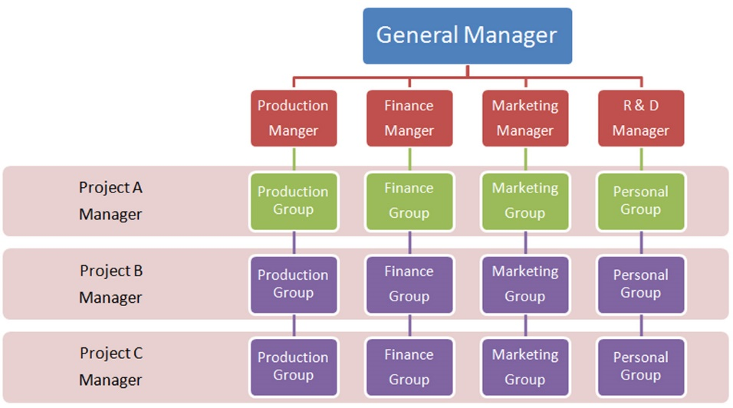
Figure: Matrix structure
Source: (Finney, 1994)
Hierarchical structure: This structure relates with hierarchy of management. Here, managing director of project has whole control and responsible for achieving the target. Project manager of different project works under this person. Controller of projects control project and handover responsibilities in different project manager.

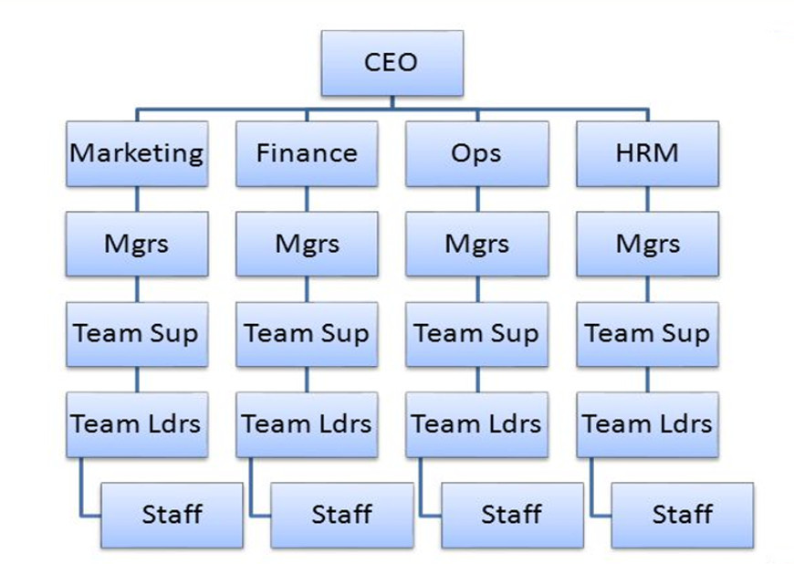
Figure: Hierarchical structure
Source: (Finney, 1994)
Project team chart: John Lewis can apply this structure fir clarifying the project within each team of project such as marketing team, development team, implementer etc. in this team, roles and responsibilities of each team are interrelated. It includes time, cost and function of project. Project manager is responsible for applying this chart to functional manager, employees etc. employees works based in this structure.
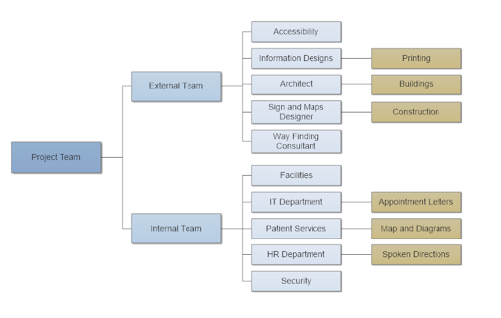
Source: (Chemuturi and Cagley, 2010)

Project Control Mechanisms
Project needs to control for achieving the success of project. There are several parties directly and indirectly include to control the project. Project manager is responsible for controlling the project. But some other parties can influence to control project like employees, functions managers, supervisors etc. Some important methodologies are showing here for controlling the project for john Lewis company and they are:
- Earned Value Analysis: It is the control technique which allows to measure the performance of project. Sit displays the quantity of success or progress of project. So, John Lewis can apply this method in their project. (Chemuturi and Cagley, 2010) Two indicators include here like Cost Performance Index and Schedule performance Index. Both helps to measure the performance of project and control it.
- Critical Path Analysis: It is the most effective method of measuring the success or progress of project. It evaluates the time of project completion and estimated who much time it will take to reach the target. It has some specific time and activities to achieve the propjet goals. Critical path shows which path is most effective and low cost for achieving target. (Burke, 2010) So, John Lewis can apply this method to measure performance and control project.
- Daily tracking: John Lewis ca apply daily meeting system with functional managers, project managers and related parties to understand the growth and provide relevant solution for solving problem. Project manager is the key person who organizes the meeting to understand the problem and control it.

Reporting Framework
Communication plays crucial role for achievement the success of project. Communication creates a flow of work among employees. So, most of eths business try to develop team to increase the efficiency of work flow. Communication plan helps John Lewis to deliver message to employees, functional managers and create a relationship. It helps to achieve the project goal and objectives. John Lewis can apply several methods of communication in their project such as:
- Interactive Communication: It is the method where John Lewis can interact with stakeholders and communicate with video conferencing, phone calls. It helps John Lewis to conduct with taking decision when need.
- Push and pull communication: It is the method of communication where John Lewis can communicate with stakeholders or stakeholders can conduct with project manager to achieve the success of project. (Burke, 2010) Project manager will communicate with stakeholders when they need information of progress of project. On the other hand, stakeholders will communicate with project manager when stakeholders need information about project and resources.
In that project, John Lewis think about some factors to communicate with several parties such as:
- Demographic factors including information availability, age variation, number of parties, location, customer’s availability etc.
- Media distribution and technology where this project will help to communicate with arties using oral communication, written communication or technology like video, audio and chatroom etc. (Burke, 2010)
- Urgency of communication also includes time based communication which relates with project manager and functional manager etc.

Stakeholders and their Involvement
Stakeholders are the key part of each business and project. A stakeholder analysis helps to clarify about the primary and secondary stakeholders and their influence on project.
Internal stakeholders are the stakeholders who directly related to organization and controlling the project. Internal stakeholders are:
- Management
- Marketing
- Designers
- Manufacturers
- Experts
- Owners
- Sales manager
- Assembly etc.
External stakeholders: They are the stakeholders who are not directly related with project of John Lewis and key external stakeholders are showing here:
- Vendors
- Governments
- Consultants
- Associations
- Tarde unions
- Regulators
- Customers
- Suppliers etc.
Stakeholder analysis by John Lewis:
After identifying the stakeholder, project manager will categorise those stakeholders based on power and interest in project and its outcome. (Allan, 2004) On the other hand, stakeholder analysis helps to find out key stakeholders, who will get priority in project and manage project to achieve the success.
- First of all, Organization thinks about high power and high interest. in that project, Suppliers, innovators and designers will get this part.
- Then, high power low interest, in business and project, project manager has high power, government, regulators has power but interest is low.
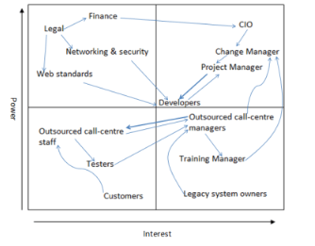
Source: (Allan, 2004)
- Low power low interest includes several stakeholders such as trade union, training manager and call centre etc.
- Low power high interest includes several stakeholders such customers, suppliers, mangers etc.

Project Planning with Milestones
Project panning includes initiation of project goals and objectives, then execution of this project to be successful and conclude project after completing or being failure. (Anon, 2018) Every project has a milestone and project manager should think about the milestone about project. It works like as project goals.
Milestone:
It is the target where a project lifecycle wants to measures its success within time. It is the ultimate gaol of project. It has a single target, start time and end time. There are several parts include in millstone for John Lewis company such as Budgeting project, Time table for project etc. key milestone of that project is to achieve the target successfully. (Smallman, 1999)
In initiation stage, milestone will work as planning and objective of project. In execution stage, milestone will work as organizing the resources to relate with target and after completing the project milestone will achieve.

Budget assumptions
Budgeting is the main part of a project., a project consists of specific time, estimated cost and particular target. So, each project needs several types of budget to achieve the target with successful implementation of cost. (Anon, 2018) John Lewis estimated a budget for development of software for tracking customers and products through online. Each project includes master budget, sales budget, marketing budget etc. A sample budget for that project is showing here:
Stages of project |  | Percentages of overall project | Cost of project (In pounds)
Planning and documentation | Development stage | 3.33% | £15000
Development of software | Development stage | 4.44% | £20000
Hardware | Development stage | 6.66% | £30000
Testing | Development stage | 8.88% | £40000
Project management | Development stage | 6.66% | £30000
Human resources(Internal and external) | Development stage | 3.33% | £15000
Server management | Development stage | 11.11% | £50000
Maintenance | Development stage | 11.11% | £50000
Marketing and sales | Marketing Stage | 44.45% | £200000
 | Total: | 100% | £450000

3) Critically evaluate your ability to manage a project using feedback from others to evaluate your own ability to plan and implement a project, identifying strengths and weaknesses
Managing project needs good quality and must need to take stress. So, evaluation of managing project starts with project initiation. So, each project manager can apply their own decision to manage the project. Before going to manage the project and evaluate how manage project, project manager must have knowledge about project. In project evaluation, there are several factors must take in mind such as risk analysis, communication methods where several parties will communicate to provide feedback, tools and techniques to apply in project to achieve target and planning about project after finding problem in project. As a project manager, I can focus on feedback from colleagues, trainees and others parties including in project like customers, employees and others. (Anon, 2018) Feedback provides a clear understanding to project manager about the project and easily take actions about solving the project. Although several barriers include at the time of seeking feedback from stakeholders. I have to manage the feedback collection and solving the problem in project after providing feedback.
- From functional managers, I can collect feedback about the progress of project. After collecting feedback from them. They provide information about the success or failure rate. They also provide information about how much resources required for project, when this project will complete etc. So, after getting information, I have to concentrate on how to manage resources like human resources, technological resource, strategic tools and financial resource to achieve the success. (Turkulainen et al., 2015)
- Employees provides feedback to project manager. I communicate with them to get information about our project and conduct with them for solving their requirement. They need favourable workplace and in have to provide to implement the project properly.
- As our goal is to develop the software to track customer information and manages inventory, I have to collect information from customers as well after launching it in market and takes maintenance to solve problem.
As a project manager I evaluate the feedback and needs several skills to identify the feedback from colleagues and provide possible outcome to them. So, as a project manager, I am identifying some strengths and weaknesses to solve the problem of feedback:
Strengths of project manager | Weakness of project manager
- Transparency: I can easily communicate with others and can clarify about the gaol of project. Strong knowledge on managing resources help to manage the feedback from others.  - Consistency: As a project manager, consistency is very essential to achieve the target. So, I focus on continuous working with related tools and techniques.  - Flexibility: I have strong ability to change myself with different culture, environment, structure and implement the resources when they need to apply in several sectors in project.  - Communication skills: I have strong ability in communicating with others which help to collect the information from different stakeholders.  - Problem solving: after collecting information, I can take immediate solution of that problem. It helps us to achieve the target of project of developing software for our company.  - Leadership: I have strong ability to lead team and work as a project manager as a leader and solving project problem is easy for me. | Comparison between hard and soft skill: for the high improvement of high skills radically reduces the activities of soft skills. This moves me to reduce the solving immediate problem of feedback.  Easily distracted: Another problem including me to solve the problem of feedback as I easily distracted to show the information and sometimes fail to solve problem (Rothamel, 2005)  Tendency to over analyse: I mostly want to evaluate more and sometimes it goes over and provides irreverent information and can be big reason to fail to solve problem of feedback provided by consumers, functional managers and employees etc.

A self-development plan is the document where a person focuses in the gaols needs to improve and conduct with successful achievement. There are several capabilities need to include inn our skills for easily understand the problem provide by colleagues and solve those problems. After evaluating the strengths and weaknesses, I can focus on the personal development plan which includes several part which will help to develop the won skills and apply in project management. (Gladden, 2015) Each target needs to be Smart which refers to the specific, measurable, attainable, reliable and timely. So, project manager must need to focus on the lacking which needs to improve based on time. So, from this perspective, development of stress taking, computer knowledge etc. are measurable and specific and can be achievable within time. I categorised my goals to improve my skill in three parts based on time such as sort term, long term and medium tem goal and they are showing in a table:
Needs to improve | Types of target | What I have to do? | How to assess? | Time
Stress development | Long term | I have to work more and taking pressure in project. | How properly I can control others. | 2 years
Controlling | Medium | I have to work with employees and participate to provide information | How properly employee are involving in tasks in project | 1 year
Computer | Short-term | Needs training on computer knowledge | Assessed by performance in implementing in project | 6 months
Leadership | Long-term | Neds to work in project | Assed by controlling capability to employees | Require 2 years

Conclusion:
Business needs to focus on successful completion of project if it wants to meets with project goals. From the concept of project manager and characteristics, project management is not easy task for anyone. It needs several qualities like leadership, personality, communication ability, flexibility and managerial capability, project manager works for achieving project target and perfect evaluation of project. So, project management needs a document for fixing the target. Project manager works from the beginning of project planning to completing the project with successfully or not. (Gladden, 2015) Project may fail for particular reasons such as lower quality leadership, imperfect planning and sue of tools. So, project manager needs to develop own skills to get feedback and evaluate those feedbacks to take proper actions. So, self-development plan is the key tool or documents developed by project manager based on time period.

References
Chapman, C. and Ward, S. (2003). Managing Project Risk and Uncertainty. Chichester: John Wiley & Sons.
CLEDEN, D. (2017). MANAGING PROJECT UNCERTAINTY. [Place of publication not identified]: ROUTLEDGE.
Harrin, E. (2013). Managing Project Budgets. Swindon: BCS Learning & Development Limited.
Melton, T. and Iles-Smith, P. (2009). Managing project delivery. Amsterdam: Butterworth-Heinemann.
Westney, R. and Westney, P. (1997). The engineer's cost handbook. New York: Marcel Dekker.
Gladden, R. (2015). Bridging the Business-Project Divide: Techniques for Reconciling Business-as-Usual and Project Cultures. Project Management Journal, 46(5), pp.e1-e1.
Turkulainen, V., Ruuska, I., Brady, T. and Artto, K. (2015). Managing project-to-project and project-to-organization interfaces in programs: Organizational integration in a global operations expansion program. International Journal of Project Management, 33(4), pp.816-827.
Malhotra, Y. (2015). Toward Integrated Enterprise Risk Management, Model Risk Management & Cyber-Finance Risk Management: Bridging Networks, Systems and Controls Frameworks. SSRN Electronic Journal.
Smallman, C. (1999). Knowledge Management as Risk Management: A Need for Open Governance?. Risk Management, 1(4), pp.7-20.
Acharyya, M. and Brady, C. (2014). Designing an Enterprise Risk Management Curriculum for Business Studies: Insights From a Pilot Program. Risk Management and Insurance Review, 17(1), pp.113-136.
Anon, (2018). How to Create a Project Management Plan. [online] Available at: https://www.projectmanager.com/blog/project-management-plan [Accessed 2019].
Anon, (2018). How to Write a Good Project Plan in 10 Steps | Project .... [online] Available at: https://www.teamgantt.com/guide-to-project-management/how-to-plan-a-project [Accessed 2019].
Allan, B. (2004). Project management. London: Facet.
Burke, R. (2010). Fundamentals of project management. Ringwood: Burke.
Anon, (2018). Project Management | 10 Steps to Creating a Project Plan. [online] Available at: https://www.projecttimes.com/articles/10-steps-to-creating-a-project-plan.html [Accessed 2019].
Chemuturi, M. and Cagley, T. (2010). Mastering software project management. Ft. Lauderdale, FL: J. Ross Pub.
Finney, M. (1994). The Stanley book of woodworking. Cincinnati, Ohio: Betterway Books.
Griffiths, A. (2010). CodeIgniter 1.7 professional development. Birmingham, U.K.: Packt Open Source.
Rad, P. and Levin, G. (2006). Project portfolio management tools and techniques. New York, N.Y.: IIL Pub.
Reiss, G. (2013). Project Management Demystified. Hoboken: Taylor and Francis.
Rothamel, S. (2005). The encyclopedia of scrapbooking tools & techniques. New York: Sterling Pub. Co.

