Professional Career Development in Health and Social Care (LCHS 4009)
Component 2: Personal Development Portfolio
Name of Student: KAUSAR PARVEEN SULTAN
Student Number: 2513140……………………………………………………
Module Code and Title: LCHS4009 – Professional Career Development within Health and Social Care
Name of Tutor: Christopher Mafuva……………………………………………………
Assignment Title: Component 2 – Personal Development Portfolio

Artificial Intelligence (AI) Declaration
I confirm that Artificial Intelligence (AI) tools were used only for proofreading and language support during the preparation of this portfolio. AI assistance was limited to checking grammar, spelling, sentence clarity, and improving the overall readability of the document. Every idea, critical reflection, analysis, and academic work are my own. I checked and revised the final submission to make sure that it reflects the personal perception and meets the academic integrity requirements of the University.

Table of Contents
Practical Portfolio 3
Introduction 3
Chosen Job Role and Vacancy 3
Job Vacancy Summary 3
Task 1: Curriculum Vitae 4
Task 2: Personal Statement 6
Task 3a: SWOT Analysis 7
Strengths 8
Weaknesses 8
Opportunities 8
Threats 9
Task 3b: Personal Development Plan (PDP) 9
Goal 1 (0–6 months): Complete the Care Certificate 9
Goal 2 (6–18 months): Build core clinical and communication skills 9
Goal 3 (18–24 months): Progress towards further qualification 9
Task 4: Critical Reflection on Component 1 Presentation Assessment (Gibbs, 1988) 10
Description 10
Feelings 10
Evaluation 10
Analysis 10
Conclusion 11
Action Plan 11
Reference List 11

Practical Portfolio

Introduction
This portfolio has been produced to demonstrate my readiness for employment within the health and social care sector and to plan my ongoing personal and professional development. It brings together a tailored curriculum vitae (CV), a personal statement, a SWOT analysis, a Personal Development Plan (PDP), and a critical reflection on my Component 1 presentation assessment. Together, these documents show my understanding of the skills and knowledge needed to work effectively in health and social care, and set out a realistic, structured plan for how I intend to develop and progress towards my chosen role.

Chosen Job Role and Vacancy
For this portfolio, I have chosen the role of Health Care Assistant (HCA) within an NHS hospital ward. This is a widely available, entry-level clinical support role that involves helping registered nurses with essential patient care, including personal care, basic clinical observations, and supporting a safe and comfortable ward environment (National Careers Service, 2026; Health Careers, 2026). It is a realistic next step for me, building on my transferable experience in staff supervision and customer-facing work, while I continue to build clinical knowledge through my current studies and the Care Certificate.

Job Vacancy Summary
Vacancy: BANK Healthcare Assistant/Support Worker – Specialist Children and Young People's Services (SCYPS)
Employer: East London NHS Foundation Trust
Location: Newham, London
Closing Date: 30 August 2026
Vacancy link: https://beta.jobs.nhs.uk/candidate/jobadvert/C9363-26-0864
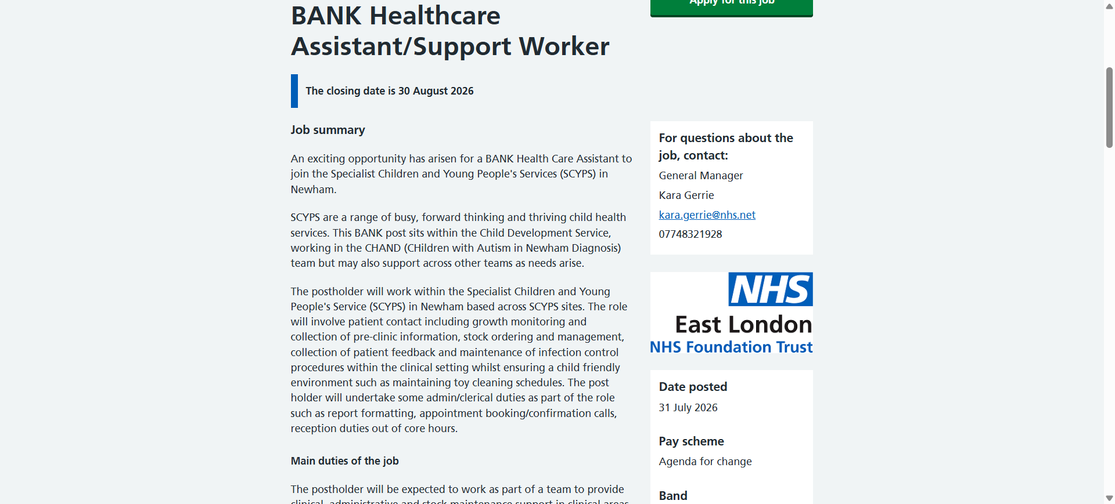
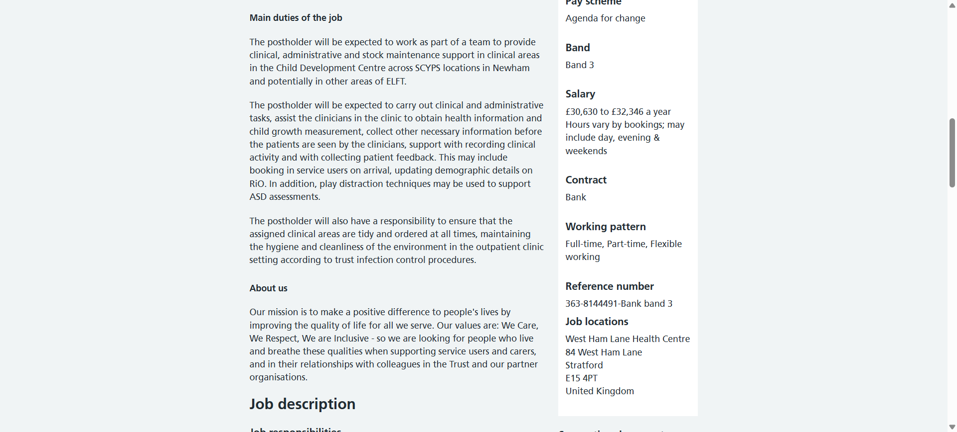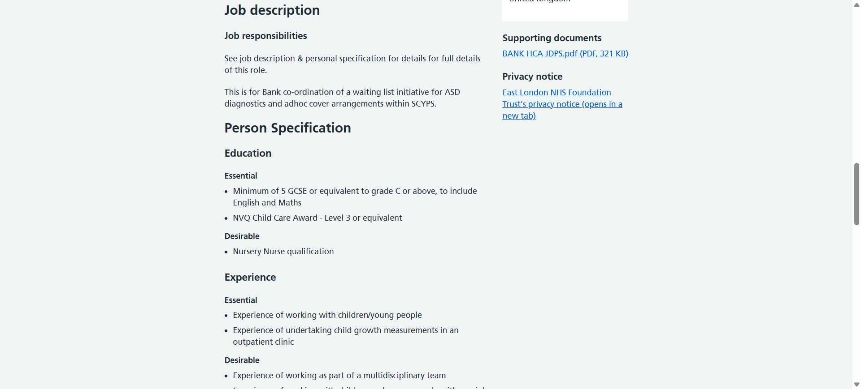

Task 1: C.V
KAUSAR PARVEEN SULTAN
Address: …LONDON………………………………… Phone: …07568911………………………… Email: ……………………………
Personal Profile
A self-driven, diligent and responsible person with a few years of supervisory and front-line experience, pursuing the Certificate of Higher Education Skills in the Workplace (Health and Social Care) at the University of Wales Trinity Saint David. Very flexible, trusted and at ease working individually or in a group. To establish a career as a Health Care Assistant, providing safe, humane, and person-centred care with the aim of taking a step forward based on good people-management and communication skills.
Key Skills
- Supervision and management of staff, rota planning and delegation.
- Effective and understandable communication with individuals with a broad spectrum of backgrounds and needs.
- Good stock, order and resource management with high consideration to detail and precision.
- Dependable, organised and composed.
- Basic IT and Functional Skills ICT competency.
- Flexible and an eager learner, and a personal desire to grow professionally.
Education
2025 – present: University of Wales Trinity Saint David
Studying: Certificate of Higher Education Skills for the Workplace (Health and Social Care)
2018 – 2019: City and Islington College
Studied: English – GCSE
2017 – 2018: City and Islington College
Studied: Mathematics – GCSE
2016 – 2017: City and Islington College
Studied: Maths Skills for Employment – Entry 2
2015 – 2016: City and Islington College
Studied: English – Level 1
2014 – 2015: City and Islington College
Studied: English – Entry 3
2014 – 2015: Oxford, Cambridge and RSA (OCR)
Studied: Functional Skills Qualification in Information and Communication Technology – Entry 3
1990 – 1992: Punjab University
Studied: BA in Sociology
1988 – 1989: Islamabad Model College for Girls
Studied: Higher Secondary School Certificate
1986 – 1987: Viqar-un-Nisa School
Studied: Secondary School Certificate
Employment History
Store Manager — Homix Enterprise Limited (September 2023 – Dec 2024)
- Oversee all day-to-day activities in four stores.
- Arrange and control staff shifts and attendance.
- Stock control, orders, and deliveries.
- Maintain high level of customer service and store appearance.
Customer Assistant — Food World (2010 – 2011)
- Counted and prepared cash for collection
- Operated the till accurately in a busy retail environment
Customer Assistant — Asda (2001 – 2010)
- Being a checkout operator, being able to count money and deal with clients in a polite way.
- Worked in various departments such as clothing, the kiosk, and petrol station.
- Design and sold special occasion displays, such as Mother Day and Father Day.
Hobbies and Interests
Cooking, and travelling — both of which I enjoy sharing with family and which have helped me build patience, planning skills, and an interest in other people's cultures and routines.
References
References available on request.

Task 2: Personal Statement
I am seeking employment as Health Care Assistant because it is the logical next step towards pursuing a long-term career in health and social care. I am pursuing the Certificate of Higher Education Skills for the Workplace (Health and Social Care) at the University of Wales Trinity Saint David, which I have selected to equip myself both academically and practically to work in a caring profession. In addition to this, I have also undertaken a variety of qualifications in English, Mathematics, and Functional Skills, which have demonstrated my personal desire to continually better myself and engage in lifelong learning.
My most appropriate experience is my present position as a Store Manager in Homix Enterprise Limited where I have a day to day running of four stores, staff rotas, attendance, stock control, orders and deliveries. Though this is a retail environment, the skills acquired are very effective in care work. I also oversee and mentor a team and this has taught me to be clear, fair in delegating tasks and calm and organised when the pressure is on. I am accustomed to assuming responsibility over the wellbeing of my people and making sound and timely decisions with limited information, the key aspects of safe, person-centred care (Care Quality Commission, 2024).
Previously in my career, I served as a Customer Assistant at Asda and Food World, and I had a long-term, first-hand experience of interaction with people. This involved dealing with delicate cases in a patient and polite manner, doing my calculations correctly with money and documentation and adjusting my style to the needs of the human being I was dealing with. I think these are the same attributes that support good care practice: treating each person with dignity, respect, and individual attention (Skills for Care, 2025).
I understand that I am yet to gain direct clinical experience, and I am taking this initiative. My theoretical knowledge of health and social care values, safeguarding, and professional communication is still developing through my current studies, and I will complete the Care Certificate, the most popular induction standard of all new health and social care support workers, as soon as I start working as an HCA post (Health Careers, 2026).
I am an independent, reliable, and very flexible individual who has been able to work effectively in a group and on my own. I feel at ease operating in a variety of settings and adapting to new habits rather fast, which I suppose will make me adapt to a hectic ward atmosphere. English is another language that I use, and with proper studies I have developed my written and oral communication skills significantly; I consider this to be a sign of strength and will and not an obstacle to the job.
Overall, I can provide a sincere long-term career commitment to a career in care, multiple years of responsibility, supervision, and customer service experience, and a realistic and organized roadmap to develop the clinical knowledge that I am yet to acquire. I would be pleased to contribute these attributes, and my will to actual change in the lives of patients, to your organisation.

Task 3a: SWOT Analysis
The SWOT analysis below outlines my own strengths, weaknesses, opportunities and threats as far as the position of a Health Care Assistant is concerned. It is based on reflective prompt questions that were discussed in the workshop of this module (such as thinking about my positive qualities and accomplishments as Strengths, and the things that hold me back as Weaknesses) and incorporates SWOT as a systematic self-assessment and planning instrument more generally (Chartered Institute of Personnel and Development, 2026).

Strengths
- Several years’ experience in supervision and staff-management as a Store Manager such as rota planning, delegation, and team responsibility - can be directly applied to working in a ward team with a nurse supervising the work.
- Good, prolonged direct customer-facing work (Asda, Food World), showing patience, politeness and composure with individuals representing a diverse group of backgrounds and needs.
- Reliability and self-motivation: has consistently worked full-time and studied continuously over several years.
- A dynamic history of advancing my English language as well as Functional Skills qualifications credentials, indicating persistence and endurance to deal with difficulties.

Weaknesses
- None of the clinical or care-setting experience so far, and thus little first-hand experience of the routine of the ward, moving and handling, or simple clinical observations.
- The Care Certificate, the acknowledged level minimum standard of new health and social care support workers, is not completed yet (Health Careers, 2026).
- As English is an additional language for me, I sometimes need more time to build confidence with clinical terminology and fast-paced verbal handovers.

Opportunities
- Health Care Assistant jobs are highly promoted, entry-level, and specially tailored to career-changers who do not have prior clinical experience, as long as they can exhibit the appropriate values (National Careers Service, 2026).
- Employers offer systematic induction with the Care Certificate and well-defined career paths, such as to Senior Healthcare Assistant, Assistant Practitioner, or Nursing Associate (Health Careers, 2026).
- My present course gives me an academic basis in professional practice, safeguarding and reflective learning, which I can enhance after going in post.

Threats
- Popular HCA vacancies may be competitive, especially the ones in the hospitals nearby my residence.
- Working full-time, family life, and additional study or training might strain my time in my first year in post.
- Pre-employment checks, e.g., an enhanced DBS check and occupational health clearance, can increase the interval between a job offer and a real start date.

Task 3b: Personal Development Plan (PDP)
Based on the above SWOT analysis, I have come up with three distinct and realistic objectives to assist me in equipping and developing in the position of a Health Care Assistant in the next 2 years.

Goal 1 (0–6 months): Complete the Care Certificate
After being assigned to a post of a Health Care Assistant, I will undertake all the standards of the Care Certificate during my probationary period since this is the accepted induction scheme of new health and social care support workers (Skills for Care, 2025). I will keep track of my progress by my Care Certificate workbook and with my employer, by having a one-to-one meeting with my assessor or mentor named in the workbook, and discussing which standards I need to achieve at each meeting.

Goal 2 (6–18 months): Build core clinical and communication skills
I will work on being confident with the simplest clinical observations (e.g., temperature, pulse, blood pressure), proper documentation, and communicating effectively and confidently with the rest of the ward team, such as registered nurses and doctors. I will keep track of this using competency sign-off documents in my ward and requesting my mentor to provide me with structured feedback after every three months and maintaining a short reflective journal of situations I have successfully managed and situations I wish to improve.

Goal 3 (18–24 months): Progress towards further qualification
I will explore pursuing a Level 3 Diploma in Health and Social Care or considering the Nursing Associate apprenticeship pathway, as an extension of my Certificate of Higher Education, to be able to further advance my career and have additional responsibility (Health Careers, 2026). I will keep this by evaluating my progress on these courses based on the entry requirements of the courses within six months and negotiating the options with my manager during my annual appraisal.

Task 4: Critical Reflection on Component 1 Presentation Assessment (Gibbs, 1988)

Description
In my assessment of Component 1, I presented on Critical Thinking as one of the essential skills in health and social care practice. I defined critical thinking, applied the framework provided by Paul and Elder (2019) to make myself think critically, and put it into practice in a situation where an elderly patient in a hospital ward became increasingly confused, and colleagues just accepted this confusion as a natural consequence of old age, whereas it may be an underlying infection or pain. I ended by connecting critical thinking to my own future practice and safe, person-centred practice.

Feelings
My anxiety before the presentation was that this was the first formally-assessed presentation I did on the course and I am also an additional language learner, so I was especially worried about my pace and pronunciation. As soon as I had my practical example, I felt more confident, as I was well informed about the material and could clearly see how it applied to a real care situation. Then I experienced a feeling of relief and also pride, coupled with some lingering concern over how well I had clearly conveyed my points.

Evaluation
Reflectively, there were a number of things that went well. I organized my presentation in a logical manner, starting with the definition, then the importance, then a named model, then a worked practical example, and subsequently my own career development, providing a clear, complete argument. My case of the confused patient was concrete and realistic and directly demonstrated how the Paul and Elder framework alters the decision-making of a care worker in practice.
Despite the general positive feedback, my lecturer also noted the following areas that need improvement: speaking too fast, using my notes extensively, and using minimal eye contact with the audience. This feedback is relevant since in health and social care good communication is crucial. Talking in a good pace is one of the ways to make sure that information is received correctly and the eye contact is a sign of confidence, professionalism and active participation in communication with others. Considering these remarks has made me realise that enhancing my presentation style is as important as good subject knowledge because they both play a role in conveying information in an efficient and clear manner.

Analysis
According to the Code (2018) of the Nursing and Midwifery Council, professionals should take action to detect and reduce the risks to patients, which is exactly what my selected example demonstrated: without the appropriate critical thinking, a curable condition might have been overlooked. The clarity of the idea in question is important, as in a real ward a hasty or incoherent transfer of the same information itself may be what causes a patient to become confused and dismissed in an incorrect manner. The use of notes might be partially due to nervousness about speaking in a second language when I am being assessed, which is a normal and understandable obstacle, but which may not be as likely to affect me when I am already confidently explaining common, real-life situations to colleagues and not making a formal academic presentation.

Conclusion
All in all, I was able to understand that I have a good understanding of the theory and can use it to convincingly apply it to real-life care situations, which will be beneficial in my future practice. Nevertheless, I also got to know that good content alone is not sufficient, the level of confidence and clarity with which I present it also influences the level of the reception of my message, which is equally applicable to delivering a handover to a nurse on a busy ward as it is to an academic presentation.

Action Plan
In the future, I will rehearse speaking aloud and, when feasible, record myself to be able to objectively look at my pace and eye contact. I will refer to the support services of the university on presentation skills of students with English as an additional language, and I will also seek to receive systematic feedback on the same with my lecturer at an earlier stage in preparing my next assessment, not just at the delivery stage. I will also seek the chance in my course, including group discussions, to speak out loud about care situations, as fluency and confidence are more naturalized before I start working directly with patients.

References
Care Quality Commission (2024) The fundamental standards. Available at: https://www.cqc.org.uk/about-us/fundamental-standards (Accessed: 3 August 2026).
Chartered Institute of Personnel and Development (2026) SWOT analysis factsheet. Available at: https://www.cipd.org/en/knowledge/factsheets/swot-analysis-factsheet/ (Accessed: 3 August 2026).
East London NHS Foundation Trust (2026) BANK Healthcare Assistant/Support Worker – Specialist Children and Young People's Services (Job advert C9363-26-0864). Available at: https://beta.jobs.nhs.uk/candidate/jobadvert/C9363-26-0864 (Accessed: 3 August 2026).
Gibbs, G. (1988) Learning by doing: A guide to teaching and learning methods. Oxford: Further Education Unit, Oxford Polytechnic. Cited in University of Edinburgh (2026) Gibbs’ reflective cycle. Available at: https://reflection.ed.ac.uk/reflectors-toolkit/reflecting-on-experience/gibbs-reflective-cycle (Accessed: 3 August 2026).
Health Careers (2026) Healthcare assistant. Available at: https://www.healthcareers.nhs.uk/explore-roles/healthcare-support-worker/roles-healthcare-support-worker/healthcare-assistant (Accessed: 3 August 2026).
National Careers Service (2026) Healthcare assistant. Available at: https://nationalcareers.service.gov.uk/job-profiles/healthcare-assistant (Accessed: 3 August 2026).
Nursing and Midwifery Council (2018) The Code: Professional standards of practice and behaviour for nurses, midwives and nursing associates. London: Nursing and Midwifery Council. Available at: https://www.nmc.org.uk/ (Accessed: 3 August 2026).
Paul, R. and Elder, L. (2019) The miniature guide to critical thinking concepts and tools. 8th edn. Lanham, MD: Rowman & Littlefield.
Skills for Care (2025) Care Certificate standards. Available at: https://www.skillsforcare.org.uk/Developing-your-workforce/Care-Certificate/Care-Certificate-standards.aspx (Accessed: 3 August 2026).

