

Programme: MSc Public Health and Social Care in Practice

Module: Population Health and Digital Health Promotion

Component 1: Blog

Lecturer Name: Dr ping Wu

Student ID: 2430822
Student Name: Muskan Lalani

BLOG 1: The Impact of Freestyle Libre on Type 2 Diabetes Management

Addressing the Public Health Problem
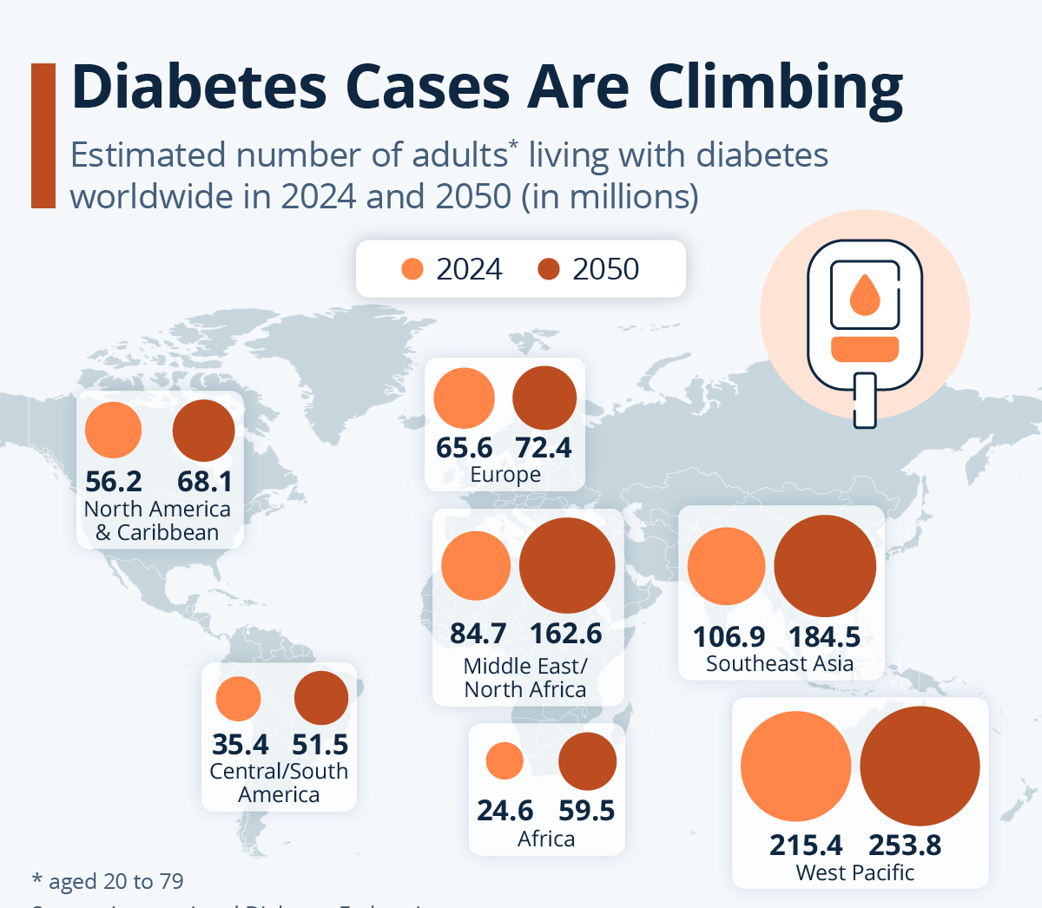
The global prevalence of Type 2 Diabetes continues to rise
(Source: Statista, 2025)
Diabetes type 2 (T2D) is one of the most relevant universal health issues, with a current number of estimated 537 million adults having the disease, and the number is expected to increase dramatically by 2030. A significant cause of serious complications, such as cardiovascular disease, loss of vision, kidney failure, neuropathy, and predisposition to premature mortality, is poor glycaemic control. Finger-prick glucose monitoring tends to be poorly adhered to traditionally, which leads to the lack of real-time data and engagement of a patient, making it hard to control the level of blood glucose. This gap indicates that more accessible, accurate and patient-centred digital monitoring solutions should be available.

How Freestyle Libre Supports Health Promotion
The Freestyle Libre Continuous Glucose Monitoring (CGM) System is a proven digital health technology, which is used to help improve diabetes self-management by substituting periodic finger-prick testing with a more comfortable and data-driven method. With a small sensor attached to the upper arm and a corresponding mobile application, the user can scan at any time to be provided with real-time glucose levels. Trend arrows, glucose variability data and historical trends are also available in the system, by allowing individuals to learn about the impacts of their lifestyle behaviours on their glucose levels, including diet, exercise, stress and timing of medication. This has a positive effect of facilitating better informed decision-making and healthier self-management practices, as it this continuous feedback.

Evidence of Effectiveness
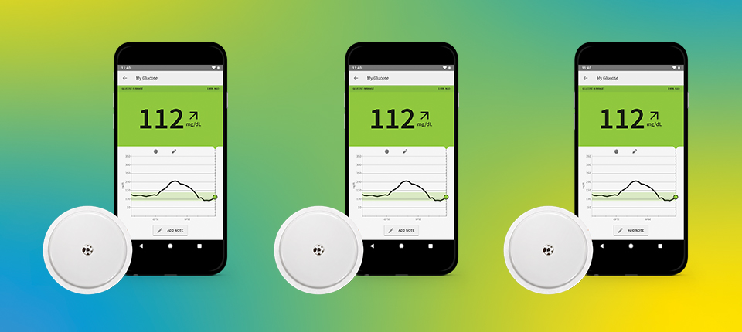
Freestyle Libre app showing glucose trends
(Source: Abbott, 2019)
Freestyle Libre is shown to have a great cost-to-utility analysis by Robles-Plaza et al. (2025) as it provides better glycaemic results in poorly controlled adults with T2D treated with basal insulin. The researchers discovered a better quality-adjusted life years (QALYs) and decreased long-term complications that were the result of increased frequency of glucose monitoring and behavioural responsiveness.
Equally, Ampudia-Blasco et al. (2025) also found that the system is cost-effective, which minimises utilisation of healthcare, hypoglycaemic events and related hospitalisations. They find Freestyle Libre to be a digitally based health intervention economically viable for diabetes management.

Critical Impact: Advantages and Shortfalls
Advantages
- Feedback in real-time promotes healthier living.
- Better compliance than the finger-prick techniques.
- Better behavioural understanding and accuracy through trend tracking.
- Cost savings were demonstrated in the case of the Spanish population
Shortfalls
- Low-income patients still face cost barriers.
- Digital inequality: needs a smartphone and digital literacy.
- Information security issues of the uninterrupted transmission of health data.
- Not all insurance schemes are comprehensive.

Addressing Shortfalls
Affordability can be promoted with subsidies, compatibility enhanced with low-cost devices, and privacy enhanced to promote equitable adoption considerably. Also, culturally-adapted education modules can be integrated to help users with poor health literacy.

References
Robles-Plaza, M., Gómez-Peralta, F., Bellido, V., Ampudia-Blasco, F.J., Carretero-Gómez, J., Cebrián-Cuenca, A.M., de la Cuadra-Grande, A. and Mezquita-Raya, P., 2025. Cost–Utility Analysis of FreeStyle Libre Systems in People with Type 2 Diabetes Mellitus on Treatment with Basal Insulin and Poor Glycemic Control in Spain. Diabetes Therapy, pp.1-20. https://link.springer.com/article/10.1007/s13300-025-01816-6
Ampudia-Blasco, F.J., de la Cuadra-Grande, A., Bellido, V., Cebrián-Cuenca, A.M., Mezquita-Raya, P., Carretero-Gómez, J., Hernández Martínez, A.M., Oyagüez, I. and Gómez-Peralta, F., 2025. Cost Analysis of the FreeStyle Libre Systems in People with Type 2 Diabetes Mellitus on Basal Insulin with Poor Glycemic Control: A Spanish Perspective. Diabetes Technology & Therapeutics. https://www.liebertpub.com/doi/abs/10.1177/15209156251363576
Statista, 2025. Diabetes Cases Are Climbing. https://www.statista.com/chart/23491/share-of-adults-with-diabetes-world-region/?srsltid=AfmBOooc4CWloB506FSQwlcZZQ-KHOehTWxedWwly-pZsScQcxLzRxn2
Abbott, 2019. Android™ APP Joins FreeStyle Libre Family. https://www.abbott.com/corpnewsroom/diabetes-care/android-app-joins-freestyle-libre-family.html

BLOG 2: GlucoGuide+ – An AI-Driven Personalised Diabetes Self-Management App

Public Health Problem
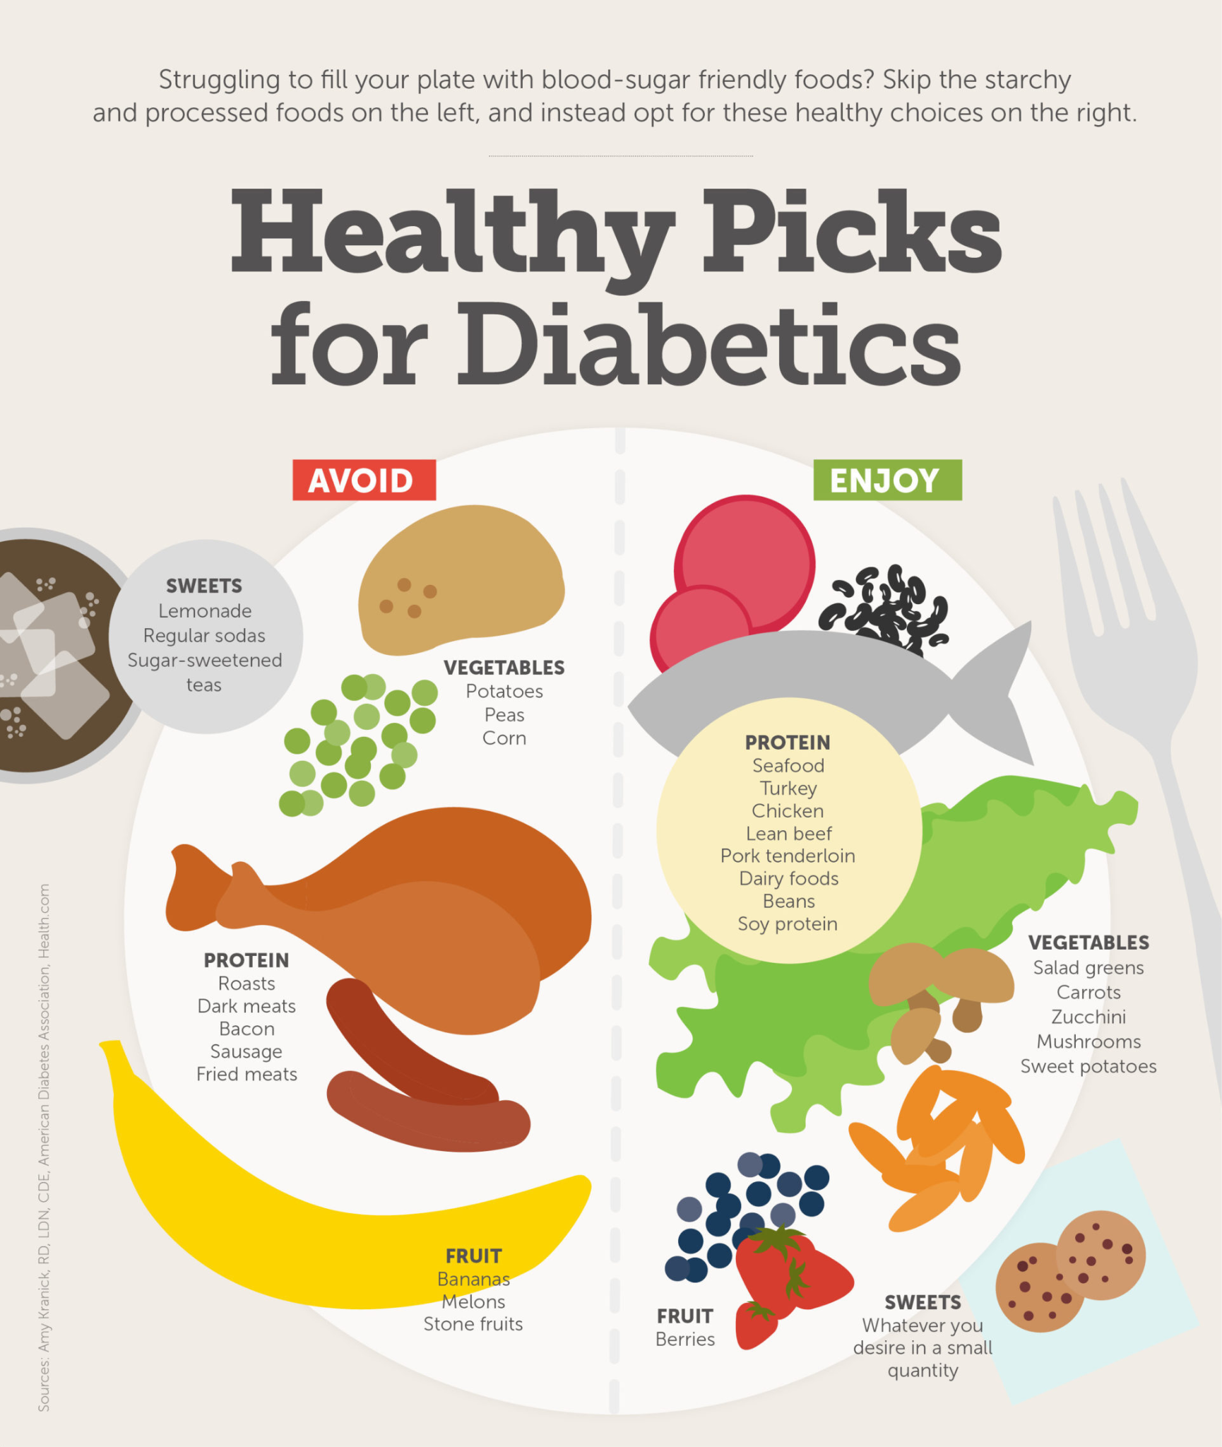
Personalised nutrition is increasingly central to diabetes control
(Source: Vanderbilt Health, 2016)
Type 2 Diabetes is an escalating menace in the world, and its rates are increasing at an alarming rate because of the rising trends of obesity, poor eating habits, and sedentary patterns. To ensure that they can avoid complications, self-management is necessary, but not everyone can comprehend their nutritional requirements or decipher their glycaemic trends. It results in unpredictable food consumption, deficient glycaemic regulation, and increased health outcomes in the long term. Digital health innovations have, in turn, responded to this challenge by providing personalised, data-driven interventions to care. These technologies deliver real-time insights and prescriptive guidance, and behavioural support to enable one to make informed decisions and enhance their daily diabetes management.

Description of the Designed Technology: GlucoGuide+
GlucoGuide+ is a proposed AI-based mobile application that is intended to cover the shortcomings of existing technologies in the field of diabetes self-management. Key features include:
- Real-time diet and glucose data-driven AI-based personalised nutrition. Behaviour-based predictive glucose modelling.
- Ethnic food suggestions for various groups.
- Voice-based coaching of low-literacy users.
- Wearable Interaction with CGM and smart watches.

How GlucoGuide+ Promotes Health
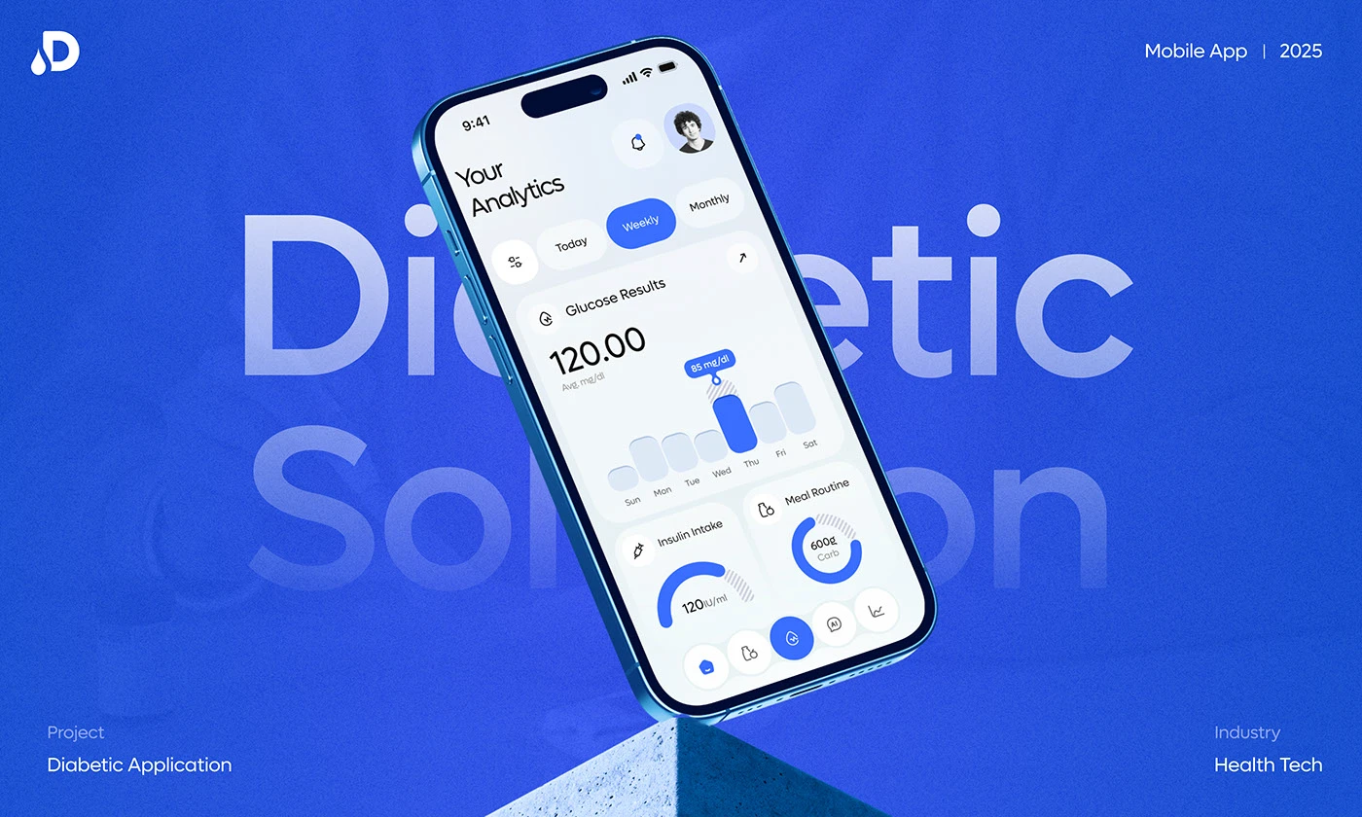
Conceptual interface for an AI-based diabetes management app
(Source: Behance, 2025)
The application offers custom comments, meal ratings, and behavioural reminders, depending on the glucose information of a user. The tool promotes healthier eating habits by incorporating AI suggestions and learning prompts. The choice of the design coincides with the results of Arshad et al. (2025), who emphasise that individualised nutrition with the help of digital health technologies can significantly increase the results in diabetes and obesity. Moreover, Muthineni (2025) also highlights that AI within mobile health applications changes how chronic diseases are managed by providing real-time analytics, adaptive coaching and user-specific interventions, which are also a part of GlucoGuide+.

Critical Impact: Advantages and Shortfalls
Advantages
- Massively customised care, enhancing user interaction.
- Predictive modelling assists users in the prediction of glucose changes.
- Culturally sensitive nutrition instructions.
- The features of accessibility (voice coaching, simple UI).
Shortfalls
- Expensive training of AI.
- Possible algorithm bias on nutrition and glucose prognosis.
- Integration with wearables is a risk to data security.
- Dependence of digital solutions on the user.

Addressing Shortfalls
In order to improve reliability and equity, the developments that can be made in the future involve the ability to incorporate various datasets to train AI, robust encryption systems, and the ability to work offline in low-connectivity areas. Clinical oversight and trust can be facilitated through a partnership with healthcare providers.

References
Arshad, M.T., Ali, M.K.M., Maqsood, S., Ikram, A., Ahmed, F., Aljameel, A.I., AL‐Farga, A. and Hossain, M.S., 2025. Personalized nutrition in the era of digital health: A new frontier for managing diabetes and obesity. Food Science & Nutrition, 13(10), p.e71006. https://onlinelibrary.wiley.com/doi/abs/10.1002/fsn3.71006
Muthineni, S.R., 2025. AI in Mobile Health Apps: Transforming Chronic Disease Management. https://www.researchgate.net/profile/Sridhar-Rao-Muthineni/publication/392627396_AI_in_Mobile_Health_Apps_Transforming_Chronic_Disease_Management/links/684b42c5e7be56124ab60894/AI-in-Mobile-Health-Apps-Transforming-Chronic-Disease-Management.pdf
Vanderbilthealth, 2016. Here’s what to eat and what not to eat when you have diabetes. https://my.vanderbilthealth.com/diabetes-diet/
Behance, 2025. Diafit | AI Powered Diabetic App | UI UX | Potential. https://www.behance.net/gallery/225245257/Diafit-AI-Powered-Diabetic-App-UI-UX-Potential

