
UNIVERSITY OF WALES TRINITY ST DAVID
ACBA5019
CONSTRUCTION TECHNOLOGY 2
STUDENT ACCOMODATION SWANSEA
By
LIAM MILES
2318509

15/01/2025
(2453 Words)

Contents

1.0 Introduction 3
2.0 Site Conditions & History 4
2.1 History 4
2.2 Importance of History 4
2.3 Borehole Logs (See Appendix) 5
3.0 Foundation Choice 5
4.0 Structural Frame 7
5.0 Proposed Building Summary 8
5.1 Proposed Site Location Plan 9
5.1.1 Key Features 9
5.2 Proposed 3D Aerial View 10
5.2.1 Key Features 10
6.0 Building Envelope 11
6.1 External Walls 11
6.2 Windows & Glazing 13
6.3 Roofing System 13
7.0 Conclusion 15
8.0 References 16
9.0 Appendices 18
9.1 Appendix A- Record of Trial Bores Prince of Wales Dock Swansea (BGS, 1880) 18
9.2 Appendix B- CISM Borehole Log (AECOM, 2019) 19
9.3 Appendix C- Proposed Site Location Plan 26
9.4 Appendix D- Proposed 3D Aerial View 27

Figures List

Figure 1- SA1 Proposed Plot of Land (Point A) 4

Figure 2- Swansea Harbour in 1852 (Swansea Docks, 1852) 5

Figure 3- Swansea University Bay Campus Opened in 2015 (Glancy Nicholls, n.d.) 7

Figure 4- Precast Concrete Wall Sections Swansea University (GPS, 2021) 8

Figure 5- UWTSD IQ Building (Google, 2023) 13

Figure 6- Aluminium Rainscreen Cladding at The Foundry Leeds Student Accommodation Opened in 2017 (Ashcourt, 2018) 13

Figure 7- The British Horse Society Headquarters (Sky Garden, 2010) 15

1.0 Introduction
This report presents the design for a medium-to-high rise student accommodation building on the provided SA1 site located in Figure 1. The design aims to integrate functionality, safety, sustainability, and modern architectural aesthetics based on the expected site conditions. It also incorporates additional student facilities to enhance the living experience, aiming to improve their experience and create a positive student community. The report will be broken down into the following key areas to provide a comprehensive accommodation building. Firstly, addressing the site conditions including nearby methods, past borehole logs and climate conditions. Then a proposed building with foundation methods, structural frame, and building envelope will be recommended. Consideration will be given to the methods on site, including prefabrication and methods to improve efficiency considering factors such as stability, fire safety, environmental, and sustainability.
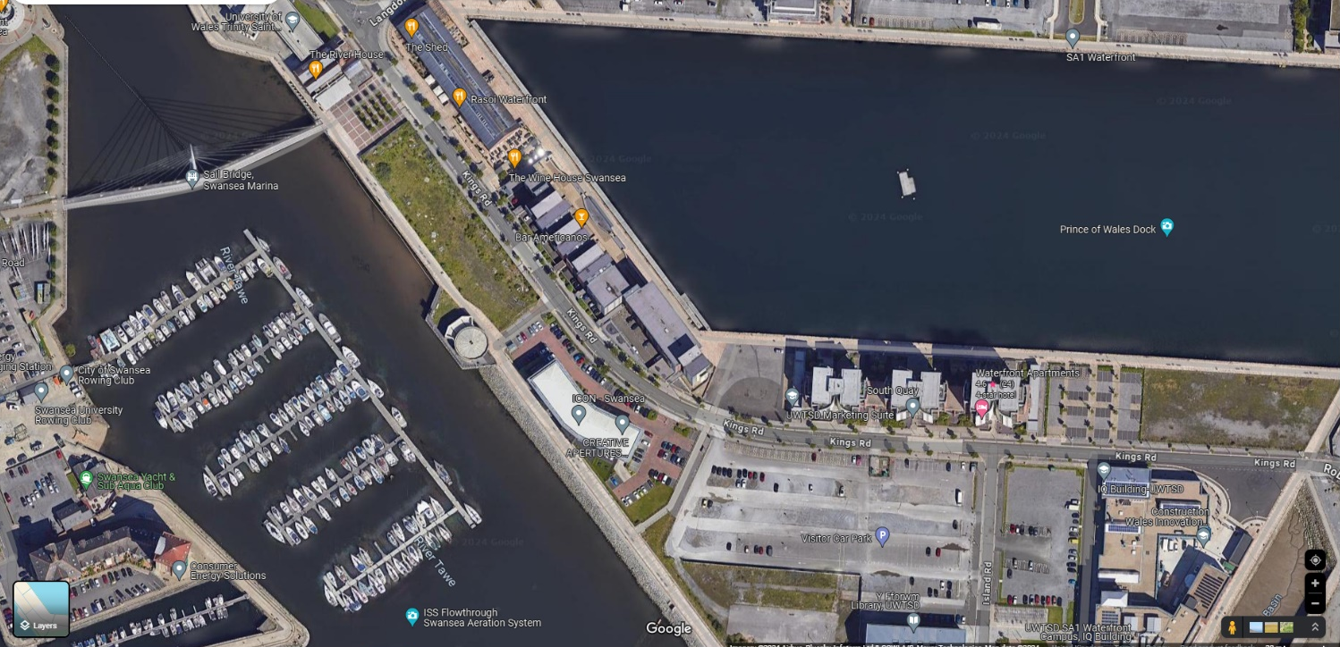
A
Figure 1- SA1 Proposed Plot of Land (Point A)

2.0 Site Conditions & History

2.1 History
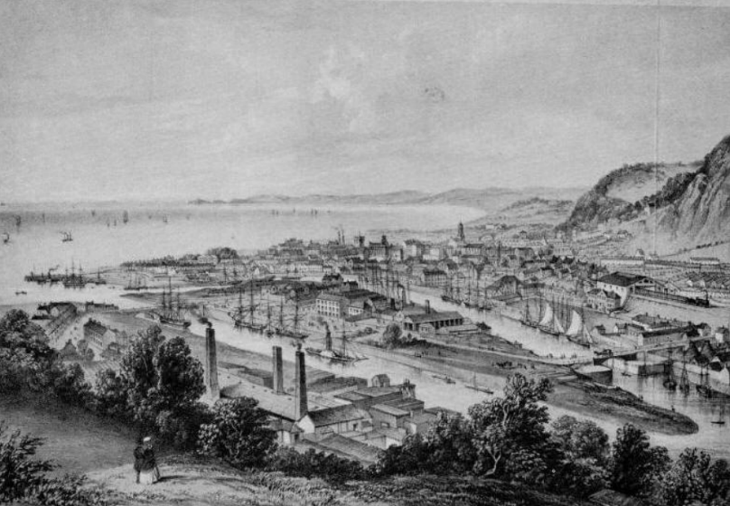
Deep consideration must be given to the current and historical site conditions of the proposed plot in order to develop a suitable plan. Dating all the way back to the 1700s, Swansea was widely famous for its maritime trade and industrial activities. Swansea became the ‘Copperopolis’ in the 1800s and the docks were constructed and expanded to support the cities activities. However, during the 1940s, Swansea was hit massively in the WWII. Since then, there has been heavy industry reductions and the docks have been revolutionised for education, healthcare, housing, offices and other types of projects (Swansea Museum, n.d.).
Figure 2- Swansea Harbour in 1852 (Swansea Docks, 1852)

2.2 Importance of History
This historical information has a vital role in all aspects of the building choice in order to meet the demands of the ground conditions, climate considerations, and coastal considerations. Due to the nature of the WWII and past history there are significant risks to the site such as contamination, potential of unexploded bombs and high ground water table.

2.3 Borehole Logs (See Appendix)
Although no borehole logs have been found on the direct site, assumptions of the expected ground conditions can be made based on nearby borehole logs. Two nearby borehole logs have been found with similar results which confirm the likelihood of poor ground conditions and potential contamination. Appendix A is a trial bore log from 1880 on the Prince of Wales Dock, so it must be noted that the site will have substantial changes since then. Appendix B is a report from AECOM in 2019 for the recently constructed CISM building at Swansea Bay University, although this a further distance from the site, ground conditions are assumed to be similar. Both borehole logs indicate poor soil conditions near the surface, indicating presence of loose/very soft sand or silts. Appendix B indicates a number of strikes of water levels at medium depths. Extremely weak mudstone is expected at depths greater than 20 metres.

3.0 Foundation Choice
These presented borehole logs used within the surrounding area indicate a high possibility of poor ground conditions including sandy/silty top surfaces, weak deeper surfaces and high ground water level. These factors combined will require a piling foundation. To understand the full scope of the required foundations, a full ground investigation survey would be recommended to confirm the anticipated site conditions. Piling foundations are inserted into the ground to transfer the load of a structure onto a lower level of subsoil (Chudley, 2010). This is much needed for the structural stability and load bearing capacity of a building this magnitude. Once a ground investigation report is completed, the appropriate type of piling can be selected, this may include bored piles, end bearing piles and driven piles depending upon the strength, type and depth of the layers of subsoil found upon the site in order to distribute the load adequately.
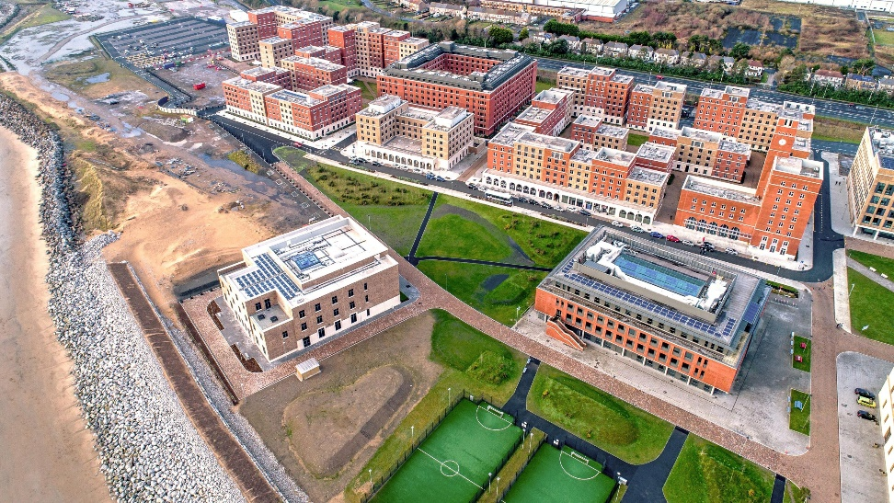
In addition, nearby projects used the same method and have had success with their design. The key example is the Swansea Bay University campus which features student accommodation with piling chosen as the foundation choice. A key consideration when using piling however is the noise and impact to nearby surroundings. Especially, in this plot with the proximity to the University, Bars/Restaurants, and Offices, close conversations with key stakeholders and raising awareness early will be important to minimise disruption.
Figure 3- Swansea University Bay Campus Opened in 2015 (Glancy Nicholls, n.d.)

4.0 Structural Frame
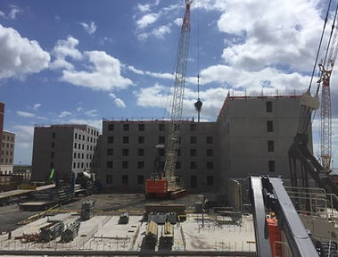
The proposed building will include a reinforced concrete frame. The proposed 10 storey student accommodation will utilise this building frame to maximise the sheer load bearing capacity, including resistance to wind loading, a big concern in the area with the proximity to the coast. To maximise strength, the design will include shear walls, and cross bracings to increase lateral and seismic force resistance. Combining concrete with steel gives a great advantage to the structural stability, as the compressive strength of concrete complements the tensile strength of steel, to provide a strong structure (Ashish, 2018). Concrete is fire resistant, with increasing concerns in the UK regarding fire safety, concrete can be used a strong base as it maintains its structural integrity in fires. Additionally, concrete is a highly durable material, it has great resistance to humidity, moisture, and corrosive conditions e.g. salt in coastal conditions (Civil Engineering, n.d). As used in the Swansea Bay campus to great benefit; to speed the construction of the building, this frame will be supported by precast concrete wall sections where they can be manufactured off-site, ensuring maximised quality control and allowing for faster construction on site, saving time and labour costs.
Figure 4- Precast Concrete Wall Sections Swansea University (GPS, 2021)

5.0 Proposed Building Summary
As described, the proposed medium-to-high rise student accommodation building combines architectural, environmental, and functional considerations to align with modern construction practices and regulations to maximise the student experience. In the following sections, key sketches have been produced and will be displayed to highlight the key recommendations and advantages of the building. Some of the key features include:
- Height & Layout- The proposed plot of land is approximately 3350m2, spanning 112 metres in length by 30 metres in width (DigiMaps, 2025) The building will include 10 stories, approximately 3 metres per storey (total height= 30 metres). These will include student rooms, shared facilities, a cinema room, games room and a rooftop recreational space to add to the student experience.
- Sustainability- A green roof system, solar panels, and landscaping to ensure energy efficiency, rainwater management and a commitment to achieving BREEAM excellence.
- Integration with the Community- The building will blend into its modern surroundings, including nearby offices, restaurants and University facilities.
- Safety & Comfort- Piled foundations, reinforced concrete, and durable cladding materials with appropriate insulation and cavity barriers will ensure compliance with fire safety and energy efficiency regulations.

5.1 Proposed Site Location Plan
Please refer to Appendix C for the full-sized sketch. The Proposed Site Location Plan illustrates the organization of the proposed building in relation to the nearby surroundings.

5.1.1 Key Features
- Building Placement- The student accommodation is centrally located on the plot of land to allow for efficient use of surrounding space including landscaping and parking.
- Accessibility- Direct access is provided via Kings Road, which has close links to the Fabian Way and subsequently the M4 within a short 10–15 minute drive.
- Surrounding Buildings- The building is adjacent to The Docks, Icon Research Centre, and directly opposite several bars & restaurants.
- Landscaping and Raingardens- Raingardens and landscaping strips have been incorporated adjacent to the site to enhance biodiversity, stormwater and to help achieve compliance with Sustainable Drainage Systems (SuDs) for surface water which came into act in 2019 (Welsh Water, 2019).
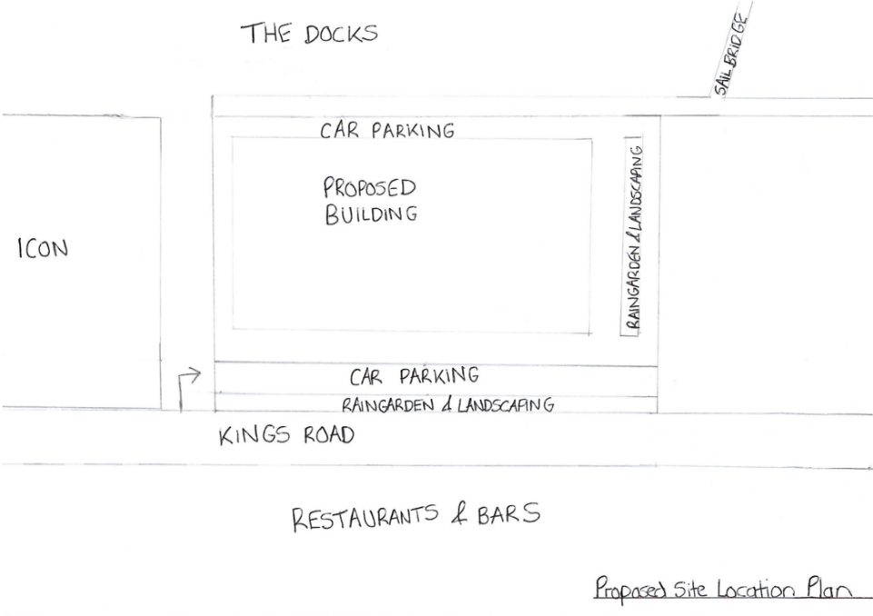
- Parking- Car parking spaces have been incorporated to the north and south of the plot, approximately aiming to achieve 80 spaces in total.

5.2 Proposed 3D Aerial View
Please refer to Appendix D for the full-sized sketch. Please note that the sketch is not drawn to scale. The Proposed 3D Aerial View represents the building’s architectural and functional features, providing a clearer view of the building’s design and intentions.

5.2.1 Key Features
- Design
  - The building is predominantly clad in aluminium rainscreen cladding.
  - Double-glazed windows and curtain walling.
  - Flat green roof system with necessary planting and landscaping
  - Solar Panels installed on the roof to generate renewable energy.
  - Rooftop recreational space available for the students
- HVAC Systems and M&E
  - Rooftop mechanical systems, including ventilation units, HVAC equipment, and air source heat pumps.
  - These systems are screened to minimize visual impact and improve safety with some of the roof available for use to students as a recreational space.
- Surrounding Features
  - The 3D view showcases the discussed raingardens and landscaped areas.
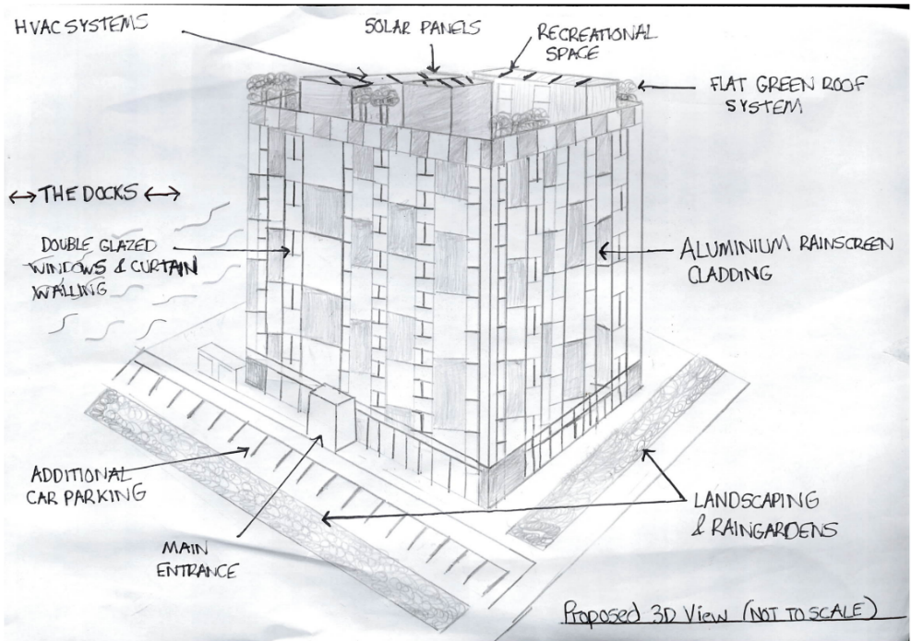
  - Parking and pedestrian pathways are designed to improve accessibility.

6.0 Building Envelope
The building envelope is a critical aspect to the design of the building, to achieve the upmost energy efficiency, structural support, weatherproofing and aesthetic appeal whilst also meeting UK building regulations and sustainability aims. This section will analyse the key elements of the building envelope which have been proposed including the external walls, roofing, glazing, insulation and cladding aiming to meet and achieve new UK standards, including The Building Establishment Environmental Assessment Method (BREEAM).

6.1 External Walls
As previously discussed in section 4.0, external walls will be made of precast concrete panels aiding the thermal mass, fire resistance and durability of the structure. The precast concrete panels will be designed as sandwich panels, including rigid mineral wool insulation between two layers of concrete. This external wall make up includes both great fire properties and thermal properties complying with both part B (fire safety) and part L (energy efficiency and heat loss) of the UK building regulations with a fantastic U-value of 0.18 W/m2K (O’Reilly Precast, n.d). Over the precast concrete panels, predominantly the building will feature aluminium rainscreen cladding to enhance the aesthetic appeal, durability, and weatherproofing. This cladding method is specifically suitable for this type of environment with its resistance to corrosion. It is low maintenance and with its long lifespan the aesthetic appeal will last for many years, unlike many types of degrading brickwork buildings in the nearby area. Figure 5, displays the current state of the UWTSD IQ building, highlighting the considerable poor conditions of the brickwork despite officially opening in only 2018. Comparing this to Figure 6, a student accommodation built in Leeds in 2017, the difference in the sustainability of the aesthetic performance is clear. It is important to note that the insulation and relevant cavity barrier system installed behind the cladding must be selected and installed properly to conform to part B of the Building Regulations. The cladding should be properly tested and adhere to the requirements set out in BS 8414, to avoid the mistake of inappropriate cladding selection leading to the disaster of Grenfell Tower in 2017.

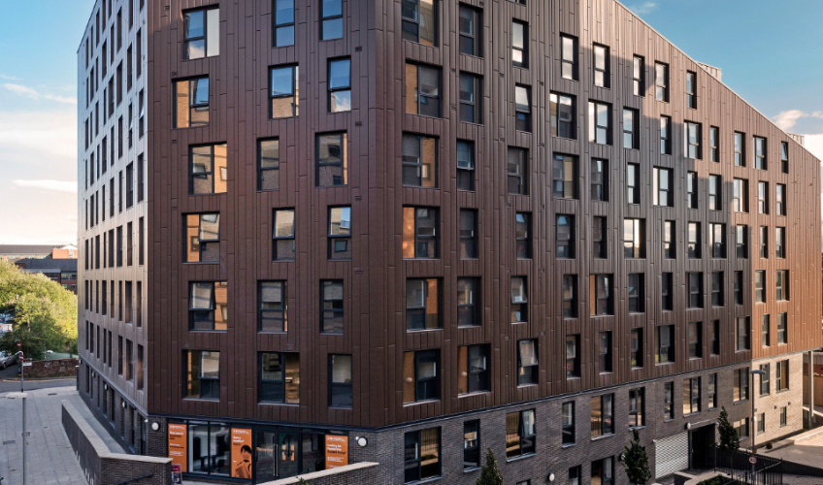
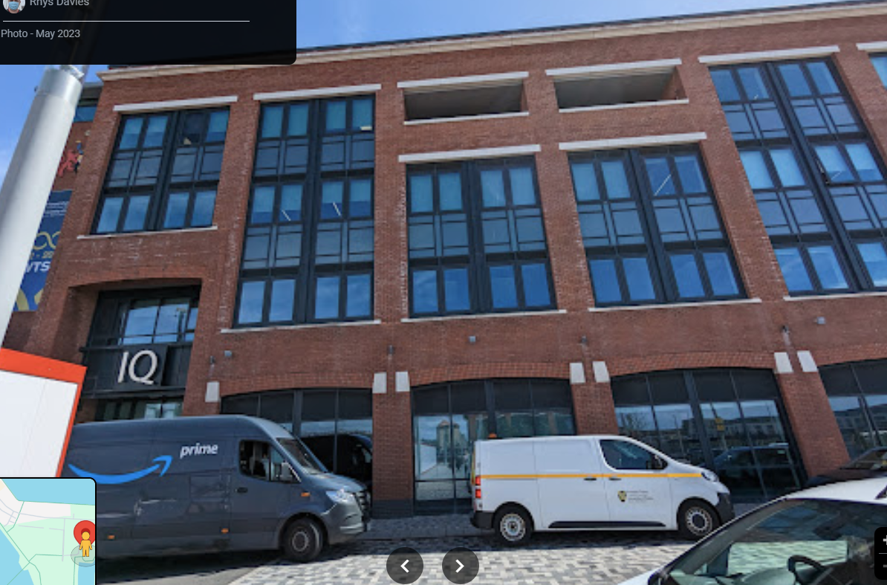
Figure 5- UWTSD IQ Building (Google, 2023)
Figure 6- Aluminium Rainscreen Cladding at The Foundry Leeds Student Accommodation Opened in 2017 (Ashcourt, 2018)

6.2 Windows & Glazing
With over 25% of a buildings heat lost through the windows and glazing the appropriate selection and use is crucial to improve a building’s energy performance (Designing Buildings, 2022). The glazing system will have a combination of curtain walling at low levels, and windows to each room. All windows used will have double-glazed units with low-emissivity glass to help reduce heat loss and maintain internal comfort. The glazing shall be designed to meet part L of the building regulations. Double glazing will add to the sound insulation, which is an important consideration for the environment, in a relatively busy, noisy and urban environment. Given these considerations, the windows shall incorporate toughened glass to ensure occupant safety. With the stand-alone nature of the building, and the climate considerations, the building will receive various types of weather, including strong coastal winds, heavy rain, and a great amount of sunlight, so solar control glass must be used (especially south facing) to minimise heat gain and appropriate weatherproofing and moisture control including vapour barriers, and rainwater management systems must be in place.

6.3 Roofing System
In parallel with the other systems, the roofing system is just as important to the building’s overall performance. The proposed flat, green roof system will be used due to its energy efficiency and aesthetic appeal. The green roof system has a number of benefits, including 54% better rainwater retention, 2-12DB sound reduction, and 239g carbon reduction/square metre (Sky Garden, n.d.). The roof will consist of insulated roofing panels, similar to the external walls to ensure compliance with part L of the building regulations. The roof will be fitted with a weatherproofing membrane (EPDM) to ensure the roof is sealed and prevent water ingress (particularly important within the UK environment). Rainwater harvesting systems will be incorporated to enhance the efficiency and sustainability by reducing water consumption and managing runoff. The roof also provides a big open space which will be utilised. The roof will provide space for the required heating, ventilation and cooling (HVAC) systems to control the temperature, humidity and air quality, maintaining comfort within the building. This system will include roof-mounted air source heat pumps, which absorb heat from the external environment, even in freezing temperatures and transfer the heat to the internal environmental, using renewable energy and this system is over 300% more efficient than a standard gas boiler (EDF, 2024). Finally, the roof will have space which will be used as a recreational space for the students, including a seating area to overview the marina area.
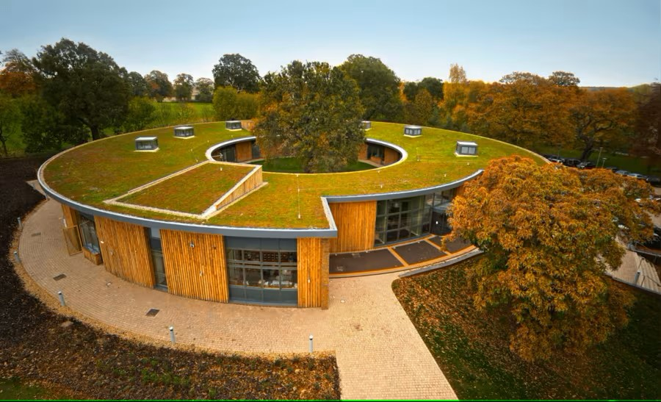
Figure 7- The British Horse Society Headquarters (Sky Garden, 2010)

7.0 Conclusion
In conclusion, this report has highlighted a comprehensive design for a medium-to-high rise student accommodation building on the SA1 site. Through careful analysis of the site’s historical, geological and urban conditions, the proposed design aims to reflect modern architecture, sustainability and efficiency tailored to student needs.
The site history and nearby past borehole logs present likely challenges such as poor soil conditions, potential contamination, and high groundwater levels, which will therefore require piling foundations for structural stability. Reinforced concrete frames, with precast wall panels were proposed to ensure durability, fire resistance and improve construction speed. The design aims to utilise advanced technologies and an efficient building envelope to meet the UK Building regulations and BREEAM excellence, setting the standard for modern student accommodation in Wales.
By considering the needs of the students, the community and the key stakeholders, the proposal is not only a solution to the immediate housing needs of students but also a long-term contribution to the ongoing development of the UWTSD campus, and the ongoing regeneration of the SA1 area, contributing to improving Swansea’s status as a city for education and innovation.

8.0 References
AECOM, 2019. Summary of Ground Conditions. Available at https://www.swansea.ac.uk/media/CISM---Ground-Conditions.pdf. [Accessed 10th January 2025]

Ashish, 2018. Why Does Concrete Have Great Compressive Strength, But Poor Tensile Strength? Available at https://www.scienceabc.com/pure-sciences/why-does-concrete-have-great-compressive-strength-but-poor-tensile-strength.html. [Accessed 11th January 2025]

BBC, 2019. Grenfell Tower- What happened. Available at https://www.bbc.co.uk/news/uk-40301289. [Accessed 12th January 2025]

BGS, 1880. Swansea Docks Borehole Logs. Available at http://scans.bgs.ac.uk/sobi_scans/boreholes/370199/images/10677848.html. [Accessed 11th January 2025].

BREEAM, n.d. About BREEAM. Available at https://breeam.com/about. (Accessed 11th January 2025)

BSI, 2017. BS 8414-1:2015+A1:2017- Fire performance of external cladding systems - Test method for non-loadbearing external cladding systems applied to the masonry face of a building. Available at https://knowledge.bsigroup.com/products/fire-performance-of-external-cladding-systems-test-method-for-non-loadbearing-external-cladding-systems-applied-to-the-masonry-face-of-a-building?version=standard. [Accessed 12th January 2025].

Chudley, R., 2010 Building Construction Handbook. Butterworth: Heinemman

Civil Today, n.d. Advantages and Disadvantages of Concrete. Available at https://civiltoday.com/civil-engineering-materials/concrete/15-advantages-and-disadvantages-of-concrete. [Accessed 11th January 2025]

Designing Buildings, 2022. Heat Loss. Available at Heat loss - Designing Buildings. [Accessed 12th January 2025].
DigiMaps, 2025. Aerial View- Measurement Tool. Available at https://digimap.edina.ac.uk/roam/map/aerial. [Accessed 12th January 2024].

EDF, 2024. A complete guide to air source heat pumps. Available at https://www.edfenergy.com/heating/heat-pumps/air-source-heat-pump-guide. [Accessed 14th January 2025].

Glancy Nicholls, n.d. Beachside student residences Swansea Bay University Campus. Available at https://www.glancynicholls.com/work/swansea-bay-campus. [Accessed 11th January 2025].

Google, 2023. UWTSD IQ Building Google Street View. Available at UWTSD IQ Building Google Image. [Accessed 12th January 2025].

O’Reilly Precast, n.d. Insulated Wall Panels. Available at https://oreillyprecast.com/insulated-wall-panels/. [Accessed 12th January 2025].

Sky Garden, 2010. Sedum Blanket British Horse Society. Available at https://www.sky-garden.co.uk/case-studies/british-horse-society/. [Accessed 13th January 2025].

Sky Garden, n.d. Features and Benefits of Commercial Green Roof Systems. Available at https://www.sky-garden.co.uk/green-roofs/commercial-green-roof-systems/. [Accessed 13th January 2025].

Swansea Museum, n.d. Swansea Museum, City and County of Swansea. Available at https://www.swanseamuseum.co.uk/. [Accessed 10th January 2025].

UK Government, 2010. Approved Documents. Available at https://www.gov.uk/government/collections/approved-documents. [Accessed 12th January 2025].

Welsh Water, 2019. Sustainable Drainage Systems. Available at https://www.gov.wales/sites/default/files/publications/2019-06/statutory-guidance.pdf. [Accessed 13th January 2024].

9.0 Appendices

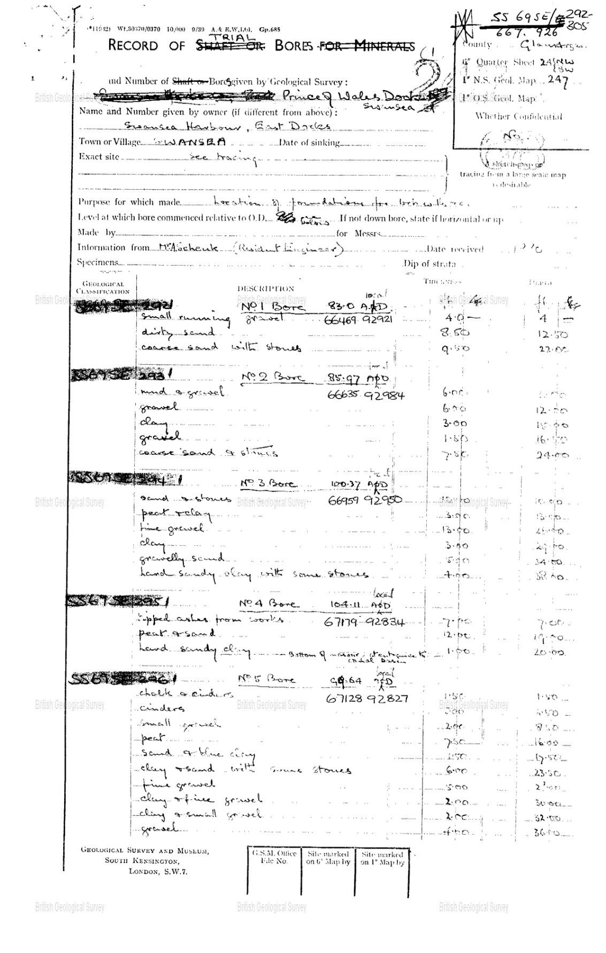
9.1 Appendix A- Record of Trial Bores Prince of Wales Dock Swansea (BGS, 1880)

9.2 Appendix B- CISM Borehole Log (AECOM, 2019)
Borehole Log taken from AECOM’s ground conditions analysis for the CISM building at Swansea Bay Campus.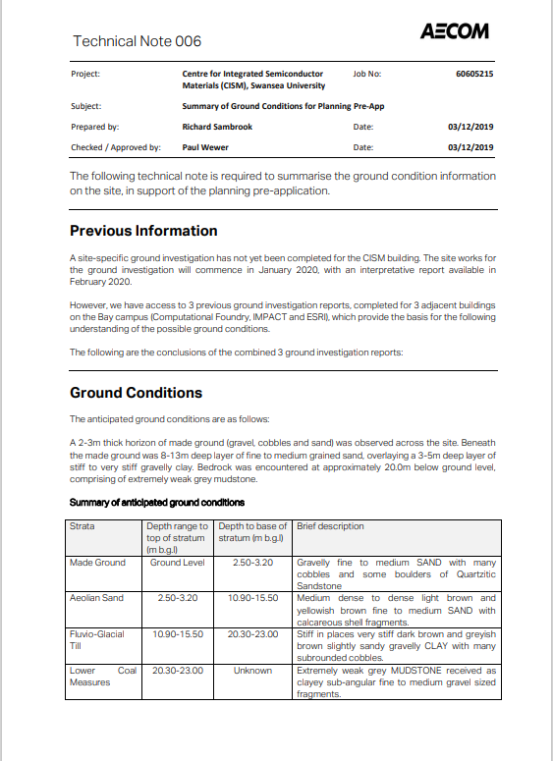
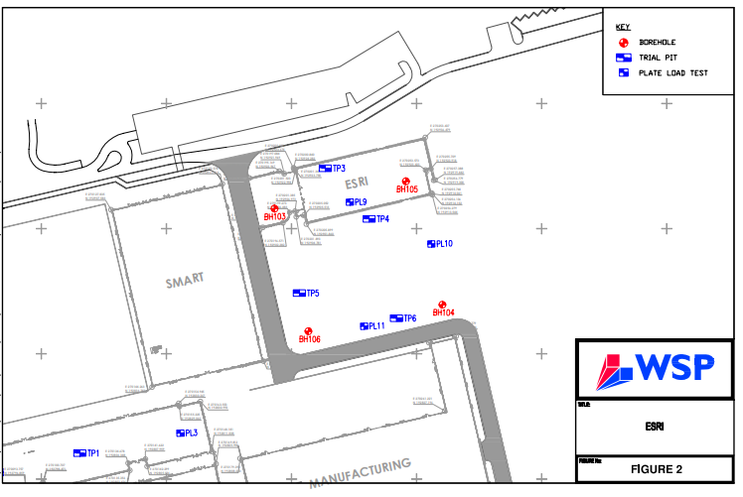
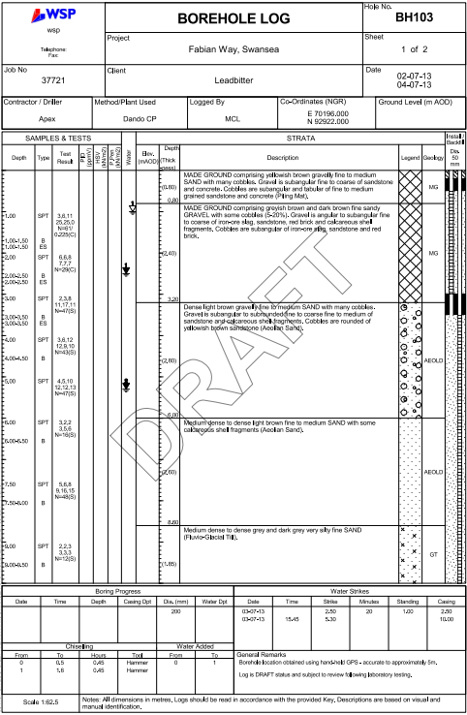
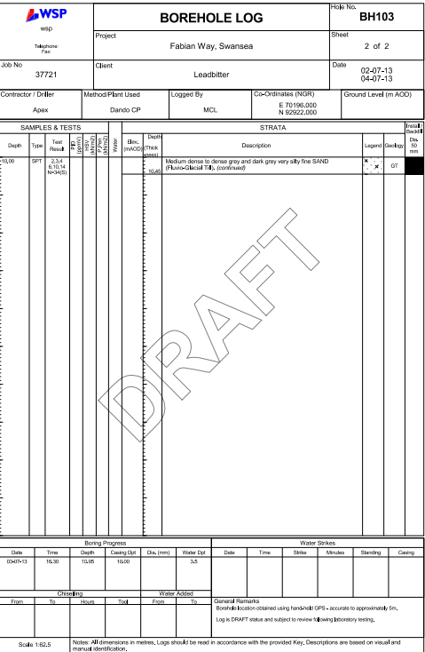
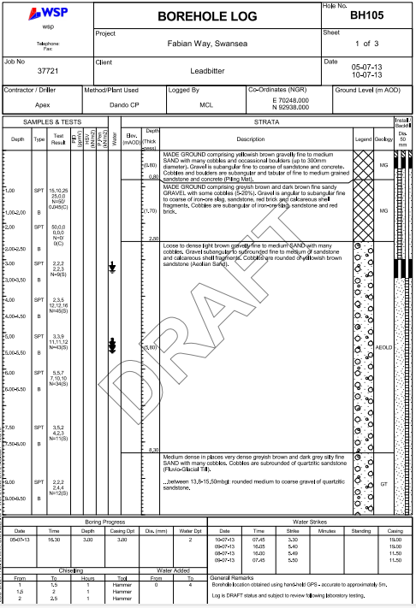
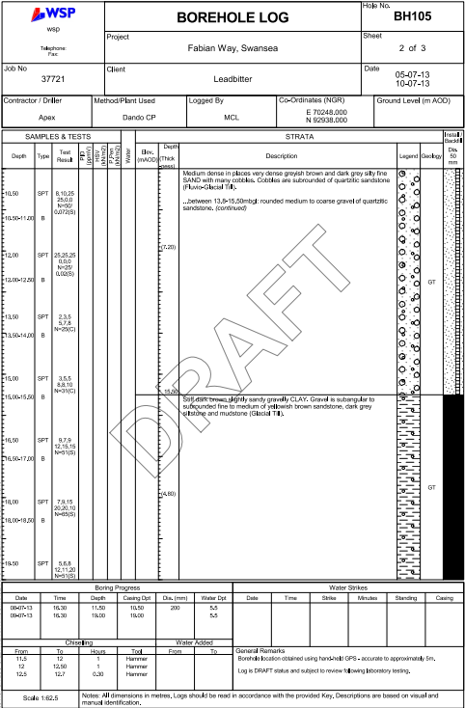
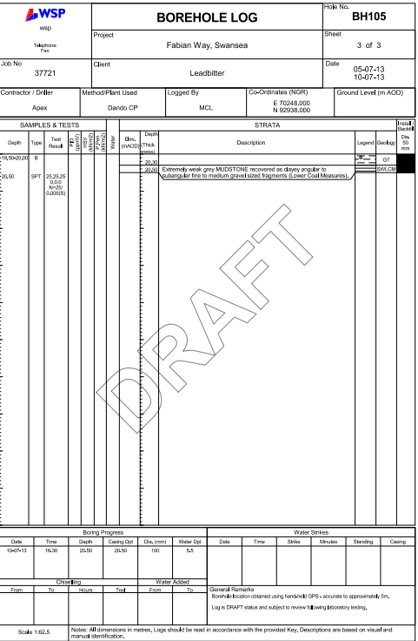
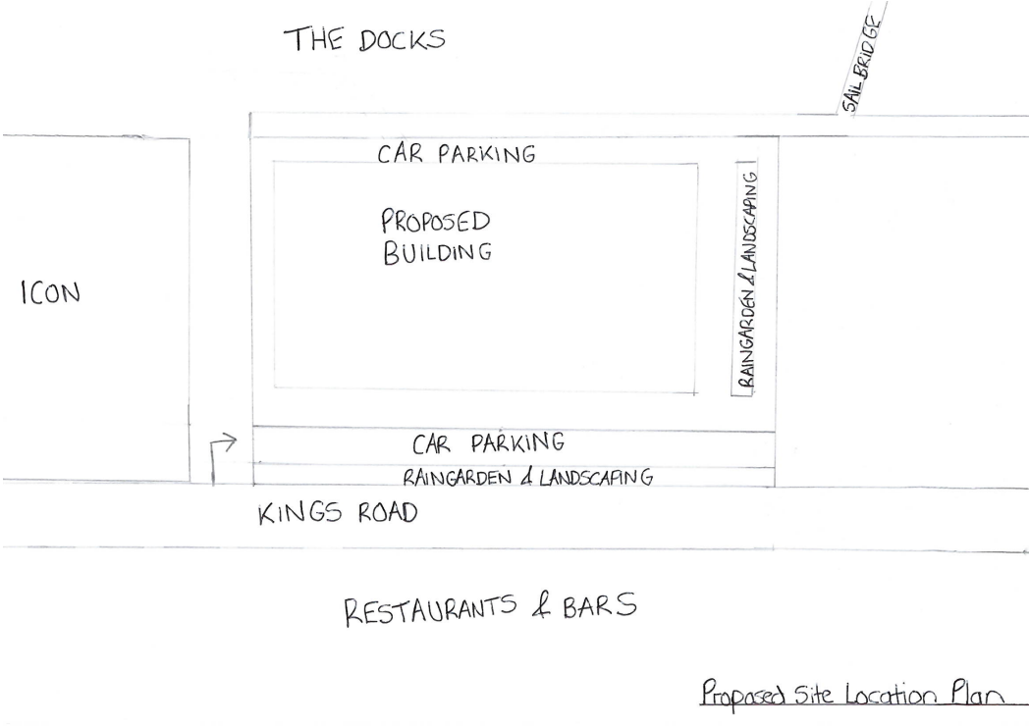
9.3 Appendix C- Proposed Site Location Plan

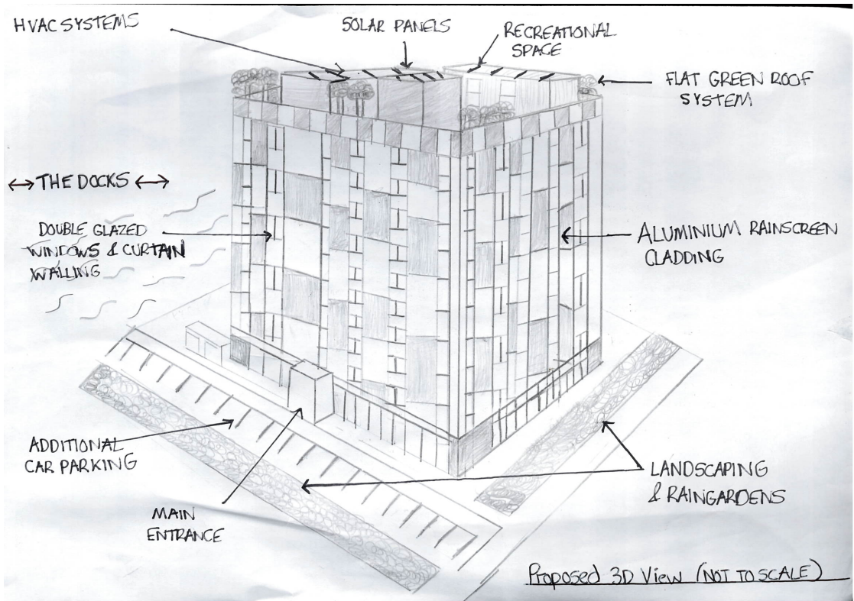
9.4 Appendix D- Proposed 3D Aerial View

