Individual Report on Knowledge and Information Management of Amazon.com

Student name ……………….. Maxim Babin
Student number ………………… 1909116
Lecturer name ……………….. Amare Desta
Module title ………………… Knowledge and Information Management of Amazon
Module code ………………… BMSW 5106

Executive Summary
The reports illustrate the overview of the knowledge and information management of Amazon in the business world. Amazon is one of the world's largest brands based on multinational technology, which is focusing on e-commerce and artificial intelligence. For analysing the market condition of Amazon, knowledge and information management are used as a tool. As the appropriate knowledge and information management are used as the success key, the report focuses on the importance and application and the collaboration of both Knowledge and information management.

Contents
Executive Summary 2
Introduction 4
Introducing the Key Elements of Knowledge Management Theories through the Example of Amazon.com 5
Demonstrating the Importance of Effective Creation, Storing, Sharing, Application through the Integration of Information for Good Knowledge Management Development Practices 9
Identifying the Effectiveness of Knowledge and Information Management Culture within Amazon 13
Evaluating the Knowledge Asset by Maintaining the Effective Customer Relationship Management of Amazon 14
Evaluating the Amazon’s Potential Knowledge Management Challenges for Making the Strength and Make the Recommendation for the Knowledge Acquisition-Retention-Transfer Perspectives 16
Conclusion 19
Reference 20

List of figures
Figure 1: Key elements of Knowledge Management 6
Figure 2: Importance of Knowledge Management 9
Figure 3: Ways of Knowledge Management Development 11
Figure 4: Customer Relationship Management of Amazon 15
Figure 5: Challenges in Knowledge Management 17

Introduction
To achieve the success of an organisation by referring to the multidisciplinary approach, knowledge management is the process of identifying, organising, storing, creating, sharing, managing and using the necessary information of the particular organisation and its surroundings. The main objective of the report is to determine effective knowledge and information management in the context of Amazon through the competitive advantage. The report is divided into four parts. In the first part, there have an overview of Amazon and a brief description of knowledge management. In the second and third parts, the report illustrates the importance and collaboration of knowledge and information management. In the last part, the reports highlight the potential challenges of knowledge management with the recommendation to turn up the challenges as the strength of Amazon.

Introducing the Key Elements of Knowledge Management Theories through the Example of Amazon.com

Amazon.com
In the business world, Amazon is the most repetitive brand name, which is mainly an e-commerce and cloud computing-based American multinational technology. These well-established industries are focusing on digital streaming and artificial intelligence with the forces of influential economic and culture (Varia and Mathew, 2014). Today’s in the competitive business world, it is one of the best companies in the information technology industry. In the year of 1994 on July 5, Amazon started its journey with Jeff Bezos in Bellevue, Washington (Varia and Mathew, 2014). Though it started its journey as an online marketplace for books to the targeted customers, it expanded its business to grab the international market for selling numerous products including electronics, software, video games, food, toys, furniture, and jewellery. For their technological innovation and mass scale, it gets a competitive advantage and it is being one of the largest internet-based companies through its revenue in the world platform (Flamand et al., 2020). Though the business felt the economic downturn in the pandemic situation in 2020, Amazon enjoyed the highest global brand valuation in the world.
Their operating and net income is gradual $22.9 billion and $21.331 billion (Johansson, 2021). The information the board interaction assists with making, utilize and deal with all the information and data inside the association by managing the organization related information, which are applicable to the clients, items, and workplace. Through information the board, Amazon is kept up and built up the information over the long haul with the goal that any individual in this organization can have the option to use it. Though they enjoy lots of competitive advantage, they have been criticised for practices of tax avoidance and anti-competitive behaviour. The largest company is now competing with numerous competitors including Walmart and Alibaba (Flamand et al., 2020). The success of Amazon depends on the key elements of knowledge management.

Knowledge management
Knowledge management (KM) first introduces in 1999 for conducting the benefits for the individuals and organisations in their concrete and action-orientated area through the process of identifying, organising, storing, disseminating creating, sharing, managing, and using the necessary information of the particular organisation and their surroundings (Mahmoudsalehi et al., 2012). It mainly uses to achieve the success of an organisation through the best use of knowledge by referring to the multidisciplinary approach.
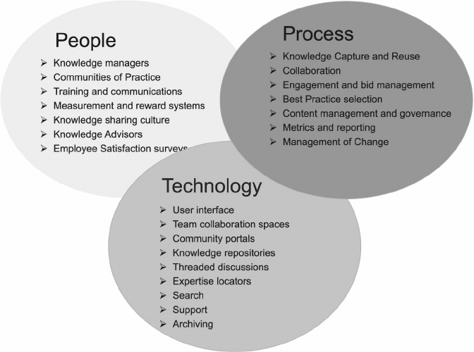
Figure 1: Key elements of Knowledge Management
Source: (Johansson, 2021)
Knowledge is not easily accessible within the company; it takes more valuable time for seeking out the necessary information that focuses on the numerous tasks for providing the best operational efficiencies by the use of knowledge base. Moreover, knowledge management provides a centralized place to store all types of information for increasing the organisational collaboration among their team members to give these facilitate faster decision-making within the business with higher employee satisfaction (Bolisani and Bratianu, 2018). In figure 1, the key elements of knowledge management through Amazon's context are given below,
People: People are the core asset of an organisation especially for the Amazon company to uphold its reputation. This online-based company has to serve the people worldwide by co-creating the customer need, want, and demand. The knowledge manager of Amazon creates a centralised place to store all types of relevant information to increase their employee’s responses (Hislop et al., 2018). Within the business with higher employee satisfaction, it mainly provides faster decision-making those results in higher quality outcomes. The proper implementation of knowledge management leads the business areas with major, urgent knowledge needs. As in the pandemic times, Amazon enjoyed high record sales. For that, the company hired more than 36,400 people that increase the percentage by 34% year over year (Johansson, 2021). Knowledge managers of Amazon are always trained their employees for meeting up the entire goal to overcome the obstacles. It ensures effective communication among the departments. As Amazon is an online platform-based company, they always make connectivity via the technical department to the selling department. Knowledge makes communication easier for them. Another influencing side of Amazon is the motivational procedure. Amazon always tries to make a reward system by measuring their performance. Amazon always keeps the employee survey for being enthusiastic (Becerra and Sabherwal, 2014). Overall through knowledge management, Amazon tries to their managers and employee upgraded about the surroundings to keep the way of their success more smooth.
Process: In an organisation, like the Amazon with having strong knowledge management processes, knowledge flows like the water supply. When someone within the organisation needs any type of relevant information, they just turn the tap for collecting the information that they. In the Amazon, the knowledge managers decorate the knowledge management team as a city planner that knows how everything can flow under the surface by measuring the inputs and outputs within the organisation (Becerra and Sabherwal, 2014). The most beneficial side of it is the end-user of the information does not need to know the overall process. For selecting the overall process, Amazon has identified a standard knowledge flow process in several step cycles. The first one is to create new knowledge all the time, across all areas of all the departments of Amazon to track the order, shipment, and delivery process. The second one is to identify the critical strategy and operations for collecting the knowledge. By that, one can share and collect any type of information. The third one is to evaluate the relevancy, accuracy, and applicability of knowledge management by the specifics method (Dalkir, 2017). Like Amazon has a specific code number to track the order, shipment procedure, and the delivery system. The fourth step is to identify the way of sharing knowledge whatever this is either documentation or collaborative activities for accessing the knowledge and relevant information through pull and push. The overall process helps to solve any kinds of problems firstly and make all the steps with more informed decisions.
Technology: The vital key element of knowledge management is technology especially in the online-based platform. For the knowledge management teams of Amazon, the technology key helps to identify the ways to make the processes easier and smooth. For example, Amazon can build knowledge collection into and integrate the overall knowledge to make the communication among the supplier, customer or consumer and this company through the delivering relevant alerts in ultimately (Dalkir, 2017). As Amazon is an advanced organisation, it uses knowledge management to provide the opportunity through collaboration, innovations in its most teachable moments.

Demonstrating the Importance of Effective Creation, Storing, Sharing, Application through the Integration of Information for Good Knowledge Management Development Practices
In the competitive business world, regardless of any kind of industry businesses must have to build their data system with proper strength for gathering the information from employees and customers to keep growing the company’s growth.
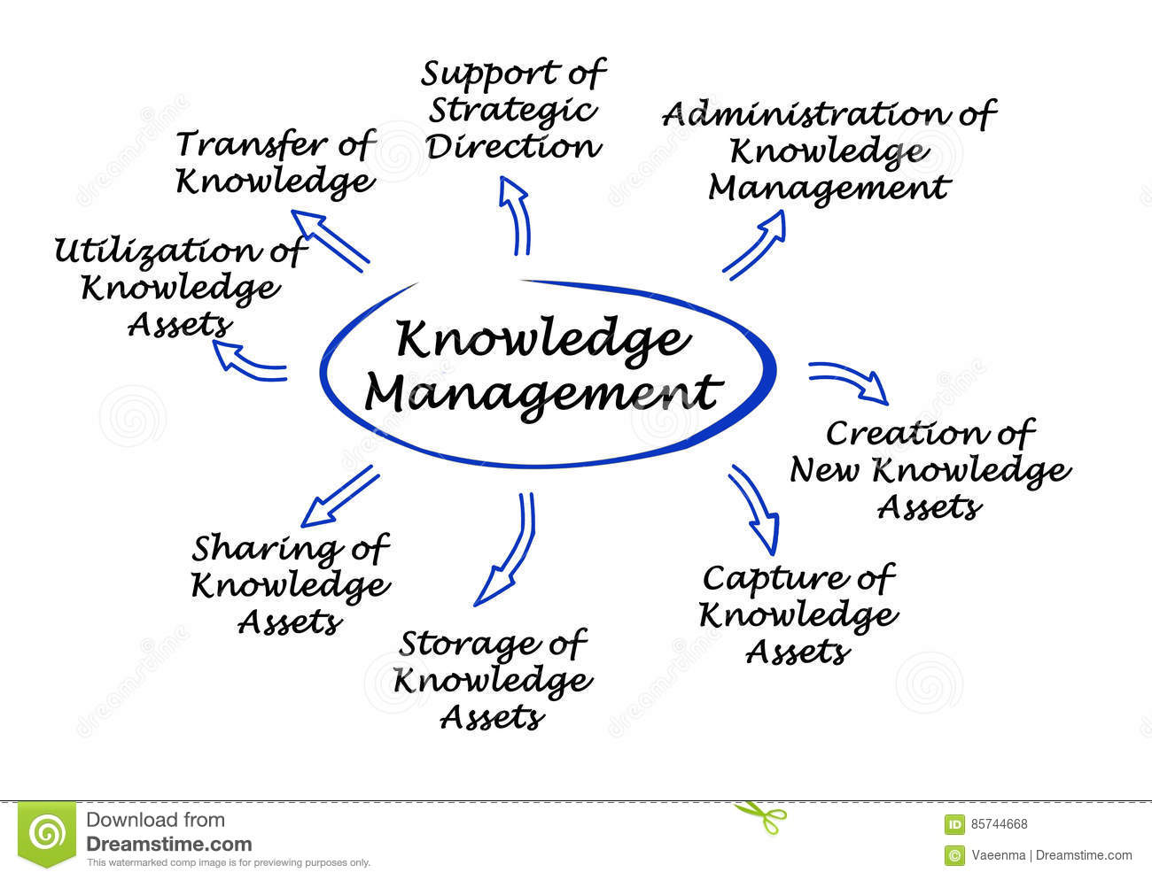
Figure 2: Importance of Knowledge Management
Source: (Jennex, 2015)
This knowledge management process is now counted as the new era of the digital revolution with efficient artificial intelligence (Becerra and Sabherwal, 2014). The knowledge management process helps to create, use and manage all the knowledge and information within the organisation by dealing with the company-related data, which are relevant to the customers, products, and working environment. Through knowledge management, Amazon is maintained and developed the knowledge over time so that any person in this company can be able to utilise it.
Moreover, it can positively influence all the departments within Amazon such as their IT team and customer support team always take the facilities to collect and share the information from the specific place by the specific code (Dalkir, 2017). So that in an online-based company like Amazon, there have numerous benefits of effective knowledge management by ensuring the proper knowledge, capabilities, and skills with better outcomes. Besides, the knowledge management of Amazon plays a key role in enabling the new technologies in terms of innovation based on artificial intelligence. The importance of knowledge management for creating, storing, and sharing the information is described below,
- Support of Strategic Direction: Increasing the operational efficiency by reducing the operational costs through knowledge management, supports all the staffs and employees to overcome any types of obstacle with a solution more quickly for supporting the strategic direction with less lost productivity.
- Administration of knowledge management: Knowledge management enhances the superior employee experience that not only provides speedier resolutions but also helps the administration to work effectively to accomplish the best result with informed decisions that result in higher quality outcomes.
- Creation of New Knowledge: Day to day, Amazon innovates new ideas to cope up with the competitive world by achieving competitive advantages. For that, they surpassed Walmart in 2015 by the best use of the supported resources and the services from the employees that they serve through the innovation self-care (Jennex, 2015). Because of the innovation, day by day, Amazon increases the selling area.
- Capture the knowledge assets: Knowledge management ensures high employee satisfaction because it minimises the overall impact of their activities and makes the working environment easier and comfortable and also friendly to work and innovate the new plan (Hislop et al., 2018). This helps Amazon to retain the expert in this organisation to uphold the reputation.
- Transfer of Knowledge: It reduces the duplication of effort by having the preferable solutions available to people rather than having to put extra time to innovate what needs to be done. Another interesting part is, anyone can find any type of relevant information through the transfer of knowledge without understanding the overall process of knowledge management.
- The utilisation of Knowledge Assets: By speeding up the delivery process and improving the overall quality Amazon is now enjoying the top of success (Becerra and Sabherwal, 2014). Many businesses like Amazon have now implemented some automated services like catboats into knowledge management programs for supporting a customer support team by tackle customer problems.
The success of a company like Amazon depends on the integration of information for good knowledge management development practices to reap the great reward of knowledge management (Hislop et al., 2018). Unfortunately, the reality in the business world is difficult in which, not all businesses are capable of building the successful path by the Knowledge management database with the organisation culture by ensuring the lucrative view. Here, in figure 3, some best practices for ensuring the lucrative knowledge management outlook are given below,

Figure 3: Ways of Knowledge Management Development
Source: (Hislop et al., 2018)
- Understanding the organisation's culture: To set up the knowledge management, the first matter is governing the employee's behaviour and their performance. It helps to measures the organisational culture before selecting the proper knowledge management system (Liebowitz and Frank, 2016). This represents the capabilities of a company for preparing knowledge management.
- Motivating the employees through rewards and appreciation: Another way for developing the policies is to motivate the employees through the rewards based on the employee's performance which is worked as a fundamental pillar of the organisation to maintain the proper knowledge management.
- Implementing the knowledge ownership practice: In that developed way, knowledge management maintenance will be much easier if all the employees and the managers are upholding their responsibility for enhancing their knowledge to ask for the proper clarifications from knowledge advisors.
- Assigning the knowledge management executive: This is needed to hire a well-established person on a long-term basis who has the experience to understand the organisation's driving factors, aims, objectives, mission, and vision to keep focusing on track.
- Publishing the brief after the important events or projects: Experience is counted as the biggest non-financial of an organisation to tacit knowledge, in which employees can overcome any kind of obstacle or any type of situation through holding the review and both the positive and negative outcomes (Liebowitz and Frank, 2016). For example, in the pandemic time, amazon enjoys high recorded sales and revenue. In the future, it helps to identify the strength and weaknesses to cope with the completive world.

Identifying the Effectiveness of Knowledge and Information Management Culture within Amazon
Amazon is the established popular brand name among the most successful e-commerce companies in the business world, and from the starting time, Amazon determined about their quality service rather than the quantity and this is possible for the effectiveness of knowledge and the information management culture in a personalised way (Holtshouse, 2013). This effectiveness of knowledge and information management adds more value to be run the successful way. Amazon uses different knowledge and information management’s principles and practices for adding significant value for upholding their brand value in many ways which are described below:
- One portal, one interface: Everything from Amazon conducts the overall business view through the same portal whatever it is food, electronics, books, or clothing. Because of the same portal, the user has not faced any difficulties to take the service or products by the familiarity and comfort with allowing the less anxiety for exploring the new areas of the site (Sousa and Rocha, 2019). This is possible for the collaboration of information management. Like the operation activities of information management, it helps handle all these things in a single portal and interface. For example, if the Amazon cloth store and the Amazon book store had different web addresses, one has to recall the different web addresses and they have to figure out the store at first before they could shop.
- Consistent presentation: Amazon deals with different products and different services for presenting every product in the same way and the same order. The key element of knowledge management is outstanding content management in a consistent manner ability to track every information for a consistent presentation (Sousa and Rocha, 2019). The leadership role among the keys of information management tries to make a consistent presentation by following some presentation strategy by figuring out to display the product towards the customer efficiently.
- Modular content: By the collaboration of knowledge and information management, Amazon organises every page for their easy-to-read sections. For example, in the cloth store, they provide additional detailed information by giving the option like “click here” to provide them the idea of the overall view of this particular product (Razmerita et al., 2016). This is possible throughout the key collaboration including technology and modular content by scanning elaborate documents.
- Magical personalisation: Because of the numerous products and services, Amazon customers are wanted to see the sites in a presentable way as if the more the customers use the sites, the better they know about the products and services of Amazon (Sousa and Rocha, 2019). This helps the customer to about their desirable products and most often time these sites are recommended some products that might like by adding the additional information. Amazon.com is a popular site for the customer because the leaders of Amazon magically personalise the website by organising the data. Ultimately, the magical personalisation and data collaboration help to boost up the total sales and revenue by enhancing the productivity and efficiency with the capabilities.
- Crowdsourcing: This is the sourcing model with more features including the customer-service ratings, reviews, and analysis of customers' demand to build the knowledge and awareness as social features to achieve a cumulative result (Razmerita et al., 2016). This is possible for the data processing of information management.

Evaluating the Knowledge Asset by Maintaining the Effective Customer Relationship Management of Amazon
From the beginning, Amazon determined that the user's best experiences are the main asset for conducting a successful business. For this, they are always trying to enhance the ability for finding out what the customer’s want, when they need it regularly to cope up with the competitive business world (Raudeliūnienė et al., 2018). To maintain an effective relationship with the customer, CRM (Customer Relationship Management) helps to find out the way to figure out the effective relationship.

Figure 4: Customer Relationship Management of Amazon
Source: (Martins et al., 2019)
Now conducting customer relationship management is mandatory for any type of business especially for Amazon because customer satisfaction is mandatory to uphold the organisation's reputation. In below, the knowledge assets by maintaining effective customer relationship management are evaluated from the perspective of Amazon. For enhancing the CRM, the first activity by maintaining customer intimacy is marketing to announce the information about their organisation by figuring out the specific marketing campaign. For the best marketing strategy, Amazon uses the 7ps of marketing through the knowledge advisor (Raudeliūnienė et al., 2018). Then another key element of CRM is to develop the website for the customers. This website helps the customer to find out the desirable products with the relevant details.
To conduct the online platform business, another key is about the analytics efficiency by the knowledge advisor and specialists. Through this, they can analysis the customer perception and the surrounding environment including the competitor’s strategy. For example, the core competitor of Amazon is Walmart. So to survive in the market, they analysis the Walmart market condition to set up their business strategy for creating customer intimacy, they have the contact center, outlook, and PABX (Shannak et al., 2012). Then the Amazon focuses on its sales. To deliver the product on time, the knowledge advisors maintain one portal and one interface to track the order, supplier, and delivery system. Then the next element of CRM is to calculate the cost, assets, revenue of Amazon. The most vital issue of Amazon by evaluating the knowledge assets for creating customer intimacy is loyalty.

Evaluating the Amazon’s Potential Knowledge Management Challenges for Making the Strength and Make the Recommendation for the Knowledge Acquisition-Retention-Transfer Perspectives
For a well-established brand like Amazon, knowledge management works as a blessing for the company because knowledge management ensures the process for identifying, organising, storing, managing, and using the relevant information within Amazon and its surrounding environment (Martins et al., 2019). Knowledge management enhances the potentiality of Amazon for taking the decision more quickly. However, to conduct the knowledge management, both the knowledge manager and the advisor are always facing numerous challenges with the recommendation are described below,
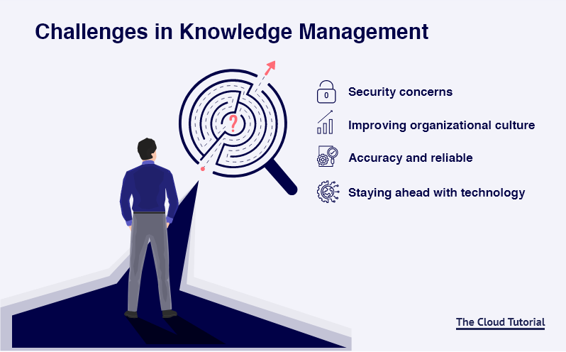
Figure 5: Challenges in Knowledge Management
Source: (Illiashenko et al., 2015)
    - Security Concerns: the main purpose of knowledge management is identifying, organising, storing, managing, and using the relevant information for ensuring the easy accessibility of the organisation's information whenever the relevant data is needed (Mahmoudsalehi et al., 2012). The reason behind the proper maintenance of knowledge management is that all the data is essential for Amazon. The challenging part of knowledge management is to maintain the proper security to ensure confidentiality among the employees, managers, staff, suppliers, customers, and the person who is, directly and indirectly, related to the organisation. This security concern mainly helps the customers for building their trust towards the brand value and stays loyal to the brand without any kind of fear of leak out the data that may happen by some mistakes. For example for purchasing the product from Amazon, customers give the bank information and the information about their address. If the information is a leak because of the lacking of security concerns, customers face some trouble issues. They are not willing to retain again the Amazon. For that Amazon always try to concern the area of security by using different knowledge management tools and operating procedures for keeping all the data safe and secure (Illiashenko et al., 2015). Ultimately, this helps to create a higher brand value, keep your data safe, and ensure that customers stay loyal to your business process.
    - Improving Organisational Culture: People are the key component of knowledge management for ensuring efficient knowledge management by both the knowledge advisor and the specialist. The knowledge manager of Amazon creates a centralised place to store all types of relevant information to increase their employee's response within the business with higher employee satisfaction and higher quality outcomes (Domínguez and Martins, 2014). But, unfortunately, the challenging part of Amazon is to improve the organisational culture. However, the main obstacle of it is the office politics that hinder the expected growth and productivity within Amazon, which is now common in many corporations (Illiashenko et al., 2015). However, the result of office politics is too worst because sometimes it breaks the flow of hidden information within the organisation. By that, managers often face numerous challenges in their teams for making better knowledge management operations. To prevent this office politics, managers of Amazon want to develop the best organisation culture to overcome all of this. For that, the recommendation is to apply proper training on knowledge strategy and enhancing the knowledge transfer by maintaining knowledge management.
    - Accuracy and Reliability: Knowledge management mainly ensures the process of storing, collecting, transferring, and storing the data. But this should be always accurate and reliable and this is counted as the most significant challenge for maintaining knowledge management (Mahmoudsalehi et al., 2012). If any type of data is not accurate, this makes the problematic situation for everyone by ensuring the tools and up to date and accurate. This encourages the client to about their attractive items and frequently time these destinations are suggested a few items that may like by adding the extra data. Amazon.com is a mainstream webpage for the client in light of the fact that the heads of Amazon mystically customize the site by getting sorted out the information. At last, the otherworldly personalisation and information coordinated effort help to support up the complete deals and income by upgrading the profitability and effectiveness with the capacities. For example, if the sales department does not update the delivery date and the address, the customer does not get the product on time. To ensure accuracy, the manager should set up regular reminders to ensure that everything by checking up the knowledge base articles.
    - Staying Ahead with Management Technology: Amazon is an online-based platform, so they always are upgraded with technological issues. No matter what types of technologies are used, they should expect some regular updates to fulfil the customer demand (Domínguez and Martins, 2014). Amazon can incorporate information assortment into and coordinate the general information to make the correspondence among the provider, client or shopper and this organization through the conveying pertinent alarms in eventually. The legitimate execution of information the executives drives the business territories with major, earnest information needs. As in the pandemic occasions, Amazon appreciated high record deals. Though it might be a concerning matter of challenges, they have to keep up the entire organisation under the constant new updates by calculating knowledge contribution.

Conclusion
The overall report is analysing the impact and influence of internal and external factors on the present condition, and competitive environment through the perspective of Amazon by the knowledge and information management in the competitive world. At first for the examination, the report analysing several elements of knowledge management. Then it evaluates the customer relationship management from the perspective of the knowledge assets of Amazon. In the pandemic time, Amazon enjoyed the recorded sales. For investigating the economic situation of Amazon, information and data the board are utilized as an instrument. As the proper information and data the executives are utilized as the achievement key, the report centers around the significance and application and the joint effort of both Knowledge and data the board. This is possible by determining the collaboration of knowledge and information management. Besides that, this report makes the recommendation for overcoming all the potential obstacles.

Reference
Becerra-Fernandez, I. and Sabherwal, R., 2014. Knowledge management: Systems and processes. Routledge.
Bolisani, E. and Bratianu, C., 2018. The emergence of knowledge management. In Emergent knowledge strategies (pp. 23-47). Springer, Cham.
Dalkir, K., 2017. Knowledge management in theory and practice. MIT press.
Domínguez Gonzalez, R.V. and Martins, M.F., 2014. Knowledge management: an analysis from the organizational development. Journal of technology management & innovation, 9(1), pp.131-147.
Flamand, O.J., Wisher, A. and Riley, S., 2020. Strategic Plan: Amazon.
Hislop, D., Bosua, R. and Helms, R., 2018. Knowledge management in organizations: A critical introduction. Oxford university press.
Holtshouse, D.K., 2013. Information technology for knowledge management. Springer Science & Business Media.
Illiashenko, S.M., Shypulina, Y.S. and Illiashenko, N.S., 2015. Knowledge management as a basis for innovative development of the company.
Jennex, M.E., 2015. Knowledge management. Wiley Encyclopedia of Management, pp.1-6.
Johansson, J., 2021. Launching a Product to Amazon Marketplace: Selling at Amazon. com.
Liebowitz, J. and Frank, M. eds., 2016. Knowledge management and e-learning. CRC press.
Mahmoudsalehi, M., Moradkhannejad, R. and Safari, K., 2012. How knowledge management is affected by organizational structure. The learning organization.
Martins, V.W.B., Rampasso, I.S., Anholon, R., Quelhas, O.L.G. and Leal Filho, W., 2019. Knowledge management in the context of sustainability: Literature review and opportunities for future research. Journal of cleaner production, 229, pp.489-500.
Raudeliūnienė, J., Davidavičienė, V. and Jakubavičius, A., 2018. Knowledge management process model. Entrepreneurship and Sustainability Issues, 5(3), pp.542-554.
Razmerita, L., Phillips-Wren, G. and Jain, L.C., 2016. Advances in knowledge management: an overview. Innovations in Knowledge Management, pp.3-18.
Shannak, R.O., Ra'ed, M. and Ali, M., 2012. Knowledge management strategy building: Literature review. European Scientific Journal, 8(15).
Sousa, M.J. and Rocha, Á., 2019. Strategic knowledge management in the digital age: JBR special issue editorial.
Varia, J. and Mathew, S., 2014. Overview of amazon web services. Amazon Web Services, 105.

