Alina Elena Adavidoaie
Student ID: 2324349
Building personal brand
Component 2

Introduction
This report will consider my employability in the context of the above advertised vacancy of Mental Health Support Worker at Queensbridge Care Ltd. It will identify the skills needed for this role and examine my own skills sets and requirements against this role before identifying ways of developing my own personal brand in the sector of health and care. This paper will also provide an action plan to develop the skills needed in the next five years to allow me to move into this role.

Job Role Employability Skills

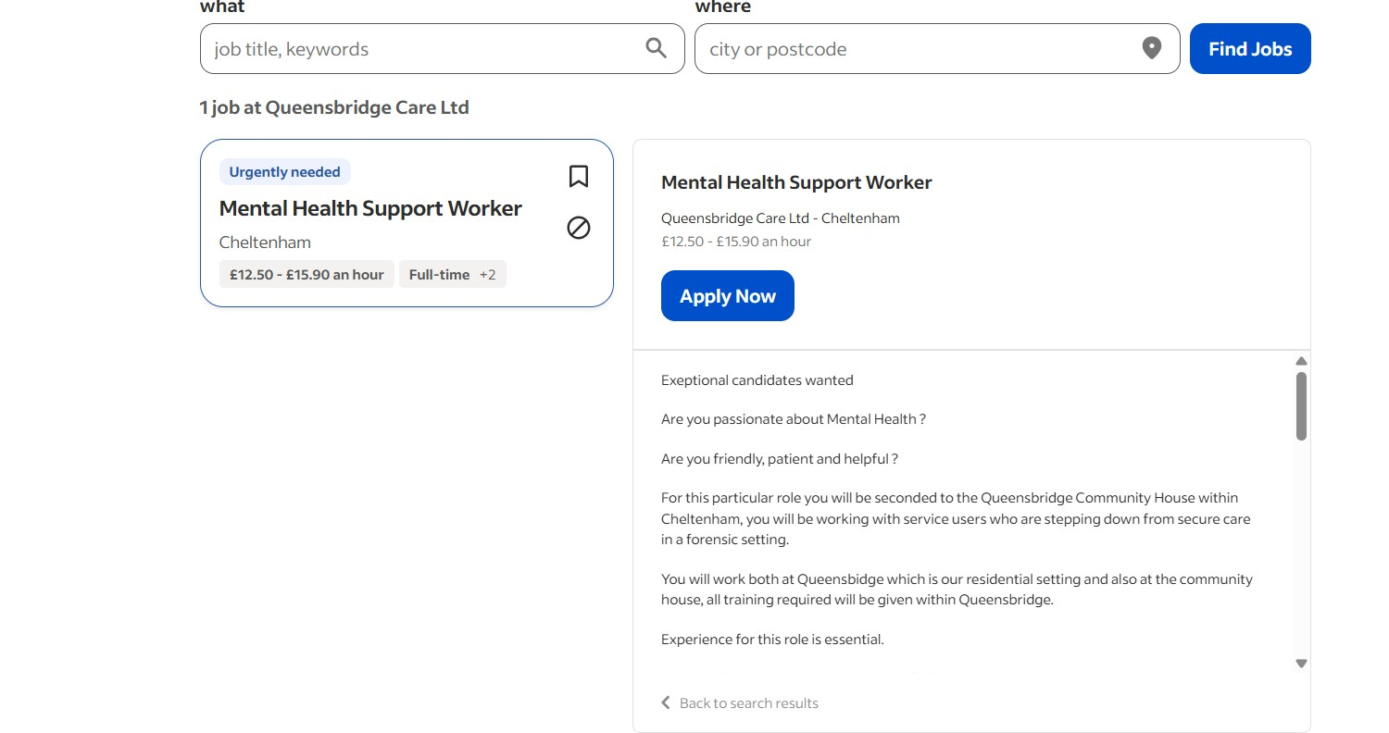
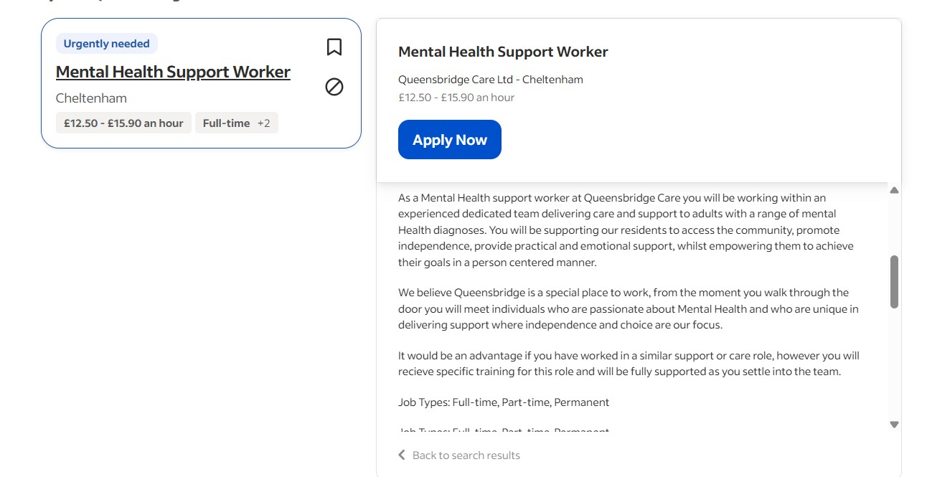

The job advertised as Mental Health Support Worker at Queensbridge Care Ltd involves the provision of practical, emotional, and recovery-based support to adults who suffer from mental ill-health, promoting their independence while maintaining a high standard of person-centred care (Job Advert Screenshot, 2025). This job description illustrates the crucial role support workers play in improving the effectiveness of recovery, autonomy, and social functioning skills around community mental health care (Morgan et al., 2022).
The job advertiser has also mentioned the qualifications of the desired applicant which must at least have one-year experience within the support environment, a valid driving license, and good interpersonal skills. The desirable skills mentioned for the support workers are NVQ Level 2 in Health and Social Care and at least two years of support work experience. Evidence supports the point that the support workers must be emotionally intelligent and able to develop the ‘therapeutic relationship’ through active listening skills founded upon the principles of trust and respect (Stickley & Freshwater, 2019). Such skills endorsed the positive relationship of the support workers with the benefit of improved service users' results (Berry et al., 2020).
The stress placed on patience, communication, and adaptability relates to wider employability skills models which point to the importance of soft skills, the ability to reflect, and being professional in health and social care work (Knight & Yorke, 2006). In addition, the need to be flexible and resilient also reflects findings which identify mental health settings as requiring constancy, awareness of the self, and the ability to work together as part of interdisciplinary teams (Trede et al., 2012). The job posting reflects the development of both skills and the ability to be professional around mental health support.

Skills Evaluation
Self-Assessment
To know the degree of my readiness for the Mental Health Support Worker position accurately, it is crucial for me to understand the level of skills that I possess at the present time. While I do not formally possess work-related experience in the controlled environment of the care industry yet, the courses of an academic nature concerning the area of health and social care I completed involved some work in terms of volunteering efforts I was involved in. Additionally, the jobs I held also involved very intensive communication/customer service interaction (Tickley & Freshwater, 2019). My work in the administration/project coordinating field also improved my organizational skills/customer literacy/command pressures tolerance. This made the level of skills I gained adequate for the work in the field of mental health (NHS England, 2023).
Strengths
My personal strengths correlate closely with the demands of the job. I possess the skills of communication and confidence in communication, having previously been involved in client support work, conflict resolution, and giving guidance. There is evidence to suggest that communication skills play an important part in the formation of the therapeutic relationship (Berry et al., 2020). Additionally, I possess the skills of being patient and having good emotional intelligence. These qualities are crucial when working with people who may suffer from complex mental health issues. My personal strengths clearly indicate that I bring something positive to the table in terms of offering a safe, supporting, and person-centred environment. My ability to work collaboratively in group work indicates that I am also very suited for the job.
Areas for Improvement
There are some areas that I want to improve. Now, I do not possess the preferred NVQ Level 2 in Health and Social Care qualifications. Also, I do not possess the relevant ‘hands-on’ work experience within the context of the regulated mental health field. According to research by Morgan et al. (2022), ‘practical’ work experience is vital to build confidence in the field. Also, I require the relevant safeguarding award along with the relevant work experience in the areas of risk assessment, de-escalation procedures, etc.
Who can Help?
To meet the various development needs raised by the respondents, help will also be sought from careers units within higher education institutions, local health and social care colleges offering workplace training, and third sector organizations. Feedback from mentors and line managers in voluntary or part-time caring work may also help in the process of gaining experiential skills. Professional networks offered by Skills for Care, NHS Training Hubs, and colleges may also assist in acquiring recognized formal qualifications.

Action Plan and Timeline
Formulation of an organized plan of action is crucial for personal skill enhancement in the context of preparing for the mental health support worker’s position. Organized plans for personal skill enhancement significantly influence employability along with the process of organizational socialization within the work context (Tomlinson, 2017). Initially, it is important to gain some work-related exposure in the regulated health and social care context. I will start by exploring work-related opportunities in mental health organizations or in supported living agencies. Volunteering for work presents the best opportunity for interaction with the service users along with risks, an aspect crucial for organizational work in the health social care context (Morgan et al., 2022).
To make myself more qualified for the position, I will also undertake the NVQ Level 2 in Health and Social Care. This is the preferred requirement for the position. This qualification will either be done in the local college near me or through an online course recognized by Skills for Care. At the same time, I will make sure that certain certifications are acquired. These certifications will include Safeguarding (Levels 1 & 2), Health & Safety Awareness Training (Levels 1 & 2), First Aid Awareness Training, & the ‘Care Certificate’ (CQC, 2021).
Building resilience and emotional regulation skills is also one of the areas I will focus on because it is an important skill for success in mental health work (Piatczanyn et al., 2023). I will benefit from the resources for well-being, journaling for self-reflection, and the opportunity for mentorship to improve self-awareness. Also, taking courses on trauma-informed care, suicide prevention, and de-escalation techniques will increase my familiarity with mental health issues.
Timeline
Short-term
- Start to volunteer in mental health/community support agencies.
- Complete Safeguarding Level 1 and 2, Health & Safety, and First Aid awards.
- Start NVQ Level 2 in Health and Social Care.
- Engage in reflective practice and wellbeing activities to increase emotional resilience.
Medium-term
- Complete the NVQ Level 2 and the Care Certificate.
- Acquire consistent part-time paid work in a supporting capacity.
- Complete trauma-informed care and suicide prevention trainings.
- Complete trauma-informed care and suicide prevention trainings.
Long-term
- Take on the position of a Full-time Mental Health Support Worker.
- Work towards NVQ Level 3 or Level 4 in Mental Health Practice.
- Contemplate progression opportunities in terms of Assistant Practitioner, Recovery Worker, or nursing.
- Continue the process of reflective practice and updating one’s skills.

Personal Brand
Creating an effective personal brand is also crucial for the process of personalising my professional identity in the field of health and social care. By having a personal brand, it becomes easier for the employing organisation to grasp the values and passion for supporting people in mental health. To establish a personal brand aligned with the objective of being a mental health support worker, I will ensure that I portray the values of being caring, trustworthy, and committed to person-centred care. These values are in high esteem in the industry (CQC, 2021).
To strengthen my professional identity, I intend to make use of the platform of sites like LinkedIn, through which I will get the opportunity to market myself on the strength of the skills that I possess. Social networking sites might also prove to be helpful in the distribution of literature related to mental health. Organizing webinars or attending job fairs might also prove to be effective tools for the marketing of my professional identity by giving me the opportunity to network. By attending webinars organized by experienced professionals in the field of mental health, I might also gain the opportunity to network.
Moreover, I can access relevant content from sources like blogging sites for writing reflections on the topic of care that highlight the way in which I am progressively building on my subject-related knowledge. Consequently, through the utilization of the sources of information in all the arenas of professional life, I can ensure the projection of my personal brand in the field of the mental health and social care industry.

Personal Identity
Enhancing my professional identity represents one of the crucial means by which I plan to prove to potential employers that I am ready, confident, and able to work effectively in the capacity of a Mental Health Support Worker. Enhancing my professional identity through the enhancement of the application process represents one of the most fundamental parts of the process by which I plan to prove to potential employers that I am the ideal individual for the job. According to Tomlinson (2017), personal applications are an effective means by which employability is maximized.
It is also essential for me to maintain an active presence on the internet. By regularly updating the courses I take on LinkedIn along with some posts expressing my reflections on them, I would make it easier for the employer to notice the efforts I am putting in for improvement. Week 1’s Personal Branding class also stressed the importance of expressing one’s values on the internet. Building a simple personal website would make it easier for me to do that.
Confidence in communication also relates to being confident in presenting experiences in networking interviews. Displaying emotional intelligence, professionalism, and insight into mental health practices is crucial in that employers want candidates who can communicate their passion for person-centred care (Stickley & Freshwater, 2019). By utilizing both online networking opportunities and in-person networking encounters to communicate experiences and career accomplishments, I can build on creating a networking identity that improves employability within the health care industry.

Building a Network for Successful Employment

Networking is an important aspect in cultivating career employability in the health and social care industry. Building good professional contacts opens the door to job offers, career guidance, and industry-related information that accelerates career advancement. There is literature that suggests networking improves confidence, professional identity, and employability outcomes by linking people to experienced professionals (Bennett et al., 2017). Also in the mental health field, networking will assist in gaining comprehension of the work expectations and current best practices in the environment.
To develop an effective professional network in the field of mental health care, I will make the most of career fairs in the NHS, Skill for Care meetings, and webinars held by mental health organizations. Such opportunities provide the means for me to network with the employer representative directly. I will also gain relevant information from professionals like support workers, nurses, social workers, and occupational therapists. Additionally, I will network with tutors from organizations who could take the role of my mentor.
LinkedIn is another networking tool that I can use to reach various professional groups, follow different organizations connected to the health and social care sector, among many other options. Week 2 resources highlighted the importance of social capital in improving job opportunities within the caring profession. Through the utilization of social capital by constructing the right network and being active within different professional groups, I will make myself visible within the mental health support profession.

Conclusion
This report has explored the present level of my readiness for the future in terms of the Mental Health Support Worker job within the context of Queensbridge Care Ltd. The tasks involved in the job analysis allowed me to understand better the tasks, values, and competencies needed within mental health support work. These included empathy, resilience, communication skills, and person-centred work. My personal analysis of myself was able to point out the areas in which I already function effectively today—in areas such as having emotional intelligence, being composed in the face of pressure, good interpersonal skills—and areas in which I could improve—in the desire for regulated care work experience, industry-based learning, and industry-related qualifications.
Additionally, the report investigated techniques for the promotion of the professional identity I want to build through the utilization of professional resources like LinkedIn. Also included in the report was the discussion on how I could benefit from the utilization of personal networks in the pursuit of professional success in mental health care. Building professional networks will assist in the improvement of my employability.

References
Berry, K., Haddock, G., Kellett, S. and Roberts, C. (2020) ‘Therapeutic relationships in mental health services: A systematic review’, Clinical Psychology Review, 80, pp. 1–14.
Bennett, D., Richardson, S. and MacKinnon, P. (2017) ‘Enacting employability: Using theory to develop employability practice’, Journal of Teaching and Learning for Graduate Employability, 8(1), pp. 1–20.
Care Quality Commission (CQC) (2021) What good looks like in care services. Available at: https://www.cqc.org.uk/
Jeske, D. and Shultz, K. (2016) ‘Using social media content for screening in recruitment and selection: Pros and cons’, Work, Employment and Society, 30(3), pp. 535–546.
Montoya, P. and Vandehey, T. (2009) The Brand Called You: Make Your Business Stand Out in a Crowded Marketplace. New York: McGraw-Hill.
Morgan, B., King, R. and Williams, A. (2022) ‘Work readiness in the social care workforce: A qualitative study’, British Journal of Social Work, 52(4), pp. 1970–1988.
NHS England (2023) The NHS Long Term Workforce Plan. Available at: https://www.england.nhs.uk/
Piatczanyn, E., Atkinson, S. and Taylor, P. (2023) ‘Emotional resilience and stress management in care work: Implications for training’, Health & Social Care in the Community, 31(2), pp. 456–468.
Queensbridge Care Ltd (2025) Mental Health Support Worker – Cheltenham [Job advertisement]. Available at: https://uk.indeed.com/viewjob?jk=3b8a9652d23817c3 (Accessed: 25 November 2025).
Skills for Care (2023) Core skills and knowledge for care workers. Available at: https://www.skillsforcare.org.uk/
Stickley, T. and Freshwater, D. (2019) ‘The importance of therapeutic relationships in mental health care’, British Journal of Mental Health Nursing, 8(2), pp. 1–8.
Tomlinson, M. (2017) ‘Forms of graduate capital and their relationship to graduate employability’, Education + Training, 59(4), pp. 338–352.
Module Materials
BMHP5015 Week 1 – Personal Branding Session.
BMHP5015 Week 2 – Social Capital and Networking.

