

MODULE CODE: Enterprise Development and Commercial Innovation (BMBS5000/CARD)

ASSESSMENT COMPONENT:
Mind Map, Value Proposition Canvas, Interview

STUDENT NAME: Rafal Sroczynski
STUDENT NUMBER:2507392

LECTURER: Chris Wilkin

DATE: Monday 12 October 2026 @23.59

Table of Contents
Cover Page……………………………………………………….1
Table of Contents………………………………………………2
AI Acknowledgement…………………………………………2
Mind Map Link…………………………………………………..3
Value Proposition Canvas ………………………………….3
Reference List………………………………………………….4-5

AI Acknowledgement
I confirm that I have not presented any AI-generated materials as my own work

Mind Map link:
https://mm.tt/map/4102815947?t=IVpspaJIkP
Value Proposition Canvas:
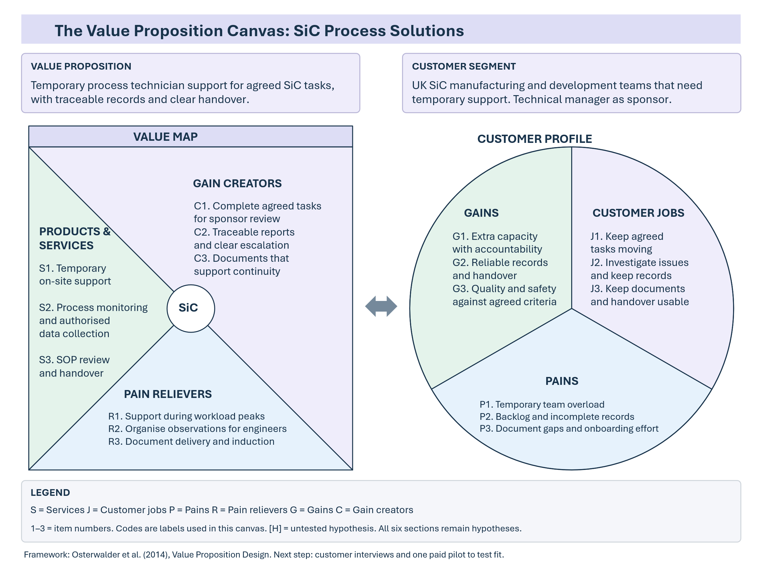

Reference list:

Barney, J. (1991). Firm resources and sustained competitive advantage. Journal of Management, [online] 17(1), pp.99–120. doi:10.1177/014920639101700108.
Barringer, B.R. and Ireland, R.D. (2021). Entrepreneurship: Successfully launching new ventures. [online] Pearson. Available at: https://www.pearson.com/en-gb/subject-catalog/p/entrepreneurship-successfully-launching-new-ventures-updated-global-edition/P200000003660 [Accessed 11 Oct. 2026].
Department for Science, Innovation and Technology (2023). National semiconductor strategy. [online] UK Government. London: UK Government. Available at: https://www.gov.uk/government/publications/national-semiconductor-strategy/national-semiconductor-strategy [Accessed 11 Oct. 2026].
European Commission (2023). Digital sovereignty: European chips act enters into force. [online] Digital Strategy. Available at: https://digital-strategy.ec.europa.eu/en/news/digital-sovereignty-european-chips-act-enters-force [Accessed 11 Oct. 2026].
HM Revenue & Customs (2025). Check employment status for tax (CEST). [online] Available at: https://www.gov.uk/guidance/check-employment-status-for-tax [Accessed 11 Oct. 2026].
Infineon Technologies (n.d.) SiC modules vs. silicon modules: which is the right choice? Available at: https://www.infineon.com/product-information/sic-modules-vs-silicon-modules-which-is-the-right-choice (Accessed: 11 October 2026).
Kimoto, T. and Cooper, J.A. (2014). Fundamentals of Silicon Carbide Technology. John Wiley & Sons [online] doi:10.1002/9781118313534.
Osterwalder, A. and Pigneur, Y. (2010). Business model generation: A handbook for visionaries, game changers, and challengers. [online] John Wiley & Sons. Available at: https://uat.store.wiley.com/en-us/business-model-generation-a-handbook-for-visionaries-game-changers-and-challengers-p-9781118656402 [Accessed 11 Oct. 2026].
Osterwalder, A., Pigneur, Y., Bernarda, G. and Smith, A. (2014). Value proposition design: How to create products and services customers want. Hoboken, New Jersey: Wiley.
Sarasvathy, S.D. (2001). Causation and effectuation: Toward a theoretical shift from economic inevitability to entrepreneurial contingency. Academy of Management Review, [online] 26(2), pp.243–263. doi:10.5465/amr.2001.4378020.
Shane, S. and Venkataraman, S. (2000). The promise of entrepreneurship as a field of research. Academy of Management Review, [online] 25(1), pp. 217–226. doi:10.5465/amr.2000.2791611.
Shepherd, D.A. and Patzelt, H. (2021). Entrepreneurial strategy: Starting, managing, and scaling new ventures. Cham: Palgrave Macmillan.
STMicroelectronics (2024). STMicroelectronics to build the world’s first fully integrated silicon carbide facility in Italy. 31 May. Available at: https://newsroom.st.com/media-center/press-item.html/c3262.html (Accessed: 11 October 2026).
Teece, D.J. (2010). Business models, business strategy and innovation. Long Range Planning, [online] 43(2–3), pp.172–194. doi:10.1016/j.lrp.2009.07.003.
Vishay Intertechnology, Inc. (2026). Form 10-Q. [online] Investor Relations. Vishay Intertechnology, Inc. Available at: https://ir.vishay.com/node/21616/htm [Accessed 11 Oct. 2026].

