Marketing Management (LCMB7001)

Atheena Mary George (2131566)

Assignment – 75%

Contents
1. Introduction 3
2. Company Overview 3
3. Communication in organisations 3
3.1 Shannon and weaver model of communication 4
3.2 Integrated Marketing Communications 5
4. Promotional Strategies for raising brand awareness 5
4.1 Online promotions 6
4.2 Offline promotions 7
5. Brand Equity 8
5.1 Keller’s Brand Equity Model 8
5.2 Applying Keller’s Brand Equity Model to Samsung 9
5.3 Advantages and disadvantages of Keller’s Brand Equity Model 10
6. Customer Journey and touch points 11
7. Total Engagement model 13
8. Conclusion and Recommendations 14
References 15

1. Introduction
Customer journey and communication channels in organisations are considered an integral part of marketing management. This assignment will focus on these aspects of marketing management with respect to Samsung. In order to improve the focus of the assignment, the flagship smartphone section of the company will be analysed in this report. The aim is to identify different communication models and brand equity models utilised by organisations. It also intends to analyse the customer journey of the flagship smartphone customer of Samsung along with providing recommendations for different marketing strategies. Different theoretical models will be applied in the case of Samsung to analyse the marketing strategies of the company and also to understand more about the theoretical models.

2. Company Overview
Samsung is a multinational company based in South Korea with major operations in consumer electronics. The company was born in 1938 as a trading company and the company entered the electronics market in the 1960s. In 1987, the death of the founder of the company lead to the company splitting into five business groups. The Samsung group that we now know was born during this split. The operations of the company in the electronics market are under the affiliate name Samsung Electronics. This company has operations in different electronic segments ranging from house appliances to laptops (Samsung, 2022). The company runs with the mission to devote its talent and technology to create better products and services that contribute to global society.
Among the operations of Samsung Electronics, the smartphone business of the company is one of the most profitable ventures. Samsung is the leading smartphone manufacturer in the world with a market share of 22 per cent for the first quarter of 2022 (IDC, 2022). Among the smartphone lineup of the brand, the flagship smartphones stand out and occupy a major part of the income generation. The brand always promotes the flagship smartphones differently with specialised marketing campaigns.

3. Communication in organisations
Organisational communication can be defined as a method of expressing concerns, and issues within the organisation as well as it helps to create a stronger bond in the organisation (Abu Dalal et al., 2022). It is an effective part of the working of an organisation because communication has played a role in developing more engagement in the company. Workplace conflicts and other problems can be eliminated through the better communication skills of the employees. Internal and external communication is part of organisational communication, in which internal communication helps to communicate with the employees, and managers whereas external communication is more productive talks with the customers and other stakeholders of the organisation.

3.1 Shannon and weaver model of communication
According to Kubota (2019), Shannon and weaver's model of communication is best to explain the path of communication between the sender and receiver. It can be analysed in detail through the support of this communication model. Generally, the Shannon and weaver model of communication model is known as the mother of all models. Claude Shannon and Warren Weaver developed this communication model which is also famous in the name of the mathematical model of communication and information theory. There are seven key steps are behind this model for explaining the concept of communication. The below figure is demonstrating the seven key concepts of this model in a pictorial way. An information source named sender, a transmitter named encoder, a medium for the communication passage named channel, a reception called decoder, a final destination or receiver, and finally response named feedback (Lee and Kim, 2018).
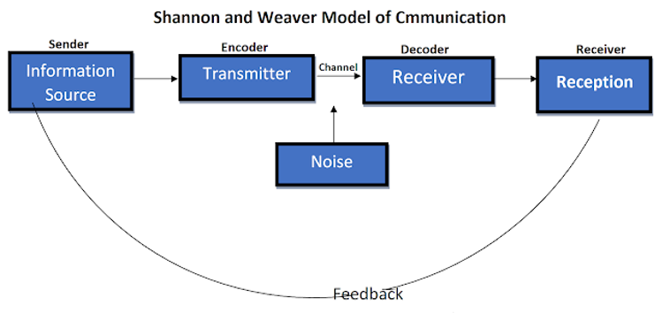
Figure 1: Shannon and weaver model of communication
Source: Adopted from Kubota (2019)
Based on this model, communication can be improved by eliminating the noises that occur in between the process of communication. Noise is an interrupting factor in communication which can be either internal or external. However, this identification of the source of noise can help to smoothen the communication process (Xu and Zhang,2021). In addition to this, this Shannon and weaver model of communication is well applicable for organisational and personal communication. Expect from the other communication model, this model is facilitating the feedback facility where the sender can able to receive feedback from the receiver about the communication process.

3.2 Integrated Marketing Communications
As the name indicates integrated marketing communication (IMC) is integrate the communication tools used in the marketing of products and services. Public relations, social media, advertising, business development, direct marketing, audience analytics, and sales promotions are the different types of communication elements normally found in marketing. As per the study of Kushwaha et al. (2020), integrated marketing communication primarily aims to provide better experiences to the customers of an organisation and it can be accounted as a marketing strategy to attract customers. With the support of this integrated marketing communication, the organisation can combine its various channels and provide an integrated message to the customer. Rather than providing the message in different channels, it will be better to unify the messages into a common platform.
It is one of the methods used to enhance brand trust and brand experience among the customers. This integrated communication model delivers the messages to their customers in a single channel which creates a large impact on the customers. The trust towards the brand can be increased through this (Kwangyong et al., 2021). A good explanation of the features and characteristics of the products and services will lead to increased brand trust and thereby improved sales performance in the organisation. Compared to other older traditional methods, this integrated communication model is facilitating an effective and good way of communication in both personal communication and business communication.

4. Promotional Strategies for raising brand awareness
Brand awareness is an important part of the smartphone market as it determines the exposure of the company among the customers. Samsung is one of the most popular smartphone brands in the world but still marketing is necessary whenever a new product is launched. The release of flagship smartphones is an important event for smartphone companies as flagship phones are considered the face of the smartphone lineup of that particular company. Thus creating awareness about the product is important to ensure good business. The promotions for increasing brand awareness are mainly carried out through two channels and they are online and offline.

4.1 Online promotions
Over the last decade, online promotions have overtaken offline promotions in almost all sectors. According to Zhou et al. (2017), online promotions are more effective in the sense that they can reach more customers. It can also be noted that online promotions are more valuable for the money spent on them compared to offline promotions. Samsung already has a strong presence on all social media platforms with access to millions of customers across the world. The company can adopt the following methods to increase the awareness of the flagship smartphones through online channels.
Influencer marketing: The influencer marketing industry is growing at a rapid pace. As per the reports of Global News Wire (2022), the influencer marketing industry is expected to reach 2.85 billion dollars by 2025. Influencer marketing turns out to be very effective than other modes of social media marketing methods as they exhibit higher retention ratios and reach. Samsung can collaborate with influencers from technology and non-technology background for the launch of their flagship smartphones. Promoting through non-tech influencers increases the exposure of the products among people other than tech enthusiasts. It can also create an image of something that is part of daily life through non-tech influencers.
Using VR: The possibilities VR can be used to get the customers more familiar with the products. A dedicated webpage can be added to the official online store of the company where the customers can closely interact with the devices. An option of experiencing the phone with the help of VR can also be added and this allows the customers to get familiar with the design and user interface of the smartphones. Not being able to experience the product before purchasing is one of the major drawbacks of online shopping (Becker and Jaakkola, 2020). The inclusion of VR in order to give a virtual preview to the customers overcomes this limitation to an extent.
Unique social media campaign: The social media campaign for the products should stand out from the rest and this should be accompanied by a tagline that depicts how the Samsung flagship stands out from other flagship smartphones in the market. The focus should be given to producing unique content catering to different social media platforms. In the opinion of Zulfikar and Mayvita (2019), video content is more appealing to the current social media users. Therefore the company should try to push more ads through social media platforms that give importance to videos like Youtube, Instagram and Facebook.
Conducting contests: It is important to build hype and increase excitement among the customers prior to the launch of the product. Arranging contests in relation to the product lineup is a good way to increase the anticipation of the customers. Appropriate rewards should also be given to these contests so that the participants are satisfied with the experience. The top winners of the contest can be provided with discounts on the newly launched product. This ensures that the reward is converted to the sale of the product. Additionally, other products of Samsung such as earbuds and smartwatches can be added to the rewards that can be acquired through purchasing the new products. These contests can be contested through its official website and social media handles of Samsung.

4.2 Offline promotions
Even though online promotions have undertaken offline promotions by quite a margin, online promotions cannot be neglected. There is a section of the customers that still prefer to purchase smartphones in the old fashion way (Lee et al., 2021). These are mostly middle-aged or old customers of the company and Samsung has a strong foothold in this section. Thus the company can adopt the following offline marketing strategies to enhance the brand awareness of the flagship smartphones.
Exclusive variants in physical stores: The flagship smartphones usually launch in different colour schemes in order to cater to the tastes of different customers. The company can reserve one or two of these colour variations for the offline stores. This ensures that the customers who prefer those colours have to visit the physical stores to buy these products. Such a move will ensure that the sales through the physical stores happen.
Print Advertising: Promotions with the help of print media are one of the most common offline marketing methods. The company can do full-page ads in major newspapers in every region announcing the release of the smartphone. This ensures that the exposure of the smartphone reaches a major chink of customers who do not have access to the internet or cannot be connected with the help of online marketing. Along with newspapers, other sources can also be used like distributing pamphlets about the new smartphones including all the specifications and unique features in major cities. Such strategies can be more beneficial in countries with a high populations like India and China.
Sponsoring tech events: the interest of people in technology has grown over the past decade and this has resulted in a big community of tech enthusiasts. These tech enthusiasts come together in technology festivals organised by various organisations where they can get to know about the latest happening in the world of tech. Samsung can either arrange such an event by itself and/or sponsor a tech event conducted by some other organisers. Both of these activities ensure good exposure for the products, especially among the tech enthusiast communities. There is also a high chance that these events are going to be attended by technology analysts.
Interactive offline store experience: Similar to the web store of the company, the physical stores can also be revamped as part of the launch of the new products. The branding around the store should mainly focus on the new lineup of smartphones. The brand can also make the shopping experience more interactive for the customers by playing demo videos and contests surrounding the stores.

5. Brand Equity
Brand equity is a well-known term used in marketing in relation to the value of a brand. According to Keller and Brexendorf (2019), brand equity defines the worth of a brand as per the perception of the majority of customers. The brand equity of a brand is formed over years of operations and is influenced by multiple factors. Companies that have a good reputation among their customers are more likely to have good brand equity. Samsung is one of the most valued brands around the world and it is also true for the smartphone market.

5.1 Keller’s Brand Equity Model
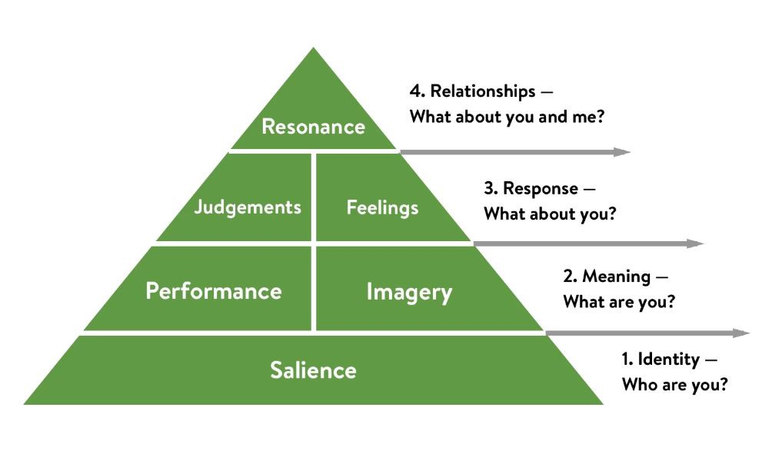
Figure 2: Keller’s Brand Equity Model
Source: Adopted from Phung et al. (2019)
Brand equity is the evaluation of the brand value concept and brand value elements (Phung et al., 2019). The models which focused on explaining the brand value concepts and significance of the brand building are widely using the business marketing, however, Keller’s Brand Equity Model is one of the models explaining brand value development and brand marketing. Sometimes this Keller’s Brand Equity Model is also known as the customer-based brand equity model which was developed by Kelvin. Çınar (2020) mentioned that, strong brand equity can be developed with the support of Keller’s Brand Equity Model which ultimately aims to increase brand awareness among the customers. Keller’s Brand Equity Model is consisting of four levels or phases which explain the nature and behaviour of the customers towards the purchasing of the products and services from the brands. Brand identity, brand meaning, brand response, and resonance are the four stages of this model arranged in a pyramidal shape shown below figure. The main application of this model is to identify and evaluate the brand from the perspective of customers. This brand equity identification and brand value creation are producing significant growth in the sales performance of the organisation (Beig and Nika, 2019).

5.2 Applying Keller’s Brand Equity Model to Samsung
Brand Salience: This refers to the identity of the brand in the perception of the customers. The Samsung smartphones are reliable, value for money and of good quality. The company has been able to maintain these things for all their smartphones and over time these features have contributed to the identity of the brand. Samsung has adopted product positioning and positioned the brand based on product characteristics such as quality, reliability and reliability.
Performance/Imagery: The customer satisfaction among the customers of Samsung are high due to which they also have a high customer retention ratio. The company has been able to build a loyal customer base for its smartphones especially in its home country South Korea. The design of the flagship Samsung smartphones always stands out from the rest. They are identified as classy yet simple by the customers. Often other phone brands copy the design language of Samsung smartphones.
Brand Response: Samsung is the biggest seller of smartphones around the world which itself indicates the response towards the brand. Additionally, the ratings from customers for the flagship models have mostly been positive. Samsung smartphones have also been positively received by technology experts.
Brand Relationship: This depicts the relationship between the customers and the brand. Samsung is one of those companies that consider the feedback from the customers. The company also provides excellent support and services to its customers which strengthens the relationship with the customers. In addition to this, the company also has effective loyalty programs through which customers are provided special discounts and exchange offers on their old Samsung phones.

5.3 Advantages and disadvantages of Keller’s Brand Equity Model
The brand equity models are nowadays widely used across all companies as part of their marketing strategies. The brand awareness creation and development of brand knowledge can be enhanced through this application of the brand equity model. In the case of Keller’s Brand Equity Model, it helps to increase brand awareness as well as brand loyalty, which is essential for the growth and high performance of the companies (Alexandra and Cerchia, 2018). Moreover, this model has been utilised for creating a good relationship with the customers by understanding their choices in purchasing and approaching a brand. This helps to increase brand loyalty among the customers. In this present study also, it can be applicable for explaining the customer relationship and loyalty to the brand.
However, the emotional choices of a customer in purchasing a product are not explained in Keller’s Brand Equity Model. This can be accounted as a weakness of this model. Because emotional attachments are closely related to the customers when they make purchasing and choose a brand. Likewise, the promotion and other advertisements need higher investments as part of creating the brand equity in the brand (de Oliveira et al., 2018).

6. Customer Journey and touch points
Awareness: The first stage in the journey of the customers is the awareness phase. In this phase, the customer identifies the problem that they have and tries to find the solution for it. Most of the awareness about the Samsung flagship products is made through online ads.
Consideration: In the second stage, the customers evaluate the options in the market and this mostly happens through e-commerce websites. The smartphones from Samsung provide better value for money than its customers and this is a favourable factor during the consideration phase.
Purchase: In this stage, the customer decides on whether to buy the device or not. Once the marketing team identifies that a customer is willing to make the purchase then that lead is transferred to the sales team. The sales team tries to help the customer through the purchasing stage. The offers and benefits provided by the company are also beneficial in this stage.
Retention: After the purchase of the smartphone the customer becomes part of the Samsung family. It is important to ensure that a customer is retained and becomes a loyal member to build a strong customer base (Alkitbi et al., 2020). The loyalty programmes offered by the company help in retaining customers.
Advocacy: After the customer has turned into a loyal and satisfied customer of the brand, the advocacy follows naturally. The customer spreads positive word of mouth about the product and this act as a strong marketing tool for the company.

 | Awareness | Discover | Purchase | Retention | Advocacy
Customer Activities | Hear from friends.  Seeing ads online, newspapers | Find other alternatives.  Compare with alternatives | Add to the cart  Place the order | Contact the brand with complaints | Recommends the product to friends and family
Customer goals | No goals | Find the best product in the market | Purchase without difficulties | Get help | Share feedback
Touchpoints | Social media | e-commerce websites, physical stores | Official website, physical stores | Phone, email, chat | Word of mouth, social media
Experience | Interested | Confused | Excited | Worried | Satisfied
Business goal | Capture the interest of customers | Emerge as the best option in the market | Ensure seamless purchasing | Quick response and solutions to the problems of the customer | Amplify the feedback from the satisfied customers
Organisational activities | Marketing campaigns through online and offline channels | Provide the best value for the money paid by customers | Provide support to the customers through sales team | Build an effective customer service team | Marketing team develops campaigns to give exposure to the satisfied customers
Responsible Department | Marketing | Marketing, Product development | Sales, Logistics | Customer Service, Logistics, Product repair | Marketing, Customer service
Table 1: Customer Journey Map
Along the journey of the customer, there are certain points in which the customer interacts with the brand and these points are called customer touchpoints (Maechler et al., 2016). Before the purchase of the products, the main interactions happen through the official website and the social media handles of the brand. The purchase of the smartphone can happen through an official website, e-commerce websites or physical stores. These form the purchase touchpoints for the customers. The customers that are satisfied with the service of the brand take part in the exclusive membership programs arranged by the company and these constitute the after purchase touchpoints.
The main strengths of the Samsung customer journey map is the marketing of the company especially through online channels like social media and websites. The customer service of the company also acts as a strength. The main weakness of the map comes in the form of competitors. In the comparison phase, the product has to face stiff competition from brands like Apple. The social media handles and official website of the company have been successful touch points for the customers. On the other hand, the physical stores and email services are unsuccessful attempts.

7. Total Engagement model
The total engagement model focuses on bringing together different segments of an organisation to achieve a deeper connection with the customers. The marketing, mission, culture, management, services and every other aspect of the organisation come together in the Total Engagement model. This ensures that the relationship between the customer and the brand is not one-dimensional. In traditional systems, the relationship gets limited between the customer service department and the customers (Roberts and Alpert, 2015).
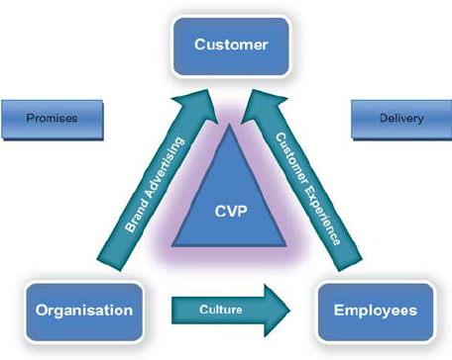
Figure 3: Total Engagement model
Source: Adapted from Roberts and Alpert (2015)
In the case of Samsung, the relationship with the customers does not end with the customer service. The management is designed in such a way that the feedback from the customers reaches the top management and also the research and development. This is evident from the products that the company launches every year. Additionally, the company has a strong community of customers on its social media platforms.

8. Conclusion and Recommendations
The analysis of the case of Samsung indicated the importance of marketing management in driving sales of a company. Different theoretical models were also evaluated as part of the report such as the Shannon and weaver model of communication, Keller’s Brand Equity Model and the Customer journey map. These models contributed to the evaluation and identified different aspects of the marketing activities of Samsung with respect to the flagship smartphone products of the company. It has been identified that its flagship smartphones of Samsung are among the leading performers in the market and the marketing done by Samsung is one of the main contributors to this performance. Samsung can adopt the following methods to improve its marketing:
- Samsung can improve its online presence of the company by adopting AI.
- Improve the design of the website for making it user friendly.
- Making use of influencer marketing opportunities.

References
Abu Dalal, H.J., Ramoo, V., Chong, M.C., Danaee, M. and Aljeesh, Y.I. (2022) The impact of organisational communication satisfaction on health care professionals' work engagement. Journal of nursing management, 30(1), pp.214-225.
Alexandra, Z. and Cerchia, A.E. (2018) The Influence of Brand Awareness and Other Dimensions of Brand Equity in Consumers Behaviour: The „Affordable Luxury” Strategy.“. Ovidius” University Annals,. Ovidius Univ Annal Economic Sci Series, 18(1), pp.222-427.
Alkitbi, S.S., Alshurideh, M., Al Kurdi, B. and Salloum, S.A. (2020) October. Factors affect customer retention: A systematic review. In International Conference on Advanced Intelligent Systems and Informatics (pp. 656-667). Springer, Cham.
Becker, L. and Jaakkola, E. (2020) Customer experience: fundamental premises and implications for research. Journal of the Academy of Marketing Science, 48(4), pp.630-648.
Beig, F.A. and Nika, F.A. (2019) Brand experience and brand equity. Vision, 23(4), pp.410-417.
Çınar, K. (2020) Customer Based Brand Equity Models in Hotel Industry: A Literature Review. Strategic Innovative Marketing and Tourism, pp.281-288.
de Oliveira, M.O.R., Stefanan, A.A. and Lobler, M.L. (2018) Brand equity, risk and return in Latin America. Journal of Product & Brand Management.
Global News Wire (2022) Influencer Marketing Market Projected to Touch 2.85 Billion by 2025, Grow at a CAGR of 8% - Report by Market Research Future (MRFR) Available at: https://www.globenewswire.com/en/news-release/2022/06/16/2463755/0/en/Influencer-Marketing-Market-Projected-to-Touch-2-85-Billion-by-2025-Grow-at-a-CAGR-of-8-Report-by-Market-Research-Future-MRFR.html (Accessed: 02 August 2022)
IDC (2022) Smartphone Market Share Available at: https://www.idc.com/promo/smartphone-market-share (Accessed: August 2022)
Keller, K.L. and Brexendorf, T.O. (2019) Measuring brand equity. Handbuch Markenführung, pp.1409-1439.
Kubota, M. (2019) What is “Communication”?―Beyond the Shannon & Weaver’s Model―. International Journal, 13(1), pp.54-65.
Kushwaha, B.P., Singh, R.K., Varghese, N. and Singh, V.N. (2020) Integrating social media and digital media as new elements of integrated marketing communication for creating brand equity. Journal of Content, Community & Communication, 11(6), pp.52-64.
Kwangyong, S., Shen, Z., Shin, H., Zhang, S., Chen, K. and Li, L. (2021) The mechanism of how integrated marketing communications influence on the Chinese online customer’s repurchase intention. Science Journal of Business and Management, 9(1), pp.26-38.
Lee, N. and Kim, Y. (2018) A conceptual framework for effective communication in construction management: Information processing and visual communication. In Construction Research Congress 2018 (pp. 531-541).
Lee, S.Y., Son, Y. and Oh, W. (2021) Effectiveness of integrated offline-and-online promotions in omnichannel targeting: A randomized field experiment. Journal of Management Information Systems, 38(2), pp.484-516.
Maechler, N., Neher, K. and Park, R. (2016) From touchpoints to journeys: Seeing the world as customers do. Retrieved March, 18, p.2017.
Phung, M.T., Ly, P.T.M. and Nguyen, T.T. (2019) The effect of authenticity perceptions and brand equity on brand choice intention. Journal of Business Research, 101, pp.726-736.
Roberts, C. and Alpert, F. (2015) Strategic drivers of customer and employee engagement: practical applications. In Customer Engagement (pp. 189-210). Routledge.
Samsung (2022) Where it all began Available at: https://www.samsung.com/us/about-us/leadership-and-mission/heritage/ (Accessed: August 2022)
Xu, H. and Zhang, L. (2021) Urban Interactive Installation Art as Pseudo-Environment Based on the Frame of the Shannon–Weaver Model. In International Conference on Human-Computer Interaction (pp. 318-336). Springer, Cham.
Zhou, Y., Kim, D.W., Zhang, J., Liu, L., Jin, H., Jin, H. and Liu, T. (2017) Proguard: Detecting malicious accounts in social-network-based online promotions. IEEE Access, 5, pp.1990-1999.
Zulfikar, R. and Mayvita, P.A. (2019) Does Green Economy Video Really Work? The Effectiveness of Using Video Content Marketing in Forming MSMEs Perception and Behavior to Implement Green Economy. JEMA: Jurnal Ilmiah Bidang Akuntansi dan Manajemen, 16(1), pp.34-45.

