Liam Jenkins (2502497)

Computer networks and cyber secuirty
(Networks and cyber security)

Contents
Introduction 2
Modern cyber threats 3
Modern security policies 5
Technical mitigation measures 7
Continuous training and awareness 8
Conclusion 9
Reference list 10

Introduction

Throughout this report modern threats in the digital landscape will be outlined alongside modern security policies that will align with the zero-trust model, these policies will be developed for a medium sized financial company so there is a clear target of what needs to be achieved. Specific mitigation measures will be proposed that are reasonable for the companies’ specific requirements and size, a plan that allows for 24/7 monitoring and incident response will also be outlined with diagrams aiding in explanation. Finally, a suitable and realistic training program will be described focusing on attack simulation to promote a security aware culture.

Modern cyber threats

In the current age nearly every aspect of life involves the use of technology, from grocery shopping, how society communicates, healthcare systems and most importantly finances. [1]. The simple fact is businesses today need to ensure high familiarity with digital threats in the modern landscape.

Due to the nature of the financial sector, which holds large amounts of sensitive data for customers, manages substantial funds and like other businesses operate within an environment with heavy utilisation of digital tools, make them a valuable high value target for bad actors [2].

In 2023 the financial sector recorded a sixty four percent increase in ransomware attacks [2], ransomware attacks can be simplified into three steps, a bad actor will establish control of a network, this allows for malicious encryption software to be installed. The ransomware then locks all data cross a network making it inaccessible, finally payment is demanded usually in the form of cryptocurrency [3].

Due to the fact ransomware can make people money there is a cyber crime model where developers sell ransomware tools to other hackers, this is called ransomware as a service (RaaS), hackers can use this service making it easier for them to undertake malicious acts, making ransomware being involved in 20% of all cyber crime incidents [4].

Phishing is another form of cyber crime, which aims to steal sensitive information. They attempt to act as a trusted party to gain sensitive information, it can lead to more serious attacks such as ransomware being installed [5].

AI is being increasingly used in vishing attacks, where voice based phishing attempts to impersonate trusted party’s to obtain sensitive information [6]. These attacks are highly effective due to human vulnerability with humans being involved in 80-90% of all successful cyber attacks in some form, AI voice cloning makes credibility easier to obtain and enables high scale social engineering attacks such as AI Vishing-as-a-Service [7].

Another form of cyber attack is a supply chain attack, it happens when a product, service or technology that has been supplied has been breached or compromised. This means when using third part IT services you must ensure they have appropriate security measures and comply with all relevant legislation [8].

As organisations shift toward cloud adoption has shifted the nature of cyber threats and protection requirements of businesses. Due to cloud computing if an account is hijacked due to weak credentials, since the cloud is centralized one account may provide attackers with extensive control over cloud resources allowing for the manipulation of data or deployment of malware unnoticed. Cloud services are also prone to denial of service (Dos) attacks, which flow large amounts of fake traffic rendering whatever is on the cloud inaccessible to real users [9].

Since Covid-19 hybrid work has become more commonplace, meaning more people work from home more often. Since a lot of the time employees will opt to use their own devices, it makes them more prone to password theft and malware. Home Wi-fi is rarely secured with firewalls nearly unheard of for home networks making them much more attack prone which is a problem when sensitive company data is being accessed [10].

Modern security policies

Financial organisations require clearly defined cybersecurity policies to ensure employers follow correct practices, so a clear outlined set of policies is required so employees can abide by them. The zero-trust model assumes breach and continuously verifies all requests no matter the origin [11]. To align with this all users, devices and applications must be verified continually before access to company systems or data is granted. Access controls should be implemented along with MFA being mandatory across all systems via use of Microsoft authenticator across employee accounts.

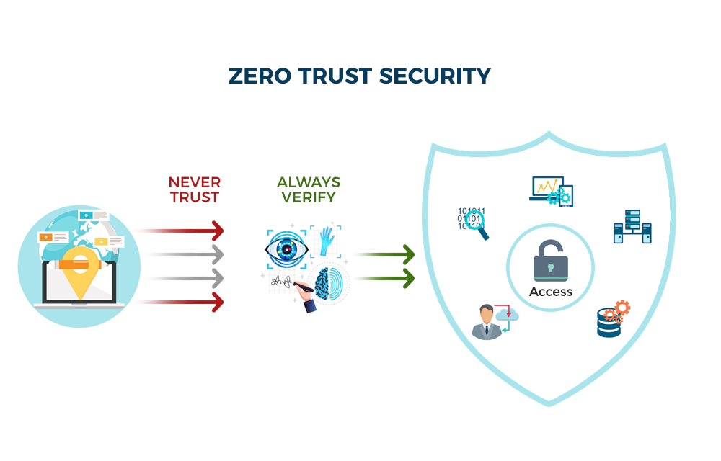[12]

Policies should also align with NIST framework for risk management, NIST is based on four main ideas, identify, protect, detect, respond, recover. NIST recognises that third party companies and suppliers add additional risk as part of cybersecurity. Third-party suppliers must comply with the same security standards, accountability requirements and incident reporting procedures as VTAM. The NIST CSF gives businesses a structure for safely managing outside companies and dealing with any cybersecurity risks and incidents [13] NIST functions of identify, protect, detect and recover will be followed to manage cyber security risks and maintain resilience of the business. All third-party suppliers must comply with the company’s security standards and complete annual security assessments while immediate reporting any cybersecurity incidents and breaches.

Policies should align with ISO 27001, one of the world’s most widely used information security system standards. The ISO 27001 standard provides companies of all sizes and sectors guidance for establishing, implementing, maintaining and constantly improving an information security management system, this is key for holding sensitive customer data [14]. ISO 27001 aims to protect three aspects of information including confidentiality, integrity and availability of information [15]. VTAM policies will maintain an ISO 27001 aligned information and security management system to ensure maintained and continuous improvement of information security controls.

Technical mitigation measures

An integrity policy should protect against unauthorised modification of files; access logging should be implemented alongside permission management this can be achieved through role-based access controls and SIEM logging system that monitor file access and modification attempts [16]. The policy should allow for critical systems and data to remain accessible implementing backup systems, disaster recovery planning and redundant infrastructure, to achieve these encrypted backups should be stored both on site and within a cloud storage system.
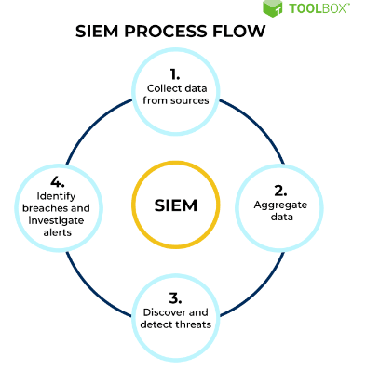[17]

End point protections and network segmentation should be implemented to reduce the impact of ransomware attacks. Endpoint detection and response software can isolate infected devices automatically [18], while network segmentations limits movement across the network [19].
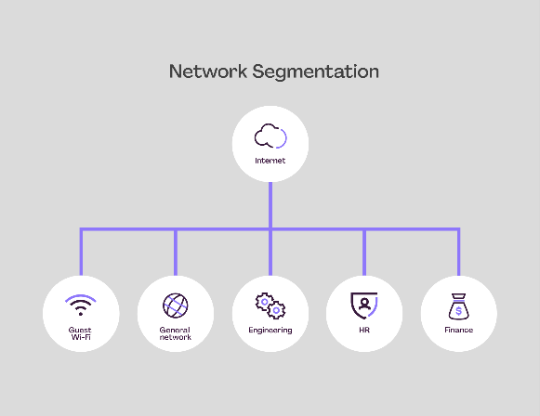[20]

Employees must complete regular phishing and vishing awareness simulations, such as fake phishing emails to catch people out and any suspicious communications must be reported [21].

Employees working remotely must use company approved VPNs, secure devices and endpoint protection software when accessing corporate systems. While accessing data from home cloud storage may be utilised, for the cloud CSPM should be implemented, this continuously monitors cloud environments for misconfigurations, weak access controls and compliance violations, that could expose sensitive financial data [22].

VTAM should implement 24/7 monitoring systems that continuously analyse network activity and automate threat detections. When there is a cyber incident infected devices should isolate immediately, logs should be preserved for investigation, and systems should be restored via secure backups to minimise disruptions caused.

Continuous training and awareness

Since humans are the main weakness when it comes to cyber security, training must be continuous. Training must ensure awareness of how to avoid and report social engineering attempts.

Training should include quarterly simulated phishing campaigns, AI vishing simulations and if employees fail this, they must attend mandatory refresher training. Training should be created to be role-specific for finance and admin staff.

Employees must be aware that suspicious emails and calls must be reported swiftly. Results from this should be monitored to identify weak areas.

VTAM should implement mandatory cybersecurity workshops that cover secure remote working, password security, MFA usage and the safe handling of sensitive data.

Conclusion

Modern cyber security threats, including ransomware, AI-powered social engineering and cloud-based attacks continue to create significant risks for financial organisations. By implementing zero trust principles alongside frameworks such as NIST and ISO 27001, VTAM can strengthen protection of sensitive customer and financial data. The implementation of technical mitigation measure and continuous monitor through SIEM and ongoing employee awareness training will improve threat detection. Altogether these measure would give a strong confidence in the cybersecurity of the company.

Reference list

[1] E. Myrczik et al., “The impact of digitalisation in everyday life,” ResearchGate, 2024. [Online]. Available: https://www.researchgate.net/publication/391388195_The_impact_of_digitalisation_in_everyday_life. [Accessed: May 5, 2026].
[2] L. Dembosky and J. R. Kelly, “Ransomware in the financial sector,” ABA Banking Journal, Aug. 29, 2024. [Online]. Available: https://bankingjournal.aba.com/2024/08/ransomware-in-the-financial-sector/. [Accessed: May 5, 2026].
[3] National Cyber Security Centre, “What you need to know about ransomware,” NCSC, [Online]. Available: https://www.ncsc.gov.uk/ransomware/home. [Accessed: May 5, 2026].
[4] J. Holdsworth and M. Kosinski, “What is ransomware as a service (RaaS)?,” IBM Think, [Online]. Available: https://www.ibm.com/think/topics/ransomware-as-a-service. [Accessed: May 5, 2026].
[5] B. Naqvi et al., “Mitigation strategies against phishing attacks: A systematic literature review,” Computers & Security, 2023. [Online]. Available: https://www.sciencedirect.com/science/article/pii/S0167404823002973. [Accessed: May 5, 2026].
[6] S. Ahmed et al., “Cybersecurity risk management in modern digital systems: A review,” Information and Management, 2025. [Online]. Available: https://www.sciencedirect.com/science/article/pii/S0885230825000270. [Accessed: May 5, 2026].
[7] M. White, “AI vishing: voice deception and how it works,” Specops Software Blog, Nov. 11, 2025. [Online]. Available: https://specopssoft.com/blog/ai-vishing-voice-deception/. [Accessed: May 5, 2026].
[8] Information Commissioner’s Office, “Supply chain attacks,” Learning from the mistakes of others: A retrospective review, [Online]. Available: https://ico.org.uk/about-the-ico/research-reports-impact-and-evaluation/research-and-reports/learning-from-the-mistakes-of-others-a-retrospective-review/supply-chain-attacks/. [Accessed: May 5, 2026].
[9] Darktrace, “The most common cloud security threats,” Cyber AI Glossary, [Online]. Available: https://www.darktrace.com/cyber-ai-glossary/the-most-common-cloud-security-threats. [Accessed: May 5, 2026].
[10] R. Cremer, B. Sheehan, M. Fortmann, A. N. Kia, M. Mullins, F. Murphy, and S. Materne, “Cyber risk and cybersecurity: a systematic review of data availability,” Cybersecurity, vol. 5, no. 1, 2022. [Online]. Available: https://pmc.ncbi.nlm.nih.gov/articles/PMC9759928/. [Accessed: May 5, 2026].
[11] Microsoft, “Zero Trust overview,” Microsoft Learn, [Online]. Available: https://learn.microsoft.com/en-us/security/zero-trust/zero-trust-overview. [Accessed: May 5, 2026].
[12] Brickwork India, “What is Zero Trust Architecture and How to Build One?,” Brickwork India Blog, Apr. 17, 2024. [Online]. Available: https://www.brickworkindia.com/blog/zero-trust-architecture-and-how-to-build-one. [Accessed: May 5, 2026].
[13] SureCloud, “Using the NIST Cybersecurity Framework for third-party risk management,” SureCloud Blog, [Online]. Available: https://www.surecloud.com/blog-hub/using-the-nist-cybersecurity-framework-for-third-party-risk-management. [Accessed: May 5, 2026].
[14] International Organization for Standardization, “ISO/IEC 27001:2022 – Information security, cybersecurity and privacy protection — Information security management systems — Requirements,” ISO, Oct. 2022. [Online]. Available: https://www.iso.org/standard/27001. [Accessed: May 5, 2026].
[15] Advisera, “What is ISO 27001?,” 27001Academy, [Online]. Available: https://advisera.com/27001academy/what-is-iso-27001/. [Accessed: May 5, 2026].
[16] Microsoft, “What is endpoint detection and response (EDR)?,” Microsoft Security, [Online]. Available: https://www.microsoft.com/en-us/security/business/security-101/what-is-edr-endpoint-detection-response. [Accessed: May 5, 2026].
[17] J. Holdsworth and M. Kosinski, “What is SIEM?,” IBM Think, [Online]. Available: https://www.ibm.com/think/topics/siem. [Accessed: May 5, 2026].
[18] Beazley Security, “Network segmentation and how it can prevent ransomware,” Beazley Security Insights, [Online]. Available: https://beazley.security/insights/network-segmentation-and-how-it-can-prevent-ransomware. [Accessed: May 5, 2026].
[19] Okta, “Phishing campaigns use employee benefits to lure logins,” Okta Threat Intelligence Blog, [Online]. Available: https://www.okta.com/blog/threat-intelligence/phishing-campaigns-use-employee-benefits-lure-logins/. [Accessed: May 5, 2026].
[20] Auvik, “What is network segmentation?,” Auvik FranklyIT Blog, 2024. [Online]. Available: https://www.auvik.com/franklyit/blog/network-segmentation/. [Accessed: May 5, 2026].
[21] Phishr, “The benefits of phishing simulations for employee training,” Phishr Blog, [Online]. Available: https://www.phishr.com/post/the-benefits-of-phishing-simulations-for-employee-training. [Accessed: May 5, 2026].
[22] Microsoft, “What is CSPM?,” Microsoft Security, [Online]. Available: https://www.microsoft.com/en-gb/security/business/security-101/what-is-cspm. [Accessed: May 5, 2026].

