PROFESSIONAL CAREER DEVELOPMENT

Table of Contents
Introduction 1
Lifeline 2
Employment world’s review 3
Self Evaluation 4
Personal Principles and Values 4
SWOT analysis 4
Audit of skills 6
Self-motivation Quiz 7
Style of Learning 9
Essence of learning style 9
Personal learning style 9
Kolb’s “Experimental Learning” 9
Theory of Learning 10
Style of Learning 11
Bruner’s “Discovery Learning” 12
Advantages 13
Disadvantages 13
Objectives 14
Aspirations and Ambitions 14
Evaluating personal capacity and capability 15
Personal development plan 15
Conclusion 16
References 18
Appendix 20

Introduction
Professional career development is a structure that helps an individual to plan his or her future using strategies and approaches. It includes the taking of decisions and planning regarding development of one's career and getting employment. As the employment sector undergoes transition from time to time, one needs to be updated regarding the changes. The approach towards career and employment needs to be aligned to the changes.
The assignment is a kind of portfolio that includes my career development and ambitions regarding starting my personal business. It discusses the steps I have taken to complete my higher education and to prepare for realisation of my ambitions and goals. I have on the way, learnt the required skills of business. An extensive review of the world of employment has been made and I have self-evaluated my skills. In the end, I have provided a personal development plan that I will be following so that my aspirations and dream is fulfilled.

Lifeline
While I had my school holidays, I had worked as a cosmetics and perfume sales representative on a short contract basis at the age of 14. After graduating from school, I started working in one of the largest cosmetics companies in Bulgaria. After working hard for 9 years, I was promoted.
After shifting to UK, I started working as a housekeeper in Grosvenor House Hotel. At first, I struggled but later, I got used to the job. I also enrolled in an agency for another job. For two years, I managed both the jobs. Then, I decided to get self-employed and listed my own cleaning company. In order to focus on my new job, I reduced my working hours in the hotel. After several months of handling hotel job and my own business, I decided to quit hotel and solely focus upon my business.
I have completed NVQ level 2 qualifications in Hospitality Services and had worked as a receptionist for three years. The job was a pleasurable one as I enjoyed tending to guests. This has created my passion for becoming a Hotel Manager.

Employment world’s review
A business firm works according to certain values and principles. While recruiting employees, certain fixed methods have to be followed. This includes formation of a recruitment team at the very beginning. Advertisement regarding vacancy is provided via electronic means like sending out emails, messages, using social websites etc and through physical advertising using printed media like banner, newspaper etc.
Furthermore, government has its own rules and regulations for the business firms. There are fixed legislations that need to be strictly adhered to while recruiting employees. The Sex Discrimination Act of 1975 states that employee must be not discriminated on grounds of gender. Both male and female employees should be treated on an equal basis. The head of the business firm monitors the employment process and makes sure that the processes adopted are transparent, genuine, and unbiased.
In the advertisement, job roles and job description is provided and it includes the minimum educational qualification for applying to a particular job. Sometimes, skill requirement is also mentioned like fluency in English, expertise in MS Office etc. The individual has to apply to those jobs that align with his or her educational background and capability (Linnenbrink-Garcia et al. 2016). This will enable the individual to be placed in the correct job segment. In order to apply for a job, the CV needs to be forwarded to the recruitment team either by electronic means through emailing or by submitting a printed hard copy of the CV.
According to Morgan (2017), it is crucial to understand how employers are develop the selection process and how the decide which candidate is better suited to be interviewed. In order not to discard CV, the application must be well prepared.
The recruitment team will carefully go through the submitted CVs and will sort out the candidates they require for interviewing. The cover letter is very important and should be well written, easy to read and professional. It is of great importance for the opportunity to be successful (Scudamore,2013). The selected candidates are called for interview. In the interview, speaking skill and overall knowledge of the candidates are tested. Selected candidates are forwarded to group discussion exam where oratory skill and problem handling skills are checked. The finally selected candidates have to go through medical tests before receiving the employment letter.

Self Evaluation

Personal Principles and Values
Everyone has a personal set of moral principle and ethical value that varies from one individual to another. This set of morals and values are referred to as ‘principles and values'. Besides possessing job-related skills and capabilities, principles and values are required because these make one sympathetic, generous, and kind towards the peers (Weiss and Johar, 2016). Some values and principles like honesty, sympathy etc are inherent while others like punctuality, empathy etc need to be developed.
The personal values and principles that I possess are honesty, passion, innovativeness and many more. Most of these have been instilled in me by my family and my religious background while others have been learnt from my surrounding. Two major values like positivity and loyalty will be essential for me to survive in my workplace, as these two values will help me to win the trust and respect of my peers and seniors (Özer et al. 2016). This will also boost my chances of securing my job. Creativity will help me to make steady progress in my job because new ideas and thoughts are essential for uniquely performing tasks. Determination will enable me to face the challenges in the workplace and will help me to remain loyal to my personal goal and objectives.

SWOT analysis
Strength | Weakness
- Can handle situations with a cool head  - Hospitality skills  - Pressure handling  - Teamworking  - Creativity  - Ability to learn from mistakes  - Attention to detail | - Time management  - Working to deadlines  - Lack of overall knowledge  - Prone to silly mistakes  - Speaking in public
Opportunity | Threat
- Workshops for learning skills  - In-job training for skill development  - Work experience | - Competitive job sector  - Lack of focus  - Neglecting one’s own weaknesses

Working in the hotel has helped me to tackle efficiently tough and challenging situations with a cool head. While working as a receptionist, I developed hospitality skills as I learnt how to welcome and please guests with good service. Starting my own business has enabled me to learn how to handle pressure. The ability to work wit others shows teamworking skills (Cottrell, 2003).
To been good Hotel manager is important communication skills (Taylor,2017).
Time management has always been my weakness. While working in the hotel, I missed task deadlines and was chided by my senior. I possess a limited knowledge of different things. Often, I commit silly mistakes that should because of haste and end up affecting my job quality. Rushing at the end of the task, being late on not be able to say “No”, Shows how well I use my time (Cottrell,2003).
In the present scenario, there are multiple opportunities for developing one's soft skills. From time to time, workshops are organized for acquiring job-related technical skills. Moreover, in-job training has helped me to develop my receptionist skill. The work experience I possess will help me to realize my dream of becoming a Hotel Manager.
There are times when I lack focus especially when I get used to the job-related activities. I get overconfident and end up committing mistakes. This is why it took me nine years to be promoted in the cosmetics company. Stella Cottrell (2003) sets out ‘People skills’ like very important and critical for the success in the career. The job sector is competitive and offers little space for mistakes. This may prevent me from properly establishing myself as a Hotel Manager.

Audit of skills
Skills I possess | Skill rating (1-10)
Time Management | 6
Hospitality skill | 9
Situational analysis | 7.5
Pressure handling | 7

Table 1: Possession of skills
(Source: Learner)

Skills I need to possess | Skill rating (1-10)
Accepting critics | 8.5
Focus | 9
General Knowledge | 9

Table 2: Skills required
(Source: Learner)
Auditing skills is my own personal rating that pertains to the skills and capabilities I possess. This evaluates both my present career and my future career. It can be seen that I possess average skills where my time management is too bad (Breslin, 2017). This is one particular skill that I need to nurture. However, there is a necessity of more skills especially general knowledge and focus that I need to develop. They have a high priority that will help me in realizing my dream of becoming a Hotel Manager (Cottrell,2005).

Self-motivation Quiz
Qualities | Actively | Occasionally | Average | Seldom | Very Rarely
Agitation |  | 
Sympathy
Time Management
Determination
Communication capacity
Passion
Ambition
Clarity of thought
Self-evaluation
Managing human resources
Table 3: Self Motivation Quiz
(Source: Learner)
The self-motivation quiz has enabled me to analyse my situation that is going to affect my present as well as future career. Presently, I am on the safe side. However, I may not be safe. I need to improve upon time management, and I need to be ambitious (Matteson et al. 2016). I need to have better clarity of thought so that I can take quick and correct decisions.

Style of Learning

Essence of learning style
The education for a human never ends. Learning is a continuous and never-ending process that follows an individual from birth to the grave. Therefore, it is necessary that an individual partly dedicate his or her life towards learning new things. Mere learning will not be enough. One needs to be aware of the needs and restructure the learning style accordingly. According Stella Cottrell (2005) there are various factors that can me learning easy like physical state to learn, enjoying what learn, information is organised and work with others.

Personal learning style
Many models and theories have been postulated related to learning styles. From my childhood, I have never been very good at memorizing. I had always loved experimenting with things, ideas, and knowledge. Therefore, the learning style that will be ideal for me is ‘experimental learning’. This is a kind of ‘self-learning’ where the individual learns whatever is needed all by oneself. However, if required, guidance of experienced persons can be taken. As I like to experiment, I may commit mistakes. At the same time, I may come up with a unique and novel idea (Huda et al. 2017). My dream is to become a Hotel Manager and the domain of hotel management is interrelated to travel and tourism sector. In order to achieve success, I will need to bring in innovation and for innovation, I will need to experiment with ideas, themes and processes related to both the sectors. Unless I bring innovative uniqueness, people will not recognize my capability and my efforts will go in vain.

Kolb’s “Experimental Learning”
Experimental learning involves learning by gaining experiences. It is related to introspections and reflections as the various experiences an individual has contributes towards his or her learning of lessons and new things. The advantages of ‘experimental learning' are:
- Helps in construction of meaning
- Builds upon existing ‘schemas’
- The process of meaning construction becomes active
- Helps in collaboration of experiences and ideas

Theory of Learning
One of the theories of ‘experimental learning’ has been postulated by David Allen Kolb, an American education theorist. His definition of ‘experimental learning’ deals with transformation of grasped experiences into knowledge (Howard et al. 2016). The theory can be explained with the help of the learning cycle that he had developed.
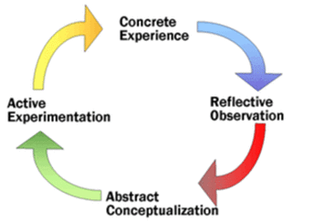
Figure 1: Kolb’s “Experimental Learning Cycle”
(Source: Rogowsky et al. 2015)
Concrete Experience
This is a kind of hands-on experience that is gathered by a learner. Here, the learner steps out of his comfort area and faces challenges. The experience thus gained decides whether the learner will commit the same mistake again or will the mistakes be avoided in near future.
Reflective Observation
This is the stage of introspection and contemplation. Both the feelings and experiences are considered for serious and deep thinking. This is where we ponder upon the gathered experiences.
Abstract Conceptualisation
This is the stage that immediately follows the thoughts and reflections related to experimental results. Plan of action is often devised at this stage based upon the risks revealed and the safety measures that can be adopted.
Active Experimentation
Finally, the learner starts performing experiments after having developed his own plan of action. The hypothetical ideas and concepts are put to test in real situations. This is where abstract ideas and theories receive a concrete form through active experimentation.
Example: Learning to use a sling
Concrete Experience: Observing a person using a sling
Reflective Observation: Understanding working theory of a sling
Abstract Conceptualisation: Approaching the sling user for gathering information about use of sling
Active Experimentation: Using the sling

Style of Learning
The style that an individual will use for ‘experimental learning’ needs to be aligned with the theory itself. The styles differ from one individual to another. For example, a passive person may prefer only to observe and reflect while an active person will love to perform experiments. Kolb has laid down four learning styles that are almost common to every individual.
“Divergence” allows the individual to step away from conventional form and adopts creative means. Activities include brainstorming new ideas. “Assimilation” adopts inductive reasoning through which, thoughts and observations can be integrated. “Convergence” enables the ideas so formed are practically applied and problem-solving method is used. “Accommodation” involves use of trial and error methods rather than simply thinking and reflecting. It is useful in case of changing situations.

Bruner’s “Discovery Learning”
‘Discovery Learning' is based upon enquiry method of learning. It is ‘learner-centric' in nature and is a ‘Constructivist theory'. The learning is consolidated because mere facts and information are not only learnt but are searched through questioning and answering (An and Carr, 2017). It was introduced by the American psychologist, Jerome Bruner. The learners build upon their existing schemas and use their ideas and creative means to search for new information to discover facts and to correlate the facts by forming generalizations. The model follows five principles of learning which are:
Solving the problem
The supervisor has to instruct, guide and motivate the learner regarding finding out the solution to the problem. The role of the supervisor will be that of a ‘facilitator' where no intervention will be made and the learners are to be left alone so that they can themselves search for a solution to the problem.
Managing the learners
The supervisor either allows the learners to learn individually or forms groups of learners. In case of groups, both ‘heterogeneous' and ‘homogenous' groups can be formed. ‘Peer grouping' will be useful too.
Integration and connection
The supervisor will teach the learner how to align the new schema with the existing schema. After the successful alignment, the learner will be taught how to form a connected network between the newly acquired schema and the old schema. This can be done by using the context of familiar incidents and scenarios known to the learner.
Analyzing and interpreting the information
The information so gathered needs to be critically studied and conclusions need to be developed regarding the result of the critical study. While forming a conclusion, it is ideal to generalize' and it must be evaluated in the context of real-life situations.
Feedback
The findings of the students may be wrong and they may fail at their attempt to discover facts. The role of the supervisor here is to provide feedback. In no way can a supervisor discourage a learner because of failure in discovery. The feedback must be constructive and must help the learner to restart the process of discovery with full enthusiasm. Even in case of success of learner in discovering facts, feedback is needed (Li et al. 2015). The feedback provided then is different in the sense that the supervisor advices how to approach the problem in a different manner that is more useful and better suited.

Advantages
- Encourages active involvement of learners
- Motivates the learners and enhances their creativity
- Enables learners to self-pace their learning
- Helps in widening the range of the existing schema of the learners

Disadvantages
- Searching for answers might become a bit confusing for the learner
- It consumes valuable time of instruction of teacher
- A teacher who is not wee-prepared will be unable to address the queries of the learners
In the process of ‘discovery learning’, the supervisor assumes an important role because his or her constant presence at the scene is necessary. The roles are:
Providing probing questions: A learner may be unable to decide upon what is to be discovered. In such cases, supervisor uses probing questions to aid the learner in understanding the area of discovery.
Explaining the problem: There are certain situations where a learner may fail to understand the problem. In this situation, the supervisor needs to explain the problem to the learner so that the learner can understand what the problem is.
Facilitator: The supervisor is the facilitator who indirectly helps the learners towards discovery learning by proving support and motivation.

Objectives

Aspirations and Ambitions
The review of my own potentials has enabled me to hold the post of supervisor in my office. At the age of 14 when I was in school, I was a cosmetics and perfume seller. After graduation, I found a permanent job in a renowned cosmetics company in Bulgaria. I have worked there for 9 years and learned a lot of things. By working hard I have promoted to a better position.
After coming to the UK I was working as a housekeeper in Grosvenor House. At first, the job was difficult but with time, I got used to it and also enrolled for an additional job. Besides I worked as a housekeeping supervisor and cleaning staff. For two years I have worked like this. After that, I became self-employed. I listed a cleaning company and for some months I balanced my work schedule at both the places. At that time I was able to choose my working hours. I also managed some time for myself and my family. It is a great feeling of being our own boss and able to manage our schedule. After working two more years I analyzed the positive and negatives points of employed and self employed. It is found that being self-employed I could choose the work time and with whom I wanted to work. But the disadvantage was there were no leave or holidays. Traveling to different types of job provides me pleasure.
After that, I have realized that it is more satisfactory to again work as a hired worker. After completing NVQ level qualification Hospitality Services I worked as a receptionist which gives me pleasure. My aim in life is to be a hotel manager.

Evaluating personal capacity and capability
By working in the different fields of job I gathered many experiences and also realized the strong points and weak points of mine. My strengths are that I am very much profound and honest about my work. I am a creative person and responsible for my job. Giving up is not in my nature. I try to solve the problems with intelligence. The ability to analyses situation, make effective decision or solve problems that other cannot, identify the effective

Besides the strengths, I also have some weaknesses. There is also a lack of self-confidence in me. Due to that reason sometimes, I am unable to work properly. The fear of making mistakes and failure, fear of speaking in front of the public are creating obstacles in my work. I find that it is really tough to maintain a balance between personal life and professional life. Being a mother, I am also responsible for my family. Besides, I also study. Though it is very difficult to manage all the things at once, However, I have tried my best to obtain high efficiency in the working environment.

Personal development plan
I have some goals in my life. I am trying to gain much knowledge to develop my working skills. The goals of my life can be divided into the following categories:

Short term goals: My short-term goal is to achieve success in CERT HE skills for Workplace level 4. I have to pass the exams. So, I want more time for learning. If I take better preparation, overcome my shyness and fears, rectify my weakness then I feel more confident about my work.

Long term goals: To be a hotel manager is my dream. I want to give my best to make the hotel superior to any other hotels. I want to please the guest by providing the best hospitality services.

Goals | Required skills | Current proficiency | Required improvements | Time
To be a hotel manager | - Knowledge in the commercial field  - Must have the leadership quality  - Have to do teamwork | - Honest and profound about the work  - Hard-working | - Have to overcome the fear of failure  - Increase the level of self-confidence | By the year 2021
Completion of CERT HE skills | - Have to learn more  - Must have good communication skills | - Have good communication skills  - Good writing ability | - Need to give more importance to the study  - Collect more knowledge about the study | 1 year
To develop innovative hotel service | - Good hospitality management  - The friendly environment of the hotel | - Good behavior of hotel staff  - Good working environment | - Use of new technologies  - Improve the profitability of hotels | In 6 months

Conclusion
It can be concluded from the assignment that the effectiveness of eth development plans highly defenders upon personal capacity and capability. Self-evaluation of different characteristics in personal development provides a great opportunity in matching the demand in professional life. It can also be concluded that assessing different strengths and weakness among itself can enhance the personal role in obtaining success. Auditing my skills and self-motivation quiz will allow me to introspect my capacity and capability of doing the job. The skills that are required for future purposes have also been dealt with that will enable me to make smoother progress in my career. The importance of learning and the adoption of a suitable learning style is necessary for me so that I can successfully add up to my existing knowledge. Furthermore, the newly acquired knowledge will help me in realizing my dream of becoming a hotel manager. Aspirations and ambitions are required for succeeding in my life. To prepare myself for a bright future, I have evaluated my personal capacity and capability. Moreover, I have formulated a personal development plan that I will be following to prepare myself for taking full responsibility for my personal business.

References
An, D. and Carr, M., 2017. Learning styles theory fails to explain learning and achievement: Recommendations for alternative approaches. Personality and Individual Differences, 116, pp.410-416.
Breslin, H., 2017. Wittier, cleverer and more ambitious: Moving beyond a standardised approach to skills audit exercises. Spark: UAL Creative Teaching and Learning Journal, 2(1), pp.15-27.
Cottrell, S. (2003) Skills for Success: Personal Development Planning Handbook. Hampshire: Palgrave Macmillan.
Cottrell, S. (2008) The Study Skills Handbook 3rd edition. Hampshire: Palgrave Macmillan.
Howard, J., Gagné, M., Morin, A.J. and Van den Broeck, A., 2016. Motivation profiles at work: A self-determination theory approach. Journal of Vocational Behavior, 95, pp.74-89.
Huda, M., Haron, Z., Ripin, M.N., Hehsan, A. and Yaacob, A.B.C., 2017. Exploring innovative learning environment (ILE): big data era. International Journal of Applied Engineering Research, 12(17), pp.6678-6685.
Lang, G., 2017. Agile learning: Sprinting through the semester. Information Systems Education Journal, 15(3), p.14.
Li, M. and Armstrong, S.J., 2015. The relationship between Kolb's experiential learning styles and Big Five personality traits in international managers. Personality and Individual Differences, 86, pp.422-426.
Linnenbrink-Garcia, L., Patall, E.A. and Pekrun, R., 2016. Adaptive motivation and emotion in education: Research and principles for instructional design. Policy Insights from the Behavioral and Brain Sciences, 3(2), pp.228-236.
Matteson, M.L., Anderson, L. and Boyden, C., 2016. " Soft Skills": A Phrase in Search of Meaning. portal: Libraries and the Academy, 16(1), pp.71-88.
Morgan, P. (2017) The Business Student`s Guide to Study and Employability. SAGE Publications
Özer, E., Hamarta, E. and Deniz, M.E., 2016. Emotional intelligence, core-self evaluation, and life satisfaction. Psychology, 7(02), p.145.
Rogowsky, B.A., Calhoun, B.M. and Tallal, P., 2015. Matching learning style to instructional method: Effects on comprehension. Journal of educational psychology, 107(1), p.64.
Scudamore, P. and Catt, H. (2013) Successful cover letters in a week. Hodder Education

Taylor, D. (2017) 6 Hotel Management Tips for New Hospitality Managers Published August 22nd, Hotel Management, available at: https://blog.capterra.com/hotel-management-tips-for-new-hospitality-managers/ [accessible August 2019]
Weiss, L. and Johar, G.V., 2016. Products as self-evaluation standards: When owned and unowned products have opposite effects on self-judgment. Journal of Consumer Research, 42(6), pp.915-930.

Appendix
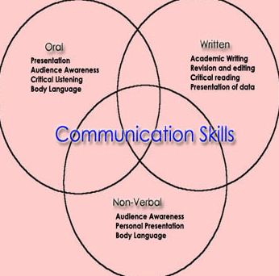
Appendix 1: communication skills

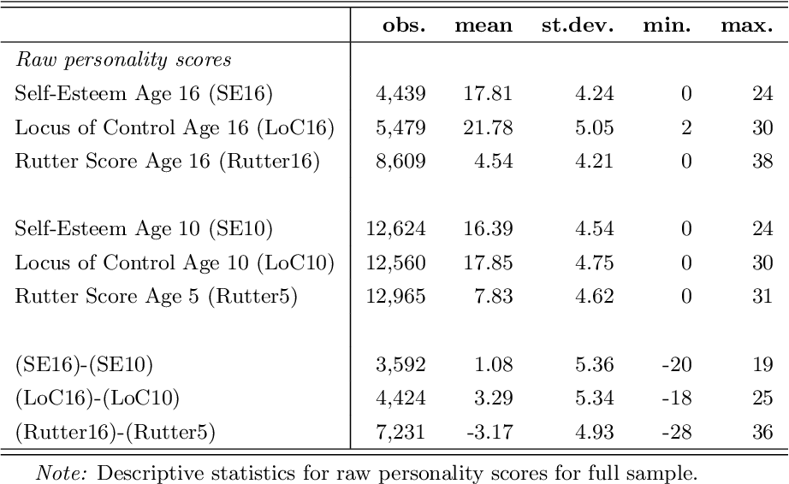
Appendix 2: personality scores

