

ENTREPRENEURSHIP
(LCMB7004)

COURSE: MBA General Management
MODULE CODE: LCMB7004
ASSIGNMENT TITLE: Assessment-1
STUDENT NAME: Muhammed Shah
STUDENT NO: 2131204
Executive summary
This study concerns entrepreneurial theories that help to create entrepreneurship successfully. It concerns economic, psychological, and sociological theories in an aspect of business development. It includes the Theory of leadership, social behaviours and change and the theory of model personality. It also implicates the processes of for-profit organisations inventing entrepreneurship values and beliefs. Entrepreneurship is influenced by social development in personalities. Entrepreneur succeeds in their role expectations in the sanctioning groups and operational requirements.

Table of Contents
Introduction 4
Theoretical sources 4
Discovery theory 5
Creation theory 6
Theory of social behaviour 6
Theory of social change 7
The theory of model personality 7
Theory of leadership 8
Innovation theory 8
Psychological theory 9
Sociological theory 10
Economic theory 10
Differentiates between ‘for profit’ and ‘not for profit small organizations on the
entrepreneur's values and beliefs 11
For-profit Organisations 11
Not-for-profit Organisations 12
Evidence with personal experiences 13
Equanimity 14
Problem-Solving 14
Critical Thinking 14
Effective Communication 15
Summary 15
References 17

Introduction
This study explains entrepreneurship for choosing the business processes and successfully developing important traits with the entrepreneurs. It includes the theoretical perspectives for developing the essential traits and characteristics of entrepreneurs. Entrepreneurs need to develop attributes and motivational factors in the aspect of business success. This study involves the differences between the activities related to profit and non-profit development within an organisation. It is associated with the beliefs and values of entrepreneurs. It includes examples of evidence related to the personal experiences of the entrepreneurs. This study is aligning the entrepreneurship traits of Mark Zuckerberg and his experiences in the internet entrepreneur business.

Theoretical sources
There are different types of theoretical aspects concerning entrepreneurship development for establishing the successful development of the business. As suggested by Wadhwani et al. (2020), it involves major two theories as discovery theory and creation theory. There are many other theories on this aspect which require including in entrepreneurship activities for business development. It includes innovation theory, the theory of social change, the theory of social behaviour, the theory of model personality and the theory of leadership. These entrepreneurship theories are based on the assumptions of different management experts. As mentioned by Claire et al. (2020), entrepreneurship theories focus on the major three perspectives of business development. It includes the nature of the opportunity, the nature of entrepreneurship and the nature of decision-making aspects.
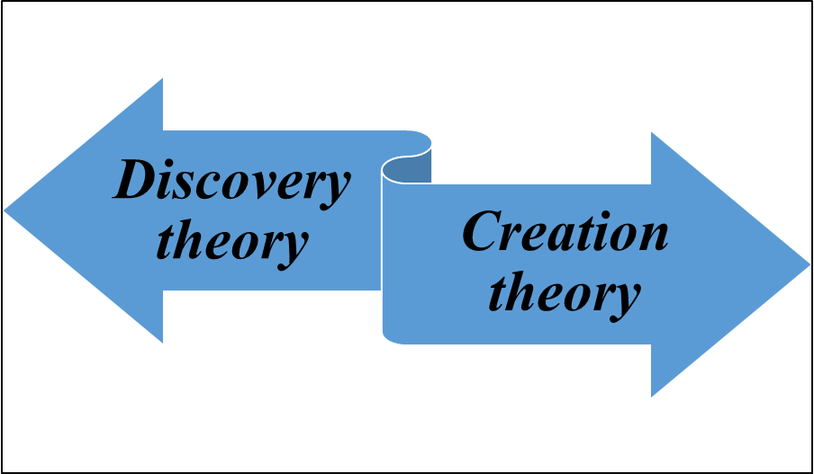
Figure 1: Main theories
(Source: self-developed)

Discovery theory
This theory is assuming the approaches such as opportunity identification, individual influences and risk-bearing entrepreneurship. As suggested by Braver and Danneels (2018), the opportunities and the individuals are dependent on each other for entrepreneurship activities. Opportunities are developed with the identification process of the individuals are placed. This action simultaneously increases entrepreneurial activities due to the existing opportunities. Opportunities are recognised with different capabilities of different individuals. There is no assurance of the success of recognised opportunities for enterprises. Thus, the discovery theory explains on opportunities include objectives; entrepreneurs are risk bearers and entrepreneurs who bear risks. As suggested by Chavoushi et al. (2021), it is developed by satisfying opportunity on the evaluated probability of such individuals being unique.

Creation theory
This theory is focusing on the factors related to the creation of enterprises with three assumptions. These three factors include opportunities related to subjective, opportunities are created by the individuals and individuals do not bears risks rather than bear uncertainty. As suggested by McMullen et al. (2021), Samsung Company is creating opportunities through the development of new products. These products are reasonably successful in the market which helps to increase the improvement of marketability of Samsung products. As suggested by Ahmed et al. (2020), creation theory suggests subjective opportunities, ordinary individuals and uncertainty-bearing entrepreneurs.
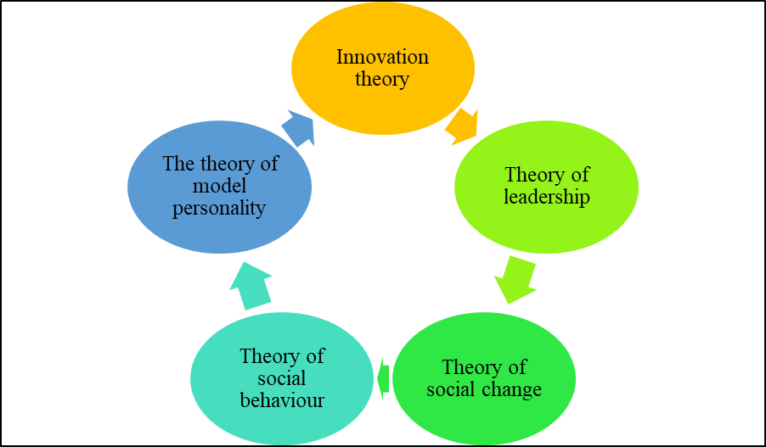
Figure 2: Other theories
(Source: self-developed)

Theory of social behaviour
This theory is suggesting for the actual and effective structures for entrepreneurship. It is concerned with the relations of entrepreneurs to the present and previous surroundings, physical conditions and social structures. There are discrepancies between the actual incidents, objectives and structures of entrepreneurs. As suggested by Tornikoski and Maalaoui (2019), it is developed because of the fact of incorrect or inadequate perceptions. Entrepreneurship is governed by the practices of specific combinations of such circumstances which are generally not available within the environment. As suggested by Pan et al. (2019), entrepreneurship supply is dependent on the structures of four social factors. It involves demand structure, limitation structure, labour structure and opportunity structure. A behavioural model of entrepreneurship is associated with the expressed activities of individuals.

Theory of social change
This theory is based on some invalid assumptions related to business development. It includes invalid assumptions of a single system of Hindu values. As suggested by Barberá-Tomás et al. (2019), internationalised values are translated into day-by-day behaviours. These values are insulted against external changes and pressures. The generation of driving entrepreneurial significance by adopting exogenously provided religious beliefs is important. It is the belief which produces intensive effort in occupational perspectives. As suggested by Bansal et al. (2019), the frequent ordering of means is to the assets accumulation and ends.

The theory of model personality
This theory suggests three performances influencing entrepreneurship. These three factors are attitudes, expectations and operational experiments. As suggested by Boldureanu et al. (2020), social values are the most important factors for the determination of expectations and attitudes toward entrepreneurial roles. This theory mainly deals with the social factors affecting entrepreneurship. According to this model of personality, the entrepreneur is not a super normal individual or deviant person whereas; it represents the social model of personality. As suggested by Vodă and Florea (2019), the encouragement of the entrepreneur is assumed to be a profitable factor of risky behaviour. Profit development procedures are expected to assume within the managerial functions of the business. This theory fails to incorporate the requirements for profit achievement.

Theory of leadership
Entrepreneurship is the functionalities related to leadership, skills and management. It also includes the financial factors whereas it is the secondary importance for business development. It is very important for making a profit which is not enough for the development of success in entrepreneurship. As suggested by Reid et al. (2018), it is uncertain that the entrepreneur creates its commodity and accessibility. There are three types of entrepreneurial leadership managers, merchant money lenders and entrepreneurs. As suggested by Steffens et al. (2018), managers are associated with authority whereas money lenders are associated with the market. Entrepreneurs in this aspect are associated with production. It is important to include the roles of education, social values, training, and behaviour for personality development.

Innovation theory
Innovators introduced new combinations and entrepreneurs are an inventor. Innovations are related to the introduction of new methods, goods, new markets and new sources as well as carrying out new organisations. As suggested by Satalkina and Steiner (2020), entrepreneurial development with innovation makes the development of the economy. Entrepreneurs carry out the basic requirements for the required changes. It is very crucial to maintain economic growth effectively. As suggested by Lüdeke‐Freund, (2020), it is essential to develop innovative performances within the organisation for better development. The most energetic type of entrepreneurship is the innovative entrepreneur.
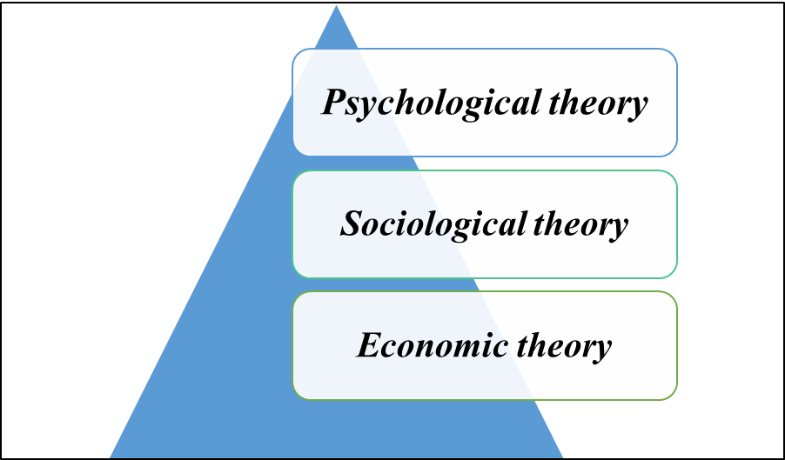
Figure 3: Important theories
(Source: self-developed)

Psychological theory
Entrepreneurship includes psychological processes and concepts as the primary source of entrepreneur development. Entrepreneurs include some psychological traits and characteristics for business development. As suggested by Chadwick and Raver (2020), it is including the traits of self-intuitions, willpower and tolerance capacity. It involves the characteristic of creative nature for better development and establishment of entrepreneurship. This theory includes the characteristics of coordination, superintended and risk-taking. It is important to develop creative and effective production of the busine4sds which helps to make a profit. As suggested by Wiklund et al. (2018), it includes the traits of ideological values, the requirement of achievements, family satisfaction and entrepreneurial behaviour. The psychological root of entrepreneurship demonstrates high achievement which is oriented toward ensuring the success of an entrepreneur.

Sociological theory
This theory depends on entrepreneurial activities which are affected by social status values and hierarchy. It is important to develop group entrepreneurs to understand the concepts related to social change. As suggested by Martinez Dy, (2020), industrial entrepreneurship is dependent on the types of society for developing changes and innovations. This theory suggests that entrepreneurship is developed with employment progress and patterns. It includes the culturally marginal groups for better development of entrepreneur characteristics. Culturally marginal groups are important to establish for increasing innovative capability. As suggested by Kimmitt and Muñoz (2018), entrepreneurship is affected by the social attitude development in the personalities of its occupation. Entrepreneur succeeds with role expectations in the sanctioning groups and operational requirements.

Economic theory
This theory suggested that entrepreneurial activities are developed because of economic incentives. It informs that the profit motive primarily drives the force which helps to transform an individual into an entrepreneur. As suggested by Urbano et al. (2019), entrepreneurs emerge because of economic profits and incentives from the business. Entrepreneurs supply because of the pre-conditional economic gains. The existence of the desire of increasing the actual income creates the tendency to the spirit of economic development. It is important to discover the products at a lower price and sell them at a higher cost which gives the entrepreneurs economic incentive. As suggested by Berglund et al. (2020), entrepreneurs' main motivation for engaging with businesses mare economic incentives. Incentives involve the marketing opportunity, taxation policy, resourcing raw materials and finance, infrastructure availability, industrial policy and investments. It requires to access information on the aspect of technologies and market conditions.

Differentiates between ‘for profit’ and ‘not for profit small organizations on the entrepreneur's values and beliefs

For-profit Organisations

Figure 4: For-profit Organisations
(Source: self-developed)
For-profit small organisations are working for gaining economic incentives and develop profit from the business. As mentioned by Sigala and Ukpabi (2019), For-profit businesses are required to develop increasing entrepreneurial values and beliefs. It is important for the development of market expansion and selling the products at a higher price and resourcing them at a lower price. For-profit businesses develop decision-making processes for discussion on how to increase profit through the implementation of cost-effective strategies. As mentioned by Reynolds and Holt (2021), an increment in profit helps organisations to build their values and establish good marketing value through entrepreneurial beliefs. The revenue of for-profit organisations is gained through selling goods and services. As mentioned by Sigala and Ukpabi (2019), it includes the preparation of cash flow, income statement and balance sheet preparation. This type of organisation is observed by business owners, entrepreneurs and partnerships.

Not-for-profit Organisations

Figure 5: Not-for-profit Organisations
(Source: self-developed)
Not-for-profit organisation works for the development of social aspects and increase the social value of the organisation. As mentioned by García-Jurado et al. (2021), it helps the organisation to gain more customers and develop more popularity in the market. Not-for-profit businesses work for social causes and are not required to acquire profit. This activity helps the organisation gain loyal customers and helps society. As mentioned by NGUYEN and PHAM (2020), it is important for the development of social approaches and applications for society and its people. This organisation processes for specific purposes rather than gaining from profit. It is responsible for working to develop social welfare and help the members of society. As mentioned by García-Jurado et al. (2021), there is no separate legal entity in this aspect. These organisations are operated by volunteers, not employees who are monthly or yearly paid. The compensation for the volunteers acquires from the fundraised. Not-for-profit organisations are trade organisations, clubs, welfare societies and religious trusts.

Evidence with personal experiences
Mark Zuckerberg, the founder of META, formerly known as Facebook, gives different learning aspects from his entrepreneurship skills and activities. As suggested by Dewinda, (2022), it helps people to develop their thinking and execute that in reality with effectiveness. Life skills involve psychological abilities for positive and adaptive behaviour which enables individuals to deal with the 'everyday challenges and demands in life. These skills include cognitive skills which help to utilise information and analyse them. There are personal skills that help in self-management as well as the development of interpersonal skills which ensures interaction and communication effectively. As suggested by Shelton and Lugo (2021), these activities help to lead an effective and successful entrepreneur.
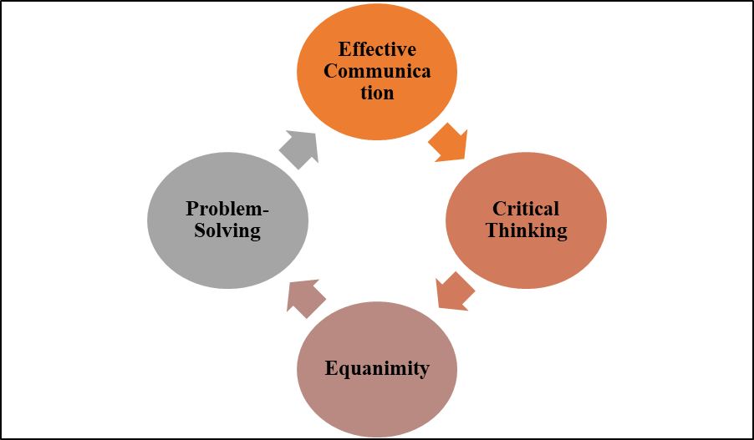
Figure 6: Entrepreneurial traits
(Source: self-developed)

Equanimity
Zuckerberg does not loss his coolness in any difficult and stressful or problematic situations. He always remains calm as anger never breeds success. It is very important to develop control over every activity in any situation. As suggested by Kim et al. (2018), the development of equanimity helps him to build strong connections and relationships with his employees and associates. It is responsible for the development of effective decision-making for any situation and working procedure. As mentioned by Polas and Afshar (2021), it is very essential for establishing a vision to achieve business objectives.

Problem-Solving
Zuckerberg always focuses on solving problems effectively and calmly. He shows the importance of identifying the most effective and informative problem and solving it quickly. As suggested by Sarooghi et al. (2019), problem-solving activities are helpful for the development of knowledge and the gathering of information. Any creative activity is considered a problem which needs to be solved for business development. It requires recognising the most important problem for spending time. As mentioned by Ahmed et al. (2019), problem-solving activities are associated with the decision-making procedures which help the business to expand.

Critical Thinking
Mark Zuckerberg always tries to go in-depth on any idea or issue and develops his interest oin that matter. As per the view of Sarooghi et al. (2019), it is important for making different, maximised and disruptive values. He critically thinks about computer programmes and functions which lead him to be the founder of Facebook. As suggested by Ghafar, (2020), success only comes from deeper and critical thinking ideas and executing that as soon as possible. Critical thinking is most important for the development of innovations within organisations.

Effective Communication
Mark Zuckerberg always takes a role in employee communication itself to develop interaction with employees. It increases the effective sense of approaching employee engagement. As suggested by Ahmed et al. (2019), he always interacts and communicates with his employees personally and reasonably. He develops ideas for increasing the willingness of team members who work on Facebook. Open communication development is responsible for the establishment of trust which makes Zuckerberg an effective entrepreneur as well as a leader. Communication leads to sharing of different types of information and knowledge among all the team members and co-workers. As suggested by Salamzadeh et al. (2019), it helps to develop an effective decision-making process for ensuring further changes in Facebook.

Summary
This study involves entrepreneurial theories which help to develop entrepreneurship successfully. It involves Psychological, economic and Sociological theories in an aspect of business development. It involves the Innovation theory, the theory of leadership, social behaviours and changes and the theory of model personality. The Discovery theory and the Creation theory are the main effective theories for entrepreneurial development. It is important for the assumption of entrepreneurial activities which are based on economic incentives. This study gives information on some personal experiences of the entrepreneurial activities of entrepreneurs. Critical thinking and problem-solving characteristics are essential for the entrepreneur's further development.
It summarises the factors related to the policy, management and resourcing procedures innovatively. It has explained the perspectives of Mark Zuckerberg and his entrepreneurial traits for developing his business. It included the differences between for-profit and not-for-profit assumptions interrelated with the entrepreneur's beliefs and values. This study has included information for the organisations serving social welfare which are not-for-profit organisations. It also involves the functions of for-profit organisations developing entrepreneurship values and beliefs. The skills and experiences of Mark Zuckerberg are essential for an entrepreneur to develop their business. The development of effective communicating traits within entrepreneurs needs to get effective success in business development in future. His communicating manner is different and more effective to increase the employee engagement process.

References
Ahmed, E.R., Rahim, N.F.A., Alabdullah, T.T.Y. and Thottoli, M.M., 2019. An examination of social media role in entrepreneurial intention among accounting students: a SEM study. Journal of Modern Accounting and Auditing, 15(12), pp.577-589. DOI: 10.17265/1548-6583/2019.12.003
Ahmed, T., Chandran, V.G.R., Klobas, J.E., Liñán, F. and Kokkalis, P., 2020. Entrepreneurship education programmes: How learning, inspiration and resources affect intentions for new venture creation in a developing economy. The International Journal of Management Education, 18(1), p.100327. DOI: https://doi.org/10.1016/j.ijme.2019.100327
Bansal, S., Garg, I. and Sharma, G.D., 2019. Social entrepreneurship as a path for social change and driver of sustainable development: A systematic review and research agenda. Sustainability, 11(4), p.1091.DOI: https://doi.org/10.3390/su11041091
Barberá-Tomás, D., Castelló, I., De Bakker, F.G. and Zietsma, C., 2019. Energizing through visuals: How social entrepreneurs use emotion-symbolic work for social change. Academy of Management Journal, 62(6), pp.1789-1817.DOI: https://doi.org/10.5465/amj.2016.0711
Berglund, H., Bousfiha, M. and Mansoori, Y., 2020. Opportunities as artifacts and entrepreneurship as design. Academy of Management Review, 45(4), pp.825-846. DOI: https://doi.org/10.5465/amr.2018.0285
Boldureanu, G., Ionescu, A.M., Bercu, A.M., Bedrule-Grigoruță, M.V. and Boldureanu, D., 2020. Entrepreneurship education through successful entrepreneurial models in higher education institutions. Sustainability, 12(3), p.1267. DOI: https://doi.org/10.3390/su12031267
Braver, L. and Danneels, E., 2018. Propensities return us to the discovery-creation debate about entrepreneurial opportunities. Academy of Management Review, 43(4), pp.812-815. DOI: https://doi.org/10.5465/amr.20180030
Chadwick, I.C. and Raver, J.L., 2020. Psychological resilience and its downstream effects for business survival in nascent entrepreneurship. Entrepreneurship Theory and Practice, 44(2), pp.233-255.DOI: https://uk.sagepub.com/en-gb/journals-permissions
Chavoushi, Z.H., Zali, M.R., Valliere, D., Faghih, N., Hejazi, R. and Dehkordi, A.M., 2021. Entrepreneurial alertness: A systematic literature review. Journal of Small Business & Entrepreneurship, 33(2), pp.123-152. DOI: https://doi.org/10.1080/08276331.2020.1764736
Claire, C., Lefebvre, V. and Ronteau, S., 2020. Entrepreneurship as practice: systematic literature review of a nascent field. Entrepreneurship & Regional Development, 32(3-4), pp.281-312. DOI: https://doi.org/10.1080/08985626.2019.1641975
Dewinda, H.R., 2022. Resilience of students who are entrepreneurial and not entrepreneurial. Jurnal RAP (Riset Aktual Psikologi Universitas Negeri Padang), 12(2), pp.223-232. DOI: 0.24036/rapun.v12i2. 109918
García-Jurado, A., Pérez-Barea, J.J. and Nova, R.J., 2021. A new approach to social entrepreneurship: A systematic review and meta-analysis. Sustainability, 13(5), p.2754.DOI: https://doi.org/10.3390/su13052754
Ghafar, A., 2020. Convergence between 21st century skills and entrepreneurship education in higher education institutes. International Journal of Higher Education, 9(1), pp.218-229. DOI: https://doi.org/10.5430/ijhe.v9n1p218
Kim, J.Y., Choi, D.S., Sung, C.S. and Park, J.Y., 2018. The role of problem solving ability on innovative behavior and opportunity recognition in university students. Journal of Open Innovation: Technology, Market, and Complexity, 4(1), p.4. DOI: https://doi.org/10.1186/s40852-018-0085-4
Kimmitt, J. and Muñoz, P., 2018. Sensemaking the ‘social’in social entrepreneurship. International Small Business Journal, 36(8), pp.859-886. DOI: https://doi.org/10.1177/0266242618789230
Lüdeke‐Freund, F., 2020. Sustainable entrepreneurship, innovation, and business models: Integrative framework and propositions for future research. Business Strategy and the Environment, 29(2), pp.665-681. DOI: https://doi.org/10.1002/bse.2396
Martinez Dy, A., 2020. Not all entrepreneurship is created equal: Theorising entrepreneurial disadvantage through social positionality. European Management Review, 17(3), pp.687-699. DOI: https://doi.org/10.1111/emre.12390
McMullen, J.S., Brownell, K.M. and Adams, J., 2021. What makes an entrepreneurship study entrepreneurial? Toward a unified theory of entrepreneurial agency. Entrepreneurship theory and practice, 45(5), pp.1197-1238. DOI: 10.1177/1042258720922460
NGUYEN, L.G.T. and PHAM, H.T., 2020. Factors affecting employee engagement at not-for-profit organizations: A case in Vietnam. The Journal of Asian Finance, Economics and Business, 7(8), pp.495-507.DOI: 10.13106/jafeb.2020.vol7.no8.495
Pan, N.D., Gruber, M. and Binder, J., 2019. Painting with all the colors: The value of social identity theory for understanding social entrepreneurship. Academy of Management Review, 44(1), pp.213-215. DOI: http://dx.doi.org/10.5465/amr.2017.0504
Polas, M.R.H. and Afshar Jahanshahi, A., 2021. The effects of individual characteristics on women intention to become social entrepreneurs?. Journal of Public Affairs, 21(2), p.e2204. DOI: 10.1002/pa.2204
Reid, S.W., Anglin, A.H., Baur, J.E., Short, J.C. and Buckley, M.R., 2018. Blazing new trails or opportunity lost? Evaluating research at the intersection of leadership and entrepreneurship. The Leadership Quarterly, 29(1), pp.150-164. DOI: https://doi.org/10.1016/j.leaqua.2017.11.005
Reynolds, N.S. and Holt, D., 2021. Sustainable development and profit? A sensemaking perspective on hybrid organisations and their founders. Business Strategy and the Environment, 30(4), pp.2147-2159.DOI: https://doi.org/10.1002/bse.2737
Salamzadeh, A., Tajpour, M. and Hosseini, E., 2019. Corporate entrepreneurship in University of Tehran: does human resources management matter?. International journal of knowledge-based development, 10(3), pp.276-292. DOI: https://doi.org/10.1108/JRME-09-2016-0034
Sarooghi, H., Sunny, S., Hornsby, J. and Fernhaber, S., 2019. Design thinking and entrepreneurship education: Where are we, and what are the possibilities?. Journal of Small Business Management, 57, pp.78-93. DOI: https://doi.org/10.1111/jsbm.12541
Satalkina, L. and Steiner, G., 2020. Digital entrepreneurship and its role in innovation systems: A systematic literature review as a basis for future research avenues for sustainable transitions. Sustainability, 12(7), p.2764. DOI: https://doi.org/10.3390/su12072764
Shelton, L.M. and Lugo, M.V., 2021. The Resilience Of Minority And Female Entrepreneurs: A Look At Ethnicity And Gender. Journal of Developmental Entrepreneurship, 26(04), p.2150026. DOI: https://doi.org/10.1142/S1084946721500266
Sigala, M. and Ukpabi, D., 2019. Citizen Engagement and Entrepreneurship: implications for sustainable tourism development. In Information and communication technologies in tourism 2019 (pp. 396-407). Springer, Cham.DOI: https://doi.org/10.1007/978-3-030-05940-8_31
Steffens, N.K., Yang, J., Jetten, J., Haslam, S.A. and Lipponen, J., 2018. The unfolding impact of leader identity entrepreneurship on burnout, work engagement, and turnover intentions. Journal of occupational health psychology, 23(3), p.373. DOI: http://dx.doi.org/10.1037/ocp0000090
Tornikoski, E. and Maalaoui, A., 2019. Critical reflections–The Theory of Planned Behaviour: An interview with Icek Ajzen with implications for entrepreneurship research. International Small Business Journal, 37(5), pp.536-550. DOI: https://doi.org/10.1177/1086026618764267
Urbano, D., Aparicio, S. and Audretsch, D., 2019. Twenty-five years of research on institutions, entrepreneurship, and economic growth: what has been learned?. Small Business Economics, 53(1), pp.21-49. DOI: https://doi.org/10.1007/s11187-018-0038-0
Vodă, A.I. and Florea, N., 2019. Impact of personality traits and entrepreneurship education on entrepreneurial intentions of business and engineering students. Sustainability, 11(4), p.1192. DOI: https://doi.org/10.3390/su11041192
Wadhwani, R.D., Kirsch, D., Welter, F., Gartner, W.B. and Jones, G.G., 2020. Context, time, and change: Historical approaches to entrepreneurship research. Strategic Entrepreneurship Journal, 14(1), pp.3-19. DOI: 10.1002/sej.1346
Wiklund, J., Hatak, I., Patzelt, H. and Shepherd, D.A., 2018. Mental disorders in the entrepreneurship context: When being different can be an advantage. Academy of Management Perspectives, 32(2), pp.182-206.DOI: https://doi.org/10.5465/amp.2017.0063

