During this essay I will be exploring three keywords, which are calligraphy, typography and technology. Calligraphy is the method of creating lettering using ink and paper, whereas typography is the technique of putting words together for print or web base. As a graphic design student I found all three of these words very interesting and important. For example, technology is very significant as It’s always changing and developing. As a graphic designer it’s therefore important to stay up to date with the current technology available as it does aid the work I create. Typography and calligraphy are just as important as the majority of the work of a graphic designer uses aspects of these daily to create beautiful pieces.

Calligraphy
The First keyword I will be exploring is calligraphy. Calligraphy is the technique of creating lettering traditionally using ink and a dip pen with a nib, allowing the creation of many different strokes including thin, light, airy, and thick lines. (Russel, 2017) The term calligraphy comes from the Greek words “kallos” which translates as “beauty” and “graphein” which means “to write”.(Turner, 2010) This is fitting as it is viewed as the most beautiful way to deliver a message. This is certainly true as according to Jessica Hische “Calligraphers train their hands to utilize tools in a way that is so perfect and consistent … they can do it swiftly and expertly.” (Hische, 2015, P16, P17) An example of this is shown below by a calligrapher called Paulan Tonio.
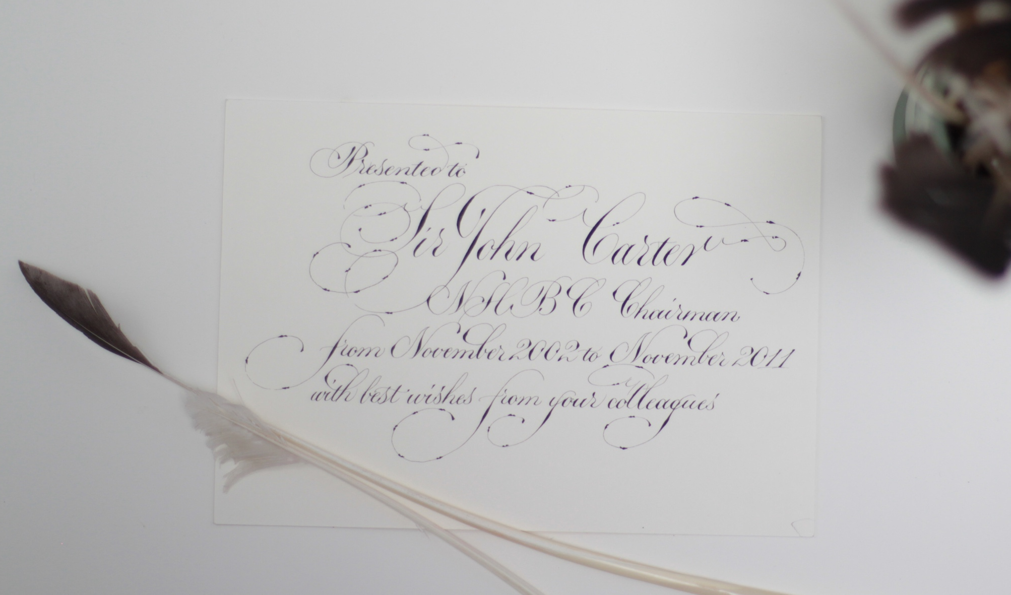
Toni, P. (2017). Custom Card. [image]

The Brief history of Calligraphy
Calligraphy has many different origins around the world including Japan, India, and Europe. According to the Met in countries in East Asian like China, korea and Vietnam there is more of a historical root, as “The earliest writing took the form of pictograms and ideographs that were incised into surfaces of jades and oracle bones, or cast into the surface of ritual bronze vessels.” (Delbanco, 2008) Ultimately it moved on paper, brushes and ink.

In many religions calligraphy was used to “print holy text.” For example in the 6th century the Gilgit script was produced using calligraphy in India. In America, the King James Version Bibles were written in calligraphy, it contained religious text and art only. Later calligraphy was adapted for the Buddhism; which was called the Tibetan calligraphy. It was believed that people who could write the Tibetan scribes were very skilled and ranked very high in society. (Cools, 2016)
Nowadays calligraphy is becoming in very high demand and is used everywhere to tell stories, not just for religious purposes only. A few examples are in packaging where you can tell where the product is from, as beers made in Germany mostly have a “gothic style lettering” within the logo. Other products include natural homemade stuff, where the calligraphy is used to connect the feeling of beauty and warmth. Calligraphy is also used at events, such at weddings. It’s starting to become very popular. It can be used for invitations which gives more of a personal touch towards the guests, as they have been beautifully handwritten. (Tareekes, 2015)

Since the invention of calligraphy, a lot has certainly changed. Ink and paint brushes are still used as the foundation of it, however more materials have been introduced. Materials used may include sharpies, pens, pencils, basically anything that isn’t ink and nipped pen. For example, a new technique adapted from calligraphy is called “faux calligraphy” or hand lettering. They are very similar however hand lettering is more about “drawing letters” rather than “writing them.” (Russel, 2017) This way is done if the project is too big for calligraphy such as signage, windows and walls, as there is more control. An example of this is by a lady called carol who has produced the company carolicityletters, she is a professional calligrapher. She uses a wide range of resources to produce her artwork but mostly water colours. (Instagram, 2017)

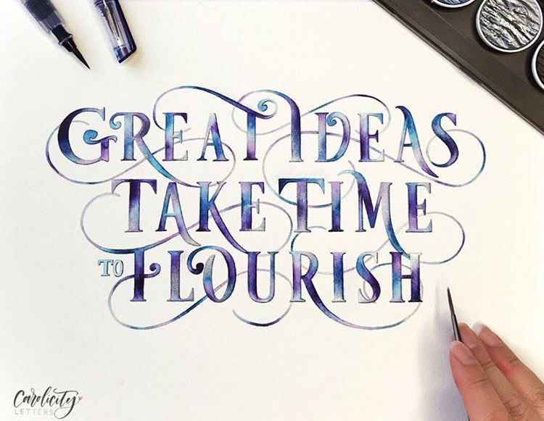
Carolicityletters (2017). Flourish. [image]

Typography
The second key word I will be exploring is typography. Typography is the style and the appearance of putting words together on screen or printed like “Fonts are part of ty­pog­ra­phy, but ty­pog­ra­phy goes be­yond fonts.” (Butterick, 2017) This means that typography isn’t designing these fonts, it’s in fact the “welding of letters to form compositions” according to Chavelli. (Tsui, 2015) However it should not get confused with calligraphy. Calligraphy is the writing of a word on paper, whereas typography is the how a word is positioned and styled online or for print. An example of typography is by Jessica Hische as follows.
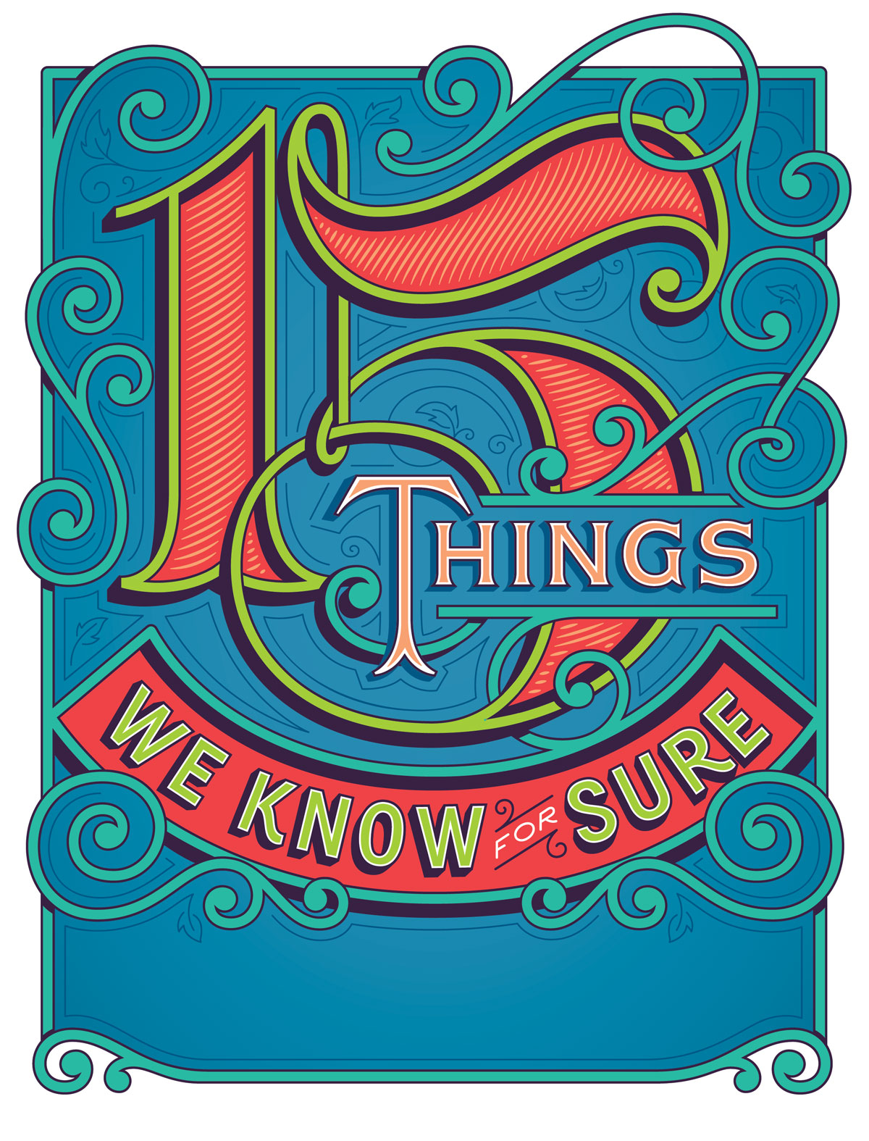
Hische, J. (2016). 15 Things We Know for Sure. [image

This is just a brief description where type originated from. Type is extremely powerful, a lot can be expressed through it. However it is always changing and developing. Type was first created by a German man called Johannes Gutenberg, He created the typeface called blackletter, it was perfect for scripting but did look very dense when printed. Later Nicholas Jenson developed a typeface called the Roman Type, in the 15th century. Compared to the black lettering, Roman Type was very clear to understand and was such an accomplishment that it quickly spread across Europe and is still here today. (Creative, 2014)

Later followed the creation of italics by Aldus Manutus in 1501, this was created so it would save money as more words could fit on the page. Then only in 17th centaury a new typeface was created by William Caslon, nowadays we called this particular type old style. Similar typefaces followed shortly after, like Didot, Bodoni, and Baskerville. (Creative, 2014)

There was soon a demand for new typefaces, when advertising become in full swing after the second industrial revolution. Typefaces become tall and wide for billboards and posters. Many typefaces were being created including Gothic, Goudy Old Style, and in 1957 Helvetica was created by Max Miedinger. It come in different weights and is “the most loved typeface of our time” according to Ashworth Creatives. (Creative, 2014)

Finally, with the invention of the computer, typography has changed forever. Now with the advancement of the internet there are thousands of typefaces out there for anyone to use, and there are ways to create your own. Typography like calligraphy has become massive, specially in branding and advertisement. As this is what sells the product and if the design is bad, then people are less likely to buy it. Many logos have been designed through typography such as Mcdonald’s, Coca Cola, George, Subway and Walt Disney.

One famous logo was designed by a great graphic designer called Milton Glaser for the Brooklyn Brewery. He designed the logo and as a result it ended up having a share in the company and making millions. Also, according to Creative Bloq Milton Glaser has “designed and illustrated more than 300 posters” including the I Love New York Logo and the a poster in 1966 for Bob Dylan. (May, 2017)

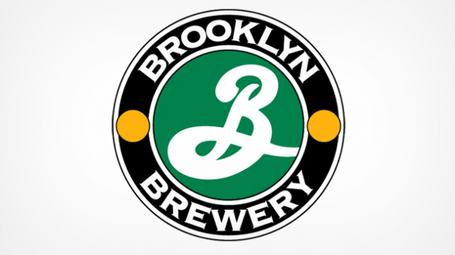
Glaser, M. (1998). Brooklyn Brewery logo. [image]

Technology
The last word I will be exploring is Technology. Technology is a vast subject and every day we are learning more. We have become so reliant on technology as it brought as many things including computers, cars and machines. According to an article by Xenlife “advancements in technology have enabled humans to do things that were previously unimaginable and it has certainly made many tasks easier than they were before.” (Capistrano, 2016) Which I would totally agree, for example we can skyped our loved ones who live across the other side of the world.

With technology there are so many aspect, and the one I will explore is the impact on design. In design there are a lot of good points to technology moving forward for example with the advancement of computers and software’s such as the Adobe programs, as it simplifies the way we do things. (Ramey, 2012) Also, in the very beginning before the advancement of technology, if a design job came about it would be a long process to complete it. As there would be various steps that would have to be completed like drawing the design out, using typesetting sheets, you’d have to know the layout, and create your own grids by hand. (Anon, 2017)

Nowadays that long process is shorted in no time due to technology, as according to Robert Harris “I have heard people say that life is way harder without technology. We know this, but technology was created to make life easier, that is the main purpose.” (Capistrano, 2016) Which is certainly true in most cases such as in the design industry.

Technology has revolutionized the design industry; one major area is in the print industry. As explained previously in the typography section, and man called Johannes Gutenberg created the first ever typeface called blackletter. He also created the first ever printing press in the 1400s, this process was cost effective as it used movable type. This is a method where metal individual letters would be moved around the press, once covered in ink. These letters could be used time and time again for creating new documents. This allowed for books to be massed produced, as previously they would be hand written, which would take an enormous amount of time. (Broadwater, 2013)

However, this invention therefore carved the way for the printing industry. The printing industry developed drastically over the years with the advancement of the steam press steamer by Thomas Koeing in 1810, then the rotary and cylinder printers, later following the offset lithography printer. These all allowed for digital printing in the 1900s. Today in every home, college and office it is common to have a digital printer, or a wireless printer. In addition to this, printing has become to do even more amazing things, like 3D printing. This particular printing can change and save lives, such as shown on the super vet television series, showcases the work of Dr. Noel Fitzpatrick, who is a veterinarian. His team uses 3D printing to create prosthetics, and bones for animals in order to save their lives. (Broadwater, 2013)

Overall within design, technology does guide and enables us to do fantastic things, according to Robert Harris “technology is not the problem. It is the way that we use it. If we just used it as a tool instead of as a way to escape reality, then all is fine. It is the people who sit on their asses playing video games all day that make it seem that way.” (Capistrano, 2016) As designers, calligraphers and typographers we are using it the correct way as “tool” in order to get our message out.

Conclusion
To conclude after researching the keywords, I have found many interesting points and quotes that have led me to come up with a question I wish to research and write about for my dissertation next year. This question is how has design evolved due to technology, and I will give specific historical examples using some of the points I have found out about calligraphy and typography.

The formal question is with the focus on historical aspects of typography and calligraphy, how has the development in technology effect type in graphic design.

Bibliography
Anon, (2017). [online] Available at: https://www.bing.com/cr?IG=3008837F512F48278C2A2FF3A82B3C44&CID=1B85B0079DA6652E34FBBBE09C096453&rd=1&h=4FHDkoH5DYD76ug4PvxGkLxBy3E9esw91IEaXy82JZE&v=1&r=https%3a%2f%2fbrainly.com%2fquestion%2f1608931&p=DevEx.LB.1,5145.1 [Accessed 1 May 2018].
Broadwater, T. (2013). Design Technology’s Impact on the Graphic Design Industry – Tim Broadwater. [online] Timbroadwater.com. Available at: http://timbroadwater.com/2013/01/design-technologys-impact-on-the-graphic-design-industry/ [Accessed 6 May 2018].
Capistrano, J. (2016). Are We Too Dependent on Technology? [online] XEN life. Available at: https://xenlife.com.au/are-we-being-too-dependent-on-technology/ [Accessed 4 May 2018].
Carolicityletters (2017). Flourish. [image] Available at: https://www.instagram.com/carolicityletters/?hl=en [Accessed 6 May 2018].
Cools, J. (2016). A Brief History of Calligraphy Leisurely Pursuits - Entity. [online] Entity. Available at: https://www.entitymag.com/brief-history-calligraphy/ [Accessed 6 May 2018].
Creative, A. (2014). A Brief History of Typography. [online] Ashworth Creative. Available at: http://www.ashworthcreative.com/blog/2014/07/brief-typography-typefaces/ [Accessed 5 May 2018].
Delbanco, A. (2008). Chinese Calligraphy | Essay | Heilbrunn Timeline of Art History | The Metropolitan Museum of Art. [online] The Met’s Heilbrunn Timeline of Art History. Available at: https://www.metmuseum.org/toah/hd/chcl/hd_chcl.htm [Accessed 6 May 2018].
Glaser, M. (1998). Brooklyn Brewery logo. [image] Available at: https://www.creativebloq.com/features/5-logos-by-famous-designers-and-why-they-work [Accessed 4 May 2018].
Hische, J. (2015). In progress. San Francisco, CA: Chronicle Books LLC.
Hische, J. (2016). 15 Things We Know for Sure. [image] Available at: http://jessicahische.is [Accessed 6 May 2018].
Instagram.com. (2017). Carol (@carolicityletters [online] Available at: https://www.instagram.com/carolicityletters/?hl=en [Accessed 7 May 2018].
May, T. (2017). 5 logos by famous designers and why they work. [online] Creative Bloq. Available at: https://www.creativebloq.com/features/5-logos-by-famous-designers-and-why-they-work [Accessed 4 May 2018].
Ramey, K. (2012). Technological Advancements and Their Effects on Humanity - Use of Technology. [online] Use of Technology. Available at: https://www.useoftechnology.com/technological-advancements-effects-humanity/ [Accessed 6 May 2018].
Russell, B. (2017). The Difference Between Hand Lettering, Calligraphy and Typography (+ Why It Truly Matters). [online] LETTER LANE DESIGN STUDIO. Available at: https://letterlanedesignstudio.com/blog/2016/3/22/the-difference-between-hand-lettering-calligraphy-and-typography [Accessed 3 May 2018].
Tareekes, A. (2015). Telling stories through calligraphy at the happiest place on earth. [online] Available at: https://www.quora.com/What-use-is-calligraphy-in-modern-society [Accessed 1 May 2018].
Toni, P. (2017). Custom Card. [image] Available at: http://paulantonioscribe.com/gallery/ [Accessed 7 May 2018].
Tsui, C. (2015). The Difference between Calligraphy and Lettering, and Typography. [online] Chavelli Tsui // Calligraphy and Design. Available at: https://chavelli.com/blog/the-difference-between-calligraphy-lettering-and-type-and-why-it-matters [Accessed 6 May 2018].
Turner, E. (2010). Calligraphy. [online] Encyclopedia Britannica. Available at: https://www.britannica.com/art/calligraphy [Accessed 6 May 2018].

