

Student Name | Aqsa Shahzadi
Student ID | 2426854
Assignment | Component 1: Online Portfolio of Set Exercises
Module | Changemakers Creativity and Value Creation
Submission Date | 6th July 2026

Introduction
This portfolio contains a series of reflective tasks undertaken during the BMHP5014 Changemakers module to illustrate learning and engagement with key concepts in creativity, value creation, leadership and innovation in health and social care. The tasks are based on theories presented in the module and then applied to a single developing idea: BridgeCare, a Community Health Navigator Programme to minimise health inequalities faced by ethnic minority communities in the UK. The exercises have demonstrated the connection between theory and a real, practical innovation that works for the common good.

Task 1 – Concept Map: Creativity, Value Creation, and Health and Social Care Improvement
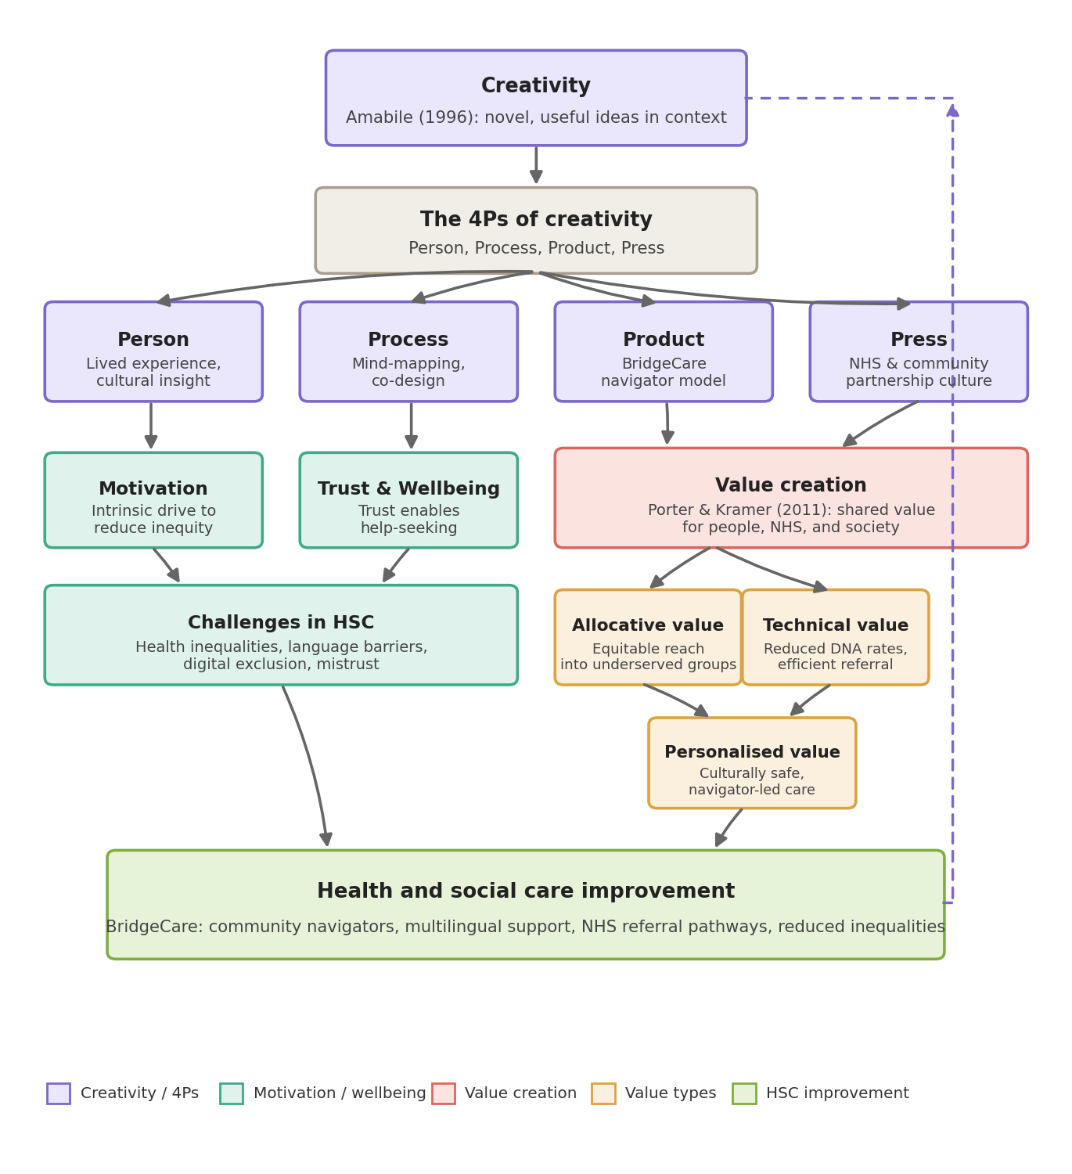
Fig 1: concept map indicating the interrelationship of creativity (4Ps model), motivation, trust, value creation (Porter and Kramer, 2011), and HSC improvement through BridgeCare, with a cyclic feedback loop.
The above concept map is based on the notion that creativity, value creation, and health and social care (HSC) improvement are processes that are constantly evolving, rather than a single project or event. On top of all this is creativity: Amabile (1996) defines it as the production of novel and useful ideas within a specific domain.
Creativity is structured in these ways: The Person (lived experience and cultural insight); the Process (mind-mapping and co-design techniques); the Product (the BridgeCare navigator model itself); and the Press (the partnership culture between the NHS and community organisations).
Within the Person and Process dimensions lie motivation and trust, since trust in the community and a natural desire to take action to equalise inequities are the factors that enable those in underserved communities to seek out help in the first place. When that trust and motivation are lacking, the map identifies the resulting difficulties: long-standing inequality, language barriers, digital exclusion, and mistrust of institutions. Building on the Product and Press dimensions, value creation is based on the shared value concept of Porter and Kramer (2011), which states that "organisations create value for themselves exactly by meeting a real social need.
Here, there are three types of value: allocative (culturally equitable access for underserved groups), technical (minimised non-attendance and more efficient referrals), and personalised (culturally safe, navigator-led care). These focus on HSC improvement (BridgeCare's community navigators), multilingual support, and NHS referral pathways. The dashed feedback loop suggests that this improvement, in turn, fosters creativity – an ongoing process of development rather than a completed product.

Task 2: Self-Reflection of Group Activity: Brainstorming Solutions to a Health and Social Care Problem
Reflective Account using Gibbs' Reflective Cycle
Description
In one of the early weeks of the module, our group was given a creative brainstorming exercise: to identify a pressing problem in health and social care and generate as many possible responses as we could within a fixed time, before narrowing these down to a single strongest idea. I chose to focus on health inequalities experienced by ethnic minority communities in the UK, an issue I have seen reflected in my own community. Using mind-mapping, the group and I generated a wide range of possible responses – a multilingual GP information platform, community outreach vans, culturally tailored health campaigns, peer support networks, and a structured community health navigator programme – before evaluating them against feasibility, scalability and community trust.
Feelings and Evaluation
At first, I felt hesitant to share ideas rooted in my own background, worried that they might be seen as too personal or not 'innovative' enough compared with technology-driven solutions. As the group discussion continued and the tone relaxed, I felt more comfortable adding my own ideas and suggestions, as well as elaborating on others'. This is in line with Edmondson's (1999) notion of psychological safety in that individuals can take Interpersonal risks without fear of being judged and produce more creative output.
Analysis and Conclusion
In retrospect, my own hesitation to communicate a community-based idea was not as isolated as it seems - in health and social care teams, the ‘weirdo' or ‘relational' approaches are often not taken up when they could be equally important as more explicit and technical ones. I learned that both divergent thinking (brainstorming multiple ideas) and convergent thinking (narrowing down until I'm left with the best idea) were important as I switched back and forth between them, since professionals must brainstorm many solutions and critically evaluate and choose the most effective one. This exercise has directly influenced the development of BridgeCare, as the navigator model was identified as the most viable, scalable and trusted approach. It also strengthened my belief that creativity is not an innate talent but a practice that improves with exposure, repetition and a supportive environment.

Task 3: Case Study of a UK Innovation: NHS Community Health and Wellbeing Workers Programme
Case Study Analysis
Introduction
A directly relevant UK innovation for BridgeCare is the NHS Community Health and Wellbeing Workers (CHWW) programme, rolled out from 2023 onwards in areas of England with high levels of deprivation and significant ethnic minority populations. The programme places trained community members, often from the communities they serve, into outreach roles that identify residents at risk of cardiovascular disease and connect them to NHS services, drawing on a model with international precedent in community health worker schemes (NHS England, 2026).
How Creativity Drove Change
The innovation of the CHWW programme is that it redefines who can provide health improvement. NHS innovators understood that, as well as being a clinical function, trust, language and lived experience also constituted a form of clinical infrastructure. Disruptive healthcare innovation, as defined by Christensen et al. (2000), adds value by appealing to populations that the system is structurally unable to reach, rather than by building attractive services for them.
An innovative approach to workforce design, both recruiting and training lay people as well as clinical staff and supervising them, also establishing referral networks that were not present before, was also required. This continues the model for the workforce in BridgeCare, which involves recruiting community members to work within their communities rather than implementing them from the outside.
Value Created
Through the CHWW programme, allocative value has been created by raising awareness of preventative care among populations who had not been aware of it; technical value by increasing efficiency in accessing the programme for at-risk populations; and personalised value by providing culturally informed, trusted engagement with populations. (NHS England, 2026). It's the same three value types that BridgeCare strives to create for ethnic minority service users, NHS practices and the wider system.
Critical Reflection
There are some limitations to this programme, however. Sustained investment is likely to be crucial to outcomes, and community workers should not be marginalised in primary care; they should not be allowed to lose their vital role in the primary care team, according to early evidence (NHS England, 2026). This serves as an example of how innovations of this sort must be evaluated for their potential for equitable, sustainable reach – a factor to consider with BridgeCare, as digital exclusion and inconsistent local commissioning can restrict reach if this isn't considered during design (McKenna, 2023).

Task 4: Research Task
Paraphrasing the Research Findings
Although there have been several commitments in the UK to tackle inequalities in health and social care, such as the NHS Long Term Plan's desire to diminish the inequalities, ethnic minority groups are still more likely to suffer from poorer access to health and social care services, as well as poorer outcomes. Two academic works help explain this long-standing divide.
Article 1: Szczepura (2005)
A review of access to healthcare for ethnic minority groups by Szczepura (2005) highlighted the fact that barriers are not solely related to clinical need but are due to a combination of factors, such as language barriers, low health literacy within certain ethnic minority communities, discrimination within the services and the lack of congruence between how services are designed and how ethnic minority groups understand and access them. The study reveals that, despite the availability of services, the service organisation – including appointment systems, written information only, etc. – can make services inaccessible. It highlights why BridgeCare chooses to work on a multilingual model, with navigators – a model which treats access not just as an individual problem, but as a structural one.
Article 2: Salway et al. (2016)
Salway et al. (2016) suggest that the health system needs to change and argue that this should go beyond individual, short-term plans and programs, extending to a more systemic approach integrated into mainstream NHS planning, staff development, and data collection for the UK's multi-ethnic population. They argue that ethnicity is often used as an ancillary element in health policy rather than a central feature in service design. That progress will require ongoing funding for community-based positions and the development of culturally appropriate service pathways. This further solidified the argument for considering BridgeCare not just a local 'pilot' but as something structurally embedded within local NHS commissioning, with ethnic outcome data disaggregated to show effects over time.

Task 5 Podcast
BridgeCare Podcast.mp3

Task 6 NHS Leadership Framework Analysis
The Healthcare Leadership Model is designed to support the development of effective, change-focused leaders in health and social care organisations (NHS Leadership Academy, 2013). It comprises nine aspects: inspiring shared purpose, leading with care, evaluating information, connecting our service, sharing the vision, engaging the team, holding to account, developing capability and influencing for results. Instead of the iconic leader, the model takes a distributed and participative approach to leadership, recognising that it is practised at every level of an organisation, from frontline community workers to senior NHS commissioners. It also acknowledges that good leadership is context-dependent – that is, what is required of a leader of a community outreach team is different to that of a leader of an acute hospital department.
The Element Chosen: Engaging the Team
The dimension most closely associated with BridgeCare is team engagement. This dimension is about establishing an environment where individuals feel heard, appreciated for their uniqueness, empowered to share their ideas, and not merely given instructions to follow (NHS Leadership Academy, 2013). This means for BridgeCare to incorporate community navigators, who lack clinical training but possess the cultural and linguistic knowledge, and treat them as equals to the service design process, instead of as ancillary personnel.
West et al. (2014) point to evidence that such engagement is closely related to innovation, with teams that feel fully engaged more likely to identify issues early, adjust practice in response to community feedback, and remain committed to a programme when resources become constrained. In practice, using this dimension in BridgeCare would involve regular and planned forums to share with the programme leadership what the community can tell them, for instance, that digital tools are still hampering rather than helping to overcome barriers.

Task 7 Self-Reflection Journal Entry
Journal entry: learning and professional development
Before this module, I thought creativity only applied to art, design, and invention, not to the slow-moving issues I see in health and social care. That all changed in week two when the brainstorming exercise was held. It was my first time using a formal creative technique to consider a subject as deeply personal to me as health inequalities in ethnic minority communities, and I found it interesting to see that some of the most powerful innovations are relational rather than about new technology; they're about rebuilding trust. The frameworks shared by Porter and Kramer (2011), Dees (2001) and the NHS Leadership Academy (2013) provided me with words and a structure to an idea I had been entertaining on my own for some time.
The importance of mapping value across different stakeholder groups was one way I realised that BridgeCare is not just delivering a service to individuals; it is creating value that extends to GP practices, community organisations and the wider system. For me, this was the most humbling piece of the module, the technology exercise! I had thought that adding digital tools to BridgeCare would automatically make it stronger. Still, when I was reminded that the communities BridgeCare serves are disproportionately affected by digital exclusion, I realised that wasn't the case.
That pause for thinking was a reminder to me that innovation in health and social care needs to be co-designed, not designed for people alone. In the future, I'm feeling more comfortable with creativity as something I can work at and develop, rather than as something I will have instead of something I'm born with. As I seek to meet the needs of the communities I wish to support, I am dedicated to bringing this learning to the further development of BridgeCare and my future practice.

Conclusion
This portfolio has shown creativity in tackling value creation and leadership theory, and has applied them to a real and pressing problem in health and social care. BridgeCare has evolved from an initial concept to a well-developed, evidence-based proposal relevant to the NHS environment in each exercise. The completion of these tasks has enhanced my awareness of the importance of innovation as both a practice and a considered process, and deepened my resolve to address health inequalities affecting ethnic minority communities in the UK.

Reference List
Amabile, T.M. (1996) Creativity In Context: Update To The Social Psychology Of Creativity. (1st edn.). New York: Routledge.
Christensen, C. M., Bohmer, R., and Kenagy, J. (2000) ‘Will disruptive innovations cure health care?’, Harvard business review, 78(5), 102–199.
Dees, J.G. (2001) The meaning of “Social Entrepreneurship”. Available at: https://web.stanford.edu/class/e145/2007_fall/materials/dees_SE.pdf (Accessed: 10 June 2026).
Edmondson, A. (1999) ‘Psychological safety and learning behavior in work teams’, Administrative Science Quarterly, 44(2), pp. 350–383.
McKenna C. (2023) ‘Michael Marmot: the health of nations’, BJPsych bulletin, 47(1), 56–59. https://doi.org/10.1192/bjb.2022.81
NHS England (2026) Health and wellbeing programmes. Available at: https://www.england.nhs.uk/supporting-our-nhs-people/health-and-wellbeing-programmes/ (Accessed: 30 June 2026).
NHS Leadership Academy (2013) Healthcare Leadership Model: The Nine Dimensions of Leadership Behaviour. Leeds: NHS Leadership Academy, 16.
Porter, M. E., and Kramer, M. R. (2011) ‘Creating Shared Value’, Harvard Business Review, 89, 62-77.
Salway, S. et al. (2020) ‘Transforming the health system for the UK's multiethnic population’, BMJ (Clinical research ed.), 368, m268. https://doi.org/10.1136/bmj.m268
Szczepura A. (2005) ‘Access to health care for ethnic minority populations’, Postgraduate medical journal, 81(953), 141–147. https://doi.org/10.1136/pgmj.2004.026237
West, M., Eckert, R., Steward, K. and Pasmore, B. (2014) Developing collective leadership for healthcare. London: The King's Fund.

