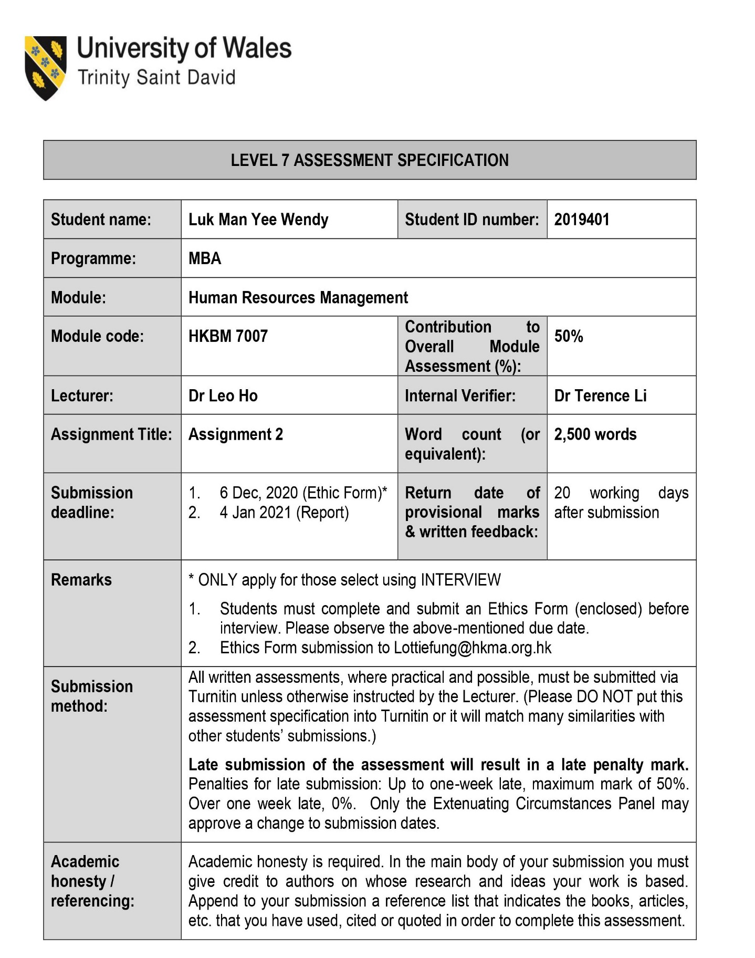

Table of Contents

Executive Summary 3
Companies Background 3
International Human Resource Recruitment Challenge 4
Uniqlo – Globalization Recruitment Challenges 4
Giordano – Globalization Recruitment Challenges 4
Consequences of Bad Hiring – Impacts to Stakeholders 5
Theoretical Analysis 5
Recommendations to Eliminate the Global HR Recruitment Challenges 6
Short-term Action Plan 7
Mid-term Action Plan 7
Long-term Action Plan 8
Expectations from the Stakeholders 8
Conclusion 9
Bibliography 11

Executive Summary

Today, many organizations have expanded their geographic footprint to the global markets. The investors see the opportunities of diversity would allow them to acquire to a new market, to attract more talents for success, and to gain competitive advantages. Hence, expansion of a business into the international markets requires Human Resource Management to manage the global workforce to meet the organizational objectives.
This consultancy report will evaluate and analyze the recruitment challenges that Human Resource Management team faced with the globalization in the Asian apparel industry. The two popular Asian apparel brands, Uniqlo and Giordano, are chosen for the literature research. Both companies started their businesses in Asia and subsequently expanded to other global markets in Europe and America. The research will focus on how the local HR team solve the recruitment challenges. This report will also provide the analysis of the positive and negative impacts to their problem solving and the potential areas that require improvement. Lastly, recommendations for the solution will be addressed from the HR professional perspective.

Companies Background

Uniqlo is a Japanese company, which was founded in 1949 in Ube, Yamaguchi, Japan. In 1984, Uniqlo opened the first casual wear store in Hiroshima. And later its operations have spread over the major cities throughout Japan with over 100 stores. Uniqlo is a fashion retailer that sells unisex casual wear and a manufacturer of private label apparel. As of 31 Dec 2019, Uniqlo has 3,630 stores in operations worldwide with 56,523 employees.
Giordano is a Hong Kong company founded in 1981. It started as a manufacturer of casual clothing in the 1970’s and later developed into the international fashion retailer of men’s, women’s, and children’s apparel and accessories. Giordano began its successful journey in the Middle East and from thereon expanded to other regions. Today, its operations have spread over 30 countries worldwide with more than 2,000 stores and over 8,000 employees.

International Human Resource Recruitment Challenge

Selecting efficient staffs for the organization in the international expansion is one of the first challenge that local HR leaders/managers encountered. Therefore, it is important for human resources to take an effective staffing approach for the recruitment process. Unlike hiring the local staffs for the domestic country, HR may consider the approach to hire from the parent country nation, host country nation, third country nation or the combination of the three approaches. Another key factor is the expansion budget that the organization invest to the host country. Moving from a low-cost country to a high-cost country will be an obstacle for the recruitment process. HR needs to evaluate the advantages and disadvantages of having expatriation or repatriation assignments. It is also a challenge for HR to select the right talent pool in the context of geographical location. HR should manage the diversity of the workforce regardless of different culture background, gender, race, age, nationality, religion, sexual orientation, education, physical appearance, or other characteristics that used to distinguish among people.

Uniqlo – Globalization Recruitment Challenges

When Uniqlo developed its operations internationally, they began to employ refugees in other host countries like France and Germany due to labor shortfall. However, they faced challenges on language barriers, cultural difference and discrimination. By providing an effective training to the managers and the employees who work with the refugees, Uniqlo managed to overcome this challenge and maintained the value of diversity in the workplace. Another recruitment challenge HR faced was the expansion to China markets. Uniqlo experienced hardship to recruit the right talent managers. They took an alternative approach to start recruiting University graduates and nurture these young people to be the future managers by training them in four regional headquarters: New York, Singapore, Paris, and Shanghai.

Giordano – Globalization Recruitment Challenges

Giordano believes that their key success relies mainly on the employees’ contribution. Therefore, they offer a competitive remuneration packages to different level of employees. When Giordano began to expand to the global markets, they realized that HR may face many issues such as recruitment, retention and development due to geographical location. They started to invest broader into staff training and development programs. The programs focus on all round personal and professional development for different level of employees including line managers. Moreover, Giordano has formed an Employee Self Learning Program to encourage the employees’ initiative and responsibility for further development.

Consequences of Bad Hiring – Impacts to Stakeholders

As employees are the primary asset of each organization, hiring the wrong people can bring serious impact to both internal and external stakeholders. Having the wrong people in the organization may decrease the staff morale, influence the behavior of the peers, and disrupting the workplace environment. Furthermore, bad hire will increase the costs of the organization such as productivity loss, reputation loss and monetary loss (Girdler, 2018). In the apparel industry, having the wrong frontline employees regardless their positions may result with lower productivity or impact the behavior of the peers. Poor customer service can also impact our main external stakeholders: customers and shareholders. Customer satisfaction is linked directly with the reputation of the organization (Sterling Backcheck, 2016) Therefore, it is vital to have the right people to build up the organization branding.

Theoretical Analysis

According to the literature research, Uniqlo and Giordano have the same approach of implementing the training and development programs for their employees. This is a good approach only when they have hired the right people. Having the right people in the right roles is the way to add more values to the organization (Abrashoff, 2017). Compared with Giordano, Uniqlo’s core philosophy of recruitment is more diverse when they expanded to the global markets. Uniqlo encourages to hire employees with different cultural background as they believe workforce diversity can bring inspirations and creativities to the company (Fast Retailing, 2020). However, language barriers and discrimination remain hurdles to those candidates with different cultural background. To overcome language barriers, HR leaders/managers should try to tie the candidates to match with the organizational culture. Try to use visual method of communications, plain languages, and be respectful to the candidates. Discrimination is something that cannot be avoided in many countries. To overcome this challenge, HR needs to educate the top line managers down to the lower level of employees by providing an effective leadership training (Bloyd, 2020).
When Uniqlo faced the challenge of attracting the talented managers in China market, they began to focus on targeting the younger generation. However, this may lead to a decrease of retention rates. In general, younger generation is more likely to switch jobs as they are more open to opportunities. To prevent job hopping practices within the organization, HR can promote a career development plan during the recruitment process. Promoting career development plan can attract talent interest of the job opportunity and help them to grow along with the company. Let the younger generation feel connected with the organization and see the values of their contributions.
Giordano believes that offering a competitive renumeration packages can attract talents and encourage loyalty (Giordano International Ltd, 2019). Indeed, this is many organizations’ philosophy because salary and fringe benefits are the crucial elements to attract talent and retain them for longer term. Attractive renumeration packages can increase job satisfactions and increase productivity. However, the downside of competitive renumeration packages may lead to imbalance of the labor force. For example, organizations too focus to pay generous salaries to those qualified candidates will often ignore other level of positions that require lesser skills. Furthermore, expanding the business from a low-cost country to a high-cost country may incur additional costs due to living standards. Therefore, Giordano should take into consideration of the return on investment whether investing high costs in the initial stage of the expansion is feasible. General speaking, higher salary means more responsibilities and more pressures. Potential candidates who fear to work longer hours and afraid to take up more pressure of the job role will ultimately turn down the opportunity. Redesign the renumeration packages can avoid the above challenges by replacing some of the fixed benefits. For example, flexible pension plans, staff allowances, healthcare programs or share options (Sheehan, 2018). Frontline workers are important in an apparel industry as their performance is directly proportional to customer satisfaction. Pay by performance scheme is one way to attract the talent and to recognize their contributions.

Recommendations to Eliminate the Global HR Recruitment Challenges

It is no doubt that human resources managers will encounter different recruitment challenges in the international expansion due to unfamiliar territory. Good international human resource management (IHRM) should undertake the strategic planning for the organization besides the functional activities as a local HR. Hence, IHRM ought to recruit the right people for the organization to ensure the success of the international business.
Here are some recommendations to IHRM to overcome the international recruitment challenges in different timeline such as short-term, mid-term and long-term plans.

Short-term Action Plan

Organizations can send expatriates from the parent country for the first six to twelve months to stabilize the business startup. Someone who knows the organization well, with extensive experience can build up a new team and to introduce the organizational culture. On the other hand, the repatriates will bring back any new perspectives, innovative ideas and business practices to the parent country.
Adapting a new environment is not easy, expatriates may face challenges moving from one country to another especially where they are not familiar with. HR can support the expatriates to prepare and succeed in taking the new role by organizing pre-assignment training. Training topics include host country lifestyle, culture, and language skills. HR can also arrange local supports such as finding the place to stay during the assignment, healthcare service, tax preparation or set up of the bank account.
Sending employees to overseas is a costly investment. It is important that HR managers to evaluate the current packages of the expatriates and adjust the renumeration packages according with the host country living standards. To protect the investment, consider putting a temporary contract in place. This can help to prevent any unexpected situations like breaching the contract and the need to hire for replacement.

Mid-term Action Plan

As market is constantly changing, develop a recruitment strategy can help HR to improve the hiring practices. During the first eighteen months of international expansion, HR can proactively attend some job fairs to build up a selection of talent pool. This is one of the easiest ways to attract potential talent in the market. People also can learn more about the organization and the job prospects. Attending job fairs can reduce the costs of advertisement and minimize the time and effort to search for qualified candidates. HR can utilize the selection of talent pool for job replacement when the turnover rates is high.
Job fairs often requires fees from the organization to set up the booth. And the costs of preparation will be worthless if there is no good match of the talent for the organization. The time and effort to set up the booth and to assign the suitable staff representatives will become a risk to the organization when HR cannot handle it efficiently within the limited time flame.
Normally, there are many applicants attending the job fairs to look for job opportunities. HR needs to make quick decisions in a short period of time among hundreds or even thousands of applicants. Unlike traditional recruitment process, screening the candidates’ profile and resumes might be eliminated in the job fairs. Moreover, decision making based on short exchange of communication and interviews may end up with a poor talent selection.

Long-term Action Plan

In the long run, organizations need to embrace diversity to meet the business goals. A diverse workforce includes people with different characteristics. They can bring all kinds of innovative ideas and creativities to the organization. Having an online job portal for the organizations can attract more talents from around the world. The time and costs of hire candidates can significantly reduce. HR can easily consolidate the resumes received and start filtering the right candidates for the job vacancies.
While there are many benefits of having a job portal to support HR on recruitment, there are some drawbacks. Some applicants are not serious for the job searching, there might be fake applications. Online portal may also attract fraudulent applicants which do not fit to the job posted. HR would need to spend time to scan through all the applications before selecting the right talent.
Adopt online job portal will require IT resources, time and effort. It is crucial that such investment can deliver the best outcome to support HR or it will become a loss for the organization.

Expectations from the Stakeholders

Every stakeholder has expectations regardless they are the customers, employees, HR managers, or shareholders. Customer is always the key stakeholder in all service industries. Organizations strive to meet the customer satisfaction by providing the best service. To achieve customer satisfaction, effective leadership is the main driver to inspire the employees to do their best. Therefore, sending experience expatriates for international assignment can greatly influence the employees with the same behavior.
Other stakeholders such as employees, HR managers and shareholders, see the value of having the right people in the right place at the right costs to achieve the organizational objectives. Thus, HR needs to exploit an efficient recruitment process to attract the right talent. Job fairs is an event where HR can find good matches of candidates for the organization without going through the long recruiting process. It reduces the time and costs of posting advertisement. Job fairs allow HR managers to make quick decision via face-to-face meeting with the potential candidates. Online job portal, on the other hand, can be treated as a long-term lean project for the organizations. Applicants will approach the organization proactively regardless there is any job posted on the company’s job portal. It can streamline the recruiting process by mapping the right talent to the job requirements.

Conclusion

Globalization brings in tremendous impacts to the organizations. It also gives pressure on human resource management function to adapt and to make changes in order to meet the organizational needs. Managing workforce then becomes one of the biggest challenges for human resource in the international expansion.
In the literature research of the two apparel companies, Uniqlo and Giordano, faced significant challenges in attracting the right talent during their globalizations. Uniqlo aims to maintain workforce diversity by recruiting refugees during the labor shortfall season. However, language barriers and discrimination remain as an obstacle for hiring. HR should undertake in educating the concept of multiculturalism to the topline managers. During its expansion to China, they turned to hire the younger generation after failing to hire the talent managers. Limitation of talent selection can be improved by promoting career development plan in the recruiting process. Giordano, on the other hand, invested heavily on the renumeration packages to attract talent for all level of employees. To avoid imbalance of the labor force, redesigning the renumeration packages by replacing some of the fixed benefits can increase the attractiveness of the job positions.
The trend of international expansion is increasing, and it is unavoidable that there are many other challenges ahead. The recommendations that are given in this report are designed to drive better solution for recruiting challenges and meet the expectation of the stakeholders. For example, adopting the expatriate’s assignment to the host country can stabilize the business and ensure the business can grow smoothly. Attending job fairs to build up a selection of talent pool can streamline the recruitment process. And lastly, implementing online job portal to attract strong talent from worldwide without too much time and effort. By adopting these recommendations, HR professionals will find success in finding the right people for the right jobs at the right costs for the organizations.

Bibliography
[1] Agarwal, S. and Mohammed Saif Al Qouyatahi, K. (2017). HRM Challenges in the Age of Globalisation. International Research Journal of Business Studies, 10(2), pp.89–98.
‌[2] Sekiguchi, T., Jintae Froese, F. and Iguchi, C. (2016). International human resource management of Japanese multinational corporations: Challenges and future directions. Asian Business & Management, 15(2), pp.83–109.
[3] Mirza, M., Verma, A., Kee, D.M.H., Awatif, A., Qistina, F.N. and Aswadi, M.K. (2020). The Key Success Factors: A Case Study of UNIQLO. Journal of The Community Development in Asia, 3(2), pp.1–10.
‌
[4] Publisher, A. removed at request of original (2016). 14.2 Staffing Internationally. [online] open.lib.umn.edu. Available at: https://open.lib.umn.edu/humanresourcemanagement/chapter/14-2-staffing-internationally/. (Accessed: 20th December,2020)

[5] Girdler, S. (2018). The Real Impact Of A Bad Hire For Your Business. [online] Entrepreneur. Available at: https://www.entrepreneur.com/article/313729. (Accessed: 28th December,2020)

[6] Sterling Backcheck. (2016). The Risks of a Bad Hiring Decision. [online] Available at:
https://www.sterlingbackcheck.ca/blog/2016/10/the-risks-of-a-bad-hiring-decision/
(Accessed: 28th December,2020)
‌
[7] LifeWear, Changing the World. (2019). [online] Available at: https://www.fastretailing.com/eng/ir/library/pdf/ar2019_en.pdf (Accessed: 28th December,2020)

[8] ‌www.mckinsey.com. (n.d.). Matching the right talent to the right roles | McKinsey & Company. [online] Available at: https://www.mckinsey.com/business-functions/organization/our-insights/the-organization-blog/matching-the-right-talent-to-the-right-roles#. (Accessed: 28th December,2020) ‌

[9] www.hvacrbusiness.com. (n.d.). Put the Right People in the Right Roles. [online] Available at: http://www.hvacrbusiness.com/right-people-right-roles.html (Accessed: 28th December, 2020)
‌
[10] LBMC Family of Companies. (2018). How to Prevent Workplace Discrimination. [online] Available at: https://www.lbmc.com/blog/how-to-prevent-workplace-discrimination/. (Accessed: 28th December, 2020).

[11] Legal-island.com. (2018). Compensation Strategies: Attracting and Retaining Talent. [online] Available at: https://www.legal-island.com/articles/uk/features/hr/2018/may/compensation-strategies-attracting-and-retaining-talent/. (Accessed: 29th December,2020)

[12] Thibault Landry, A., Schweyer, A. and Whillans, A. (2017). Winning the War for Talent: Modern Motivational Methods for Attracting and Retaining Employees. Compensation & Benefits Review, 49(4), pp.230–246.
‌
[13] Glazyrina, M. (2020). Human Resource Management Challenges of International Business and their possible solutions. pp.1-35.
‌
[14] HR Daily Advisor. (2020). Expanding Internationally? A 5-Step Process to Ensure Success. [online] Available at: https://hrdailyadvisor.blr.com/2020/04/23/expanding-internationally-a-5-step-process-to-ensure-success/ (Accessed: 29th December,2020)
‌
[15] Zojceska, A. (2018). Top 10 Benefits of Diversity in the Workplace. [online] Blog. Available at: https://www.talentlyft.com/en/blog/article/244/top-10-benefits-of-diversity-in-the-workplace. (Accessed: 29th December,2020)

[16] HR Daily Advisor. (2018). Pros and Cons of Job Fairs and Expos for HR Professionals - HR Daily Advisor. [online] Available at: https://hrdailyadvisor.blr.com/2018/12/27/pros-and-cons-of-job-fairs-and-expos-for-hr-professionals/. (Accessed: 30th December,2020)

[17] Inderscience.com. (2019). International Journal of Human Resources Development and Management (IJHRDM) Inderscience Publishers - linking academia, business and industry through research. [online] Available at: https://www.iderscience.com/jhome.php?jcode=ijhrdm (Accessed: 30th December,2020)

[18] Chron.com. (2019). What Are the Five Main Functions of Global Human Resource Management? [online] Available at: https://smallbusiness.chron.com/five-main-functions-global-human-resource-management-61538.html. (Accessed: 30th December,2020)

[19] Maurer, R. and Maurer, R. (2017). Align Stakeholders in the Hiring Process to Boost Results. [online] SHRM. Available at: https://www.shrm.org/resourcesandtools/hr-topics/talent-acquisition/pages/align-stakeholders-in-the-hiring-process-to-boost-results.aspx (Accessed: 30th December,2020)

[20] Moreno, S. (2019). A successful global HR strategy involves all stakeholders. [online] Glocalthinking.com. Available at: https://www.glocalthinking.com/en/a-successful-global-hr-strategy-involves-all-stakeholders. (Accessed: 30th December,2020)

‌

‌

‌

‌

