THE EFFECTIVENESS OF AI IN RECRUITMENT AND SELECTION PROCESSES IN UK RETAIL SECTOR

Table of Contents
1. Introduction 3
1.1 Background 3
1.2 Research rationale 3
1.3 Research aim, objectives and research questions 4
2. Literature review 4
2.1 Evolution of Recruitment and Selection in the Digital Era 4
2.2 Artificial Intelligence Uses in Recruitment. 5
2.3 AI affects the efficiency of the recruitment process and its decision-making. 6
2.4 Theoretical framework 6
2.5 Literature gap 7
3. Methodology 8
4. Expected findings 9
5. Limitations 9
6. Timeframe 10
7. Conclusion 10
Reference list 11

1. Introduction

1.1 Background
AI technologies have become available, including machine learning, natural language processing, and predictive analytics, and now organizations have the opportunity to automatize much of the hiring process, resulting in quicker and more data-driven hiring (Meshram, 2023). AI technologies can scan thousands of applications, name the right candidates in accordance with the pre-established set of conditions, and even forecast on the work performance through behavioural and linguistic patterns. This not only increases efficiency in the operations but also strives to reduce unconscious bias and ensure the hiring processes are fairer.
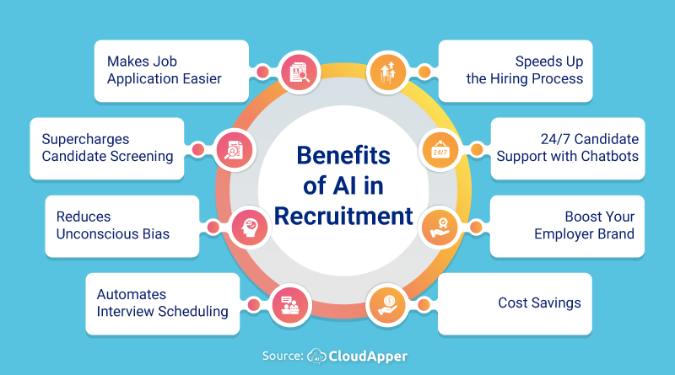
Figure 1: Benefit of AI in recruitment
(Source: Talwar and Agarwal, 2022)
The critics suggest that algorithmic bias, the absence of transparency in choice-making, and the excessive dependence on data-driven judgments would unwillingly support the inequalities. Also, there is doubt regarding how far AI can be effective in assessing human qualities, including creativity, flexibility, and emotional intelligence (Talwar and Agarwal, 2022). With the growing usage of AI-based recruitment tools within organizations, there is a need to determine their actual efficacy in relation to delivering equitable and efficient hiring results in the retail industry in the UK. The study seeks to find out the positives, negatives, and the overall effects of AI in recruitment and selection and thus developing a holistic view of how technology can transform human resource management and the overall effects of the technology on the workforce diversity and the success of organizations.

1.2 Research rationale
The decision to conduct this research to understand the effectiveness of Artificial Intelligence (AI) in recruitment and selection process is anchored on the current digital revolution that has taken place in human resource management, especially in the retail industry in the UK. Although AI has become popular in promoting recruiting in order to simplify the process, increase objectivity, and increase matching with candidates, the practical effectiveness and the ethical aspects of its application are frequently discussed (Ore, 2022). The introduction of AI technologies in most of the retail organizations in the UK is not well informed about the limits of their new use, their bias capabilities and how these influence applicants.
The question of the conflict between efficiency and ethical responsibility is vital to consider so that the HR professionals in the UK retail would use AI in a morally responsible way. The results of this research will assist the retail organizations to evaluate the quality and impartiality of the AI in selecting candidates and foster the concept of inclusiveness and fairness in their workforce. Additionally, the study will add to the scholarly body of literature on technological innovation in human resource management and present the understanding of the optimal practices of introducing the AI tools (Ligeiro et al., 2024). Analyzing the benefits and issues of AI-based recruitment, this study will provide the evidence-based recommendations that UK-based retail organizations may consider in their further policies to ensure that AI is the driver of successful, fair, and transparent recruitment and not the source of additional ethical issues.

1.3 Research aim, objectives and research questions
Aim
To evaluate the effectiveness of Artificial Intelligence in improving the efficiency, accuracy, and fairness of recruitment and selection processes in UK retails sector.
Objectives
- To assess how AI tools enhance the efficiency of recruitment and selection in UK retails sector.
- To examine the accuracy and reliability of AI in candidate evaluation in UK retails sector.
- To analyse the impact of AI on reducing human bias in recruitment in UK retails sector.
- To identify challenges and ethical concerns associated with AI-based hiring in UK retails sector.
Research Question
- How does AI improve the efficiency of recruitment and selection processes in UK retails sector?
- To what extent is AI reliable in evaluating candidate suitability in UK retails sector?
- Does AI help reduce human bias or create new types of bias in UK retails sector?
- What ethical or organizational challenges arise when implementing AI in recruitment in UK retails sector?

2. Literature review

2.1 Evolution of Recruitment and Selection in the Digital Era
The digital age has revolutionized the process of recruitment and selection, which has drastically changed the way organizations find, recruit and employ talent. Historically, recruitment used to be a manual process including newspaper advertising, paper applications and face to face interviewing systems, which were potentially time consuming and not extensive. The first decade of the 21st century experienced the decline of paper-based job boards, application through email, and the adoption of databases to track candidates with the emergence of digital technology (Mukherjee and Krishnan, 2022). This saw the inception of technology-based recruitment whereby organizations were able to tap a broader range of applicants at a lower cost.
With the increased technological development, the recruitment landscape started having a new look with the emergence of social media in LinkedIn and artificially intelligent software. In particular, recruitment processes have been transformed by Artificial Intelligence, which allows making quicker decisions and lessening the administrative burden due to the introduction of automated shortlisting and chatbots (Prabhakar, 2023). Nevertheless, the transformation is also problematic in terms of the preservation of human contact and equality in the evaluation process with robots. Generally, the digital age has turned recruitment and selection processes into more strategic, data-driven, and efficient, and it is a definite change in the human resource management practices.

2.2 Artificial Intelligence Uses in Recruitment.
The Artificial Intelligence (AI) has become a disruptive technology in the recruitment industry that automates and optimises various phases of hiring in the UK retail market. The innovation saves time and effort that would have been used in shortlisting manually. An example of AI usage is candidate sourcing, during which predictive analytics allow AI tools to determine the prospective employees on professional networks such as LinkedIn and other online databases (Aamer et al., 2022). Moreover, chatbots are now more frequently deployed to communicate with the applicants, answer questions and pre-screens to have interview interviews that are more efficient and predictable.
Another application of AI is in the analysis of video interviews where the system looks at speech patterns, facial expressions, and tone to determine the suitability of the candidate. Predictive analytics also assists HR professionals to predict the performance of employees, their likelihood of retention, and cultural fit using historical data. The recruitment systems being AI contribute to better candidate experience by providing personalized communication and real-time feedback (Hunkenschroer, 2022). Although these have benefits, it should be closely monitored to avoid biases and accuracy in interpreting data. On the whole, AI has enabled the retail recruitment process in the UK to be more strategic, data-driven, and useful in helping to make informed human resource decisions.

2.3 AI affects the efficiency of the recruitment process and its decision-making.
The effects of Artificial Intelligence (AI) on recruitment effectiveness and decision making have been tremendous, transforming the process through which talent acquisition is done by organizations. The automation of tasks like screening of resumes, matching candidates, and scheduling interviews has eased recruiting procedures by automatically doing repetitive tasks that are automated through AI-driven systems (Albassam, 2023). This has saved a lot of time in hiring and the recruiters have become able to concentrate on strategic processes such as talent engagement and organizational fit. AI supplements the process of decision-making because it delivers insights based on the data, which enriches the accuracy and objectivity of the evaluation of candidates.
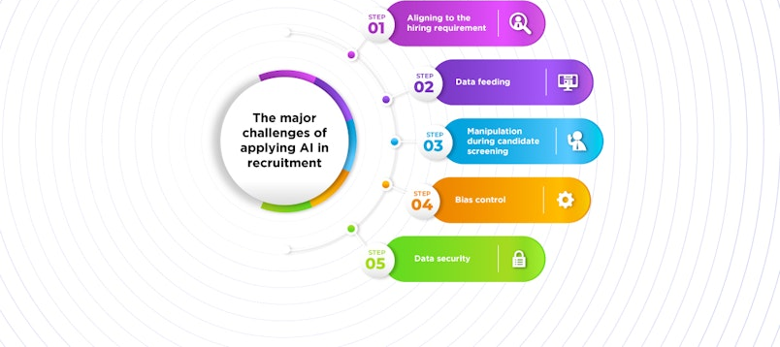
Figure 2: Effect of AI in recruitment
(Source: Albassam, 2023)
It is a data-centric method that reduces human errors and assists to make hiring decisions more consistent. Additionally, AI can help in more efficient planning of the workforce forecasting the hiring tendencies and talent requirements (Allal-Chérif et al. 2021). Nevertheless, although AI leads to better efficiency, excessive dependency on computer processes can jeopardize the possibility of missing qualitative aspects like creativity, flexibility, and interpersonal abilities that can be evaluated in the best way by humans. Thus, AI integration should not involve the elimination of the human decision-making factor. In general, AI has helped recruitment to be more efficient, as it is automated and the hiring process is more strategic, consistent and aligned with the organizational purpose.

2.4 Theoretical framework
Technology Acceptance Model (TAM) is an excellent theoretical framework that can be used to explain the adoption and use of Artificial Intelligence (AI) in the recruitment and selection processes by Human Resource (HR) professionals and organizations. TAM as developed by Davis (1989) can be used to explain technology adoption in terms of two important constructs, namely Perceived Usefulness (PU) and Perceived Ease of Use (PEOU) (Mogaji et al. 2024). Perceived usefulness is the level of perceptions that people hold regarding the use of a given technology, perceived ease of use refers to the ease and usability of the technology by the people. When discussing AI-based recruitment, HR managers will be more inclined to use AI-based tools when they view them as solutions to increasing the efficiency of a hiring process, decreasing the number of manual operations, and improving the accuracy of decisions.
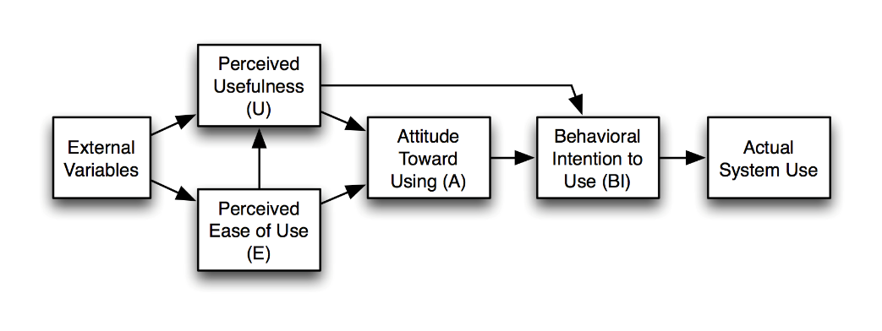
Figure 3: Technology acceptance model
(Source: Aburbeian et al. 2022)
In the same way, the chances of acceptance are high when AI applications, including automated screening systems, chatbots, or predictive analytics, are simple and user-friendly (Aburbeian et al. 2022). These perceptions are also affected by external variables such as organizational support, training and technological infrastructure, which eventually affects the intention to use AI in HR practices. Therefore, TAM is used to explain behavioural and psychological opportunities that can impact the adoption of AI in recruitment, which states that the successful implementation is not only technologically feasible but also requires the acceptance and trust of the user in the reliability and equity of AI usage.

2.5 Literature gap
Despite the studies that have been conducted to establish the position of Artificial Intelligence in the recruitment and selection processes, there are still outstanding gaps in the comprehension of its overall effectiveness and ethical concerns. The majority of the available literature dwells on the technology and efficiency advantages of AI, and there is little focus on the effects of AI on fairness, transparency and candidate experience. The empirical evidence to assess the long-term performance of AI-based hiring decisions in organizations and diversity is lacking.

3. Methodology
The nature of the research methodology in this study will be secondary qualitative research where the study will evaluate the applicability of Artificial Intelligence (AI) in recruitment and selection processes. The secondary methodology will be suitable in this research because it will allow the researcher to elaborate on the data presented, hypotheses, and empirical data without necessarily gathering data (Cheong et al. 2023). It provides an in-depth summary of how AI has been applied in various recruitment scenarios and how far it has gone in enhancing efficiency, objectivity, and equity in the recruitment process.
The secondary data will also be conducted on the bases of scholarly journals, published reports, conference papers, books, organizational case studies and well-known online databases, e.g., Google Scholar and ScienceDirect. This type of source will provide access to peer-reviewed studies and industry perspectives that will discuss the reception, application and impact of AI on human resource management (Rampioni et al. 2021). The process of data collection will be premised on the search of the relevant literature published in the past decade in order to take into account the latest findings and tendencies. The use of such keywords as AI in recruitment, automated hiring system, machine learning in HR, and ethical implications of AI hiring allows retrieving relevant materials.
The method of analysis allows the researcher to group similar thoughts and findings into coherent groups that make sense to the research goals of the study (Spernes, 2022). The most prominent themes that might emerge will be (1) the efficiency of AI in the recruitment sphere, (2) the decrease of inaccuracy and bias in the hiring process, (3) the moral and ethical concerns, and (4) the consequences of AI in the human resources management in the future. The analysis will be based on thematic analysis to synthesize divergent academic values and make productive conclusions on the overall effectiveness of AI in recruitment and hiring process.
The quality in terms of reliability and validity of secondary research is the selection of the source and critical evaluation of the authenticity of the data. Only current and peer-reviewed and reputable publications are used to guarantee validity of the academic text and accuracy. The use of different sources is also helpful to make triangulation and makes the findings more credible due to the opportunity to compare the results of other studies (Naeem et al. 2023). There are also ethical concerns that are observed during the research. The participants of the study are not human therefore there is no privacy or risk of lack of informed consent. However, every author is credited through proper referencing and citation of secondary data sources, which causes them to abide by the academic ethical standards.

4. Expected findings
The hypotheses of the proposed research are based on the idea that the adoption of Artificial Intelligence (AI) in recruitment and selection activities dramatically increases the efficiency, accuracy and decision-making in organizations. It is expected that AI will simplify the hiring process through the automation of repetitive benchmarks of resume screening, shortlisting of the candidates and scheduling of the interviews, helping to save time and administrative expenses during the recruitment process (da Motta Veiga et al. 2023). Another aspect that is likely to be discovered during the study is that AI can be effective in enhancing decision-making since information-based algorithms can be used to select the most fit candidates according to their skills, experience, and other predictive performance indicators in the UK retail business area. Moreover, the results can be used to suggest that AI can help to minimize human bias in the hiring process and make the selection process more objective and fairer.
Nonetheless, it could also be assumed that issues like algorithmic bias, the absence of transparency, and ethical dilemmas regarding the privacy of personal data will become the crucial limitations (Basnet, 2024). The study will most likely reflect the necessity of the automation and human control balance in order to provide fairness and inclusiveness in the hiring practice in the UK. On the whole, the research will probably end with the conclusion that even though AI has enormous potential in transforming the recruitment and selection process, its efficiency will rely on the adequate application, ethics, and constant monitoring to ensure that the technological benefits are aligned with the organizational and societal values.

5. Limitations
The primary weakness of this study is that it uses secondary data sources, which can lead to a restriction of the ability to obtain real-time information or the experience of organizations with AI-driven recruitment. Since the study relies on already existing works, the results are affected by the quality, relevance, and timeliness of the existing literature. Also, depending on the contexts and methods of studies used by the sources, the conclusions can be less generalized (Lochmiller, 2021). Having no primary data collection. interviews or surveys among HR professionals, does not allow finding results to be directly validated as well.

6. Timeframe
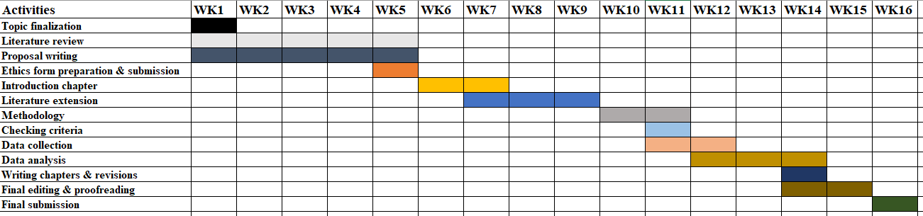
Figure 4: Research timeline
(Source: Self-developed)

7. Conclusion
The technologies of AI implementation enable companies to automatize their routine, spend less time on hiring, and enhance objectives in the process of assessing candidates. However, the paper also admits that the phenomenon of algorithmic bias, the absence of transparency, and the ethical concerns are also some of the impediments to its supreme potential. These findings point out that organizations ought to balance between technological advancement and human manipulation to have equity and inclusivity in the recruitment of individuals in the UK retails business. It is important to ensure that AI is well implemented through clear policies, constant monitoring and ethics to build confidence between the candidates and employers. On balance, taking into account the possibilities of AI, it is important to mention that its popularity can only be achieved with accountable use, in which case, the utilization of technology will not replace human judgment during the process of hiring, but it will provide it with support.

Reference list
Aamer, A.K.A., Hamdan, A. and Abusaq, Z., 2022, March. The impact of artificial intelligence on the human resource industry and the process of recruitment and selection. In International Conference on Business and Technology (pp. 622-630). Cham: Springer International Publishing.
Aburbeian, A.M., Owda, A.Y. and Owda, M., 2022. A technology acceptance model survey of the metaverse prospects. Ai, 3(2), pp.285-302.
Albassam, W.A., 2023. The power of artificial intelligence in recruitment: An analytical review of current AI-based recruitment strategies. International Journal of Professional Business Review: Int. J. Prof. Bus. Rev., 8(6), p.4.
Allal-Chérif, O., Aránega, A.Y. and Sánchez, R.C., 2021. Intelligent recruitment: How to identify, select, and retain talents from around the world using artificial intelligence. Technological Forecasting and Social Change, 169, p.120822.
Basnet, S., 2024. Artificial Intelligence and machine learning in human resource management: Prospect and future trends. International Journal of Research Publication and Reviews, 5(1), pp.281-287.
Cheong, H.I., Lyons, A., Houghton, R. and Majumdar, A., 2023. Secondary qualitative research methodology using online data within the context of social sciences. International Journal of Qualitative Methods, 22, p.16094069231180160.
da Motta Veiga, S.P., Figueroa-Armijos, M. and Clark, B.B., 2023. Seeming ethical makes you attractive: Unraveling how ethical perceptions of AI in hiring impacts organizational innovativeness and attractiveness. Journal of Business Ethics, 186, p.199.
Hunkenschroer, A.L. and Luetge, C., 2022. Ethics of AI-enabled recruiting and selection: A review and research agenda. Journal of Business Ethics, 178(4), pp.977-1007.
Ligeiro, N., Dias, I. and Moreira, A., 2024. Recruitment and selection process using artificial intelligence: How do candidates react?. Administrative Sciences, 14(7), p.155.
Lochmiller, C.R., 2021. Conducting thematic analysis with qualitative data. The qualitative report, 26(6), pp.2029-2044.
Meshram, R., 2023. The role of artificial intelligence (ai) in recruitment and selection of employees in the organisation. Russian Law Journal, 11(9S), pp.322-333.
Mogaji, E., Viglia, G., Srivastava, P. and Dwivedi, Y.K., 2024. Is it the end of the technology acceptance model in the era of generative artificial intelligence?. International Journal of Contemporary Hospitality Management, 36(10), pp.3324-3339.
Mukherjee, I. and Krishnan, L.R.K., 2022. Impact of AI on aiding employee recruitment and selection process. Journal of the International Academy for Case Studies, 28.
Naeem, M., Ozuem, W., Howell, K. and Ranfagni, S., 2023. A step-by-step process of thematic analysis to develop a conceptual model in qualitative research. International journal of qualitative methods, 22, p.16094069231205789.
Ore, O. and Sposato, M., 2022. Opportunities and risks of artificial intelligence in recruitment and selection. International Journal of Organizational Analysis, 30(6), pp.1771-1782.
Prabhakar, N.J., 2023. Role of new emerging technologies in recruitment and selection process. The Online Journal of Distance Education and e-Learning, 11(1), pp.306-314.
Rampioni, M., Moșoi, A.A., Rossi, L., Moraru, S.A., Rosenberg, D. and Stara, V., 2021. A qualitative study toward Technologies for Active and Healthy Aging: A thematic analysis of perspectives among primary, secondary, and tertiary end users. International Journal of Environmental Research and Public Health, 18(14), p.7489.
Spernes, K., 2022. The transition between primary and secondary school: A thematic review emphasising social and emotional issues. Research Papers in Education, 37(3), pp.303-320.
Talwar, R. and Agarwal, P., 2022. Effectiveness of AI tools with respect to Recruitment and Selection Process. Global Journal of Enterprise Information System, 14(4), pp.15-24.

