UNIVERSITY OF WALES TRINITY SAINT DAVID
LONDON CAMPUS
Assignment 2
Learning in the Digital Era
Video Link: https://www.youtube.com/watch?v=yDZdSCxKSSM

Please be sure to give unrestricted access to your video presentation so that your work can be marked by the examiner.
Module Name: Learning in the Digital Era
Module Code: ACCA 4025

Student Name: Surendheran Sugumaran
Student ID:2533422
Group:1

Lecturer’s Name: Koushik Modak

Table of Contents
Introduction 2
Main Body 2
Conclusion 8
References 9

Introduction
This assignment presents a self-evaluation, professional development plan, and summary of the topic "learning to learn." it begins with a self-evaluation that identifies my strengths, weaknesses, and the traits i have developed through self-reflection using Gibbs’ reflective model. It also includes a smart professional development plan that outlines the steps i will take to achieve my career goal of becoming a cybersecurity professional. Finally, the assignment summarises the importance of learning agility and the characteristics of an agile learner, highlighting how continuous learning, reflection, and adaptability contribute to personal growth, academic success, and future career development.

Main Body
The main body explains my self-evaluation and professional development plan. It also discusses my Smart goals and career plans. Finally, it summarises the Learning to Learn topic.
Video Link: https://www.youtube.com/watch?v=yDZdSCxKSSM
Slide 1 This is my cover page
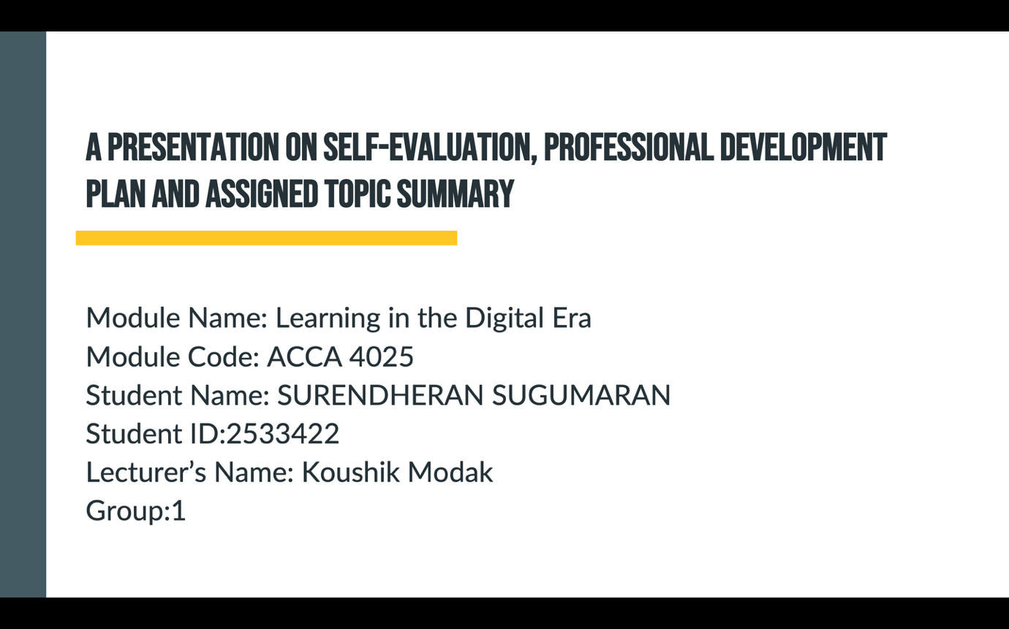

Slide 2 This is my content page
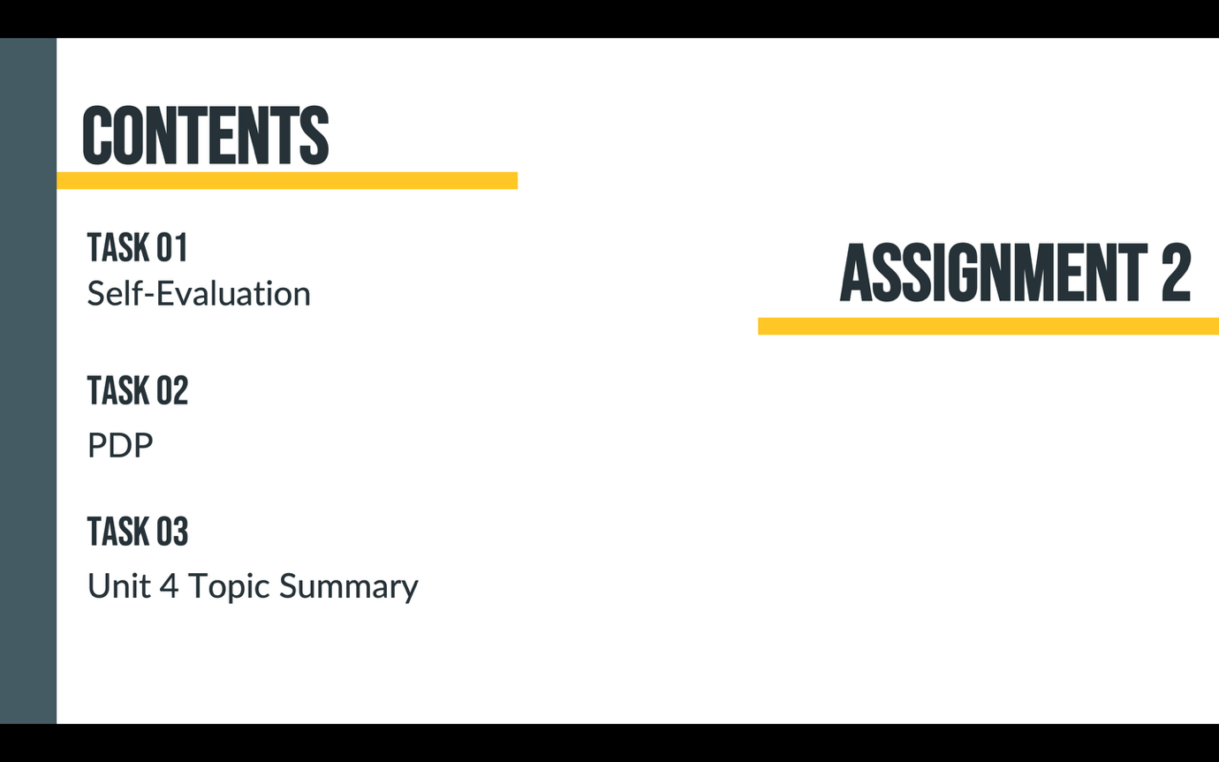

Slide 3 This is my introduction page

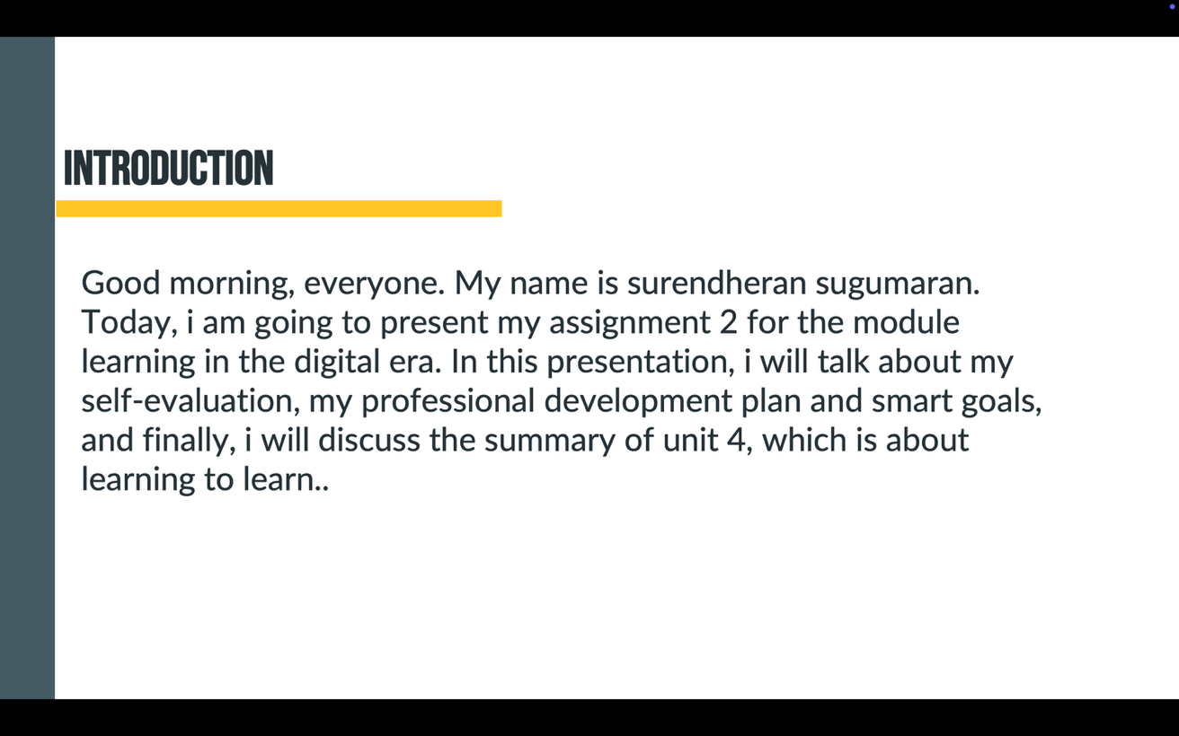
Slide 4 This is my Main Body page
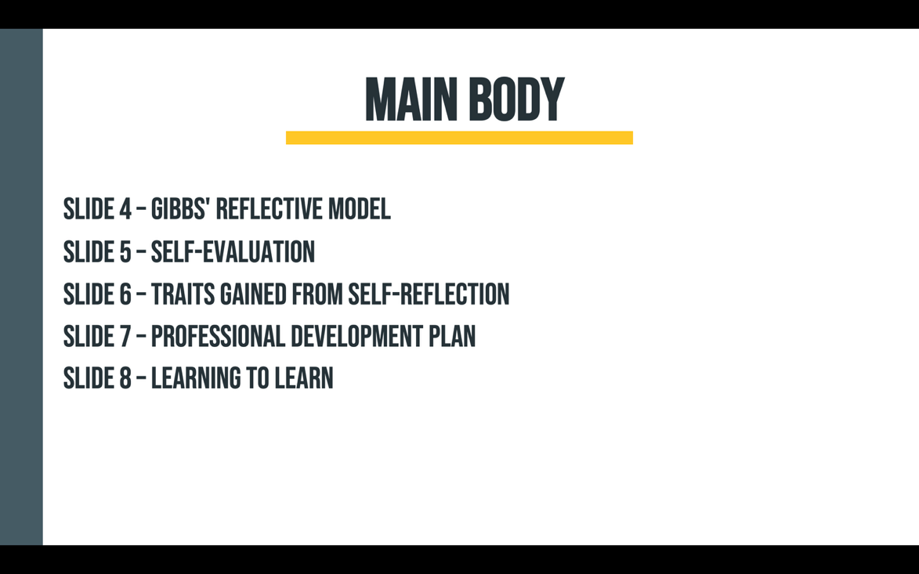

Slide 5 This is my GIBBs reflective model page
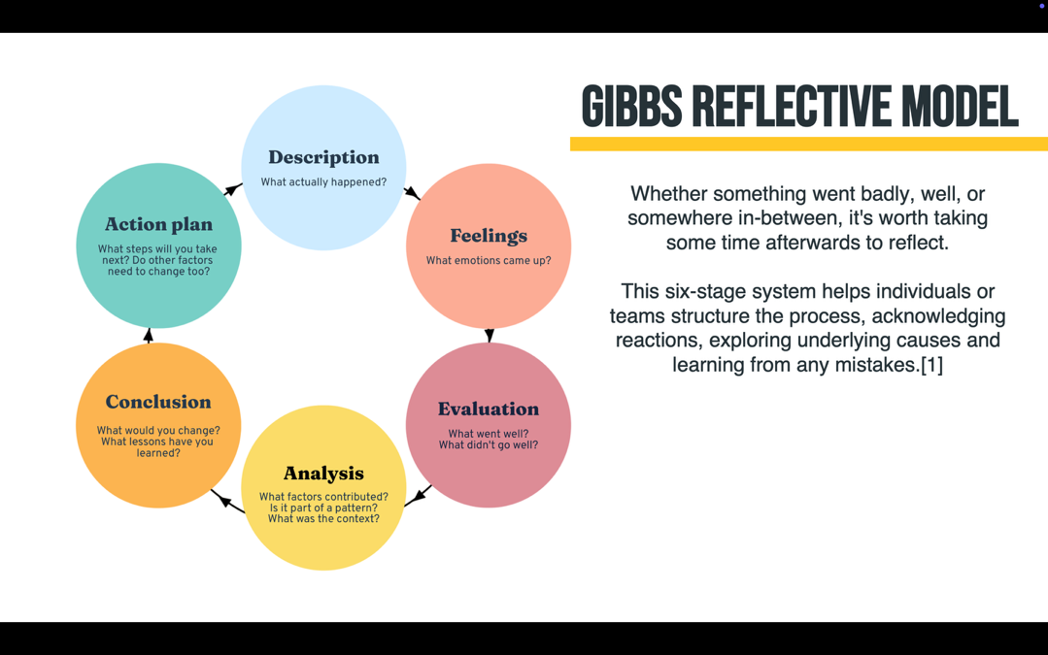
Gibbs' Reflective Cycle is a structured method that helps people learn from their experiences and improve their future performance. It has six stages: Description, Feelings, Evaluation, Analysis, Conclusion, and Action Plan. First, we describe what happened and consider how we felt about the experience. Next, we evaluate what went well and what could have been better. We then analyse the reasons behind the experience and identify what we have learned. Finally, we make an action plan to decide what we would do differently next time. This process helps individuals understand their experiences, learn from mistakes, and develop their skills [1]

Slide 6 This is my Self Evaluation Page
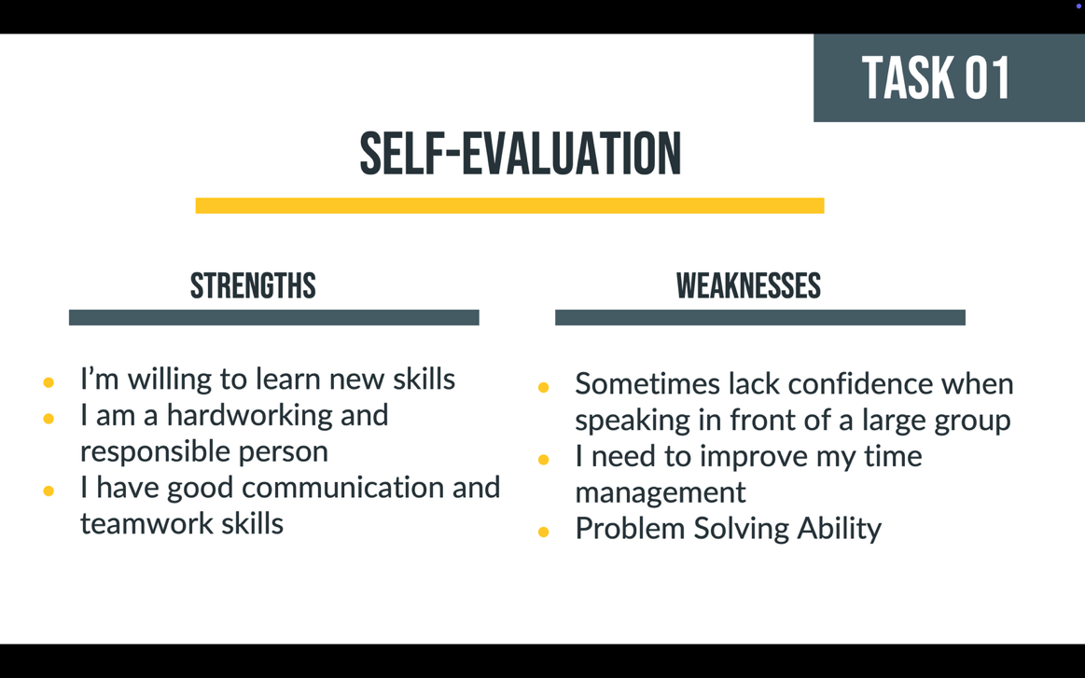
Self-Evaluation: My Strengths and Weaknesses
One of my strengths is having good communication and teamwork skills. I can share ideas clearly, listen to others, and work well with team members. I respect different opinions and support others when needed. However, I sometimes lack confidence when speaking in front of a large group and may feel nervous. To improve, I will practise presentations, prepare my ideas in advance, and participate more in group discussions. This will help me build confidence and improve my speaking skills.

Slide 7 This is my Triantis gained from the Self Reflection Page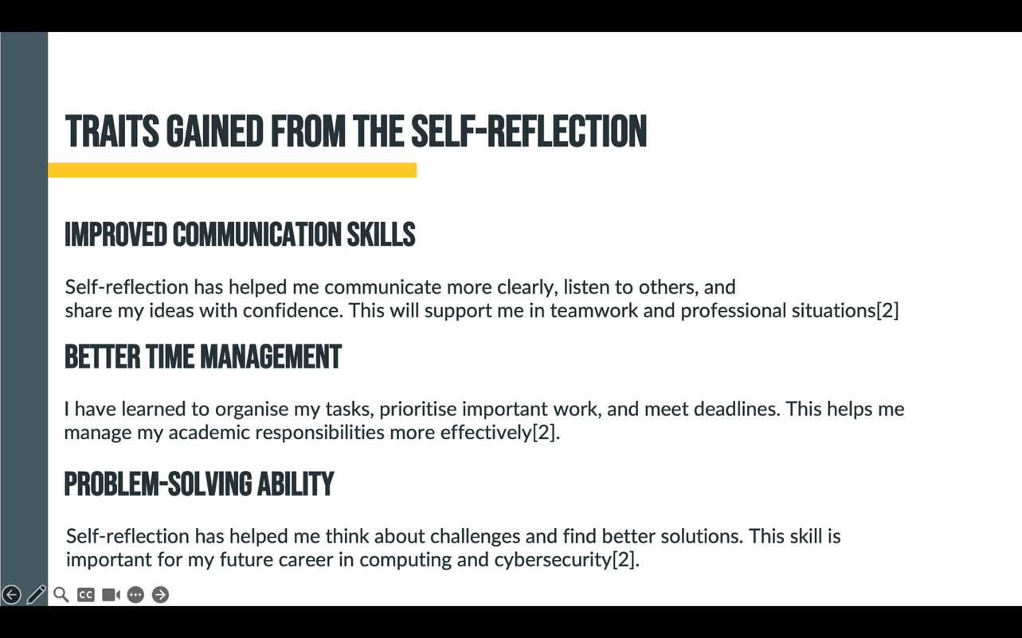 [2]
Slide 8 This is Professional development plan with smart goals page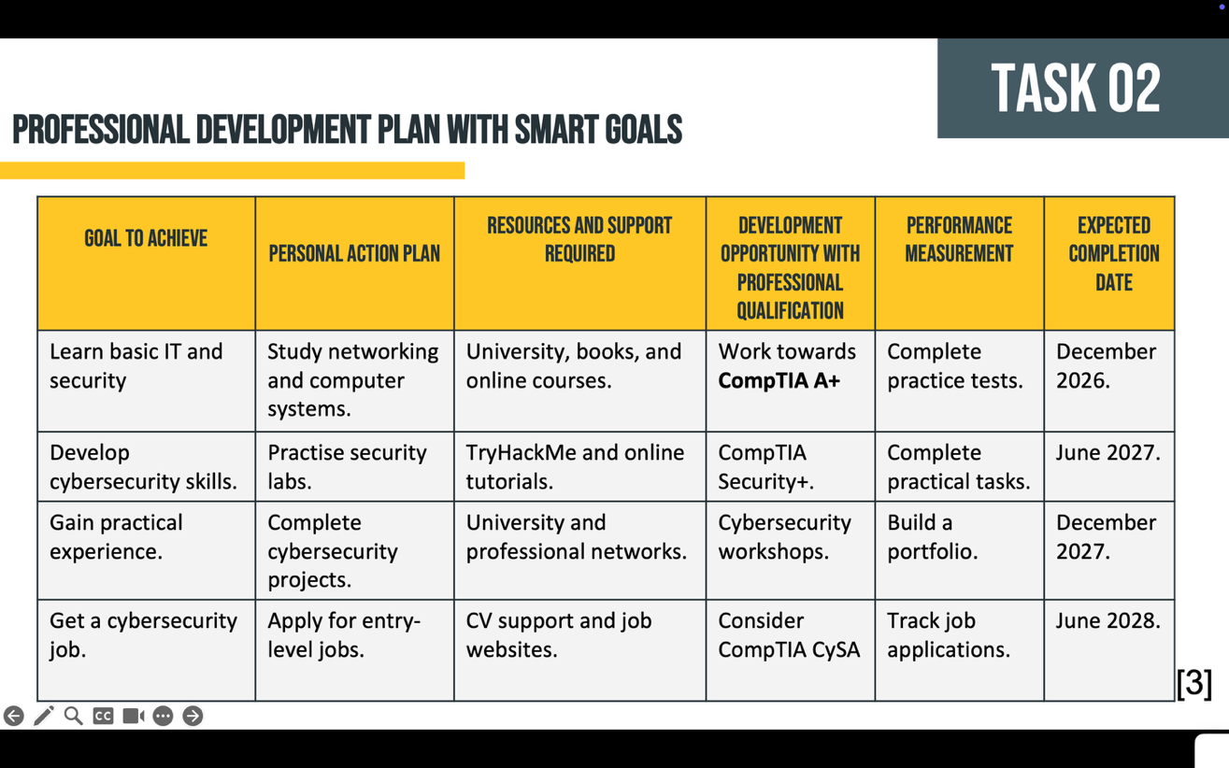 [3]

My Professional Development Plan focuses on achieving my goal of becoming a cybersecurity professional. First, I will develop basic IT, networking and security knowledge and work towards CompTIA A+. Next, I will improve my cybersecurity skills through practical labs and work towards CompTIA Security+. I will then gain practical experience by completing cybersecurity projects and building a portfolio. Finally, I will apply for entry-level cybersecurity jobs and continue developing my skills through further qualifications such as CompTIA CySA+. This plan will help me achieve my career goals step by step. [3]

Slide 9 This is my unit 4 topic summary Learning to learn Page
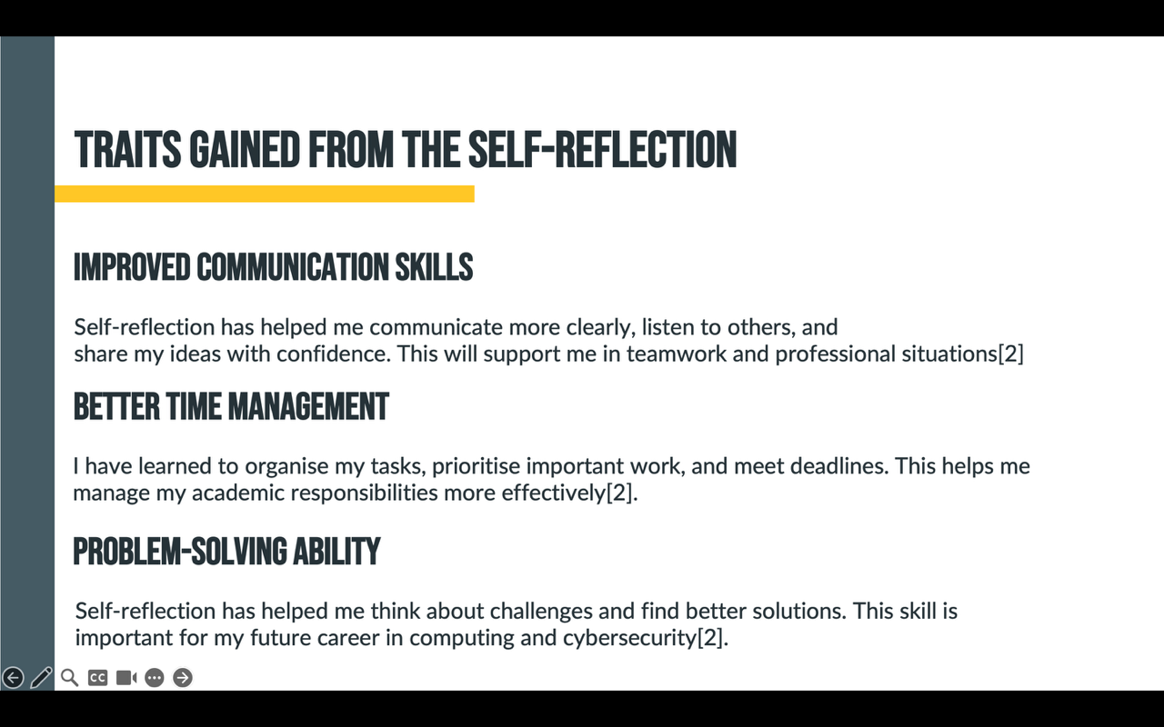 [4]

Slide 10 This is my Conclusion Page
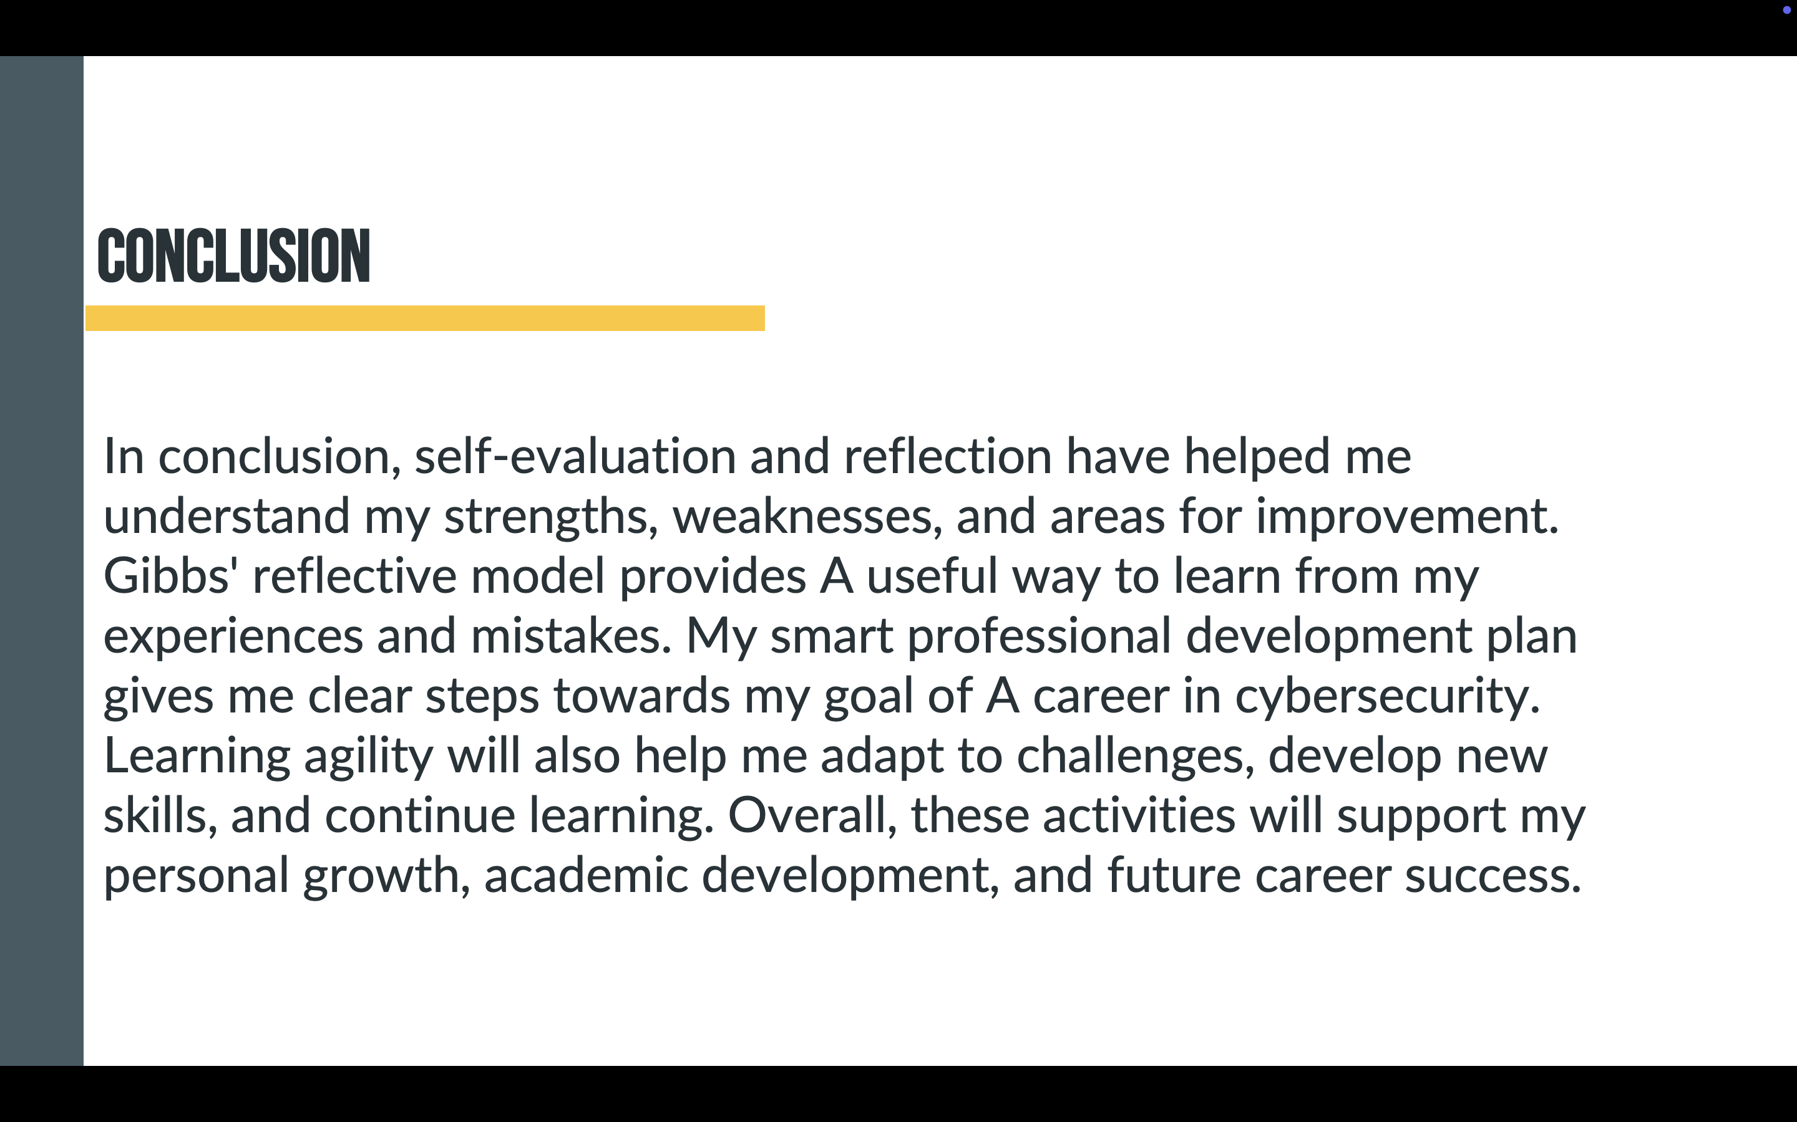

Slide 11 This is my Reference Page
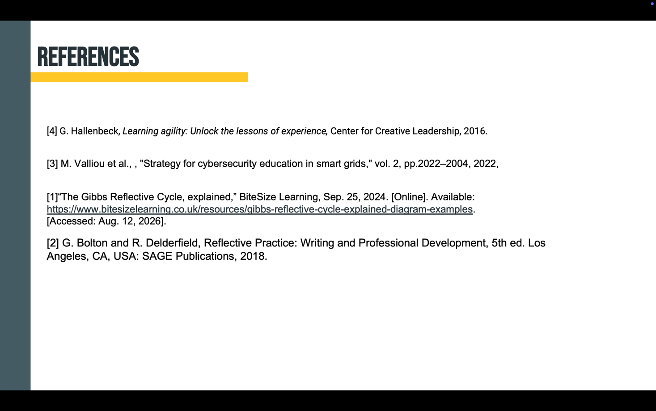

Conclusion
Self-evaluation and reflection have helped me understand my strengths and weaknesses. Gibbs’ Reflective Model helps me learn from my experiences, while my SMART development plan provides clear steps towards a career in cybersecurity. Learning agility will help me adapt, develop new skills, and achieve my future career goals.

References

[1] | B. Learning, “Bitesize Learning,” 25 sepetember 2024. [Online].  Available: https://www.bitesizelearning.co.uk/resources/gibbs-  reflective-cycle-explained-diagram-examples.  [Accessed 13 august 2026].
[2] | Bolton, Gillie; Delderfield, Russell, “google books sage,” 2018. [Online].  Available: https://books.google.co.uk/books?id=zbpBDwAAQBAJ&pg=PA1926&source=  gbs_selected_pages&cad=1#v=onepage&q&f=false.  [Accessed 13 august 2026].
[3] | Valliou, Maria; Chronis, Alexandros; Kotsampopoulos, Panos; Eltahawy,  Bahaa; Vartiainen, Tero; Mekkanen, Mike; Romānovs, Andrejs; Bikovska,  Jana; Pekša, Jānis; Pirta-Dreimane, Rūta; Kamsamrong, Jirapa; Siemers, Bjoern,  “Cybersecurity Curricula Recommendations for Smart Grids (CC-RSG),” april 2022.  [Online]. Available: https://www.uwasa.fi/sites/default/files/2022-04/Strategy%20for%  20cybersecurity%20education%20in%20smart%20grids%20CCRSG%20project.pdf.  [Accessed 13 august 2026].
[4] | Hallenbeck, George, “Learning Agility: Unlock the Lessons of Experience book,” 2016.  [Online]. Available: https://books.google.co.uk/books?hl=en&lr=&id=Ius2DwAAQBAJ&oi=fnd&pg=PP7&dq=  learning+agility+books&ots=avxUVtzGt7&sig=fp_lQ9OSy1mrWtMsJGAyD7gum9I&redir_esc  =y#v=onepage&q=learning%20agility%20books&f=false. [Accessed 13 august 2026].

