Design and Analysis of Electromagnetic Systems
Oliver Atkinson

21/03/2025
ACDC5009
Stalin Jacob
Contents
Abstract 4
Task 1 5
Introduction 5
Vacuum filled PEC Waveguide 5
Waveguide Modes 6
TE 6
TM 6
TEM 6
Port Field Displays 7
Mode 1 7
Mode 2 7
Mode 3 8
Electric field Magnitude and Vector diagrams 9
Magnitude diagram 9
Vector diagram 9
Mode 1 9
Mode 2 9
Mode 3 10
Magnetic Field Magnitude and Vector diagrams 11
Mode 1 11
Mode 2 11
Mode 3 12
Rectangular Graph 13
Cut Off Frequencies 13
Mode 1 14
Mode 2 14
Mode 3 14
Comparison 14
Teflon Filled PEC Waveguides 15
Waveguide modes 15
Port Field Displays 16
Mode 1 16
Mode 2 16
Mode 3 16
Electric field Magnitude and Vector diagrams 17
Mode 1 17
Mode 2 17
Mode 3 18
Magnetic Field Magnitude and Vector diagrams 19
Mode 1 19
Mode 2 19
Mode 3 20
Rectangular Graph 21
Cut Off Frequencies 21
Comparison 22
Task 2 23
Antenna Design 23
Antenna Parameters 23
Simulation results and Conclusion 24
Impedance matching 24
Far Field Transmission Plot 24
Task 3 25
Introduction 25
Traditional Radar Returns 25
Radar Cross Section (RCS) 25
Radar Clutter 26
Current and Improving Drone Detection 26
High Data Sampling Rate 26
AI integration 26
Micro doppler integration 26
Conclusion 26
References 27

Figure 1 - PEC, Vacuum Waveguide 5
Figure 2 - Waveguide length calculations 5
Figure 3 - TE modes [3] 6
Figure 4 - waveguide mode 1 7
Figure 5 - waveguide mode 2 7
Figure 6 - waveguide mode 3 8
Figure 7 - Mode 1 Mag_E diagram 9
Figure 8 - Mode 1 Vector_E diagram 9
Figure 9 - Mode 2 Mag_E diagram 9
Figure 10 - Mode 2 Vector_E diagram 9
Figure 12 - mode 3 vector diagram 10
Figure 11 - mode 3 mag_E diagram 10
Figure 14 - mode 1 vector_H 11
Figure 13 - Mode 1 Mag_H 11
Figure 15 - mode 2 Mag_H diagram 11
Figure 16 - mode 2 Vector_H diagram 11
Figure 17 - mode 3 Mag_H diagram 12
Figure 18 - mode 3 vector_H diagrm 12
Figure 19 - Gamma Plot 13
Figure 20 - Teflon waveguide 15
Figure 21 - mode 1 port field display 16
Figure 22 - mode 2 port field display 16
Figure 23 - mode 3 port field display 16
Figure 24 - teflon Vector_E mode 1 diagram 17
Figure 25 - teflon Mag_E mode 1 diagram 17
Figure 26 - mode 2 teflon Mag_E diagram 17
Figure 27 - mode 2 teflon vector_E diagram 17
Figure 28 - mode 3 teflon Mag_E diagram 18
Figure 29 – mode 3 Vector_E teflon diagram 18
Figure 30 - mode 1 Mag_H teflon diagram 19
Figure 31 - mode 1 Vector_H teflon diagram 19
Figure 33 - Mode 2 Teflon Mag_H diagram 19
Figure 32 - Mode 2 Teflon Vector_H diagram 19
Figure 34 - mode 3 Mag_H teflon diagram 20
Figure 35 - mode 3 Vector_H teflon diagram 20
Figure 36 - rectangular plot for teflon waveguide 21
Figure 37 - dipole antenna 23
Figure 38 - s parameter plot for dipole antenna 24
Figure 39 - far field transmission plot 24

Abstract

This report includes the simulation of waveguide technology and a dipole antenna. The results shown in report are the simulated results from the software Ansys and CST. It was found that Teflon had a lower cut off frequency than a vacuum filled waveguide.

The dipole antenna was incorrectly designed at first using 50 ohms impedance however once impedance matching was performed this issue was corrected. The dipole functioned as intended.

Task 1

Introduction

This task involves designing and simulating various waveguide technologies. One of which is filled with a vacuum and the other is filled with Teflon. The length and width of the waveguide have been decided using the first 3 digits my student number.

Vacuum filled PEC Waveguide

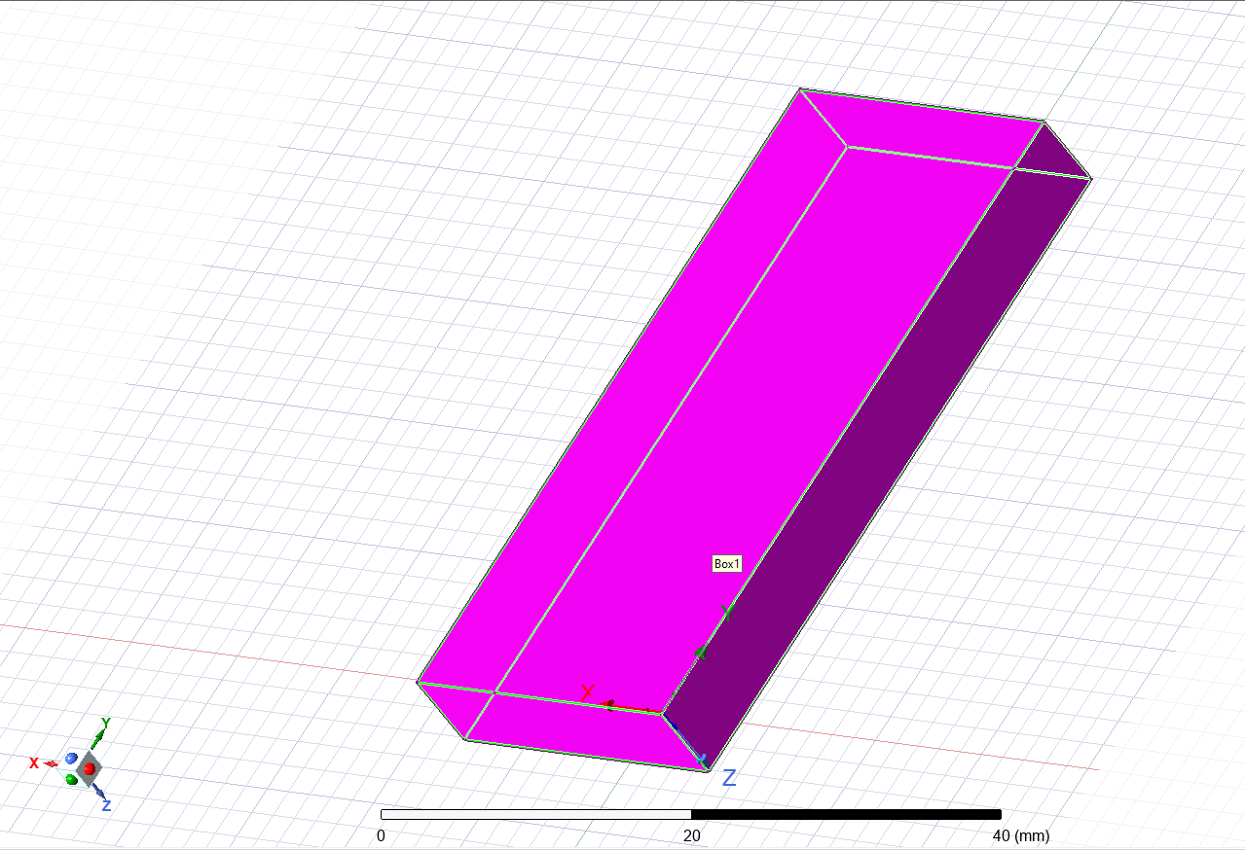
The waveguide shown in figure 1 is a PEC walled, Vacuum filled waveguide with the dimensions of 23mm by 6mm by 50mm. decided using the first 3 digits of my student number. The two end faces are the waveguide ports and each of the four wrapping faces are PEC, Perfect Electrical Conductor.
Figure 1 - PEC, Vacuum Waveguide

The length was decided using the formula in figure 2.

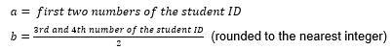

Figure 2 - Waveguide length calculations

Waveguide Modes

A waveguide mode is a unique way of characterising the propagation of electric and magnetic wave through a waveguide. Theses modes are TE, TM, and TEM. [1]

TE
In TE mode, the electric field is only transverse to the direction of propagation of the wave. The magnetic field can be both parallel and transverse to the direction of propagation. [2]

The most common TE mode used in a rectangular waveguide is TE 10. This is due to TE10 having the lowest cut off frequency. The first digit in TE10 represents the number of half waves across the width of the waveguide. The second digit represents the number of half waves across the height of the waveguide. Shown in figure 3. [3]

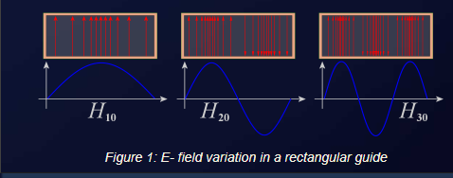
Figure 3 - TE modes [3]

TM

In TM the magnetic field is only Transverse of the direction of propagation of the wave, while the electric field is both parallel and perpendicular to the direction of travel. [4]

The most common TM mode in a rectangular waveguide is TM11. Again, this is because TM11 has the lowest cut off frequency. Using the same notation as TE10, TM11 has 1 half wave across the width and 1 half wave across the height of the waveguide.

TEM

In TEM mode both the electric and magnetic fields are only perpendicular to the direction of propagation. This generates a perfectly symmetrical and uniform wave inside the waveguide. The downside of TEM mode is that it is limited to specific waveguide dimensions. [5]

Port Field Displays

The Port field displays are a physical display of the different modes mentioned previously. It shows a heat map of the half waves in each mode.

Mode 1

Mode 1 is where the width of the wave guide is equal to 1 half wavelength, shown in figure 4. Also known as TE\M10.
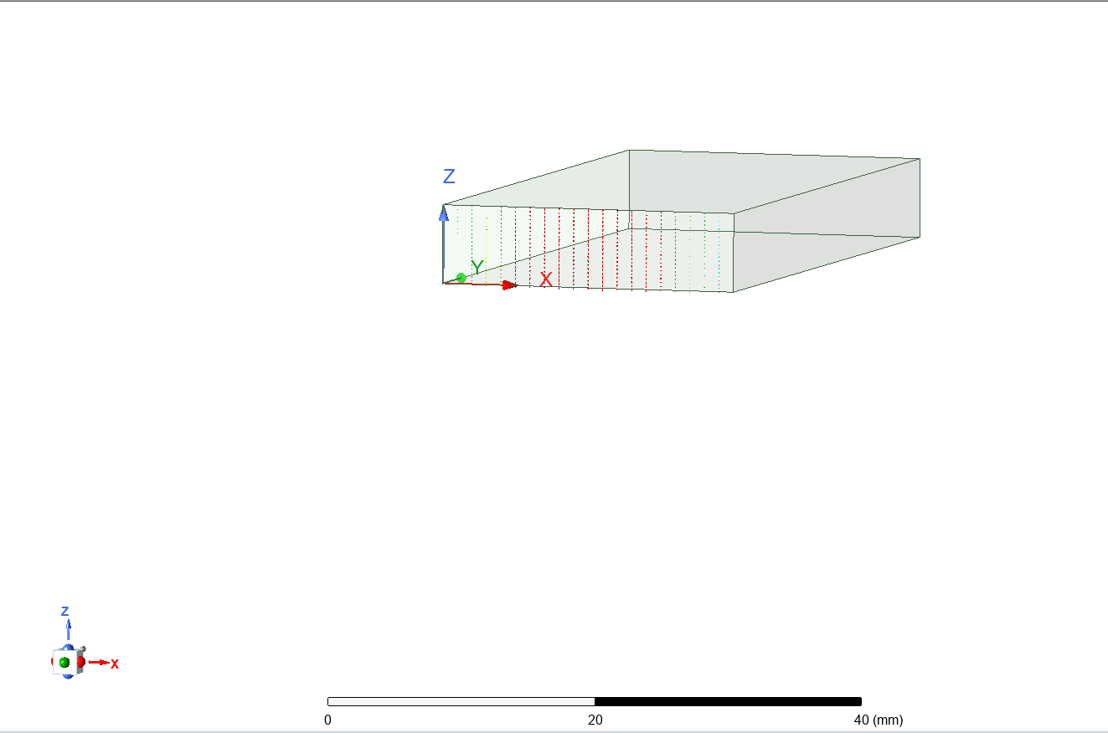
Figure 4 - waveguide mode 1

Mode 2
For mode 2 the width of the waveguide is equal 1 wavelength, shown in figure 5. Also known as TE/M20.
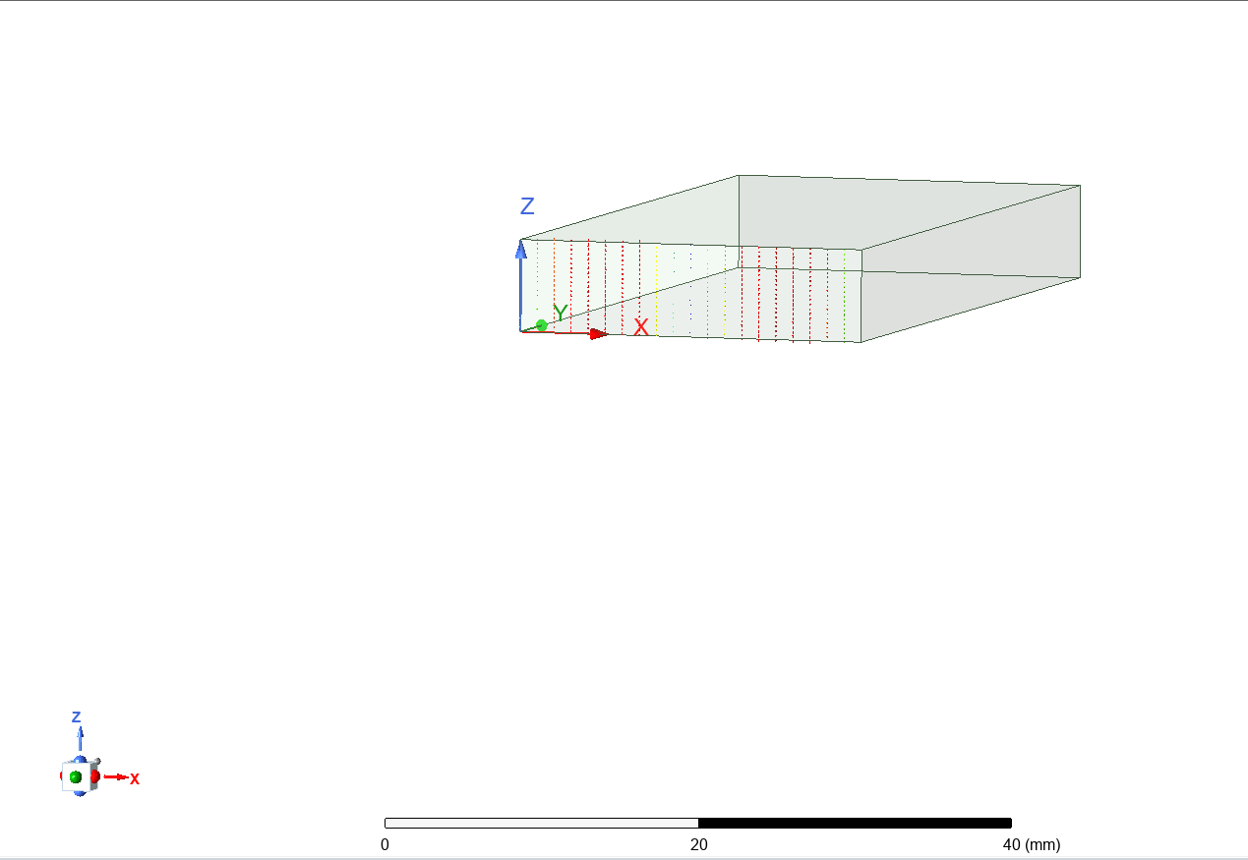
Figure 5 - waveguide mode 2

Mode 3

In mode 3 the width of the waveguide is equal to 1.5 wavelengths. Also known as TE/M30.
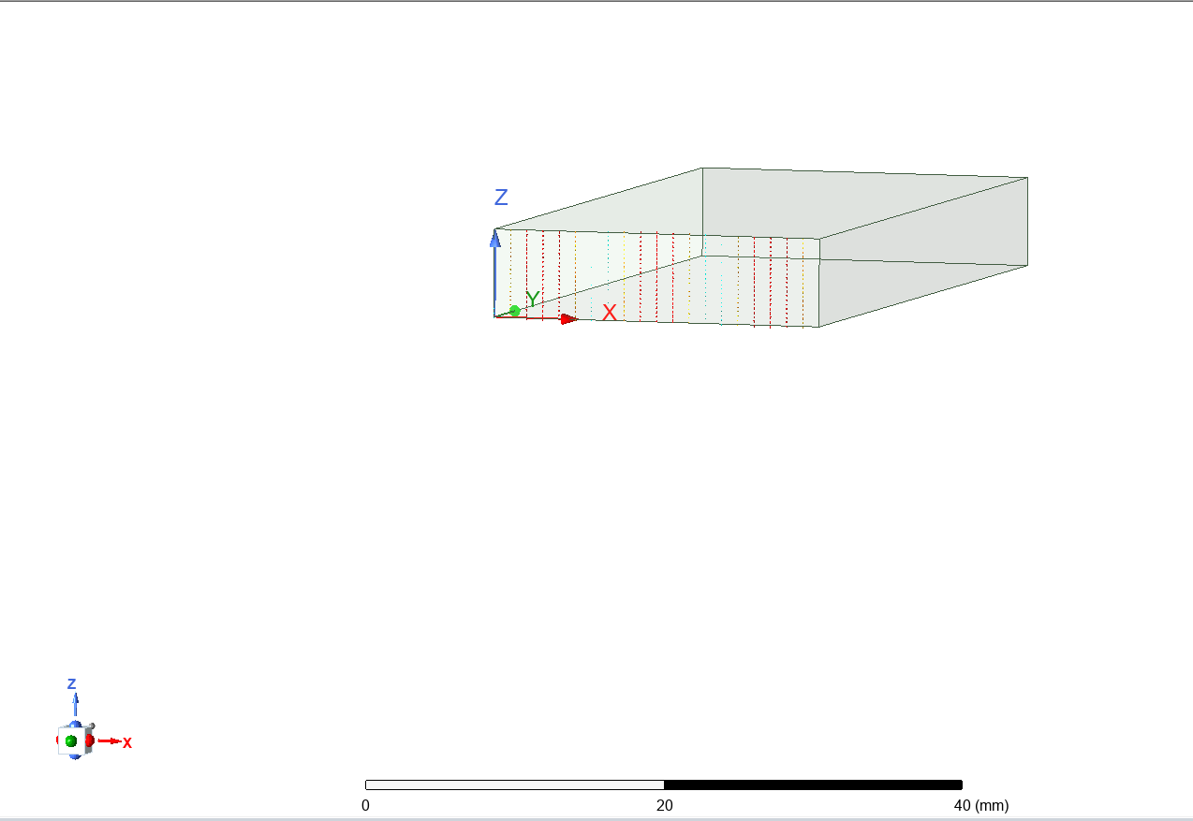
Figure 6 - waveguide mode 3

Electric field Magnitude and Vector diagrams

Magnitude diagram

A magnitude diagram shows the strength of the electric field present in the waveguide as the wave passes through it. Acting like a heat map the blue sections show a lack of electric fields and the red hotspots show high intensity peaks of the electric fields. The figures below show the different magnitude diagrams for each mode.

Vector diagram

A vector diagram is a visual representation of the direction of propagation of the electric fields.

Mode 1
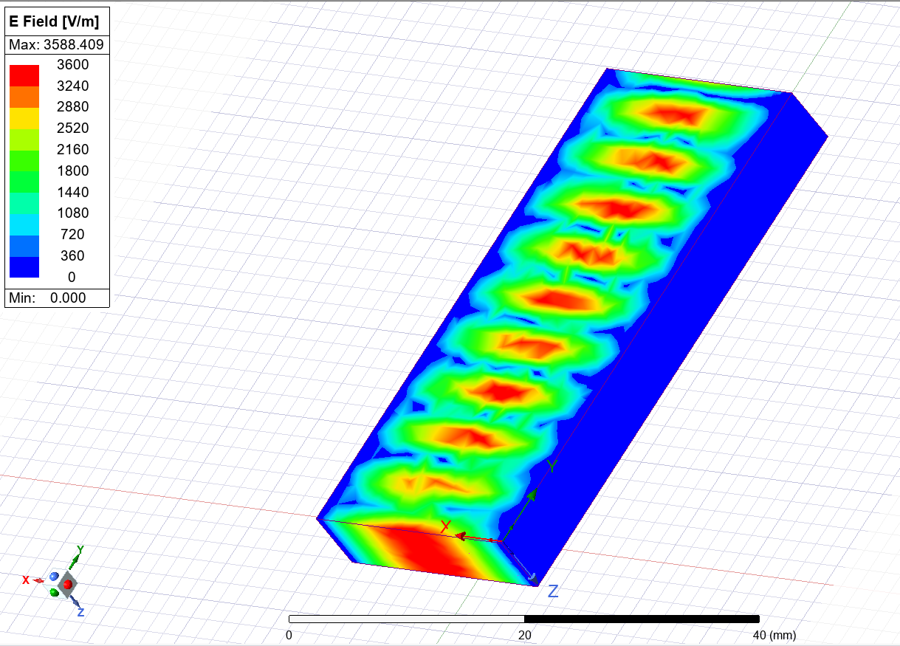
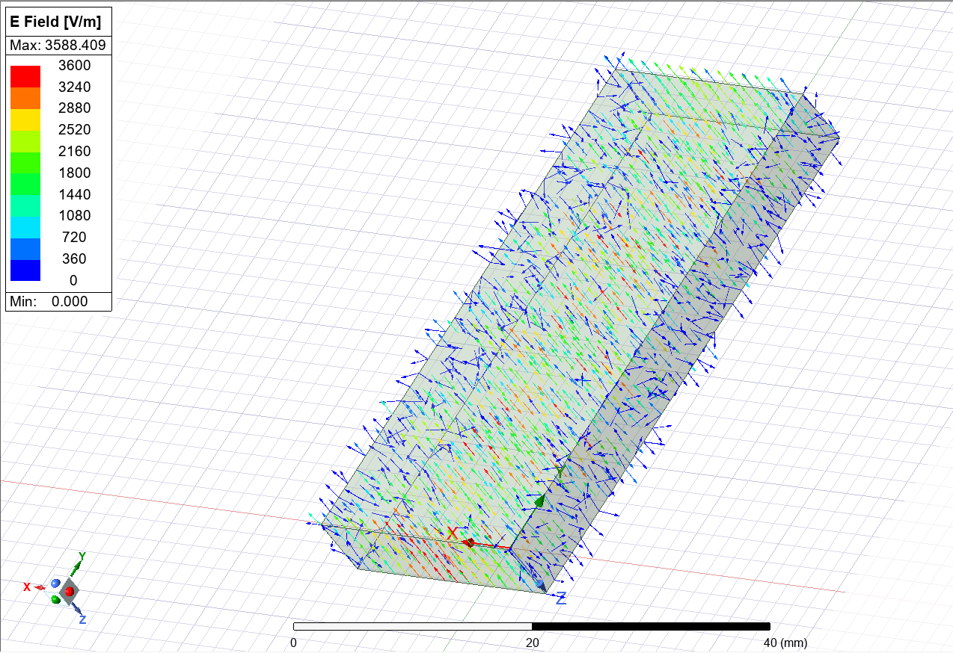
Figure 7 - Mode 1 Mag_E diagram
Figure 8 - Mode 1 Vector_E diagram

Mode 2
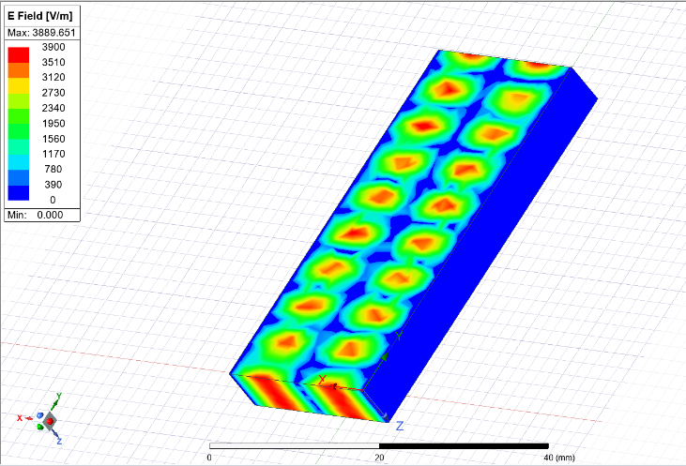
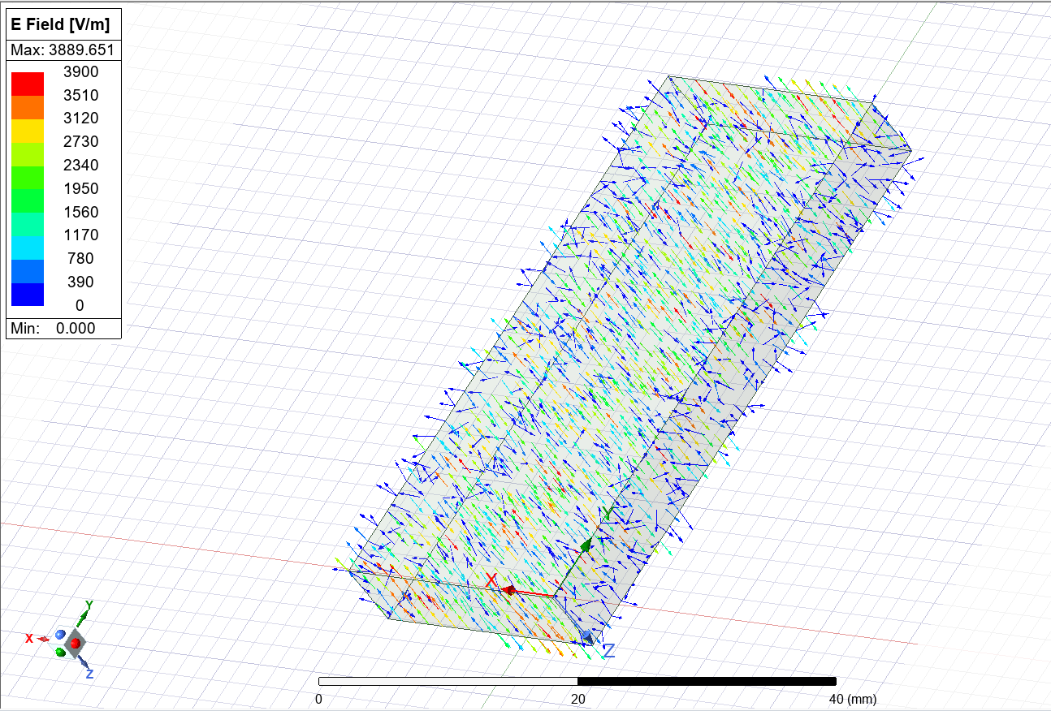
Figure 10 - Mode 2 Vector_E diagram
Figure 9 - Mode 2 Mag_E diagram

Mode 3
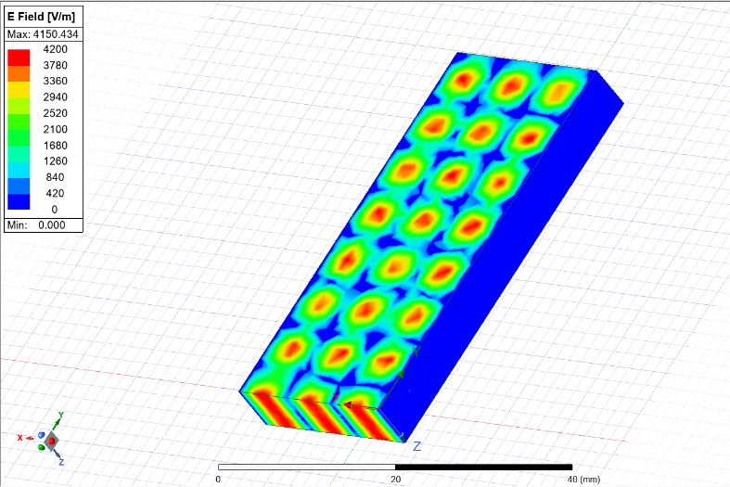
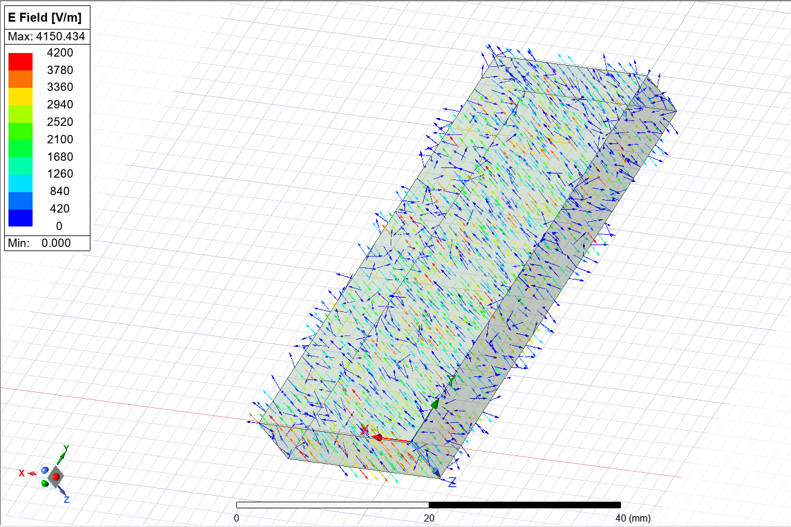
Figure 12 - mode 3 vector diagram
Figure 11 - mode 3 mag_E diagram

Magnetic Field Magnitude and Vector diagrams

These diagrams will show the strength and direction of the magnetic fields.

Mode 1
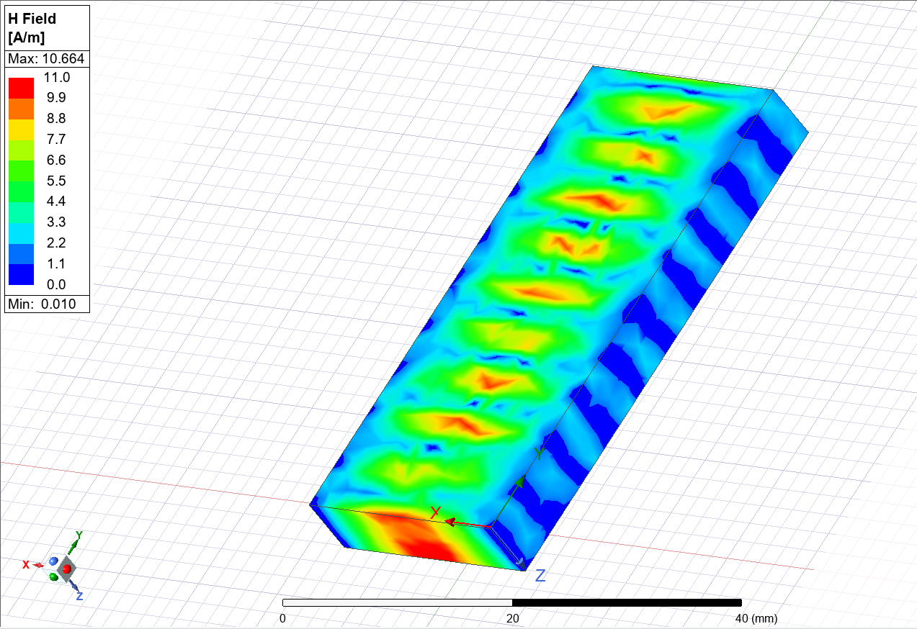
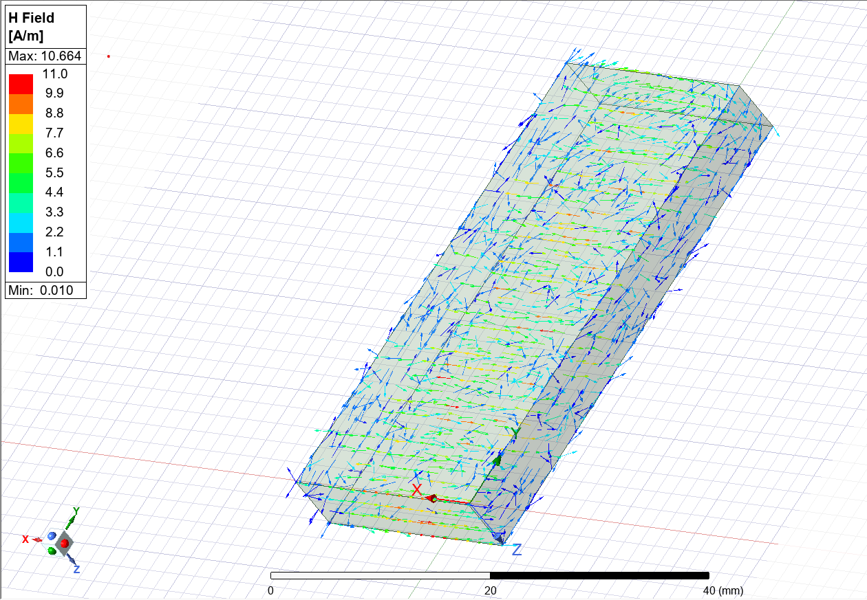
Figure 14 - mode 1 vector_H
Figure 13 - Mode 1 Mag_H

Mode 2

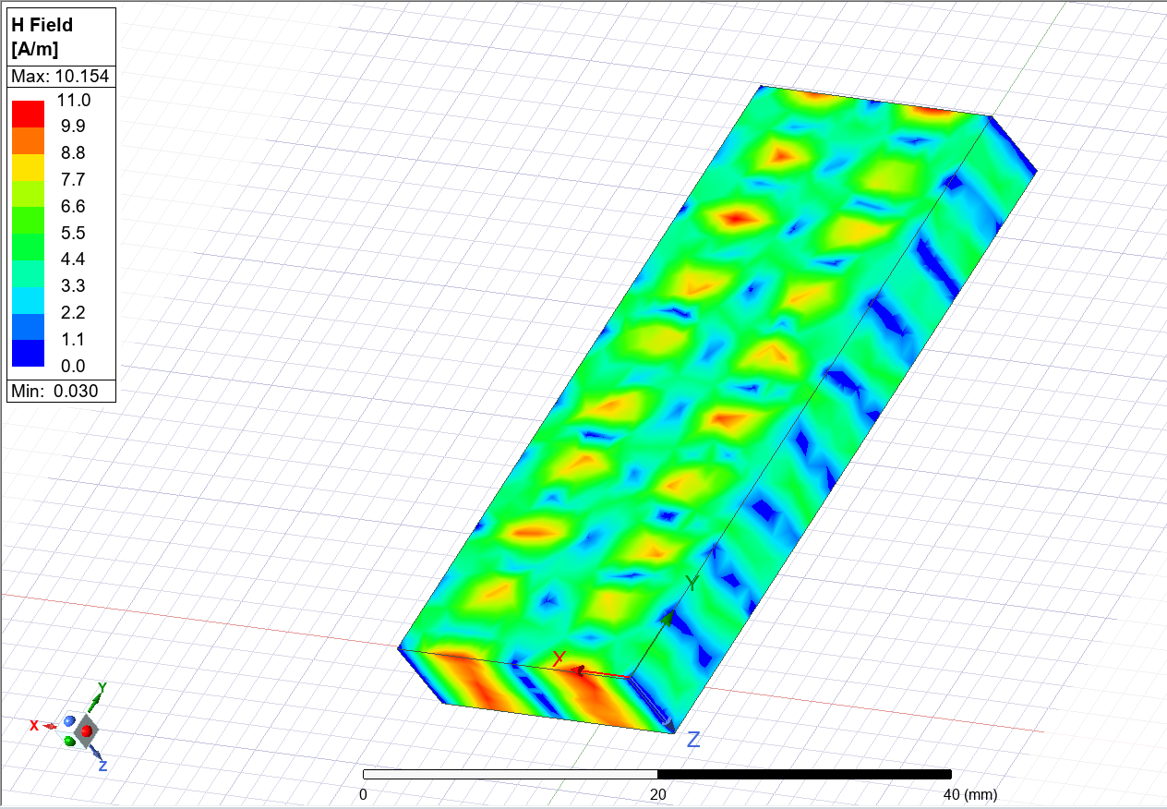
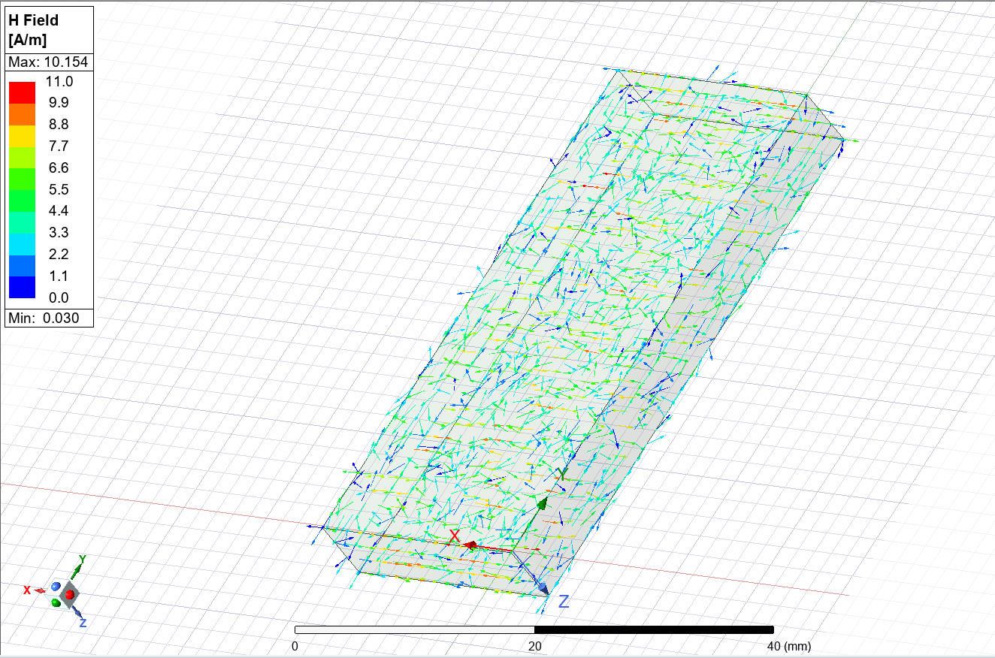
Figure 16 - mode 2 Vector_H diagram
Figure 15 - mode 2 Mag_H diagram

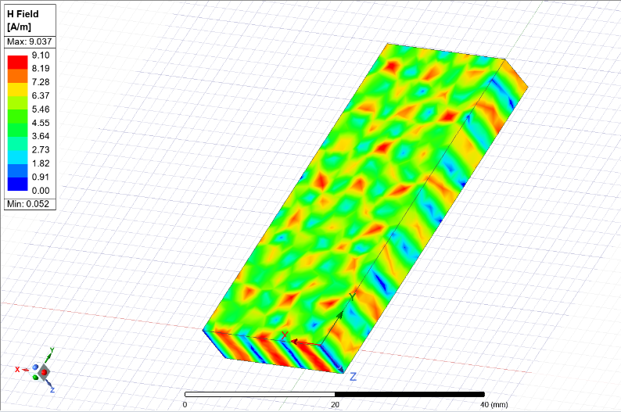
Mode 3
Figure 17 - mode 3 Mag_H diagram
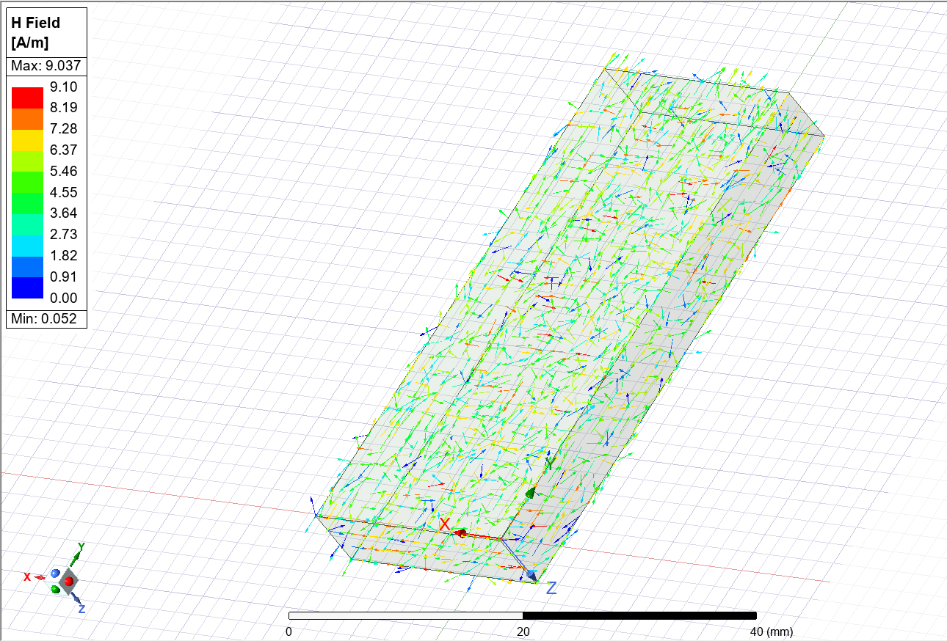
Figure 18 - mode 3 vector_H diagrm

Rectangular Graph

A rectangular plot shows the relationship between frequency and gain. Each of the markers on the graph show the simulated cut off frequencies of each mode. One the cut off frequency has been passed, the waveguide will cease to operate correctly. The waveguide will have gain which is not ideal.

After this frequency the gain of the wave guide will no longer be equal to zero. It will be compared to an ideal calculated frequency.
- Mode 1 – 6.48GHz
- Mode 2 – 12.99GHz
- Mode 3 – 19.50GHz
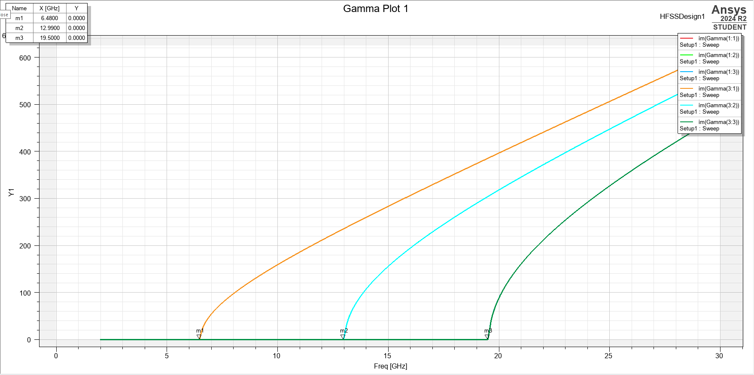
Figure 19 - Gamma Plot

Cut Off Frequencies

The cut off frequency of this waveguide can be calculated using the equation shown below.

- Fc – cut off frequency
- C – speed of light
- M – number of horizontal wavelengths
- N – number of vertical half wavelengths
- A – width of the waveguide
- B – height of the waveguide
$$f_{c}=\frac{c}{2}\sqrt{{\left(\frac{m}{a}\right)}^{2}+{\left(\frac{n}{b}\right)}^{2}}$$

Mode 1

A and B will be the same throughout the calculations as these are the height and width of the waveguide. 0.023 m and 0.006 m respectively.

M and N will be 1 and 0 respectively.
$$f_{c}=\frac{3x10^8}{2}\sqrt{{\left(\frac{1}{0.023}\right)}^{2}+{\left(\frac{0}{0.006}\right)}^{2}}$$
The cut off frequency of this mode is 6.52 GHz

Mode 2

M and N will be 2 and 0 respectively.

$$f_{c}=\frac{3x10^8}{2}\sqrt{{\left(\frac{2}{0.023}\right)}^{2}+{\left(\frac{0}{0.006}\right)}^{2}}$$
The cut of frequency for this mode is 9.22 GHz

Mode 3

M and N will be 3 and 0 respectively.

$$f_{c}=\frac{3x10^8}{2}\sqrt{{\left(\frac{3}{0.023}\right)}^{2}+{\left(\frac{0}{0.006}\right)}^{2}}$$

The cut off frequency for this mode is 11.30 GHz

Comparison

The simulation showed cut off frequencies for mode 1,2 and 3 as 6.48 GHz, 12,99 GHz and 19.50 Ghz. However, the calculated values differ from these significantly.

The calculated cut off frequency for the first mode is 6.52 GHz. This minor difference can be explained by the nature of both the calculation and simulation.

A calculation while incredibly accurate, does not account for various real-world issues. The simulation accounts for an in-perfect vacuum and waveguide structure.
In modes 2 and 3, the difference between the results is much greater. With the calculated frequencies being 9.22 GHz and 11.30 GHz and the simulated results being 12.99 GHz and 19.50 GHz it shows that the simulation can produce results closer to that seen in real life as the calculated results. Because it takes the material or lack off into account which the equation misses.

Teflon Filled PEC Waveguides

This waveguide will have the exact same dimensions as the vacuum filled waveguide however this waveguide will be filled with Teflon.

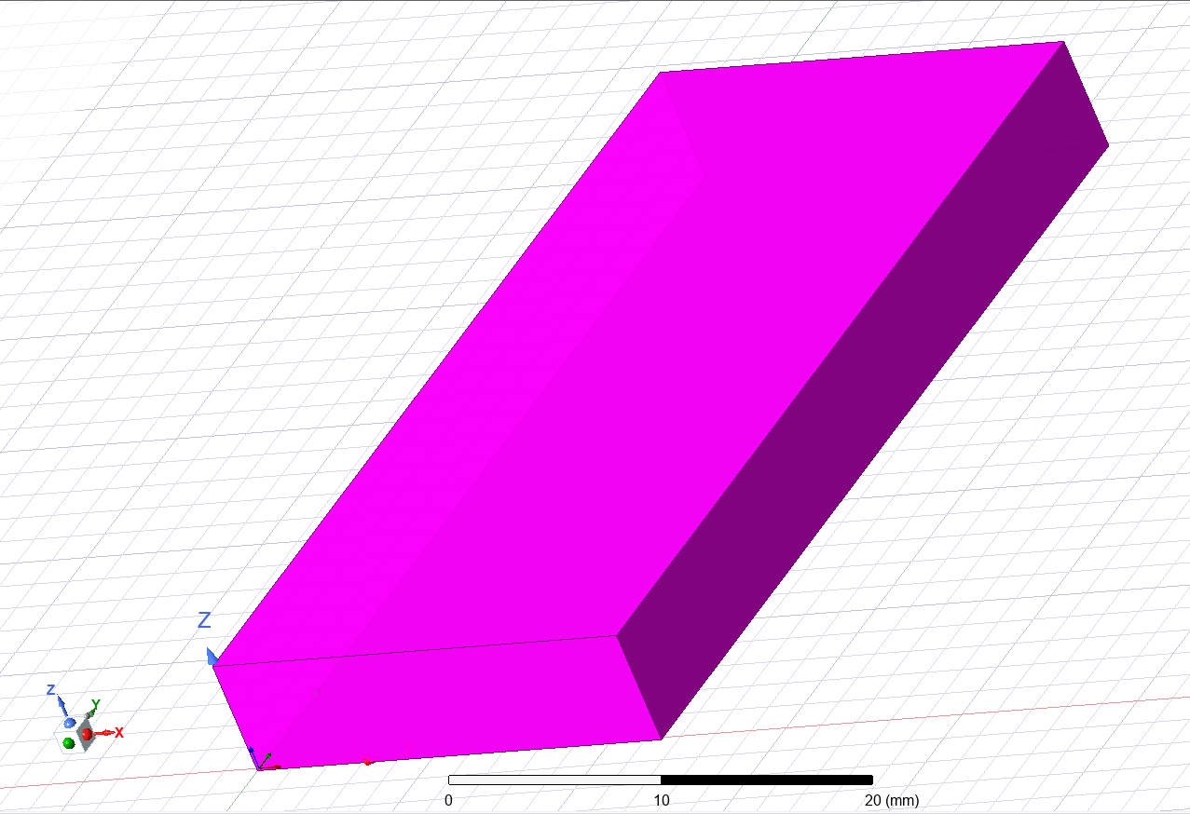
Figure 20 - Teflon waveguide

Teflon has a higher refractive index in comparison to the vacuum, this means the simulated results should be different to the results shown earlier.

Waveguide modes
Much like before this waveguide will use the same modes as before with mode 1, 2, and 3 being equal to the same amount of half wavelengths as before.

Port Field Displays

Mode 1

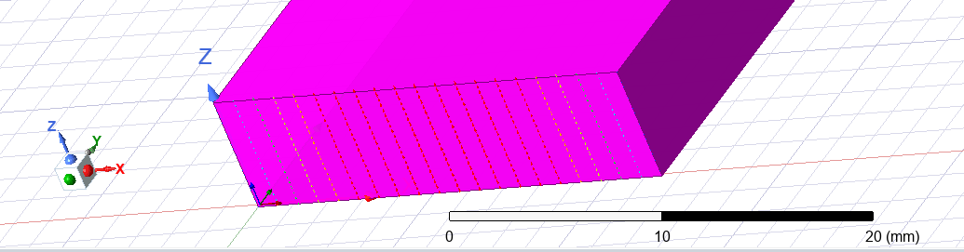
Figure 21 - mode 1 port field display

Mode 2

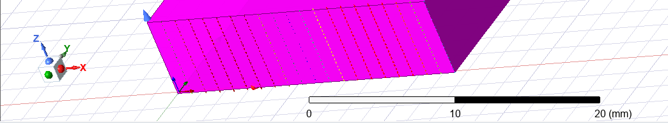
Figure 22 - mode 2 port field display

Mode 3

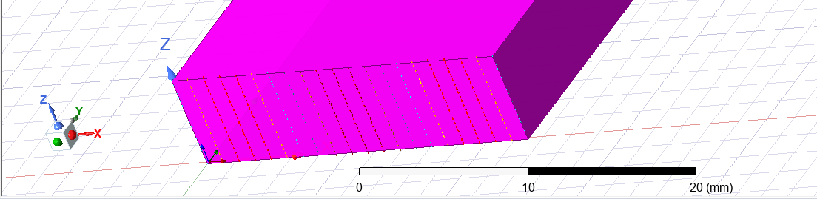
Figure 23 - mode 3 port field display

Electric field Magnitude and Vector diagrams

These shows both the strength and direction of the electric fields present in a waveguide during the simulation.

Mode 1

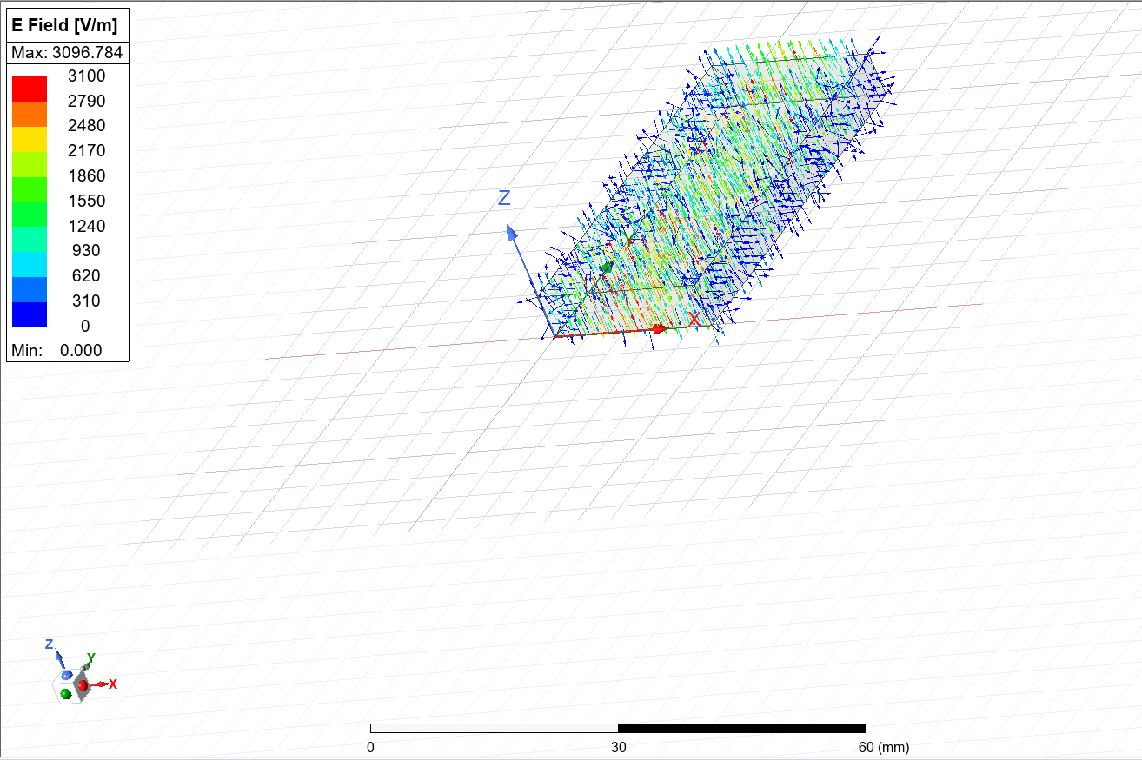
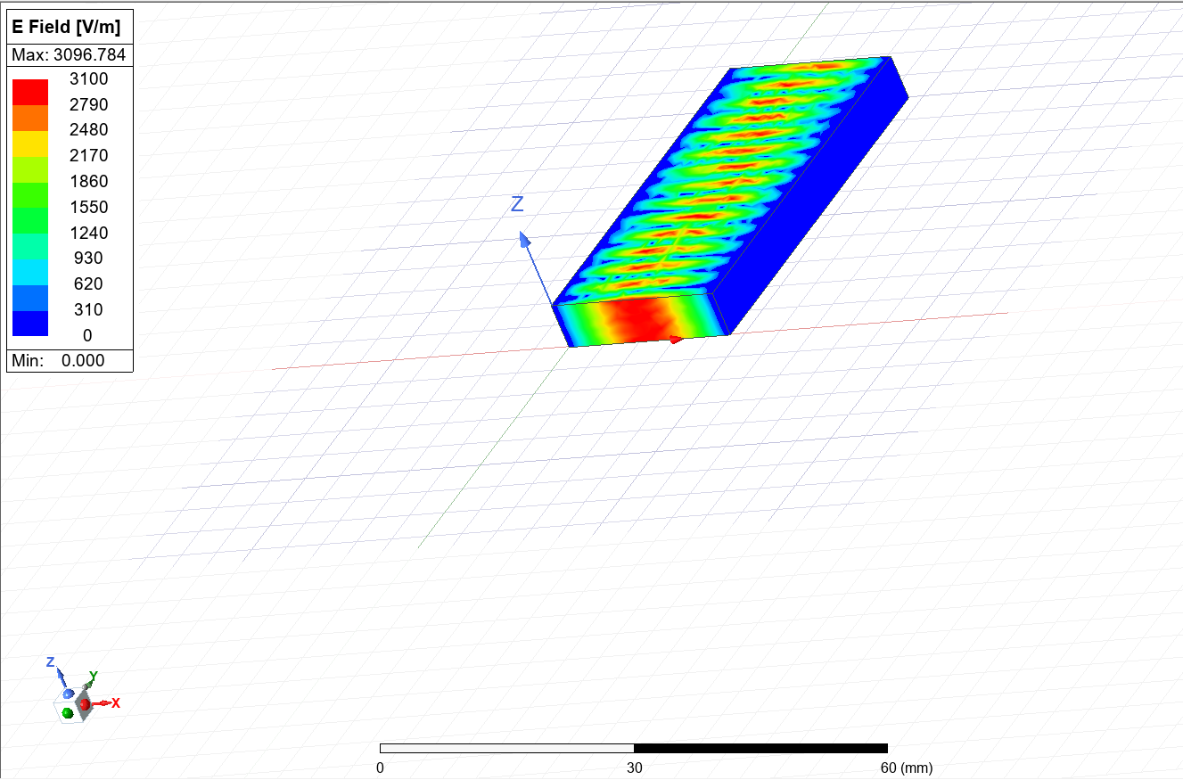
Figure 24 - teflon Vector_E mode 1 diagram
Figure 25 - teflon Mag_E mode 1 diagram

Mode 2
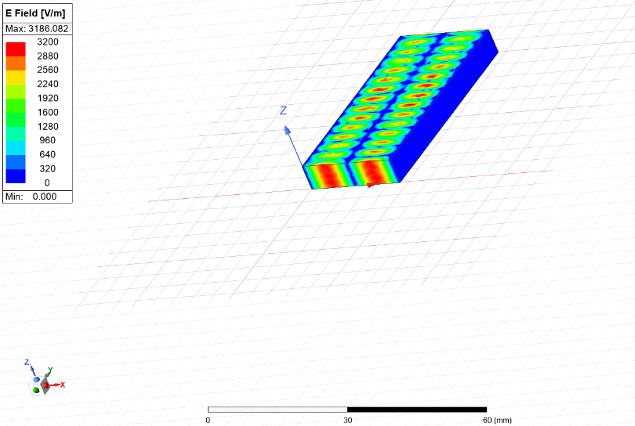
Figure 26 - mode 2 teflon Mag_E diagram
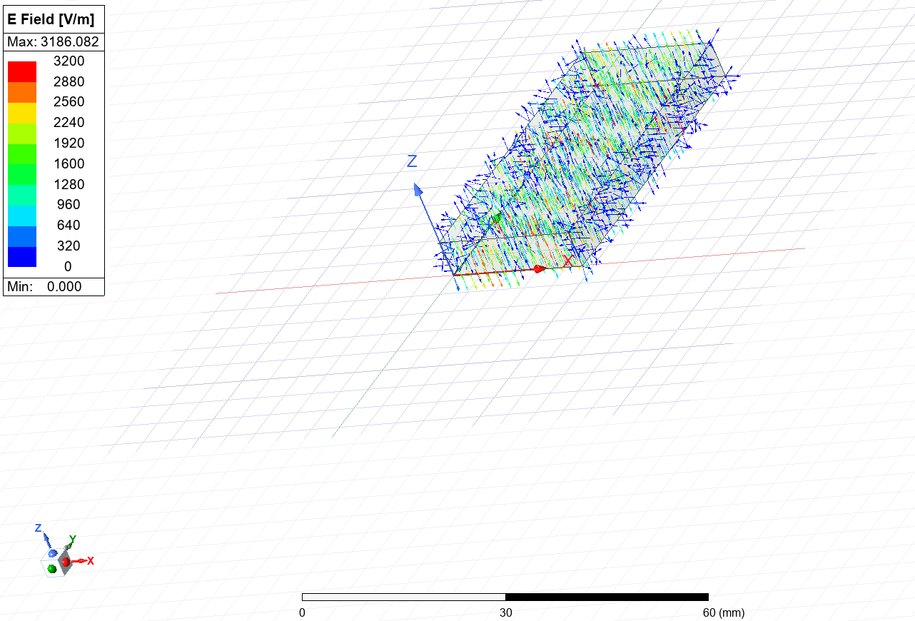
Figure 27 - mode 2 teflon vector_E diagram

Mode 3

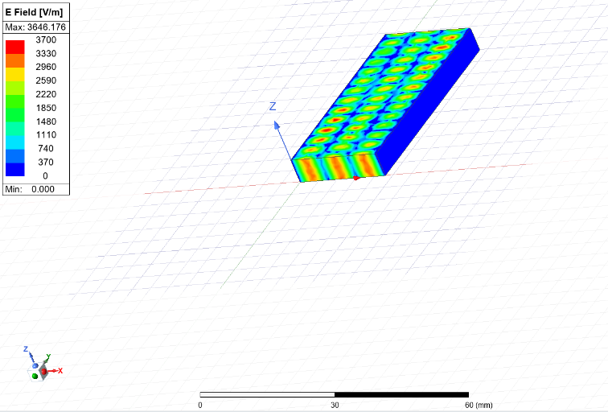
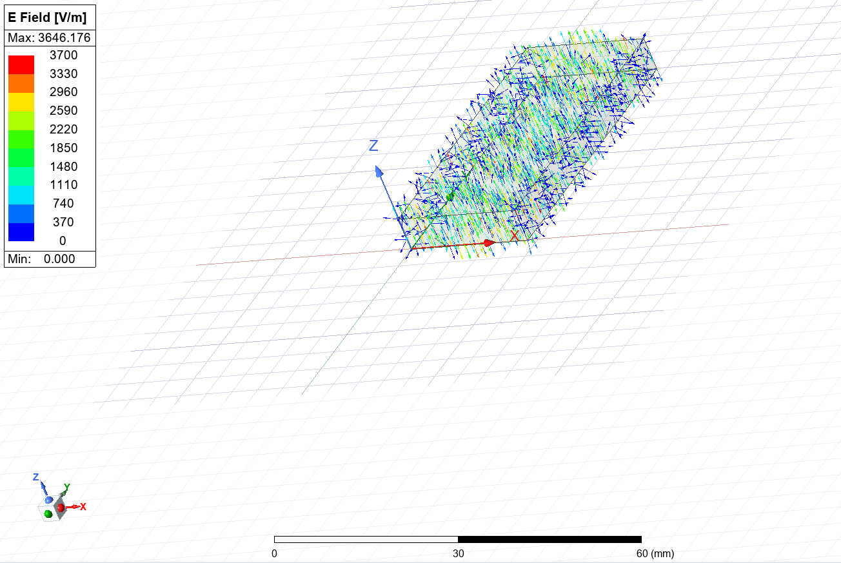
Figure 28 - mode 3 teflon Mag_E diagram
Figure 29 – mode 3 Vector_E teflon diagram

Magnetic Field Magnitude and Vector diagrams

These diagrams show the strength and direction of the magnetic field present in the waveguide during the simulation.

Mode 1
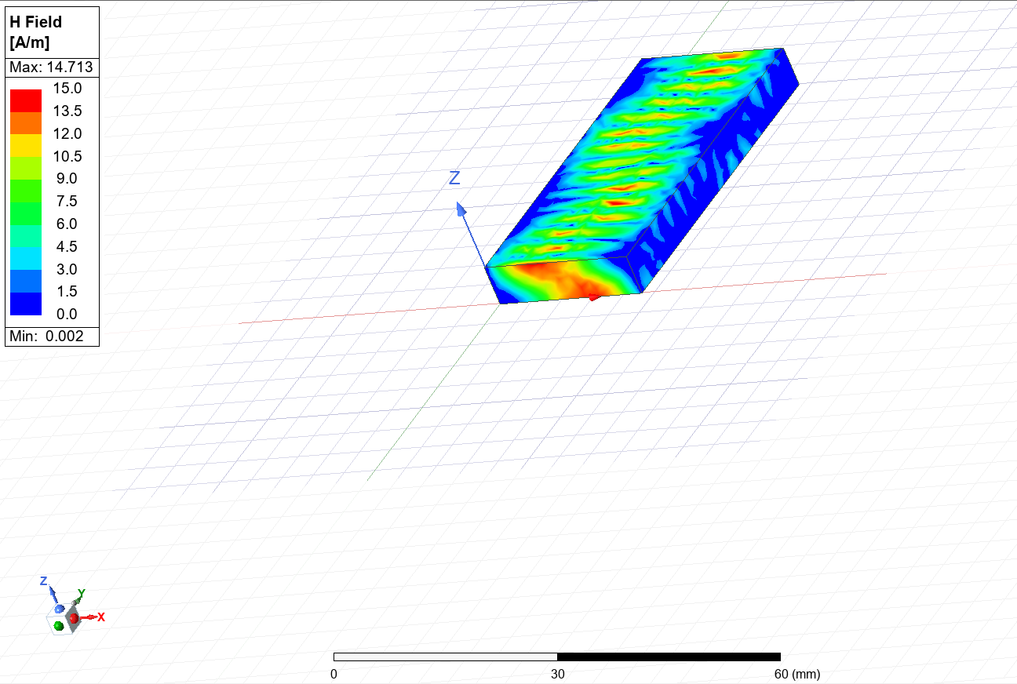
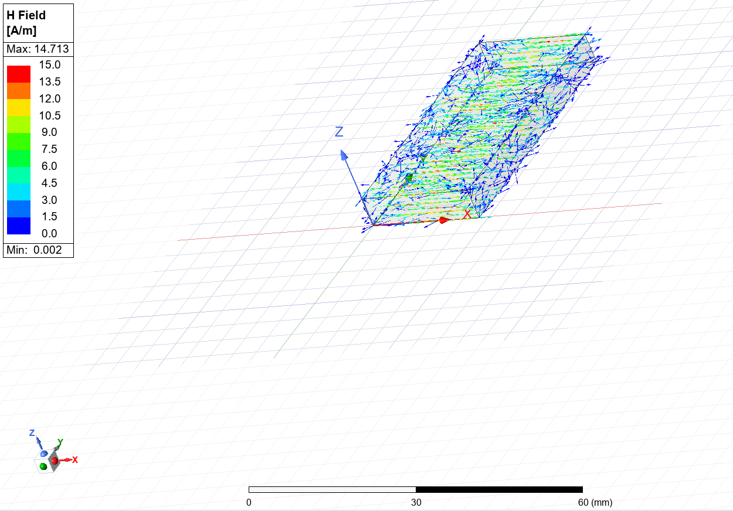
Figure 30 - mode 1 Mag_H teflon diagram
Figure 31 - mode 1 Vector_H teflon diagram

Mode 2
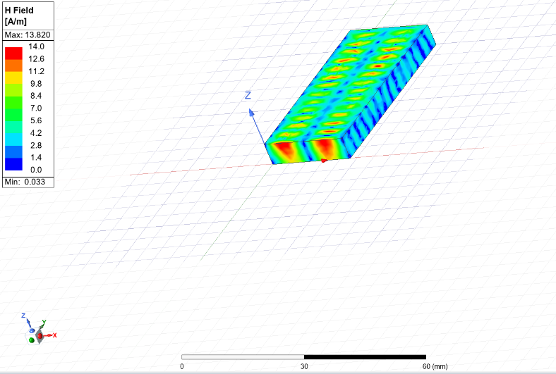
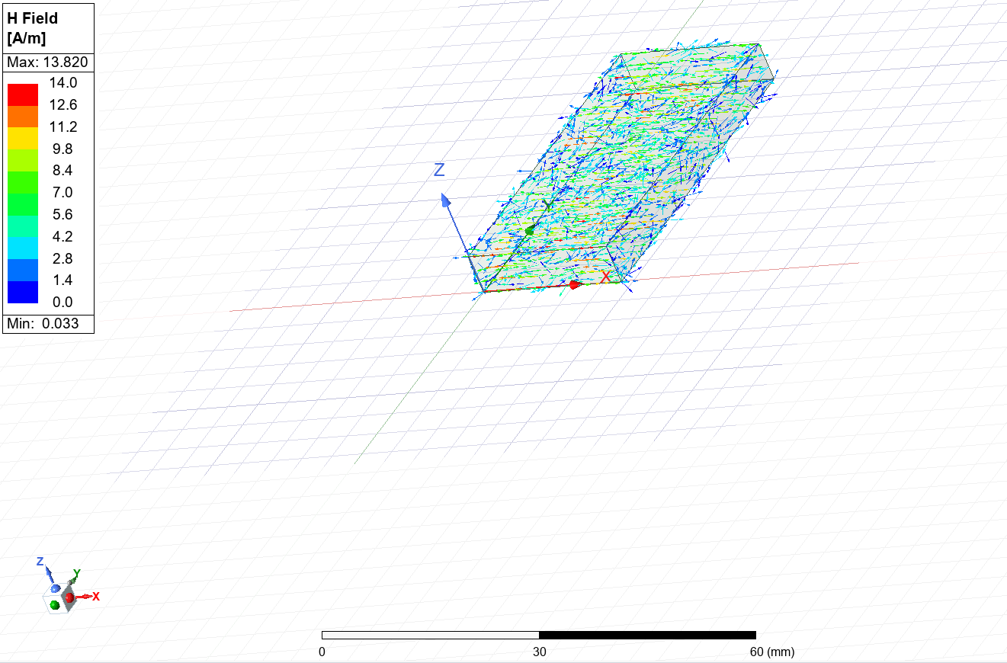
Figure 32 - Mode 2 Teflon Vector_H diagram
Figure 33 - Mode 2 Teflon Mag_H diagram

Mode 3
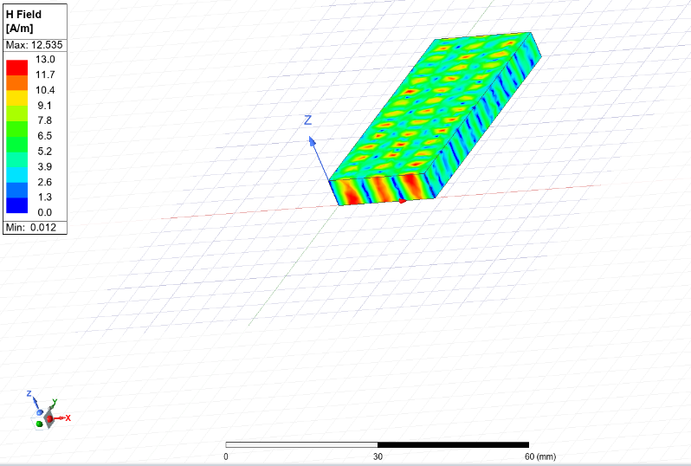
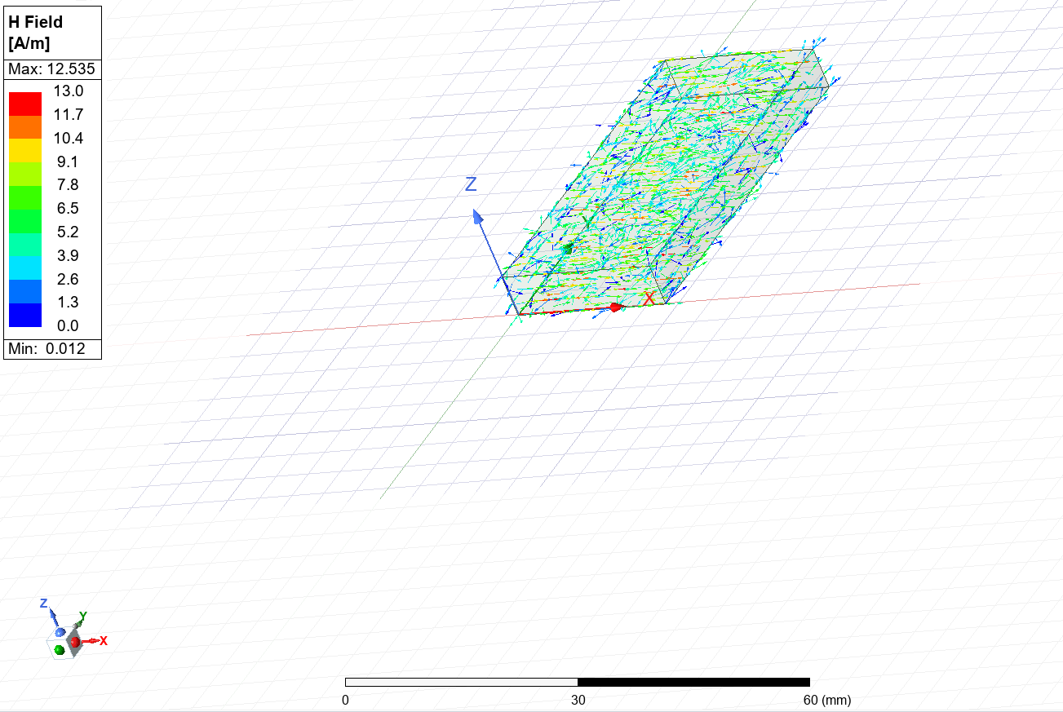
Figure 35 - mode 3 Vector_H teflon diagram
Figure 34 - mode 3 Mag_H teflon diagram

Rectangular Graph

This graph shows the simulated cut off frequencies of the Teflon filled waveguide.

- Mode 1 = 4.45 GHz
- Mode 2 = 9.00 GHz
- Mode 3 = 13.48 GHz

After this point the waveguide will no longer have 0 gain and will affect the signal passing through the waveguide.
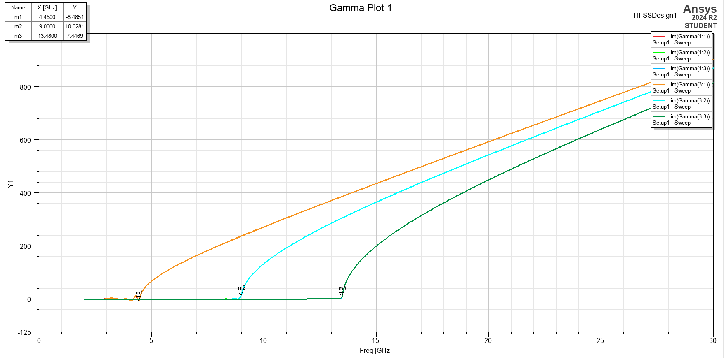
Figure 36 - rectangular plot for teflon waveguide

Cut Off Frequencies

The calculated cut off frequencies for this waveguide will be the same to the previous results for the vacuum filled waveguide. This is due the cut off frequency equation not considering the material inside the waveguide.

- Mode 1 = 6.52 GHz
- Mode 2 = 9.22 GHz
- Mode 3 = 11.30 GHz

Comparison

The difference between the vacuum and Teflon waveguides are shown in the cut off frequencies. Teflon has a lower cut off frequency than the vacuum equivalent. This means that Teflon has better signal transmission. The max value for Teflon is also lower so therefore Teflon is less efficient at higher transmissions.

The dominant mode of both the waveguides will be TE10 because this mode has the lowest cut off frequency. This also is correct because the operating frequency should be higher than the dominant mode cut off frequency. This results in minimal signal degradation in the dominant mode. [6]

Task 2

Antenna Design
The design of the antenna follows basic dipole antenna design. Two cylinder and a lumped port in the middle. Shown in figure 34. The antenna is constructed from PEC (perfect electric conductor).

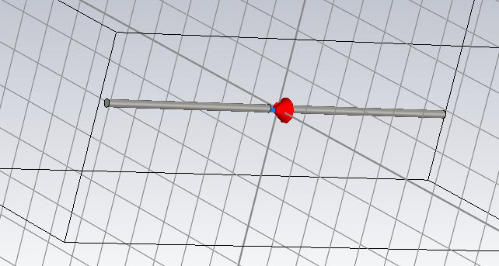
Figure 37 - dipole antenna

The length of the dipole is equal to half the wavelength of the chosen signal. This is calculated using the equation shown below.

$$l= λ/2$$

Dipole was chosen over monopole because a dipole antenna has larger bandwidth of available frequencies.

Antenna Parameters

The wavelength of the signal being emitted from the dipole antenna was decided using the first 3 digits of my student number.

This meant that the operating frequency can be calculated using the equation shown below.

$$C = fλ$$

Rearranged for F:

$$f = c/λ$$

This means that the frequency should be 1.298 GHz. This is the ideal operating frequency of the dipole antenna.

Simulation results and Conclusion
The s-parameter plot shown in figure 36 displays the ideal operating frequency of the dipole antenna. S1,1 (1) shows the frequency for the dipole when the impedance of the port is 50 ohms. The reason this is incorrect is due to an effect called impedance matching.

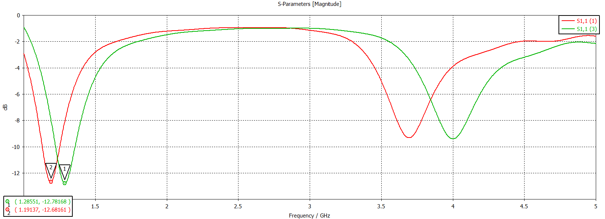
Figure 38 - s parameter plot for dipole antenna

Impedance matching
To ensure maximum power transmission on the dipole antenna, the impedance od the port must be set to 73 ohms. This makes the efficiency of transmission at resonance the highest. [7]

The impedance given by the assignment brief was 50 ohms. This would give the incorrect operating frequency shown by S1,1 (1).

However, when the impedance is set to 73 ohms, the correct operating frequency of the dipole is achieved shown in S1,1(2). The simulated operating frequency at this impedance is 1.291 GHz. The antenna functions as intended once this change was made

Far Field Transmission Plot

The far field transmission plot shows how the signals are transmitted along. The red spots show the max DBi transmitted and the blue spots show the nulls in the transmission. A dipole antenna acts much like a magnet. Figure 37 shows the ideal far field plot for a dipole antenna.
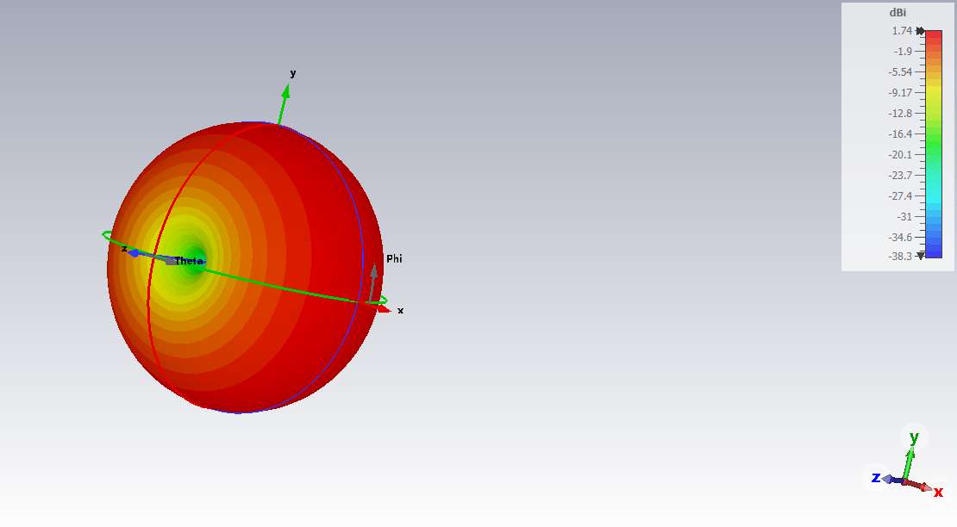

Figure 39 - far field transmission plot

Task 3

Introduction

This section of the report will discuss and evaluate the methods of optimizing current radar technology for the detection of small drones or unmanned aerial vehicles (UAV). Starting with the issues faced when detecting drones.

Traditional Radar Returns

Radar Cross Section (RCS)
The RCS of an aircraft is a measure of a target’s ability to reflect radar signals, often depending on the aircraft’s size, speed and outer shell material. RCS is measured in meters squared as the RCS of an aircraft determines how larger the aircraft will appear on a radar. [8]

RCS depends on many things:
- Aircraft size
- Outer material
- Shape
- Mounted hardpoints

A drones’ RCS can be affected by a few more factors specific to small agile aircraft. With this in mind compared to other common aircraft a drone has an extremely small RCS, about 0.001 squares.

Flight behaviour

The RCS of a drone gets larger with more extreme movements. A hovering drone will be very likely not to appear on a radar apart from a minimal return from the spinning rotor(s). High speed manoeuvres change how the radar signals are bounced back to an antenna. [9]

Fixed wing or Rotary

Traditionally a fixing wing drone will have a smaller RCS than a quadcopter Rotary style drone. This is due to the rotating aspects of the propellers on the quadcopter style drone. The propellers give a stronger radar return because of the doppler effect. The moving props shift the frequency of the radar signals even more than normal. This scenario is called micro doppler shift. A fixed wing drone, on the other hand, only has the doppler shift from the main wings and fuselage of the drone. Allowing radar operators to distinguish type of drone and propeller rpm from the micro doppler shift or lack of. [10]

Radar Clutter
A radar, when pointed at a landscape, will receive returns from everything, birds, mountains, boats and aircraft. Therefore, a return from a target aircraft has to fight with numerous other returns from noise or clutter. [11] This means a small aircraft will be hidden in clutter if not distinguished by other means.

Determining between a target and radar clutter can be done using a variety of methods. The first and simplest method involves paying attention to the amplitude of the signals picked up by the radar. The target signature will always be larger and more prominent on a radar screen than the noise surrounding it. [12]

Current and Improving Drone Detection

High Data Sampling Rate
High sampling rates allow radars to capture high amounts of data with unprecedented speed and precision. This enables much finer definitions in both range and doppler domains, which is crucial for detecting and tracking small agile targets like drones. This is particularly useful in cluttered urban environments when imaging drones apart from radar clutter is of up most importance. [13]

AI integration
The introduction of AI into a radar system has enabled the classification of threats and non-threats faster than ever before. It can also be used to mitigate interference and jamming techniques enhancing sensing techniques in cluttered airspace. [13]

Micro doppler integration
Integrating the micro doppler effect into drone radar detection enables the classification of targets. The micro doppler shift from the propellers are a giveaway that the target is in fact a drone and not a bird. This has the same effect for when the drone makes sharp movements whilst in flight.

Conclusion

In conclusion, there a number of enhancements that can be made to overcome the issue mentioned previously. Some of which are more effective than others. As technology continues to improve so will drone and hence the ability to track will need to improve alongside this.

References

[1] | Quick Wave, "Waveguide Mode," Quick Wave, 2024. [Online]. Available: https://www.qwed.eu/QuickWave/help/microwave_course/2_2_waveguide_mode.htm#:~:text=Waveguide%20mode%20stands%20for%20a,and%20TM%20(Transverse%20Magnetic).. [Accessed 26 04 2025].
[2] | Cadence, "TE Modes in Rectangular and Circular Waveguides," Cadence, 2025. [Online]. Available: https://resources.system-analysis.cadence.com/blog/msa2021-te-modes-in-rectangular-and-circular-waveguides. [Accessed 26 04 2025].
[3] | Radartutorial, "Modes of propagation," radartutorial.eu, [Online]. Available: https://www.radartutorial.eu/03.linetheory/tl12.en.html#:~:text=The%20dominant%20mode%20in%20a,longitudinal%20electric%20field%20is%20present.. [Accessed 26 04 2025].
[4] | Cadence, "The Transverse Magnetic Mode of Wave Propagation in Rectangular and Circular Waveguides," Cadence, 2025. [Online]. Available: https://resources.system-analysis.cadence.com/blog/msa2021-the-transverse-magnetic-mode-of-wave-propagation-in-rectangular-and-circular-waveguides. [Accessed 26 04 2025].
[5] | Geeks for Geeks, "TEM Mode," Geeks for Geeks, 2025. [Online]. Available: https://www.geeksforgeeks.org/tem-mode/. [Accessed 26 04 2025].
[6] | Cadence, "The Rectangular Waveguide Cut-Off Frequency," Cadence, 2025. [Online]. Available: https://resources.system-analysis.cadence.com/blog/msa2021-the-rectangular-waveguide-cut-off-frequency. [Accessed 27 04 2025].
[7] | Dolph Microwave, "5 Essential Factors that Influence the Impedance of Dipole Antennas," Dolph Microwave, 27 04 2024. [Online]. Available: https://dolphmicrowave.com/default/5-essential-factors-that-influence-the-impedance-of-dipole-antennas/#:~:text=As%20a%20result%2C%20the%20impedance,efficiency%20in%20resonance%20the%20highest.. [Accessed 27 04 2025].
[8] | MIT Lincoln Laboratory, "Introduction to radar system 2002 radar cross section," 2002. [Online]. Available: https://www.ll.mit.edu/sites/default/files/outreach/doc/2018-07/lecture%204.pdf.
[9] | Airsight, "Why Drone Detection with Radar Is More Complex Than You Think," Airsght, 2025. [Online]. Available: https://www.airsight.com/blog/drone-detection-radar-complex#:~:text=Ever%20noticed%20how%20a%20hovering,to%20distinguish%20from%20other%20objects.. [Accessed 23 04 2025].
[10] | S. A. K. K. A. H. A. M. S M Danish Rizvi, "Deep Learning Approach for Fixed and Rotary-Wing Target Detection and Classification in Radars," IEEE, 2022.
[11] | radartutorial, "radar tutorial.eu radar clutter," radar tutorial.eu, [Online]. Available: https://www.radartutorial.eu/11.coherent/co04.en.html. [Accessed 25 03 21].
[12] | Cambridge Pixel, "How to Track and Detect Small Targets with Radar," Cambridge Pixel, 2025. [Online]. Available: https://cambridgepixel.com/insights/how-to-track-and-detect-small-targets-with-radar/. [Accessed 02 04 2025].
[13] | N. Knight, "The evolving battlefield: How radar technology is advancing in the age of advanced electronic warfare and C-UAS," Military Embedded Systems, 12 02 2025. [Online]. Available: https://militaryembedded.com/radar-ew/rf-and-microwave/the-evolving-battlefield-how-radar-technology-is-advancing-in-the-age-of-advanced-electronic-warfare-and-c-uas. [Accessed 27 04 2025].
[14] | Stealth Fighter Association, "F-117 Development," 2025. [Online]. Available: https://www.f117sfa.org/f117-development#:~:text=The%20model%20was%20taken%20to,top%20of%20the%20Hopeless%20Diamond..

