

Name: Lwys Daniel Davies
Student Number: 1810422
Module Title: Project Management and Research Methods (ACDA5004)
Assignment Title: Managing a Hardware/Software Project for Disaster Recovery
Lecturer’s Name: Sue Maw

Project Initiation Document - Centralised Alignment Logistical Medication of Emergency Resources (C.A.L.M.E.R)
Project Plan

After thorough research within the healthcare/natural disaster industry, we have found that currently there is no system available to provide key information for the availability of medical supplies within and around towns in the event of a natural disaster. As a team we have come up with an idea which will allow hospitals and accident and emergency departs across the country to decrease the amount of people arriving at certain departments when in the event of a natural disaster. This will hopefully put a stop to health care departments becoming over run and will allow more time for people with more serious injuries or conditions that are more important. We have decided to name the project Centralised Alignment Logistical Medication of Emergency Resources (C.A.L.M.E.R) as this indicates what our project is about.

Purpose

The aim of the project is to create an accessible database within Tableau so that potential patients, medical staff and organisations can access or advise people where to find certain equipment/supplies that may be needed during a natural disaster. This could include medical supplies, food and water supplies or general emergency supplies that may be needed to survive.

Objectives
- Implementation of a database within Tableau which will hold key information based on medical requirements and basic supplies.
- Allow patients to access database and easily locate supplies.
- To decrease errors where supplies are allocated.
- Decrease demand at A&E departments at hospitals during the disaster.
- Assist people to receive medical supplies and advice.
- Advise people on transport routes and where to find supplies.

Scope

The database will be based on a geographical interface which will be built within Tableau. The interface will include multiple categories and will be shown for the different areas of a town, city or village. The categories we will include and that we consider important during a natural disaster are as follows:

- Medication supplies (Continuous prescriptions)
- Medication supply shortages
- Emergency medical equipment
- Dialysis needs
- Buildings (Allocate locations to collect supplies)
- Travel Routes

Assumptions

For the database to be used in an event of a natural disaster, there will be a need for services to be available, so the database can fulfil its potential to the maximum use. The following services will need to be available:

- Internet Access (3G,4G or Wired Connections at buildings)
- Power or Battery packs (Will there be power, or emergency power be provided?)
- Device that has an interface (Laptop, Smart phone or Tablet)
- Transport (Will public transport be running?)
- Stock availability (Medication, Food, Water and Equipment)

Constraints

The following could be considered as a constraint:
- Power (Power cuts or access to power)
- Disaster type (Depending on what type the disaster is could affect the system)
- Hardware/Software failure (There could be issues during the disaster with certain hardware which could prevent the software from working)
- Accessibility (Patients may not own a device to use the database)

Authority

- Project Sponsors – UK Government, Local Government, Ministers, MP’s, Councillors or head of divisions
- Project Managers (Sue Maw)
- Stake Holders (Please see Figure 1)

Responsibility

People who will be responsible for making this project a success are as follows:

- Project Managers – Responsible for entire project and managing the team.
- Team Members – Responsible for completing tasks that are set out.
- Stake Holders – Responsible for completing services that are asked of.(Please see Figure 1)

Resources
The resources we will need to complete the project are as follows:

- Team Members – Matthew Stokes, Christine Woods, Silvia Settle and Lwys Davies
- Hardware – PC, Tablet and Smart phone (Implementation and Testing purposes)
- Software – Tableau (Implementation of database), Microsoft Office (Creation of Instruction manual, training guides and other documentation)
- Information – Stock levels, Locations and Contact numbers.

Project Benefits

There are many benefits to this project as it will allow, improve and provide the following service to patients and medical staff:

- Decrease the amount of people that will go to an accident and emergency department.
- Patients will have easier access to supplies.
- The database will be accessible from different devices.
- Resources will be allocated their own location.
- Information is available 24 hours a day,7 days a week.
- Database will be regularly updated.

Cost and Timescale

The cost of this project isn’t expensive however we will need to consider the time that is put into the project as this could be vital for the project to be a success. We would need to ensure that a budget is assigned for the licensing of the software (Tableau) and other resources that is need such as a server where the database will be hosted from. We would also need to consider the cost and time for system updates.

Stakeholders
Name | Project Role | Position | Internal/External | Contact Information
Sue Maw | Project Manager | Project Sponsor | Internal | Sue.Maw@uwtsd.ac.uk
Lwys Davies | Team Member | N/A | Internal | 1810422@student.uwtsd.ac.uk
Christine Woods | Team Member | N/A | Internal | 1704446@student.uwtsd.ac.uk
Matthew Stokes | Team Member | N/A | Internal | 1707417@student.uwtsd.ac.uk
Silvia Settle | Team Member | N/A | Internal | 1708386@student.uwtsd.ac.uk
Andrew Jones | Database Tester | Database Analyst | External | Andrewjones@swanseasystems.co.uk
Charlotte Evans | Information Advisor | Department Manager | External | Charlotte.Evans2@wales.nhs.uk
Phillip Morgan | Information Advisor | Health Manager | External | Phillip.Morgan@wales.nhs.uk
Alison Mahoney | Stock Advisor | Stock Controller | External | Alison.Mahoney@wales.nhs.uk
David Southall | Stock Advisor | Stock Controller | External | David.Southall@wales.nhs.uk
(Figure 1)

Gantt Chart
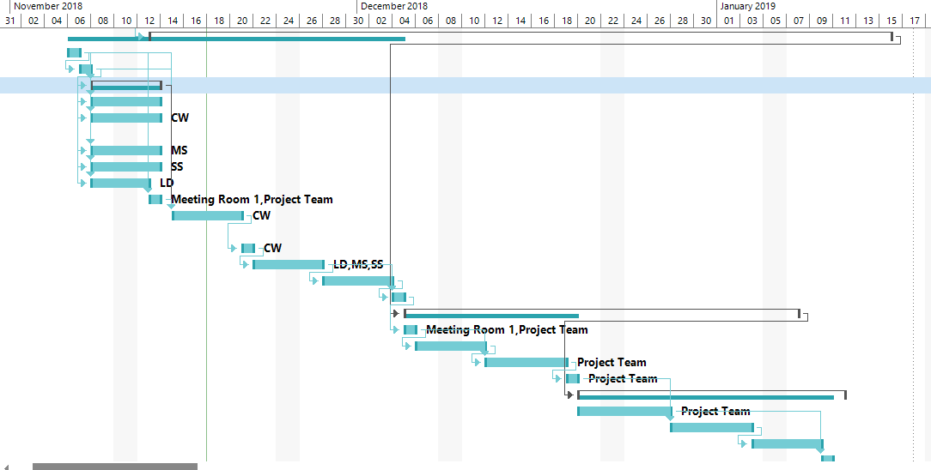(Figure 2)

Schedule
Task Name | Duration | Start | Finish | Predecessors | Resource Names
Submit Project Plan | 1 day | Mon 12/11/18 08:00 | Mon 12/11/18 17:00 | 4 | Project Team
Design | 46 days | Tue 13/11/18 08:00 | Tue 15/01/19 17:00 | 5
Agree design with team | 1 day | Tue 06/11/18 08:00 | Tue 06/11/18 17:00
Assign design tasks to team | 1 day | Wed 07/11/18 08:00 | Wed 07/11/18 17:00 | 7
Design individual tasks | 4 days | Thu 08/11/18 08:00 | Tue 13/11/18 17:00 | 7,8
Set up Tableau database | 4 days | Thu 08/11/18 08:00 | Tue 13/11/18 17:00 | 7,8
Define staffing for allocated areas (Specialised/General) | 4 days | Thu 08/11/18 08:00 | Tue 13/11/18 17:00 | 7,8 | CW
Define buildings to use | 4 days | Thu 08/11/18 08:00 | Tue 13/11/18 17:00 | 7,8 | MS
Define transport routes | 4 days | Thu 08/11/18 08:00 | Tue 13/11/18 17:00 | 7,8 | SS
Allocate resources | 3 days | Thu 08/11/18 08:00 | Mon 12/11/18 17:00 | 7,8 | LD
Meet to review individual tasks | 1 day | Tue 13/11/18 08:00 | Tue 13/11/18 17:00 | 7,8 | Meeting Room 1,Project Team
Implement individual tasks into main database | 4 days | Thu 15/11/18 08:00 | Tue 20/11/18 17:00 | 15,7,8,9 | CW
Showcase database to team | 1 day | Wed 21/11/18 08:00 | Wed 21/11/18 17:00 | 16 | CW
Design Testing/Risk Assessment | 4 days | Thu 22/11/18 08:00 | Tue 27/11/18 17:00 | 17 | LD,MS,SS
Development | 4 days | Wed 28/11/18 08:00 | Mon 03/12/18 17:00 | 18
Testing | 1 day | Tue 04/12/18 08:00 | Tue 04/12/18 17:00 | 19,18
Demonstration and Implementation | 24 days | Wed 05/12/18 08:00 | Mon 07/01/19 17:00 | 6
Showcase to stakeholders | 1 day | Wed 05/12/18 08:00 | Wed 05/12/18 17:00 | 20 | Meeting Room 1,Project Team
Request feedback from stakeholders | 4 days | Thu 06/12/18 08:00 | Tue 11/12/18 17:00 | 22
Update agreed changes | 5 days | Wed 12/12/18 08:00 | Tue 18/12/18 17:00 | 22,23 | Project Team
Final testing | 1 day | Wed 19/12/18 08:00 | Wed 19/12/18 17:00 | 24 | Project Team
Training | 17 days | Thu 20/12/18 08:00 | Fri 11/01/19 17:00 | 21
Write on-line training manual | 6 days | Thu 20/12/18 08:00 | Thu 27/12/18 17:00 |  | Project Team
First phase | 5 days | Fri 28/12/18 08:00 | Thu 03/01/19 17:00 | 25
Second phase | 4 days | Fri 04/01/19 08:00 | Wed 09/01/19 17:00 | 28
Release on-line training manual | 1 day | Thu 10/01/19 08:00 | Thu 10/01/19 17:00 | 27

