

Is good design quality affordable for homes in Wales?
School of Architecture, Built and Natural Environment
Course: BSc Architecture

Name: Ionut Marius Rosu
Student Number: 1910143
Module code: M6X01986
Word count 10,191
Date: 11 April 2022


Author’s Declaration
I declare that the work in this dissertation was carried out in accordance with the regulations of the University of Wales, Trinity Saint David. The work is original except where indicated by special references in the text and no part of the dissertation has been submitted for any other degree.
Any views expressed in the dissertation are those of the author and in no way represent those of the University of Wales, Trinity Saint David.
The dissertation has not been presented to any other University for examination either in the United Kingdom or overseas.
I hereby give permission for my work, if accepted, to be available for photocopying and inter-library loan, and for the title and summary to be made available to outside organisations.

Signed: | Ionut Marius Rosu
Date: | 11 April 2022

Copyright statement

The copyright of this dissertation rests with the University of Wales, Trinity Saint David. No information derived from this dissertation shall be published without the prior written consent of the University.

Signed: | Ionut Marius Rosu
Date: | 11 April 2022

Abstract

There are many house types that can be built around Wales, but not all of them can be a good design. But what is a good design? A subjective thing like a beautiful house. A house that is easy to navigate? Or is it a house that performs well and uses it`s environment to reduce energy consumption. And is it possible to have affordable good design in Wales?

This dissertation explores what is the process of creating a design, what are the design types prevalent in Wales housing market. There will be four chapters discussing in order: Chapter 1, which discusses how designs are created, Chapter 2 explains what the prevalent design types in Wales are, and what are their advantages and disadvantages, Chapter 3 describes the chosen case studies, and Chapter 4 looks at what is good design and if the case studies are good designs.

Additionally, a selection of relevant case studies will be compared against the design quality requirements of Technical Advice Note 12 – Design and 2021 Welsh development quality requirements to find out which one is the best design. Finally, an above ground cost analysis for the case studies will tell if good quality design in Welsh housing is affordable.

Acknowledgements

This research paper would`ve been impossible to write without the help of the tutors: Ryan Stuckey who convinced me not to “throw the baby with the bathwater” and Ian Standen who pointed me in the proper direction and made the subject of the dissertation less boring.

Thanks also go to the architects who took their time to answer my questions: Peter Wray from Wray Architects, Nic Downs from Downs Merrifield Architects, Nick Hill of Rural Studio of Architecture, David Darkin from Darkin Architects, Steven George from George and Co. and Gavin Traylor. I must also thank Rhys Thomas, project manager for Sero Homes, for providing me with information for the Parc Hadau case study.

Special thanks to Dr. Elizabeth Walder, whose knowledge in writing academic papers, patience and willingness to help students proved invaluable.

Table of Contents

PAGE TITLE | PAGE NO
Author`s Declaration | 2
Copyright statement | 3
Abstract | 4
Acknowledgements | 5
List of Illustrations | 7
Introduction | 8
Chapter 1: Design creation and evolution | 11
Chapter 2: What are the prevalent design options in housing? | 15
Chapter 3: Design option case studies  Aber Llwchwr House – Darkin Architects  Parc Hadau Development – Sero Homes  Plymouth House – Studio George & Co. | 20  20  23  24
Chapter 4: Definition of good design quality | 25
Conclusion | 69
Bibliography: Published Works  Bibliography: Unpublished Works  Appendix A: Space Requirements from Welsh Development Quality Requirements 2021 design requirements  Appendix B: Space Requirements from Welsh Development Quality Requirements 2021 for gross internal area  Appendix C: Interview questions for architects and their responses  Appendix D: Interview questions for Plymouth House and transcript  Appendix E: Aber Llwchwr House Project Brief  Appendix F: Design and Access Statement for Aber Llwchwr House  Appendix G: Building Regulations Note for Plymouth House  Appendix H: Bill of quantities for Aber Llwchwr House | 71  73  74  76  77  82  87  101  121  128
List of Illustrations

Figure number and title | PAGE NO
Figure 1: Aber Llwchwr House Front View | 21
Figure 2: Aber Llwchwr House Rear View | 22
Figure 3: Parc Hadau  Figure 4: Objectives of good design  Figure 5: Plymouth House Site Plan  Figure 6: Plymouth House 1:20 Section  Figure 7: Plymouth House Floorplans  Figure 8: Parc Hadau House Type 1 Ground Floor Plan  Figure 9: Parc Hadau House Type 1 First Floor Plan  Figure 10: Parc Hadau House Type 2 Ground Floor Plan  Figure 11: Parc Hadau House Type 2 First Floor Plan  Figure 12: Parc Hadau House Type 3 Ground Floor Plan  Figure 13: Parc Hadau House Type 3 First Floor Plan (Plot 17)  Figure 14: Parc Hadau House Type 3 First Floor Plan (Plot 18)  Figure 15: Parc Hadau House Type 4 Ground Floor Plan  Figure 16: Parc Hadau House Type 4 First Floor Plan  Figure 17: Aber Llwchwr House Ground Floor Plan  Figure 18: Aber Llwchwr House First Floor Plan  Figure 19: Aber Llwchwr House Site Plan  Figure 20: Parc Hadau House Type 1 Services Drawings  Figure 21: Parc Hadau House Type 2 Services Drawings  Figure 22: Parc Hadau House Type 3 Services Drawings  Figure 23: Parc Hadau House Type 4 Services Drawings  Figure 24: Plymouth House Section  Figure 25: Parc Hadau Site Layout Base Drawing Revision B | 23  26  28  32  33  35  36  37  38  39  40  41  42  43  47  48  50  57  58  59  60  63  67

Introduction

The world is changing, and homes must be able to keep up with the changes. Good design is not only about aesthetics, but also integrates the home in its context, allows for user adaptation and can evolve with fashion and needs. Current trends dictate that sustainability is key and when a better-quality design uses materials and technologies, a home can perform smarter under different conditions.

The following chapters discuss how designs are created, what are prevalent design options in housing, and the milestones of good design.

Methodology

Methodology approach
To investigate if good design in housing is economically viable in Wales a mixed methods of data collection was used. By using both quantitative and qualitative methods, it allowed for both a numerical and an in-depth exploration of the subject matter.

Rationale and assumptions undermining the methodology:
This dissertation addresses a practical problem. Population is predicted to grow in Wales, and this requires more homes for people to use. But the current housing market is not satisfying all the required performance criteria. This dissertation was about exploring if good design methods can be implemented is Wales, and if they are affordable.

The most suitable approach to answer the question was to interview architects and volume house builders about the costs of their projects, materials, client feedback and risks. Also, a series of case studies were used to further explore the subject matter and to get comparative data from various types of housing projects.
During the data collection and analysis, there were some ethical considerations. Firstly, all the plans, sections and elevations were the designer`s intellectual property and protected by the copyright laws. This means that they cannot be copied in any future designs. Also, they could not be shared except for this research piece. Also, when emailing the interviews, the architects` contact details were protected by the GDPR laws, and they had to remain private.

Case studies selection:
The three case studies explore Welsh homes that go in different directions. Only one of these houses was completed, while the other two are still under construction. For the ongoing projects, they had to be at least in Stage 3 of the 2020 RIBA Plan of Work.

Having said that, the selected case studies were:
- Aber Llwchwr House, a highly bespoke home for a family of four, designed by Darkin Architects and completed in 2018 in Aber Llwchwr, Llangenneth.
- Parc Hadau, an affordable housing development still being built in Pontardawe at the time when this dissertation was written, developed by Sero Homes.
- Plymouth House, a development designed by Studio George and Co., still being built in Merthyr Tydfil at the time when this dissertation was written.

Fieldwork survey

A series of questionnaires were constructed and distributed to Chartered architects, members of the Architects Register Board, with experience in house design. Additionally, questionnaires were sent to volume house builders as well. The purpose of this survey was to account for the professionals` opinion on the quality and pricing of Welsh houses.

For further information on Plymouth House, an interview was conducted with the lead designers of the development, Steven George of Studio George and Co. and Gavin Traylor.

The interviewees were selected by searching in the ARB for local architects, by meeting them via the RIBA Student Mentorship Program, speaking with architects that were guest lecturers at the University of Wales Trinity Saint David, and under guidance from the tutors.

Out of 13 local architects that received the interview questions, only 4 answered them. None of the volume house builders answered the interviews.

Aims and objectives

The aim of this research was to identify design quality in domestic properties in Wales.

The dissertation addressed the following objectives:
- Exploring how designs are created.
- Discussing of what are the prevalent types of design.
- Presenting the case studies.
- Definition of what was good design quality.

Literature Review

Key works which were reviewed included several online articles, journals and case studies. Meeting reports from the Design Commission for Wales were also helpful including the Wales’ Innovative Housing Program (IHP) Design Review Report Parc Hadau. Additionally, the author examined relevant legislative documents, such as Technical Advice Note 12 (TAN12) – Design, the 2020 RIBA Plan of Work and the 2021 Welsh Development Quality Requirements.

Chapter 1: Design creation and evolution

The 2020 RIBA Plan of Work is a document that shows what targets the design team should achieve at each stage. This document breaks down a project into eight stages. Because Stages 4 to 7 cover the production of technical drawings, construction phase, handover and the use of the building, they were not explored in this chapter.

Therefore, using the 2020 RIBA Plan of Work as guidance, the process of design creation and evolution is:

Stage 0: Strategic Definition

Outcome of this stage is satisfaction of the confirmed client requirements in the best manner.

This stage is where the client needs are discussed, with the pros and cons of their desired project. To give options for the project, Project Risks and Budget need to be accounted, and if necessary, “site surveys “and “corresponding planning appraisals” need to be carried out. All this work is undertaken for making a comparative analysis that gives the best options for satisfying the client requirements.

Stage 1: Preparation and Briefing

This stage`s outcome should be the approval of the project brief by the client and confirmation that it can be accommodated on the site.

Once “Stage 0” has been completed and the client requirements confirmed and “satisfied”, a Project Brief is created by considering and recording the said requirements in more detail, all relative to the specific site.
Guidance on Project and Sustainability Outcomes and Quality Aspirations is included in the project brief. The outlined elements can influence on the assembly of the client, design and construction teams (which are part of the Procurement Strategy). Also, the same elements may dictate key milestones of the Project Programme.

This stage gives the design team chance to gather necessary information to start the design process at Stage 2. Although they are not part of the design process, Feasibility Studies may be required to demonstrate that the site can accommodate the necessary Spatial Requirements. Also, because costs and a building`s area are correlated, the Spatial Requirements need to be tested against the Project Budget.

In preparation for Stage 2, selection of the design team must take place. This team must have the necessary knowledge, skills and experience to deliver the Project Outcomes.

As well as the above, Site Information including Site Surveys need to be sourced for commencing Stage 2.

Stage 2: Concept Design

The outcome of this stage is to come up with an Architectural Concept that embodies client`s liking and Project Brief.

Stage 2 sets the project`s Architectural Concept. This concept is a prepared proposal, drawn from the Site Information, Project Brief and Spatial Requirements. Client`s feedback is considered during regularly held Design Reviews and the design is adapted according to it. Any Project Brief Derogations are agreed, or the Project Brief is adjusted to align with the Architectural Concept.

The proposals within the Architectural Concept must also consider design team`s and specialist consultants` feedback. The proposals must also line up with the Project Strategies. All this data should be captured in a Stage Report. The Cost Plan should show that the Architectural Concept and Outline Specification are within the Project Budget.

The project proposals should show that they respect the Spatial Requirements and any adjacency requirements. The exterior of the proposed building should embody the client’s vision along with the local context and environmental demands. Additionally, the Architectural Concept must also be compared to the Quality Aspirations. Clarification and agreement need to be made for the route to compliance of the Building Regulations.

A Stage 2 Design Programme must be prepared, lining up with the Project Programme and Responsibility Matrix. Its purpose is to guide the design process and ensure that the Stage Report contains the Information Requirements and is signed off by the client.

Stage 3: Spatial Coordination

The outcome of this stage is to Spatially Coordinate the architectural and engineering information.
Stage 3 is about testing the Architectural Concept, to ensure that the architectural and engineering drawings from Stage 2 are Spatially Coordinated before the detailed drawings for raising the building are produced at Stage 4.

Detailed Design Studies and Engineering Analysis are taken to make possible the concepts from Stage 2, and to apply more details to the agreed design. Stage 3 should not radically change the Architectural Concept but it can alter it to the detailed design or engineering tasks, to ensure the building is Spatially Coordinated. Any changes to the Architectural Concept should be agreed via the Change Control Procedure.

Design Studies should follow the Cost Exercises and the Outline Specification – design changes may be needed, to ensure that the Cost Plan adheres to the Project Budget. A Spatially Coordinated design allows the members of the design team to finish their input at Stage 4 without major altering the design.

The Project Strategies need updating, and additional detail added. Additionally, the Building Regulations need reviewing.

A Stage 3 Design Programme is compiled to ensure the right works are carried at the appropriate times. The Planning Application can be submitted at the end of Stage 3, once the client signs the Stage Report which shows the work done to date.

Chapter 2: What are the prevalent design options in housing?

What is a bespoke design?

A bespoke design (of a product) means it is produced to meet certain specifications and requirements (Oxford University Press, 2022).

A home is a bespoke design when it suits the client`s requirements and considers their present and future needs. (Downs, 2021).

Also, when it comes to a bespoke designed home, the design of the home comes directly from the client`s brief (Wray, 2021).

Every client is different, and they have needs in accordance with their unique nature. A bespoke design for these clients takes into consideration their needs, desires and taste and creates for them a home them that not only provides a roof over their head, but it`s also tailored to satisfy the previously mentioned considerations. A bespoke design for a domestic client can be seen as an extension to the lifestyle and personality of the client.

Advantages associated with bespoke designs

A bespoke design is created to directly satisfy the needs and requirements of the client (occupant). Also, in a bespoke design, the material choice is primarily driven by the performance rather than costs (Darkin, 2021).

Occupants also have a saying in choosing the material`s aesthetic. Another advantage is that the client can receive a home built to the highest possible quality standards, by using better contractors. A bespoke design also keeps a relationship between client and architect, where certain issues can be resolved post completion (Downs, 2021).

A bespoke home has the occupant`s needs and lifestyle at its core. The home provides the best environment for its users. Some people might need more or bigger bedrooms, while others would like the have ensuite bathrooms, balconies, or roof terraces.

The aesthetic is subject to the clients taste and can be an extension to their personality, but when it comes to a material`s performance, the client can decide how much they`re willing to spend for acquiring better quality materials. This is done to obtain the desired level of performance from the building (thermal, acoustic, etc.).

Because it has the satisfaction of the occupant at its core, a bespoke design is usually built at a higher quality standard, with the best available contractors and materials, that are chosen based on the quality of the results produced on other projects.

Bespoke designs are made following a client`s budget (Downs, 2021).

Financial restrictions might prevent the client from investing above the agreed budget. Clever bespoke designs and ingenious construction techniques can be implemented to offer a home that satisfies the client needs while respecting the budget.

Disadvantages associated with bespoke designs

They are some disadvantages associated with a bespoke design:

Due to the nature of individuality of bespoke designs there is not a template that can be adapted. Some things in a bespoke design could potentially go wrong (especially when compared to a standardized design), so it`s important to study other architects` work and find similar designs to the project at hand (precedent studies), to find ways to limit the instances where problems might occur (Wray, 2021).

Bespoke homes can also be commercially risky because a project can have different looks (while still satisfying the brief with each iteration) and it can limit the profitability of the said project (Darkin, 2021).

Being a bespoke design there can also be a problem with the raising prices of building supplies, materials, labour, plant etc. (Downs, 2021).
Bespoke designs are also prone to the issue of not finding the exact specified material for a detail element, and a replacement material could increase the cost for the client (Hill, 2021).

These are some of the risks associated with bespoke designed homes. Drawing a conclusion from the above, it can be said that bespoke designs need more attention to detail, and they are subject to certain issues due to the individuality of their nature.

What is a standardised design?

A standard design is driven by the cost of producing that design, cost of materials and works (Downs, 2021).

While bespoke designs tender the needs of the individual ”standardisation creates opportunity to bring great design to all” (Darkin, 2021).

Standardisation is a “one type fits all” design philosophy, that takes an already designed and built home type and uses it with every opportunity, with minimal adjustments to the plans and elevations, in accordance to building regulations and Local Development Plan (LDP). Standardisation is mostly used by the volume house builders because when design has already been proved effective, it can be reproduced at a cost-effective rate and the houses are built faster when compared to a bespoke design.

Advantages associated with standardised designs

Drawing from the definition of standardised design, and from the disadvantages of bespoke designs (as they are opposites), a standardised design has the following advantages:

Standardised design houses are quick to produce and build as they use a template that only needs adapting to the conformity of building regulations and LDP.

Because they only adapt existing plans, a house built using a standardised plan is less likely to have problems caused by faulty design.

Standardised design uses the least expensive material options that can satisfy the minimum performance criterion required. This means lower pricing when building a house.

With a standard designed house, the profitability margins are known beforehand.
A standardised design does not dependent on a certain type of material. In consequence, if a material suddenly becomes unavailable, a replacement can be found and used.

Disadvantages associated with standardised designs

Standardised designs are characterized by their cost driven nature, being mass produced for the lowest possible cost (Downs, 2021).

To do that, volume house builders try to use a layout that can be reused and adapted multiple times for different locations. Additionally, the materials are chosen by their price, while their aesthetics takes a secondary place on the list of priorities. Looking at their performance, the materials must only meet the minimum requirements.

Standardised layout homes are not usually built around the occupant`s needs. This means that extra work is required to adapt a home to its users’ requirements and lifestyle (Downs, 2021).

Because of the standardisation and the “recycling” of the layout, volume house builders` homes cannot fully satisfy the occupant`s individual needs. Some people might enjoy outdoor activities like mountain-biking, camping, surfing, etc., and therefore, they need additional equipment storage. Other might like cooking, so they need a bigger kitchen to accommodate for the special equipment and a bigger dining room. There are also people who like arts and crafts, or that work from home, so they need an office or a workshop. Because a standardised design cannot satisfy all these needs, the home must be adapted to accommodate them, at the occupant`s expense.

The materials aesthetic in a standardised home might be unappealing for the occupants. Aesthetic aside, because in a standardised home the materials performance usually satisfies only the minimum requirements, the occupant might have additional expenses while using the home: extra expenses with the heating and ventilation of the home, sound insulation, maintenance, etc.

Chapter 3: Design option case studies

The case studies represent different categories of homes. Aber Llwchwr House is a highly bespoke home in Aber Llwchwr, Llangenneth. Parc Hadau is a development of 35 houses and a community building in Pontardawe, commissioned by Sero Homes. The last case study is Plymouth House, a development in Merthyr Tydfil.

Aber Llwchwr House – Darkin Architects

Commissioned by a private client, this new home, completed in 2018 offers a residence for a family with children (Darkin Architects, 2022).

From the initial client brief, the home was required to have set dimensions of 15m x 15m. Another requirement was that the house should be a timber frame construction. Client`s personal research revealed that the house should be built on raft foundations. The styling of the house was required to be Georgian, exhibiting a façade comprised from orange brickwork with stone quoins. An important requirement was that the house should be soundproof. Returning to the house`s appearance, it was a client wish that the house had sash windows and a fake slate roof. As a future addition, the client wanted to have the possibility of adding a swimming pool, so there was the need to plan the space to accommodate for it. The initial budget proposed by the client was between £275,000-£350,000.

After the client meeting and further research, the architect`s initial response to the brief was as follows:
-a new house development with 2 levels. The ground floor plan containing a kitchen-diner, TV room, kids’ room, a hall, toilet, porch, library, and utility room. The proposal for the first floor contained a master bedroom with an en suite bathroom and dressing, two bedrooms for the daughters with a shared ensuite, and airing cupboard, a landing area, and a guest bedroom with an ensuite. The layout of the rooms was flexible, and it could be rearranged to best suit the clients.
-a sprinkler system was needed if the planning application was submitted after 1st January 2016.
-the property was situated in an area where the LDP promoted the construction of new properties.
- part of the planning policing requirements was the provision of parking spaces.
-a Quantity Surveyor was required to give an appropriate building cost.
- the flood risk maps of Natural Resources for Wales showed the property was in a clear area.
The final proposal kept the overall look of the initially proposed design, with some changes to the layout of the rooms, façade and positioning of the windows and doors (see Appendix F).
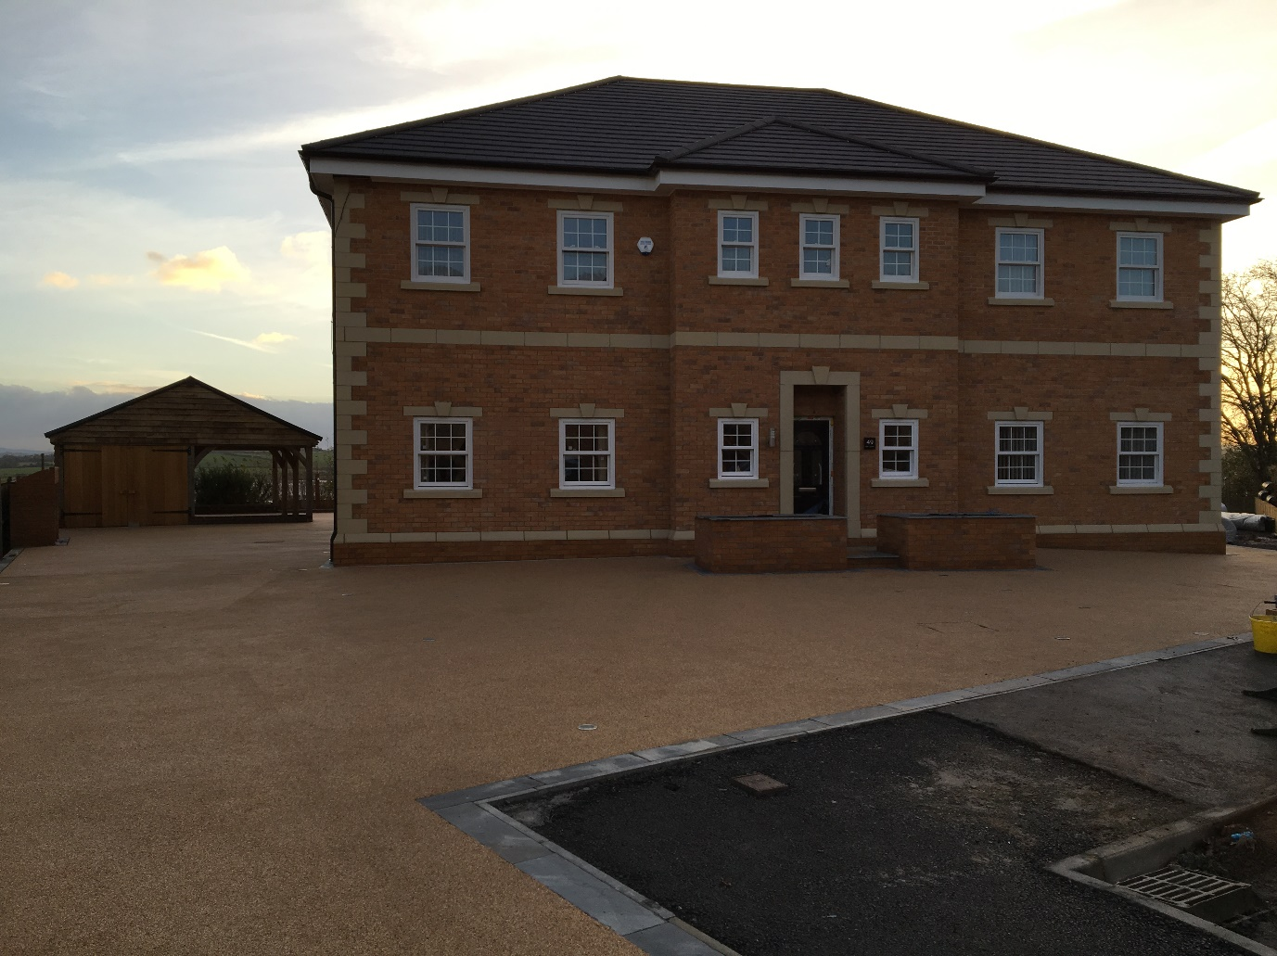
Figure 1: Aber Llwchwr House Front View
Photo credit: Darkin Architects, 2018
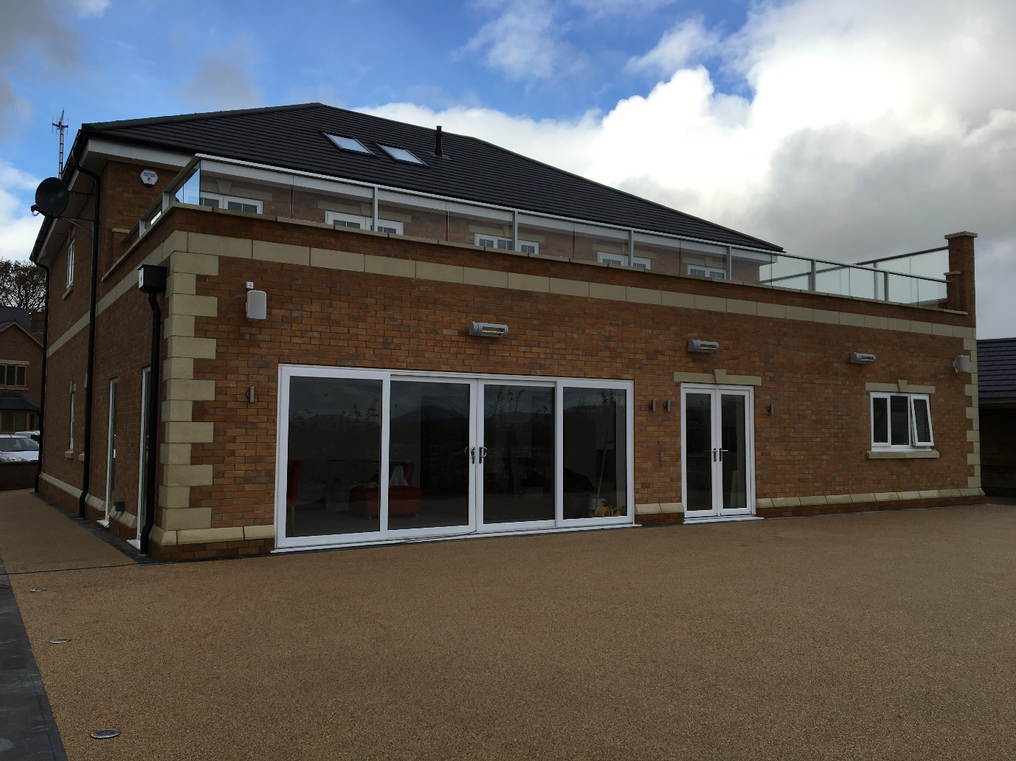
Figure 2: Aber Llwchwr House Rear View
Photo credit: Darkin Architects, 2018

Parc Hadau Development – Sero Homes (ongoing project)

This project in Pontardawe, is a net-zero carbon development of 35 homes and a community building that focus on community. There are four house types, ranging from 2 bedroom houses to 4 bedroom layouts.

It is the first development in the UK that monitors for how long grid energy is used and adjusts the home energy use to reduce carbon emissions. Carbon levels measurements will be taken using live emissions markers from the grid. The homes` intelligent energy management system, along with the building materials, energy storage and on-site renewables will give zero or below zero levels of emissions (UK Green Building Council, 2022).
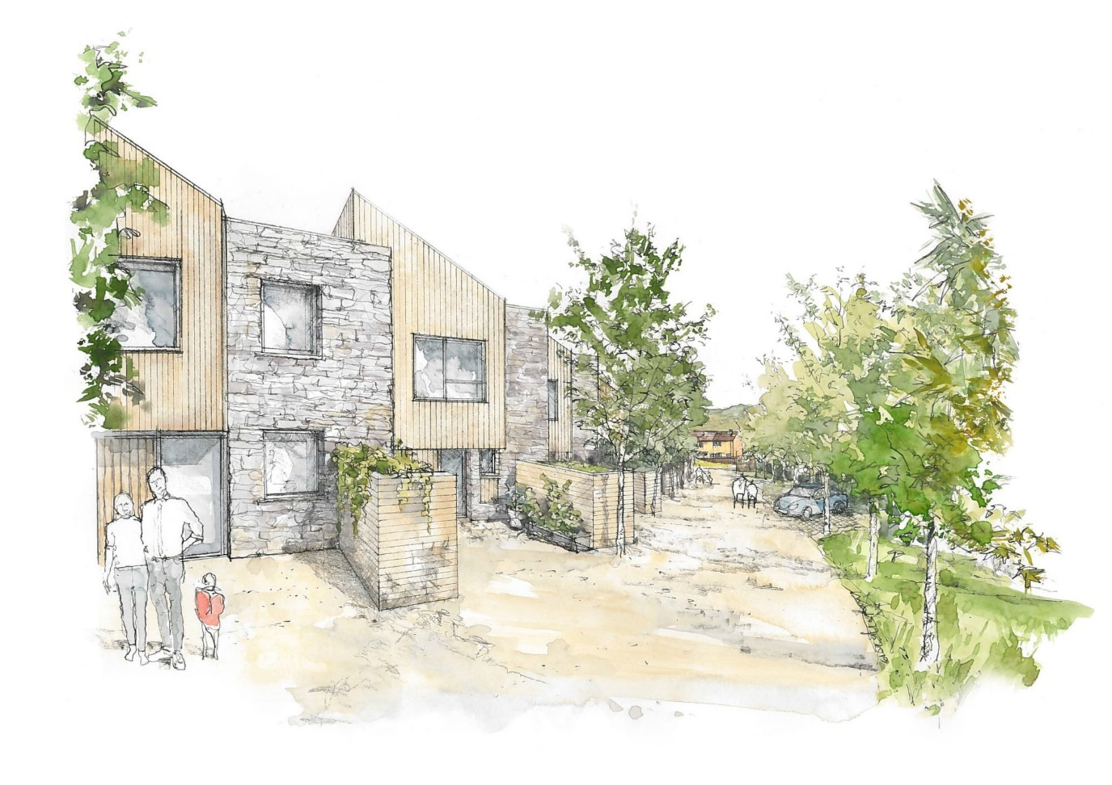
Figure 3: Parc Hadau
Photo credit: Sero Homes
Plymouth House – Studio George & Co.

Plymouth House`s project brief describes it as a bespoke design created for a client that wanted to use an adjacent, unused terrain at the side of his property, to develop several homes in Merthyr Tydfil. After a feasibility study, the commissioned designers came up with two house types that could be constructed on the terrain. One of them is Plymouth House Type and it is used on plots 1, 2 and 3 (see Figure 5). Plymouth House Type is a two level, 4 bedroom house. It must be outlined that this was an ongoing project, and it has not been built at the time this dissertation was written.

Chapter 4: Definition of good design quality

Before defining good design and what are its principles, there are some terms that must be defined as they are mentioned several times in the following lines.

Sustainable development:
The 1987 Bruntland Commission Report defines a sustainable development as a “development that meets the needs of the present without compromising the ability of future generations to meet their own needs” (UNESCO, 2021).

Sustainable Drainage Systems (SuDS):
Sustainable Drainage Systems locally manage the surface water by mimicking the natural drainage processes. Managing both flooding and pollution risks resulting from urban runoff, their design contributes to the possibility of enhancing the environment (Southampton City Council, 2022).

Technical Advice Note (TAN) 12 – Design
TAN 12 - Design is an official document released by the Welsh Government and used in conjunction with the Planning Policy Wales (PPW) documents. They are used by the Welsh Government and Planning Inspectors to decide if a development is granted planning application. TAN 12 is emitted to offer guidance for the design team on how the “Promoting sustainability through good design” and “Planning for sustainable building” can be facilitated through the planning system.

Good design in both built and natural environment serves its goals while being sustainable, helps developing of local economy, includes every social category, and does it at all scales throughout Wales. This is applicable to all designs.

TAN 12 defines design as: “the relationship between all of the natural and built environment”, and goes on to emphasise that “good design is also inclusive design” (p.6).

This means that an inclusive design considers the diversity and differences between people, offers alternative options when the design solution cannot satisfy all the users’ preferences, allows for a flexible use of the development, gives spaces that everyone can enjoy using, and focuses the design process on the people.

Objectives of good design can be seen in the following figure:
Figure 4: Objectives of good design
Photo credit: Ty Predn/ Feliden Fowles, 2016

A further explanation into the meaning and objectives of good design from the above diagram is as follows:

Access:
The design facilitates circulation for all categories of people (including disabled people), emergency and service vehicles, pedestrians and cyclists.

This can be achieved through careful use of design elements such as ramps, lifts, flush thresholds for people (including people with disabilities), clearly marked routes for pedestrians, cyclists and vehicles, and other design choices.

The Design and Access Statement (DAS) of Aber Llwchwr House shows that the nearest bus stop is located on Hendre Road while the nearest railway station is located is Pontarddulais Train Station. The development is not big enough have an impact on these public transport hubs. Aber Llwchwr provides the pedestrian access to the property. To enhance this access point, the development proposes new hard landscaping between the public footpath/highway and the access points that provides access to disabled people. For the benefit of visually impaired persons, the colours scheme contrasts between walls, floors, and doors (see Appendix F).

Looking at Parc Hadau development, the IHP Design Review Report of the Design Commission for Wales states that the development satisfies the above. It was also suggested that the development`s private spaces and communal areas need transitional passages and a method that makes the spaces to follow the design language, while avoiding the “privatisation” of public spaces. Furthermore, the report outlines that the site entrance needed further detailing to create legibility and a sense of arrival while considering the attenuation pond and a contextually appropriate elevation onto the street.

Plymouth House site plans show that the development is accessible via an extended drive from the main road. This can be used by all categories of people, but it might provide a challenge when accessed by large servicing or emergency vehicles (see Figure 5).
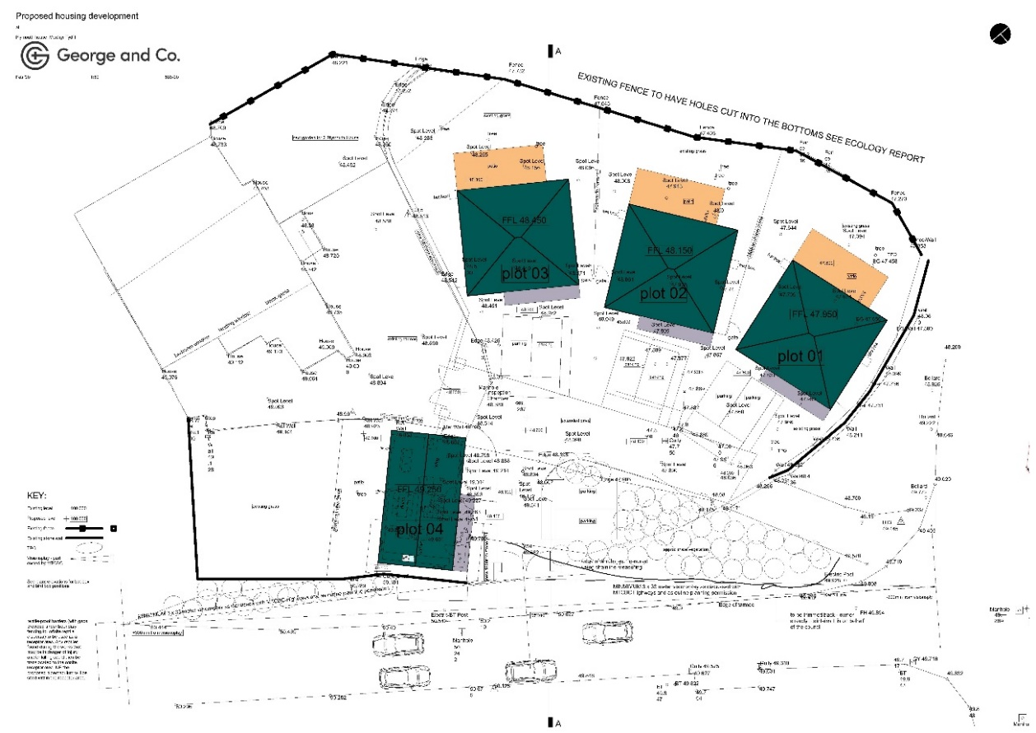
Figure 5: Plymouth House Site Plan
Photo credit: George and Co., 2016

Character:
Good design character can be obtained by considering the development`s context. This context includes the local landscape, culture, biodiversity, design language, buildings, infrastructure and boundaries as well as the mix of uses of local buildings and local landmarks.

Looking at the DAS of Aber Llwchwr House, written using the principles of TAN 12-Design, the proposal enhances and sustains the area`s character. It fills an unused land plot while continuing the area`s historical character. The proposal`s location follows the area`s development pattern while the layout integrates the development with its surroundings. The appropriate scale of Aber Llwchwr House to its surroundings does not affect privacy or daylight of neighbouring developments. The house`s appearance follows the neighbouring developments, by using similar materials. The development`s landscape protects the site and local amenities, while retaining most of the site`s existing shrubs, and reduces hard landscaping to prevent excess surface water (see Appendix F).

The IHP report on Parc Hadau states that the design of the development should consider the present and future neighbourhoods.

In the interview, the designers of Plymouth House stated that they used render for finishing material to keep it in the context (George and Traylor, 2022).

Community Safety
Community safety can be achieved by promoting qualitative public realms, with clearly marked routes that provide opportunities for physical and recreational activities that satisfy the society’s needs. Crime prevention can be obtained by designing the development to allow natural surveillance, to reduce the conflicts in use for improving everyone`s safety and by nurturing the sense of ownership and responsibility.

Further study of Aber Llwchwr House`s DAS shows that the property offers sufficient access for emergency vehicles and increases surveillance for community safety through occupation of the property. The planted trees do not aid in climbing over the boundaries or into the buildings and they do not obstruct the site entrance, which makes it visible and offers good visibility of the road. The layout of the development clearly distinguishes between private, semi-private and public spaces (see Appendix F).

The IHP report on Parc Hadau describes the “green” approach to the site as a positive element that supports social interaction and biodiversity. The communal building and activity areas encourage interaction between residents.

The site plan drawings of Plymouth House, show the homes offering an enclosed space between the developments, that can be used safely. The fencing around the development offers a safe environment, while the homes` orientation allows natural surveillance of the central space. There are no trees on site that could help in climbing over fences. The layout makes a clear space between private, semi-private and public spaces (see Figure 5).
Environmental sustainability
This is obtained by taking steps to decrease the buildings` environmental impact through minimization of demand for energy resources (naturals and artificial) and by minimizing waste creation. Environmental sustainability is achievable through enhancing local biodiversity and allowing for a building to be adapted to various future demands, without demolishing it.

Choosing sustainable materials, intelligent use of the natural resources in the design (like solar gain, wind power and others), along with reducing waste and creating opportunities for biodiversity, reduces the developments impact to the environment.

The DAS of Aber Llwchwr House states that the energy hierarchy has been used to reduce the building`s carbon emissions where possible. The proposal`s envelope was designed to respond to the site`s climate. Where possible, rainwater harvesting was used. Responsibly sourced materials were used as well as, if practical, using low embodied energy materials. During construction, minimisation of waste materials was used. Waste materials were either recycled or properly disposed of. The proposal also tackled future climate changes for the buildings life expectancy by pitching the roof at an angle that allows for snow to fall of it and by minimising the eaves to prevent strong winds from damaging the roof (see Appendix F).

As mentioned before, the IHP report on Parc Hadau validates the “green” approach to the site as a positive support for biodiversity. The report stated that the use of space and the “ecological landscape design principles” must be intertwined, while considering adding to the biodiversity. The scheme aimed at a zero-carbon status by having a low carbon fabric to the buildings, and using a SuDS system. The SuDS system will enhance the site landscape by bringing the water to the surface and allowing it to pass through site unhinged by barriers or hard obstacles. This also improved biodiversity and the resident`s delight.

The UKGBC case study on Parc Hadau mentions that zero carbon status will be achievable using a network of photovoltaic panels (PV or solar panels) that can provide energy to both residents and the national grid, and by using storage of electrical and thermal energy. The solar panels are stored on the “blue roofs” of the houses, roofs that are designed to allow for rainwater to be used for certain instances in the house. Excess energy produced on site will be fed back into the national grid to displace the carbon emissions generated by both the national grid and the energy that the houses use at peak times from the national grid. Continuous monitoring and control of the net zero carbon balance will be done using sensors in the houses that measure in real time the energy use of operating the homes. This process starts from the completion of the homes. The homes of Parc Hadau have the structure in the exterior walls` envelope to allow for an open space plan inside, which makes the homes adaptable to the changes in preference (UK Green Building Council, 2022).

During the interview for Plymouth House, the designer said that the homes` sustainability was influenced by his education and the drive for offer a good design (George and Traylor, 2022).

Looking at the plans and construction drawings, it is evident that sustainability was a factor that influenced the design of the home. The homes are designed using cavity walls, to offer good U-values. Adding to that, the use of timber for the floor joists helps capturing carbon levels. The non-load bearing walls inside the homes, make them open-plan and adaptable for future needs (see Figures 6 and 7).
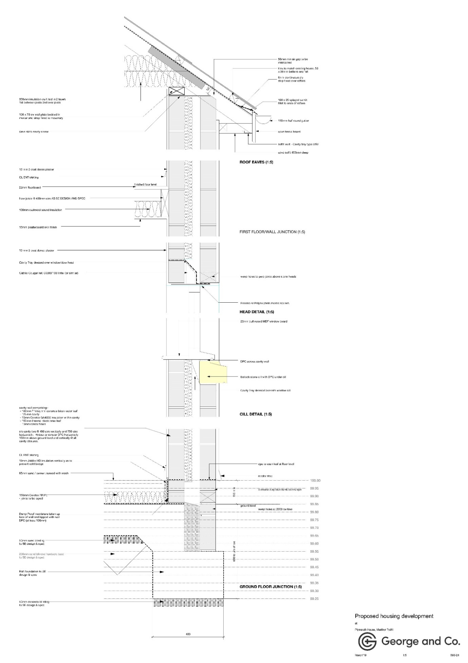
Figure 6: Plymouth House 1:20 Section
Photo credit: George and Co., 2019
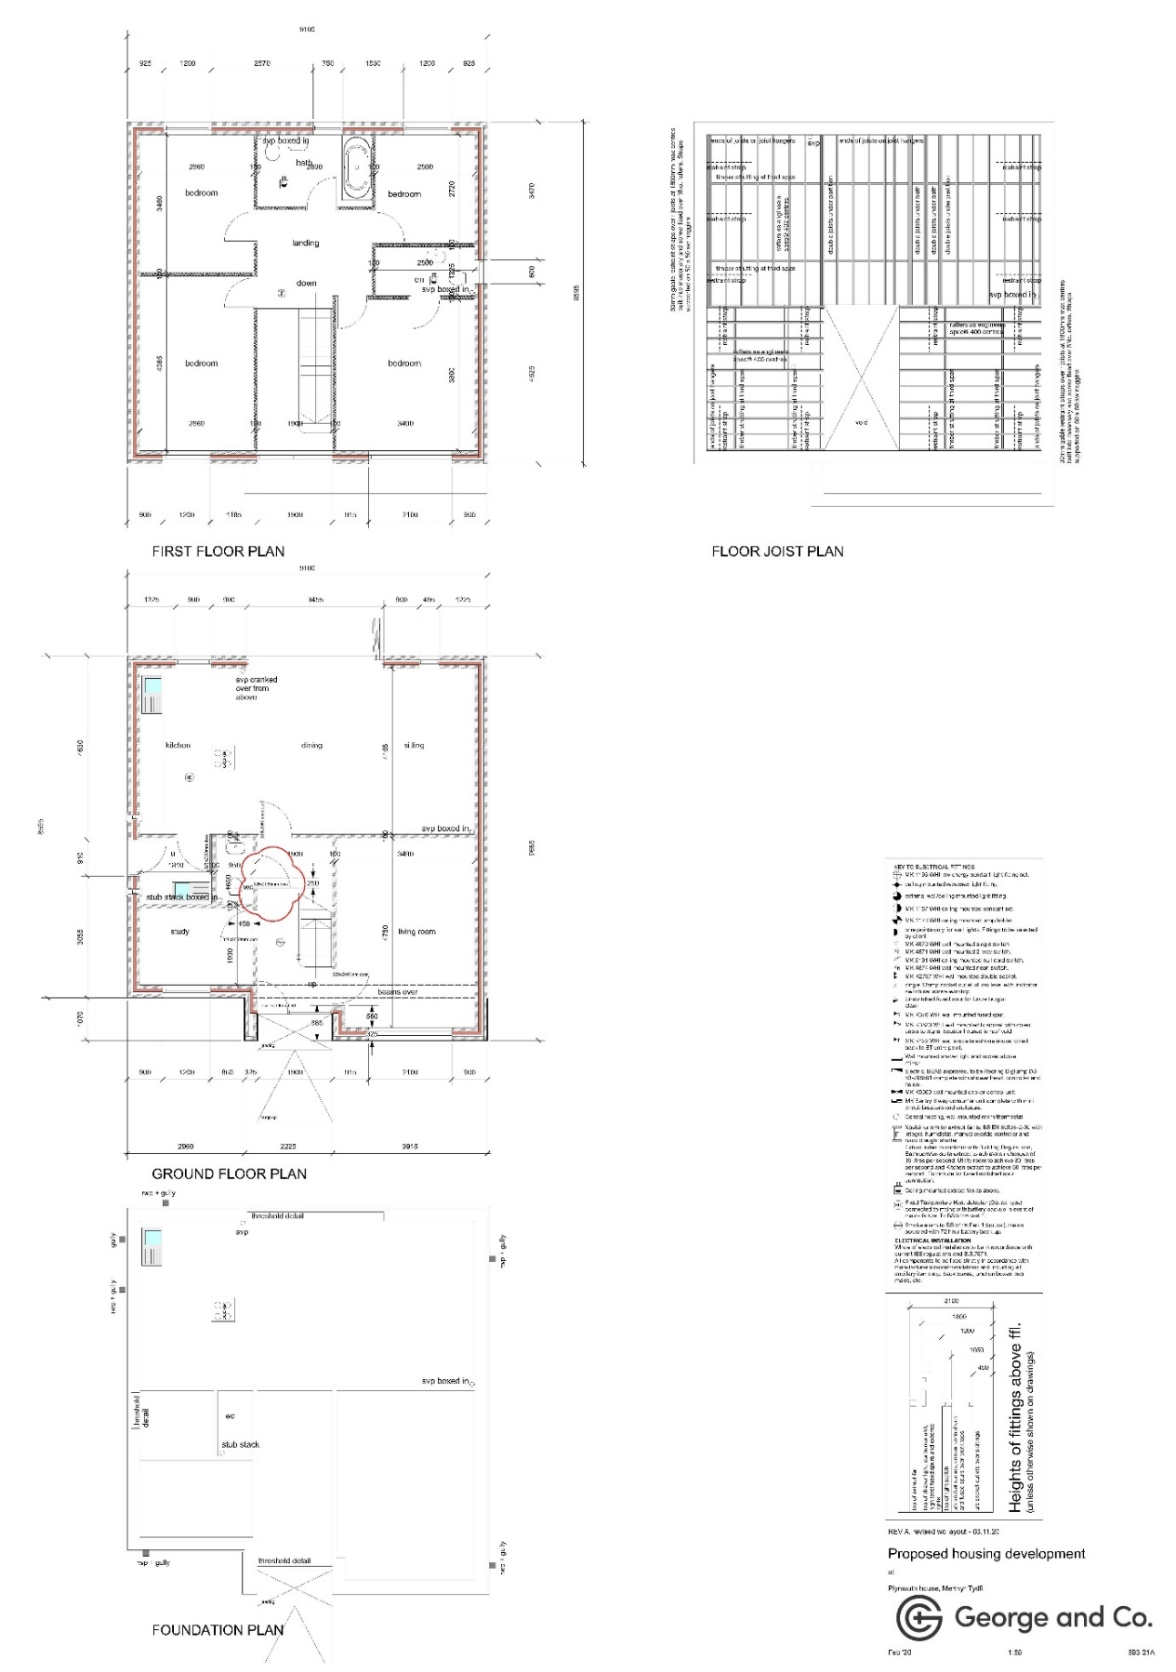
Figure 7: Plymouth House Floorplans
Photo credit: George and Co., 2020

Movement
Sustainable means of travel can be promoted by making safe and clear connections between circulation routes, creating “green” transportation routes (cycling, walking, public transport) that minimize the need to use personal cars, and by connecting existing transport routes and hubs to the site circulation. Other methods to promote sustainable movement are the integration of new transportation ways without taking away from the existing network, and creating an easy, safe and attractive environment for sustainable and by providing facilities within the developments for these means of transport.

The DAS of Aber Llwchwr House offers little information for this point. The development`s primary pedestrian and vehicle access are provided via the fronting road. There are four parking spaces, two in the garage and two on the driveway (see Appendix F).

As per the IHP report, on Parc Hadau a car sharing scheme can be implemented on site to fully use the potential of the electric car charging points and home integrated batteries.

The tender drawings for the houses of Parc Hadau show that excepting House Type 3, all houses have dedicated storage spaces for bicycles at the front (see Figures 8 to 16).

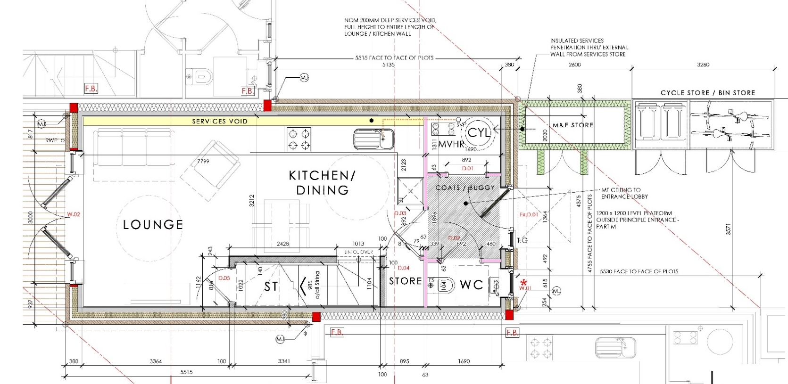
Figure 8: Parc Hadau House Type 1 Ground Floor Plan
Photo credit: LeTruccodesign Architecture, 2021
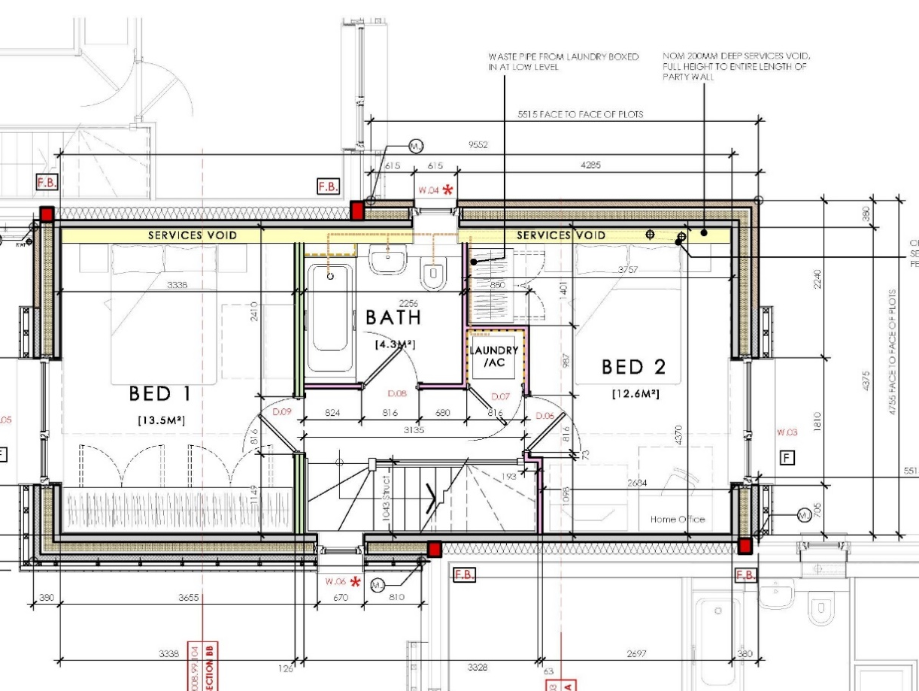
Figure 9: Parc Hadau House Type 1 First Floor Plan
Photo credit: LeTruccodesign Architecture, 2021
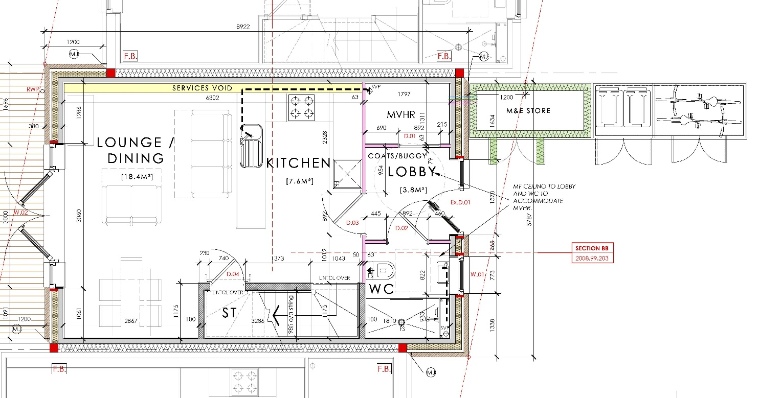
Figure 10: Parc Hadau House Type 2 Ground Floor Plan
Photo credit: LeTruccodesign Architecture, 2021

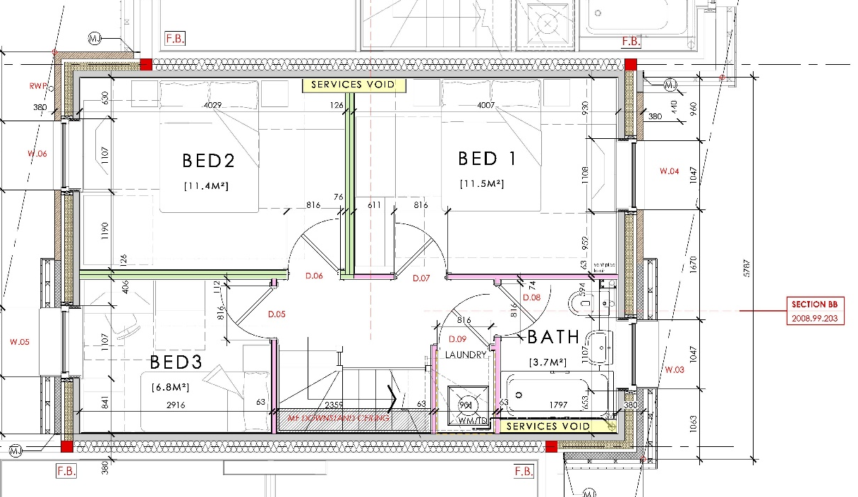
Figure 11: Parc Hadau House Type 2 First Floor Plan
Photo credit: LeTruccodesign Architecture, 2021
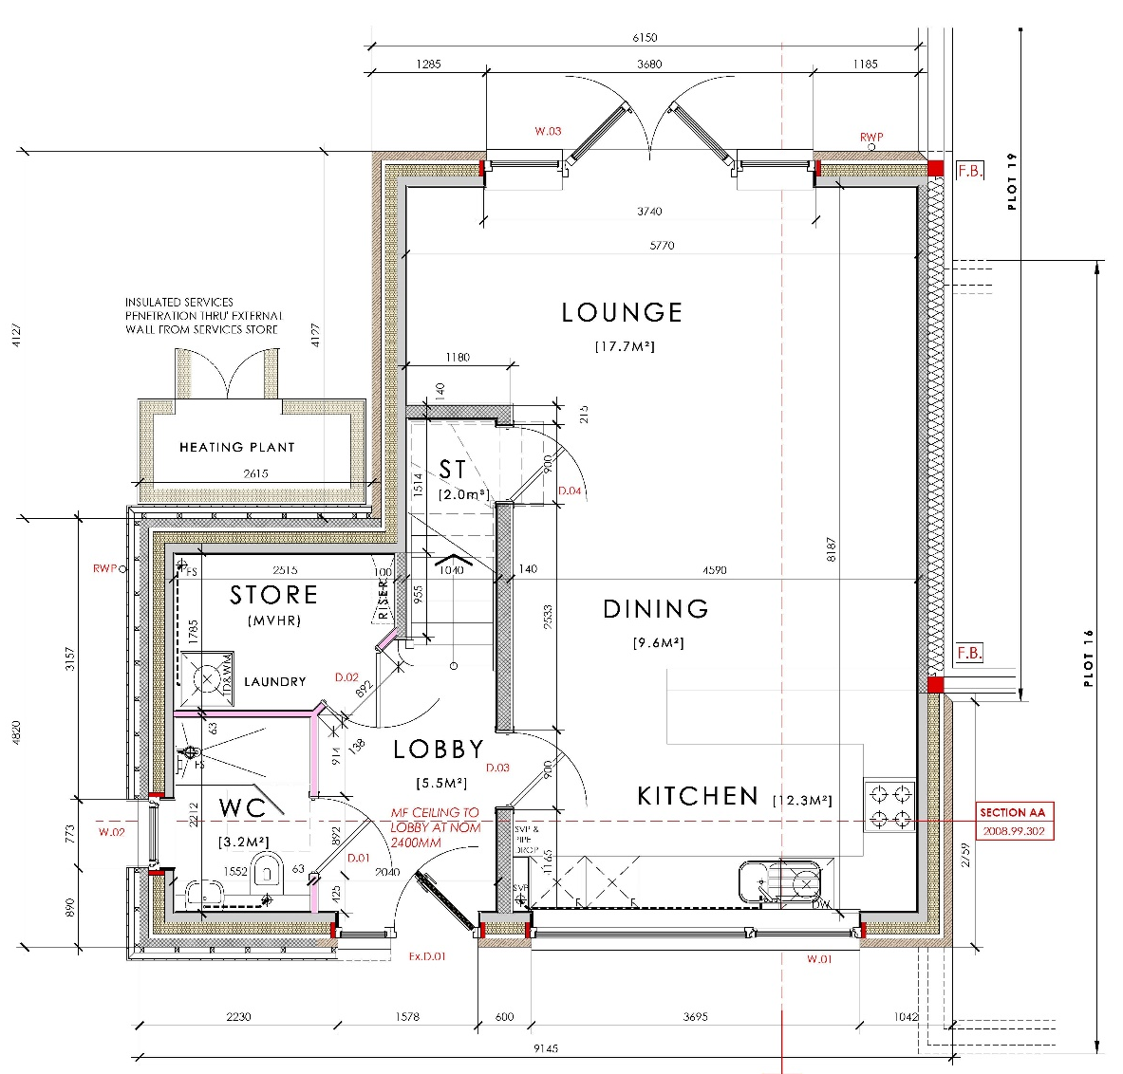
Figure 12: Parc Hadau House Type 3 Ground Floor Plan
Photo credit: LeTruccodesign Architecture, 2021
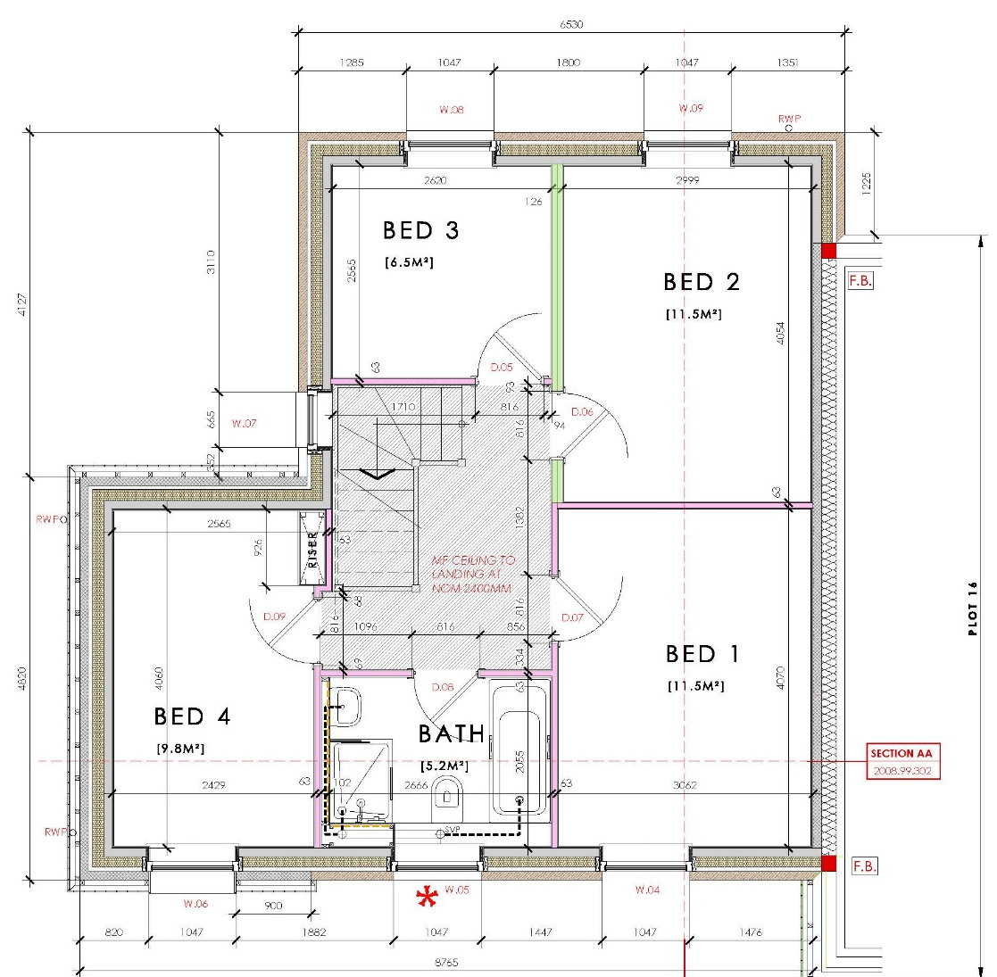
Figure 13: Parc Hadau House Type 3 First Floor Plan (Plot 17)
Photo credit: LeTruccodesign Architecture, 2021
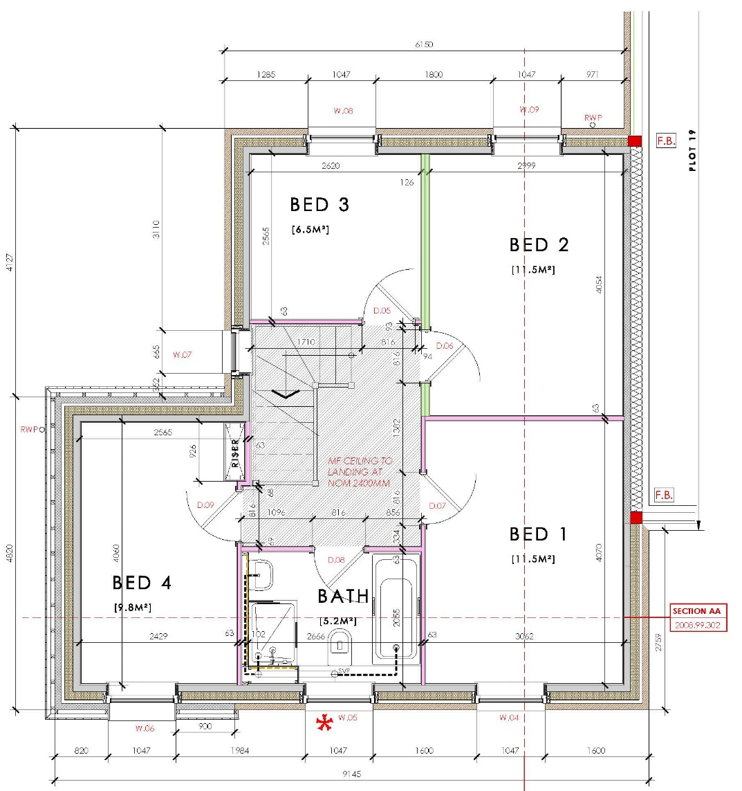
Figure 14: Parc Hadau House Type 3 First Floor Plan (Plot 18)
Photo credit: LeTruccodesign Architecture, 2021

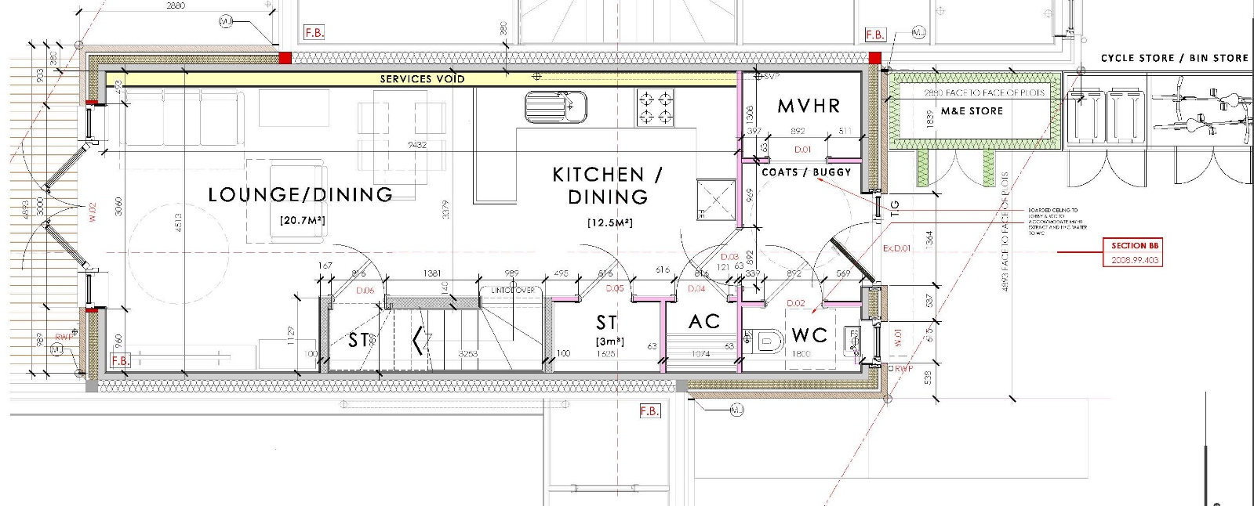
Figure 15: Parc Hadau House Type 4 Ground Floor Plan
Photo credit: LeTruccodesign Architecture, 2021

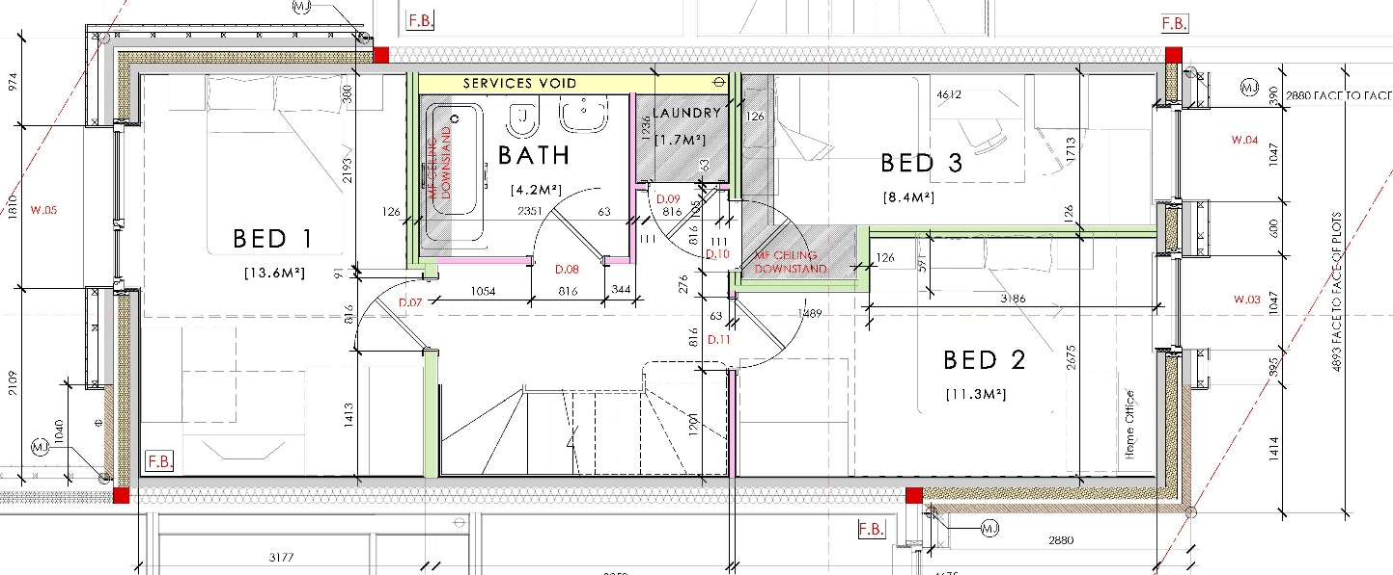
Figure 16: Parc Hadau House Type 4 First Floor Plan
Photo credit: LeTruccodesign Architecture, 2021

The site plan of Plymouth House shows that there are two parking spaces in front of each house. There is no information if there are dedicated charging points for electric cars, or storage for bicycles or other sustainable means of transport (see Figure 5).

2021 Welsh Development Quality Requirements

This document sets out the minimum requirements in quality for new and refurbished affordable homes. It is encouraged by the Welsh Government that all professionals involved in designing and building affordable homes to go beyond these minimum standards for everyone`s benefit.

Housing quality is about the design of the homes and the value of their context. They should all be designed to work together to create aesthetically attractive places, with an incline towards sustainability. Their quality should be high enough to meet the needs of a community, family or individual.

The quality of a home is not limited at the building`s design or sustainability levels. It extends beyond these, towards it`s context as well, which should create spaces that give a feeling of belonging and meet everyone`s needs.

Housing providers and their consultants are responsible for creating quality homes. To do that, they must go beyond the basic guidance to provide their best possible results. Engaging with the community in which they are developing is also encouraged, to get feedback from the people of the community`s experience of living in previously occupied areas.

The feedback can provide vital information on their previous experiences, what worked and what has not worked, as well as what they would find appealing to improve their community and wellbeing.

Refurbished homes should aim to meet the set standards. If this is impossible due to impracticability or cost inefficiency, the homes should still provide enough space and facilities for everyday living.

Application of this standards began from 01 October 2021, and it was enforced to all affordable housing schemes, publicly funded through the Welsh Government.

From 01 October 2021, new housing schemes were required to meet only the conditions of Appendix A and Appendix B.

Requirements:
1 “Homes should be of high quality, innovative and sustainable.”

To comply with this:
- The homes should represent value for money and the “whole life cost” should be a comparison between future maintenance cost and the initial capital cost.

There is no information available from Aber Llwchwr to check if that comparison has been made.

The IHP report on Parc Hadau mentions that early site testing, monitoring and training could reduce the performance data difference between design expectations and real-life results. Full collaboration between energy consultant and design team could help achieving the set objectives.

Same as with Aber Llwchwr, there is no information available if such comparison has been made for Plymouth House.

- The homes should be built using “Modern Methods of Construction”. MMC include construction methods and technologies that can replace or work with traditional constructions methods. Using MMC in raising the homes should be a “step change” and not just a way to include construction elements that are usually produced off-site.

- Take steps towards a decarbonised and circular built environment by:
- Reducing carbon during design and construction of new homes and when refurbishing old ones

The DAS of Aber Llwchwr House states that the home has been built with a sustainable agenda in mind, which means that it considers the reduction of carbon emissions (see Appendix F).

The UKGBC case study on Parc Hadau mentions the project`s drive to reduce carbon emissions (UK Green Building Council, 2022).

There is no information on what steps did Plymouth House took to reduce carbon emissions.
- Try to reuse existing buildings, specify recycled and reused materials, and design the buildings to be easily adapted, reused, or deconstructed and their fabric to be recirculated at the end of the building’s life cycle.

The Project Brief of Aber Llwchwr House states that it is a timber frame construction (see Appendix E). Looking at the floor plans, it is shown that it is an open plan design, which can be adapted for future needs (see Figures 17 and 18). There is no information on the sourcing of the materials, so full compliance with this quality marker cannot be verified.
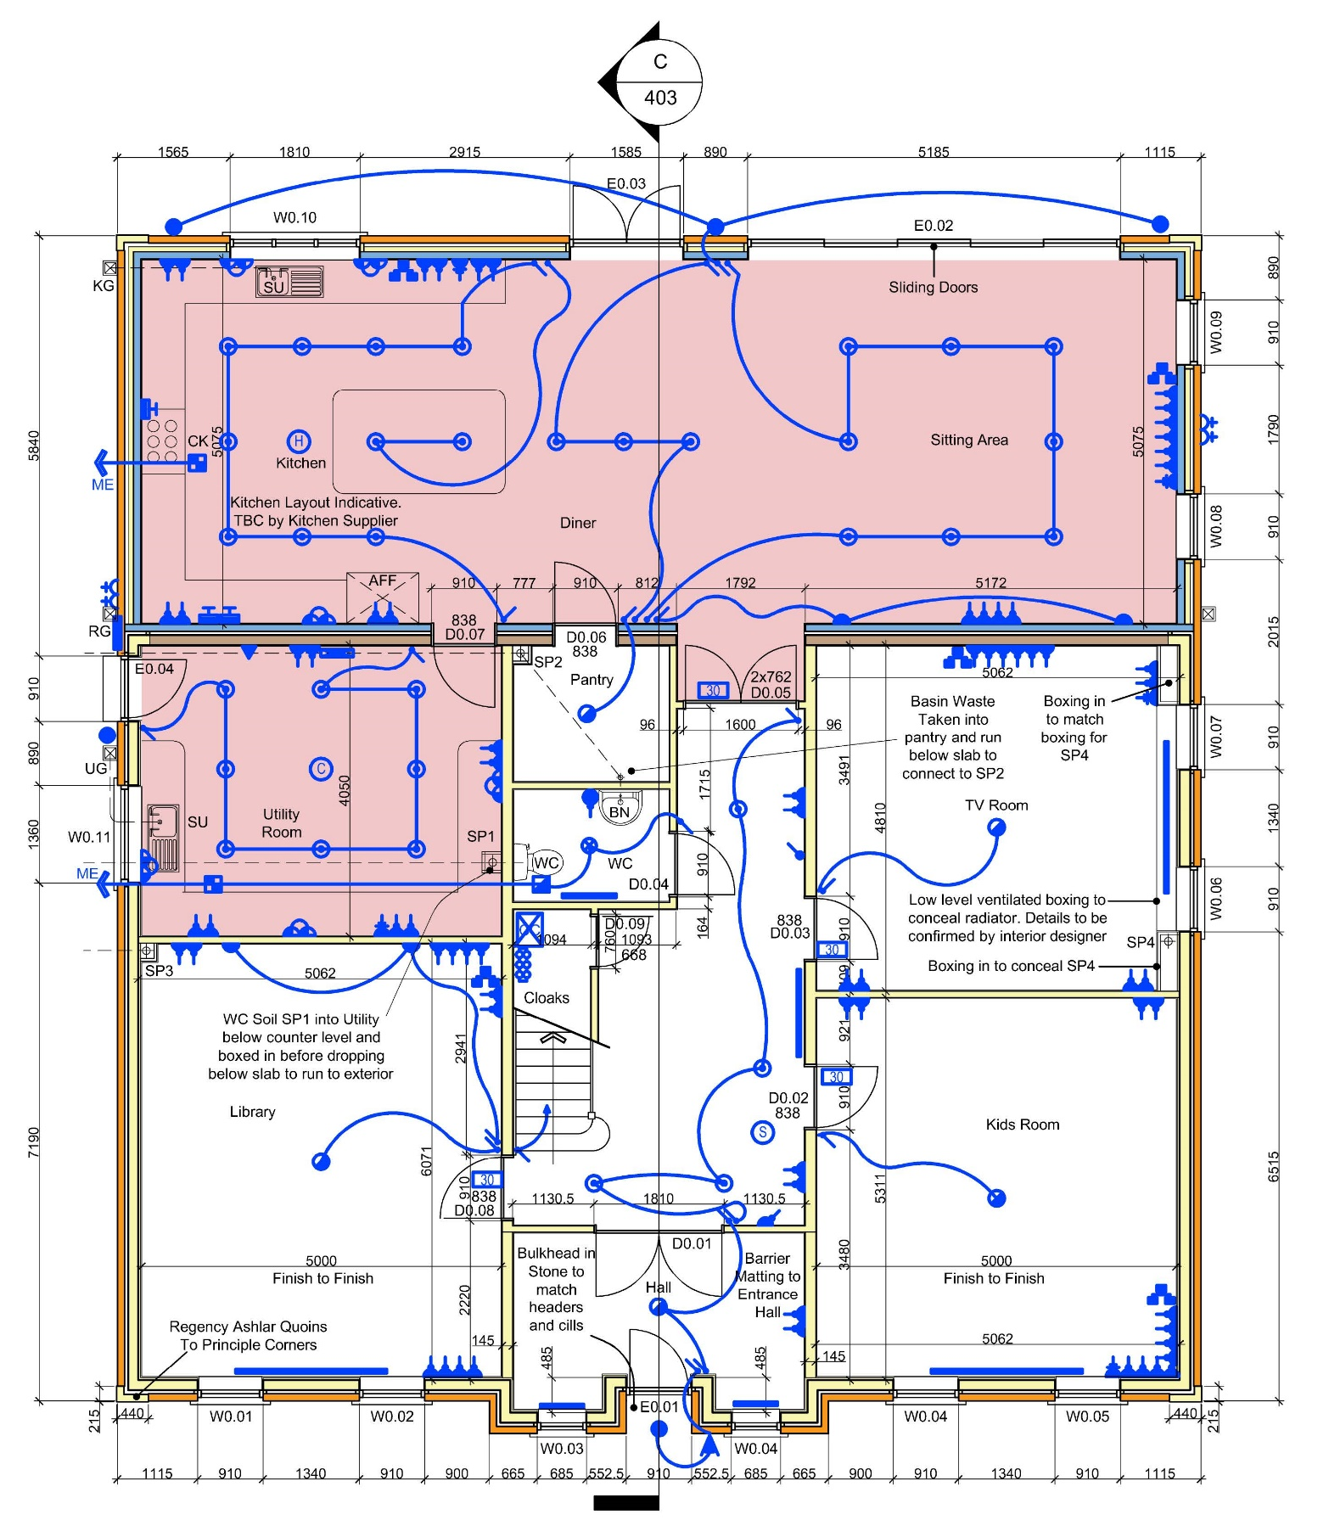
Figure 17: Aber Llwchwr House Ground Floor Plan
Photo credit: Darkin Architects, 2016

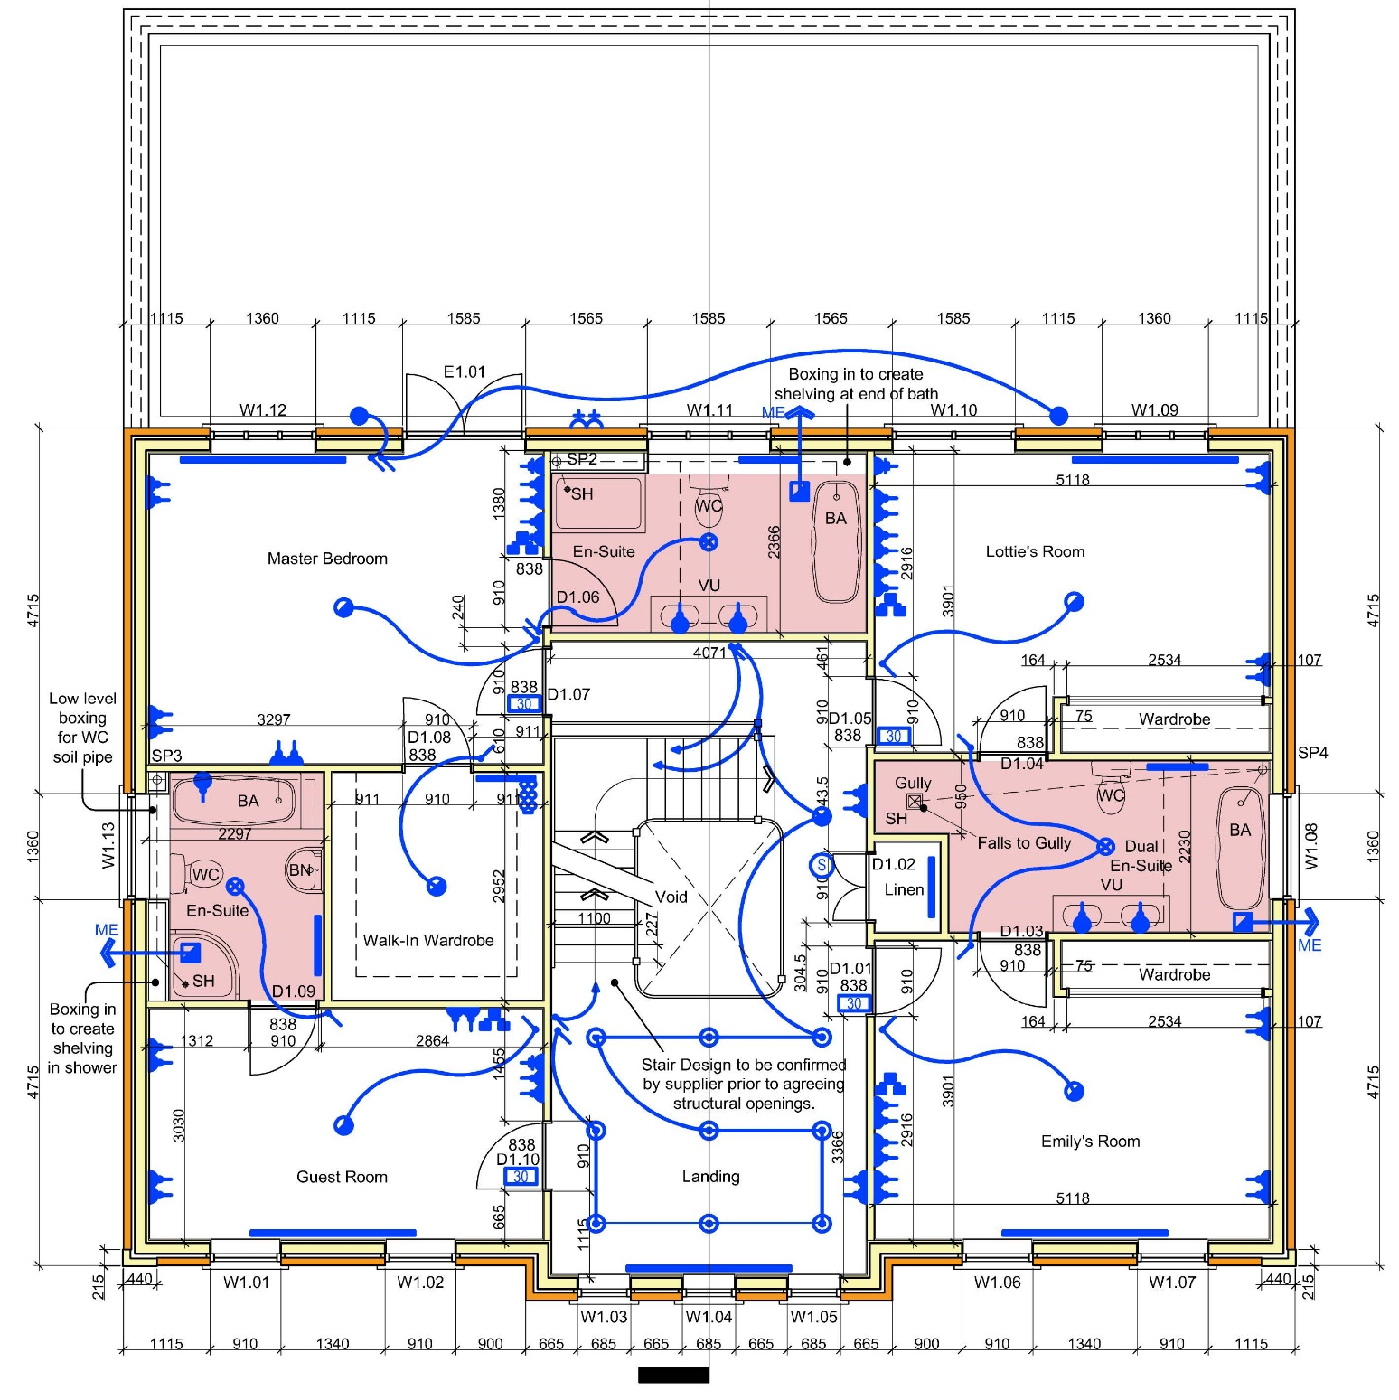
Figure 18: Aber Llwchwr House First Floor Plan
Photo credit: Darkin Architects, 2016

Looking at the homes of Park Hadau the cladding blends timber with locally quarried stone or recycled brick masonry. Both materials can be recycled at the end of the houses` use, and they have low embodied carbon. The homes of Parc Hadau have the structure in the exterior walls` envelope to allow for an open space plan inside, which makes the homes adaptable to the changes in preference (UK Green Building Council, 2022).

The plans of Plymouth House show the open plan layout that allows for the homes to be adapted for future needs of the occupants (see Figure 7). There is no information available about the providence of the materials.

- Use timber efficiently in construction for increased carbon storage in the materials.

The structure of the Aber Llwchwr House is made from timber frame. A timber frame as the quality of capturing and retaining carbon for the building`s lifetime (see Appendix E).

Returning to Parc Hadau, low embodied carbon materials like the Cross Laminated Timber (CLT) used for the structure of the homes capture and store large volumes of carbon for the entire life of the home. The CLT is also used to balance out the use of the concrete floor decks chosen for their thermal massing (UK Green Building Council, 2022).

Plymouth House uses timber just for the upper floor joists, roof construction and interior walls (see Figure 6 and Figure 7). It is unknown why the method of construction was not a timber frame, because that is seen as a more sustainable than using load-bearing walls and it would capture more carbon for the building’s lifetime.

- Reduce carbon production by decreasing the energy demand during operations, and if possible, try using on site renewables.

Parc Hadau, to achieve net-zero carbon status, uses on-site renewables (UK Green Building Council, 2022).

There is no verifiable information if Aber Llwchwr House and Plymouth House use on-site renewables.

- Ensuring that recyclables can be stored and efficiently collected, including food storage bins.

There is no information of dedicated storage for bins on the Aber Llwchwr House, but judging from the Site Plan, there should be any difficulty in collection of recyclables or food storage bins (see Figure 19).
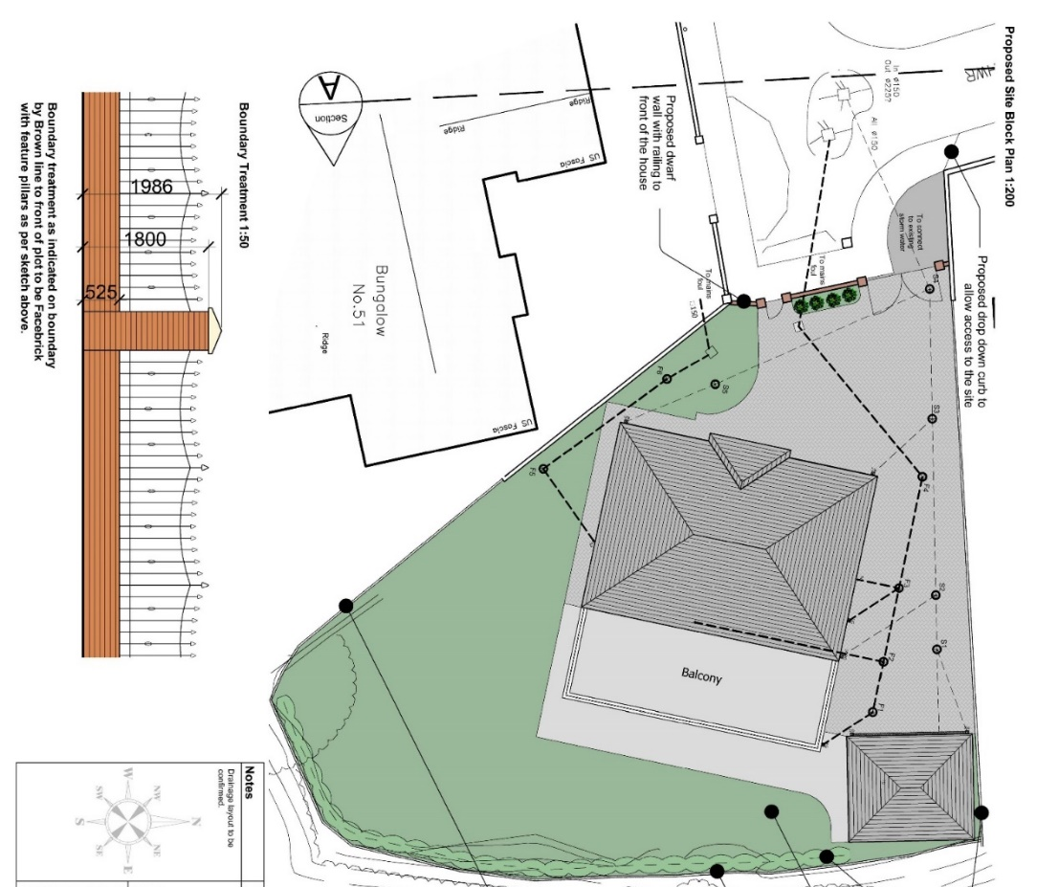

Figure 19: Aber Llwchwr House Site Plan
Photo credit: Darkin Architects, 2016
The IHP report mentions that the design of Parc Hadau should give an early consideration of services and waste collection.

The tender drawings of the Parc Hadau House Types show that except for House Type 3, all other House Types have dedicated storage for recyclables and food store bins. The bin storages are situated at the front of the house, and they can be easily collected (see Figures 8, 10, 12, and 15).

The information available on Plymouth House does not show dedicated storage for recyclables or food storage bins, although, looking at the site plan, it is appearing that there is no difficulty in making the bins available for collection (see Figure 5).

- Compare the design intent against an as-built assessment of whole life carbon and building`s post occupancy performance evaluation.

There is no post occupancy evaluation available for the Aber Llwchwr House.
Since Parc Hadau and Plymouth House are still ongoing projects, such comparative data is not available.

- Use robust offsetting schemes to advance to net-zero whole life carbon, as soon as upfront, embodied, and operational carbon are minimised.

- There are energy and decarbonisation requirements that new homes must abide by:
- Achieve EPC A (SAP92 of grater) by using the minimum fabric standard outlined in “Appendix E” – Elemental specification for the DER TER, of the “Building Regulations Approved Document Part L Wales 2020”, and by providing domestic hot water and heating of the spaces without the use of fossil fuel fired boilers. It is acceptable to provide alternative proposals if independent certification demonstrates that the building`s energy demand is lowered to be in line with the “Energy Hierarchy for Planning in Welsh Government`s Planning policy Wales”.

There is no information on how the hot water and space heating are provided for the residents of Aber Llwchwr House.

To provide for the occupants` needs of hot water and heating the spaces in a sustainable way, the homes of Parc Hadau do not use fossil fuel fired boilers. Instead, they use a system of ground source heat pumps (Sutton, 2020).

The Plymouth House uses a fossil fuel fired boilers with condensing technology (see Appendix G).

- The overheating risk must be assessed based on the CIBSE TM59 methodology (for “Category 1 Buildings”). The assessment should demonstrate compliance with the aforementioned methodology compliance criteria, for apartments/flats and houses without cross-ventilation facilitated by two or more parallel aspects.
There is no information available from the case studies to check if the assessment has been done.

2) Homes should be flexible and adaptable, to respond to the changing requirements of the occupiers to the end of the building`s life.

By this:
- Rooms are large enough to house the occupants` reasonably expected furniture needs.

The floorplan drawings of Aber Llwchwr House show that the rooms are large enough to accommodate any furniture needs. Being a highly bespoke design, the room sizes exceed the set parameters of Appendices A and B (see Figures 17 and 18).

Studying the tender drawing on the house types of Parc Hadau, they provide sufficient information on the room dimensions and how much furniture they can accommodate. These drawings show that the homes can accommodate additional furniture if needed. All the room sizes are within the set parameters of Appendices A and B (see Figures 8 to 16).

The floorplan drawings of Plymouth House show that the rooms are of enough size to satisfy the furniture needs. The room sizes satisfy the requirements of Appendices A and B (see Figure 7).

- The circulation and paths to each home, points of access, stairs and lifts should be designed to allow for easy movement of furniture and belongings within the home`s rooms.

The floor plans of Aber Llwchwr House show that the ground floor rooms are accessible from a central hall. The doors are wide enough to allow for reasonable size items and furniture transportation. Because there is not a straight flight of stairs, it could be difficult to carry larger items to the upper level (see Figures 17 and 18).

The tender drawings of Parc Hadau show that circulation in the homes is designed to facilitate easy movement. Apart from House Type 3, the ground floors of the homes have a linear circulation from the front to the back entrance. This allows for items to be carried through easily, without the need to go around corners. House Type 3 has a lobby at the ground floor that allows for the items to be rotated and transferred in the other rooms. Because none of the house types have got a straight flight of stairs, it might prove difficult to move larger items to the upper floors (see Figures 8 to 16).

The circulation of Plymouth House, as demonstrated by the drawings, facilitates movement. All rooms are accessible from a central lobby on ground floor and a landing at the first floor. The straight flight of stairs facilitates movement of furniture to the upper floors. The narrow doors might prove inconvenient when transporting furniture in a room (see Figure 7).

- Homes` internal and external spaces should have dedicated, convenient and adequate storage. Dedicated spaces for bicycles would encourage the residents to use a sustainable means of travel.
The plans of Aber Llwchwr House show that there are storage options at all levels of the house (see Figures 17 and 18). Additionally, the DAS offers information on the parking spaces (see Appendix F). The internal storage options exceed the dimensions required by Appendixes A and B. It can be assumed that the garage can accommodate bicycles but there is no information if there are electric car charging points.

All the House Types shown in Parc Hadau provide internal storage items and convenient storage spaces for 2 bicycles at the front entrances (excepting House Type 3), which encourages the occupants travel sustainably. Additionally, the provided internal storage spaces of the homes exceed the requirements of Appendix B (see Figures 8 to 16).

The IHP report shows that Parc Hadau offers electric car charging points for every home.

The interior storage spaces on Plymouth House are on par with Appendices A and B. The drawings do not show dedicated storage for bicycles as sustainable transportation method (see Figure 7).

- The space standards of Appendices A and B should be clearly found in the homes.

Due to its bespoke manner, Aber Llwchwr House exceeds the space requirements of Appendices A and B (see Figures 17 and 18).

Parc Hadau is a development that is designed in accordance with the Welsh Development Quality Requirements, and this is evidently in the plans (see Figures 8 to 16).

The floorplans of Plymouth House show that it satisfies the dimensions of Appendices A and B (see Figure 7).

- In addition to a bath, all homes should have a shower at ground floor with adequate provision of plumbing, and electrical and mechanical ventilation connections. This would allow in the future for a barrier free shower facility to be installed, which would suit a wheelchair bound person. Homes with an occupancy level of plus six should have already got barrier free shower.

Even though Aber Llwchwr House does not have a shower at the ground floor, the bathroom at this level is of sufficient dimensions to accommodate for easy installation of a shower (see Figure 17).

Throughout the ground floor plans of the home types of Parc Hadau it is seen that House Types 1 and 4 do not have shower provisions at the ground floor. Additionally, the dimensions and layout of the bathrooms in these House Types do not allow for an easy installation of a shower provision. House Types 2 and 3 have already got shower provisions at the Ground Floor (see Figures 8, 10, 12 and 15).

The floorplans of Plymouth House do not show the provision of a shower at the ground floor. Also, for future instalment of one, the ground floor toilet is too small, so it would need adapting (see Figure 7).

- All flats and bungalows have both baths and showers. Bungalows and flats at ground floor or accessible by lift have a bathroom that can be adapted to be used by a wheelchair bound person.

Aber Llwchwr House is a two-floor,4 bedroom house and makes this point invalid (see Figures 17 and 18).

The development of Parc Hadau does not have flat or bungalows, which makes this point non applicable (see Figures 8 to 16).

As well as with the above, this point is non-applicable for Plymouth House (see Figure 7).

- Consider the impact of technology (ventilation and heating systems) on the space requirements.

Aber Llwchwr House partially uses underfloor heating. It frees up the space used by radiators. Curiously, underfloor heating is used only in the kitchen, sitting area, utility room and first floor en suite bathrooms. The bedrooms, library, TV room and children’ room do not benefit from this system, and it can potentially negatively impact the heating and energy performance of the home. The heating and ventilation systems do not take from the room sizes to make them uncompliant with Appendices A and B (see red areas of Figures 17 and 18 for underfloor heating).

The underfloor heating system used in the Home Types of Parc Hadau allows for an efficient use of the spaces by not requiring radiators that would take up space. The distance between the final floor layer and ceilings satisfies the requirements from the Appendix A. The plans of the House Types allow for sufficient storage of M&E and heating systems and services without sacrificing the space requirements of Appendices A and B (see Figures 20 to 23).
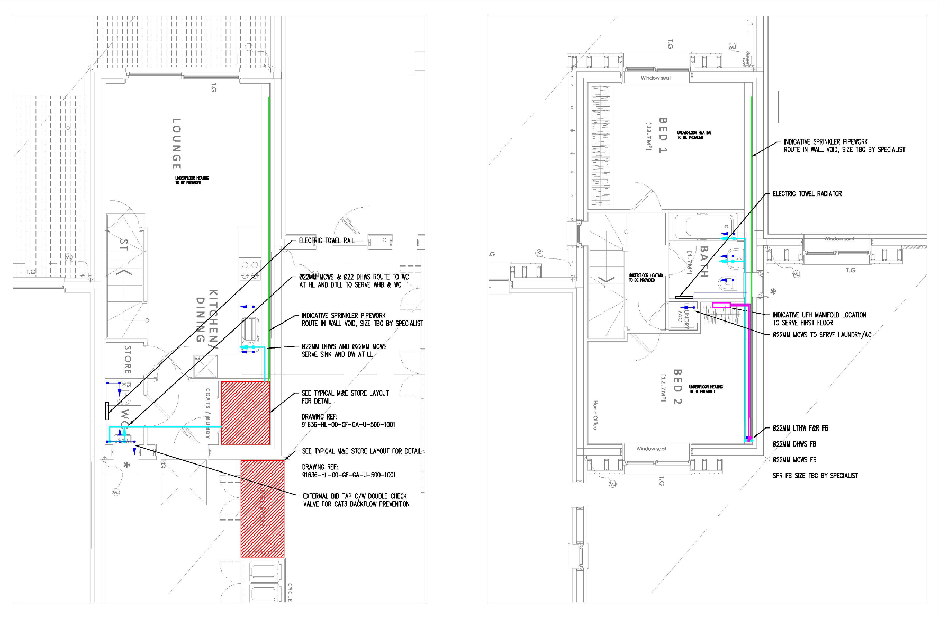

Figure 20: Parc Hadau House Type 1 Services Drawings
Photo credit: Hoare Lea, 2021
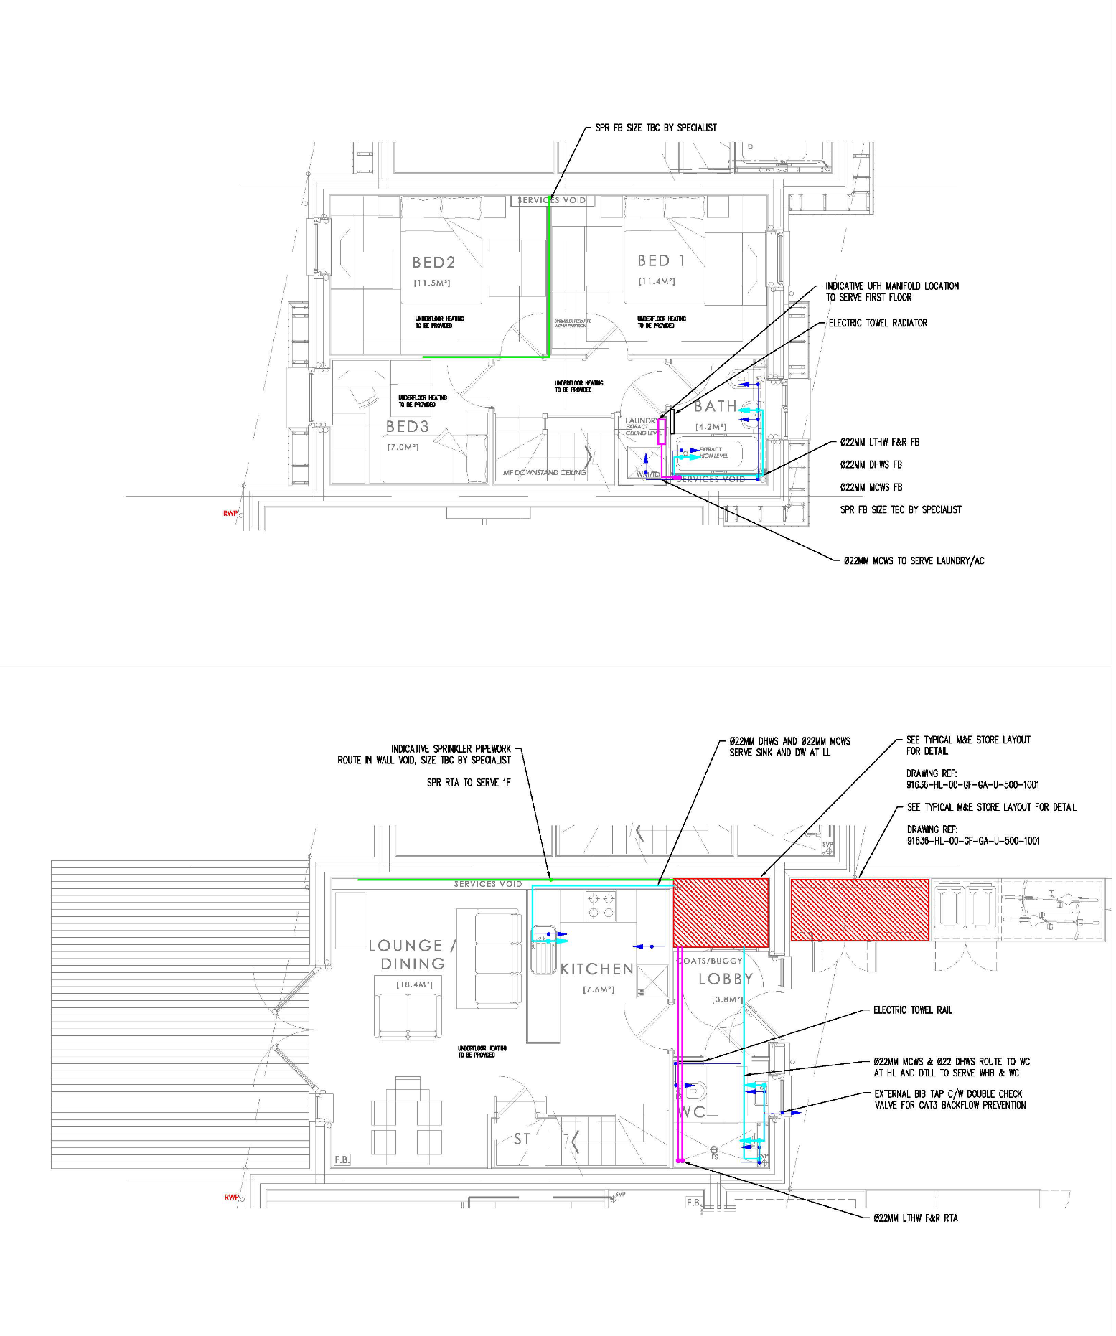
Figure 21: Parc Hadau House Type 2 Services Drawings
Photo credit: Hoare Lea, 2021

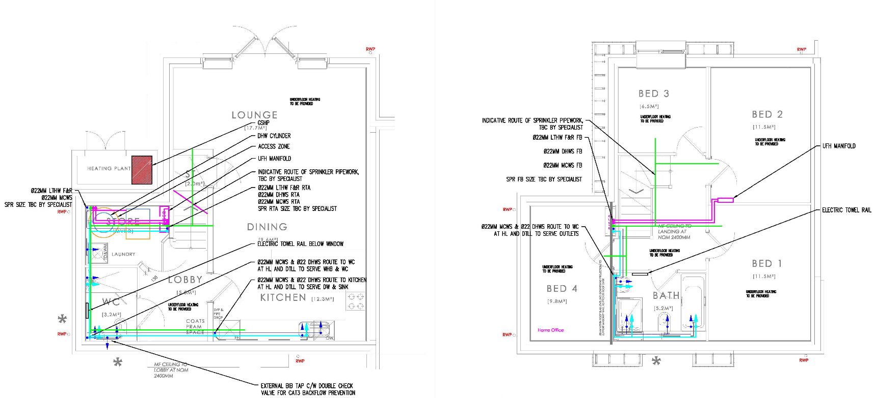
Figure 22: Parc Hadau House Type 3 Services Drawings
Photo credit: Hoare Lea, 2021

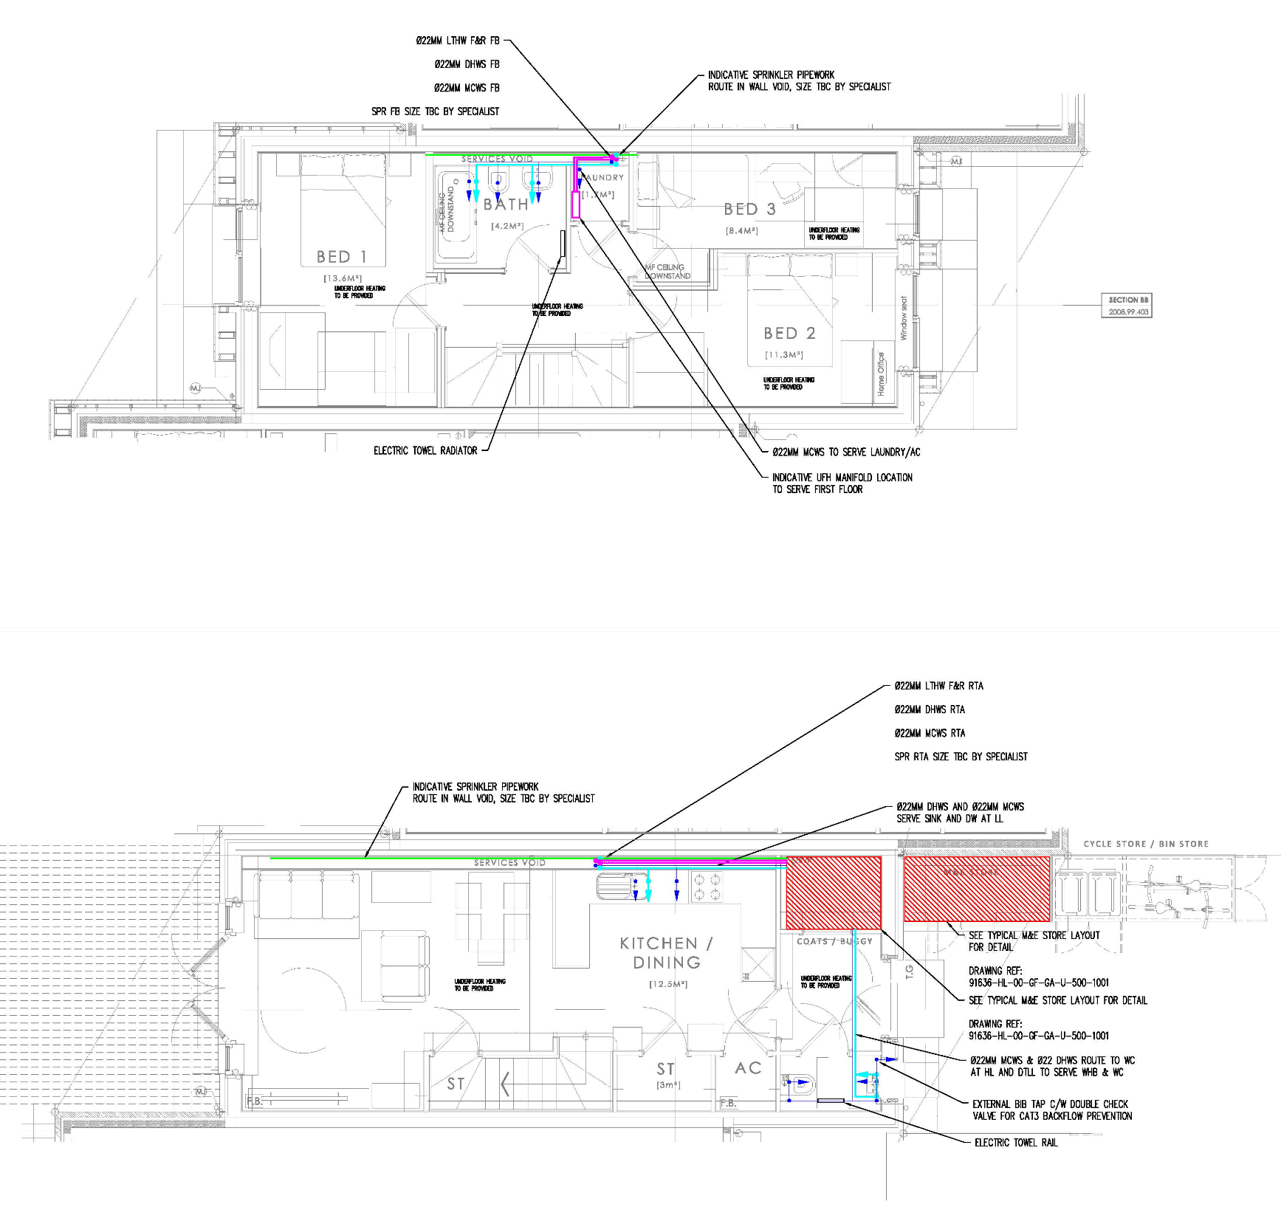
Figure 23: Parc Hadau House Type 4 Services Drawings
Photo credit: Hoare Lea, 2021

Plymouth House uses underfloor heating at the ground floor and radiators at the first floor. It is unclear how this approach affects the heating and energy performance of the development. The space requirements of Appendices A and B are still satisfied by the above choice (see Appendix G).

- The homes` design should maintain dignity of occupants and visitors by making sure that bathrooms and shower rooms, excepting ensuites, do not open directly towards habitable rooms or kitchens.

The Floorplan Drawing of Aber Llwchwr House show that the ground floor bathroom opens towards the lobby and does not affect the dignity of the occupants. The first floor has only en suite bathrooms (see Figures 17 and 18).

The Tender Drawings of the House Types of Parc Hadau show that they are no ensuites. Additionally, the existing bathrooms open towards lobbies at the Ground Floors and First Floors respectively (see Figures 8 to 16).

The floorplan drawings of Plymouth House show that none of the bathrooms open towards habitable rooms, except for the master bedroom ensuite (see Figure 7).

- Providing enough and suitable space to allow for home offices and working from home.

The Ground Floor Drawing of Aber Llwchwr House shows that the home has a library, which can be used as a home office (see Figure 17).

The plans of Parc Hadau show that there is sufficient space to have a home office in the living rooms of the House Types. Furthermore, in House Types 2, 3, and 4, if a bedroom is not needed, it can be converted into a home office (see Figures 8 to 16).

The Plymouth House offers a study at the ground floor which can be used for working from home. If more space is needed, one bedroom can be converted if it`s not used (see Figure 7).

- Allow for an open-plan layout by not using load bearing internal walls.

The floor plans of Aber Llwchwr House show that this home is open plan and can be adapted to changes (see Figures 17 and 18).

As mentioned above, the homes of Parc Hadau have the structure in the exterior walls` envelope to allow for an open space plan inside, which makes the homes adaptable to the changes in preference (UK Green Building Council, 2022).

A section drawing shows that Plymouth House has a load bearing internal wall at the ground floor. This might raise issues if the home needs adapting (see Figure 24).
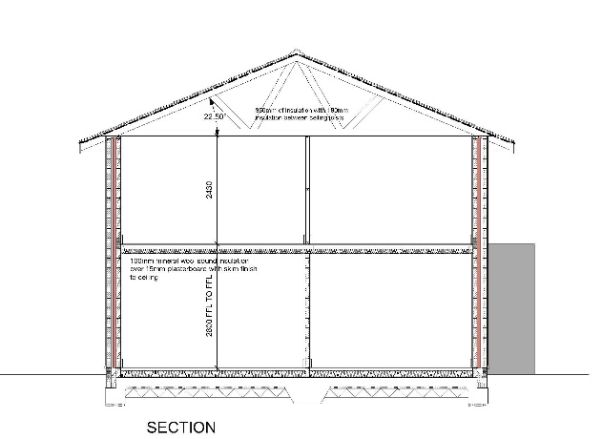
Figure 24: Plymouth House Section
Photo credit: George and Co., 2020

- In 1 bedroom homes, consider allowing space for overnight stay.

Aber Llwchwr House is a 4 bedroom home and makes this point nonapplicable (see Figures 17 and 18).

The development of Park Hadau does not have 1 bedroom homes, and such, this point becomes nonapplicable (see Figures 8 to 16).

In line with the above, the design of Plymouth House makes this point invalid (see Figure 7).

- Considering using MMC techniques and innovation that maximise flexibility for future adaptations would allow the homes to accommodate the occupant`s needs over the building`s/occupant`s lifetime.
- Broadband connectivity or wireless internet connectivity should be available in every home:
- It should be considered to install in the homes, networks that offer a choice of internet service providers.
- If internet connectivity is not yet available, infrastructure should be provided for future installation of internet service throughout the site and homes.

All homes have internet connectivity according to floorplans, bills of quantities and building reg notes (see Figures 19 to 22) (see Appendices G and H).

3) Homes should be safe and secure.

This means that:
- The development`s design should fully comply with “Secure by Design” (SBD) Gold Standard, which can be found in online at https://www.securedbydesign.com/.
- Developments with mixed tenure, not fully controlled by the housing provider must at least achieve the Security Standard elements of SBD.
- Functional kitchens and bathrooms decrease the risk of accidents.

The floorplans of Aber Llwchwr House show a functional kitchen built around the client`s needs. Excepting the ground floor bathroom, which does not have a shower, all the other bathrooms offer the necessary facilities (see Figures 17 and 18).

The tender drawings of the house types in Parc Hadau show that the kitchens offer space for the minimum required kitchenware. The bathrooms offer all the required amenities, except for the ground floor bathrooms in House Type 1 and House Type 4, where they don’t have shower provisions (see Figures 8 to 16).

Floorplans of Plymouth House show that the development satisfies the occupiers reasonably expected needs, when it comes to the kitchen and bathrooms, excepting the ground floor bathroom, which doesn’t have a shower (see Figure 7).

- Design of the stairs should minimise accidents, avoid creating inconvenience by giving enough room for installation of a stair lift in the future and allow moving furniture between floors.

Aber Llwchwr House has relatively easy to use stairs, and their width of 1094 mm allow for future installation of a stair lift which only needs 850mm (Stair Lifts Experts, 2022) (see Figure 17).

The tender drawings of the House Types in Parc Hadau show that the stairs are relatively easy to use as well, and with a width between 985 and 1043 mm they allow for the installation of a stair lift which requires a stair width of around 850mm (Stair Lifts Experts, 2022) (see Figures 8, 10, 12, 15).

The Building Regulations note of Plymouth House, shows that with a width of 900mm, the stairs allow for the installation of a stair lift, where the minimum requirement is 850mm (Stair Lifts Experts, 2022) (see Appendix G).

- Homes should have enough and conveniently located socket outlets.

Looking at the floorplans of the Aber Llwchwr House, there appears to be sufficient provision of socket outlets. This could potentially be because it is a bespoke design that was made around a specific client`s needs (see Figures 17 and 18).

Due to the unavailability of information for Parc Hadau and Plymouth House, it is impossible to accurately determine if the developments satisfy this point.

- Easy to maintain private gardens should be provided for family homes. These gardens should allow for small children to play in, be easy to use and of sufficient dimensions. It should also be considered the provision of private or communal amenity spaces for flats.

The site plan of Aber Llwchwr House shows a fenced garden which is safe for children to use. The garden is accessible directly from the site entrance or from the house via the back doors. The garden looks easy to maintain as it is composed of grass and shrubs, but easy maintenance is a relative term (see Figure 19).

The site layout base drawing Revision B shows that each house of Parc Hadau is provided with a garden. These gardens provide a safe area for children to play in and are easily accessible from the homes via the provided double doors at ground floor, in each House Type. The providing drawings show that the gardens are made from soil and grass. In theory, these would be easy to maintain, but easy maintenance is a relative term, and it depends on the possibilities of the occupants. Additionally, the development provides a communal garden as well as a community building (see Figure 25).
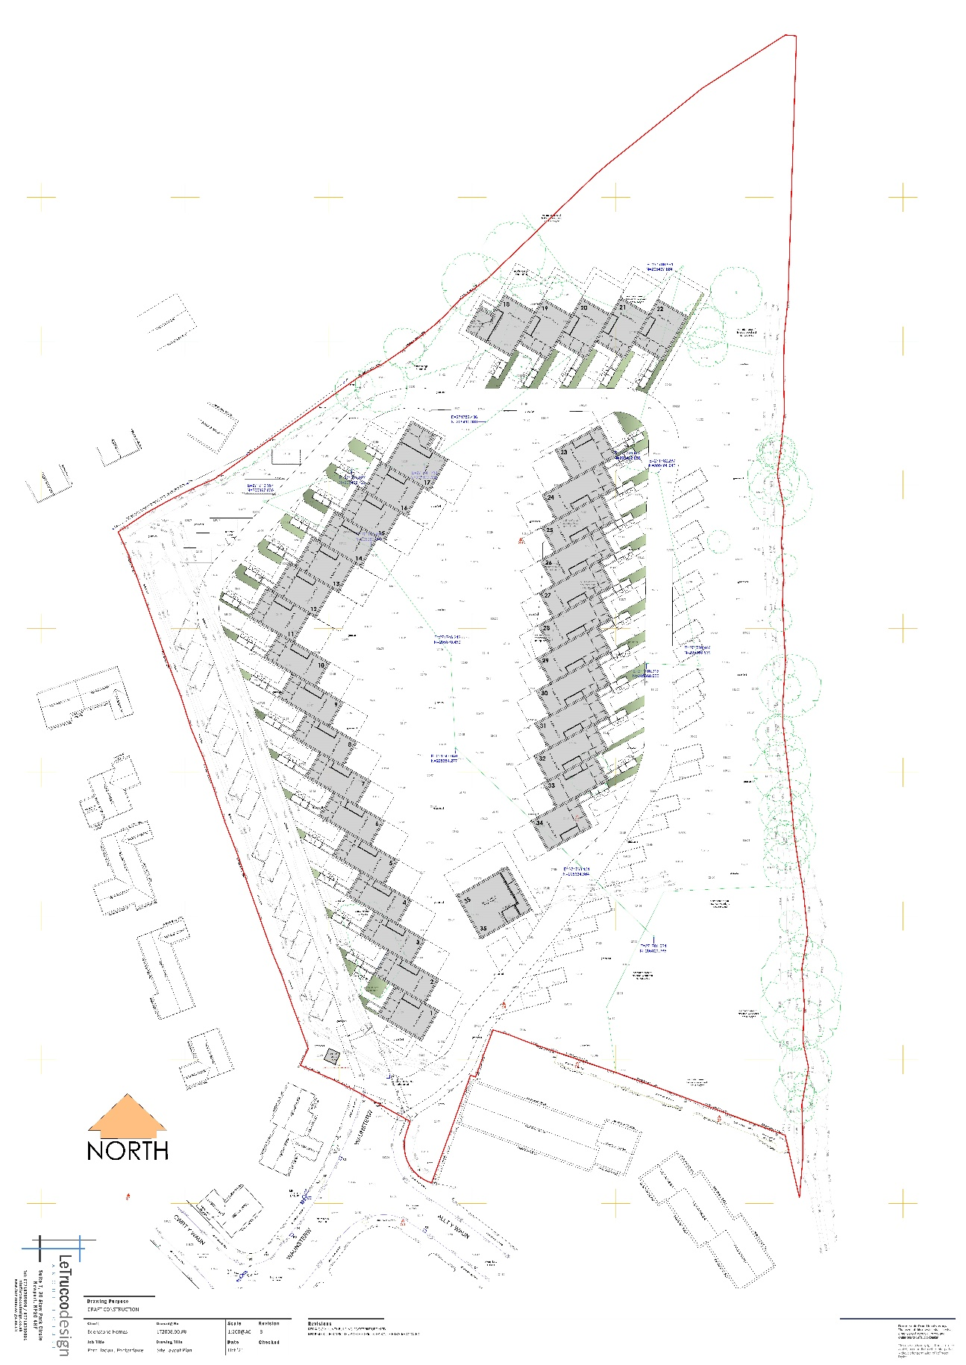
Figure 25: Parc Hadau site layout base drawing Revision B
Photo credit: LeTruccodesign Architecture, 2021

Plymouth House offers safe, enclosed gardens in which children can play. Ease of maintaining the gardens is again a relative term (see Figure 5).

- Provision of car parking spaces should be easily accessible, reflect the location and be spacious enough to accommodate the anticipated levels of car ownership.

As stated before, Aber Llwchwr House provides a total parking space for four cars (see Appendix F).

The site layout base drawing B and tender drawings of the House Types in Parc Hadau show that each house has parking space for one car (see Figures 25 and 8, 10, 12, 15)

The development of Plymouth House offers two parking spaces per house (see Figure 5).

- Wired carbon monoxide detectors should be present in any home. These detectors should have a battery back-up power supply.

There is no information available on provision of carbon monoxide detectors for the selected case studies.

- Going further that the mandatory fire safety requirements, the fire detection system should equip the kitchen with a heat detector and alarm. All these devices must have a tamper proof stand-by supply that is designed to last for the lifetime of the fitting.

None of the selected case studies offer information that can be checked to see if this point is satisfied.

Conclusion

Doing a quick analysis to check how much the case studies satisfy the selected quality requirements, using the available sources of information, Parc Hadau leads with 57 points, closely followed by Aber Llwchwr House with 56.5 points, while Plymouth House scored 29.5 points.

The used scoring method was simple, where 1 point was awarded for each satisfied requirement, while 0.5 points were awarded if the case studies only partially satisfy the markers.

It must be noted that these scores do not offer the full picture of the quality of design for the case studies and these figures can change if more information is made available, or if an evaluation of the home`s performance is made over time.

A cost analysis of the pricing /m² of the above ground materials, building and labour costs for the case studies can answer the question: “Is it affordable to build good quality housing in Wales?”

Aber Llwchwr House is a highly bespoke designed home with a total gross internal area (GIA) if approximately 380 m². With an above ground cost of £500,000 , it comes to a cost/m² of £1,425/m².

The Parc Hadau development has 35 homes and a community building with a total GIA of 3286.72 m². For this case study, the total GIA was found by calculating the GIA of each house type and of the community building and multiplying that GIA by the number of homes on site. With an initial cost assessment of £7,814,635, which excludes groundworks and site clearance, the cost/m² is £2,377/m² .

Due to the unavailability of pricing for Plymouth House, it`s difficult to calculate the cost of the development. Using an online calculator, the pricing of Plymouth House would be around £1200/m² .
Looking at the case studies and the provided information, it can be concluded that it is affordable to build good quality homes in Wales. There is a price difference of £952/m² between Parc Hadau and Aber Llwchwr House, but both developments had similar scores when challenged against TAN12 – Design and the 2021 Welsh Development Quality Requirements. Also, there is a price difference of only £225/m² between Aber Llwchwr House and Plymouth House (which scored much lower).

As stated earlier in the interviews, good design determines the pricing and quality of a development.

It should be noted that there are gaps in the available information, and that this research paper does not present the whole scope of how good these case studies are from a design point of view. A long-term review of the performance of the case studies could change the above results, so these findings might not be definitive.

Bibliography: Published Works

Darkin Architects, 2022. Aber Llwchwr, Carmarthenshire.
Available at: https://www.darkinarchitects.com/new-homes/aber-llwchwr-carmarthenshire
[Accessed 28 March 2022].

Design Commission for Wales, 2019. Parc Hadau, Pontardawe - IHP (May 19).
Available at: http://dcfw.org/parc-hadau-pontardawe-ihp-may-19/
[Accessed 03 February 2022].

Oxford University Press, 2022. Oxford Learner`s Dictionaries.
Available at: https://www.oxfordlearnersdictionaries.com/definition/american_english/bespoke#:~:text=adjective-,adjective,bespoke%20software%20synonym%20tailor%2Dmade
[Accessed 18 January 2022].

RIBA, 2021. RIBA Plan of Work.
Available at: https://www.architecture.com/knowledge-and-resources/resources-landing-page/riba-plan-of-work#available-resources
[Accessed 16 October 2021].

Southampton City Council, 2022. Sustainable Drainage Systems (SuDS).
Available at: https://www.southampton.gov.uk/environmental-issues/flood-risk-management/suds/
[Accessed 07 February 2022].

Stair Lifts Experts, 2022. Narrow Stairlifts for a Slim Staircase - Your Options.
Available at: https://www.stairliftexperts.co.uk/stairlifts-for-a-narrow-staircase/
[Accessed 10 March 2022].
Sutton, A., 2020. Ground zero for new homes.
Available at: https://whq.org.uk/the-magazine/issue/118/ground-zero-for-new-homes/
[Accessed 13 January 2022].

Ty Predn/ Feliden Fowles, 2016. GUIDANCE Technical advice note (TAN) 12: design.
Available at: https://gov.wales/technical-advice-note-tan-12-design
[Accessed 03 March 2022].

UK Green Building Council, 2022. Case Study: Parc Hadau.
Available at: https://www.ukgbc.org/solutions/case-study-parc-hadau/
[Accessed 22 March 2022].

UNESCO, 2021. Sustainable Development.
Available at: https://en.unesco.org/themes/education-sustainable-development/what-is-esd/sd
[Accessed 17 November 2021].

Welsh Government, 2021. Guidance: Development quality requirements for housing associations and local authorities: 2021.
Available at: https://gov.wales/development-quality-requirements-housing-associations-and-local-authorities-2021
[Accessed 05 March 2022].

Bibliography: Unpublished Works

Darkin Architects, 2015. Project Brief for Aber Llwchwr House
Darkin Architects, 2016. Design and Access Statement for Aber Llwchwr House
Darkin Architects, 2018. Bill of quantities for Aber Llwchwr House
George and Co., 2019. Building regulations note for Plymouth House

Appendix A: Space Requirements from Welsh Development Quality Requirements 2021 design requirements

Homes should be of sufficient size to meet the needs of occupants, have a convenient layout for everyday living and have adequate circulation space.
Space requirements will be met where:
• The dwelling provides the Gross Internal (floor) Area (GIA) and built-in storage area set out in Appendix B.
• Accessibility requirements will be satisfied by designing dwellings to meet the Lifetime Homes Standards as published by the Joseph Rowntree Foundation.

http://www.lifetimehomes.org.uk/pages/revised-design-criteria.html
• Homes are provided with adequate facilities for clothes washing, drying and a dedicated airing cupboard containing an appropriate source of heat.
• A dwelling with two or more bed spaces has at least one double (or twin) bedroom.
• Critical room dimensions meet intended purposes, in particular; o A single bedroom must have a floor area of at least 6.5m2 and must be at least 2.1m wide.
o A double or twin bedroom must have a floor area of at least 11.5m2.
o One double (or twin bedroom) must be at least 2.75m wide and every other double (or twin) bedroom must be at least 2.55m wide.

• The minimum floor to ceiling height is 2.3m for at least 75% of the GIA.
• Gross Internal (floor) Area (GIA) is measured to the internal finished surfaces of main containing walls on each floor, including private staircases, internal partitions, flues and ducts; it excludes external dustbin enclosures or stores, any porch open to the air or enclosed.
• The measurement of floor area of common access flats excludes the area of the communal stairs and circulation space.
• The measurement of floor areas of individual ground floor external access flats includes the area occupied by the staircase and entrance hall necessary to gain access to the first floor flat. The areas of the ground floor and upper floor flats (walk-up) shall be averaged in order to make comparisons against the minimum floor areas shown above.
• Space for mechanical and electrical installations should be provided in addition to the above general storage areas.
• The areas in the table are based on single or two storey homes and it is recognised that larger homes and homes over two storeys will have a proportionate increase in area.
Source: Welsh Government (2021)
Appendix B: Space Requirements from Welsh Development Quality Requirements 2021 for gross internal area

Appendix BFloor AreasHomeDesignation | HomeType | Gross Internal(floor)Area (GIA) m2 | General Storage m2(included in GIA)
7P4B | 2 Storey House | 114 | 3
6P4B | 2 Storey House | 110 | 3
5P3B | 2 Storey House | 93 | 2.5
4P3B | 2 Storey House | 88 | 2.5
4P2B | 2 Storey House | 83 | 2.5
3P2B | 2 Storey House | 74 | 2
3P2B | Bungalow | 58 | 2
3P2B | Flat–Walk up | 65 | 2
3P2B | Flat–Common access | 58 | 2
2P1B | Flat–Walk up | 53 | 1.5
2P1B | Flat–Common access | 50 | 1.5

Provided that designs do not compromise the quality of homes intended to be delivered by this standard, a reduction of up to 5% of the above GIA may be applied
Source: Welsh Government (2021)

Appendix C: Interview questions for architects and their responses

The questionnaire was created in Microsoft Word, and was sent in 2021, by email, to a targeted list of named, Chartered Architects, who are all members of ARB.

The questions were devised by the author of this dissertation:

- a) In your opinion, what sets apart a bespoke design from standardisation?
b) And to what lengths should architects go in the detailed design process?
- There is a general perception that “good design” or “bespoke design” is expensive. Do you agree with this? And how can we debunk this myth?
- Is it possible to create an affordable bespoke design and how can we persuade clients this is possible?
- How do you choose materials and what are their most important qualities? Aesthetics, performance, price or a balance between these?
- How can we justify our costs /fees to a client for architectural services over less experienced/qualified designers?
- What is the impact of a bespoke design when it comes to the level of satisfaction of a client? Do you request feedback from clients post occupancy, and how does this influence future projects?
- When advising clients on a new domestic project, what costs per Sq, M would you generally advise?
- What are the risks involved in bespoke design over standardisation and how would this impact your design process?

The interviews were distributed via email as a Microsoft Word attachment for the respondent to edit and answer in their own time.

All responses were received via email and analysed as part of the dissertation.
Interview responses from David Darkin:
1.a. A bespoke design directly meets the needs of an individual client; Standardisation creates opportunity to bring great design to all.
1.b. Architects can only work to their appointment agreement in a commercial setting. This may otherwise differ in public sector e.g. council or housing association.
2. Good design is considered expensive because the role of the architect is little understood and undervalued.
3. It very much depends on the context of the scenario discussed and affordable is very much a relative term.
4. I’m a great believe in the Mies Van der Rohe philosophy of ‘Form follows function’. All aspects are considered but are driven by performance and cost requirements.
5. I don’t. If the client’s priority is price, then I’m not the architect for them. I do compete with other architects, but not with unqualified designers. The types of clients that don’t value our services are not the type of client I’m looking for.
6. Personalisation is critical in domestic projects, but less so in commercially driven projects. We request feedback after all projects and feedback is reviewed and opportunities for improvement are implemented wherever identified.
7. I don’t provide cost advice. I always instruct clients to seek advice from a quantity surveyor if they require advice on costings
8. Primarily, it’s a commercial risk as bespoke design can involve multiple iterations that limit the profitability of the project.

Interview responses from Peter Wray:
- a) The design of the building is generated from the clients brief and considered as a whole. b) This should always be a response to the client and their needs but always needs to be sufficient to convey the design intention clearly to the contractor
- It certainly can be but often a client’s brief can be bet by a careful use of standard and simple building techniques
- Yes, it is all about a very careful development of the brief and looking at a creative and efficient way of meeting that need.
- It is a balance, but the balance is shaped by the needs of the client. Some clients will favour appearance over cost. But usually, it is a pragmatic mix of all three
- At the end of the process of design with an architect the client should have a building that is exactly tailored to their needs which also meets all regulatory standards and responds to wider societal concerns such as inclusion, disability and climate.
- I don't formally request feedback, but most clients do give feedback. The client should always be satisfied if the development of the brief and design has been done within the context of a healthy client/architect relationship with good communication
- I normally start with a guide price of £1000 - £1500m², but this does need revising in the current climate.
- Every bespoke design is a one off and there are no prototypes. Therefore, reusing elements from previous designs and studying the designs of other architects in the architectural press is very important to learn from others mistakes and successes.

Interview response from Nic Downs:

- Standardisation is cost driven, mass produced, a few sizes fit all copybook architecture. Bespoke design is tailored to suit the client’s requirements, design to a detailed brief with the client’s current and future needs taken into account. It brings to the fore experience in bespoke design to hopefully avoid errors.
- Good/bespoke design is often designed to a budget, established by the client. Poor design is where costs are allowed to escalate beyond agreed amounts
- Architects usually provide well designed and well detailed solutions which inevitably cost more than standard product from the volume housebuilders, however, these costs mask the poor quality control and lack of longevity in many estates in the UK. Clients who are happy to pay extra for perceived quality cars by Audi/Mercedes need to reconcile this attitude with their most expensive asset. We are actually carrying out a significant number of redesigns of poorly laid out homes from the volume housebuilders, as clients realise that their homes are far from ideal and fail to meet modern living requirements
- Performance has to come first as this is a major requisite, price second but increasingly clients are also concerned with the look of their property.
- It’s all about a service, if clients are looking for the cheapest solution they’ll find someone to draw up the plans and they can then deal with the builders, if they want professionalism, quality construction form an approved list of trusted contractors and someone to oversee the process this all comes at a price but will hopefully remove a lot of the stress from the process.
- That’s a good question that we don’t do enough of. We do however, stick with the client and continue to sort minor teething issues post completion.
- For a good quality scheme we’d usually start at £2000/sqm, sometimes going up to as high as £3600/sqm
- The risks on any project are usually in the ground and unforeseen issues with existing construction, if it is a refurbishment or extension. The other hot topic, risk wise, is escalating prices for building supplies.

Interview response from Nick Hill:

Dear Ionut

You have formulated some interesting questions which, I’m sorry to say, I don’t have time to answer individually. However, regarding the central issue – ‘the myth that bespoke designs are expensive’ – my own experience would tend to support that claim rather than debunk it.

Bespoke designs needn’t require expensive materials, nor even complicated assembly methods, but in my experience they do require a couple of other things that will still likely increase the cost:

Firstly they will almost certainly require more design time than standard solutions. If all is as it should be, more design time = more cost to the client!

Secondly, to succeed bespoke designs need more, or better, management during construction and this will usually lead to an increased cost. More control is required to avoid things going wrong e.g. last minute changes of specification (‘we couldn’t get exactly the right materials in time so we had to switch to something that looks similar’) might be OK for standardised designs but will often lead to problems for anything bespoke. Whatever the contract says, problems on site have a knack of finding their way back to the client’s pocket, at least in part.

I hope that helps. Good luck with your dissertation!

Kind regards

Nick
Appendix D: Interview questions for Plymouth House and transcript

The questionnaire was created in Microsoft Word, and was sent, by email, to the members of the design team.
The questions were devised by the author of this dissertation.

Plymouth House Interview
- What is the project brief? What does the client need?
- Were there any modifications needed to the design after presenting it to the client?
- What was the initially agreed budget?
- Where there any Local Development Plan conditions that you had to abide by? (Styling of the house, appearance, materials for the façade, etc.)
- What was the reasoning for choosing the materials? Price vs. performance, building regulations, LDP, sustainability, quality of materials?
- Does the design of the house consider the “TAN 12 – Design” or the “Welsh Development Quality Requirements 2021” documents?

The responses were received via an online interview and analysed as part of this dissertation.
An online video conversation took place between Steven George, Gavin Traylor and the author in March 2022. Below are relevant extracts from the transcript.

Steven George
If I, if I use Plymouth house as my, as my starter for all these things. So I think number one what is the project brief from? What does the client needs?
Uhm, it's pretty simple. The client comes to us and says right, I want to develop this this land that I got into the side of my garden and how many houses can I get on there and what can I build?
So we do a very loose feasibility and sketch to say, well, you know, we were able to get a…
Maybe like a 9x8 floor plate here and there and then then this one becomes a different one or two smaller, maybe a 3 bed and those kind of things. So we kind of move in shapes around the plot until we get to almost like a like a kind of like a feasible.
Uh [unintelligible]… but I think that kind of leads onto to number 2. And every time I'm talking to clients about this, this always comes up before we end up quoting.
Because I think what? What we… what we say is… we'll go off and use fresh eyes and come up with a design, me and [name redacted] will argue for a while in the office.
Uhm, until we think this is the design and we present it, then we go: the design! and they'll go: I love it or I hate it, you know, it's very much that point. So you kind of, the first… the first design is always… I always find that the line in the sand to see whether you are kind of meeting the brief but not just that the brief is the brief but sometimes the claims got different aspirations and their mind…
…of what the brief is, so you could be thinking about two separate things, even though it's black and white,… no I want 4 houses, 4 bedrooms, one with an ensuite, dressing room, utility room, those kind of things.
And yeah, so once, once as presented we either do very minor amendments on it or it's a complete redesign.
Until we get to a point to where the client is happy or…
…uhm, where we are happy as well? I know that sounds daft, you've got to still enjoy the design process as well.
Steven George
But then going back on your Word, you would less… number 3 is the. Yeah, the budgets are always agreed, we always say…
We always, we always say in the weeks before we need an honest conversation about budget like just us designing a £2 million extension when the budget is only £60,000, you know there's, there's no way impacting that design back down to there, it's just physically impossible.
Item 5 is the reasoning for choosing material. But the short answer is I don't know. I think it's very it's very much [inaudible]…
…reasoning so you know that there's like, we've been doing an extension in [redacted] on a stone…
…the reasoning for it isn't price versus performance, or building regulations or sustainability or… it is quality of materials, but I think it's the quality of the design against what is theirs…
Gavin Traylor
Yeah, it's probably. It's probably a mix of all that, wasn't it?
Steven George
Yes.
Steven George
But it's very much… see the Plymouth House one was easy for us because everything in our area was render…
…so the terrace was rendered the Plymouth House itself... 'cause it's a big, big…
…Uhm, high end masters house.
Uh, which isn't listed strangely? UM, that's render. So everything around was render, so we didn't really wanna push and say: are we are doing timber clad buildings because we can…
Ionut Rosu
Yeah, you wanted to follow the design language of that area.
Gavin Traylor
Yeah, I mean you can look at it at a tech… on a technical point of view and you can always look at materials from a technical point of view. How are they going to work? Are they suitable for that location? And you'll always have your technical head on, but it's not necessarily a technical question that either.
Gavin Traylor
Yeah. So there's a whole host of other things as Steve was saying to think about which could be related to, you know…The location... it could be related to... You know, the client might want a certain thing, you know…
Steven George (Guest)
Weather permitted.
Gavin Traylor
You know it's a whole host of things really.
Gavin Traylor
Question number 6, Steve?
Steven George
Does the design of the house considered TAN 12-Design?
I can't… it… it's always one of those documents that you kind of look back in hindsight because you…
This is the … It probably is… It probably highlights the naivety of our studio, because we just go in, and design, and we get wrapped up into it, and then, you know, we look at these documents 'cause it…
Gavin Traylor
Yeah, but is, is that the right? I'd…. I'd push this back to, you know, it. Who is what is TAN 12 aimed at? Who is it aimed at? Is it aimed at architects?
Ionut Rosu
It's involved… TAN 12, if I'm not mistaken its…
…. designers, if I'm not mistaken…
Gavin Traylor
Uh-huh. OK all designers. So being trained to understand many of the principles in there… I know…you know, teaching how to [inaudible] is the term that…
…That Steve used…
There are a lot of things in there which you learn through being a designer, being an architect, going through those processes anyway. You may not record it. And so as Steve pointed out, many, many architects do record that, and they use that as the… to demonstrating over the process throughout...
…But a lot of it is, you know, in your head and you kind of filter that out…. So I know you said you go back to this, Steve.. what I would probably say is: a lot of the principles are general principles.
Steven George
Yeah, we, we, I mean we've seen other peoples` design and access statement this TAN 12 almost serves as a copy and paste of “Wales Design”…
…And I think it's only the case of when we're having difficulty with a contemporary design that we would go back and use… a… I don't want to…[redacted] work as an example, 'cause it's in there or…
…We have done all this inclusive design. We looked at the historic environment, the urban regeneration, the public of… the realm…
…And this is where we've got to. So we've used that document in our…
As Gavin said… as part of our training.

Appendix E: Aber Llwchwr House Project Brief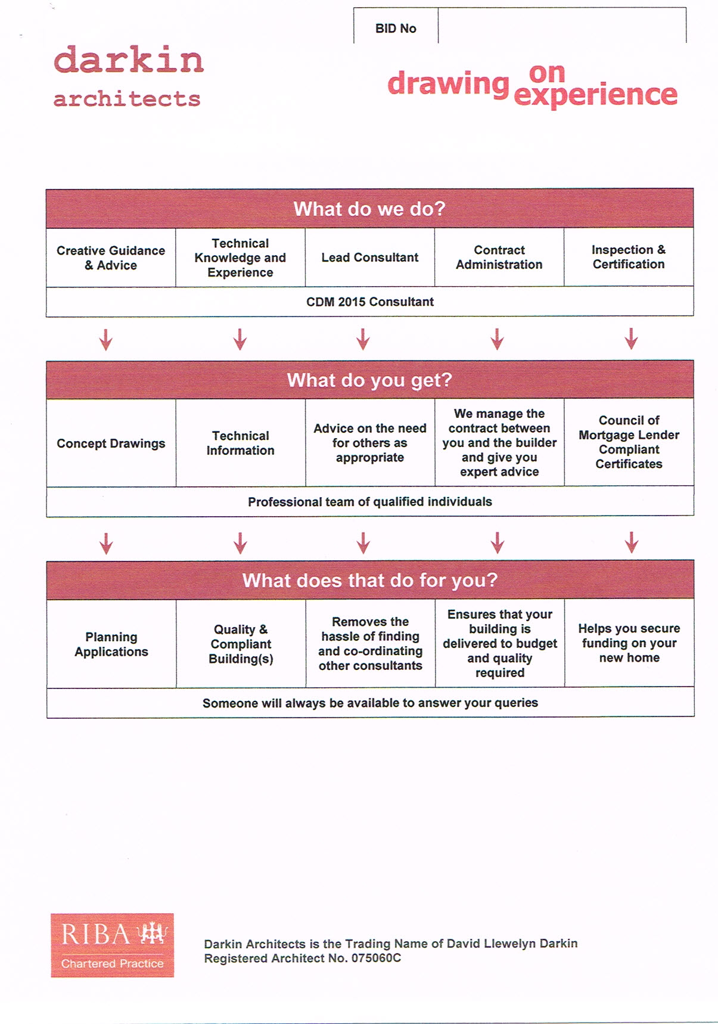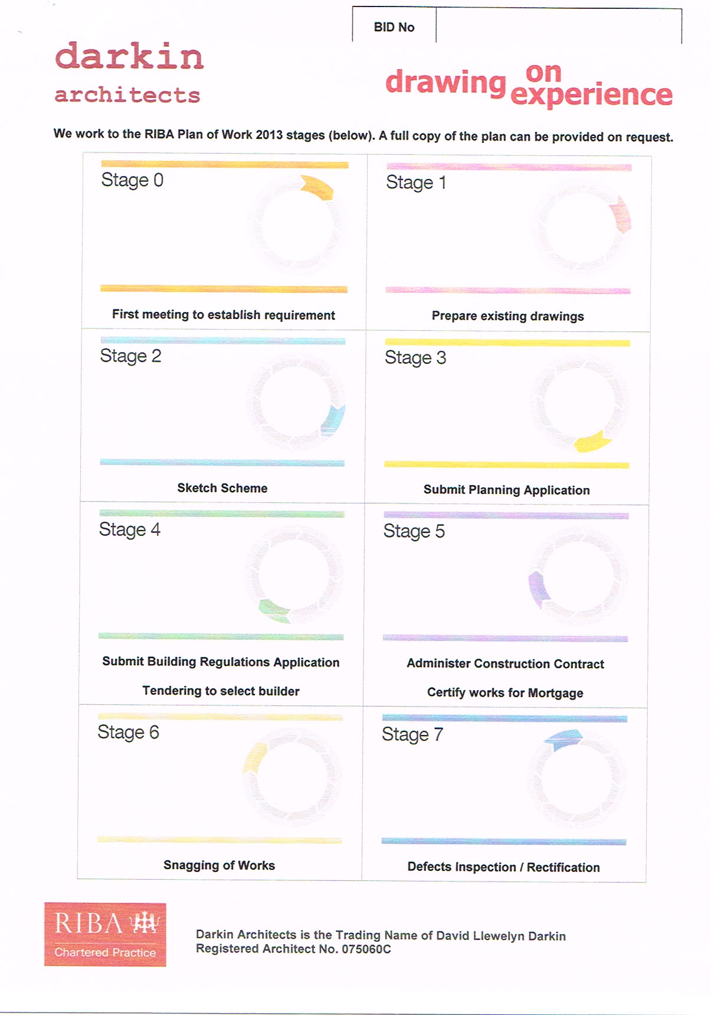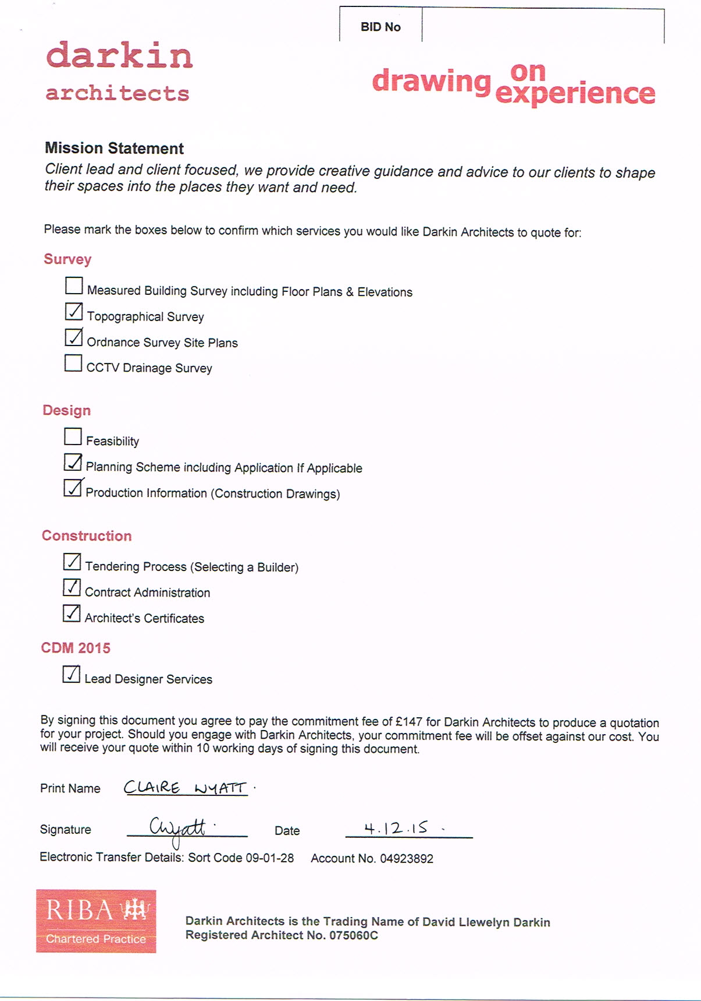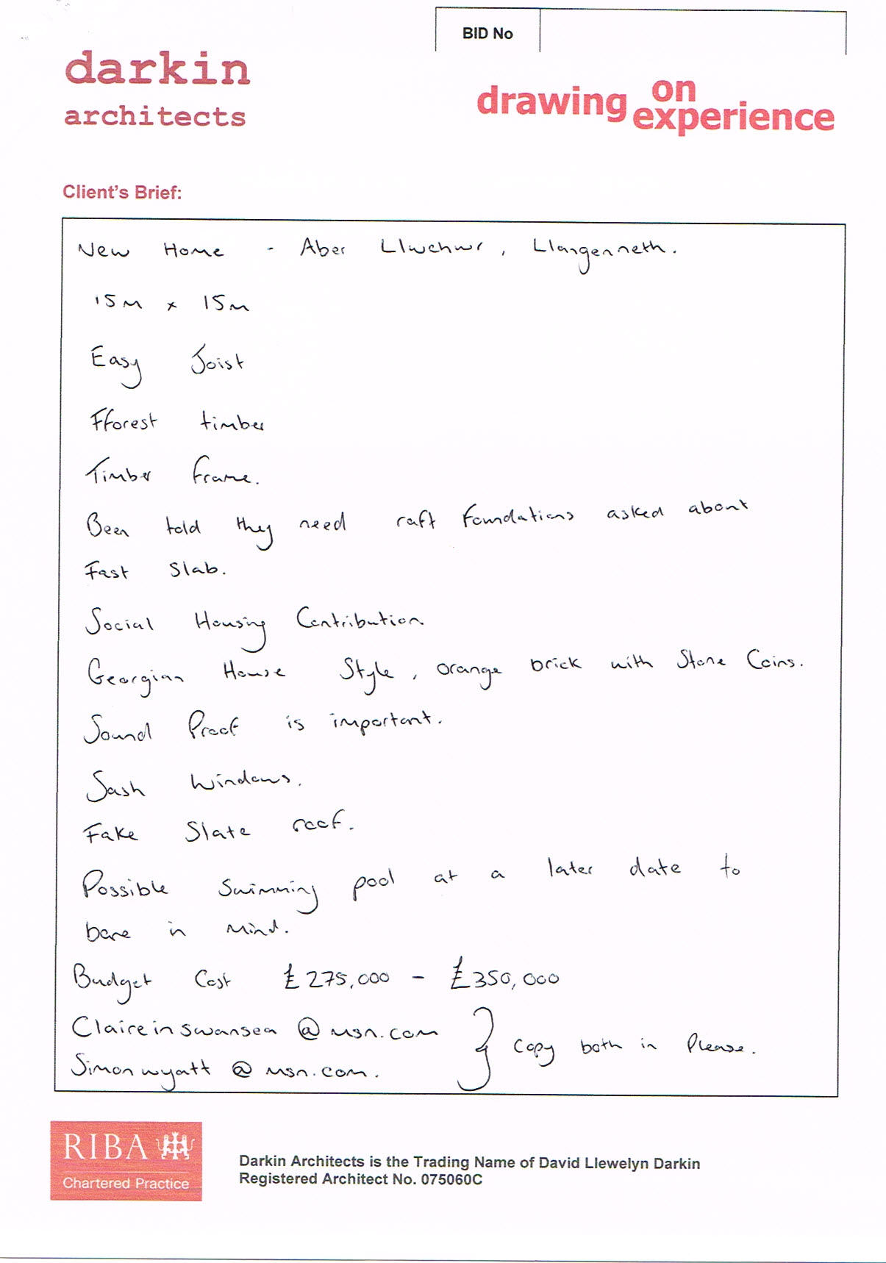
New Home at Plot C, Aber Llwchwr, Llanegennech, Llanelli, SA14 8AH

I write further to your meeting with Robert last week. I would be delighted to work on this project – it is very much my mainstream work. Thank you for inviting me to submit my offer and observations to you.

As well as my own experience as a qualified architect of many years, I operate a Chartered Architects Practice, established over 19 years. This ensures we operate a stringent code of ethics, audits, disciplinary procedures and the requirement to carry professional Indemnity Insurance. Darkin Architects therefore offers you a professional service based on a rich experience with a fully supported customer service.

This letter seeks to set out my understanding of your ‘Brief’ (what you are looking for) and to provide my initial considered response, along with fees and other key remarks. This is to enable ongoing realistic and productive discussions and is not ‘set in concrete’.

The ‘Brief’
My understanding of your requirements is as follows:
- New Home as discussed as approximately shown in your sketch plans below

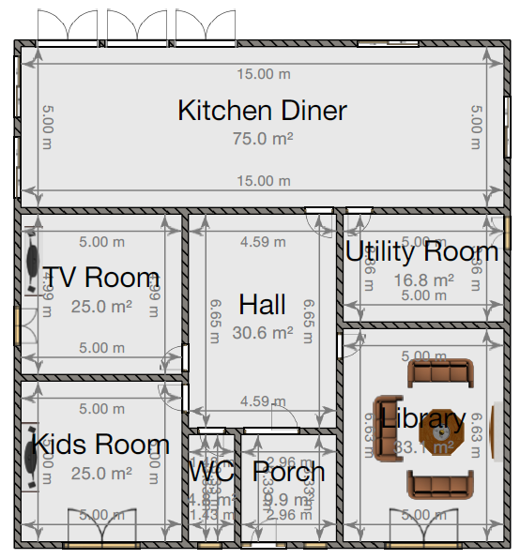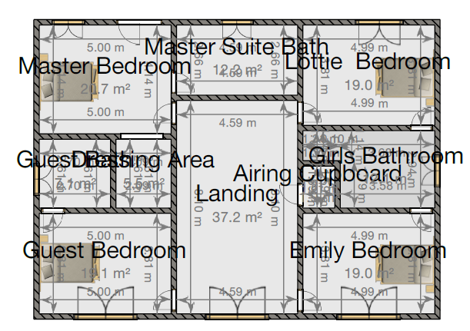

Sprinkler Systems
As discussed, sprinkler systems will be a requirement from 1st January 2016. If you are able to confirm our appointment before 21.12.2015, we will submit a Building Notice Application in time to meet the deadline and avoid the requirement.

NOTE: As the processing of the application would be by a Third Party i.e. Local Authority or Private Building Control, we are not able to guarantee the processing of the application to avoid the requirement for sprinklers.

Planning Policy
Our research indicates that your property is situated within the development limits of Llangennech as indicated in the development plan extract below. Your site is specifically associated with Policy GA2 / H51 which promotes the development of new homes.

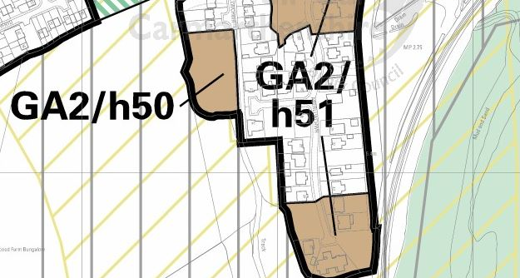

Planning History
Our research shows that there are numerous applications within recent years for one-off developments in the area. Key points raised during planning applications related to the provision of appropriate parking facilities and the external appearance of the properties. Properties have been required to be of a traditional appearance, although due to the numerous variations of design in the area, there appears to be a certain amount of flexibility within these requirements.

The map below indicates planning history for the area. Areas shaded in pink illustrate properties subject to planning applications since 2007. This clearly shows that there have been no applications for your plot since 2007 and therefore, it is our professional opinion that there is no existing planning. However, a brief overview of the planning history and policies of the site, together with our own experience working on this site, suggests that it should be possible to gain planning consent for a dwelling here.

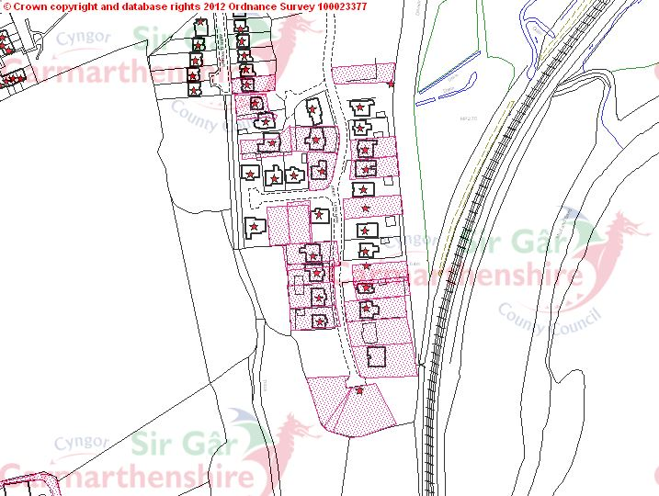

CDM 2015 (Health & Safety)
As discussed, you will have responsibilities under health and safety law which I will go into in more detail if you are happy with this proposal. One of the key duties is to appoint a ‘lead designer’ responsible for coordinating design information relating to health and safety including the preparation of a health and safety file. Unless you instruct me otherwise, my fees are inclusive of this service as noted below.

Building Costs
I can give a rough estimate of building costs and will endeavour to work within your budget. However, as discussed at our meeting, calculating building costs is complicated and an entire profession in itself. My estimates will have quite a wide margin of error and so if you wish to be more certain about costs, I recommend that you hire a Quantity Surveyor to help you.

Flood Risk
Our research indicates that your property is not in an area considered at risk of flooding by Natural Resources Wales (Formerly the Environment Agency).

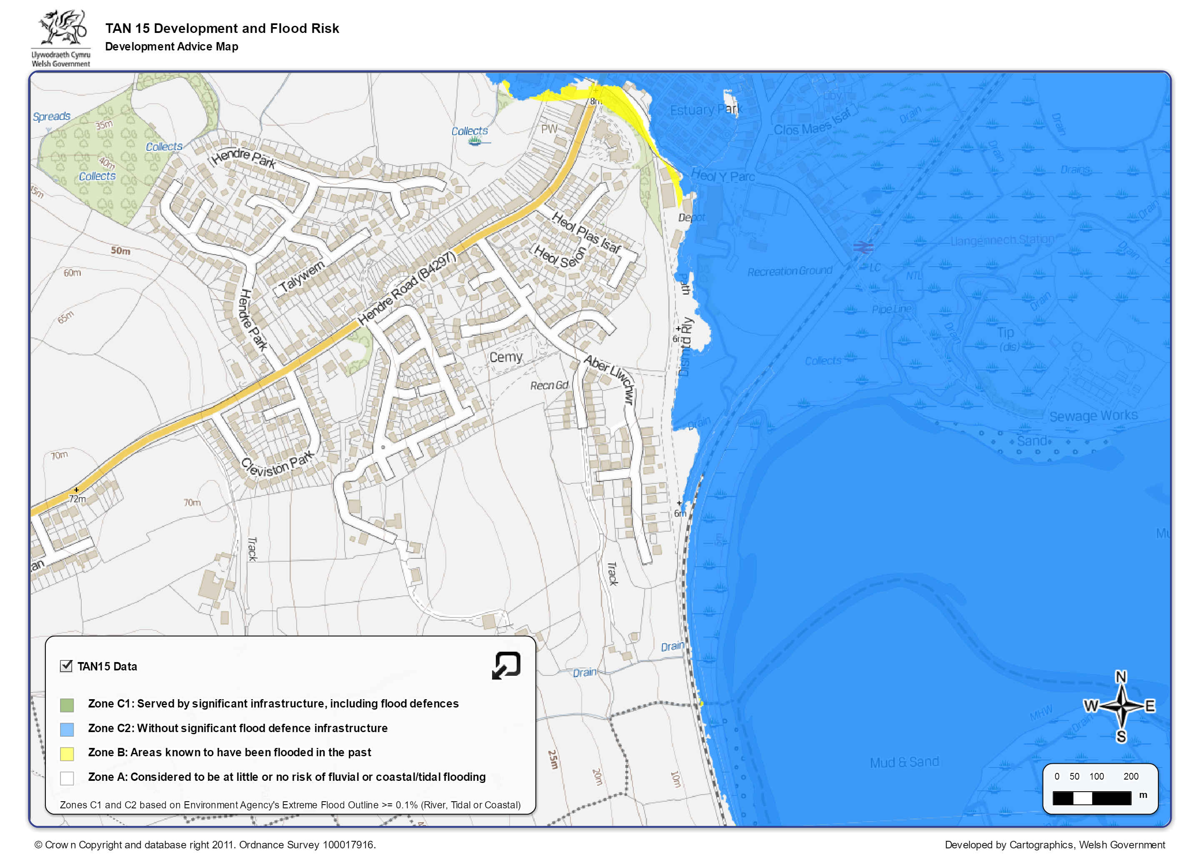

Work stages/fees

The attached ‘RIBA 2013 Plan of Work’ sets out the key stages against which I set out my input and fees, with approximate timescales to delivery also indicated:

A. Topographical Survey
Accurate measured drawings are required as the basis for the design. You will be provided with accurate drawings as pdf’s and also as ‘.dwg files’ which other professional use as the standard CAD file language. Please note that this service does not have to be provided by us and we are happy to work with drawings from suitably qualified surveyors, providing they meet with a minimum professional standard.

My stage fee will be £865 plus expenses 2 Weeks

B. Sketch Design, Stages 0-2
Designing a floor plan examining all possible realistic options for the design and tweaking them until a favoured option emerges; working that up to a level suitable for submitting a Pre Application Enquiry.

My stage fee will be £940 plus expenses 4 Weeks

C. Planning, Stage 3
Developed design to planning level including submission of planning application.

My fee for this stage will be £959 plus expenses 1 Week

Note: Application Process should take 5-10 weeks

D. Technical Design, Stage 4
This is the most labour intensive stage and includes full specification, schedules, and working drawings and will be the basis of a building regulations application.

My fee for this stage will be £2,784 plus expenses 4 Weeks

E. Tendering for Contractors, Stage 4
Preparing and administrating a tendering process in line with the CIB code of Practice for the selection of principal contractors.

My fee for this stage will be £552 plus expenses

F. Contract Administration, Stage 5, 6, 7
Preparing and administrating an appropriate construction contract between you and the builder, includes inspections and certification for contract purposes as well as certification for mortgage purposes in line with the Council of Mortgage Lenders Standard Format.

My estimated fee for this stage will be £2,885 plus expenses

Please note that the fee for contract administration can go up or down as it is charged on an hourly rate. I estimate 29 hours of work at £92 per hour + office administrative support.

All fees are exclusive of normal disbursements plus any local authority building control fees, other consultants fees, the Ordnance Survey extract required for planning, which is around £40 for an on-line download in .dwg format. I would invoice on a stage-by-stage basis. The practice is not VAT registered.

You may need, at different stages, the services of other consultants such as an Energy Consultant, Structural Engineer and Civil Engineer. You may also need to procure reports and searches. We will advise you on the need for other consultants and reports and can obtain these for you at the best price available for a 10% administration charge.

If the scope of the project should change in a significant way from that set out above I reserve the right to amend the offer accordingly. The appointment would be under the ‘RIBA SFA: Conditions of Appointment 2010 (2012 revised), a copy of which can be made available by the practice, or can be viewed on-line.

I trust that this covers all the initial areas of enquiry and discussion, and look forward to your response. Please feel free to raise as many questions as you have, as clarity and good communication are essential in any successful project and I don’t want to assume anything that would undermine good progress.

If appointed the use of the phone and email for ongoing communications and setting aside key dates and stages to meet together normally works well and saves time for all. I welcome calls and emails and please never hesitate to contact me for clarity or discussion etc.

If I receive instructions to proceed with any design or investigations work after receipt of this letter my proposal shall be deemed to be acceptable and instructed on the basis of the terms set out above. This appointment would be formalised as soon as possible in a signed contract, and until then this letter and any further qualifying correspondence would act as the basis of our contract until that point.

Kind regards,



David Llewelyn Darkin
BA[Hons] Dip.Arch Dip.Prac RIBA

01554 778 730
david@darkinarchitects.com

Below is an outline to the RIBA Plan of Work 2013 stages. A full copy of the plan can be provided on request.

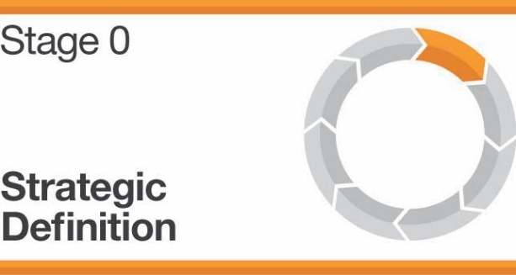 | 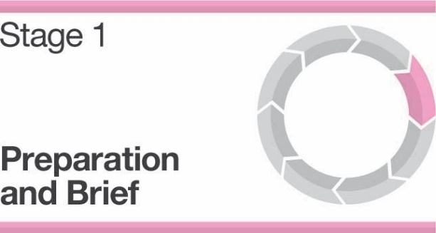
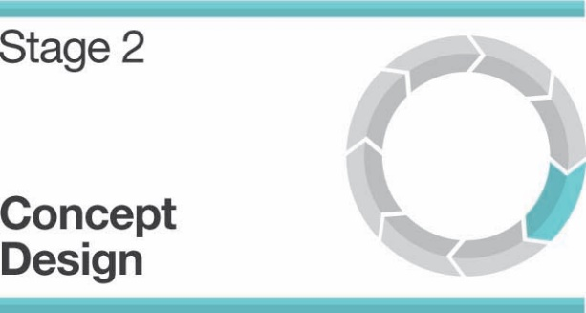 | 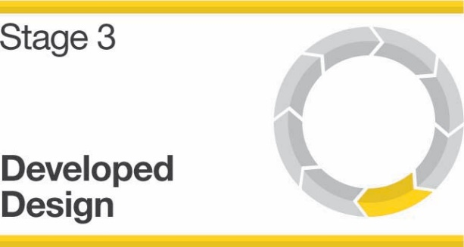
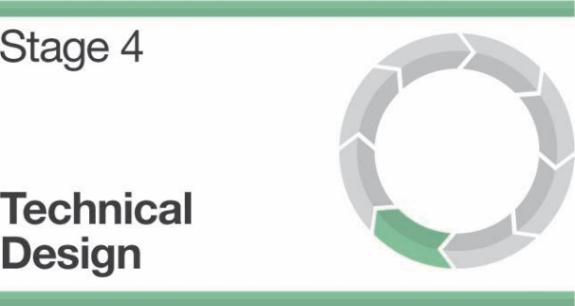 | 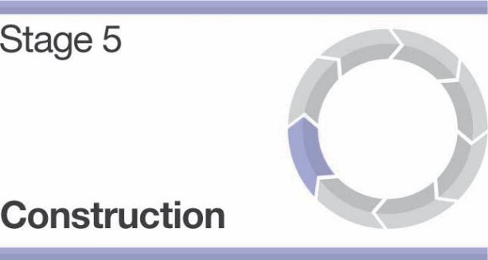
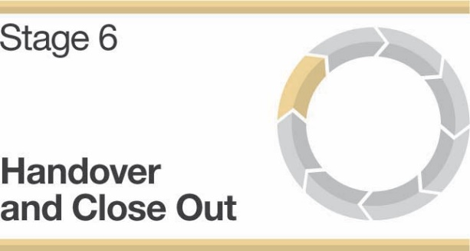 | 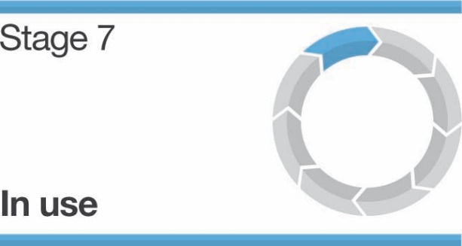
Source: Darkin Architects (2015)

Appendix F: Design and Access Statement for Aber Llwchwr House

New Home
Plot C, Aber Llwchwr, Llangennech, Llanelli, SA14 8AH
Design & Access Statement


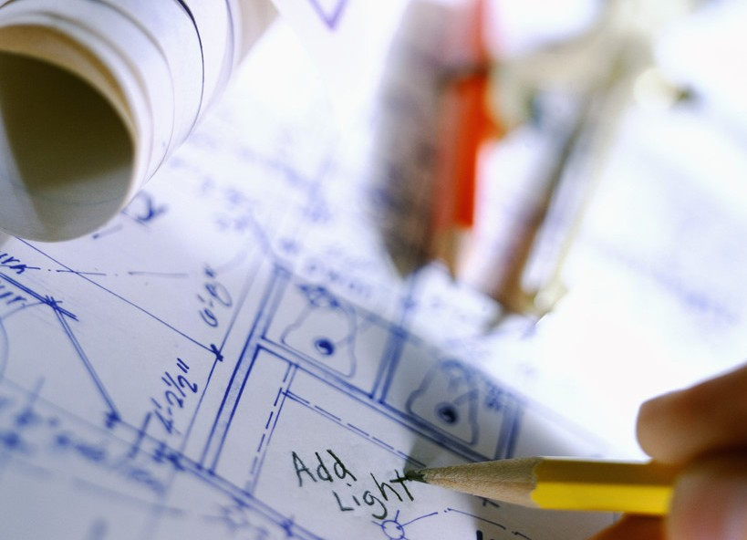
NH278 19 February 2016

Contents
- Introduction 3
- Project Brief + Design Brief 3
- Access & Inclusive Design 4
CAR PARKING 4
BUS STOPS 4
RAILWAY STATIONS 4
ROUTES TO ENTRANCE 4
ENTRANCE 4
DÉCOR 4
- Character 4
Amount 6
Layout 6
Scale 6
Appearance 7
Landscaping 9
- Community Safety, Social Context & Economy 9
- Environmental Sustainability 9
ENERGY & CO₂ 10
WATER 10
MATERIALS 10
CLIMATE RESISTANCE 10
FLOOD RISK 11
ECOLOGY / BIODIVERSITY 11
- Movement 11
- Policy Context 11
- Conclusion 12
- Bibliography 12

Introduction
  - This design and access statement has been prepared to accompany and support a planning application for a new home at Plot C, Aber Llwchwr, Llangennech, Llanelli, SA14 8AH. This Design & Access Statement has been prepared following the guidance set out in Technical Advice Note 12: Design (2014).
  - This statement describes our client's proposal and explains the design philosophy and approach taken in the formulation of the scheme. It will be concluded that our client's proposal should receive support and be granted planning consent.
  - Design is defined in Planning Policy Wales (PPW) as: “the relationship between all elements of the natural and built environment. To create sustainable development, design must go beyond aesthetics and include the social, environmental and economic aspects of the development, including its construction, operation and management, and its relationship to its surroundings.”
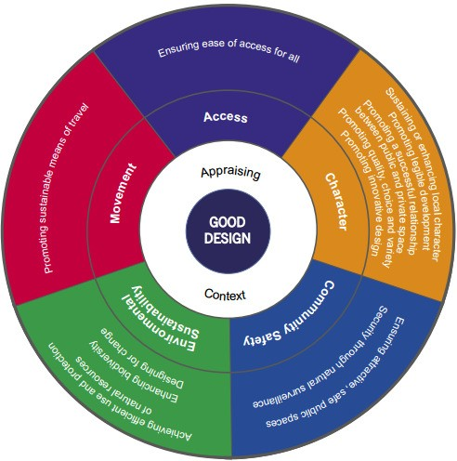
  - The project has been designed with the ‘Objectives of good design’ in mind as illustrated in TAN12. As shown right.
  - The project was initiated by establishing design objectives, based upon a context appraisal. A site analysis has been attached which graphically represents the analysis. The analysis illustrates that the proposed development is suitably located.
  - Principal Design Objectives
    - Holistic Design Approach
    - Integrated inclusive design
    - Integrated Sustainable design for community and the environment
    - Integrate with local architecture matching the vernacular
    - Provide rich heritage for the future

Project Brief + Design Brief
  - The client’s project brief was to design a new family home.
  - Following on from the context appraisal and consultations with others, the project brief was evolved into the following design brief:
    - Four bedroom home
    - Master bedroom to include en-suite and walk in wardrobe

    - Balcony to master bedroom
  - This allowed us to formulate the following design objectives:
    - Proposed dwelling should be of traditional design aesthetic to integrate with prevailing local architecture

Access & Inclusive Design
  - PPW emphasises that: “Good design is also inclusive design. The principles of inclusive design are that it places people at the heart of the design process, acknowledges diversity and difference, offers choice where a single design solution cannot accommodate all users, provides for flexibility in use, and, provides buildings and environments that are convenient and enjoyable to use for everyone.”
  - Inclusive design has been considered from the outset of the development process and this section is intended to demonstrate that this building has been designed with an inclusive agenda in mind. This will ensure that reasonable provision has been made to ensure that all users will have equal and convenient access.

CAR PARKING
  - 2 parking spaces located in garage.
  - 2 parking spaces located on drive.

BUS STOPS
  - The nearest bus stop is Located on Hendre Road, The development is not sufficient in magnitude to impact on public transport decisions.

RAILWAY STATIONS
  - The nearest train station is Pontarddulais Train Station. The development is not sufficient in magnitude to impact on public transport decisions.

ROUTES TO ENTRANCE
  - Pedestrian access is provided from Aber Llwchwr. The development proposes to enhance this access point. New hard landscaping between the public footpath/highway and the access points to the proposal will provide access assistance to persons with mobility impairments.

ENTRANCE
  - The proposal is to have a door half glass half solid with lever handle and have weighting <20N

DÉCOR
  - The colour scheme will include colour contrast between walls, floors, door and ironmongery to assist usage by persons with visual impairment.

Character
  - The principles of good design have been applied to this development and this section is intended to demonstrate that the proposal is of good design and appropriate to the area.

  - This section will demonstrate that the proposal sustains and enhances local character and promotes legible development.
  - Below are some photographs of the site and surrounding area

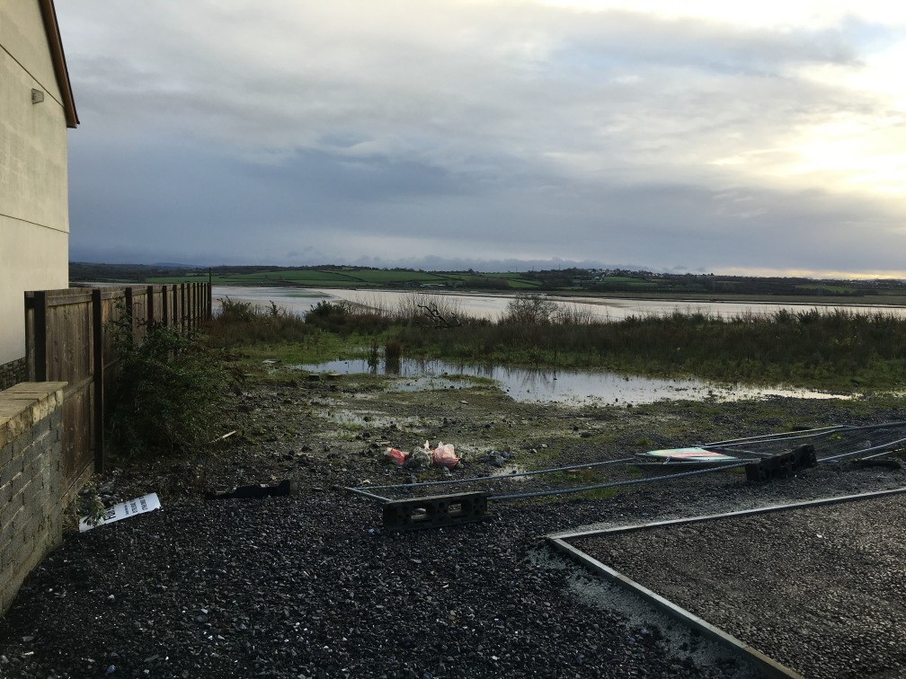 | 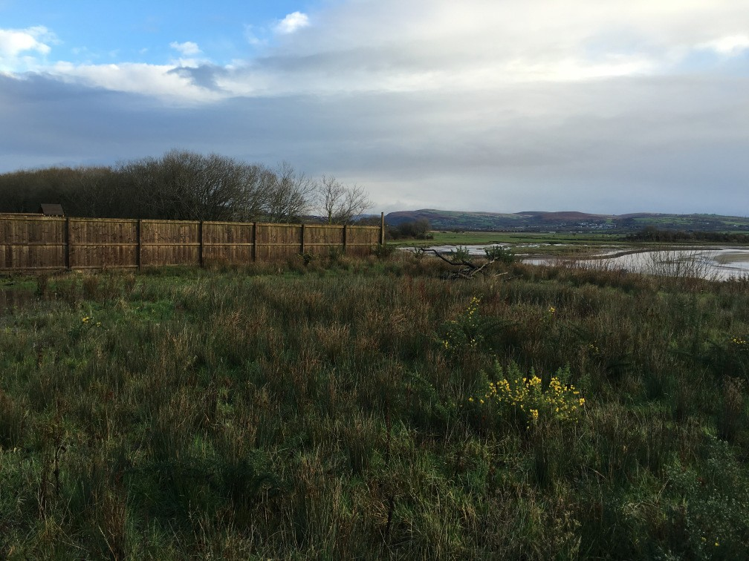
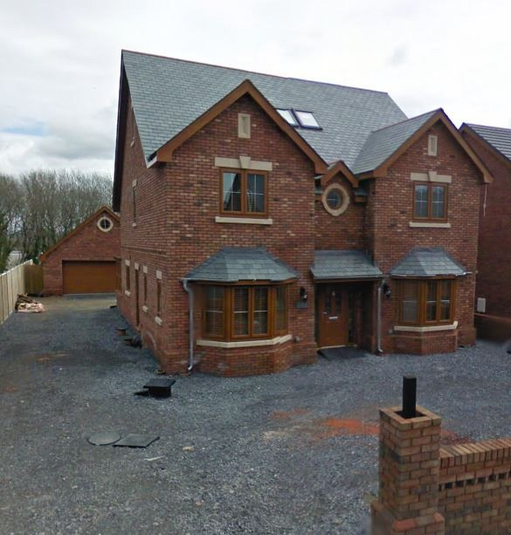 | 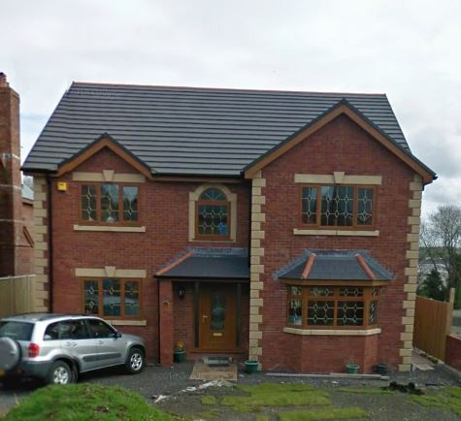

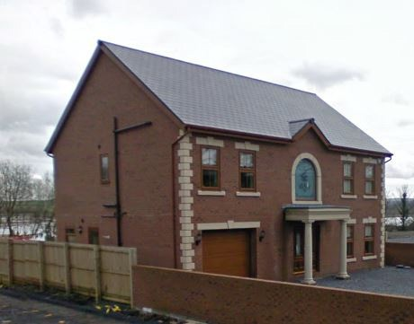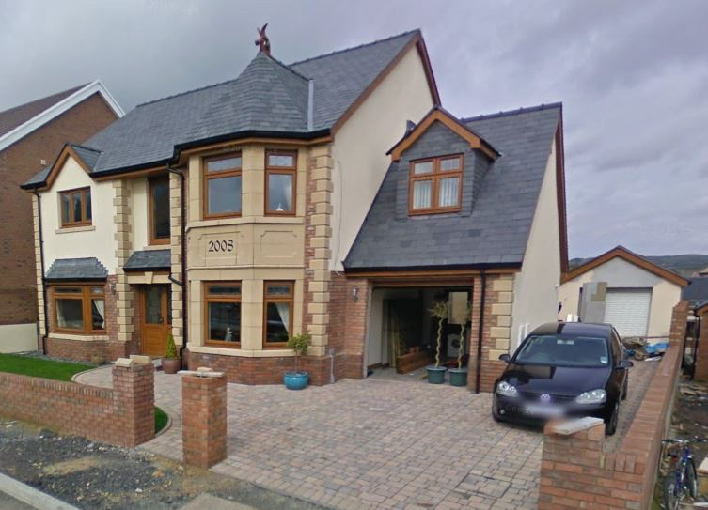

  - The Topography Landscape Character of the site is flat as illustrated in the photographs above.
  - The historic development pattern is most clearly illustrated on the site analysis and clear shows a pattern of domestic development along the frontage of Aber Llwchwr. This has been continued with this proposal which in fills an unused plot of land.

Amount
  - The site currently contains no development
  - The proposed development is to be a New Home with a footprint of 240m² and a single storey garage with a footprint of 42m²
  - The amount of development proposed will be an efficient use of land that will safeguard quality of life in the area

Layout
  - In addition, the proposed layout will promote a clear relationship between public and private space
  - The location of the proposal follows the natural pattern of development
  - The layout makes the development integrate with it’s surroundings and appropriately links in with adjacent spaces

Scale
  - The scale of development is appropriate to the surroundings, with the massing of the proposal appropriately contributing to the existing hierarchy of the site to reinforce local character
  - The height and mass of the proposal will not affect privacy or daylight in relation to adjacent land uses / buildings
  - The scale of proposal will interact with the public realm in appropriate way such that it will not decrease community safety
  - The height of the proposal is to be similar to that of its immediate neighbors
  - The footprint is to be similar to that of most dwellings in the area and significantly smaller to that of its immediate neighbors

Approx Max Total Height | 1m | Approx Min Total Height | 9m
Approx Max Height to Eaves | 6m | Approx Min Height to Eaves | 5.2m
Approx Max Length | 17m | Approx Min Length | 16m
Approx Max Width | 16m | Approx Min Width | 15m

Appearance
  - All materials are to be similar to that of the nearby buildings and appropriate to the area i.e.

PROPOSED
Element | Description | Example
Roof | Rivius Antique Slate | 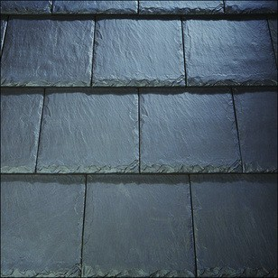
Walls | Leicestershire Russet Mixture Brick | 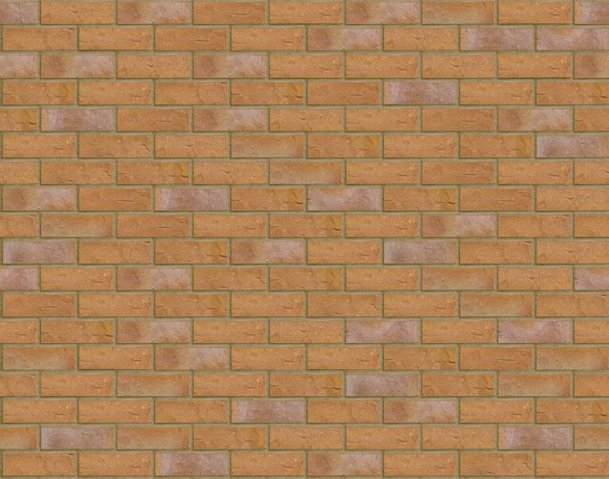
Windows | White Upvc Sash. Windows to have stone heads and cills | 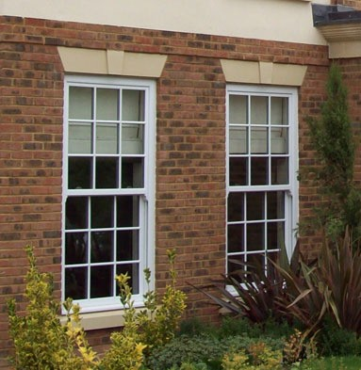

Doors | White Upvc | 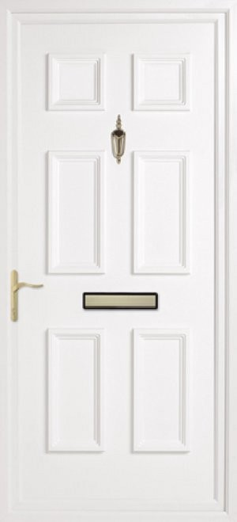
Rainwater Goods | White Upvc | 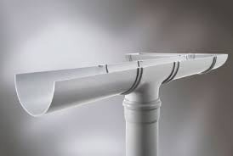
Boundary Treatments | Brick Dwarf Wall with Railings & Close Boarded Timber Fence | 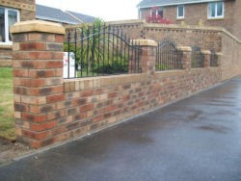
 |  | 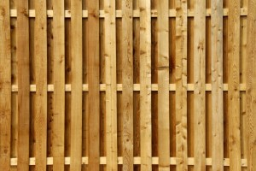

  - The fenestration will also be designed to match the local vernacular with a similar scale of windows.

Landscaping
  - The landscaping has been designed such that it will enhance/protect the amenities of the site and the area in which it is situated
  - Existing shrubs on the site will be mostly retained
  - Rainwater to soakaways
  - Hard landscaping reduced to reduce surface water creation.

Community Safety, Social Context & Economy
  - Access for emergency vehicles is sufficient
  - As the property will be occupied there will be an increased presence on the site which increases community safety
  - The application will seek to maximise natural surveillance as a fundamental means of discouraging intrusion
  - The property will be deigned to reduce risks from criminal activities e.g. minimising superfluous access points to the proposal
  - Shrub planting immediately adjacent to footpaths, or in other areas requiring a high-level of natural surveillance, should have a natural growth height of no more than 1 metre
  - Use of lighter foliage planting will provide visual permeability whilst still offering amenity screening. Trees will be located so as not to become aids to climbing over boundaries or onto buildings
  - The layout will seek to provide clear distinction between private, semi-private and public spaces
  - Additional boundaries between properties will provide additional security
  - There are no trees or other obstructions at the entrance, as such the entrance to the site is clear and there is more than sufficient visibility of the road for exiting vehicles
  - As a result of the proposal, natural surveillance will be increased

Environmental Sustainability
  - In this section attention is drawn to relevant policies to be considered during the design of the proposal as well as possible avenues of environmental sustainability to be considered.
  - Planning Policy Wales 2014 (PPW) sets out the Welsh Government’s land use policy in respect of ‘Promoting sustainability through good design’ and ‘Planning for sustainable buildings’.
  - As noted in TAN12 “Design issues, as influenced through the planning system, should not duplicate the role of Building Regulations. As a general rule, planning relates to the external appearance of a building and its relationship with its context. Building Regulations deal with the technical performance of a building’s structure and services”. Therefore, technical detailing has not been illustrated in great detail in this DAS.

  - The building has been designed with a sustainable agenda in mind from the outset, considering the various aspects of sustainability from the outset such as materials, water, and energy.

ENERGY & CO₂
  - The building will reduce carbon (CO₂) emissions where possible through implementation of the energy hierarchy
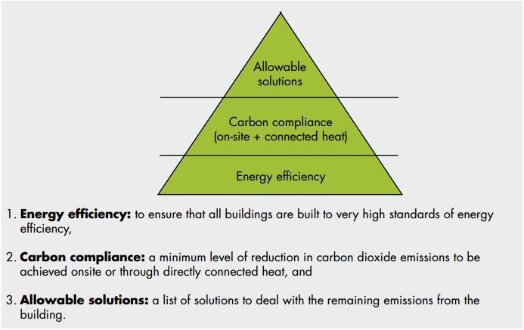
  - The level of carbon reduction expected will be determined by the minimum required by Building Regulations Approved Document Part L
  - The physical envelope of the proposal will be appropriately designed for the climate
  - External drying space for clothes has been provided

WATER
  - Rainwater harvesting systems to be utilised where possible
  - Rainwater to soakaways

MATERIALS
  - Waste materials produced during construction to be minimised.
  - Waste materials produced during construction to be sorted, recycled where practical and responsibly disposed of where not
  - Space to be provided for external storage of both recyclable and non recyclable refuse
  - Materials to be responsibly sourced
  - Materials with a low embodied energy to be used where practical

CLIMATE RESISTANCE
  - Proposal has been proofed to take into account the local climate likely to be experiences over its expected lifetime, e.g. the roof pitch promotes natural movement of snow loads, minimised eaves discourages wind uplift during high winds

FLOOD RISK
  - As indicated in the Flood Map below this site is not at risk of flooding
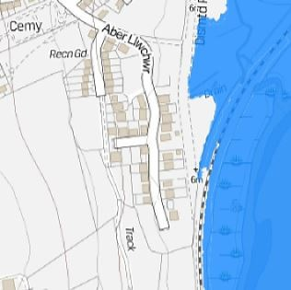

ECOLOGY / BIODIVERSITY
  - The proposed landscaping scheme will maintain/enhance the biodiversity and local environment

Movement
  - Primary pedestrian movement into the site is provided via the fronting road
  - Vehicular movement into the site is provided via the fronting road
  - See Section 4 for details of proposed vehicle parking
  - As previously noted in Sections 4 & 6, sustainable means of travel will be promoted

Policy Context
  - Local Development Plan (LDP) Policy GP1 "Sustainability & High Quality Design”" encourages environmentally sustainable proposals which utilise vacant, underused or previously developed land.
  - Policy GP2 "Development Limits" encourages good quality design which ". . . achieves the aims of the development and ensures its fitness for purpose." Ten strategic objectives are listed which include requirements that proposals will sustain or enhance the local environment in terms of mass and scale, and will be of a suitable design appropriate to its location and utilising materials appropriate to the character of the area.

Conclusion
  - The site utilises an underused area of land, improving the natural surveillance of the area
  - In conclusion it is considered that the proposed development represents a high quality design solution
  - It is respectfully requested, therefore, that both Officers and Members of the County Council look favourably on this proposal and grant planning permission

Bibliography
- Maps taken from http://www.openstreetmap.org © OpenStreetMap contributors, CC-BY-SA
- (2014) Planning Policy Wales
- (2014) Technical Advice Note 12: Design Published by Feliden Fowles, retrieved from wales.gov.uk
- (2010) The Equality Act
- (2014) Building Regulations Approved Document Part L
- Ordanance Survey Maps Downloaded through Promap. Licence No. 100020449
- www.cartoplus.co.uk

Source: Darkin Architects (2016)

Appendix G: Building Regulations Note for Plymouth House

BUILDING REGULATION NOTES (to read in conjunction with the contract specification)
FOUNDATIONS
To be raft foundations to as Engineers design and calculations and to the Building Inspectors approval.
GROUND FLOOR TO MAIN HOUSE
To comprise:-
- 65mm screed
- Underfloor heating
-VCL
- 150mm Celotex FR5000 floor insulation - tape joints with insulating tape - 1200 guage polythene damp proof membrane - Raft foundation.
Damp Proof Membrane taken up walls and lapped with wall DPC to form continuous waterproof barrier.
To have a 'U' value of 0.1 lw/K or better, to comply with the Approved document LIA
EXTERNAL WALLS GROUND FLOOR
325mm cavity wall comprising:- 19mm render finish
- 102mm brickwork to outer leaf
- 50mm cavity
- 75mm Celotex GA4000 insulation
- 100mm blockwork to inner leaf - see section
- 25mm service zone
- plasterboard and 3mm skim
All to have a 'U' value of O. 13Wm2K or better, to comply with the Building Regs 2010,
WINDOW CILLS cills to be pressed aluminum cills to match windows with DPC under cill (as detailed on drawings).
FIRST FLOOR
As SE design and spec .
SOUND
All internal walls and internal first floors to be fully insulated with 100mm ROCKWOOL RW2 insulation inbetween joists and studs.
CEILINGS AND INTERNAL WALLS
1 layer of 12.5mm plasterboard with 3mm skim smooth finish.
WINDOWS AND DOORS
Windows to be VELFAC 200 series windows, with double or triple glazed sealed units, with opening lights as indicated on elevation drawings. Windows frames to be SET AS DETAILED.
Glass to all windows to be low emission 'K' glass or similar approved and to have a whole unit 'U' value of 1.4Wm2K or better and to have a low g factor 0.5 to comply with the Approved document LIA.
All windows to have trickle ventilators in window frame head
Toughened glass to be fixed to all external doors AND WINDOWS.
Installation to be in strict accordance with manufacturers specification. Weatherseal window head, jambs and cill to be Compriband 600.
Doors and windows, to meet the security requirements of British Standards publication PAS 24:2012
FRONT DOOR TO BE A MINIMUM 775mm WIDE
EXTERNAL SLIDING DOORS
Sliding Doors to be as clients requirements, Smart Systems Visoglide Plus profile, with double glazed sealed units, to have a whole unit 'U' value of 1.5Wm2K or better and to have a low g factor 0.5, toughened double glazed units as indicated. All accessories for the correct installation in accordance with the manufacturers specification.
Front door to be softwood timber as elevations, set in hardwood frame. To include Exitex MDS/140 Mobility Inward Door Sill 1m - Aluminium - 19121 low level threshold on DPC.
RAMP TO FRONT ENTRANCE
1 in 12 ramp up to a x 900mm landing. 150mm Concrete Brushed finished, on 100mm compacted Hardcore. Front door to have brick laid as soldier course with low rise 'bump over' threshold by door manufacturer . With a vertical DPC at wall/ramp junction, see detail showing upvc gutter set within concrete ramp.
STAIRCASE
Timber from ground to first floor, to have maximum rise 200mm, maximum going 240mm, clear headroom 2000mm vertically, 900mm wide overall strings set into depth of stud walls, handrail minimum 900mm above flight and a minimum 900mm to landing. Balusters to be formed using solid studwork and skim plaster finish with ss stopbeads at all edges.
ROOF STRUCTURE
Trussed rafters at 600mm maximum centres to BS. 5268 part 3 1985, with the bottom cord capable of taking a uniformly distributed imposed load of 1.5Kn/Msq with galvanised ms plate connectors and 100 x 25mm diagonal and lateral bracing to BS 5268.
All to specialist manufacturer's design.
100 x 50mm wall plate strap fixed to walls using 30 x 5 x 900mm galvanised ms straps at 2000mm centres
End 3 trusses rafters and ceiling ties abutting gable walls stap fixed to masonary using 30 x 5 x 1500mm galvanised ms straps at 2000mm centres. Provide noggins between trusses at strap positions to support straps.
Form storage platform over bottom chord of trusses using 22mm chipboard base on 100 x 50 sw bearers at 400mm centres.
ROOF FINISH - TO PORCH & MAIN HOUSE
Artifical Slate Marley 600mm x 300mm Thrutone Man-Made Fibre Cement Slate - Graphite, all to be laid in accordance with the manufacturers recommendations on 50 x 25mm treated sw battens on sarking felt to BS 747 type F.
Roofing felt to be continuous over ridge, hips and valleys, dressed down into gutter and fixed to top side of softwood roof trusses.
Incorporate 'Cavity tray' over fascia ventilator - OFV25 to give 25mm continuous slot ventilation.
VENTILATION
Natural ventilation opening lights to Habitable rooms, kitchens and toilets to be provided Of at least 1120th of the floor area of the room.
Mechanical ventilation equivalent to 68 litres per second is to be provided to bathroom, 151/s to WC and 60 litres per second to kitchens,.
Vent ducts to incorporate condensation traps and outfall pipework.
To avoid the build up of condensation in the warm roof structure breathable Intello Plus VCL allows venting to inside when conditions require. Trickle vents to be provided to all windows to achieve 8000mmSq background ventilation in habitable rooms.
SPRINKLER SYSTEM
Sprinkler system to be designed and installed by a competent person to comply with Approved Document B in Wales
CONSERVATION OF FUEL AND POWER.
U values as listed above comply with Approved Document LIA in Wales
AIR PRESSURE TESTING.
Air Pressure tightness of 5 and is to be carried out in accordance with The Building Regualtions 2013, Approved Document I-la, Section 2 : Quality of construction and commissioning.
ABOVE GROUND PLUMBING AND DRAINAGE - Employers requirements: Single stack AAV system to be provided and fitted in accordance with the manufacturers recommendations comprising 100mm upvc pipe vented in accordance with part HI of the Building Regulations, 32mm wastes to basins, 40mm wastes to sinks and 100mm outlets to wc pans. 50mm traps to wc pans, 75mm deep seal traps to all other fittings.
Resealing traps to be provided to 32mm wastes exceeding 1500mm in length and 40mm wastes exceeding 3000mm in length. Where visible, white internally, black externally

RAINWATER DISPOSAL- Employers requirements:
Rainwater system and gutters to be min 115mm half round dia as detailed, installed in accordance with the manufacturers recommendations.
BELOW GROUND DRAINAGE - Employers requirements:
Underground drainage to to be OSMA (or similar approved) Upvc drainage system and fittings laid in accordance with the manufacturers recommendations, to BS 4660: 1973.
Foul Drains laid to 1 in 40 max falls. Surface water drains laid to 1 in 80 minimum falls.
Inspection chambers and covers to be Osma 450mm dia. universal inspection chambers including base, shaft and 4D.491 cover and frame or similar approved. All bedded and backfilled to Osma's recommendations.
Manhole with dropshaft to accomodate change in level from site to mains sewer to be provided
Rodding Eyes to be Osma sealed rodding eye and cover ref: 4D 356 or similar approved.
PIPEWORK UNDER THE BUILDING
All pipework under the building to be encased with a minimum of 150mm thick concrete of ST4 strength placed in one operation, to incorporate 18mrn thick compressible expansion board at regular intervals as dictated by pipe joints
WALL PENETRATIONS- Employers requirements:
All drains which pass through walls to have a 600mm long rocker pipe and RC lintols over. Fill gap between around wall penetrations with expanding form.
EXTERNAL GULLIES- Employers requirements:
Provide and lay PVC-U Osma (or similar approved) plain hopper gully (4D.700) connected to universal pipework, laid on a 75mm thick 1 :2:4 square concrete bed. Black backfill around gully with selected material, grating to be set in path 10mm below finished level to aid surface water discharge into prescribed underground drainage. To include trap insert.
SOIL & VENT- Employers requirements:
Stub stacks are to terminate above flood level of cisterns via 4S.304 air admittance valve.
HEAT PRODUCING APPLIANCES - Employers requirements:
Space and Hot Water Heating

To be Worcester Bosch Greenstar condensing boiler to be 90% efficient, and minimum 5" dia flue ducted out to the elevation; with underfloor heating system on the ground floor and rads and the first floor positions and sizes to be as M&E consultant.
Towel rail in bathroom to be plumbed into central heating but have electrical heating element for use in summer.
Heating zones: provide 3 different heating zones: Bed 1, Bed 2 and rest of house with thermostats in each zone.
The whole of the installation to meet the requirements of the current British Standard Code of Practice.
ELECTRICAL INSTALLATIONS- Employers requirements:
Power and Lighting
All light & power fittings to be supplied by MK or similar approved.
All power points to be double switch socket outlets.
All power outlets to be double pole.
The responsibility of design, adequacy and suitability of each system shall be the contractors. All to meet the requirements of Part P, to design, install, inspect and test all electrical work in accordance with BS 7671.

Internet
The houses will have an access point linked by ducting to a network termination point. As Diagrams 1 (a) The access point is on an outside wall and connected by a through-wall duct to the network termination point
Extract Fans.
Extract fans to be fitted as indicated on plan.
HYGIENE - Employers requirements:
The hot water system is to be vented.
HOT WATER LIMITED TO 48 DEGREES
MATERIALS AND WORKMANSHIP
All materials and workmanship are to comply with the relevant and current British Standards, Codes of Practice, current edition of the Building Regulations, and shall be to the approval of the Building Inspector.
Plumbing to comply with BS 5572.
Electrical work to comply with the current edition of the IEE Regulations.
Generally structural timbers to be SW or whitewood C24 grade to BS 4978. TO be C16 where specified by the Engineer.
All softwood to be vacuum pressure impregnated.
Softwood for joinery to BS 1186 part 1, screws to BS 1210, nails to BS 1202.
Carpentry to comply to CP 112.
All brickwork below DPC level to be Class B engineering bricks.
GENERAL.
Do not scale off the drawings.
All heights, levels, sizes and dimensions to be checked on site before any work is put in hand.
Locate existing services/drainage runs prior to construction. Existing services through site to be protected during construction. There is an OH power line on site near entrance follow HSE guidelines for electrical safety at work.
The manufacturers recommendations are to be followed in respect of the installation and fixing of all products and any discrepancies between those recommendations and any other requirements of the specification and/or drawings are to be notified to the architects.

Proposed housing development at Plymouth house, Merthyr Tydfil

Source: Studio George and Co. (2019)
Appendix H: Bill of quantities for Aber Llwchwr House

PLOT C
ABER LLWCHWR, LLANGENNECH,
CARMARTHENSHIRE, SA14 8AH
 | GENERAL SUMMARY
Bill No |  | Page No
1 | PRELIMINARIES | 2 |  |  | 54,910.00
2 | WORK BY OTHERS DIRECTLY EMPLYED BY THE EMPLOYER | 4 |  |  | 92,288.70
3 | MATERIALS PROVIDED BY OR ON BEHALF OF THE EMPLOYER | 6 |  |  | 30,970.59
4 | GROUNDWORKS | 10 |  |  | 23,465.60

5 | INSITU CONCRETE / PRECAST CONCRETE | 14 |  |  | 47,766.60
6 | MASONRY | 22 |  |  | 66,446.50
7 | STRUCTURAL / CARCASSING METAL / TIMBER | 25 |  |  | 5,908.00
8 | CLADDING / COVERING | 27 |  |  | 12,865.00
9 | WATERPROOFING | 29 |  |  | 6,354.00
10 | LININGS / SHEATHING / DRY LINING | 31 |  |  | 16,489.60
11 | WINDOWS / DOORS / STAIRS | 33 |  |  | 5,796.00
12 | SURFACE FINISHES | 36 |  |  | 19,739.20
13 | BUILDING FABRIC SUNDRIES | 40 |  |  | 37,828.04
14 | PAVING / PLANTING / FENCING | 43 |  |  | 39,953.50
15 | DISPOSAL SYSTEMS | 50 |  |  | 8,993.00
16 | MECHANICAL INSTALLATION | 52 |  |  | 21,968.10
17 | ELECTRICAL INSTALLATION | 54 |  |  | 8,493.60
18 | RETAINING WALL | 58 |  |  | 57,307.70
19 | STATUTORY SERVICES INSTALLATION | 60 |  |  | 1,460.00
TENDER SUM TOTAL |  |  |  |  | 559,003.73

Source: Darkin Architects (2018)

Chapter 1 explains what the 2020 RIBA Plan of Work is and why the case studies had to be at Stage 3 or further.
Architects Register Board (ARB) is the governing body for architects. Only members of ARB can carry the title of architect.
2020 RIBA Plan of Work (published 2021)
Ty Predn/ Feliden Fowles, 2016
Design Commission for Wales, IHP Design Review Report Parc Hadau, Cardiff, 10 June 2019
Welsh Government, 2021
Pricing of the community building is unknown, and as such, it could not be excluded from the calculations.
Attempts to get an accurate pricing were made by the author of this dissertation, using SPONS 2020. Due to the lack of knowledge, these attempts proved futile, as there was not enough information available for the cost of materials and labour. It must be pointed out that pricing of a development is a qualification.
See attached disbursements list
http://www.ribabookshops.com/agreements/RIBAAgreementsSite//Guidance.aspx#

