Irina Alechina

HPCA 7016 Essay 2

What are the views on the astrology of members of a private golf club?

The current research aim is to examine an interest and belief in astrology among people of Jewish origin, using data from respondents who are members of a private Jewish golf club in Ontario, Canada. The data shows the openness of participants and their interest in astrology, horoscopes, and knowledge of astrological signs, although their firm belief is that astrology is a pseudoscience. The research was done using the structure method, sending questionnaires with closed questions (Yes/no/prefer not to say), and sending them via email. Questions about education and age include answers with multiple choice. The Jewish community was chosen because not much is known about their relationship with the New Age movement, and in astrology in particular. The respondents were introduced to the author by her husband who is a member of the private Jewish golf club.

Simply speaking, astrology is the interpretation of the influence of celestial bodies and omens sent from the sky to people on Earth. Every day millions of people around the world are reading their horoscopes. How profound is the impact of reading horoscopes on their lives after reading them, or are they just for entertainment? The belief in astrology and other paranormal events was common during history. These beliefs helped shape how people behaved and dealt with everyday life. “In present-day Europe, around 30% of people report that they believe in astrology (Boy, 2002) and 25% of Americans believe that the stars and planets influence their lives. Nearly every day, millions of people read their daily horoscopes. It seems quite automatic and harmless to open a magazine and search for your Zodiac”.

In contemporary society astrology in the form of newspaper horoscopes probably works as a tool, which helps most readers shape individual expectations, even if they don't know about how astrology works and what influence it brings into their lives. Gallop, a global analytics and consulting firm, in their article by Davis W. Moore, 16, 2005 “Three in Four Americans Believe in Paranormal Little Change from Similar Results in 2001” brought the following results of their The Quest survey. The following questions were asked of 1,002 adults, age 18 and older, during a telephone interview conducted June 6-8, 2005. “For each of the following items I am going to read to you, please tell me whether it is something you believe in, something you're not sure about, or something you don't believe in. How about -- [RANDOM ORDER]?”. The following chart summarizes answers connected to respondents' opinions about astrology.

Astrology or the position of the stars and planets can affect people’s lives

Date of research | Believe in (%) | Not sure about (%) | Don't believe (%) | No opinion (%)
2005 Jun 6-8 | 25 | 19 | 55 | 1
2001 May 10-14 | 28 | 18 | 52 | 2
1996 Sep 3-5 | 25 | 22 | 52 | 1
1994 Dec 16-18 | 23 | 16 | 61 | --
1990 Jun 14-17 | 25 | 21 | 54 | --

Dean, Mather, & Kelly, 1996 in their article tried to explain why people believe in astrology despite the fact, that in their opinion, astrology is not a science:

“Empirical research has consistently shown astrology to be without validity. Along the way, it has been claimed that if people were educated in science a pseudoscience like astrology would cease to exist. But this argument misses the point. Education hasn't worked because clients of astrologers see astrology as a source of meaning and spiritual benefit, not as a source of truth. It has survived because enough people find it personally meaningful (and enough other people find it lucrative) to give it a leading place in modern popular belief.”

Several studies have examined the impact of horoscopes on human behaviour and cognition. One (Van Rooij, 1994) has suggested that horoscopes may affect people's awareness of their personalities. Fichten and Sunnerton (1983), in their study, concluded that people tend to associate themselves with the description of their Zodiac sign. T.L.Brink in his study tried to hypothesize that “a study of beliefs of adolescent girls will show acceptance of only one of three belief sets (Roman catholic, astrology, reincarnation) accompanied by a rejection of the others”, but his hypothesis was not confirmed.
It is surprising that little research has been conducted directly on the topic of the relationship between the Jewish community and astrology. Interestingly, there are mentions of astrology in some religious sources, which gives way to the idea that ancient Jewish people used astrology in their lives.

As with any other religion, Judaism completely denied astrology as a piece of advice and divination to their future, which was inhered to Christianity as well.

Astrology is a belief that is known in some Eastern religions, but it is not a formal part of Judaism and not a part of Christianity. Jewish scholars completely denied the possibility of seeking astrological advice and practising astrology, which was written in the Old Testament and analyzed by T. Witton in 1899 in his work “Magic, Divination, and Demonology among the Semitesk“. He wrote about this the following:

“Although the earliest parts of the Old Testament show no traces of astrology, post-exilic writings, and even the second Isa., 47:13, and Jer. 10:3, show clear traces of the belief in divination by the heavenly bodies. See especially the book of Daniel, which, however, was not written until far on in the second century before our era. There can be no doubt that it was when the Hebrews came into contact with the Babylonians, during their residence in Babylon, that they became acquainted with this method of divination, and, at least to some extent, adopted it. Not only are astrologers regarded with favour in the book of Daniel, but the hero of the book is promoted to be their chief, showing that at the period when the book was written, the Jews had no ill-will toward astrology or astrology”.

History of astrology in Israel keeps the names of prominent astrologers and philosophers of the Middle Ages when Saadia Gaon, Solomon ibn Gabirol and Abraham ibn Ezra considered astrology as a pearl of true wisdom. Saadi Gaon used astrology to establish a new calendar. Astrology is not a part of the Jewish religion, but some could choose astrology as a personal choice. There are several mentions of astrology in the Talmud, which is beautifully described in the dissertation “Astrology in the Torah: a comparative study of astrological themes in the Hebrew Bible and Babylonian Talmud”, by David Rubin.

In Jewish Mysticism, Mazal refers to an individual fate, which is influenced by various cosmic forces that may be considered as some form of astrology. The Mazal is some spiritual energy which comes to an individual from the universe, affecting the events of personal life. “Mazal” is often translated as “Luck”, “good fortune”, and “Destiny”. According to Jewish tradition, a person can improve Mazal with prayer, good deeds and charity.

One of the well-known opponents of astrology was Sephardic Jewish Philosopher Moses ben Maimon, also known as Maimonides who dedicated the last years of his life to fighting the idea of astrology. In his “Letter to the Jews of Marseilles” in 1194 he wrote: ”The basic principle of our Torah is that the Creator is the First and Last and that there is no one besides”. At that time the use of astrology was
widespread and Maimonides was seeking any opportunity to eradicate it. Since that time, Jewish people were forbidden to use astrology. For a consultation, they had to go to the prophet or rabbi, whose advice was considered reliable while astrological consultation was deemed to be highly unreliable. In contrast, Abraham Ibn Ezra, a medieval Sephardic Jewish scholar who wrote extensively on astrology and astronomy, argues Maimonides tried to internalise Judah Halevi's interpretation of the Jewish tradition which included the science and Arabic astrology of al-Biruni, the Brethren of Purity, and others. Halevi's thinking had deep ties to al-Ghazali and various streams within Shi'ism. While halakhic inquiry was a key aspect of his practice, Maimonides gave little consideration to his medieval Jewish predecessors, nor did he engage in any debates. All the above-left questions about what astrology means for people of Jewish origin open. Yes, astrology is not a part of their religious studies but are they interested in astrology or not?

The intention of this study is to show what astrology means to the modern Jewish community and define whether an interest in astrology may be associated with conventional Jewish beliefs. Because it is an intriguing topic, the study was done using structured interviews with closed questions. Closed questions were chosen so as not to differentiate by age, level of education or religious attachment.

“A closed question is a type of question posed by researchers to participants in research projects that specifies the parameters within which participants can frame their answers. Closed questions typically provide possible responses to the questions, request specific facts or information from interviewees or survey respondents, or may even limit responses to “yes” or “no.” Closed questions are associated with structured interview formats and spoken and written questionnaires, and they assume that people's experiences may be reduced to facts that can be coded with pre established researcher-generated categories”.

As a result of closed questions, scoring and comparing results from questionnaires becomes easier, resulting in more efficient survey reporting. The questionnaire was sent by email and handled personally.

Questionnaires are powerful research tools. To get a result, the questionnaire should have a correct construction, implementation, and management of research tools and research methods as the techniques for creating meaningful data. Bias was minimized. Bias refers to the predisposition of a researcher to get a result that confirms a hypothesis. The term ‘bias’ refers to influences that might compromise the accuracy of sampling, data collection, data interpretation, and the reporting of findings in qualitative research. A researcher may exhibit bias when he or she ignores contradictory data or collects and analyzes data to reach a predetermined conclusion. The best way to manage bias is to be aware of one's values and assumptions, look for contradictory data, and be open to alternative interpretations. That survey intended to discover the range of meaning and understanding of astrology among the Jewish community. Because the questionnaire usually was sent by email, which allowed respondents to answer on their terms, and the interviewer did not ask any leading questions or gave any advice. Respondents included in this survey were not only of Jewish cultural origin, but people who were familiar with Jewish religious beliefs, usually got a special education in Hebrew schools and usually followed Jewish traditions.

The subjects were members of a private Jewish golf club, who have different backgrounds and levels of education but all have a Jewish cultural origin. Most of the respondents were not entertained with the idea of astrology, but some of them had some knowledge about it. Most respondents were raised in a Jewish environment but the religious diversity of modern society makes it difficult to choose one religion over the others, and one respondent had affiliations with more than one religion, which were not identified. In the 21st century, religious affiliation is getting weaker and more Jews are happier to spend time at home than in synagogues.

“At a time when powerful social forces are eroding many aspects of American Jewish life, over four million adults by their reckoning continue to identify with Judaism. To be sure, they vary considerably in their religious beliefs and practices. Some are minimalists, allowing religious activities into their lives only on rare and carefully circumscribed occasions; others are
maximalists, regular participants in public worship who observe many traditional religious rituals and some new ones; and then some fall somewhere in between— practicing some customs faithfully but ignoring many others.”

Pew research centre conducted a study about how American Jews think about being Jewish. The survey makes it clear that there are several different ways that American Jews think about being Jewish. Many Jewish respondents selected some combination of ancestry, religion, or culture when asked whether being Jewish is mostly about religion, ancestry, or culture. One of the most common answers – expressed by about one in five U.S. Jews (19%) – is that being Jewish is about religion, culture and ancestry.

Based on the results of the survey, 22% of the respondents considered themselves Jewish by culture, 21% by ancestry, while 11% said being Jewish was mainly about religion alone. In addition, 10% of respondents said that being Jewish is about both ancestry and culture.
In total, roughly half of respondents mentioned ancestry in their responses. A similar proportion of respondents gave culture as a single factor or in conjunction with other responses (55%). However, only 36% mention religion, indicating that the majority of Jews in the United States do not view being Jewish as primarily religious.
Although Orthodox Jews stand out in this regard, only 44% of Jews who identify as religious cite religion as a primary aspect of their Jewish identity. 40% of Orthodox adults believe that being Jewish is only about religion, while another three out of ten adults believe that being Jewish is about religion, ancestry, and culture, or all three.
By far most of Jews of no religion express that for them, being Jewish is chiefly a question of parentage (41%), culture (25%) or both (15%).
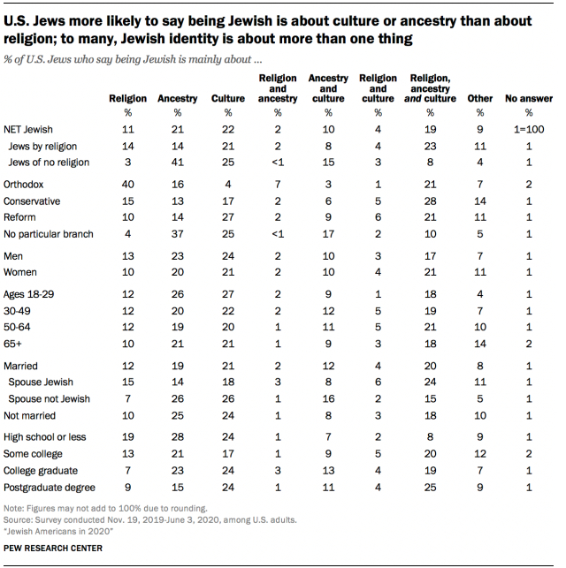

Based on Pew Research Center findings, American Jews are not exceptionally religious, at least in a traditional way. They mostly engage with Judaism following their religious holidays, food and cultural connection. For example, approximately one in seven Jews cook or eat traditional Jewish food, one in six share their religious holidays with their non-Jewish friends and only one in five attend religious services at synagogue once or twice a month; 39% of respondents keep Shabbat because it is “personally meaningful for them”. When respondents were asked the reason they don’t attend synagogue more often, they often answer “I’m not religious”.

“When asked about their agreement with a traditional conception of
a God Who “rewards good people and punishes bad people,” 74 percent ­
rejected that concept and only 40 percent believed in an all­-powerful deity.
“And is God just?” the survey asked. Although 26 percent said yes, 30 percent indicated they do not believe God is just and 43 percent were not sure.
Perhaps most telling of what impedes their belief in such a deity, “two hundred congregants expressed concerns about justice, such as: ‘God, why do bad things happen to good people?’ ”

Relationship between Jews and Judaism (at least in North America) has changed significantly. It’s more common nowadays for modern Jews to spend time at home with their family, do sports, spend time with friends then learn Torah or go to synagogue. Following Jewish traditions gives a sense of belonging and a connection to their roots and ancestors. Orthodox Jews are an exception.

If religion for Jews in modern times is a matter of personal choice, how has their opinion about astrology changed? Do they become more open to the idea of the New Age?
Fourteen respondents participated in the survey, aged 28-80. All are members of the Jewish private golf club. All had a Jewish upbringing, and Judaism is a religion they knew from an early age.

The survey was conducted in April of 2023. There were fourteen respondents. Due to the limited number of respondents, the survey may not be deemed to be statistically significant, it does however provide interesting insights.

Below are the results of the survey.
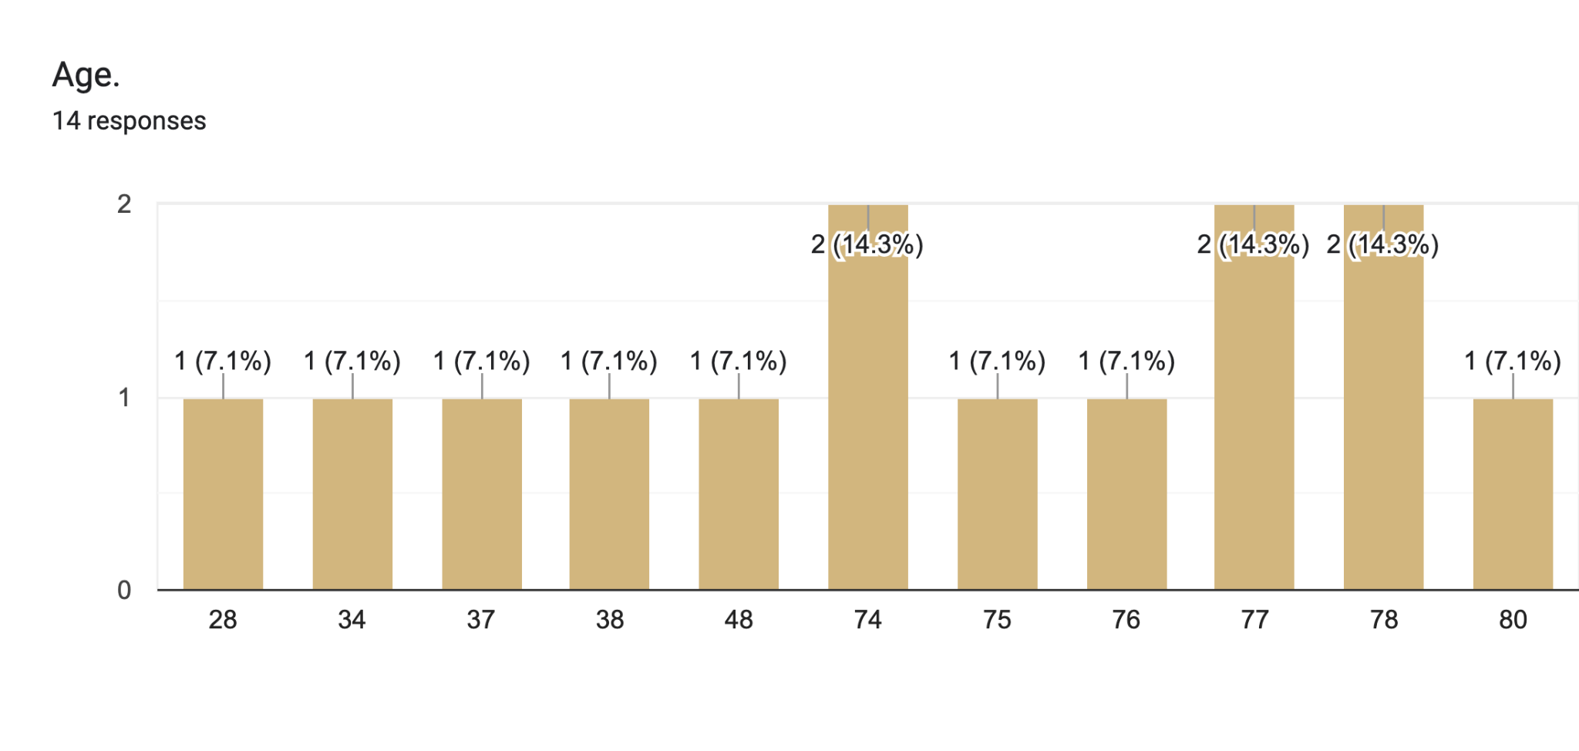
Five respondents were under the age of 50, and nine were over the age of 70.

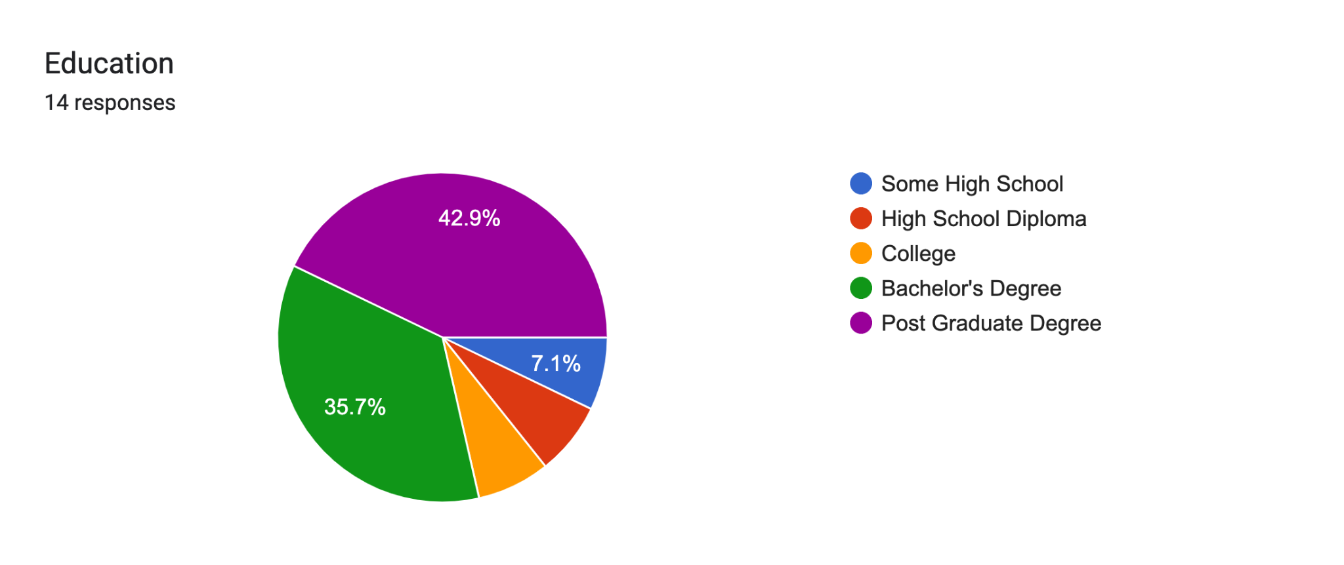 | Some high school | 1
 | High school | 1
 | College | 1
 | Bachelor’s degree | 5
 | Post Graduate degrees | 6

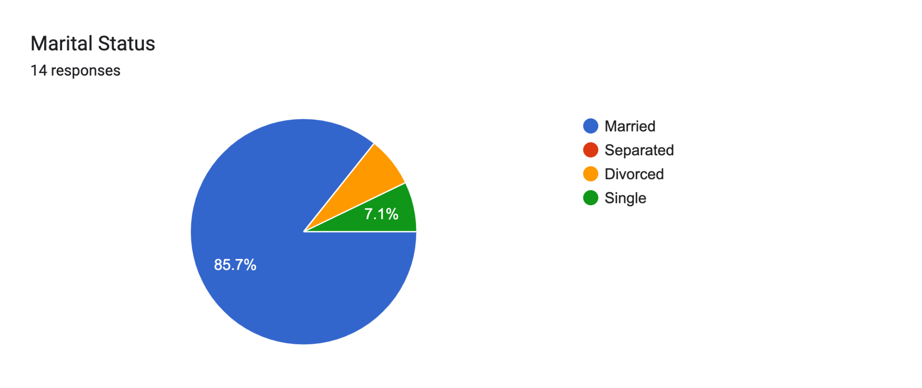 | Married | 12
 | Single | 1
 | Divorced | 1

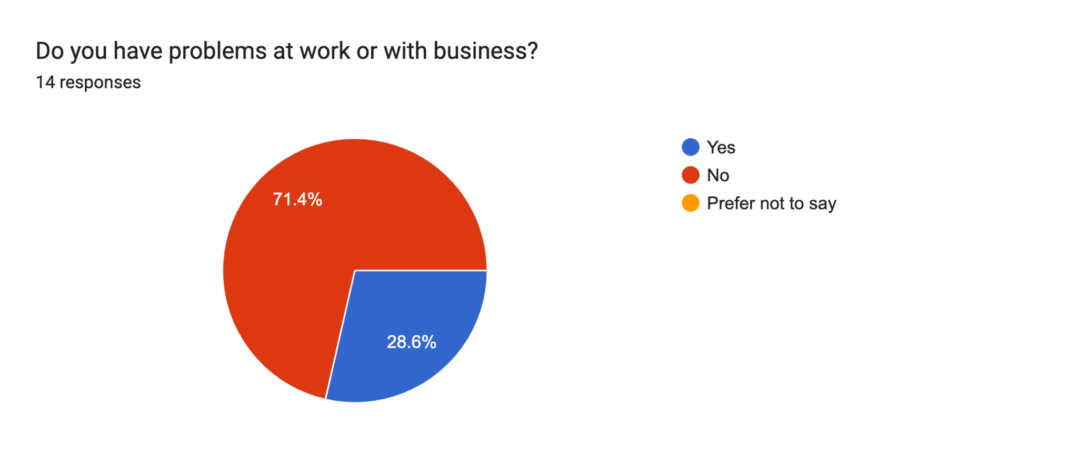 | Yes | 4
 | No | 10
 | Prefer not to say | 0

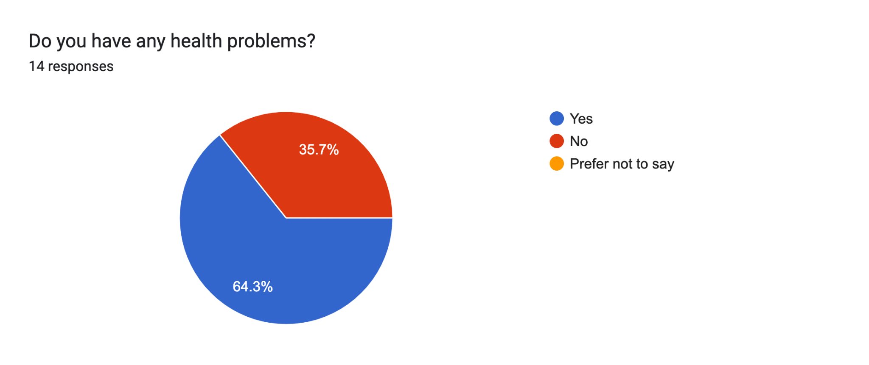 | Yes | 9
 | No | 5
 | Prefer not to say | 0

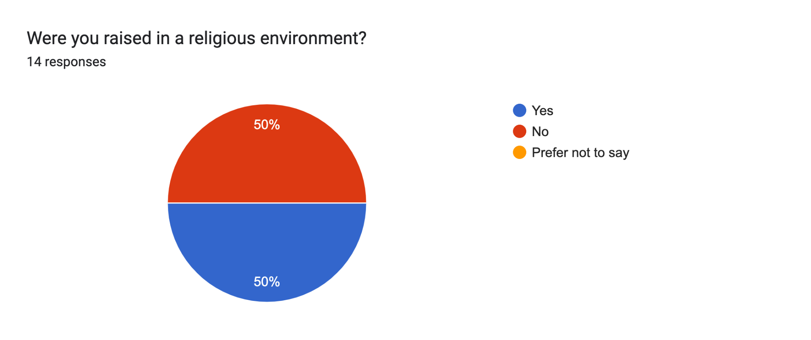 | Yes | 7
 | No | 7
 | Prefer not to say | 0

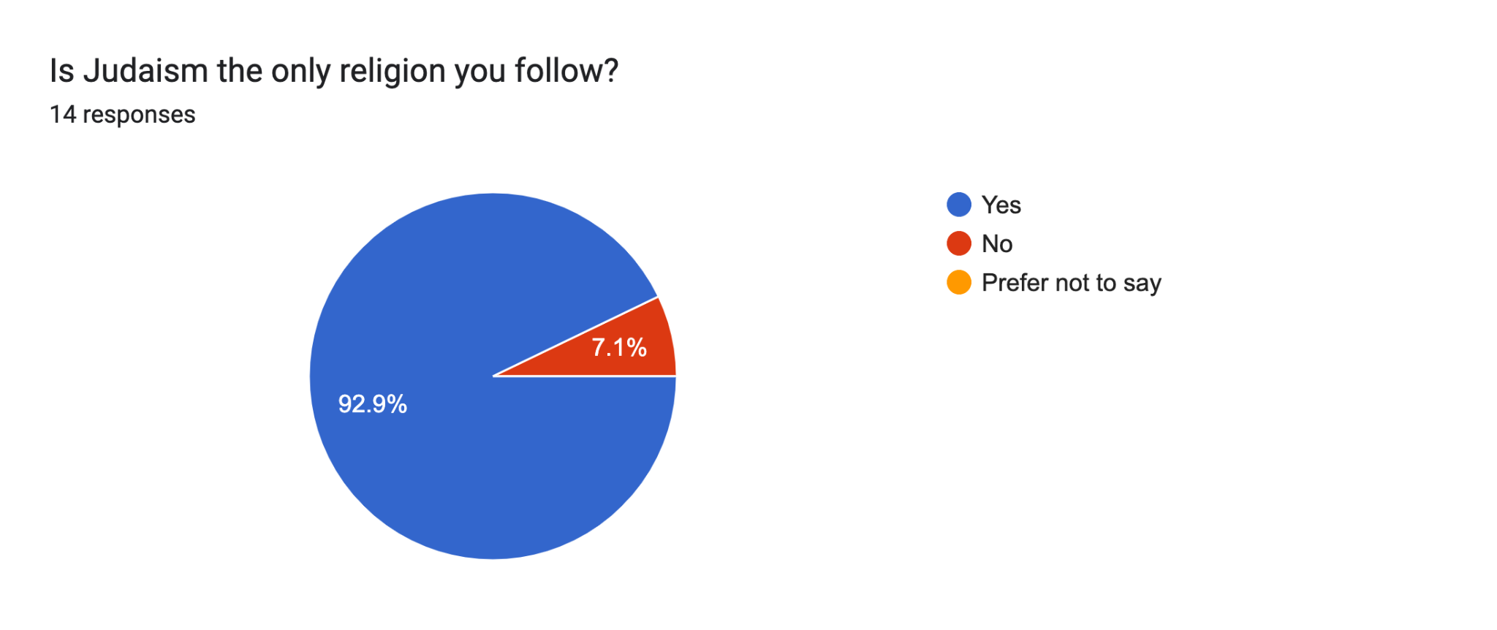 | Yes | 13
 | No | 1
 | Prefer not to say | 0

One respondent confirms that they follow not only Judaism, but different religions. No details.

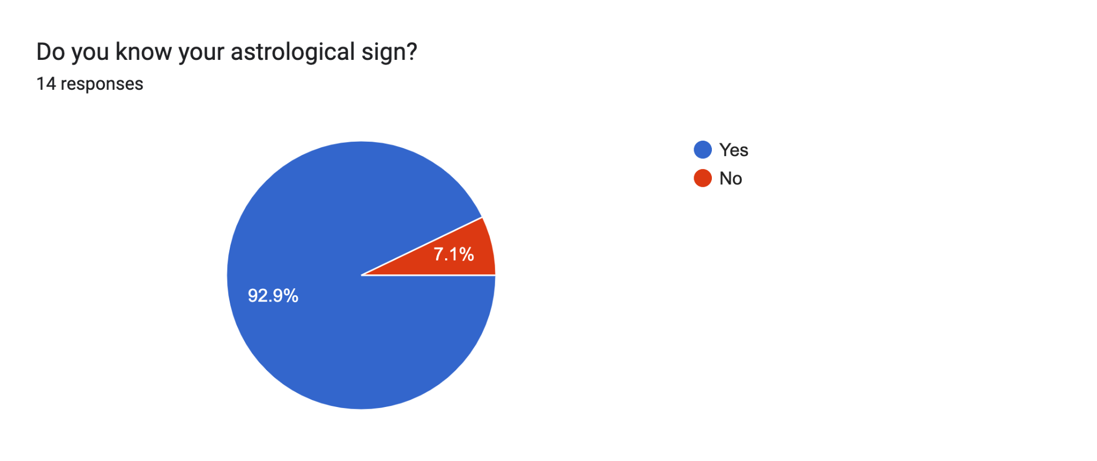 | Yes | 13
 | No | 1

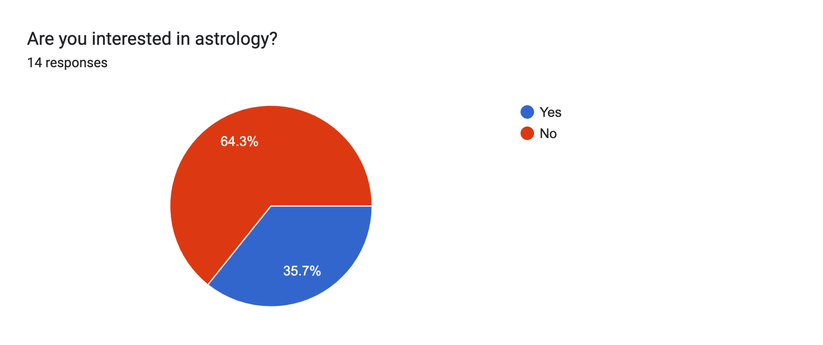 | Yes | 5
 | No | 9

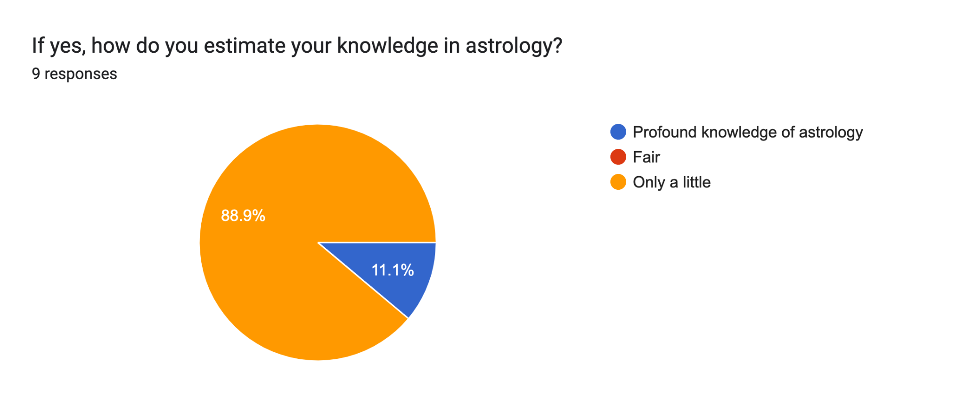 | Profound knowledge of astrology | 1
 | Fair | 0
 | Only a little | 8

Only 9 respondents answered that question and among them, one person mentioned “profound knowledge of astrology”

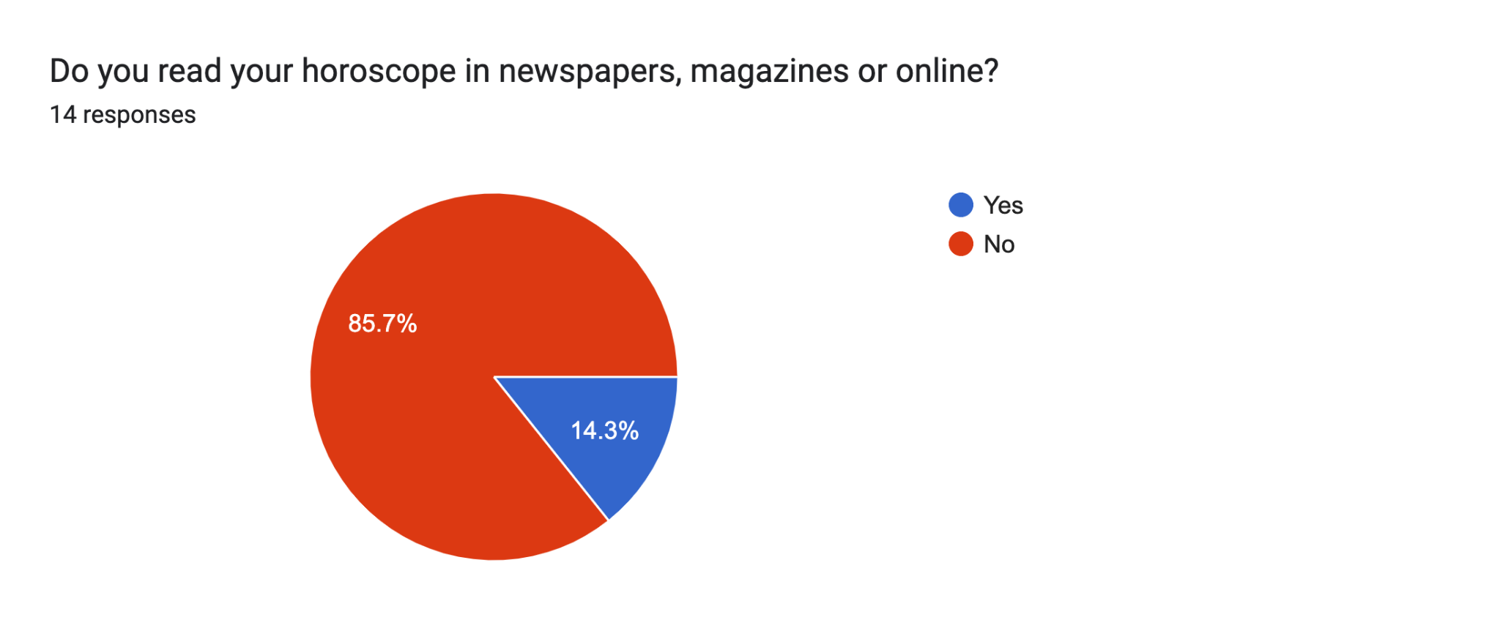 | Yes | 2
 | No | 12

Only 2 respondents read their horoscopes in newspapers, magazines and online. For the question “Do you find them useful?” answers only 9 respondents and all answers were negative.

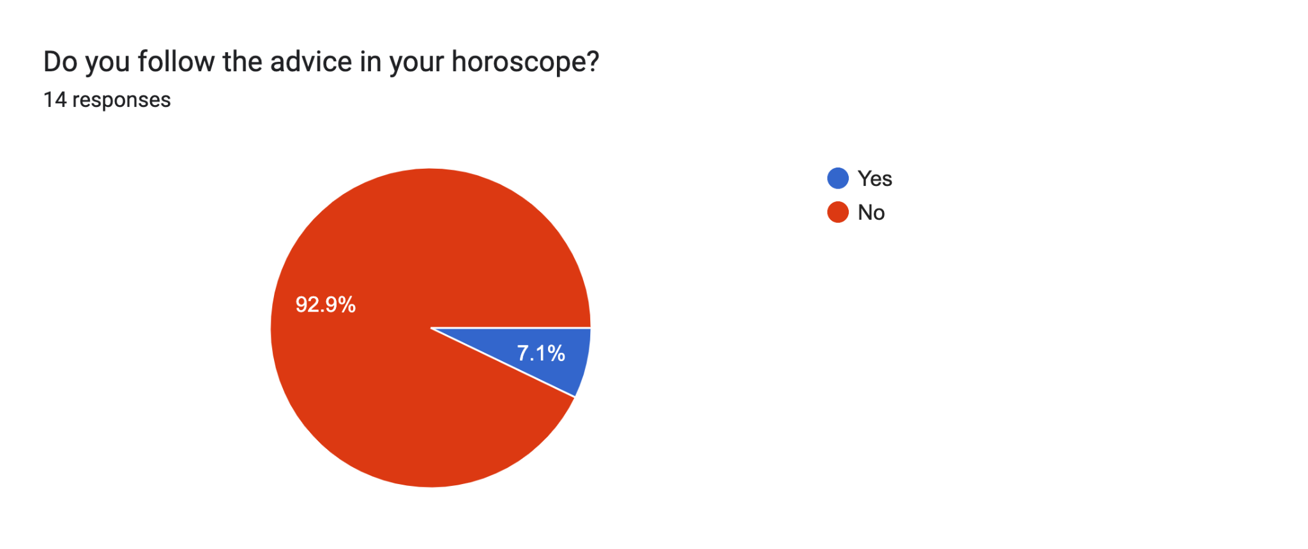 | Yes | 1
 | No | 13

Only one respondent found horoscopes in newspapers and magazines useful.

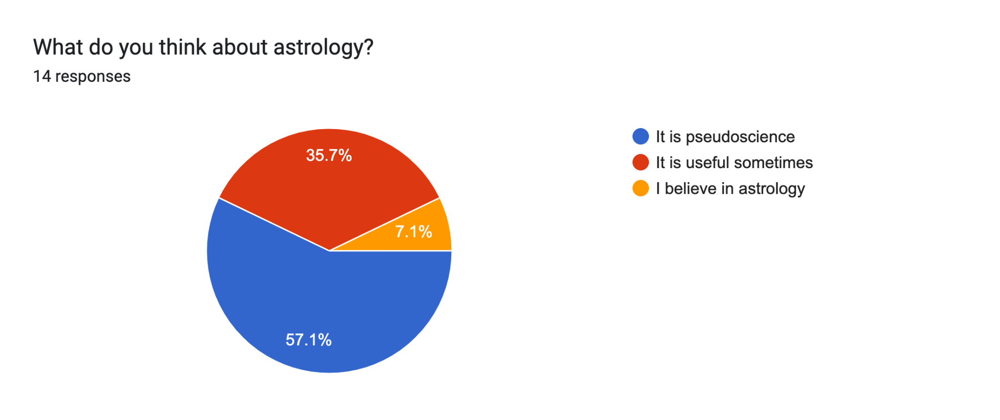 | It’s pseudoscience | 8
 | It’s useful sometimes | 5
 | I believe in astrology | 1

More than half of the respondents are older than 50. This is not surprising as golf at a private club is expensive and time-consuming. Younger people are often raising families and building their careers and do not have the time or financial resources to commit to a private golf club.

But despite some disadvantages, more people are getting involved in golf, because it is not only a sport, it is a good opportunity to spend time with your friends and meet new ones. Respondents to this survey are members of this club and well-known members of the Jewish community of Toronto. All of them are of Jewish origin and half of them grew up in a religious environment.

Thirteen of fourteen respondents know Judaism as only one religion and only one person, who is 80 years old, said that they follow another religion.

Two respondents provided very interesting information. One of them (34 years old, divorced, has a bachelor’s degree, was raised and lives in a religious environment, followed Judaism and has an interest in astrology), said that he has a profound knowledge of astrology and has had a personal horoscope reading multiple times. That fact confirms the hypothesis that religious people can have an interest in New Age beliefs, and astrology in particular.

A second respondent, (37 years old, has a postgraduate degree, is married, but feels lonely, has problems at work, knows Judaism as their only religion but grew up in a non-religious environment), has to have an interest in astrology, basic knowledge about astrology, reads horoscopes in newspapers and magazines regularly, thinks that astrology nor useful, pseudoscience, but will be interested in having a personal horoscope reading.

The answers of both respondents confirm the idea of H.Waterhouse and T.Walter’s survey, that nowadays people may both follow a religion and New Age beliefs.. In the age group under 50 years old, respondents are more open to the idea of learning about horoscopes.

What do findings indicate about the Jewish attitude to astrology? For responders of this survey:

- Responders aged under 50 were more open to the idea of astrology, but mostly they think that astrology is a pseudoscience, or they know little about astrology;
- Responders over 50 years old denied the idea of astrology and have no interest whatsoever, and only one respondent in this age group has an interest in astrology and knows a little about it;
- The attitude to astrology between respondents doesn’t depend on the level of education. That conclusion contradicts the conclusion of R.Wuthnow:

“ With respect to the social location of astrology relative to education (see Table 2), those most likely to be interested in their horoscopes and to believe in astrology were the grade school educated. With each increase in educational level, there is a more or less steady decrease in commitment to astrology”.

Further research may provide more cogent data to get information about the correlation between educational level in Jewish communities and the acceptance of the idea of astrology.

The single and divorced respondents were quite interested in their horoscopes and tended to believe in astrology

- Some of the questions in the questionnaire were about their personal issues (Do you feel lonely), problems with work (Do you have problems with work or business), and health problems (Do you have healthcare problems). The results were easily predictable: respondents, who have emotional issues and problems with work and business were interested in having their horoscopes read. Respondents with health issues were not interested in astrology and were not knowledgeable about it. This group of participants is in an age group of above 50+.
- For the question “What do you think about astrology?" one person answered “I believe in astrology, and four respondents answered, “It is useful sometimes”. Among them are people of different ages, levels of education and marital status. The rest of the respondents said that in their opinion “Astrology is a pseudoscience”.
- But among respondents who characterized astrology as a pseudoscience was one person, 37 years old, with a post-graduate degree, who expressed interest to have personal horoscope reading.

Most of the respondents considered astrology to be a pseudoscience. Scholars still argue about whether astrology is a pseudoscience. Nick Campion’s opinion is the follows:

“Astrology is a familiar feature of modern culture, yet is widely ignored by the Academy. Our attempts to understand its claims, practices and philosophical context have tended to fall prey to the legacy of the self-defined Enlightenment struggle against superstition, and it has too often been condemned or dismissed, rather than subjected to systematic investigation.”

Scholars argue about the scientific basis of astrology but still don’t have an opinion about this. Another scholar, who investigated this topic is Gary Philipson, who made a valuable statement in his article “Modern Science, epistemology and Astrology”:

“Advances in modern science do not prove astrology, any more than they prove the existence of intelligence and purpose underpinning the universe. What – I have suggested – they can offer is a framework of understanding in which the question of astrology’s validity is for the individual to address for him or herself, with the hope of an authoritative answer from an omniscient Science having shattered”.

Wolfgang Pauli was a theoretical physicist from Austria who was one of the early pioneers of quantum physics. He won the Nobel Prize for his work in discovering a new law of nature, called “Pauli principals”. He was in correspondence with Jung between 1932-1957 and was once a patient of his clinic in Zurich. When Jung and Pauli first met, their scientific discussions primarily consisted of ideas being compared; Pauli sought after Jung's synchronicity thesis and Jung cultivated Pauli's comprehension of the archetypal and collective factors in the psyche. Laurikainen, K.V. in his memoirs about W. Pauli, wrote:

“But when concentrating on the foundations of quantum mechanics, Pauli found that it is not possible to omit psychological aspects in analyzing the nature of observations. Then he also saw that there is no absolute border between the scientific conception of reality and mysticism. This was the result of most rigorous criticism, not an expression of a “weakness for mysticism”. Simultaneously, the border between physics and metaphysics becomes dim. Besides a strictly rational science, we must - especially during the phases of strong development of science and when examining its philosophical foundations
- accept knowledge of another kind, which perhaps can best be called intuitive. It cannot be described by using exact concepts and strict rational theories. We must also accept less exact means of describing reality - for example, the use of analogies.”

Pauli's philosophical ideas were not taken seriously, and many of his contemporary coworkers and friends found him to be very "mystical," especially in his later years, but he was and remains very rationalistic in his scientific work, but his ideas probably were more ahead of his time. During his work on the foundations of quantum mechanics, he discovered that it was very difficult to ignore psychological aspects when analyzing the nature of observations. In his opinion, there is no line between the logical origination of the real world and supernatural quality. It is a very interesting observation, especially made by a world-known physicist.

According to this survey, all but one participant did not believe in astrology. Some respondents, not being religious people, just follow the Jewish tradition and keep rituals. Why is Judaism so important to them? Why is religion still so attractive to them?

The hypothesis of belongingness, which was proposed by Baumeister and Leary in 1995, suggested that humans have an almost universal need to form and maintain at least some degree of interpersonal relationships with other humans. This is the best way to explain why Jews, even when they consider themselves to be non-religious, follow their traditions and rituals. The theory holds that belongingness is an innate quality that evolved over time and would clearly benefit survival and reproduction.

“People form social bonds readily, even under seemingly adverse conditions. People who have anything in common, who share common (even unpleasant) experiences, Or who simply are exposed to each other frequently tend to form friendships or other attachments. Moreover, people resist losing attachments and breaking social bonds, even if there is no material or pragmatic reason to maintain the bond and even if maintaining it would be difficult.”

Baumeister and Leary studies conducted in the area of individual belongingness showed that the need to belong shapes cognition and emotion. Positive emotions are generally triggered by social attachments., whereas the lack of social ties can be the reason for unpleasant emotions and even sicknesses, such as depression, emotional eating etc.

“Deficits in belongingness apparently lead to a variety of ill effects, consistent with the view that belongingness is a need (as opposed to merely a want). Both psychological and physical
health problems are more common among people who lack social attachments. Behavioral pathologies, ranging from eating disorders to suicide, are more common among people who are
unattached. Although most of these findings are correlational and many alternative explanations can be suggested, recent efforts have begun controlling for these other factors, and the pure, primary effects of belongingness appear to remain strong. It appears, then, that belongingness is not only pleasant but also apparently very beneficial to the individual in multiple ways.”

Change in belongingness is a strong and prevalent reason for emotion in ways that support the hypothesis of the need to belong. It is also evident that people think a great deal about belongingness. They devote an excessive amount of mental processes to actual or possible friendly or intimate partners, and their patterns of information processing are different and more extensive when it comes to people with whom they share social bonds.

Belongingness, the establishment of social ties should have some emotional, intellectual or even spiritual basis. And here, religion and cults play a significant role in creating the feeling of belongingness. The authors explained:

“The role of belongingness is also apparent in religion. Although ideological belief and acceptance of metaphysical doctrines are often regarded as the essence of religious participation, Stark and Bainbridge (1985) reviewed considerable evidence suggesting that the need to belong may be a more compelling factor than the need to believe. They noted that movement into and out of religious groups (including cults, sects, and mainstream denominations) depends much more heavily on social ties than on ideological belief. Indeed, many many people do not fully grasp or understand the theological belief structure of their own religion (e.g., the subtle differences between the many Protestant denominations), but they are well aware of what sort of people in their community belong to which religion. Cults mainly attract people who are socially isolated or lonely, and these individuals are often attracted particularly by the promise of becoming part of a community or gaining a sense of belonging. Those who form social attachments to other members of the cult tend to remain, whereas those who do not form social bonds tend to leave soon. By the same token, Kirkpatrick and Shaver (1992) have shown multiple links between religious beliefs and adult attachment styles or relationship patterns”.

That explains why Judaism is so important for people of Jewish origin. Israel was established as an independent state on 14 May 1948, one day before the British Mandate had expired. Israeli independence was declared by the Jewish Agency's head, David Ben-Gurion. Until that time, the Jewish population lived in the diaspora, and the only things that gave and preserved their sense of belonging were their religion, traditions and rituals. That may explain the fact that nowadays, the young generation of Jewish people sometimes are not so religious but still keep their traditions and religious holidays. That gives them feelings about who they are and where they came from. That keeps the Jewish community solid.

The survey, conducted among members of a Jewish private golf club confirmed the above hypothesis only partially, which stated that it is possible to follow Judaism and accept the idea of astrology. 35% (five respondents from 14) who expressed interest in astrology also follow Jewish and Judaism traditions. That group mostly included young people (the exception is one member, who is 80 years old and thinks that astrology is “useful sometimes”) aged under 50 more open to the idea of astrology, who expressed interest in astrology (the exception is one member, who is 80 years old and thinks that astrology is “useful sometimes”). The idea that keeping religious traditions and accepting the idea of astrology is mostly denied by older members. Of course, most respondents have no idea what astrology is about and treat the idea of astrology not seriously.

Findings indicate the following:

- Little knowledge of the subject of astrology;
- Think that astrology is a pseudoscience;
- The idea that astrology is a pseudoscience has nothing to do with the age of members and education;
- Respondents, who experienced problems at work, business and personally prone to have a personal chart and possible reading.

But, the fact that part of the respondents expressed interest in astrology, is a signal that some shift in their consciousness, and acceptance of astrology has happened and perhaps further research can be very useful. But the greatest appeal to astrology remains with members of the Jewish private golf club who have emotional issues, like loneliness or divorce, or having problems with business or work who were most taken with astrology. Astrology may become a prototype of a sort of new spiritual belief that does not require either a church or any special accommodation. For the older members Hebrew religion probably will stay the way they navigate their private lives in their community.

Bibliography:

Research Questionnaire results: https://docs.google.com/spreadsheets/d/1z1JL-Ug2D1YBgvmiwpV_8EFfAU0q30CNzBTkbiKOTrU/edit?usp=sharing

Atom and Archetype: The Pauli/Jung Letters, 1932-1958. Editor ‎C. A. Meier, 2014, Princeton University Press

Baumeister, Roy F; Leary, Mark R. “The Need to Belong: Desire for Interpersonal Attachments as a Fundamental Human Motivation”, Psychological Bulletin 1995, Vol. 117 pp.497-529

Brink, T.L.“Inconsistency of Belief among Roman Catholic Girls: Concerning Religion, Astrology, reincarnation”, Source: Review of Religion Research, Autumn, 1978, Vol.20, No.1, pp.82-85

Campion Nicholas ”Astrology and popular religion in the modern West prophecy, cosmology, and the New Age movement”, 2012; Ashgate

Clobert Magali, Van Cappellen Patty, Marianne Bourdon, Cohen, Adam B. “Good day for Leos: Horoscope's influence on perception, cognitive performances, and creativity”, Elsevier Ltd; Personality and individual differences, 2016, Vol.101, p.348-355

Davies, T. Witton “Magic, Divination, and Demonology among the Semites”
Source: The American Journal of Semitic Languages and Literatures, Jul. 1898, Vol. 14,
No. 4 (Jul. 1898), The University of Chicago Press

Dean, G, Mather, A, Kelly, , I.W. “ Astrology as a Spiritual BSkeptic [Altadena, CA], vol. 26, no. 2, spring 2021, Gale Academic OneFile, link.gale.com/apps/doc/A667306438/AONE?u=anon~7f940c8f&sid=googleScholar&xid=6590f1ca. Accessed 23 Apr. 202

Fichten, C.S., Sunnerton, B. “Popular horoscopes and the Barnum effect”, Journal of Psychology, 114 (1983), pp. 123-134

Gallup “Three in four Americans believe in paranormal.” (2005)
(Retrieved from) http://www.gallup.com/poll/16915/Three-Four-Americans-Believe-Paranormal.asp

Halbertal, M” Maimonides: Life and Thought” Translated from the Hebrew by Joel Linsider,
Copyright Date: 2014, Published by: Princeton University Press

Laurikainen, K.V. “The message from the Atom. Essay of Wolfgang Pauli and the unspeaksble”’ Springer, 2012.

Pew Research Center “Jewish Americans in 2020”, May 11, 2021.

Phillipson,G. “Modern science, epistemology and astrology”, Correlation, Vol.23(2), 2006

Rubin, David (2019) Astrology in the Torah: a comparative study of astrological themes in the Hebrew Bible and Babylonian Talmud. Masters thesis, University of Wales Trinity Saint David.

The Sage Encyclopedia of qualitative research methods” Given, Lisa M, editor.

2008; SAGE

Van Rooij, Jan J.F. “Introversion-extraversion: astrology versus psychology”, Personality and Individual Differences, Volume 16, Issue 6, June 1994, Pages 985-99

Walters, Tony; Waterhouse, Helen. “A very private Belief: Reincarnation in Contemporary England”. Sociology and Religion, Summer,1999, Vol.60, No.2, pp.187-197

Wertheimer, Jack “The New American Judaism.: How Jews Practice Their Religion Today”, 2018, Princeton University Press.

Wuthnow, R, “Astrology and marginality”. Journal for the scientific study of Religion 15 (June), pp.157-168

Gallup Three in four Americans believe in paranormal. (2005) (Retrieved from) http://www.gallup.com/poll/16915/Three-Four-Americans-Believe-Paranormal.asp
Magali Clobert , Patty Van Cappellen , Marianne Bourdon , Adam B. Cohen “Good day for Leos: Horoscope's influence on perception, cognitive performances, and creativity”, Elsevier Ltd; Personality and individual differences, 2016, Vol.101, p.348-355
MOSHE HALBERTAL” Maimonides: Life and Thought” Translated from the Hebrew by Joel Linsider, Copyright Date: 2014, Published by: Princeton University Press, p.22
T. Witton Davies “Magic, Divination, and Demonology among the Semites” Source: The American Journal of Semitic Languages and Literatures, Jul. 1898, Vol. 14, No. 4 (Jul. 1898), pp. 247, Published by: The University of Chicago Press
Jan J.F. van Rooij “Introversion-extraversion: astrology versus psychology” , Personality and Individual Differences, Volume 16, Issue 6, June 1994, Pages 985-98
G. Dean, A. Mather, I.W. Kelly “ Astrology as a Spiritual BSkeptic [Altadena, CA], vol. 26, no. 2, spring 2021, pp. 30+. Gale Academic OneFile, link.gale.com/apps/doc/A667306438/AONE?u=anon~7f940c8f&sid=googleScholar&xid=6590f1ca. Accessed 23 Apr. 2023
C.S. Fichten, B. Sunnerton “Popular horoscopes and the Barnum effect”, Journal of Psychology, 114 (1983), pp. 123-134
T.L.Brink “Inconsistency of Belief among Roman Catholic Girls:Concerning Religion, Astrology, reincarnation”, Source:Review of Religion Research, Autumn, 1978, Vol.20, No.1, pp.82-85
Rubin, David (2019) Astrology in the Torah: a comparative study of astrological themes in the Hebrew Bible and Babylonian Talmund. Masters thesis, University of Wales Trinity Saint David.
“The Sage encyclopedia of qualitative research methods” Lisa M. Given, editor. 2008; SAGE
Wertheimer, Jack “The New American Judaism: How Jews Practice Their Religion Today” 2018; Princeton: Princeton University Press, p.25
Jack Wertheimer “The New American Judaism.: How Jews Practice Their Religion Today”, 2018, Princeton University Press, p.32
Wuthnow, R, “Astrology and marginality”. Journal for the scientific study of Religion 15 (June), p.160
Nicholas Campion.”Astrology and popular religion in the modern West prophecy, cosmology, and the New Age movement”, 2012; Ashgate, Preface and Acknowledgement
Phillipson,G. “Modern science, epistemology and astrology”, Correlation, Vol.23(2), 2006, p.21
Laurikainen, K.V. “The message from the Atom. Essay of Wolfgang Pauli and the unspeaksble”’Springer, 2012, p.17
Baumeister Roy F, Leary Mark R. “The Need to Belong: Desire for Interpersonal Attachments as a Fundamental Human Motivation”, Psychological Bulletin 1995, Vol. 117, p.520.
Baumeister Roy F, Leary Mark R. “The Need to Belong: Desire for Interpersonal Attachments as a Fundamental Human Motivation”, Psychological Bulletin 1995, Vol. 117, p.520.
Walters, Tony; Waterhouse, Helen. “A very private Belief: Reincarnation in Contemporary England”. Sociology and Religion, Summer,1999, Vol.60, No.2, pp.187-197
Baumeister Roy F, Leary Mark R. “The Need to Belong: Desire for Interpersonal Attachments as a Fundamental Human Motivation”, Psychological Bulletin 1995, Vol. 117, p.522

