

Student Name: Dhruv Jivanbhai Suvagiya

Student ID: 2509973

Module Name: Human Capital Management
Module Code: LCMB7023

Lecturer's Name: Dr. Gladius Kulothungan

Words Count: 2690

Executive Summary
Technology has its massive impact on the international and national job market by serving new job opportunities which encounter transition in the workforce. The use of AI showcases job displacement by involving repetitive tasks and addressing changes in skill in order to remain competitive in the market. The hiring of the skilled talents and AI led interviews enhance transition in the workplace by infused with proper reskilling opportunities and AI-driven training enhance career development. Trade war, political instability have a negative impact on employment leading to rise of consumer spending in the volatile market environment. The skill gap is the major issue faced by the HR professional by serving proper reskilling opportunities and uses of talent analytical platforms which encounter productivity. The Gibbs' Reflective Cycle showcases current working in international context by relying on teamwork, technology and communicating with team members.

Table of content
Introduction 3
Question 1 4
1.1 Reshaping labor market through technology 4
1.2 Implications for Human Resource Management (HRM)/IHRM 6
Question 2 8
2.1 Key Demographic Factors 8
2.2 Key Geopolitical Factors 10
2.3 Challenges addressed by HR Professionals 12
Question 3 16
3.1 Causes of Skills Gaps 16
3.2 Strategic HRM Approaches 17
3.3 Sector-Specific Responses 17
Question 4 21
4.1 Introduction 21
4.2 Self-Assessment (Gibbs' Reflective Cycle) 21
4.3 SWOT Analysis 22
4.4 Development Plan 23
4.4.1 Strengths 23
4.4.2 Weakness 23
Conclusion 24
Reference list 25

Introduction
Human Capital has been considered as an important tool that helps companies in improving the quality of its business operations. The report emphasises on evaluating the influence of advanced technologies such as artificial intelligence on the job opportunities for labour across the globe. In addition, the investigation also includes discussions regarding the demographic and geopolitical challenges observed by organisations in managing the requirements of its workers. The report also provides a personal evaluation that helps individuals in identifying professional strength and weaknesses.

Question 1

1.1 Reshaping labor market through technology
- Automation & AI
AI enhances transformation in the labour market, as 92 million jobs are displaced in 2030 due to uses of automation among 170 million which leads to increased revenue (Kumar, 2025). It has been addressed that 80% of the responses stated that organisations accelerate automation which displace jobs by doing repetitive tasks related to custom services and data entry (WEF, 2023). The UK AI ethicist rises about 40% varies based on the industrial sector which showcase growth streamline improvement in business operation (Zaheer, 2024).
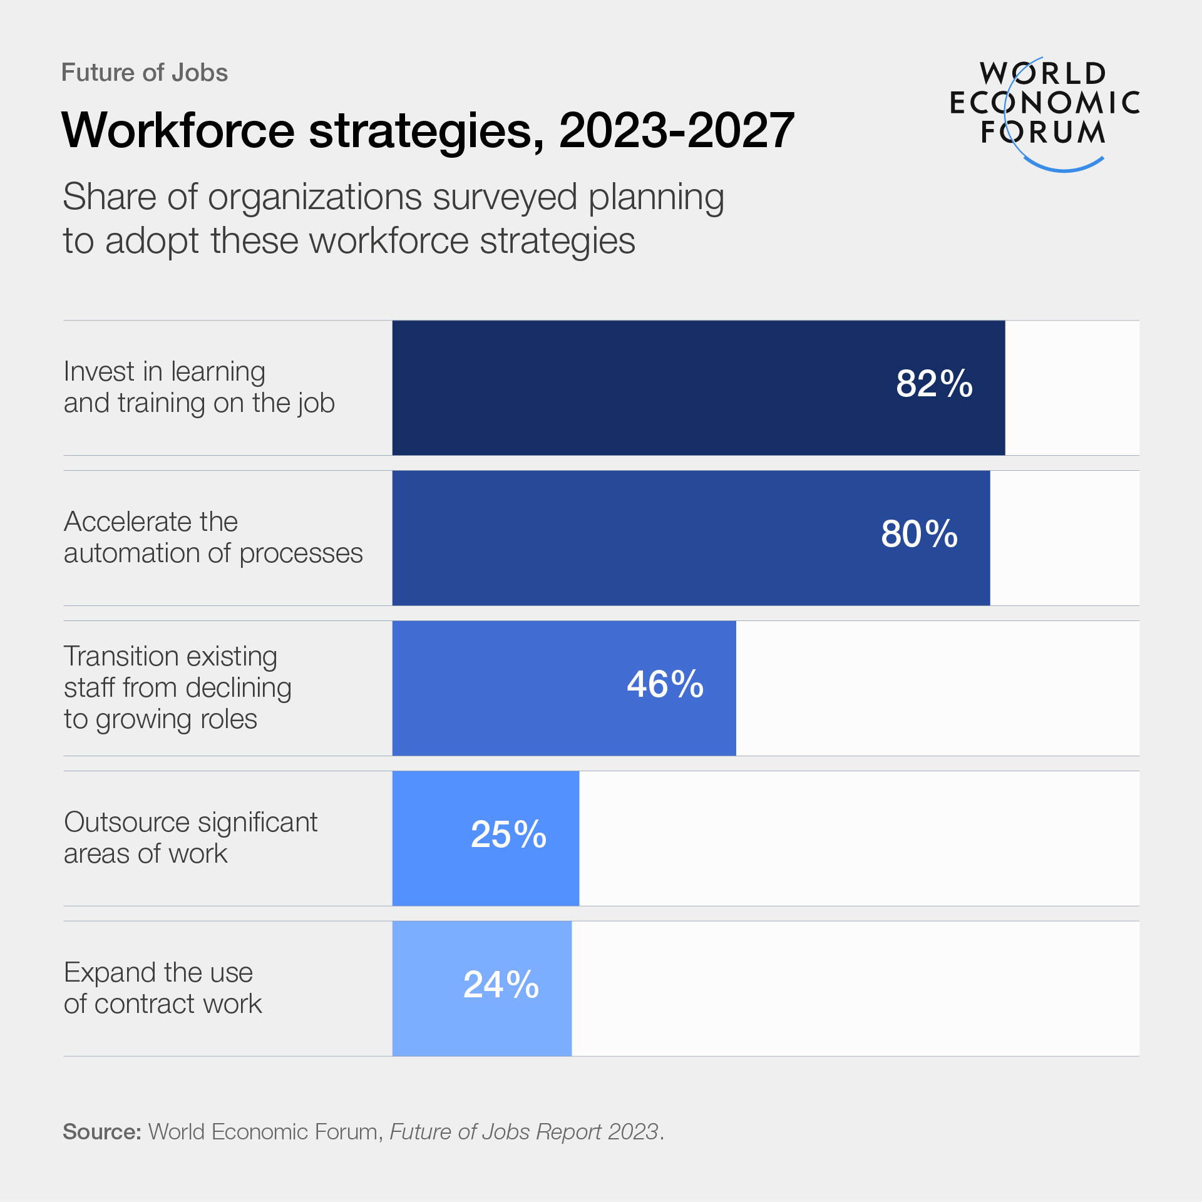
Figure 1: Organisation planned to adopt workforce strategies
(Source: WEF, 2023)
- The Gig Economy & Digital Platforms
The shifting in employment is due to the rise of the digital platform and gig economy which poses significant threats for right talent and job security. 32.5 million UK workers rely on the gig economy to address issues related to job security while upholding traditional employment (CIPD, 2023). It has been addressed that 36% of responses are based on 35-49 aged people's interest towards the gig economy (CIPD, 2023). The gig economy expands its talent pool by hiring employees who respond to changes in market conditions.
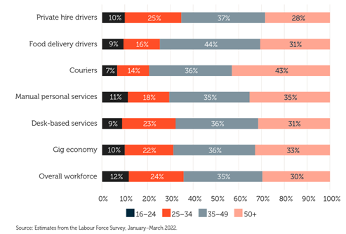
Figure 2: Gig worker age breakdown
(Source: CIPD, 2023)
- Skills Churn
In the competitive era, the demand for technical skill has its huge popularity , as 350 million people have reached its demand in achieving better skills which encounter business productivity (WEF, 2023b). The reskilling revolution in the workplace is about 1 billion which encounters a transition in the UK achieved by 2030 (WEF, 2023b). GSK invested £6m for young people by serving them with STEM education and on hand training encounter career development(GSK, 2023).

1.2 Implications for Human Resource Management (HRM)/IHRM
- Talent Acquisition
The adoption of AI in recruitment encounters the right talent and saves recruitment times by relying on job descriptions which enhance efficiency in business. AI led interviews help to expand the opportunities of candidates by reduction of recruitment bias and quick rejection through constructive feedback (Esposito and Fitoussy, 2025). BBC addresses that 42% of tech firms use AI to recruit and screen candidates for interviews which enhance adaptability for career development (Lytton, 2024).
- Learning & Development
Upskilling and reskilling improve the performance of HR by ability to find out the right talent and keeping engaged and responding with market changes. In the UK, 29.3% of employees address concern due to lack of reskilling and upskilling in the job role which will encounter shifts in 2024 (Soliman, 2025). 41% of HR professionals adopt AI-driven training by serving personalised learning opportunities to encounter career development.
- Strategic HR Planning
HR collaborate with different business leaders by serving them knowledge of different skills which serve potential reskilling opportunities enhance improvement in workforce. It has been addressed that 60% of HR have its massive demand in utilising technological tools which enhance employee engagement (Bernzweig, 2024).
- IHRM Specifics
The international HR address significant complexities to survive in the digital landscape by ability to manage remote work culture and navigating with regulation. The remote global digital job rises about 25% which is around 92 million showcasing significant work life balance (Masterson, 2024). HR manage employee data following “Data Protection Act 2018” which is more reliable to enhance data privacy (White, 2022).
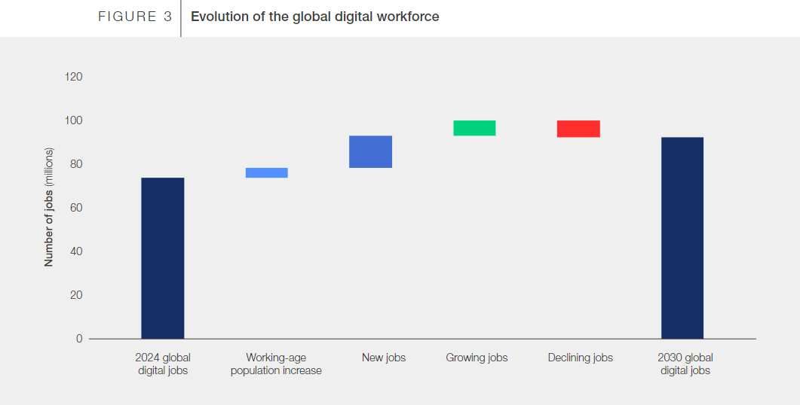
Figure 3: Remote job of UK
(Source: Masterson, 2024)

Question 2

2.1 Key Demographic Factors
- Ageing Populations
Then shrinkage in the labour force was also identified in more than 170 countries which included a negative trend for the ageing population. After 2020, negative-growth countries rise sharply—from about 25 in 2020 to nearly 90 by 2050 (Kenny, 2024). Further, China's dependency ratio of shrinkage labour force will also be higher between 16-59 with generating 870 million by 2030 (Caixin, 2024).
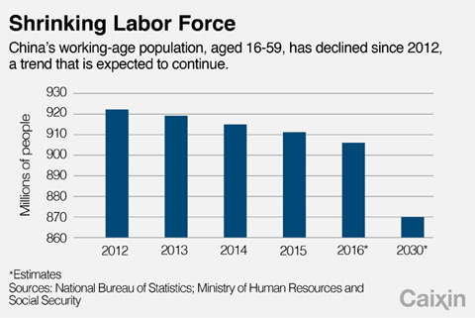
Figure 4: Shrinkage labour in China
(Source: Caixin, 2024)
- Changing Migration Patterns
The Immigration policies help the UK fill critical talent gaps by attracting skilled workers in sectors such as healthcare, engineering, and technology. UK net migration reached 900,000, the highest on record, driven by non-EU arrivals and post-pandemic travel recovery (McNeil, 2024). Hence, suitable immigration policy in the UK increasing inflows from Afghan, Ukrainian, and Hong Kong schemes increased numbers of immigrants effectively (Casciani, 2023).
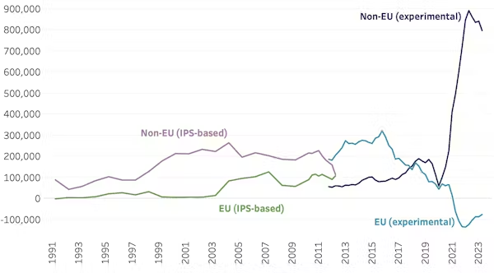
Figure 5: UK immigration
(Source: McNeil, 2024)
- Increasing Workforce Diversity
Workforce diversity in the UK shows major variation in earnings and participation. Bangladeshi, Pakistani, and Black women face the largest gaps, earning 17–27% less than White British men (McKinsey & Company, 2024). Labour-force participation ranges from 59% (other ethnic minority women) to 85% (White other men), highlighting the need for stronger inclusion, communication, and team-support policies.
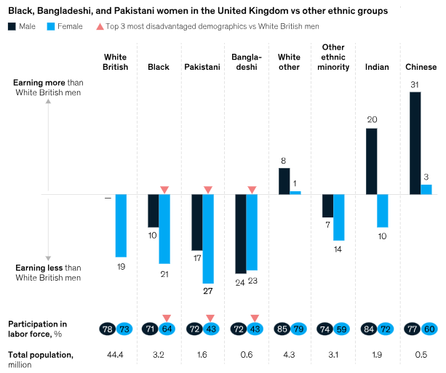
Figure 6: Diversity
(Source: McKinsey & Company, 2024)

2.2 Key Geopolitical Factors
- Trade War
The occurrence of trade wars has an adverse impact on the employment opportunities for skilled individuals across the globe. In the USA, the volume of employees eligible for the H-1B visa has declined from 758994 in 2021 to 343981 in 2025 (Malik, 2025). The existence of accommodation issues has reduced the economic growth of the workers.
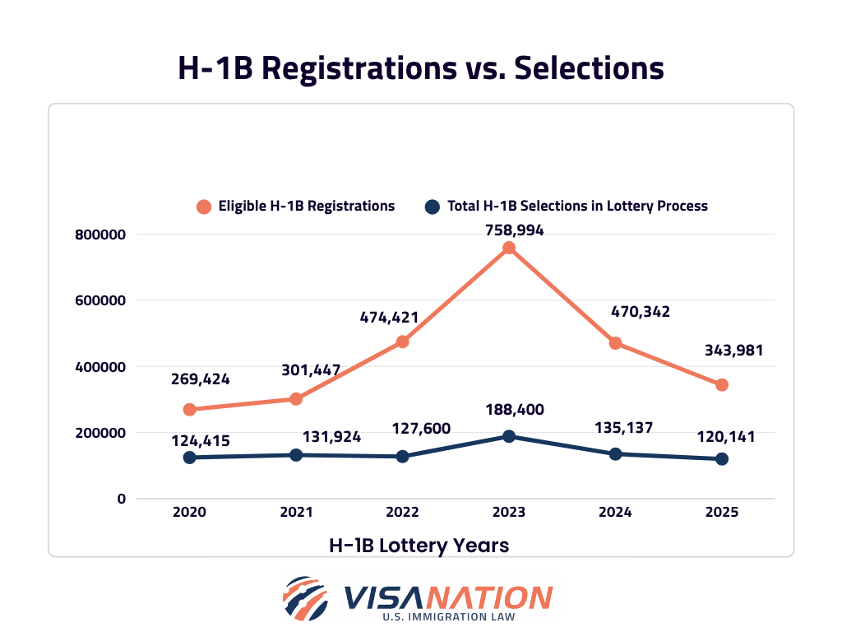
Figure 7: H-1B Visa Registrations
(Source: Malik, 2025)
- Political Instability
The existence of a stable government helps in enhancing the economic development of the country. In the UK, the market volume of the FTSE 100 index has increased from 25000 units in 2021 to 125000 units in 2024 (Veldhuizen, 2024). The improvements in the financial revenue of the stock exchange has provided strength to monetary growth in the country.
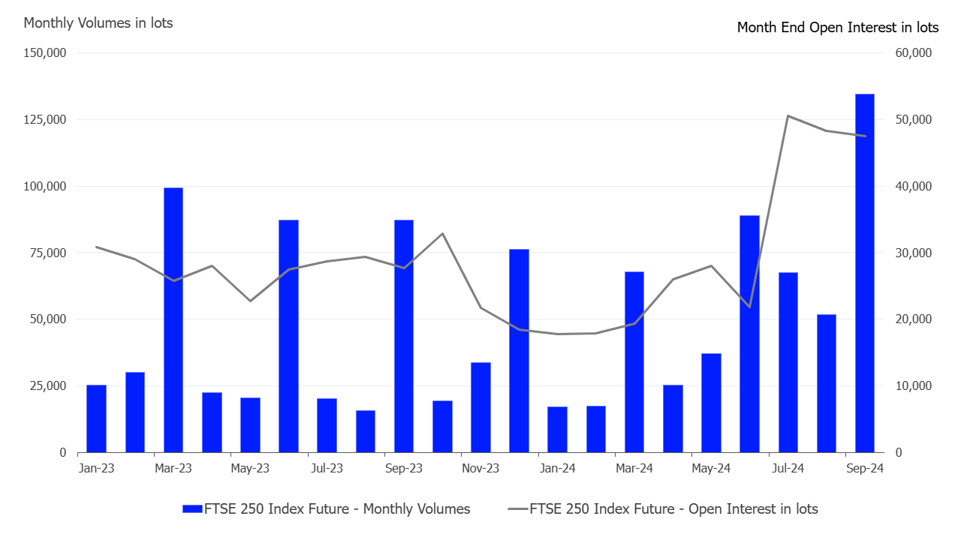
Figure 8: Growth of the FTSE Index
(Source: Veldhuizen, 2024)
- Pandemic and Global Health Crisis
The occurrence of pandemics such as COVID-19 had an adverse impact on the work patterns of companies across the globe. For example, PwC had provided a hybrid working model for 2000 employees in 2021 (PwC, 2023). The strategy has helped the organisation in enhancing its productivity in the pandemic situation.

2.3 Challenges addressed by HR Professionals
- Talent mobility
Talent mobility is increasingly challenging as HR professionals navigate complex visa rules. In the UK, Skilled Worker Visas now require a £38,700 salary threshold, renewals every 3–5 years. In the US, a new proclamation introduces a $100,000 H-1B application fee, significantly raising the cost of global talent mobility (Financial times, 2025).
- Risk management
Risk management is significant that considering key factor associated with cost of living standard and employee retention policy effectively (PwC, 2024). In 2023, international remote working (43%) and rising cost of living (35%) surged significantly, while cost pressures (30%) and compliance (28%) remained key issues (ECA, 2023). Technology (15%) and sustainability/DE&I (5%) also showed noticeable increases compared to 2019.
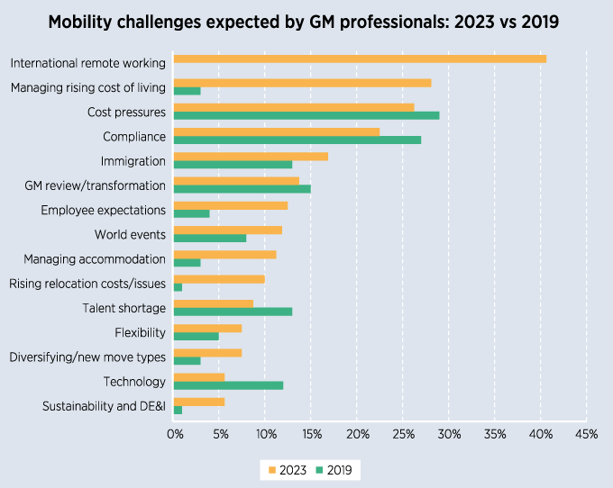
Figure 9: Mobility index
(Source: ECA, 2023)
- Compliance
The absence of proper safety provisions has reduced the productivity of the workers across the globe. In the UK construction sector, around 52% of the occupational accidents have occurred due to “fall from heights” in 2025 (Emma, 2024). The enhancement in the physical and mental health issues has hampered the engagement level of the employees.
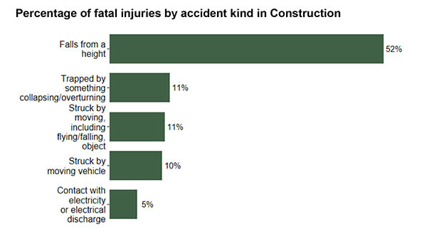
Figure 10: Accidents in the UK Construction Sector
(Source: Emma, 2024)
- Cultural integration
The adoption of cultural integration activities has enhanced communication issues among workers. In the UK, around 6800 workers of German origin have reduced the coordination between the workforce in 2025 (Sonnad, 2024). The cultural diversification has caused language issues among the workers.
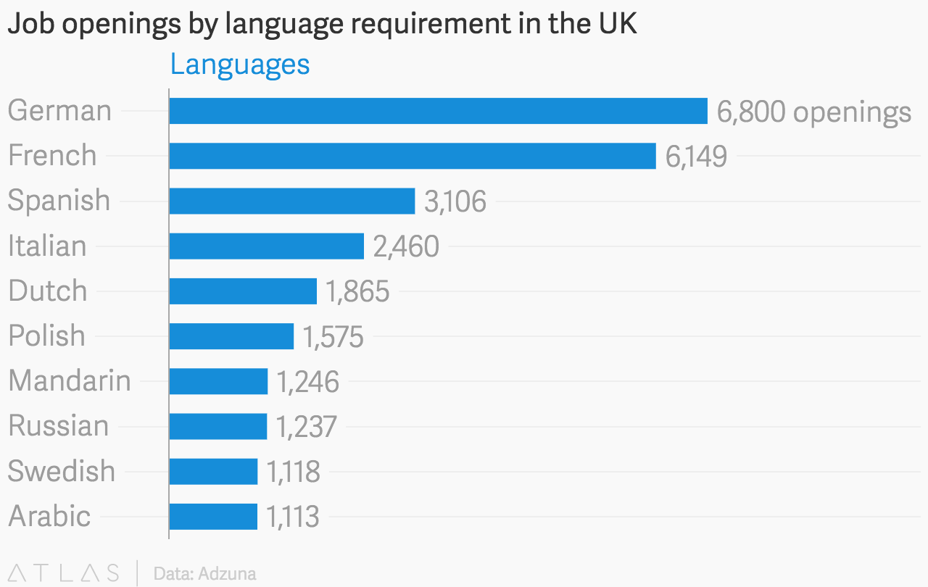
Figure 11: Diversification in the Workforce of UK
(Source: Sonnad, 2024)

Question 3

3.1 Causes of Skills Gaps
In the rapid changing era, skill gaps are the complex challenges that affect workers due to misalignment with educational offerings and technological advancement. It has been addressed that 39% of UK workers lack in core skills that will change by 2030 (World Economic Forum, 2025). This in term leads to rises of unemployment which in term affect economic growth of business by reduction of innovation. It has been addressed that 59% of organisations address difficulty in finding qualified candidates which hamper innovation (Contributor, 2024). In order to enhance the skill gap, the organisation invests in reskilling opportunities and provides specialised technical training which encounter career development.
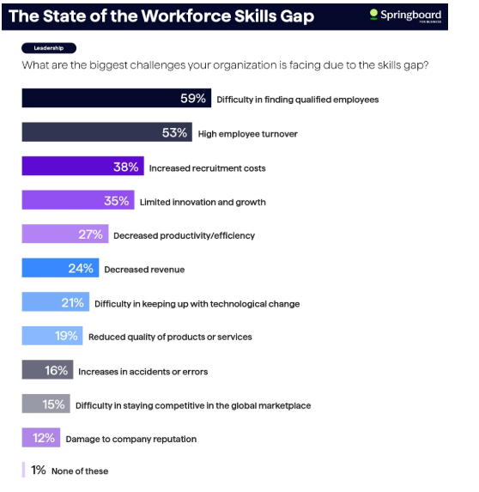
Figure 12: Disruption in skills affect organisation
(Source: Contributor, 2024)

3.2 Strategic HRM Approaches
- "Build" Strategies
Enhancing skill gap issue addressed through providing HR with proper upskilling opportunities which enhance productivity of the organisation. It has been addressed that 50% of the employees adopt reskilling opportunities regarding technology in order to address job change responsibilities (Li, 2022). HR are provided with professional “Professional Apprenticeship” and structured on job training by ability to manage payroll through informed decision making (CIPD, 2023a).
- "Buy" Strategies
HR utilises talent analytics software to find relevant talent for this specific job role in examining skills which enhance workforce productivity. For instance Microsoft teams use “Eightfold AI” in verifying right talent which provides proper opportunities by enhancing recruitment (Eightfold, 2024). The annual wages of UK HR is about £43153 based on performance, experiences and encounter productivity (GlassDoor, 2025).
- "Borrow" Strategies
HR professionals adopt a “hybrid workforce model” to manage long term employment by involving gig workers, consultant and outsourcing teams. HR collaborated with the consultant by serving technical skills to the employees to deal with the challenging situation in order to deal with operational inefficiencies.
- "Bind" Strategies
HR offers proper mentorship opportunities to the employees by ability to develop their skills which enhance job satisfaction. The implementation of the job rotation enhances perceived job satisfaction by serving adequate training to the employees which enhances employee engagement.

3.3 Sector-Specific Responses
- Technology
In the UK IT sector, companies have adopted the use of digitalisation to ensure the smooth execution of the business operations. For example, the revenue of the UK AI industry has increased to $5.96bn in 2023 (Spherical Insights, 2024). The adoption of the “build strategy” will help the IT companies in developing the AI skills of the workers. In addition, the inclusion of “borrow strategies” will assist the industry in acquiring the services of technical experts that will strengthen the cybersecurity operations of the organisations.
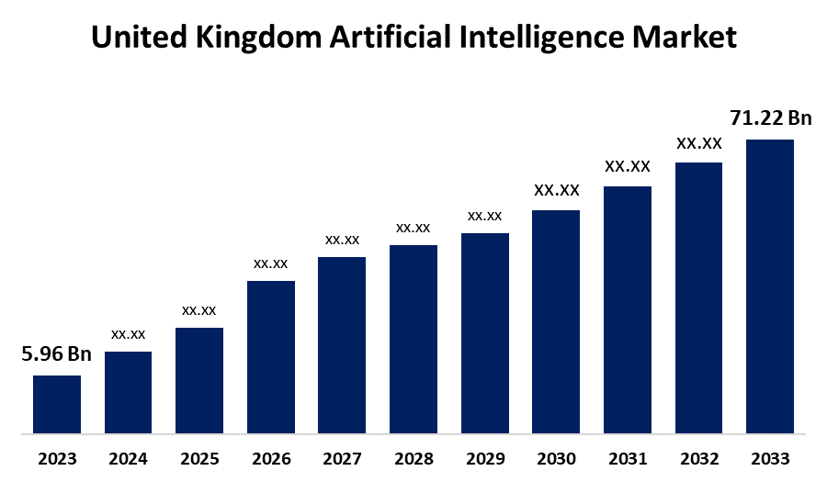
Figure 13: Revenue of the UK AI Industry
(Source: Spherical Insights, 2024)
- Healthcare
In the USA healthcare sector, the recruitment of nurses has increased by 45.7% in 2025 (Government of USA, 2025). The adoption of “buy strategies” has helped the industry acquire the services of trained healthcare staff that has improved its operational quality. On the other hand, the adoption of “bind strategy” has assisted the sector in providing financial and operational incentives to the workers that has enhanced the engagement level of the employees.
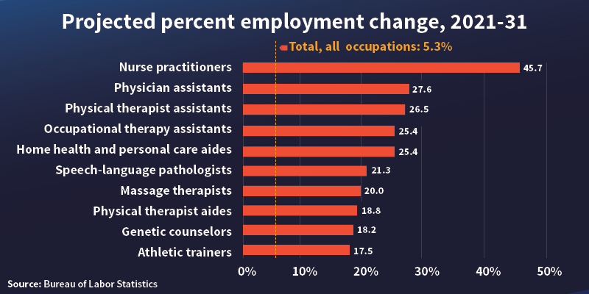
Figure 14: Recruitment of Nurses in the USA
(Source: Government of USA, 2025)
- Hospitality
Technological transformation to improve global hospitality market size reached $5,244.22 billion in 2024 and expanded to $7011.13 billion in 2029 with a CAGR rate of 6.1%. Thus, “Build” strategies are also incorporated into the platform of automated guest service for predictive maintenance. In addition, “buy” pathways are expanding as hotels implement cloud-based PMS and CRM tools to boost efficiency.
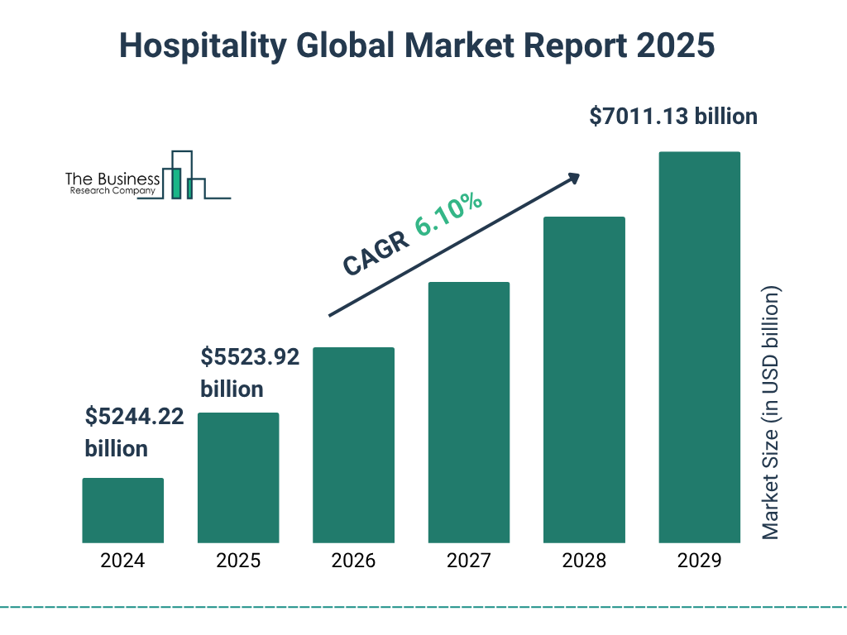
Figure 15: Global hospitality market
(Source: BRC, 2025)

Question 4

4.1 Introduction
The implication of global and adaptive competencies necessary for MBA due to tacking future organisational roles with fast-changing environments. These adaptive skills enable them to fit across cultures, respond to market shifts, lead diverse teams, and make strategic decisions in negative situations. As a result, it improves impairment employability, leadership effectiveness, and long-term career success in global business.

4.2 Self-Assessment (Gibbs' Reflective Cycle)
- Description
During the completion of my MBA Course, I was involved in developing projects related to ChatGPT that helped me in improving my technical knowledge. I also had the availability of a diversified team that helped me in enhancing my communication skills through detailed interactions related to my courses.
- Feelings
Based on my experience from the MBA course, I feel that I was able to evaluate the feedback regarding my presentation that assisted me in improving my confidence of undertaking complex responsibilities. I also resolved conflicts between my team members that helped me strengthen my relationships with my superiors.
- Evaluation
From the MBA module, I have gained valuable insights by ability to handle multiple data, adaptability in handling new software and communicating with the team members for informed decisions. I used my problem solving skills to manage conflict among team members by my ability to satisfy immediate needs while nurturing a positive atmosphere in the workplace.
- Analysis
I have improved my technical knowledge by utilising technologies such as MS Teams and ChatGPT in my MBA Project. I also improved my leadership skills through enhancing my creativity and providing solutions to my team members.
- Conclusion
During completion of my MBA courses, I think that my leadership qualities, self-directed learning help to develop my self efficacy which is more reliable for professional development. I have mentioned that my analytical and communication skills help me to engage with the project which helps to boost overall confidence in the rapidly changing environment.
- Action Plan
Goal | Action Steps | Timeline | Expected Outcome
Strengthen technical expertise | - Complete advanced AI and software workshops  - Practise using analytical tools weekly | 3–6 months | Improved efficiency and confidence in digital tasks
Enhance leadership and communication | - Lead team discussions  - Seek monthly feedback from mentors | Ongoing | Stronger teamwork, clearer communication, and better decision-making
Table 1: Action Plan

4.3 SWOT Analysis
Strength | Weakness
- Strong analytical thinking and problem-solving skills.  - Effective communication in group and professional settings. | - Tendency to overanalyse decisions.  - Limited experience with advanced digital tools.
Opportunity | Threats
- Growing demand for adaptable, globally minded professionals.  - Ability to develop leadership skills through MBA projects. | - High competition in the job market.  - Rapid technological changes requiring constant skill updates.
Table 2: Personal SWOT

4.4 Development Plan

4.4.1 Strengths
- My primary strength is to access information instantly by increasing cross functional and adoptability skills through adoption of a new HR platform.
- I through my analytical skill constantly solve problems through informed decision making addressing better outcome in handling talent analytics platform

4.4.2 Weakness
- I have the ability to improve my leadership skills which hamper my continuous learning opportunities in explaining real-world experiences.
- I faced a struggle to deal with job trends in the market due to ineffective critical thinking skills by reduction of biassed information.

Conclusion
The key analysis also revealed the strategic importance of HRM in maintaining the stability of the global market through external factors of technological advances, demographic transitions, and geopolitical tensions. Thus, proper adoption of workforce strategies and investment in reskilling also be helpful to improve potentiality of risk management practice. Overall, completion of MBA graduate course also be helpful for implication of global awareness activity in managing complex business environment associated with future carrier option.

Reference list
Bernzweig, M. (2024) Big Rise of HR Technology Skills: 11 Top Statistics and Data, Software Oasis. Available at: https://softwareoasis.com/hr-technology-skills/.
BRC (2025) Hospitality Market Analysis, Size And Trends Global Forecast To 2022-2030, www.thebusinessresearchcompany.com. Available at: https://www.thebusinessresearchcompany.com/report/hospitality-global-market-report.
Caixin (2024) China’s Shrinking Workforce Affects Economic Transition, Expert Says - Caixin Global, Caixinglobal.com. Available at: https://www.caixinglobal.com/2016-11-21/chinas-shrinking-workforce-affects-economic-transition-expert-says-101009777.html (Accessed: 8 November 2025).
Casciani, D. (2023) ‘UK net migration hits all-time record at 504,000’, BBC News, 24 November. Available at: https://www.bbc.com/news/uk-63743259.
CIPD (2023a) CIPD | Level 5 People Professional Apprenticeship, CIPD. Available at: https://www.cipd.org/uk/learning/apprenticeships/standards/level-5-people-professional-apprenticeship/ (Accessed: 8 November 2025).
CIPD (2023b) The True Story of the UK Gig Economy, CIPD. Available at: https://www.cipd.org/uk/views-and-insights/thought-leadership/cipd-voice/uk-gig-economy/.
Contributor, G. (2024) Workforce Skills Gap Trends 2024: Survey Report, Springboard Blog. Available at: https://www.springboard.com/blog/business/skills-gap-trends-2024/.
ECA (2023) Global Mobility in 2023: what will your biggest challenges be?, Eca-international.com. Available at: https://www.eca-international.com/insights/blog/february-2023/global-mobility-in-2023-what-will-your-biggest-ch.
Eightfold (2024) Eightfold AI for Microsoft Teams, Eightfold. Available at: https://eightfold.ai/eightfold-ai-for-microsoft-teams/ (Accessed: 8 November 2025).
Emma (2024) HSE 2024 Statistics Reveal Biggest Cause of Construction Fatalities - Roofing Today, Roofing Today. Available at: https://roofingtoday.co.uk/hse-2024-statistics-reveal-biggest-cause-of-construction-fatalities/.
Esposito, M. and Fitoussy, A. (2025) Responsibly designed automation and the recruitment process, World Economic Forum. Available at: https://www.weforum.org/stories/2025/09/ai-powered-recruitment-inclusion-transparency/.
Fennell, A. (2024) AI in Recruitment statistics UK 2024 | Latest reports & data, StandOut CV | Create a winning CV in minutes with our simple CV builder. Available at: https://standout-cv.com/stats/ai-in-recruitment-statistics-uk.
Financial times (2025) FirstFT: Confusion after White House makes changes to work visas, @FinancialTimes. Financial Times. Available at: https://www.ft.com/content/711b5eed-ad3e-41f9-80c9-c50176d22f8d (Accessed: 8 November 2025).
GlassDoor (2025) https://www.glassdoor.co.uk/Salaries/human-resources-salary-SRCH_KO0,15.htm. Available at: https://www.glassdoor.co.uk/Salaries/human-resources-salary-SRCH_KO0,15.htm.
Government of USA (2025) World Health Day: Celebrating Good Health and In-Demand Healthcare Jobs, DOL Blog. Available at: https://blog.dol.gov/2023/04/05/world-health-day-celebrating-good-health-and-in-demand-healthcare-jobs.
GSK (2023) GSK launches £6m programme to boost STEM career progression for young people from under-represented groups in the UK | GSK, www.gsk.com. Available at: https://www.gsk.com/en-gb/media/press-releases/gsk-launches-6m-programme-to-boost-stem-career-progression-for-young-people-from-under-represented-groups-in-the-uk/.
Kenny, C. (2024) The Perils of a Declining Labor Force, Center For Global Development. Available at: https://www.cgdev.org/blog/perils-declining-labor-force.
Kumar, A. (2025) Why AI is replacing some jobs faster than others, World Economic Forum. Available at: https://www.weforum.org/stories/2025/08/ai-jobs-replacement-data-careers/.
Li, L. (2022) ‘Reskilling and Upskilling the future-ready Workforce for Industry 4.0 and beyond’, Information Systems Frontiers, 24(3), pp. 1–16. doi: https://doi.org/10.1007/s10796-022-10308-y.
Lytton, C. (2024) AI hiring tools may be filtering out the best job applicants, BBC. Available at: https://www.bbc.com/worklife/article/20240214-ai-recruiting-hiring-software-bias-discrimination.
Malik, S. (2025) H1B Lottery Results: The Definitive Guide on 2024-2025 Lottery Chances, VisaNation Law Group. Available at: https://www.immi-usa.com/h1b-lottery-results-chances-odds/.
Masterson, V. (2024) More and more jobs can be done from anywhere. What does that mean for workers?, World Economic Forum. Available at: https://www.weforum.org/stories/2024/01/remote-global-digital-jobs-whitepaper/.
McKinsey & Company (2024) Race in the UK workplace: The intersectional experience, McKinsey & Company. Available at: https://www.mckinsey.com/institute-for-economic-mobility/our-insights/race-in-the-uk-workplace-the-intersectional-experience.
McNeil, R. (2024) Election 2024: the UK’s migration situation in five charts, The Conversation. Available at: https://theconversation.com/election-2024-the-uks-migration-situation-in-five-charts-232190.
PwC (2023) Productivity has risen with remote/hybrid working, but worker trust may pose a larger challenge: PwC survey, PwC. Available at: https://www.pwc.com/gx/en/news-room/press-releases/2021/pwc-future-of-work-survey-2021.html.
PwC (2024) The next test of corporate resilience: how to manage risks from geopolitical and related crises, PwC. Available at: https://www.pwc.com/us/en/services/consulting/cybersecurity-risk-regulatory/library/managing-risks-from-geopolitical-crises.html.
Soliman, I. (2025) Reskilling trumps wellbeing as top HR challenge for 2025, study shows, Peoplemanagement.co.uk. PeopleManagement. Available at: https://www.peoplemanagement.co.uk/article/1914280/reskilling-trumps-wellbeing-top-hr-challenge-2025-study-shows.
Sonnad (2024) The languages most in demand in the UK, World Economic Forum. Available at: https://www.weforum.org/stories/2016/10/the-languages-most-in-demand-in-the-uk/ (Accessed: 8 November 2025).
Spherical Insights (2024) U.K. Artificial Intelligence Market Size, Growth, Forecasts To 2033, Spherical Insights. Available at: https://www.sphericalinsights.com/reports/united-kingdom-artificial-intelligence-market.
Veldhuizen, N. V. (2024) UK political stability and market confidence spur interest in FTSE 250 Index derivatives, Lseg.com. Available at: https://www.lseg.com/en/insights/ftse-russell/uk-political-stability-and-market-confidence-spur-interest-in-ftse-250-index-derivatives.
WEF (2023a) The future of jobs in the age of AI, sustainability and deglobalization. Available at: https://www.weforum.org/stories/2023/05/future-of-jobs-in-the-age-of-ai-sustainability-and-deglobalization/.
WEF (2023b) The Reskilling Revolution: 350 Million People Reached with Future-Ready Skills, Education and Jobs, World Economic Forum. Available at: https://www.weforum.org/press/2023/01/the-reskilling-revolution-350-million-people-reached-with-future-ready-skills-education-and-jobs/.
White, B. (2022) Data Protection for HR Professionals | Common HR Challenges, Harper James. Available at: https://harperjames.co.uk/article/data-protection-for-hr/.
World Economic Forum (2025) The Future of Jobs Report 2025, World Economic Forum. Available at: https://www.weforum.org/publications/the-future-of-jobs-report-2025/in-full/3-skills-outlook/.
Zaheer, M. (2024) Why Hiring an AI Ethicist or AI Policy Expert is Essential for UK Businesses. Available at: https://hireaiexperts.co.uk/blogs/why-uk-businesses-need-ai-ethicists-policy-experts/.

