
Write a report of 2000 words demonstrating your understanding of the models of communication, the communication skills discussed in class and the advantages and disadvantages of Communication Technology and refer to any case studies done to show how these helped your understanding.
Firas Jghaimi student number: 2029865 Lecturer: Soban Sadiq Module: “Effective team working and communication” (BMSW4002_LON)


Table of contents
- Introduction…………………………………………………………………………………………..2
- Communication models…………………………………………………………………………3
- Communication skills……………………………………………………………………………..7
- Conclusion……………………………………………………………………………………………..9
- References…………………………………………………………………………………………..10

Introduction
“Communication”. From the Latin “communicare”, “to be in relation with”. An apparently simple word that hides a lot of meanings. It is difficult to give a definition to such a complicated concept. It could be described as an imaginary bridge built between two or more people to share their thoughts, news and feelings towards something. Its importance in nowadays businesses is huge, without communication no business would survive because it is simply the base of our society and everything involving social interactions.
Due to the importance communication has, people usually ensure no misunderstandings occurs during the process, but sometimes people may face some problems that can create uncomfortable situations such as barriers.
There are a lot of types of communication barriers: physical, emotional, linguistic, cultural and so on.
Physical barriers are anything tangible in real world that can interfere with the communication just by being there or by not being there. Nowadays physical barriers mainly obstacle the journey of a message from one point to another. They can be whether natural or human made, natural physical barriers may be rivers, trees, mountain and so on, while human made barriers can be walls.
Emotional barriers are the negative feelings we might have while listening to something unpleasant said by people we are having a conversation with. Our feelings and emotional state are determined by the people surrounding us and the message’s subject delivered to us. Emotions that usually impact negatively communication are anxiety, fear and sadness.
Linguistic barriers are the difficulties that people face when working in a multicultural environment and they are faced by two or more people whose main language is not the same. For this reason, now more than ever everyone needs to learn at least English and another language to make sure they can communicate with everyone no matter where they come from, in order to make sure there are no misunderstandings while communicating. Experts advise learning one from Spanish, French, or Arabic because they are the languages used in a lot of countries all over the world on different continents and Arabic, in particular, is known as the language of the future because it is used in the countries that supply oil all over the world such as the United Arab Emirates, Kuwait and Qatar.
Cultural barriers are a type of barrier that is usually bonded to language ones. People coming from different countries, or even different continents, will inevitably have a different cultural backgrounds which may cause some uncomfortable situations or even clashes during the time. The main reason this happens is that some of the actions people do on a daily basis may be unusual or even forbidden for people from a different ethnicity. For example in the western countries, pork meat is very important in the daily diet of the people there, while in Middle-Eastern countries and in the northern part of Africa people do not deal with this animal in the food environment because majority of the people there are Muslim and they are forbidden to eat this specific meat. A similar situation can be found in India as well, where a high percentage of the population follows Hinduism, a religion which believes Cow is a holy animal and for this reason it is absolutely forbidden to eat beef meat.
Communication models
Shannon and Weaver (1948/49)
In 1949, the two social scientists E. Shannon and Warren Weaver decided to create a communication model and named it after them. This model is also known as the “mother of all models”, and it can be represented in this way:
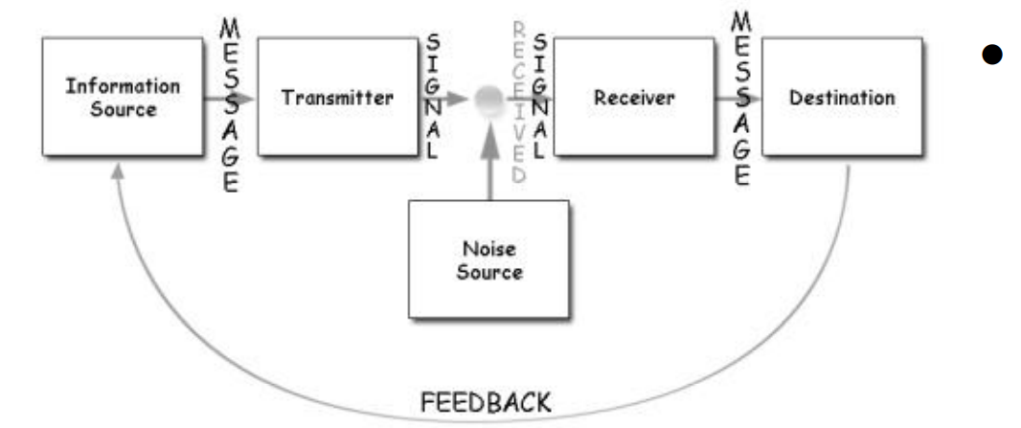
- As shown in the picture, the sender, marked as “information source” is the person who makes the messages and makes the decision regarding what channel the messages shall be sent from.
- We then have the Encoder, marked as “transmitter”, which is basically a sender that uses a translating system that converts messages into binary data or another type of signal
- The “channel” is simply the platform used to send the messages
- There is a “decoder”, which is the receiver and it can either be a person or a system that converts the binary data or signals into messages
- The receiver is also the final destination of the message and it gives feedback related to the message received
- Noise is the disruption faced while transmitting the message and it is caused by the noise generated by people and the environment that surrounds the way the message travels and it prevents the message from reaching the receiver accurately
The sender puts his thoughts regarding something in an encoded message taking responsibility for deciding what technical medium (like for example a phone) he should use to send the message. Once the receiver receives the message he will decode it into thoughts and ideas so he can understand it. However, noise disruption could impact the channel causing issues in the transmission progress of the message.
During one of the lectures, we applied this model of communication and noticed that the story of Maria and Pedro has been hugely impacted by a disruption that caused the misunderstanding that made Pedro go to the kitchen instead of buying the chicken he has been asked for by Maria
Schramm’s model of communication (1954)
In 1954, Wilber Schramm released his model of communication, named Schramm’s model. While creating this model, Wilber was influenced by Shannon and Weaver’s “mother of all models”.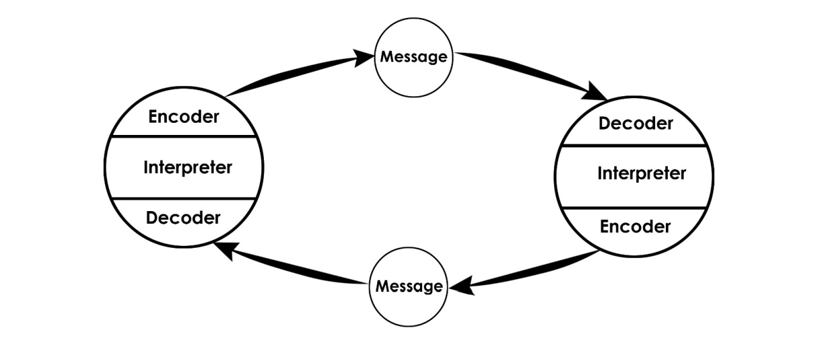
Encoding is a fundamental element since it translates the ideas and thoughts into messages and initiate the communication cycle. When the message reaches the receiver, the receiver automatically tries to understand what he is being told. For this reason encoding and decoding are very important, since without them information would never travel from one person to another .
According to Schramm, communication is a two-way system and therefore, in order to be made properly, the sender needs a feedback from the receiver.
Also, in Schramm’s model elements like knowledge, cultural background and experience need to be considered to ensure an effective communication since people coming from different backgrounds might have different points of view and opinions regarding a topic.
Berlo’s model of communication (1964)
Communication theorist David Merlo created a new communication model known as “Berlo’s SCMR model of communication”. Once again, this model was influenced by Shannon and Weaver’s one. Berlo identified elements that have a positive impact on the communication between people.
This model has something in common with Schramm’s: encoding and decoding have a massive importance in both models.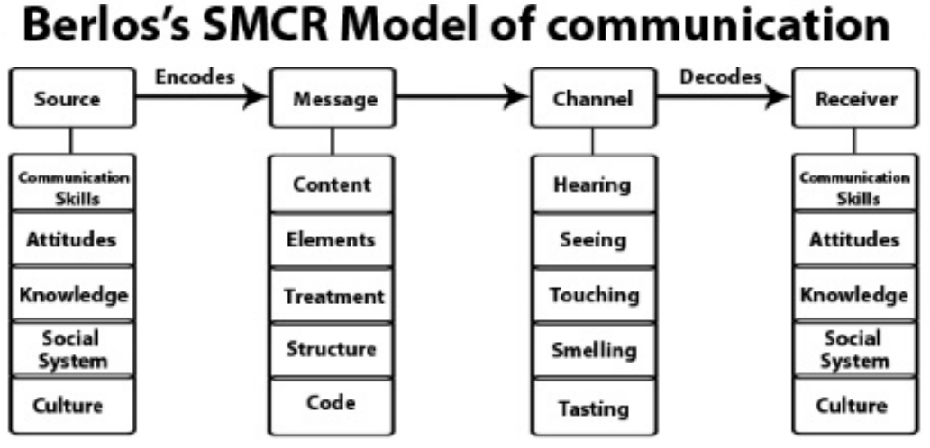
To understand it better, Berlo’s model has been divided into four sections (SMCR): Sender, Message, Channel and Receiver.
- The sender is the starting point of communication, he holds the responsibility of sending the message to the recipient. The sender might be positively or negatively affected by his own communication skills, depending on whether his skills are advanced or not his skills actually are. The sender’s behaviour can also be an element that influences the message too just like the culture and social systems. People’s beliefs, cultural background, religion and values can make a difference in processing the message.
- The message is the information that the sender develops and sends to the receiver. It can be a an image, a written text, a speech, etc. The message content can influence the message itself; elements like non-verbal signals lacks, the transmission way of the message, the message structure, in what form is the message being sent (email or video)and in what way the message has been arranged.
- The channel is the method chosen to transmit the message from the sender to the receiver and vice versa. It can be mobile phones, internet, mail and so on. It is also important to make clear that even the human sense acts as a channel for communication and it can affect the efficiency of the channel itself via hearing, touching, smelling, seeing and tasting.
- The receiver is the message’s final destination and it is the person who receives the message sent by the sender. Berlo’s model states that the receiver and the sender need to have the same thinking process to ensure a mutual understanding. Other factors that need to be on the same level are attitude, knowledge, communication skills, culture and social system. In Shannon Weaver and Schramm's Model, barriers in communication such as noise and a feedback approach are not considered. As mentioned, communication is one-way, and both parties must conform to the same factor.
Communication skills
Nowadays experts agree in saying that there are four main types of communication: verbal communication, which happens while we are speaking to someone; written communication, such as emails, postcards and letters; visual communication, which includes graphics and maps; and last but not least, non-verbal communication, like body language and proxemics.
Verbal communication consists in transmitting information through speech. In the workplace environment, verbal communication consists in team meetings, phone calls, informal and formal discussions, normal conversations and presentations. An efficient verbal communication is a priority in the employability business because in an organization with a lot of people with different cultural backgrounds it can prevent having problems caused by cultural and language barriers.
Written communication is when information are shared through written words. In the business environment, written communication happens when someone send an email, a letter, a report and so on. Since this written documents are used in a professional environment, they must be formal, clear and concise. It is vital for the businesses to ensure that these points are followed because by doing so they will define themselves. If the points are not matched, readers may think the company is not professional and that it is only a matter of time before it fails. When this specific type of communication is done properly, clients and other businesses will be more likely to start a partnership.
Non-verbal communication is a type of communication-based on body language. According to Forbes, 93% of communication is made through body language, this percentage has been determined thanks to research done by Dr Albert Mehabrian in which he stated that the overall impact of a message depends on a lot of different aspects: 7% words used; 55% hand gestures, postures, facial expressions and other types of body language; 38% rate of speech, tone of voice, vocal pitch and volume. That means that our body speaks more than the words we pronounce, but we still need to use verbal communication after non-verbal communication to make a complete conversation.
Visual communication is the transmission of information via images, symbols and visual forms. To improve the efficiency of visual communication people usually use some visual aids such as short sentences that summarize the main idea behind the project. The most used ways to communicate visually are pictures, maps, posters, graphics and so on. In addition, we can also help ourselves by sending a message using body language.
To the skills listed above, there is one more skill that must be considered too and it is listening. This skill is known as “the neglected skill” because people are usually taught to read, write and speak without considering the importance of listening, that is actually the main reason of why we can remember only 50% of what we hear. To have an idea of how important listening is, in 2009 Stanton said that “unless somebody listens to the message and understands it, there is no communication, only noise”
There are two main categories of listening, active and empathetic.
Active listening is when we listen to something or someone paying attention to what is been said without dealing with distraction sources such as mobile phones assuming what the interlocutor is going to say or completing his phrases.
Empathetic listening is when we listen to someone and try to put ourselves in his shoes to understand his point of view and to figure out how he feels and why he feels in a certain way. This specific type of listening has been analysed during the lecture in which we went through the story of “Max the multitasker”. In particular, we noticed how Tamara did not put herself in Max’s shoes and have in a very rude way when he did a mistake caused by the big amount of stuff he was trying to do at the same time ruining the party she was wishing to have.

Advantages and disadvantages of communication theory
The communication theory has several advantages and disadvantages we can learn from and apply to our benefit. The way we behave and speak may be similar and different as we communicate. If we share the same experiences and cultural background, we might be able to communicate better. By adapting our communication styles to those who are different from us, we are also more likely to understand and learn about things, knowledge, and cultures that are completely foreign to us. As a result, we become more knowledgeable and sensitive about people's differences and viewpoints.

Conclusion
We should use the gift of communication to learn more about the world we live in. In many ways, we should be able to express our thoughts and interact with one another while maintaining a considerate and respectful approach. This avoids compromising or looking down on others' status within society. Learning about the ways in which we can adjust our practices to make them more acceptable to others is fundamental to creating better understanding between people around the world. Considering the differences in any aspect, as well as communication may be difficult, but learning about the ways in which we can do that creates a better understanding.

References
see, C. and Strate, L., 2022. Children are the living messages we send to a time we will not see. [online] Smfurh.blogspot.com. Available at: <http://smfurh.blogspot.com/2011/03/children-are-living-messages-we-send-to.html> [Accessed 3 May 2022].
Communication Theory. 2022. OSGOOD- SCHRAMM MODEL OF COMMUNICATION. [online] Available at: <https://www.communicationtheory.org/osgood-schramm-model-of-communication/> [Accessed 3 May 2022].
En.wikipedia.org. 2022. David Berlo - Wikipedia. [online] Available at: <https://en.wikipedia.org/wiki/David_Berlo> [Accessed 3 May 2022].
Goman, C., 2022. Busting 5 Body Language Myths. [online] Forbes. Available at: <https://www.forbes.com/sites/carolkinseygoman/2012/07/24/busting-5-body-language-myths/?sh=7a2c05713922> [Accessed 3 May 2022].
2022. [online] Available at: <https://helpfulprofessor.com/shannon-weaver-model/> [Accessed 3 May 2022].
Making Business Matter. 2022. 13 Barriers to Effective Communication & How to Overcome them. [online] Available at: <https://www.makingbusinessmatter.co.uk/barriers-to-effective-communication/> [Accessed 3 May 2022].
Managementstudyguide.com. 2022. Schramm's Model of Communication. [online] Available at: <https://www.managementstudyguide.com/schramm-model-of-communication.htm> [Accessed 3 May 2022].
Businesstopia. 2022. Berlo's SMCR Model of Communication - Businesstopia. [online] Available at: <https://www.businesstopia.net/communication/berlo-model-communication> [Accessed 3 May 2022].
Businesstopia. 2022. Shannon and Weaver Model Of Communication - Businesstopia. [online] Available at: <https://www.businesstopia.net/communication/shannon-and-weaver-model-communication> [Accessed 3 May 2022].

