Effective Team Working and Communication

Submitted by: Constantin Calin
Student Id- 2107673
Table of Contents
Contents
Executive summary 1
INTRODUCTION 1
MAIN BODY 1
How can Abdul develop an effective team 1
What are the types of roles that are needed to create an effective team 3
What type of impact can effective team working have on team success 4
What are the barriers to effective team working 5
CONCLUSION 6
REFERENCES 7

Executive summary
The report is based on a case study of Abdul who is worked in Vodafone and assigned a new project to manage 18 of employees so as to deliver community event with commercial business, stakeholders and voluntary organisations. The team isn’t able to get face to face contact due to restriction of COVID and thus Abdul discuss all the team roles and responsibility to each through digital platform. But in this Abdul receives complaint from community group that they have poor level of communication from project community. In addition, team also faced to achieve respective task and in this Abdul requires taking urgent actions so as to advance effect team working with this success is achieved in timely frame. In this different of theories are supported as GRPI model and in this significant information is developed to achieve systematic understanding in timely frame with this team working get improvised and lead to attain regular based success.

INTRODUCTION
The effective team working and communication is preferred through specific transparency and suitable communication under which individual is encouraged to process effective decision making with this sustainable changes are attained in reliable manner (Jacox, 2019). The effective team consist of members those have specific unity and clear vision with this employees are able to achieve motivated surround and in this measurable changes are attained with this employee engagement and commitment both get enhanced on direct basis. The team also have clear mission, lots of discussion, active listening, openness and trust, disagreement, issue-oriented criticism with this excellent working is supported in reliable manner. The report is based on case study of Abdul who worked in Vodafone, UK and faces problem related to team working and it resulted to fail in project and members of team are looking to resign. Thus report consist of theoretical approach of effective team, types of role required to create effective team, impact of effective team working and is barrier over success of team.

MAIN BODY

How can Abdul develop an effective team
The development of effective team is based on well communication, establishment of suitable trust and respect, connect with all the members of teams, practice feedback, encourage contribution level, provide and maintain an effective working surround. Abdul face complexity within working consequence and in this it is hard for business to manage and control and for this there is a need to develop theoretical understanding with this reliable and relevant change is induced within working of a team and it is as supported below as:
GRPI Model: It is a model based on team effectiveness and stands for goals, roles, procedure and interpersonal relationship that assist to understand and acknowledge behaviour of a team (Juneja, 2020). The team is considered as wokhorse in organisation and in this Abdul acknowledge the series of working and with this maintain focus to develop effective interpersonal relationship.
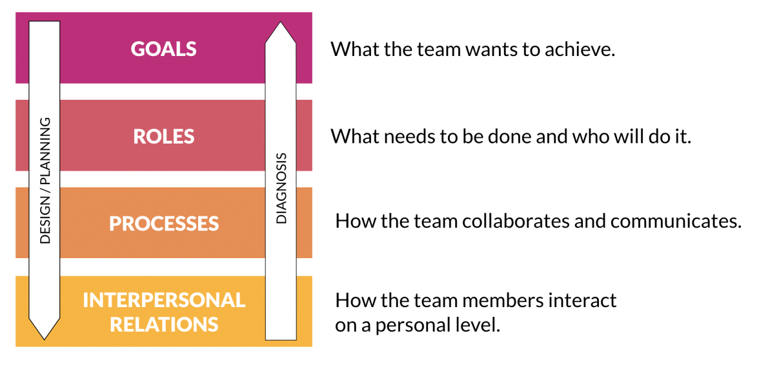
Goal: In this team must have developed and design a clear goals and objectives and in this Abdul ensure to accomplish preferred working so as to attain effective understanding about working. In addition, it also assists to maintain respective working in specific direction that lead to resolve all the disagreements and disputes.
Roles: In this each and every member of a team ensure to advance preferred requirement with this acknowledge respective knowledge and authority under which accountability get developed with precision. As not knowing maintain lead in conflict thus Abdul ensure to direct respective roles and responsibility to each member of team.
Processes: It is based on setting of specific process that is take place so as to operate the team working and its attentiveness in successful manner (Hayes, 2020). It isn’t only limited to decision making, workflow but also consist of suitable communication practice, conflict resolution strategies, procedures and many others as well.
Interpersonal relations: It is related to crucial team making and in this Abdul ensures to develop and create specific relationship with others and in this ensure to develop and build effective trust, adequate adaptability and efficient interaction.
In this Abdul is able to depict a clear image of team performance under which specific changes are induced as per according to requirement and demand of situation. It also tends to recognise shared emotions and time with this transformation of ideas and concept get developed in systematic form.

What are the types of roles that are needed to create an effective team
According to the viewpoint of Paul Merchant, 2022, Belbin identified the nine roles of team and consist of three different categories as action-oriented, people-oriented and thought oriented roles (Hawkins, 2021). Shaper is a role that is performed by individual those are relish and dynamic challenges instead of quite the challenges and always work with positive approach, Implementer is a role that is played by one who is efficient, practical and well-organised with this able to implement thoughts and ideas into reality, finisher used to be perfectionist and able to detect errors and omit them as per requirement, coordinator always possess the traditional working in team and be confident and mature to deal with different situation, team workers is the one who ensure to remain united and resolve conflict without affecting team working, resource investigator is inquisitive and enthusiastic to develop networking skills, monitor evaluator is able to maintain critical thinking with this decision making get improvised, specialist is the one who is having expert knowledge about specific area thus contribute with expertise, plants is an innovative one who work with original idea and approaches.
As per according to the viewpoint of SACHIN KHANNA, 2022, building of effective team is considered as critical aspect as it ensure to take inclusion of right people with right role and appropriate responsibility. In effective team it is required that each and every individual assist others to encourage team interaction and bonding. The roles of leader consist of leader as they come with suitable effectiveness with this able to influence others to attain better performance (Folsom-Kovarik, Sieh and Sinatra, 2021). The leader is expected to generate suitable guidance, motivation, goals and direction. Creative director is the one who is able to work with creative approach and with this critical success is achieved and in this team is able to develop unique ideas. Facilitator is the one who worked to assist decision making of business and assist others to understanding about respective goals and objectives with this path of achievement get developed with prominence. Coach offer adequate support with this suitable training is offered and in this approach of working gets developed with prominence and team player is the one who is able to make efficiency task with this ensure that misunderstanding get reduced and everyone is clear about respective thoughts and ideas.
As per according to point of view of Sherrie Scott, 2022, the sociability traits basically related to preferred characteristics that possess and encourage to build effective relationship with this natural display is process in terms of self control, integrity, adaptability and team spirit. Leadership is an approach that is related to specific trait and it allows the employee to make preferred interaction with others that aid to gain specific trust and respect from staff and co-workers. Employee interaction also assists to improvise interaction of team as it assist to manage and resolve all the conflicts with effectiveness (Prasad, 2020). The advancement of opportunities basically creates more solution and builds appropriate confidence to advance working opportunity in reliable manner.

What type of impact can effective team working have on team success
According to the viewpoint of TRACY MIDDLETON, 2022, the collaborative problem solving always tends to create and generate better outcome and the use of team and its collaboration is much consistent within today’s working. The organisational effectiveness and teamwork is considered as essential aspect and it turn to generate suitable success as each individual is having specific skills, knowledge, talent that collectively advances working value of an organisation on direct basis (Tannenbaum and et. al., 2021). The team working assist to advance better problem solving, increase potential for innovation and development, make team member happier and satisfied, enhance personal and professional growth, less burnout, create more opportunity for growth, boost ability of productivity and profitability, advance risk taking capability, reduces ability of mistake and expand working creativity with this possible solutions are created to deal many of perspective that is related to brainstorming with this innovative changes are attained in constructive manner.
According to the point of view of Lisa Magloff, 2022, the team work is involved with many of people those have worked together so as to maximised and enhance efficiency as well as reach of working towards attainment of common goal. The team working supposed to advance organised working under which developed changes are induce and it turn to create and form organised change under which team members and their experience get turn to generate many of benefits that consist of enhanced efficiency, morale, innovation and financial saving. It tends to improvise morale by promoting ownership, build trust and enhance relationship.
As per according to the point of view of Lisa McQuerrey, 2022, the team working consist of improvised productivity, advancement of morale under which quality of project and services of organisation get developed with prominence (Wildman and et. al., 2021). The team working pushed out the dynamic of group with this strong working culture is developed that assist to attain preferred objective in timely frame and it also turn to enhance and attain both short and long term goal with support of specific strategies. It buoyed the mutual support with this defensive working is created and it also turn to generate effective working and suitable collaboration with this ability to achieve respective outcome get developed as per basis of higher quality goods and services of business.

What are the barriers to effective team working
As per according to viewpoint of Victor Garro-Abarca, 2022, in digital era the process and routine of business dynamics get changes and in this many of organisation have adapt globalisation platform to strive respective success and growth (Sherman and et. al., 2020). The virtualisation is digital transformation and life of organisation affect relations of employee as the technology is accelerated to advance technological implication as cloud computing. The virtual team facilitate to joint innovation and creation as they didn’t have enough of time to travel and restriction of pandemic also affects the same. Thus pandemic also forced the employee to perform at remote working and it consists of confusion that tends to affect performance of an organisation.
According to viewpoint of Megan Thompson, 2021, the employee engagement is considered as barrier in pandemic as it hinder the performance of employee and organisation that turn to generate negative consequences. Due to pandemic many of issues has been faced by people and in this productivity get affected as switched working resulted to affect wellbeing and mental health of employees. The employers are responsible for safety and health of workers with concern of reasonable practicable as social isolation affect 30.9% of adults and they start feeling loneliness. The increased stress and anxiety also affects the working performance of employees and it enhances disruption and uncertainty and it resulted to induce sudden impact over physical and social connect.
According to point of view of Marcel Fowler, 2022, the pandemic resulted to induce unprecedented impact over all across the nation and it also affects the lives and mental wellbeing of employees (Dirks, 2019). The indefinite lockdown and reinsert of routines tends to create unfamiliar situation and in this work from home resulted as obstacle for business and it induce effective, efficient or energised interaction as in between employee and team. Virtual space tends to affect personal relation with this there is obvious troublesome to interact with others and it lead to create miscommunication and in this team isn’t able to achieve its goal in timely frame.

CONCLUSION
It has been concluded from the above that effective team working is supported with clear and effective communication, delegation, ideas, support and efficiency and associated with many of characteristics such as shared goals, defined roles, effective and timely interaction, optimistic approach, mutual respect and trust, shared skills and knowledge and many others as well. In addition, in order to enhance the approach of working team effectiveness is supported through GRPI model and with this management is able to acknowledge preferred understanding with this reliable understanding is developed and created in systematic manner. Moreover, the barrier of communication is resulted through active involvement and preferred engagement of employees as in this individual is able to advance working suitability in timely frame.

REFERENCES
Books and Journals
Dirks, J.L., 2019. Effective strategies for teaching teamwork. Critical care nurse, 39(4), pp.40-47.
Folsom-Kovarik, J.T., Sieh, J. and Sinatra, A.M., 2021, May. Reasoning about Team Roles and Responsibilities for Team Assessment. In Proceedings of the Ninth Annual GIFT Users Symposium (GIFTsym9) (p. 201). US Army DEVCOM–Soldier Center.
Hawkins, P., 2021. Leadership team coaching: Developing collective transformational leadership. Kogan Page Publishers.
Hayes, C., 2020. Team Transitions. In Transition Leadership (pp. 67-83). Springer, Cham.
Jacox, B., 2019. What are the key qualities and skills of an effective team coach?. In The practitioner’s handbook of team coaching (pp. 353-364). Routledge.
Juneja, K., 2020. Design of Programmer’s Skill Evaluation Metrics for Effective Team Selection. Wireless Personal Communications, 114(4), pp.3049-3080.
Prasad, L.M., 2020. Principles and practice of management. Sultan Chand & Sons.
Sherman, J.M. and et. al., 2020. Barriers to effective teamwork relating to pediatric resuscitations: perceptions of pediatric emergency medicine staff. Pediatric emergency care, 36(3), pp.e146-e150.
Tannenbaum, S.I. and et. al., 2021. Managing teamwork in the face of pandemic: evidence-based tips. BMJ quality & safety, 30(1), pp.59-63.
Wildman, J.L. and et. al., 2021. Student teamwork during COVID-19: Challenges, changes, and consequences. Small Group Research, 52(2), pp.119-134.
ONLINE
Merchant. P., 2022. What Are the Nine Types of Team Roles?. [Online] Available through: < https://smallbusiness.chron.com/benefits-having-sociability-traits-workplace-11003.html >.
KHANNA. S., 2022. What Are The 5 Roles Of An Effective Team?. [Online] Available through: <https://wheon.com/what-are-the-5-roles-of-an-effective-team/>.
Scott. S., 2022. What Are the Benefits of Having Sociability Traits in the Workplace?. [Online] Available through: <https://smallbusiness.chron.com/benefits-having-sociability-traits-workplace-11003.html>.
MIDDLETON. T., 2022. The importance of teamwork. [Online] Available through: <https://www.atlassian.com/blog/teamwork/the-importance-of-teamwork#:~:text=Research%20shows%20that%20collaborative%20problem,job%20satisfaction%2C%20and%20reduces%20stress.>.
Magloff. L., 2022. What Are the Benefits of Teamwork in Business?. [Online] Available through: <https://smallbusiness.chron.com/benefits-teamwork-business-3250.html>.
McQuerrey. L., 2022. What Are the Benefits of Teamwork on Organization Effectiveness?. [Online] Available through: <https://smallbusiness.chron.com/benefits-teamwork-organization-effectiveness-78220.html>.
Abarca. V.,2022. Virtual Teams in Times of Pandemic: Factors That Influence Performance. [Online] Available through: <https://www.frontiersin.org/articles/10.3389/fpsyg.2021.624637/full>.
Thompson. M., Dismantling Employee Engagement Barriers During Covid-19 and Beyond. [Online] Available through: <https://wethrive.net/guides/dismantling-employee-engagement-barriers-during-covid-19-and-beyond/>.
Fowler. M., 2022. COVID-19: Breaking Down Barriers to Communication When WFH. [Online] Available through: <https://www.newmotionlabs.com/all-articles/covid19-working-from-home-c2j4t-a3dhr-mpxfr-tszxg-7tmd5-7prgh-rcnw8-wyxbw>.

