

Strategic Marketing

Strategic Marketing

Student name: Kaiyi Yan

Student ID number:2405907

Lecturer：Gwyneth Jones

Module code：BMBM6016

Word count：2682words

Executive Summary
This marketing plan outlines a strategy to enhance Five Guys UK's market position by addressing a critical weakness: low mobile app user retention (58%) despite significant growth in mobile ordering (projected 48% by 2025). The core objective is to redevelop the Five Guys mobile application to significantly improve user experience, boost retention to 70%, and increase the proportion of total UK sales via the app to 55% within 18 months.
The strategy focuses on customer-centric digital transformation through a revamped app featuring an intuitive UI/UX, advanced customization, real-time order tracking, and a compelling tiered loyalty program. This initiative targets existing digitally-savvy customers and younger demographics, positioning the app as "Your Personal Five Guys Experience: Premium Quality, Customized for You, Rewarded Every Time."
Tactics involve a multi-channel promotional launch, comprehensive staff training, and continuous app monitoring and iteration. Key Performance Indicators include app user retention, percentage of sales via the app, and customer satisfaction scores. Successful execution of this SOSTAC-aligned plan is expected to strengthen Five Guys' competitive advantage, cultivate customer loyalty, drive mobile-derived revenue, and enhance long-term profitability in the dynamic UK fast-food market.

CONTENT
Executive Summary 2
1.0 Introduction 4
2.0Main Findings 4
3.0Situation Analysis (S) 5
3.1 Summary of Five Guys' Current Market Position 5
3.2 Chosen Area of Focus for Improvement/Innovation & Justification 6
3.3 Focused SWOT Analysis (relevant to the Chosen Area of Focus) 7
4.0 Objectives (O) 9
4.1 Overall Marketing Objective (for the Chosen Area of Focus) 9
4.2 Specific SMART Objectives 9
5.0Strategy (S) 10
5.1 Strategic Direction (to address the Chosen Area of Focus) 10
5.2 Segmentation, Targeting, and Positioning (STP) (for the initiative) 11
6.0 Tactics (T) – Marketing Mix (7Ps) 11
6.1 Product 12
6.2 Price 12
6.3 Place 12
6.4 Promotion 12
6.5 People 13
6.6 Process 13
6.7 Physical Evidence 13
7.0 Action (A) 14
7.1 Implementation Plan Outline 14
7.2 Broad Timeline Overview 15
8.0 Control (C) 16
8.1 Key Performance Indicators (KPIs) 16
8.2 Monitoring, Measurement & Evaluation 16
8.3 Budget Considerations Overview 17
8.4 Adaptation and Continuous Improvement 17
9.0 Recommendations 18
10.0 Conclusion 19
References 20

1.0 Introduction
This marketing plan outlines a strategy to bolster Five Guys UK's competitive standing by tackling a key improvement area identified in the marketing audit. Five Guys, renowned for premium fast-food, notably fresh burgers and hand-cut fries (Anon, 2024), navigates a dynamic UK market. Employing the SOSTAC framework, this plan details the strategic direction, objectives, and tactical execution. Informed by the audit's internal and external analyses, which highlighted evolving consumer habits, technological shifts (Sheetal Temara, 2024), and economic pressures (FoodManufacture.co.uk, 2024), this plan innovatively aims to enhance customer engagement and drive growth. Successful execution will leverage core strengths like food quality and customization (Anon, 2024), strengthening market share and profitability, consistent with foundational marketing principles (Fahy & Jobber, 2015), ensuring Five Guys' sustained relevance.

2.0 Main Findings
Following the internal and external audits, the main finding is a critical strategic vulnerability for Five Guys UK: despite significant growth in mobile ordering (projected 48% by 2025) and strong brand equity, the current mobile application exhibits poor performance, evidenced by a low user retention rate of 58%, well below the industry average. This represents a substantial missed opportunity to convert digital traffic into loyal customers and direct revenue. The underperforming app hinders the ability to capitalize on personalization trends and build deeper customer relationships in an increasingly digital marketplace. Addressing this gap is paramount not only for capturing growth but also for optimizing a direct sales channel to potentially mitigate rising operational costs. Therefore, enhancing the mobile app user experience and functionality emerges as the key strategic imperative for improved market performance and competitive positioning.

3.0 Situation Analysis (S)

3.1. Summary of Five Guys' Current Market Position
Five Guys UK operates as a premium fast-food entity, differentiated by high-quality, fresh ingredients—its "no freezer" policy, hand-cut fries, and over 250,000 customization options (Anon, 2024)—appealing to a less price-sensitive clientele (Evangelista, 2024). However, external pressures are significant. This analysis will be based on the theoretical steps of the PESTLE model as shown in Figure1 analysis. Brexit-related political uncertainties affect supply chains and raw material costs (Wright, 2024), while policy changes like increased National Insurance contributions are projected to cost £4 million, impacting expansion (Woolfson, 2025). Economically, UK inflation at 5.2% in 2024 drove an 8.3% rise in ingredient costs (FoodManufacture.co.uk, 2024), and a 6.7% minimum wage increase from April 2025 will escalate labour costs (Woolfson, 2025). Socially, growing health consciousness (Quinn, 2025) contrasts with fast food's obesity image, despite 60% of UK consumers visiting weekly (Quinn, 2025). Technologically, while mobile orders grew from 35% (2023) towards a projected 48% (2025) (Sheetal Temara, 2024), app retention is low. Environmentally, Five Guys shows commitment via the Zero Carbon Forum (Walton, 2023) and 100% zero landfill (Andrew Seymour, 2021). Legally, rising labour costs (Woolfson, 2025) and strict allergen labelling (Natasha's Law, 2021) demand compliance.
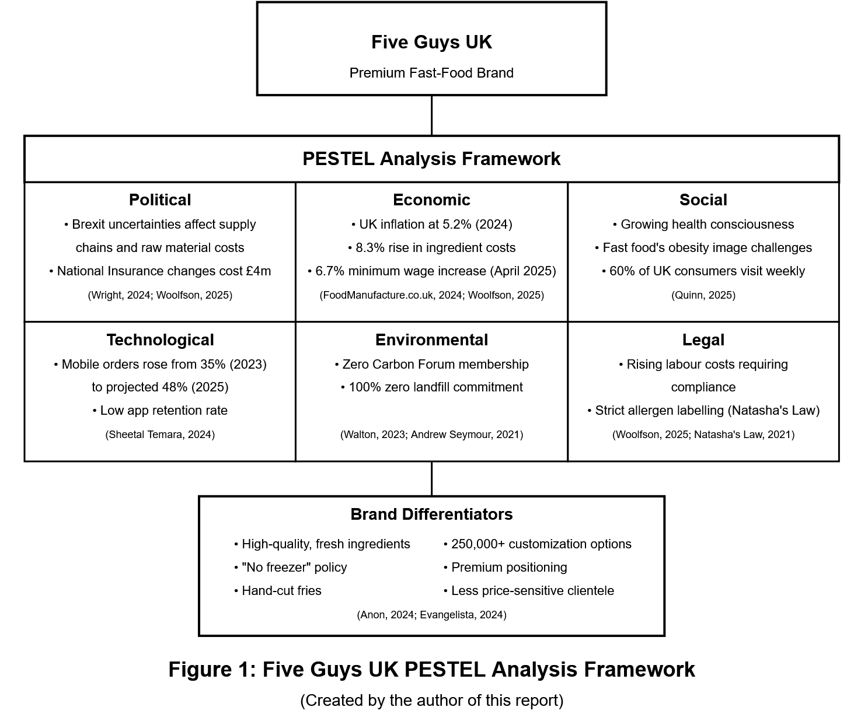

3.2 Chosen Area of Focus for Improvement/Innovation & Justification
The primary focus for improvement is enhancing Five Guys' mobile application user experience and retention. The audit revealed a critical disparity in figure 2: while mobile orders are significantly increasing (from 35% in 2023, projected to 48% by 2025), the app's user retention rate is only 58%, markedly below the 67% industry average (Sheetal Temara, 2024). This underperformance in a key growth channel represents a substantial untapped opportunity. In an increasingly digital food service landscape, a subpar app directly hinders sales potential and customer loyalty. Addressing this aligns with the strategic opportunity to "enhance interactions through personalized mobile apps" (Anon, 2024) and is crucial for converting the mobile ordering trend into sustained customer relationships and revenue. As Dibb et al. (Marketing: Concepts and Strategies, 7th ed.) emphasize, adapting to evolving customer touchpoints is vital. Improving app engagement can also mitigate rising operational costs by optimizing a direct, efficient sales channel, reflecting Danciu's (2013) call for marketing to respond to technological shifts.
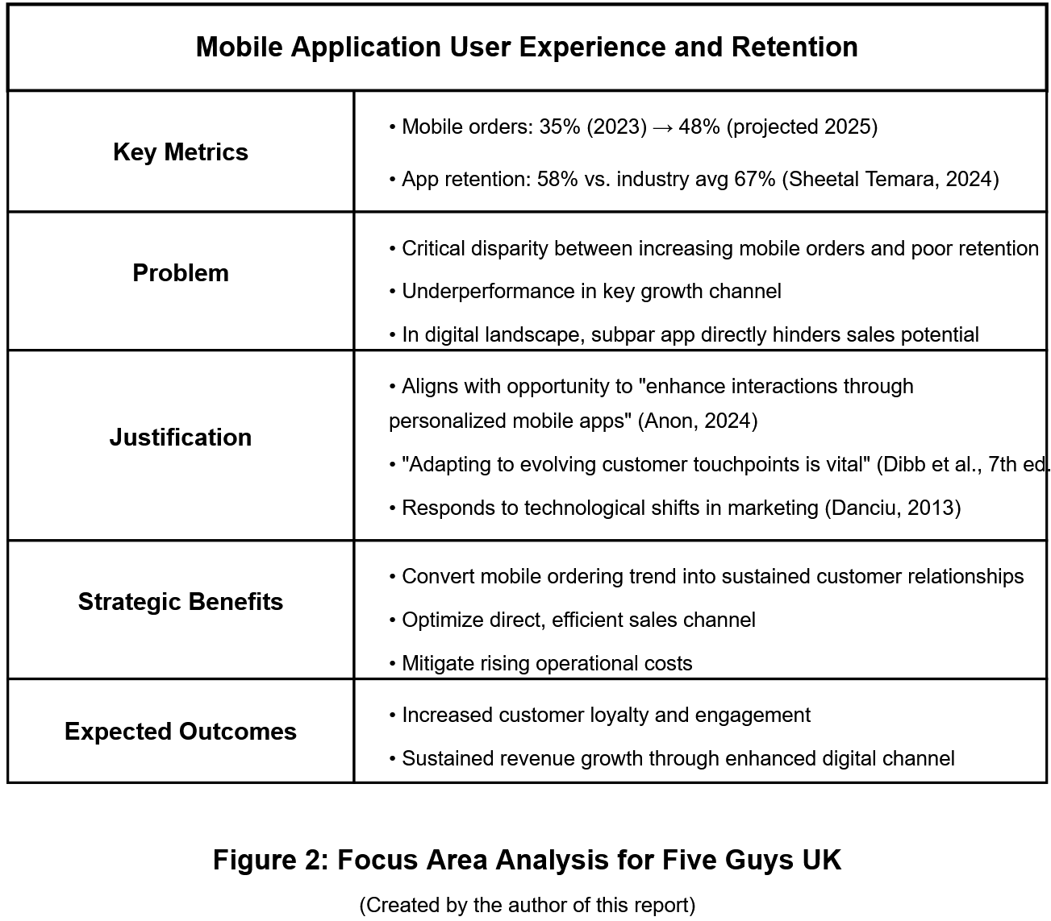

3.3 Focused SWOT Analysis (relevant to the Chosen Area of Focus)
Regarding the mobile app enhancement:
Strengths: Five Guys' strong brand reputation for quality (Anon, 2024) and unique value-added services like free peanuts (Sun, 2022) can drive initial app adoption. The existing mobile order volume (35% in 2023, potentially 48% by 2025, as per Sheetal Temara, 2024) indicates a ready user base.
Weaknesses: The app's current user retention of 58% is significantly below the 67% industry average (Sheetal Temara, 2024), signalling issues with usability or value. High staff turnover (Sun, 2022) might also affect in-store app promotion and support.
Opportunities: There's a clear opportunity to boost online order share by improving app retention and incorporating personalized features or even AR/VR (Anon, 2024). The app could also cater to young consumers' social preferences (Fischer, 2024) with shareable or group ordering features.
Threats: Emerging boutique burger brands (Anon, 2024) may offer superior digital experiences. Increased consumer price sensitivity (Anon, 2024) demands the app delivers clear value. Any negative app experiences, like the 23% complaint rate from the dynamic pricing pilot (Sheetal Temara, 2024), could further harm retention.
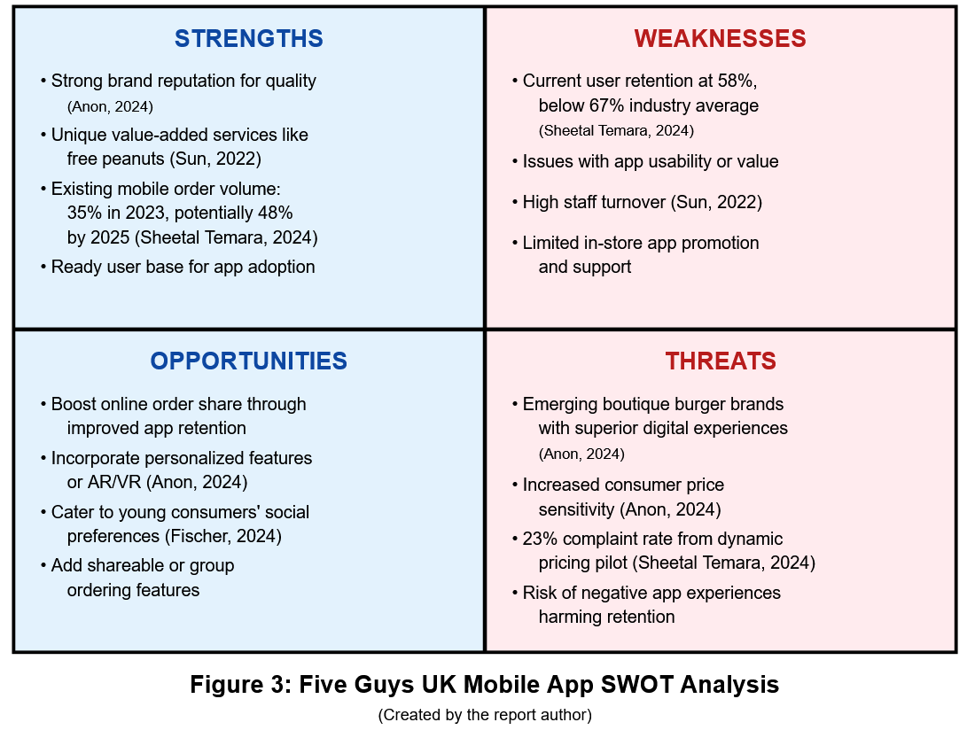

4.0 Objectives (O)

4.1 Overall Marketing Objective (for the Chosen Area of Focus)
The primary marketing objective is to significantly elevate Five Guys UK's digital customer engagement and boost mobile-derived revenue by redeveloping its mobile application. This aims to achieve superior user experience and substantially improve user retention rates from the current 58% (Sheetal Temara, 2024) within the next 18 months, establishing the app as a preferred customer interaction and transaction channel. This directly addresses the low app retention weakness and capitalizes on mobile ordering growth (Sheetal Temara, 2024) and personalization opportunities (Anon, 2024), crucial for competitive advantage (Vriens & Brazell, 2013).

4.2 Specific SMART Objectives
To realize the overall objective, the following SMART goals are set:
- Specific: Increase the Five Guys UK mobile app's monthly active user (MAU) retention rate from 58% (Sheetal Temara, 2024) to 70% within 12 months post-revamped app launch.
- Measurable: Grow the proportion of total UK sales via the mobile app from its current estimated 40-42% (extrapolated from Sheetal Temara, 2024) to 55% within 18 months of launch.
- Achievable: Improve the average customer satisfaction score (CSAT) for app-based orders by 15%, measured via in-app surveys, within 9 months of new app deployment.
- Relevant: Increase order frequency per active app user by 20% within 12 months, driven by personalized promotions and an integrated loyalty program.
- Time-bound: Design, develop, test, and launch a revamped Five Guys UK mobile application with enhanced UI/UX, personalization, and a loyalty program within 6 months.
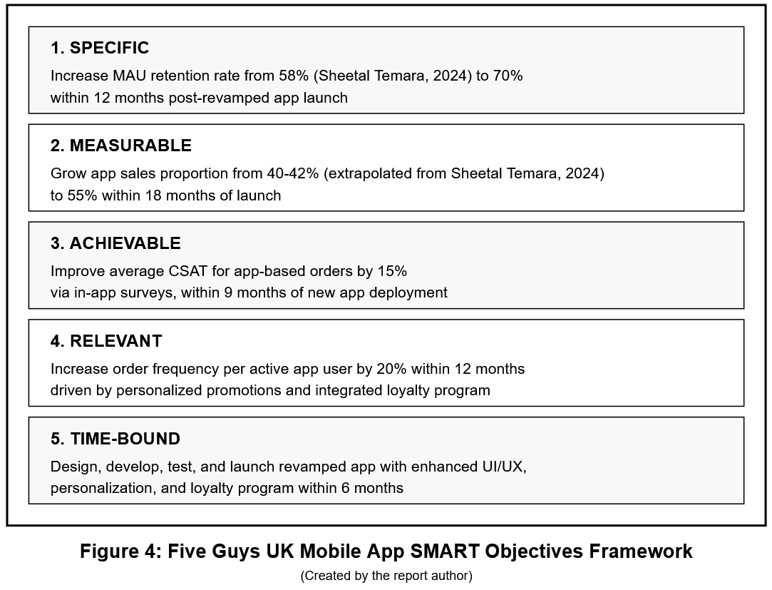

5.0 Strategy (S)

5.1 Strategic Direction (to address the Chosen Area of Focus)
The strategic direction is customer-centric digital transformation and loyalty cultivation via a substantially enhanced mobile application. This strategy focuses on creating an engaging digital experience that fosters repeat business, aligning with Taghian's (2010) principles on operationalising market orientation. The core aim is to improve not just app usability—addressing the low 58% retention (Sheetal Temara, 2024)—but to enrich it with tangible user benefits like personalized offers, early menu access, and a compelling loyalty program. This acknowledges the significant growth in mobile orders (from 35% in 2023 to a projected 48% in 2025, Sheetal Temara, 2024) and seeks to make the Five Guys app indispensable. This approach also strategically positions Five Guys against competitors (Anon, 2024) by developing a superior digital platform that reinforces its premium quality image (Evangelista, 2024) and serves as a marketing tool itself, thereby evolving its customer orientation as suggested by Foreman et al. (2014).

5.2 Segmentation, Targeting, and Positioning (STP) (for the initiative)
For the revamped mobile app:
Segmentation: Key segments include: 1) Existing, digitally-savvy Five Guys customers who use food ordering apps (reflecting the mobile order growth from 35% to a projected 48% - Sheetal Temara, 2024) but may not be retained by the current app. 2) Younger demographics (Gen Z, Millennials) valuing convenience, personalization, and social experiences (Fischer, 2024). 3) Regular patrons ordering in-store or via third parties, convertible to direct app usage.
Targeting: The primary target is the first segment (existing digital customers), with a strong secondary focus on younger demographics, as they are most likely to engage with an enhanced, rewarding mobile experience. Converting third-party app users to the direct Five Guys app is also a key tactical aim.
Positioning: The revamped app will be positioned as: "Your Personal Five Guys Experience: Premium Quality, Customized for You, Rewarded Every Time." This highlights core brand strengths of quality and customization (Anon, 2024, notes over 250,000 combinations), extends this to digital personalization, and adds a clear value proposition through loyalty rewards. This appeals to Five Guys' less price-sensitive demographic (Evangelista, 2024) while offering benefits to improve retention beyond the current 58% (Sheetal Temara, 2024), creating a distinct, value-added brand experience.

6.0 Tactics (T) – Marketing Mix (7Ps)

6.1 Product
The 'Product' is the revamped Five Guys UK mobile application, featuring an intuitive UI/UX. Key elements include advanced customization mirroring the in-store 250,000+ options (Anon, 2024), saved preferences, quick reordering, secure integrated payments, real-time order tracking, and a tiered loyalty program. Crucially, clear allergen information (Natasha's Law, 2021), especially regarding peanut oil (Sun, 2022), will be prominent. Future iterations might explore AR for visualizing customizations (Anon, 2024), enhancing the digital offering.

6.2 Price
The app will be free. Menu item prices via the app will align with in-store rates, maintaining the premium brand position (Evangelista, 2024). However, strategic price-related incentives like app-exclusive deals, personalized discounts, and loyalty points redeemable for free items or discounts will be used. This aims to increase order frequency and AOV, fostering loyalty to mitigate impacts from rising ingredient costs (8.3% year-on-year, FoodManufacture.co.uk, 2024) rather than engaging in direct price wars.

6.3 Place
'Place' refers to the app's accessibility and order fulfilment. It will be available on major app stores (iOS, Android), heavily promoted via in-store signage, website, and social media. Order fulfilment will integrate with restaurant operations for click-and-collect or delivery options. An in-app store locator with real-time service availability will connect the digital interface to the physical restaurant infrastructure (FabricAcademy, 2024), ensuring a seamless customer journey.

6.4. Promotion
A multi-channel promotional strategy will launch the revamped app. Targeted digital advertising (social media, SEM) will highlight new features and the loyalty program. In-store promotions, with staff encouraging downloads and explaining benefits (perhaps with a first-order incentive), will be vital. Email marketing will target existing customers. User-generated content campaigns could leverage word-of-mouth, a traditional Five Guys strength (Anon, 2022), capitalizing on the existing mobile user base (mobile orders projected to be 48% by 2025 - Sheetal Temara, 2024).

6.5 People
The 'People' element is crucial. Staff require comprehensive training on the new app, its benefits, and how to assist customers, especially for smooth order pick-up. This is vital given high staff turnover (Sun, 2022), necessitating robust, ongoing training. Customer support for app-related queries must be responsive and well-informed. Positive staff interactions, both digital and physical, will reinforce Five Guys' value-added experience (Sun, 2022) and drive app adoption.

6.6 Process
'Process' covers the app's end-to-end customer journey: easy onboarding, intuitive menu navigation and customization (reflecting 250,000+ combinations - Anon, 2024), streamlined secure checkout, and clear order status communication. Backend processes must ensure efficient order transmission to kitchens. Loyalty point redemption must be simple. Regular testing and optimization are key to improving user retention from its current 58% (Sheetal Temara, 2024) and ensuring a frictionless experience.

6.7 Physical Evidence
'Physical Evidence' supports the digital experience. The app's visual design—aesthetics, branding, high-quality food imagery—must reflect Five Guys' premium image. Digital receipts, notifications, and the loyalty program's in-app representation are key. In-store, clear app promotion, dedicated pick-up areas, and even packaging for app orders contribute. This ensures a cohesive brand message, aligning digital interactions with the positive physical cues like a comfortable dining environment (FabricAcademy, 2024) associated with Five Guys.
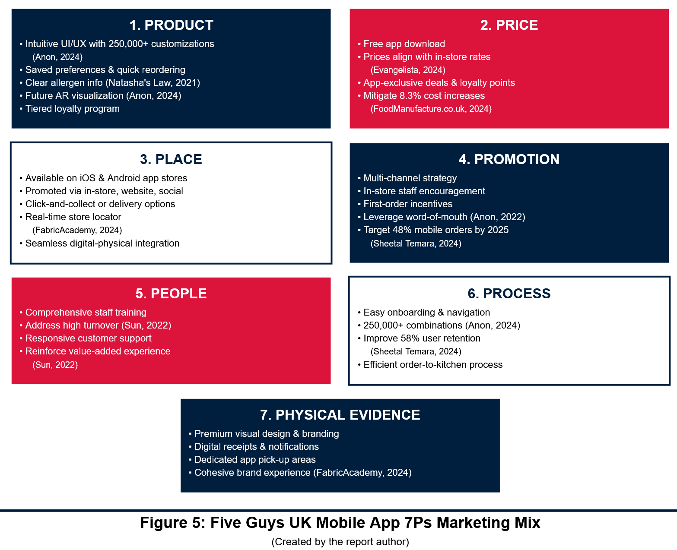

7.0 Action (A)

7.1 Implementation Plan Outline
Implementation will be phased:
Phase 1 (Months 1-3): App Development & Internal Testing. UI/UX design, core feature development (ordering, loyalty), and rigorous internal testing, including with store managers.
Phase 2 (Months 4-5): Staff Training & Pilot Launch. Develop and roll out training. Pilot in limited store locations to gather user feedback and identify issues, avoiding problems like the 23% complaint rate with the dynamic pricing pilot (Sheetal Temara, 2024).
Phase 3 (Month 6): Full UK Rollout & Initial Marketing. Final adjustments based on pilot feedback, then full launch with a promotional campaign.
Phase 4 (Months 7-12): Ongoing Promotion, Monitoring & Iteration. Continuous marketing, performance monitoring, and iterative app updates.

7.2 Broad Timeline Overview
Months 1-3: App design, development, internal testing.
Month 4: Staff training module development, pilot program design.
Month 5: Staff training delivery, pilot launch, initial feedback collection.
Month 6: Analysis of pilot, final refinements, full UK launch, major promotions begin.
Months 7-8: Sustained marketing, loyalty program rollout, first review of app performance against objective 1 (retention target of 70% from 58% - Sheetal Temara, 2024).
Months 9-12: New feature introduction based on data, continued optimization, final review against all SMART objectives (e.g., 55% mobile sales).
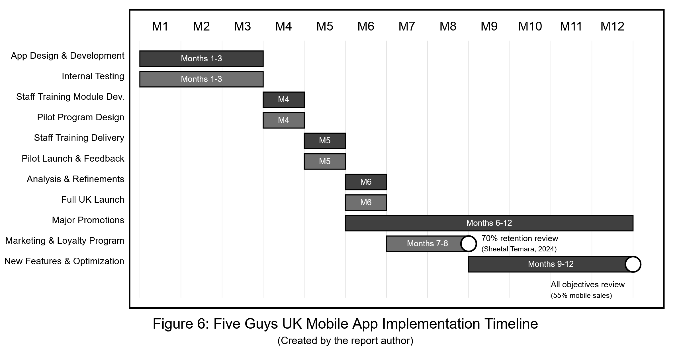

8.0 Control (C)

8.1 Key Performance Indicators (KPIs)
Primary KPIs aligned with SMART objectives include: App User Retention Rate (target 70% from 58% - Sheetal Temara, 2024); Percentage of Sales via App (target 55%); Average App Store Rating (target 4.5 stars); App AOV (target 10% increase); App Download Rate & Active Users; Customer Acquisition Cost via App; Loyalty Program Engagement; App Crash Rate; Customer Support Tickets (app-related); Task Completion Rate within App.

8.2 Monitoring, Measurement & Evaluation
Continuous monitoring via app analytics (e.g., Firebase) and EPOS sales data. Weekly KPI dashboards for marketing/digital teams. Monthly performance reviews (marketing, operations, IT) against SMART objectives. Customer feedback (app store reviews, in-app surveys for CSAT, social media) systematically collected. A/B testing for feature optimization. Formal evaluations at 6, 12, and 18 months, reflecting Jobber and Ellis-Chadwick's (2016) emphasis on marketing control.

8.3 Budget Considerations Overview
Budget allocation for: App Development (initial build, UI/UX); Marketing & Promotion (launch, ongoing); Staff Training; Loyalty Program Costs (rewards); Ongoing Maintenance & Updates; Analytics Tools. The £4 million NI cost impact (Woolfson, 2025) highlights the need for this digital investment to drive efficiency and revenue, potentially offsetting costs by increasing direct sales.

8.4 Adaptation and Continuous Improvement
A Plan-Do-Check-Act cycle will ensure continuous improvement. Regular KPI reviews and feedback will guide enhancements. If retention targets (currently 58% - Sheetal Temara, 2024) are missed, user journey analysis and A/B testing will identify and address issues. Responses to competitor app innovations (Anon, 2024) will be formulated. Future AR/VR integration (Anon, 2024) offers an avenue for adaptation. This iterative approach (Lynch, 2015) ensures long-term app relevance and effectiveness.
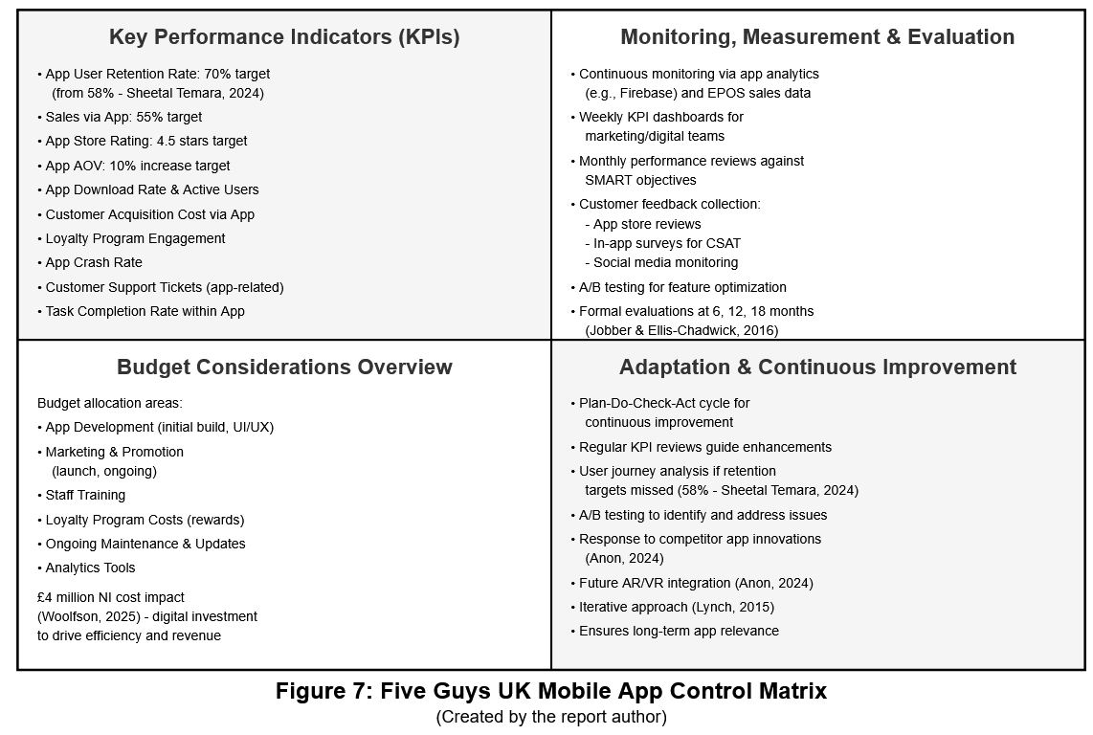

9.0 Recommendations
Based on the analysis and strategic objectives, it is strongly recommended that Five Guys UK invests significantly in the redevelopment of its mobile application. This should prioritize creating an intuitive UI/UX, integrating advanced customization features mirroring the in-store experience, implementing real-time order tracking, and embedding a compelling tiered loyalty program. A targeted promotional strategy should accompany the launch, focusing on existing digital users and younger demographics. Crucially, comprehensive staff training is essential for successful rollout and ongoing support. Furthermore, establish rigorous monitoring using the defined KPIs (app retention, % sales via app, CSAT) to track progress against SMART objectives. Allocate dedicated budget resources for development, marketing, loyalty rewards, and continuous iteration based on user feedback and performance data. This focused digital enhancement will drive engagement, loyalty, and mobile-derived revenue, strengthening Five Guys' market position.

10.0 Conclusion
This strategic marketing plan for Five Guys UK focuses on a critical digital initiative: revamping its mobile application to significantly boost user retention from the current 58% (Sheetal Temara, 2024) and increase mobile-driven sales. By emphasizing customer-centric design, personalization, and a robust loyalty program, this plan directly tackles identified weaknesses while capitalizing on the growing mobile order trend (projected to be 48% by 2025 - Sheetal Temara, 2024). The SOSTAC framework guides the achievement of specific objectives, such as increasing mobile sales to 55%. Diligent execution, monitoring, and continuous improvement are paramount for this plan to strengthen Five Guys' competitive edge, cultivate customer loyalty, and enhance long-term profitability in the UK's evolving fast-food sector, demonstrating effective marketing planning (Taghian, 2010).

References
- Andrew Seymour (2021). Rising profits, more stores and greener operations - why Five Guys UK is no longer in crisis mode. Foodservice Equipment Journal. Available at: https://www.foodserviceequipmentjournal.com/rising-profits-more-stores-and-greener-operations-why-five-guys-uk-is-no-longer-in-crisis-mode/.
- Anon (2022). The secrets of Five Guys’ success: Consistency, word of mouth and clever locations - Caterer Middle East. Caterer Middle East. 4 Aug. Available at: https://www.caterermiddleeast.com/business/five-guys-uae-interview-2022.
- Anon (2024). Five Guys Marketing Strategy 2024: A Case Study – Latterly.org. Available at: https://www.latterly.org/five-guys-marketing-strategy/.
- Coyne, A. (2025). Which way will the wind blow for the UK food industry in 2025? Just Food. Available at: https://www.just-food.com/features/uk-food-industry-outlook-in-2025/.
- Danciu, V. (2013) The future of marketing: an appropriate response to the environment changes. Theoretical & Applied Economics, May, Vol20 (5), pp33-52.
- Dibb, S., Simkin, L., Pride, W.M., & Ferrell, O.C. Marketing: Concepts and Strategies 7th ed Houghton Mifflin.
- Dorich, A. (2019). Five Guys. Supply Chain World magazine. Available at: https://scw-mag.com/news/1198-five-guys/.
- Eastlake, D. (2024). The UK has a new government: How will food and beverage be impacted? FoodNavigator.com. Available at: https://www.foodnavigator.com/Article/2024/07/05/How-will-the-new-UK-government-affect-the-food-and-beverage-industry/.
- Edwards, K. (2024). The Secret Behind Five Guys’ Distribution Success in the Fast-Casual Market - Keegan Edwards. Keegan Edwards. Available at: https://keeganedwards.com/the-secret-behind-five-guys-distribution-success-in-the-fast-casual-market/.
- Evangelista, A. (2024). What Sets Five Guys Apart from Its Competitors? American Builders Quarterly. Available at: https://americanbuildersquarterly.com/2024/five-guys-stands-apart-from-the-competition/.
- FabricAcademy (2024). Five Guys marketing strategy: The fundamental difference between marketing and advertising. www.fabric-academy.com. Available at: https://fabric-academy.com/insights-tools/five-guys-marketing.
- Fahy, J., & Jobber, D. (2015) Foundations of Marketing, 5th ed., London, McGraw-Hill.
- Fischer, K. (2024). Food choices: what influences young people’s food choices? NIHR Evidence. Available at: https://evidence.nihr.ac.uk/alert/what-influences-young-peoples-food-choices/.
- Food Standards Agency (2023). Homepage. Food Standards Agency. Available at: https://www.food.gov.uk.
- FoodManufacture.co.uk. (2024). 4 big F&B issues that will dominate 2025. Available at: https://www.foodmanufacture.co.uk/Article/2024/12/23/food-and-drink-regulation-2025/.
- Foreman, J. et al (2014) The performance implications of planning, implementation, and evolution of firms’ customer and competitor orientations. Journal of Marketing Theory and Practice, Fall, Vol22 (4), pp349-366.
- Jobber, D., & Ellis-Chadwick, F. (2016) Principles and Practice of Marketing 7th revised ed. Berkshire, McGraw-Hill.
- Kim, W.C. and Mauborgne, R. (2004) Blue ocean strategy. Harvard Business Review, October, Vol82 (10), pp76-84.
- Lynch, R. (2015) Strategic Marketing 7th ed. Harlow, Pearson.
- Magbanua, D. (2024). What’s in store for the QSR industry in 2025? QSR Media UK. Available at: https://qsrmedia.co.uk/executive-insights/exclusive/whats-in-store-qsr-industry-in-2025.
- Natasha's Law (2021). (Implied reference from text).
- Quinn, I. (2025). Fast food comes under fire from ShareAction health demands. The Grocer. Available at: https://www.thegrocer.co.uk/news/fast-food-comes-under-fire-from-shareaction-health-demands/702025.article.
- Sheetal Temara (2024). The Ransomware Epidemic: Recent Cybersecurity Incidents Demystified. Asian Journal of Advanced Research and Reports, 18(3), pp.1–16.
- Shivakumar, R. (2014) How to tell which decisions are strategic. California Management Review, Spring, Vol56 (3), pp78-97.
- Sun, C. (2022). Market Analysis of Five Guys. Available at: https://www.atlantis-press.com/article/125971715.pdf.
- Taghian, M. (2010) Marketing planning: operationalising the market orientation strategy. Journal of Marketing Management, August, Vol26 (9/10), pp825-841.
- Udell, M. (2015) Competitive edge. Marketing Insights, May/Jun, Vol27 (3), p48.
- Vanifatova, M. (2025). UK Fast – Food: 2024 Review and 2025 Outlook. Meaningful Vision |. Available at: https://meaningfulvision.com/uk-fast-food-2024-review-and-2025-outlook/.
- Vriens, M. and Brazell, J.D. (2013) Competitive advantage. Marketing Insights, Fall, Vol25 (3), pp32-38.
- Walton, J. (2023). Five Guys UK Joins Zero Carbon Forum. Foodservice Equipment Journal. 12 Dec. Available at: https://www.foodserviceequipmentjournal.com/five-guys-uk-joins-zero-carbon-forum/.
- Woolfson, D. (2025). Five Guys: Rachel Reeves’s tax raid will cost us £4m. The Telegraph. Available at: https://www.telegraph.co.uk/business/2025/02/22/reeves-tax-raid-will-cost-me-4m-five-guys/.
- Wright, I. (2024). Food & drink faces a decisive political year in 2025. The Grocer. Available at: https://www.thegrocer.co.uk/comment-and-opinion/food-and-drink-faces-a-decisive-political-year-in-2025/698795.article.

