Ashleigh Rogers
Student number 2431357
Management communication
bmsk4013

Contents page
Introduction
Communication models
Tone, Language, Formality, Structure and Content
Verbal and written communication in a nursery setting
Motivation Models
Personal Development Plan
Conclusion
Reference List
Appendix page

Introduction
This assignment aims to thoroughly explore and critically evaluate the essential role of communication in management, with a particular focus on its effectiveness in the workplace. In today’s fast paced and dynamic organizational environments, effective communication plays a pivotal role in achieving both individual and collective success. A variety of communication methods commonly utilized within organizations will be examined, encompassing both formal and informal channels, as well as verbal and non-verbal forms of communication. This exploration will include how these methods impact daily operations, employee morale, and overall organizational performance. Through a comprehensive analysis, different communication models and techniques will be reviewed, with emphasis placed on their applicability and relevance in diverse professional contexts. The strengths and weaknesses of each method will be discussed, along with real-world examples to illustrate their practical implementation. By the end of this assignment, the knowledge and insights gained from these evaluations will be applied to develop more effective management practices. The ultimate goal is to enhance communication skills, increase productivity, and foster positive relationships within the workplace, thereby laying the foundation for improved management and professional success in future settings.

What is Communication and Why Is It Important?
Communication is the process of exchanging information, ideas, emotions, and thoughts between individuals or groups. It involves a sender conveying a message through a selected medium, which may be verbal, non-verbal, or both. Effective communication is essential to ensure that all parties involved are on the same page. Clear communication reduces the risk of misunderstanding and confusion, which can lead to errors or inefficiency. Strong communication skills are essential not only for job performance but also for building relationships and fostering collaboration within the workplace. Effective communication promotes accurate information sharing, problem-solving, and teamwork, making it a cornerstone of success. Key strategies for effective communication include active listening, providing clear messages, and giving constructive feedback, all of which are crucial in any organizational context.
In summary, communication is fundamental for both personal growth and professional success, as well as for fostering business development and maintaining healthy workplace dynamics (Stevenson University, 2022).

Communication models
- Communication Cycle
- 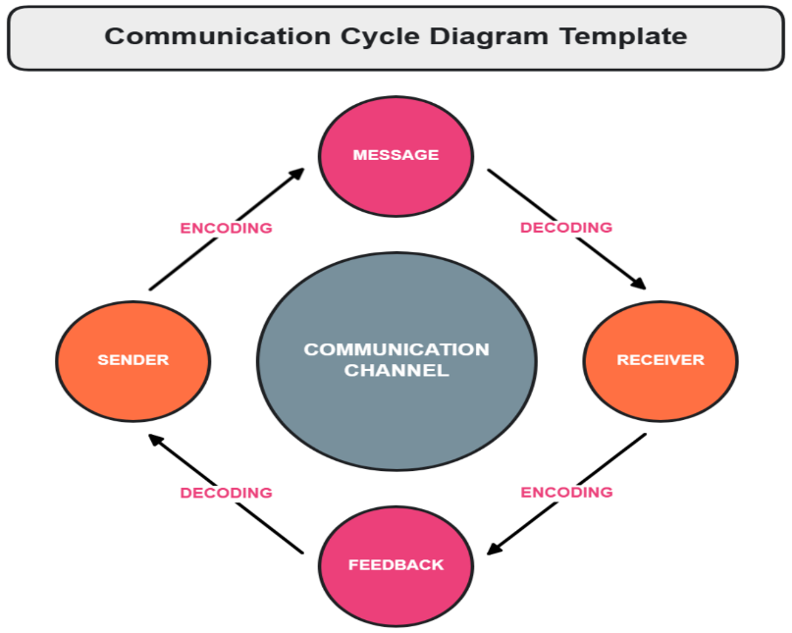
The communication cycle describes a continuous process of transmitting and interpreting messages between sender and receiver. The key components are:
- Sender
- Message
- Encoding
- Channel
- Receiver
- Decoding
- Feedback
- Noise (interference)
This model emphasizes that communication is cyclical and dynamic, where feedback is critical to ensure the message was understood (McLean, 2005).
Relevance:
The communication cycle helps recognize the importance of feedback and clarity in communication. It is especially relevant in healthcare, education, and business communication where understanding and response are essential.
2. Shannon and Weaver Model (1949) 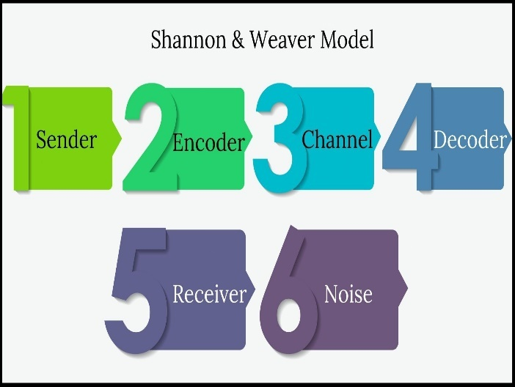
Developed by Claude Shannon and Warren Weaver, this linear model focuses on the technical transmission of a message:
- Information Source → Transmitter → Channel (with Noise) → Receiver → Destination
It introduced the concept of "noise"—any distortion that interferes with the message.
Relevance:
This model is useful for understanding communication in mass media, technology, and engineering. It emphasizes the importance of clear encoding and reducing external interference.
3. Schramm’s Model (1954) 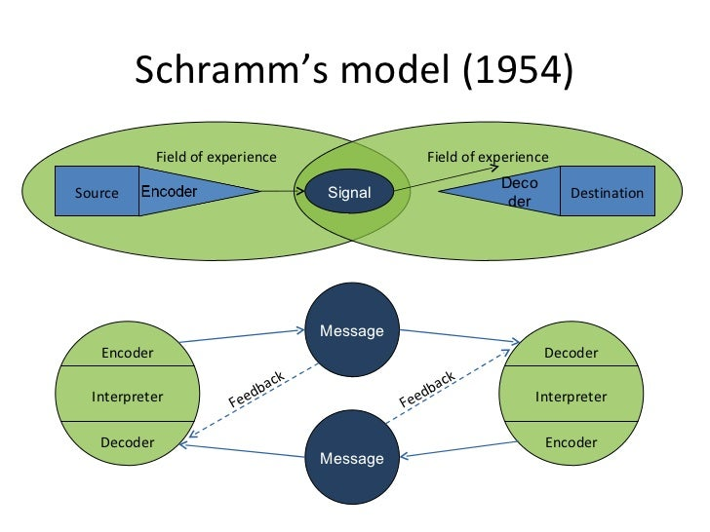
Wilbur Schramm built upon earlier models by proposing that communication is a two-way process. He introduced the concept of:
- Shared field of experience: Communication is successful only when sender and receiver share common ground—such as language, culture, or context.
Relevance:
Schramm’s model is especially important in interpersonal communication, cross-cultural communication, and education, where miscommunication often stems from different experiences or backgrounds.
4. Berlo’s SMCR Model (1960) 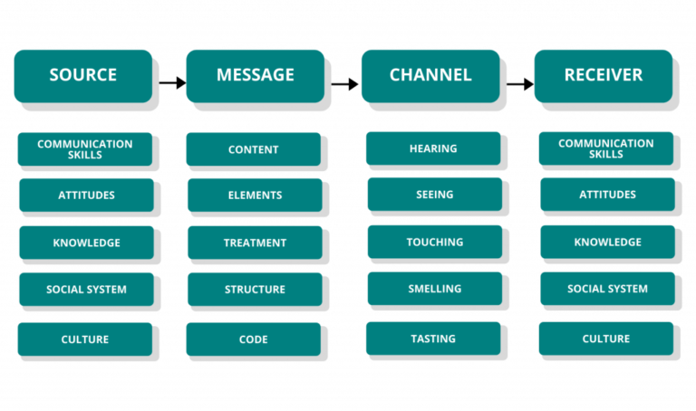
Berlo's model focuses on four key elements:
- Source
- Message
- Channel
- Receiver
Each element is influenced by factors like communication skills, attitudes, knowledge level, social systems, and culture.
Relevance:
Berlo's model is practical for understanding how communication is shaped by personal characteristics. It’s often applied in public speaking, advertising, and interpersonal dialogue to tailor messages effectively.
Conclusion Table with References
Model | Key Concept | Relevance | Reference
Communication Cycle | Feedback and continuous interaction | Ensures mutual understanding | McLean (2005)
Shannon & Weaver | Linear process, noise, clarity | Important in media and technical settings | Shannon & Weaver (1949)
Schramm | Shared experiences and feedback | Explains cultural/contextual differences | Schramm (1954)
Berlo’s SMCR | Source and receiver characteristics | Tailoring messages to the audience | Berlo (1960)
The Communication Cycle, Shannon and Weaver model, Schramm’s model, and Berlo’s SMCR model are all communication theories that aim to explain how messages are transmitted and understood. While they share some similarities, such as including core elements like sender, message, channel, and receiver. They differ in structure and focus. The Communication Cycle emphasizes the importance of feedback and views communication as a continuous, two-way process. In contrast, the Shannon and Weaver model is a linear, one-way process that introduced the concept of "noise," highlighting the technical challenges that can interfere with message clarity. Schramm expanded on this by incorporating the idea of a shared field of experience, suggesting that communication is more effective when both sender and receiver have similar backgrounds or knowledge. Berlo’s SMCR model focuses more deeply on the individual components of communication, particularly the influence of the sender and receiver’s skills, attitudes, and cultural context. While the models are similar in their basic structure and purpose, each contributes a unique perspective that helps explain different aspects of effective communication.
Although developed decades ago, the Communication Cycle, Shannon and Weaver’s model, Schramm’s model, and Berlo’s SMCR model remain relevant in today’s communication landscape. These models provide foundational frameworks for understanding how communication works by identifying key components such as sender, message, channel, receiver, and feedback (McLean, 2005). In particular, Shannon and Weaver’s concept of "noise" is especially applicable in the digital age, where technical issues and information overload can disrupt communication (Shannon and Weaver, 1949). Schramm’s emphasis on shared experience is increasingly significant in multicultural and globalised contexts, while Berlo’s focus on the communicator’s attitudes, skills, and cultural background helps explain why tailored messaging is critical in marketing and interpersonal communication (Berlo, 1960). However, these models do have limitations; for instance, linear models do not fully capture the interactive, fast paced, and multi-platform nature of digital communication today. Despite this, they continue to be useful as educational tools and analytical frameworks when used alongside modern theories and digital media perspectives.
The Communication Cycle, Shannon and Weaver, Schramm, and Berlo’s SMCR models offer several strengths in helping to understand and improve communication. A major strength of these models is that they clearly outline the basic components of communication—sender, message, channel, and receiver—which are fundamental in both personal and professional settings (McLean, 2005). Shannon and Weaver’s model is particularly effective in identifying technical barriers through its concept of "noise", making it useful in modern digital and broadcast communication (Shannon and Weaver, 1949). Schramm’s model adds value by highlighting the importance of a shared field of experience, which helps explain miscommunication due to cultural or knowledge differences (Schramm, 1954). Berlo’s SMCR model is praised for acknowledging how personal factors such as communication skills, attitudes, and cultural background influence understanding (Berlo, 1960).
However, these models also have limitations. One key weakness is that linear models, like Shannon and Weaver’s, fail to represent the interactive and dynamic nature of real-world communication, especially in digital environments where communication is often simultaneous and multi-directional (Fiske, 2010). Additionally, most traditional models overlook non-verbal cues, emotions, and the impact of social context, which are crucial in face-to-face and mediated communication. They also do not adequately account for new technologies, such as AI-driven platforms or social media algorithms, which play a significant role in shaping communication today. Therefore, while these models remain useful, they need to be applied critically and complemented with more contemporary theories for a full understanding of modern communication.
The Communication Cycle, along with the models proposed by Shannon and Weaver, Schramm, and Berlo, remains highly relevant for achieving effective communication in both traditional and modern contexts. These models provide structured frameworks that help individuals and organisations understand how communication works and identify potential barriers to understanding. The Communication Cycle highlights the importance of feedback and two-way interaction, which is essential for confirming understanding and promoting clarity (McLean, 2005). Shannon and Weaver’s model, while originally designed for technical communication, is still useful for identifying disruptions in the message known as "noise" which can occur in digital communication, such as poor internet connections or media overload (Shannon and Weaver, 1949). Schramm’s model brings attention to the shared field of experience between sender and receiver, showing how effective communication depends on mutual understanding of language, culture, and context (Schramm, 1954). Berlo’s SMCR model expands on this by emphasizing the role of individual characteristics such as communication skills, attitudes, and social background which must be considered when tailoring messages to specific audiences (Berlo, 1960). In today’s complex and diverse communication environments, these models remain relevant because they offer practical guidance for reducing misunderstanding, enhancing clarity, and improving message delivery across various platforms and cultural settings.

Tone, Language, Formality, Structure and Content
Using appropriate levels of formality, language, and structure is crucial when communicating with different audiences, as it ensures the message is understood, well-received, and suited to the context. For instance, in professional or academic settings, formal language and structured communication are expected. A manager writing a report to senior executives would typically use formal vocabulary, clear headings, and a logical structure to convey authority and professionalism. In contrast, the same manager might use more casual language and an informal tone when emailing a colleague or giving a team update, which helps build rapport and creates a more relaxed environment. Audience expectations heavily influence language choice; for example, when speaking to children, simpler vocabulary, a friendly tone, and visual aids are more effective, while communicating with specialists or academics might require technical terminology and evidence-based language. Structure also matters—social media posts may use short, engaging sentences and emojis to connect with a younger audience, whereas a business proposal would follow a structured format with an introduction, analysis, and conclusion. Using the wrong level of formality or inappropriate language can lead to confusion, misinterpretation, or even offence. Therefore, adapting communication style based on the audience enhances understanding, builds credibility, and strengthens relationships (McLean, 2005).
Adapting content and tone to suit different modes of communication, audiences, and situations is essential for ensuring effective and appropriate interaction. Each communication mode—whether written, verbal, visual, or digital—requires a tailored approach to what is said (content) and how it is said (tone). For example, in a formal business letter or email to a client, the content should be clear, concise, and informative, while the tone should be respectful and professional to reflect the seriousness of the context. Conversely, when communicating via instant messaging with a colleague, a more informal and conversational tone is often acceptable, allowing for quicker, more relaxed exchanges that still maintain mutual understanding. The situation also plays a critical role in shaping tone: a company-wide email announcing layoffs must use sensitive, empathetic language, while a social media post promoting a product may adopt an upbeat and persuasive tone to engage potential customers. Similarly, delivering a presentation to senior executives would require a structured, confident tone with content backed by data, whereas explaining the same topic to new trainees might involve simplified content and an encouraging, friendly tone. Failure to match content and tone appropriately can result in misunderstandings, damaged relationships, or a lack of credibility. Therefore, evaluating the audience and context is essential for determining the most effective tone and content across various communication modes (McLean, 2005).

Verbal and written communication in a nursery setting
  - Daily Briefings: Verbal exchanges between staff members at the beginning or end of the day to share important information about children’s well-being, any incidents, or updates on their development.
  - Team Meetings: Group discussions to address nursery policies, activities, and any challenges regarding children’s care and learning.
  - Instructional Language: Teachers or caregivers use clear and simple instructions when guiding children, such as “Please put your toys away” or “Let’s line up for lunch.”
  - Storytelling and Teaching: Caregivers engage children with stories or songs, often using repetition and emphasis to help them learn new words or concepts.
- Staff-to-Child Communication:
  - Positive Reinforcement: Verbal praise such as “Well done!” or “Good job!” encourages children to feel proud of their achievements.
  - Clarifying Instructions: When giving children directions, caregivers might say, “Can you please share your toy with your friend?” or “It’s time to clean up.”
  - Comforting Language: When a child is upset, staff use calm and reassuring tones, such as “It’s okay, I’m here to help you.”
- Staff-to-Parent Communication:
  - Daily Updates: Verbal communication with parents about their child’s day, including details about meals, naps, activities, and any concerns.
  - Parent-Teacher Conferences: One-on-one meetings where staff discuss a child’s progress, development, and any issues that might need attention.
Written Communication in a Nursery Setting
- Staff-to-Staff Communication:
  - Care Plans/Reports: Written records outlining individual children's needs, routines, and preferences to ensure consistent care among different staff members.
  - Incident Reports: Written documentation of any accidents or injuries, which are essential for legal and safety purposes.
  - Bulletin Boards: Notices or announcements about schedules, activities, or any changes in policies or procedures.
- Staff-to-Child Communication:
  - Activity Sheets: Written instructions or charts used for planned activities, like crafts or educational exercises, often displayed in the room to guide children through the process.
  - Labels: Written labels on toys, cubbies, and personal belongings to help children recognize their possessions and develop early literacy skills.
- Staff-to-Parent Communication:
  - Daily Diaries or Reports: Some nurseries provide written summaries of a child’s day, including meals, naps, and behavior, giving parents insight into their child's routine and experiences.
  - Newsletters: Monthly or weekly newsletters inform parents about upcoming events, learning themes, or general nursery updates.
  - Parent Consent Forms: Written documentation required for certain activities, such as field trips, medical treatments, or photo permissions.
  - Progress Reports: Written assessments that outline a child’s developmental progress and areas for improvement, which are often shared during parent-teacher meetings.
Both verbal and written communication are essential in ensuring that everyone—staff, children, and parents—is informed, engaged, and able to support the child’s development effectively. The key to successful communication in a nursery setting lies in using the appropriate mode for the specific situation and audience.

Motivation Models
Motivation plays a crucial role in both child development and staff performance in a nursery setting. Understanding motivational theories can help early years practitioners create environments where children are eager to learn and staff feel valued and driven. Three well-known theories of motivation. Maslow’s Hierarchy of Needs, Herzberg’s Two factor Theory, and Skinner’s Behaviourist Theory (Operant Conditioning) are especially relevant.
Maslow’s Hierarchy of Needs (1943) proposes that individuals are motivated by five levels of needs, starting from basic physiological needs up to self-actualisation. In a nursery setting, this theory is useful for both children and staff. Children must have their basic needs met (food, sleep, safety) before they can engage in meaningful learning and play. For example, a hungry or tired child is less likely to concentrate during an activity. Emotional needs such as love, belonging, and esteem are addressed through nurturing relationships and praise. Staff, similarly, need a safe working environment, positive team relationships, and opportunities for development to feel motivated and perform well. However, a criticism of Maslow’s theory is that the needs do not always occur in a strict order, and individuals may move between levels depending on context.
Herzberg’s Two-Factor Theory (1959) divides motivation into hygiene factors (e.g. salary, working conditions) and motivators (e.g. achievement, recognition, personal growth). In nursery settings, hygiene factors must be met to prevent staff dissatisfaction for example, providing fair wages and a safe, supportive environment. However, these do not necessarily lead to motivation. What truly motivates nursery staff are factors such as recognition for good work, opportunities for professional development, and the ability to make a meaningful impact on children’s lives. This theory helps nursery managers understand the importance of both maintaining basic job conditions and fostering intrinsic motivation. A limitation, however, is that what motivates one practitioner may not motivate another, as personal values and life stages vary.
Skinner’s Operant Conditioning (1953) Behaviourist Theory focuses on how positive and negative reinforcement influence behaviour. This theory is particularly applicable when working with children in early years settings. For instance, using positive reinforcement (such as praise, stickers, or encouragement) motivates children to repeat desired behaviours like sharing or tidying up. Similarly, gentle negative reinforcement (e.g., removing a privilege after inappropriate behaviour) can help guide learning and discipline. Practitioners use this approach daily in behaviour management strategies. While effective, this theory has been critiqued for focusing too heavily on external rewards, which may not always lead to intrinsic motivation or long-term behavioural change.
Each of these motivation theories offers valuable insights for nursery settings. Maslow helps staff ensure that both children and practitioners have their essential and emotional needs met. Herzberg’s theory guides management in creating motivating work environments for staff, and Skinner’s theory provides practical tools for encouraging positive behaviour in children. However, all theories have limitations and should be applied flexibly, with attention to individual needs and context. A combined, reflective approach ensures both staff and children in nursery settings remain engaged, valued, and motivated.

Personal Development Plan
As a nursery manager improving my communication skills is essential for effective leadership, fostering a positive environment for staff, me and maintaining strong relationships with parents. To enhance communication it is recommended that the manager I focus on improving their ability to handle difficult conversations with staff and parents, ensuring feedback is delivered assertively but with empathy. Attending training in conflict resolution and emotional intelligence can be beneficial. Additionally, refining written communication by using templates for parent updates and ensuring clarity and professionalism in all written correspondence is essential. Encouraging two-way communication with staff through regular one-to-one meetings and feedback channels will create a more open and inclusive environment. Supporting multilingual families by offering translated materials and cultural competence training can help improve engagement with diverse families. By leading by example in all communication interactions, a manager can set the tone for staff modelling effective communication practices. To facilitate this growth, a Personal Development Plan (PDP) can be created, setting specific goals such as attending workshops on difficult conversations, improving written materials, increasing staff engagement through regular feedback, and supporting diverse families. Progress should be reviewed every 2–3 months, with adjustments made based on feedback from staff and parents. Ultimately, strengthening these communication skills will improve staff performance, enhance parent relationships, and foster a more effective nursery environment.

Conclusion
In conclusion, effective communication is fundamental in any nursery setting, influencing not only the learning and development of children but also the overall functioning of the team and relationships with parents. This research highlights the importance of both verbal and non-verbal communication, as well as the use of formal and informal methods to ensure clear, consistent exchanges of information. Theories such as Shannon and Weaver's Communication Model, Berlo’s SMCR Model, and Maslow's Hierarchy of Needs provide a theoretical framework for understanding communication processes and their relevance in the nursery context. Furthermore, communication is integral to management practices, where techniques like active listening, clarity, and feedback can improve staff relations, reduce misunderstandings, and enhance overall team performance. In addition to these interpersonal communication strategies, digital platforms and written communication methods like newsletters and daily diaries play a crucial role in parent engagement, contributing to a stronger partnership between home and nursery. The research also underscores the necessity for continuous improvement through staff training and professional development, including areas such as handling difficult conversations, developing emotional intelligence, and understanding diverse cultural needs. By focusing on these communication strategies, nursery managers and staff can foster an environment where both children and adults thrive, ensuring that information is shared effectively and that all stakeholders feel supported and valued.

Reference List
- • Berlo, D.K., 1960. The Process of Communication: An Introduction to Theory and Practice. New York: Holt, Rinehart and Winston.
- • Herzberg, F., Mausner, B. and Snyderman, B.B., 1959. The Motivation to Work. New York: Wiley.
- • Maslow, A.H., 1943. A theory of human motivation. Psychological Review, 50(4), pp.370–396.
- • McLean, S., 2005. The Basics of Interpersonal Communication. Boston: Allyn & Bacon.
- • Schramm, W., 1954. How communication works. In: W. Schramm, ed. The Process and Effects of Mass Communication. Urbana: University of Illinois Press, pp.3–26.
- • Shannon, C.E. and Weaver, W., 1949. The Mathematical Theory of Communication. Urbana: University of Illinois Press.
- • Skinner, B.F., 1953. Science and Human Behavior. New York: Macmillan.
- • Stevenson University, 2022. The Importance of Effective Communication. [online] Stevenson University. Available at: https://www.stevenson.edu/online/about-us/news/importance-effective-communication/

Appendix page
How effectively do staff communicate with each other on a daily basis?
- ☐ Very effectively
- ☑ Effectively
- ☐ Sometimes effectively
- ☐ Not effectively
Sample Answer: Staff generally communicate effectively through daily handovers and regular team meetings, although sometimes updates are missed if someone is off-duty.
2. How clearly are instructions and routines communicated to children?
- ☑ Very clearly
- ☐ Clearly
- ☐ Occasionally unclear
- ☐ Often unclear
Sample Answer: Staff use simple language and visual cues which help children understand routines, especially during transitions like tidy-up time or snack time.
3. What methods of communication are used with parents? (Tick all that apply)
- ☑ Verbal updates at drop-off/pick-up
- ☑ Written daily diaries
- ☑ Emails or newsletters
- ☑ Notice boards
- ☑ Parent meetings
Sample Answer: A mix of methods is used, and parents appreciate verbal updates the most for real-time feedback.
4. How confident are staff when communicating with parents about concerns (e.g., behaviour, development)?
- ☑ Very confident
- ☐ Somewhat confident
- ☐ Neutral
- ☐ Not confident
Sample Answer: Most staff feel confident discussing sensitive topics, although some newer staff may need support in structuring these conversations professionally.
Section B: What Works Well
5. What communication strategies do you think work well in your nursery setting?
Sample Answer:
- Daily verbal handovers between staff and parents help maintain consistency.
- The use of Makaton and visuals supports children with additional needs.
- Regular team meetings allow everyone to stay informed and aligned.
6. How do children respond to verbal communication in the nursery?
Sample Answer:
Children respond positively to encouraging and friendly tones. Staff using consistent phrases helps children feel secure and understand expectations.
7. What written communication methods are most effective with families?
Sample Answer:
Weekly newsletters and digital updates (e.g., via apps) are helpful for informing parents of events and learning themes. Daily diaries work well for younger children.

