

BA Business Management
Entrepreneurship
LCBB5001

Assessment 2

Business Plan

Student Name: Miroslava Velkova
Student Number: 2125655
Lecturer: Nishi Ramsurru

BUSINESS DESCRIPTION / MARKET OPPORTUNITY
Vision
The business will be named Sweet Station in order to become the central destination for exquisite, innovative, and personalized cakes in the UK. We aim to create delightful experiences and bring joy to our customers' special moments through our exceptional cakes.

Mission Statement
At Sweet Station the main mission will be to craft an memorable and visually stunning cakes that not only satisfies the taste buds but also creates a memorable lasting design. Sweet Station are dedicated on the using the finest ingredients, employing creative designs, and providing exceptional customer service to ensure that every cake we create is a work of art.

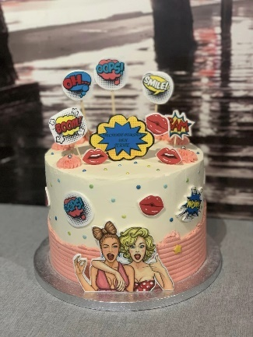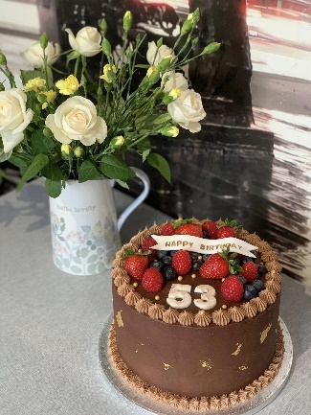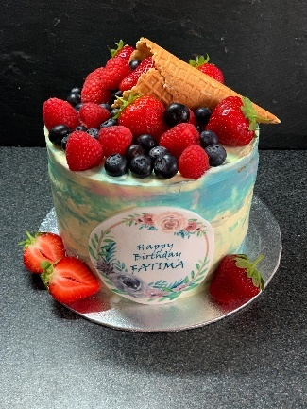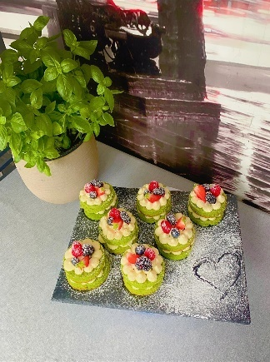
Product Description and Innovation
Sweet Station will offer a wide range of cake for various occasions, that includes birthdays, weddings as well as anniversaries and celebrations of all kinds. What differentiates it self and sets it apart from post covid-19 business landscape will be our focus on innovation in both design and delivery. We understand the evolving needs and preferences of customers who seek convenience, safety, and personalization.

Design Innovation
The team will be full of skilled pastry chefs and cake artists that will constantly push the boundaries of creativity to design cakes that are more visually stunning and unique and from the interaction handcrafted sugar flowers to custom 3D cake sculptures, we strive to bring our customers' visions to life and surpass their expectations.

Delivery Innovation
The world is in the post of covid-19 stage and its importance is recognized by offering safe and convenient delivery options. Sweet Station will be providing online ordering through our user-friendly website, allowing customers to browse our portfolio, select designs, and customize their cakes. Our efficient delivery service ensures that our cakes reach customers' doorsteps promptly and securely.
Milestones Achieved
Even though the Sweet Station is a new venture in nature but few milestones that needs to be established is laid out that will help on measuring performance.
Development of a Robust Menu: The brand has curated a diverse menu of flavors, fillings, and designs to cater to a wide range of preferences and occasions.
Supplier Partnerships: We have established strong relationships with reputable suppliers to ensure the highest quality ingredients, supporting local businesses and promoting sustainability.
Legal Structure
Sweet Station will operate as a sole proprietorship, owned and managed by the entrepreneur. As the sole proprietor, full responsibility for the business's operations, decision-making, and financial obligations will be assumed by the sole owner (Lip, 2020). The sole proprietorship legal structure allows for flexibility and ease of management, enabling Sweet Station to quickly adapt to changing market demands and customer preferences (Acra.gov.sg, 2023).

INDUSTRY ANALYSIS – Porter’s 5 forces

Threat of new entry: The cake shop industry in the UK faces a moderate threat of new entrants. While setting up a cake shop requires relatively low initial investment and does not require complex technology, establishing a reputable brand and gaining customer loyalty can be challenging.

Threat of substitutes: The threat of substitutes in the cake shop industry is relatively low because cakes are viewed in an unique position as a celebratory and indulgent food item, and no direct substitutes can replicate the experience of a beautifully designed and delicious cake. However, there may be indirect substitutes such as pastries, desserts, or other baked goods.

Bargaining power of customers: The bargaining power of buyers in the cake shop industry is moderate. Customers have access to a wide range of cake shops, both online and offline, providing them with options and the ability to compare prices and quality.

Bargaining power of suppliers: The bargaining power of suppliers in the cake shop industry is quite low as ingredients like flour, sugar, and decorations are widely available from various suppliers, allowing cake shops to switch between suppliers easily.

Competitive Rivalry: The three main competition for the new company of Sweet Station will be Cakes by Robin, Konditor and the Peggy Porschen Cakes. Peggy Porschen Cakes differentiates itself through its extensive menu offering a wide variety of Flavors and designs. While there are other cake shops in the market, Peggy Porschen stands out due to its unique flavour combinations and intricate designs (Peggy Porschen Cakes Ltd, 2023). Cakes by Robin differentiates itself by specializing in luxury, designer cakes for high-end events such as weddings and upscale parties. Cakes by Robin custom-made designer cakes are rare and exclusive. They collaborate with renowned event planners and caterers, making their cakes sought-after by clients looking for unique, show-stopping centrepieces for their high-profile events (Cakes by Robin, 2023). The Konditor differentiates itself by focusing on a niche market personalised celebration cake. They offer a wide variety of flavours and designs, appealing to customers seeking individual-sized treats for various occasions. The Konditor’s recipes, flavour profiles, and artistic decorations require specialized knowledge and expertise (Konditor.co.uk, 2023).

Name of competitor | Differentiation
Peggy Porschen Cakes | Offering a fusion of globally inspired flavours and bold artistic designs that create an unforgettable cake experience.
Cakes by Robin | Combining modern elegance with whimsical creativity, our cakes redefine luxury celebrations with innovative designs and unexpected flavour pairings.
Konditor | They offer a wide variety of flavours and designs, appealing to customers seeking individual-sized treats for various occasions. The Konditor’s recipes, flavour profiles, and artistic decorations require specialized knowledge and expertise.

OPERATIONS AND MANAGEMENT TEAM OPERATIONS
Supply Chain
In order to ensure that high quality ingredients for the cakes; Sweet Station can ensure partnerships with various trusted suppliers that will provide fresh and organic as well ingredients that will be locally sourced. The suppliers will include reputable wholesalers, farmers markets, and specialty vendors. The supplies we will need include flour, sugar, butter, eggs, flavourings, decorations, and packaging materials.
Equipment and Facility
Sweet Station will utilize a well-equipped kitchen facility that will be used to prepare and bake the cakes. The necessary equipment includes commercial-grade mixers, ovens, baking pans, decorating tools, refrigerators, and storage shelves. The kitchen will be designed to comply with food safety regulations, with designated areas for each step of the baking process.
Production Process
- Recipe Development: The skilled pastry chefs of Sweet Station will develop and refine the signature cake recipes, focusing on flavour profiles, texture, and moistness to create exceptional taste experiences.
- Ingredient Preparation: The required ingredients will be measured, sifted, and prepared in accordance with the specific recipes.
- Mixing and Baking: The ingredients will be mixed and combined according to the recipe, followed by baking the cakes at precise temperatures and durations to achieve optimal texture and consistency.
- Cooling and Levelling: After baking, the cakes will be allowed to cool and then levelled to ensure even layers for stacking and decorating.
- Decorating: Our talented cake artists will skilfully decorate the cakes with frostings, icings, fondant, and decorative elements based on customer preferences and design requests.
- Packaging: The finished cakes will be carefully packaged in appropriate cake boxes or containers to ensure their safe transportation and presentation.
Transportation & Delivery
In order to deliver the cakes to customers; Sweet Station will establish a partnerships with reliable delivery services or employ a very own delivery team. The cakes will be transported in temperature-controlled vehicles to maintain their freshness and structural integrity during transit. We will prioritize timely deliveries and ensure that the cakes are handled with care to preserve their designs.
In order to generate revenue; the company Sweet Station will utilize a wide variety of strategies that includes upselling and upgrading. As the company will offer additional services that will help on elements regarding customized cake designs, edible printing, and premium ingredients to upsell to customers. Upgrading options will include tiered cakes, specialty flavours, and intricate decorations for higher-priced offerings. Economies of scale will be achieved by optimizing ingredient procurement, streamlining production processes, and maximizing efficiency (Carlino, 2012). To prevent loss of revenue, we will focus on quality control, minimizing waste, and monitoring inventory levels to avoid overstocking. Additionally, excellent customer service, strong brand reputation, and proactive marketing efforts will help attract and retain customers, minimizing revenue loss (Goworek, and McGoldrick, 2015).
MANAGEMENT TEAM

Name | Skills | What do they bring to the firm
Pastry Chef | Baking, recipe development | Expertise in creating delicious and unique cake flavours, ensuring high-quality products.
Cake Artist | Cake decorating, design | A creative force in the baking process and makes new designs for the cake.
Delivery Personnel | Timely delivery, logistics | Reliable and efficient transportation of cakes, ensuring on-time and safe delivery to customers.
Marketing Specialist | Marketing, branding | Strategic marketing campaigns, building brand awareness, and attracting customers through effective promotional efforts.

MARKETING: The Four P’s must be used to describe your marketing strategy
Product: Sweet Station will offer a wide range of cakes for various occasions that will include birthdays, weddings and celebrations. The shop will provide a custom designed cake and it will incorporate a wide range of unique flavours and eye catching designs (Kotler et al., 2020).
Price: The pricing strategy for Sweet Station will be based on market research, considering factors such as ingredient costs, labour, and overhead expenses. The shop will focus on a competitive pricing, considering the quality, uniqueness, and customization options we provide. Price points will be determined to ensure profitability while also delivering value to customers (Kotler et al., 2020).
Promotional Mix: To promote the new Brand Sweet Station in the competitive industry; various methods and techniques will be used.
- CRM Model: The company will implement a customer relationship management strategy that will based on IDIC model which will focus on the Identify, Differentiate, Interact, Customize (Peppers and Rogers, 2011). This involves identifying our target audience, differentiating our offerings, interacting through personalized (Chalmeta, 2006.).
- Word of Mouth: Encouraging satisfied customers to spread the word about Sweet Station through testimonials, referrals, and social media sharing will be a key element of our promotional strategy (Kotler et al., 2020).
Place (Distribution strategy): The distribution strategy needs to be diverse and Sweet Station will be used by multiple channels in order to ensure convenience and accessibility for customers (Kotler et al., 2020).
- Physical Store: The Sweet Station will have a centrally located cake shop with an inviting ambiance, providing a space for customers to view cake displays, consult with cake artists, and place orders.
- Online Ordering: Customers will have the option to place orders through our user-friendly website, allowing them to browse cake designs, select customization options, and schedule deliveries.
- Delivery Service: The Sweet Station will be a reliable and efficient delivery services to transport cakes to customers' doorsteps, ensuring timely and secure delivery of our products.

FINANCIALS
The three main sources of funds will be owners personal funds, Small Business Loans. The repayment plan for the loan would be the loan assessment as well determining loan amount and terms loan amount and terms. The second step would be to cash flow management as Sweet Station needs to monitor its income, control costs, optimize revenue. Allocation of funds for loan repayments and other expenses. Maintain transparent communication and address any challenges (Government Digital Service, 2017).
Use of funds
 | Month 1 | Month 2 | Month 3 | Month 4 | Month 5 | Month 6
Revenue (from your operations and marketing section) | £ 5000 | £ 4000 | £ 3000 | £ 6800 | £ 4200 | £ 4800
Fixed Costs  (List out your fixed costs) | £ 600  £ 1200  £ 800 | £ 600  £ 1200  £ 800 | £ 600  £ 1200  £ 800 | £ 600  £ 1200  £ 800 | £ 600  £ 1200  £ 800 | £ 600  £ 1200  £ 800
Variable Costs  (List out your variable costs) | £ 300  £ 400 | £ 300 | £ 400 | £ 600  £ 300  £ 300 | £ 700  £ 500  £ 500 | £ 300  £ 300
Profit | £ 1700 | 1100 | 0 | 300 | -100 | 1600

MARKET RESEARCH
In order to be a established cake shop that will operating in United Kingdom; the first step would be to understand more about the target market’s demographic and preference. Analyse competitors, their pricing strategies, and unique selling points to differentiate your cake shop. Stay updated on emerging trends, dietary requirements, and ingredient preferences. Evaluate potential locations for foot traffic and accessibility. Gather customer feedback through surveys and focus groups to refine your offerings. Analyze online platforms and social media for customer sentiment (Birn and Forsyth, 2016).

REFERENCES
Acra.gov.sg. (2023). What is a sole proprietorship. [online] Available at: https://www.acra.gov.sg/how-to-guides/starting-sole-proprietorships/what-is-a-sole-proprietorship [Accessed 20 Jul. 2023].
Birn, R. and Forsyth, P. (2016). Market Research. Oxford: Capstone Pub.
Barringer, B., Ireland, D., (2019) Entrepreneurship: Successfully Launching New Ventures. Sixth edition; Global edition.
Cakes by Robin. (2023). Bespoke Cake Company London | Cakes by Robin. [online] Available at: https://www.cakesbyrobin.co.uk/ [Accessed 21 Jul. 2023].
Carlino, G.A., 2012. Economies of scale in manufacturing location: theory and measure (Vol. 12). Springer Science & Business Media.
Chalmeta, R., 2006. Methodology for customer relationship management. Journal of systems and software, 79(7), pp.1015-1024.
Government Digital Service (2017). Apply for a Start Up Loan for your business. [online] GOV.UK. Available at: https://www.gov.uk/apply-start-up-loan [Accessed 28 Jul. 2023].
Goworek, H. and McGoldrick, P., 2015. Retail marketing management. Harlow: Pearson Education Limited.
‌Konditor.co.uk. (2023). Konditor • Cakes & Brownies Delivered Nationwide. [online] Available at: https://konditor.co.uk/ [Accessed 25 Jul. 2023].
Kotler, P., Armstrong, G., Harris, L.C. and He, H. (2020). Principles of Marketing. 8th ed. Harlow: Pearson.
‌Lip, G. (2020). Sole Proprietorship. [online] Corporate Finance Institute. Available at: https://corporatefinanceinstitute.com/resources/management/sole-proprietorship/ [Accessed 01August. 2023].
Peggy Porschen Cakes Ltd. (2023). Peggy Porschen Cakes Ltd. [online] Available at: https://www.peggyporschen.com/ [Accessed 04August. 2023].
Peppers, D. and Rogers, M. (2011). Managing customer relationships : a strategic framework. Hoboken (N.J.): J. Wiley, Cop.

‌

