Database Design (The Book Store)
Author: Patrick Frank Atkinson (1811357)
ACCB4013 – Information Engineering
Faculty of Architecture, Computing and Engineering
Date of submission: 3rd May 2019 at 15:00

Abstract
This report covers the design and implementation of an Access database to meet a set of user requirements. The first part of the report discusses the process of creating the entity relationship diagram is outlined, including the process of normalising the entities. The second part of the report documents the creation of the Access file, including an overview of the forms and reports that have been developed and a user guide for the application.

Contents
1. Introduction 1
2. Task 1 1
2.1. Analysis of data requirements 1
2.2. Normalisation of the data 1
2.3. Entity Relationship Diagram (ERD) 2
3. Task 2 3
3.1. Structured Query Language (SQL) implementation 3
3.2. Table design 3
3.3. Relationship diagram 3
3.4. Report outputs 3
3.5. Form layouts 13
3.6. User guide 18
4. Glossary 19
5. Reference list 20
6. Further reading 21
7. Appendices 22
7.1. Appendix A – Design brief 22
7.2. Appendix B – Unnormalised form 24
7.3. Appendix C – 1st normalised form 25
7.4. Appendix D – 2nd normalised form 26
7.5. Appendix E – 3rd normalised form 27
7.6. Appendix F – Table field properties 28
7.7. Appendix G – Access relationship diagram 37
7.8. Appendix H – SQL CREATE TABLE queries 38
7.9. Appendix I – SQL INSERT statements 43
7.10. Appendix J – User guide 44

Introduction
The author has been tasked with developing a suitable solution to the design brief outlined in Appendix A. The requirement is that the development of the solution is split into two tasks. This report will also be split in this manner. Task 1 will be the creation of an Entity Relationship Diagram (ERD) and the documentation associated with this. Task 2 will be to create a database based on the ERD from Task 1. The Database Management System (DBMS) will be Microsoft Access. In addition to the database structure, forms, queries and reports are expected as a means to interact with the data stored in the database. Documentation, including a user guide, is also required for this system.

Task 1

Analysis of data requirements
Analysis of the design brief indicates a requirement for storing the following data:
- Customer data (names and addresses)
- Current stock
- Order details
- Supplier data
Each of these will become an entity, or table. These entities will be normalised to ensure data integrity and prevent data redundancy.

Normalisation of the data
The data in its unnormalised form (shown in Appendix B) presents numerous examples of redundant data and potential issues with data integrity. This is particularly noticeable in the tables tblOrder and tblNewsletter where customer addresses would need to be entered for each book in the order or newsletter. There is also the potential for duplicate keys if there were multiples of the same book in an order or newsletter.
For the data to be in first normal form, each column must contain atomic values (i.e. values that cannot be divided into smaller parts) and there should be no repeating groups of columns. Each row of data should also have a unique primary key, made up of one or more columns, that identifies the row [1].
The ERD for the data in first normal form can be found in Appendix C. To meet the requirements for first normal form, the customer and supplier contact details were split into their own tables. This necessitated the supplier details being moved from tblBook into their own table. A new table for stock details (tblStock) was created to allow multiple instances of the same book without duplication of data and ensures each copy of the book has a unique stock number. Link tables were also added for stock linked to orders and newsletters (tblOrderStock and tblNewsletterStock respectively). This removes the duplication of book details in tblOrder and tblNewsletter.
For the data to be in second normal form, all data in a table should be dependent on the primary key [2]. The ERD for the data in second normal form can be found in Appendix D. Data such as author and publisher names were moved into their own tables with foreign keys in their original tables.
Columns in a table should be ‘non-transitively dependent’ for the table to be in third normal form. This means the columns should be entirely dependent on the primary key and not on any through an intermediate column [3]. The final ERD in third normalised form can be found in Appendix E. Further analysis once the data had been normalised to second normal form showed that there were no transitively dependent columns and the data was therefore already in third normal form.

Entity Relationship Diagram (ERD)
The final ERD in Appendix E was referenced when creating the entities and their relationships in the DBMS. The entities defined in the ERD account for the user requirements. Details can be stored for customers and supplier. Book details can also be stored, as well as details of current and previous stock. There is provision for storing order data and data relating to newsletters sent out to customers. The relationships between the entities and their membership classes are outlined below. The numbers correspond to the numbering on the ERD in Appendix E.
Number | Table 1 (Field) | Table 2 (Field) | Relationship | Membership class
1 | tblOrder (OrderID) | tblOrderStock (OrderID) | One-to-many | Table 1 – mandatory  Table 2 – mandatory
2 | tblCustomer (CustomerID) | tblOrder (CustomerID) | One-to-many | Table 1 – optional  Table 2 – mandatory
3 | tblCustContactDet (CustContactID) | tblOrder (DeliveryAddress) | One-to-many | Table 1 – optional  Table 2 – mandatory
4 | tblCustContactDet (CustContactID) | tblOrder (BillingAddress) | One-to-many | Table 1 – optional  Table 2 – mandatory
5 | tblOrderStatus (OrderStatusID) | tblOrder (OrderStatusID) | One-to-many | Table 1 – optional  Table 2 – mandatory
6 | tblCustomer (CustomerID) | tblCustContactDet (CustomerID) | One-to-many | Table 1 – mandatory  Table 2 – mandatory
7 | tblCustomer (CustomerID) | tblNewsletter (CustomerID) | One-to-many | Table 1 – optional  Table 2 – mandatory
8 | tblStock (StockID) | tblOrderStock (StockID) | One-to-one | Table 1 – optional  Table 2 – mandatory
9 | tblStock (StockID) | tblNewsletterStock (StockID) | One-to-many | Table 1 – optional  Table 2 – mandatory
10 | tblBook (BookID) | tblStock (BookID) | One-to-many | Table 1 – optional  Table 2 – mandatory
11 | tblGenre (GenreID) | tblBook (GenreID) | One-to-many | Table 1 – optional  Table 2 – mandatory
12 | tblAuthor (AuthorID) | tblBook (AuthorID) | One-to-many | Table 1 – optional  Table 2 – mandatory
13 | tblPublisher (PublisherID) | tblBook (PublisherID) | One-to-many | Table 1 – optional  Table 2 – mandatory
14 | tblSupplier (SupplierID) | tblBook (SupplierID) | One-to-many | Table 1 – optional  Table 2 – mandatory
15 | tblSupplier (SupplierID) | tblSuppContactDet (SupplierID) | One-to-many | Table 1 – mandatory  Table 2 – mandatory
16 | tblNewsletter (NewsletterID) | tblNewsletterStock (NewsletterID) | One-to-many | Table 1 – mandatory  Table 2 – mandatory

Task 2

Structured Query Language (SQL) implementation
The tables in the database have been created using SQL CREATE TABLE queries. The queries have been stored in the Access database file, all having a query name beginning with ‘qryCREATE’. They can also be found in Appendix H.
Some data was entered into tables using INSERT statements. Examples of INSERT statements for a adding a book can be found in Appendix H. INSERT and DELETE statements are also used on the sub forms subfrmSelectOrderStock and subfrmRemoveOrderStock.

Table design
The validation on the tables was reviewed after they had been created. Fields were marked as mandatory, input masks were defined and validation rules and error text were added. Lookups were set up where fields were foreign keys. Details of the field properties for each table can be found in Appendix F.

Relationship diagram
A screenshot of the final relationship diagram from Access can be found in Appendix G.

Report outputs
This section gives screenshots of example outputs from the reports in the DBMS. The query used for each report is stated in the caption of each screenshot. It should be noted that each of these reports has a button in the header for closing the report. The buttons are configured to not display when the report is being printed, hence them not being shown in the following screenshots. Some of the reports have fields with calculated values. Examples include the item and invoice totals in rptSearchInvoice and the author names in rptSearchBook and rptSearchCurrentStock.
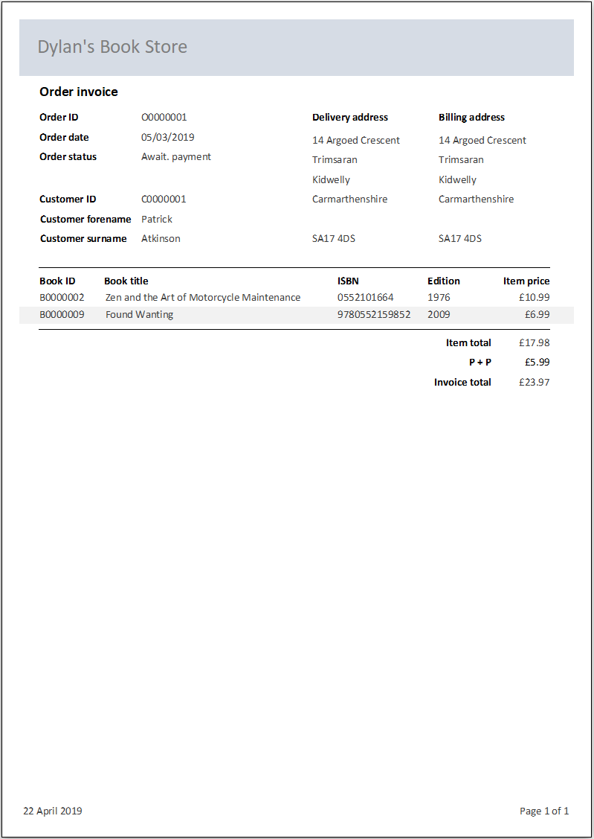
Figure 1: Order invoice report (rptSearchInvoice). Uses the query qryRptSearchInvoice.

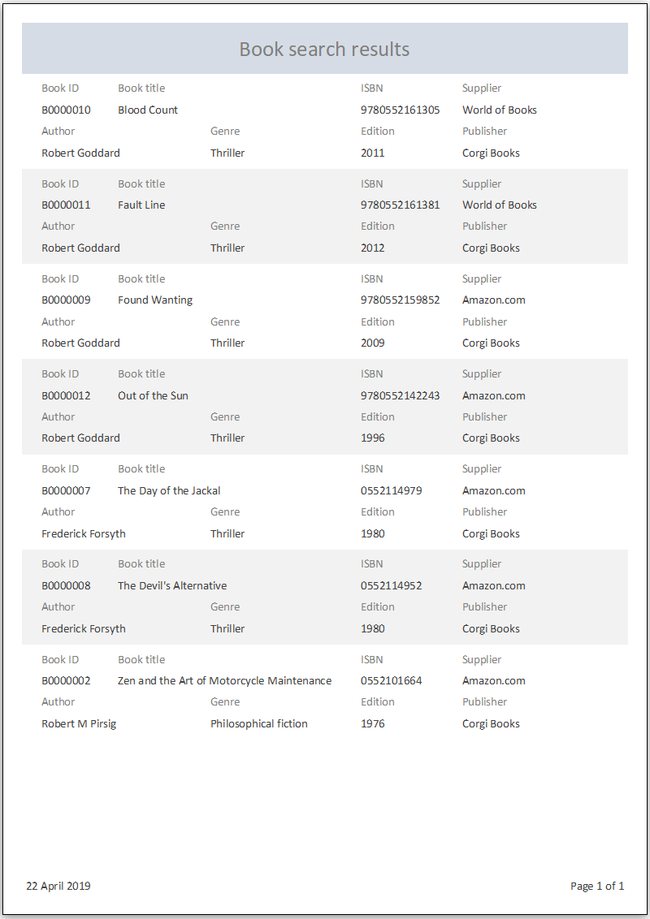
Figure 2: Book search report (rptSearchBook). Uses the query qryRptSearchBook.
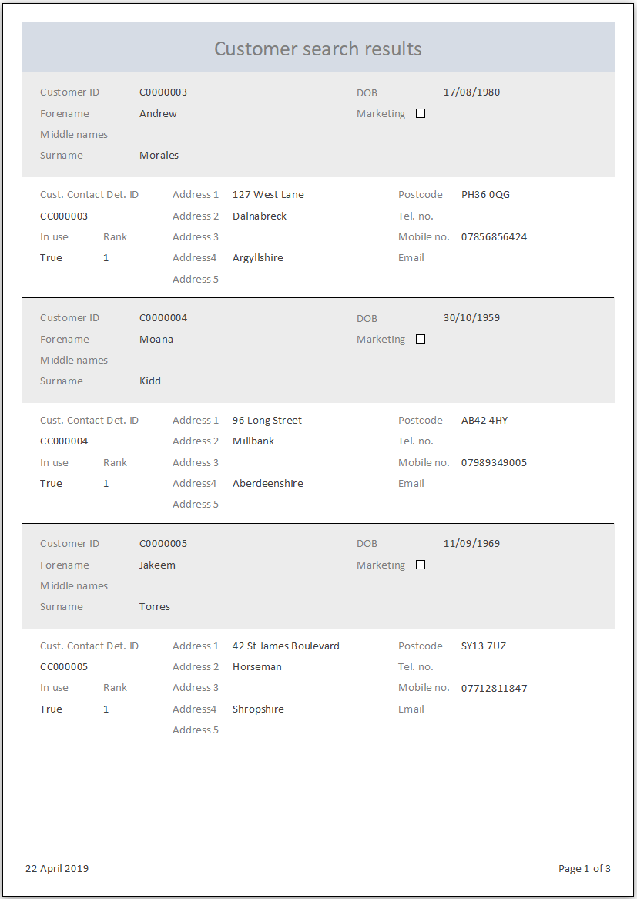
Figure 3: Customer search report (rptSearchCustomer). Uses the query qryRptSearchCustomer.
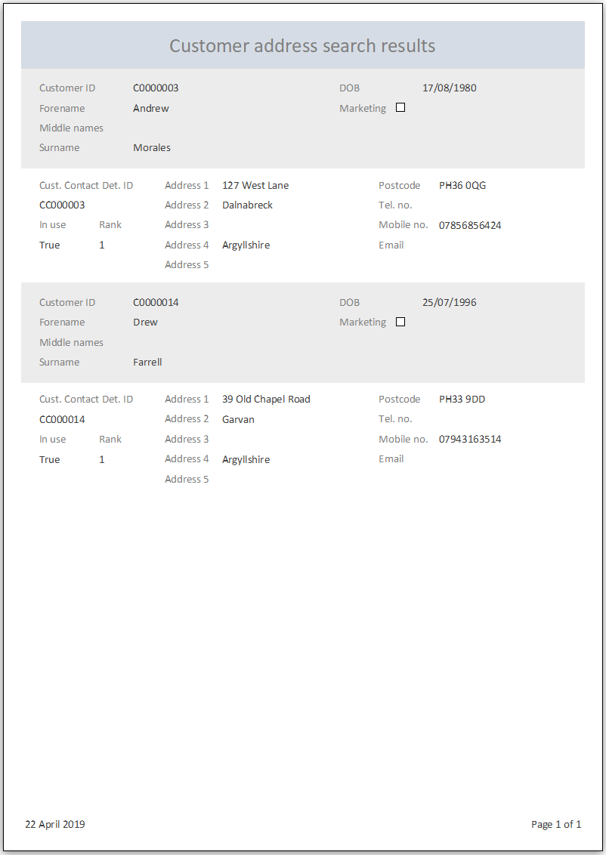
Figure 4: Customer address search report (rptSearchCustAddresses). Uses the query qryRptSearchCustAddresses.
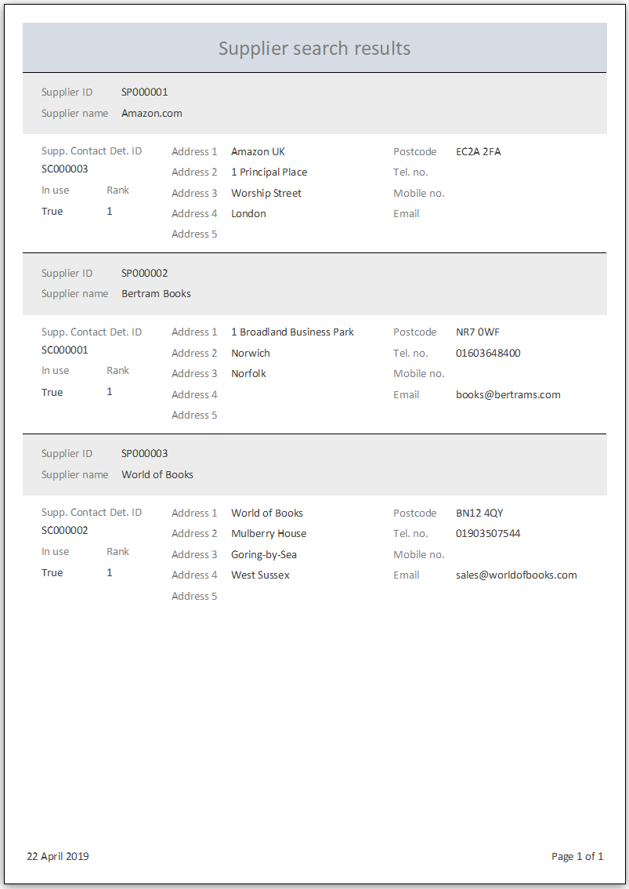
Figure 5: Supplier search results (rptSearchSupplier). Uses the query qryRptSearchSupplier.
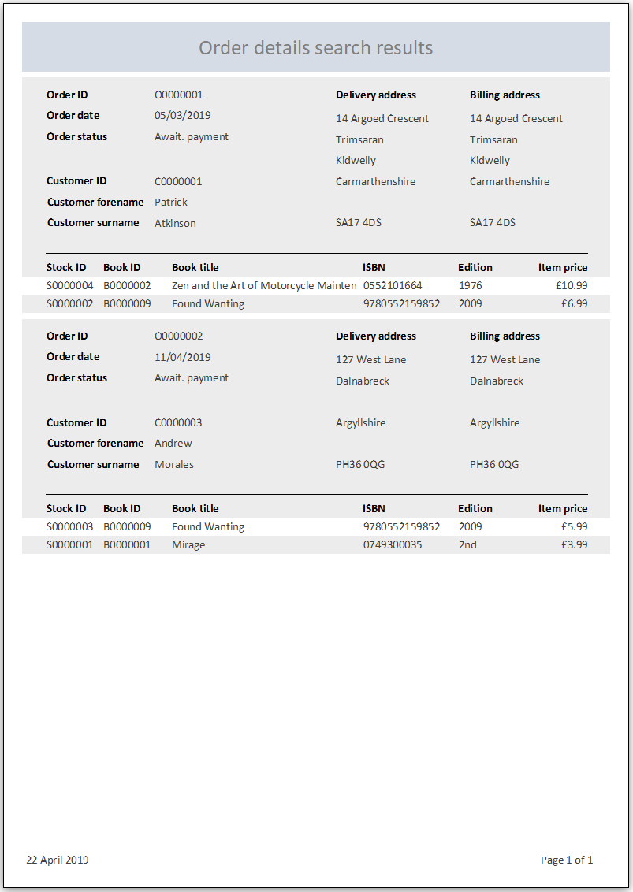
Figure 6: Order details search report (rptSearchOrderDetails). Uses the query qryRptSearchOrderDetails.
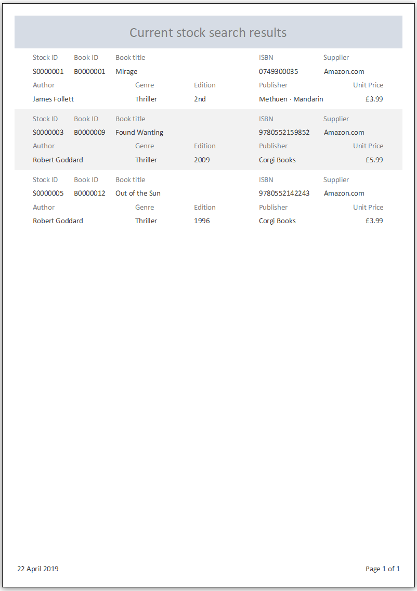
Figure 7: Current stock search report (rptSearchCurrentStock). Uses the query qryRptSearchCurrentStock.
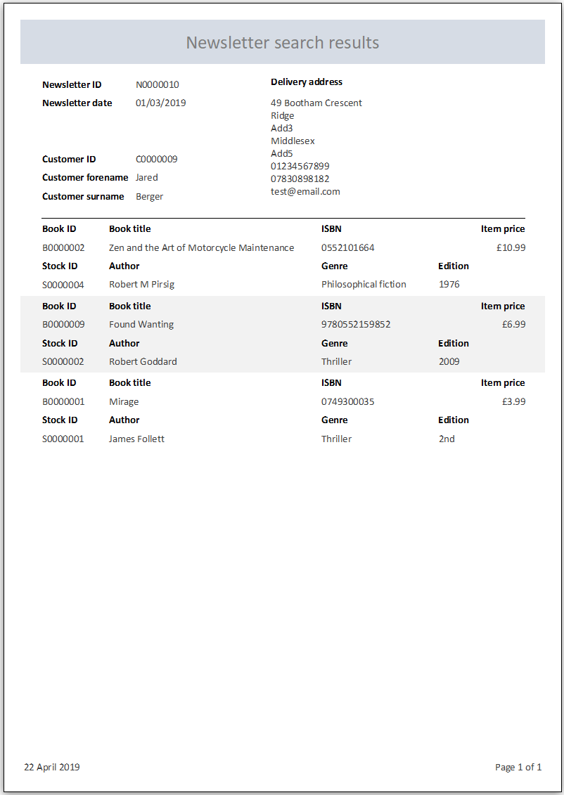
Figure 8: Newsletter search report (rptSearchNewsletter). Uses the query qryRptSearchNewsletter.

Form layouts
A main menu form (frmMainMenu) has been created that includes buttons linking to the other forms in the DBMS. The buttons are organised using tabs as illustrated in Figures 9 and 10. The main menu form automatically opens when the Access file is opened.
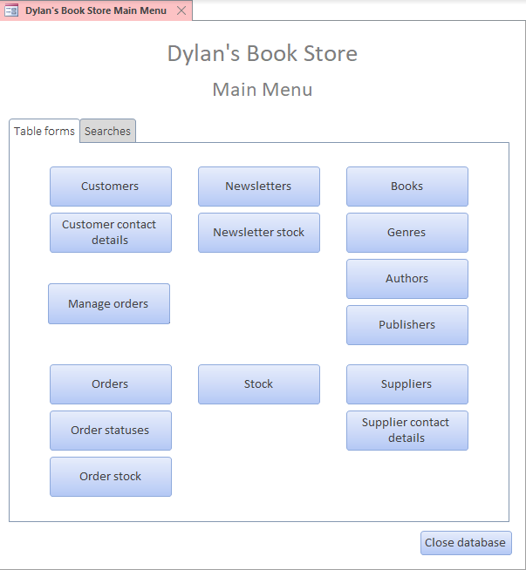  Figure 9: Main menu form (frmMainMenu) - 'Table forms' tab | 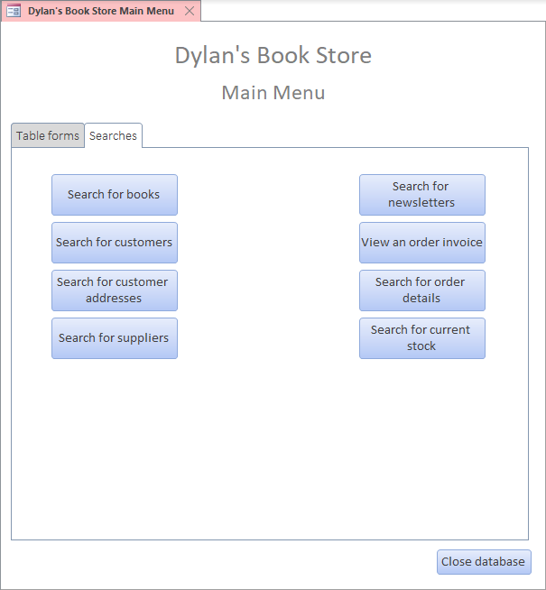  Figure 10: Main menu form (frmMainMenu) - 'Searches' tab
A form has been created for each table to provide the end user with a more user-friendly method of entering data. The names for these forms all begin with ‘frmTbl’ and they are all accessible from the ‘Table forms’ tab of the main menu form.

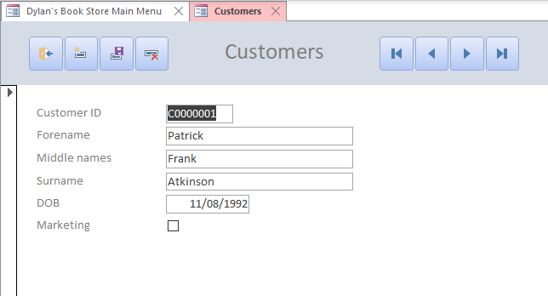  Figure 11: Customers form (frmTblCustomer) | 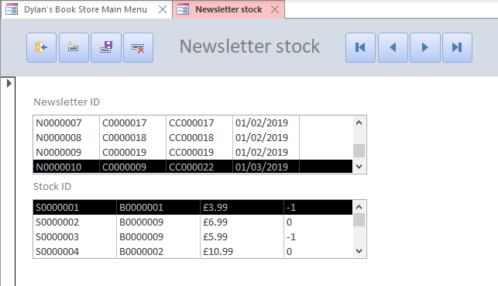  Figure 12: Newsletter stock form (frmTblNewsletterStock)

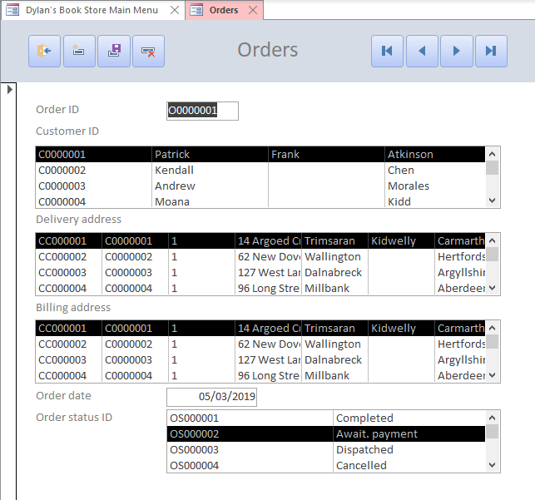  Figure 13: Orders form (frmTblOrder) | 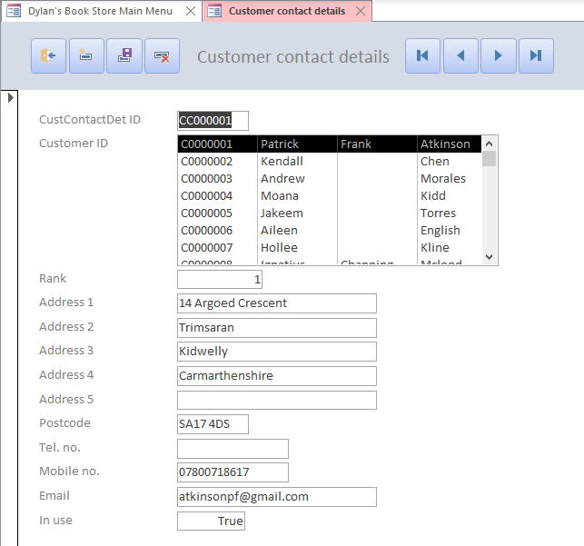  Figure 14: Customer contact details form (frmTblCustContactDet)
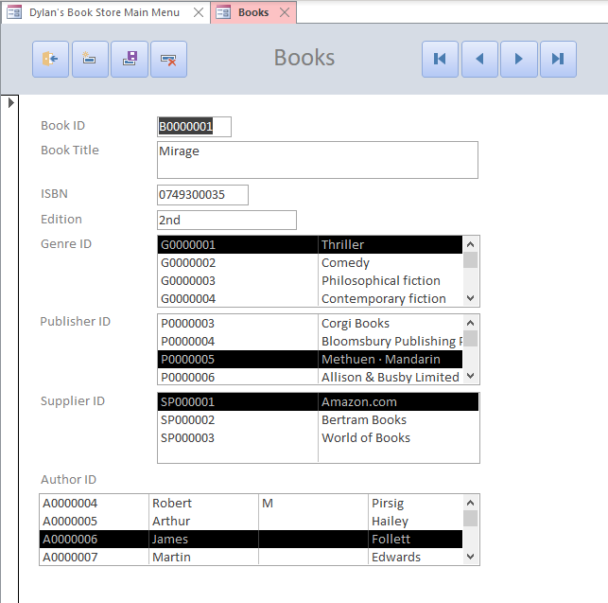  Figure 15: Books form (frmTblBook) | 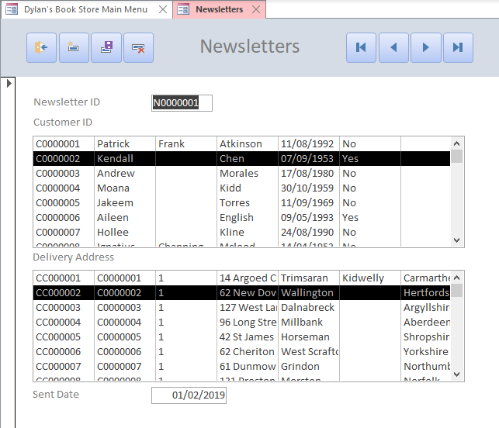  Figure 16: Newsletters form (frmTblNewsletter)
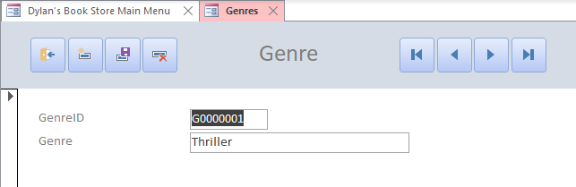  Figure 17: Genre form (frmTblGenre) | 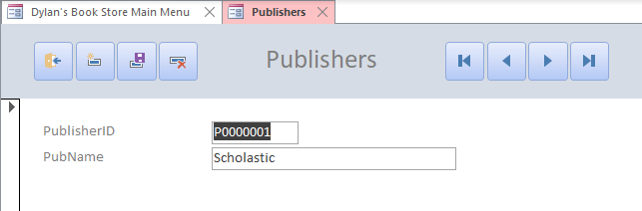  Figure 18: Publishers form (frmTblPublisher)
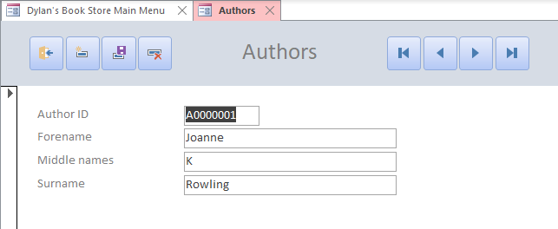  Figure 19: Authors form (frmTblAuthor) | 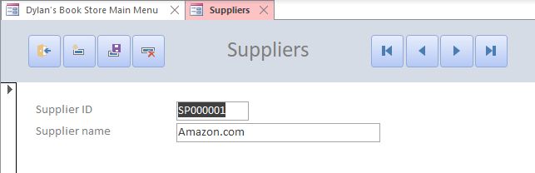  Figure 20: Suppliers form (frmTblSupplier)
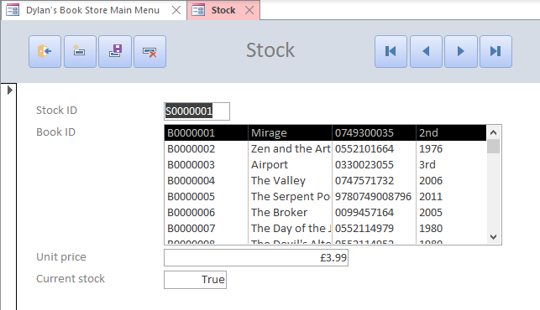  Figure 21: Stock form (frmTblStock) | 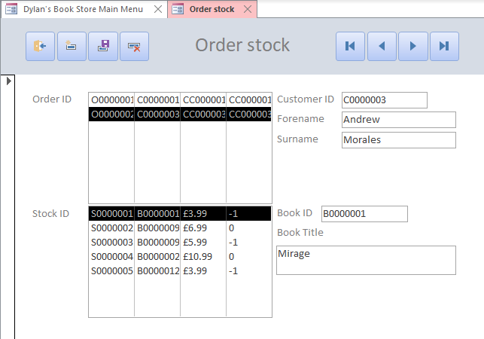  Figure 22: Order stock form (frmTblOrderStock)
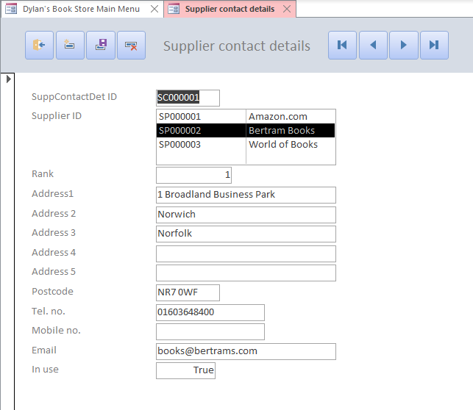  Figure 23: Supplier contact details form (frmTblSuppContactDet) | 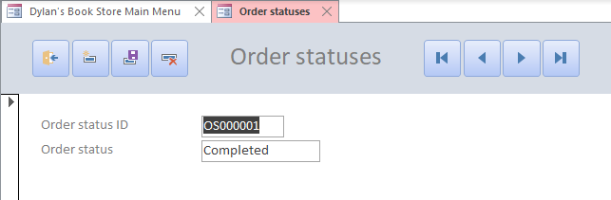  Figure 24: Order statuses form (frmTblOrderStatus)

There is a form specifically for making adding new orders easier (Figure 25). There are windowed sub forms for selecting the customer and the addresses for the order. There is an embedded form showing which stock items are associated with the order and there are buttons for adding and removing stock items. The macros for these buttons execute INSERT and DELETE SQL statements respectively.
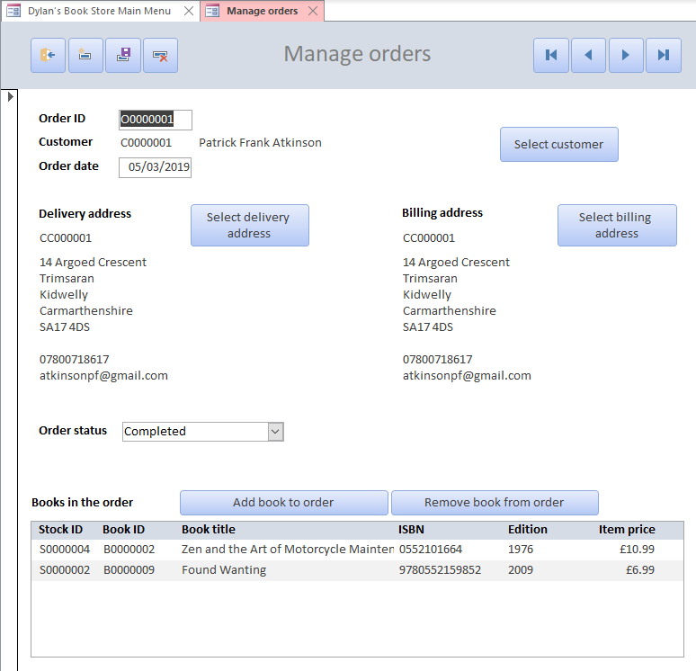
Figure 25: Manage orders form
There are also forms for generating the reports outlined in the previous section. These forms are accessed from the ‘Searches’ tab of the main menu form and allow the user to enter search criteria before generating the reports. The names for these forms all begin with ‘frmSearch’. They make use of macros to call the associated report. The macro names all begin with ‘mcrSearch’ and the report names begin with ‘rptSearch’.
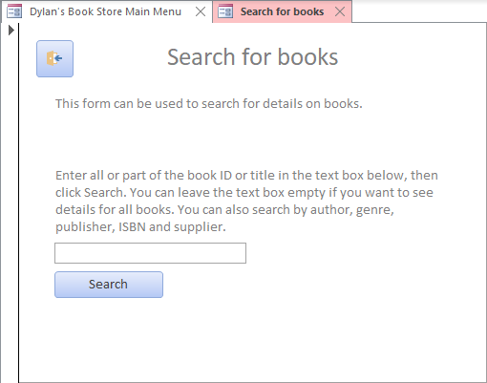  Figure 26: Form to search for books (frmSearchBook) | 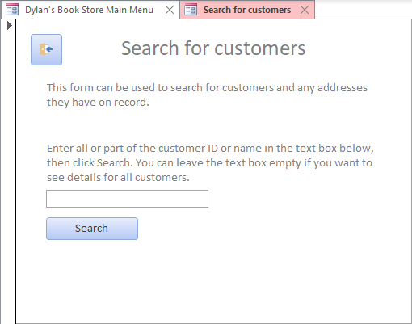  Figure 27: Form to search for customers (frmSearchCustomer)
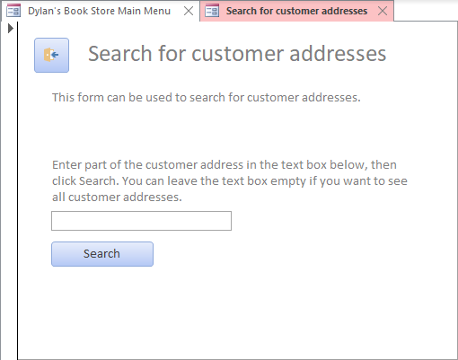  Figure 28: Form to search for customer addresses (frmSearchCustAddresses) | 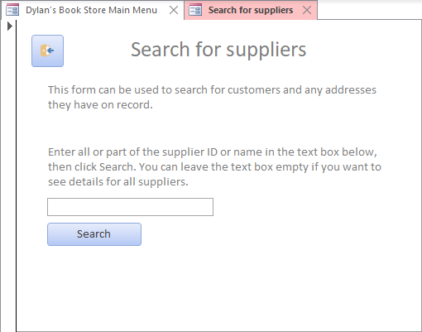  Figure 29: Form to search for suppliers (frmSearchSupplier)
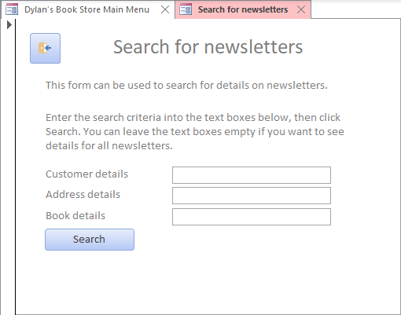  Figure 30: Form to search for newsletters (frmSearchNewsletter) | 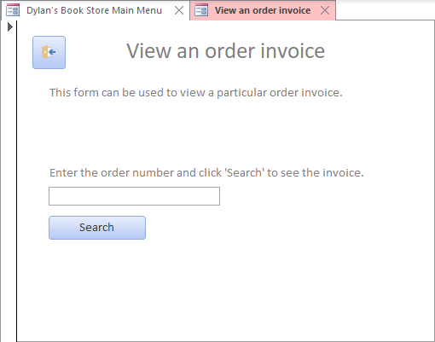  Figure 31: Form to view an order invoice (frmSearchInvoice)
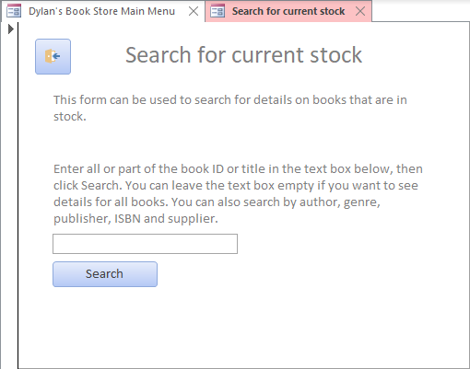  Figure 32: Form to search for current stock (frmSearchCurrentStock) | 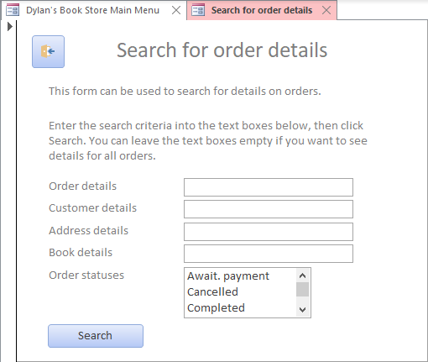  Figure 33: Form to search for order details (frmSearchOrderDetails)

User guide
A brief user guide for the database can be found in Appendix J.

Glossary
Acronym | Term
DBMS | Database Management System
ERD | Entity Relationship Diagram
SQL | Structured Query Language

Reference list
[1] K. Wenzel, “Learn about the First Normal Form and Database Design,” Essential SQL. [Online]. Available: https://www.essentialsql.com/get-ready-to-learn-sql-8-database-first-normal-form-explained-in-simple-english/. [Accessed: 03-Apr-2019].
[2] K. Wenzel, “Database Second Normal Form Explained in Simple English,” EssentialSQL. [Online]. Available: https://www.essentialsql.com/get-ready-to-learn-sql-10-database-second-normal-form-explained-in-simple-english/. [Accessed: 03-Apr-2019].
[3] K. Wenzel, “Database Third Normal Form Explained in Simple English,” EssentialSQL, 2018. [Online]. Available: https://www.essentialsql.com/get-ready-to-learn-sql-11-database-third-normal-form-explained-in-simple-english/. [Accessed: 03-Apr-2019].

Appendices

Appendix A – Design brief
Dylan’s Book Store has been running successfully in Swansea for many years. The shop has customers from all over the Principality and a number of loyal English, Scottish and Irish fans. They specialise in selling classic titles and new best sellers. In particular they try to look for first editions of many of the classics (for example ‘Under Milk Wood’ has become very desirable this year for some unknown reason).
The following points document the working procedures of the book shop: -
- Staff place orders with suppliers (publishers and collectable book dealers). This is carried out mainly by intuition and guessing what the customers may be interested in.
- Customers will also place orders for copies of books, both popular titles and rare first editions.
- They have many customers outside the Swansea area and for many years they have operated a mail order service. The release a newsletter once every three months, detailing current interesting stock etc.
- They have on small computer used for word processing and what could loosely be termed as a data base (a collection of names and addresses of customers typed into one document which isn’t update regularly)
Due to the various factors such a prompt and friendly service and much media coverage of the works of a famous welsh author the company are gaining an ever-increasing customer base. To maintain their level of service, the company has decided that fast information retrieval and processing is a must. They realise it’s time to computerise. They require a user-friendly database system, in MS-Access, that will satisfy their processing needs.
Additional information
The database system should be menu driven. The design of the record structure of any tables you use has been left to your discretion.
The book shop would like to use the system to query information for customer seeking out specific titles in particular the classic rare first editions and produce relevant reports on availability.
Although this is a typical stock plus mail order system, the shop would like to maintain its friendly service and customer care that has gained them their reputation. They hope the system will allow for this flexibility
Using the above scenario, ensure that your system includes the following features: -
- User has the ability to add or delete information from any table.
- User should be able to view, on screen, Book, stock , order and customer details.
- User should be able to view ongoing customer orders.
- User should be able to query the system and print out relevant reports.

Appendix B – Unnormalised form
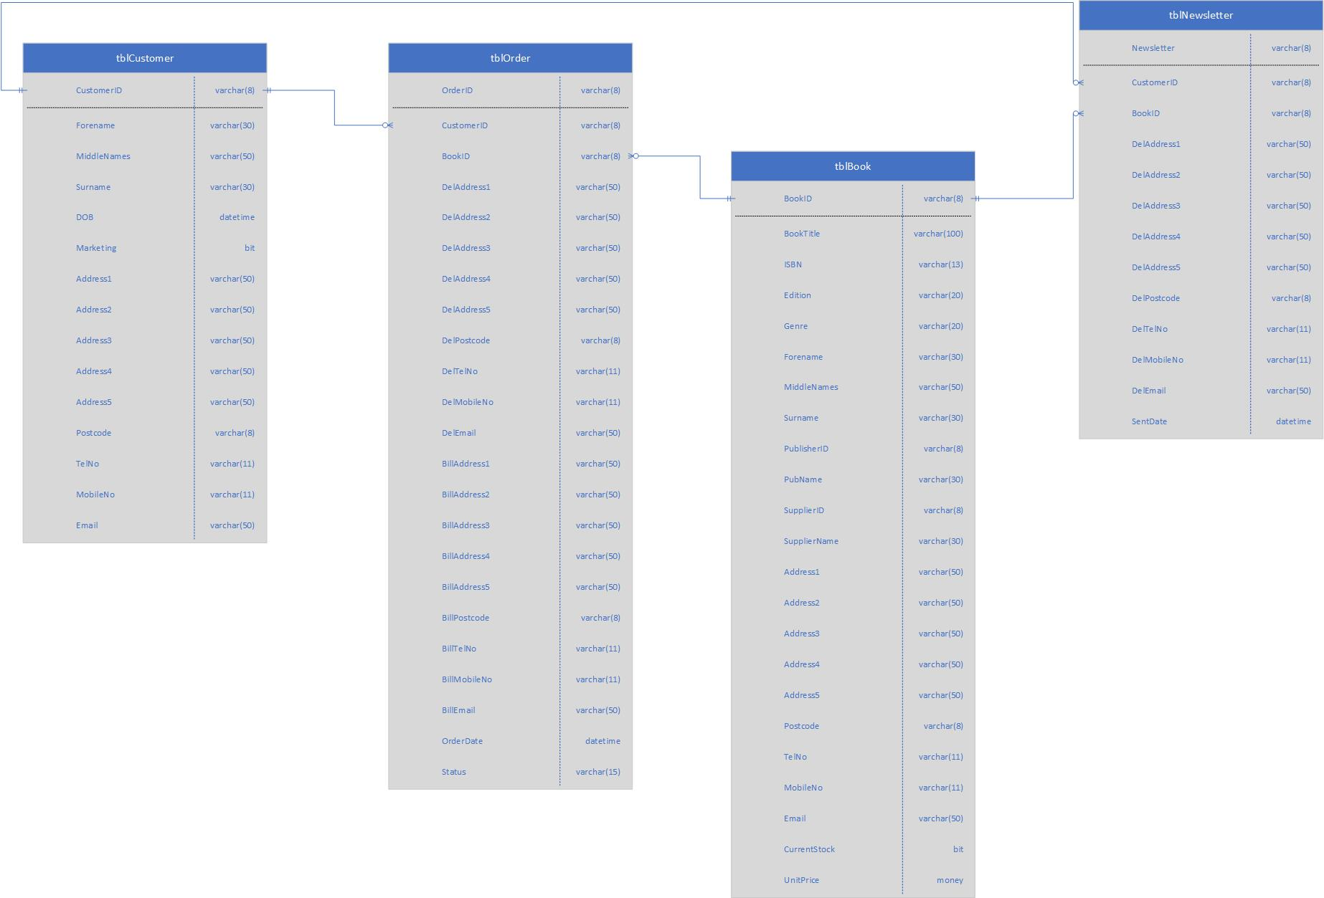

Appendix C – 1st normalised form
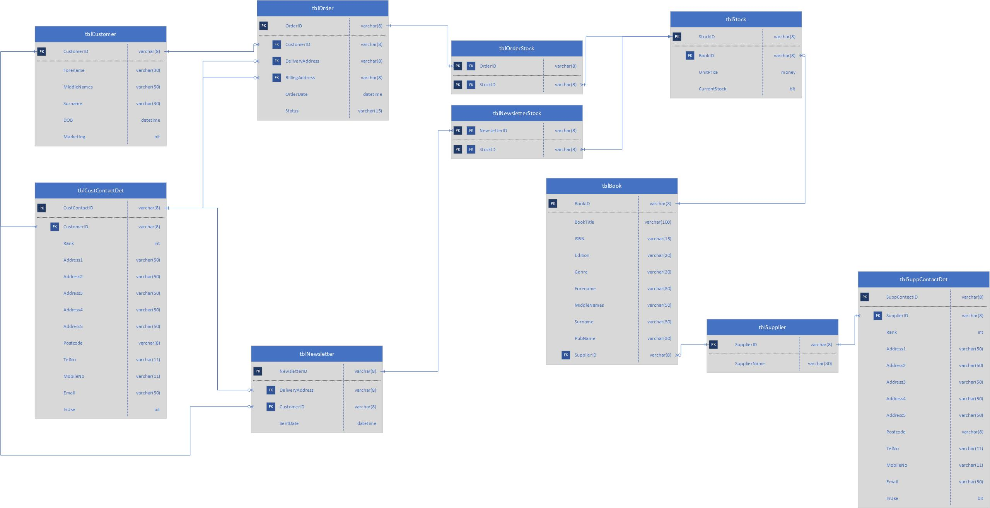

Appendix D – 2nd normalised form
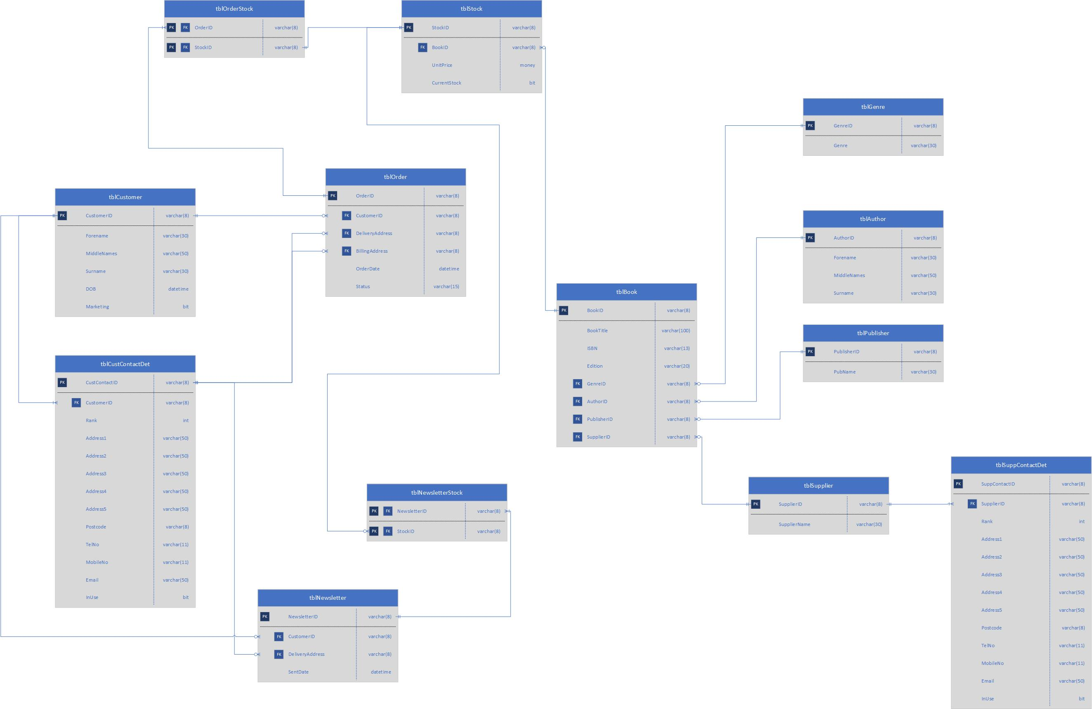

Appendix E – 3rd normalised form
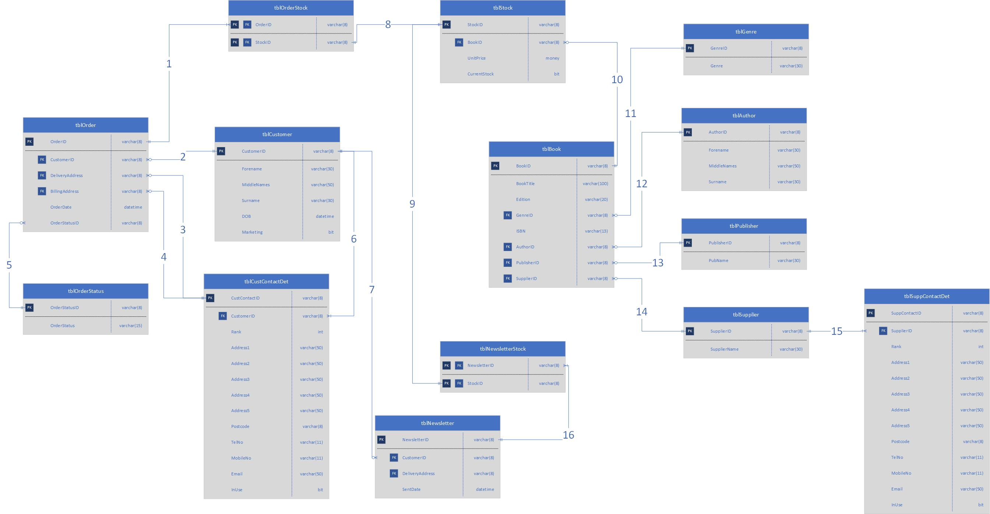

Appendix F – Table field properties
tblAuthor
Field | Data type | Field size | Key | Required | Lookup | Input mask | Validation rule | Validation text
AuthorID | Short text | 8 | Primary | Y | N
Forename | Short text | 30 |  | Y | N
MiddleNames | Short text | 50 |  | N | N
Surname | Short text | 30 |  | Y | N

tblBook
Field | Data type | Field size | Key | Required | Lookup | Input mask | Validation rule | Validation text
BookID | Short text | 8 | Primary | Y | N
BookTitle | Short text | 100 |  | Y | N
ISBN | Short text | 13 |  | N | N | 0000000000999
Edition | Short text | 20 |  | Y | N
GenreID | Short text | 8 | Foreign | Y | tblGenre
AuthorID | Short text | 8 | Foreign | Y | tblAuthor
PublisherID | Short text | 8 | Foreign | Y | tblPublisher
SupplierID | Short text | 8 | Foreign | Y | tblSupplier

tblCustContactDet
Field | Data type | Field size | Key | Required | Lookup | Input mask | Validation rule | Validation text
CustContactDetID | Short text | 8 | Primary | Y | N
CustomerID | Short text | 8 | Foreign | Y | N | tblCustomer
Rank | Number |  |  | Y | N
Address1 | Short text | 50 |  | Y | N
Address2 | Short text | 50 |  | N | tblGenre
Address3 | Short text | 50 |  | N | tblAuthor
Address4 | Short text | 50 |  | N | tblPublisher
Address5 | Short text | 50 |  | N | tblSupplier
Postcode | Short text | 9 |  | Y
TelNo | Short text | 11 |  | N
MobileNo | Short text | 11 |  | N
Email | Short text | 50 |  | N |  |  | Is Null OR ((Like "*?@?*.?*") AND (Not Like "*[ ,;]*")) | Please ensure a valid email address is entered.
InUse | Yes/No |  |  | Y

tblCustomer
Field | Data type | Field size | Key | Required | Lookup | Input mask | Validation rule | Validation text
CustomerID | Short text | 8 | Primary | Y
Forename | Short text | 30 |  | Y
MiddleNames | Short text | 50 |  | N
Surname | Short text | 30 |  | Y
DOB | Date/Time |  |  | Y
Marketing | Yes/No |  |  | Y

tblGenre
Field | Data type | Field size | Key | Required | Lookup | Input mask | Validation rule | Validation text
GenreID | Short text | 8 | Primary | Y
Genre | Short text | 30 |  | Y

tblNewsletter
Field | Data type | Field size | Key | Required | Lookup | Input mask | Validation rule | Validation text
NewsletterID | Short text | 8 | Primary | Y
CustomerID | Short text | 8 | Foreign | Y | tblCustomer
DeliveryAddress | Short text | 8 | Foreign | N | tblCustContactDet
SentDate | Date/Time |  |  | Y

tblNewsletterStock
Field | Data type | Field size | Key | Required | Lookup | Input mask | Validation rule | Validation text
NewsletterID | Short text | 8 | Primary | Y | tblNewsletter
StockID | Short text | 8 | Primary | Y | tblStock

tblOrder
Field | Data type | Field size | Key | Required | Lookup | Input mask | Validation rule | Validation text
OrderID | Short text | 8 | Primary | Y
CustomerID | Short text | 8 | Foreign | Y | tblCustomer
DeliveryAddress | Short text | 8 | Foreign | Y | tblCustContactDet
BillingAddress | Short text | 8 | Foreign | Y | tblCustContactDet
OrderDate | Date/Time |  |  | Y
OrderStatusID | Short text | 8 | Foreign | Y | tblOrderStatus

tblOrderStatus
Field | Data type | Field size | Key | Required | Lookup | Input mask | Validation rule | Validation text
OrderStatusID | Short text | 8 | Primary | Y
OrderStatus | Short text | 15 |  | Y

tblOrderStock
Field | Data type | Field size | Key | Required | Lookup | Input mask | Validation rule | Validation text
OrderID | Short text | 8 | Primary | Y | tblOrder
StockID | Short text | 8 | Primary | Y | tblStock

tblPublisher
Field | Data type | Field size | Key | Required | Lookup | Input mask | Validation rule | Validation text
PublisherID | Short text | 8 | Primary | Y
PubName | Short text | 30 |  | Y

tblStock
Field | Data type | Field size | Key | Required | Lookup | Input mask | Validation rule | Validation text
StockID | Short text | 8 | Primary | Y
BookID | Short text | 8 | Foreign | Y | tblBook
UnitPrice | Currency |  |  | Y
CurrentStock | Yes/No |  |  | Y
tblSuppContactDet
Field | Data type | Field size | Key | Required | Lookup | Input mask | Validation rule | Validation text
SuppContactDetID | Short text | 8 | Primary | Y | N
SupplierID | Short text | 8 | Foreign | Y | N | tblSupplier
Rank | Number |  |  | Y | N
Address1 | Short text | 50 |  | Y | N
Address2 | Short text | 50 |  | N | tblGenre
Address3 | Short text | 50 |  | N | tblAuthor
Address4 | Short text | 50 |  | N | tblPublisher
Address5 | Short text | 50 |  | N | tblSupplier
Postcode | Short text | 9 |  | Y
TelNo | Short text | 11 |  | N
MobileNo | Short text | 11 |  | N
Email | Short text | 50 |  | N |  |  | Is Null OR ((Like "*?@?*.?*") AND (Not Like "*[ ,;]*")) | Please ensure a valid email address is entered.
InUse | Yes/No |  |  | Y

tblSupplier
Field | Data type | Field size | Key | Required | Lookup | Input mask | Validation rule | Validation text
SupplierID | Short text | 8 | Primary | Y
SupplierName | Short text | 30 |  | Y

Appendix G – Access relationship diagram
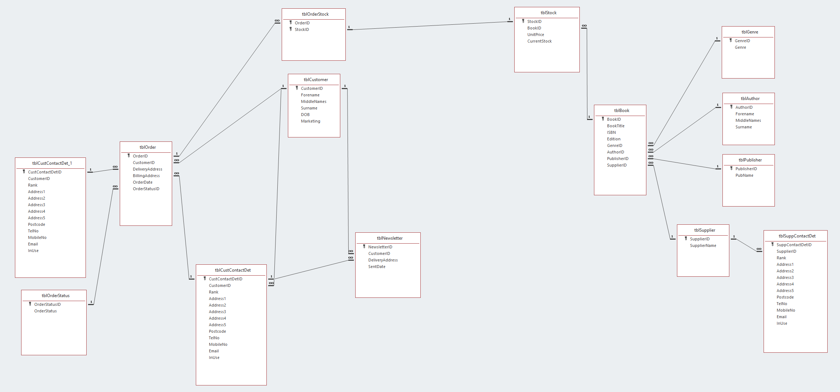

Appendix H – SQL CREATE TABLE queries
qryCREATEtblAuthor
CREATE TABLE tblAuthor
(
AuthorID TEXT(8) CONSTRAINT AuthorID_pk PRIMARY KEY,
Forename TEXT(30),
MiddleNames TEXT(50),
Surname TEXT(30)
);
qryCREATEtblBook
CREATE TABLE tblBook
(
BookID TEXT(8) CONSTRAINT BookID_pk PRIMARY KEY,
BookTitle TEXT(100),
ISBN TEXT(13),
Edition TEXT(20),
GenreID TEXT(8) CONSTRAINT GenreID_fk REFERENCES tblGenre (GenreID),
AuthorID TEXT(8) CONSTRAINT AuthorID_fk REFERENCES tblAuthor (AuthorID),
PublisherID TEXT(8) CONSTRAINT PublisherID_fk REFERENCES tblPublisher (PublisherID),
SupplierID TEXT(8) CONSTRAINT SupplierID_fk REFERENCES tblSupplier (SupplierID)
);
qryCREATEtblCustContactDet
CREATE TABLE tblCustContactDet
(
CustContactDetID TEXT(8) CONSTRAINT CustContactDetID_pk PRIMARY KEY,
CustomerID TEXT(8) CONSTRAINT CustomerContID_fk REFERENCES tblCustomer (CustomerID),
Rank INTEGER,
Address1 TEXT(50),
Address2 TEXT(50),
Address3 TEXT(50),
Address4 TEXT(50),
Address5 TEXT(50),
Postcode TEXT(8),
TelNo TEXT(11),
MobileNo TEXT(11),
Email TEXT(50),
InUse BIT
);
qryCREATEtblCustomer
CREATE TABLE tblCustomer
(
CustomerID TEXT(8) CONSTRAINT CustomerID_pk PRIMARY KEY,
Forename TEXT(30),
MiddleNames TEXT(50),
Surname TEXT(30),
DOB DATE,
Marketing BIT
);
qryCREATEtblGenre
CREATE TABLE tblGenre
(
GenreID TEXT(8) CONSTRAINT GenreID_pk PRIMARY KEY,
Genre TEXT(30)
);
qryCREATEtblNewsletter
CREATE TABLE tblNewsletter
(
NewsletterID TEXT(8) CONSTRAINT NewsletterID_pk PRIMARY KEY,
CustomerID TEXT(8) CONSTRAINT CustomerNewsletterID_fk REFERENCES tblCustomer (CustomerID),
DeliveryAddress TEXT(8) CONSTRAINT NewsletterDelAddressID_fk REFERENCES tblCustContactDet (CustContactDetID),
SentDate DATE
);
qryCREATEtblNewsletterStock
CREATE TABLE tblNewletterStock
(
NewsletterID TEXT(8) CONSTRAINT NewsletterID_fk REFERENCES tblNewsletter (NewsletterID),
StockID TEXT(8) CONSTRAINT NewsletterStockID_fk REFERENCES tblStock (StockID),
PRIMARY KEY (NewsletterID, StockID)
);
qryCREATEtblOrder
CREATE TABLE tblOrder
(
OrderID TEXT(8) CONSTRAINT OrderID_pk PRIMARY KEY,
CustomerID TEXT(8) CONSTRAINT CustomerOrderID_fk REFERENCES tblCustomer (CustomerID),
DeliveryAddress TEXT(8) CONSTRAINT DelAddressID_fk REFERENCES tblCustContactDet (CustContactDetID),
BillingAddress TEXT(8) CONSTRAINT BillAddressID_fk REFERENCES tblCustContactDet (CustContactDetID),
OrderDate DATE,
OrderStatusID TEXT(8) CONSTRAINT OrderStatusID_fk REFERENCES tblOrderStatus (OrderStatusID)
);
qryCREATEtblOrderStatus
CREATE TABLE tblOrderStatus
(
OrderStatusID TEXT(8) CONSTRAINT OrderStatusID_pk PRIMARY KEY,
OrderStatus TEXT(15)
);
qryCREATEtblOrderStock
CREATE TABLE tblOrderStock
(
OrderID TEXT(8) CONSTRAINT OrderID_fk REFERENCES tblOrder (OrderID),
StockID TEXT(8) CONSTRAINT OrderStockID_fk REFERENCES tblStock (StockID),
PRIMARY KEY (OrderID, StockID)
);
qryCREATEtblPublisher
CREATE TABLE tblPublisher
(
PublisherID TEXT(8) CONSTRAINT PublisherID_pk PRIMARY KEY,
PubName TEXT(30)
);
qryCREATEtblStock
CREATE TABLE tblStock
(
StockID TEXT(8) CONSTRAINT StockID_pk PRIMARY KEY,
BookID TEXT(8) CONSTRAINT StockBookID_fk REFERENCES tblBook (BookID),
UnitPrice CURRENCY,
CurrentStock BIT
);
qryCREATEtblSuppContactDet
CREATE TABLE tblSuppContactDet
(
SuppContactDetID TEXT(8) CONSTRAINT SuppContactDetID_pk PRIMARY KEY,
SupplierID TEXT(8) CONSTRAINT SupplierContID_fk REFERENCES tblSupplier (SupplierID),
Rank INTEGER,
Address1 TEXT(50),
Address2 TEXT(50),
Address3 TEXT(50),
Address4 TEXT(50),
Address5 TEXT(50),
Postcode TEXT(8),
TelNo TEXT(11),
MobileNo TEXT(11),
Email TEXT(50),
InUse BIT
);
qryCREATEtblSupplier
CREATE TABLE tblSupplier
(
SupplierID TEXT(8) CONSTRAINT SupplierID_pk PRIMARY KEY,
SupplierName TEXT(30)
);

Appendix I – SQL INSERT statements
Examples of INSERT statement used to add details for a book.
Author added to the author table (tblAuthor).
INSERT INTO tblAuthor (AuthorID, Forename, MiddleNames, Surname)
VALUES ("A0000010", "Sebastian","","Faulks");

Publisher added to the publisher table (tblPublisher).
INSERT INTO tblPublisher (PublisherID, PubName)
VALUES ("P0000008", "Vintage Books");

Genre added to the author table (tblGenre).
INSERT INTO tblGenre (GenreID, Genre)
VALUES ("G0000004", "Contemporary fiction");

Book added to the book table (tblBook).
INSERT INTO tblBook (BookID, BookTitle, ISBN, Edition, GenreID, AuthorID, PublisherID, SupplierID)
VALUES ("B0000013", "A Week in December", "9780099458289", "2010", "G0000004", "A0000010", "P0000008", "SP000003");

Appendix J – User guide


