
The Business of Sport Template
Assignment 1

Student Name
Olyfer Frost

P Number

Event Title
BSRFC charity 7’s

Word Count
2466

Task A – Definition 1 (Plus 2+ Academic References) (Circa 400 words)

Marketing is vital for the growth of most sports; this is very prominent in women’s football. The sport of women’s football has seen a large amount of growth over the past number of years. a large contributor to this is marketing. This includes sponsorships, media coverage, brand partnerships and visibility campaigns. All of these are aimed at increasing awareness, viewership, and participation. However, there are discussion over the impacts of the money being pumped into women’s football, predominantly the WSL, and how this is going to affect the sport in the long term. In the short term however, A study by Visa concluded that 70% of fans believe brands help boost the visibility of women’s football, and 67% say brands are essential to its development (Innes, 2024). This largely shared opinion can be seen in terms of broadcasting deals for competitions and leagues such as the FIFA women’s world cup and the WSL, both competitions are now widely shown on TV, a change from how it used to be in the 2010’s. The increase in coverage has given the sport a lot more publicity over the last 4 years with women’s football participation across the England rising 56% and the number of registered women’s football teams doubling (The FA, 2024). Most of the WSL rely heavily on these partnerships to make their revenue with many teams not being able to support themselves without brand sponsorships, however the league is moving to be more self-sustainable with new broadcast deals (Middleton, 2025). Another piece of evidence for the WSL becoming more reliable is it has seen a 256% increase in attendance, this attendance increase can be seen in the WSL’s financial report. In 2018 the WSL’s revenue was £8 million, in 2020 the revenue was £18 million, in 2023 the annual revenue was £48 million (Ramble, 2024).

Task A – Definition 2 (Plus 2+ Academic References) (Circa 400 words)

The importance of recruitment and retention of employees within leisure facilities is extremely important. Many roles in leisure facilities require the right qualifications finding these people qualifications can be hard so retaining them is crucial for the reputation of the business. Reputation will spread through word of mouth and will reflect customer service and knowledge of the employees. some key strategies to employ the right people are advertising in the right places, promoting career development and offering a competitive salary, the average starting salary for a leisure centre worker is £19000 (nationalcareers.service.gov.uk, n.d.). retention is vital for keeping on good employees as it costs less as you do not need to train new employees, secondly it builds team morale, long term employees will understand how coworkers work. Thirdly it enhances customer experience, customers will enjoy seeing familiar faces and consistent service. Finaly it will increase efficiency as experienced staff understand how different systems work, routines, and customer needs better than new hires. One of the main reason people will leave is through seasonal employment as many employees in the leisure industry are young and students, so cannot work when in education, to improve retention in this case you would have to give day shifts to full time workers and evening shifts to those in education and maybe with less hours. Other strategies to improve retention include, providing training and professional development, recognise and reward good performance, offer flexible hours and support a healthy work/life balance, create a positive work environment and encourage internal promotions to keep staff motivated. Good retention will have 4 main impacts on business success. Firstly, customer loyalty, friendly, knowledgeable, and consistent staff help build a good and trustful relationship between customers and employees. Secondly, operational stability, reliable employees ensure the facility runs smoothly. Thirdly, word of mouth, happy customers and staff can act as an advertisement for the leisure centre by recommending it to others. Lastly, compliance and standards, having consistent staffing means that policies and safety procedures are followed. retention is vital to the success of leisure facilities. By attracting the right people and keeping them engaged, facilities can deliver high-quality services, maintain safety, reduce costs, and build a loyal customer base. Investing in staff is ultimately investing in the facility’s long-term success.

Task A – Definition 3 (Plus 2+ Academic References) (Circa 400 words)

Firstly, Unai Emery, is a good example of a manager and leader in football. He is known in the football world for his skill, strategy, clear communication, and dedication to preparation before matches and tactical awareness. Emery has managed many of the top clubs in Europe, such as Sevilla, PSG, Arsenal, Villareal, and currently Aston Villa. Since joining Aston Villa, he has taken them from a team on the verge of relegation to a contender on Europe’s biggest stage, bringing in new sponsors, players and fans. His leadership style is based on hard work, discipline and adaptability. Emery is known for studying his opponents closely and has on many occasions been found sleeping at training facilities so he can work more. He is constantly adjusting his team to give them the best possible chance of winning, and this seems to be working as with 2 games left of this season Villa are pushing for a champion’s league place and currently are unbeaten in 20 at home (Aston, 2025). Importantly, Emery will often build strong relationships with his players and encourage communication. His ability to manage the egos of his players, his ability to deal with media stress, and take responsibility shows his maturity as a leader. Unai Emery’s career reflects how effective leadership in sport requires a lot more than just tactical knowledge, it requires the ability to inspire and manage people successfully.
Secondly, Warren Gatland, Gatland is a prime example of a leader who excels in his sport. As the old head coach of the WRU and British and Irish lions he is known as one of the great managers of rugby. Gatland has demonstrated exceptional leadership through motivation, strategic thinking, and team building. His ability to operate in such high-pressure environments and bring out the best ion players has made him shine as one of the great rugby managers. Gatland’s leadership style is rooted in his strong communication, discipline, and deep-rooted understanding of the game. He is known for his bold decisions, such as picking younger players over more mature and experienced players and trusting them to perform when needed. Not only this if this method would end badly, but he would also take the brunt of the blame to defend his players in the media. Gatland’s strength as a manager is his ability to unite players from different backgrounds and create a well-glued team. This was especially evident during his time with the B&I Lions, where he brought players from 4 nations together and led them to a historic win over Australia in 2013.

Task B – Stakeholder Diagram (with appropriate communication channels selected for each stakeholder) and referenced material detailing role, emphasis, funding and performance of organisation (Internal and External) – Diagram + Circa 600 Words (References 5+)

Task C – Complete Operational Planning Document for your Event (Fill, 2006) (1200 words)

Title of Event | Charity rugby 7s
Event Purpose Link to Case study and (Fill, 2006)  Think Why? | this will be a community event with contributions to local community initiatives, eg community centres and fun runs (Fill, 2006). The purpose will be to have a community day and raise money for a charity.
Event Description  Think What?  What is your USP? | The event will be held at Bishops Stortford RFC in Essex, the reason for this is that there is already a range of available facilities including: 4 rugby pitches, changing rooms, toilets plenty of extra space for events and activities. There are going to be 2 stages to the day; it will start with the first kick-off at 10. this will be the Colt's tournament and will run in a standard group stage and then a knockout tournament format, team entry will cost £75 with a max squad size of 12. The second stage will be the men's tournament which will kick off at 2:30 and run in the same format, entry will cost £120 with a max squad size of 12. Both winners will win a small trophy. after there will be a Dj, bar and fund raisers such as a charity raffle with prizes donated from local business. With everything finished by 9pm. At 12 there will be a small rugby tots introduction to rugby session as well to help the rugby club.
Overall Funding Required (Financial Statement) | The Case study Organisation gives a Fixed grant of £10,000.  Forecasted Profit/ Loss =
Partners | Bishop's Stortford RFC - help with Admin and providing refs  Christian Aid – charity sponsor
Strategic Impacts (Government, Local Authority, NGB’s) | It’ll bring a few strategic impacts including publicity and increased public profile. Significant funds can be raised through ticket sales, sponsorships, auctions and donations. It can also set the foundation for future donations, as people look back at a great day and remember the charity.
Venue/ Facility (Justify) | Bishops' Stortford RFC – the reason this place has been chosen is that it has the facilities to hold an event like this, such as 4 pitches, many changing rooms, and public transport access. as well as already having a large community that would part take in the event, the also have a number of registered refs that would be willing to ref charity matches. As well as this they have an alcohol licence, so we wouldn’t have to purchase one, in addition they’ll be donating 20% of the profit from the day to us (estimated from average daily revenue estimates: £7,500.)
Marketing Plan (Segmentation, Competition, Media, Sponsorship and Promotional Activities) | Posters would cost £152.28 for 500 units. These would be place around Bishop’s Stortford and the surrounding villages such as Hertford, Epping, Harlow, Dunmow and Braintree. As all these places have a large rugby playing population as well as being in high income areas which is a good thing for a charity event. As well as this we shall send posters round to local schools to gather interest for attending and playing. There will also be a number of personal emails sent round to local business and sport personalities asking them if they’d like to donate anything to the raffle, such as a signed shirt or a gift card.
Staffing Requirements (Duties, Technical Certificates etc.) | We would pay the rugby club a lump sum of £500 to deal with the staffing of the facilities whilst a team of volunteers would help with the raffle and the organisation of the tournament. Catering, food and drinks will be left to food trucks. The food truck would be happy to donate 15% of their total revenue to charity. (average revenue is about £5500 for an event like this)
Equipment Required | Rugby balls x 20 – provided by club  Rugby post pads x 4 sets – provided by club  Different coloured bibs x 6 different colours x 12 per colour
Key Legislation | Health and Safety at Work etc. Act 1974  The Management of Health and Safety at Work Regulations 1999  Licensing Act 2003  Food Safety Act 1990 and Food Hygiene Regulations 2006  Children Act 1989 / Safeguarding Vulnerable Groups Act 2006  Equality Act 2010
Health and Safety Risks | Sporting Injuries.  Controls: Ensure trained first aiders and a designated first aid station on site.  Qualified referees to enforce safe play.  Pre-match warm-ups and proper playing surface inspections.  Emergency vehicle access route planned.  Slips, Trips, and Falls  Controls: Keep pathways clear and dry.  Mark and cover all wires or cables.  Signpost uneven or restricted areas.  Regular site walkarounds to spot hazards.  Crowd Control and Overcrowding  Controls:  Limit ticket sales if necessary.  Use barriers and signage to direct crowd flow.  Appoint stewards/volunteers to manage busy areas.  Food Safety (Food Trucks)  Controls:  Ensure all vendors are registered and rated by local authorities.  Require allergen info display and hygiene certificates.  Provide hand sanitiser stations near eating areas.  Alcohol-Related Incidents  Controls:  Responsible alcohol service (challenge 25 policy).  Limit serving hours.  Clearly designated security or stewards.  Free water available at all times.  Weather Conditions  Controls:  Provide shaded/rest areas and drinking water.  Monitor weather in advance and have a wet weather plan.  Encourage spectators to dress appropriately.  Children's Safety (Rugby Tots, Youth Players)  Controls:  Appoint a Designated Safeguarding Officer (DSO).  Secure parental consent for all under-18 participants.  Volunteers should be DBS checked.  Have a lost child procedure in place.  Fire Risks (Food Vans, Electrical Equipment)  Controls:  Fire extinguishers at key points.  No open flames near flammable materials.  Equipment checked before the event.  Emergency exits clearly marked and unobstructed.  Vehicle Movement (Deliveries, Setup, Emergency Access)  Controls: Restrict vehicle access to non-public hours.  Have marshals guide delivery vehicles.  Keep emergency vehicle routes clear at all times.  Electrical Hazards (DJ, Lights, PA Systems)  Controls:  Only use PAT-tested equipment.  Cables to be covered and secured.  Qualified person to oversee all electrical installations.
Economic and Operational Considerations | Venue Logistics  - Confirm exclusive use of Bishop’s Stortford RFC facilities.  - Check access to:  - Toilets  - Changing rooms  - Electricity (for DJ, PA)  - Parking for teams and spectators  - Emergency vehicle access  Staffing and Volunteers  - Club to provide venue staff for £500 (cleaning, facility management).  - Volunteers for:  - Raffle ticket sales  - Team check-in  - Safeguarding children  - Set-up and clean-up  Scheduling and Timings  - Colts: 10:00–2:00  - Rugby Tots session: 12:00  - Men’s: 2:30–6:30  - DJ, bar, raffle: 6:30–9:00  - Allow buffer time for delays and transitions between matches.  Health & Safety  - Risk assessment and site safety checks  - First aid provision  - Lost child procedure  - Weather contingency (e.g. marquee, rescheduling policy)  Licensing & Compliance  - Confirm venue’s alcohol licence covers your hours.  - Food vendors must be registered and meet food hygiene standards.  - If music is amplified, a Temporary Event Notice (TEN) may be required.  Transport and Parking  - Ensure there's adequate parking for teams and spectators.  - Promote public transport access.  - Consider marshals to direct traffic.  Waste Management  - Bins and recycling stations  - Volunteers or external provider for post-event clean-up

Financial Statement / Profit and Loss Forecast Accounts (Insert from Excel) (Adapt version on Moodle based on your event which considers Revenue, Expenditure, Anticipated Profit or Loss
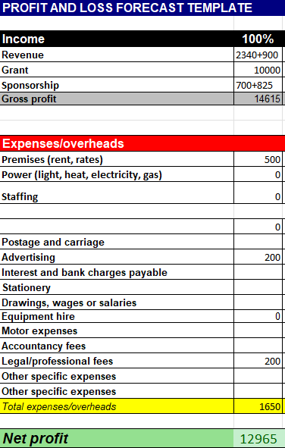
Gantt Chart (Insert from Excel)
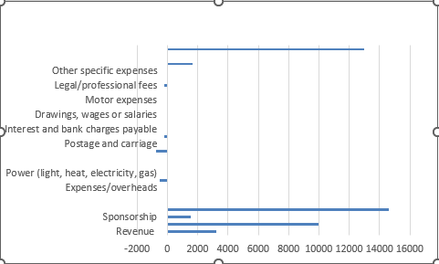

Eventbrite Page for your event (Screenshot from Website page and insert into table below)

https://www.eventbrite.co.uk/e/bsrfc-charity-7s-tickets-1370017442049?utm-campaign=social&utm-content=attendeeshare&utm-medium=discovery&utm-term=listing&utm-source=cp&aff=ebdsshcopyurl
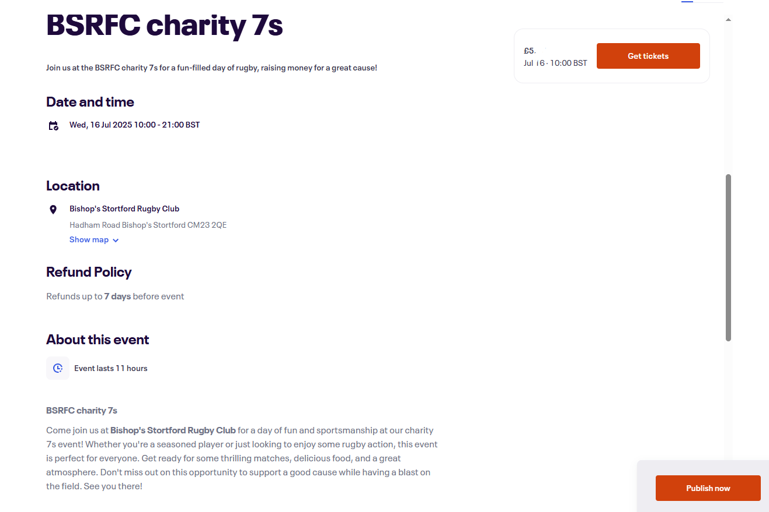

Survey Monkey Audit of relevant questions, consider grouping questions to ask into 3 categories - before, during and after the event. (Screenshot from Website page and insert into table below)

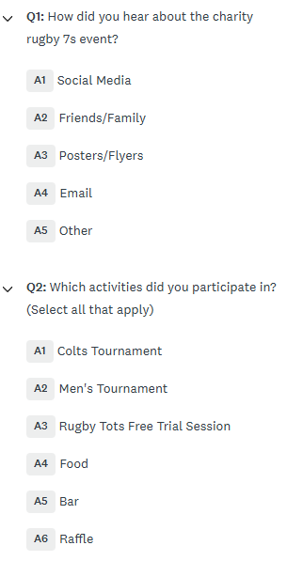

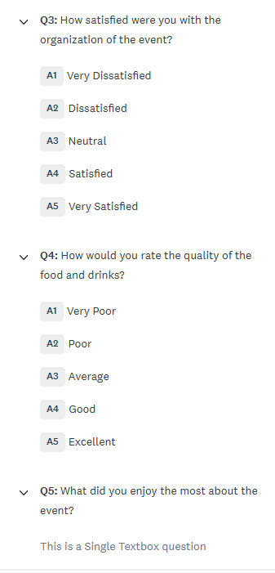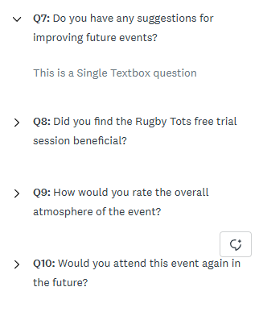

Event Floorplan (Screenshot from PC or Picture Drag and Drop into table below)

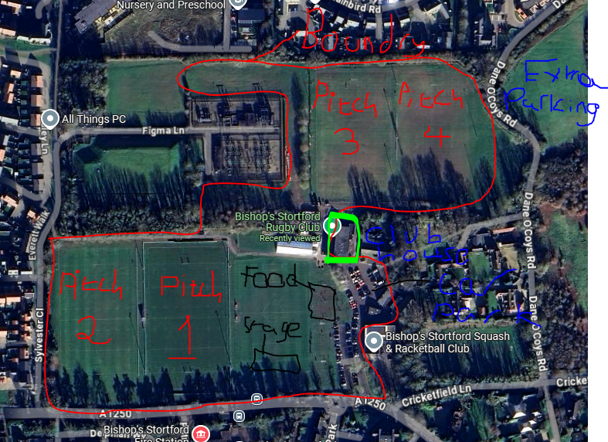

Event Poster (Screenshot from PC or Picture Drag and Drop into table below)



Reference List and Bibliography

Appendix (Add Screenshot evidence here of any online costings etc.)



Appendix (Add Screenshot evidence here of any online costings etc.)



UWTSD SPORT

