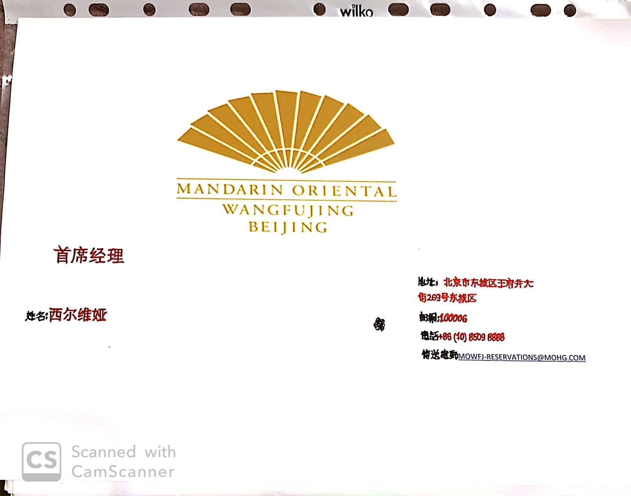
Silviya Nikolova Tsekova.
1815097
MOODLE
FOREIGN LANGUAGES&CULTURAL AWARENESS
(M5X01923).
11 December 2019
WEDNESDAY
LECTURE:
JINPING LI
Hotel Practice for Chinese.

