MOR20857548 (Max Morton-Lewis)

Critiquing and Creating data visualisation

Contents
Introduction 2
Task 2: 3
Make the first Row as a header 3
ii) Replace Null with 0 4
v) 7
Task 3: Inspect the relationship of the data in Data Model tab 8
Task 4: Analyze the data using visualizations 9
ii) 10
iii) 11
iv) 11
Task 5: 12
i) 12
ii) 13
Task 6: 14
i) 14
Task 7: 15
i) 15
Task 8: 16
i) 16
ii) 16
iii) 17
Task 9: 17
i) 17
ii) 18
Task 10: 19

Introduction
I will be using power bi to visual data in an appealing way. I will be using all the tools accessible to me to display data for an aircraft company.

Task 1:

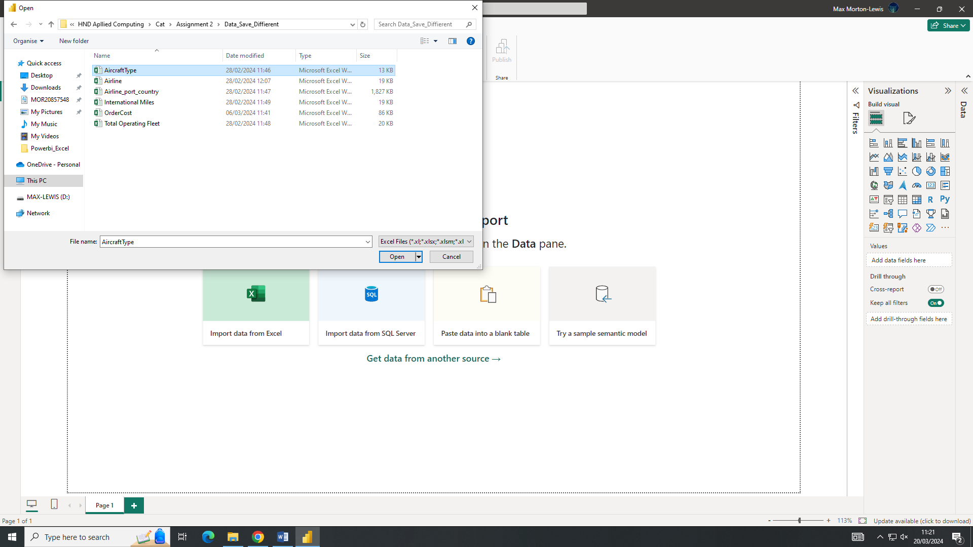

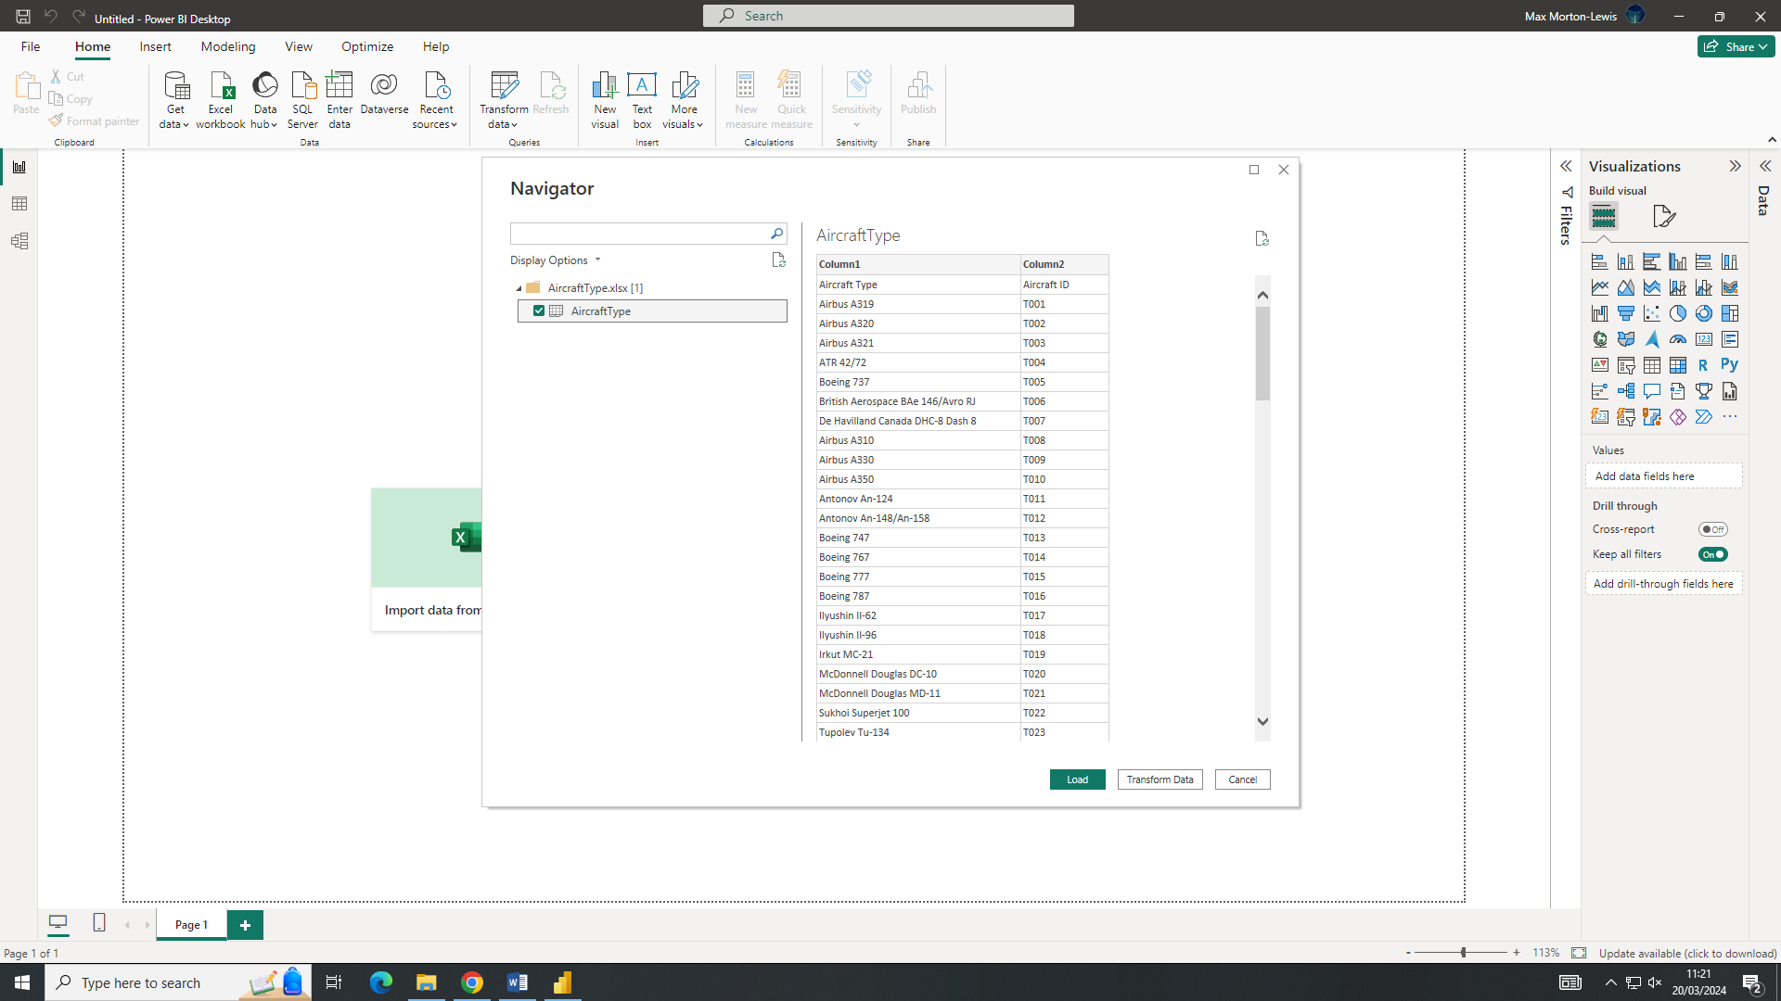

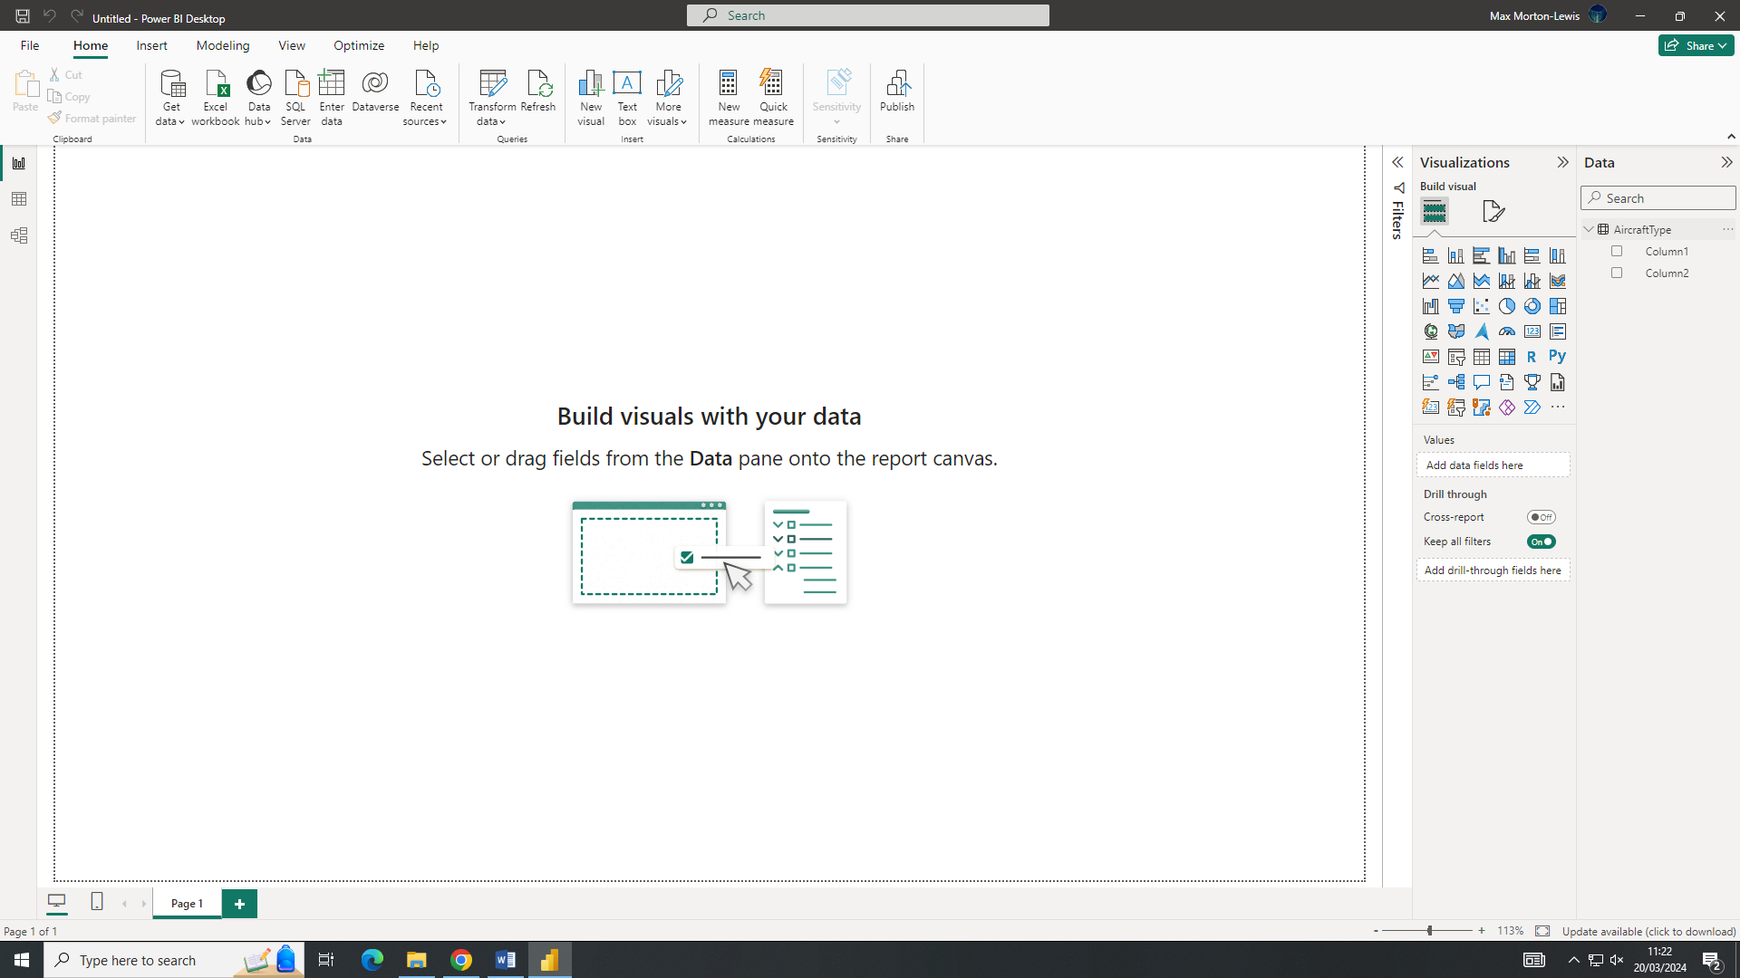

Task 2:

Make the first Row as a header
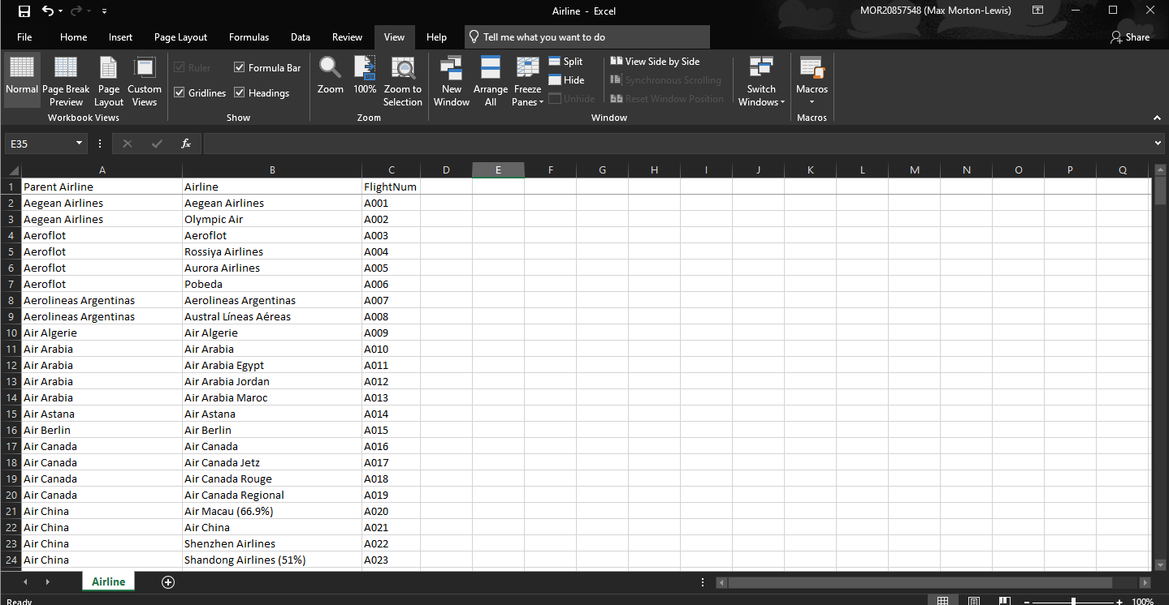

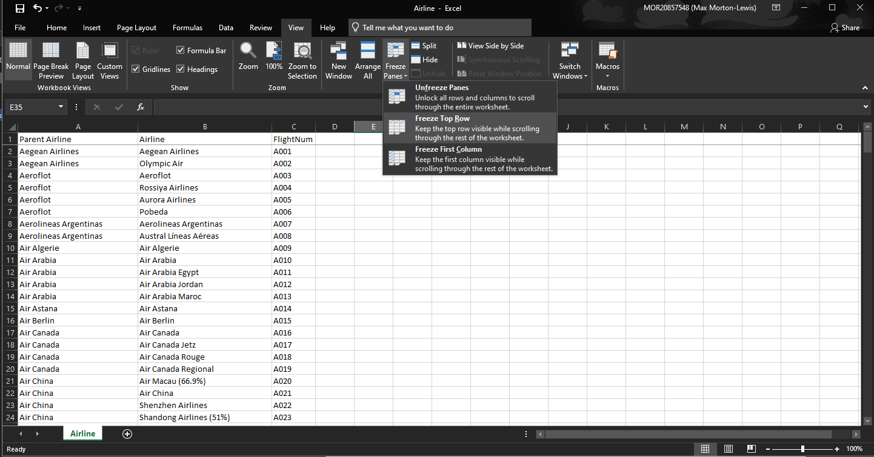
I froze the top headers of the spreadsheet to make is easier for the user to see what data they are looking at. This just required me to go to “View” then “Freeze Panes” then “Freeze Top Row”.

ii) Replace Null with 0
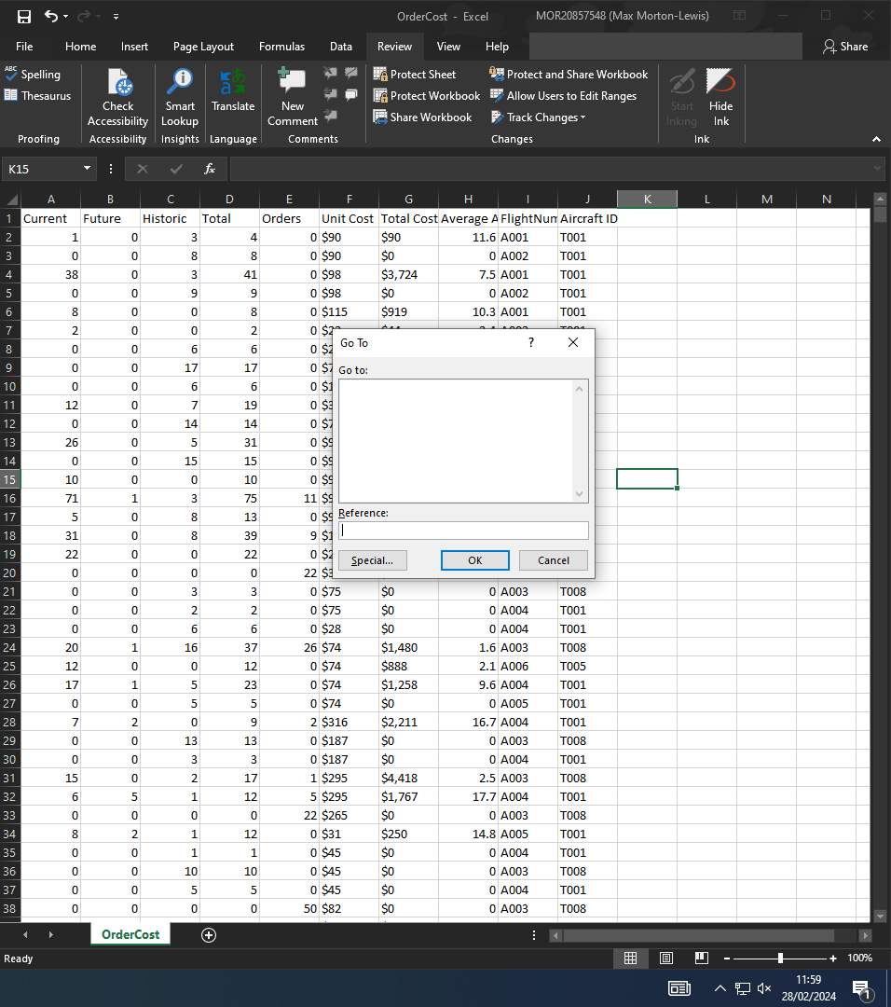
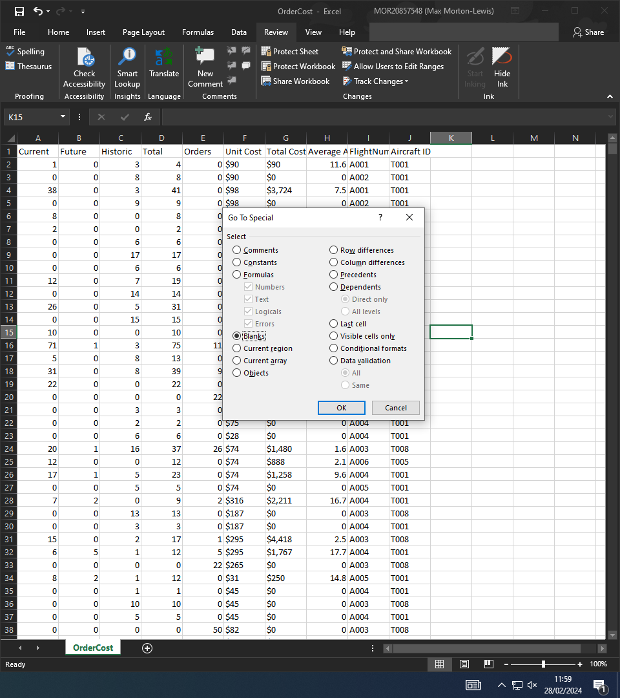

So to replace all empty cells with a zero we have to press “CTRL G” This will bring up a menu that we then have to press the cells we want to replace. After that we select blanks.

iii) Total Cost to fixed Decimal Number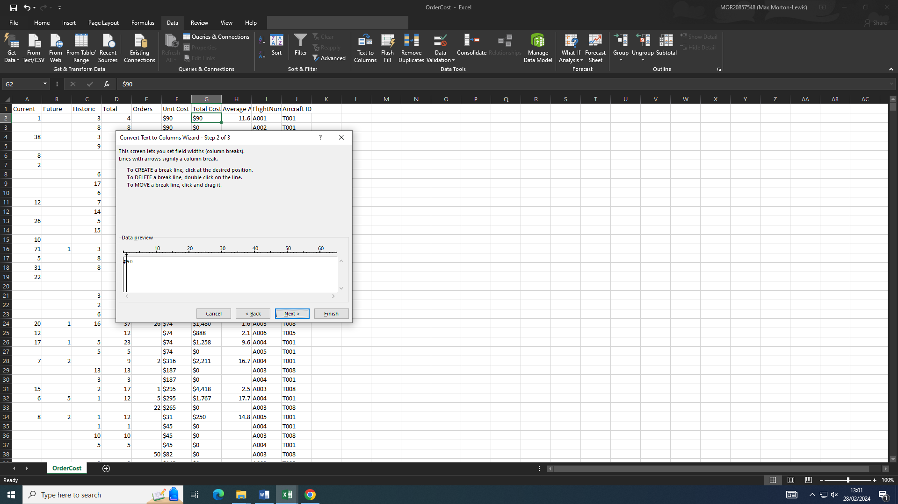

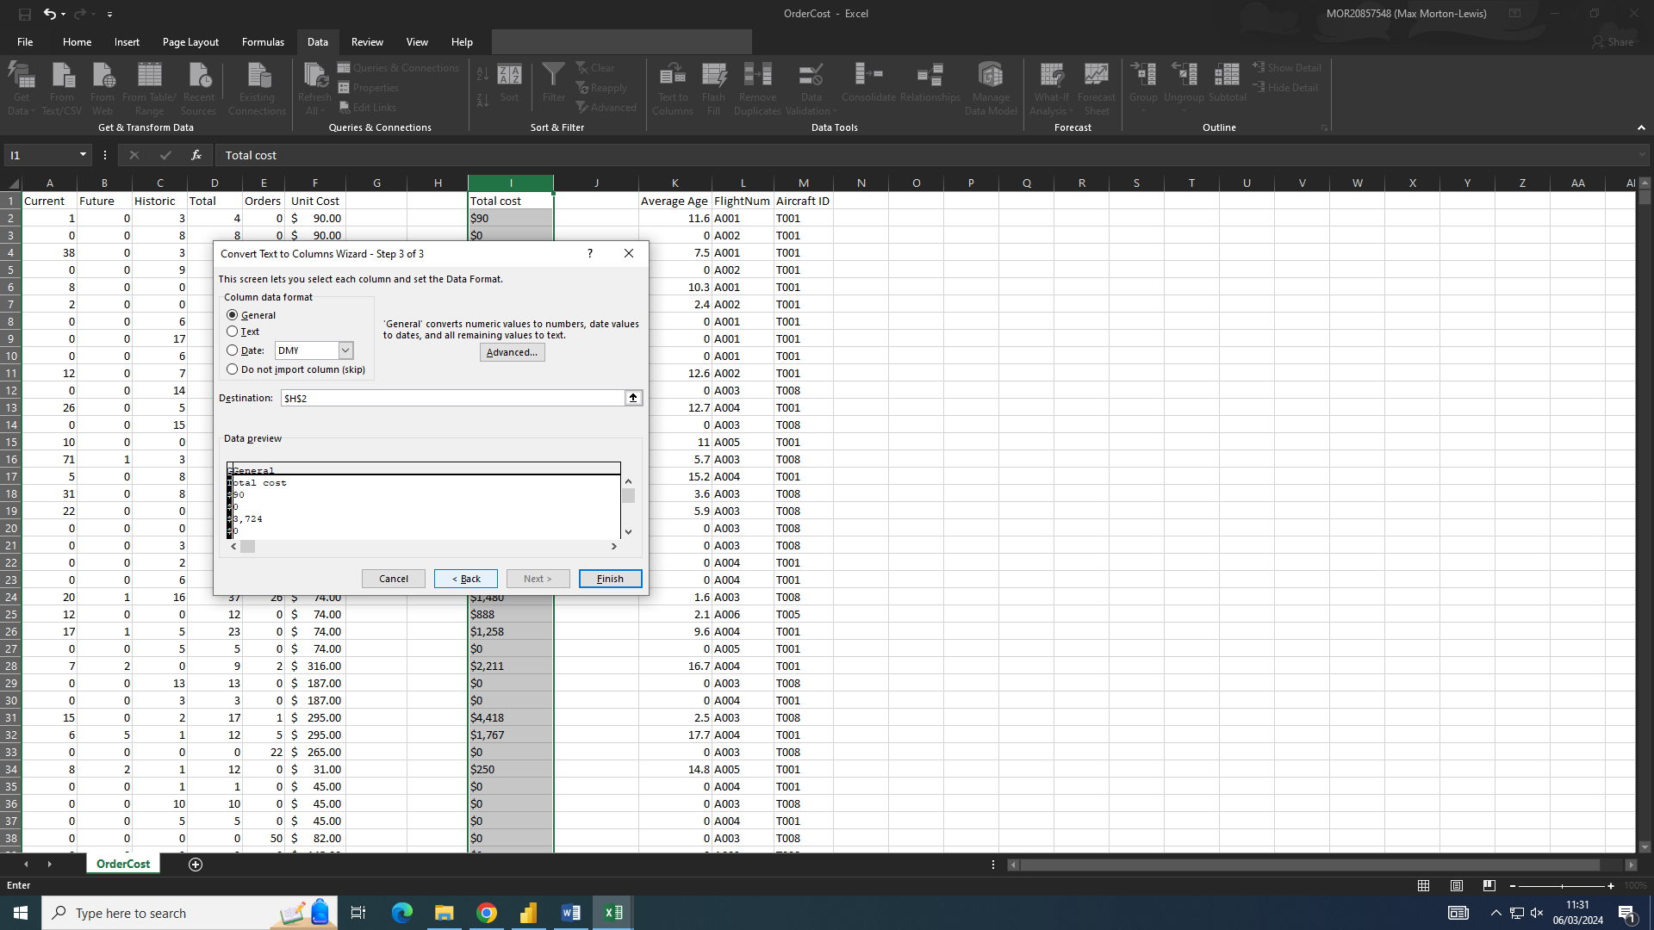
We go to data tap at the top and select “Convert data to columns” we then select the columns we want, after that we move the line to split the dollar symbol and the number. After this we then delete the columns with the dollar sign in.

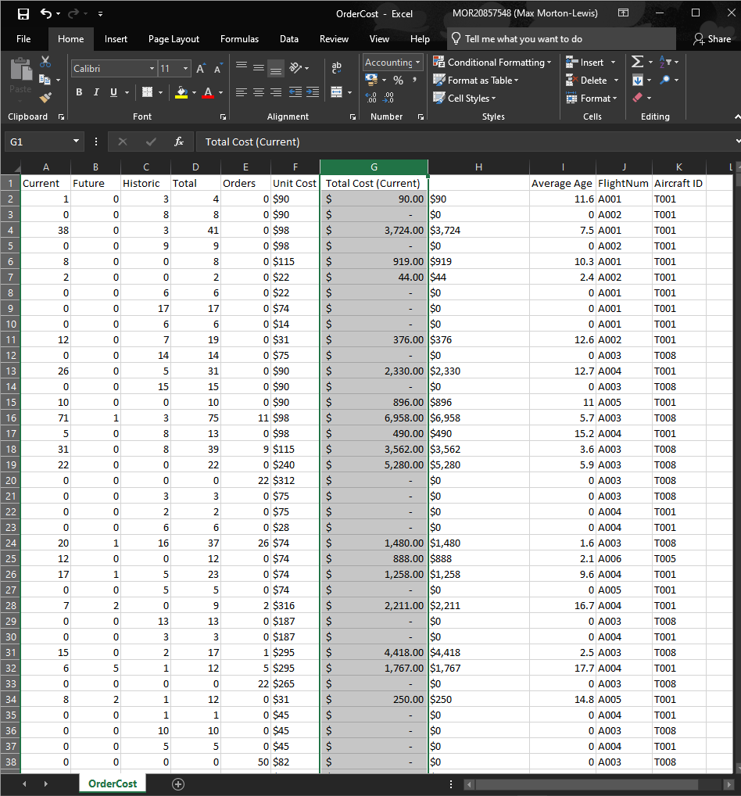
We go to data tap at the top and select “Convert data to columns” we then select the columns we want, after that we move the line to split the dollar symbol and the number. After this we then delete the columns with the dollar sign in.

v)
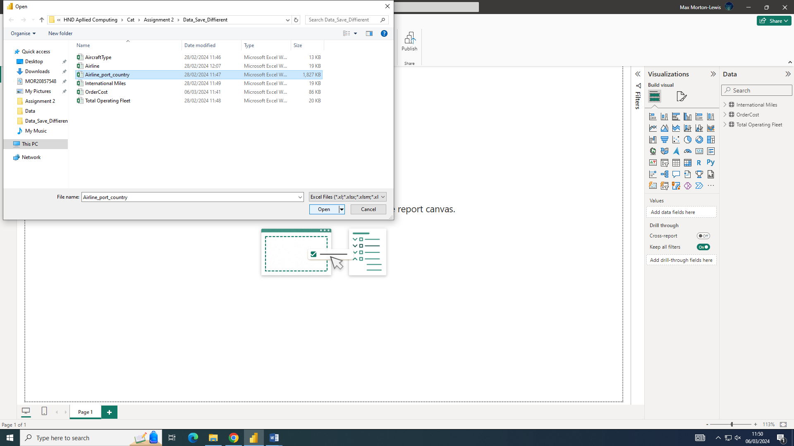

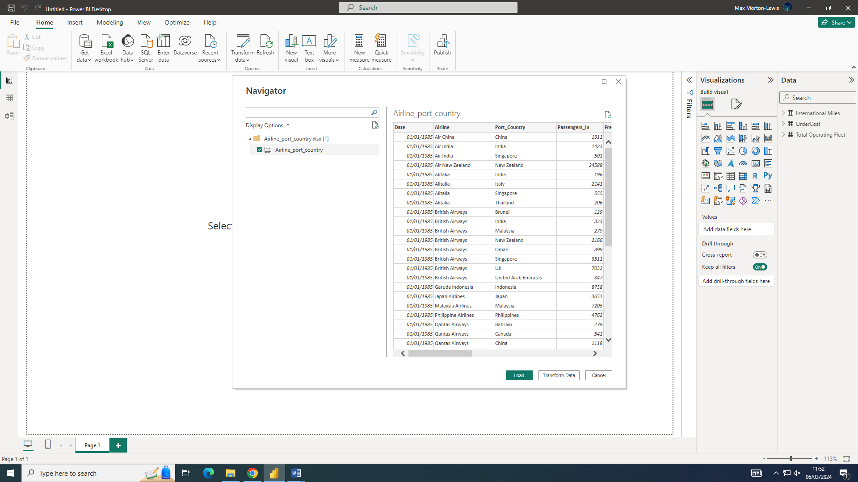
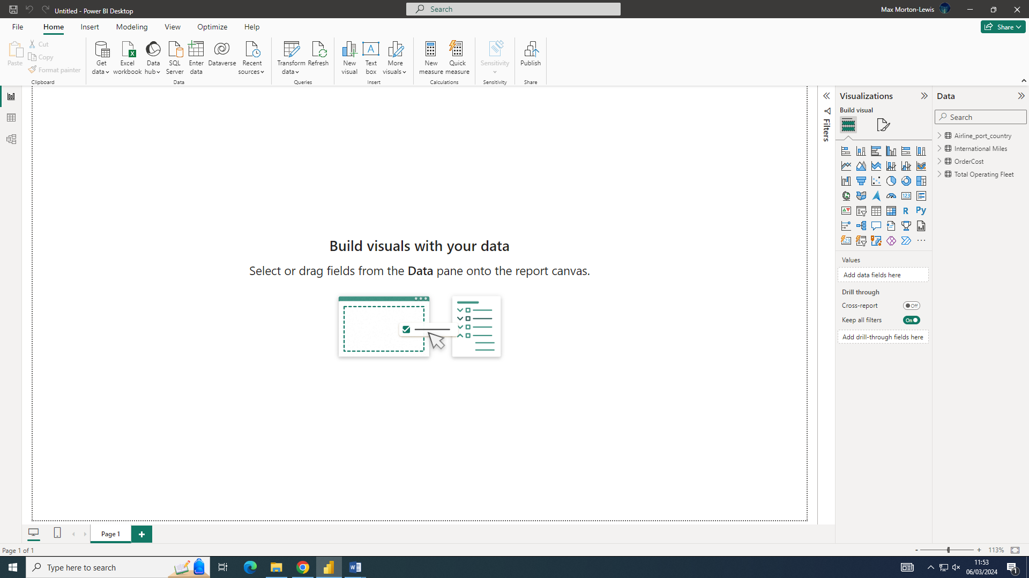

Task 3: Inspect the relationship of the data in Data Model tab
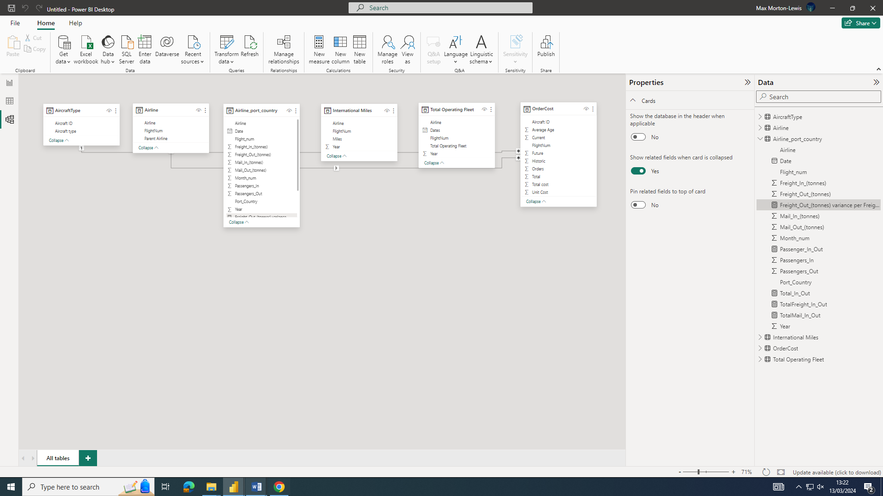

Task 4: Analyze the data using visualizations
i)
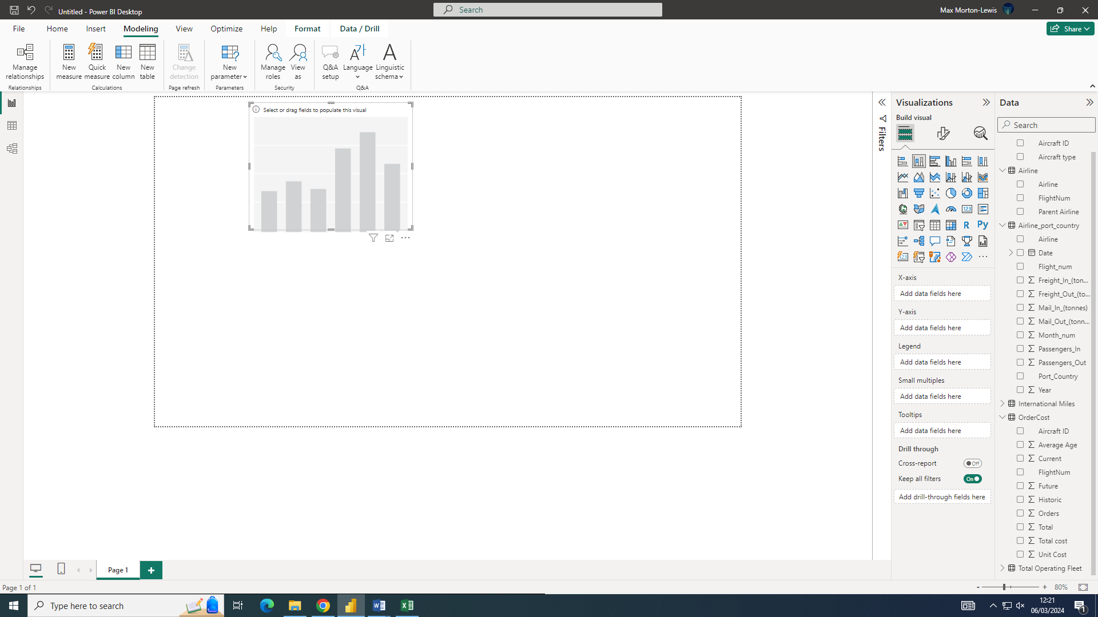
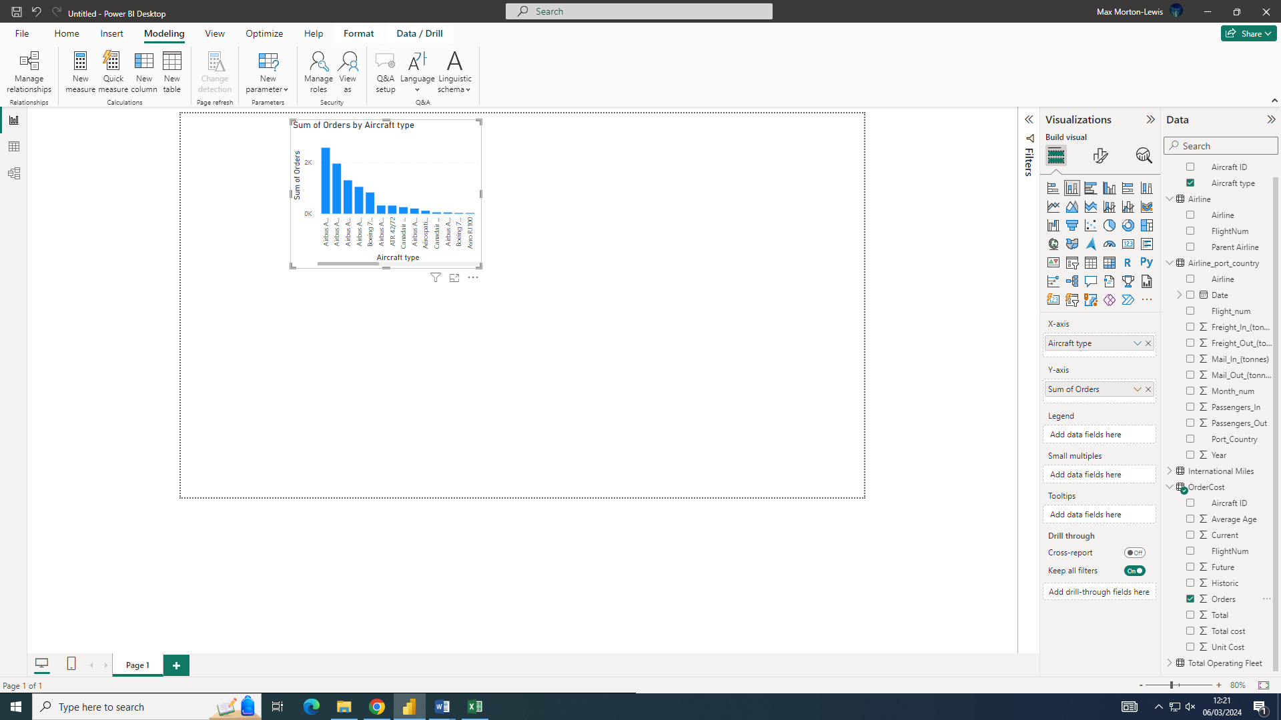
Creating the bar chart I when to the visualisation selected the bar chart. I then moved orders and aircraft type over and dropped into the bar chart.

ii)
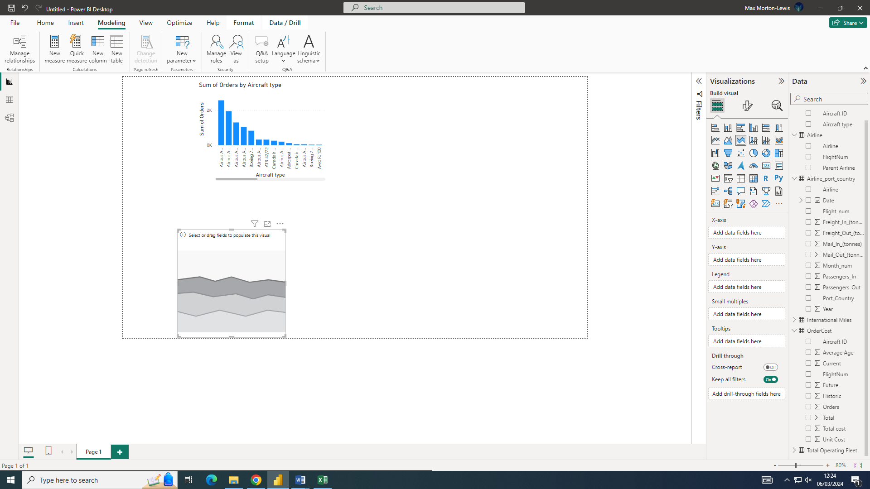
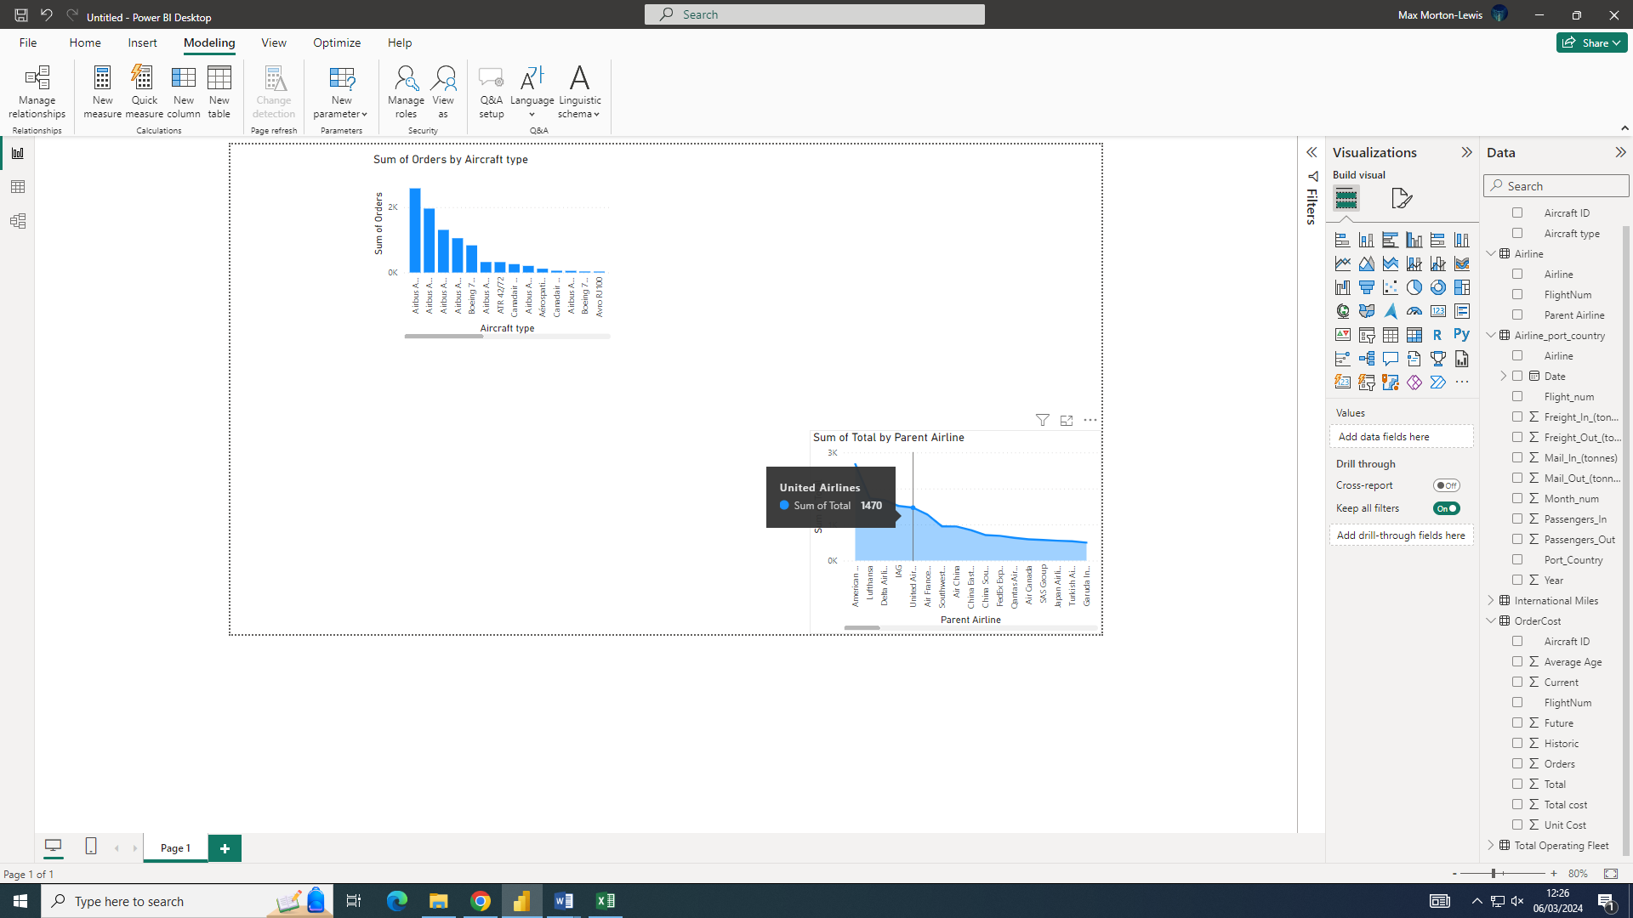
I selected the stacked area bar chart and dragged and dropped Airline and Total cost into it. I then went to format visuals and selected X-axis and turned on the values. I then selected Y-axis and then turned o values

iii)
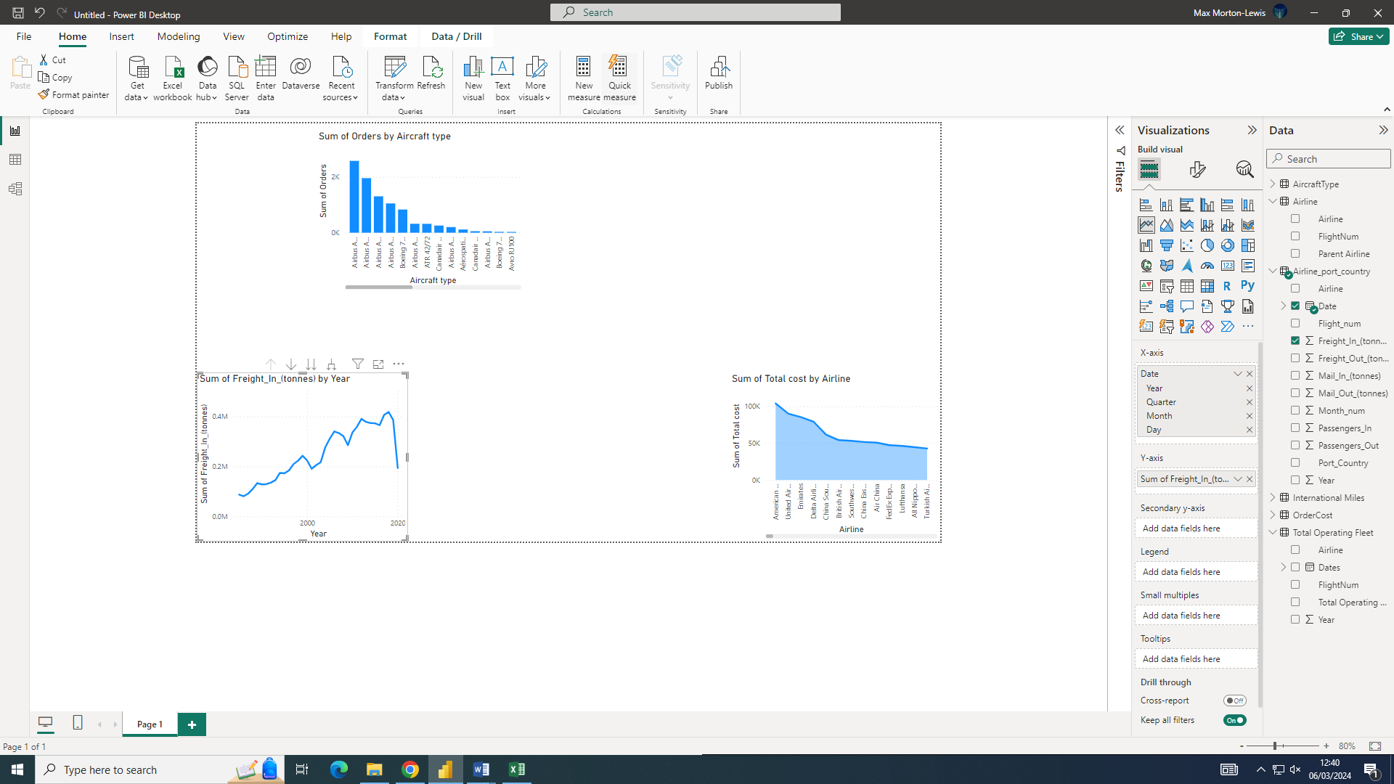

iv)
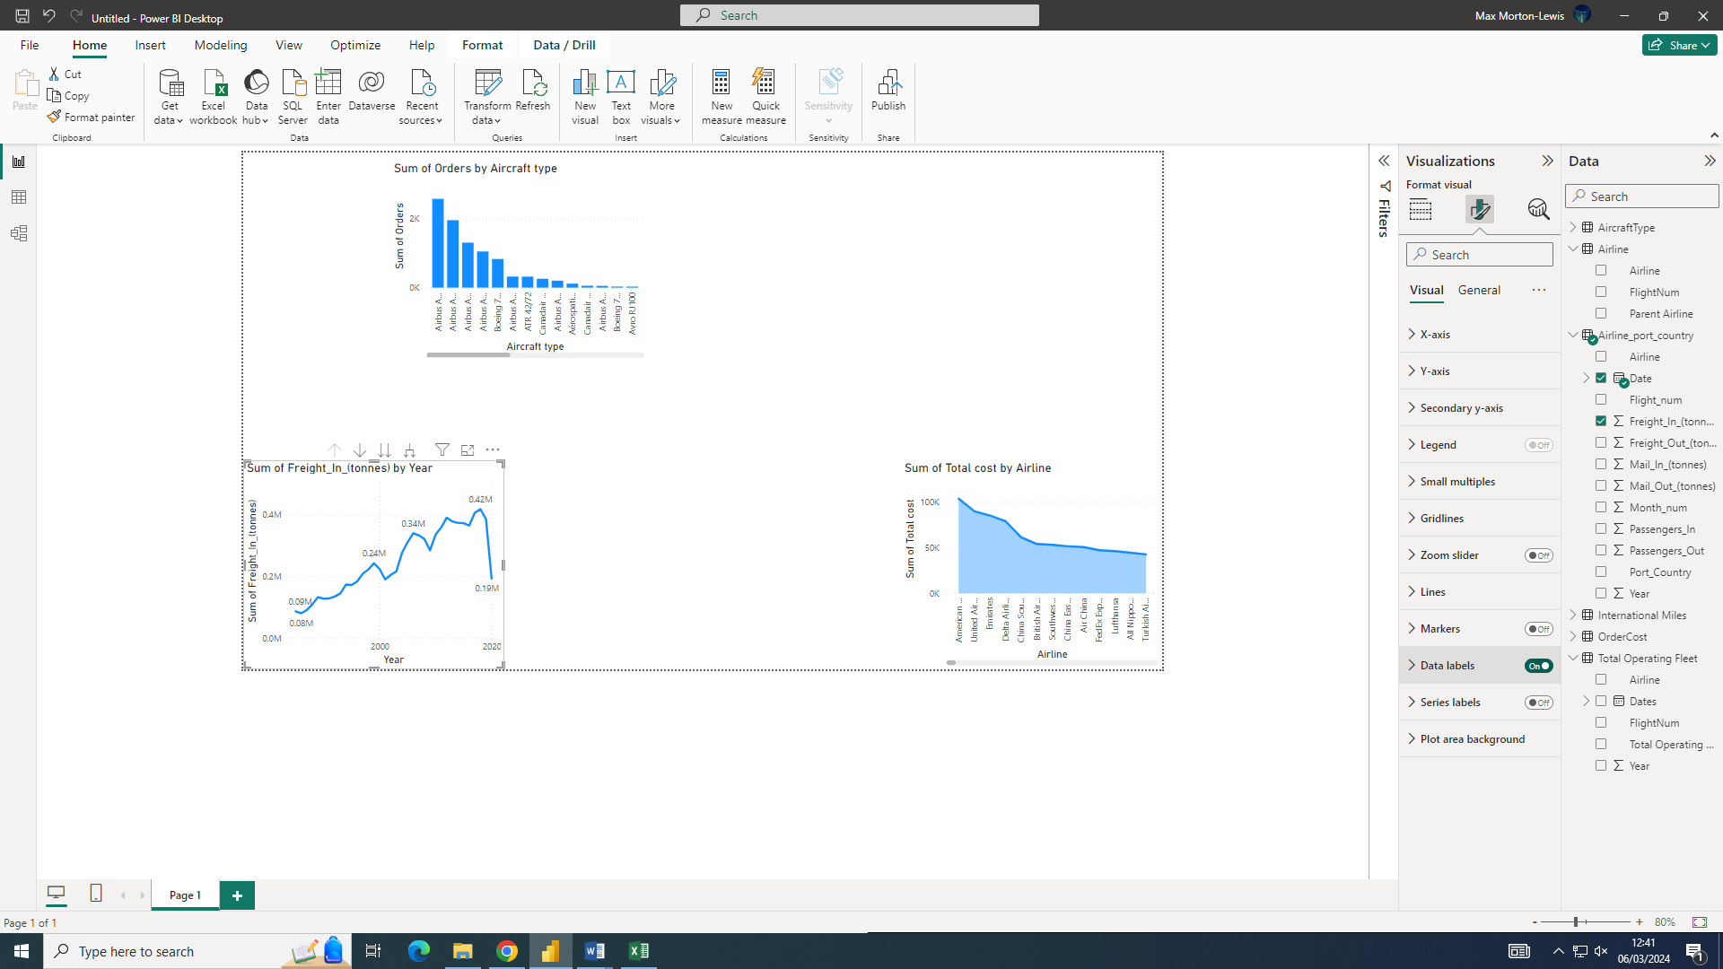
I selected Line chart and dragged and dropped the “Freight_In_(Tonnes)”. After this I then selected “X-axis” and “Y-axis” and turned on values, I then turned on “Data Values”
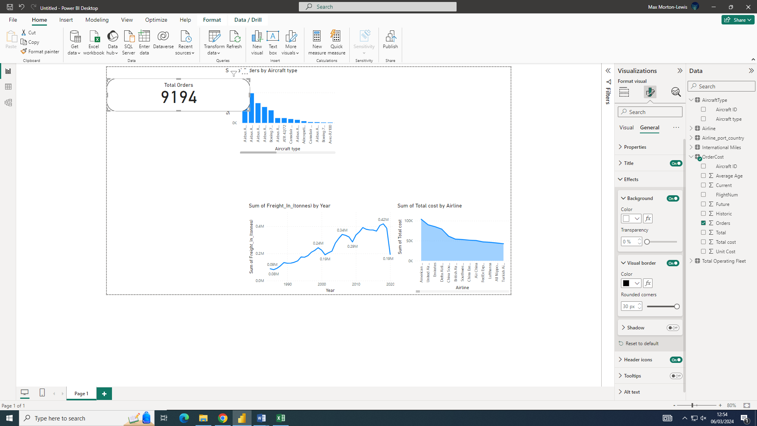
I grabbed the “card” visual from the visual tap and the dragged and drop “Orders” into it

Task 5:

i)
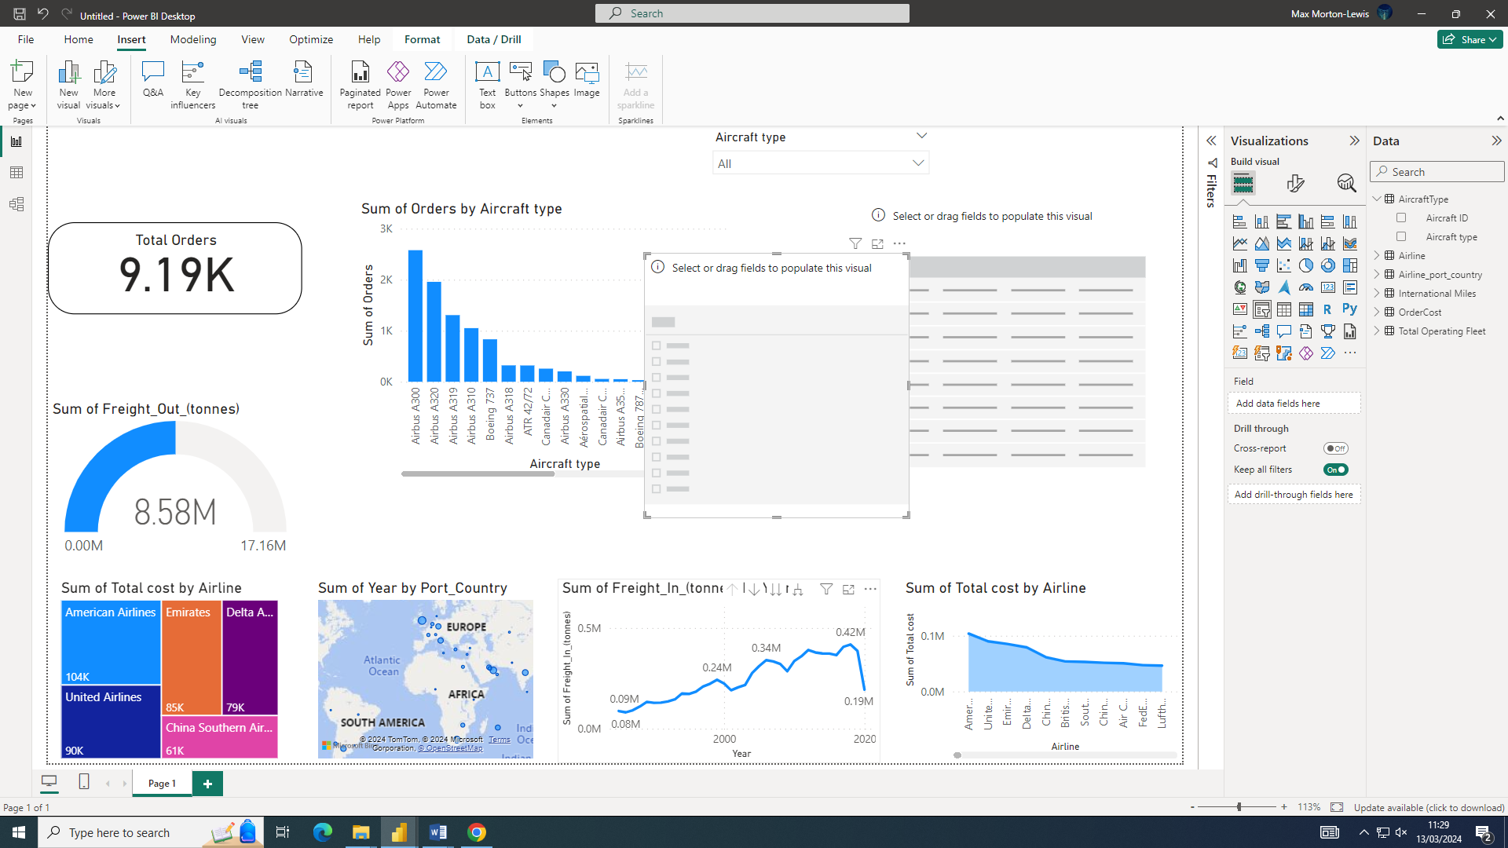

ii)
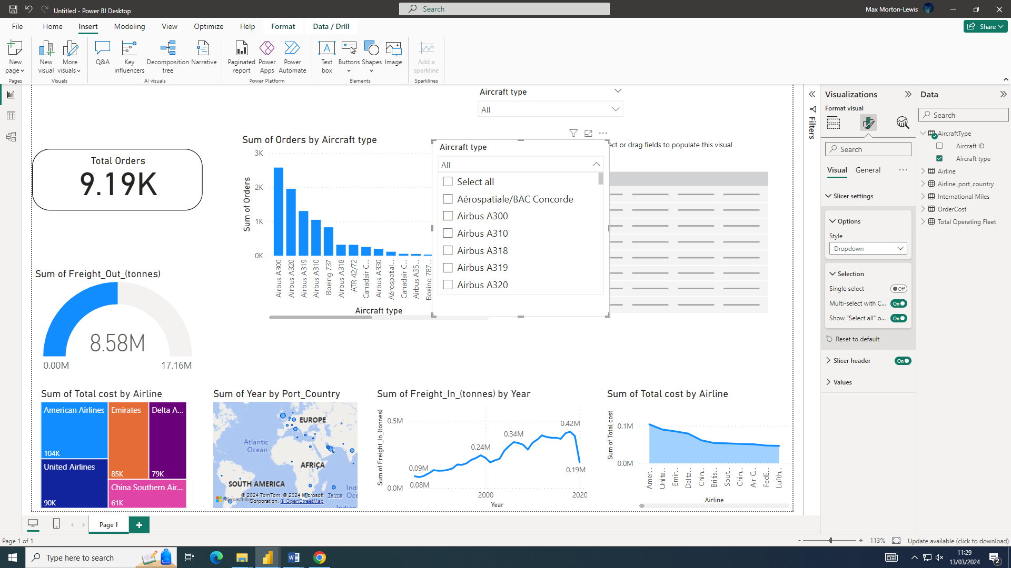
I selected the slicer tool and then dragged and dropped the aircraft type data into the slicer. I then customised the slider by adding in the selected all button. I did this by pressing the paint brush, slicer setting and in there selecting “dropdown” and ticking the “Select all” Button

Task 6:

i)
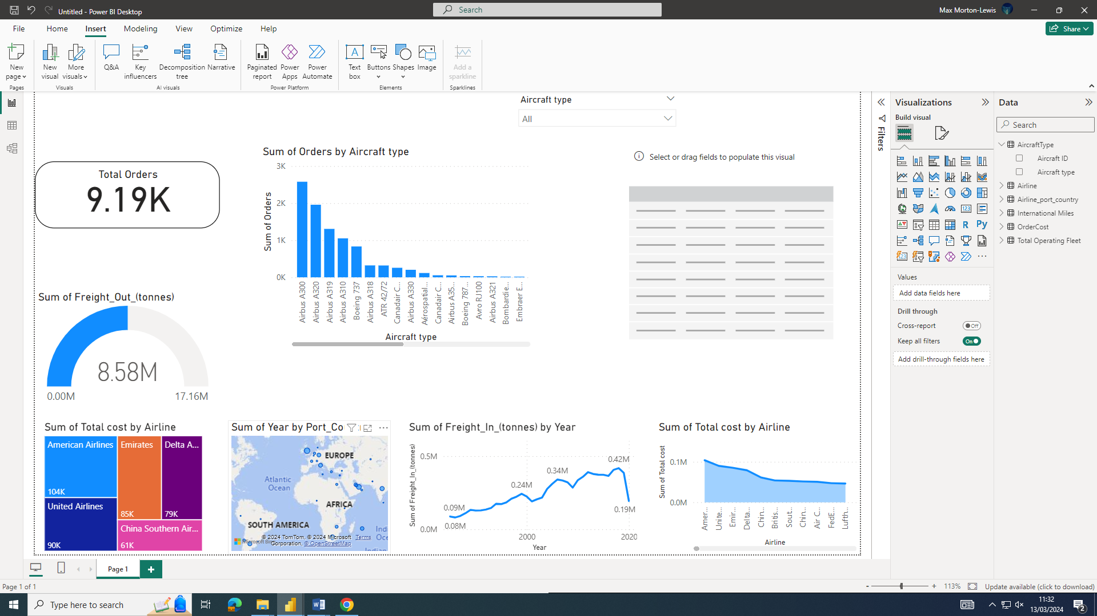
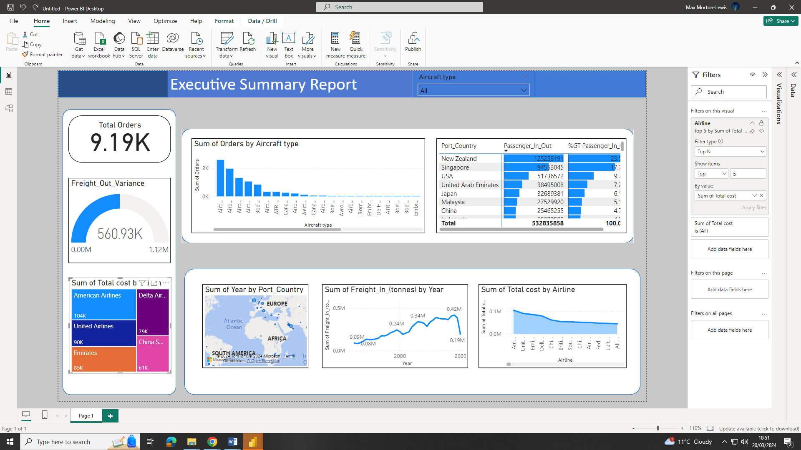
I used the “Three map” visual and dragged and dropped “Airline” and “Total Cost” I then selected “Format visuals” then I turned on “Data labels” and Category labels. I then when om filers and added “airline” to the field after this I selected “Top N” for the filter type. For show items I selected “Top then 5. Then for sum

Task 7:
i) 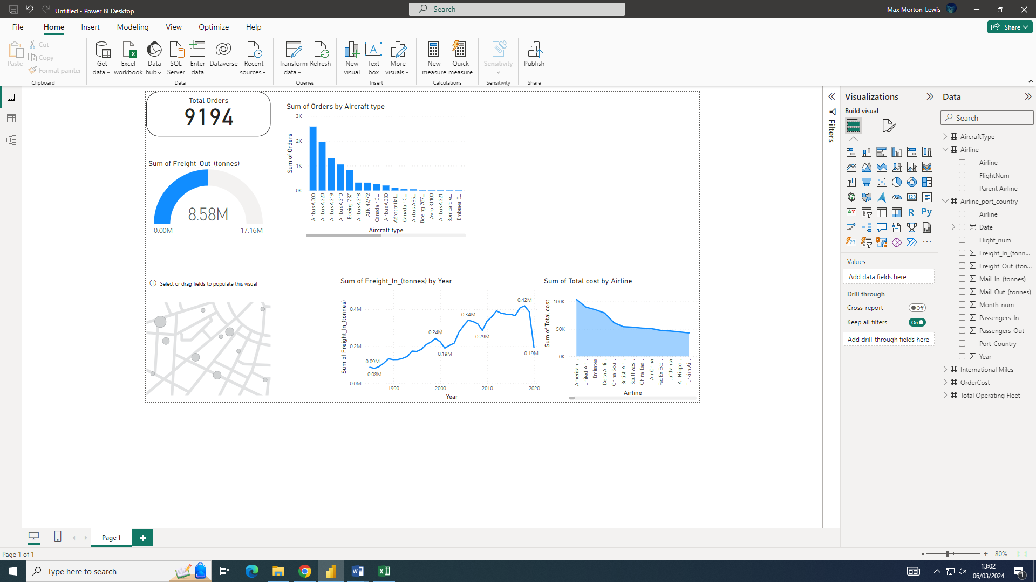
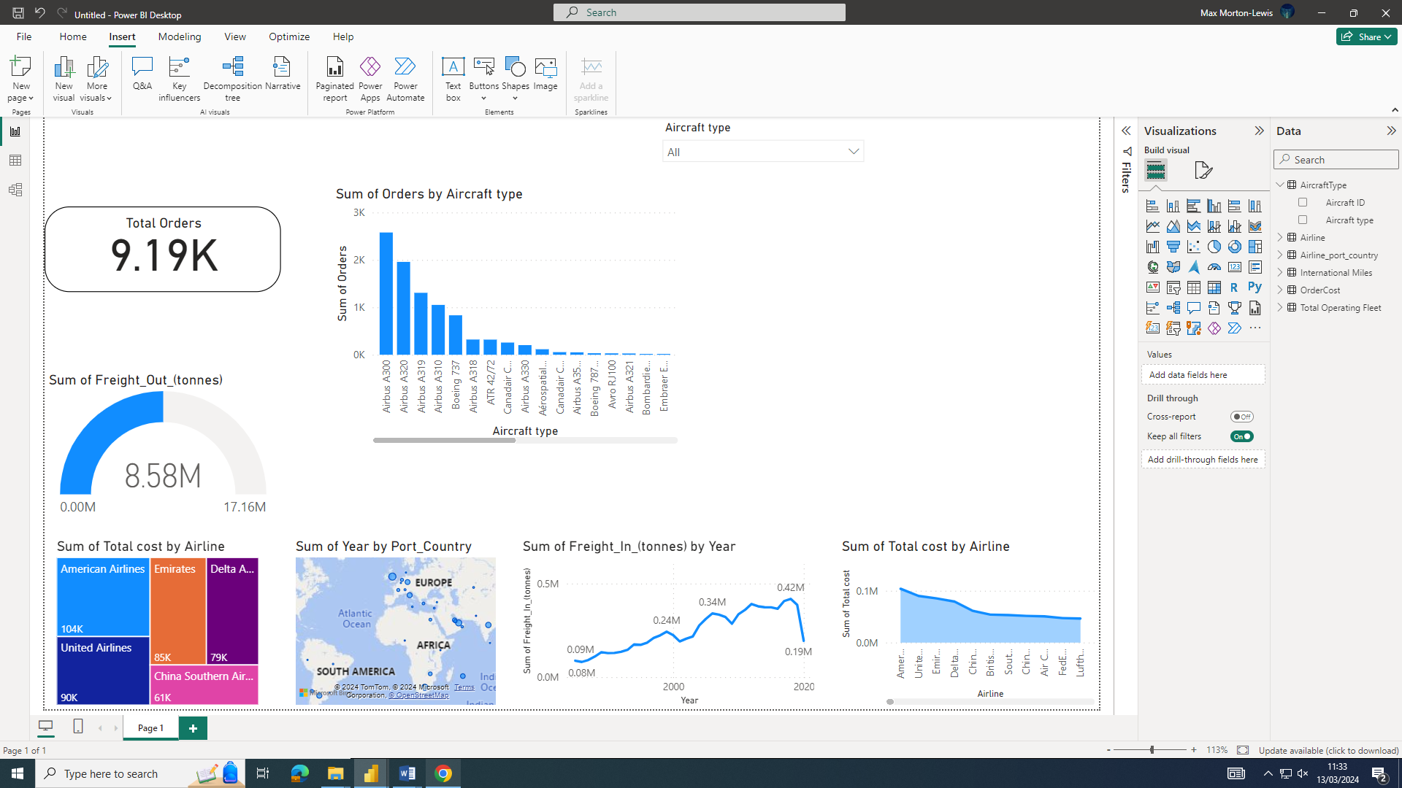
I selected the “map” visual and then dragged and dropped the “port_Country and “Year” I then went to “Format visuals” then “ Map settings” after this I turned on “Show labels”

Task 8:

i)
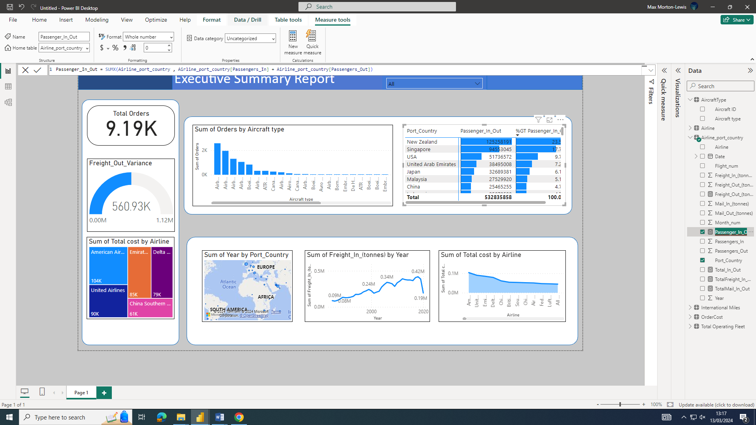
I selected the “Matrix” visual after this I added a “New measure” where I added the passengers in and out together.

ii)
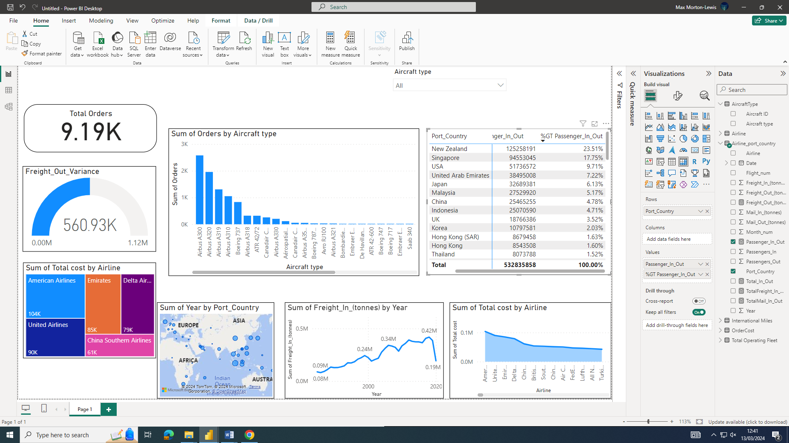
I selected the “Matrix” visual

iii)
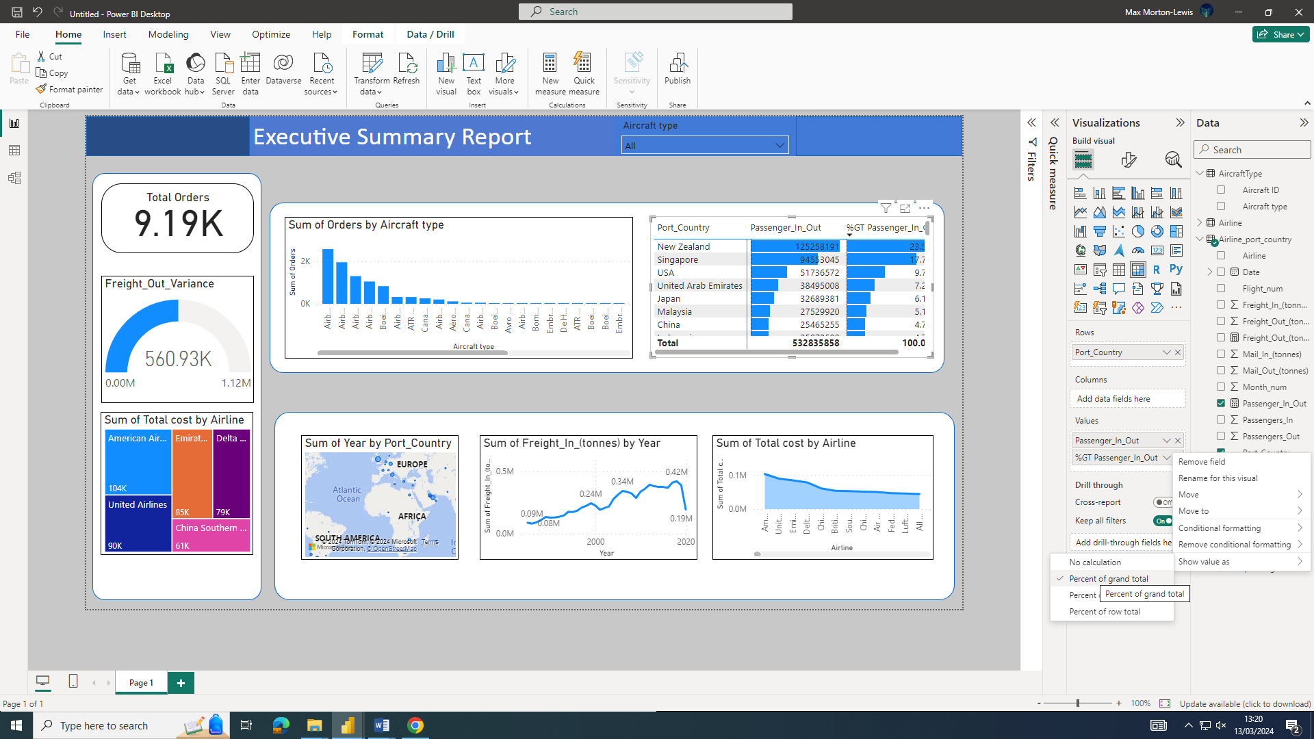
To get the percentages on the matrix I selected the arrow on “percentage grand total of passengers” the at the bottom of the new window I selected show visual as and then selected “percentage of grand total”

Task 9:

i)
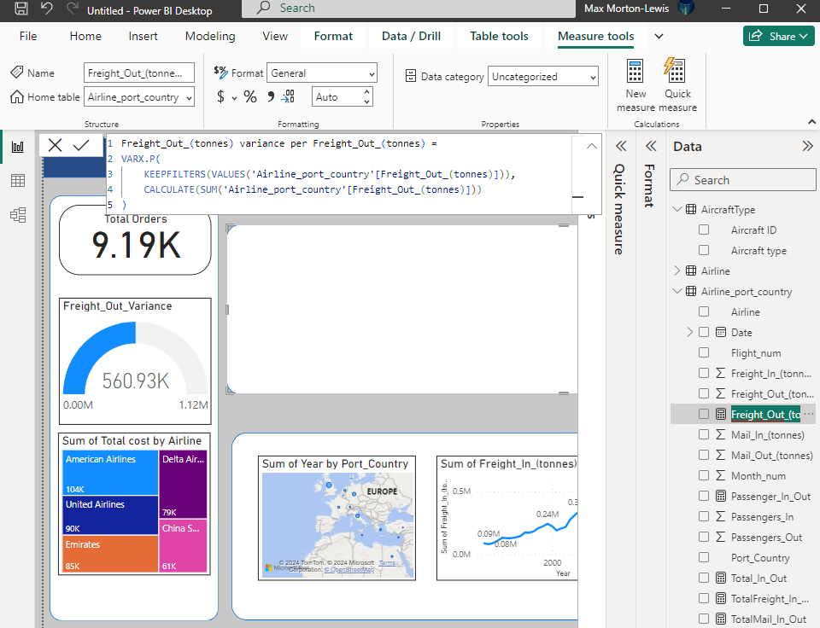
I created a measure where I calculate the variance of freight out

ii)
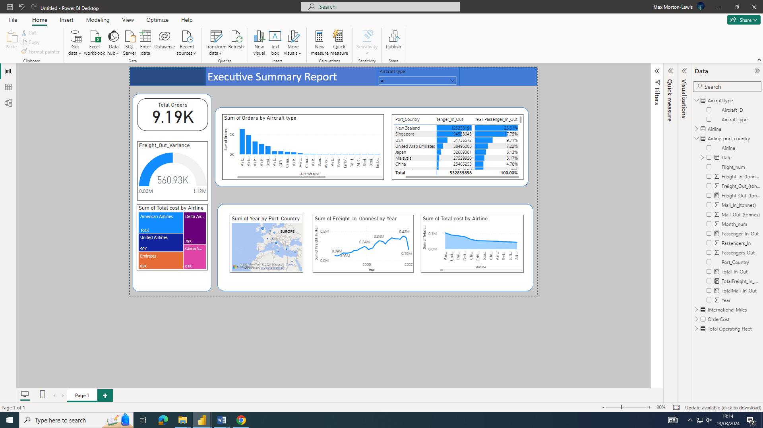iii)
I created a “Gauge chart” and then dragged and dropped the measure I made into gauge chart. I then selected and turned on the “Data labels” and “Callout value.

Task 10:
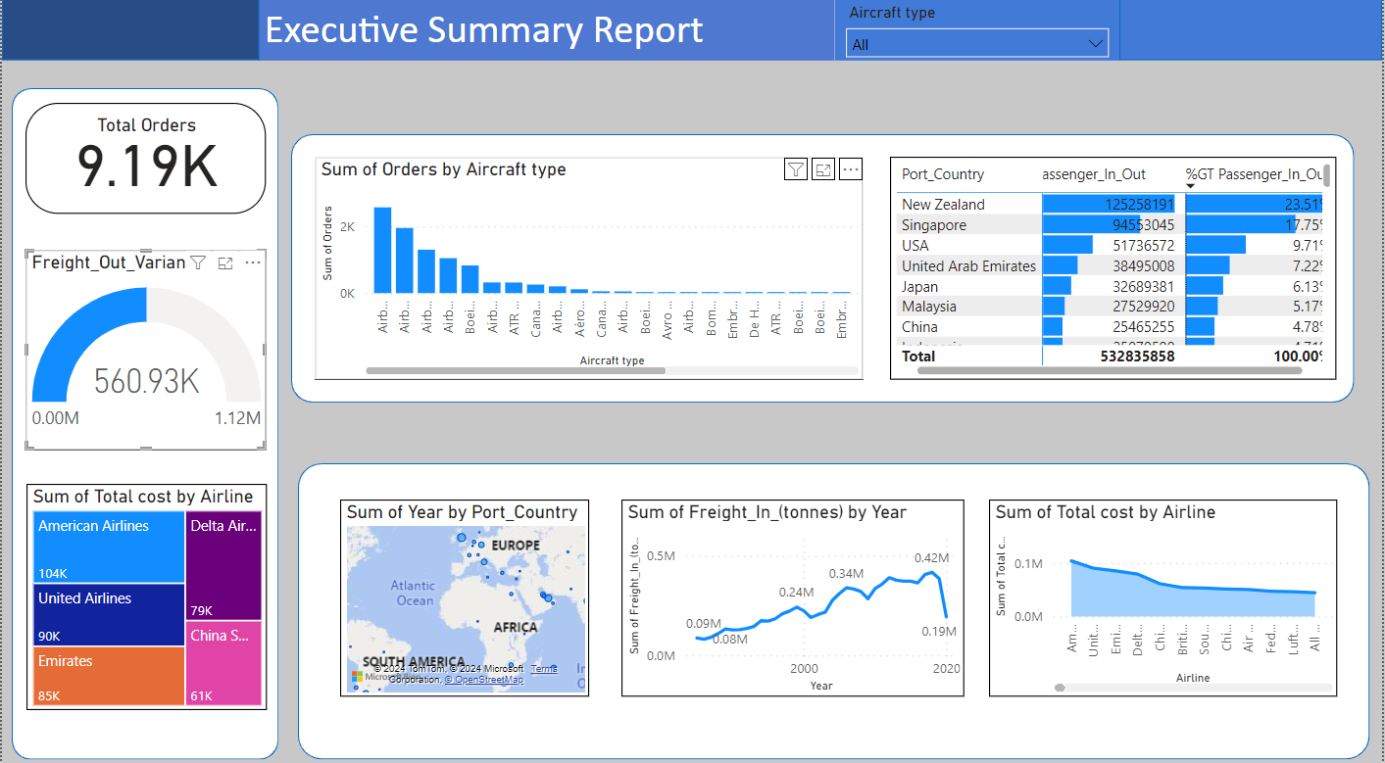

Link to assignment Just in case something goes wrong
https://gowercollegeswanseaacuk-my.sharepoint.com/:u:/g/personal/mor20857548_stu_gcs_ac_uk/EcjEKvglAdNJkPUkugQRmz4BvJzmPXCGXcaq_m77mrk7pQ?email=Catherine.Wilkes%40gowercollegeswansea.ac.uk&e=g1zeh6

