University Of Wales, Trinity Saint David

Banking Financial Management and Financial Markets

Name : Mohammed Tauseef Iqbal
Student I'd : 2212389
Module : Banking Financial Management and Financial Markets
Module code :LCMB7012

Table of Contents
Introduction 2
Question 1: Identify the key laws, regulations, and contracts enacted post-2008 financial crises by the UK, US, or EU authorities and other key players in the financial system to end the financial crises. 3
Question 2: “Critically review the extent to which you think that these reforms have contributedtowards stabilizing the financial system and the different banking institutions post the2008 crises”. 8
Question 3:“Effect of reforms on Rolls Royals on the business model and the level of compliance/non-compliance regarding the reforms” 13
Conclusion 16
References 17

Introduction
Financial markets and banking financial management are crucial aspects of the world economy. Banking financial management engages with effective management of the financial resources in the financial institutions and banks to maximize profits and underestimate risk. Various activities are engaged, like investment, risk, and asset-liability management. On the other hand, the financial markets are considered a common platform where trade occurs between the sellers and the buyers with the help of financial instruments like currencies, derivatives, stocks, and bonds. These financial markets help provide the necessary transparency and liquidity so that the financial resources can be efficiently allocated. It is crucial to understand these concepts as this allows businesses and individuals to make informed financial decisions, which would help them achieve financial goals.
The 2008 financial crisis significantly impacted the global financial system, and the effects were felt for many years. The crisis started when the real estate market began to tumble, and the delinquencies in the underwritten mortgages started to pinpoint. This resulted in severe recessions in many developed nations, and there were freezing billions of dollars about to be invested in real estate. It was viewed that to address the crisis's main impacts, government advisors and central bankers started flooding the market with liquidity and money to increase government spending, reduce interest rates and provide financial assistance to various financial institutions. Some reforms will be critically reviewed regarding their contribution, which stabilized the financial assistance to various banking organizations post the 2008 crisis.

Question 1: Identify the key laws, regulations, and contracts enacted post-2008 financial crises by the UK, US, or EU authorities and other key players in the financial system to end the financial crises.
It is studied that the financial crisis of 2008 resulted in a significant loss of confidence in the global financial systems. Various reforms and regulations were developed and implemented after the crisis, intending to strengthen the regulatory frameworks to prevent similar events from happening again. The EU, US, and UK authorities and some major players in the finance systems introduced various regulations, laws, and contracts to end the financial crisis. The UK government introduced the Financial Services Act 2012, which created the Financial Conduct Authority (FCA) and the Prudential Regulation Authority (PRA), which helped regulate the financial services industry (Cabane and Lodge, 2022). It was studied that the FCA is very much responsible for regulating conduct and consumer protection in the financial service industry. On the other hand, the PRA helps regulate the prudential standards of banks and other institutions o finance. The Act has developed the “Financial Policy Committee (FPC), which can intervene in financial markets to prevent and help them mitigate systematic risks.
The Dodd-Frank Wall Street Reform and Consumer Protection Act was started in the US in 2010. This act focused on improving financial stability and consumer protection by creating new regulatory agencies like the FSOC “Financial stability Oversight Council” and the CFPB, the “Consumer Financial Protection Bureau.” It is studied that the FSOC takes responsibility for monitoring the systems of faces and identifying all types of potential risks (Michie, 2022). On the other hand, the CFPB is responsible for protecting consumers from abusive financial practices.
The EU initiated various significant regulations after the financial crisis of 2008. The “Capital Requirements Directive” CRD and the “Capital Requirement Regulation” CRR were initiated to increase the bank’s capital requirements. The “European Systematic Risk Board” ESRB was developed to monitor the systematic risk in the financial systems of the European Union and help them have significant recommendations or suggestions for preventing and mitigating all forms of financial risks.
In addition, more laws and regulations and several contacts were developed for the financial crisis of 2018. The “International Swaps and Derivatives Association” ISDA is one of the examples initiated by the Dodd-Frank protocol in helping market participants show compliance with the new regulatory requirements introduced under the Dodd-Frank Act (García, 2021). The market protocol supported this with a framework for the market participants in amending the derivative contracts that were already existing and complying with new regulations.
It can be viewed the impacts of such regulations, contracts, and laws on Rolls Royce can be analyzed in various ways. In the first go, they initiated by increasing regulatory requirements and developing new regulatory structures, which increased their compliance costs for Rolls Royce. The company had to allocate various resources to ensure it complied with the new rules, which increased administrative costs. In addition to that, with the increases in the regulatory requirements, there was a plunged in the risk-taking capabilities by the financial institutions, which created more challenges for Rolls Royce in getting access to financial credit. However, more new regulations have created scope for advantages for Rolls Royce (Violante, 2022). The increased regulatory farsightedness and continuous supervision have led to a financial system that is more stable and even has made a reduction in the threat of financial shocks. This has increased investor confidence in the financial markets and made it easy for rolls Royce to raise financial capital. Moreover, the initial new regulations have positively encouraged financial organizations to adopt better risk management practices. It can be studied that Rolls Royce is one of the publicly listed companies that had to comply with the new regulations and maintain the listing status; when the company complied with the regulations that have supported them in adopting improved and better risk management practices which helped them in ensuring a better prepared to face any future financial shocks (James, 2022).
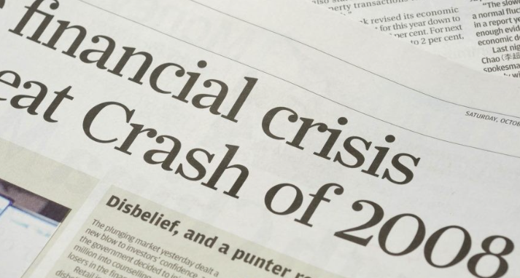
Figure 1: Financial Crisis
Source: (The Balance, 2018)
It can be discussed that the financial crisis of 2008 had a deep impact on the world's economy and made the collapse of various financial institutions, and caused recessions in the developed nations. It was studied that the deep root cause of the crisis was subprime mortgages, excessive risk-taking by financial organizations, and debt securitizations. There were various responses taken to define the crisis by the financial intuitions. To do that, the US, UK, and EU started creating new rules, policies, reforms, and regulations to be well-prepared when a similar situation arises again (Gil et al., 2021). The reforms have enormously impacted the financial industry, including companies like Rolls-Royce, considered one of the leading manufacturers of aero engines for civil and military aircraft in the world. In particular, the Dodd-frank act had a profound impact on Rolls-Royce.
The Act ensured that companies implemented risk management procedures and enabled the company to hold more capital to ensure their financial stability. With this, Rolls-Royce had to adopt and req their risk management processes to comply with w regulations. The company also had to raise capital to ensure financial stability and compliance with the new regulations. With the Volcker Rule, a prohibition prevented banks from engaging in proprietary trading or owning private equity funds and hedge funds as it did not impact rolls-Royce because it is not a bank. However, the rule affected the broader financial industry of the whole world, which could indirectly impact Rolls-Royce's operational activities (Apaydin and Çoban, 2022). For example, when the financial institutions were not able to provide finance to rolls-Royce because of the new regulations, the company had to face various challenges in raising its capital to finance its operations.
It was viewed that after the crisis of 2008, Rolls Royce faced numerous advantages and disadvantages resulting from various regulations, laws, and contracts enacted by various nations and their authorities. The reforms enacted post-2008 financial crises have helped the company to improve its financial stability, mainly due to the implementation of stricter regulations on financial institutions. These regulations have helped ensure that companies like Rolls-Royce operate more responsibly, with greater transparency and oversight. As a result, the company is better positioned to weather economic downturns, such as those caused by the 2008 financial crisis. The reforms enacted post-2008 financial crisis has resulted in lower interest rates, making it easier for companies like Rolls-Royce to obtain cheaper financing. This has allowed the company to invest in growth opportunities and undertake projects it may have otherwise been unable to fund (Jain, 2022). The reforms enacted post-2008 financial crisis helped restore the public's trust and confidence in the financial system, thereby improving the company's reputation. This has helped to attract investors and customers who may have been wary of investing in or doing business with companies in the wake of the financial crisis.
The reforms enacted post-2008 financial crises have significantly increased the regulatory burden on companies like Rolls-Royce. This has led to increased compliance costs, which must be factored into the company's operating costs, thus reducing profitability.
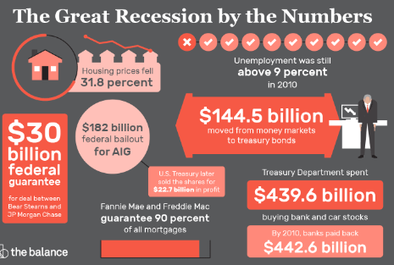
Figure 2: Great Recession by the number
Source: (The Balance, 2018)
The reforms enacted post-2008 financial crises have also resulted in increased scrutiny of the financial statements and practices of companies like Rolls-Royce. This has resulted in greater disclosure requirements and more frequent audits, which can be time-consuming and costly.
The reforms enacted post-2008 financial crisis have reduced the flexibility of companies like Rolls-Royce to engage in certain activities, such as proprietary trading, which have been deemed risky by regulators (Aicha et al., 2022). This has limited the company's ability to generate revenue from some of its traditional business lines.
In conclusion, the reforms enacted post-2008 financial crises have had both advantages and disadvantages for Rolls-Royce. While the company has benefited from increased financial stability, access to cheaper financing, and greater trust and confidence in the financial system, it has also faced increased regulatory burden, greater scrutiny, and reduced flexibility. Nonetheless, the reforms have been necessary to prevent a repeat of the 2008 financial crisis and have helped improve the financial system's overall stability and resilience. It resulted in severe recessions in many developed nations, and there were freezing billions of dollars about to be invested in real estate. It was viewed that to address the crisis's main impacts, government advisors and central bankers started flooding the market with liquidity and money to increase government spending, reduce interest rates and provide financial assistance to various financial institutions (Zhang et al., 2023). Some reforms will be critically reviewed regarding their contribution, which stabilized the financial assistance to various banking organizations post the 2008 crisis.

“Critically review the extent to which you think that these reforms have contributedtowards stabilizing the financial system and the different banking institutions post the2008 crises”.
Economies throughout the globe felt the effects of the global financial crisis of 2008. As a result of the crisis, the housing market suffered severely. Within a few months, evictions and foreclosures had begun. As a result, the stock market crashed, and huge corporations throughout the globe started going under, costing billions. Naturally, this led to firings at a global scale and prolonged unemployment for many people. Fewer investments were made, and those who were made were more cautious; international commerce stopped. The failure of numerous significant financial institutions, such as "investment and commercial banks," "mortgage lenders," "insurance corporations," and "savings and loan organizations," was the precipitating factor that led to the Great Recession” (Datet al., 2020). The "Dodd-Frank Wall Street Reform" and "Consumer Protection Act" and the "Emergency Economic Stabilization Act (EESA)", which established the "Troubled Asset Relief Program (TARP)", were two of the many pieces of legislation signed into law by Presidents Bush and Obama in reaction to the financial crisis (Spatt, 2020).
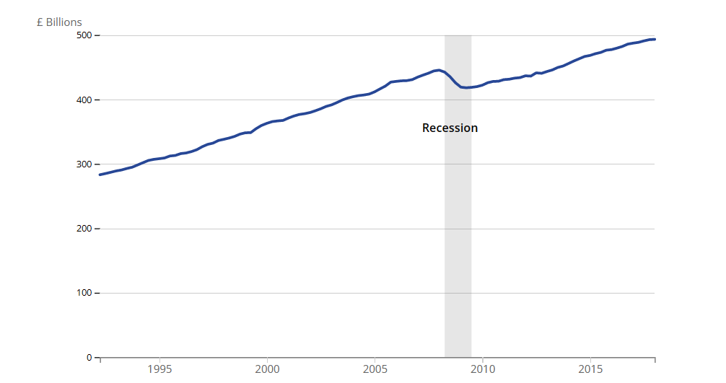
Figure: 2008 recession effect on the UK
(Source: ons.gov.uk, 2023)
The most influential pieces of legislation were the "Dodd-Frank Wall Street Reform" and the "Consumer Protection Act." Both pieces of legislation included measures to oversee the financial industry’s activities and protect consumers. Dodd-Frank, which was passed into law in July 2010, brought about substantial changes to the financial sector in the United States. The "Financial Stability Oversight Council" and the "Orderly Liquidation Authority" were both formed as a result of the "Dodd-Frank Act" to ensure the sustained good health of the nation's top financial institutions (Reform, Actand Protection, 2019). The implosion of these companies, which are often thought to be too massive to fail, might have a devastating effect on the economy of the United States (Wilder,2019).
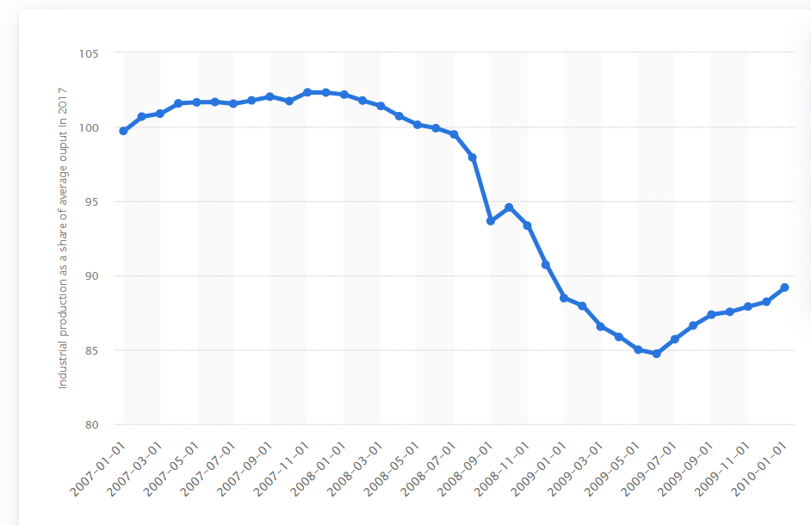
Figure: “Monthly industrial production in the US from 2007 to 2010”.
(Source: Statista, 2023)
In June 2009, amid the depths of the Great Recession, the “Industrial Production Index (IPI)” for the United States reached a new low. The recession was caused by the failure or near-collapse of several big, systemically significant financial institutions during the financial crisis of 2007 and 2008. This crisis was triggered by the collapse of the US housing market. As a result of the financial crisis, lending standards tightened, and consumer confidence plunged, both of which had severe consequences for firms throughout the economy. The financial sector was impacted badly by the collapse of Lehman Brothers and the following involvement of the US government in September 2008, causing the IPI to drop more than any other month that month. While industrial production was still much lower than it had been before the crisis, it began to increase again by the summer of 2009 (Statista, 2023).
Another legal instrument that may be used for liquidations and reorganizations is called the "Orderly Liquidation Fund." In order to prevent the use of money contributed by taxpayers to prop up financial organizations that have been placed in receivership, a fund that will assist with the dissolution of these businesses has been established (Herring,2019). The Council retains the authority to break up a bank into many institutions if it determines that its size threatens the financial system. As a direct consequence of this, banks may believe they are obligated to institute more stringent reserve requirements. The newly established "Federal Insurance Office" was tasked with locating and monitoring insurance companies that were considered too big to go bankrupt on their own.
The purpose of the "Consumer Financial Protection Bureau (CFPB)," which was established by the "Dodd-Frank" Act, is to shield consumers from deceptive mortgage lending practices and guarantee that borrowers have a thorough understanding of the terms of their mortgage agreements (Bastani, Namavariand Shaffer, 2019). This exemplified the widespread opinion at the time that the subprime mortgage industry was to blame for the financial crisis that occurred in 2007 and 2008. Mortgage brokers are discouraged by the "Consumer Financial Protection Bureau" from obtaining higher fees for originating and/or closing loans with more costly conditions. This is because the bureau is charged with protecting consumers' financial interests. In other words, mortgage brokers are not permitted to steer customers toward the loan that would provide them with the highest compensation. The "Consumer Financial Protection Bureau" (CFPB) is responsible for handling customer complaints and regulating a wide variety of consumer finance options. The only exemption to this rule is for lenders specializing in vehicle loans; otherwise, they must give customers information in a user-friendly style. One example of such a development is simplifying the terminology used in credit card applications (O'Connoret al., 2019).
The widespread panic essentially froze the interbank market, which facilitates the transfer of funds among financial institutions throughout the globe. Northern Rock approached the Bank of England for help after it was unable to obtain money elsewhere. In October 2007, UBS was the first major bank to announce losses on subprime assets. In the end, they were $3.4 billion in the red (Hirt, 2021). So far in 2008, the financial sector has seen a lot of death and ruin(Taskinsoy, 2019). With the failure of IndyMac Bank, the nation's biggest financial institution, the federal government took over the nation's two largest mortgage lenders, Fannie Mae and Freddie Mac (Christophers,2022).
It is clear from the financial crisis that the existing regulatory and supervisory procedures are not sufficient. To mitigate future crises and enhance crisis management, efforts should be made in at least four areas, as shown by historical evidence. During times of economic growth, systemic risk can be reduced in a number of ways. These include (a) improving the accuracy with which the financial system is assessed and constructing strategies for avoiding its concentration; (b) raising the openness and candor of risks taken by different market participants; (c) expanding regulation reach across institutions and boundaries while safeguarding productive uniqueness; and (d) monitoring procedures for resolving systemic risks when they arise (Kouet al., 2019).
For free and open financial markets to thrive, strict regulation is essential. Stricter regulation was a topic of discussion during the November Summit Meeting on Financial Markets and the Global Economy. Shocks now propagate more quickly and widely across asset classes and nations as a result of growing financial innovation and integration, which have blurred the distinctions between formerly distinct systemic and no systemic institutions. Yet, financial institutions remain subject to extensive oversight and regulation. The systemic and worldwide repercussions of domestic institution actions are under-accounted for in the United States' regulatory procedures (Chauhanand Bist Joshi, 2021).
The suggested changes are an attempt to stabilise the situation by fixing the broken regulatory and market structures that underlie it. The jury is still undecided on whether or not three interconnected sets of elements led to the rise in systemic risk. Global macroeconomic imbalances, an increase in risk-taking, and the subsequent collapse of asset price bubbles have all been blamed for the historically low-interest rate environment that has endured for the better part of a decade (Adarov,2019). Second, rising levels of instability may be attributable to risk management that has not kept pace with financial innovation over the previous two decades. At the end of the day, the main reason why stressed financial firms need regulation is that they are pressured to take on moral hazard without really incurring any of it.
Nevertheless, governments and central banks did not respond sufficiently to the systemic threats that fast credit growth and asset price bubbles indicated. For this reason, financial assets produced in deficit nations, namely the United States, are in high demand. This is because many countries have enjoyed substantial current account surpluses over the last decade. The United States' loose monetary policy also contributed to the trend since it encouraged more people to take risks and sped up the expansion of credit, resulting in historically low real interest rates. Financial transactions and investments play a crucial part in any economy. Therefore it's critical to make it easy for both consumers and companies to have access to banking services. Banks and other financial institutions are very important to the functioning of the economy. Thus governments typically regulate them and keep a close check on their operations (McKillopet al., 2020). In the event of a major bank failure, the general public tends to experience a state of panic.
The most well-known and often used monetary services are those offered by banks and other similar organizations like thrifts and credit unions. Financing for large capital expenditures, stock sales (including initial public offers), and public relations services are just a few of the many services offered by investment banks, which are a unique subset of financial institutions that cater to the requirements of companies. It offers brokerage services to clients and handles routine corporate restructurings such as mergers and acquisitions (Hartana, 2019). The insurance industry is one of the most well-known types of non-bank financial institutions. Insurance has been around for quite some time, and in that time, it has morphed into various types of products and services for individuals and corporations.
There are many different sorts of banks and other financial institutions, but the most common ones include commercial banks, investment banks, insurance companies, and brokerage businesses. There are several other types of financial institutions present. These financial institutions provide a full range of banking services to personal and commercial clients, including deposits, loans, investments, currency exchange, and more. Most people across the globe rely on commercial banks, which accept deposits, provide checking account services, and provide loans for business, personal, and mortgage purposes. Certificates of deposit and savings accounts are two more staple banking services commercial banks provide (Adriet al., 2021).
In April 2008, the Financial Stability Forum and the International Monetary Fund both published studies implying that a widespread failure to appraise may be at the foundation of the current crisis. It discusses the prevalence of corporations with high debt-to-equity ratios (leverage) and the associated dangers (FSF). Inflationary asset prices and increased risk-taking might result from insufficient risk management, transparency, regulation, and monitoring. Attempts to stabilise the system have been hampered by recent advancements and structural changes. From "inception" through "distribution," the business model takes into consideration every factor, whether it is the wholesale finance markets, procyclical capital, accounting practices, regulations, etc. An excessive amount of dependence, on the part of risk management approaches and systems, on the past performance of the market (Kiffet al., 2020).

“Effect of reforms on Rolls Royce on the business model and the level of compliance/non-compliance regarding the reforms”
Rolls-Royce was first formed in 1906 by Frederick Henry Royce and Charles Stewart Rolls, who later became the company's namesake. Has headquarters in London. Rolls-Royce is a worldwide company that is successful in competing in four unique sectors all over the globe. These industries include the civil aircraft industry, the military aerospace industry, the maritime industry, and the energy industry. You may locate a factory or service center managed by this company in any one of the fifty different countries on the planet. Rolls-civil Royce's defense aerospace branch serves over 650 airlines, 4,000 corporate and utility aircraft and helicopter operators, and 160 armed forces worldwide (Rolls-Royce, 2023).
Rolls-Royce is not only one of the most important makers of maritime propulsion systems, but it also supplies the oil and gas industry with equipment for power generation. Its principal zones of influence are located in North America, Europe, and Asia; however, it is beginning to make headway in the Middle East as well. While the current economic crisis is the top priority, developments in technology will continue to play an important part in the sector's future. This is because technology is expected to continue to be a driving force behind the sector's growth. Rolls-Royce has to provide rising countries with more energy as well as a wider range of commodities. Increasing the amount of cultural exchange that occurs throughout the globe would hasten the process of technological advancement in the aviation industry (Rolls-Royce, 2023).
As a direct reaction to the worldwide financial crisis that occurred in 2008, governments have demanded a great deal of economic reform. Rolls-Royce PLC, a maker of aircraft engines, reported an annual loss of 1.34 billion pounds, which is equivalent to $1.9 billion, as a result of the effect of currency changes. As compared to the surplus of 606 million pounds in 2007, the loss in 2008 was much larger (economic times. indiatimes, 2023). The “Dodd-Frank Wall Street Reform” and “Consumer Protection Act of 2010” was passed with the intention of enhancing the openness and oversight of the financial industry in the United States, in addition to strengthening the consumer protections that were already in place. In recent years, rigorous new banking regulations have also been implemented in a number of other countries. The Consumer Protection Act has a considerable influence on the automobile industry, including Rolls Royce. As a consequence of false or misleading promises, guarantees, and assurances, customers may receive timely and effective recourse via the appropriate Consumer Dispute Redressal Agency in accordance with the Consumer Protection Act, passed in 1986 (Chander, Kaminskiand McGeveran, 2020).
It is an unfair business practice to make statements, representations, or warranties that are false or misleading, to encourage the sale, use, or supply of any goods, or to provide any service. Additionally, it is an unfair business practice to use other deceitful or unjust techniques or procedures on the public or consumers. This piece of law was passed in order to protect consumers from potentially harmful business practices and to serve their best interests overall. Rolls-Royce has included this policy into its operating model for just this reason: to ensure that it continues to be legal and compliant. This legislation prohibits enterprises from participating in practices that are deceptive and misleading, including but not limited to making false or misleading promises about their goods or services; charging unreasonable costs for offerings like canceling or replacement; participating in unlawful sales tactics (like spamming); and more (Tonini, 2022).
In 1971, when it seemed like things were about to become worse for Rolls-Royce, a Conservative government intervened and took the company into public ownership. In 1987, Margaret Thatcher went ahead and privatized Rolls-Royce, even though just a handful of airlines were still using the company's engines at the time. It was anticipated that General Electric and Pratt & Whitney would come to dominate their respective markets in the engine sector. Following that, the most important thing for the company was to have its engines installed in more civilian airplanes throughout the globe so that it could increase its market share. Rolls-First Royce's most important client when it came to the production of jet engines was the British government. They were used in the aircraft flown by the Royal Air Force, and nuclear power units were placed in the submarines operated by the Royal Navy. Nonetheless, the United States is now its biggest defense client (Rolls-Royce, 2023).
The United States uses its jet engines on operational jump-jet aircraft and plans to use them on the Lockheed Martin F-35 fighter, which is anticipated to be the subject of the single largest transaction in the history of the military. Despite the fact that terrorist organizations are now a danger to the United States and the United Kingdom, there is still reason to be optimistic about the business. Because more tankers are required to transport oil and gas throughout the world, there is a growing demand for marine gas turbines that are both efficient and powerful. These engines are intended to take the place of diesel-electric hybrid engines, which have traditionally held the dominant market share (Rolls-Royce, 2023).
While considering the implications of the Consumer Protection Act for their business, there are positives and negatives for the corporation to take into account. In the event that a client experiences financial loss or another injury as a direct result of the firm's unethical business practices, that client has the legal right to make a claim for damages or compensation against the corporation. According to these laws, customers who buy a product and then discover that it has a flaw in some way have the legal right to get a complete refund for the money they spent. It stops companies from taking advantage of clients during the bargaining process by compelling them to put out all of their fees and charges in advance (Perkasaand Saly, 2022).
On the other hand, this legislation does not apply to services for which payment has already been made, which is one of the many disadvantages that could have an effect on the company's operations. There are also a number of other restrictions that could have an adverse effect on the company as a result of this legislation (Álvarezand Francia, 2022). The provisions of this Act do not apply to state-mandated services like water distribution, which are mandated by law to be provided by the State. If the law is followed to the letter, Rolls Royce may be compelled to deal with its clientele in a more straightforward and truthful manner. The Act's purpose is to ensure that businesses act properly and do not damage their clients or patrons.

Conclusion
It can be concluded that the financial crisis of 2008 had a major impact on the world's financial systems. The effects are so profound that it is still felt today. The crisis highlighted the need for strong regulations and oversight of financial institutions, which helped prevent an event as catastrophic as it was from happening again. As an outcome, various reforms were implemented by the authorities of the EU, UK and US, and other significant players in the financial system so that they could fight and stop the impact of the financial crisis. These reforms created regulations that were strict on financial organizations, which helped them increase transparency in reporting financial statements and creating a new regulatory structure. It was studied that the reforms have contributed to stabilizing the systems of financial bodies and helped the banking institutions get a different outlook after the 2008 crisis.
It was studied that banks are now required to have more financial accounts and capital and create better risk management practices that should maintain transparency in their operational activities. This change in the financial systems posts the 2008 crisis led to a more stable and resilient form of financial systems. However, more concerns still exist, as the reforms have not reached far enough in dressing a few of the root causes of the financial crisis, like the excessive risk-taking by the financial institutions. Moreover, these reforms have impacted publicly listed companies, but they varies. Some companies have been adopting their business models so that they can comply with the new regulations and have improvements in all of their financial performances. Some companies have faced challenges and still face the challenges to comply with the new rules and have financial difficulties. It can be summarized that the financial crisis of 2008 was one of the wake-up calls for the financial industry, and subsequent reforms have supported the creation of more resilient and stable financial systems.
The EMIR regulation in the EU also had a significant impact on Rolls-Royce. The regulation required companies to report their derivatives transactions to trade repositories and implement risk management procedures. Rolls-Royce had to review and adapt its risk management procedures to comply with the new regulations. The company also had to report its derivatives transactions to trade repositories to ensure compliance with the new regulations.

References
Adarov, A., 2019. Dynamic interactions between financial and macroeconomic imbalances: A panel VAR analysis (No. 162). wiiw Working Paper.
Adri, H.I., Supriyanto, J., Adistri, L.P.C.K.T., Labieb, M.A., Ivanka, M., Danang, N.F., Keiva, P.M. and Fadillah, R., 2021. Comparison of performance between national bank and private bank on customers in Indonesia. Priviet Social Sciences Journal, 1(1), pp.21-26.
Aicha, L.A.K.A.F. and Abdelkader, B.O.U.K.E.R.D.I.D., 2022. Implications of the Corona virus (Covid-19) for financial reporting, BMW case study. Revue Organisation & Travail Volume, 11(1).
Álvarez, C.C. and Francia, O.A., 2022. Consumer Protection in Peru: Origins, Evolution, and Main Regulatory Influences. Journal of Consumer Policy, 45(1), pp.87-102.
Apaydin, F. and Çoban, M.K., 2022. The political consequences of dependent financialization: Capital flows, crisis and the authoritarian turn in Turkey. Review of International Political Economy, pp.1-27.
Bastani, K., Namavari, H. and Shaffer, J., 2019. Latent Dirichlet allocation (LDA) for topic modeling of the CFPB consumer complaints. Expert Systems with Applications, 127, pp.256-271.
Cabane, L. and Lodge, M., 2022. Banking Regulation in and for Crisis. In Oxford Research Encyclopedia of Politics.
Chander, A., Kaminski, M.E. and McGeveran, W., 2020. Catalyzing privacy law. Minn. L. Rev., 105, p.1733.
Chauhan, D. and Bist Joshi, S., 2021. Care Principles and Care-Responsiveness Barometer: Guidelines and toolkit for international financial institutions (IFIs).
Christophers, B., 2022. The role of the State in the transfer of value from Main Street to Wall Street: US single‐family housing after the financial crisis. Antipode, 54(1), pp.130-152.
Dat, P.M., Mau, ND, Loan, BTT and Huy, D.T.N., 2020. COMPARATIVE CHINA CORPORATE GOVERNANCE STANDARDS AFTER FINANCIAL CRISIS, CORPORATE SCANDALS AND MANIPULATION. Journal of security & sustainability issues, 9(3).
economictimes.indiatimes, 2023. Rolls-Royce posted $ 1.9 bn loss in 2008. [Online] Available at: Rolls-Royce post $ 1.9 bn loss in 2008 - The Economic Times (indiatimes.com) [Accessed on: 1st April, 2023].
García-Lamarca, M., 2021. Real estate crisis resolution regimes and residential REITs: Emerging socio-spatial impacts in Barcelona. Housing Studies, 36(9), pp.1407-1426.
Gil García, J. and Martínez López, M.A., 2021. State-led actions reigniting the financialization of housing in Spain. Housing, theory and society, pp.1-21.
Hartana, H., 2019. Initial Public Offering (Ipo) Of Capital Market And Capital Market Companies In Indonesia. Ganesha Law Review, 1(1), pp.41-54.
Herring, R.J., 2019, September. Meeting the Liquidity Challenge in Resolution: the US Approach (Presentation Slides). In Proceedings of the 4th Chapman Conference on Money & Finance on Liquidity: Pricing, Management and Financial Stability.
Hirt, B., 2021. The Swiss Miracle? Analysis of the actions and monetary policy changes of the Swiss National Bank during and after the Great Financial Crisis of 2007/08 (Doctoral dissertation, University of Geneva).
Jain, K., 2022. Aerospace and Defense the Financial Impact of Covid-19 on the Rolls-Royce Supply Chain. The Journal of Purdue Undergraduate Research, 12(1), p.32.
James, W.M., Ideas, Learning, and Reputation: Politics of Post-2008 Systemic Risk Regulation in the United States.
Kiff, M.J., Alwazir, J., Davidovic, S., Farias, A., Khan, M.A., Khiaonarong, M.T., Malaika, M., Monroe, M.H.K., Sugimoto, N., Tourpe, H. and Zhou, P., 2020. A survey of research on retail central bank digital currency.
Kou, G., Chao, X., Peng, Y., Alsaadi, F.E. and Herrera-Viedma, E., 2019. Machine learning methods for systemic risk analysis in financial sectors. Technological and Economic Development of Economy, 25(5), pp.716-742.
McKillop, D., French, D., Quinn, B., Sobiech, A.L. and Wilson, J.O., 2020. Cooperative financial institutions: A review of the literature. International Review of Financial Analysis, 71, p.101520.
Michie, J., 2022. The coming financial crisis. International Review of Applied Economics, 36(3), pp.291-301.
O'Connor, G.E., Newmeyer, C.E., Wong, N.Y.C., Bayuk, J.B., Cook, L.A., Komarova, Y., Loibl, C., Ong, L.L. and Warmath, D., 2019. Conceptualizing the multiple dimensions of consumer financial vulnerability. Journal of Business Research, 100, pp.421-430.
ons.gov.uk, 2023. The 2008 recession 10 years on. [Online] Available at: The 2008 recession 10 years on - Office for National Statistics (ons.gov.uk) [Accessed on: 1st April, 2023].
Perkasa, J. and Saly, J.N., 2022, April. Legal Liability of Marketplace Companies Against Leaking of User Data Due to Third Party Breaking According to Law Number 8 of 1999 Concerning Consumer Protection (Case Example: Tokopedia User Data Leaking in 2020). In 3rd Tarumanagara International Conference on the Applications of Social Sciences and Humanities (TICASH 2021) (pp. 606-614). Atlantis Press.
Reform, DFWS, Act, CP and Protection, CCF, 2019. Dodd-Frank Act. Pub. L, pp.111-203.
Rolls-Royce, 2023. Our history. [Online] Available at: Our History | Rolls-Royce [Accessed on: 1st April, 2023].
Rolls-Royce, 2023. Products & Services. [Online] Available at: Rolls-Royce: Delivering complex power solutions [Accessed on: 1st April, 2023].
Spatt, C.S., 2020. A tale of two crises: The 2008 mortgage meltdown and the 2020 COVID-19 crisis. The Review of Asset Pricing Studies, 10(4), pp.759-790.
Statista, 2023. Monthly industrial production during the Great recession in the United States from 2007 to January 2010. [Online] Available at: Great Recession: monthly US industrial production 2007-2010 | Statista [Accessed on: 1st April, 2023].
Taskinsoy, J., 2019. Asian miracle, Asian tiger, or Asian myth? Financial sector and risk assessment through FSAP experience: Enhancing bank supervision in Thailand. Financial Sector and Risk Assessment through FSAP Experience: Enhancing Bank Supervision in Thailand (May 9, 2019).
Tonini, F., 2022. A critical analysis of Rolls-Royce Holdings plc’s Shareholder Wealth creation in the five-year period from 2017 to 2021.
Violante, A.D.O., 2022. The impact of post 2008 financial crisis regulations on organized exchange markets of interest rate derivatives in the United States (Doctoral dissertation).
Wilder, M., 2019. Impacts of the Dodd-Frank Wall Street Reform and Consumer Protection Act on the Consolidation of the US Banking Industry (Doctoral dissertation, Vanderbilt University).
Zhang, D., Zhuang, Y., Tang, P., Peng, H. and Han, Q., 2023. Financial price dynamics and phase transitions in the stock markets. The European Physical Journal B, 96(3), p.35.

