
LEVEL 4 ASSESSMENT SPECIFICATION
Student Name: Christine Hope Castro
Student ID Number: 2426721

Programme: Certificate of Higher Education in Business Skills for the Workplace
Module: Academic Skills
Module code: LCLM 4001

Assignment Title: Academic Skills
Task 3 - Reflective report
Task 3 – 1000 words (+/-10%)

Submission deadline: Task 3 – Report: 25th April 2025, 14:00 AM

Table of Contents
Introduction 3
Description of Experiences 4
Analysis and Personal Reflection 5
Conclusion 8
References 9

Introduction
This reflective report aims to analyse and discuss my learning journey across LCLM4001 Academic Skills and its implications for my personal and academic development. This report summarizes my reflection on classroom activities such as Task 1 (Academic Skills Quiz), Task 2 (Application of Academic Skills Exercise) and other in-class experiences including group discussions and note-taking sessions. These skills are important for achieving higher education so these experiences are upgrading my academic writing skills, time management skills, research, and referencing skills.

Description of Experiences
During the course of the module, I engaged in several activities which were intended to support me to be able to explore my academic context more effectively. Firstly, I would like to mention the Academic Skills Quiz( Task 1) next week 5. The quiz comprised critical areas like time management, referencing, academic writing, and note-taking. While I was all nervous before, the quiz pointed out my weakness with references while I still needed to learn more about academic integrity (Cottrell, 2024).
The Application of Academic Skills Exercise (Task 2) will also come up again on the list of key milestones in Week 7. The Task in this 75-minute task, I had to write notes from a short text in an academic field, paraphrase the main ideas in sentences, and develop a paragraph with academic conventions. It was a real challenge though, as it forced me to connect my knowledge to actual activity. Group discussions were also very helpful because I was able to share and compare work with others to see what needed fixing in my paraphrasing and ways to build a correct sentence (Lumen, 2025).
Moreover, the module contained many interactive lectures and workshops on matters such as plagiarism, library databases, and how to build an argument within an essay. These sessions were practical and hands-on.

Analysis and Personal Reflection
In hindsight, I think I could say that the learning journey in this module has indeed been a transformative one. Academic writing is one of the many areas where I have grown I did know some basics regarding how to structure a paragraph, or even how to quote a source. But my writing was often unclear and what today I would call informal. The workshops on sentence structure and coherence provided me with a framework to follow, and I use transition words now more effectively and ensure my arguments are clear (Philpot, 2018).
From the quiz in Task 1, I realised that knowing the concept of academic integrity and the correct format for referencing is important. In the past, I thought that referencing systems like Harvard were not as important. This activity helped me to conclude that academic integrity is not only based on avoiding plagiarism but as you may have noticed it also refers to academic integrity, and academic honesty to a larger extent, which means respecting other's work but also that we cannot work in isolation and each time we build on the foundation of others. Post this experience I paid more attention to the way I used sources in my writing. I now always check that I have correctly placed all in-text citations and have included an appropriate reference list by Harvard referencing conventions as indicated in CiteThemRight (Caulfield, 2020).
The other big area with an impact on developing as a learner was managing: time. The first few weeks of the module were tough for me in terms of juggling the readings, tasks and everything else going on. Nonetheless, it was during a class regarding time management that I learnt to use the Eisenhower Matrix to classify and prioritise what needs to be done depending on how urgent and/or important one person finds the tasks. I started using a planner to break big projects into small, actionable steps which helped a lot in reducing my stress levels and overall productivity (Randel, 2020).
Particular appreciation for Task 2 which provided valuable academic skills for application. In particular, I found paraphrasing difficult. Either I reproduced too much text or rephrased it to such a degree that the original meaning was lost. We were given a few sentences to paraphrase and later on, combine them into a full academic paragraph. This exercise was great as it demonstrated a way to keep the same meaning whilst switching up the grammatical structure and vocabulary of the original. I feel far more confident with paraphrasing and summarising, skills that will be important in future unit assessments (Trent University, 2023).
I also found that the module had an unanticipated advantage: I felt I was now much more confident as a learner. At the beginning of the term, I was shy to be vocal in groups and did not ask questions. But there, as I got more used to the academic environment and joined the discussions, my confidence increased. The lecturers and people in my course allowed for a safe space to learn. So now I am participating in class and when I don’t understand something I ask.
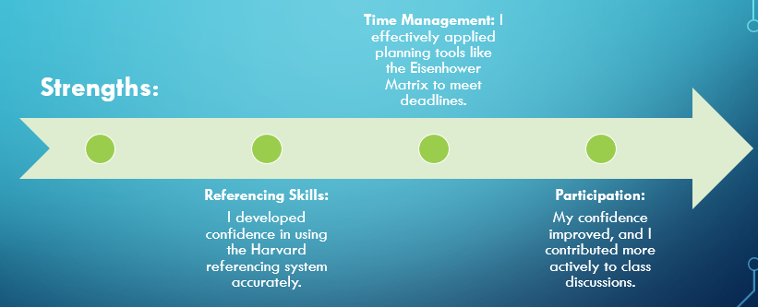
Figure 01: My Strengths (Author).
Last but not least, I have realised my strengths as well as weaknesses. I am good at referencing, managing my time and working with fellow students. However, I still have to work on my critical thinking and the building of an argument. At times, it becomes a struggle to move past summarising information to in-depth analysis. My excursion to another field will be through reading and analyzing academic writings based on something I read in a class with its analytical structures (Controllah Gabi Phd, 2022).
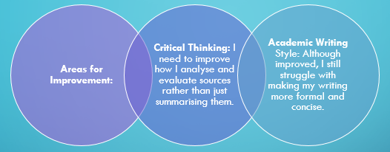
Figure 02: Areas for Improvement (Author).

Conclusion
To sum up, the Academic Skills module has enriched me with a lot of academic skills and also a boost in personal development. All the experiences of learning how to reference in Task 1 to learning how to write more practically, Task 2 helped me become a more confident and more capable student. This module has equipped me with the necessities I need to excel at higher education such as the study topics, research skills, and time management needed. From here, I will continue to work on these skills even more, especially my critical analysis. All in all, the latter was a crucial part of my educational journey (Philpot, 2018).

References
Caulfield, Jack (2020). A Quick Guide to Harvard Referencing | Citation Examples. [online] Scribbr. Available at: https://www.scribbr.co.uk/referencing/harvard-style/.
Controllah Gabi PhD (2022). ACADEMIC WRITING I Academic Writing. [online] ResearchGate. Available at: https://www.researchgate.net/publication/369850655_ACADEMIC_WRITING_i_Academic_Writing.
Cottrell, S. (2024). The Study Skills Handbook. 6th ed. London: Bloomsbury Academic.
Lumen, L. (2025). Paraphrases & Summaries to Re-State Ideas | College Reading and Writing. [online] Lumenlearning.com. Available at: https://courses.lumenlearning.com/suny-esc-introtocollegereadingandwriting/chapter/summary-paraphrase/.
Philpot, S. (2018). Academic Skills : reading, writing, and Study skills. Introductory level, Teacher’s Guide. Oxford: Oxford University Press.
Randel, J. (2020). The Skinny on Time Management. RAND Media Co.
Trent University (2023). Paraphrasing and Summarizing - Academic Skills - Trent University. [online] www.trentu.ca. Available at: https://www.trentu.ca/academicskills/how-guides/how-use-sources/avoiding-plagiarism/paraphrasing-and-summarizing.

