
Early years education and care

(Source: http://clipart-library.com/, no date)
Transition into a Nursery

Key themes

- Communication

- Partnerships

- Children’s learning

- Development

- Importance of play
Contents page

Introduction 3

Safeguarding 4-5

Transitions 6-7

Theorists 8-9

The needs of the child 10-11

The role of the adult 12-13

Communication 14

Interventions 15

Outcomes 16
(Source: pbs.twimg.com, no date)

Introduction
The outcome of this handbook is to offer information and advice to ensure a child has a positive transition.

This handbook is for key workers in a Nursery to understand the importance of effective communication and a child’s learning development through transition. A Crèche is a supervised area provided for children for a short period of time, in a crèche there are separate rooms depending on their age for them to play in (www.collinsdictionary.com, no date).

The purpose of the handbook is for practitioners in a Nursery setting to understand and get assistance on how to help a child during transition. The key subjects will be communication with both family of child and other professionals, how transition is good for a child’s development and examples of interventions to help a transition.

When Children transition into crèche some are more venerable than others. By creating a smooth transition it is vital that the child gets the best possible start into a new setting (http://www.earlyyearscareers.com/, no date). The topics, which will be covered, will allow a practitioner in their setting to have guide when encouraging a child through their process into a setting. Also will cover the development of a child through importance of play at the challenging stages. Also this handbook will cover and go into detail into the age rage of a child going from home to a Nursery.

Between the ages of 4-7 months of age children have developed a sense of object permanence, they don’t realize that things (Mam, Dad and guardian) still exist even when they are out of sight, some children may cry until ‘mother’ is back into sight again. From 8 months to 1 year old children get more uncertain about leaving a parents and realize more when they are going to leave, some children may go through it later on between the ages of 18 months and 2 and a half years old as some children wont leave their parents until later on in life e.g. nursery and primary school (kidshealth.org, no date).

This handbook is appropriate for use in a crèche setting for a practitioner to use for guidance during a children’s transition from home to Nursery.

Safeguarding
What is the early years foundation stage?

The early foundation stage set its standards fro all children providers to meet to ensure that children learn and develop in a safe and healthy environment. This covers the first stage of a child’s care, learning and development, from birth to 5 years old (www.northamptoonshire.gov.uk, no date).

Safeguarding in an early years setting, school and further education should have a safe environment where children, young people and vulnerable adults can learn and develop. In a setting it is important that safeguarding and promoting a child’s welfare you are protecting them from any maltreatment, preventing impairment of children’s health or development, ensuring that a child is growing up in circumstances consistent with the provision of safe and effective care and taking action to enable a child to have the best outcome. It is important that for all staff receive a regular updates on safeguarding. Also staff needs to have safeguarding training every two years, with knowledge and skills refreshed (www.nurseryworld.co.uk, no date).

Nurseries should recognize that all children should grow up into an environment, which is free from harm and should encourage a child to reach their full, potential. All staff in an early years setting are required to have a DBS (disclosure and barring check) to ensure they are safe to work in this type of setting.
Safeguarding covers a wide range of aspects of care and education such as:
- The children’s and learners’ health and safety, wellbeing and including their mental health.
- Meeting the needs of a child with special educational needs or disability.
- The use of reasonable force.
- Meeting the needs of children and learners with a medical condition.
- Providing first aid in a setting.
- Educational visits for children.
- Intimate care and emotional well being.
- Online safety and associated issues e.g. block inappropriate websites.
- Having appropriate arrangements to make sure children and learners security is taken into account.
(www.gov.com, no date)


Five outcomes of safeguarding are:

- Stay safe
Stay safe
Looking after the children’s welfare and ensuring that there is safe environments.

Be healthy
By safeguarding and promoting children’s health and well being.

- Be healthy
Organization
Making sure all government policies, procedures and practice are strictly followed.

- Enjoy and achieve

- Make a positive contribution
Enjoy and achieve
Support children during that learning and development stages.

- Organization
Making a positive contribution
Work with parents to encourage children to play a beneficial part in their nursery and wider community.

(www.asquithnurseries.co.uk , no date)

(Source: https://content.mycutegraphics.com, no date)
(Source: pbs.twimg.com, no date)

Transition
How will transition affect children?

Transition is essential in a child’s life are essential in their development, these changes can be gradual or sudden. Transitions can be stressful and can affect their emotional well-being so its important that during this time the child is supported. How a child deals with transition id greatly affected by the support and response children receive from those around them (www.cram.com, 2013)

What is transition?

Transition is the process of changing from one state or condition to another (en.oxforddictionaries.com, no date).


Why are quality transitions important?

It is important that during transition both the child and family feel suitable in the new environment (Brostom, S 2004). From this the child will feel secure, confident and will help towards challenges ahead. Children’s first experiences with transition are important it will have an impact on their progress and future (Margretts, K 2007).

What is quality transition?

It is important that the practitioner takes into consideration that all children are unique. The practitioners in the setting need to recognize the importance of giving the child who is coming into nursery without knowing anyone consideration. (fixby.org.com, no date)

Key questions:
- What play choices do the children make?
- What is the child really interested in?
- How do they enjoy learning?
- What can the child do now? What are you trying to do next?
- Do they have specific individualised needs?
- What do parents and carers tell you about the child?
- Would the child benefit from additional transition activities?
- Are any of the child’s friends moving to the same nursery?

(fixby.org.com, no date, 4)

It is important that there is effective communication and partnership working during a child transition. This will allow the practitioners to take unto account and plan for the child coming into a nursery for a smooth transition for both the family of the child and the child. The parent/ guardian of the child plays a key role in supporting a smooth transition. It is important that children and parents are given opportunities to get familiar with the nursery and the environment to start build relationships with the staff. It is also important that the guardian/ parent of the child get information about what is happening during this transition (fixby.org.com, no date).

Theorists
Maslow’s hierarchy of needs:

- Physiological- this is the basic need to support such as food, water and sleep, which are your primary needs.
- Safety- this is the security, safety and stability, which are your secondary needs. This will also cover the security of roof over an individual’s head.
- Belonging- people need social contact; they wish to have friendships, acceptance, and care for other people are important needs.

- Esteem- people need esteem and recognition for what they do, which is recognition needs.
- Self- actualization- this is the development of certain qualities, which is your development needs. Maslow suggested that people would always have the urge to develop and chase new needs.
(https://www.toolshero.com/effectiveness/hierarchy-of-needs-maslow/)

Bowlby’s attachment theory

Bowlby’s theory of attachment suggests that children come into the world pre-programmed to form an attachment with others to help them survive. The attachment behaviors are instinctive and can be activated by a condition that seems to threaten the achievement of proximity, such as separation, insecurity and fear. Bowlby (1969-1988) also suggested that the fear of strangers represents an important survival mechanism built in by nature. Babies are born with the tendency to display certain behaviors, which help ensure proximity and contact with mother or attachment figure, examples would be smiling, crying, crawling etc. (www.simplypsychology.org, 2007).
(Source: http://static.wixstatic.com/, no date)

Bronfenbrenner

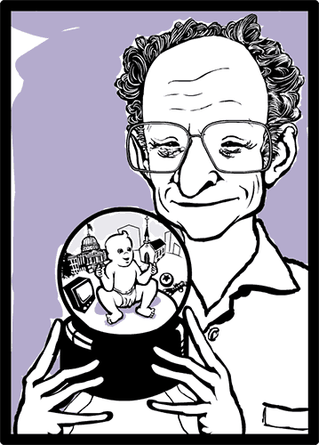
Bronfenbrenner (1917-2005) developed the theory of the ecological system, which is to explain everything in a child and the child environment that affects how the child grows and develops. There is different levels of the environment that influence a child’s development which are:
- Microsystems
- Mesosystymes
- Exosystem
- Macroystem
(https://www.nap.edu/openbook/23482/xhtml/images/img-92-1.jpg, no date)
(Source: http://www.catherineshafer.com/, No date)

Bronfenbrenner (1917-2005) discusses that a children’s environment affects them, this is important to consider when a child is transitioning into nursery, as some children will find it more difficult than others. Some children may not get upset when parents leave and others will cry, this is due to their attachment with parent/ carer (https://www.nap.edu/openbook/23482/xhtml/images/img-92-1.jpg, no date).


The needs of the child
What does evidence tell us about what they need in times of transition?

Carlson (2007) suggested that children’s basic needs are:
- Stable living environment- is a peaceful and safe place a child is able to call home.
- Proper nutrition- if allowed a child they would eat junk food, so adults give the balance of what they want and what they need. Good nutrition is important to health and growth.
- Structured discipline- is setting rules and sticking to them, so a child does not get confused.
- Physical exercise- a child needs exercise to keep healthy and also emotionally healthy.
If one of these factors was not fulfilled with a child’s life can cause problems, it can cause problems with a smooth transition as the child wont feel secure at home or at the nursery.

(Source: www.muralswallpaper.co.uk, No date)
(Source: www.muralswallpaper.co.uk, No date)
What are key people that aid a smooth transition?

Parent
It is important that one a child is transitioning into a nursery they should take the child for visits to the nursery to familiarizes themselves with the place so that when they do attended it is not an unknown place. Also the parent should give staff a ‘brief’ about their child, as the more staff knows the more staff will understand about the child. Share some positive stories and comments about a nursery so that the child will see a nursery as a positive place (Denlay, no date). It is also important that the child has a positive relationship with their parents/ carer to have a smooth transition.

Key workers
In a nursery the key workers role is to enable a child to have an effective way of developing a strong relationship with an adult in the nursery. Also this will allow the child to feel secure and cared for which will encourage them to become familiar with the nursery environment and develop the confidence and feel secure. The key worker will also watch the child to plan and organize appropriate tasks to encourage they learning (http://www.turtlesnursery.co.uk/key-worker, no date)

A Childs voice
It is important that you listen to the child; Clark (2005) suggested that when listening to children you acknowledge their rights for views and experiences. By listening to children you gain understanding of children’s priorities, interests and concerns. When listening it is a vital part in establishing respectful relationships with the children and gets a better understanding for a right path for their learning process.
When you have a clear understanding of children’s lives, parents and practitioners able to respond to any changes in that child’s life and will be able to meet their diverse needs and improve their care and services (Lancaster and Broadbent, 2010: 4).

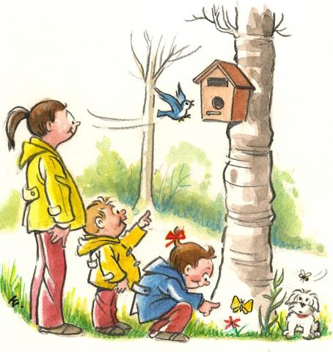
The role of the adult

In a nursery setting the role of the adult is to have a clear understanding of the child’s development and how a child learns, they will also need to take into consideration that what has gone on before the nursery and how that child needs to progress.

Fisher (no date) suggested that there are four parts a practitioner needs to consider:
- Time to talk- this is important as effective communication with young children will help have a better understand and children will know what is worthwhile to them.

- In tune- this is to ensure that an adult doesn’t become between a child’s learning through play.
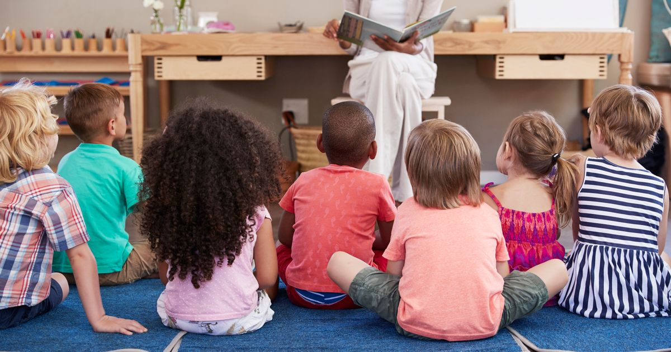
- Under control- it is important that the adult role supports a child when doing child-led activities rather than adult- led learning.
- Now you are talking! – Take an interest when a child is talking.

For the practitioner it is important that you planned the transition before, a well-planned and thoughtful transition will often go smoother and will be more beneficial for a child and parent/ carers. All children are individuals so not all theories will work for every child. The key worker will play an essential role in transition. Toddlers have little understanding of time; each child will take a different amount of time to transition into a nursery. When the child is taking visits into the nursery it is important that the child has their primary attachment figure when them as they need to feel more comfortable enough to explore their environment (http://www.choochoos.co.uk/, no date)
(Source: https://i2-prod.somersetlive.co.uk, No date)
(Source: http://www.twixus.co.uk/, No date)
A key Adult is:
(Source: http://www.twixus.co.uk/, No date)
(http://www.choochoos.co.uk/, no date)

Someone to build relationship with the child and parents
Someone who helps the child become familiar with the provision.
Someone who meets children’s individual needs and care needs (e.g. dressing, toileting etc.)
Someone who responds sensitively to children’s feelings, ideas and behavior
A person who keeps in contact with parents about their child.
A named member of staff who has more contact than others with the child

Communication


It is important that in a setting you understand the difference between verbal and non-verbal communication as some children can find it difficult to communicate.
(Source: http://melibeeglobal.com/, No date)

Non-verbal examples would be:
- Shaking hands,
- Patting the back,
- Hugging,
- Pushing,
- Or other kinds of touch.
There are also other forms, which are:
- Facial expressions,
- Gestures,
- Eye contact. (http://examples.yourdictionary.com/, no date)

Verbal communication would be:
- Oral discussions,
- Written messages,
- Mediated messages.

It is important that we make verbal communication fun for children for them to gain skills.
(Classroom.synonym.com, no date)

Interventions

An early intervention is about taking action and tackling a problem for children and families before they become worse. This could help a child by ensuring they get the support to not cause problems in their learning. For a nursery they would look at the holistic approach and would support the child and their families, some nurseries to fly start, which helps parents (http://www.eif.org.uk/,no date).

When a child does start nursery they will transition into nursery and there is some activities that could be done:
- Rhymes and songs which involve going to nursery
- Rhymes and songs that they already know
- Creating a “all about me” book
- Read starting nursery books
- Make the rules fun and easy to follow. e.g. sit on the carpet for story time

From three years old to five years old there is a gap between children from the poorest families and the wealthiest families about a 19-month age gap in their learning. For a practitioner it is important that we recognize if any children are struggling and need extra support during their transition into a nursery. But it is not just supporting their children but also their families. In a setting in a child is needing support staff should considering trying one to one to help encourage the child to feel more settled (Otte, J. 2017)

(Source: s3-eu-west-1.amazonaws.com, No date)
Outcomes

Transition from a home to a nursery is an important milestone in both a child and their families’ lives. This will encourage them later on their achievements. A child’s ability to transition successfully into the nursery can depend on their personal characteristics such as temperament, personality etc. and it also depends on their parents characteristics such as attitude towards learning and, maternal education. Some areas don’t have the access to a nursery, which can make it more difficult for a parent to take their child. For a child do have a successful transition it is important that the practitioner in the setting gives a range of approaches such as assisting children to understand the routines and practices of the nursery their attending. During the child’s transition it is important the key staff keep the parents/ carers of the child aware of what is going on, if both work together to help the child the transition will become more successful (Rosier, K. Mcdonald, M. 2011). The outcome of a successful transition would be that a child is happy in their nursery and engaging with staff and other children.

(Source: https://funmagicshows.com, no date)

